Annual immunisation coverage report 2020
17 September 2021
Brynley Hull, Alexandra Hendry, Aditi Dey, Julia Brotherton, Kristine Macartney, Frank Beard

Abstract
We analysed Australian Immunisation Register (AIR) data as at 31 March 2021 for children, adolescents and adults. This is the first time that adolescent and adult coverage data from the AIR have been included in our annual coverage report.

Children
‘Fully vaccinated’ coverage was 0.5–1.0 percentage points higher in 2020 than 2019 across the three standard age milestones, reaching 94.8% at 12 months, 92.1% at 24 months and 94.8% at 60 months. Rotavirus vaccine coverage (2 doses) increased from 91.9% in 2019 to 92.5% in 2020. ‘Fully vaccinated’ coverage in Aboriginal and Torres Strait Islander (hereafter respectfully referred to as Indigenous) children increased by 0.1–1.2 percentage points in 2020, reaching 93.1% at 12 months, 91.2% at 24 months and 97.0% at 60 months (2.2 percentage points higher than in children overall). Influenza vaccination coverage in children aged 6 months to < 5 years increased by 4.2 percentage points to 45.2% in 2020, and remained stable for Indigenous children at 43.6%. Longstanding issues with timeliness of vaccination in Indigenous children persist. We also examined timeliness of ‘fully vaccinated’ coverage at earlier age milestones (3 months after the due date of the last scheduled vaccine) of 9, 15, 21 and 51 months, by Indigenous status, socioeconomic status and remoteness of area of residence. Coverage in children living in the least advantaged residential area quintile was 1.9–2.5 percentage points lower than for those living in the most advantaged quintile at these earlier milestones, a 0.4–1.0 percentage points greater disparity than in 2019. Coverage at the earlier milestones in Indigenous children in remote areas was 2.6–7.8 percentage points lower than for Indigenous children in major cities and regional areas, with disparity at 21 months of age 0.5–0.8 percentage points higher in 2020 than in 2019, and 1.1–3.2 percentage points higher at 51 months. Importantly, although Indigenous children had slightly lower coverage for the second dose of measles-mumps-rubella-containing vaccine at 24 months (93.9% versus 94.0% overall), coverage among Indigenous children increased to 98.8% when measured at 60 months; coverage was also high overall at 96.8%, above the 95% target critical to measles control.

Adolescents
In 2020, the human papillomavirus (HPV) vaccination schedule was completed by 80.5% of females and 77.6% of males (75.0% and 68.0% for Indigenous) by 15 years of age, an increase of 0.6–0.7 of a percentage point on 2019 (2.6–3.4 percentage points for Indigenous). Additionally, 86.8% of adolescents (84.2% for Indigenous) had received the recommended booster dose of diphtheria-tetanus-acellular pertussis (dTpa) vaccine by 15 years, and 74.3% (68.1% for Indigenous) had received the recommended meningococcal ACWY vaccine dose by 17 years of age. However, the proportion of adolescents completing the 2-dose HPV vaccination schedule within a calendar year was 11.6 percentage points lower in 2020 than 2019; the number of dTpa doses in adolescents aged 11–15 years was 13.7 percentage points lower; and the number of meningococcal ACWY doses in adolescents aged 14–19 years was 4.1 percentage points lower, with these reductions likely due to COVID-19 pandemic-related disruption to school-based programs.

Adults
Recorded zoster vaccine coverage was relatively low in 70-year-old adults in 2020 at 30.4%, similar to 2019. Recorded influenza vaccination coverage in adults in 2020 increased with increasing age group, reaching 64% in the 65–69 year and 70% in the ≥ 75 year age group. Coverage also increased across all age groups between 2019 and 2020. These figures likely reflect some underreporting, with true coverage probably higher.

Conclusions
We found continuing improvements across a range of childhood immunisation indicators in Australia in 2020. While this predominantly reflects vaccinations due in 2019, due to the use of standard assessment time points 6–12 months after vaccines are due, other reports have indicated a lack of impact of the coronavirus disease of 2019 (COVID-19) pandemic on routine childhood vaccination in Australia. However, issues with timeliness of vaccination persist, particularly in Indigenous and socioeconomically disadvantaged children. Adolescent coverage was also relatively high, although with some evidence of pandemic impacts, so it will be important to monitor levels of adolescent catch-up vaccination. Adult coverage figures are likely underestimates due to underreporting of adult vaccinations to the AIR. Mandatory reporting of National Immunisation Program (NIP) vaccinations to the AIR, introduced in 2021, should improve reporting and enhance the AIR’s value for monitoring the successful delivery of the NIP.
Keywords: vaccination coverage, vaccination timeliness, Aboriginal and Torres Strait Islander vaccination coverage, influenza vaccination.

Introduction
This is the fourteenth annual Australian immunisation coverage report, with reports now covering the years 2007–2020.^{1–13} This 2020 report is the first in the series to report ‘whole-of-life’ coverage data for children, adolescents and adults from the Australian Immunisation Register (AIR), following the AIR’s expansion in 2016. This report complements other sources of data on vaccination coverage in Australia,^{14,15} by highlighting important trends and their relationship to relevant policy and program changes. The report includes detailed analyses of coverage data for the calendar year 2020, with a particular focus on changes from 2019. It also shows trend data from 2011 onwards.
This report uses the longstanding international practice of reporting at key childhood and adolescent milestone ages to measure coverage against national targets and to track trends over time. National vaccination coverage and timeliness for 2020 was measured using AIR data as at 31 March 2021. Childhood cohort vaccination status was assessed for the ‘fully vaccinated’ category (as defined by the Australian Government Department of Health) and for individual vaccines at the standard milestones—12 months of age (for vaccines due at 6 months); 24 months of age (for vaccines due at 6, 12 and 18 months); and 60 months of age (for vaccines due at 48 months)—including by Aboriginal and Torres Strait Islander (hereafter respectfully referred to as Indigenous) status and at small area level (Primary Health Network [PHN] and Australian Bureau of Statistics Statistical Area 3 [SA3]). Coverage for vaccines included in the National Immunisation Program (NIP) for Indigenous children only was also assessed, using appropriate milestones/cohorts and for relevant jurisdictions. Timeliness of childhood vaccination was assessed by calculating ‘on-time’ vaccination (within 30 days of recommended age) for selected vaccine doses, by Indigenous status, and ‘fully vaccinated’ coverage at earlier age milestones of 9, 15, 21 and 51 months by socioeconomic status and remoteness of area of residence. Coverage for vaccines included in the NIP for adolescents and adults was also assessed, using appropriate milestones/cohorts. We focused on HPV, dTpa and meningococcal ACWY vaccine coverage for adolescents by jurisdiction, Indigenous status, age group and gender; and on zoster vaccine coverage for adults aged 70 years by jurisdiction and Indigenous status. Influenza vaccination coverage in 2019 and 2020 was assessed across all ages by Indigenous status. A more detailed description of the methods used in this report is provided in the Appendix.
The NIP schedule for children aged 0–4 years, adolescents and adults in 2020 is summarised in Appendix Table A.1. Important recent changes to vaccination policy, the incentive payment system and ‘fully vaccinated’ coverage algorithms are shown in Appendix Box A.1. An important change in relation to this report occurred in March 2020, when all children aged 6–59 months were funded for influenza vaccine under the NIP (previously funded under state and territory programs). While meningococcal B vaccine was funded from July 2020 for Indigenous infants and for people of all ages with specific high risk medical conditions, along with 13-valent pneumococcal conjugate vaccine (13vPCV) for Indigenous adults at 50 years of age and non-Indigenous adults at 70 years of age, coverage data for these vaccines are not included in this report given the early and limited data available.

Vaccine abbreviations
Abbreviation | Description
13vPCV | 13-valent pneumococcal conjugate vaccine
DTPa | diphtheria-tetanus-acellular pertussis (children aged under 10 years formulation)
dTpa | diphtheria-tetanus-acellular pertussis (children and adolescents aged over 10 years formulation)
23vPPV | 23-valent pneumococcal polysaccharide vaccine
Flu | influenza
Hep A | hepatitis A
Hep B | hepatitis B
Hib | Haemophilus influenzae type b
HPV | human papillomavirus
MenACWY | meningococcal ACWY
MenB | meningococcal B
MenC | meningococcal C
MMR | measles-mumps-rubella
MMRV | measles-mumps-rubella-varicella
PRP-OMP | Haemophilus influenzae type b conjugate (meningococcal outer membrane conjugate)

Results

Children

Coverage at 12, 24 and 60 months of age

‘Fully vaccinated’
‘Fully vaccinated’ coverage for all children (incorporating all vaccines/antigens included in the relevant assessment algorithm; refer to detailed methods section in Appendix) increased between 2019 and 2020 at all three age milestones: 12 months (from 94.3% to 94.8%); 24 months (from 91.1% to 92.1%); and 60 months (from 94.2% to 94.8%) (Table 1). Longer-term trends in ‘fully vaccinated’ coverage are shown in Figure A.1 in the Appendix. ‘Fully vaccinated’ coverage estimates for 2020 at the three age milestones are also provided by PHN in Appendix Table A.4. For the 12-months age milestone, ‘fully vaccinated’ coverage ranged from a low of 90.1% in the North Coast PHN to a high of 96.9% in the Western NSW PHN. For the 24-months age milestone, ‘fully vaccinated’ coverage ranged from a low of 87.8% in the North Coast PHN to a high of 94.8% in the Western Victoria PHN. For the 60-months age milestone, ‘fully vaccinated’ coverage ranged from a low of 91.0% in the North Coast PHN to a high of 97.6% in the Western NSW PHN.
Table 1: Vaccination coverage estimates (%) in children by age assessment milestone, vaccine/antigen and Indigenous status, Australia, 2019 versus 2020ª
Vaccine/antigen | Milestone age | Indigenous (%) |  | All children (%)
 |  | 2019^{b} | 2020 | 2019^{b} | 2020
‘Fully vaccinated’^{c} | 12 months^{d} | 92.9 | 93.1 | 94.3 | 94.8
 | 24 months^{e} | 90.0 | 91.2 | 91.1 | 92.1
 | 60 months^{f} | 96.9 | 97.0 | 94.2 | 94.8
Diphtheria-tetanus- acellular pertussis | 12 months^{d} (Dose 3) | 93.2 | 93.3 | 95.0 | 95.3
 | 24 months^{e} (Dose 4) | 91.5 | 92.5 | 93.1 | 93.5
 | 60 months^{f} (Dose 4 or 5) | 97.4 | 98.5 | 94.8 | 96.7
Polio | 12 months^{d} (Dose 3) | 93.1 | 93.3 | 95.0 | 95.3
 | 24 months^{e} (Dose 3) | 97.1 | 97.3 | 96.4 | 96.6
 | 60 months^{f} (Dose 4) | 97.0 | 97.0 | 94.3 | 94.9
Haemophilus influenzae type b | 12 months^{d} (Dose 3) | 93.1 | 93.2 | 94.9 | 95.2
 | 24 months^{e} (Dose 4) | 94.6 | 94.6 | 94.1 | 94.3
 | 60 months^{f} (Dose 4) | 98.9 | 98.8 | 96.6 | 96.7
Hepatitis B | 12 months^{d} (Dose 3) | 93.1 | 93.2 | 94.8 | 95.1
 | 24 months^{e} (Dose 3) | 97.1 | 97.3 | 95.9 | 96.4
 | 60 months^{f} (Dose 3) | 98.7 | 98.8 | 96.4 | 96.6
Measles-mumps-rubella | 12 months^{g} | N/A | N/A | N/A | N/A
 | 24 months^{e} (Dose 1) | 96.6 | 96.9 | 95.3 | 95.8
 | 24 months^{e} (Dose 2) | 92.9 | 93.9 | 93.5 | 94.0
 | 60 months^{f} (Dose 2) | 98.9 | 98.8 | 96.5 | 96.8
Varicella | 12 months^{g} | N/A | N/A | N/A | N/A
 | 24 months^{e} (Dose 1) | 92.7 | 93.6 | 93.6 | 94.0
 | 60 months^{f} (Dose 1) | 98.8 | 98.8 | 96.4 | 96.8
Meningococcal C-containing vaccine | 12 months^{g} | N/A | N/A | N/A | N/A
 | 24 months^{e} (Dose 1) | 96.6 | 96.9 | 95.2 | 95.7
 | 60 months^{f,g} (Dose 1) | 98.9 | 98.9 | 96.7 | 97.1
13-valent pneumococcal conjugate vaccine | 12 months^{d} (Dose 2 or 3) | 97.0 | 96.7 | 96.1 | 96.5
 | 24 months^{e} (Dose 3) | 96.7 | 96.8 | 95.7 | 95.6
 | 60 months^{f} (Dose 3) | 96.9 | 97.4 | 94.5 | 95.2
Rotavirus vaccine | 12 months^{d} (Dose 2) | 87.3 | 87.6 | 91.9 | 92.5
 | 24 months^{g} | N/A | N/A | N/A | N/A
 | 60 months^{g} | N/A | N/A | N/A | N/A
a Source: Australian Immunisation Register, data as at 31 March 2020 for 2019 estimates and 31 March 2021 for 2020 estimates.
b 2019 estimates for ‘fully vaccinated’ at 24 months, MMR (dose 2) varicella (dose 1) and 13vPCV (at 24mths & 60mths for each) have been revised due to an issue with the recording of dose numbers for 13vPCV and MMRV on AIR and are therefore slightly different to what is presented in the 2019 report.
c Refer to Appendix for details of ‘fully vaccinated’ assessment algorithms. Coverage estimates in this table are calculated using 12-month-wide cohorts and may differ slightly from estimates published elsewhere using rolling annualised cohorts.
d Cohort born 1 January 2018 – 31 December 2018 (2019 estimate) and 1 January 2019 – 31 December 2019 (2020 estimate).
e Cohort born 1 January 2017 – 31 December 2017 (2019 estimate) and 1 January 2018 – 31 December 2018 (2020 estimate).
f Cohort born 1 January 2014 – 31 December 2014 (2019 estimate) and 1 January 2015 – 31 December 2015 (2020 estimate).
g N/A Not applicable (vaccine either not given prior to this milestone, or contraindicated after previous milestone).

Coverage by individual vaccines/antigens
Coverage for all individual vaccines/antigens at 12 months of age increased between 2019 and 2020, by 0.3–0.6 of a percentage point (Table 1). For vaccines/antigens included in the ‘fully vaccinated’ algorithm, coverage was 95.1–95.3% in 2020 for the third dose of diphtheria-tetanus-acellular pertussis (DTPa), hepatitis B, polio, and Hib antigens (usually given together in a hexavalent combination vaccine at 6 months of age), and 96.5% for 13vPCV. Coverage for the second dose of rotavirus vaccine, which is not included in the ‘fully vaccinated’ algorithm due to upper age limits, increased by 0.6 of a percentage point, from 91.9% to 92.5%. Longer-term trends in individual vaccine/antigen coverage at 12 months of age are shown in Appendix Figure A.2.
Coverage for all individual vaccines/antigens included in the ‘fully vaccinated’ algorithm at 24 months of age increased between 2019 and 2020: by 0.5 of a percentage point for those due at 12 months (meningococcal C [MenC]-containing vaccine and the first dose of measles-mumps-rubella [MMR]), reaching 95.7% and 95.8%, respectively; and by 0.2–0.5 percentage points for those due at 18 months (fourth dose of DTPa, reaching 93.5%, and the second dose of MMR and varicella, usually given together as measles-mumps-rubella-varicella [MMRV] vaccine, reaching 94.0%), while the third dose of 13vPCV decreased by 0.1 of a percentage point to 95.6%. (Table 1). Longer-term trends in individual vaccine/antigen coverage at 24 months of age are shown in Appendix Figure A.3.
Coverage for all individual vaccines/antigens at 60 months of age increased between 2019 and 2020. For antigens included in the ‘fully vaccinated’ algorithm, coverage increased from 94.8% to 96.7% for the fourth (or fifth) dose of DTPa and from 94.3% to 94.9% for the fourth dose of polio (Table 1). For vaccines/antigens not included in the ‘fully vaccinated’ algorithm, coverage increased by 0.1 to 0.7 of a percentage point, reaching 96.6% for hepatitis B, 95.2% for 13vPCV, 96.7% for Hib, and 96.8% for MMR and varicella. Longer-term trends in individual vaccine/antigen coverage at 60 months of age are shown in Appendix Figure A.4.

Influenza vaccine coverage
Influenza vaccine coverage in children aged 6–59 months increased from 41.0% in 2019 to 45.2% in 2020 (Figure 1), and in children aged 5–9 years from 24.1% to 29.7% (Figure 2). There was substantial variation in recorded coverage for children aged 6–59 months by jurisdiction in 2020, with coverage highest in the Australian Capital Territory and Northern Territory at 63.0% and 58.8% respectively, and three other jurisdictions above 45% (Western Australia, South Australia and Victoria at 49.9%, 49.5% and 49.0%, respectively; Figure 1).

Figure 1: Recorded coverage of seasonal influenza vaccineª in all children aged 6–59 months, by jurisdiction, 2019 versus 2020, Australia^{b,c}
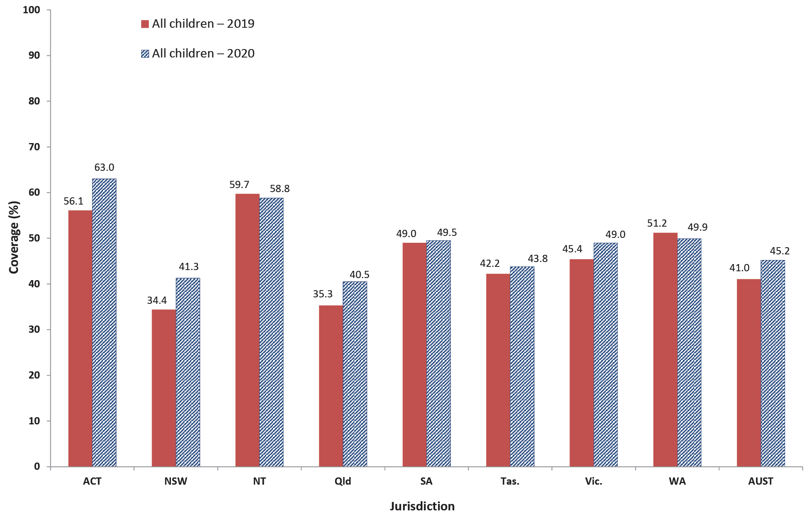
a At least one dose of any influenza vaccine.
b Source: Australian Immunisation Register, data as at 31 March 2021.
c ACT = Australian Capital Territory; NSW = New South Wales; NT = Northern Territory; Qld = Queensland; SA = South Australia; Tas. = Tasmania; Vic. = Victoria; WA = Western Australia; AUST = Australia.

Figure 2: Recorded coverage of seasonal influenza vaccineª by age group, 2019 versus 2020, Australia^{b}
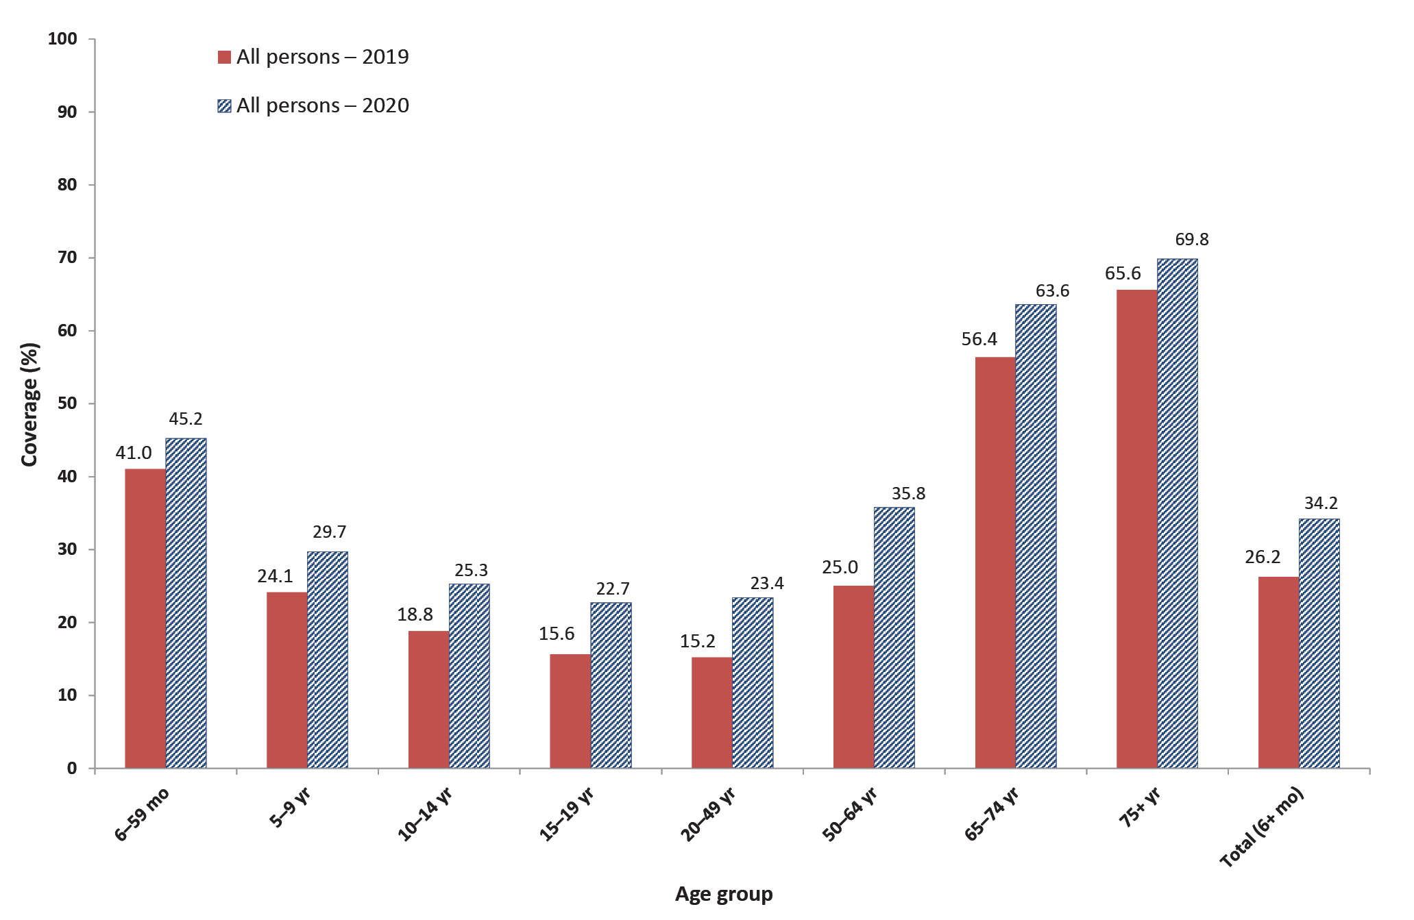
a At least one dose of any influenza vaccine.
b Source: Australian Immunisation Register, data as at 31 March 2021.

Coverage estimates by Indigenous status

‘Fully vaccinated’ at 12, 24 and 60 months of age
Between 2019 and 2020, ‘fully vaccinated’ coverage for Indigenous children increased at all three age milestones: 12 months (from 92.9% to 93.1%), 24 months (from 90.0% to 91.2%) and 60 months (from 96.9% to 97.0%) (Table 1).
The disparity in ‘fully vaccinated’ coverage between Indigenous and all children at 12 months of age in 2020 was 1.7 percentage points (up from 1.4 percentage points in 2019), and 0.9 of a percentage point at 24 months (down from 1.1 percentage points in 2019) (Table 1). ‘Fully vaccinated’ coverage at 60 months of age remained higher in Indigenous children than in all children, by 2.2 percentage points in 2020.
Trends in ‘fully vaccinated’ coverage estimates by Indigenous status are shown in Appendix Figures A.5, A.6 and A.7.

Coverage by individual vaccines/antigens at 12, 24 and 60 months of age
Coverage at 12 months of age in Indigenous children increased for all individual vaccines/antigens between 2019 and 2020, by 0.1–0.3 of a percentage point, except for 13vPCV coverage which decreased from 97.0% to 96.7% (Table 1).
Coverage at 24 months of age in Indigenous children increased for all individual vaccines/antigens between 2019 and 2020, by 0.1–0.5 percentage points, except for Hib vaccine which stayed the same at 94.6%. Coverage in Indigenous children in 2020 was higher than in all children for polio, Hib, hepatitis B, MMR dose 1 and MenC-containing and 13vPCV vaccine, but lower for DTPa, MMR dose 2 and varicella (Table 1).
Coverage at 60 months of age in Indigenous children in 2020 remained very high (over 97%) for all vaccines/antigens, and higher than in all children (Table 1). Coverage was particularly high for MenC-containing, hepatitis B, MMR dose 2, varicella and Hib (all 98.8–98.9%).

Influenza vaccine coverage
In Indigenous children aged 6–59 months, coverage in 2020 remained the same as in 2019 at 43.6% (Figure 3), while in those aged 5–9 years it increased from 32.3% to 34.8% (Figure 4). Coverage in Indigenous children aged 6–59 months varied substantially by jurisdiction in 2020, and was highest in the Northern Territory at 71.0%, with three other jurisdictions above 45% (the Australian Capital Territory, Victoria and Western Australia, at 53.6%, 49.1% and 45.1%, respectively; Figure 3).
Figure 3: Recorded coverage of seasonal influenza vaccineª in Indigenous children aged 6–59 months, by jurisdiction, 2019 versus 2020, Australia^{b,c}
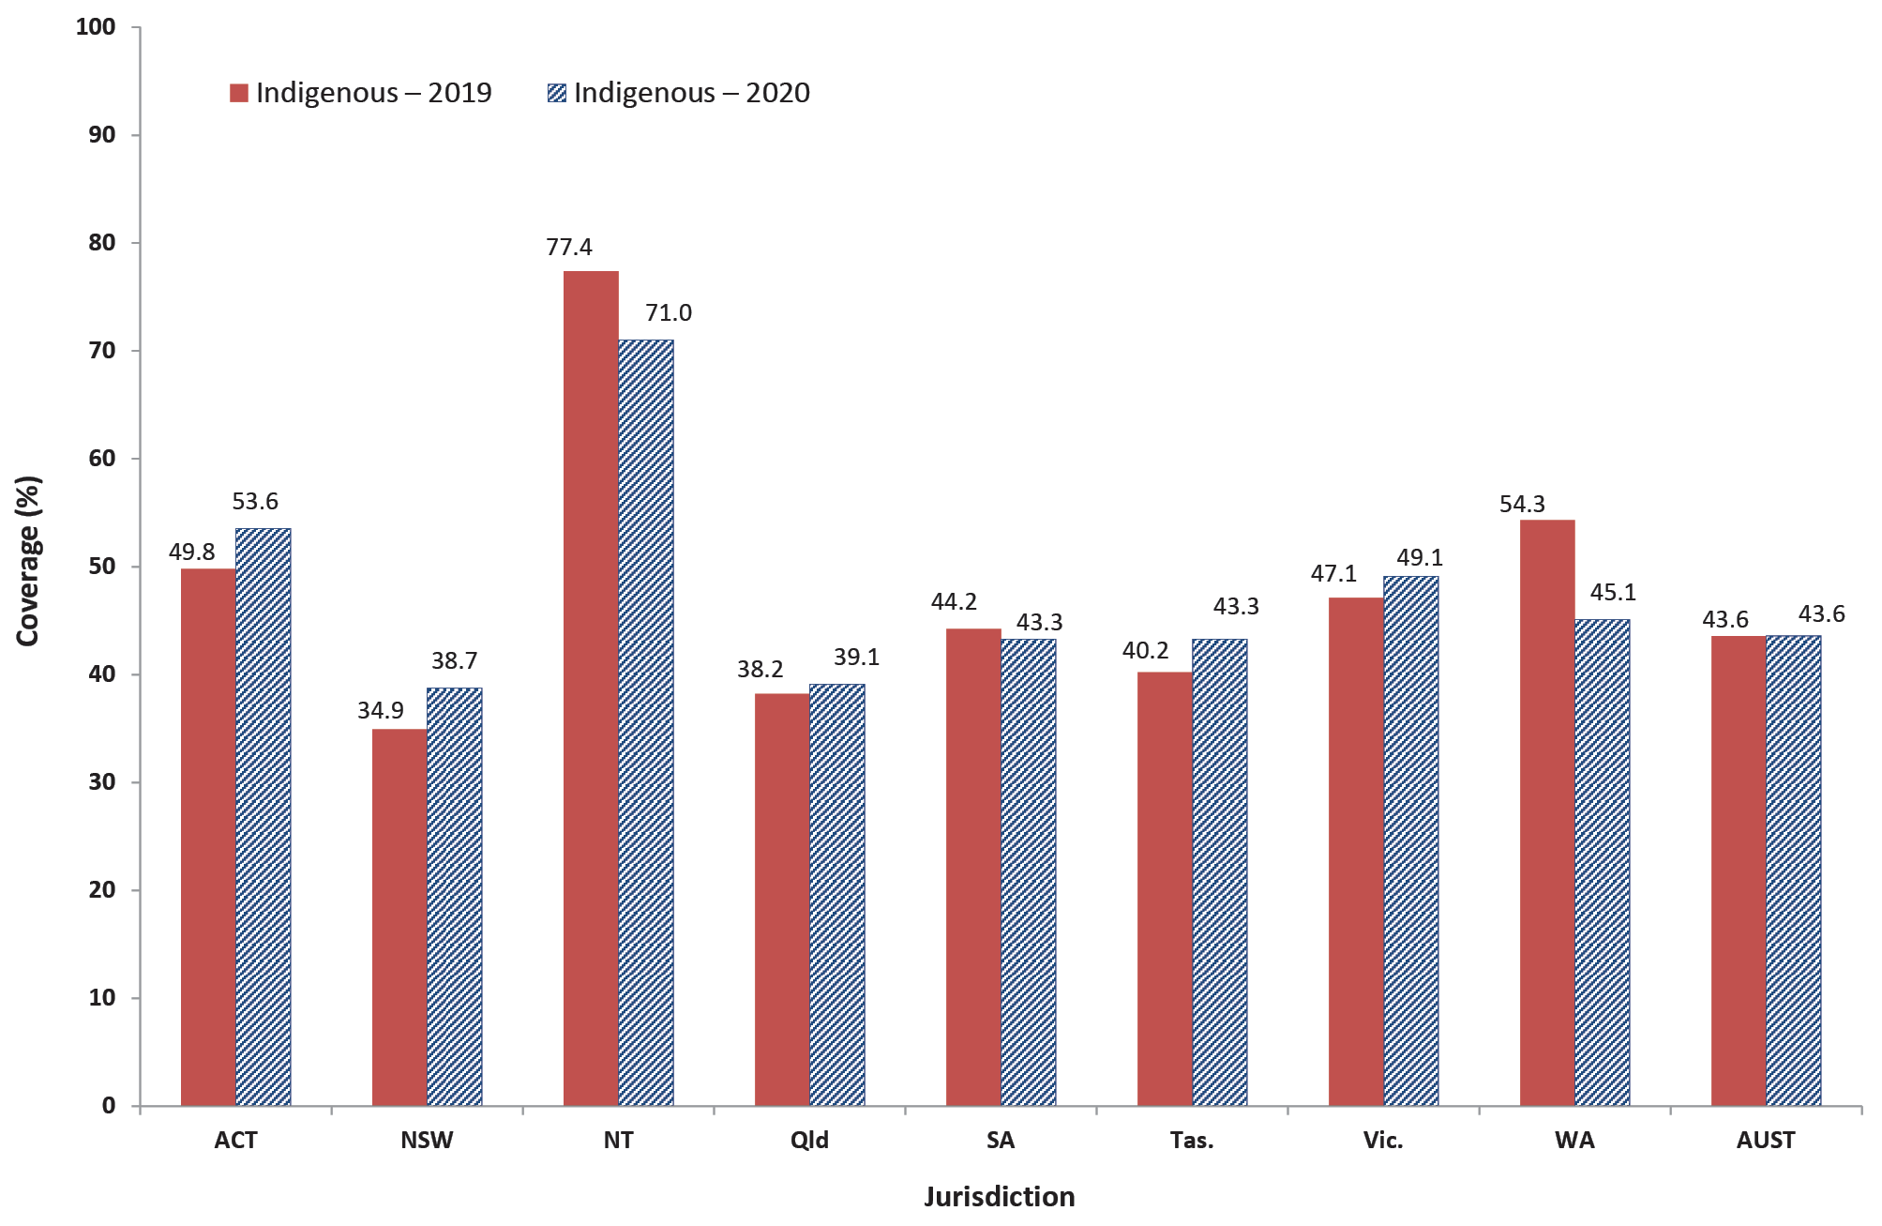
a At least one dose of any influenza vaccine.
b Source: Australian Immunisation Register, data as at 31 March 2021.
c ACT = Australian Capital Territory; NSW = New South Wales; NT = Northern Territory; Qld = Queensland; SA = South Australia; Tas. = Tasmania; Vic. = Victoria; WA = Western Australia; AUST = Australia.

Figure 4: Recorded coverage of seasonal influenza vaccineª by age group for Indigenous persons, 2019 versus 2020, Australia^{b}
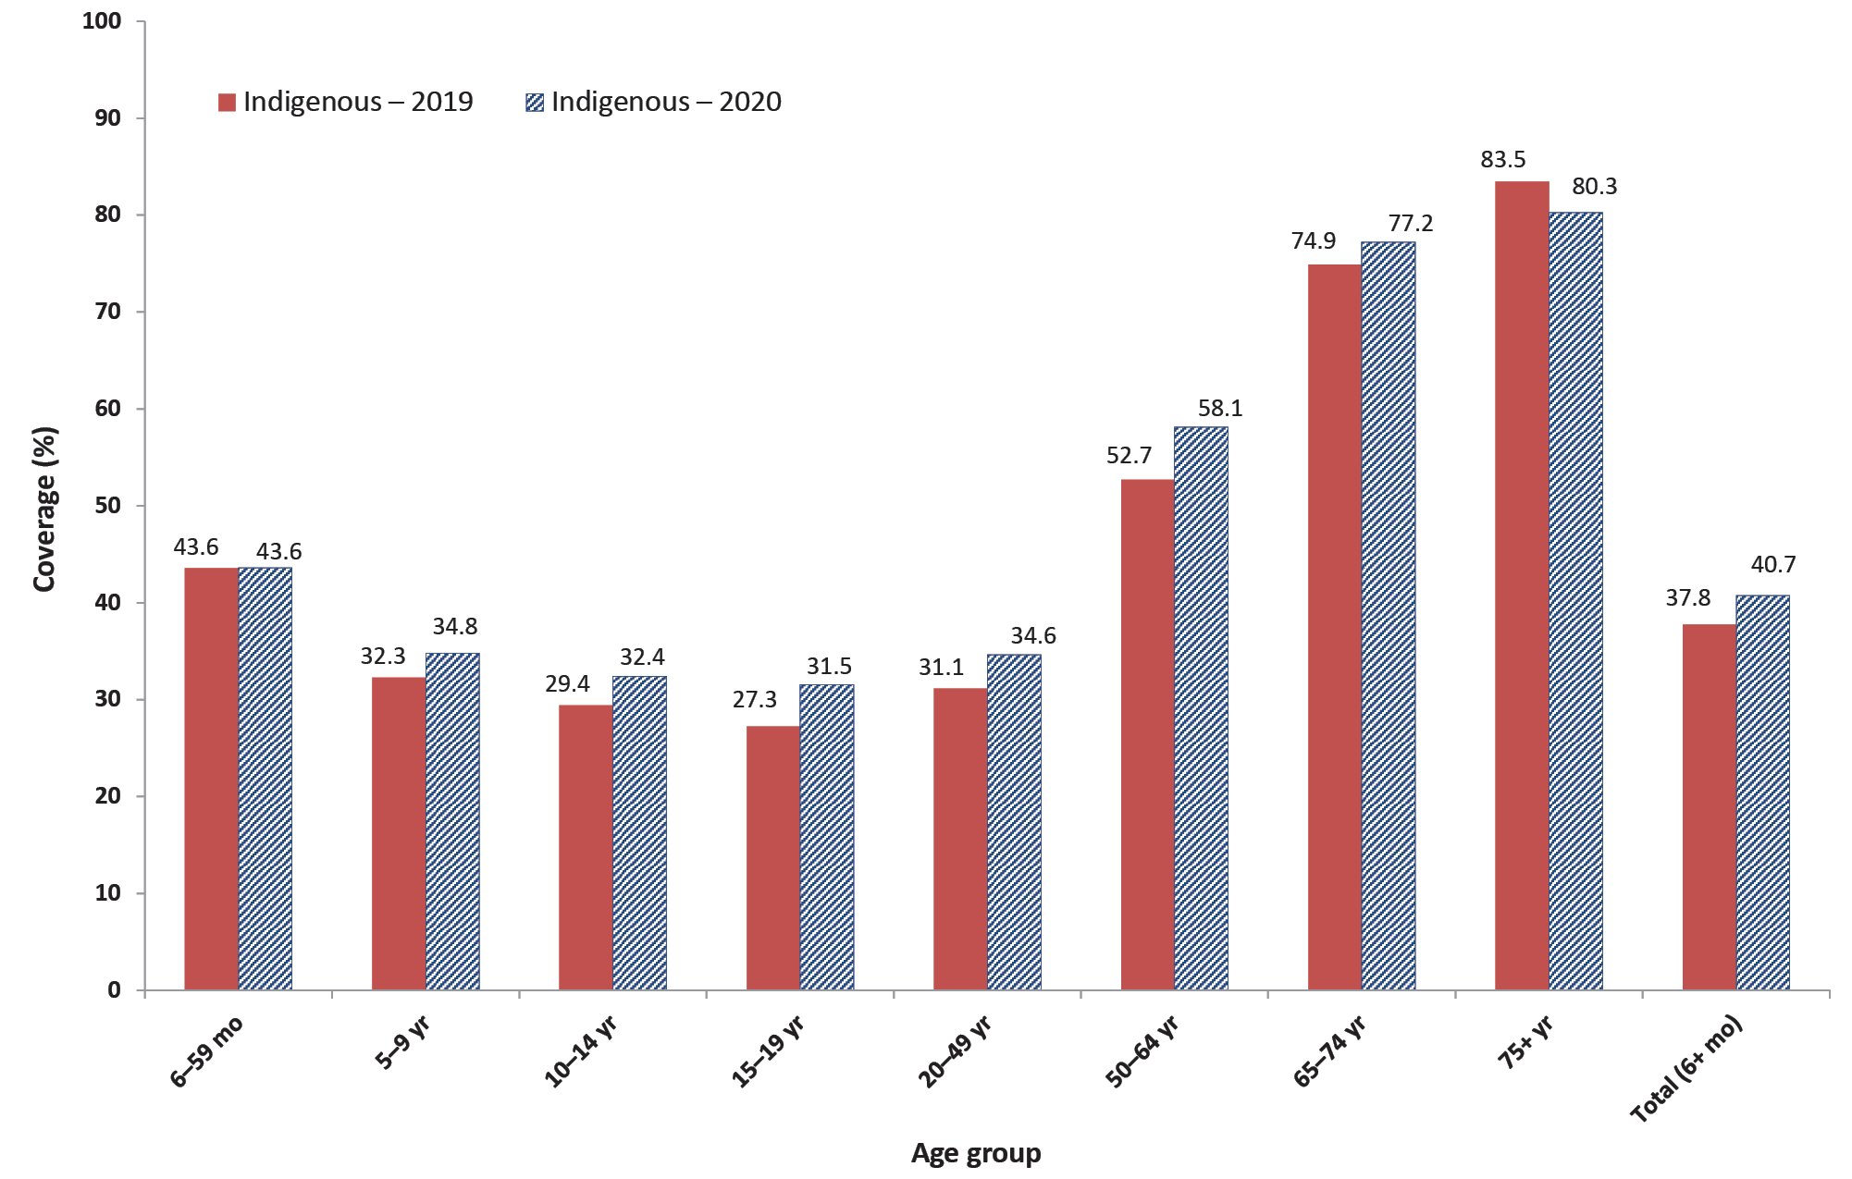
a At least one dose of any influenza vaccine.
b Source: Australian Immunisation Register, data as at 31 March 2021.

Hepatitis A vaccine for Indigenous children
Coverage for the second dose of hepatitis A vaccine by 30 months of age, for the combined four jurisdictions where it is funded under the NIP for Indigenous children (Northern Territory, Queensland, South Australia and Western Australia), increased from 72.2% in 2019 to 72.7% in 2020. Longer-term trends in hepatitis A vaccine coverage (Appendix Figure A.8) show that the highest coverage levels are consistently achieved in the Northern Territory (85.0% in the September 2020 quarter).

Pneumococcal vaccine for Indigenous children
Coverage for the additional fourth dose of 13vPCV by 30 months of age, for the combined four jurisdictions where it is funded for Indigenous children (Northern Territory, Queensland, South Australia and Western Australia), increased from 62.0% in 2019 to 73.5% in 2020. Longer-term trends in 13vPCV fourth dose coverage (Appendix Figure A.9) show that the highest coverage levels are consistently achieved in the Northern Territory (93.9% in the June 2020 quarter).

Timeliness of vaccination
The difference in percentage of infants with on-time receipt (within 30 days of the recommended age) of the second dose of DTPa vaccine, between Indigenous and non-Indigenous infants, was 10.0 percentage points in 2020 (Figure 5). The differential narrowed with increasing age, with only a 1.6 percentage point differential at 9 months of age.
Figure 5: Cumulative percentage of infants vaccinated with the second dose of DTPa-containing vaccine^{a,b} by age in months and Indigenous status, Australia, 2020^{c,d}
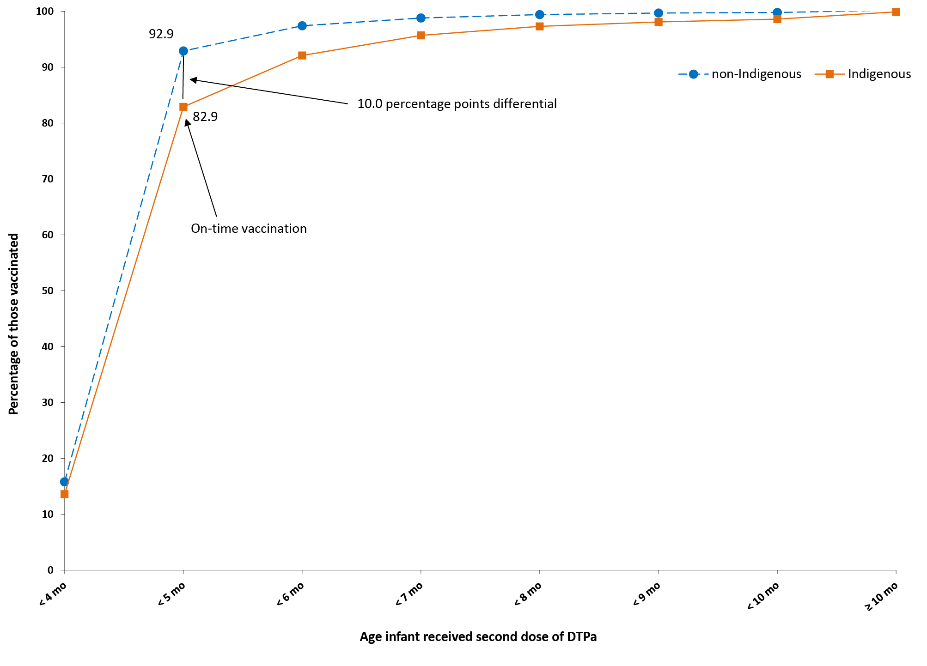
a DTPa = diphtheria-tetanus-acellular pertussis-containing vaccine (child formulation).
b Shown as cumulative percentage vaccinated (number of infants who received vaccine dose at particular age / total number of infants who received the vaccine dose, expressed as a percentage).
c Source: Australian Immunisation Register, data as at 31 March 2021.
d Cohort born in 2019.
The on-time vaccination differential for the second dose of 13vPCV, between Indigenous and non-Indigenous infants in 2020, was 9.7 percentage points, narrowing to a 1.4 percentage point differential at 9 months of age (Figure 6).

Figure 6: Cumulative percentage of infants vaccinated with the second dose of 13vPCV^{a,b} by age in months and Indigenous status, Australia, 2020^{c,d}
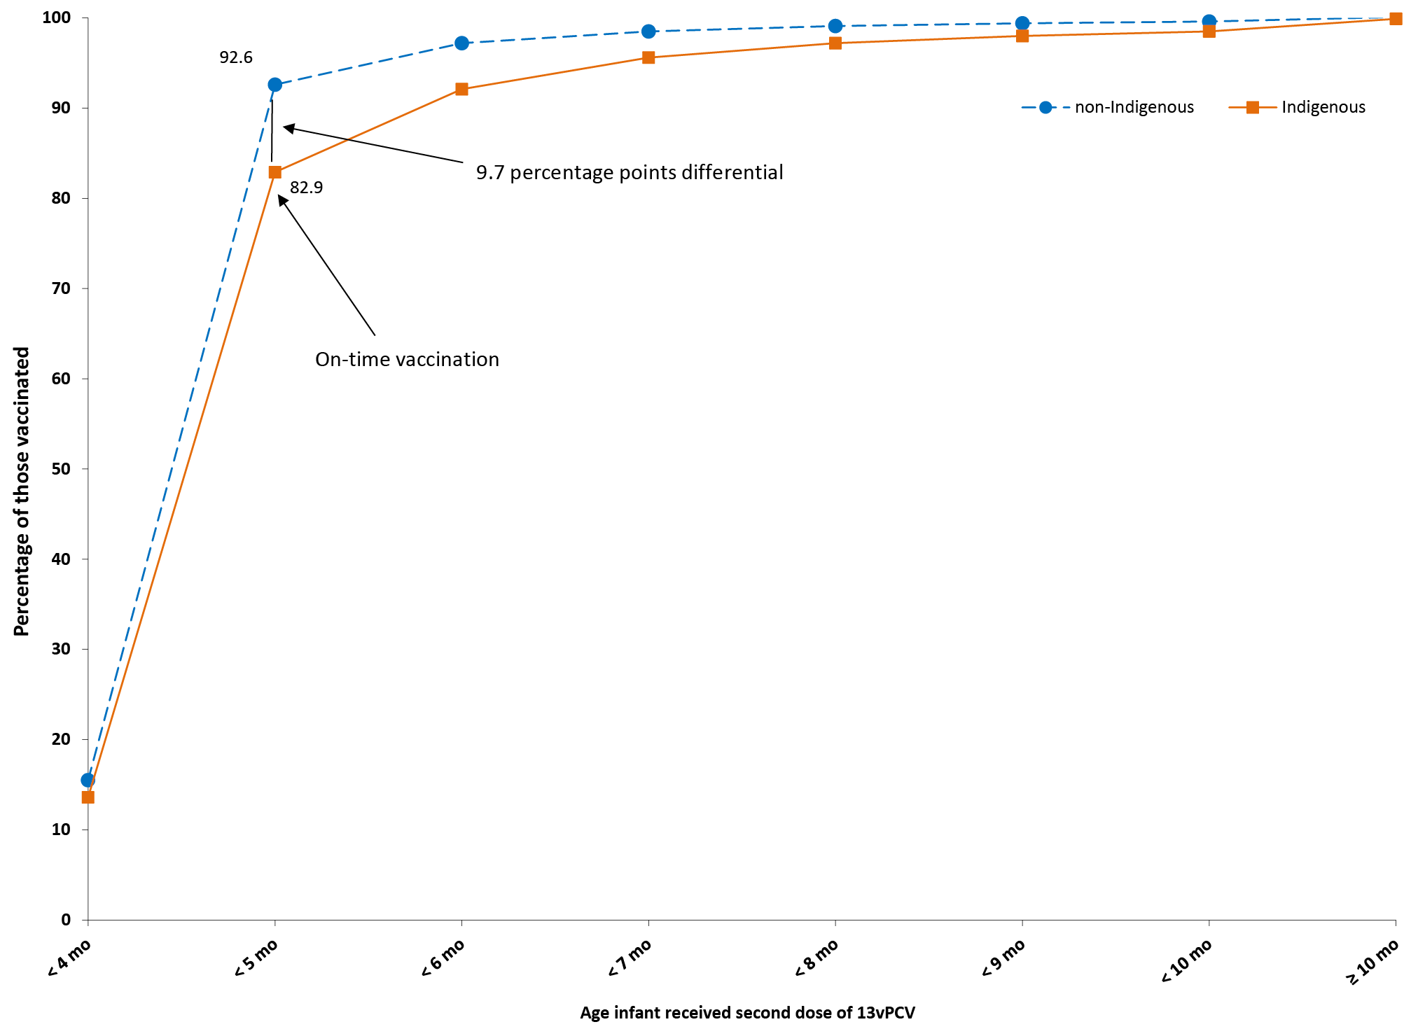
a 13vPCV = 13-valent pneumococcal conjugate vaccine.
b Shown as cumulative percentage vaccinated (number of infants who received vaccine dose at particular age / total number of infants who received the vaccine dose, expressed as a percentage).
c Source: Australian Immunisation Register, data as at 31 March 2021.
d Cohort born in 2019.
The on-time vaccination differential for the second dose of rotavirus vaccine, between Indigenous and non-Indigenous infants in 2020, was lower than that for DTPa-containing vaccine and 13vPCV at 4.3 percentage points, narrowing with increasing age to only 0.2 of a percentage point at 6 months of age (Figure 7).

Figure 7: Cumulative percentage of infants vaccinated with the second dose of rotavirus vaccineª by age in months and Indigenous status, Australia, 2020^{b,c}
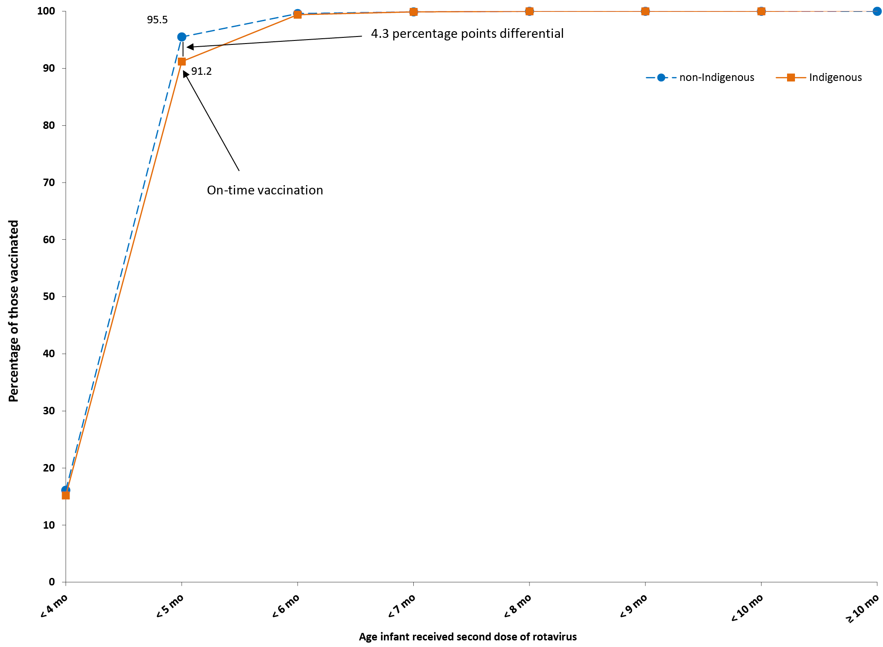
a Shown as cumulative percentage vaccinated (number of children who received vaccine dose at particular age / total number of children who received the vaccine dose, expressed as a percentage).
b Source: Australian Immunisation Register, data as at 31 March 2021.
c Cohort born in 2019.
The on-time vaccination differential for the first dose of MMR vaccine, between Indigenous and non-Indigenous children in 2020, was 11.8 percentage points. The differential narrowed with increasing age, with a 1.7 percentage point differential at 17 months of age (Figure 8).

Figure 8: Cumulative percentage of infants vaccinated with the first dose of measles-mumps-rubella (MMR) vaccineª by age in months and Indigenous status, Australia, 2020^{b,c}
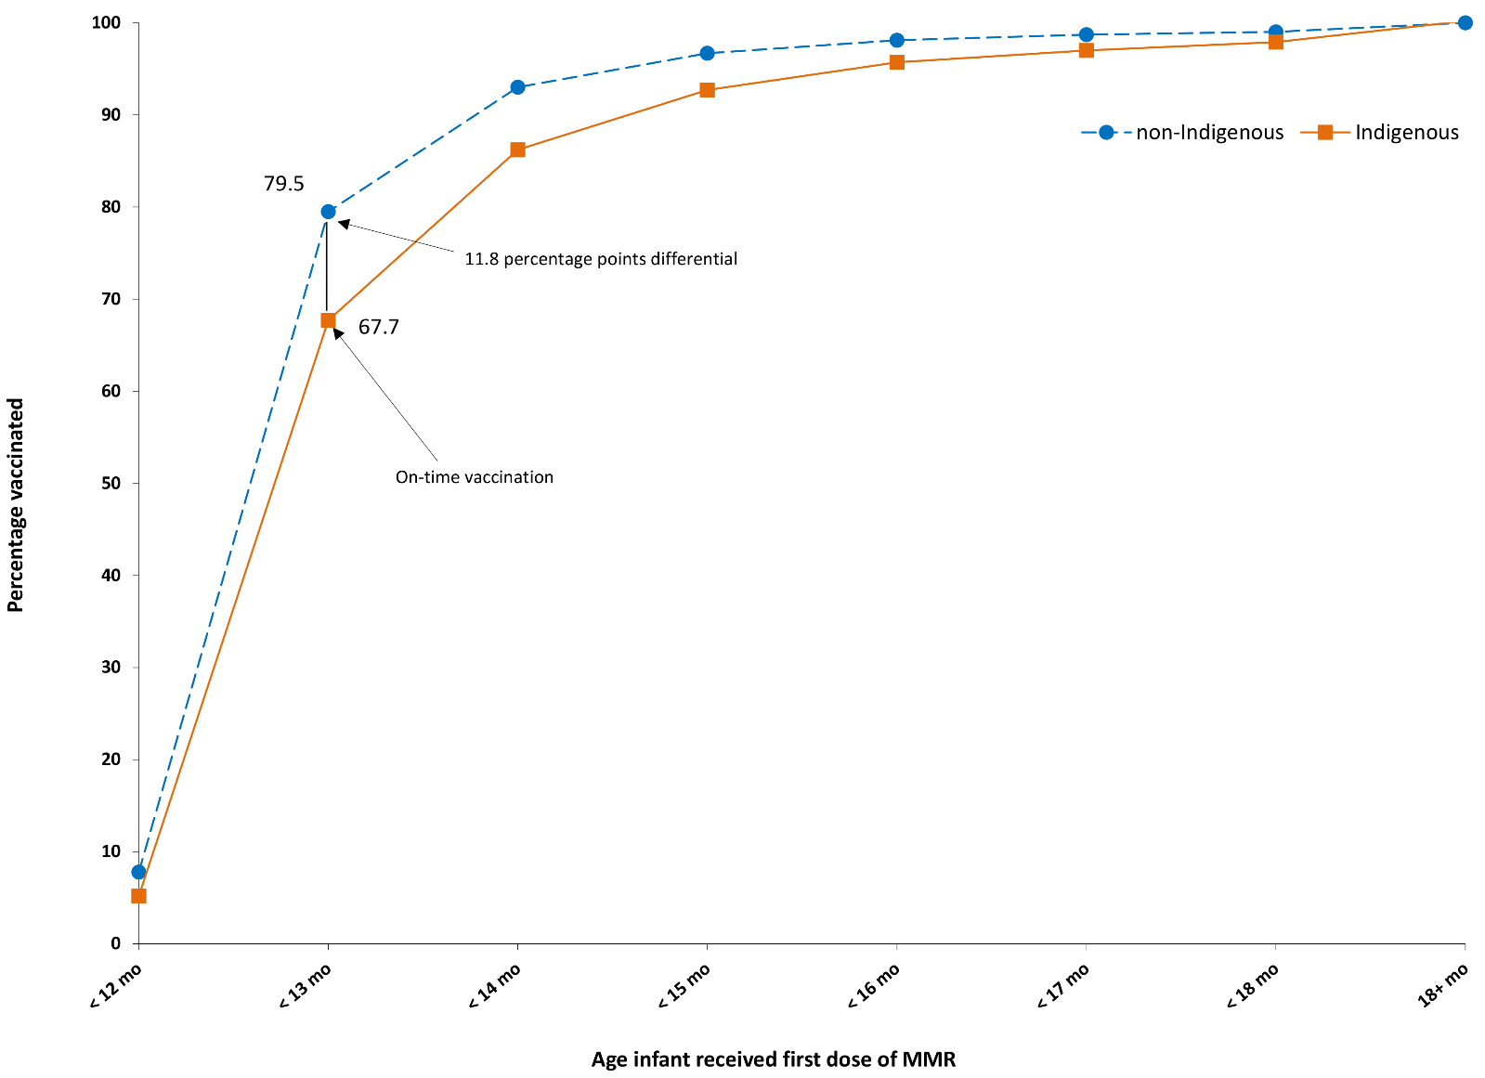
a Shown as cumulative percentage vaccinated (number of infants who received vaccine dose at particular age / total number of infants who received the vaccine dose, expressed as a percentage).
b Source: Australian Immunisation Register, data as at 31 March 2021.
c Cohort born in 2018.
The on-time vaccination differential for the first dose of MenACWY vaccine, between Indigenous and non-Indigenous children in 2020, was 8.2 percentage points, narrowing to a 1.1 percentage point differential at 17 months of age (Figure 9).

Figure 9: Cumulative percentage of infants vaccinated with the first dose of MenACWY vaccine^{a,b} by age in months and Indigenous status, Australia, 2020^{c,d}
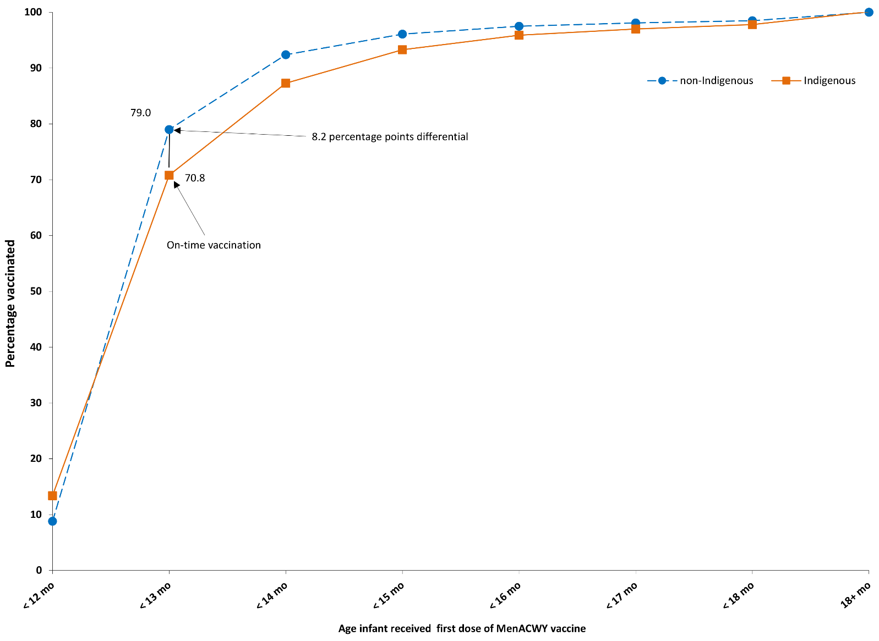
a MenACWY = meningococcal ACWY.
b Shown as cumulative percentage vaccinated (number of infants who received vaccine dose at particular age / total number of children who received the vaccine dose, expressed as a percentage).
c Source: Australian Immunisation Register, data as at 31 March 2021.
d Cohort born in 2018.
Compared to 2019, the disparity between Indigenous and non-Indigenous children for on-time receipt of vaccines in 2020 marginally increased by 0.1–0.3 of a percentage point for vaccine doses due at 4 months of age (second doses of DTPa-containing vaccine, 13vPCV, and rotavirus vaccine; refer to Table 2). For vaccine doses due at 12 months of age, the disparity increased slightly by 0.3 of a percentage point for the first dose of MMR vaccine (timeliness not assessed for MenACWY vaccine in 2019). Longer-term trend data for on-time receipt of vaccines can be found in our 2017 report.¹¹

Table 2: Disparity in on-time vaccination between Indigenous and non-Indigenous children for selected vaccine doses, Australia, 2019 and 2020ª
Vaccine/antigen | Disparity in on-time vaccination (percentage points) |  | Change (increase) in disparity (from 2019 to 2020)
 | 2019 | 2020
Diphtheria, tetanus, acellular pertussis – dose 2 | 9.8 | 10.0 | 0.2
13-valent pneumococcal conjugate – dose 2 | 9.6 | 9.7 | 0.1
Rotavirus – dose 2 | 4.0 | 4.3 | 0.3
Measles-mumps-rubella – dose 1 | 11.5 | 11.8 | 0.3
a Source: Australian Immunisation Register, data as at 31 March 2021.
Tables 3 and 4 present ‘fully vaccinated’ coverage estimates assessed 3 months after the last vaccine dose due, that is, earlier than the standard assessment milestones, to capture aspects of timeliness, along with the standard 12-month, 24-month and 60-month age milestones. For all four of the earlier assessment milestones (9-month, 15-month, 21-month and 51-month), ‘fully vaccinated’ coverage in 2020 was lower in Indigenous children residing in remote areas than in those residing in major cities and regional areas, with the greatest coverage differential at 21 months of age (Table 3). In contrast, while ‘fully vaccinated’ coverage for non-Indigenous children was 1.1–1.3 percentage points lower in remote areas at 21 months of age and 1.5 percentage points lower at 51 months of age than for children in major cities and regional areas, it was similar at 15 months of age. ‘Fully vaccinated’ coverage in 2020 was substantially higher at the standard milestones than the earlier milestones, most marked for vaccines due at 48 months when assessed at 60 months versus 51 months, for both Indigenous and non-Indigenous children, and across all remoteness categories (Table 3).
When stratified by socioeconomic status of area of residence, children residing in areas included in the most advantaged (fifth) quintile in 2020 had 2.4 percentage points or higher ‘fully vaccinated’ coverage than children in the least advantaged (first) quintile at the youngest three earlier assessment milestones (9, 15 and 21 months), but only 1.9 percentage points higher at the 51-month milestone (Table 4). The disparity between vaccination coverage in the most and least advantaged quintiles at the standard milestones ranged from 1.9 percentage points at 24 months of age to 0.9 percentage points at 60 months of age.
‘Fully vaccinated’ coverage estimates assessed at the earlier and standard age milestones in 2020, by PHN, are shown in Table A.3 in the Appendix.

Table 3: ‘Fully vaccinated’ coverage estimates assessed at earlier (9, 15, 21, 51) and standard (12, 24, 60 months of age: shaded) milestones,ª by Indigenous status and remoteness of area of residence,^{b} Australia, 2020^{c}
Indigenous status | Remoteness category^{b} | 9 mo^{d,e}  (%) | 12 mo^{d,e}  (%) | 15 mo^{d,f}  (%) | 21 mo^{d,f}  (%) | 24 mo^{d,f}  (%) | 51 mo^{d,g}  (%) | 60 mo^{d,g}  (%)
Indigenous | Major cities | 86.7 | 92.6 | 88.3 | 85.1 | 91.3 | 86.8 | 97.1
 | Inner and outer regional | 87.0 | 93.6 | 89.1 | 85.7 | 92.0 | 85.8 | 97.0
 | Remote and very remote | 84.0 | 92.8 | 85.0 | 77.9 | 88.3 | 83.2 | 96.8
 | All | 86.5 | 93.1 | 88.2 | 84.4 | 91.2 | 85.7 | 97.0
Non-Indigenous | Major cities | 92.4 | 94.9 | 90.8 | 89.3 | 92.1 | 88.2 | 94.6
 | Inner and outer regional | 92.5 | 95.0 | 90.9 | 89.5 | 92.4 | 88.2 | 95.1
 | Remote and very remote | 92.0 | 94.8 | 91.0 | 88.2 | 92.0 | 86.7 | 94.9
 | All | 92.4 | 94.9 | 90.8 | 89.3 | 92.1 | 88.2 | 94.7
All children | Major cities | 92.2 | 94.9 | 90.7 | 89.2 | 92.1 | 88.2 | 94.7
 | Inner and outer regional | 91.7 | 94.8 | 90.7 | 89.0 | 92.3 | 87.9 | 95.3
 | Remote and very remote | 88.8 | 94.0 | 88.6 | 84.0 | 90.5 | 85.3 | 95.6
 | All | 92.0 | 94.8 | 90.6 | 89.0 | 92.1 | 88.0 | 94.8
a The coverage algorithm used for 9/21/51 month milestones is the same as that used for 12/24/60 month milestones, respectively; the algorithm used for 15 months is the same as that for 24 months but excludes doses due at 18 months; for further detail regarding algorithms, refer to Table A.2 in Appendix A.
b Accessibility/Remoteness Index of Australia (ARIA++).
c Source: Australian Immunisation Register, data as at 31 March 2021.
d mo: months.
e Cohort born 1 January 2019 – 31 December 2019.
f Cohort born 1 January 2018 – 31 December 2018.
g Cohort born 1 January 2015 – 31 December 2015.
Table 4: ‘Fully vaccinated’ coverage estimates assessed at earlier (9, 15, 21, 51) and standard (12, 24, 60 months: shaded) age milestones,ª by socio-economic status of area of residence,b Australia, 2020^{c}
SEIFA quintile | 9 mo^{d,e}  (%) | 12 mo^{d,e}  (%) | 15 mo^{d,f}  (%) | 21 mo^{d,f}  (%) | 24 mo^{d,f}  (%) | 51 mo^{d,g}  (%) | 60 mo^{d,g}  (%)
First (least advantaged) | 90.6 | 94.2 | 89.2 | 87.2 | 91.0 | 87.0 | 94.4
Second | 91.3 | 94.4 | 90.2 | 88.5 | 91.7 | 87.4 | 94.8
Third | 92.4 | 95.1 | 91.0 | 89.4 | 92.3 | 88.1 | 94.7
Fourth | 92.8 | 95.2 | 91.4 | 89.9 | 92.6 | 88.9 | 95.0
Fifth (most advantaged) | 93.1 | 95.4 | 91.6 | 90.3 | 92.9 | 88.9 | 95.3
All | 92.0 | 94.8 | 90.6 | 89.0 | 92.1 | 88.0 | 94.8
a The coverage algorithm used for 9/21/51 month milestones is the same as that used for 12/24/60 month milestones, respectively; the algorithm used for 15 months is the same as that for 24 months but excludes doses due at 18 months; for further detail regarding algorithms, refer to Table A.2 in Appendix A.
b SEIFA Index of Economic Resources.
c Source: Australian Immunisation Register, data as at 31 March 2021.
d mo: months.
e Cohort born 1 January 2019 – 31 December 2019.
f Cohort born 1 January 2018 – 31 December 2018.
g Cohort born 1 January 2015 – 31 December 2015.

Small area coverage analysis
Childhood vaccination coverage in Australia in 2020 varied within jurisdictions and major capital cities, with coverage in some areas substantially below the national average, especially the north coast region of NSW and the Gold Coast region of Queensland (Figures 10–12). More than 60% of the SA3 areas had coverage of 93% or higher at 24 months of age for the second dose of MMR vaccine (227/329; 68.4%) (Figure 10); for the fourth dose of DTPa-containing vaccine (213/329; 64.7%) (Figure 11); and for meningococcal ACWY vaccine (277/329; 84.2%) (Figure 12).

Figure 10: Coverage of two doses of measles-mumps-rubella (MMR)-containing vaccine at 24 months of ageª by Statistical Area 3, Australia and major capital cities, 2020
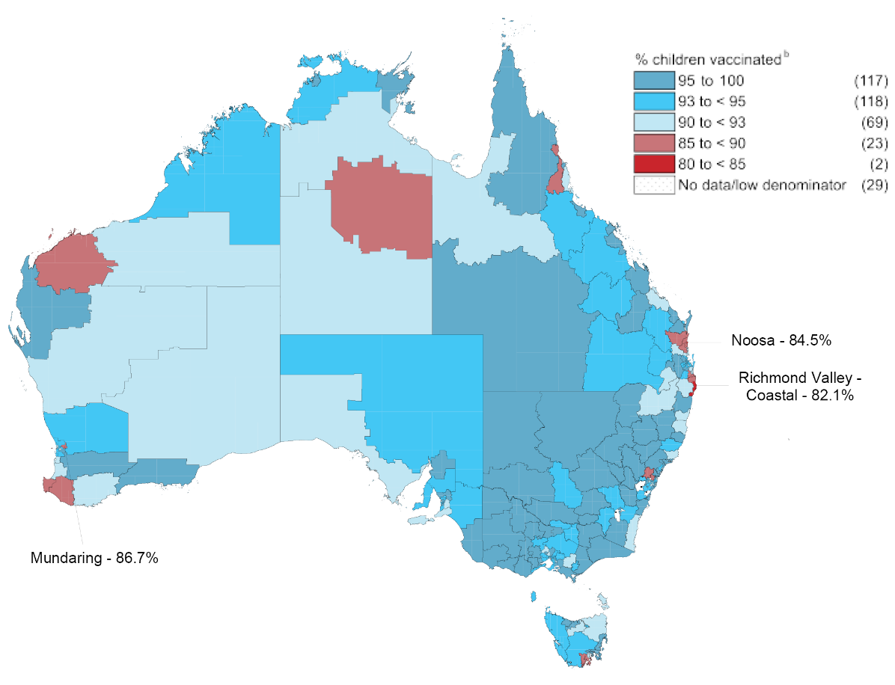
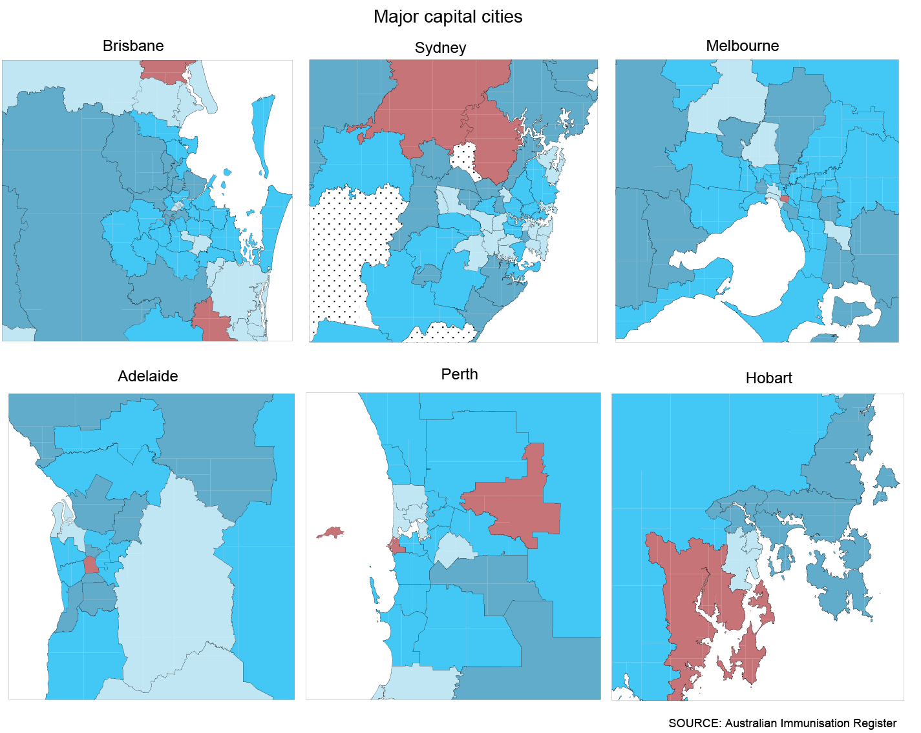
a Cohort born 1 January 2018 – 31 December 2018.
b Number in parentheses = number of Statistical Area 3s in each coverage category.
Figure 11: Coverage of four doses of diphtheria-tetanus-acellular pertussis (DTPa)-containing vaccine at 24 months of ageª by Statistical Area 3, Australia and major capital cities, 2020
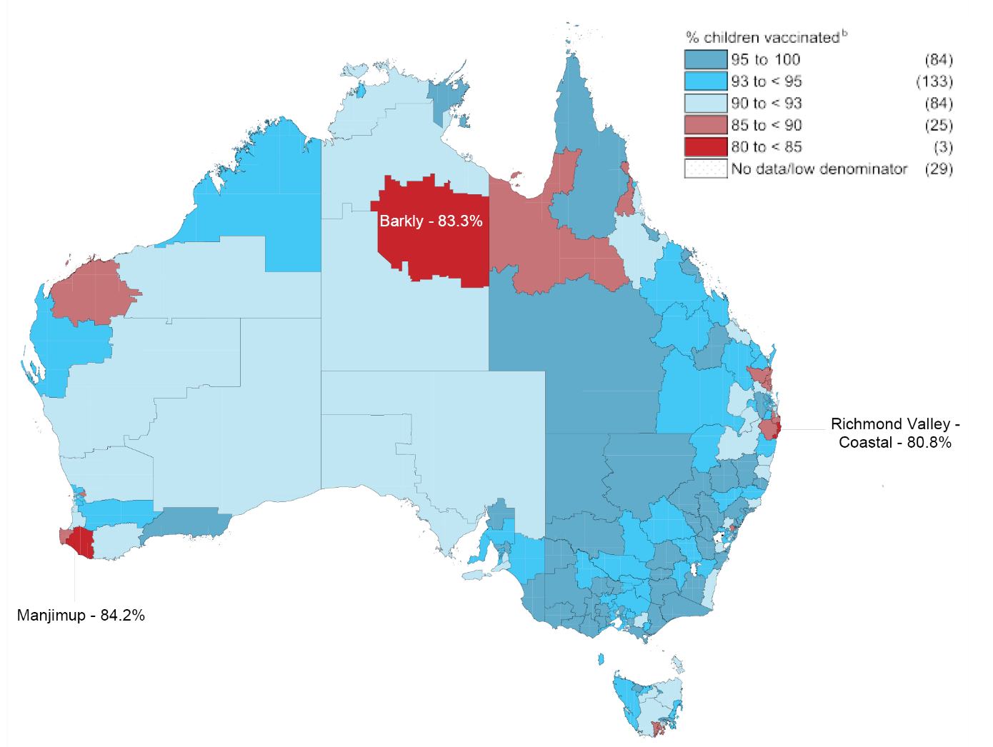
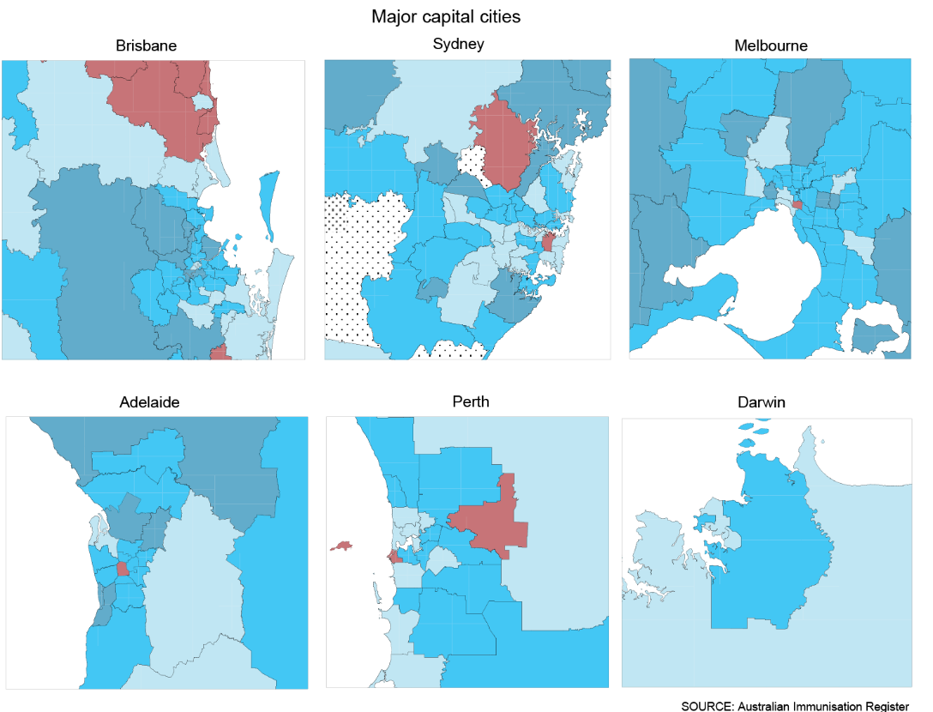
a Cohort born 1 January 2018 – 31 December 2018.
b Number in parentheses = number of Statistical Area 3s in each coverage category.
Figure 12: Coverage of one dose of meningococcal ACWY vaccine at 24 months of ageª by Statistical Area 3, Australia and major capital cities, 2020
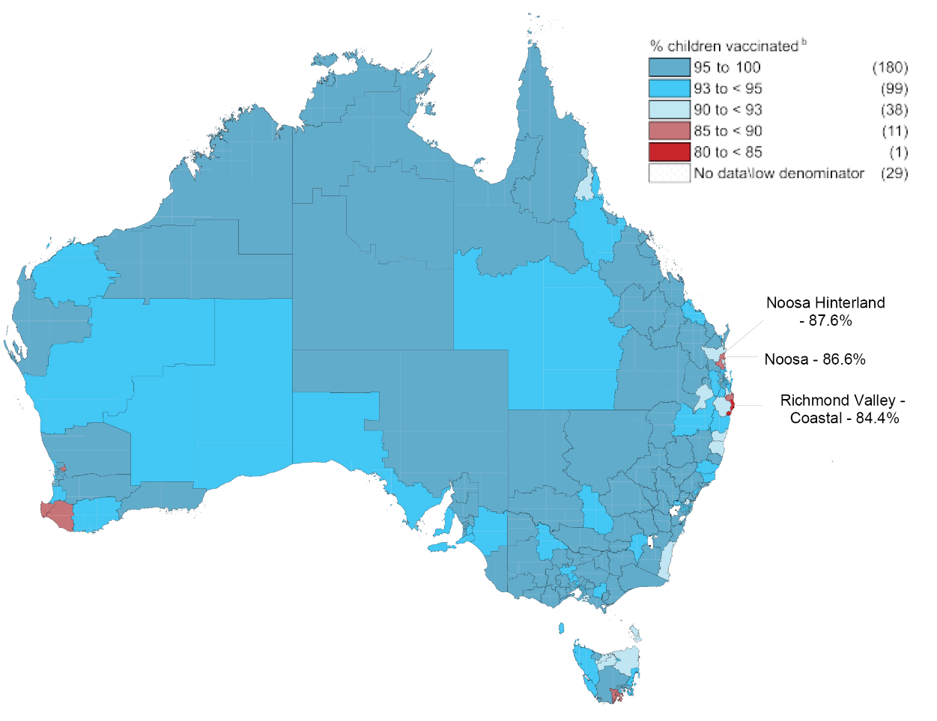
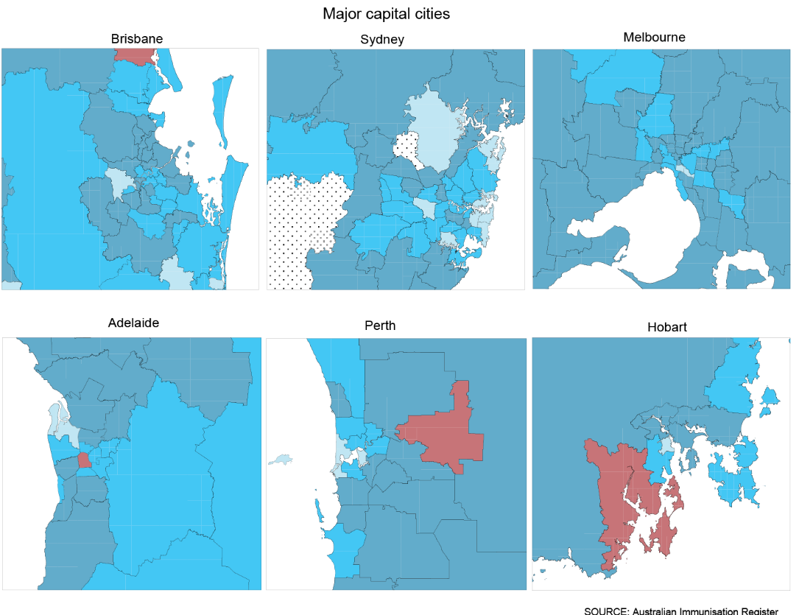
a Cohort born 1 January 2018 – 31 December 2018.
b Number in parentheses = number of Statistical Area 3s in each coverage category.

Provider type and reporting to AIR
In 2020, the large majority (82.8%) of vaccinations given to children aged 0–6 years in Australia were administered in general practice settings, with the Northern Territory the only jurisdiction with a minority of vaccinations (21.5%) in young children given in general practice (Figure 13). Overall, 9.4% of vaccinations were delivered in local council clinic settings (with the proportion highest in Victoria at 21.3%), 6.1% in community health services (highest in the Northern Territory [51.3%], Australian Capital Territory [26.7%] and Western Australia [17.7%]) and 0.7% in Indigenous health services (highest in the Northern Territory at 22.3%), and 1.0% in hospitals. The distribution of vaccinations given to children aged 0–6 years by provider type was generally similar to that in people of all ages (Figure A.10 in the Appendix), but with none administered in pharmacy settings (pharmacists are not currently authorised to vaccinate young children).
Figure 13: Proportion of vaccinations given to children aged 0–6 years by provider type and jurisdiction, Australia, 2020^{a,b}
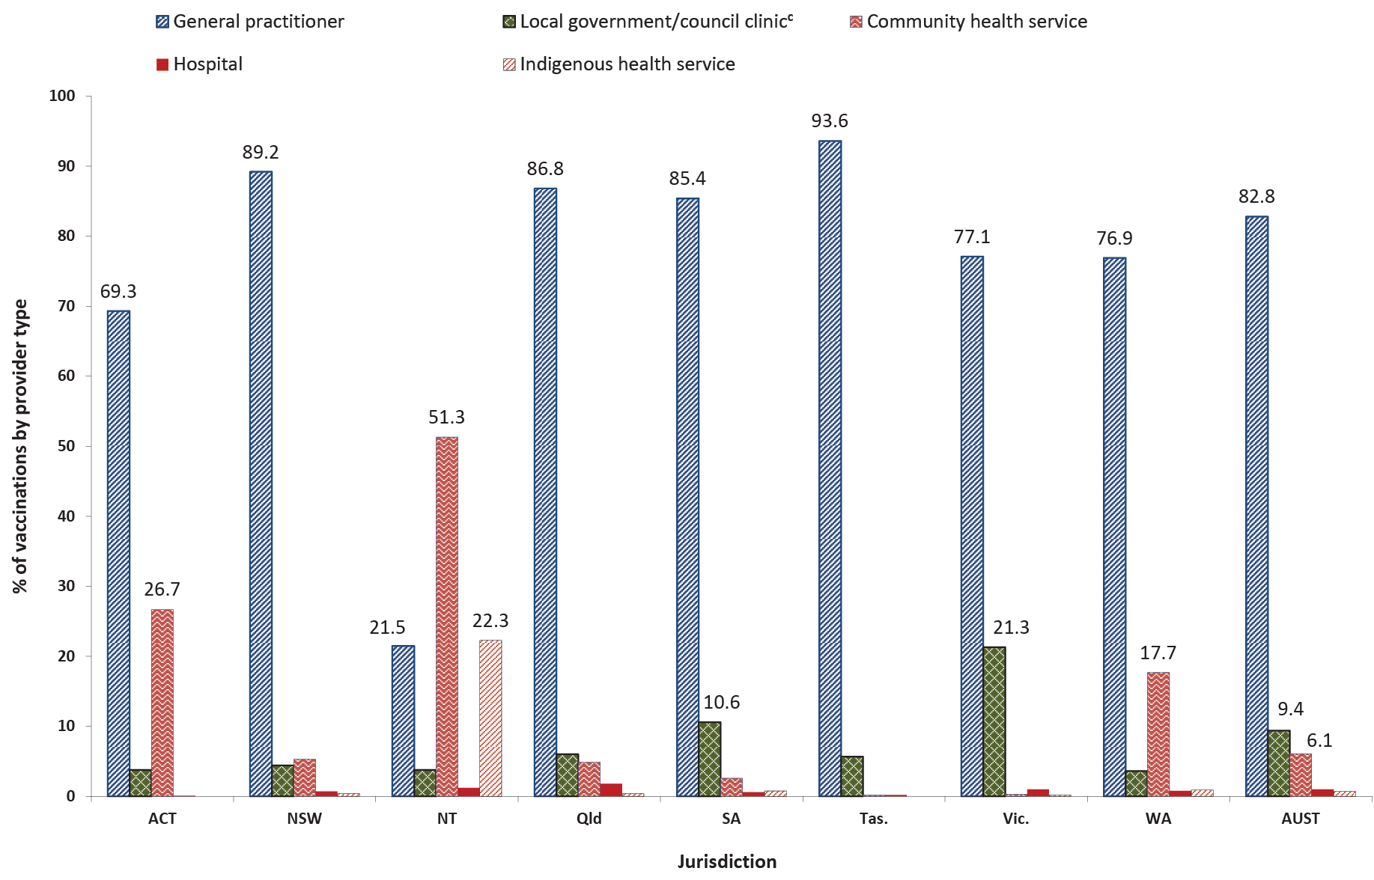
a Source: Australian Immunisation Register, data as at 31 March 2021.
b ACT = Australian Capital Territory; NSW = New South Wales; NT = Northern Territory; Qld = Queensland; SA = South Australia; Tas. = Tasmania; Vic. = Victoria; WA = Western Australia; AUST = Australia.
c Includes public health units and state health.
In 2020, a total of 84.9% of vaccinations given to children aged 0–6 years on the AIR were reported using practice management software (jurisdictional range 25.8%–89.7%; Figure 14), which was 2.6 percentage points higher than in 2019. Less common methods of reporting included the AIR website (11.6%; jurisdictional range 1.7–30.4%), and internet data interchange (IDI) upload, where immunisation providers/organisations send vaccination encounter details in bulk to the AIR (3.1%; jurisdictional range 0.1%–72.5%). The percentage of vaccinations given to all persons on the AIR in 2020 that were reported using practice management software was higher at 87.3% (jurisdictional range 39.8%–90.0%) (data not shown).
Figure 14: Proportion of vaccinations given to children aged 0–6 years by type of reporting mechanism and state or territory, Australia, 2020^{a,b}
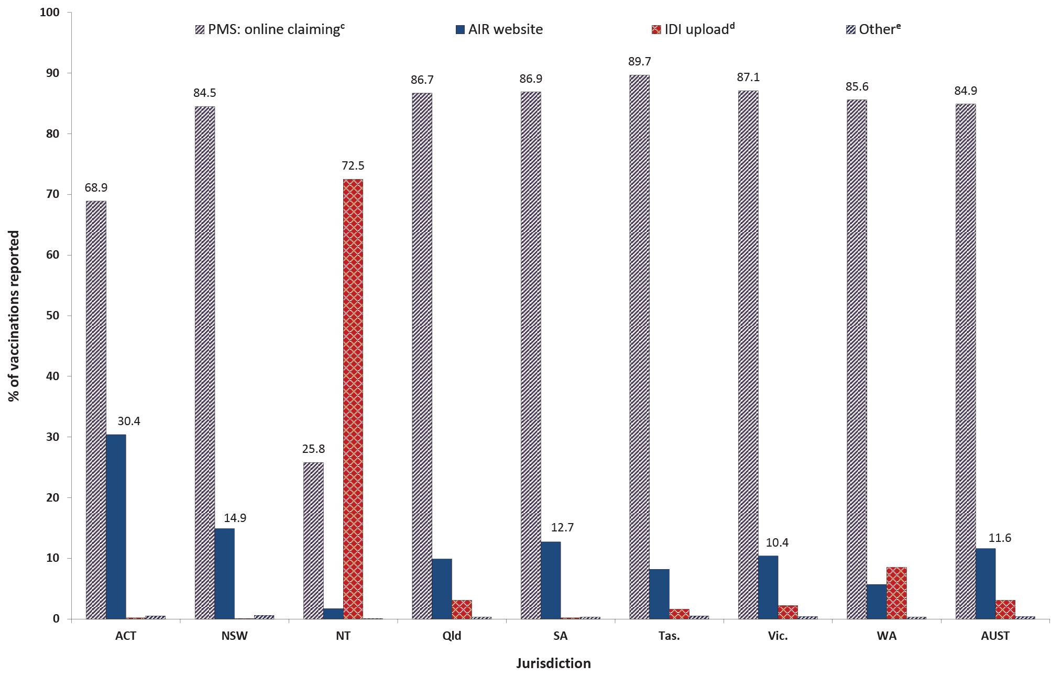
a Source: Australian Immunisation Register, data as at 31 March 2021.
b ACT = Australian Capital Territory; NSW = New South Wales; NT = Northern Territory; Qld = Queensland; SA = South Australia; Tas. = Tasmania; Vic. = Victoria; WA = Western Australia; AUST = Australia.
c PMS: practice management software.
d IDI: internet data interchange (approved immunisation providers/organisations can send vaccination encounter details in bulk to the AIR using the IDI upload facility).
e Other: manual and history forms.

Adolescents

Human papillomavirus vaccine coverage
HPV vaccination coverage estimates in girls, for receipt of first dose and course completion by 15 years of age, are shown in Table 5, by Indigenous status and jurisdiction for 2019 and 2020. In 2020, a total of 80.5% of Australian girls had completed a full course of HPV vaccine by 15 years of age, up from 79.8% in 2019. Course completion varied from 76.7% in Queensland to 83.6% in the Australian Capital Territory (Table 5).

Table 5: Human papillomavirus (HPV) vaccination (dose 1 and course completion)ª coverage estimates (%) for girls by 15 years of age,^{b} by Indigenous status and jurisdiction, Australia, 2019 and 2020^{c}
Jurisdiction^{d} | All girls |  | Indigenous girls
 | 2019 | 2020 | 2019 | 2020
ACT  Dose 1  Course completion | 88.6  82.9 | 89.8  83.6 | 85.0  75.0 | 86.4  75.8
NSW  Dose 1  Course completion | 86.8  82.4 | 87.7  83.4 | 90.6  79.5 | 92.1  83.5
NT  Dose 1  Course completion | 88.2  78.2 | 87.7  76.9 | 91.4  76.0 | 89.1  76.2
Qld  Dose 1  Course completion | 82.7  76.2 | 83.6  76.7 | 85.8  71.1 | 85.6  71.5
SA  Dose 1  Course completion | 85.8  77.4 | 86.8  78.2 | 72.8  53.1 | 82.2  58.8
Tas.  Dose 1  Course completion | 88.1  78.1 | 88.3  78.3 | 88.0  72.6 | 91.5  80.3
Vic.  Dose 1  Course completion | 87.6  81.4 | 88.2  82.0 | 90.3  74.4 | 88.2  77.0
WA  Dose 1  Course completion | 83.5  77.3 | 84.9  78.7 | 80.8  59.5 | 82.4  65.4
AUST  Dose 1  Course completion | 85.7  79.8 | 86.6  80.5 | 86.8  71.8 | 87.8  75.0
a Course completion defined as receipt of two doses if dose 2 given ≥ 5 months after dose 1 or receipt of three doses if dose 2 given < 5 months after dose 1.
b HPV vaccinations received before fifteenth birthday in cohort born 1 January – 31 December 2004 for 2019 coverage estimates and in cohort born 1 January – 31 December 2005 for 2020 coverage estimates.
c Source: Australian Immunisation Register, data as at 31 March 2020 (for 2019 data) and as at 31 March 2021 (for 2020 data).
d ACT: Australian Capital Territory; NSW: New South Wales; NT: Northern Territory; Qld: Queensland; SA: South Australia; Tas.: Tasmania; Vic.: Victoria; WA: Western Australia; AUST: Australia.

Table 6: Human papillomavirus (HPV) vaccination (dose 1 and course completion)ª coverage estimates (%) for boys by 15 years of age,^{b} by Indigenous status and jurisdiction, Australia, 2019 and 2020^{c}
Jurisdiction^{d} | All boys |  | Indigenous boys
 | 2019 | 2020 | 2019 | 2020
ACT  Dose 1  Course completion | 86.6  79.6 | 87.6  80.4 | 80.4  62.7 | 79.6  55.6
NSW  Dose 1  Course completion | 84.1  79.5 | 85.8  80.6 | 82.4  70.3 | 88.1  77.3
NT  Dose 1  Course completion | 86.4  71.5 | 83.9  70.0 | 88.3  66.3 | 82.5  63.7
Qld  Dose 1  Course completion | 80.3  72.9 | 82.0  73.8 | 80.0  65.2 | 80.9  64.8
SA  Dose 1  Course completion | 83.1  73.7 | 85.5  75.3 | 70.3  48.6 | 69.3  47.5
Tas.  Dose 1  Course completion | 85.9  75.4 | 85.6  73.3 | 86.1  68.9 | 86.4  69.1
Vic.  Dose 1  Course completion | 85.7  78.6 | 86.2  78.4 | 87.8  73.4 | 85.6  73.1
WA  Dose 1  Course completion | 82.9  76.7 | 84.3  77.6 | 75.5  56.4 | 78.7  60.4
AUST  Dose 1  Course completion | 83.6  77.0 | 84.9  77.6 | 81.3  65.4 | 83.0  68.0
a Course completion defined as receipt of two doses if dose 2 given ≥ 5 months after dose 1 or receipt of three doses if dose 2 given < 5 months after dose 1.
b HPV vaccinations received before fifteenth birthday in cohort born 1 January – 31 December 2004 for 2019 coverage estimates and in cohort born 1 January – 31 December 2005 for 2020 coverage estimates.
c Source: Australian Immunisation Register, data as at 31 March 2020 (for 2019 data) and as at 31 March 2021 (for 2020 data).
d ACT: Australian Capital Territory; NSW: New South Wales; NT: Northern Territory; Qld: Queensland; SA: South Australia; Tas.: Tasmania; Vic.: Victoria; WA: Western Australia; AUST: Australia.
HPV vaccine course completion was lower in Indigenous girls in 2020 than in all girls nationally (75.0% versus 80.5%), ranging from 58.8% in South Australia to 83.5% in New South Wales (Table 5).
In 2020, a total of 77.6% of Australian boys had completed a full course of HPV vaccine by 15 years of age, up from 77.0% in 2019. Course completion varied from 70.0% in the Northern Territory to 80.6% in the Australian Capital Territory (Table 6).
HPV vaccine course completion was lower in Indigenous boys in 2020 than in all boys (68.0% versus 77.6%), ranging from 47.5% in South Australia to 77.3% in New South Wales (Table 6).

Table 7: Number of girls aged 11–14 years who received a first dose of human papillomavirus (HPV) vaccine,ª percentage of those who received a second dose in the same calendar year, and number who received dTpa vaccine,^{b} by Indigenous status and jurisdiction, Australia, 2019 and 2020
All girls aged 11–14 years
Jurisdiction^{c} | 2019 |  |  | 2020
 | HPV  dose 1  (n) | % received HPV  dose 2^{d} | dTpa  (n) | HPV  dose 1  (n) | % received HPV  dose 2d | dTpa  (n)
ACT | 2,422 | 85.8 | 2,508 | 2,499 | 86.4 | 2,382
NSW | 44,284 | 85.5 | 45,454 | 41,100 | 71.6 | 41,421
NT | 1,490 | 66.0 | 1,525 | 1,411 | 60.8 | 1,426
Qld | 29,414 | 84.3 | 30,286 | 29,143 | 79.0 | 29,527
SA | 8,840 | 86.7 | 9,195 | 9,001 | 83.1 | 9,211
Tas. | 2,862 | 81.9 | 2,886 | 2,618 | 65.0 | 2,616
Vic. | 34,376 | 87.7 | 35,194 | 33,859 | 71.3 | 33,719
WA | 28,478 | 88.7 | 29,563 | 15,238 | 78.3 | 15,491
AUST | 152,166 | 86.2 | 156,611 | 134,869 | 74.7 | 135,793

Indigenous girls aged 11–14 years
Jurisdiction^{c} | 2019 |  |  | 2020
 | HPV  dose 1  (n) | % received HPV  dose 2^{d} | dTpa  (n) | HPV  dose 1  (n) | % received HPV  dose 2^{d} | dTpa  (n)
ACT | 38 | 71.1 | 48 | 48 | 66.7 | 43
NSW | 2,708 | 74.7 | 2,762 | 2,346 | 67.2 | 2,344
NT | 619 | 41.8 | 641 | 524 | 35.3 | 518
Qld | 2,242 | 71.0 | 2,250 | 2,224 | 62.4 | 2,247
SA | 281 | 63.0 | 282 | 276 | 63.0 | 284
Tas. | 261 | 79.3 | 266 | 265 | 63.4 | 260
Vic. | 518 | 76.8 | 528 | 543 | 57.1 | 543
WA | 1,687 | 70.0 | 1,691 | 971 | 59.7 | 958
AUST | 8,354 | 70.2 | 8,468 | 7,197 | 61.3 | 7,197
a Source: Australian Immunisation Register, data as at 31 March 2021.
b dTpa: diphtheria, tetanus, pertussis (acellular) – adolescent/adult formulation.
c ACT: Australian Capital Territory; NSW: New South Wales; NT: Northern Territory; Qld: Queensland; SA: South Australia; Tas.: Tasmania; Vic.: Victoria; WA: Western Australia; AUST: Australia.
d Percentage who received the first dose of HPV vaccine in 2019 or 2020 and went on to receive the second dose in the same calendar year.
Table 7 shows the percentage of girls aged 11–14 years who received a first dose of HPV vaccine in 2019 or 2020 and then went on to receive a second dose in the same calendar year, by jurisdiction and Indigenous status. The percentage of girls aged 11–14 years who received both a first and second dose of HPV vaccine was 11.5 percentage points lower in 2020 than in 2019, ranging from 16.9 percentage points lower in Tasmania to 0.6 of a percentage point higher in the Australian Capital Territory. Similar trends were seen for Indigenous girls aged 11–14 years (Table 7).
Table 8 shows the percentage of boys aged 11–14 years who received a first dose of HPV vaccine in 2019 or 2020 and then went on to receive a second dose in the same calendar year, by jurisdiction and Indigenous status. The percentage of boys aged 11–14 years who received both a first and second dose of HPV in 2020 was 11.7 percentage points lower than in 2019, ranging from 16.7 percentage points lower in Victoria to 0.1 of a percentage point higher in the Australian Capital Territory. Similar trends were seen for Indigenous boys (Table 8).
Table 8: Number of boys aged 11–14 years who received a first dose of human papillomavirus (HPV) vaccine,ª percentage of those who received a second dose in the same calendar year, and number who received dTpa vaccine,^{b} by Indigenous status and jurisdiction, Australia, 2019 and 2020
All boys aged 11–14 years
Jurisdiction^{c} | 2019 |  |  | 2020
 | HPV  Dose 1  (n) | % received HPV  Dose 2^{d} | dTpa  (n) | HPV  Dose 1  (n) | % received HPV  Dose 2^{d} | dTpa  (n)
ACT | 2,620 | 84.0 | 2,640 | 2,508 | 84.1 | 2,378
NSW | 45,052 | 83.0 | 46,276 | 41,870 | 69.1 | 42,173
NT | 1,495 | 60.2 | 1,534 | 1,370 | 60.1 | 1,356
Qld | 30,599 | 81.9 | 31,554 | 29,838 | 75.7 | 30,081
SA | 9,221 | 85.1 | 9,523 | 8,932 | 81.2 | 9,120
Tas. | 2,877 | 81.0 | 2,941 | 2,545 | 67.5 | 2,532
Vic. | 35,147 | 86.2 | 36,170 | 35,029 | 69.5 | 34,834
WA | 29,562 | 88.0 | 30,536 | 15,846 | 77.6 | 16,097
AUST | 156,573 | 84.3 | 161,174 | 137,938 | 72.6 | 138,571

Indigenous boys aged 11–14 years
Jurisdiction^{c} | 2019 |  |  | 2020
 | HPV  Dose 1  (n) | % received HPV  Dose 2d | dTpa  (n) | HPV  Dose 1  (n) | % received HPV  Dose 2^{d} | dTpa  (n)
ACT | 75 | 69.3 | 71 | 58 | 63.8 | 53
NSW | 2,582 | 67.9 | 2,618 | 2,186 | 64.8 | 2,161
NT | 654 | 35.9 | 670 | 531 | 35.2 | 512
Qld | 2,050 | 65.1 | 2,070 | 2,198 | 60.1 | 2,203
SA | 303 | 64.7 | 301 | 298 | 58.4 | 290
Tas. | 229 | 76.4 | 238 | 236 | 63.1 | 229
Vic. | 479 | 69.1 | 478 | 523 | 53.7 | 525
WA | 1,609 | 66.0 | 1,611 | 952 | 53.2 | 931
AUST | 7,981 | 64.4 | 8,057 | 6,982 | 58.3 | 6,904
a Source: Australian Immunisation Register, data as at 31 March 2021.
b dTpa: diphtheria, tetanus, pertussis (acellular) – adolescent/adult formulation.
c ACT: Australian Capital Territory; NSW: New South Wales; NT: Northern Territory; Qld: Queensland; SA: South Australia; Tas.: Tasmania; Vic.: Victoria; WA: Western Australia; AUST: Australia.
d Percentage who received the first dose of HPV vaccine in 2019 or 2020 and went on to receive the second dose in the same calendar year.

Diphtheria-tetanus-acellular pertussis (dTpa) booster vaccine coverage
Figure 15 shows coverage, by 15 years of age, of the adolescent booster dose of diphtheria-tetanus-acellular pertussis (dTpa) vaccine in 2019 and 2020, by jurisdiction. Nationally, dTpa coverage was 1.7 percentage points higher in 2020 than 2019 (86.8% versus 85.1%). Coverage in all jurisdictions was higher in 2020 than 2019, with the largest increase in Tasmania (from 71.9% to 83.9%). Coverage in 2020 ranged from 83.9% in Tasmania to 88.5% in South Australia.
Figure 16 shows coverage, by 15 years of age, of the booster dose of dTpa vaccine in 2019 and 2020 in Indigenous adolescents, by jurisdiction. Nationally, dTpa coverage for Indigenous adolescents was 3.3 percentage points higher in 2020 than in 2019 (84.2% versus 80.9%), and was 2.6 percentage points lower than coverage overall in 2020. Coverage in 2020 ranged from 73.3% in the Australian Capital Territory to 88.9% in New South Wales.
In 2020, the number of dTpa vaccinations recorded as administered to girls aged 11–14 years was 13% lower nationally than in 2019, ranging from 47.6% lower in Western Australia to 0.2% higher in South Australia, and 15% lower in Indigenous girls, ranging from 43.3% lower in Western Australia to 2.8% higher in Victoria (Table 7).
The number of dTpa vaccinations recorded as administered to boys aged 11–14 years was 14% lower nationally in 2020 than in 2019, ranging from 47.3% lower in Western Australia to 3.7% lower in Victoria, and 14.3% lower in Indigenous boys, ranging from 42.2% lower in Western Australia to 9.9% higher in Victoria (Table 8).
Figure 15: Coverage (%) of the adolescent booster dose of diphtheria-tetanus-acellular pertussis (adolescent/adult formulation, dTpa) vaccine by 15 years of age,ª by jurisdiction, Australia, 2019 and 2020^{b,c}
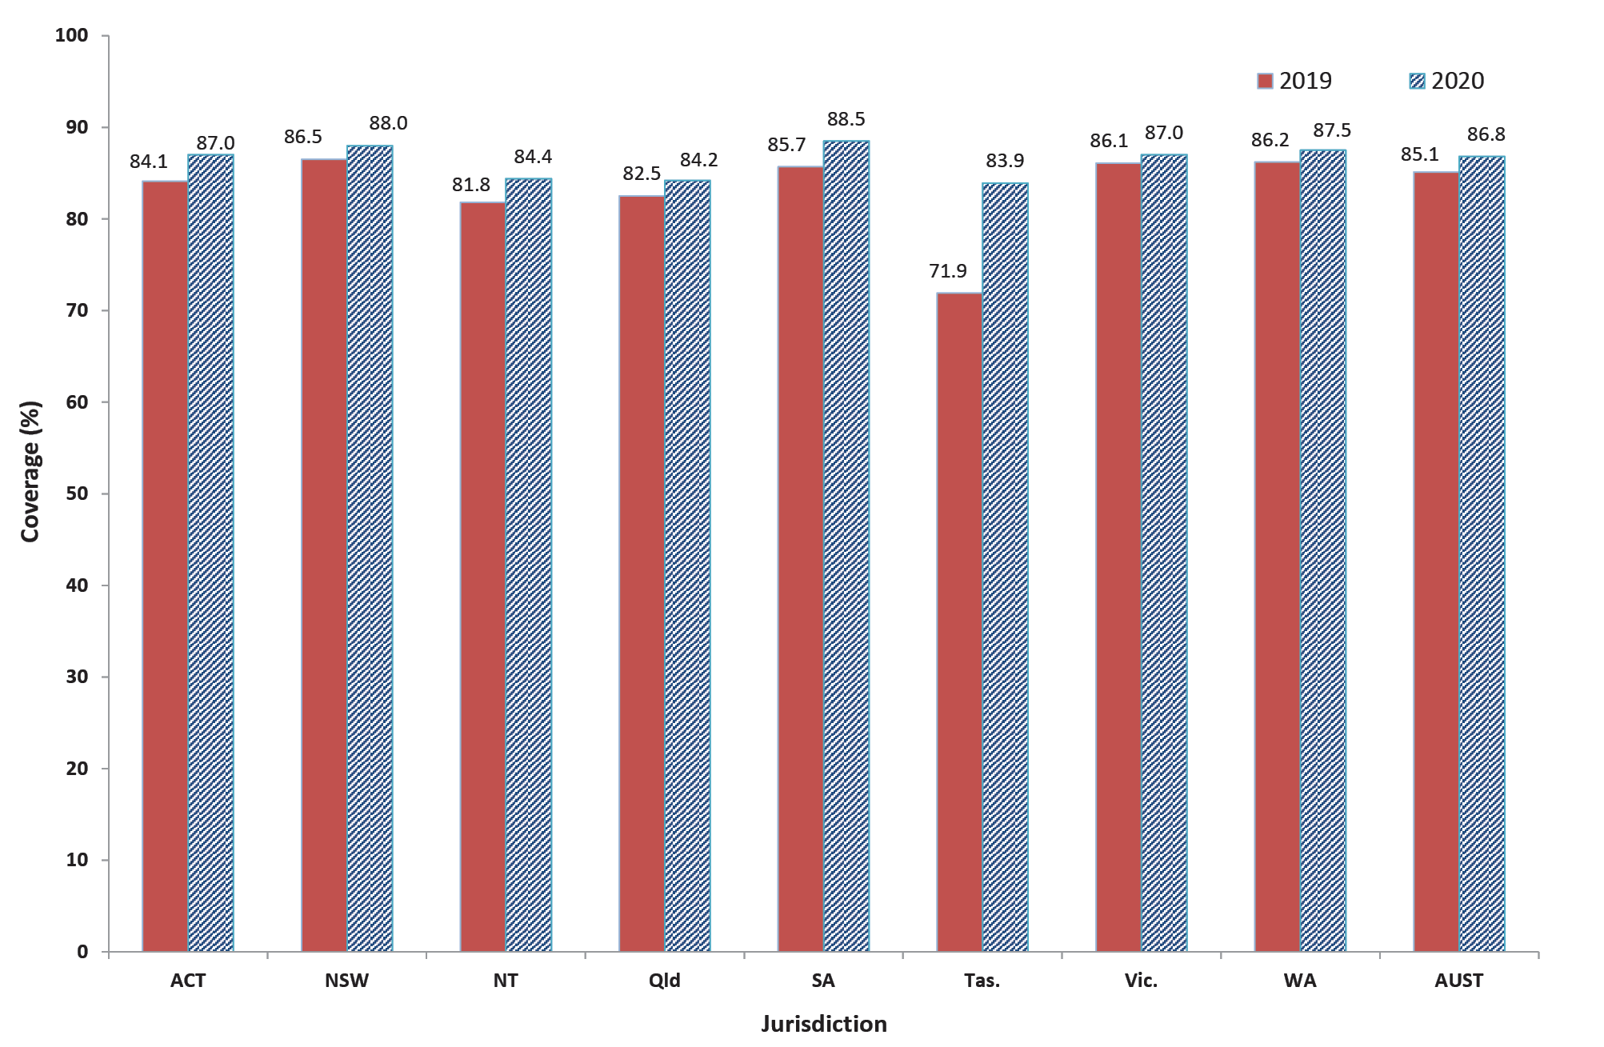
a dTpa vaccinations received before fifteenth birthday in cohort born 1 January – 31 December 2004 for 2019 coverage estimates and in cohort born 1 January – 31 December 2005 for 2020 coverage estimates.
b Source: Australian Immunisation Register, data as at 31 March 2020 (for 2019 data) and as at 31 March 2021 (for 2020 data).
c ACT: Australian Capital Territory; NSW: New South Wales; NT: Northern Territory; Qld: Queensland; SA: South Australia; Tas.: Tasmania; Vic.: Victoria; WA: Western Australia; AUST: Australia.
Figure 16: Coverage (%) of the adolescent booster dose of diphtheria-tetanus-acellular pertussis (adolescent/adult formulation, dTpa) vaccine in Indigenous adolescents by 15 years of age,ª by jurisdiction, Australia, 2019 and 2020^{b,c}
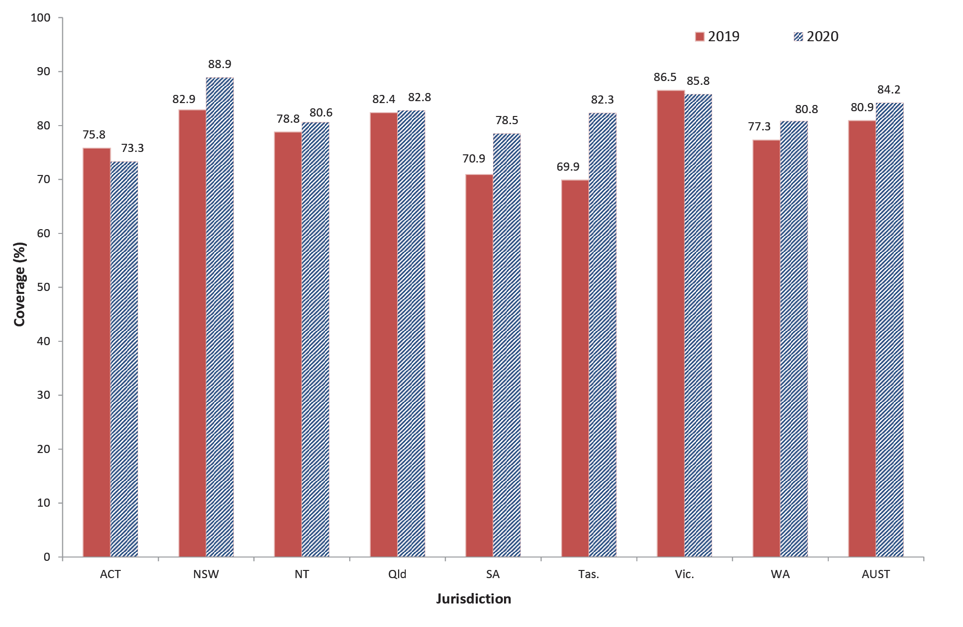
a dTpa vaccinations received before fifteenth birthday in cohort born 1 January – 31 December 2004 for 2019 coverage estimates and in cohort born 1 January – 31 December 2005 for 2020 coverage estimates.
b Source: Australian Immunisation Register, data as at 31 March 2020 (for 2019 data) and as at 31 March 2021 (for 2020 data).
c ACT: Australian Capital Territory; NSW: New South Wales; NT: Northern Territory; Qld: Queensland; SA: South Australia; Tas.: Tasmania; Vic.: Victoria; WA: Western Australia; AUST: Australia.

Meningococcal ACWY vaccine coverage
Figure 17 shows coverage in 2020 of meningococcal ACWY vaccine in adolescents by 17 years of age, by Indigenous status and jurisdiction. Coverage was lower for Indigenous adolescents than for all adolescents nationally (68.1% versus 74.3%) and in all jurisdictions except Tasmania and the Northern Territory. Coverage was considerably lower in South Australia than in other jurisdictions, at 58.1% for all adolescents and 50.3% for Indigenous adolescents (Figure 17).
Figure 18 shows the number of adolescents who received a meningococcal ACWY dose in 2019 and 2020 by age group. Overall, the number of doses administered was 4.1 percentage points lower in 2020 than in 2019, and lower in all age groups except those aged 16 and 17 years (Figure 18).
Figure 19 shows the number of adolescents who received a meningococcal ACWY dose in 2020 by age group and provider type. Overall, the highest numbers of doses were recorded as administered by council clinics and State Health/Public Health Units i.e. through school-based programs. This pattern was seen in all age groups except for those aged 17 and 18–19 years, where the highest number of doses was administered in general practice (Figure 20).

Figure 17: Coverage (%) of meningococcal ACWY vaccine in adolescentsª by 17 years of age, by Indigenous status and jurisdiction, Australia, 2020^{b,c}
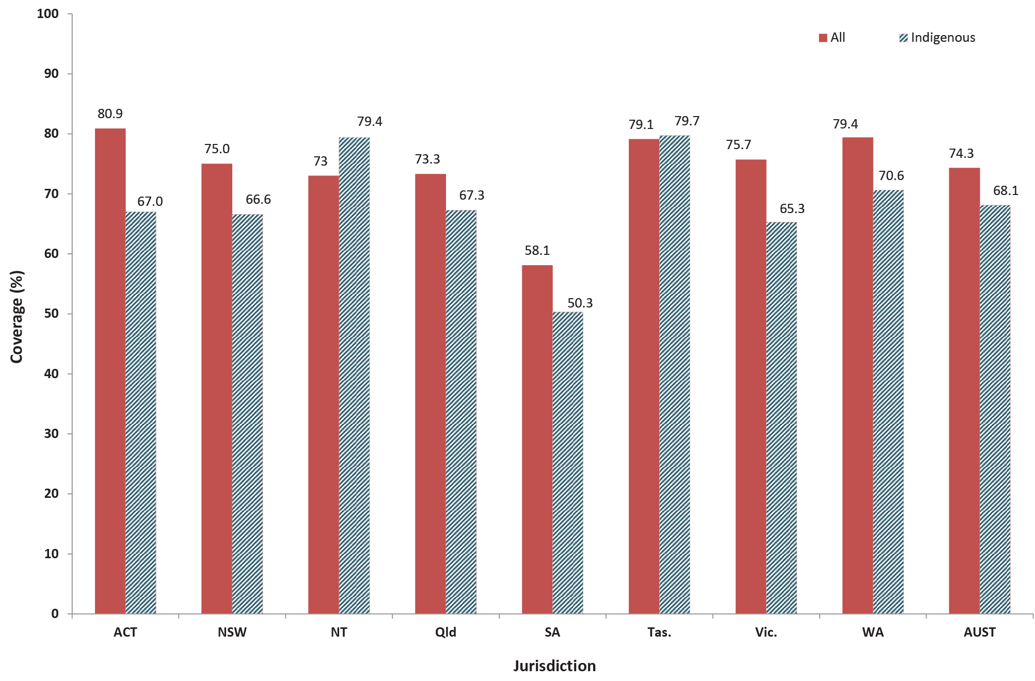
a Cohort born 1 January 2003 – 31 December 2003.
b Source: Australian Immunisation Register, data as at 31 March 2021.
c ACT: Australian Capital Territory; NSW: New South Wales; NT: Northern Territory; Qld: Queensland; SA: South Australia; Tas.: Tasmania; Vic.: Victoria; WA: Western Australia; AUST: Australia.

Figure 18: Number of adolescentsª receiving a meningococcal ACWY dose by age group, Australia, 2019 and 2020^{b}
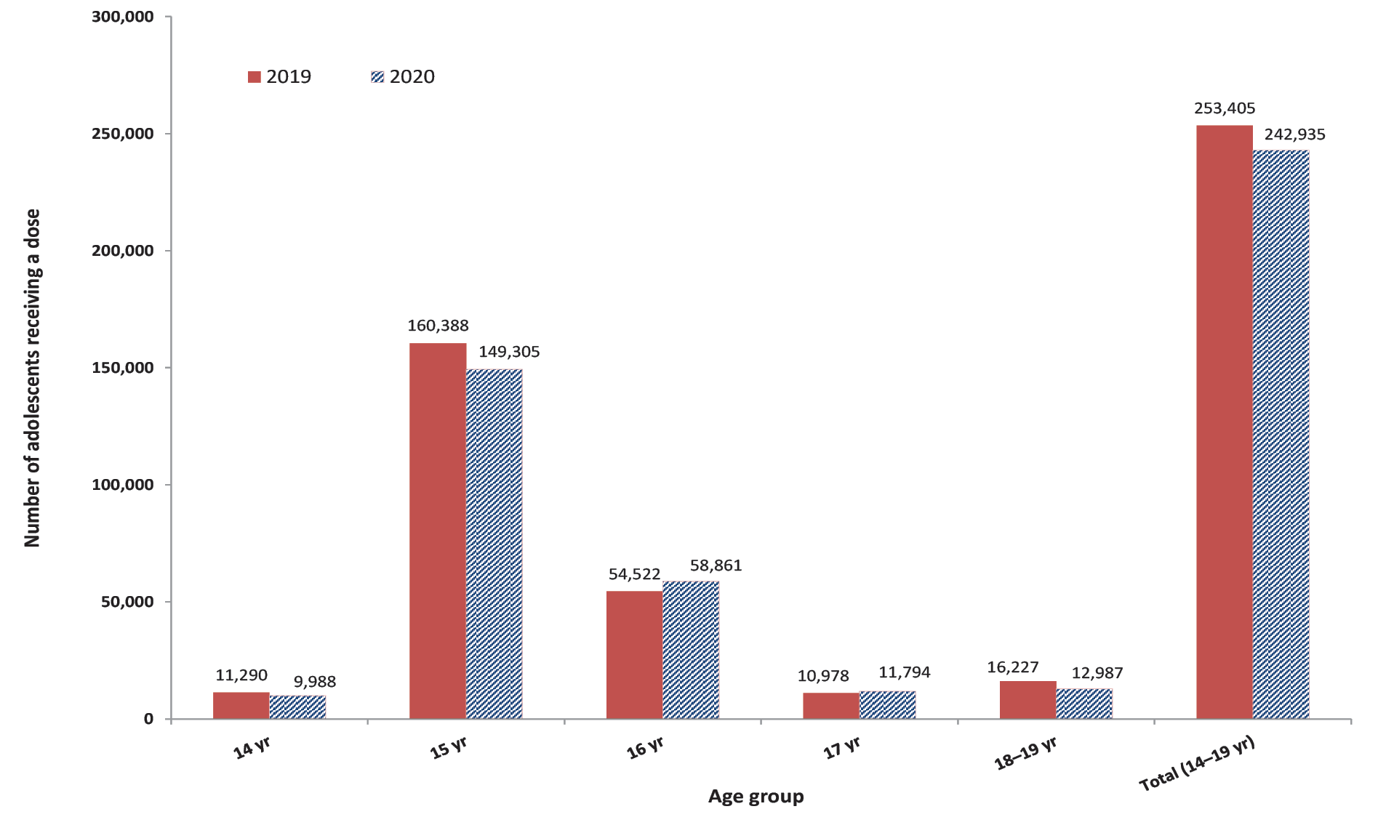
a Aged 14–19 years as at date of vaccination.
b Source: Australian Immunisation Register, data as at 31 March 2021.

Figure 19: Number of adolescentsª receiving a meningococcal ACWY dose in 2020 by age group and provider type, Australia^{b}
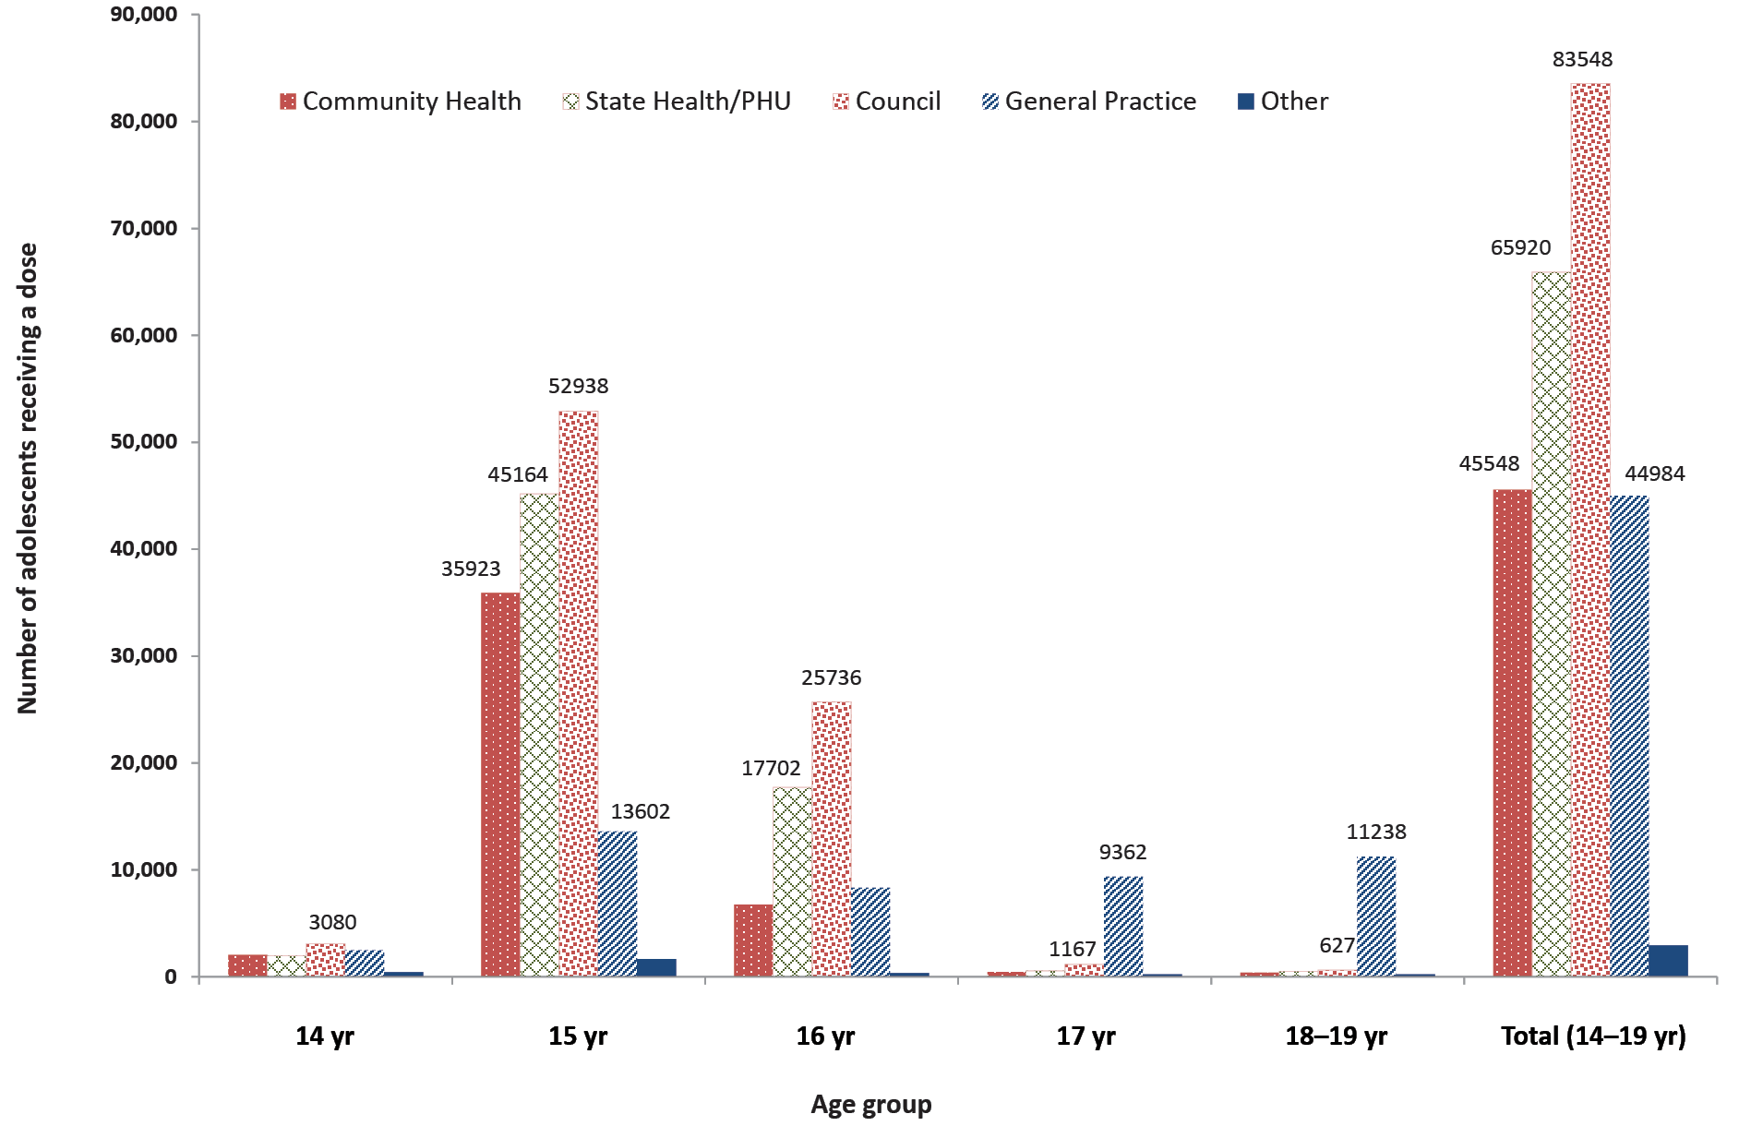
a Aged 14–19 years as at date of vaccination.
b Source: Australian Immunisation Register, data as at 31 March 2021.

Influenza vaccine coverage
Recorded influenza vaccine coverage in adolescents aged 10–14 years and 15–19 years increased by 6.5 and 7.1 percentage points between 2019 and 2020, reaching 25.3% and 22.7%, respectively (Figure 2). In 2020, recorded coverage for adolescents aged 10–14 years ranged from 22.2% in Queensland to 31.9% in Western Australia, and for adolescents aged 15–19 years from 20.6% in Queensland to 27.6% in the Northern Territory (Table A.3 in Appendix).
Recorded influenza vaccine coverage in Indigenous adolescents aged 10–14 years and 15–19 years increased by 3.0 and 4.2 percentage points between 2019 and 2020, reaching 32.4% and 31.5%, respectively (Figure 4). Recorded coverage for Indigenous adolescents aged 10–14 years in 2020 ranged from 29.3% in New South Wales to 43.3% in the Northern Territory and for adolescents aged 15–19 years from 28.1% in New South Wales to 44.9% in the Northern Territory (Table A.3 in Appendix).

Adults

Zoster vaccine coverage
Nationally, recorded zoster vaccine coverage for adults of age 70 years was 30.5% in 2019 and 30.4% in 2020, with coverage in 2020 ranging from 19.7% in the Northern Territory to 46.2% in Queensland (Figure 20).
Nationally, recorded coverage in Indigenous adults of age 70 years decreased from 33.2% in 2019 to 31.7% in 2020 but was higher than for adults overall in both years (Figure 21). Zoster coverage in Indigenous adults in 2020 ranged from 16.4% in the Northern Territory to 44.6% in Queensland.

Figure 20: Zoster vaccination coverage for adults aged 70 years, by jurisdiction, Australia, 2019 and 2020^{a,b}
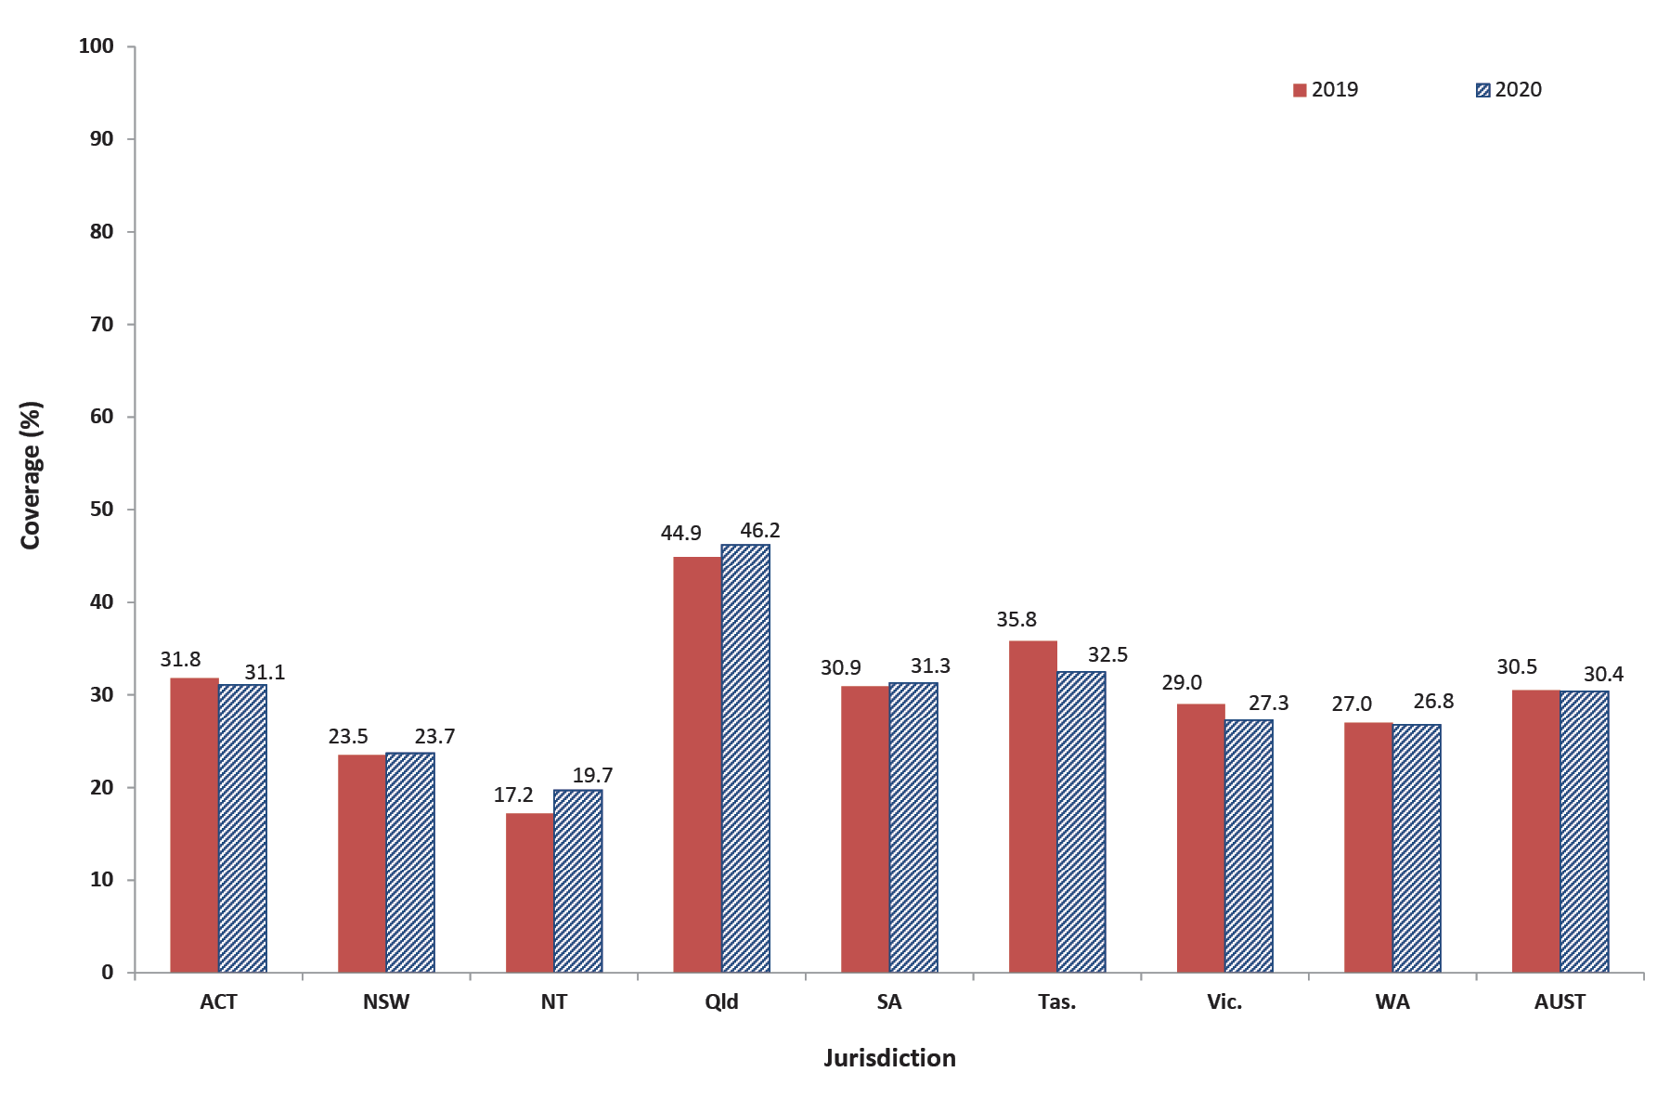
a Source: Australian Immunisation Register, data as at 31 March 2020 (for 2019 data) and as at 31 March 2021 (for 2020 data).
b ACT: Australian Capital Territory; NSW: New South Wales; NT: Northern Territory; Qld: Queensland; SA: South Australia; Tas.: Tasmania; Vic.: Victoria; WA: Western Australia; AUST: Australia.

Figure 21: Zoster vaccination coverage for Indigenous adults aged 70 years, by jurisdiction, Australia, 2019 and 2020^{a,b}
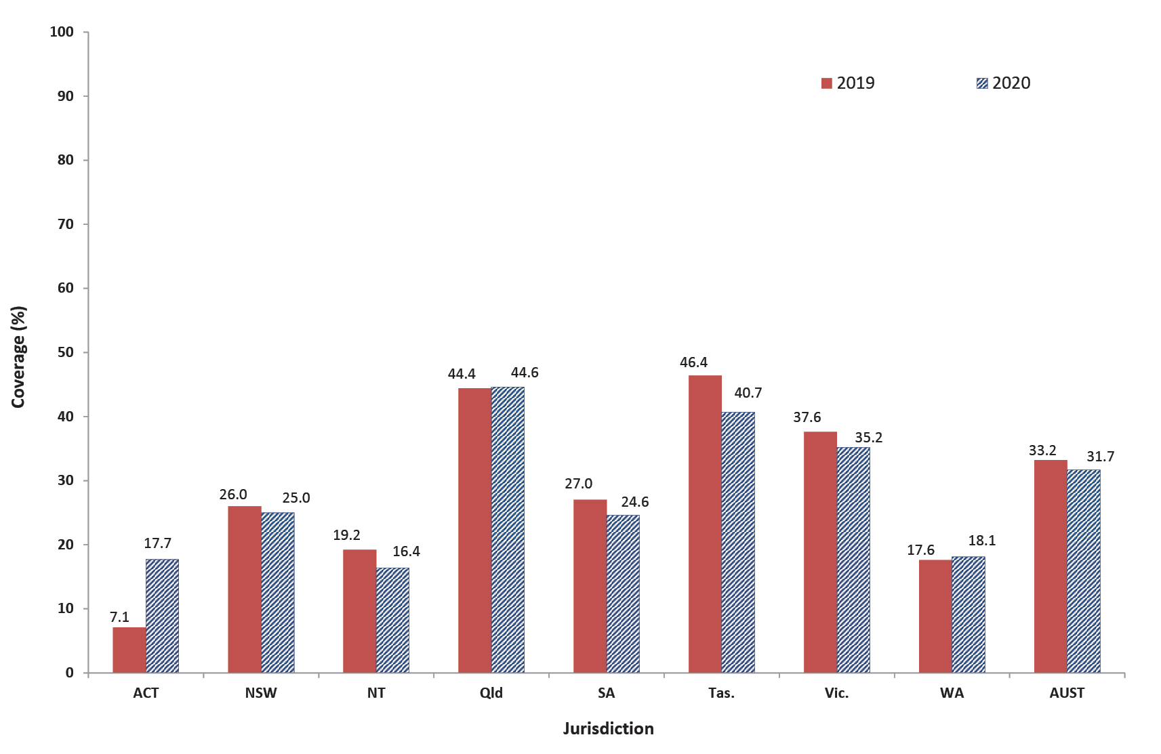
a Source: Australian Immunisation Register, data as at 31 March 2020 (for 2019 data) and as at 31 March 2021 (for 2020 data).
b ACT: Australian Capital Territory; NSW: New South Wales; NT: Northern Territory; Qld: Queensland; SA: South Australia; Tas.: Tasmania; Vic.: Victoria; WA: Western Australia; AUST: Australia.

Influenza vaccine coverage
The recorded influenza vaccine coverage in adults aged 20–49 years and 50–64 years increased by 8.2 and 10.8 percentage points between 2019 and 2020, reaching 23.4% and 35.8%, respectively, while coverage in adults aged 65–74 years and ≥ 75 years increased by 7.2 and 4.2 percentage points, reaching 63.6% and 69.8%, respectively (Figure 2).
Overall, the national recorded influenza vaccine coverage in Indigenous adults aged 20–49 years and 50–64 years increased by 3.5 and 5.4 percentage points between 2019 and 2020, reaching 34.6% and 58.1% respectively, while coverage in Indigenous adults aged 65–74 years increased by 2.3 percentage points, reaching 77.2%, but decreased by 3.2 percentage points to 80.3% in the ≥ 75 years age group (Figure 4).

Discussion

Overall findings

Vaccination coverage in children
‘Fully vaccinated’ coverage in Australian children increased between 2019 and 2020, by 0.5–1.0 percentage points at the 12-month, 24-month and 60-month age assessment milestones, reaching 94.8%, 92.1% and 94.8%, respectively. While this predominantly reflects vaccinations due in 2019, i.e. prior to the coronavirus disease 2019 (COVID-19) pandemic, due to the use of standard assessment time points 6–12 months after vaccines are due, other reports have indicated a lack of impact of the COVID-19 pandemic on routine childhood vaccination in Australia,^{16,17} unlike in many other countries.^{18–20} True coverage in Australian children is likely to have been even higher, given underreporting to the AIR,^{21,22} and probably above the national coverage target of 95% at the 12- and 60-month age milestones. The increases in coverage at these milestones over recent years have potentially been contributed to by a range of measures, including the federal government’s ‘No Jab No Pay’ policy (implemented from 1 January 2016) and the ‘No Jab No Play’ policies implemented in several states.²³
‘Fully vaccinated’ coverage at the 24month milestone is nearly three percentage points below ‘fully vaccinated’ coverage at 12 and 60 months of age. This disparity is most likely due to the greater number of antigens required in order to be classified as ‘fully vaccinated’ at 24 months, including vaccine doses due at 6 and 12 months as well as the three vaccines (DTPa, Hib and MMRV) now scheduled at 18 months of age, only six months before the assessment time point.⁹ In contrast, only one vaccine (DTPa-polio) is scheduled at 48 months and assessed 12 months later at 60 months. Expansion of the 60-month assessment algorithm, to include a more comprehensive range of the vaccines/antigens that should have been received by that age, would be useful to better monitor uptake under the NIP. While this could present communication challenges in managing perceptions of a resultant ‘drop’ in coverage,²⁴ our report shows that coverage is now over 95% for all other individual vaccines/antigens when assessed at 60 months of age.
Coverage was higher in 2020 than in 2019 for all individual vaccines/antigens included in the ‘fully vaccinated’ assessment algorithms. The largest increase in coverage was for DTPa-containing vaccine at 60 months of age (1.9 percentage point increase). In the context of Australia’s 95% coverage targets, which are particularly critical to measles control, coverage at 24 months of age in 2020 was 95.8% for the first dose of measles-containing vaccine, and while coverage at this milestone was slightly lower for the second dose at 94.0%, it increased to 96.8% by 60 months of age.
Recorded influenza vaccine coverage in children aged 6–59 months increased from 41.0% in 2019, when state/territory-funded influenza vaccination programs were in place in all jurisdictions,²⁵ to 45.2% in 2020, the first year during which the vaccine was funded under the NIP for all children in this age group.²⁶

Vaccination coverage in adolescents
HPV vaccination coverage (now derived from the AIR rather than from the National HPV Vaccination Program Register as in earlier reports) continues to increase, reflecting a successful predominantly school-based program. In 2020, a total of 80.5% of Australian girls completed a full course of the vaccine by age 15 years, up from 79.8% in 2019, as did 77.6% of boys, up from 77.0%. With modelling of HPV vaccination programs for both sexes suggesting that sustained population vaccination coverage of over 80% will be sufficient for elimination of targeted HPV types, Australia looks well placed to achieve this.²⁷
However, of adolescents aged 11–14 years who received a first dose of HPV vaccine, the proportion who went on to receive their second dose in the same calendar year was 11.6 percentage points lower in 2020 than in 2019. This may reflect a flow-on effect from dose 1 vaccination delays due to the COVID-19 pandemic and associated control measures, particularly school closures, given the minimum 6-month interval recommended between doses.¹⁷ While dTpa vaccination coverage by age 15 years was 1.7 percentage points higher in 2020 than 2019, this reflects children vaccinated in the school-based program prior to the COVID-19 pandemic. There was evidence of impact of the pandemic on dTpa vaccination uptake in 2020, with the number of dTpa vaccinations administered to adolescents 13.7 percentage points lower than in 2019. However, the number of meningococcal ACWY vaccinations administered to adolescents in 2020 was only 4.1% lower than in 2019, which could be due to adolescents and parents prioritising meningococcal vaccination due to perceived greater risk and severity of disease. Given lower vaccination uptake in adolescents in 2020, it will be important to monitor catch-up vaccination activity into 2021 and beyond.

Vaccination coverage in adults
Adult vaccination coverage data from the whole-of-life AIR are included in this report for the first time. Recorded zoster vaccine coverage was relatively low in 70-year-old adults in both 2019 and 2020, at just over 30%. This likely reflects some under-reporting to the AIR, with true coverage probably higher.^{28,29} Recorded influenza vaccination coverage in adults rose with increasing age group, reaching 64% in the 65–69 year and 70% in the ≥ 75 year age group. Estimates also increased across all age groups between 2019 and 2020, which could reflect both increased completeness of reporting and a true increase in coverage due to early program rollout and associated public messaging in the early stages of the COVID-19 pandemic.²⁶ The level of underreporting for influenza vaccine is likely greater in younger adults, due to the non-GP settings in which it is often administered (including workplaces and pharmacies).²⁴ It will be important to monitor trends in adult vaccine coverage following the introduction of mandatory reporting to the AIR for all NIP vaccines in 2021.³⁰

Vaccination coverage in Indigenous people

Children
‘Fully vaccinated’ coverage for Indigenous children increased between 2019 and 2020 at all three age milestones: 12 months (from 92.9% to 93.1%), 24 months (from 90.0% to 91.2%) and 60 months (from 96.9% to 97.0%).
The disparity in ‘fully vaccinated’ coverage between Indigenous and all children in 2020 was 1.7 percentage points at 12 months of age (up from 1.4 percentage points in 2019), and 0.9 of a percentage point at 24 months (down from 1.1 percentage points in 2019). ‘Fully vaccinated’ coverage at 60 months of age remained higher in Indigenous children than in all children, by 2.2 percentage points in 2020.
The lower coverage at the 12- and 24-month milestones highlights timeliness issues among Indigenous children, as coverage of individual vaccines/antigens due at 6 or 12 months with no further doses required at older ages (MenC, polio and hepatitis B-containing vaccines) increased to 96.5% or greater at 24 months. Similarly, although coverage in 2020 for the second dose of MMR and varicella (given as MMRV vaccine at 18 months) in Indigenous children was just below 94% at 24 months, it was over 4 percentage points higher (98.8%) at 60 months. This pattern is consistent with long-standing vaccination timeliness issues among Indigenous children.^{1,9}
Recorded influenza vaccination coverage in Indigenous children aged 6–59 months remained the same in 2020 as in 2019, at 43.6%, slightly lower than coverage in all children, while in those aged 5 to 9 years, coverage increased from 32.3% to 34.8%, 5.1 percentage points higher than in all children. Influenza vaccination is funded for all Indigenous children aged 6 months and older, whereas it is only funded for non-Indigenous children aged 6–59 months or with specified underlying medical conditions. Coverage in Indigenous children aged 6–59 months varied substantially by jurisdiction in 2020, and was highest in the Northern Territory at 71.0%.
Coverage for hepatitis A vaccine and the fourth dose of 13vPCV, which are funded under the NIP for Indigenous children in four jurisdictions only (South Australia, Northern Territory, Queensland and Western Australia), remained suboptimal in 2020, at 72.7% and 73.5%, respectively, although coverage in the Northern Territory continued to be substantially higher.

Adolescents
HPV vaccination coverage (both first dose and course completion) for Indigenous girls and boys by 15 years of age was 1–3 percentage points higher in 2020 than 2019. However, coverage was lower than in adolescents overall: 2–3 percentage points lower for the first dose and 8–9 percentage points lower for course completion. Further efforts to address these disparities are required, given the much higher rates of cervical cancer in Indigenous women,³¹ whilst noting that there is increasing evidence that a single dose of HPV vaccine is highly effective in preventing infection and subsequent disease.^{32–34} Recorded influenza vaccine coverage in Indigenous adolescents was 3–4 percentage points higher in 2020 than 2019, and 7–9 percentage points higher than in all adolescents. Influenza vaccination is funded for all Indigenous adolescents but is only funded for non-Indigenous adolescents with specified underlying medical conditions.

Adults
Recorded zoster vaccination coverage in 2020 was slightly higher in Indigenous 70-year-olds than overall, but still relatively low at 31.7%. This could be due in part to underreporting, and potentially also to COVID-19 pandemic impacts.¹⁷ While recorded influenza vaccine coverage was relatively high in older Indigenous adults, at 77.2% for those aged 65–74 years and 80.3% for 75 years and over, coverage in younger adults was suboptimal, ranging from 34.6% for those aged 20–49 years to 58.1% for 50–64 years. Further efforts to increase uptake are required given that annual influenza vaccination is funded on the NIP for all Indigenous adults, due to their increased risk of severe disease. However, influenza vaccine coverage was higher in Indigenous adults in 2020 than in adults overall, across all age groups, ranging from 10.2 percentage points higher for the 20–49 year age group to 22.3 percentage points higher for the 50–64 year age group. Influenza vaccination is only funded for non-Indigenous adults aged 65 years and over or with specified underlying medical conditions.

A focus on timeliness
We examined a broad range of timeliness indicators in this report. The traditional measure—of vaccination receipt within 30 days of the age recommended on the NIP schedule—showed some improvement in 2020, with the disparity between Indigenous and non-Indigenous children in on-time coverage for the first dose of meningococcal C-containing vaccine decreasing by 2.1 percentage points compared to 2019. However, the disparity between Indigenous and non-Indigenous children in on-time coverage for the second doses of DTPa-containing vaccine, 13vPCV and rotavirus vaccine increased marginally by 0.1–0.3 percentage points. In addition, we examined ‘fully vaccinated’ coverage at four earlier milestones, three months after the due date of the last scheduled vaccine, with a focus on remoteness and socioeconomic status of area of residence. ‘Fully vaccinated’ coverage at the earlier milestones in Indigenous children in remote areas was lower than that for Indigenous children in major cities and regional areas. The differential was highest at the 21-month age assessment milestone, with coverage 7.2 percentage points lower in Indigenous children in remote areas compared to major cities, 0.5 percentage points higher than the disparity in 2019.¹² This disparity is likely due to greater logistic issues in providing and accessing vaccination in remote areas. ‘Fully vaccinated’ coverage at the earlier assessment time points was 1.9–3.1 percentage points lower for children living in areas in the most socioeconomically disadvantaged quintile than for those in the least disadvantaged quintile, generally similar to the disparity in 2019 although 1.0 percentage point higher at 51 months of age, which might reflect some increased access issues related to the COVID-19 pandemic. While coverage improved substantially across the board by 60 months of age, the current ‘fully vaccinated’ assessment algorithm at this milestone may not be optimal, given that it only includes the single vaccine due at 48 months of age.

Conclusions
This is the first in this series of reports to present whole-of-life coverage data from the AIR, following its expansion in 2016. We found continuing improvements across a range of childhood immunisation indicators in Australia in 2020. Adolescent coverage, reported using AIR data for the first time, was also relatively high in 2020, reflecting a successful predominantly school-based vaccination program, although with some evidence of pandemic impacts, particularly on completion of the 2-dose HPV vaccination schedule. It will therefore be important to monitor levels of catch-up vaccination in adolescents.
Some issues with timeliness of childhood vaccination persist, particularly in Indigenous and socioeconomically disadvantaged children. As younger children are generally more vulnerable to severe disease, and Indigenous and socioeconomically disadvantaged children even more so, equitable coverage of vaccination at the earliest appropriate age, in line with the NIP schedule, should be a public health goal for countries such as Australia where high levels of overall vaccine coverage at standard milestone ages have been achieved. New coverage targets for earlier protection in the first two years of life could be useful, along with review of current ‘fully vaccinated’ assessment algorithms, particularly at the 60-month age milestone where only a single vaccine is currently assessed.
While recorded influenza vaccination coverage in adults increased in 2020, reaching over 60% in those aged 65 years and above (over 75% in Indigenous adults in this age group), recorded zoster vaccination coverage remained relatively low at just over 30%. However, these figures likely underestimate true coverage due to underreporting of adult vaccinations to the AIR.^{24,26} With more vaccinations being given across the entire life course, it will be important to optimise reporting to the AIR to enhance its value for monitoring the successful delivery of the NIP throughout Australia and across the age spectrum. The mandatory reporting of all NIP vaccinations to the AIR, introduced in 2021, should help in this regard.

Acknowledgments
The National Centre for Immunisation Research and Surveillance is supported by the Australian Government Department of Health, the NSW Ministry of Health and The Sydney Children’s Hospitals Network. The opinions expressed in this report are those of the authors, and do not necessarily represent the views of these agencies.

Author details
Brynley Hull¹
Alexandra Hendry¹
Aditi Dey¹
Julia Brotherton¹
Kristine Macartney¹
Frank Beard¹
- National Centre for Immunisation Research and Surveillance, The Children’s Hospital at Westmead and The University of Sydney

Corresponding author
Brynley Hull
National Centre for Immunisation Research and Surveillance, The Children’s Hospital at Westmead and The University of Sydney, Locked Bag 4001, Westmead NSW 2145.
Telephone: +61 2 9845 1435.
Facsimile: +61 2 9845 1418.
Email: brynley.hull@health.nsw.gov.au

References
- Hull B, Deeks S, Menzies R, McIntyre P. Immunisation coverage annual report, 2007. Commun Dis Intell Q Rep. 2009;33(2):170–87.
- Hull BP, Mahajan D, Dey A, Menzies RI, McIntyre PB. Immunisation coverage annual report, 2008. Commun Dis Intell Q Rep. 2010 Sep;34(3):241–58.
- Hull B, Dey A, Mahajan D, Menzies RI, McIntyre PB. Immunisation coverage annual report, 2009. Commun Dis Intell Q Rep. 2011;35(2):132–48.
- Hull B, Dey A, Menzies R, McIntyre P. Annual immunisation coverage report, 2010. Commun Dis Intell Q Rep. 2013;37(1):E21–39.
- Hull BP, Dey A, Beard FH, Menzies RI, Brotherton JM, McIntyre PB. Immunisation coverage annual report, 2013. Commun Dis Intell Q Rep. 2016;40(1):E146–69.
- Hull BP, Dey A, Menzies RI, Brotherton JM, McIntyre PB. Immunisation coverage annual report, 2011. Commun Dis Intell Q Rep. 2013;37(4):E291–312.
- Hull BP, Dey A, Menzies RI, Brotherton JM, McIntyre PB. Immunisation coverage, 2012. Commun Dis Intell Q Rep. 2014;38(3):E208–31.
- Hull BP, Hendry AJ, Dey A, Beard F, Brotherton J, McIntyre P. Immunisation coverage annual report, 2014. Commun Dis Intell Q Rep. 2017;41(1):E68–90.
- Hull B, Hendry A, Dey A, Beard F, Brotherton J, McIntyre P. Immunisation coverage annual report, 2015. Commun Dis Intell (2018). 2019;43. doi: https://doi.org/10.33321/cdi.2019.43.11.
- Hull B, Hendry A, Dey A, Beard F, Brotherton J, McIntyre P. Annual immunisation coverage report, 2016. Commun Dis Intell (2018). 2019;43. doi: https://doi.org/10.33321/cdi.2019.43.44.
- Hull B, Hendry A, Dey A, Brotherton J, Macartney K, McIntyre P. Annual immunisation coverage report 2017. Commun Dis Intell (2018). 2019;43. doi: https://doi.org/10.33321/cdi.2019.43.47.
- Hull B, Hendry A, Dey A, McIntyre P, Macartney K, Beard F. Annual Immunisation Coverage Report 2018. Commun Dis Intell (2018). 2021;45. doi: https://doi.org/10.33321/cdi.2020.45.17.
- Hull B, Hendry A, Dey A, Macartney K, Beard F. Immunisation Coverage Annual Report 2019. Commun Dis Intell (2018). 2021;45. doi: https://doi.org/10.33321/cdi.2020.45.18.
- Australian Institute of Health and Welfare (AIHW). In Focus: Healthy Communities. Immunisation rates for children in 2015–16. Canberra: Australian Government, AIHW; 2017. [Accessed on 19 August 2018.] Available from: https://www.aihw.gov.au/getmedia/40ddbc3e-5238-435a-8469-a83e270836ee/aihw-mhc-hpf-4-immunisation-rates-children-2015-16-in-focus-june-2017.pdf. Accessed 2018 09/08/2018.
- Australian Government Department of Health. Immunisation coverage rates for all children. [Internet.] Canberra: Australian Government Department of Health; 16 August 2020. [Accessed on 8 August 2020.] Available from: https://www.health.gov.au/health-topics/immunisation/childhood-immunisation-coverage/immunisation-coverage-rates-for-all-children.
- National Centre For Immunisation Research and Surveillance (NCIRS). COVID-19: Impact on routine childhood vaccination uptake in Australia. Sydney: NCIRS; 10 November 2020. [Accessed on 9 September 2021.] Available from: https://www.ncirs.org.au/sites/default/files/2020-11/COVID-19_Impact_Analysis_Final%20Report.pdf.
- Hull BP, Hendry AJ, Dey A, Bryant K, Radkowski C, Pellissier S et al. The impact of the COVID-19 pandemic on routine vaccinations in Victoria. Med J Aust. 2021;215(2):83–4. doi: https://doi.org/10.5694/mja2.51145.
- World Health Organization (WHO). WHO and UNICEF warn of a decline in vaccinations during COVID-19. [Internet.] Geneva: WHO; 15 July 2020 [Accessed on 9 September 2021.] Available from: https://www.who.int/news/item/15-07-2020-who-and-unicef-warn-of-a-decline-in-vaccinations-during-covid-19.
- Santoli JM, Lindley MC, DeSilva MB, Kharbanda EO, Daley MF, Galloway L, et al. Effects of the COVID-19 pandemic on routine pediatric vaccine ordering and administration – United States, 2020. MMWR Morb Mortal Wkly Rep. 2020;69(19):591–3. doi: https://doi.org/10.15585/mmwr.mm6919e2.
- Public Health England (PHE). Impact of COVID-19 on childhood vaccination counts to week 43, and vaccine coverage to September 2020 in England: interim analyses. London: United Kingdom Government, Department of Health and Social Care, PHE; 10 November 2020. [Accessed on 24 November 2020.] Available from: https://assets.publishing.service.gov.uk/government/uploads/system/uploads/attachment_data/file/933545/hpr2120_chldhd-vc_wk43.pdf.
- Dalton L, Meder K, Beard F, Dey A, Hull B, McIntyre P et al. Australian Immunisation Register Data Transfer Study - Stage 2 Final Report. Sydney: National Centre for Immunisation Research and Surveillance; August 2018. [Accessed on 9 September 2021.] Available from: https://ncirs.org.au/sites/default/files/2018-12/2018%20AIR%20data%20tranfer%20report_FINAL_0.pdf.
- Law C, McGuire R, Ferson MJ, Reid S, Gately C, Stephenson J et al. Children overdue for immunisation: a question of coverage or reporting? An audit of the Australian Immunisation Register. Aust N Z J Public Health. 2019;43(3):214–20.
- National Centre For Immunisation Research and Surveillance (NCIRS). No Jab No Play, No Jab No Pay. [Internet.] Sydney: NCIRS; 1 January 2020. [Accessed on 16 March 2020.] Available from: http://www.ncirs.org.au/public/no-jab-no-play-no-jab-no-pay.
- Hull B, Hendry A, Dey A, Macartney K, McIntyre P, Beard F. Exploratory analysis of the first 2 years of adult vaccination data recorded on AIR. Sydney: National Centre for Immunisation Research and Surveillance; November 2019. [Accessed on 24 June 2020.] Available from: http://ncirs.org.au/sites/default/files/2019-12/Analysis%20of%20adult%20vaccination%20data%20on%20AIR_Nov%202019.pdf.
- Beard FH, Hendry AJ, Macartney K. Early success with room for improvement: influenza vaccination of young Australian children. Med J Aust. 2019;210(11):484–6.
- Beard F, Hendry A, Macartney K. Influenza vaccination uptake in Australia in 2020: impact of the COVID-19 pandemic? Commun Dis Intell (2018). 2021;45. doi: https://doi.org/10.33321/cdi.2021.45.10.
- Brisson M, Bénard É, Drolet M, Bogaards JA, Baussano I, Vänskä S et al. Population-level impact, herd immunity, and elimination after human papillomavirus vaccination: a systematic review and meta-analysis of predictions from transmission-dynamic models. Lancet Public Health. 2016;1(1):e8–17. doi: https://doi.org/10.1016/S2468-2667(16)30001-9.
- Lin J, Wood JG, Bernardo C, Stocks NP, Liu B. Herpes zoster vaccine coverage in Australia before and after introduction of a national vaccination program. Vaccine. 2020;38(20):3646–52. doi: https://doi.org/10.1016/j.vaccine.2020.03.036.
- Rashid H, Dey A, Manocha R, Tashani M, Macartney K, Beard F. Australia’s national zoster vaccination program: knowledge, attitudes and behaviour of general practitioners. Commun Dis Intell (2018). 2020;44. doi: https://doi.org/10.33321/cdi.2020.44.59.
- Australian Government Department of Health, The Hon Greg Hunt MP. Building a stronger Australian Immunisation Register. [Internet.] Canberra: Australian Government Department of Health, Ministers; 4 February 2021. [Accessed on 9 September 2021.] Available from: https://www.health.gov.au/ministers/the-hon-greg-hunt-mp/media/building-a-stronger-australian-immunisation-register.
- Australian Institute of Health and Welfare (AIHW). National Cervical Screening Program monitoring report 2020. Canberra: Australian Government, AIHW; 1 December 2020. [Accessed on 9 September 2021.] Available from: https://www.aihw.gov.au/getmedia/dfb6c1fa-6c45-45de-a513-0f13a3739a53/aihw-can-138.pdf.
- Brotherton JM, Budd A, Rompotis C, Bartlett N, Malloy MJ, Andersen RL et al. Is one dose of human papillomavirus vaccine as effective as three?: A national cohort analysis. Papillomavirus Res. 2019;8:100177. doi: https://doi.org/10.1016/j.pvr.2019.100177.
- Brotherton JML, Sundström K. More evidence suggesting that 1-dose human papillomavirus vaccination may be effective. Cancer. 2020;126(8):1602–4. doi: https://doi.org/10.1002/cncr.32696.
- Whitworth HS, Gallagher KE, Howard N, Mounier-Jack S, Mbwanji G, Kreimer AR et al. Efficacy and immunogenicity of a single dose of human papillomavirus vaccine compared to no vaccination or standard three and two-dose vaccination regimens: a systematic review of evidence from clinical trials. Vaccine. 2020;38(6):1302–14. doi: https://doi.org/10.1016/j.vaccine.2019.12.017.
- National Centre For Immunisation Research and Surveillance (NCIRS). History of vaccination in Australia. [Internet.] Sydney: NCIRS; 2018. [Accessed on 19 September 2018.] Available from: http://www.ncirs.edu.au/provider-resources/vaccination-history/.
- Hull BP, McIntyre PB, Heath TC, Sayer GP. Measuring immunisation coverage in Australia: a review of the Australian Childhood Immunisation Register. Aust Fam Physician. 1999;28(1):55–60.
- Australian Digital Health Agency (ADHA). Australian Immunisation Register. [Website.] Canberra: Australian Government, ADHA; 2019. [Accessed on 27 August 2019.] Available from: https://developer.digitalhealth.gov.au/products/australian-immunisation-register.
- O’Brien ED, Sam GA, Mead C. Methodology for measuring Australia’s childhood immunisation coverage. Commun Dis Intell. 1998;22(3):36–7.
- Hull BP, McIntyre PB. Immunisation coverage reporting through the Australian Childhood Immunisation Register – an evaluation of the third-dose assumption. Aust N Z J Public Health. 2000;24(1):17–21.
- Hull BP, Lawrence GL, MacIntyre CR, McIntyre PB. Estimating immunisation coverage: is the ‘third dose assumption’ still valid? Commun Dis Intell Q Rep. 2003;27(3):357–61.
- Hugo Centre for Migration and Population Research. Accessibility/Remoteness Index of Australia - ARIA++(2011). [Internet.] Adelaide: University of Adelaide, Hugo Centre for Migration and Population Research, 2011. [Accessed on 17 November 2017.] Available from: https://www.adelaide.edu.au/hugo-centre/spatial_data/.
- Australian Bureau of Statistics. Socio-Economic Indexes for Areas. [Internet.] Canberra: Australian Bureau of Statistics; 2013. [Accessed on 26 February 2018.] Available from: http://www.abs.gov.au/websitedbs/censushome.nsf/home/seifa.
- Australian Bureau of Statistics. Australian Statistical Geography Standard (ASGS). Canberra: Australian Bureau of Statistics; 2011. [Accessed on 17 November 2014.] Available from: http://www.abs.gov.au/websitedbs/d3310114.nsf/home/australian+statistical+geography+standard+%28asgs%29.
- MapInfo. MapInfo Pro version 15.0. [Software.] Pitney Bowes Software, Stamford, Connecticut, USA; 2015.
- Australian Bureau of Statistics. ASGS Geographic Correspondences (2016). Canberra: Australian Bureau of Statistics; 4 April 2018. [Accessed on 15 December 2020.] Available from: https://data.gov.au/dataset/ds-dga-23fe168c-09a7-42d2-a2f9-fd08fbd0a4ce/details

Appendix
Table A.1: Australian NIP Schedule in 2020
Age | Vaccineª
Children
Birth | Hep B
2 months | Hep B | DTPa | Hib | Polio |  |  |  |  | 13vPCV | Rotavirus |  | MenB^{b}
4 months | Hep B | DTPa | Hib | Polio |  |  |  |  | 13vPCV | Rotavirus |  | MenB^{b}
6 months | Hep B | DTPa | Hib | Polio |  |  |  |  | 13vPCV^{c} |  |  | MenB^{b}
12 months |  |  |  |  | MMR |  | MenACWY | Hep A^{d} | 13vPCV |  |  | MenB^{b}
18 months |  | DTPa | Hib |  |  | MMRV |  | Hep A^{d}
24 months
48 months |  | DTPa |  | Polio |  |  |  |  | 23vPPVe
6 months–9 years |  |  |  |  |  |  |  |  |  |  | Flu^{f}
Adolescents
12–15 years |  | dTpa |  |  |  |  |  |  |  |  |  | HPV
14–19 years |  |  |  |  |  |  | MenACWY
10–19 years |  |  |  |  |  |  |  |  |  |  | Flu^{f}
Adults
20–49 years |  |  |  |  |  |  |  |  |  |  | Flu^{f}
≥ 50 years |  |  |  |  |  |  |  |  |  |  | Flu^{f} | 13vPCV, 23vPPV^{g}
≥ 65 years |  |  |  |  |  |  |  |  |  |  | Flu^{f}
Pregnant women (any age) |  | dTpa^{h} |  |  |  |  |  |  |  |  | Flu^{i}
70 years |  |  |  |  |  | HZ^{j} |  |  |  |  |  | 13vPCV^{k}
a Hep B: hepatitis B; DTPa: diphtheria–tetanus–pertussis (acellular) – paediatric formulation; Hib: Haemophilus influenzae type b; IPV: inactivated polio vaccine; 13vPCV: 13-valent pneumococcal conjugate vaccine; Flu: influenza; MMR: measles-mumps-rubella; MenACWY: meningococcal ACWY conjugate vaccine; MenB: meningococcal B vaccine; MMR: measles-mumps-rubella-varicella; dTpa: diphtheria–tetanus–pertussis (acellular) – adolescent/adult formulation; HPV: human papilloma virus; 23vPPV: Pneumovax 23 vaccine; HZ: herpes zoster.
b Aboriginal and Torres Strait Islander children only (since July 2020) receive a dose of Meningococcal B vaccine at 2, 4 and 12 months of age, with an additional dose at 6 months of age for those with specific medical risk conditions.
c Aboriginal and Torres Strait Islander children living in the Northern Territory, Western Australia, Queensland and South Australia, and children with specified underlying medical conditions that predispose them to invasive pneumococcal disease.
d Aboriginal and Torres Strait Islander children – doses at 12 months and 18 months of age in the Northern Territory, Western Australia, Queensland and South Australia.
e Medically at-risk children.
f Annual vaccination - all Aboriginal and Torres Strait Islander persons aged over 6 months, non-Indigenous adults aged ≥ 65 years.
g Aboriginal and Torres Strait Islander adults aged ≥ 50 years and all adults aged ≥ 65 years. 13vPCV vaccine replaced 23vPPV vaccine in mid-2020.
h During the third trimester of pregnancy.
i At any stage of pregnancy.
j A single dose of HZ vaccine is funded for adults aged 70 years (with catch up for 71–79 year olds to 2021) who have not previously received a dose of HZ vaccine.
k A 13vPCV vaccine for non-Indigenous elderly adults from mid-2020.

Box A.1: Significant changes in immunisation policy, immunisation incentives and coverage calculation algorithms, Australia, 2016 to 2020
July 2020 – Funded schedule expanded for Aboriginal and Torres Strait Islander children living in the NT, SA, Qld and WA from 13vPCV at 2, 4, 6 and 12 months (3+1) to include an additional dose of 23vPPV at 4 years of age and a 2nd dose 5–10 years later.
A single dose of 13vPCV is recommended and funded for Indigenous adults at 50 years of age, followed by a dose of 23vPPV 12 months later and a 2nd dose of 23vPPV 5–10 years after that.
A single dose of 13vPCV is recommended and funded for non-Indigenous adults at 70 years of age, replacing the previously funded dose of 23vPPV at 65 years of age.
Meningococcal B vaccine funded for all Aboriginal and Torres Strait Islander children (age <12 months) and individuals of any age with specified high risk medical conditions. Catch-up available for all Aboriginal and Torres Strait Islander children <2 years of age (up to 23 months) for 3 years - until 30 June 2023.
March 2020 – All children aged 6 months to <5 years funded for influenza vaccine under NIP.
First enhanced quadrivalent influenza vaccine (adjuvanted) funded nationally for adults aged 65 years and over.
April 2019 – Meningococcal ACWY conjugate vaccine funded under NIP for adolescents aged 14 – 16 years delivered through school-based vaccination programs and for adolescents aged 15 – 19 years delivered through primary care providers as part of an ongoing catch-up program.
March 2019 – annual seasonal influenza vaccination funded by NT for all children aged 6 months to <5 years.
February 2019 – Aboriginal and Torres Strait Islander children and adolescents aged 5–14 years of age funded for influenza vaccine under NIP (all Aboriginal and Torres Strait Islander persons aged 6 months and older now eligible for a funded annual influenza vaccine).
July 2018 – Schedule for routine childhood vaccination with 13vPCV changed from 2, 4 and 6 months of age to 2, 4 and 12 months of age. Vaccination coverage assessment algorithm for ‘fully vaccinated’ at the 12-month milestone amended to require either 2 or 3 doses of 13vPCV. Vaccination coverage assessment algorithm for ‘fully vaccinated’ at the 24-month milestone amended to require 3 doses of 13vPCV.
Meningococcal ACWY conjugate vaccine funded for all children at 12 months of age, replacing combined Hib and MenC- containing, with the Hib dose moved to 18 months and given as monovalent Hib vaccine.
May 2018 – ACT, NSW, Qld, SA, Tas, Vic: annual seasonal influenza vaccination program funded for all children aged 6 months to <5 years (in place in WA since 2008).
April 2018 – Enhanced trivalent influenza vaccines (high-dose and adjuvanted) funded nationally for all adults aged 65 years and over.
February 2018 – A 2-dose schedule of 9vHPV vaccine recommended and funded under NIP for female and male adolescents aged 12–14 years, delivered through a school-based program (changed from a 3-dose schedule of 4vHPV vaccine in place since 2007 for females and 2013 for males).
July 2017 – Queensland, South Australia, Victoria and Western Australia changed from 3-dose RotaTeq® rotavirus vaccine schedule to 2-dose Rotarix® schedule.
Coverage for the second dose of MMR-containing vaccine no longer assessed at 60 months of age.
All individuals aged 10 to 19 years and refugees and humanitarian entrants aged 20 years and over are eligible to receive free catch-up vaccinations through an expansion to the National Immunisation Program (NIP).
December 2016 – Vaccination coverage assessment algorithm for ‘fully vaccinated’ at the 24-month milestone amended to require 4 doses of DTPa-containing vaccine.
November 2016 – National herpes zoster (HZ) vaccination program commenced with a single dose of HZ vaccine at 70 years of age and a five-year catch-up program for people aged 71–79 years.
March 2016 – Booster dose of DTPa vaccine funded at 18 months of age.
January 2016 – New immunisation requirements for federal government family assistance payments (‘No Jab, No Pay’) come into effect. Only parents of children (aged <20 years, up from <7 years previously) who are ‘fully vaccinated’ or on a recognised catch-up schedule are eligible to receive the Child Care Benefit, Child Care Rebate and/or the Family Tax Benefit Part A end-of-year supplement. Children with medical contraindications or natural immunity for certain diseases continue to be exempt from the requirements; however, objection on non-medical grounds is no longer a valid exemption.
Source: NCIRS History of Vaccination³⁵

Table A.2: Vaccinations required to be deemed ‘fully vaccinated’ by each assessment milestone
Milestone | Vaccinationsª
9 months/12 months  (Cohort born 1 January 2019 –31 December 2019) | 3rd dose DTPa (given at 6 months)  3rd dose polio (given at 6 months)  3rd dose HepB (given at 6 months)  3rd dose Hib (given at 6 months)  2nd or 3rd dose 13vPCV (given at 4 or 6 months)
15 months  (Cohort born 1 January 2018 –31 December 2018) | 3rd dose DTPa (given at 6 months)  3rd dose polio (given at 6 months)  3rd dose HepB (given at 6 months)  4th dose Hib (given at 12 months)  3rd dose 13vPCV (given at 6 or 12 months)  1st dose MenC (given at 12 months)  1st dose MMR (given at 12 months)
21 months/24 months  (Cohort born 1 January 2019 –31 December 2019) | 4th dose DTPa (given at 18 months)  3rd dose polio (given at 6 months)  3rd dose HepB (given at 6 months)  4th dose Hib (given at 12 or 18 months)  1st dose MenC (given at 12 months)  1st dose varicella (given at 18 months)  2nd dose MMR (given at 18 months)  3rd dose 13vPCV (given at 6 or 12 months)
51 months/60 months  (Cohort born 1 January 2015 –31 December 2015) | 4th or 5th dose DTPa (given at 48 months)  4th dose polio (given at 48 months)
a DTPa: diphtheria-tetanus-pertussis (acellular) paediatric formulation; Hep B: hepatitis B; Hib: Haemophilus influenzae type b; 13vPCV: 13-valent pneumococcal conjugate vaccine; MenC: menigococcal C-containing vaccine; MMR: measles-mumps-rubella.

Detailed methods

The Australian Immunisation Register
The Australian Childhood Immunisation Register (ACIR) was established on 1 January 1996 by incorporating demographic data from Medicare on all enrolled children aged under 7 years.³⁶ On 30 September 2016, the ACIR expanded to become the Australian Immunisation Register (AIR), to collect data on vaccinations given from birth to death.³⁷ All people registered with Medicare are automatically added to AIR. Participation in AIR is ‘opt-out’ and so constitutes a nearly-complete population register for Australian residents.³⁶ Individuals not enrolled in Medicare can also be added to AIR via a supplementary number. Data are transferred to AIR when a recognised immunisation provider supplies details of an eligible vaccination. This occurs via medical practice management software, through direct data entry on the AIR website or by submitting paper encounter or history forms. High levels of reporting to AIR for child vaccinations are maintained by a system of incentive payments for immunisation providers and carers. These have been discussed in detail elsewhere.^{1,7}

Indigenous status
Aboriginal and Torres Strait Islander status on AIR is recorded as ‘Indigenous’, ‘non-Indigenous’ or ‘unknown’. For this report, individuals whose Indigenous status was not specified (1.3% of persons on the AIR) were classified as non-Indigenous for the purposes of analysis. While Indigenous status is available in AIR, other parameters such as country of birth, ethnicity and medical conditions (including pregnancy) are not.

Provider type and reporting mechanism to AIR
The proportion of vaccinations given to children aged under 7 years and to persons of all ages and reported on the AIR in Australia during 2020 was calculated by provider type, reporting mechanism, and by jurisdiction.

Coverage estimates – children
This report details national vaccination coverage using AIR data as at 31 March 2021. The cohort method has been used for calculating coverage at the population level (national and state/territory) since the ACIR’s inception.³⁸ Cohort vaccination status was assessed at 12 months of age (for vaccines due at 6 months), 24 months of age (for vaccines due at 6, 12 and 18 months), and 60 months of age (for vaccines due at 48 months). A minimum three-month lag period was allowed for late notification of vaccinations to AIR, but only vaccines given on or before a child’s first, second or fifth birthday, respectively, were included in coverage calculations.³⁸ If a child’s records indicated receipt of the last dose of a vaccine that required more than one dose to complete the series, it was assumed that earlier vaccines in the sequence had been given. This assumption has been shown to be valid in the past.^{39,40}
For most analyses in this report, 12month-wide cohorts were used: children born between 1 January 2019 and 31 December 2019 for the 12-month milestone; between 1 January 2018 and 31 December 2018 for the 24-month milestone; and between 1 January 2015 and 31 December 2015 for the 60-month milestone. However, to assess ‘fully vaccinated’ trends over time, we used three-month-wide birth cohorts, with children aged 12–14 months for the 12-month assessment age, children aged 24–26 months for the 24month assessment age and children aged 60–62 months for the 60-month assessment age.
The proportion of children ‘fully vaccinated’ was calculated using the number of children completely vaccinated with the vaccines of interest by the designated age as the numerator and the total number of children registered on AIR in the relevant age cohort as the denominator. Definitions of ‘fully vaccinated‘ coverage are provided in Table A.2; the definitions for the 12-, 24- and 60-month milestones have been developed by the Australian Government Department of Health for the purpose of standardised reporting. However, vaccination coverage estimates in this report may differ slightly from estimates published elsewhere that are calculated using rolling annualised quarterly coverage data.
Vaccination coverage estimates were also calculated for individual NIP vaccines/antigens, including the three NIP vaccines given in early childhood but not routinely reported on and not part of ‘fully vaccinated’ calculations at 12, 24 and 60 months of age. These are a second dose of rotavirus vaccine by 12 months of age; a second dose of hepatitis A vaccine in Indigenous children by 30 months of age; and a fourth dose of 13vPCV in Indigenous children by 30 months of age. The proportion of children vaccinated with the relevant vaccine/antigen and dose was calculated using the number of children vaccinated with the relevant vaccine/dose by the designated age as the numerator and the total number of children registered on AIR in the relevant age cohort as the denominator.
Influenza vaccination coverage for children aged 6–59 months and 5–9 years was calculated by dividing the number of children in the relevant age group with at least one dose of influenza vaccine recorded on AIR in the calendar year of interest (i.e 2019 or 2020) by the total number of children in the age group registered on AIR in the year of interest, by Indigenous status and jurisdiction.

Timeliness of vaccination
On-time vaccination was defined as receipt of a scheduled vaccine dose within 30 days of the recommended age. For example, a child who received the first dose of DTPa vaccine (due by 60 days of age under the NIP but recommended from as early as 6 weeks of age) when they were more than 90 days of age was classified as late for that dose. On-time vaccination was measured in 12-month birth cohorts, with children included in the analysis assessed at up to 3 years after doses were due, to allow time for very late vaccinations to be assessed. Therefore, cohorts assessed for timeliness are not the same as those assessed for coverage milestones. The interval between doses was not evaluated. Timeliness of different vaccines and doses was compared by plotting the cumulative percentage receiving each vaccine dose by age in months.
‘Fully vaccinated’ coverage estimates were also assessed at 3 months after last vaccine dose due, that is, earlier than the standard assessment milestones to capture aspects of timeliness, by remoteness and socioeconomic status of area of residence. The definitions of ‘fully vaccinated’ coverage used are provided in Table A.2.

Remoteness status
The area of residence of children was defined as ‘major cities’, ‘inner regional’, ‘outer regional’, ‘remote’ and ‘very remote’ using the Accessibility/Remoteness Index of Australia (ARIA++).⁴¹ ARIA++ is a continuous varying index with values ranging from 0 (high accessibility) to 15 (high remoteness), and is based on road distance measurements from over 12,000 populated localities to the nearest Service Centres in five categories based on population size. For analysis in this report, we combined the two ‘regional’ categories (‘inner regional’ and ‘outer regional’) into one category and the two ‘remote’ categories (‘remote’ and ‘very remote’) into one category. ARIA accessibility/remoteness categories were assigned to each child using their current recorded postcode on AIR.

Socio-economic status
Vaccination coverage and timeliness were assessed by socio-economic status using the Australian Bureau of Statistics (ABS) Socio Economic Indexes for Areas (SEIFA) Index of Economic Resources.⁴² The SEIFA index category was assigned for each individual using their recorded postcode of residence on AIR. For this analysis, we compared vaccination coverage for children living in postcodes classified as being in the top quintile of all postcodes with regard to economic resources with vaccination coverage for children living in postcodes classified as being in the bottom quintile of postcodes with regard to economic resources.

Small area analysis

SA3
Analysis of coverage was undertaken at small area level using the ABS-defined Statistical Area 3 (SA3),⁴³ chosen because each is small enough to show differences within jurisdictions but not so small as to render maps unreadable. For both privacy and precision reasons, SA3s with denominators of less than 26 children were not included in any small area analysis. Maps were created using version 15 of the MapInfo mapping software⁴⁴ and the ABS Census Boundary Information. As postcode is the only geographical indicator available from AIR, the ABS Postal Area to SA3 Concordance 2016 was used to match AIR postcodes to SA3s.⁴⁵

PHN
Analysis of coverage was also undertaken at Public Health Network (PHN) level. PHNs are organisations that work to improve coordination of healthcare in their area, with the boundaries defined by the Australian Government Department of Health. There are 31 PHNs in Australia.

Coverage estimates – adolescents
The World Health Organization recommends assessing HPV coverage at 15 years of age for the purpose of comparison internationally and over time. As HPV vaccination in Australia is delivered routinely in early high school, usually around the age of 12–13 years, all adolescents have had the opportunity to complete the vaccination course by age 15 years. HPV vaccination coverage was calculated using the number of 15-year-old adolescents in 2020 and in 2019 (i.e those born in 2005 and in 2004 respectively) recorded on the AIR to have received dose 1, dose 2 and/or dose 3 of the HPV vaccine by 31 December 2020 and 31 December 2019, respectively as the numerator, and the total number of Medicare-registered adolescents in the cohorts aged 15 years in 2020 and 2019 in AIR as the denominators. The 2019 fiftyeen-year-old cohort (those born in 2004) was the first cohort to include some students eligible for the two-dose schedule after the change from a three-dose schedule in 2018. The outcome of interest in this cohort is completion of a clinically valid course (either two or three doses). As all individuals in the 2020 cohort (and the 2019 cohort) were under 15 years of age at dose 1, course completion was defined as receipt of two doses if dose 2 was given following a minimum interval of five months after dose 1 or receipt of three doses if dose 2 was given less than five months after dose 1. The percentage of eligible adolescents in the population completing the vaccination course (course completion) is therefore a different measure to population coverage with either dose 2 or dose 3. HPV vaccination coverage and course completion analysis was undertaken by year, gender, Indigenous status and jurisdiction.
Adolescent dTpa vaccination coverage was also calculated, using the number of 15-year-olds in 2020 and in 2019 (i.e. those born in 2005 and in 2004 respectively) recorded on the AIR to have received a booster dose of dTpa vaccine by 31 December 2019 and 31 December 2020, respectively as the numerator, and the total number of Medicare-registered adolescents in the cohorts aged 15 years in 2019 and 2020 in AIR as the denominators. Analysis was undertaken by Indigenous status, year and jurisdiction.
Adolescent meningococcal ACWY vaccination coverage was calculated using the number of 17-year old adolescents in 2020 (i.e. those born in 2003) recorded on the AIR to have received a booster dose of meningococcal ACWY vaccine by 31 December 2020, as the numerator, and the total number of Medicare-registered adolescents in the cohorts aged 17 years in 2020 in AIR as the denominators. Analysis was undertaken by Indigenous status, year and jurisdiction.
In addition to adolescent coverage of HPV, dTpa and meningococcal ACWY vaccines, the number of these vaccinations given during 2020 to adolescents aged 11–14 years (for HPV and dTpa) and aged 14–18 years (for meningococcal ACWY) was determined by gender (HPV and dTpa only), Indigenous status, age group (meningococcal ACWY only), jurisdiction (HPV and dTpa only) and provider type (meningococcal ACWY only). The number of these vaccinations given during 2020 was then compared to the number of vaccinations given in 2019. Additionally, for the adolescents aged less than 15 years who received a first dose of HPV in 2019 or 2020, the proportion who also received the second dose in the same calendar year was calculated and compared.
Influenza vaccination coverage estimates, for adolescents aged 10–14 years and 15–19 years, were calculated by dividing the number of adolescents in the relevant age group with at least one dose of influenza vaccine recorded on AIR in the calendar year of interest (i.e 2019 or 2020) by the total number of adolescents in the 10–14 years and 15–19 years age groups registered on AIR in the year of interest, by Indigenous status and jurisdiction.

Coverage estimates – adults
Adult zoster vaccination coverage was calculated using the number of 70 year olds in 2019 and in 2020 recorded on the AIR to have received a dose of zoster vaccine by 31 December 2019 and 31 December 2020, respectively as the numerator, and the total number of Medicare-registered adults of age 70 years in the cohorts in 2019 and 2020 in AIR as the denominators. Analysis was undertaken by Indigenous status, year and jurisdiction.
Influenza vaccination coverage for adults aged 20–49 years, 50–64 years, 65–74 years and 75+ years was calculated by dividing the number of adults in the relevant age group with at least one dose of influenza vaccine recorded on AIR in the calendar year of interest (i.e. 2019 or 2020) by the total number of adults in the relevant age group registered on AIR in the year of interest, by Indigenous status and jurisdiction.

Figure A.1: Trends in ‘fully vaccinated’ coverage estimates by quarter,ª Australia, 2011 to 2020^{b,c}
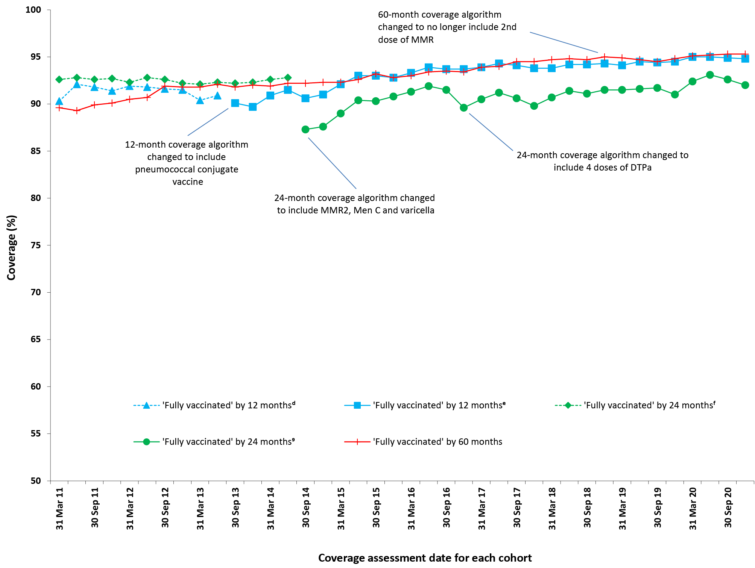
a By three-month birth cohorts born between 1 January 2010 and 31 December 2019. Coverage assessment date was 12, 24 or 60 months after the last birth date of each cohort. Vaccination coverage estimates are calculated by quarter and may differ slightly from estimates published elsewhere using rolling annualised data.
b Source: Australian Immunisation Register, data as at 31 March 2021.
c MMR2: second dose of MMR vaccine; MenC: meningococcal C-containing; DTPa: diphtheria-tetanus-acellular pertussis.
d Coverage algorithm before 1 July 2013.
e Coverage algorithm from 1 July 2013.
f Coverage algorithm before 1 July 2014.
g Coverage algorithm from 1 July 2014.

Figure A.2: Trends in vaccination coverage estimates at 12 months of age, by vaccine/antigenª and quarter,^{b} Australia, 2011 to 2020^{c,d}
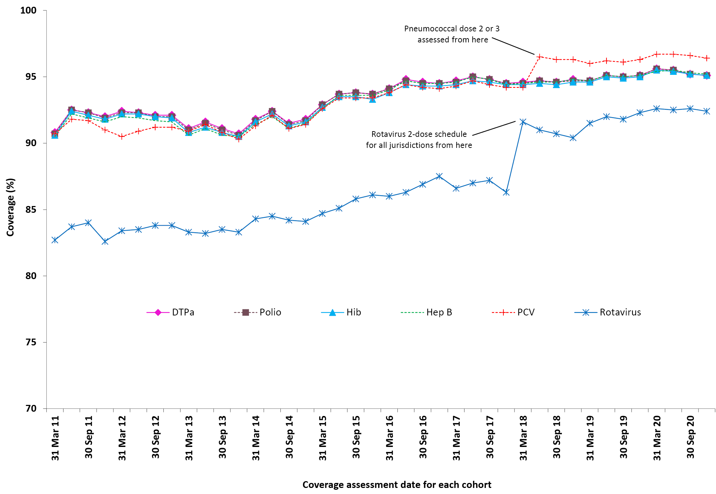
a Third dose of DTPa vaccine, polio vaccine and 13vPCV, second or third dose of Hib and rotavirus vaccines, and third dose of hepatitis B vaccine.
b By three-month birth cohorts born between 1 January 2010 and 31 December 2019. Coverage assessment date was 12 months after the last birth date of each cohort. Vaccination coverage estimates are calculated by quarter and may differ slightly from estimates published elsewhere using rolling annualised data.
c Source: Australian Immunisation Register, data as at 31 March 2021.
d DTPa: diphtheria-tetanus-acellular pertussis; Hib: Haemophilus influenzae type b; Hep B: hepatitis B; 13vPCV: pneumococcal conjugate vaccine.

Figure A.3: Trends in vaccination coverage estimates at 24 months of age by vaccine/antigen* and quarter, Australia, 2011 to 2020
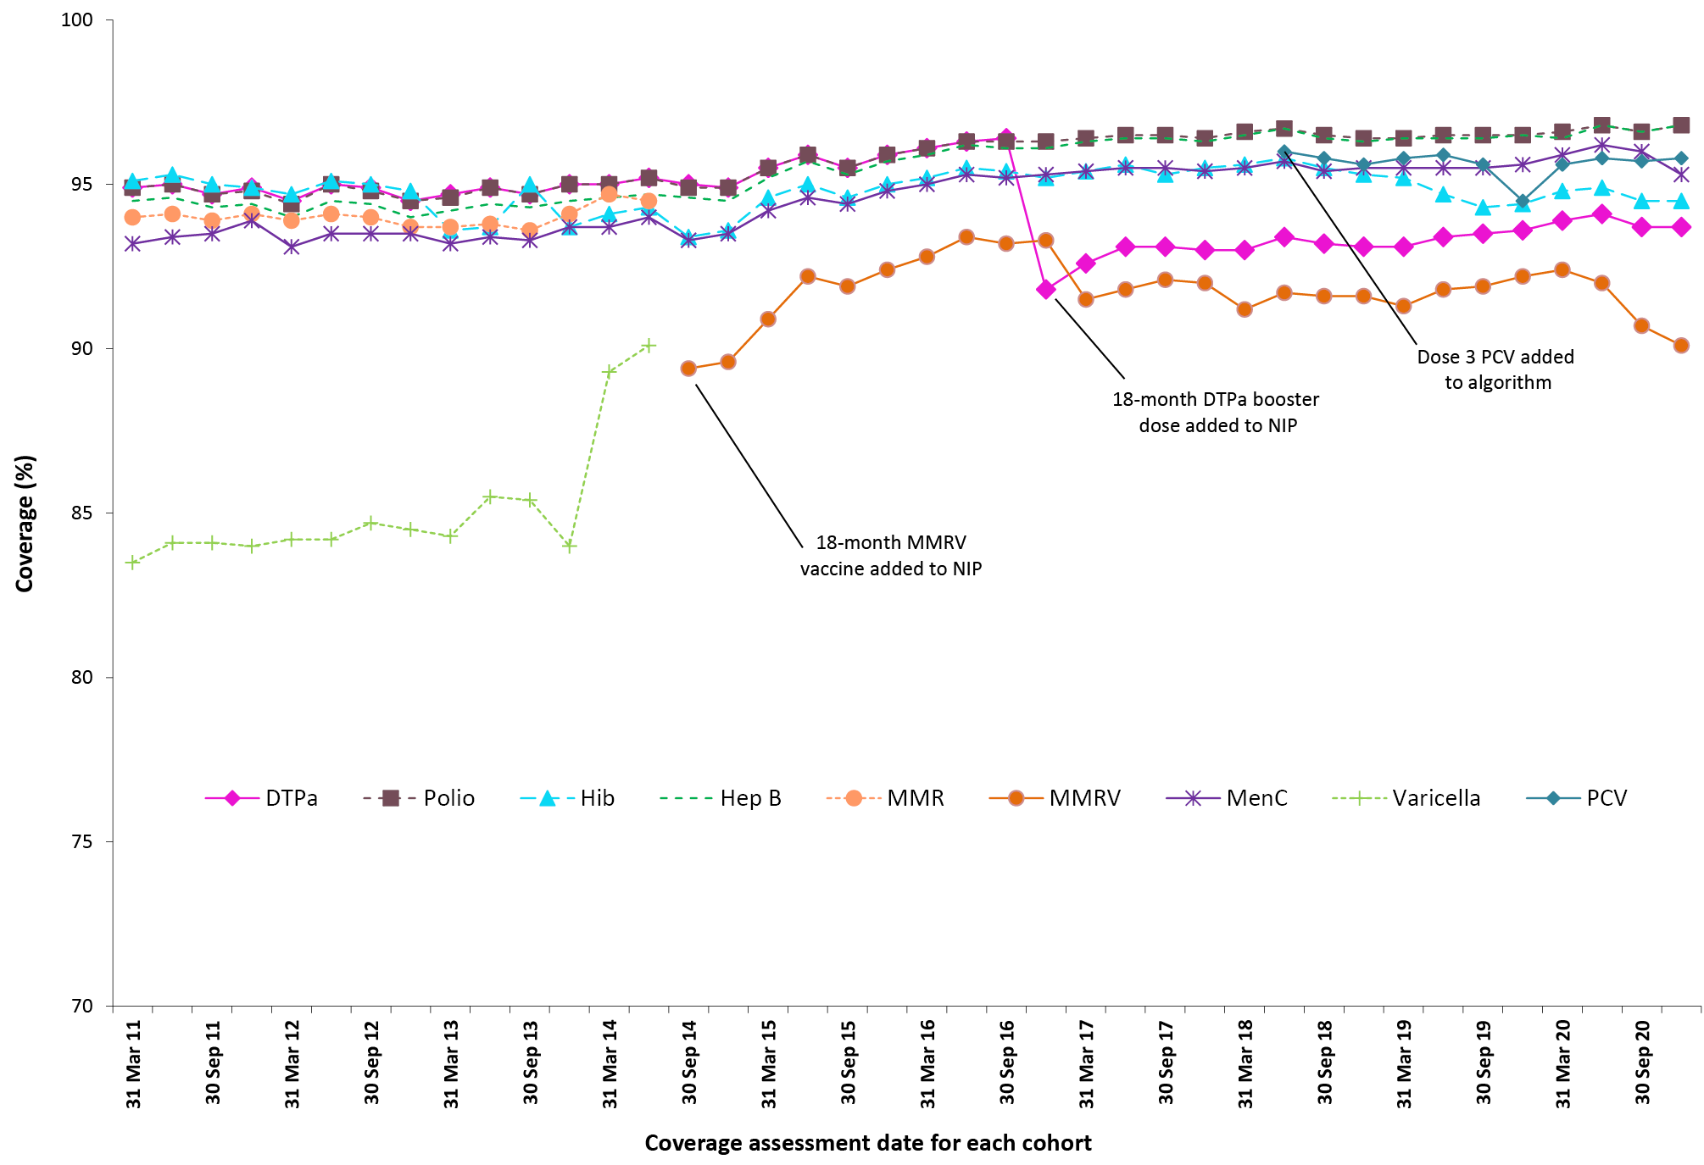
a Fourth dose of DTPa (from October 2016), third dose of polio, third or fourth dose of Hib, third dose of hepatitis B, a dose of varicella, second dose of MMR (from September 2014), and first dose of MenC (MenACWY from July 2018).
b By three-month birth cohorts born between 1 January 2009 and 31 December 2018. Coverage assessment date was 24 months after the last birth date of each cohort. Vaccination coverage estimates are calculated by quarter and may differ slightly from estimates published elsewhere using rolling annualised data.
c Source: Australian Immunisation Register, data as at 31 March 2021.
d DTPa: diphtheria-tetanus-acellular pertussis; Hib: Haemophilus influenzae type b; Hep B: hepatitis B; MMR: measles-mumps-rubella; MenC: meningococcal C-containing; MMRV: measles-mumps-rubella-varicella; 13vPCV: pneumococcal conjugate vaccine.

Figure A.4: Trends in vaccination coverage estimates at 60 months of age by vaccine/antigenª and quarter,^{b} Australia, 2011 to 2020^{c,d}
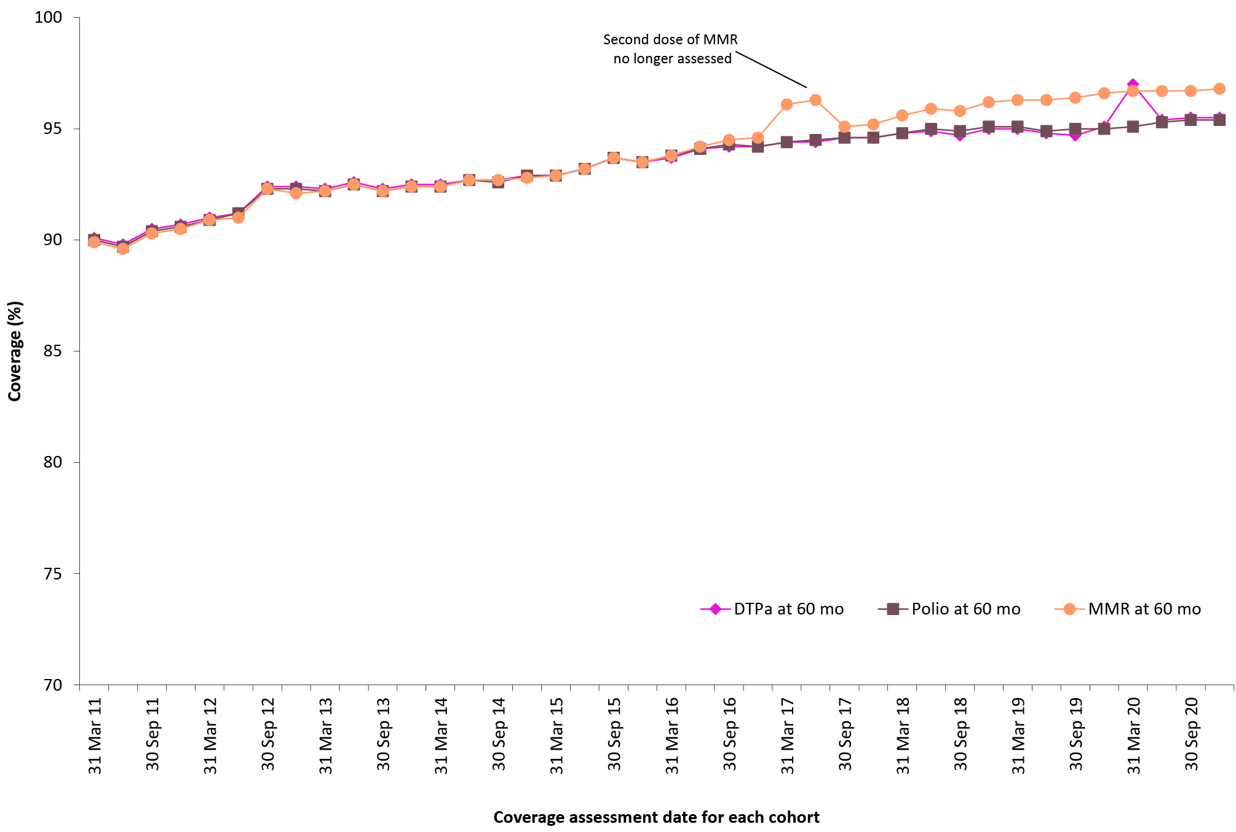
a Fourth or fifth dose of DTPa and fourth dose of polio, second dose of MMR (up until June 2017).
b By three-month birth cohorts born between 1 January 2006 and 31 December 2015. Coverage assessment date was 60 months after the last birth date of each cohort. Vaccination coverage estimates are calculated by quarter and may differ slightly from estimates published elsewhere using rolling annualised data.
c Source: Australian Immunisation Register, data as at 31 March 2021.
d DTPa: diphtheria-tetanus-acellular pertussis; MMR: measles-mumps-rubella.

Figure A.5: Trends in ‘fully vaccinated’ coverage at 12 months of age by Indigenous status and quarter, Australia, 2011 to 2020^{a,b}
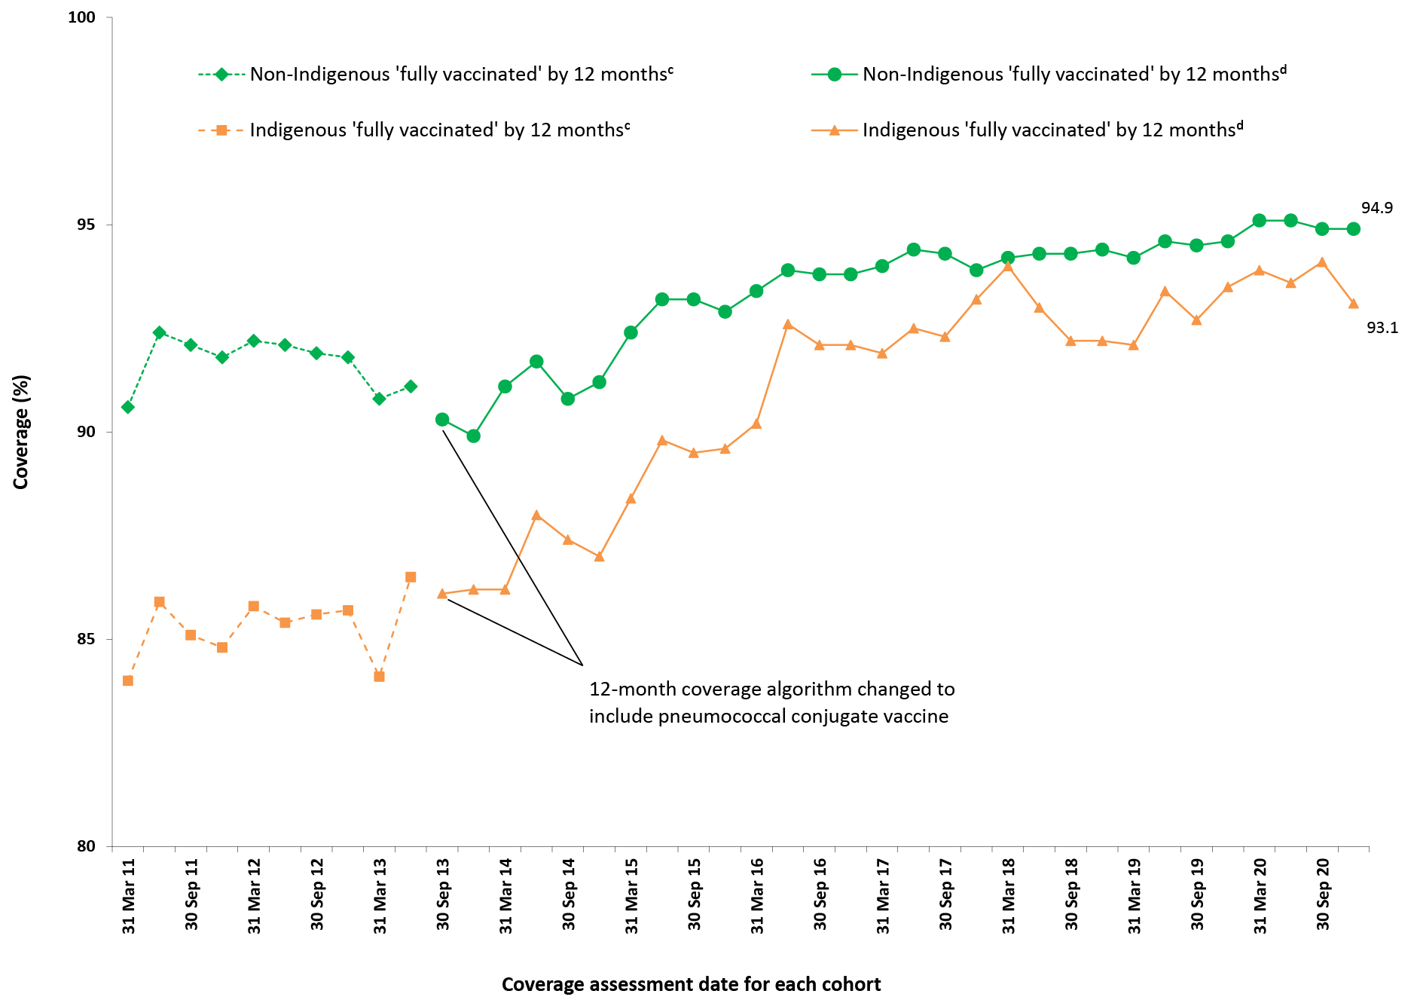
a Source: Australian Immunisation Register, data as at 31 March 2021.
b Vaccination coverage estimates are calculated using three-month wide birth cohorts by quarter and may differ slightly from estimates published elsewhere using rolling annualised data.
c Coverage algorithm before 1 July 2013.
d Coverage algorithm from 1 July 2013.

Figure A.6: Trends in ‘fully vaccinated’ coverage at 24 months of age by Indigenous status and quarter, Australia, 2011 to 2020^{a,b}
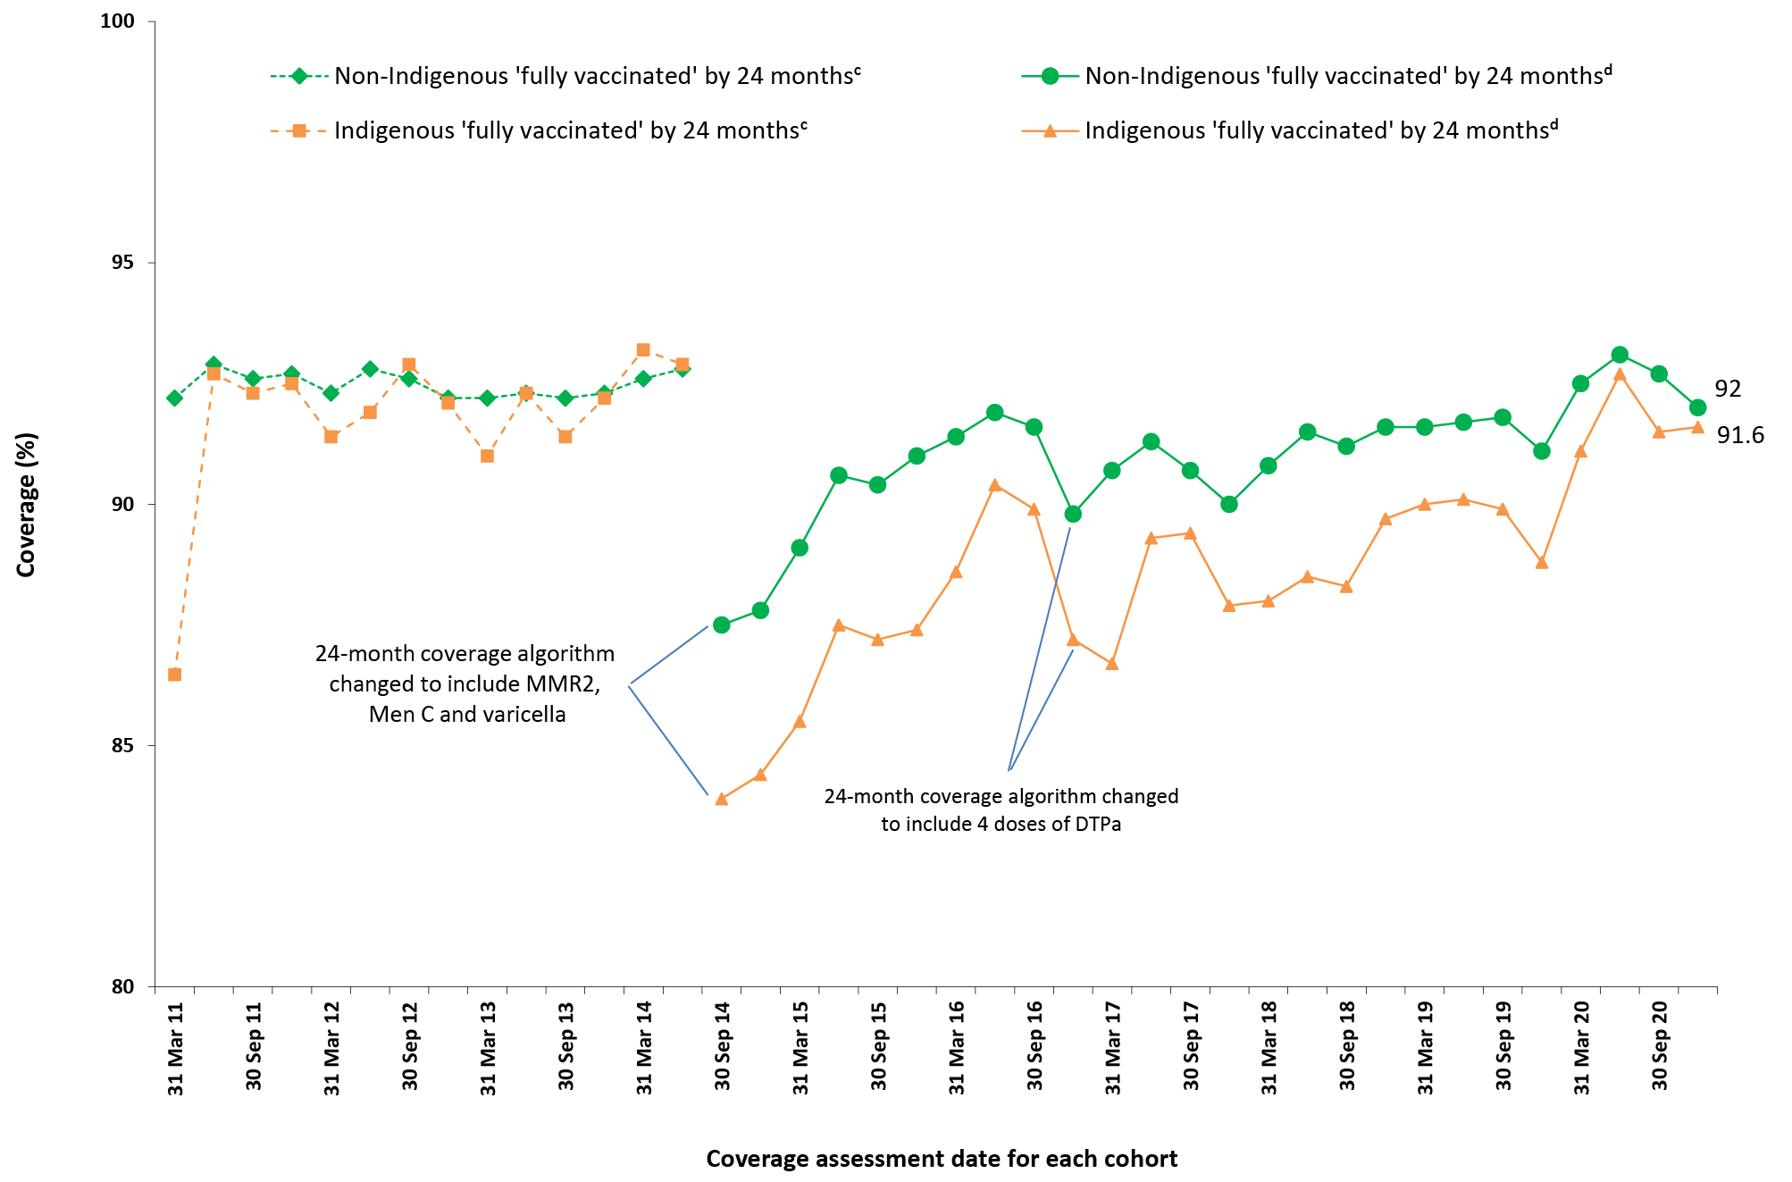
a Source: Australian Immunisation Register, data as at 31 March 2021.
b Vaccination coverage estimates are calculated using three-month wide birth cohorts by quarter and may differ slightly from estimates published elsewhere using rolling annualised data.
c Coverage algorithm before 1 July 2014.
d Coverage algorithm from 1 July 2014.

Figure A.7: Trends in ‘fully vaccinated’ coverage at 60 months of age by Indigenous status and quarter, Australia, 2011 to 2020^{a,b}
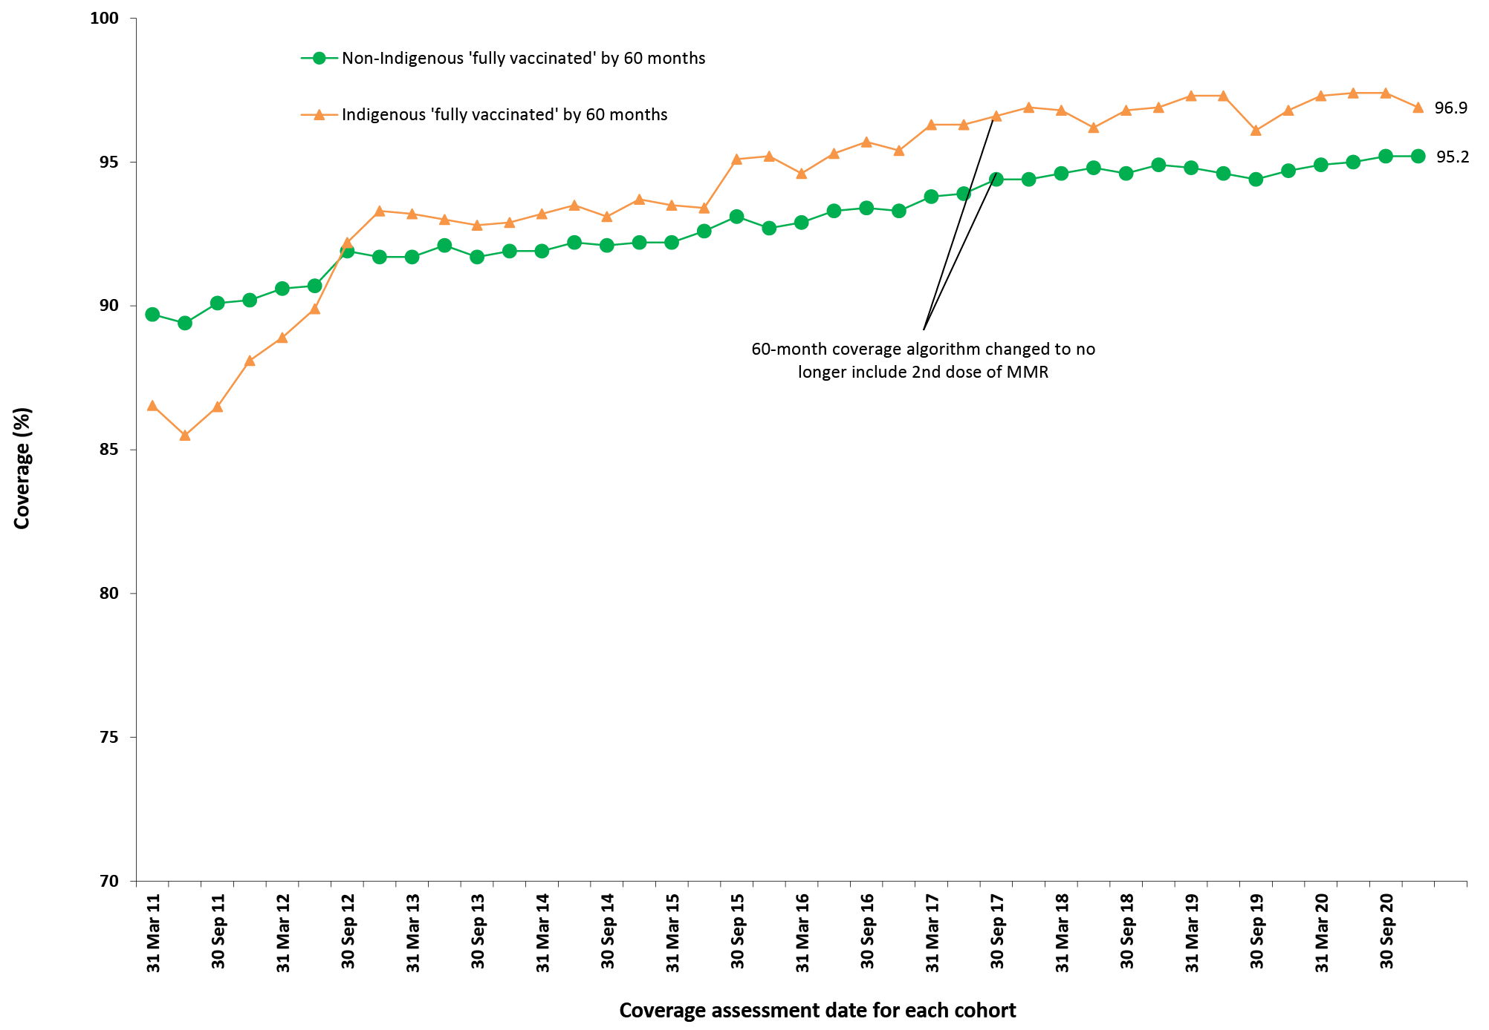
a Source: Australian Immunisation Register, data as at 31 March 2021.
b Vaccination coverage estimates are calculated using three-month wide birth cohorts by quarter and may differ slightly from estimates published elsewhere using rolling annualised data.

Figure A.8: Trends in coverage estimates for hepatitis A vaccineª for Indigenous children by jurisdiction, Australia,^{b} 2011 to 2020^{c,d}
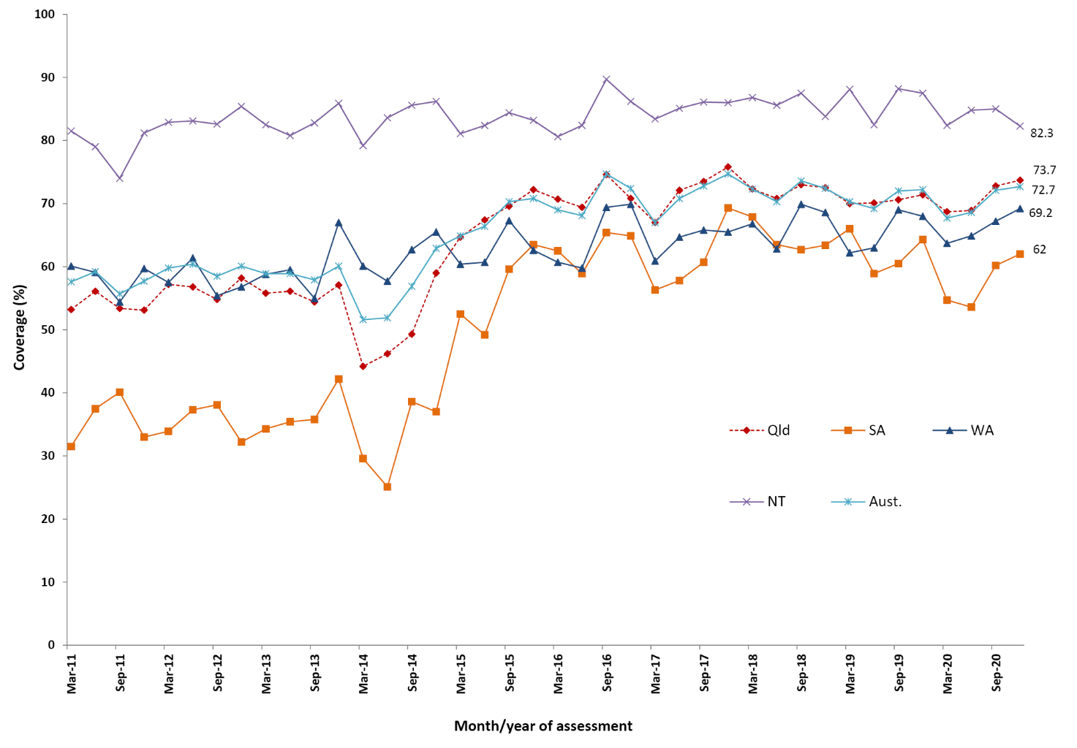
a 18-month dose assessed at 30 months of age in all four jurisdictions.
b Northern Territory (NT), Queensland (Qld), South Australia (SA) and Western Australia (WA) only;
Aust. = Australia.
c Source: Australian Immunisation Register, data as at 31 March 2021.
d Vaccination coverage estimates are calculated using three-month wide birth cohorts by quarter.

Figure A.9: Trends in coverage estimates for pneumococcal vaccine^{a,b} for Indigenous children by jurisdiction,^{c} Australia, 2011 to 2020^{d,e}
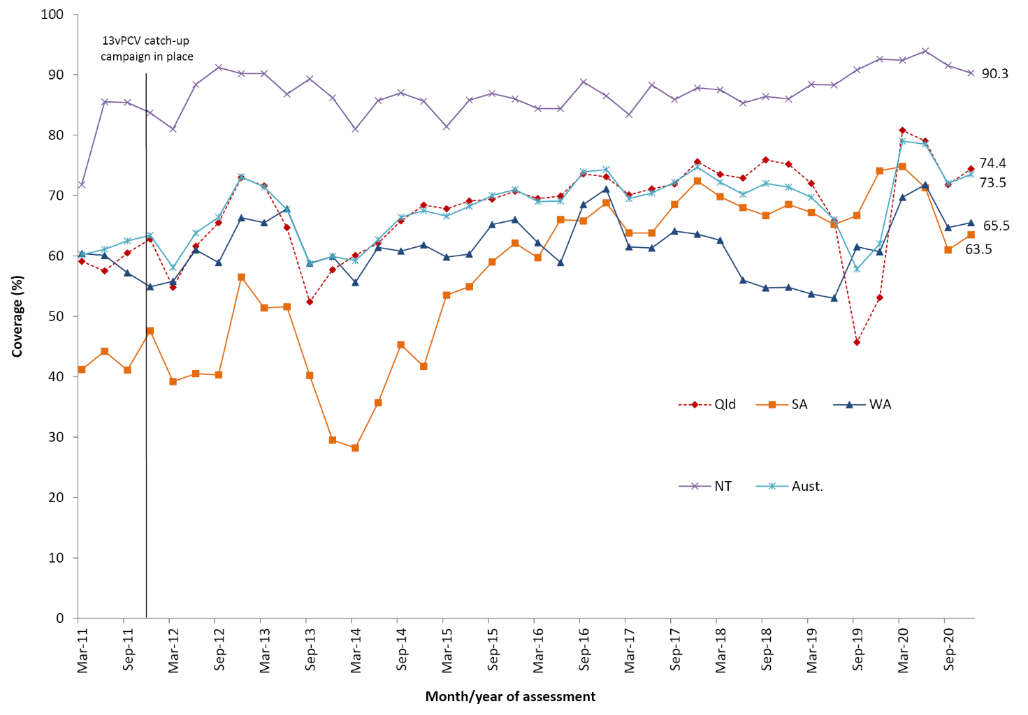
a 12-month booster dose assessed at 30 months of age in all four jurisdictions.
b 13vPCV = 13-valent pneumococcal conjugate vaccine.
c Northern Territory (NT), Queensland (Qld), South Australia (SA) and Western Australia (WA) only; Aust. = Australia.
d Source: Australian Immunisation Register, data as at 31 March 2021.
e Vaccination coverage estimates are calculated using three-month wide birth cohorts by quarter.

Figure A.10: Proportion of vaccinations given to all persons by provider type and jurisdiction, Australia, 2020ª
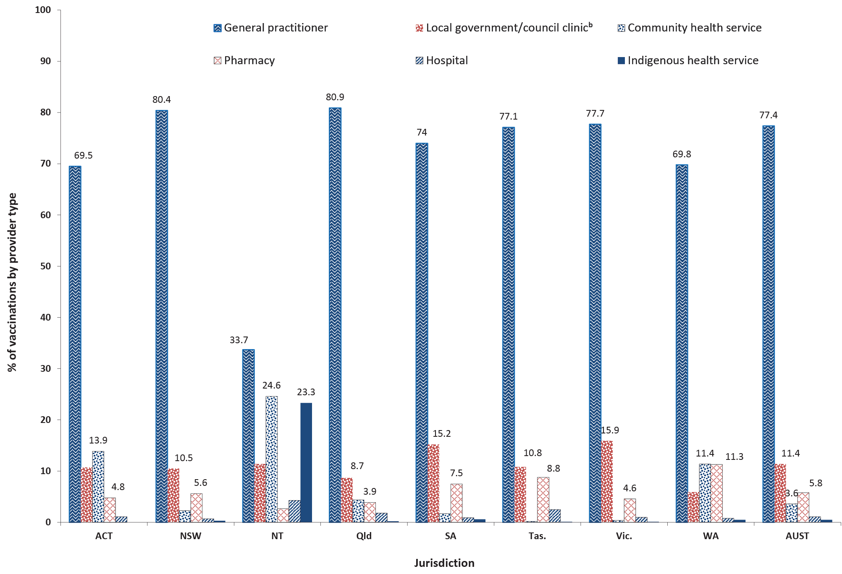
a Source: Australian Immunisation Register, data as at 31 March 2021.
b Includes public health units and state/territory health departments.

Table A.3: Recorded coverage of seasonal influenza vaccineª by age group, jurisdictions, Indigenous persons and all persons, 2020, Australia^{b}
Age group | Jurisdiction^{c}
 | ACT |  | NSW |  | NT |  |  | Qld |  | SA |  | Tas. |  | Vic. |  | WA
 | All | Indigenous^{d} | All | Indigenous | All | Indigenous | All |  | Indigenous | All | Indigenous | All | Indigenous | All | Indigenous | All | Indigenous
6–59 mo | 63.0 | 53.6 | 41.3 | 38.7 | 58.8 | 71.0 | 40.5 |  | 39.1 | 49.5 | 43.3 | 43.8 | 43.3 | 49.0 | 49.1 | 49.9 | 45.1
5–9 yr | 37.5 | 38.5 | 27.1 | 32.7 | 28.9 | 46.3 | 25.7 |  | 30.5 | 32.5 | 35.3 | 26.6 | 34.3 | 31.8 | 40.4 | 38.2 | 37.9
10–14 yr | 31.0 | 36.1 | 22.9 | 29.3 | 26.6 | 43.3 | 22.2 |  | 30.1 | 28.1 | 33.6 | 25.4 | 31.5 | 26.8 | 38.1 | 31.9 | 34.7
15–19 yr | 27.2 | 29.8 | 20.8 | 28.1 | 27.6 | 44.9 | 20.6 |  | 29.5 | 25.2 | 29.7 | 23.9 | 33.8 | 24.1 | 34.3 | 26.7 | 32.4
20–49 yr | 23.9 | 31.8 | 22.2 | 31.5 | 25.9 | 54.2 | 21.1 |  | 30.9 | 26.0 | 32.3 | 27.2 | 36.7 | 24.6 | 35.1 | 25.8 | 33.1
50–64 yr | 36.3 | 56.6 | 34.2 | 57.4 | 30.0 | 68.3 | 34.0 |  | 57.1 | 38.3 | 56.0 | 43.4 | 64.7 | 36.6 | 56.1 | 39.2 | 55.3
65–74 yr | 67.0 | 76.3 | 60.5 | 78.3 | 46.1 | 78.7 | 66.0 |  | 79.9 | 66.5 | 75.3 | 70.8 | 85.2 | 62.8 | 73.1 | 67.6 | 77.3
75+ yr | 74.1 | 81.7 | 66.1 | 86.4 | 43.6 | 71.0 | 74.4 |  | 83.1 | 72.7 | 75.5 | 79.6 | 95.5 | 67.6 | 77.0 | 76.0 | 76.4
Total (≥ 6 mo) | 35.8 | 39.9 | 32.5 | 37.8 | 30.9 | 55.5 | 32.3 |  | 36.7 | 38.0 | 38.6 | 40.0 | 43.2 | 35.0 | 47.6 | 37.5 | 39.2
a At lease one dose of any influenza vaccine.
b Source: Australian Immunisation Register, data as at 31 March 2021.
c ACT: Australian Capital Territory; NSW: New South Wales; NT: Northern Territory; Qld: Queensland; SA: South Australia; Tas.: Tasmania; Vic.: Victoria; WA: Western Australia.
d Indigenous persons.

Table A.4: ‘Fully vaccinated’ coverage estimates assessed at standard age milestones (12, 24 and 60 months) and earlier (9, 15, 21, 51 months) milestones,ª by primary health network (PHN), 2020^{b}
PHN | 9 mo (%)^{c} | 12 mo (%)^{c} | 15 mo (%)^{d} | 21 mo (%)^{d} | 24 mo (%)^{d} | 51 mo (%)^{e} | 60 mo (%)^{e}
Western NSW | 94.3 | 96.9 | 92.8 | 90.8 | 94.1 | 90.4 | 97.6
Murrumbidgee | 93.6 | 96.2 | 92.7 | 90.9 | 93.5 | 92.0 | 97.2
Western Victoria | 93.7 | 96.3 | 93.1 | 92.0 | 94.8 | 91.3 | 97.1
Gippsland | 92.7 | 95.4 | 92.3 | 90.7 | 94.1 | 91.1 | 96.9
Murray | 92.5 | 95.9 | 92.1 | 90.5 | 93.8 | 89.9 | 96.5
Hunter New England and Central Coast | 93.5 | 96.0 | 92.9 | 91.2 | 94.1 | 89.4 | 96.4
South Eastern NSW | 93.6 | 95.5 | 91.9 | 90.7 | 93.6 | 89.5 | 96.2
Nepean Blue Mountains | 93.7 | 95.9 | 92.6 | 91.1 | 93.7 | 89.0 | 96.1
Eastern Melbourne | 93.0 | 95.5 | 92.0 | 90.5 | 92.8 | 90.9 | 96.0
Australian Capital Territory | 94.8 | 96.5 | 92.9 | 91.6 | 93.6 | 90.4 | 95.9
Western Queensland | 89.7 | 94.9 | 88.5 | 83.2 | 89.9 | 85.6 | 95.9
Northern Queensland | 90.6 | 94.9 | 91.0 | 88.9 | 92.9 | 87.5 | 95.8
South Western Sydney | 91.3 | 94.2 | 89.4 | 88.4 | 91.6 | 88.5 | 95.7
Country SA | 90.9 | 94.3 | 89.8 | 88.0 | 92.1 | 86.9 | 95.4
North Western Melbourne | 91.6 | 94.7 | 90.4 | 88.8 | 91.5 | 90.1 | 95.4
South Eastern Melbourne | 92.0 | 94.9 | 91.9 | 90.1 | 92.7 | 89.5 | 95.3
Adelaide | 92.3 | 95.2 | 90.8 | 89.4 | 92.6 | 87.1 | 95.2
Darling Downs and West Moreton | 91.6 | 94.9 | 91.2 | 89.4 | 93.1 | 88.7 | 95.0
Western Sydney | 91.6 | 94.1 | 89.7 | 88.3 | 91.3 | 88.4 | 94.9
Tasmania | 92.7 | 95.4 | 89.1 | 87.5 | 90.5 | 87.7 | 94.8
Brisbane North | 93.4 | 95.7 | 91.7 | 90.1 | 93.1 | 88.3 | 94.6
Country WA | 88.9 | 93.3 | 87.4 | 84.9 | 89.6 | 83.7 | 94.0
Brisbane South | 91.9 | 94.8 | 90.6 | 89.0 | 92.2 | 86.3 | 93.9
Northern Sydney | 93.7 | 95.3 | 91.0 | 89.5 | 91.7 | 88.1 | 93.8
Northern Territory | 91.0 | 95.2 | 88.8 | 85.6 | 90.9 | 82.5 | 93.6
Perth North | 91.5 | 94.3 | 90.5 | 88.3 | 91.7 | 85.9 | 93.6
Perth South | 91.0 | 94.5 | 89.9 | 88.0 | 91.7 | 85.6 | 93.6
Central Queensland, Wide Bay, Sunshine Coast | 90.6 | 93.6 | 89.1 | 87.3 | 90.4 | 86.0 | 93.5
Gold Coast | 89.4 | 92.2 | 88.0 | 86.4 | 90.1 | 85.1 | 92.3
Central and Eastern Sydney | 93.0 | 94.8 | 89.8 | 88.1 | 90.4 | 85.8 | 92.2
North Coast | 86.9 | 90.1 | 86.2 | 84.3 | 87.8 | 83.3 | 91.0
a The coverage algorithm used for the 9/21/51 month milestones is the same as for the 12/24/60 month milestones, respectively; the algorithm used for 15 months is the same as that for 24 months but excludes doses due at 18 months. For further detail of algorithms, refer to Appendix Table A.2.
b Data sorted by the ‘< 60 months’ column (highest to lowest).
c Cohort born 1 January 2019 – 31 December 2019.
d Cohort born 1 January 2018 – 31 December 2018.
e Cohort born 1 January 2015– 31 December 2015.
Communicable Diseases Intelligence
ISSN: 2209-6051 Online

Communicable Diseases Intelligence (CDI) is a peer-reviewed scientific journal published by the Office of Health Protection and Response, Department of Health and Aged Care. The journal aims to disseminate information on the epidemiology, surveillance, prevention and control of communicable diseases of relevance to Australia.

Editor: Noel Lally
Deputy Editor: Simon Petrie
Design and Production: Kasra Yousefi
Editorial Advisory Board: David Durrheim, Mark Ferson, John Kaldor, Martyn Kirk and Linda Selvey

Website: http://www.health.gov.au/cdi

Contacts
CDI is produced by the Office of Health Protection and Response, Australian Government Department of Health and Aged Care, GPO Box 9848, (MDP 6) CANBERRA ACT 2601

Email: cdi.editor@health.gov.au

Submit an Article
You are invited to submit your next communicable disease related article to the Communicable Diseases Intelligence (CDI) for consideration. More information regarding CDI can be found at: http://health.gov.au/cdi.
Further enquiries should be directed to: cdi.editor@health.gov.au.

This journal is indexed by Index Medicus and Medline.

Creative Commons Licence - Attribution-NonCommercial-NoDerivatives CC BY-NC-ND
© 2022 Commonwealth of Australia as represented by the Department of Health and Aged Care
This publication is licensed under a Creative Commons Attribution-NonCommercial-NoDerivatives 4.0 International Licence from https://creativecommons.org/licenses/by-nc-nd/4.0/legalcode (Licence). You must read and understand the Licence before using any material from this publication.

Restrictions
The Licence does not cover, and there is no permission given for, use of any of the following material found in this publication (if any):
- the Commonwealth Coat of Arms (by way of information, the terms under which the Coat of Arms may be used can be found at www.itsanhonour.gov.au);
- any logos (including the Department of Health and Aged Care’s logo) and trademarks;
- any photographs and images;
- any signatures; and
- any material belonging to third parties.

Disclaimer
Opinions expressed in Communicable Diseases Intelligence are those of the authors and not necessarily those of the Australian Government Department of Health and Aged Care or the Communicable Diseases Network Australia. Data may be subject to revision.

Enquiries
Enquiries regarding any other use of this publication should be addressed to the Communication Branch, Department of Health and Aged Care, GPO Box 9848, Canberra ACT 2601, or via e-mail to: copyright@health.gov.au

Communicable Diseases Network Australia
Communicable Diseases Intelligence contributes to the work of the Communicable Diseases Network Australia.
http://www.health.gov.au/cdna

NB: coverage estimates in this report may differ slightly from estimates published elsewhere that are calculated using rolling annualised quarterly coverage data.
NB: coverage estimates in this report may differ slightly from estimates published elsewhere that are calculated using rolling annualised quarterly coverage data.

