Australian Meningococcal Surveillance Programme Annual Report, 2021
Monica M Lahra, CR Robert George and Tiffany R Hogan for the National Neisseria Network

Abstract
Invasive meningococcal disease (IMD) is a notifiable disease in Australia, with both probable and laboratory-confirmed cases of IMD reportable to the National Notifiable Diseases Surveillance System (NNDSS). In 2021, there were 74 notifications of IMD made, the lowest number recorded since 1991 when records began. Ninety-one percent of notified cases (67/74) were laboratory confirmed, with 69% of laboratory-confirmed cases (46/67) diagnosed by bacterial culture and 31% (21/67) by nucleic acid amplification testing. The serogroup was determined for 63/67 laboratory-confirmed cases (94%): serogroup B (MenB) accounted for 52% of infections (35/67); MenW for 22% (15/67); MenY for 19% (13/67); there were no infections attributed to MenC. Fine typing was available on 37/67 (55%) where the serogroup was determined. The greatest variability was in MenB, with nine different porA types represented. All MenW infections belonged to a single porA type (P1.5,2) with five different MLST sequence types represented: 11, 574, 1287, 12351, 13135; all belonged to clonal complex 11, the hypervirulent strain reported in recent outbreaks in Australia and overseas. All MenY were from the same porA antigen type, P1.5-1,10-1: MLST sequence type 1655; clonal complex 23.
Peaks occurred in children less than 5 years, reaching 24% (16/67) of reported cases, and in those aged 15–19 years reaching 16% (11/67) of reported cases. It is notable that 15% (10/67) of notifications were in persons aged 45–64 years, and an equivalent proportion (15%; 10/67) in adults aged 65 years and above. MenB infections predominated in persons aged 15–19 years (100%, 11/11), and comprised 56% (9/16) of infections in children aged less than 5 years. By contrast, Men W infections accounted for half (5/10) of IMD detections in infants less than 1 year, and 30% (3/10) of infections in persons aged 45–65 years. MenY infections predominated in adults aged 65 years and greater, resulting in 70% (7/10) of IMD in this age group.
All 46 IMD isolates had antimicrobial susceptibility testing performed. Minimum inhibitory concentration (MIC) values were categorised using Clinical Laboratory Standards Institute (CLSI) interpretative criteria: 13% (6/46) were defined as penicillin resistant (MIC value, ≥ 0.5 mg/L); 59% (27/46) had intermediate susceptibility to penicillin (MIC values, 0.125 and 0.25 mg/L) and 28% (13/46) were susceptible to penicillin. All isolates were susceptible to ceftriaxone and rifampicin. A single MenB IMD isolate from New South Wales exhibited ciprofloxacin resistance (MIC value, 0.125 mg/L).
Keywords: antimicrobial resistance; disease surveillance; invasive meningococcal disease; Neisseria meningitidis

Introduction
Australia’s National Neisseria Network (NNN) was established in 1979 as a collaborative network of reference laboratories in each state and territory that contribute to the laboratory surveillance of the pathogenic Neisseria : N. meningitidis and N. gonorrhoeae. The NNN has coordinated laboratory data from cases of invasive meningococcal disease (IMD) for the Australian Meningococcal Surveillance Programme (AMSP) since 1994 and is supported by the Australian Government Department of Health and Aged care and the jurisdictions. ¹ The NNN laboratories supply data to supplement notification data from the National Notifiable Diseases Surveillance System (NNDSS), which includes cases of probable and laboratory confirmed IMD.
Notifications of IMD in Australia peaked in 2002 at 3.5 cases per 100,000 persons, ² with the majority of disease at that time caused by MenB and MenC. In 2003 the introduction of the conjugate serogroup C meningococcal vaccine to the National Immunisation Program (NIP) was followed by significant and sustained reduction of the number of serogroup C IMD notifications, and of overall notifications to a nadir of 0.6 cases per 100,000 in 2013. ^{3,4} The IMD notification rate increased to 1.5 cases per 100,000 in 2017, ² when MenACWY immunisation programmes were implemented across jurisdictions in targeted age groups. In 2018, a change in the NIP was effected, substituting monovalent MenC vaccine with the quadrivalent MenACWY vaccine. IMD notifications declined to 1.1 per 100,000 in 2018, and to 0.8 per 100,000 in 2019. In 2020, there were 0.4 cases per 100,000 recorded and a continued reduction in 2021 recorded 0.3 cases per 100,000, representing a reduction in disease rate beyond expected vaccine impact and likely attributable to the impact of public health measures implemented in the coronavirus disease 2019 (COVID-19) pandemic. IMD is a rare disease in Australia, but one of public health concern; continued monitoring of phenotypic and genotypic features of IMD strains is critical to plan and inform clinical management of cases, case clusters and outbreaks of IMD locally and nationally, and for informing and monitoring public health interventions.

Methods

Case confirmation of invasive meningococcal disease
Case confirmation is based on culture of N. meningitidis , or molecular diagnoses from a normally sterile site, defined as laboratory-definitive evidence of IMD according to national case definitions. ⁵ Information regarding the site of infection, age and sex of the patients is collated by the NNN for the AMSP.
Invasive N. meningitidis infections are categorised according to the site from which N. meningitidis was isolated, or from which meningococcal DNA was detected (blood, joint fluid, and vitreous fluid). When N. meningitidis is detected from both blood and cerebrospinal fluid (CSF) from the same patient, the case is classified as one of meningitis.

Serogroup and genotyping of Neisseria meningitidis
Serogrouping is determination by detection of soluble polysaccharide antigens, with molecular testing playing an increasing role. ⁶ Genotyping of both isolates and DNA extracts is performed by sequencing products derived from amplification of the porA gene. Multi-locus sequence typing and clonal complex assignment is also reported by some jurisdictions.

Antimicrobial susceptibility testing
Meningococcal isolates are tested to determine their minimum inhibitory concentration (MIC) values for antibiotics used for treatment (ceftriaxone, penicillin) and for clearance of carriage (ciprofloxacin and rifampicin). In this report, antibiotic susceptibilities are reported according to the Clinical Laboratory Standards Institute’s (CLSI) M100 guidelines; ⁷ this differs from historical reporting. By CLSI guidelines, MIC breakpoints are categorised as follows, for penicillin: susceptible (MIC ≤ 0.06 mg/L); intermediate susceptibility (MIC 0.125–0.25 mg/L); and resistant (MIC ≥ 0.5 mg/L); for ceftriaxone: susceptible (MIC ≤ 0.125 mg/L); for ciprofloxacin: susceptible (MIC ≤ 0.03 mg/L), intermediate susceptibility (MIC 0.06 mg/L) and resistant (MIC ≥ 0.125 mg/L); and for rifampicin: susceptible (MIC ≤ 0.5 mg/L), intermediate susceptibility (MIC 1.0 mg/L) and resistant (MIC ≥ 2 mg/L).

Results
In 2021, there were 74 IMD cases notified to the NNDSS, of which 67 were laboratory confirmed. ² Laboratory data were available to the AMSP for all 67 laboratory-confirmed IMD cases, as shown in Figure 1. In 2021, there was a continued decrease in notifications of IMD across all jurisdictions excluding South Australia, which reported an increase in notifications from 2020. In 2021, the peak incidence of IMD occurred in autumn through early winter (1 April to 30 June); and in spring through early summer (1 October to 31 December), as shown in Table 1.
Figure 1: Number of invasive meningococcal disease cases reported to the National Notifiable Diseases Surveillance System compared with laboratory-confirmed data from the Australian Meningococcal Surveillance Programme, Australia, 1991–2021ª
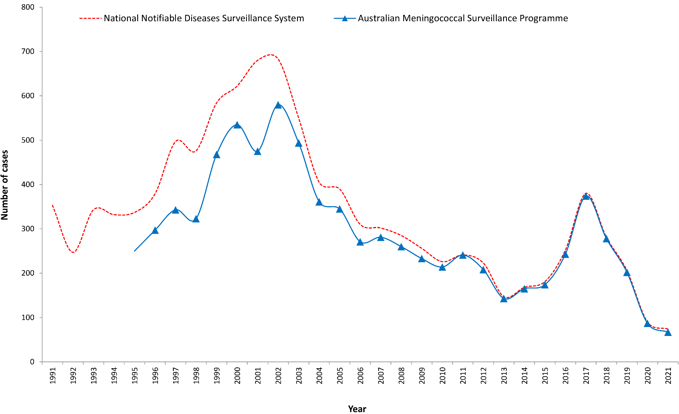
a Source: National Notifiable Diseases Surveillance System. Data extracted 4 May 2022.
Table 1: Laboratory-confirmed cases of invasive meningococcal disease, Australia, 2021
IMD  serogroup  2021ª | 1 January – 31 March | 1 April – 30 June | 1 July – 30 September | 1 October – 31 December | 2021 total
B | 8 | 11 | 4 | 12 | 35
C | 0 | 0 | 0 | 0 | 0
Y | 4 | 5 | 2 | 2 | 13
W | 2 | 4 | 4 | 5 | 15
ND | 2 | 2 | 0 | 0 | 4
Total | 16 | 22 | 10 | 19 | 67
a ND: not determined.

Laboratory diagnosis of IMD
In 2021, laboratory diagnosis of IMD was by culture in 69% of laboratory-confirmed cases (46/67) and by molecular testing (nucleic acid amplification testing) in 31% (21/67), as shown in Table 2. There were 11 diagnoses of meningitis, 53 diagnoses of bacteraemia, and three IMD diagnoses from joint fluid aspirates.
Table 2: Number of laboratory-confirmed cases of invasive meningococcal disease, Australia, 2021, by specimen type and method of confirmation
Specimen | Bacterial culture | Nucleic acid amplification test | Total
Blood | 42 | 11 | 53
CSF +/- blood | 3 | 8 | 11
Joint aspirate | 1 | 2 | 3
Total | 46 | 21 | 67

Notifications by jurisdiction
Across the jurisdictions in 2021, New South Wales reported the highest number of IMD notifications (27%; 18/67), an increased percentage of the national total but a reduction in this state’s notifications from the 2020 values (24%; 21/87). Queensland had the second-highest number of notifications (21%, 14/67), a reduction from 27/87 notifications (31%) in 2020. South Australia was the only jurisdiction recording a rise in IMD cases in 2021, increasing from 5/87 cases (6%) in 2020 to 12/67 cases (18%) in 2021. The number of cases from each jurisdiction for 2021 is shown in Table 3.
Table 3: Number of laboratory-confirmed cases of invasive meningococcal disease, Australia, 2021, by state or territory, and by serogroup
State/territory | Serogroup
 | B | C | Y | W | NDª | Total
Australian Capital Territory | 0 | 0 | 0 | 0 | 0 | 0
New South Wales | 12 | 0 | 3 | 2 | 1 | 18
Northern Territory | 0 | 0 | 0 | 1 | 0 | 1
Queensland | 5 | 0 | 6 | 3 | 0 | 14
South Australia | 6 | 0 | 0 | 6 | 0 | 12
Tasmania | 2 | 0 | 0 | 0 | 0 | 2
Victoria | 7 | 0 | 2 | 0 | 1 | 10
Western Australia | 3 | 0 | 2 | 3 | 2 | 10
Australia | 35 | 0 | 13 | 15 | 4 | 67
% | 52.2 | 0.0 | 19.4 | 22.4 | 6.0 | 100%
a ND: not determined.
MenB accounted for 52% of IMD notifications in 2021 as shown in Table 3. Over the years 2006–2012, the proportion of IMD attributable to MenB ranged within 84–88% nationwide. In 2013–2014, rates on MenB were lower (75–80%), falling to 64% in 2015, and then to 36% in 2016–2017. There was a marked increase in attributable proportion in 2018 to 44%, reaching 50% in 2019 and then 62% in 2020. In 2021, the proportion has decreased again, to 52% of IMD reported as shown in Figure 2.
Figure 2: Proportion of serogroups of laboratory-confirmed invasive meningococcal disease, Australia, 2000 – 2021 by year
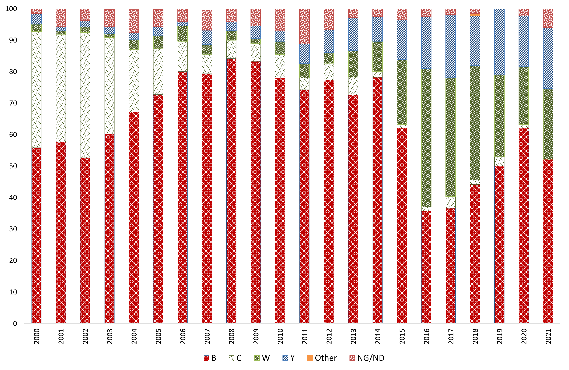
MenW and MenY respectively accounted for 22% and 19% of IMD nationally in 2021, as shown in Table 3. The rise in IMD notifications in Australia since 2014 coincided with increases in numbers of infections of both MenW and MenY, as shown in Figure 1 and Figure 2. Prior to 2015, the proportion of cases of IMD caused by MenW was low, ranging within 1.1–4.8% in 1997–2012, then increasing to 8.4–9.7% in 2013–2014. By 2015, the proportion of IMD cases caused by MenW increased to 21%, reaching 44% in 2016, before declining to 36–38% in 2017–2018 and then to 18% in 2020. In 2021, the MenW proportion has risen again, to 22% (Figure 2). The proportion of cases of IMD caused by MenY prior to 2015 ranged within 1.3–4.6% in the period 1997–2010. Rates increased in 2011–2014 to 6.2–11%; then to 13% in 2015; to 17% in 2016; and then to 20% in 2017. The proportion of MenY was lower in 2018 (16%), increasing to 21% in 2019. In 2020, the proportion of MenY decreased to 16%, and in 2021 has increased again to 19% as shown in Figure 2.
There was no MenC IMD reported from Australia in 2021. Very few or no cases of any serogroup of IMD were reported from the Australian Capital Territory (0 cases); the Northern Territory (1 case); and Tasmania (2 cases).

IMD age and serogroup distribution
In 2021, IMD was reported in all age groups. Disease peaks occurred in children less than 5 years at 24% of cases (16/67) and in persons aged 15 to 19 years comprising 16% of cases (11/67). It is notable that 15% of notifications (10/67) were in adults aged 45–64 years, with an equivalent proportion in adults 65 and above years, as shown in Table 4. Serogrouping was determined for 63/67 cases of IMD (94%), with MenB accounting for 52%, MenW for 22%, and MenY for 19% of national notifications, as shown in Table 3. No notifications of MenC IMD occurred nationwide.
By age group, 24% (16/67) of IMD notifications in 2021 were in children less than 5 years, a decrease from 29% in 2020. In this age group, 56% of IMD (9/16) was attributable to MenB, and 31% (5/16) to MenW (all reported from infants less than 1 year of age), as is shown in Table 4 and Figure 3.
Table 4: Laboratory-confirmed cases of invasive meningococcal disease (IMD), Australia, 2021, by age and serogroup, and the proportion of IMD attributable to MenB
Serogroup | Age group (years) |  |  |  |  |  |  |  |  | Total
 | < 1 | 1–4 | 5–9 | 10–14 | 15–19 | 20–24 | 25–44 | 45–64 | 65+
B | 5 | 4 | 1 | 0 | 11 | 5 | 4 | 4 | 1 | 35
C | 0 | 0 | 0 | 0 | 0 | 0 | 0 | 0 | 0 | 0
Y | 0 | 1 | 0 | 0 | 0 | 0 | 2 | 3 | 7 | 13
W | 5 | 0 | 1 | 1 | 0 | 1 | 2 | 3 | 2 | 15
ND | 0 | 1 | 1 | 2 | 0 | 0 | 0 | 0 | 0 | 4
Total | 10 | 6 | 3 | 3 | 11 | 6 | 8 | 10 | 10 | 67
%B within age group | 50% | 67% | 33% | 0% | 100% | 83% | 50% | 40% | 10% | 52%

Overall, 17% of IMD (11/67) was reported in teenagers aged 15–19 years, and all such cases (100%; 11/11) were MenB disease. Further, 83% (5/6) of IMD in adults aged 20–24 years was attributable to MenB, as shown in Table 4 and Figure 3.
Adults aged 45–64 years accounted for 15% of national IMD notifications (10/67), comprising 40% MenB (4/10); 30% MenW (3/10); and 30% MenY (3/10) reported, as shown in Table 4 and Figure 3.
In adults aged 65 years and greater, IMD accounted for a further 15% of national notifications (10/67); MenY represented 70% (7/10) of these notifications, which is a higher proportion than reported in 2020 (58%; 7/12), also shown in Table 4 and Figure 3.

IMD and genotyping
Finetyping on MenB IMD cases was performed on 18 of 35 cases; this serogroup showed the greatest variability, with nine porA types represented, and with two porA types predominating: P1.22,14 (6/18; 33%) and P1.7-2,4 (4/18; 22%). The porA type P1.7,16-26, which was predominant in previous years, accounted for only one MenB notification in 2021, as shown in Figure 4 and Table 5.
Of the 15 MenW that had finetyping performed, ten were determined to be from por A type P1.5,2 as shown in Figure 4 and Table 5. However, five different MLST sequence types were represented: 11, 574, 1287, 12351, and 13135, with all belonging to the same clonal complex 11. The porA type P1.5,2 has been the predominant genotype in recent years, from the clonal complex 11, which is the same strain type as the hypervirulent serogroup W strain also reported in the United Kingdom and South America since 2009. ^{9,10}
Nine of the 13 MenY that had finetyping performed were determined to be from a single porA type, P1.5-1,10-1 (shown in Figure 4 and Table 5) and belonged to MLST sequence type 1655 and clonal complex 23. The porA type, P1.5-1,10-1 has been the predominant genotype circulating in Australia since 2014, when the increase in serogroup Y IMD was first noted in Australia.

Figure 3: Number of serogroup B, C, Y and W cases of laboratory-confirmed invasive meningococcal disease, Australia, 2021, by age
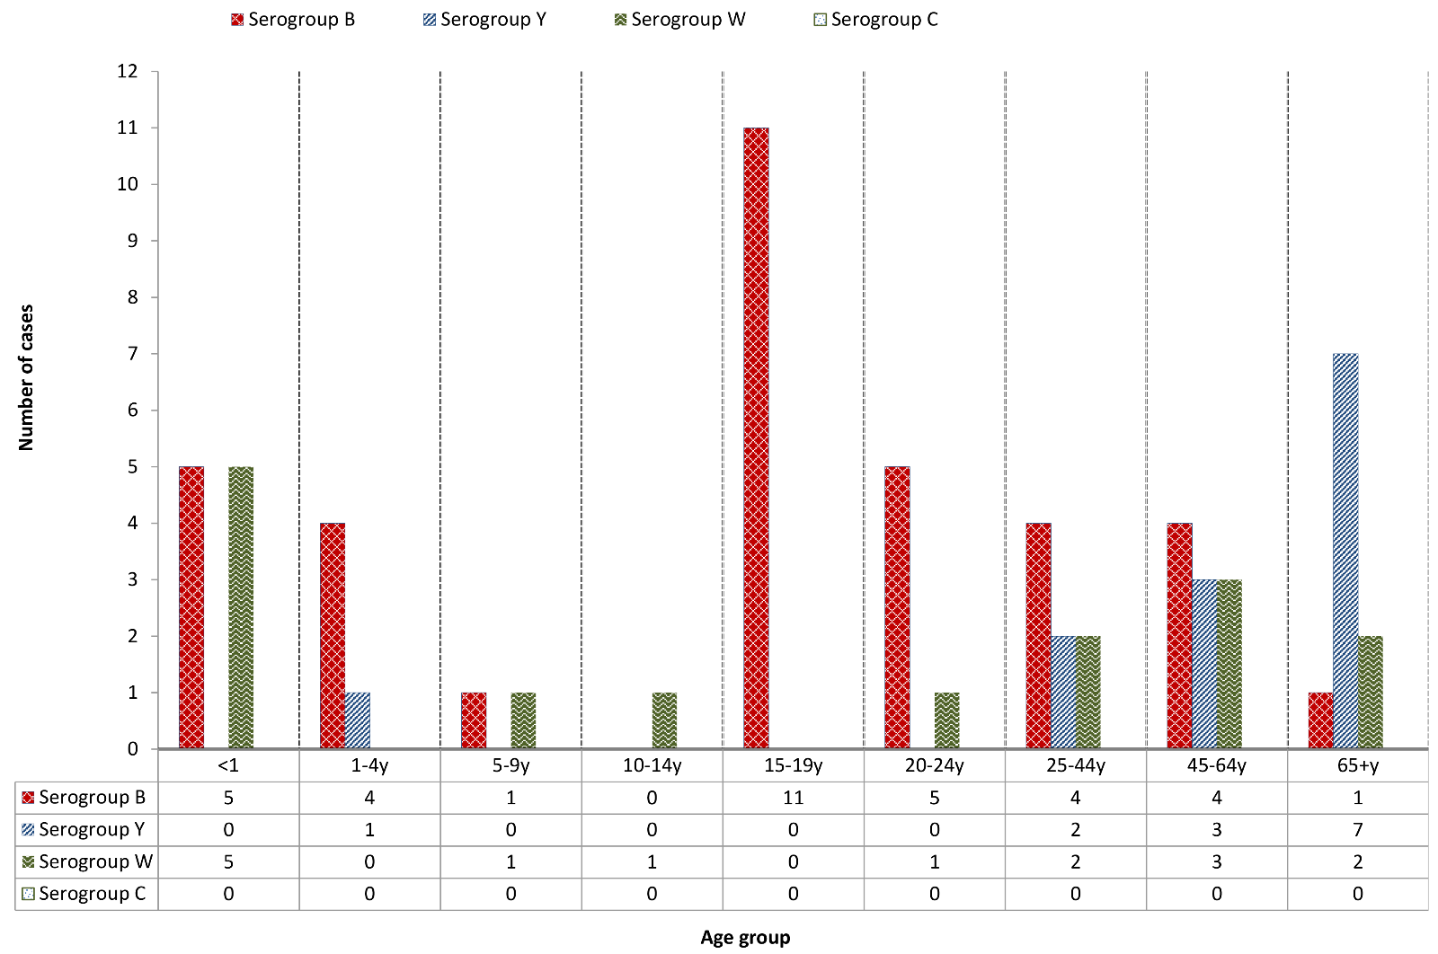

Figure 4: The number of porA types represented in serogroup B, W and Y invasive meningococcal disease notifications in Australia in 2021
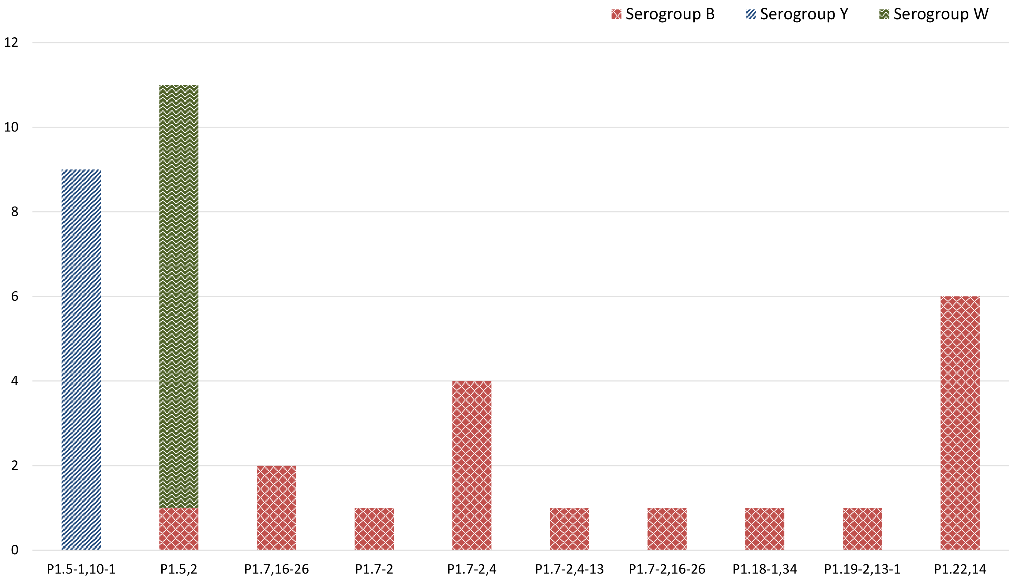
Table 5: Distribution of porA genotypes in laboratory-confirmed cases of invasive meningococcal disease, Australia, 2021, by state or territory
2021 AMSP |  | Number per serogroup per state / territory
Serogroupª | PorA genotype | ACT | NSW | NT | Qld | SA | Tas | Vic | WA | Total
Y | P1.5-1,10-1 | 0 | 0 | 0 | 5 | 0 | 0 | 2 | 2 | 9
B | P1.5,2 | 0 | 0 | 0 | 0 | 0 | 1 | 0 | 0 | 1
W | P1.5,2 | 0 | 1 | 0 | 3 | 4 | 0 | 0 | 2 | 10
B | P1.7,16-26 | 0 | 0 | 0 | 0 | 0 | 0 | 1 | 1 | 2
B | P1.7-2 | 0 | 0 | 0 | 0 | 0 | 0 | 1 | 0 | 1
B | P1.7-2,4 | 0 | 0 | 0 | 2 | 2 | 0 | 0 | 0 | 4
B | P1.7-2,4-13 | 0 | 0 | 0 | 0 | 0 | 0 | 1 | 0 | 1
B | P1.7-2,16-26 | 0 | 0 | 0 | 0 | 0 | 0 | 1 | 0 | 1
B | P1.18-1,34 | 0 | 0 | 0 | 0 | 0 | 0 | 0 | 1 | 1
NT | P1.18-4,25-15 | 0 | 0 | 0 | 0 | 0 | 0 | 0 | 1 | 1
B | P1.19-2,13-1 | 0 | 0 | 0 | 0 | 0 | 0 | 0 | 1 | 1
B | P1.22,14 | 0 | 0 | 0 | 2 | 0 | 1 | 3 | 0 | 6
Total |  | 0 | 1 | 0 | 12 | 6 | 2 | 9 | 8 | 38
a NT: non typeable.

Antimicrobial susceptibility testing
Isolates of N. meningitidis are tested against both treatment (ceftriaxone and penicillin) and clearance antibiotics (rifampicin and ciprofloxacin). In 2021, the national antimicrobial susceptibility testing (AST) data are reported according to the CLSI interpretative guidelines, changed from historical reporting (1997 to 2020). Sixty-nine percent of laboratory confirmed IMD (46/67) had N. meningitidis cultured, permitting antimicrobial susceptibility testing to be performed by the NNN laboratories. Ceftriaxone susceptibility testing was performed on all 46 isolates in 2021 and all were susceptible. With regards to penicillin, the distribution of penicillin MIC values is shown in Table 6. Twenty-eight percent of IMD isolates (13/46) were susceptible to penicillin (MIC ≤ 0.06 mg/L); 59% (27/46) had intermediate susceptibility to penicillin (MIC 0.125–0.25 mg/L); and 13% (6/46) were resistant to penicillin (MIC, ≥ 0.5 mg/L), as shown in Table 6. Of these isolates regarded as penicillin resistant, 5/6 were MenW IMD. In recent years, MenW has demonstrated higher penicillin MIC values and higher proportions of resistance. Regarding the clearance antibiotics for IMD, one isolate was resistant to ciprofloxacin (MIC 0.125 mg/L) and all isolates were susceptible to rifampicin.
Table 6: Penicillin MIC distribution of laboratory-confirmed invasive meningococcal disease isolates, Australia, 2021
Penicillin MIC distribution
MIC mg/L | ≤ 0.032 | 0.064 | 0.125 | 0.25 | 0.5 | 1 | 2 | ≥ 4 | Total
Number of isolates | 5 | 8 | 8 | 19 | 6 | 0 | 0 | 0 | 46
% | 11% | 17% | 17% | 41% | 13% | 0% | 0% | 0% | 100%

Discussion
In 2021, ninety-one percent of IMD notifications in Australia (67/74) were laboratory confirmed, ³ a lower proportion than in previous years. Notably in 2021, there was an overall decrease in notifications of IMD by 23% when compared with 2020, coincident with widespread public health initiatives designed to reduce COVID-19 transmission. ¹¹ These included physical distancing; hand hygiene and cough etiquette; use of masks; and restrictions to travel and to access to aged care facilities and hospitals. Of note, during January–March 2020, prior to the introduction of COVID-19-related restrictions, there were a total of 31 cases of IMD, whereas for the equivalent period in 2021 there were 18 cases. ¹¹ Notifications of influenza were also reduced from 313,465 cases in 2019 to 748 cases in 2021. ¹¹ This finding is of key relevance, as antecedent infection with influenza is a risk factor for IMD.
In Australia in 2016–2017, increased notifications of MenW and MenY IMD prompted time-limited, jurisdictional MenACWY vaccination programs for target age groups. ^{4,12} In July 2018, the National Immunisation Program (NIP) replaced MenC vaccine at 12 months of age with a quadrivalent ACWY vaccine. There followed a decrease in both notifications and proportion of MenW and MenY disease, accompanied by a gradual increase in the proportion of disease caused by MenB (from 44% to 62% in 2018–2020; but lower in 2021 to 52% of IMD). Prior to the introduction of the MenC vaccine in 2003 in Australia, the proportion of MenB IMD was 84–88% in the years 2006–2012, and then declining. Notifications of IMD subsequently increased with the emergence of MenW and MenY disease since 2014 in Australia.⁴
With regards to serogroup infections by age group, MenB accounted exclusively for IMD in 15–19 year olds and for 83% of IMD (5/6 cases) in 20–24 year olds. A recombinant multi-component meningococcal B vaccine has been available in Australia since 2014, ¹³ although this vaccine is not currently on the NIP. MenW caused 22% (15/67) of IMD in Australia, an increase from 18% in 2020, but remained lower than in 2019 (26%). Of these MenW IMD cases, 25% (5/20) occurred in those aged 45 years and older, but of growing concern is that MenW accounted for 50% (5/10) of IMD notifications in infants less than one year old. In the previous year, by contrast, MenW IMD was absent in children under five years of age, and thus continued surveillance of IMD in this age group is required. In 2021, MenY accounted for 19% of IMD nationally (13/67) and predominantly affected older age groups, accounting for 30% of notifications (3/10) in 45–64 year olds and for 70% of notifications (7/10) in those aged 65 years and older.
With regards to prevailing IMD serogroups and genotypes, the number and proportion of IMD cases caused by MenB in 2021 (35/67; 52%) was less than in 2020 (54/87; 62%); New South Wales reported the largest number of MenB notifications. Fine typing of MenB notifications exhibited nine different porA types from the 18 typed cases. The predominant MenB porA genotype in Australia was P1.22,14 (6/18), followed by genotype P1.7-2,4 (4/18), marking a change from recent years where the previous dominant MenB genotype, P1.7,16-26, accounted for only 1/18 of MenB IMD in 2021. The predominant circulating strain of MenW continues to be porA genotype P1.5,2 and MLST sequence type 11. This same MenW strain previously emerged in the United Kingdom (UK) and South America in 2009, ^{9,10} and spread to account for 25% of IMD in the UK in 2014–2015 and 59% of all cases in Chile in 2012. MenW ST11 is hypervirulent and associated with atypical clinical presentations, more severe disease, and a higher case fatality rate. ¹⁰ The initial increase in MenW overseas and in Australia was seen in older adults, but was subsequently reported in all age groups, particularly in adolescents and infants. ¹⁴ The predominant MenY genotype since 2014 continues to be P1.5-1,10-1, whereas previously MenY genotype distribution had been more heterogeneous. ¹⁵
Antimicrobial susceptibility testing of IMD isolates in 2021, as categorised by the CLSI interpretative criteria, detected 13% (6/67) penicillin resistance (MIC values, ≥ 0.5 mg/L) in clinical isolates. The incidence of penicillin resistance in N. meningitidis in Australia is greater than previous rates due to the change from historical reporting criteria. All IMD isolates tested in 2021 were susceptible to ceftriaxone and rifampicin, however there was one NSW isolate resistant to ciprofloxacin (MIC 0.125 mg/L). Ciprofloxacin resistance has been reported globally but remains an uncommon finding, except in China where the rapid clonal expansion of ciprofloxacin-resistant N. meningitidis led to its withdrawal as the primary clearance agent for IMD contacts. ¹⁶
There has been an ongoing decrease in IMD notifications from 1.5 cases per 100,000 in 2017; to 1.1 per 100,000 in 2018; 0.8 cases per 100,000 in 2019; 0.4 cases per 100,000 in 2020; and 0.3 cases per 100,000 in 2021. The year 2021 has also seen an increase in the proportion of isolates attributable to MenW and MenY. This was coincident both with widespread public health initiatives designed to reduce COVID-19 transmission and following changes in the NIP. The NNN is continuing to lead further investigations with the Australian Government Department of Health and Aged Care and is closely monitoring the phenotypic and genotypic features of N. meningitidis causing IMD in Australia. Additional investigations by the NNN, including whole genome sequencing of IMD isolates, are in progress to enhance IMD surveillance in Australia. The AMSP data are used for informing treatment guidelines and disease prevention strategies; and to monitor the effect of interventions.

Acknowledgements
Meningococcal isolates were received in the reference centres from many laboratories throughout Australia. The considerable time and effort involved in forwarding these isolates is recognised and these efforts are greatly appreciated. These data could not have been provided without this assistance and the help of clinical colleagues and public health personnel. The Australian Government Department of Health and Aged Care provided funding for the National Neisseria Network.
Members of the AMSP in 2021, to whom isolates and samples should be referred, and enquiries directed, are listed below.

Australian Capital Territory
P Collignon, S Bradbury, C. O’Brien
Microbiology Department, The Canberra Hospital, Gilmore Crescent, Garran ACT 2605.
Telephone: +61 2 6244 2510.
Email: peter.collignon@act.gov.au

New South Wales
MM Lahra, EA Limnios, TR Hogan, RL Kundu, J El Nasser, S Ray, M Shoushtari
Microbiology Department, New South Wales Health Pathology, The Prince of Wales Hospital, Barker Street, Randwick NSW 2031.
Telephone: +61 2 9382 9084.
Facsimile: +61 2 9382 9098.
Email: monica.lahra@health.nsw.gov.au
M Maley, R Porritt
Department of Microbiology and Infectious Diseases, New South Wales Health Pathology, Liverpool Hospital, Locked Mail Bag 7090, Liverpool BC NSW 1871.
Telephone: +61 8738 5124.
Facsimile: +61 2 8738 5129.
Email: Robert.Porritt@sswahs.nsw.gov.au

Northern Territory
R Baird, K Freeman
Microbiology Department, Territory Pathology, Royal Darwin Hospital, Rocklands Drive. Tiwi NT 0810.
Telephone: +61 8 8922 8167.
Facsimile: +61 8 8922 7788.
Email: rob.baird@nt.gov.au

Queensland
S Schlebusch, H Smith, V Hicks, A. Jennison
Public Health Microbiology, Queensland Health Forensic and Scientific Services, 39 Kessels Road, Coopers Plains Qld 4108.
Telephone: +61 7 3096 2825.
Facsimile: +61 7 3096 2973, +61 7 3274 9175.
Email: Amy.Jennison@health.qld.gov.au

South Australia
I Bastian, Lex Leong, Megan Hodgson, Casey Moore
SA Pathology, Royal Adelaide Hospital Site, Microbiology and Infectious Diseases, Royal Adelaide Hospital, North Terrace, Adelaide, SA 5000.
Telephone: +61 8 8222 3335.
Facsimile: +61 8 2223543.
Email: andrew.lawrence@health.sa.gov.au

Tasmania
L Cooley, B McEwan
Department of Microbiology and Infectious Diseases, Royal Hobart Hospital, 48 Liverpool Street, Hobart Tasmania 7000
Telephone: +61 3 6222 8656
Email: belinda.mcewan@dhhs.tas.gov.au

Victoria
B Howden, K Stevens, S. Tawil.
Microbiological Diagnostic Unit Public Health Laboratory, Department of Microbiology and Immunology, The Peter Doherty Institute, The University of Melbourne, Parkville Victoria 3052.
Telephone: +61 3 8344 5713.
Facsimile: +61 3 8344. 7833
Email: kerries@unimelb.edu.au

Western Australia
D Speers, J Bew
Department of Microbiology, QEII Medical Centre, PP Block Level 5, PathWest Laboratory Medicine WA, Hospital Avenue, Nedlands, WA 6009.
Telephone: +61 8 6383 4501.
Facsimile: +61 8 9382 8046.
Email: jane.bew@health.wa.gov.au

Author details
Monica M Lahra ^{1, 2}
CR Robert George ³
Tiffany R Hogan ¹
- World Health Organisation Collaborating Centre for STI and AMR, Sydney and Neisseria Reference Laboratory, Department of Microbiology, NSW Health Pathology, The Prince of Wales Hospital, Randwick, 2031, NSW Australia
- School of Medical Sciences, Faculty of Medicine, The University of New South Wales, NSW, 2052 Australia
- N S W Health Pathology, John Hunter Hospital, Newcastle, 2300, NSW Australia

Corresponding author
Professor Monica Lahra,
Director, Microbiology Department Neisseria Reference Laboratory and WHO Collaborating Centre for STI and AMR, NSW Health Pathology, Level 4, Campus Centre, The Prince of Wales Hospital, RANDWICK NSW, 2031
Email: monica.lahra@health.nsw.gov.au

References
- National Neisseria Network. Meningococcal Isolate Surveillance Australia 1994. Commun Dis Intell. 1995;19(12):286–9.
- Australian Government Department of Health. National Notifiable Disease Surveillance System. [Webpage.] Canberra: Australian Government Department of Health; 2021. [Accessed on 4 May 2022.] Available from: http://www9.health.gov.au/cda/source/cda-index.cfm.
- National Notifiable Diseases Surveillance System (NNDSS). Number of notifications of Meningococcal disease (invasive), received from State and Territory health authorities in the period of 1991 to 2012 and year-to-date notifications for 2014–2021. Available from: http://www9.health.gov.au/cda/source/rpt_4_sel.cfm.
- Australian Government Department of Health. Invasive meningococcal disease. [Internet.] Canberra: Australian Government Department of Health; 20 March 2020. Available from: https://www.health.gov.au/internet/main/publishing.nsf/Content/ohp-meningococcal-W.htm.
- Communicable Diseases Network Australia (CDNA). Invasive meningococcal disease: CDNA national guidelines for public health units. Canberra: Australian Government Department of Health, CDNA; March 2017. [Accessed in April 2022.] Available from: https://www1.health.gov.au/internet/main/publishing.nsf/Content/0A31EEC4953B7E6FCA257DA3000D19DD/$File/IMD-SoNG.pdf.
- George CRR, Smith HV, Lahra MM. Neisseria meningitidis. In de Filippis I, ed. Molecular Typing in Bacterial Infections, Volume I. London: Springer International Publishing, Springer Cham, 2022;85–99.
- Clinical and Laboratory Standards Institute (CLSI). Performance standards for antimicrobial susceptibility testing. 31st ed. CLSI supplement M100. Wayne, PA: CLSI; 2021.
- Tapsall JW, Shultz T, Limnios E, Munro R, Mercer J, Porritt R et al. Surveillance of antibiotic resistance in invasive isolates of Neisseria meningitidis in Australia 1994–1999. Pathology. 2001;33(3):359–61. doi: https://doi.org/10.1080/pat.33.3.359.361.
- Abad R, López EL, Debbag R, Vázquez JA. Serogroup W meningococcal disease: global spread and current affect on the Southern Cone in Latin America. Epidemiol Infect. 2014;142(12):2461–70. doi: https://doi.org/10.1017/S0950268814001149.
- Ladhani SN, Beebeejaun K, Lucidarme J, Campbell H, Gray S, Kaczmarski E et al. Increase in endemic Neisseria meningitidis capsular group W sequence type 11 complex associated with severe invasive disease in England and Wales. Clin Infect Dis. 2015;60(4):578–85. doi: https://doi.org/10.1093/cid/ciu881.
- George CR, Booy R, Nissen MD, Lahra MM. The decline of invasive meningococcal disease and influenza in the time of COVID-19: the silver linings of the pandemic playbook. Med J Aust. 2022. doi: https://doi.org/10.5694/mja2.51463.
- Chiu C, Dey A, Wang H, Menzies R, Deeks S, Mahajan D et al. Vaccine preventable diseases in Australia, 2005 to 2007. Commun Dis Intell Q Rep. 2010;34(Suppl):S1–167.
- Australian Government Department of Health. Immunise Australia Program. Meningococcal Disease. [Internet.] Canberra: Australian Government Department of Health; 20 April 2015. Available from: https://www.health.gov.au/internet/immunise/publishing.nsf/Content/immunise-meningococcal.
- Araya P, Fernández J, Del Canto F, Seoane M, Ibarz-Pavón AB, Barra G et al. Neisseria meningitidis ST-11 clonal complex, Chile 2012. Emerg Infect Dis. 2015;21(2):339–41. doi: https://doi.org/10.3201/eid2102.140746.
- Bröker M, Jacobsson S, Kuusi M, Pace D, Simões MJ, Skoczynska A et al. Meningococcal serogroup Y emergence in Europe: update 2011. Hum Vaccin Immunother. 2012;8(12):1907–11. doi: https://doi.org/10.4161/hv.21794.
- Willerton L, Lucidarme J, Walker A, Lekshmi A, Clark SA, Walsh L et al. Antibiotic resistance among invasive Neisseria meningitidis isolates in England, Wales and Northern Ireland (2010/11 to 2018/19). PLoS One. 2021;16(11):e0260677. doi: https://doi/org/10.1371/journal.pone.0260677.

Communicable Diseases Intelligence
ISSN: 2209-6051 Online

Communicable Diseases Intelligence (CDI) is a peer-reviewed scientific journal published by the Office of Health Protection and Response, Department of Health and Aged Care. The journal aims to disseminate information on the epidemiology, surveillance, prevention and control of communicable diseases of relevance to Australia.

Editor: Noel Lally
Deputy Editor: Simon Petrie
Design and Production: Kasra Yousefi
Editorial Advisory Board: David Durrheim, Mark Ferson, John Kaldor, Martyn Kirk and Linda Selvey

Website: http://www.health.gov.au/cdi

Contacts
CDI is produced by the Office of Health Protection and Response, Australian Government Department of Health and Aged Care, GPO Box 9848, (MDP 6) CANBERRA ACT 2601

Email: cdi.editor@health.gov.au

Submit an Article
You are invited to submit your next communicable disease related article to the Communicable Diseases Intelligence (CDI) for consideration. More information regarding CDI can be found at: http://health.gov.au/cdi.
Further enquiries should be directed to: cdi.editor@health.gov.au.

This journal is indexed by Index Medicus and Medline.

Creative Commons Licence - Attribution-NonCommercial-NoDerivatives CC BY-NC-ND
© 2022 Commonwealth of Australia as represented by the Department of Health and Aged Care
This publication is licensed under a Creative Commons Attribution-NonCommercial-NoDerivatives 4.0 International Licence from https://creativecommons.org/licenses/by-nc-nd/4.0/legalcode (Licence). You must read and understand the Licence before using any material from this publication.

Restrictions
The Licence does not cover, and there is no permission given for, use of any of the following material found in this publication (if any):
- the Commonwealth Coat of Arms (by way of information, the terms under which the Coat of Arms may be used can be found at www.itsanhonour.gov.au);
- any logos (including the Department of Health and Aged Care’s logo) and trademarks;
- any photographs and images;
- any signatures; and
- any material belonging to third parties.

Disclaimer
Opinions expressed in Communicable Diseases Intelligence are those of the authors and not necessarily those of the Australian Government Department of Health and Aged Care or the Communicable Diseases Network Australia. Data may be subject to revision.

Enquiries
Enquiries regarding any other use of this publication should be addressed to the Communication Branch, Department of Health and Aged Care, GPO Box 9848, Canberra ACT 2601, or via e-mail to: copyright@health.gov.au

Communicable Diseases Network Australia
Communicable Diseases Intelligence contributes to the work of the Communicable Diseases Network Australia.
http://www.health.gov.au/cdna

