Changes in norovirus incidence in Victoria, Australia, during the COVID-19 pandemic, 2020–2021
Leesa D Bruggink

Abstract
There were 142 norovirus positive outbreaks in Victoria for the 2020–2021 calendar years; however, almost half of these (48.6%) occurred in Q1 (January–March) of 2021. For the two-year period, 69.0% of all norovirus positive outbreaks were in childcare settings, and the predominant genotype was GII.P16/GII.2 (64.9%) followed by GII.P31/GII.4_2012 (20.9%). Norovirus incidence was particularly low in 2020 (n = 26) and close to average in 2021 (n = 116), but genotype diversity was low in both years. With the thought that 2022 will approach a more normal aspect to socialising and travel, norovirus incidence in 2022 may be predicted to increase above typical levels.
Keywords: norovirus, viral gastroenteritis, childcare, outbreak, genotypes, COVID-19 restrictions
Noroviruses are non-enveloped single-stranded RNA viruses that can cause gastroenteritis in individuals of all ages; they are primarily transmitted person-to-person with a faecal-oral pathway.¹ They are recognised as a major cause of morbidity and mortality globally; it has been estimated that norovirus infections annually cause 212,000 deaths around the world.¹ Viral particles are particularly resilient, able to withstand freezing and temperatures up to 60 °C, as well as disinfection with alcohol.¹ There are ten norovirus genogroups that have been described, with genogroups one (GI), two (GII) and four (GIV) most often associated with human disease.¹ However, GII noroviruses are by far the most common, accounting for roughly 93% of infections.¹
Gastroenteritis outbreaks reported to the Victorian Department of Health have faecal specimens sent to the Victorian Infectious Diseases Reference Laboratory (VIDRL) for norovirus testing. A gastroenteritis outbreak in a care facility is defined as two or more residents/staff having onset of symptoms (that cannot be explained by medication or other medical conditions) within 72 hours of each other in a setting that makes epidemiological sense.² Norovirus is detected using a commercial quantitative real-time reverse transcription polymerase chain reaction (RT-qPCR) assay (RIDAGENE Norovirus I & II, R-Biopharm, PG1415) previously evaluated at VIDRL³. One specimen from each norovirus positive outbreak undergoes genotyping for epidemiological purposes. The specimen chosen for genotyping from a given outbreak is that with the lowest cycle threshold and therefore potentially the highest viral load and test sensitivity. Genotyping is performed in both the polymerase and capsid regions of the viral genome to identify recombinant viruses.
All specimens included in this study were referred from outbreaks occurring in Victoria, Australia. Data are collected as part of routine clinical microbiology testing and for public health surveillance purposes, and are not identifiable to individual patients.
During 2020–2021, VIDRL received and tested 705 faecal specimens from 279 gastroenteritis outbreaks, with norovirus detected in 142 outbreaks (50.9%). Norovirus genogroup II (GII) was detected in 141 outbreaks; one outbreak had norovirus genogroup I (GI) detected. For this two-year period, almost half of the norovirus positive outbreaks (48.6%; n = 69) occurred during the first quarter (Q1, January–March) of 2021, with a sharp rise in positive outbreaks in February 2021 mainly associated with childcare settings.
Melbourne, the capital of Victoria, Australia, in late 2021 became regarded as the most locked-down city in the world due to coronavirus disease 2019 (COVID-19) restrictions. There were six lockdowns during 2020 and 2021, with four lasting 14 days or more.⁴ The longest was 111 days from 8 July 2020 to 27 October 2020. Some of the restrictions that occurred during these lockdowns included: all non-essential retail, gyms and beauty closed; work from home; online schooling; childcare only for essential workers; restrictions on healthcare visitors (including aged care); restaurants/cafes takeaway only; limits on home visitors; travel restrictions between metropolitan and regional Victoria; mask wearing; curfew; and a 5 km travel limit from home. Public messaging was also prominent throughout 2020–2021, with an emphasis on social distancing (1.5 m) and hand hygiene. The monthly distribution of norovirus positive outbreaks shown, along with the lockdown periods, is displayed in Figure 1.
Figure 1: Monthly norovirus positive outbreaks in Victoria, Australia, for the 2020 and 2021 calendar years, also showing periods of lockdown of 14 days or more
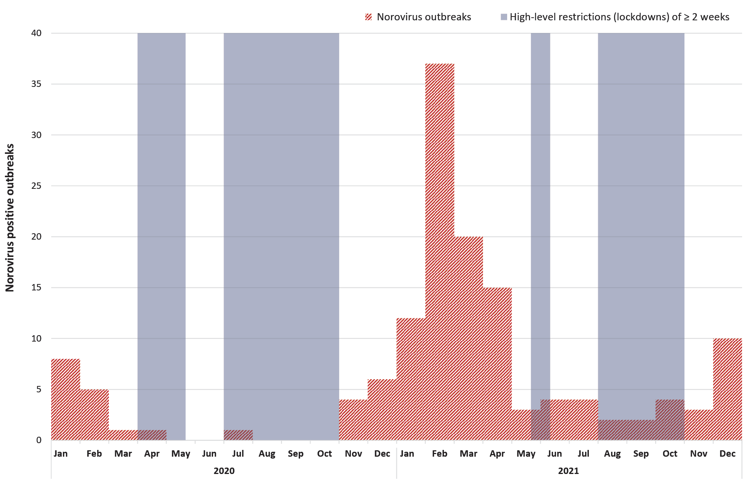
The predominant setting for norovirus positive outbreaks during 2020–2021 was childcare centres (69.0%, n = 98). Norovirus outbreaks at healthcare settings (including aged care) and community settings (other than childcare) were fairly limited in 2020–2021. Community setting outbreaks (such as restaurants, gatherings and schools) occurred in small numbers each month during February–June 2021, which was mostly free of COVID-19 lockdowns and probably reflected public confidence and ability to socialise. Across the remainder of 2020–2021, numbers of community-based norovirus outbreaks were almost non-existent, with only one in October 2021, and none in 2020. Prior to the COVID-19 pandemic, the majority of norovirus outbreaks detected at VIDRL were from aged care settings (67.3%; 2017–2019), but norovirus outbreaks in the aged care setting remained consistently low throughout 2020–2021 and only accounted for 23.2% of outbreaks (n = 33). This is probably due to COVID-19 measures including increased diligence around hand hygiene (which conversely young children in childcare settings are not adept at) as well as visitor restrictions and staff wearing personal protective equipment. This shift in the population demographic for norovirus outbreaks during the COVID-19 pandemic resulted in a significant change (p < 0.05) in the age distribution of samples received, with a 2020–2021 average patient age of 48.5 years (range 0–103 years) compared to the 2017–2019 average patient age of 70.8 years (range 0–107 years).
Of the 142 outbreaks with norovirus detected by RT-qPCR in at least one specimen during 2020–2021, a total of 134 were successfully typed. Monthly genotyping results are displayed in Figure 2. The dominant genotype for the two-year period was GII.P16/GII.2 (64.9%; n = 87), followed by GII.P31/GII.4 (20.9%; n = 28). However, there were shifts within this period: 2020 started with the predominant genotype of GII.P16/GII.4 (75.0%; January–March 2020), which was also predominant throughout 2019 (54.1%). Then, after the first COVID-19 lockdown began on 30 March 2020, norovirus incidence became almost non-existent until late 2020. When norovirus re-emerged in November, after the second major lockdown ended on 27 October 2020, the genotype had shifted to GII.P16/GII.2 (91.2%; November 2020 – April 2021), which dominated through a large spike in cases in early 2021 primarily linked to childcare centres. After further lockdowns and uncertainty through mid-2021, the dominant norovirus genotype shifted again to GII.P31/GII.4 (82.4%; October–December 2021).
Figure 2: Monthly norovirus genotyping results for Victoria, Australia, 2020–2021^{a,b}
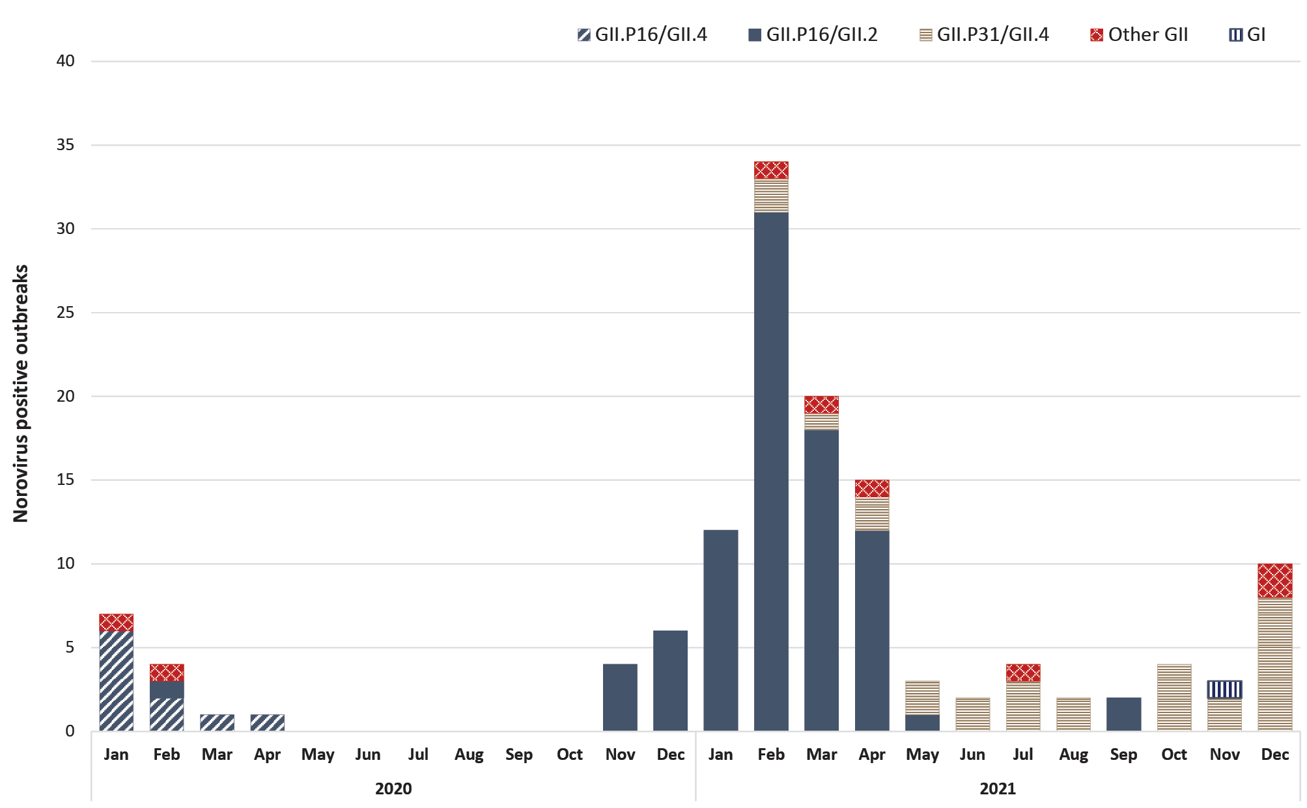
a The first half of the genotype designates the typing of the polymerase region and the second half the capsid region (i.e. polymerase/capsid).
b The ‘Other GII’ combined category represents four separate uncommon genotypes.
The 2020–2021 dominant genotype, GII.P16/GII.2, was detected sporadically in Victoria in previous years, but was epidemic internationally during 2016–2017.^{5–7} The second main genotype seen in Victoria during 2020–2021, GII.P31/GII.4, is the 2012 pandemic norovirus strain. It has taken over as the predominant strain in the second half of 2021. Additionally, a single GI norovirus outbreak was detected in November 2021. Prior to the COVID-19 pandemic, GI noroviruses were detected in approximately 10–15% of all norovirus positive outbreaks in a given year (2017–2019), and have been detected almost every year since molecular testing began in Victoria (2001), with 2020 the only exception.
The 2020 calendar year had a significantly lower number of specimens tested (n = 236), outbreaks tested (n = 78) and norovirus positive outbreaks (n = 26) than the previous three-year annual averages for these values (n = 657; n = 202; and n = 137 respectively), while the 2021 calendar year approached these averages (n = 469; n = 201; n = 116). Figure 3 provides a comparison of norovirus outbreaks by month across 2017–2021. The ultra-low outbreak numbers in 2020 were most likely due to strict COVID-19 restrictions in place for most of that year, with Melbourne experiencing 154 days of lockdown in 2020 alone, across two lockdowns of 43 and 111 days,⁴ and with moderate levels of restrictions continuing outside of the strict lockdowns. Such restrictions also occurred in 2021 (113 days total in lockdown), but on a more intermittent basis over four lockdowns, with individual lockdowns lasting 5, 12, 14 and 82 days.⁴
Figure 3: Comparison of monthly norovirus positive outbreaks for 2017–2021
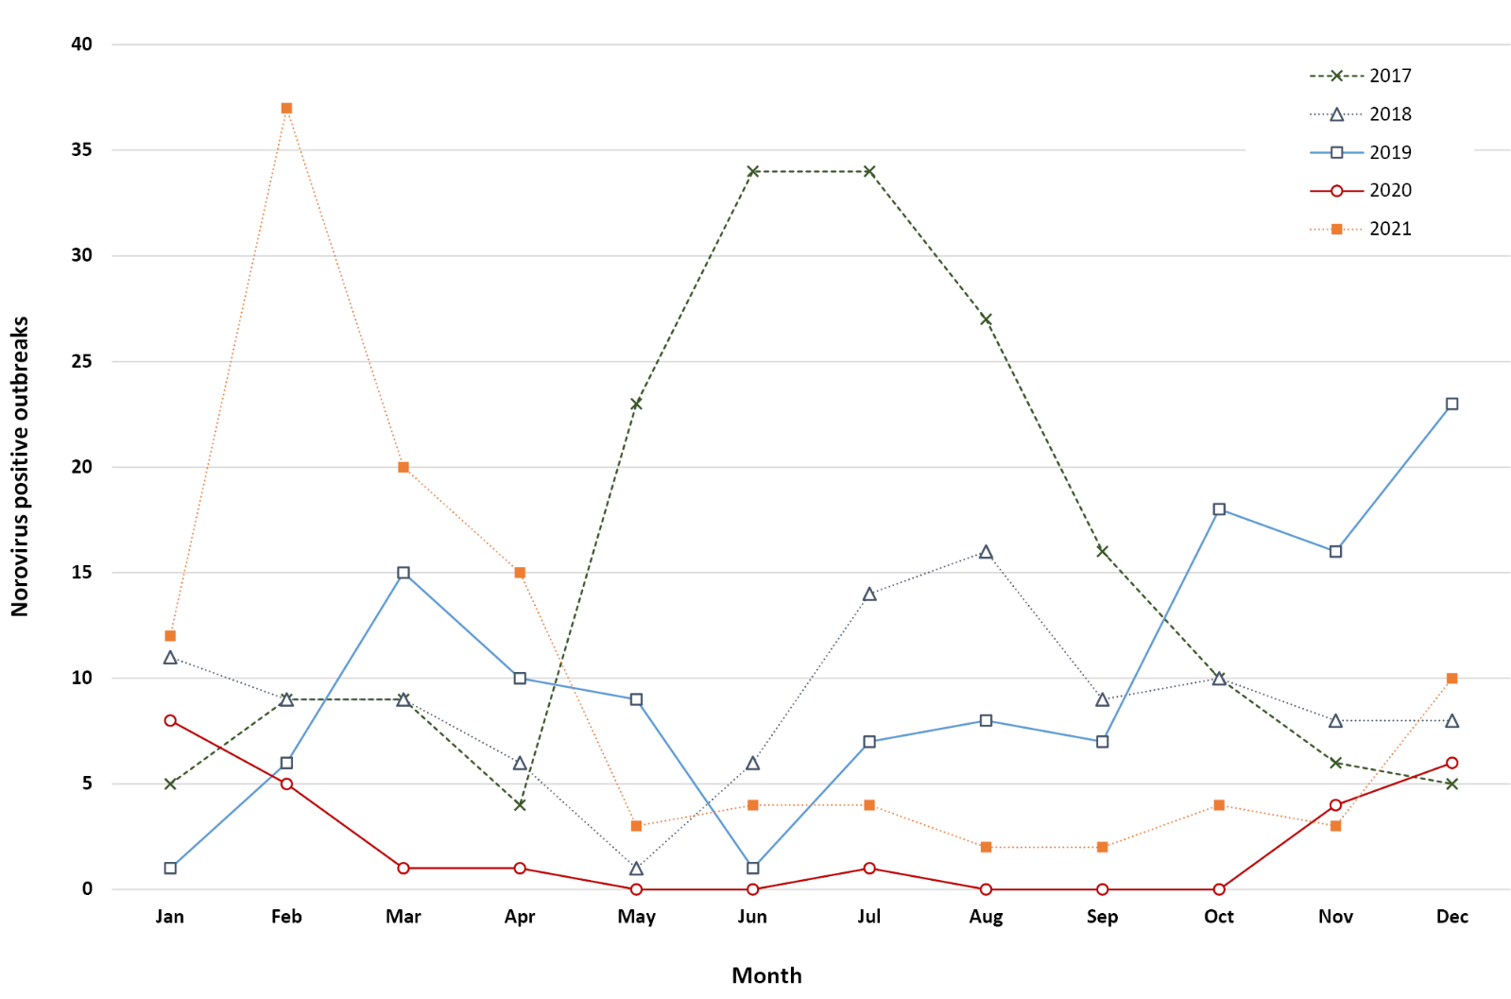
Furthermore, norovirus genotype diversity has decreased significantly in 2020 and 2021 compared to previous years. The 2017–2019 yearly average number of different polymerase/capsid genotype combinations was 14. However, in 2020 there were only four different genotype combinations, and six in 2021. Interstate and international travel resuming will potentially restore the norovirus diversity circulating in the community.
This study is limited in the sense that there is no way to know if reporting or sample referral was reduced due to a shift in focus to COVID-19 during this period. It is noted, however, that there were still gastroenteritis outbreak notifications to the Victorian Department of Health in every month of this two-year period, as well as samples referred for testing. Even in the five calendar months of 2020 where norovirus was not detected in any outbreaks, samples were still tested from between two and eight outbreaks. This implies that the reporting process and sample referral system was still operational. It is also worth noting that, while lockdowns (i.e. severely restricted socialising) are the main discussion point here, other measures taken to reduce the spread of COVID-19 would have had an impact on the transmission of norovirus. These include general social distancing, improved hand hygiene (but not the use of alcohol hand sanitiser) and quarantine for travellers.
With the thought that 2022 may approach a more normal aspect to socialising and travel, with both interstate and international borders re-opening, norovirus incidence in 2022 may be predicted to increase. Such an increase has been forecast in England,⁸ for which modelling has projected that, if adult social contact returns completely to pre-pandemic levels, then the annual norovirus incidence may be double that of a typical year. This is due to recent low levels of norovirus incidence resulting in a largely susceptible population. The significance of this has already been seen, to an extent, in the large increase of norovirus in childcare at the start of 2021 when restrictions were eased. Further restrictions throughout mid-late 2021 transitioned to widespread opening-up at the end of the year, combined with a shift in norovirus genotype distribution that will potentially be amplified by importations from travel. The implication is that we may have a larger than average norovirus season in 2022.

Author details
Dr Leesa D Bruggink, Senior Medical Scientist¹
- Enteric Virus Laboratory, Victorian Infectious Diseases Reference Laboratory (VIDRL), Royal Melbourne Hospital, at the Peter Doherty Institute for Infection and Immunity

Corresponding author
Leesa D Bruggink
Victorian Infectious Diseases Reference Laboratory, Royal Melbourne Hospital, at the Peter Doherty Institute for Infection and Immunity, 792 Elizabeth St, Melbourne, Victoria, Australia
Email: leesa.bruggink@vidrl.org.au
Phone: +61 03 93429607

References
- Lucero Y, Matson DO, Ashkenazi S, George S, O’Ryan M. Norovirus: facts and reflections from past, present, and future. Viruses. 2021;13(12):2399. doi: https://doi.org/10.3390/v13122399.
- Victoria State Government Department of Health. Guidelines for the investigation of gastroenteritis for Environmental Health Officers. [Internet.] Melbourne: Victoria State Government Department of Health; 4 December 2020. [Accessed on 28 June 2022.] Available from: https://www.health.vic.gov.au/publications/guidelines-for-the-investigation-of-gastroenteritis-for-environmental-health-officers.
- Dunbar NL, Bruggink LB, Marshall JA. Evaluation of the RIDAGENE real-time PCR assay for the detection of GI and GII norovirus. Diagn Microbiol Infect Dis. 2014;79(3):317–21. doi: https://doi.org/10.1016/j.diagmicrobio.2014.03.017.
- Judd Boaz. Melbourne passes Buenos Aires’ world record for time spent in COVID-19 lockdown. [Internet.] Sydney: Australian Broadcasting Corporation, ABC News; 3 Octobet 2021. [Accessed on 12 January 2022.] Available from: https://www.abc.net.au/news/2021-10-03/melbourne-longest-lockdown/100510710.
- Bidalot M, Théry L, Kaplon J, De Rougemont A, Ambert-Balay K. Emergence of new recombinant noroviruses GII.p16-GII.4 and GII.p16-GII.2, France, winter 2016 to 2017. Euro Surveill. 2017;22(15):30508. doi: https://doi.org/10.2807/1560-7917.es.2017.22.15.30508.
- Kwok K, Niendorf S, Lee N, Hung T-N, Chan L-Y, Jacobson S et al. Increased detection of emergent recombinant norovirus GII.P16–GII.2 strains in young adults, Hong Kong, China, 2016–2017. Emerg Infect Dis. 2017;23(11):1852–5. doi: https://doi.org/10.3201/eid2311.170561.
- Barclay L, Cannon JL, Wikswo ME, Phillips AR, Browne H, Montmayeur AM et al. Emerging novel GII.P16 noroviruses associated with multiple capsid genotypes. Viruses. 2019;11(6):535. doi: https://doi.org/10.3390/v11060535.
- O’Reilly KM, Sandman F, Allen D, Jarvis CI, Gimma A, Douglas A et al. Predicted norovirus resurgence in 2021–2022 due to the relaxation of nonpharmaceutical interventions associated with COVID-19 restrictions in England: a mathematical modeling study. BMC Med. 2021;19(1):299. doi: https://doi.org/10.1186/s12916-021-02153-8.

Communicable Diseases Intelligence
ISSN: 2209-6051 Online

Communicable Diseases Intelligence (CDI) is a peer-reviewed scientific journal published by the Office of Health Protection and Response, Department of Health and Aged Care. The journal aims to disseminate information on the epidemiology, surveillance, prevention and control of communicable diseases of relevance to Australia.

Editor: Noel Lally
Deputy Editor: Simon Petrie
Design and Production: Kasra Yousefi
Editorial Advisory Board: David Durrheim, Mark Ferson, John Kaldor, Martyn Kirk and Linda Selvey

Website: http://www.health.gov.au/cdi

Contacts
CDI is produced by the Office of Health Protection and Response, Australian Government Department of Health and Aged Care, GPO Box 9848, (MDP 6) CANBERRA ACT 2601

Email: cdi.editor@health.gov.au

Submit an Article
You are invited to submit your next communicable disease related article to the Communicable Diseases Intelligence (CDI) for consideration. More information regarding CDI can be found at: http://health.gov.au/cdi.
Further enquiries should be directed to: cdi.editor@health.gov.au.

This journal is indexed by Index Medicus and Medline.

Creative Commons Licence - Attribution-NonCommercial-NoDerivatives CC BY-NC-ND
© 2022 Commonwealth of Australia as represented by the Department of Health and Aged Care
This publication is licensed under a Creative Commons Attribution-NonCommercial-NoDerivatives 4.0 International Licence from https://creativecommons.org/licenses/by-nc-nd/4.0/legalcode (Licence). You must read and understand the Licence before using any material from this publication.

Restrictions
The Licence does not cover, and there is no permission given for, use of any of the following material found in this publication (if any):
- the Commonwealth Coat of Arms (by way of information, the terms under which the Coat of Arms may be used can be found at www.itsanhonour.gov.au);
- any logos (including the Department of Health and Aged Care’s logo) and trademarks;
- any photographs and images;
- any signatures; and
- any material belonging to third parties.

Disclaimer
Opinions expressed in Communicable Diseases Intelligence are those of the authors and not necessarily those of the Australian Government Department of Health and Aged Care or the Communicable Diseases Network Australia. Data may be subject to revision.

Enquiries
Enquiries regarding any other use of this publication should be addressed to the Communication Branch, Department of Health and Aged Care, GPO Box 9848, Canberra ACT 2601, or via e-mail to: copyright@health.gov.au

Communicable Diseases Network Australia
Communicable Diseases Intelligence contributes to the work of the Communicable Diseases Network Australia.
http://www.health.gov.au/cdna

