(Figure 4 of this article is in error due to truncation of one data series. Please refer to this report’s Erratum (https://doi.org/10.33321/cdi.2022.46.50) to view the corrected Figure 4.)

Utilisation of antimicrobials used to treat bacterial pneumonia in principal referral hospitals during the COVID-19 pandemic, Australia, 2020
Erin Connor, Kavita Rasiah, Nadine Hillock

Abstract

Background
Concerns have been raised internationally, regarding possible increased antimicrobial use during the COVID-19 pandemic and the potential impact on antimicrobial resistance. This analysis aimed to investigate hospital usage rates of broad-spectrum antibacterial agents used to treat community-acquired pneumonia (CAP) and/or hospital-acquired pneumonia (HAP) in Australian principal referral hospitals during 2020. Secondly, usage rates in Victoria were compared with equivalent national rates.

Methods
Monthly antimicrobial dispensing data for all 31 Australian principal referral hospitals were analysed for the period January 2019 to December 2020. Grams of antimicrobial agents used were converted into the World Health Organization (WHO) assigned metric ‘Defined Daily Dose’ (DDD). Using the hospital activity metric Occupied Bed Days (OBD), a standardised usage density rate was calculated (in units of DDD / 1,000 OBD).

Results
The typical expected seasonal trend in aggregate usage rates, for antibacterials used in the treatment of CAP, was not evident in 2020. Overall usage of doxycycline, azithromycin, amoxicillin and cefuroxime decreased in principal referral hospitals compared to 2019. Aggregated monthly usage rates for broad-spectrum agents used to treat HAP increased nationally, on average, by 5.0% in 2020 compared to 2019. Victoria’s second COVID-19 wave (July–October 2020) coincided with higher usage rates of antibacterials used for CAP.

Conclusion
Public health interventions introduced to limit the spread of SARS-CoV-2 infections may have had unintended benefits on other respiratory infection rates. The drop in hospital usage of antibacterials typically used to treat CAP suggests that the number of cases of pneumonia acquired in the community requiring hospitalisation was markedly reduced in 2020.
Keywords: AMS, surveillance, pneumonia, COVID-19, antimicrobial stewardship, antimicrobial resistance

Introduction
A number of recently-published studies have reported a high proportion of severe acute respiratory syndrome coronavirus 2 (SARS-CoV-2)-positive patients being administered antibacterials despite low reported rates of bacterial co-infection.^{1–3} These reports have increased global concern that the coronavirus disease 2019 (COVID-19) pandemic may adversely affect ongoing efforts to reduce global antimicrobial consumption.⁴ Antibacterial use may be initiated as part of empiric therapy for bacterial infections while awaiting viral swab results, due to symptomatic similarities in patients presenting with COVID-19-compatible illnesses. Bacterial identification is also challenging both from the perspective of obtaining sputum and identifying a bacterial pathogen. Patients diagnosed with COVID-19 may be at increased risk of concomitant bacterial infections requiring antibacterial therapy, particularly associated with critical care and mechanical ventilation.⁵ Bacterial co-infection with multi-drug resistant pathogens has been reported in COVID-19 patients in India and other countries where the incidence of COVID-19 is high.⁶
Despite international concerns regarding increased antimicrobial use during the COVID-19 pandemic, the recently-published AURA 2021: Fourth Australian report on antimicrobial use and resistance in human health reported a dramatic reduction in community Pharmaceutical Benefit Scheme (PBS) dispensing of antibiotics for upper respiratory tract infections in 2020.⁵ There was a reduction in the number of prescriptions for doxycycline, amoxicillin, amoxicillin-clavulanate, cefalexin and roxithromycin of 21–35% across all states and territories. Although the volume of prescriptions in the community fell during 2020, a high proportion of patients continued to be prescribed antimicrobials for which there is no evidence of benefit, for example acute bronchitis (81.5%) and acute sinusitis (80.1%).⁵
The objective of this paper is to investigate the impact of the COVID-19 pandemic on the usage rates of broad-spectrum antibacterial agents commonly used to treat community and/or hospital-acquired pneumonia in Australian principal referral hospitals. Larger tertiary hospitals that are classified as principal referral hospitals by the Australian Institute of Health and Welfare (AIHW) ⁷ have been the main custodians of care for patients diagnosed with COVID-19 in Australia. A secondary aim was to compare usage rates in the state of Victoria with usage in other Australian principal referral hospitals. Victoria experienced a protracted second wave of COVID-19 cases in the latter half of 2020 while cases elsewhere in Australia were minimal.

Method
Monthly antibacterial dispensing and distribution data for all 31 Australian principal referral hospitals were collected and analysed for the period January 2019 to December 2020. Antibacterial usage was aggregated into the total number of grams used each month for each individual antibacterial, and converted from total grams into the Defined Daily Dose (DDD) metric assigned by the World Health Organization (WHO). ⁸ The DDD values are assigned by the WHO based on “the assumed average maintenance dose per day for the main indication in adults”. ⁸ The usage was converted to a standardised usage density rate using occupied bed days (OBDs) as the denominator, and reported as DDDs per 1,000 OBDs. Usage rates for antibacterials commonly included in prescribing guidelines used to treat bacterial pneumonia were compared for principal referral hospitals between 2020 and the corresponding months in 2019.
Data included in this study, routinely collected as part of the National Antimicrobial Usage Surveillance Program (NAUSP), are non-identifiable, aggregated hospital data representing negligible risk. The authors deemed this study exempt from ethical review in accordance with the National Statement. ⁹

Results
Utilisation rates for antibacterials used to treat community-acquired pneumonia (CAP) typically follow a seasonal trend, with higher usage in the winter months. In 2020, the usual seasonal peak in winter was not apparent. Figure 1 illustrates the usual seasonal trend as observed in principal referral hospitals nationally in 2019 and shows the deviation from the usual trend in 2020, with usage reducing from May 2020. Doxycycline usage rates in 2019 were 77.3, 79.9 and 79.5 DDD / 1,000 OBD in June, July and August respectively. In 2020, rates in these months fell to 55.0 DDD / 1,000 OBD in June 2020 (-28.8%), 56.3 DDD / 1,000 OBD in July 2020 (-29.5%) and 57.3 DDD / 1,000 OBD in August (-28.0%). In the non-critical-care setting, usage of oral amoxicillin and of oral azithromycin for the July to December period fell, on average, by 21.1% and 23.7% respectively between 2019 and 2020. Total acute inpatient use of cefuroxime in principal referral hospitals was 6.4 DDD / 1,000 OBD in June 2020, a decrease of 34.1% from June 2019. Usage rates for cefuroxime for the period July-December were on average 25.9% lower in 2020 compared to the same period in 2019. Combined oral and parenteral moxifloxacin usage in principal referral hospitals averaged 4.3 DDD / 1,000 OBD during July–December 2020, a decrease of 15.6% on the same six months in 2019.
Figure 1: National principal referral total-hospital usage rates for antibacterials used to treat community-acquired pneumonia (oral and parenteral), January 2019 – December 2020
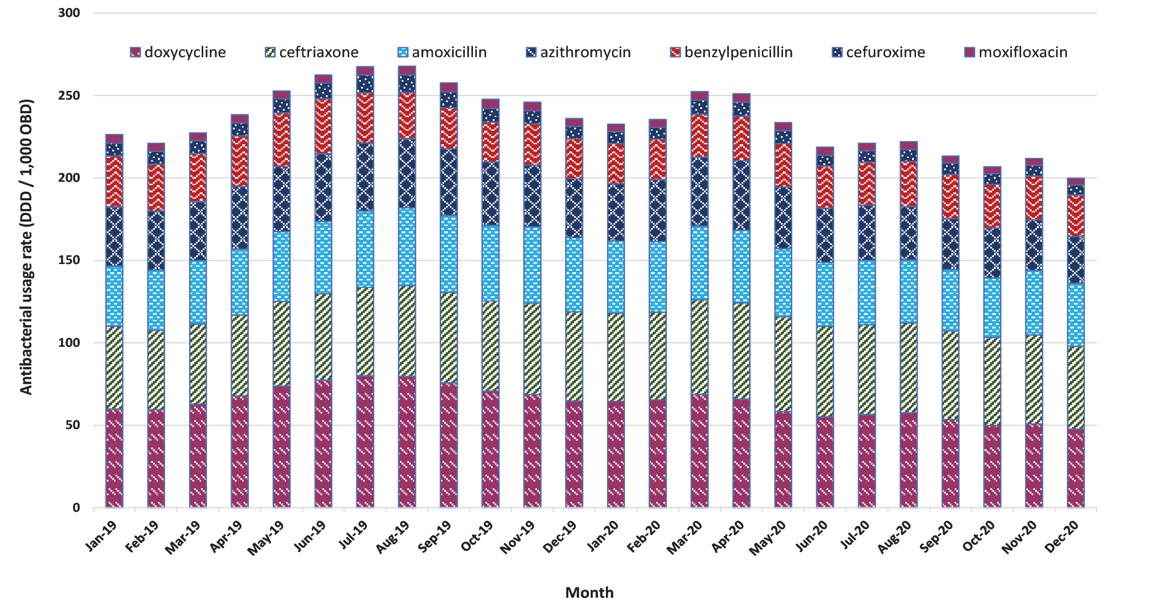
For broad-spectrum antibacterials used to treat hospital-acquired pneumonia (HAP), there was an overall increase in monthly total acute hospital usage rates (Figure 3a). When aggregating the total-hospital monthly usage of parenteral ceftriaxone, piperacillin-tazobactam, amoxicillin-clavulanate, cefepime, gentamicin and metronidazole, monthly usage in principal referral hospitals nationally was on average 5.0% higher in 2020 than in 2019.
Table 1 provides the aggregated annual usage rates for parenteral broad-spectrum antibacterials in all 31 principal referral hospitals for 2019 to 2020 and illustrates the variation in usage rates across the reported periods. There was a decrease in the annual usage rates between 2019 and 2020 for benzylpenicillin, azithromycin, moxifloxacin, metronidazole and piperacillin-tazobactam; however, these changes were not statistically significant. Annual usage of intravenous amoxicillin-clavulanic increased from 18.6 to 23.8 DDD / 1,000 OBD, an increase of 27.8% ( p = 0.000). The increase in cefepime use was also statistically significant ( p = 0002). Other antibacterials used for HAP or CAP also increased between 2019 and 2020; however, these changes were not statistically significant (Table 1).

Table 1: Change in acute hospital usage of parenteral broad-spectrum antibacterials used in all Australian principal referral hospitals, 2019–2020
 | 2019 | 2020 | % change  2019 to 2020 | t-stat  (11 degrees of freedom) | p (2-tailed)
Amoxicillin | 7.72 | 8.28 | 7.3% | 1.79 | 0.101
Amoxicillin – clavulanic acidª | 18.6 | 23.8 | 27.8% | 6.96 | 0.000
Azithromycin | 9.87 | 9.72 | -1.5% | 0.19 | 0.855
Benzylpenicillin | 28.6 | 26.2 | -8.1% | 1.54 | 0.152
Cefepime | 7.31 | 8.38 | 14.6% | 3.93 | 0.002
Ceftriaxone | 52.5 | 54.9 | 4.6% | 1.72 | 0.114
Gentamicin | 23.1 | 23.5 | 1.9% | 0.78 | 0.452
Metronidazole | 23.2 | 23.1 | -0.8% | 0.30 | 0.772
Moxifloxacin | 1.01 | 0.96 | -5.0% | 0.53 | 0.605
Piperacillin – tazobactam | 54.8 | 54.4 | -0.9% | 0.68 | 0.508
a Parenteral amoxicillin-clavulanate was registered in Australia in 2017.
The annual increase in cefepime usage from 2019 to 2020 was driven by an increase in usage in the critical care setting. Cefepime distributions increased significantly between March and May 2020, and dropped off during the middle of the year before rising again in November (Figure 2). Aggregated usage of intravenous broad-spectrum agents used in critical care are shown in Figure 3b.
Victorian COVID-19 case numbers peaked in the first week of August 2020, with 6,768 active cases reported on 7 August. ¹⁰ Aggregate usage of CAP and HAP antibacterials is illustrated in Figure 4, comparing usage in Victorian principal referral hospitals with the national principal referral rate.
Table 2 shows the percentage change in acute-care OBDs for Victorian principal referral hospitals between 2019 and 2020 across critical care and non-critical care areas. There was a marked reduction in acute inpatient hospital activity between March and October 2020, which is reflected in the reduction in OBDs when compared to the same months in 2019. Total acute OBDs in Victorian principal referral hospitals (critical care and non-critical care combined) fell from 70,675 OBDs in April 2019 to 50,045 OBDs in April 2020, a reduction of 29.1%. Occupied bed days in the critical care setting fell between March and June, with the largest proportional reduction in April when OBDs were down 16.4% compared to the same month in 2019.
The fluctuations in hospital activity were most substantial in Victoria between April and September, when COVID-19 case numbers were highest. Figure 5 illustrates the variation in median monthly OBDs in principal referral hospitals nationally compared to principal referral hospitals in Victoria. Nationally, a similar reduction in acute OBDs was seen in April and May of 2020, with drops of 26.5% and 16.2% observed respectively when compared to 2019.

Figure 2: Cefepime use in principal referral critical care, 2019 versus 2020
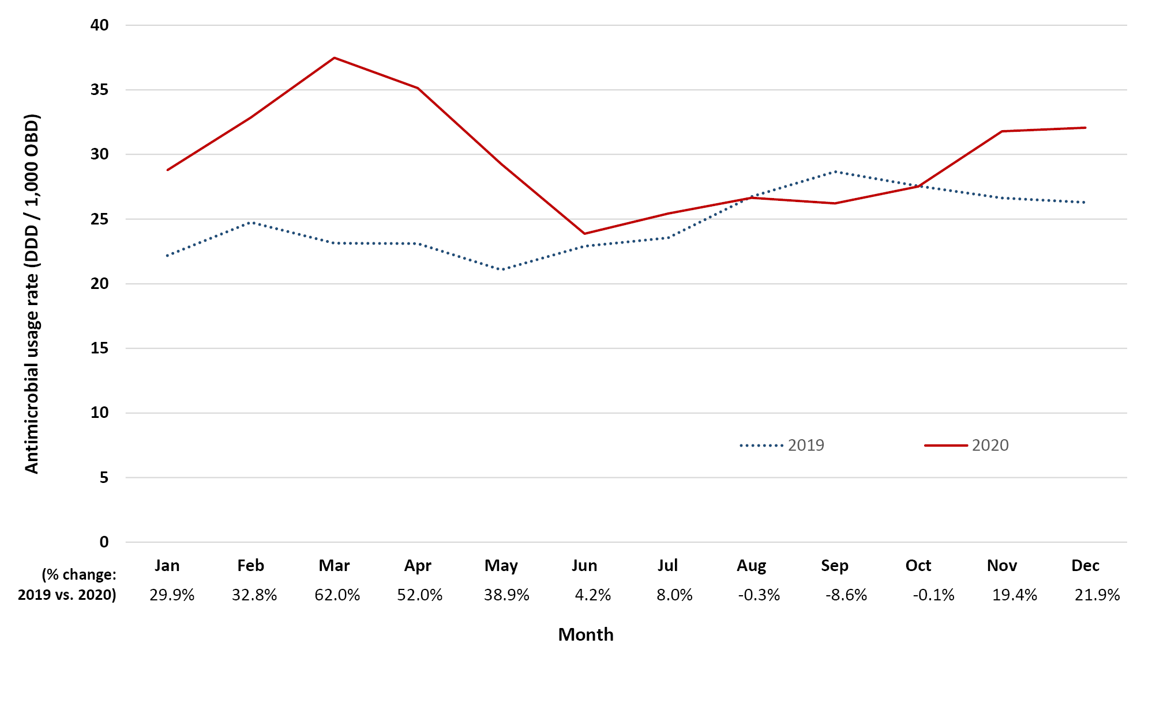Figure 3: National principal referral total-hospital usage rates for parenteral antibacterials used to treat hospital-acquired pneumonia January 2019 – December 2020ª
(a) Total hospital
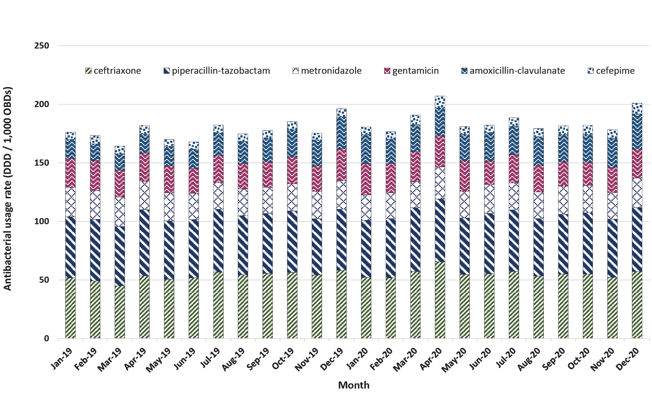
(b) Critical care
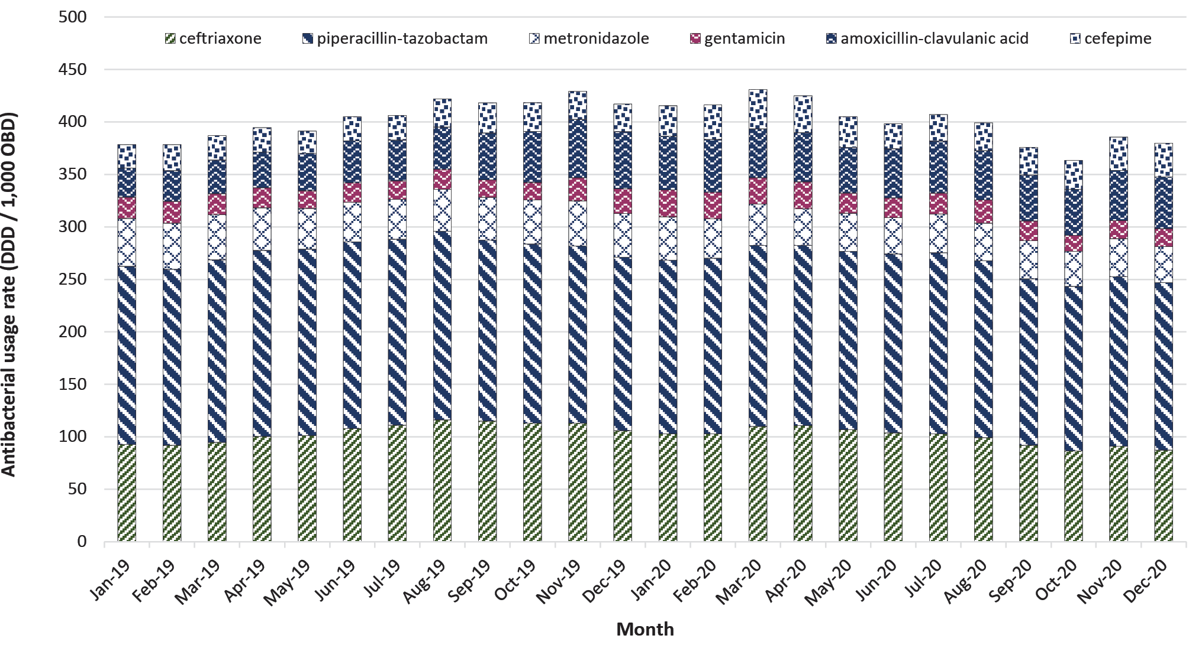
a Parenteral moxifloxacin not included with HAP agents although may be used in penicillin-allergic patients.
Figure 4: Aggregate usage of CAP and HAP antibacterials (oral and parenteral combined),^{a,b} Victorian and national principal referral hospitals, 2019-2020, and active COVID-19 cases in Victoria
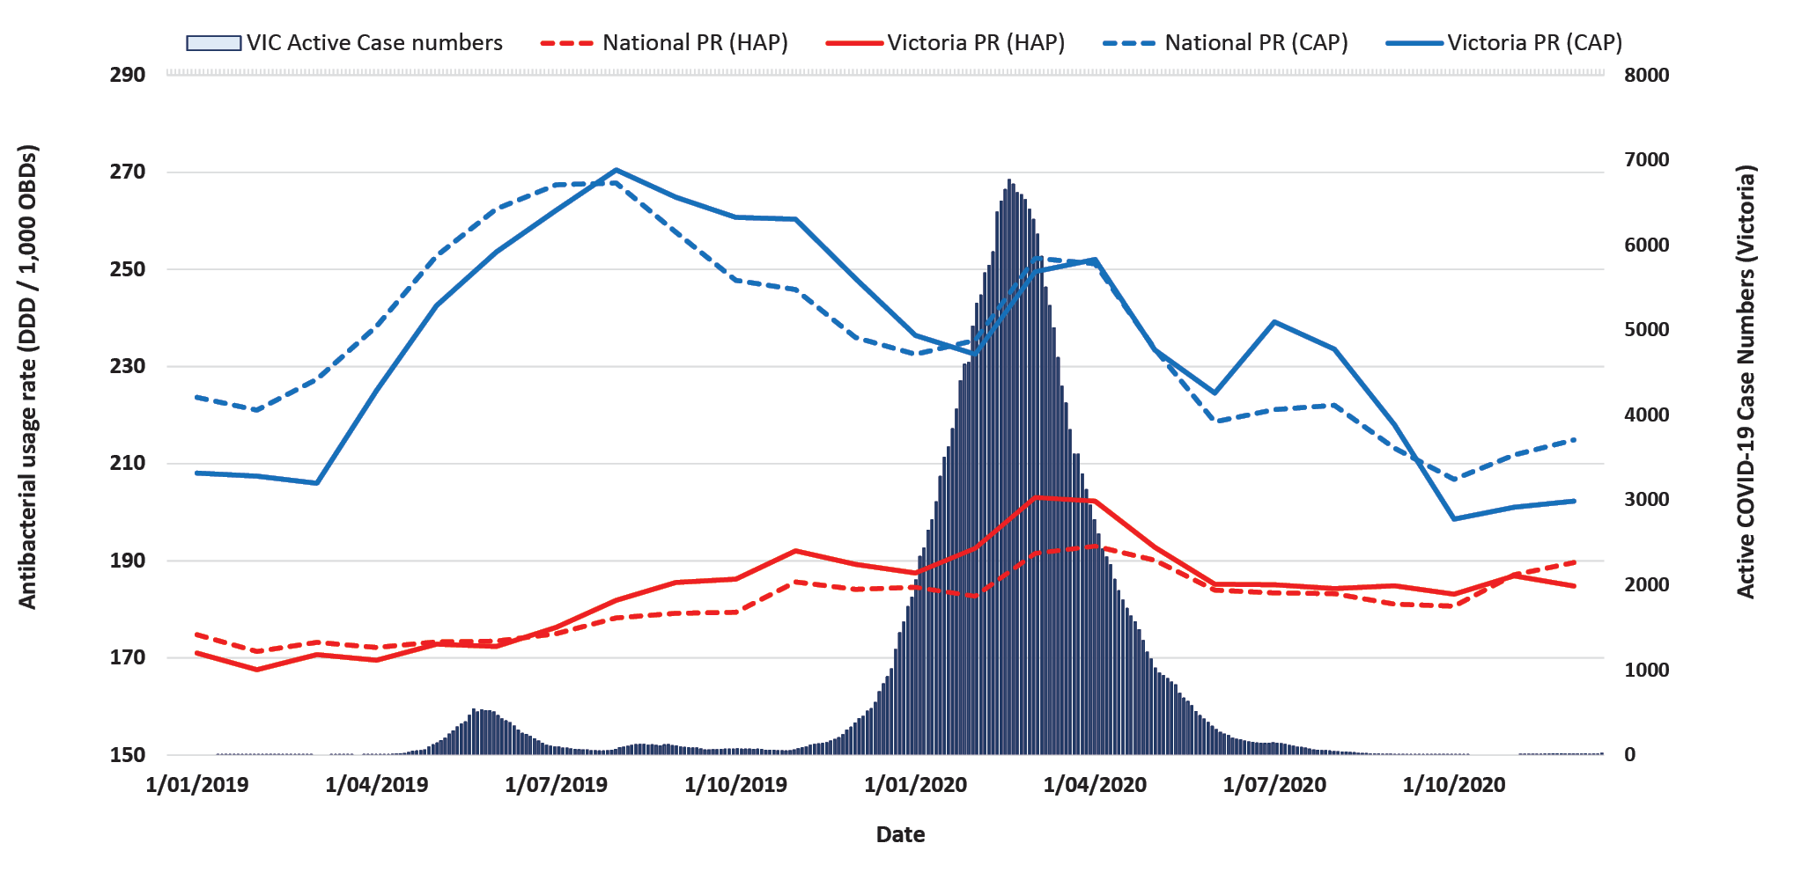
a CAP antibacterials (parenteral and oral): doxycycline, ceftriaxone, amoxicillin), azithromycin, benzylpenicillin, cefuroxime, moxifloxacin.
b HAP antibacterials (parenteral): ceftriaxone, piperacillin-tazobactam, metronidazole, gentamicin, amoxicillin-clavulanate, cefepime.
Table 2: Total acute occupied bed days (OBD) for Victorian principal referral hospitals, 2019 and 2020 (n = 6 hospitals)
 | Critical care |  |  | Non-critical care
Month | 2019 | 2020 | % change 2019 to 2020 | 2019 | 2020 | % change 2019 to 2020
January | 3,945 | 4,264 | 8.1 | 64,734 | 65,572 | 1.3
February | 3,736 | 4,044 | 8.2 | 60,678 | 65,012 | 7.1
March | 4,109 | 3,994 | -2.8 | 67,504 | 61,201 | -9.3
April | 3,957 | 3,309 | -16.4 | 66,718 | 46,736 | -29.9
May | 4,272 | 3,742 | -12.4 | 70,887 | 57,593 | -18.8
June | 4,076 | 3,765 | -7.6 | 67,430 | 61,787 | -8.4
July | 4,179 | 4,251 | 1.7 | 70,554 | 62,203 | -11.8
August | 4,144 | 4,207 | 1.5 | 69,747 | 59,730 | -14.4
September | 4,126 | 4,169 | 1.0 | 67,072 | 61,057 | -9.0
October | 4,323 | 4,142 | -4.2 | 69,306 | 65,935 | -4.9
November | 4,118 | 4,105 | -0.3 | 65,789 | 66,155 | 0.6
December | 4,147 | 4,430 | 6.8 | 65,297 | 66,809 | 2.3

Figure 5: Acute monthly occupied bed days (OBD) for all Australian principal referral hospitals, 2019 and 2020ª
National (n=31)
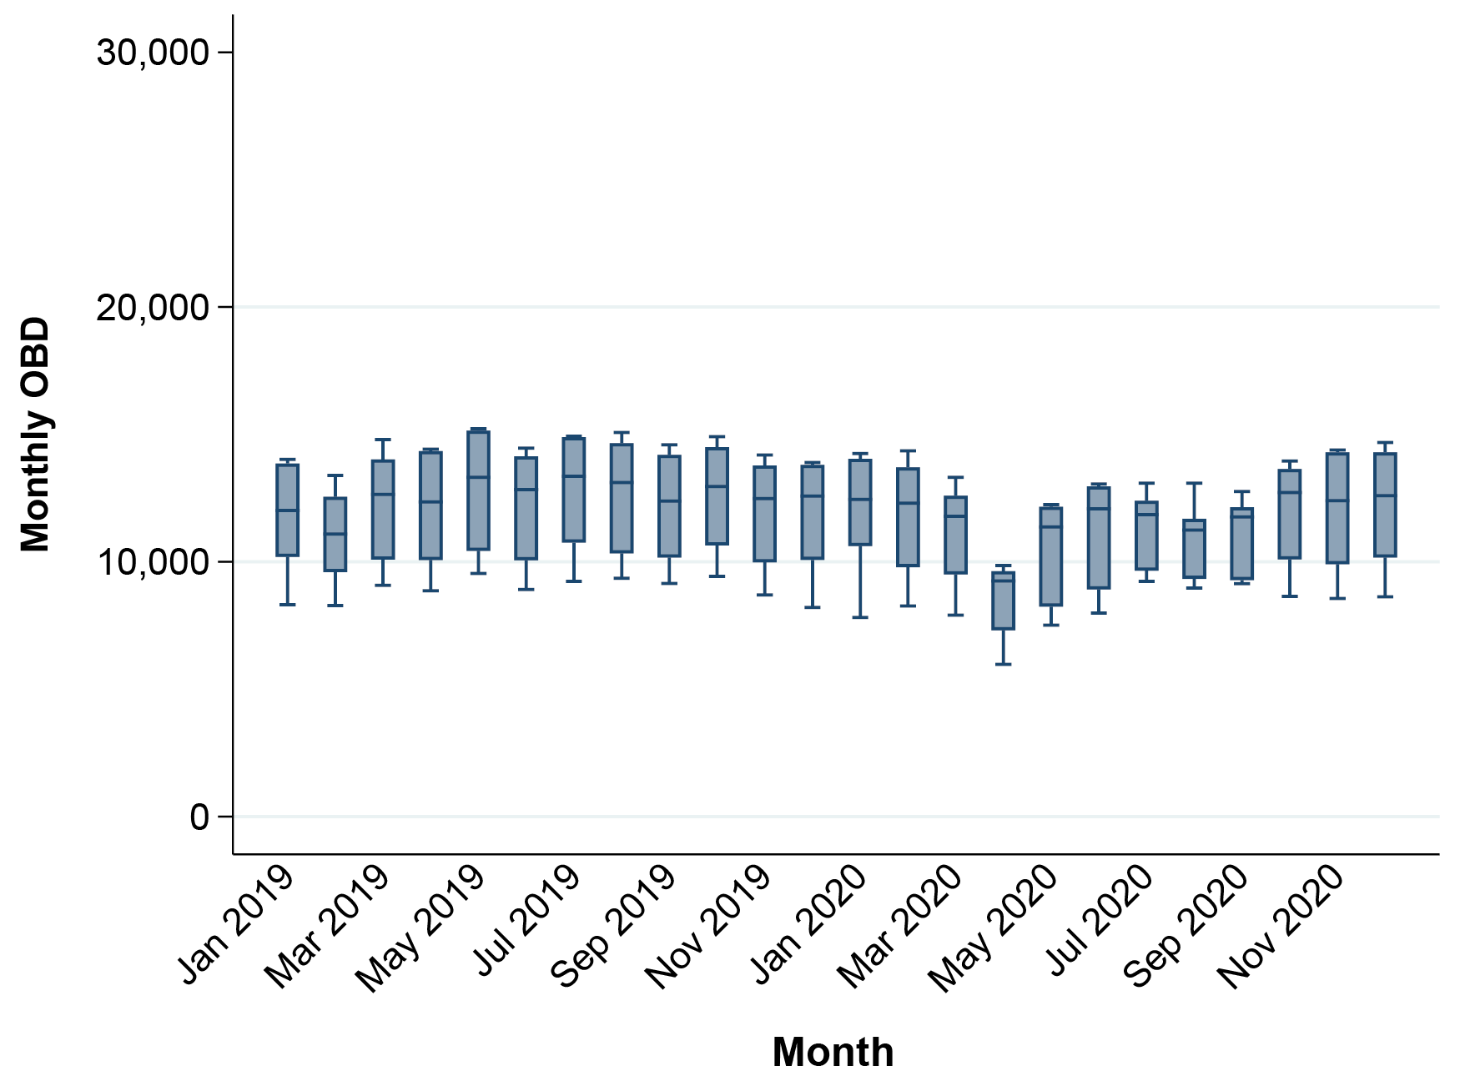
Victoria (n=6)
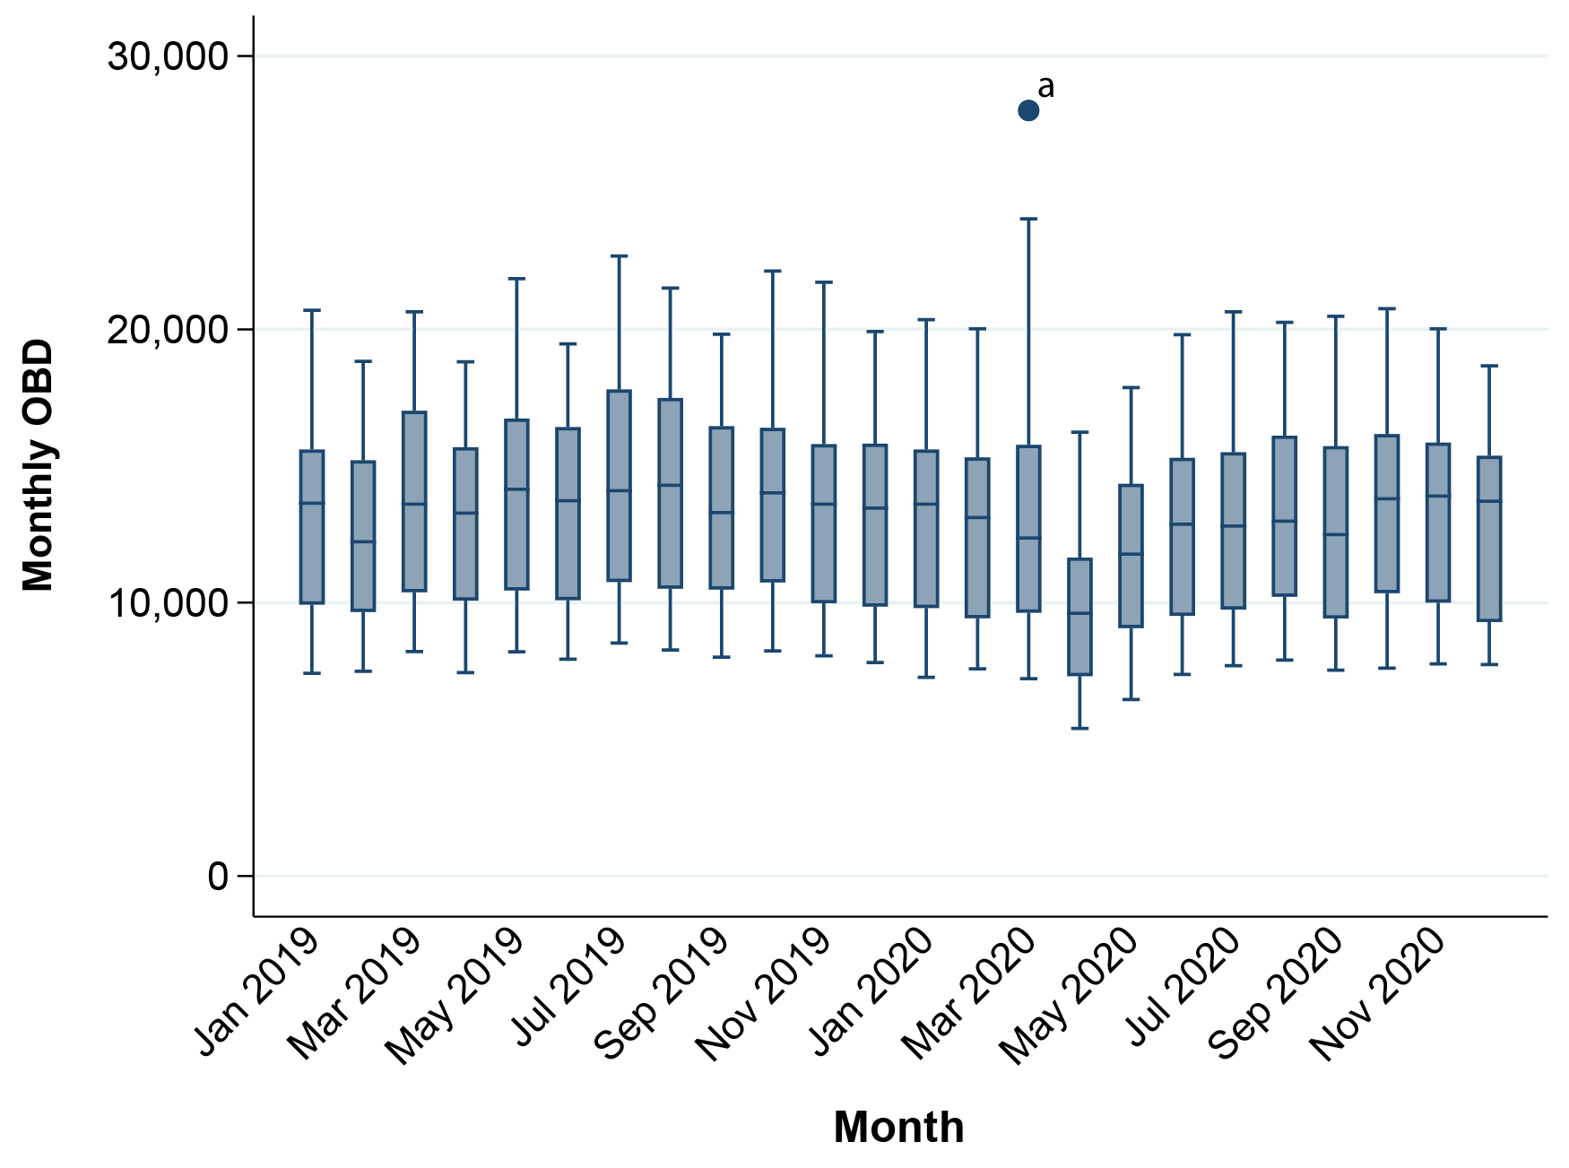
a This datapoint represents an outlier hospital (OBDs for March 2020 = 28,008).

Discussion
Despite an initial increase in the usage of antibacterials used to treat CAP in March and April 2020, usage rates dropped in the latter part of the year, with monthly usage rates lower on average than in 2019. Data submitted to the NAUSP reflects dispensing and/or distribution, not actual consumption. It is therefore probable that the observed increase in usage rates in March and April can be attributed to increased levels of stock held on ward imprests in anticipation of increased patient admissions and demand. This increased stock holding may also account for some of the increased usage rates seen for parenteral broad-spectrum agents used to treat HAP, along with establishment and stocking of dedicated COVID-19 wards. Increased usage of some of these agents, however, persisted throughout 2020. While these agents are used for other serious infections, it may also reflect empiric treatment of HAP/COVID-19-adjacent presentations during the first wave in 2020. Cefepime is a fourth-generation cephalosporin used as an alternative agent to piperacillin-tazobactam in penicillin-allergic patients with severe HAP or with a high risk of multi-drug resistant pathogens. Cefepime usage rates in Australian hospitals has historically remained low; however, usage rates of this broad-spectrum antimicrobial are increasing. ¹¹ Annual cefepime usage was 9.0% higher across all principal referral hospitals in 2020 than in 2019. Parenteral amoxicillin-clavulanate usage increased in 2020 to 18.5 DDD / 1,000 OBD, a rise of 32.4% from 2019. Parenteral amoxicillin-clavulanate was not registered for use in Australia until 2017; usage has steadily grown each year since, with incorporation into routine clinical practice. Prior to 2017, piperacillin-tazobactam was the only parenteral penicillin – ß-lactamase combination available in Australia. Inclusion of parenteral amoxicillin-clavulanate into local protocols for treatment of HAP may account for some of the increase in usage observed; however, the simultaneous decrease in piperacillin-tazobactam use from 2019 to 2020 was only 0.8%.
The large reduction in acute-care OBDs observed in April and May—both in Victoria and nationally—coincides with the suspension of non-urgent surgeries during the first COVID-19 wave. The reduction in OBDs in the non-critical care setting between March and October 2020 also reflects the suspension of, or reduction in, elective surgeries during the first and second COVID-19 waves. There is insufficient information included in NAUSP data to stratify usage by ward or admission type. Facilities that established dedicated COVID-19 wards reported associated antibacterial usage to NAUSP as ‘other acute’. As such, any COVID-19-related antimicrobial usage was not captured as part of the critical care data set.
As seen elsewhere internationally, pandemic-related interventions such as social distancing, wearing of masks and government-issued stay-at-home policies introduced to limit the spread of SARS-CoV-2 infections may have had unintended benefits on non-SARS-CoV-2 infection rates. The drop in hospital usage of antibacterials typically used in the treatment of CAP suggests that the number of cases of pneumonia acquired in the community requiring hospitalisation was markedly reduced in 2020. Due to the current metric used to report antimicrobial usage rates by NAUSP (DDD / 1,000 OBD), paediatric data is excluded on the basis that WHO-issued defined daily doses have only been validated in adults. There is therefore no national surveillance data available on the rates of paediatric antibacterial usage to compare the change in 2020 to previous years. Fluctuations in the incidence of non-SARS-CoV-2 infections might be expected to be larger in children, who disproportionately contribute to the transmission of many respiratory infections. ¹² There was an 85% reduction (95% confidence interval: 85–86%) in the incidence of hospitalisations for lower respiratory tract infections in children and adolescents associated with the introduction of pandemic restrictions in Victoria. ¹² This reduction in children may translate to a general reduction in respiratory viruses circulating in the community, which in turn, may contribute to a reduction in pneumonia rates in the adult population. Further, notifications of laboratory-confirmed influenza to the National Notifiable Diseases Surveillance System in the 2020 influenza season were almost eight times lower than the five-year average. ¹³ Antiviral use was not a focus of this paper; however, analysis of hospital usage rates for antivirals such as oseltamivir, or other agents used experimentally for the treatment of COVID-19, such as remdesivir, could be a further area for investigation.
A limitation of the surveillance data generated by NAUSP is that pharmacy distribution data is utilised as a surrogate measure for actual consumption. The data does not allow a direct analysis of consumption at patient level, nor does it allow an insight into the indications for which antimicrobials are used. Broad-spectrum antibacterials are also used for other secondary infections not linked to respiratory presentations, such as bacteraemia. The data does, however, demonstrate trends of overall usage over time at both a national and state level. Infection control measures introduced to manage transmission of SARS-CoV-2 have likely contributed to the reduction in lower respiratory infections in 2020 and to the consequent reduction in antibacterials used to treat CAP. A large proportion of reported bacterial co-infections in COVID-19-positive patients appear to be healthcare-associated, including central-line-associated bloodstream infections and ventilator-associated pneumonia. ⁵ The overall increase in usage of broad-spectrum antibacterial agents may be connected with healthcare-associated complications of COVID-19 or other infections. It is important that antimicrobial stewardship programs continue to focus on supporting the optimal selection of empirical therapies and on the rapid de-escalation or cessation of antibacterial therapy once SARS-CoV-2 infection is confirmed.

Author details
Ms Erin Connor, Antimicrobial Surveillance Pharmacist ^{1,2}
Dr Kavita Rasiah, Infectious Diseases Physician ²
Ms Nadine Hillock, Senior Pharmacist | Program Manager ^{1,2}
- National Antimicrobial Utilisation Surveillance Program
- Communicable Disease Control Branch, SA Health, Adelaide

Corresponding author
Nadine Hillock
Communicable Disease Control Branch, Department for Health and Wellbeing, Level 13 / 25 Grenfell St, Adelaide, South Australia, Australia.
Email: nadine.hillock@sa.gov.au
Phone: +61 8 74257169

References
- Cong W, Poudel AN, Alhusein N, Wang H, Yao G, Lambert H. Antimicrobial use in COVID-19 patients in the first phase of the SARS-CoV-2 pandemic: a scoping review. Antibiotics (Basel) . 2021;10(6):745. doi: https://doi.org/10.3390/antibiotics10060745.
- Langford BJ, So M, Raybardhan S, Leung V, Westwood D, MacFadden DR et al. Bacterial co-infection and secondary infection in patients with COVID-19: a living rapid review and meta-analysis. Clin Microbiol Infect . 2020;26(12):1622–9. doi: https://doi.org/10.1016/j.cmi.2020.07.016.
- Lansbury L, Lim B, Baskaran V, Lim WS. Co-infections in people with COVID-19: a systematic review and meta-analysis. J. Infect . 2020;81(2):266–75. doi: https://doi.org./10.1016/j.jinf.2020.05.046.
- Monnet DL, Harbarth S. Will coronavirus disease (COVID-19) have an impact on antimicrobial resistance? Euro Surveill . 2020;25(45). doi: https://doi.org/10.2807/1560-7917.ES.2020.25.45.2001886.
- Rawson TM, Wilson RC, Holmes A. Understanding the role of bacterial and fungal infection in COVID-19. Clin Microbiol Infect . 2021;27(1):9–11.
- Vijay S, Bansal N, Rao BK, Veeraraghavan B, Rodrigues C, Wattal C et al. Secondary infections in hospitalised COVID-19 patients: Indian experience. Infect Drug Resist . 2021;14:1893–903.
- Australian Institute of Health and Welfare (AIHW). Australian hospital peer groups . Canberra: Australian Government, AIHW; 16 November 2015. Available from: https://www.aihw.gov.au/reports/hospitals/australian-hospital-peer-groups.
- World Health Organization (WHO). ATC/DDD Index. [Online database.] Oslo: WHO Collaborating Centre for Drug Statistics Methodology, Norwegian Institute of Public Health; 2021. [Accessed on 6 July 2021.] Available from: https://www.whocc.no/atc_ddd_index/.
- National Health and Medical Research Council (NHMRC), Australian Research Council (ARC), Universities Australia. National Statement on Ethical Conduct in Human Research 2007 (Updated 2018) . Canberra: NHMRC, ARC, Universities Australia; 2018. Available from: https://www.nhmrc.gov.au/about-us/publications/national-statement-ethical-conduct-human-research-2007-updated-2018.
- Victorian Government. Victorian COVID-19 data. [Website.] Melbourne: Victorian Government; 2021. [Accessed on 7 September 2021.] Available from: https://www.coronavirus.vic.gov.au/victorian-coronavirus-covid-19-data.
- SA Health, Australian Commission on Safety and Quality in Health Care (ACSQHC). National Antimicrobial Utilisation Surveillance Program: 2019 Key Findings . Sydney: ACSQHC; March 2021. Available from: https://www.safetyandquality.gov.au/publications-and-resources/resource-library/2019-annual-report-national-antimicrobial-utilisation-surveillance-program-nausp.
- Todd IMF, Miller JE, Rowe SL, Burgner DP, Sullivan SG. Changes in infection-related hospitalisations in children following pandemic restrictions: an interruped time-series analysis of total population data. Int J Epidemiol . 2021. doi: https://doi.org/10.1093/ije/dyab101.
- Australian Government Department of Health. National 2020 Influenza Season Summary . Canberra: Australian Government Department of Health; 2 December 2020. Available from: https://www1.health.gov.au/internet/main/publishing.nsf/Content/03943F9CD20D2CCCCA2586410078F296/$File/National-Influenza-Season-Summary2020.pdf.

Communicable Diseases Intelligence
ISSN: 2209-6051 Online

Communicable Diseases Intelligence (CDI) is a peer-reviewed scientific journal published by the Office of Health Protection and Response, Department of Health. The journal aims to disseminate information on the epidemiology, surveillance, prevention and control of communicable diseases of relevance to Australia.

Editor: Jennie Hood
Deputy Editor: Simon Petrie
Design and Production: Kasra Yousefi
Editorial Advisory Board: David Durrheim, Mark Ferson, John Kaldor, Martyn Kirk and Linda Selvey

Website: http://www.health.gov.au/cdi

Contacts
CDI is produced by the Office of Health Protection and Response, Australian Government Department of Health, GPO Box 9848, (MDP 6) CANBERRA ACT 2601

Email: cdi.editor@health.gov.au

Submit an Article
You are invited to submit your next communicable disease related article to the Communicable Diseases Intelligence (CDI) for consideration. More information regarding CDI can be found at: http://health.gov.au/cdi.
Further enquiries should be directed to: cdi.editor@health.gov.au.

This journal is indexed by Index Medicus and Medline.

Creative Commons Licence - Attribution-NonCommercial-NoDerivatives CC BY-NC-ND
© 2021 Commonwealth of Australia as represented by the Department of Health
This publication is licensed under a Creative Commons Attribution-NonCommercial-NoDerivatives 4.0 International Licence from https://creativecommons.org/licenses/by-nc-nd/4.0/legalcode (Licence). You must read and understand the Licence before using any material from this publication.

Restrictions
The Licence does not cover, and there is no permission given for, use of any of the following material found in this publication (if any):
- the Commonwealth Coat of Arms (by way of information, the terms under which the Coat of Arms may be used can be found at www.itsanhonour.gov.au);
- any logos (including the Department of Health’s logo) and trademarks;
- any photographs and images;
- any signatures; and
- any material belonging to third parties.

Disclaimer
Opinions expressed in Communicable Diseases Intelligence are those of the authors and not necessarily those of the Australian Government Department of Health or the Communicable Diseases Network Australia. Data may be subject to revision.

Enquiries
Enquiries regarding any other use of this publication should be addressed to the Communication Branch, Department of Health, GPO Box 9848, Canberra ACT 2601, or via e-mail to: copyright@health.gov.au

Communicable Diseases Network Australia
Communicable Diseases Intelligence contributes to the work of the Communicable Diseases Network Australia.
http://www.health.gov.au/cdna

https://www.amr.gov.au/resources/aura-2021-fourth-australian-report-antimicrobial-use-and-resistance-human-health.
Amoxicillin, amoxicillin-clavulanate, azithromycin, benzylpenicillin, cefepime, ceftriaxone, cefuroxime, doxycycline, gentamicin, metronidazole, moxifloxacin, piperacillin-tazobactam.

