COVID-19 Australia: Epidemiology Report 32
Four-week reporting period ending 3 January 2021
COVID-19 National Incident Room Surveillance Team
Trends – Australia continues to report low numbers of COVID-19 cases, with a total of 28,574 COVID-19 cases including 909 deaths reported nationally. There has been a recent shift from overseas-acquired cases to locally-acquired cases, largely attributed to localised outbreaks in New South Wales and Victoria this reporting period.
Demographics – Demographic trends have remained consistent this reporting period: persons aged ≥ 90 years have the highest cumulative rate of infection; children aged 0–9 years have the lowest rate of infection; and cases in Aboriginal and Torres Strait Islander persons account for less than 1% of all confirmed cases.
Local cases – There were 211 locally-acquired cases reported this reporting period, with the majority of these in New South Wales (91%; 191/211). Nationally, there were 12 cases from an unknown source.
Overseas cases – There were 259 overseas-acquired cases this reporting period. Approximately half were from New South Wales (51%; 131/259), with the remainder dispersed across all jurisdictions.
Virology – The majority (89%; 70/79) of Australian SARS-CoV-2 sequences uploaded to GISAID from the last month were from New South Wales, noting there may be delays between jurisdictional reporting and uploads. Seventy-three percent (51/70) of these sequences were strains in the B.1 lineage. There were four cases of the UK variant (B.1.1.7 lineage) and no cases of the South African variant (B1.351) uploaded to GISAID in Australia at the end of the reporting period; however, jurisdictions had reported one additional case of the UK variant and two cases of the South African variant in the reporting period not yet represented on GISAID. All such cases were detected in managed quarantine facilities.
Severity – For all cases since the beginning of the pandemic, 13% have been admitted to hospital, noting that cases may be hospitalised for isolation purposes and not severe disease. According to sentinel surveillance data, of hospitalised patients, 20% were admitted to the intensive care unit. The national level cumulative case fatality rate has decreased slightly since the last reporting period to 3.2%.
Testing – Testing rates increased by 13% compared to the previous four-week reporting period, largely due to an increase in testing rates in New South Wales. The positivity rate remains low at 0.04%.
Public health measures – In response to clusters in New South Wales and Victoria, New South Wales and Victoria implemented public health measures in response to their relevant outbreaks. Border restrictions were implemented by most jurisdictions.
International situation – To date, over 83.3 million COVID-19 cases and 1.8 million deaths have been reported globally. A number of countries continue to report over 500,000 cases and 10,000 COVID-19 deaths per month.
Keywords: SARS-CoV-2; novel coronavirus; 2019-nCoV; coronavirus disease 2019; COVID-19; acute respiratory disease; epidemiology; Australia

Summary
Australia continues to report very low numbers of COVID-19 cases when compared internationally. This reporting period, there was an increase in locally-acquired cases predominantly in New South Wales and Victoria, which resulted in large testing rates and temporary public health measures. Less than a month ago, Australia reported 102 locally-acquired cases in one week (Figure 1). In response, jurisdictions rapidly commenced intense contact tracing, increased testing and implemented temporary public health measures. As a result, at the end of this reporting period, Australia reported only 39 locally-acquired cases in one week.
Figure 1: Recent COVID-19 notified cases by source of acquisition and diagnosis date, Australia, week ending 3 January 2021ª
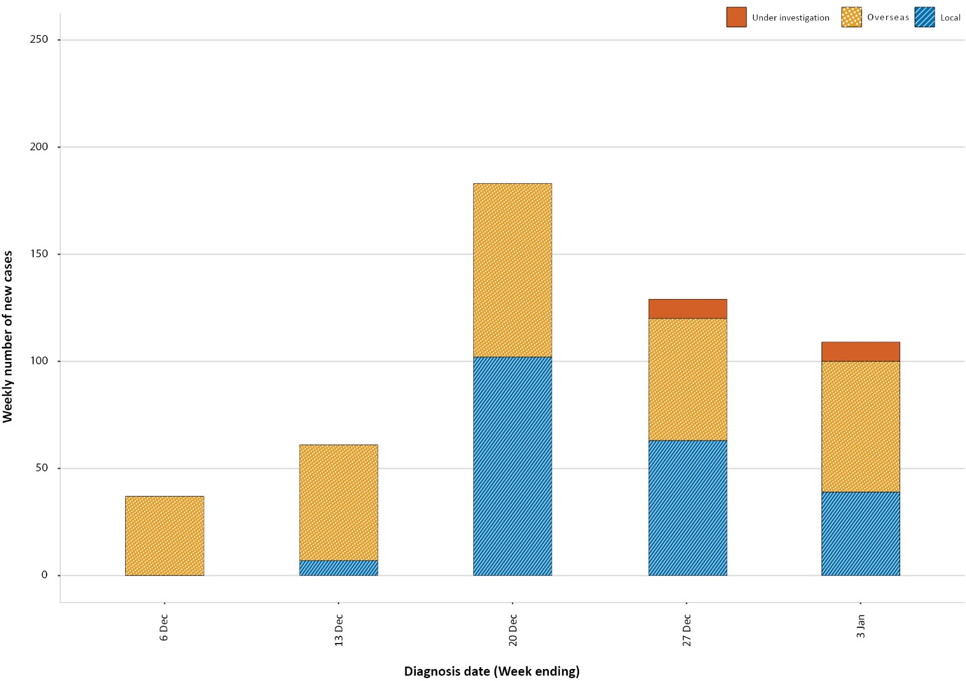
a Source:NNDSS
Several recent locally-acquired cases and associated clusters have utilised genomic epidemiology to link localised outbreaks to overseas-acquired cases that were being managed in quarantine. As a result, a number of public health measures have been implemented to strengthen Australia’s quarantine program, including routine testing of workers in these settings and tightened protocols on air arrivals and crew. With COVID-19 cases rising internationally, ongoing surveillance of overseas arrivals is vital in Australia’s response to the pandemic.
Since 30 August 2020, the hospitalisation rate of COVID-19 cases has remained stable at 13% of all cases. This figure is based on the National Notifiable Disease Surveillance System (NNDSS) data, and is the best current national level estimate. Because there have been few hospital admissions to sentinel sites since the last severity report (data to 22 November) there is reduced detail in the severity section of this report.
This is the first epidemiology report for COVID-19 for 2021, for which the reporting period covers the last four weeks (7 December 2020 to 3 January 2021). For comparability, the previous reporting period is the preceding four weeks (9 November to 6 December 2020).

Background
See Appendix B for information on coronavirus disease 19 (COVID-19) including modes of transmission, common symptoms and severity.

Data sources
See Appendix C for a description of the data sources used in this report.

Activity

Acute respiratory illness
(FluTracking and Commonwealth Respiratory Clinics)
Based on self-reported FluTracking data,¹ prevalence of fever and cough in the community remains low and steady at less than 0.5% (Figure 2). Runny nose and sore throat symptoms in the community increased during this reporting period, however the prevalence in the community was less than 1%.

Figure 2: Weekly trends in respiratory illness amongst FluTracking survey participants (age-standardised) compared to the average of the previous five years, Australia, 1 March 2020 – 3 January 2021ª
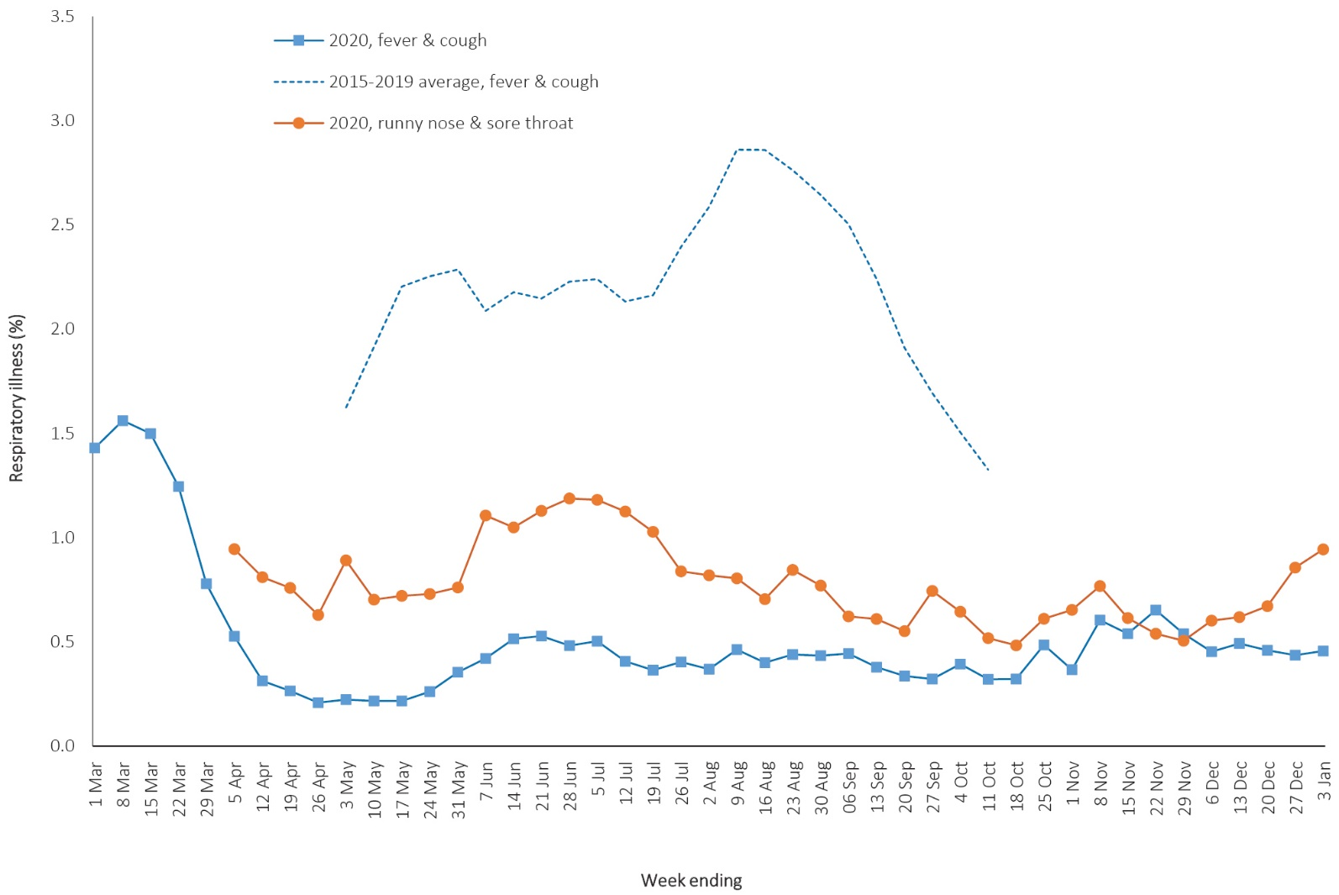
a In previous years, FluTracking was activated during the main Influenza season from May to October. A historical average beyond the week ending 11 October is therefore not available. In 2020, FluTracking commenced ten weeks early to capture data for COVID-19. Data on runny nose and sore throat were only collected systematically after 29 March 2020, therefore a historical average for this symptom profile is unavailable.
In this reporting period, acute respiratory illness was highest in those aged 0–9, 20–29 and 30–39 years old, based on both self-reported FluTracking data and presentations to Commonwealth Respiratory Clinics. Females reported respiratory illness more frequently than males. Rates of fever and cough by jurisdiction ranged from 1.7/1,000 FluTracking participants in South Australia to 5.9/1,000 participants in the Northern Territory.
FluTracking data indicate that 46% of those in the community with ‘fever and cough’ and 34% of those with ‘runny nose and sore throat’ were tested for SARS-CoV-2. This represents a stabilisation in testing among those with ‘fever and cough’ since the previous reporting period and an increase in testing among those self-reporting ‘sore throat and runny nose’. Testing rates varied by jurisdiction, being lowest in Western Australia, the Northern Territory and Queensland, and highest in Victoria and New South Wales. It is important to acknowledge that there may be legitimate reasons why people did not get tested, including barriers to accessing testing. Symptoms reported to Flutracking were not specific to COVID-19 and may also be due to chronic diseases.
During this reporting period, there were 70,461 assessments at Commonwealth Respiratory Clinics with 95% tested for SARS-CoV-2. The positivity rate for SARS-CoV-2 at these clinics was < 0.01% for this reporting period.
In patients experiencing influenza-like illness in this reporting period who were tested through the Australian Sentinel Practice Research Network (ASPREN) and Victorian Sentinel Practice Influenza Network (VicSPIN) general practitioner (GP) sentinel surveillance systems, the most frequent respiratory viruses detected were respiratory syncytial virus (RSV).
Based on FluTracking data, the rate of self-reported fever and cough among Aboriginal and Torres Strait Islander peoples and health care workers during the reporting period was similar to that observed for all other participants based on FluTracking data.
Based on all presentations to Commonwealth Respiratory Clinics to date, the principal symptoms reported in COVID-19 cases were cough, sore throat, tiredness, runny nose, and fever.

Transmission trends of confirmed COVID-19
(NNDSS and jurisdictional reporting to NIR)
As at 3 January 2021, there were 28,574 COVID-19 cases including 909 deaths reported nationally, with two distinct peaks in March and July 2020 (Figure 3). In this reporting period, there were 489 cases nationwide; one death was reported, by New South Wales. This death was in a person that was diagnosed with COVID-19 in March 2020 and is noted to have died from complications relating to their original COVID-19 infection. On average, 17 cases were notified each day over this reporting period, an increase from the average of ten cases reported per day over the previous reporting period. The largest number of cases diagnosed in this reporting period was from New South Wales (70%; 343/489), followed by Victoria (10%; 47/489); Queensland (6%; 31/489); Western Australia (5%; 23/489); Northern Territory (4%; 22/489); and South Australia (4%; 19/489). Small numbers of cases were reported in Tasmania (1%; 3/489) and the Australian Capital Territory (0%; 1/489).

Figure 3: COVID-19 notified cases by source of acquisition and diagnosis date, Australia, week ending 3 January 2021ª
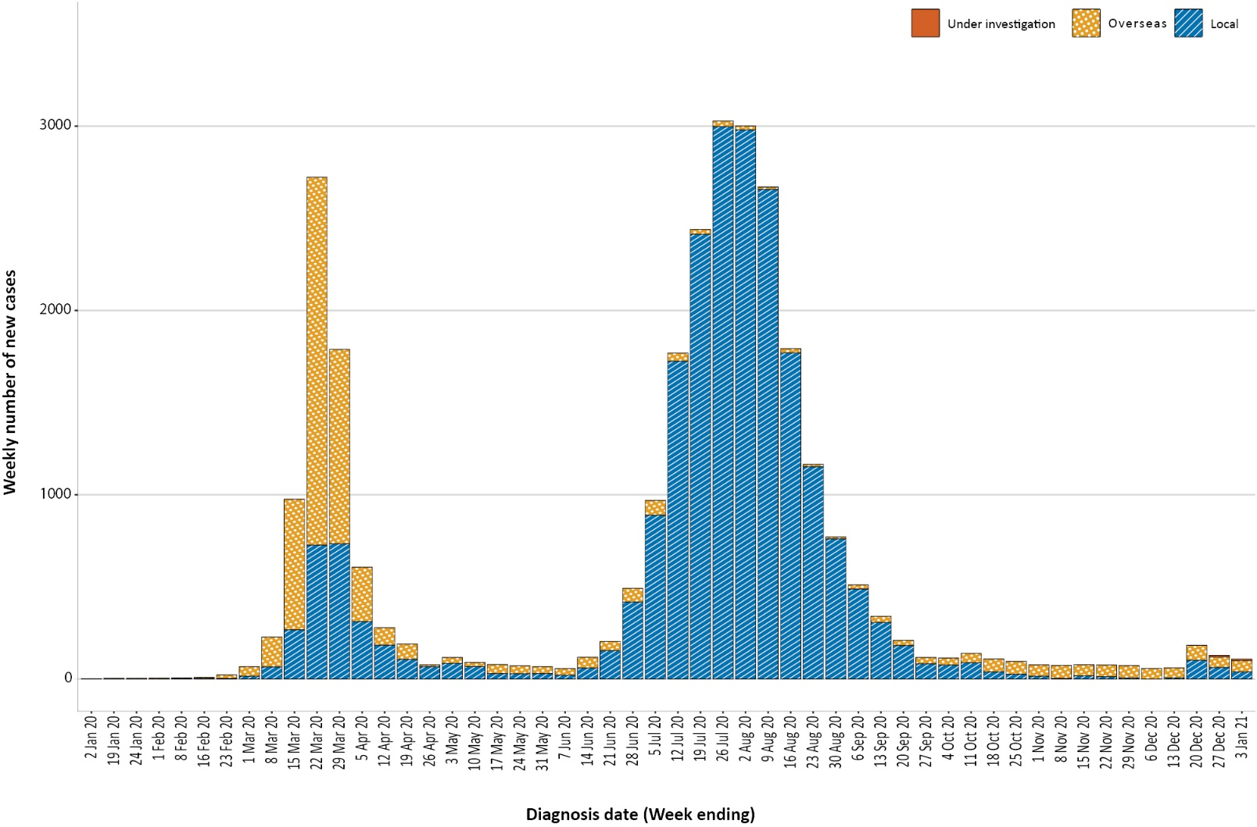

Source of acquisition
(NNDSS)
In this reporting period, around half of cases were reported as overseas acquired (53%; 259/489), which is a lower fraction than in the previous period (87%; 254/291). Locally-acquired cases accounted for 43% (211/489) of cases, and the contact was not identified for 6% (12/211) of these cases, which is higher than the previous reporting period (3%; 1/36). Additionally, 4% (19/489) of cases reported in this reporting period were under investigation at the time of reporting (Table 1).

Table 1: COVID-19 notifications by jurisdiction and source of acquisition, Australia, reported by diagnosis date, 7 December 2020 to 3 January 2021
Source | NSW | Vic. | Qld | WA | SA | Tas. | NT | ACT | Australia
Overseas | 151 | 23 | 22 | 21 | 16 | 3 | 22 | 1 | 259
Local — source known | 179 | 17 | 0 | 2 | 0 | 0 | 0 | 0 | 198
Local — source unknown | 12 | 0 | 0 | 0 | 0 | 0 | 0 | 0 | 12
Local — interstate | 0 | 0 | 0 | 0 | 1 | 0 | 0 | 0 | 1
Under investigationª | 1 | 7 | 9 | 0 | 2 | 0 | 0 | 0 | 19
Total | 343 | 47 | 31 | 23 | 19 | 3 | 22 | 1 | 489
a 'Under investigation' includes cases whose source of infection has not yet been reported to NNDSS.

Table 2: Locally-acquired COVID-19 case numbers and rates per 100,000 population by jurisdiction and reporting period, reported by diagnosis date, Australia, 9 November 2020 to 3 January 2021
Jurisdiction | Reporting period | Reporting period | Cumulative cases
 | 9 November –  6 December | 7 December –  3 January
 | Number of cases | Number of cases | Number of cases | Rate per 100,000 population
NSW | 1 | 191 | 2,167 | 26.8
Vic. | 0 | 17 | 19,377 | 293.9
Qld | 2 | 0 | 304 | 6.0
WA | 0 | 2 | 103 | 3.9
SA | 33 | 1 | 186 | 10.6
Tas. | 0 | 0 | 152 | 28.4
NT | 0 | 0 | 6 | 2.4
ACT | 0 | 0 | 29 | 6.8
Australia | 36 | 211 | 22,324 | 88.0

Table 3: Days since last locally-acquired COVID-19 case (source known and source unknown), by jurisdiction, reported by notification received date, up to 3 January 2021
Jurisdiction | Locally acquired — source unknown |  | Locally acquired — source known
 | Date of last case | Days since last case | Date of last case | Days since last case
NSW | 3 January 2021 | 0 | 3 January 2021 | 0
Vic. | 29 October 2020 | 66 | 3 January 2021 | 0
Qld | 26 August 2020 | 130 | 28 November 2020 | 36
WA | 12 April 2020 | 266 | 30 December 2020 | 4
SA | 15 April 2020 | 263 | 29 November 2020 | 35
Tas. | 11 August 2020 | 145 | 6 May 2020 | 242
NTª | NA | NA | 4 April 2020 | 274
ACT | 28 March 2020 | 281 | 9 July 2020 | 178
a The Northern Territory has not reported any locally-acquired cases with an unknown source of infection.
In this reporting period, the largest number of locally-acquired cases was reported in New South Wales (91%; 191/211), followed by Victoria (8%; 17/211). The higher number of locally-acquired cases reported in New South Wales reflects the recent ‘Avalon’ cluster, associated with approximately 150 cases, including two cases that were diagnosed in other jurisdictions. Western Australia reported two locally-acquired cases this month; both cases were in people who were acting as guardians of a recent arrival in a quarantine hotel.
Cumulatively, the infection rate to date for all locally-acquired cases was highest in Victoria with 293.9 infections per 100,000 population (Table 2). The rate of infection in Tasmania was 28.4 infections per 100,000 population, largely as a result of an outbreak in North West Tasmanian hospitals in April 2020, which represented half of all their cases. The increase in the New South Wales cumulative rate of infection for locally-acquired cases was driven by the recent Avalon cluster.
In this reporting period, the largest number of overseas-acquired cases was reported in New South Wales (58%; 151/259), followed by Victoria (9%; 23/259), Northern Territory (8%; 22/259) and Queensland (8%; 22/259). The higher number of overseas-acquired cases reported in New South Wales reflects the number of returned travellers managed there.
In this reporting period, the largest numbers of overseas-acquired cases were from the United States of America (20%; 51/259) followed by India (13%; 34/259) and the United Kingdom (12%; 31/259), which is similar to the previous reporting period. The number of cases by country is influenced by travel patterns of returning Australians as well as by the prevalence of COVID-19 in the country the person is arriving from.

Demographic features
(NNDSS)
In this reporting period, the largest number of cases occurred in those aged 30 to 39 years (112/489 cases). For all notifications to date, the highest rate of infection was in those aged 90 and over with a rate of 386.8 per 100,000 population (Appendix A, Table A.1). Children under 10 years of age had the lowest rate of infection (46.6 cases per 100,000 population). This age group also reported the lowest testing rate in the reporting period, approximately half that of those aged 30–39 years.
Cumulatively, the male-to-female rate ratio of cases was approximately 1:1 in most age groups. Notification rates were higher among females than among males in the 20–29 years age group and those aged ≥ 80 years, and higher among males than among females in the 70–79 years age group (Figure 4). The largest difference in cumulative rates was in the 90 years and over age group, where the cumulative rate among males was 333.7 cases per 100,000 population and among females 413.3 cases per 100,000 population (Appendix A, Table A.1).
Figure 4: Cumulative COVID-19 cases, by age group and sex, Australia, 23 January 2020 to 3 January 2021
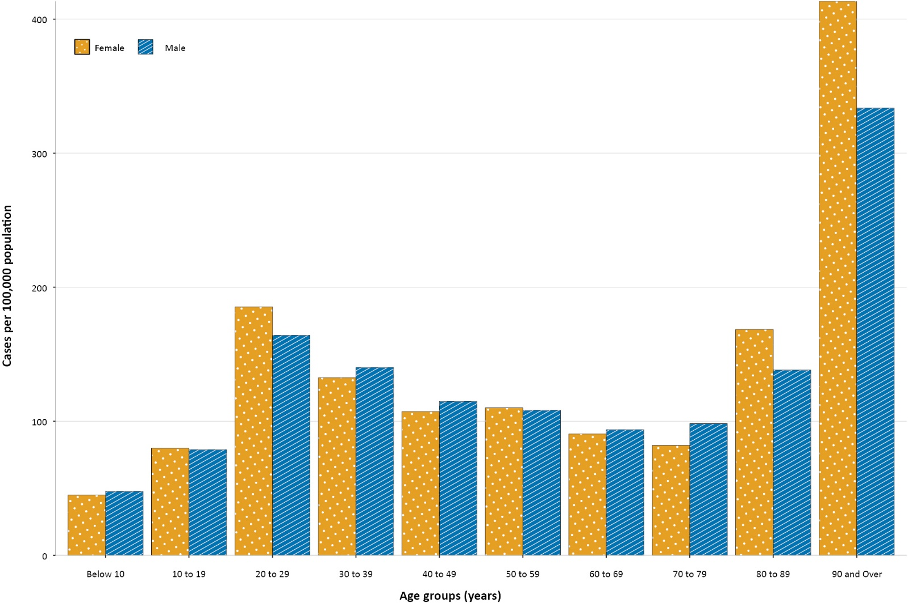
Since the beginning of the epidemic in Australia, the median age of all cases was 37 years (interquartile range, IQR: 25–56) which has not changed since the beginning of August. Prior to 1 June 2020, COVID-19 cases were slightly older, with a median age of 46 years (IQR: 29–62), associated with a high proportion of cases having a recent travel history or acquisition on a cruise ship. In cases reported after 1 June 2020, the median age was 34 years (IQR: 23–53) reflecting transmission in the community and across a range of settings, especially in Victoria. The median age of cases in this reporting period was 36 years (IQR: 24–51).

Aboriginal and Torres Strait Islander persons
(NNDSS)
There have been 148 confirmed cases of COVID-19 notified in Aboriginal and Torres Strait Islander people since the beginning of the epidemic. One additional Aboriginal and Torres Strait Islander case was notified in the reporting period. This case was reported to be locally acquired and associated with the Avalon cluster in New South Wales. This represents approximately 0.2% of confirmed cases in the reporting period and 0.5% of all confirmed cases. Table 4 compares the remoteness of cases in Aboriginal and Torres Strait Islander people with those in the Non-Indigenous population. No new overseas-acquired cases have been reported among Aboriginal and Torres Strait Islander people since the end of August and only one locally-acquired case has been reported since the start of September.
Table 4: COVID-19 notifications by Aboriginal and Torres Strait Islander status by jurisdiction, source of acquisition and remoteness classification, Australia, 3 January 2021
 | Locally acquired |  |  |  | Interstate acquired | Overseas acquired | Unknownª | Total
 | Major Cities of Australia | Inner Regional Australia | Outer Regional Australia | Remote / Very Remote Australia
Aboriginal and  Torres Strait Islander^{b} | 91 | 15 | 6 | 1 | 4 | 31 | 0 | 148
Non-Indigenous | 20,687 | 917 | 223 | 20 | 151 | 6,195 | 206 | 28,426
a Includes 28 Non-Indigenous cases classified as overseas residents who were diagnosed in Australia and 178 Non-Indigenous cases with an unknown remoteness classification.
b Excludes one probable Aboriginal and Torres Strait Islander case.
The median age of COVID-19 cases in Aboriginal and Torres Strait Islander people was 31 years (IQR: 21–50), which was younger than for Non-Indigenous cases where the median age was 37 years (IQR: 25–56).
The notification rate across all age groups was higher in Non-Indigenous people than in Aboriginal and Torres Strait Islander people (Figure 5). The age-standardised Aboriginal and Torres Strait Islander:Non-Indigenous notification rate ratio was 0.2, indicating that the Aboriginal and Torres Strait Islander population had a lower COVID-19 case rate than the Non-Indigenous population after accounting for differences in age structure. Amongst Aboriginal and Torres Strait Islander cases, the highest notification rate was in those aged 70–79 years (36.0 cases per 100,000 population), followed by the 60–69 years age group (34.4 cases per 100,000 population). Similar to Non-Indigenous cases, children aged 0–9 years had the lowest notification rate among Aboriginal and Torres Strait Islander cases (6.9 cases per 100,000 population).

Figure 5: National COVID-19 notification rate per 100,000 population by age group, Aboriginal and Torres Strait Islander people and Non-Indigenous people, Australia, 23 January 2020 – 3 January 2021
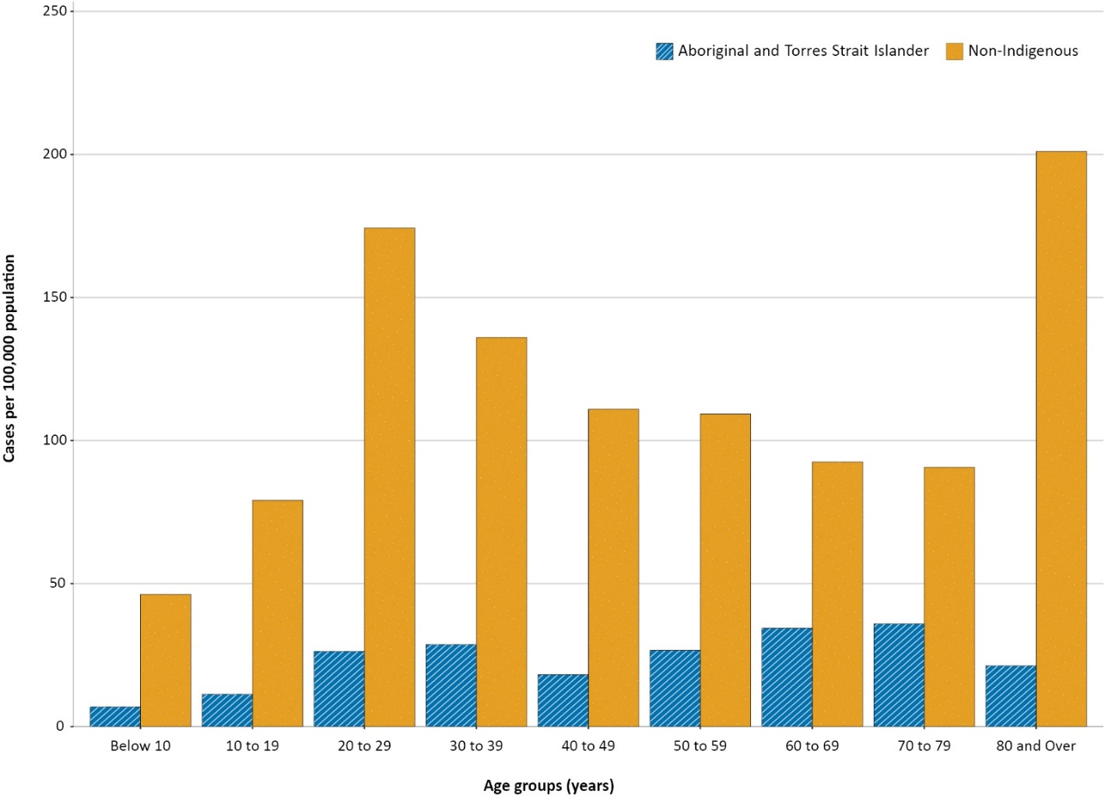

Severity
(NNDSS, FluCAN)
Based on NNDSS data, the proportion of all COVID-19 cases hospitalised to date remains at 13%. This hospitalisation rate concurs with a New South Wales linkage study which examined New South Wales notification and hospitalisation data (12% hospitalisation rate: January to May 2020); it should be noted however that during these earlier stages in the pandemic a more cautionary approach was taken in which cases were hospitalised for isolation purposes rather than clinical reasons.²
Since 16 March 2020, FluCAN has recorded 468 COVID-19 cases hospitalised in sentinel sites,³ of which 92 (20%) have been subsequently admitted to an intensive care unit (ICU). There were only three hospital admissions for confirmed COVID-19 cases in participating sites since the last severity report (COVID-19 epidemiology report 30: data to 22 November).⁴

Length of hospital stay
Length of hospital stay for patients with confirmed COVID-19 increases with advancing age category (Table 5). For those discharged alive (n = 369), the median length of stay was 8 days (IQR: 3.0–13.0); mean (sd) = 10 days (11.6); this has changed little compared to the previous severity report (data to 22 November),⁴ with only a small number of updates made to the discharge status of cases in the intervening six-week period (n = 31). Length of stay in ICU for survivors can be found in the previous severity report (data to 22 November).⁴

Table 5: Hospital length of stay for confirmed COVID-19 cases discharged alive from sentinel sites Australia between 16 March 2020 and 3 January 2021ª
 |  | Hospital length of stayª
Age group (years) | n | Median (IQR) | Mean (SD)
< 18 | 38 | 3.0 (1.0–7.0) | 5.3 (6.7)
18–39 | 80 | 5.0 (2.0–10.0) | 7.0 (7.1)
40–59 | 107 | 8.0 (4.0–15.0) | 11.0 (16.2)
60–79 | 99 | 10.0 (6.0–15.0) | 11.9 (10.9)
≥ 80 | 45 | 12.0 (8.0–16.0) | 12.6 (7.3)
a Source: FluCAN. Includes patients with a discharge outcome (n = 369).

Characteristics of those with severe COVID-19 disease
The median age of cases who were hospitalised in sentinel sites (57 years; IQR: 38–73) and admitted to ICU (59 years; IQR: 47–68) was higher than for cases overall (37 years; IQR: 25–56). The ratio of males to females (1.2:1) remains stable for hospitalised cases, with slightly higher admissions for males. Of those hospitalised in sentinel sites (n = 468),³ six (1.3%) were identified in Aboriginal and/or Torres Strait Islander people (1 unknown and 8 missing data; > 98% completeness).
Comorbidity and other risk factor analysis can be found in the second-most-recent previous severity report (data to 25 October).⁵ We have not updated risk factor data in the present report, as hospital cohorts have remained largely unchanged in the intervening ten weeks.

COVID-19 deaths
Overall, the crude case fatality rate (CFR: 3.2%, Table 6) is slightly decreased compared to that reported previously (3.3%; data to 22 November),⁴ with only two cases updated in NNDSS in this time as having died. The highest CFR remains in males over the age of 80 years (41.1%), particularly those admitted to hospital (46.9%). For hospitalised cases, since the last severity report (data to 22 November)⁴ three have been updated retrospectively as having died bringing the CFR for hospitalised cases to 11.5%. The CFR rate amongst those admitted to ICU was last reported in issue 30 (13.2%; data to 22 November).⁴
Table 6: Number of fatalities and case fatality rate (CFR) for all cases and hospitalised cases, by age group and sex, Australia, up to 3 January 2021
 | All casesª  n (CFR) |  |  | Hospitalisation^{b}  n (CFR)
 | Male | Female | Persons | Male | Female | Persons
Total | 440 (3.2) | 469 (3.2) | 909 (3.2) | 27 (12.2) | 21 (10.7) | 48 (11.5)
< 50 | 5 (0.1) | 0 (0.0) | 5 (0.0) | 0 (0.0) | 0 (0.0) | 0 (0.0)
50–64 | 19 (0.8) | 10 (0.4) | 29 (0.6) | 1 (1.9) | 3 (7.9) | 4 (4.35)
65–79 | 119 (8.9) | 63 (5.0) | 182 (7.0) | 11 (21.2) | 2 (6.5) | 13 (15.7)
80+ | 297 (41.1) | 396 (29.8) | 693 (33.8) | 15 (46.9) | 16 (36.4) | 31 (40.8)
a Source: NNDSS. (Total cases = 28,574).
b Source: FluCAN. Includes 21 sentinel hospitals. (Total cases = 418).

Clusters and outbreaks
(State and territory reporting)
For the four-week reporting period ending 3 January 2021, there was a total of 20 new outbreaks associated with 195 cases reported to COVID-Net. The majority of outbreaks were in New South Wales as associated with the ‘Avalon cluster’; there were two outbreaks in Western Australia, one outbreak in South Australia, one outbreak in the Northern Territory and one multijurisdictional outbreak involving New South Wales and Victoria. Outbreaks were reported in the following settings: hospitality and entertainment (8); workplace/industry (6); other settings (2); education (2); and travel & transport (2).
During the reporting period, three of the 20 notified outbreaks closed or were retrospectively reported outbreaks. Therefore, at the end of this reporting period, there was a total of 17 open outbreaks³ associated with 180 cases.
Nationally, since the beginning of the epidemic, there have been 849 outbreaks associated with 13,428 cases; 2,020 hospitalisations; and 799 deaths. Consistent with the national epidemic case trend, the first peak in outbreaks occurred in mid-March (Figure 6). This was followed by a rapid increase in outbreaks which began in early July, corresponding with community transmission in Victoria.
Figure 6: Number of outbreaks throughout the course of the pandemic, Australia, 3 January 2021
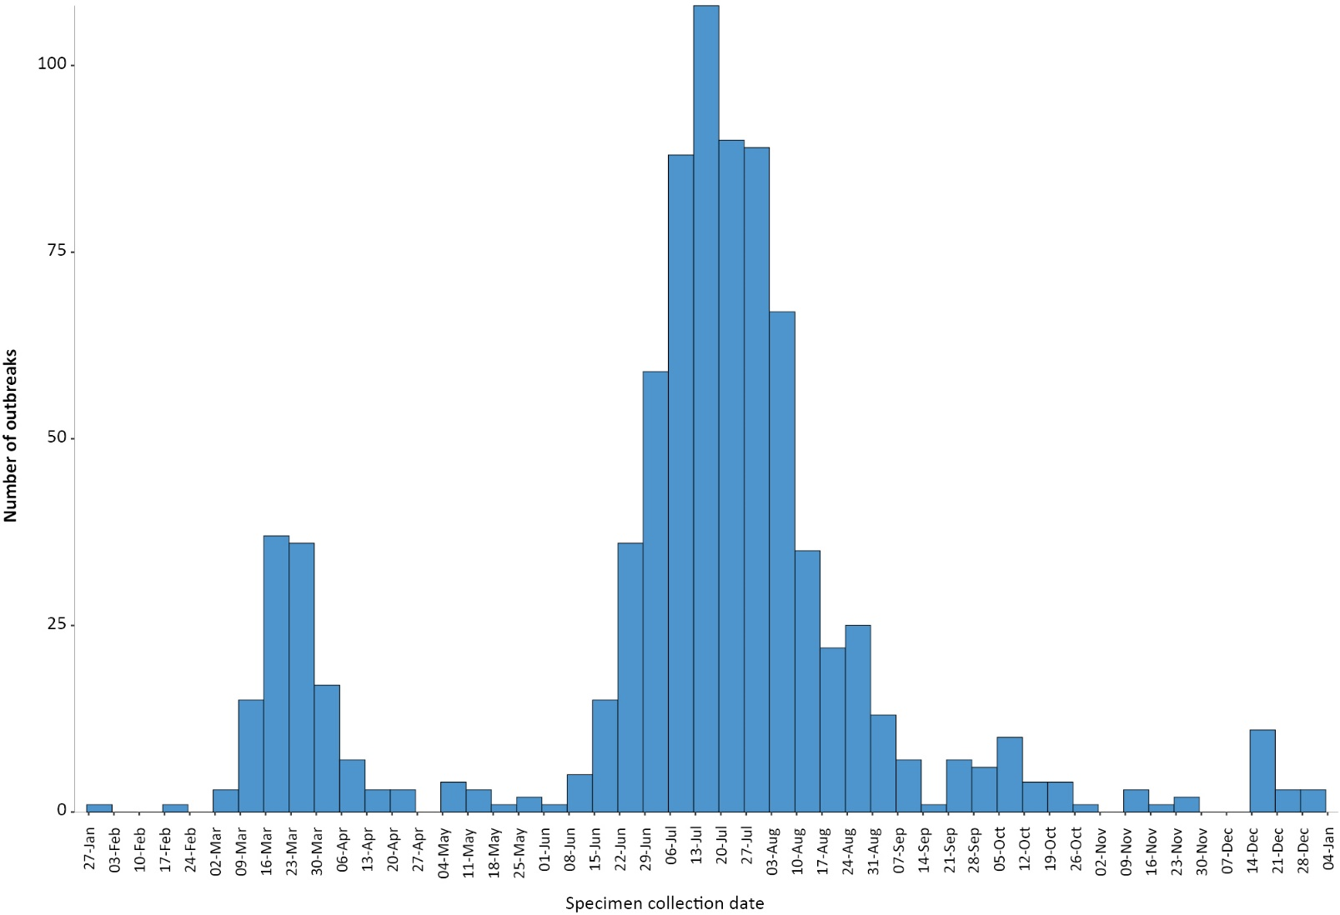
The median number of cases in each outbreak was six (range 2–331). Forty percent (328/849) of outbreaks had 6–24 cases, and almost a third (32%, 268/849) had only 3–5 cases (Figure 7). The number of cases associated with outbreaks was consistent across the two peaks in mid-March and July. The largest single jurisdictional outbreak occurred in a residential aged care facility and was associated with 260 cases.
Figure 7: Number of outbreaks by size, Australia, 3 January 2021
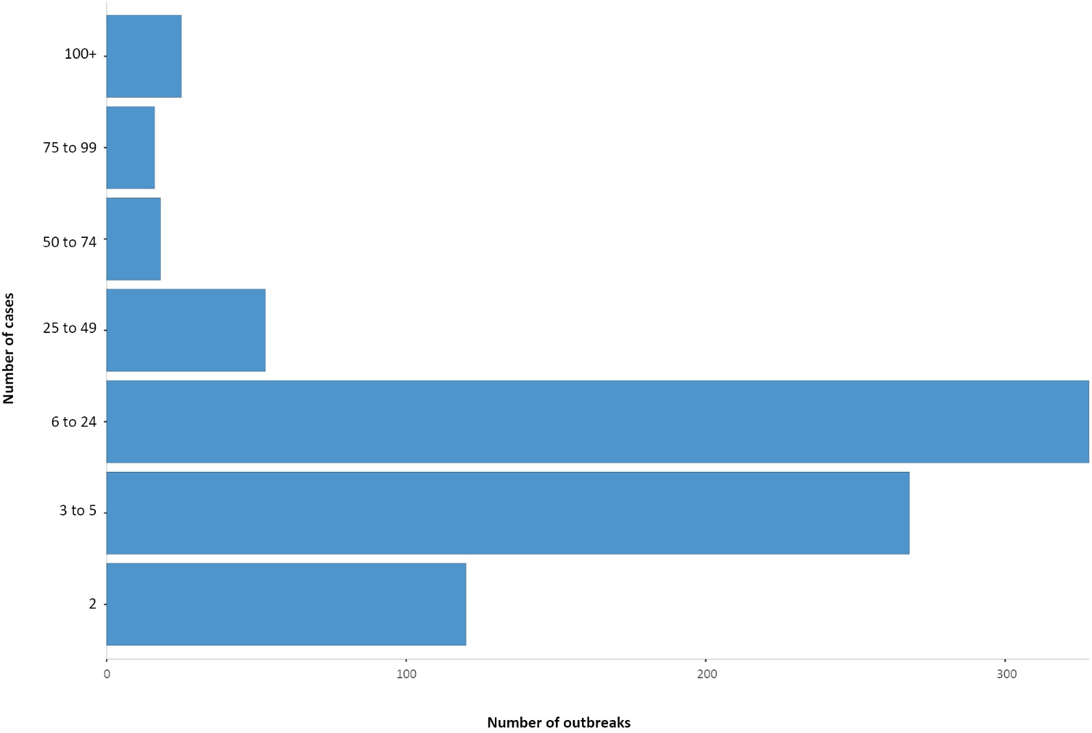
The most outbreaks have occurred in workplace/industry settings (188/849, 22% outbreaks; 1,559/13,428, 12% cases), followed by aged care facilities (128/849, 15% outbreaks; 4,827/13,428, 36% cases), educational facilities (112/849, 13% outbreaks; 1,132/13,428, 8% cases) and hospitals (83/849, 10% outbreaks; 1326/13,429, 10% cases) (Figure 8). Despite having a low percentage of outbreaks (34/849, 4%), food industry settings had a substantial amount of cases (1,128/13,428, 8%). The other category includes other various settings not captured by the other exposure settings, e.g. extended family gatherings (where two or more separate households come together), religious services, and hostels, sports and recreation venues, cruise ships and other mass transport.

Figure 8: Number of outbreaks and cases by setting, Australia, 3 January 2021
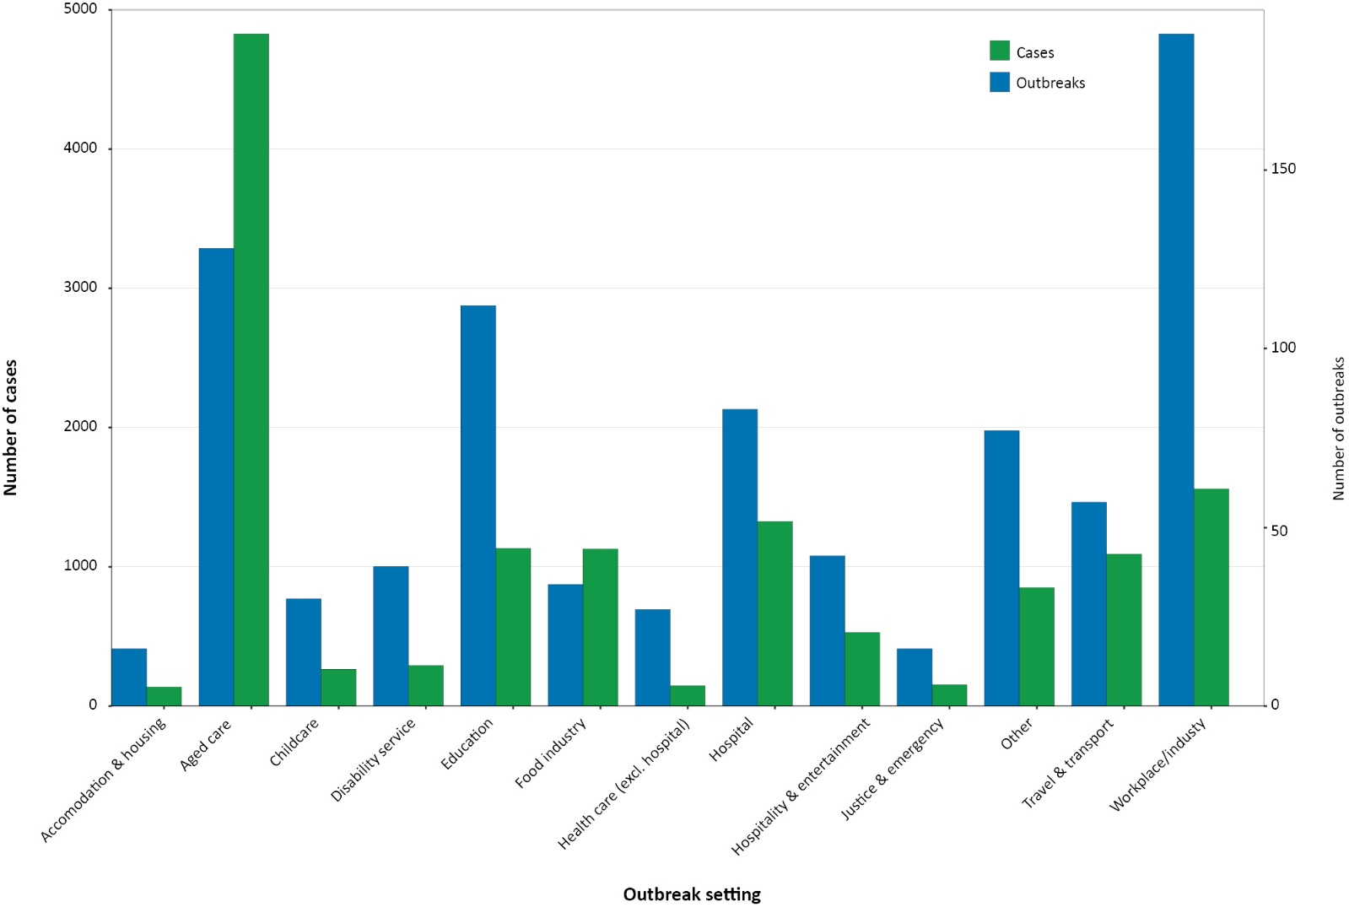
Residents of aged care facilities are at increased risk of COVID-19 infection due to the environment of communal living facilities and are more vulnerable to serious complications if they do become infected. As at 3 January 2021, there have been 4,300 cases of COVID-19 associated with 220 residential aged care facilities, with 3,615 recoveries and 685 deaths. Of these cases, 2,049 occurred in aged care residents, with the remaining 2,251 cases occurring in care staff. The Commonwealth is actively supporting services with reported incidents and outbreaks of COVID-19 providing access to personal protective equipment and additional staffing resources where required. Advice and guidelines have been provided to aged care services, including the release of an outbreak management guide.^{6,7}

Virology
(GISAID)
At the time of this report, there were 16,604 SARS-CoV-2 genome sequences available from Australian cases on the global sequence repository, GISAID, noting there may be delays between jurisdictional reporting and uploads to GISAID.⁸ These sequences were dispersed throughout the global lineages, reflecting multiple concurrent introductions into Australia.^{9–11} In this reporting period, there were 79 new Australian sequences uploaded to GISAID, which was an increase from the previous four-week period (56). The majority (89%; 70/79) of Australian SARS-CoV-2 sequences from this reporting period were from New South Wales, with 73% (51/70) of these the B.1 lineage, reflecting the cluster of locally acquired cases in New South Wales this reporting period. Eight sequences were from South Australia and one sequence was from the Australian Capital Territory. The United Kingdom has designated the new B.1.1.7 variant as a ‘variant of concern’.^{12,13} Additionally, South Africa has detected a new variant, termed 501Y.V2. There were four cases of the UK variant (B.1.1.7 lineage) and no cases of the South African variant (B1.351 lineage) uploaded to GISAID in Australia at the end of the reporting period; however, jurisdictions had reported one additional case of the UK variant and two cases of the South African variant in the reporting period not yet represented on GISAID. All such cases were detected in managed quarantine facilities. National genomic surveillance of SARS-CoV-2 has been implemented and laboratories across Australia are routinely monitoring sequences for variant strains, including the United Kingdom variant (lineage B.1.1.7) and the South African variant (B.1.351).

Public health response measures
Since COVID-19 first emerged internationally, Australia has implemented public health measures informed by the disease’s epidemiology (Figure 9). States and territories have decision making authority in relation to public health measures and have implemented or eased restrictions at their own pace, depending on the local public health and epidemiological situation, and in line with the ‘Framework for National Reopening’.^{14,15} During the current reporting period, there has been a resurgence of cases in New South Wales with an outbreak also occurring in Victoria. New South Wales and Victoria consequently implemented public health measures in response to their relevant outbreaks. Border restrictions were implemented by most jurisdictions.(Table 7).

Table 7: State and territory changes to COVID-19 restrictions, Australia, 7 December 2020 to 3 January 2021
Jurisdiction | Summary of changes to COVID-19 restrictions
New South Wales | From 17 December, the Northern Beaches Local Government Area was placed under heightened restrictions, including limits on gatherings, travel and stay at home requirements.¹⁶  From 20 December, restrictions were implemented for Greater Sydney, the Blue Mountains and the Central Coast including:  - Cap of 10 visitors in private households  - Cap on public gatherings in indoor venues  For the period 24 to 26 December restrictions on the Northern Beaches were temporarily eased for the Christmas period, allowing 10 visitors in the southern zone and 5 in the northern zone.  From 2 January, additional restrictions were implemented for Greater Sydney including:  - Requirement to wear face masks in indoor venues  - Caps on weddings and funerals  - Caps on indoor and outdoor gathering sizes
Victoria | From 31 December, Victoria implemented the following restrictions:¹⁷  - Cap of 15 visitors in private households  - Requirement to wear face masks in indoor venues  From 1 January, Victoria closed the border to New South Wales.
Queensland | From 21 December, Queensland closed the border to hotspot areas in New South Wales.¹⁸
Western Australia | From 20 December, Western Australia closed the border to New South Wales.¹⁹  From 31 December, Western Australia closed the border to Victoria and implemented retrospective quarantine requirements.
South Australia | From 1 January, South Australia closed the border to New South Wales.²⁰
Tasmania | From 17 December, Tasmania implemented border restrictions for hotspot areas in New South Wales.²¹
Australian Capital Territory | From 2 January, the Australian Capital Territory closed the border to non-ACT residents who have travelled to hotspot areas in New South Wales.²²
Northern Territory | From 1 January, the Northern Territory closed the border to travellers from hotspot areas in New South Wales (Greater Sydney).²³

Figure 9: COVID-19 notifications in Australia by week of diagnosis and jurisdiction to 3 January 2021 with timing of key public health measures
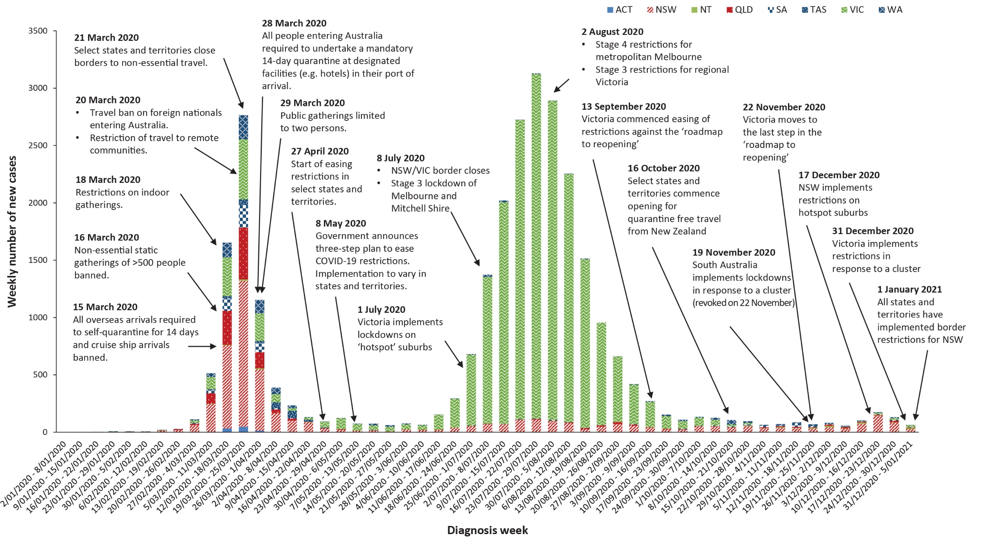

Figure 10: SARS-CoV-2 polymerase chain reaction (PCR) testing rates per 1,000 population per week by age group, Australia, 1 May 2020 – 1 January 2021^{a,b}
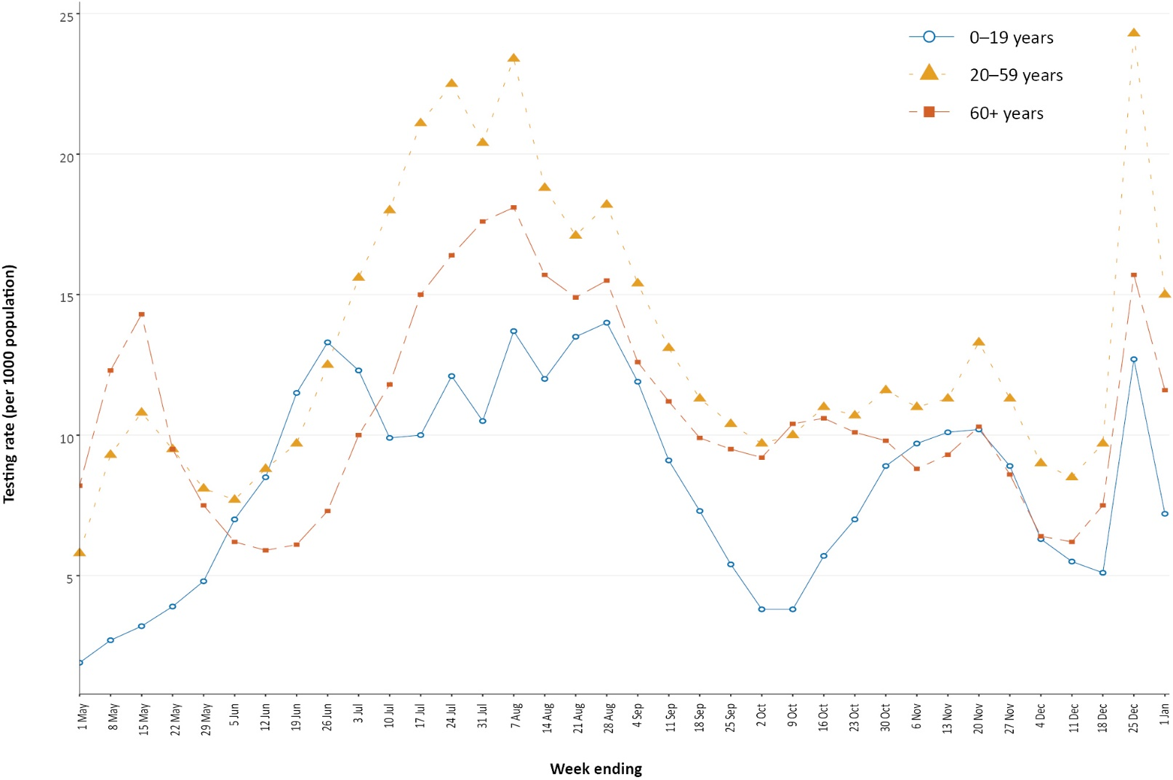
a Data provided by jurisdictions to the NIR weekly.
b The jurisdictions reporting each week (i.e. the denominator population) may vary.

Testing
(State and territory reporting)
As at 3 January 2021, a cumulative total of 11,428,730 tests were conducted in Australia. The cumulative nationwide proportion of positive tests remained low at 0.25% (Table 8). With the exception of Victoria, the cumulative testing positivity in individual jurisdictions was < 0.2%.

Table 8: Diagnostic tests performed, by jurisdiction, Australia, 3 January 2021
Jurisdiction | Tests performed 9 November –  6 December |  |  | Tests performed 7 December –  3 January |  |  | Cumulative tests performed  to 3 January
 | n | Positivity (%) | Per 1,000 populationª | n | Positivity (%) | Per 1,000 populationª | n | Positivity (%) | Per 1,000 populationª
NSW | 371,591 | 0.04 | 46.0 | 631,458 | 0.06 | 78.1 | 4,170,366 | 0.12 | 515.8
Vic | 328,944 | 0.00 | 49.9 | 301,569 | 0.02 | 45.7 | 3,929,815 | 0.52 | 596.0
Qld | 108,198 | 0.03 | 21.2 | 114,550 | 0.04 | 22.5 | 1,488,315 | 0.08 | 292.3
WA | 62,329 | 0.09 | 23.8 | 62,690 | 0.06 | 23.9 | 626,447 | 0.14 | 238.9
SA | 177,215 | 0.03 | 101.1 | 96,956 | 0.02 | 55.3 | 846,789 | 0.07 | 483.2
Tas | 11,104 | 0.00 | 20.8 | 13,524 | 0.03 | 25.3 | 144,920 | 0.16 | 271.1
NT | 12,072 | 0.17 | 49.1 | 9,930 | 0.24 | 40.3 | 83,251 | 0.10 | 338.3
ACT | 12,530 | 0.02 | 29.4 | 16,256 | 0.01 | 38.1 | 138,827 | 0.09 | 325.8
Australia | 1,083,983 | 0.03 | 42.7 | 1,246,933 | 0.04 | 49.2 | 11,428,730 | 0.25 | 450.7
a Population data based on Australian Bureau of Statistics (ABS) Estimated Resident Population (ERP) as at 30 December 2019.
During this reporting period, 1,246,933 tests were conducted nationally, with a positivity rate of 0.04%. This represented a 13% increase in tests conducted compared to the previous four-week reporting period and a significant increase in positivity. Testing rates increased to an average of 12.2 tests per 1,000 population per week during this reporting period, consistent with increased locally-acquired cases and public health messaging in New South Wales and Victoria. The testing rate in the reporting period is lower than the peak of 19.4 tests per 1,000 population per week in early August. Jurisdictional testing rates are driven by both current case numbers and numbers of people experiencing symptoms. All states except the Northern Territory reported a positivity rate of < 0.10% in this reporting period. The Northern Territory reported a positivity rate of 0.24%, which is an increase from the previous reporting period (0.17%), and was associated with an increased number of overseas-acquired cases linked with repatriation flights. The positivity rate in New South Wales increased to 0.06% in this reporting period, consistent with increases in locally acquired cases and overseas acquired cases. The low national positivity rate, along with high rates of testing, indicates a low prevalence of COVID-19 nationally.
For the four-week period ending 1 January 2021, testing rates increased among all age groups prior to Christmas, then declined sharply (Figure 11). The lowest testing rates were among children and young adults aged 0–19 years for the reporting period. Testing rates are highest in major cities and urban areas of Australia; lower testing rates, with little variation between classification areas, are seen across regional and remote areas across Australia.

Countries and territories in Australia’s near region
According to the World Health Organization (WHO), as of 3 January 2021, 46 countries and territories in Australia’s near region (WHO’s South East Asia (SEARO) and Western Pacific (WPRO) regions) reported 1,177,860 newly-confirmed cases and 18,601 deaths in the four-week reporting period since 6 December 2020, bringing the cumulative cases in the two regions to 13.1 million and 204,781 cumulative deaths.²⁴ Although this represents 30% fewer cases and 16% fewer deaths than in to the previous four-week report to 6 December, this and other short-term trends in data should be interpreted with caution over the end-of-year holiday season, as numbers may be influenced by presentation, testing and reporting delays. Testing rates per million are variable across and within countries indicating that reported cases may not be reflecting the true infection rate.
Countries in the SEARO and WPRO regions that reported the highest number of new cases were:
- India reported between 24–30% fewer new cases and 25% fewer deaths each fortnight in this reporting period compared to the previous four weeks (679,743 new cases since 6 December; 10,323,965 cumulative cases; 9,253 new deaths; 149.435 cumulative deaths);
- Indonesia reported an increase in new cases of around 15% in this reporting period and a 39% increase in deaths compared to the previous four weeks (188,766 new cases since 6 December; 758,473 cumulative cases; 4,966 new deaths; 22,555 cumulative deaths);
- Bangladesh reported a decreasing trend in new cases of around 33% each fortnight in this reporting period, representing a little over half as many newly reported cases (51%) compared to new cases in the previous reporting period. Deaths are also becoming fewer with 22% fewer deaths in the past fortnight compared to the previous reporting period. (30,598 new cases since 6 December; 476,879 cumulative cases; 457 new deaths; 6,807 cumulative deaths).
- Japan reported a 25% increase in new cases in each fortnight over this reporting period compared to the previous reporting period. More than a third of Japan’s deaths from COVID-19 have taken place in the past 4 weeks (80,856 new cases since 6 December; 240,954 cumulative cases; 1,233 new deaths; 3548 cumulative deaths).
- Malaysia reported a 16–23% increase in new cases each fortnight over this reporting period compared to the previous fortnightly reporting period, with reported deaths from COVID-19 per fortnight remaining steady between 40–50 deaths per fortnight (46,014 new cases since 6 December; 117,373 cumulative cases; 103 new deaths; 483 cumulative deaths). Twenty two percent of deaths have taken place in the past four weeks.
Countries such as Fiji, the Solomon Islands, Singapore, Marshall Islands, New Caledonia and New Zealand are detecting cases mainly among international arrivals while in quarantine, thus preventing further transmission into the community.^{25,26} Fifteen countries in the Western Pacific region reported no new cases in the past month.
Table 9 outlines the current Transmission Classification set by WHO for Australia’s near region. Under the WHO’s classification Australia has a transmission classification of ‘sporadic cases’.

Table 9: Transmission patterns for countries in Australia’s near region, WHO, 5 January 2021ª
Category | Country
No cases  Countries/territories/areas with no cases | American Samoa, Brunei Darussalam, Cook Islands, Kiribati, Federated States of Micronesia, Nauru, Niue, Palau, Pitcairn Islands, Samoa, Solomon Islands, Tokelau, Tonga, and Tuvalu Vanuatu
Sporadic cases  Countries/territories/areas with one or more cases, imported or locally detected | Cambodia, Fiji, French Polynesia, Wallis and Futuna, Lao PDR, Marshall Islands, New Caledonia, Timor-Leste and Australia
Clusters of cases  Countries/territories/areas experiencing cases, clustered in time, geographic location and/or by common exposures | Bhutan, China, Guam, Japan, Malaysia, Maldives, India, Myanmar, Nepal, New Zealand, Republic of Korea, Singapore, Sri Lanka, Thailand, and Vietnam
Community transmission  Countries /territories/areas experiencing larger outbreaks of local transmission defined through an assessment of factors including, but not limited to:  - large numbers of cases not linkable to transmission chains  - large numbers of cases from sentinel lab surveillance or increasing positive tests through sentinel samples (routine systematic testing of respiratory samples from established laboratories)  - multiple unrelated clusters in several areas of the country/territory/area. | Bangladesh, Indonesia, Papua New Guinea and Philippines
a Classifications are as indicated in reference 24.
Globally, reported new cases and deaths have remained steady in the past four weeks at about 4 million cases per week. To date, over 83.3 million COVID-19 cases and 1.8 million deaths have been reported globally. Two regions continue to carry the largest burden of disease, with the Region of the Americas accounting for around 48.2% of all new cases and 41.2% all newly reported deaths and Europe accounting for 38.5% of all new cases and 44.9% of newly reported deaths. The highest number of new cases in the past four weeks was in the United States of America (5,783,115; 17,423 new cases per 1 million population), which reported almost five times the number of the confirmed cases reported in the country with the second highest number of new cases, Brazil (1,166,610; 1,185 new cases per 1 million population). This was followed by the United Kingdom (893,818; 13,296 new cases per 1 million population), the Russian Federation (776,019; 5,381 new cases per 1 million population), and India (679,743; 492 new cases per 1 million population). The highest number of deaths from COVID-19 in this reporting period was reported in the United States of America (68,750) which reported more than three times the number of deaths than the next highest country, Brazil (19,447). The next highest death tolls were reported in Mexico (17,644), Germany (15,500), Italy (15,471), the Russian Federation (15,365) and the United Kingdom (13,556).
An international summary by WHO Region can be found in the WHO Epidemiological Update dated 7 December 2020.^{24,27}

Definitions
“Cluster” in relation to COVID-19 refers to two or more cases (who do not reside in the same household) that are epidemiologically related in time, place or person where a common source (such as an event or within a community) of infection is suspected but not yet established.
“COVID-19” is the disease caused by a novel coronavirus—SARS-CoV-2—that emerged in China in late 2019. ‘CO’ stands for corona-, ‘V’ stands for virus, ‘ID’ stands for infectious disease, and ‘-19’ refers to the year that this disease was first reported.
“COVID-19 associated death” is defined for surveillance purposes as a death in a probable or confirmed COVID-19 case, unless there is a clear alternative cause of death that cannot be related to COVID-19 (e.g. trauma).³⁷ There should be no period of complete recovery from COVID-19 between illness and death. Where a Coroner’s report is available, these findings are to be observed.
“Date of illness onset” is derived from data collected by the NNDSS and represents the diagnosis date, or reported true onset of disease date. If unknown, the earliest of specimen collection date, notification date or notification receive date is used.
“Notification received date” is reported in the NNDSS and represents the date the case is first notified on the NNDSS. As notification can only occur after testing is completed and information processed, counts for a defined period will vary according to the date type used.
“Outbreak” in relation to COVID-19 refers to two or more cases (who do not reside in the same household) among a specific group of people and/or over a specific period of time where illness is associated with a common source (such as an event or within a community). Some states and territories may report a single case associated with a residential aged care facility as an outbreak.
“SARS-CoV-2” is the virus that causes the disease COVID-19. It is a betacoronavirus genetically related to the 2003 Severe acute respiratory syndrome coronavirus (SARS-CoV).
“This reporting period” refers to the period covered by this report, i.e. 7 December 2020–3 January 2021.

Acknowledgements
This report represents surveillance data reported through Communicable Diseases Network Australia (CDNA) as part of the nationally-coordinated response to COVID-19. We thank public health staff from incident emergency operations centres and public health units in state and territory health departments, and the Australian Government Department of Health, along with state and territory public health laboratories. We thank those who provided data from surveillance systems, such as Commonwealth respiratory clinics, Flutracking, and FluCan.

Author details

Corresponding author
COVID-19 National Incident Room Surveillance Team, Australian Government Department of Health, GPO Box 9484, MDP 14, Canberra, ACT 2601.
Email: epi.coronavirus@health.gov.au

References
- Dalton C, Durrheim D, Fejsa J, Francis L, Carlson S, d’Espaignet ET et al. Flutracking: a weekly Australian community online survey of influenza-like illness in 2006, 2007 and 2008. Commun Dis Intell Q Rep. 2009;33(3):316–22.
- Liu B, Spokes P, Alfaro-Ramirez M, Ward K, Kaldor J. Hospital outcomes after a COVID-19 diagnosis from January to May 2020 in New South Wales Australia. Commun Dis Intell (2018). 2020;44. doi: https://doi.org/10.33321/cdi.2020.44.97.
- Monash Health. FluCAN (Influenza surveillance): FluCAN (The Influenza Complications Alert Network) [Internet.] Melbourne: Monash Health; 2020. Available from: https://monashhealth.org/services/monash-infectious-diseases/research/influenza-research/flucan-influenza-surveillance-2/.
- COVID-19 National Incident Room Surveillance Team. COVID-19 Australia: Epidemiology Report 30: Fortnightly reporting period ending 22 November 2020. Commun Dis Intell (2018). 2020;44. doi: https://doi.org/10.33321/cdi.2020.44.91.
- COVID-19 National Incident Room Surveillance Team. COVID-19 Australia: Epidemiology Report 28: Fortnightly reporting period ending 25 October 2020. Commun Dis Intell (2018). 2020;44. doi: https://doi.org/10.33321/cdi.2020.44.84.
- Australian Government Department of Health. Coronavirus (COVID-19) advice for the health and aged care sector. [Internet.] Canberra: Australian Government Department of Health; 2020. [Accessed on 13 August 2020.] Available from: https://www.health.gov.au/news/health-alerts/novel-coronavirus-2019-ncov-health-alert/coronavirus-covid-19-advice-for-the-health-and-aged-care-sector.
- Communicable Diseases Network Australia (CDNA). Coronavirus disease 2019 (COVID-19) outbreaks in residential care facilities: CDNA national guidelines for the prevention, control and public health management of COVID-19 outbreaks in residential care facilities in Australia. Canberra: Australian Government Department of Health, CDNA; 13 March 2020. [Accessed on 13 August 2020.] Available from: https://www.health.gov.au/sites/default/files/documents/2020/03/coronavirus-covid-19-guidelines-for-outbreaks-in-residential-care-facilities.pdf.
- Global Initiative on Sharing All Influenza Data (GISAID). [Website.] Berlin: Federal Republic of Germany, Freunde von GISAID e.V.; 2020. [Accessed on 4 January 2021.] Available from: https://www.gisaid.org/.
- Rockett RJ, Arnott A, Lam C, Sadsad R, Timms V, Gray KA et al. Revealing COVID-19 transmission in Australia by SARS-CoV-2 genome sequencing and agent-based modeling. Nat Med. 2020. doi: https://doi.org/10.1038/s41591-020-1000-7.
- Seemann T, Lane CR, Sherry NL, Duchene S, Goncalves da Silva A, Caly L et al. Tracking the COVID-19 pandemic in Australia using genomics. Nat Commun. 2020;11(1):4376. doi: https://doi.org/10.1038/s41467-020-18314-x.
- Eden JS, Rockett R, Carter I, Rahman H, de Ligt J, Hadfield J et al. An emergent clade of SARS-CoV-2 linked to returned travellers from Iran. Virus Evol. 2020;6(1):veaa027. doi: https://doi.org/10.1093/ve/veaa027.
- Public Health England (PHE). Investigation of novel SARS-COV-2 variant. Variant of concern 202012/01. London: United Kingdom Government, Department of Health and Social Care, PHE; December 2020. [Accessed on 8 January 2020.] Available from: https://assets.publishing.service.gov.uk/government/uploads/system/uploads/attachment_data/file/947048/Technical_Briefing_VOC_SH_NJL2_SH2.pdf.
- Australian Government Department of Health. Australian Health Protection Principal Committee (AHPPC) statement on new variant of the virus that causes COVID-19. [Internet.] Canberra: Australian Government Department of Health; 22 December 2020. [Accessed on 4 January 2021.] Available from: https://www.health.gov.au/news/australian-health-protection-principal-committee-ahppc-statement-on-new-variant-of-the-virus-that-causes-covid-19.
- Prime Minister of Australia. National Cabinet media statement. 13 Nov 2020. Prime Minister. [Internet.] Canberra: Australian Government Department of Prime Minister and Cabinet; 13 November 2020. [Accessed on 24 November 2020.] Available from: https://www.pm.gov.au/media/national-cabinet-2.
- Australian Government Department of Health. Framework for national reopening – October 2020. [Internet.] Canberra: Australian Government Department of Health; 23 October 2020. [Accessed on 10 November 2020.] Available from: https://www.health.gov.au/resources/publications/framework-for-national-reopening-october-2020.
- Government of New South Wales. What you can and can’t do under the rules. [Internet.] Sydney: Government of New South Wales; 2021. [Accessed on 4 January 2021.] Available from: https://www.nsw.gov.au/covid-19/what-you-can-and-cant-do-under-rules.
- Victoria State Government. Coronavirus. New Year’s Eve Restrictions. [Internet.] Melbourne: Victoria State Government; 2020. [Accessed on 4 January 2021.] Available from: https://www.coronavirus.vic.gov.au/new-years-eve-restrictions.
- Queensland Government. Border restrictions. [Internet.] Brisbane: Queensland Government; 2020. [Accessed on 4 January 2021.] Available from: https://www.qld.gov.au/health/conditions/health-alerts/coronavirus-covid-19/current-status/public-health-directions/border-restrictions.
- Government of Western Australia. COVID-19 coronavirus: Controlled interstate border. Medium risk states and territories. [Internet.] Perth: Government of Western Australia; 31 December 2020. [Accessed on 4 January 2021.] Available from: https://www.wa.gov.au/organisation/covid-communications/covid-19-coronavirus-controlled-interstate-border#mr.
- Government of South Australia. Travel restrictions. [Internet.] Adelaide: Government of South Australia; 1 January 2021. [Accessed on 4 January 2021.] Available from: https://www.covid-19.sa.gov.au/restrictions-and-responsibilities/travel-restrictions.
- Tasmanian Government. Coronavirus disease (COVID-19). Important community updates. [Internet.] Hobart: Tasmanian Government; 1 January 2021. [Accessed on 4 January 2021.] Available from: https://coronavirus.tas.gov.au/facts/important-community-updates.
- Australian Capital Territory Government. COVID-19. Travel advice: New South Wales (NSW). [Internet.] Canberra: Australian Capital Territory Government; 2 January 2021. [Accessed on 4 January 2021.] Available from: https://www.covid19.act.gov.au/community/travel/nsw.
- Northern Territory Government. Coronavirus (COVID-19): Hotspots Covid-19. [Internet.] Darwin: Northern Territory Government; 2020. [Accessed on 4 January 2021.] Available from: https://coronavirus.nt.gov.au/travel/quarantine/hotspots-covid-19.
- WHO. Weekly epidemiological update - 5 January 2021. [Internet.] Geneva: WHO; 5 January 2021. [Accessed on 6 January 2021.] Available from: https://www.who.int/publications/m/item/weekly-epidemiological-update---5-january-2021.
- Government of Singapore, Ministry of Health. Situation Report Coronavirus Disease (COVID-19). [Internet.] Singapore: Government of Singapore Ministry of Health; 3 January 2021. [Accessed on 4 January 2021.] Available from: https://www.moh.gov.sg/covid-19/situation-report.
- New Zealand Government Ministry of Health. Data and statistics - current cases. [Internet.] Wellington: New Zealand Government Ministry of Health; 3 January 2021. [Accessed on 4 January 2021.] https://www.health.govt.nz/our-work/diseases-and-conditions/covid-19-novel-coronavirus/covid-19-data-and-statistics/covid-19-current-cases#current-situation.
- WHO. Weekly epidemiological update - 8 December 2020. [Internet.] Geneva: WHO; 8 December 2020. [Accessed on 5 January 2021.] Available from: https://www.who.int/publications/m/item/weekly-epidemiological-update-8-december-2020.
- World Health Organization (WHO). Transmission of SARS-CoV-2: implications for infection prevention precautions. Scientific brief. [Internet.] Geneva: WHO; 9 July 2020. [Accessed on 14 October 2020.] Available from: https://www.who.int/news-room/commentaries/detail/transmission-of-sars-cov-2-implications-for-infection-prevention-precautions.
- McAloon C, Collins Á, Hunt K, Barber A, Byrne AW, Butler F et al. Incubation period of COVID-19: a rapid systematic review and meta-analysis of observational research. BMJ Open. 2020;10(8). doi: https://doi.org/10.1136/bmjopen-2020-039652.
- Australian Government Department of Health. Australian National Disease Surveillance Plan for COVID-19. [Internet.] Canberra: Australian Government Department of Health; 30 May 2020. Available from: https://www.health.gov.au/resources/publications/australian-national-disease-surveillance-plan-for-covid-19.
- Yuan Z, Xiao Y, Dai Z, Huang J, Zhang Z, Chen Y. Modelling the effects of Wuhan’s lockdown during COVID-19, China. Bull World Health Organ. 2020;98(7):484–94.
- Rothan HA, Byrareddy SN. The epidemiology and pathogenesis of coronavirus disease (COVID-19) outbreak. J Autoimmun. 2020;109. doi: https://doi.org/10.1016/j.jaut.2020.102433.
- Hu Y, Sun J, Dai Z, Deng H, Li X, Huang Q et al. Prevalence and severity of corona virus disease 2019 (COVID-19): A systematic review and meta-analysis. J Clin Virol. 2020; 127. doi: https://doi.org/10.1016/j.jcv.2020.104371.
- WHO. Report of the WHO-China Joint Mission on Coronavirus Disease 2019 (COVID-19). Geneva: WHO; 2020. [Accessed on 14 October 2020.] Available from: https://www.who.int/docs/default-source/coronaviruse/who-china-joint-mission-on-covid-19-final-report.pdf.
- Australian Government Department of Health. Coronavirus Disease 2019 (COVID-19): CDNA national guidelines for public health units. Canberra: Australian Government Department of Health; 28 October 2020. [Accessed on 9 November 2020.] Available from: https://www1.health.gov.au/internet/main/publishing.nsf/Content/7A8654A8CB144F5FCA2584F8001F91E2/$File/COVID-19-SoNG-v3.10.pdf.
- Bedford T, Neher R, Hadfield J, Hodcroft E, Sibley T, Huddleston J et al. Nextstrain: Genomic epidemiology of novel coronavirus - Oceania-focused subsampling. [Internet.] Nextstrain; 2020. [Accessed on 3 January 2021.] Available from: https://nextstrain.org/ncov/oceania.
- WHO. WHO Coronavirus Disease (COVID-19) dashboard. [Internet.] Geneva: WHO; 3 January 2021. [Accessed on 3 January 2021.] Available from: https://covid19.who.int/.

Appendix A: Supplementary figures and tables

Table A.1: COVID-19 case notifications and rates per 100,000 population, by age group and sex, Australia, 3 January 2021

Age Group | This reporting period |  |  |  |  |  | Cumulative
 | Cases |  |  | Rate per 100,000 population |  |  | Cases |  |  | Rate per 100,000 population
 | Male | Female | People | Male | Female | People | Male | Female | People | Male | Female | People
0 to 9 | 26 | 12 | 38 | 1.6 | 0.8 | 1.2 | 782 | 701 | 1,483 | 47.8 | 45.2 | 46.6
10 to 19 | 29 | 23 | 52 | 1.8 | 1.5 | 1.7 | 1,242 | 1,190 | 2,432 | 79.1 | 80.1 | 79.6
20 to 29 | 42 | 41 | 83 | 2.3 | 2.3 | 2.3 | 3,062 | 3,349 | 6,433 | 164.8 | 186 | 175.8
30 to 39 | 67 | 45 | 112 | 3.7 | 2.4 | 3 | 2,553 | 2,470 | 5,038 | 140.4 | 133.1 | 137.1
40 to 49 | 53 | 20 | 73 | 3.3 | 1.2 | 2.2 | 1,869 | 1,781 | 3,678 | 115.5 | 107.5 | 112.3
50 to 59 | 33 | 26 | 59 | 2.2 | 1.7 | 1.9 | 1,645 | 1,739 | 3,392 | 109.1 | 110.6 | 110.1
60 to 69 | 22 | 23 | 45 | 1.7 | 1.7 | 1.7 | 1,200 | 1,233 | 2,435 | 94.4 | 91.8 | 93.1
70 to 79 | 12 | 11 | 23 | 1.4 | 1.2 | 1.3 | 865 | 764 | 1,629 | 99.4 | 82.9 | 90.9
80 to 89 | 3 | 1 | 4 | 0.8 | 0.2 | 0.5 | 494 | 778 | 1,272 | 138.2 | 168.7 | 155.4
90 and over | 0 | 0 | 0 | 0 | 0 | 0 | 229 | 552 | 782 | 333.7 | 413.3 | 386.8

Appendix B: Background
Figure B.1: Severity spectrum of COVID-19 cases and data sources used to measure severity in Australia
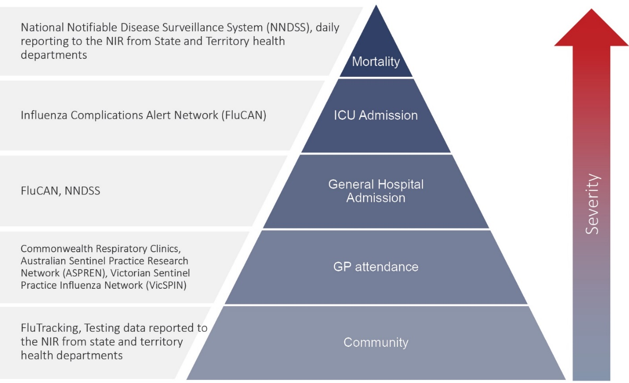
Coronavirus disease 19 (COVID-19), caused by the novel severe acute respiratory syndrome coronavirus 2 (SARS-CoV-2), was first identified in humans in Wuhan, China, in December 2019. The disease subsequently spread rapidly, leading to a global pandemic.²⁸ The predominant modes of transmission for COVID-19 are through direct or close contact with an infected person via respiratory droplets, or indirectly via contact with contaminated fomites.²⁸ The median incubation period of COVID-19 is 5–6 days, ranging from 1 to 14 days.^{29,30} The infectious period remains uncertain; however, it is estimated to be from 48 hours before symptoms develop until two weeks after symptom onset.^{29,31} The predominant symptoms reported in COVID-19 cases are cough, sore throat, fatigue, runny nose and fever.³² The majority of cases recover from the disease without clinical intervention; however, approximately 20% of global cases result in more severe outcomes, such as shortness of breath and pneumonia, necessitating hospitalisation and the requirement of additional oxygen or ventilation.^{33,34} Severe or fatal outcomes are generally more common among elderly cases or those with comorbid conditions.³⁴ A visual depiction of the severity spectrum of COVID-19, and of the data sources that we use in this report to measure aspects of severity, is provided in Figure B.1.
The epidemiology of COVID-19 in Australia has continued to evolve since cases were first detected in the country in late January 2020. This report provides an ovesrview of the Australian COVID-19 epidemic, and compiles data from a variety of sources to describe cases and clusters, testing patterns, disease severity, public health response measures and the international situation. The report addresses indicators listed in the Australian National Disease Surveillance Plan for COVID-19,³⁰ which describes a national approach for disease surveillance for COVID-19 and its causative agent, SARS-CoV-2.

Appendix C: Data sources

Notifications to health departments
The majority of data presented in this report were derived from the National Notifiable Diseases Surveillance System (NNDSS). COVID-19 is a notifiable disease under public health legislation in all states and territories and is listed on the National Notifiable Diseases List under the National Health Security Act (2007). Accordingly, all jurisdictions report confirmed and probable cases of COVID-19 through the NNDSS. The national case definition for surveillance is available in the COVID-19 Series of National Guidelines.³⁵ Due to the dynamic nature of the NNDSS, numbers presented in this report may be subject to revision and may vary from numbers previously reported and from case notifications released by states and territories. Case numbers for the most recent dates of illness onset may be subject to revision, due to reporting delays. Data for the current report were extracted from the NNDSS on 5 January 2021 for notifications received up to 3 January 2021. Data for COVID-19 deaths notified in this reporting period were extracted from daily notifications from state and territory health departments to the National Incident Room (NIR), received up to 3 January 2021.

Acute respiratory illness
We report data from surveillance systems that monitor trends in the number of people reporting symptoms of mild respiratory illnesses in the community and in primary care settings. These systems gathered information from across Australia and include the online FluTracking syndromic surveillance system,² the Commonwealth General Practice (GP) Respiratory Clinics, and the Australian Sentinel Practice Research Network (ASPREN) and Victorian Sentinel Practice Influenza Network (VicSPIN) GP sentinel surveillance systems. These systems capture data on any respiratory illness experienced by participants, including pathogens such as SARS-CoV-2.

Hospitalisations
To report on COVID-19 disease severity, we draw on hospitalisations and intensive care unit (ICU) admissions data provided from a sentinel surveillance system: the Influenza Complications Alert Network (FluCAN)³ FluCAN is a real-time hospital sentinel surveillance system for acute respiratory disease requiring hospitalisation. Established to monitor for seasonal influenza, FluCAN has been modified to include surveillance for COVID-19. Participating sites collect detailed clinical and laboratory information from all hospitalised patients with a confirmed diagnosis of COVID-19. Data may be subject to retrospective adjustments following publication. Data on severity is presented in the report each four weeks, rather than on a fortnightly basis.

Viral genomics
The Global Initiative on Sharing All Influenza Data (GISAID) is an international virus sequence database that provides open access to SARS-CoV-2 genomic data.⁸ Phylogenetic analyses are publicly available through the Nextstrain platform, which uses virus sequence data from GISAID to track the global evolution and spread of SARS-CoV-2.³⁶

Testing data
Aggregated testing data were reported daily to the NIR by jurisdictions. Testing data by demographic breakdown were also reported on a weekly basis by jurisdictions.

Denominators
We used population data from the Australian Bureau of Statistics (ABS) Estimated Resident Population (as at 30 December 2019) to estimate rates of infection by jurisdiction, age group, sex and Indigenous status.

International
All data reported in the international section were extracted from the World Health Organization (WHO) Dashboard on 3 January 2021 unless otherwise specified.³⁷

Appendix D: Frequently asked questions
Q: Can I request access to the COVID-19 data behind your CDI reports?
A: National notification data on COVID-19 confirmed cases is collated in the National Notifiable Disease Surveillance System (NNDSS) based on notifications made to state and territory health authorities under the provisions of their relevant public health legislation.
Normally, requests for the release of data from the NNDSS requires agreement from states and territories via the Communicable Diseases Network Australia, and, depending on the sensitivity of the data sought and proposed, ethics approval may also be required.
Due to the COVID-19 response, unfortunately, specific requests for NNDSS data have been put on hold. We are currently looking into options to be able to respond to data requests in the near future.
We will continue to publish regular summaries and analyses of the NNDSS dataset and recommend the following resources be referred to in the meantime:
- NNDSS summary tables: http://www9.health.gov.au/cda/source/cda-index.cfm
- Daily case summary of cases: https://www.health.gov.au/news/health-alerts/novel-coronavirus-2019-ncov-health-alert/coronavirus-covid-19-current-situation-and-case-numbers
- Communicable Diseases Intelligence COVID-19 epidemiology report: https://www1.health.gov.au/internet/main/publishing.nsf/Content/novel_coronavirus_2019_ncov_weekly_epidemiology_reports_australia_2020.htm
- State and territory public health websites.
Q: Can I request access to data at postcode level of confirmed cases?
A: Data at this level cannot be released without ethics approval and permission would need to be sought from all states and territories via the Communicable Diseases Network Australia. As noted above, specific requests for NNDSS data are currently on hold.
Where current or recent reported case numbers are high enough to justify it, a GIS/mapping analysis of cases will be included in the Communicable Diseases Intelligence COVID-19 epidemiology report. In order to protect privacy of confirmed cases, data in this map will be presented at SA3 level.
Q: Where can I find more detailed data on COVID-19 cases?
A: We are currently looking into ways to provide more in-depth epidemiological analyses of COVID-19 cases, with regard to transmission and severity, including hospitalisation. These analyses will continue to be built upon in future iterations of the Communicable Diseases Intelligence report.
Communicable Diseases Intelligence
ISSN: 2209-6051 Online

Communicable Diseases Intelligence (CDI) is a peer-reviewed scientific journal published by the Office of Health Protection, Department of Health. The journal aims to disseminate information on the epidemiology, surveillance, prevention and control of communicable diseases of relevance to Australia.

Editor: Tanja Farmer
Deputy Editor: Simon Petrie
Design and Production: Kasra Yousefi
Editorial Advisory Board: David Durrheim, Mark Ferson, John Kaldor, Martyn Kirk and Linda Selvey

Website: http://www.health.gov.au/cdi

Contacts
CDI is produced by Environmental Health and Health Protection Policy Branch, Office of Health Protection and Response, Australian Government Department of Health, GPO Box 9848, (MDP 6) CANBERRA ACT 2601

Email: cdi.editor@health.gov.au

Submit an Article
You are invited to submit your next communicable disease related article to the Communicable Diseases Intelligence (CDI) for consideration. More information regarding CDI can be found at: http://health.gov.au/cdi.
Further enquiries should be directed to: cdi.editor@health.gov.au.

This journal is indexed by Index Medicus and Medline.

Creative Commons Licence - Attribution-NonCommercial-NoDerivatives CC BY-NC-ND
© 2021 Commonwealth of Australia as represented by the Department of Health
This publication is licensed under a Creative Commons Attribution-NonCommercial-NoDerivatives 4.0 International Licence from https://creativecommons.org/licenses/by-nc-nd/4.0/legalcode (Licence). You must read and understand the Licence before using any material from this publication.

Restrictions
The Licence does not cover, and there is no permission given for, use of any of the following material found in this publication (if any):
- the Commonwealth Coat of Arms (by way of information, the terms under which the Coat of Arms may be used can be found at www.itsanhonour.gov.au);
- any logos (including the Department of Health’s logo) and trademarks;
- any photographs and images;
- any signatures; and
- any material belonging to third parties.

Disclaimer
Opinions expressed in Communicable Diseases Intelligence are those of the authors and not necessarily those of the Australian Government Department of Health or the Communicable Diseases Network Australia. Data may be subject to revision.

Enquiries
Enquiries regarding any other use of this publication should be addressed to the Communication Branch, Department of Health, GPO Box 9848, Canberra ACT 2601, or via e-mail to: copyright@health.gov.au

Communicable Diseases Network Australia
Communicable Diseases Intelligence contributes to the work of the Communicable Diseases Network Australia.
http://www.health.gov.au/cdna

