COVID-19 Australia: Epidemiology Report 34
Reporting period ending 31 January 2021
COVID-19 National Incident Room Surveillance Team

Summary
Two-week reporting period:
Trends – Australia continues to report low numbers of COVID-19 cases. The daily average number of cases for this reporting period was six compared to an average of 13 cases per day in the previous fortnight. There were 82 cases of COVID-19 and no deaths this fortnight, bringing the cumulative case count to 28,794 with 909 deaths.
Demographics – Demographic trends have remained consistent this reporting period: persons aged ≥ 90 years have the highest cumulative rate of infection; children aged 0–9 years have the lowest rate of infection; and cases in Aboriginal and Torres Strait Islander persons account for less than 1% of all confirmed cases.
Local cases – There were no locally-acquired cases reported in Australia this fortnight, with one case under investigation. This case was linked to a hotel quarantine setting in Western Australia and reported at the end of the reporting period.
Overseas cases – There were 81 overseas-acquired cases this reporting period. Of these, 41% (33/81) were from New South Wales, with the remainder dispersed across all jurisdictions.
Testing – Testing rates decreased by 44% compared to the previous fortnight, likely in response to a decrease in locally-acquired cases. The cumulative positivity rate remains low at 0.2%.
Virology – Since 30 November 2020, there have been 64 sequences of the UK variant of concern (B.1.1.7 lineage), eight sequences of the South African variant (B.1.351 lineage) and no cases of the Brazilian variant (P.1 lineage) uploaded to GISAID in Australia as at the end of the reporting period.
Four-week reporting period:
Severity – For all cases since the beginning of the pandemic, 13% have been admitted to hospital. According to sentinel surveillance data, of hospitalised patients, 19% were admitted to the intensive care unit. The national level cumulative case fatality rate has decreased slightly since the last reporting period, to 3.1%.
Public health measures – In response to cases of variants of concern, short-term lockdowns were implemented in Western Australia and Queensland. Nationally, a number of public health measures were implemented to limit the spread of variants of concern when travelling, including pre-flight testing for travellers entering Australia.
International situation – Cumulative global COVID-19 cases and deaths now exceed 100 million and 2 million respectively. A number of countries continued to report high numbers of cases and deaths, with some reporting over 500,000 new cases and 10,000 COVID-19 deaths in the past four weeks.
Australia continues to report small numbers of COVID-19 cases when compared internationally. This fortnight, there were no locally-acquired cases reported in Australia, with one case reported as being under investigation in Western Australia at the time of reporting. Recent locally-acquired cases linked to hotel quarantine settings have been associated with variants of concern in international arrivals. With the increasing incidence and concern over variant viruses internationally, a robust quarantine program in Australia remains a key strategy in preventing community transmission.
At the end of this reporting period, it was one year since the first case of COVID-19 was reported in Australia. A year on, the response to this pandemic has changed dramatically. At the start of 2020, Australia was one of the first nations to introduce restrictions on international arrivals. By the end of March 2020, all international arrivals were required to quarantine for 14 days in a hotel. Throughout the year various measures were implemented to restrict human movement and ultimately reduce community transmission. Both the March and July waves taught vital lessons in our pandemic response. Jurisdictions now have a range of public health measures in their toolbox to mitigate community transmission. Domestic border controls, mask wearing, restrictions on gatherings, whole genome sequencing, quarantine and self-isolation are now commonly employed to respond to new locally-acquired infections. As the COVID-19 vaccine program is rolled out in Australia and internationally, public health measures will continue to play an important role in mitigating the burden of COVID-19.
This reporting period covers the last two weeks (18–31 January 2021). The previous reporting period is the preceding two weeks (4–17 January 2021). As Australia continues to experience low numbers of COVID-19 cases, this report is transitioning to a brief update on case numbers each fortnight and a more detailed analysis every four weeks. Acute respiratory illness, severity, clusters and outbreaks, public health response measures and the international situation are reported in detail on a four-weekly basis and are included in this report. The reporting period for these topics covers 4–31 January 2021. For comparability, the previous reporting period is the preceding four weeks (7 December 2020 – 3 January 2021).
Keywords: SARS-CoV-2; novel coronavirus; 2019-nCoV; coronavirus disease 2019; COVID-19; acute respiratory disease; epidemiology; Australia

Two-week reporting period (18–31 January 2021):

Background and data sources
See the Technical Supplement for information on coronavirus disease 19 (COVID-19) including modes of transmission, common symptoms and severity.¹

Activity

Transmission trends of confirmed COVID-19

(NNDSS and jurisdictional reporting to NIR)
As at 31 January 2021, there were 28,794 COVID-19 cases including 909 deaths reported nationally, with two distinct peaks in March and July (Figure 1). In this reporting period, there were 82 cases and no deaths reported. On average, six cases were notified each day over this reporting period, a decrease from the average of 13 cases reported per day over the previous reporting period. The largest number of cases diagnosed this fortnight was from New South Wales (40%; 33/82), followed by Victoria (32%; 26/82) (Table 1).

Figure 1: COVID-19 notified cases by source of acquisition and diagnosis date, Australia, week ending 31 January 2021ª
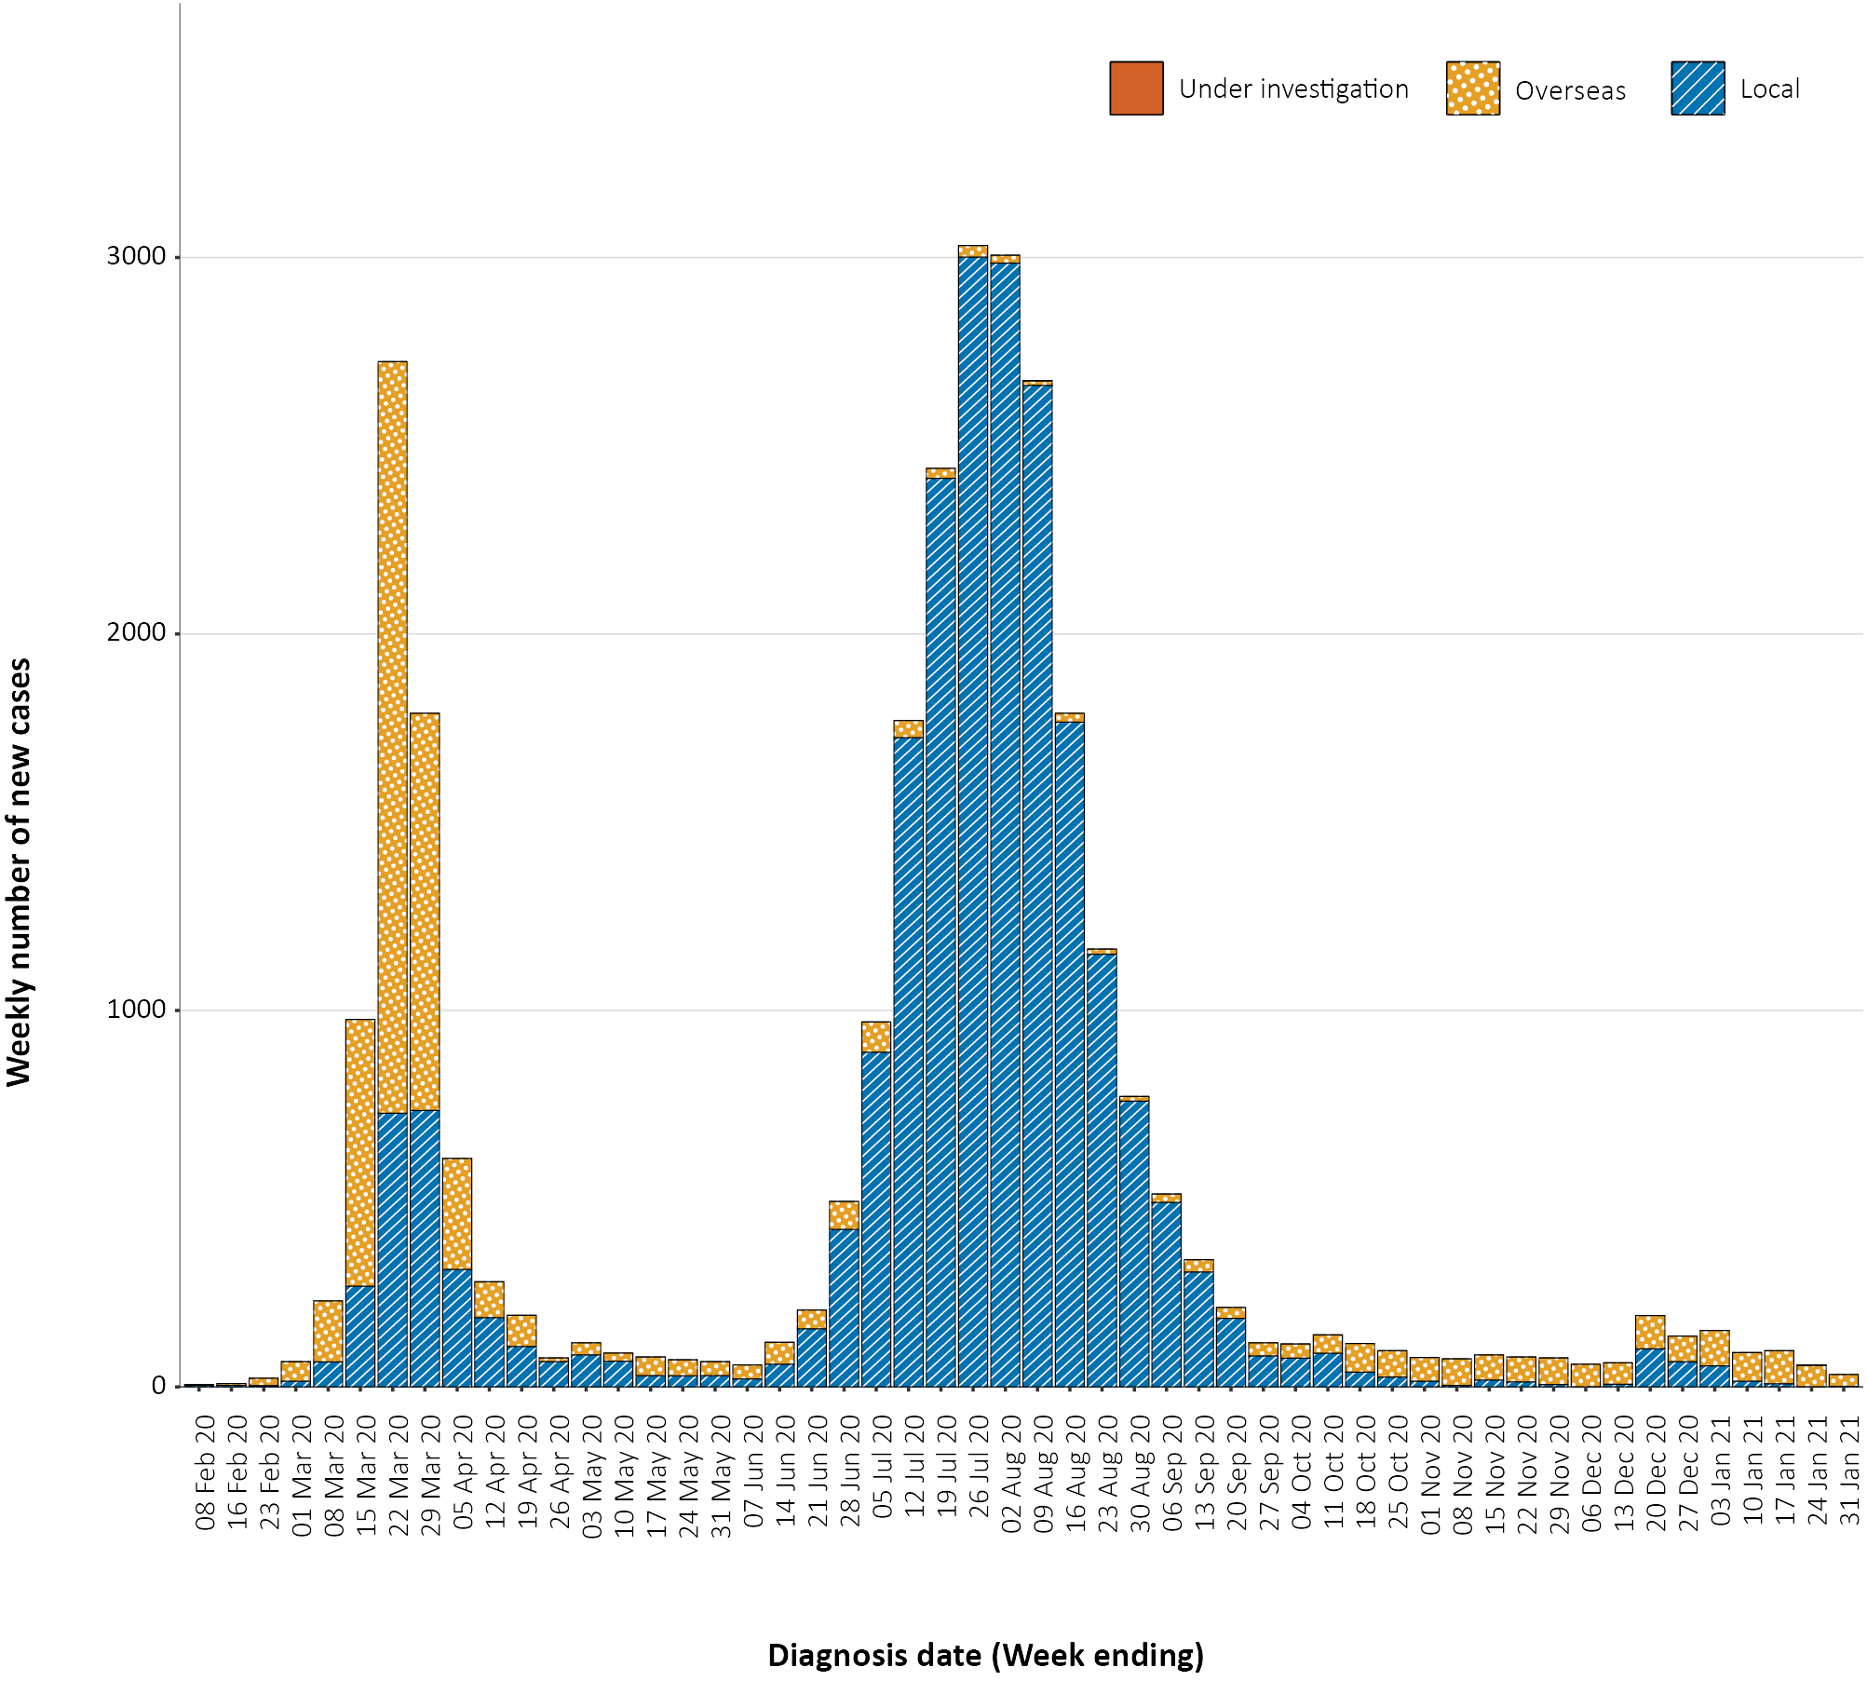
a Source: NNDSS.

Table 1: COVID-19 notifications by jurisdiction and source of acquisition, Australia, 18–31 January 2021
Source | NSW | Vic. | Qld | WAª | SA | Tas. | NT | ACT | Australia
Overseas | 33 | 26 | 10 | 8 | 2 | 0 | 2 | 0 | 81
Local — source known | 0 | 0 | 0 | 0 | 0 | 0 | 0 | 0 | 0
Local — source unknown | 0 | 0 | 0 | 0 | 0 | 0 | 0 | 0 | 0
Local — interstate | 0 | 0 | 0 | 0 | 0 | 0 | 0 | 0 | 0
Under investigation | 0 | 0 | 0 | 1 | 0 | 0 | 0 | 0 | 1
Total | 33 | 26 | 10 | 9 | 2 | 0 | 2 | 0 | 82
a Western Australia’s locally-acquired infection was classified as under investigation at the time of reporting.

Source of acquisition

(NNDSS)
In this reporting period, the majority of cases were reported as overseas acquired (99%; 81/82). There were no locally-acquired cases, a decrease from 23 locally-acquired cases in the previous fortnight. At the end of this reporting period, one case linked to a hotel quarantine setting in Western Australia was under investigation (Table 1).
Cumulatively, the infection rate to date for all locally-acquired cases was highest in Victoria with 294 infections per 100,000 population (Table 2). The rate of infection in Tasmania was 27.9 infections per 100,000 population, largely as a result of an outbreak in North West Tasmanian hospitals in April 2020, which represented half of all their cases. Nationally, it has been 16 days since there was a locally-acquired case of unknown source (Table 3).
Table 2: Locally-acquired COVID-19 case numbers and rates per 100,000 population by jurisdiction and reporting period, Australia, 31 January 2021
Jurisdiction | Reporting period  4–17 January 2021 | Reporting period  18–31 January 2021 | Cumulative cases  23 January 2020 – 31 January 2021
 | Number of cases | Number of cases | Number of cases | Rate per 100,000 population
NSW | 17 | 0 | 2,176 | 26.9
Vic. | 2 | 0 | 19,387 | 294.0
Qld | 4 | 0 | 302 | 5.9
WAª | 0 | 0 | 98 | 3.7
SA | 0 | 0 | 184 | 10.5
Tas. | 0 | 0 | 149 | 27.9
NT | 0 | 0 | 6 | 2.4
ACT | 0 | 0 | 29 | 6.8
Australia | 23 | 0 | 22,331 | 88.1
a Western Australia’s locally-acquired infection was classified as under investigation at the time of reporting.
Table 3: Days since last locally-acquired COVID-19 case (source known and source unknown), by jurisdiction, reported by notification received date, 31 January 2021
Jurisdiction | Locally acquired — source unknown |  | Locally acquired — source known
 | Date of last case | Days since last case | Date of last case | Days since last case
NSW | 15 January 2021 | 16 | 16 January 2021 | 15
Vic. | 5 January 2021 | 26 | 4 January 2021 | 27
Qld | 26 August 2020 | 158 | 12 January 2021 | 19
WAª | 12 April 2020 | 294 | 3 January 2021 | 28
SA | 15 April 2020 | 291 | 29 November 2020 | 63
Tas. | 11 August 2020 | 173 | 6 May 2020 | 270
NT^{b} | NA | NA | 4 April 2020 | 302
ACT | 28 March 2020 | 309 | 9 July 2020 | 206
a Western Australia’s locally-acquired infection was classified as under investigation at the time of reporting.
b The Northern Territory has not reported any locally-acquired cases with an unknown source of infection.
In this reporting period, the largest number of overseas-acquired cases was reported in New South Wales (41%; 33/81), followed by Victoria (32%; 26/81). The higher number of overseas-acquired cases reported in New South Wales and Victoria reflects the number of managed international arrivals there.
In this reporting period, the largest numbers of overseas-acquired cases were from the United States of America (36%; 29/81) followed by United Kingdom (17%; 14/81) and India (15%; 12/81), which is similar to the previous reporting period. The number of cases by country is influenced by travel patterns of returning Australians as well as by the prevalence of COVID-19 in the country the person is arriving from.

Demographic features

(NNDSS)
In this reporting period, the largest number of cases occurred in those aged 40 to 49 years (19/82 cases). For all notifications to date, the highest rate of infection was in those aged 90 and over with a rate of 386.8 per 100,000 population (Appendix A, Table A.1). Children under 10 years old had the lowest rate of infection (47.4 cases per 100,000 population). This age group also reported the lowest testing rate in the reporting period, approximately half that of those aged 30–39 years old.
Cumulatively, the male-to-female rate ratio of cases was approximately 1:1 in most age groups. Notification rates were higher among females than among males in the 20–29 years age group and those aged ≥ 80 years old, and higher among males than among females in the 70–79 years age group (Figure 2). The largest difference in cumulative rates was in the 90 years and over age group, where the cumulative rate among males was 333.7 cases per 100,000 population and among females 413.3 cases per 100,000 population (Appendix A, Table A.1).

Figure 2: Cumulative COVID-19 cases, by age group and sex, Australia, 23 January 2020 to 31 January 2021
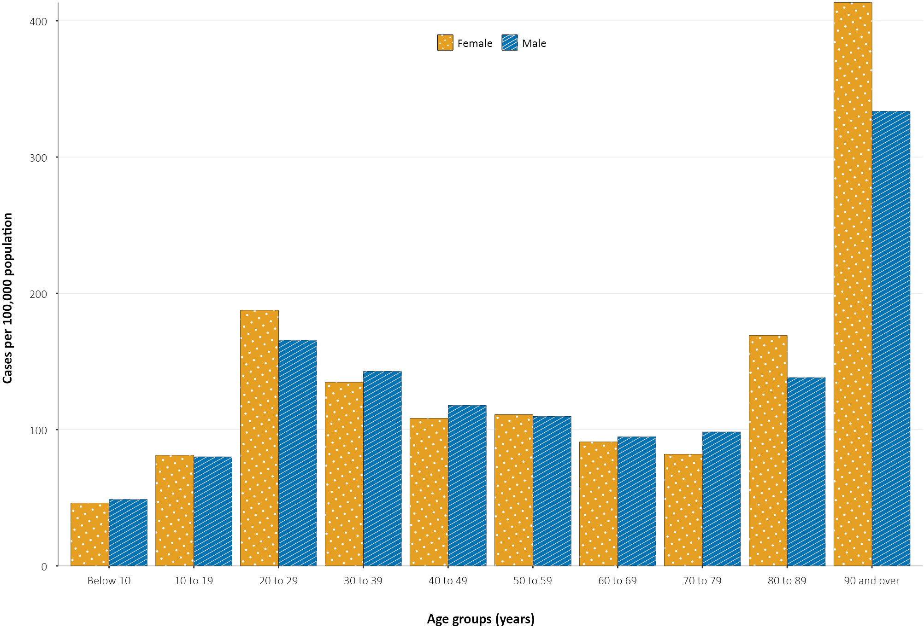
Since the beginning of the epidemic in Australia, the median age of all cases was 37 years (interquartile range, IQR: 25–56) which has not changed since the beginning of August. Prior to 1 June 2020, COVID-19 cases were slightly older, with a median age of 46 years (IQR: 29–62), associated with a high proportion of cases having a recent travel history or acquisition on a cruise ship. In cases reported after 1 June 2020, the median age was 34 years (IQR: 23–53) reflecting transmission in the community and across a range of settings, especially in Victoria. The median age of cases in this reporting period was 33 years (IQR: 22–43).

Aboriginal and Torres Strait Islander persons

(NNDSS)
There have been 151 confirmed cases of COVID-19 notified in Aboriginal and Torres Strait Islander people since the beginning of the epidemic. Three additional Aboriginal and Torres Strait Islander cases were notified in the reporting period, two of which acquired their infection overseas and a third which was a historical case from South Australia’s cluster of locally-acquired cases in November 2020. This represents approximately 0.5% (151/28,794) of all confirmed cases. Table 4 compares the remoteness of cases in Aboriginal and Torres Strait Islander people with those in the non-Indigenous population.

Table 4: COVID-19 notifications by Aboriginal and Torres Strait Islander status by jurisdiction, source of acquisition and remoteness classification, Australia, 31 January 2021
 | Locally acquired |  |  |  | Interstate acquired | Overseas acquired | Unknownª | Total
 | Major Cities of Australia | Inner Regional Australia | Outer Regional Australia | Remote / Very Remote Australia
Aboriginal and  Torres Strait Islander | 91 | 15 | 6 | 1 | 4 | 33 | 1 | 151
non-Indigenous | 20,678 | 915 | 219 | 16 | 147 | 6,454 | 214 | 28,643
a Includes 26 non-Indigenous cases classified as overseas residents who were diagnosed in Australia.
The median age of COVID-19 cases in Aboriginal and Torres Strait Islander people was 31 years old (IQR: 21–49), which was younger than for non-Indigenous cases where the median age was 37 years old (IQR: 25–56).
The notification rate across all age groups was higher in non-Indigenous people than in Aboriginal and Torres Strait Islander people (Figure 3). The age-standardised Aboriginal and Torres Strait Islander:non-Indigenous notification rate ratio was 0.2, indicating that the Aboriginal and Torres Strait Islander population had a lower COVID-19 case rate than the non-Indigenous population after accounting for differences in age structure. Amongst Aboriginal and Torres Strait Islander cases, the highest notification rate was in those aged 70–79 years (36.0 cases per 100,000 population), followed by the 60–69 years age group (34.4 cases per 100,000 population). Similar to non-Indigenous cases, children aged 0–9 years had the lowest notification rate among Aboriginal and Torres Strait Islander cases (6.9 cases per 100,000 population).

Figure 3: National COVID-19 notification rate per 100,000 population by age group, Aboriginal and Torres Strait Islander people and non-Indigenous people, Australia, 23 January 2020 – 31 January 2021
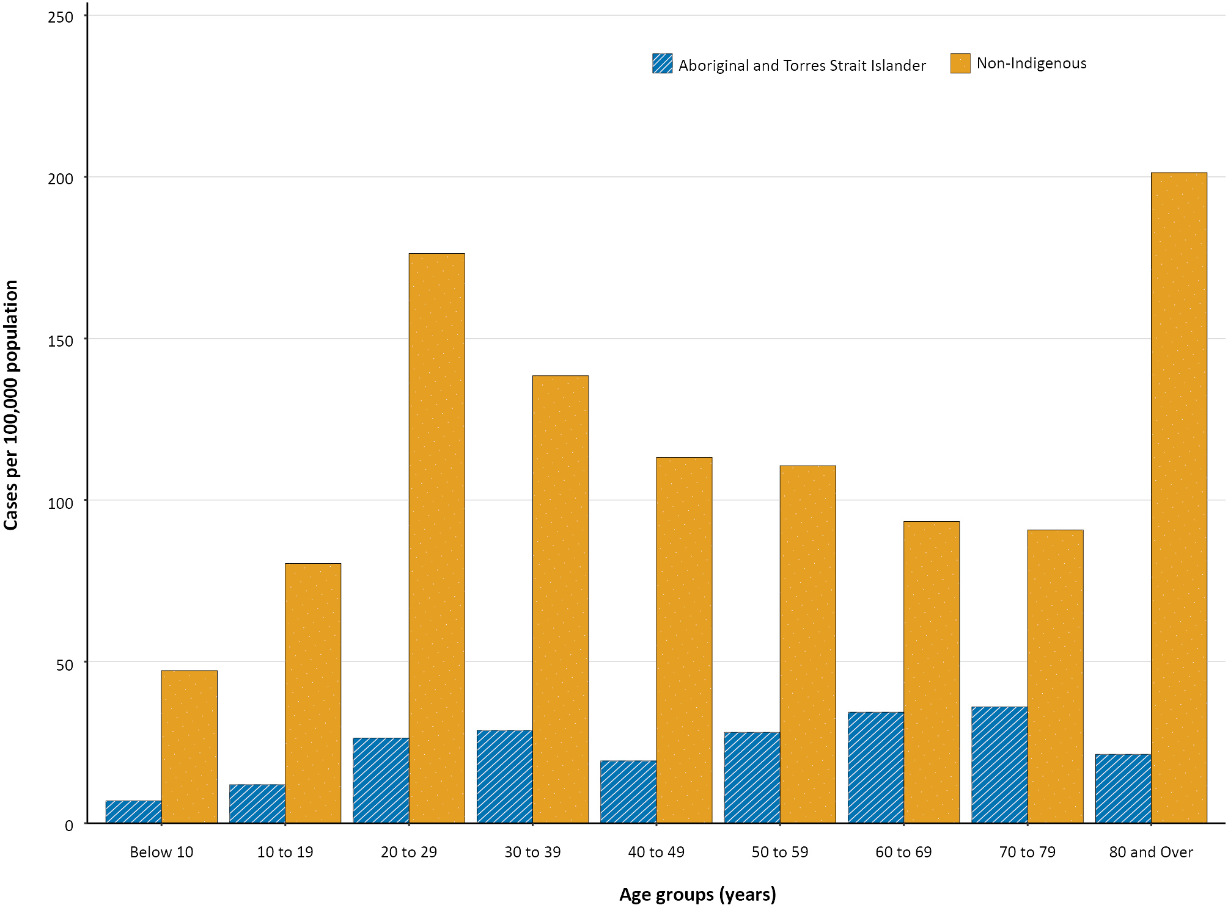

Testing

(State and territory reporting)
As at 31 January 2021, a cumulative total of 12,951,776 tests were conducted in Australia. The cumulative nationwide proportion of positive tests remained low at 0.2% (Table 5). With the exception of Victoria, the cumulative testing positivity in individual jurisdictions was < 0.2%.

Table 5: Diagnostic tests performed, by jurisdiction, Australia, 31 January 2021
Jurisdiction | Tests performed  4–17 January 2021 |  |  | Tests performed  18–31 January |  |  | Cumulative tests performed  to 31 January
 | n | Positivity (%) | Per 1,000 populationª | n | Positivity (%) | Per 1,000 populationª | n | Positivity (%) | Per 1,000 populationª
NSW | 302,550 | 0.04 | 37.4 | 156,936 | 0.03 | 19.4 | 4,629,852 | 0.11 | 572.6
Vic | 322,323 | 0.01 | 48.9 | 205,001 | 0.01 | 31.1 | 4,457,139 | 0.46 | 676
Qld | 193,106 | 0.02 | 37.9 | 83,079 | 0.02 | 16.3 | 1,764,500 | 0.07 | 346.5
WA | 56,875 | 0.04 | 21.7 | 38,637 | 0.04 | 14.7 | 721,959 | 0.12 | 275.4
SA | 71,460 | 0.02 | 40.8 | 43,451 | 0.01 | 24.8 | 961,700 | 0.06 | 548.8
Tas | 8,518 | 0.00 | 15.9 | 5,648 | 0.00 | 10.6 | 159,086 | 0.15 | 297.6
NT | 10,023 | 0.12 | 40.7 | 8,498 | 0.06 | 34.5 | 101,772 | 0.10 | 413.5
ACT | 12,369 | 0.00 | 29.0 | 4,572 | 0.00 | 10.7 | 155,768 | 0.08 | 365.5
Australia | 977,224 | 0.02 | 38.5 | 545,822 | 0.02 | 21.5 | 12,951,776 | 0.22 | 510.8
a Population data based on Australian Bureau of Statistics (ABS) Estimated Resident Population (ERP) as at 30 December 2019
During this reporting period, 545,822 tests were conducted nationally, with a positivity rate of 0.02%. This represented a 44% decrease in tests conducted compared to the previous two-week reporting period; this decrease was consistent across all jurisdictions. Testing rates also decreased to an average of 10.8 tests per 1,000 population per week during this reporting period, consistent with a decrease in locally-acquired cases this period. Jurisdictional testing rates are driven by both current case numbers and numbers of people experiencing symptoms. All states reported a positivity rate of < 0.1% in this reporting period. The low national positivity rate, along with high rates of testing, indicates a low prevalence of COVID-19 nationally.
For the two-week period ending 31 January 2021, testing rates decreased among all age groups after a peak in early January (Figure 4). Testing rates among children and young adults aged 0–19 years tend to be lower than those of other age groups. Testing rates are highest in major cities and urban areas of Australia; lower testing rates, with little variation between classification areas, are seen across regional and remote areas across Australia.

Figure 4: SARS-CoV-2 polymerase chain reaction (PCR) testing rates per 1,000 population per week by age group, Australia, 1 May 2020 – 29 January 2021^{a,b}
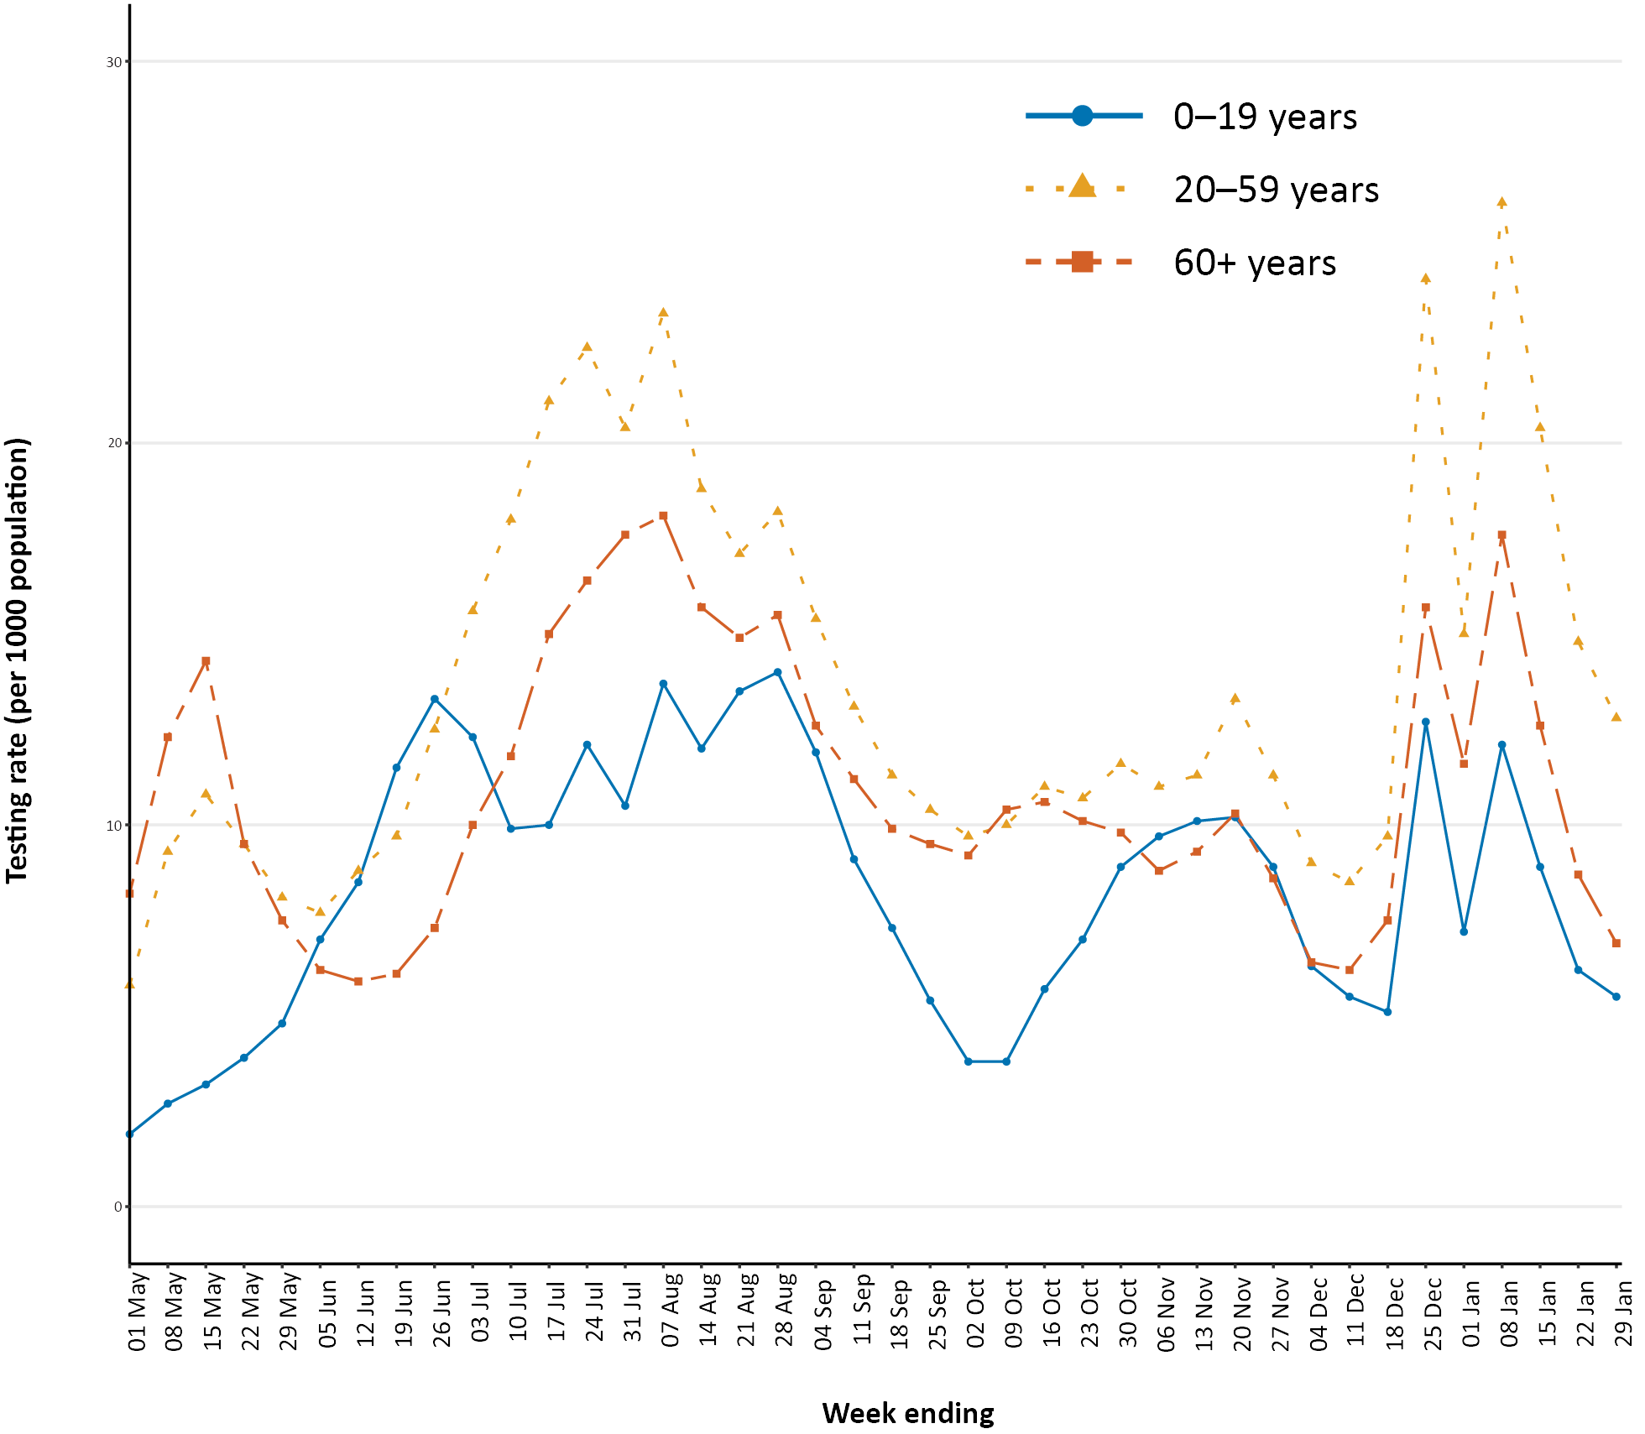
a Data provided by jurisdictions to the NIR weekly.
b The jurisdictions reporting each week (i.e. the denominator population) may vary.

Virology

(GISAID)
At the time of this report, there were 17,292 SARS-CoV-2 genome sequences available from Australian cases on the global sequence repository, GISAID.² These sequences were dispersed throughout the global lineages, reflecting multiple concurrent introductions into Australia.^{3–5} In this fortnight, there were 14 new Australian sequences uploaded to GISAID, which was a decrease from the previous fortnight (92), noting that sequences are uploaded retrospectively. Uploads to GISAID this fortnight were from New South Wales (5) and Victoria (9). Half (7/14) of all sequences on GISAID this fortnight were of the United Kingdom (UK) variant of concern (B.1.1.7 lineage).
Across Australia, there have been 38 uploaded sequences of the UK variant of concern in the last four weeks: Victoria (19); New South Wales (8); Western Australia (5); South Australia (1); and 5 sequences of this lineage with no jurisdictional information. Since 30 November 2020, there have been 64 sequences of this lineage uploaded. There were four sequences of the South African variant of concern (B.1.351) uploaded to GISAID in the past four weeks, three from New South Wales and one from South Australia, bringing the cumulative total on GISAID to eight sequences. It is important to note that there may be delays between jurisdictional reporting and uploads. All cases of these variants of concern have been linked to overseas arrivals in mandatory hotel quarantine. Australia has reported no cases of the P.1 Brazilian variant of concern. National genomic surveillance of SARS-CoV-2 has been implemented and laboratories across Australia are routinely monitoring sequences for variant strains.

Four-week reporting period (4–31 January 2021):

Acute respiratory illness

(FluTracking and Commonwealth Respiratory Clinics)
Based on self-reported FluTracking data,⁶ prevalence of fever and cough in the community remains low at less than 0.5% (Figure 5). Runny nose and sore throat symptoms in the community remained stable during this reporting period and the prevalence in the community remained at less than 1%.
Figure 5: Weekly trends in respiratory illness amongst FluTracking survey participants (age-standardised) compared to the average of the previous five years, Australia, 1 March 2020 – 31 January 2021ª
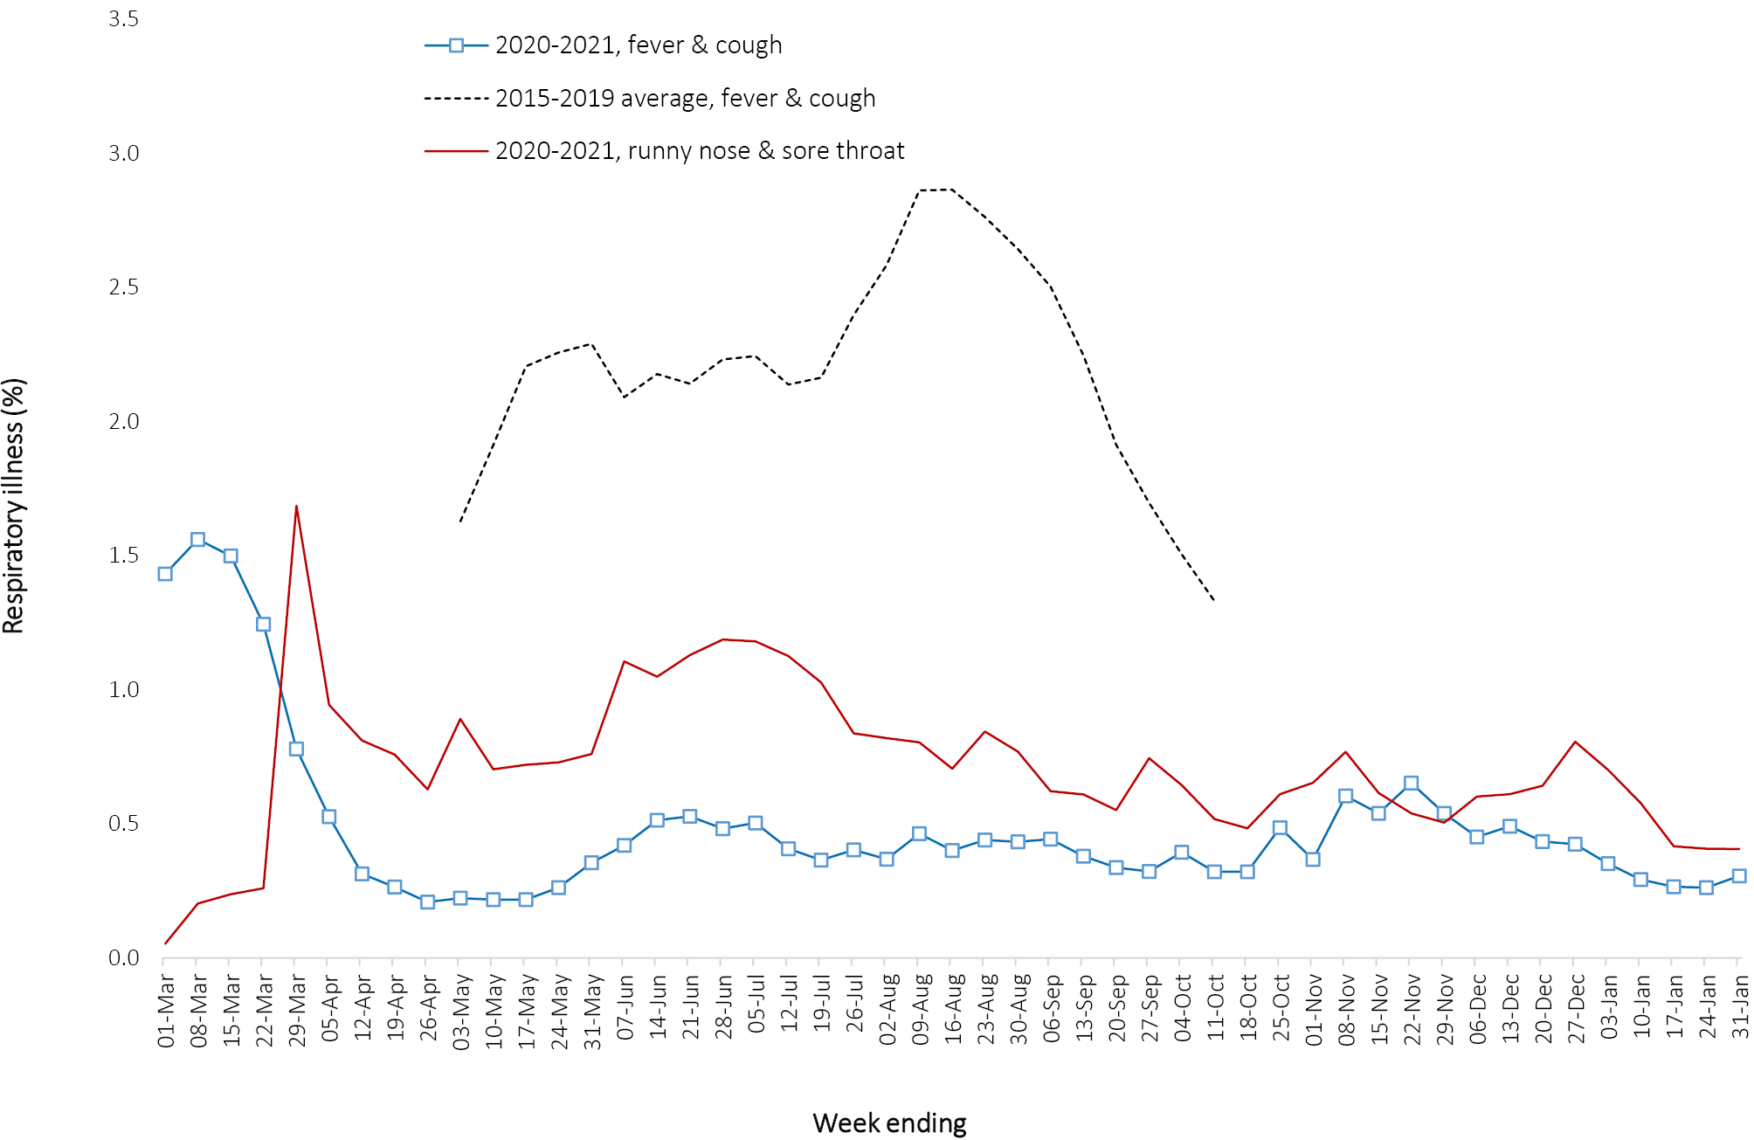
a In previous years, FluTracking was activated during the main Influenza season from May to October. A historical average beyond the week ending 11 October is therefore not available. In 2020, FluTracking commenced 10 weeks early to capture data for COVID-19. Data on runny nose and sore throat were only collected systematically after 29 March 2020, therefore a historical average for this symptom profile is unavailable.
In this reporting period, acute respiratory illness was highest in those aged under 40 years old, based on both self-reported FluTracking data and presentations to Commonwealth Respiratory Clinics. Females reported respiratory illness more frequently than males. Rates of fever and cough by jurisdiction ranged from 1.1/1,000 FluTracking participants in the Australian Capital Territory to 4.2/1,000 participants in the Northern Territory.
FluTracking data indicate that 61% of those in the community with ‘fever and cough’ and 29% of those with ‘runny nose and sore throat’ were tested for SARS-CoV-2. This represents an increase in testing among those with ‘fever and cough’ since the previous reporting period and a decrease in testing among those self-reporting ‘sore throat and runny nose’. Testing rates varied by jurisdiction and symptom. For fever and cough, rates were lowest in the Australian Capital Territory and highest in Northern Territory. For runny nose and sore throat, rates were lowest in Tasmania and highest in the Australian Capital Territory and Queensland. It is important to acknowledge that there may be legitimate reasons why people did not get tested, including barriers to accessing testing. Symptoms reported to Flutracking were not specific to COVID-19 and may also be due to chronic diseases.
During this reporting period, there were 23,846 assessments at Commonwealth Respiratory Clinics with 95% tested for SARS-CoV-2. The positivity rate for SARS-CoV-2 at these clinics was < 0.1% for this reporting period.
In patients experiencing influenza-like illness in this reporting period who were tested through the Australian Sentinel Practice Research Network (ASPREN) and Victorian Sentinel Practice Influenza Network (VicSPIN) general practitioner (GP) sentinel surveillance systems, the most frequent respiratory viruses detected were respiratory syncytial virus (RSV).
Based on FluTracking data, the rate of self-reported fever and cough among Aboriginal and Torres Strait Islander peoples was higher than that of all other participants this reporting period. The rate for health care worker participants during the reporting period was similar to that observed for all other participants based on FluTracking data.
Based on all presentations to Commonwealth Respiratory Clinics to date, the principal symptoms reported in COVID-19 cases were cough, sore throat, tiredness, runny nose, and fever.

Severity

(NNDSS, FluCAN)
Based on NNDSS data, the proportion of all COVID-19 cases hospitalised to date remains at 13%. It should be noted that cases may be hospitalised for isolation purposes and not severe disease. Since 16 March 2020, FluCAN has recorded 473 COVID-19 cases hospitalised in sentinel sites,⁷ of which 92 (19%) have been subsequently admitted to an intensive care unit (ICU). There have been no hospital admissions for confirmed COVID-19 cases in participating sites since the last severity report (COVID-19 epidemiology report 32: data to 3 January 2021).⁸

Length of hospital stay
Length of hospital stay for patients with confirmed COVID-19 increases with advancing age category (Table 6). For those discharged alive (n = 375), the median length of stay remains at 8 days (IQR: 3.0–13.0); mean (sd) = 10 days (11.6); this has not changed compared to the previous severity report (data to 3 January, 2020),⁸ with the discharge status of only six cases updated in the intervening four-week period. Length of stay in ICU for survivors can be found in a previous severity report (data to 22 November, 2021).⁹

Table 6: Hospital length of stay for confirmed COVID-19 cases discharged alive from sentinel sites Australia between March 16 2020 and 3 January 2021ª
Age group (years) | Hospital length of stayª
 | n | Median (IQR) | Mean (SD)
< 18 | 41 | 2.0 (1.0–7.0) | 4.9 (6.6)
18–39 | 82 | 5.0 (2.0–10.0) | 7.0 (7.0)
40–59 | 108 | 8.0 (4.0–14.5) | 11.0 (16.1)
60–79 | 99 | 10.0 (6.0–15.0) | 11.9 (10.9)
≥ 80 | 45 | 12.0 (8.0–16.0) | 12.6 (7.3)
a Source: FluCAN. Includes patients with a discharge outcome (n = 375).

Characteristics of those with severe COVID-19 disease
The median age of cases who have been hospitalised in sentinel sites since 16 March 2020 (58 years; IQR: 37–73) and admitted to ICU (59 years; IQR: 47–68) was higher than for cases overall (37 years; IQR: 25–56). The ratio of males to females (1.2:1) remains stable for hospitalised cases, with slightly higher admissions for males. Of those hospitalised in sentinel sites (n = 475),⁷ six (1.3%) were identified as Aboriginal and Torres Strait Islander people (1 unknown and 8 missing data; > 98% completeness). Comorbidity and other risk factor analysis can be found in a previous severity report (data to 25 October 2020).¹⁰ We have not updated risk factor data in the present report, as hospital cohorts have remained largely unchanged in the intervening weeks.

COVID-19 deaths
Overall, the crude case fatality rate (CFR: 3.1%, Table 7) is slightly decreased compared to that reported previously (3.2%; data to 3 January),⁸ with no cases updated in NNDSS in this time as having died. The highest CFR remains in males over the age of 80 years (41.1%), particularly those admitted to hospital (46.9%). For hospitalised cases, the total number who have died in hospital remains unchanged since the last severity report (data to 3 January, 2020).⁸ The CFR rate amongst those admitted to ICU was last reported in issue 30 (13.2%; data to 22 November).⁹
Table 7: Number of fatalities and CFR for all cases and for hospitalised cases, by age group and sex, Australia, 31 January 2021
 | All casesª  n (CFR) |  |  | Hospitalisation^{b}  n (CFR)
 | Male | Female | Persons | Male | Female | Persons
Total | 440 (3.1) | 469 (3.2) | 909 (3.1) | 27(12.0) | 21 (10.6) | 48 (11.3)
< 50 | 5 (0.1) | 0 (0.0) | 5 (0.0) | 0 (0.0) | 0 (0.0) | 0 (0.0)
50–64 | 19(0.8) | 10 (0.4) | 29 (0.6) | 1 (1.9) | 3 (7.9) | 4 (4.4)
65–79 | 119(8.8) | 63 (5.0) | 182 (7.0) | 11 (21.2) | 2 (6.5) | 13 (15.7)
80+ | 297(41.1) | 396(29.7) | 693 (33.7) | 15 (46.9) | 16 (36.4) | 31 (40.8)
a Source: NNDSS. (Total cases = 28,801).
b Source: FluCAN. Includes 21 sentinel hospitals. (Total cases = 424).

Clusters and outbreaks

(State and territory reporting)
For the four-week period ending 31 January 2021, there were 25 newly-reported outbreaks associated with 98 cases reported to COVID-Net. The majority of these outbreaks were retrospectively reported by Victoria (21) and Western Australia (1). Outbreaks also occurred in the Northern Territory (2) and Queensland (1). Outbreaks occurred in education (10), disability services (5), workplace/industry (3), travel and transport (3), ‘other’ settings (2), hospitality and entertainment (1) and childcare (1). As at the end of the reporting period, there were no open outbreaks.
Nationally, since the beginning of the epidemic, there have been 859 outbreaks associated with 14,022 cases; 2,061 hospitalisations; and 800 deaths. Consistent with the national epidemic case trend, the first peak in outbreaks occurred in mid-March. This was followed by a rapid increase in outbreaks which began in early July, corresponding with community transmission in Victoria.
The median number of cases in each outbreak was six (range 2–331). Forty percent (342/859) of outbreaks had 6–24 cases, and almost a third (32%, 279/859) had only 3–5 cases. The number of cases associated with outbreaks was consistent across the two peaks in mid-March and July. The largest single jurisdictional outbreak occurred in a residential aged care facility and was associated with 301 cases.
The largest number of outbreaks occurred in workplace/industry settings (191/859, 22% outbreaks; 1,583/14,022, 11% cases), followed by educational facilities (122/859, 14% outbreaks; 1,189/14,022, 8% cases), aged care facilities (114/859, 13% outbreaks; 5,275/14,022, 38% cases), and hospitals (83/859, 10% outbreaks; 1,326/14,022, 9% cases) (Figure 6). Despite having a low percentage of outbreaks (34/859, 4%), food industry settings had a substantial amount of cases (1,129/14,022, 8%). The ‘other’ category includes various settings not captured by the other exposure settings, e.g. extended family gatherings (where two or more separate households come together); religious services; hostels; sports and recreation venues; cruise ships and other mass transport.

Figure 6: Number of outbreaks and cases by setting, Australia, 31 January 2021
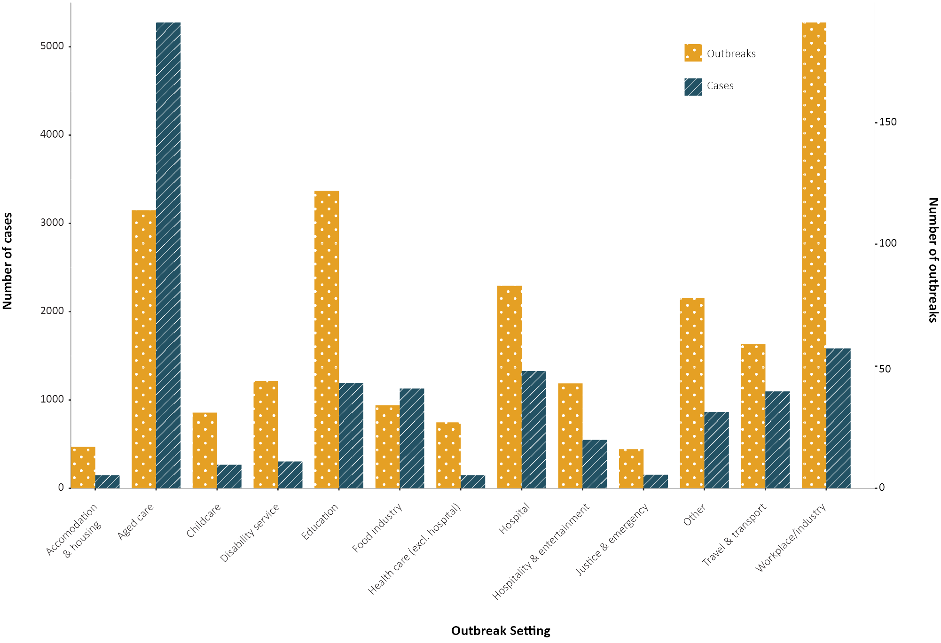
Residents of aged care facilities are at increased risk of COVID-19 infection due to the environment of communal living facilities and are more vulnerable to serious complications if they do become infected. As at 31 January 2021, there have been 4,291 cases of COVID-19 associated with 220 residential aged care facilities, with 3,606 recoveries and 685 deaths. Of these cases, 2,051 occurred in aged care residents, with the remaining 2,240 cases occurring in care staff. The Commonwealth is actively supporting services with reported incidents and outbreaks of COVID-19 providing access to personal protective equipment and additional staffing resources where required. Advice and guidelines have been provided to aged care services, including the release of an outbreak management guide.^{11,12}

Public health response measures
Since COVID-19 first emerged internationally, Australia has implemented public health measures informed by the disease’s epidemiology (Figure 7). States and territories have decision-making authority in relation to public health measures and have implemented or eased restrictions at their own pace (Table 8), depending on the local public health and epidemiological situation, and in line with the ‘Framework for National Reopening’.¹³ During the current reporting period, there have been short-term lockdowns in Queensland and Western Australia in response to cases of COVID-19 that have been identified as variants of concern. Nationally, there have been a range of new public health measures in response to variants of concern,¹⁴ including the introduction of pre-flight testing for travellers entering Australia and requirements to wear masks when travelling domestically or internationally.

Table 8. State and territory changes to COVID-19 restrictions, Australia, 4–31 January 2021
Jurisdiction | Summary of changes to COVID-19 restrictions
New South Wales | From 10 January, New South Wales eased restrictions for the Northern Beaches hotspot in line with restrictions for Greater Sydney.¹⁵  From 29 January, New South Wales eased restrictions for Greater Sydney:  - Cap of 30 visitors per day in private households  - Gatherings of up to 50 people permitted in outside public places  - Gatherings of up to 300 people permitted at weddings and funerals  - Up to 25 permitted in hospitality venues before density restrictions apply  - Face masks required in select indoor settings.
Victoria | From 17 January, the following restrictions were eased:¹⁶  - Cap of 30 visitors per day in private households  - Gatherings of up to 100 people permitted in outside public places  - Up to 25 permitted in hospitality venues before density restrictions apply  - No cap on the number of attendees at weddings, funerals and religious gatherings (density restrictions apply)  - Face masks no longer mandatory in all indoor settings (required in some settings)
Queensland | On 8 January, Greater Brisbane entered a three day lockdown in response to a case of variant B.1.1.7. Individuals were required to stay home unless:¹⁷  - Shopping for essential items  - Medical or healthcare needs including emergency situations and to escape harm  - Exercise with up to one other person  - Work, volunteering or study when remote work is not possible  From 11 January, lockdown restrictions in Greater Brisbane eased, however restrictions remained for:  - Mandatory requirement to wear face masks in some settings  - Venue capacity restrictions  From 22 January, the following restrictions were eased for the entirety of Queensland:¹⁸  - Cap of 50 visitors in private households  - Gatherings of up to 100 people permitted in public places (with density restrictions)  - Gatherings of up to 200 permitted at weddings and funerals  - Up to 1500 permitted at outdoor major events and 500 permitted in indoor major events
Western Australia | From 31 January, Perth metropolitan area and the Peel and South West regions entered a 5-day lockdown following a case in a hotel quarantine worker. Individuals were required to stay home unless:¹⁹  - Shopping for essential items  - Medical or healthcare needs  - Exercise with up to one other person in their neighbourhood  - Work if working from home or remotely is not an option
South Australia | No further easing of restrictions during this reporting period.²⁰
Tasmania | No further easing of restrictions during this reporting period.²¹
Australian Capital Territory | No further easing of restrictions during this reporting period.²²
Northern Territory | No further easing of restrictions during this reporting period.²³

Figure 7: COVID-19 notifications in Australia by week of diagnosis and jurisdiction to 31 January 2021 with timing of key public health measures
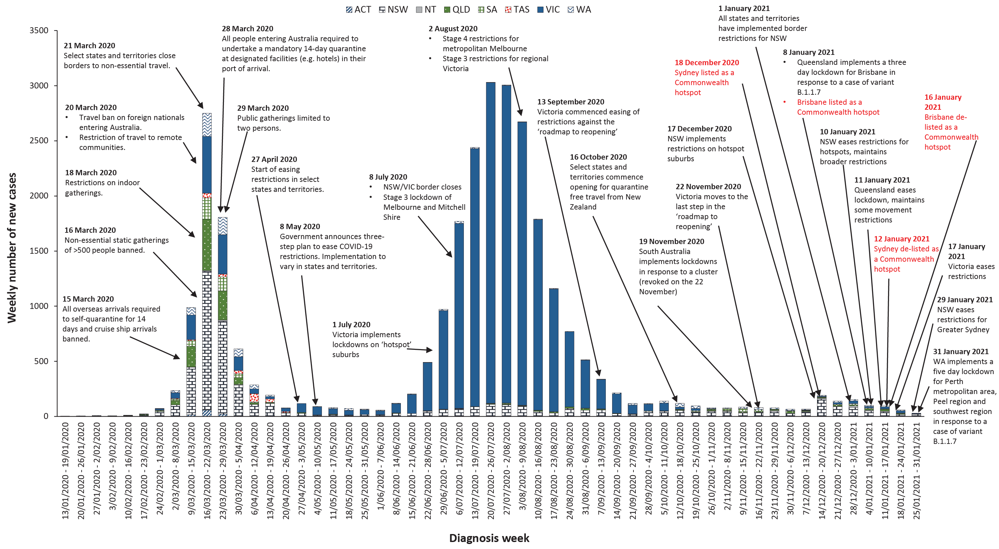

Countries and territories in Australia’s near region
According to the World Health Organization (WHO), as of 31 January 2021, 46 countries and territories in Australia’s near region (WHO’s South East Asia (SEARO) and Western Pacific (WPRO) regions) reported 1,113,019 newly-confirmed cases and 17,514 deaths in the four-week reporting period since 4 January 2021, bringing the cumulative cases in the two regions to 14.3 million and 222,295 cumulative deaths.²⁴ In the Western Pacific, both new case numbers and deaths have increased by 55.2% and 67.6%, respectively, in the last four weeks compared to the previous four-week period. Conversely, cases and deaths in South East Asia have decreased this four-week period by 17.8% and 17.6% respectively, compared to the figures for the preceding four-week period.
Countries in the regions that reported the highest number of new cases were:
- India reported 38% fewer new cases and 48% fewer deaths this reporting period compared to the previous four weeks (422,218 new cases since 4 January; 10,746,183 cumulative cases; 4,839 new deaths; 154,274 cumulative deaths);
- Indonesia reported an increase in new cases of around 63% and a 44% increase in deaths compared to the previous four weeks (307,840 new cases since 4 January; 1,066,313 cumulative cases; 7,173 new deaths; 29,728 cumulative deaths);
- Bangladesh reported a decreasing trend in new cases of around 50% this reporting period. Deaths are also becoming fewer with 35% fewer deaths in the past four weeks compared to the previous four-week period. (19,586 new cases since 4 January; 534,770 cumulative cases; 512 new deaths; 8,111 cumulative deaths).
- Japan reported an 80% increase in new cases this reporting period compared to the previous four-week period. More than a third of Japan’s deaths from COVID-19 have taken place in the past four weeks (145,788 new cases since 4 January; 386,742 cumulative cases; 2,106 new deaths; 5,654 cumulative deaths).
- Malaysia reported a 101% increase in new cases this reporting period compared to the previous four-week period, with reported deaths from COVID-19 this reporting period increasing by 155% (92,288 new cases since 4 January; 209,661 cumulative cases; 263 new deaths; 746 cumulative deaths). Over a third of Malaysia’s deaths have taken place in the past four weeks.
Countries such as Fiji, the Solomon Islands, Marshall Islands, New Caledonia are detecting cases mainly among international arrivals while in quarantine, thus preventing further transmission into the community. Of note since the last report, New Zealand reported three cases who acquired their infection in a hotel quarantine setting, all of which were the South African variant 20C/501Y.V2 (lineage B.1.351). Fifteen Pacific Island countries reported no new cases in the past month.
Table 9 outlines the current Transmission Classification set by WHO for Australia’s near region. Under the WHO’s classification Australia has a transmission classification of ‘cluster of cases’.

Table 9: Transmission patterns for countries in Australia’s near region, WHO, 31 January 2021ª
Category | Country
No cases  Countries/territories/areas with no cases | American Samoa, Cook Islands, Democratic People’s Republic of Korea, Kiribati, Marshall Islands, Federated States of Micronesia, Nauru, Niue, Palau, Pitcairn Islands, Samoa, Solomon Islands, Tokelau, Tonga, Tuvalu and Vanuatu
Sporadic cases  Countries/territories/areas with one or more cases, imported or locally detected | Brunei Darussalam, Cambodia, Fiji, French Polynesia, Lao PDR, New Caledonia, Singapore, Timor-Leste, Wallis and Futuna
Clusters of cases  Countries/territories/areas experiencing cases, clustered in time, geographic location and/or by common exposures | Australia, Bhutan, China, Guam, India, Japan, Malaysia, Maldives, Mongolia, Myanmar, Nepal, New Zealand, Republic of Korea, Sri Lanka, Thailand, and Vietnam
Community transmission  Countries /territories/areas experiencing larger outbreaks of local transmission defined through an assessment of factors including, but not limited to:  large numbers of cases not linkable to transmission chains  large numbers of cases from sentinel lab surveillance or increasing positive tests through sentinel samples (routine systematic testing of respiratory samples from established laboratories) multiple unrelated clusters in several areas of the country/territory/area. | Bangladesh, Indonesia, Papua New Guinea and Philippines
a Classifications are as indicated in reference 25.
Globally, reported new cases have declined in the past four weeks; however, deaths have gradually increased in the same period. To date, over 102 million COVID-19 cases and 2.2 million deaths have been reported globally. Two regions continue to carry the largest burden of disease, with the Region of the Americas accounting for around 50.7% of all new cases and 46.7% all newly reported deaths and Europe accounting for 35.8% of all new cases and 40.3% of newly reported deaths. The highest number of new cases in the past four weeks was in the United States of America (5,702,199; 17,180 new cases per 1 million population), which reported almost five times the number of the confirmed cases reported in the country with the second highest number of new cases, Brazil (1,417,935; 6,671 new cases per 1 million population). This was followed by the United Kingdom (1,143,945; 17,017 new cases per 1 million population), the Russian Federation (613,652; 4,255 new cases per 1 million population), and France (527,224; 7,817 new cases per 1 million population). The highest number of deaths from COVID-19 in the last four weeks was reported in the United States of America (87,920) which reported more than two times the number of deaths seen in the next highest country, Mexico (30,072). The next highest death tolls for this four-week period were reported in the United Kingdom (28,556), Brazil (27,255) and Germany (22,673).
An international summary by WHO Region can be found in the WHO Epidemiological Update dated 3 January 2021.^{24,25}

Acknowledgements
We thank public health staff from incident emergency operations centres and public health units in state and territory health departments, and the Australian Government Department of Health, along with state and territory public health laboratories. We thank those who have provided data from surveillance systems, such as Commonwealth respiratory clinics, Flutracking, and FluCAN.

Author details

Corresponding author
COVID-19 National Incident Room Surveillance Team Australian Government Department of Health, GPO Box 9484, MDP 14, Canberra, ACT 2601. Email: epi.coronavirus@health.gov.au

References
- COVID-19 National Incident Room Surveillance Team. Technical supplement. COVID-19 Australia: Epidemiology reporting. Commun Dis Intell (2018). 2021;45. doi: https://doi.org/10.33321/cdi.2021.45.2.
- Global Initiative on Sharing All Influenza Data (GISAID). [Website.] Berlin: Federal Republic of Germany, Freunde von GISAID e.V.; 2020. [Accessed on 20 January 2021.] Available from: https://www.gisaid.org/.
- Rockett RJ, Arnott A, Lam C, Sadsad R, Timms V, Gray KA et al. Revealing COVID-19 transmission in Australia by SARS-CoV-2 genome sequencing and agent-based modeling. Nat Med. 2020. doi: https://doi.org/10.1038/s41591-020-1000-7.
- Seemann T, Lane CR, Sherry NL, Duchene S, Goncalves da Silva A, Caly L et al. Tracking the COVID-19 pandemic in Australia using genomics. Nat Commun. 2020;11(1):4376. doi: https://doi.org/10.1038/s41467-020-18314-x.
- Eden JS, Rockett R, Carter I, Rahman H, de Ligt J, Hadfield J et al. An emergent clade of SARS-CoV-2 linked to returned travellers from Iran. Virus Evol. 2020;6(1):veaa027. doi: https://doi.org/10.1093/ve/veaa027.
- Dalton C, Durrheim D, Fejsa J, Francis L, Carlson S, d’Espaignet ET et al. Flutracking: a weekly Australian community online survey of influenza-like illness in 2006, 2007 and 2008. Commun Dis Intell Q Rep. 2009;33(3):316–22.
- Monash Health. FluCAN (Influenza surveillance): FluCAN (The Influenza Complications Alert Network). [Internet.] Melbourne: Monash Health; 2020. Available from: https://monashhealth.org/services/monash-infectious-diseases/research/influenza-research/flucan-influenza-surveillance-2/.
- COVID-19 National Incident Room Surveillance Team. COVID-19 Australia: Epidemiology Report 32: Four-week reporting period ending 3 January 2021. Commun Dis Intell (2018). 2021;45. doi: https://doi.org/10.33321/cdi.2021.45.1.
- COVID-19 National Incident Room Surveillance Team. COVID-19 Australia: Epidemiology Report 30: Fortnightly reporting period ending 22 November 2020. Commun Dis Intell (2018). 2020;44. doi: https://doi.org/10.33321/cdi.2020.44.91.
- COVID-19 National Incident Room Surveillance Team. COVID-19 Australia: Epidemiology Report 28: Fortnightly reporting period ending 25 October 2020. Commun Dis Intell (2018). 2020;44. doi: https://doi.org/10.33321/cdi.2020.44.84.
- Australian Government Department of Health. Coronavirus (COVID-19) advice for the health and aged care sector. [Internet.] Canberra: Australian Government Department of Health; 2020. [Accessed on 13 August 2020.] Available from: https://www.health.gov.au/news/health-alerts/novel-coronavirus-2019-ncov-health-alert/coronavirus-covid-19-advice-for-the-health-and-aged-care-sector.
- Communicable Diseases Network Australia (CDNA). Coronavirus disease 2019 (COVID-19) outbreaks in residential care facilities: CDNA national guidelines for the prevention, control and public health management of COVID-19 outbreaks in residential care facilities in Australia. Canberra: Australian Government Department of Health, CDNA; 13 March 2020. [Accessed on 13 August 2020.] Available from: https://www.health.gov.au/sites/default/files/documents/2020/03/coronavirus-covid-19-guidelines-for-outbreaks-in-residential-care-facilities.pdf.
- Australian Government Department of Health. Framework for national reopening – October 2020. [Internet.] Canberra: Australian Government Department of Health; 23 October 2020. [Accessed on 10 November 2020.] Available from: https://www.health.gov.au/resources/publications/framework-for-national-reopening-october-2020.
- Australian Government Department of Health. Australian Health Protection Principal Committee (AHPPC) statement on new variant of the virus that causes COVID-19. [Internet.] Canberra: Australian Government Department of Health; 22 December 2020. [Accessed on 4 January 2021.] Available from: https://www.health.gov.au/news/australian-health-protection-principal-committee-ahppc-statement-on-new-variant-of-the-virus-that-causes-covid-19.
- Government of New South Wales. What you can and can’t do under the rules. [Internet.] Sydney: Government of New South Wales; 2021. [Accessed on 1 February 2021.] Available from: https://www.nsw.gov.au/covid-19/what-you-can-and-cant-do-under-rules.
- Victoria State Government. How we live - Information for all Victorians. Victoria’s COVIDSafe Summer. [Internet.] Melbourne: Victoria State Government; 2021. [Accessed on 1 February 2021.] Available from: https://www.coronavirus.vic.gov.au/how-we-live.
- Queensland Health. Greater Brisbane lockdown: clarifying movement restriction. [Internet.] Brisbane: Queensland Government, Queensland Health; 8 January 2021. [Accessed on 1 February 2021.] Available from: https://www.health.qld.gov.au/news-events/doh-media-releases/releases/greater-brisbane-lockdown-clarifying-movement-restriction.
- Queensland Government. Queensland’s COVID Safe Future. Brisbane: Queensland Government; 2021. [Accessed on 1 February 2021.] Available from: https://www.covid19.qld.gov.au/__data/assets/pdf_file/0016/127150/DPC7309-COVID-19-Restrictions-roadmap.pdf.
- Government of Western Australia. Perth metro, Peel and South West to enter hard lockdown. [Internet.] Perth: Government of Western Australia; 31 January 2021. [Accessed on 1 February 2021.] Available from: https://www.wa.gov.au/government/announcements/perth-metro-peel-and-south-west-enter-hard-lockdown.
- Government of South Australia. COVID-19 response. [Internet.] Adelaide: Government of South Australia; 2021. [Accessed on 1 February 2021.] Available from: https://www.covid-19.sa.gov.au/recovery.
- Tasmanian Government. Coronavirus disease (COVID-19). Important community updates. [Internet.] Hobart: Tasmanian Government; 2021. [Accessed on 1 February 2021.] Available from: https://coronavirus.tas.gov.au/facts/important-community-updates.
- Australian Capital Territory Government. Canberra’s Recovery Plan: Easing of Restrictions. [Internet.] Canberra: Australian Capital Territory Government; 25 January 2021. [Accessed on 1 February 2021.] Available from: https://www.covid19.act.gov.au/community/canberra-recovery.
- Northern Territory Government. Coronavirus (COVID-19). [Internet.] Darwin: Northern Territory Government; 2021. [Accessed on 1 February 2021.] Available from: https://coronavirus.nt.gov.au.
- WHO. Weekly epidemiological update - 2 February 2021. [Internet.] Geneva: WHO; 2 February 2021. [Accessed on 3 February 2021.] Available from: https://www.who.int/publications/m/item/weekly-epidemiological-update---2-february-2021.
- WHO. WHO Coronavirus Disease (COVID-19) dashboard. [Internet.] Geneva: WHO; 31 January 2021. [Accessed on 1 February 2021.] Available from: https://covid19.who.int/.

Appendix A: Supplementary figures and tables
Table A.1: COVID-19 case notifications and rates per 100,000 population, by age group and sex, Australia, 31 January 2021
Age group | This reporting period  18–31 January 2021 |  |  |  |  |  | Cumulative  23 January 2020 – 31 January 2021
 | Cases |  |  | Rate per 100,000 population |  |  | Cases |  |  | Rate per 100,000 population
 | Male | Female | People | Male | Female | People | Male | Female | People | Male | Female | People
0 to 9 | 4 | 2 | 6 | 0.2 | 0.1 | 0.2 | 796 | 715 | 1,511 | 48.7 | 46.1 | 47.4
10 to 19 | 5 | 7 | 12 | 0.3 | 0.5 | 0.4 | 1,258 | 1,206 | 2,464 | 80.1 | 81.2 | 80.6
20 to 29 | 9 | 9 | 18 | 0.5 | 0.5 | 0.5 | 3,077 | 3,379 | 6,478 | 165.6 | 187.6 | 177.1
30 to 39 | 10 | 3 | 13 | 0.5 | 0.2 | 0.4 | 2,595 | 2,502 | 5,112 | 142.7 | 134.8 | 139.1
40 to 49 | 14 | 5 | 19 | 0.9 | 0.3 | 0.6 | 1,905 | 1,794 | 3,727 | 117.7 | 108.3 | 113.8
50 to 59 | 6 | 3 | 9 | 0.4 | 0.2 | 0.3 | 1,654 | 1,745 | 3,407 | 109.7 | 111.0 | 110.6
60 to 69 | 3 | 2 | 5 | 0.2 | 0.1 | 0.2 | 1,204 | 1,222 | 2,428 | 94.7 | 91.0 | 92.9
70 to 79 | 0 | 0 | 0 | 0.0 | 0.0 | 0.0 | 855 | 756 | 1,611 | 98.3 | 82.0 | 89.9
80 to 89 | 0 | 0 | 0 | 0.0 | 0.0 | 0.0 | 494 | 780 | 1,274 | 138.2 | 169.1 | 155.6
90 and over | 0 | 0 | 0 | 0.0 | 0.0 | 0.0 | 229 | 552 | 782 | 333.7 | 413.3 | 386.8

Communicable Diseases Intelligence
ISSN: 2209-6051 Online

Communicable Diseases Intelligence (CDI) is a peer-reviewed scientific journal published by the Office of Health Protection and Response, Department of Health. The journal aims to disseminate information on the epidemiology, surveillance, prevention and control of communicable diseases of relevance to Australia.

Editor: Tanja Farmer
Deputy Editor: Simon Petrie
Design and Production: Kasra Yousefi
Editorial Advisory Board: David Durrheim, Mark Ferson, John Kaldor, Martyn Kirk and Linda Selvey

Website: http://www.health.gov.au/cdi

Contacts
CDI is produced by Environmental Health and Health Protection Policy Branch, Office of Health Protection and Response, Australian Government Department of Health, GPO Box 9848, (MDP 6) CANBERRA ACT 2601

Email: cdi.editor@health.gov.au

Submit an Article
You are invited to submit your next communicable disease related article to the Communicable Diseases Intelligence (CDI) for consideration. More information regarding CDI can be found at: http://health.gov.au/cdi.
Further enquiries should be directed to: cdi.editor@health.gov.au.

This journal is indexed by Index Medicus and Medline.

Creative Commons Licence - Attribution-NonCommercial-NoDerivatives CC BY-NC-ND
© 2021 Commonwealth of Australia as represented by the Department of Health
This publication is licensed under a Creative Commons Attribution-NonCommercial-NoDerivatives 4.0 International Licence from https://creativecommons.org/licenses/by-nc-nd/4.0/legalcode (Licence). You must read and understand the Licence before using any material from this publication.

Restrictions
The Licence does not cover, and there is no permission given for, use of any of the following material found in this publication (if any):
- the Commonwealth Coat of Arms (by way of information, the terms under which the Coat of Arms may be used can be found at www.itsanhonour.gov.au);
- any logos (including the Department of Health’s logo) and trademarks;
- any photographs and images;
- any signatures; and
- any material belonging to third parties.

Disclaimer
Opinions expressed in Communicable Diseases Intelligence are those of the authors and not necessarily those of the Australian Government Department of Health or the Communicable Diseases Network Australia. Data may be subject to revision.

Enquiries
Enquiries regarding any other use of this publication should be addressed to the Communication Branch, Department of Health, GPO Box 9848, Canberra ACT 2601, or via e-mail to: copyright@health.gov.au

Communicable Diseases Network Australia
Communicable Diseases Intelligence contributes to the work of the Communicable Diseases Network Australia.
http://www.health.gov.au/cdna

https://www.health.gov.au/news/australian-health-protection-principal-committee-ahppc-statement-on-hotel-quarantine.
New outbreaks as reported to COVID-Net in the reporting period; some outbreaks are reported retrospectively.
Open outbreaks are defined as those where a new epidemiologically-linked case was identified in the previous 14 days. Note the period of surveillance for clusters reporting differs from this reporting period.
Changes in the past 28 days reflects new and reconciled numbers due to data cleaning.

