COVID-19 Australia: Epidemiology Report 41
Reporting period ending 9 May 2021
COVID-19 National Incident Room Surveillance Team

Summary
Trends – Australia continues to report low numbers of COVID-19 cases. The daily average number of cases for this reporting period was twelve compared to an average of seventeen cases per day in the previous fortnight. There were 163 cases of COVID-19 this fortnight, bringing the cumulative case count to 29,710.
Demographics – Among cases notified in this calendar year, the notification rate has been higher among males than females in all age groups above 30 years old.
Local cases – There were five locally-acquired cases reported in Australia this fortnight, three from Western Australia and two from New South Wales. One of these New South Wales cases was recognised as being acquired in Australia, but the investigation into the source is ongoing; the other locally-acquired cases were of known source. Three further cases were reported as under initial investigation at the end of the reporting period, two from New South Wales and one from Western Australia.
Overseas-acquired cases – There were 155 overseas-acquired cases this reporting period, a decrease compared to the previous reporting period when there were 240 overseas-acquired cases. Of overseas-acquired cases this reporting period, 49% (76/155) were from New South Wales, 19% (30/155) were from Victoria and 17% (27/155) were from Queensland, with the remainder dispersed across all jurisdictions except Tasmania and the Australian Capital Territory.
Vaccinations – As at 10 May 2021, there have been 2,736,107 doses of COVID-19 vaccine administered in Australia.
This reporting period covers the last two weeks (26 April – 9 May 2021). The previous reporting period is the preceding two weeks (12–25 April 2021). As Australia continues to experience low numbers of COVID-19 cases, this report has transitioned to a brief update on case numbers each fortnight and a more detailed analysis every four weeks. Acute respiratory illness, severity, clusters and outbreaks, testing, public health response measures, virology and the international situation are reported in detail on a four-weekly basis and are not included in this report. The latest information on these topics can be found in Epidemiology Report 40,¹ state and territory health websites, the World Health Organization’s weekly situation reports, and the Department of Health’s current situation and case numbers webpage.
These reports now focus on the epidemiological situation in Australia since the beginning of this year, 2021. Readers are encouraged to consult prior reports for information on the epidemiology of cases in Australia in 2020.
Keywords: SARS-CoV-2; novel coronavirus; 2019-nCoV; coronavirus disease 2019; COVID-19; acute respiratory disease; epidemiology; Australia

Background and data sources
See the Technical Supplement for information on coronavirus disease 19 (COVID-19) including modes of transmission, common symptoms and severity.²

Activity

COVID-19 trends

(NNDSS)
In this two-week reporting period, from 26 April to 9 May 2021, there were 163 cases reported. On average, twelve cases were diagnosed each day over this reporting period, representing a decrease compared to the previous reporting period when an average of seventeen cases were diagnosed each day. The largest number of cases diagnosed this fortnight was from New South Wales (49%; 80/163), followed by Victoria (18%; 30/163) (Table 1).
Table 1: COVID-19 notifications by jurisdiction and source of acquisition, 26 April – 9 May 2021ª
Source | ACT | NSW | NT | Qld | SA | Tas. | Vic. | WA | Australia
Overseas | 0 | 76 | 1 | 27 | 14 | 0 | 30 | 7 | 155
Local | 0 | 2 | 0 | 0 | 0 | 0 | 0 | 3 | 5
source known | 0 | 1 | 0 | 0 | 0 | 0 | 0 | 3 | 4
source unknown | 0 | 0 | 0 | 0 | 0 | 0 | 0 | 0 | 0
interstate, source known | 0 | 0 | 0 | 0 | 0 | 0 | 0 | 0 | 0
interstate, source unknown | 0 | 0 | 0 | 0 | 0 | 0 | 0 | 0 | 0
investigation ongoing | 0 | 1 | 0 | 0 | 0 | 0 | 0 | 0 | 1
Under initial investigation | 0 | 2 | 0 | 0 | 0 | 0 | 0 | 1 | 3
Missing source of acquisition | 0 | 0 | 0 | 0 | 0 | 0 | 0 | 0 | 0
Total | 0 | 80 | 1 | 27 | 14 | 0 | 30 | 11 | 163
a Source: NNDSS, extract from 11 May 2021, based on diagnosis date.
In the year to date, from 1 January 2021 to the end of this reporting period 9 May 2021, there have been 1,242 COVID-19 cases reported nationally. Cases notified weekly have remained low this year, ranging from approximately 30 to 125 cases per week (Figure 1). This is in contrast to the two distinct peaks in March 2020 and July 2020, with weekly notifications reaching approximately 2,700 and 3,000, respectively (Figure 2).
Cumulatively since the beginning of the epidemic in Australia, there have been 29,710 COVID-19 cases reported nationally (Figure 2).

Figure 1: COVID-19 notified cases by source of acquisition and diagnosis date, 28 December 2020 – 9 May 2021ª
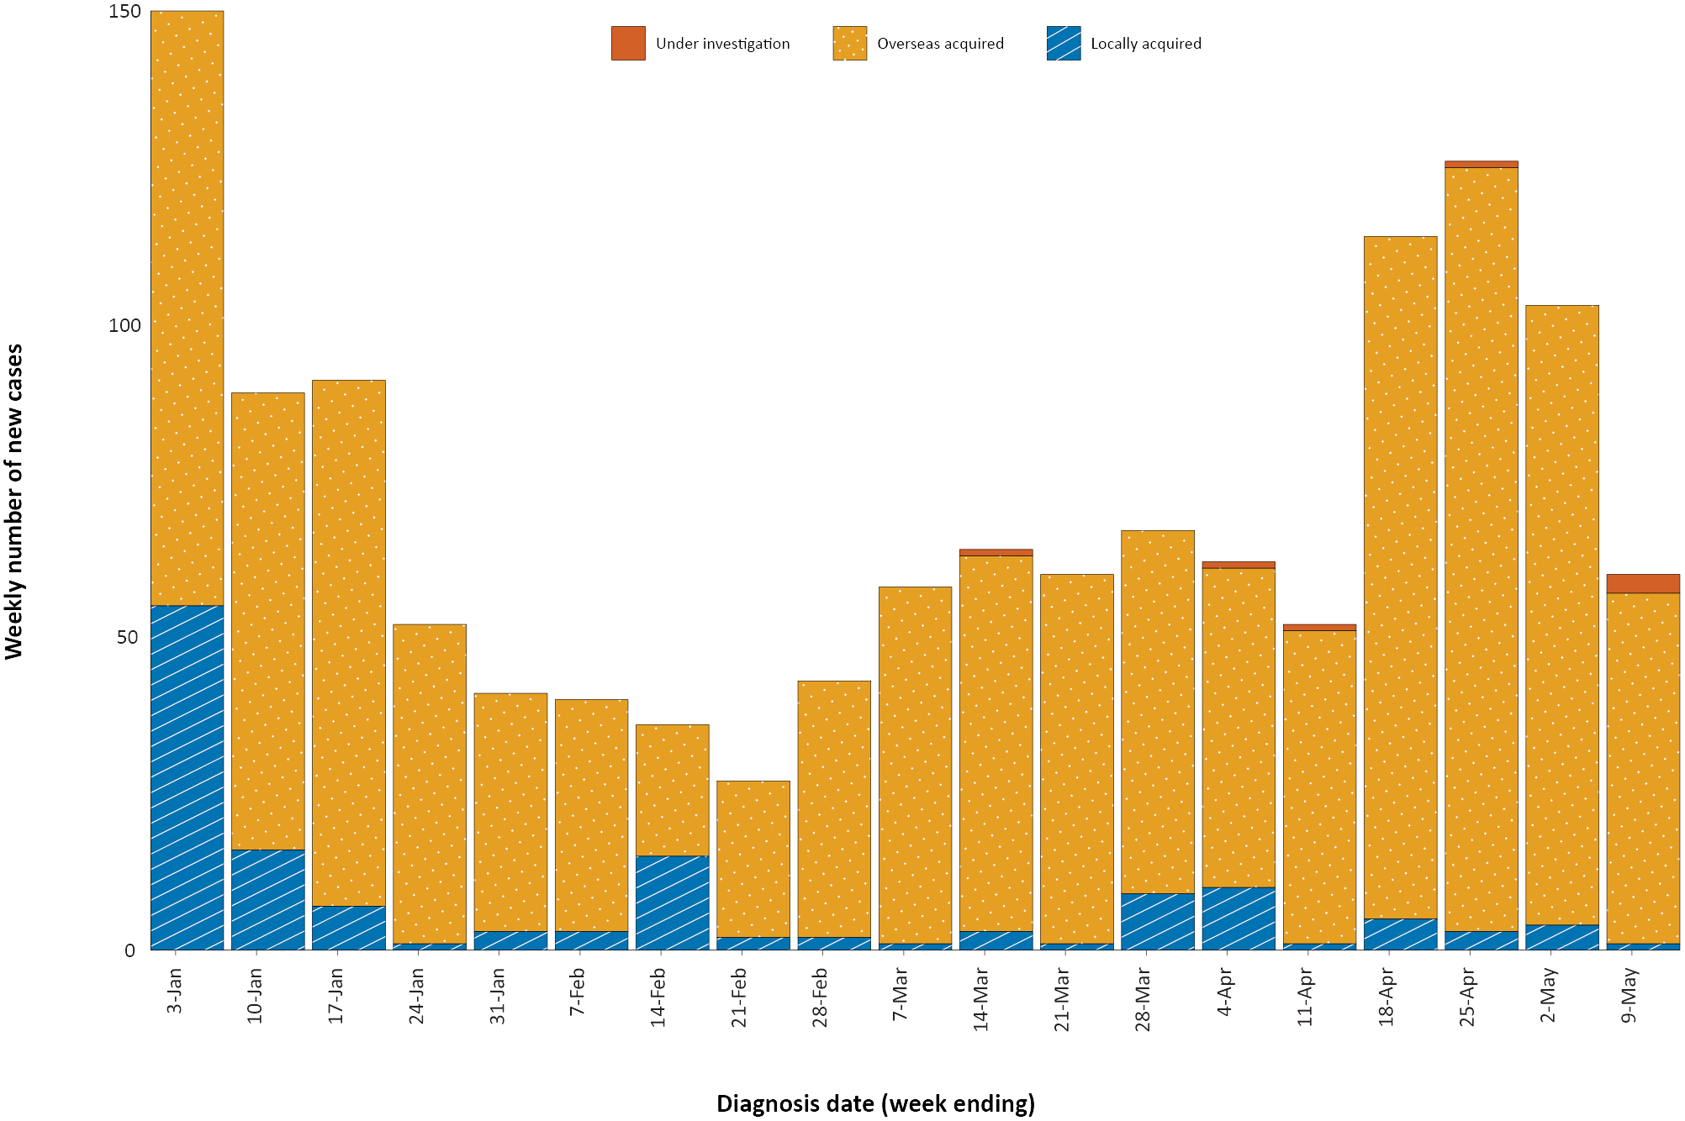
a Source: NNDSS, extract from 11 May 2021, based on diagnosis date.

Figure 2: Cumulative COVID-19 notified cases by source of acquisition and diagnosis date, 2 March 2020 – 9 May 2021ª
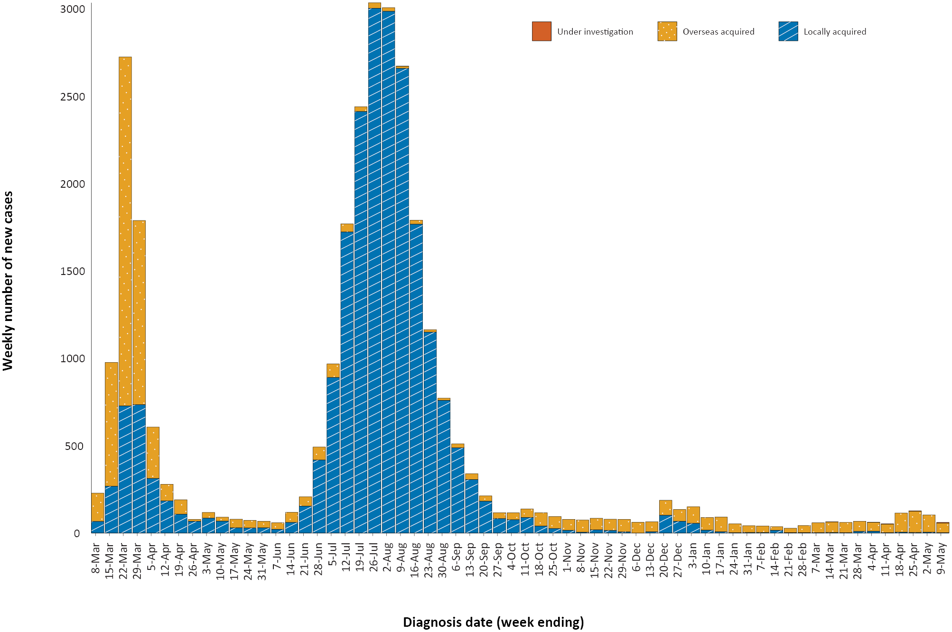
a Source: NNDSS, extract from 11 May 2021, based on diagnosis date.

Source of acquisition

(NNDSS)
In this reporting period, the majority of cases were reported as overseas acquired (95%; 155/163). There were five cases reported as locally acquired this fortnight, three from Western Australia and one from New South Wales with source known, and a further case from New South Wales with the investigation into the source ongoing. At the end of this reporting period, three cases were classified as under initial investigation: two from New South Wales and one from Western Australia (Table 1).
The largest number of overseas-acquired cases was reported in New South Wales in this reporting period (49%; 76/155), followed by Victoria (19%; 30/155).
Of overseas-acquired cases that reported a country of acquisition, the largest number in this reporting period were from India (27%; 37/138), followed by Nepal (16%; 22/138), Papua New Guinea (13%; 18/138) and Pakistan (9%; 12/138). The country of acquisition was reported as unknown for 11 percent of overseas-acquired cases (17/155). The number of cases by country is influenced by travel patterns of returning Australians, by restrictions on travel enforced by the Australian government, and also by the prevalence of COVID-19 in the country the person arrived from.
For 2021 to date, Victoria has the highest infection rate for locally-acquired cases with 0.52 infections per 100,000 population (Table 2). At the end of this reporting period, there had been four days since the last locally-acquired case of known source and seven days since the last locally-acquired case of unknown source (Table 3).
Table 2: Locally-acquired COVID-19 case numbers and rates per 100,000 population by jurisdiction and reporting period, Australia, 1 January to 9 May 2021ª
Jurisdiction | Reporting period  26 April – 9 May 2021 | Reporting period  12–25 April 2021 | Cases this year  1 January 2021 – 11 April 2021
 | Number of cases^{b} | Number of cases^{b} | Number of cases^{b} | Rate per 100,000 population^{c}
ACT | 0 | 0 | 0 | —
NSW | 2 | 3 | 36 | 0.44
NT | 0 | 0 | 0 | —
Qld | 0 | 0 | 25 | 0.48
SA | 0 | 0 | 0 | —
Tas. | 0 | 0 | 0 | —
Vic. | 0 | 1 | 35 | 0.52
WA | 3 | 4 | 8 | 0.30
Australia | 5 | 8 | 104 | 0.40
a Source: NNDSS, extract from 11 May 2021, based on diagnosis date.
b This total does not include cases that are under initial investigation.
c Population data based on Australian Bureau of Statistics (ABS) Estimated Resident Population (ERP) as at June 2020.
Table 3: Days since last locally-acquired COVID-19 case (source unknown and source known), by jurisdiction, 9 May 2021ª
Jurisdiction | Locally acquired — source unknown |  | Locally acquired — source known
 | Date of last case | Days since last case | Date of last case | Days since last case
ACT | 21 March 2020 | 414 | 7 July 2020 | 306
NSW | 2 May 2021 | 7 | 5 May 2021 | 4
NT^{b} | – | – | 3 April 2020 | 401
Qld | 23 August 2020 | 259 | 3 April 2021 | 36
SA | 24 March 2020 | 411 | 27 November 2020 | 163
Tas. | 9 August 2020 | 273 | 24 April 2020 | 380
Vic. | 30 December 2020 | 130 | 22 April 2021 | 17
WA | 3 April 2020 | 401 | 1 May 2021 | 8
a Source: NNDSS, extract from 11 May 2021, based on diagnosis date.
b The Northern Territory has not reported any locally-acquired cases with an unknown source of infection.

Demographic features

(NNDSS)
In this reporting period, the largest number of cases occurred in those aged 30 to 39 years (32%; 52/163 cases). For notifications this year, the highest rate of infection is in those aged 30 to 39 years with a rate of 9.1 infections per 100,000 population (Figure 3; Appendix A, Table A.1). Adults over 80 years of age have the lowest rate of infection this year.
Figure 3: Cumulative COVID-19 cases for the calendar year to date, by age group and sex, Australia, 1 January 2021 to 9 May 2021ª
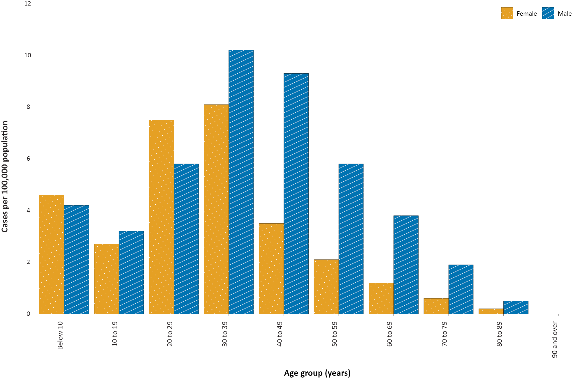
a Source: NNDSS, extract from 11 May 2021, based on diagnosis date.
Focusing on cases in this year only, there is a difference in notification rates among males and females in most age groups. The notification rate is higher in males than females in all age groups over 30 years old (Figure 3). The largest difference in rates this year is in the 40 to 49 years age group, where the cumulative rate among males is 9.3 cases per 100,000 population and among females is 3.5 cases per 100,000 population (Appendix A, Table A.1). The median age of cases in this reporting period is 34 years (range: 0 to 72).

Aboriginal and Torres Strait Islander persons

(NNDSS)
There have been 153 confirmed cases of COVID-19 notified in Aboriginal and Torres Strait Islander people since the beginning of the epidemic. No new Aboriginal and Torres Strait Islander cases were notified with a diagnosis date within this reporting period. Overall, Aboriginal and Torres Strait Islander people represent approximately 0.5% (153/27,687) of all confirmed cases with Indigenous status known. The Indigenous status is unknown for 6.8% (2,023/29,710) of all cases. The majority of locally-acquired cases in Aboriginal and Torres Strait Islander people have been reported in people residing in major cities of Australia (79%; 93/117), with only a very small number of cases (n < 10) reported in people residing in outer regional Australia or remote or very remote Australia. The median age of COVID-19 cases in Aboriginal and Torres Strait Islander people is 31.5 years (range: 1–95).

Vaccinations

(Department of Health)
As of 10 May 2021, a total of 2,736,107 doses of COVID-19 vaccine have been administered (Table 4), including 267,120 doses provided to aged care and disability residents.
Table 4: Total number of vaccinations administered, by jurisdiction, Australia, 10 May 2021ª
Jurisdiction | Total number of doses administered
ACT | 34,757
NSW | 242,149
NT | 20,040
Qld | 159,795
SA | 72,110
Tas. | 44,804
Vic. | 273,220
WA | 116,975
Aged care and disability facilities^{b} | 267,120
Primary care^{c} | 1,505,137
Total | 2,736,107
a Source: Australian Government Department of Health website.³
b Commonwealth vaccine doses administered in aged care and disability facilities.
c Commonwealth vaccine doses administered in primary care settings.

Acknowledgements
We thank public health staff from incident emergency operations centres and public health units in state and territory health departments, and the Australian Government Department of Health, along with state and territory public health laboratories.

Author details

Corresponding author
COVID-19 National Incident Room Surveillance Team
Australian Government Department of Health, GPO Box 9484, MDP 14, Canberra, ACT 2601.
Email: epi.coronavirus@health.gov.au

References
- COVID-19 National Incident Room Surveillance Team. COVID-19 Australia: Epidemiology Report 40: Fortnightly reporting period ending 25 April 2021. Commun Dis Intell (2018). 2021;45. doi: https://doi.org/10.33321/cdi.2021.45.25.
- COVID-19 National Incident Room Surveillance Team. Technical supplement: COVID-19 Australia: epidemiology reporting. Commun Dis Intell (2018). 2021;45. doi: https://doi.org/10.33321/cdi.2021.45.2.
- Australian Government Department of Health. Getting vaccinated for COVID-19: Australia’s vaccine rollout. [Internet.] Canberra: Australian Government Department of Health; 2021. [Accessed on 13 April 2021.] Available from: https://www.health.gov.au/initiatives-and-programs/covid-19-vaccines/getting-vaccinated-for-covid-19#australias-vaccine-rollout.

Appendix A: Supplementary figures and tables
Table A.1: COVID-19 case notifications and rates per 100,000 population, by age group and sex, Australia, 9 May 2021^{a,b}
Age group | This reporting period  26 April – 9 May 2021 |  |  |  |  |  | This year only^{c}  1 January 2021 – 9 May 2021
 | Cases |  |  | Rate per 100,000 population |  |  | Cases |  |  | Rate per 100,000 population
 | Male | Female | People | Male | Female | People | Male | Female | People | Male | Female | People
0 to 9 | 10 | 10 | 20 | 0.6 | 0.6 | 0.6 | 68 | 81 | 139 | 4.2 | 4.6 | 4.4
10 to 19 | 4 | 8 | 12 | 0.3 | 0.5 | 0.4 | 50 | 40 | 90 | 3.2 | 2.7 | 2.9
20 to 29 | 17 | 14 | 31 | 0.9 | 0.8 | 0.9 | 106 | 134 | 240 | 5.8 | 7.5 | 6.6
30 to 39 | 31 | 21 | 52 | 1.7 | 1.1 | 1.4 | 189 | 154 | 343 | 10.2 | 8.1 | 9.1
40 to 49 | 18 | 7 | 25 | 1.1 | 0.4 | 0.8 | 152 | 59 | 211 | 9.3 | 3.5 | 6.4
50 to 59 | 9 | 4 | 13 | 0.6 | 0.3 | 0.4 | 88 | 34 | 122 | 5.8 | 2.1 | 3.9
60 to 69 | 7 | 0 | 7 | 0.5 | 0.0 | 0.3 | 50 | 17 | 67 | 3.8 | 1.2 | 2.5
70 to 79 | 2 | 1 | 3 | 0.2 | 0.1 | 0.2 | 17 | 6 | 23 | 1.9 | 0.6 | 1.2
80 to 89 | 0 | 0 | 0 | 0.0 | 0.0 | 0.0 | 2 | 1 | 3 | 0.5 | 0.2 | 0.4
90 and over | 0 | 0 | 0 | 0.0 | 0.0 | 0.0 | 0 | 0 | 0 | 0.0 | 0.0 | 0.0
a Source: NNDSS, extracted on 11 May 2021.
b Population data based on Australian Bureau of Statistics (ABS) Estimated Resident Population (ERP) as at June 2020.
c Note the change to focus on rates in this year only. For cumulative rates since the beginning of the epidemic in Australia, readers are encouraged to consult previous reports.

Communicable Diseases Intelligence
ISSN: 2209-6051 Online

Communicable Diseases Intelligence (CDI) is a peer-reviewed scientific journal published by the Office of Health Protection and Response, Department of Health. The journal aims to disseminate information on the epidemiology, surveillance, prevention and control of communicable diseases of relevance to Australia.

Editor: Jennie Hood
Deputy Editor: Simon Petrie
Design and Production: Kasra Yousefi
Editorial Advisory Board: David Durrheim, Mark Ferson, John Kaldor, Martyn Kirk and Linda Selvey

Website: http://www.health.gov.au/cdi

Contacts
CDI is produced by Environmental Health and Health Protection Policy Branch, Office of Health Protection and Response, Australian Government Department of Health, GPO Box 9848, (MDP 6) CANBERRA ACT 2601

Email: cdi.editor@health.gov.au

Submit an Article
You are invited to submit your next communicable disease related article to the Communicable Diseases Intelligence (CDI) for consideration. More information regarding CDI can be found at: http://health.gov.au/cdi.
Further enquiries should be directed to: cdi.editor@health.gov.au.

This journal is indexed by Index Medicus and Medline.

Creative Commons Licence - Attribution-NonCommercial-NoDerivatives CC BY-NC-ND
© 2021 Commonwealth of Australia as represented by the Department of Health
This publication is licensed under a Creative Commons Attribution-NonCommercial-NoDerivatives 4.0 International Licence from https://creativecommons.org/licenses/by-nc-nd/4.0/legalcode (Licence). You must read and understand the Licence before using any material from this publication.

Restrictions
The Licence does not cover, and there is no permission given for, use of any of the following material found in this publication (if any):
- the Commonwealth Coat of Arms (by way of information, the terms under which the Coat of Arms may be used can be found at www.itsanhonour.gov.au);
- any logos (including the Department of Health’s logo) and trademarks;
- any photographs and images;
- any signatures; and
- any material belonging to third parties.

Disclaimer
Opinions expressed in Communicable Diseases Intelligence are those of the authors and not necessarily those of the Australian Government Department of Health or the Communicable Diseases Network Australia. Data may be subject to revision.

Enquiries
Enquiries regarding any other use of this publication should be addressed to the Communication Branch, Department of Health, GPO Box 9848, Canberra ACT 2601, or via e-mail to: copyright@health.gov.au

Communicable Diseases Network Australia
Communicable Diseases Intelligence contributes to the work of the Communicable Diseases Network Australia.
http://www.health.gov.au/cdna

https://www.health.gov.au/news/health-alerts/novel-coronavirus-2019-ncov-health-alert#local-outbreak-information.
https://www.who.int/emergencies/diseases/novel-coronavirus-2019/situation-reports/.
https://www.health.gov.au/news/health-alerts/novel-coronavirus-2019-ncov-health-alert/coronavirus-covid-19-current-situation-and-case-numbers.

