Australian Rotavirus Surveillance Program: Annual Report, 2020
Susie Roczo-Farkas, Sarah Thomas, Celeste M Donato, Nada Bogdanovic-Sakran, Julie E Bines and the Australian Rotavirus Surveillance Group

Abstract
This report from the Australian Rotavirus Surveillance Network describes the circulating rotavirus genotypes identified in children and adults during the period 1 January – 31 December 2020. During this period, 229 faecal specimens were referred for rotavirus G- and P- genotype analysis, including 189 samples that were confirmed as rotavirus positive. Of these, 98/189 were wildtype rotavirus strains and 86/189 were identified as vaccine-like. A further five samples could not be determined as wildtype or vaccine-like due to poor sequence reads. Genotype analysis of the 98 wildtype rotavirus samples from both children and adults demonstrated that G3P[8] was the dominant genotype identified for the third consecutive year, identified in 27.6% of samples, followed by G2P[4] in 20.4% of samples. Forty-six percent of rotavirus positive samples received were identified as vaccine-like, highlighting the need to add caution in interpreting rotavirus positive results in children aged 0–8 months. This surveillance period was significantly impacted by the coronavirus disease 2019 ( COVID-19 ) pandemic. The reduction in rotavirus notifications reflected reduced healthcare-seeking behaviour and a decrease in community spread, with ‘community lockdowns’, school and day-care centre closure and improved compliance with hand hygiene. Fewer stool samples were collected throughout Australia during this period. There was a reluctance to store samples at collaborating laboratories and uncertainties regarding the safety and feasibility of the transport of samples to the central laboratory during the closure of state and territory borders. Systems have now been adapted to manage and send biological samples safely and confidently. Ongoing rotavirus surveillance is crucial to identify changes in genotypic patterns and to provide diagnostic laboratories quality assurance by reporting incidences of wildtype, vaccine-like, or false positive rotavirus results.
Keywords: rotavirus, gastroenteritis, genotype, surveillance, Australia, vaccine, Rotarix, COVID-19 , diagnostic, notifiable

Introduction
Group A rotaviruses are the most common cause of severe diarrhoea in young children worldwide, estimated to have caused 128,500 deaths and 258 million episodes of diarrhoea among children < 5 years of age in 2016. ¹ Two rotavirus vaccines, Rotarix ™ [GlaxoSmithKline] and RotaTeq ™ [Merck], have been successfully introduced in the National Immunisation Programs (NIP) of 110 countries, drastically reducing the rotavirus burden of disease. ² In Australia, both vaccines were implemented in the Australian NIP on 1 July 2007, leading to a significant reduction in both rotavirus-coded and non-rotavirus-coded hospitalisations of children ≤ 5 years of age with acute gastroenteritis. ^{3–5} Within six years of vaccine introduction, an estimated 77,000 hospitalisations were prevented, 90% of which were in children ≤ 5 years of age, with indications of herd protection occurring in older age groups. ⁵ RotaTeq was administered in Queensland, South Australia, and Victoria, whereas Rotarix was administered in the Australian Capital Territory, New South Wales, Northern Territory, and Tasmania. Western Australia initially administered Rotarix and changed to RotaTeq in May 2009. On 1 July 2017, all states and territories in Australia changed to Rotarix. ^{6,7}
Rotavirus surveillance programs utilise a binary classification system based on the two outer capsid proteins, VP7 (G, glycoprotein) and VP4 (P, protease-sensitive), to describe rotavirus genotypes. ⁸ Globally, there are five common genotype combinations identified in humans: G1P[8], G2P[4], G3P[8], G4P[8], and G9P[8], with G12P[8] recently also described as a globally-important genotype. ^{9,10} Additionally, whole genome classification assigns genotypes to each of the eleven genes: Gx-P[x]-Ix-Rx-Cx-Mx-Ax-Nx-Tx-Ex-Hx, denoting the VP7-VP4-VP6-VP1-VP2-VP3-NSP1-NSP2-NSP3-NSP4-NSP5/6 genes. ^{11,12} The majority of human rotavirus genomes fall under two genotype constellations: Wa-like (genogroup 1: G1/3/4/9/12-P[8]-I1-R1-C1-M1-A1-N1-T1-E1-H1), and DS-1-like (genogroup 2: G2-P[4]-I2-R2-C2-M2-A2-N2-T2-E2-H2). ^{11,12} A third genogroup, AU-1-like, is also detected in humans, however less frequently (genogroup 3: G3-P[9]-I3-R3-C3-M3-A3-N3-T3-E3-H3). ^{11,12}
Numerous mechanisms contribute to rotavirus diversity including genetic drift, reassortment and zoonotic transmission. The segmented genome allows for reassortment both within and between human and animal strains, leading to the emergence of novel strains and unusual genotype combinations. ¹³
The Australian Rotavirus Surveillance Program (ARSP) has characterised rotavirus genotypes causing severe disease in Australian children ≤ 5 years of age since 1999. Genotype surveillance data has revealed changes in diversity, as well as temporal and geographic fluctuations over time. ¹⁴ Furthermore, differences in genotype diversity and dominance were observed when comparing vaccines by jurisdictions, suggesting that RotaTeq and Rotarix exert different immunological pressures. ¹⁴ The continued surveillance and characterisation of rotavirus genotypes circulating in Australia will provide important insights into whether changes in vaccine immunisation programs can impact virus epidemiology and alter strain diversity, which could have ongoing consequences for the success of current and future vaccination programs.
This report describes the G- and P- genotype distribution of rotavirus strains causing severe gastroenteritis in Australia for the period 1 January to 31 December 2020.

Methods
Faecal samples were tested for the presence of rotavirus by quantitative Reverse Transcription Polymerase Chain Reaction (RT-qPCR), enzyme immunoassay (EIA), or latex agglutination by collaborating laboratories Australia-wide. Positive samples were frozen and sent to the National Rotavirus Reference Centre (NRRC) Melbourne, together with available metadata including date of collection (DOC), date of birth (DOB), gender, postcode, and the RT-qPCR cycle threshold (Ct) values generated by collaborating laboratory. Specimens were received from the following 11 collaborating centres located in the Australian Capital Territory (ACT), New South Wales (NSW), Northern Territory (NT), Queensland (Qld), South Australia (SA), Victoria (Vic.), and Western Australia (WA), where n is the number of specimens received:
- Microbiology Department, Canberra Hospital, ACT (n = 2);
- Microbiology Department, SEALS-Randwick, Prince of Wales Hospital, NSW (n = 10);
- Virology Department, The Children’s Hospital, Westmead, NSW (n = 17);
- Douglass Hanly Moir Pathology, NSW (n = 5);
- The Microbiology Department, Central Coast, Gosford, NSW (n = 4);
- Territory Pathology, Royal Darwin Hospital, Tiwi, NT (n = 34);
- Pathology Queensland, Royal Brisbane and Women’s Hospital, Herston, Qld (n = 33);
- Microbiology and Infectious diseases laboratory, SA Pathology, Adelaide, SA (n = 4);
- Department of Microbiology, Monash Medical Centre, Clayton, Vic. (n = 41);
- Enteric Virus Reference Laboratory, Victorian Infectious Diseases Reference Laboratory, Melbourne, Vic. (n=6);
- The Serology Department, Royal Children’s Hospital, Parkville, Vic. (n = 25); and
- QEII Microbiology Department, PathWest Laboratory Medicine, Nedlands, WA (n = 48).
No samples were collected this year in Tasmania.
Samples were allocated a unique laboratory code and entered into the NRRC database (Excel and REDCap). Samples were stored at -80 ⁰C until analysed. Viral RNA was extracted from 10–20% faecal extracts using the QIAamp Viral RNA mini extraction kit (QIAGEN), according to the manufacturer’s instructions. Rotavirus G- and P- genotypes were determined using an in-house hemi-nested multiplex RT-PCR assay. The first-round RT-PCR reactions were performed using the One Step RT-PCR kit (QIAGEN), in conjunction with VP7 (VP7F/VP7R) or VP4 (VP4F/VP4R) conserved primers. ^{15,16} The second-round genotyping PCR reactions were conducted using specific oligonucleotide primers for G types G1, G2, G3, G4, G8, and G9, or P types P[4], P[6], P[8], P[9], P[10], and P[11]. ^{15,17,18} The G- and P- genotype was determined using agarose gel electrophoresis of second-round PCR products. Samples failing to generate a second-round PCR amplicon or with inconclusive results were further tested by VP6-specific RT-PCR using the Superscript III One-Step RT-PCR System with Platinum Taq DNA Polymerase (Invitrogen) and primers Rot3 and Rot5 as described previously. ^{19,20}
Sanger sequencing was used to determine the VP7 and/or VP4 nucleotide sequence for PCR non-typeable or VP6 positive samples. The current set of primers in the second-round G-typing protocol are not able to assign genotypes to equine-like G3, G12, and unusual rotavirus strains. The VP7 gene of each G1P[8] sample was sequenced to determine if wildtype or Rotarix vaccine strain was detected. Samples which had no first-round PCR amplicon were re-amplified using the Superscript III One-Step RT-PCR System with Platinum Taq DNA Polymerase (Invitrogen), in conjunction with VP7 (Beg9/End9) or VP4 (Con2/Con3) primers, as described previously. ^{17,18,21} First-round VP7 or VP4 amplicons were purified using the Wizard SV Gel for PCR Clean-Up System (Promega) or the QIAquick Gel Extraction Kit (QIAGEN), according to the manufacturer’s protocol. Purified DNA and oligonucleotide primers (Rot3/Rot5, VP7F/VP7R, VP4F/VP4R, Beg9/End9, or Con2/Con3) were sent to the Australian Genome Research Facility (AGRF), Melbourne, and sequenced using an ABI PRISM BigDye Terminator Cycle Sequencing Reaction Kit (Applied Biosystems) in an Applied Biosystems 3730xl DNA Analyzer (Applied Biosystems). Electropherograms were visually analysed and edited using Sequencher v.4.10.1. Genotype assignment was determined using BLAST.
Rotavirus has been a notifiable disease in Australia since 2010, with all states and territories reporting through the National Notifiable Diseases Surveillance System (NNDSS) in 2020. ²²

Results

Number of specimens
A total of 229 specimens determined to be rotavirus positive by collaborating laboratories were sent to the NRRC during the period 1 January to 31 December 2020 (Figure 1). A subset of samples was not analysed further due to sample being duplicate (n = 8), insufficient (n = 1), missing (not received; n = 1), or negative by VP6 PCR (n = 30).
A total of 189 samples were genotyped. Samples were then classified as wildtype (no vaccine component identified) or vaccine-like (Rotarix vaccine component identified), based on genotype and the analysis of the top BLAST hits of any G1 VP7 sequence. Of the 98 samples confirmed as wildtype; 49 were collected from children < 5 years of age, and 49 were from children ≥ 5 years of age and adults (Table 1). In addition, 86 samples were identified as vaccine-like by VP7 sequencing (Figure 1). An additional five samples were genotyped as G1P[8]; however, these samples could not be confirmed by sequencing as being wildtype or vaccine-like due to poor sequence quality and were therefore excluded from subsequent analysis (Figure 1). These samples were from patients aged 1 month (n = 2), 2 months (n = 2), and 4 months old (n = 1), and likely related to a recent rotavirus vaccination.
Figure 1: Consort diagram of rotavirus positive stool samples included in the 2020 ARSP, 1 January – 31 December 2020
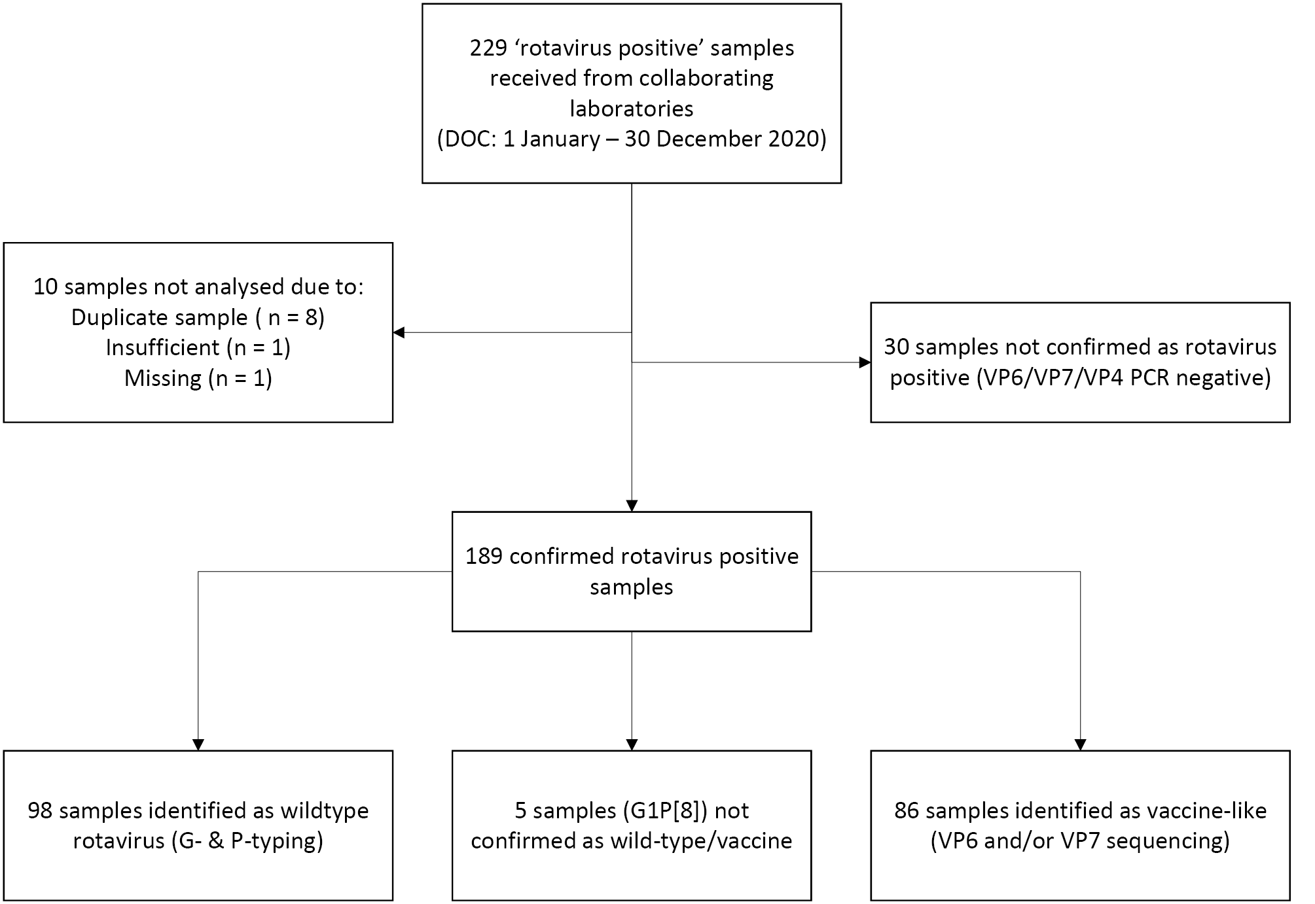

Rotavirus positive samples identified by month, compared to NNDSS rates
Wildtype and vaccine-like rotavirus positive samples were analysed by DOC [month], to determine if the number of samples received was comparable to notification trends reported by the NNDSS (Figure 2). Of note, the largest number of wildtype specimens received was collected in the month of January. The substantial decrease in both notification rates and samples received in the following months was most likely due to the impact of public health interventions related to the novel severe acute respiratory syndrome coronavirus 2 (SARS-CoV-2). Of interest, vaccine-like rotavirus was identified more often than wildtype in the period from June to December.
The number of samples submitted to NRRC overall was lower than expected, based on NNDSS data. This was due to collaborating diagnostic laboratories predominantly focusing on SARS-CoV-2 testing throughout the year, resulting in the temporary suspension of sample storage and collection for other surveillance projects. Laboratories were consulted throughout the year to indicate if and when sample collection would resume; most reported that sample collection/storage would not recommence until 2021. In addition, no samples were collected in Tasmania in 2020.
Figure 2: Number of analysed wildtype and vaccine-like specimens compared to NNDSS rotavirus notification rates per 100,000 population, Australia, 1 January – 31 December 2020
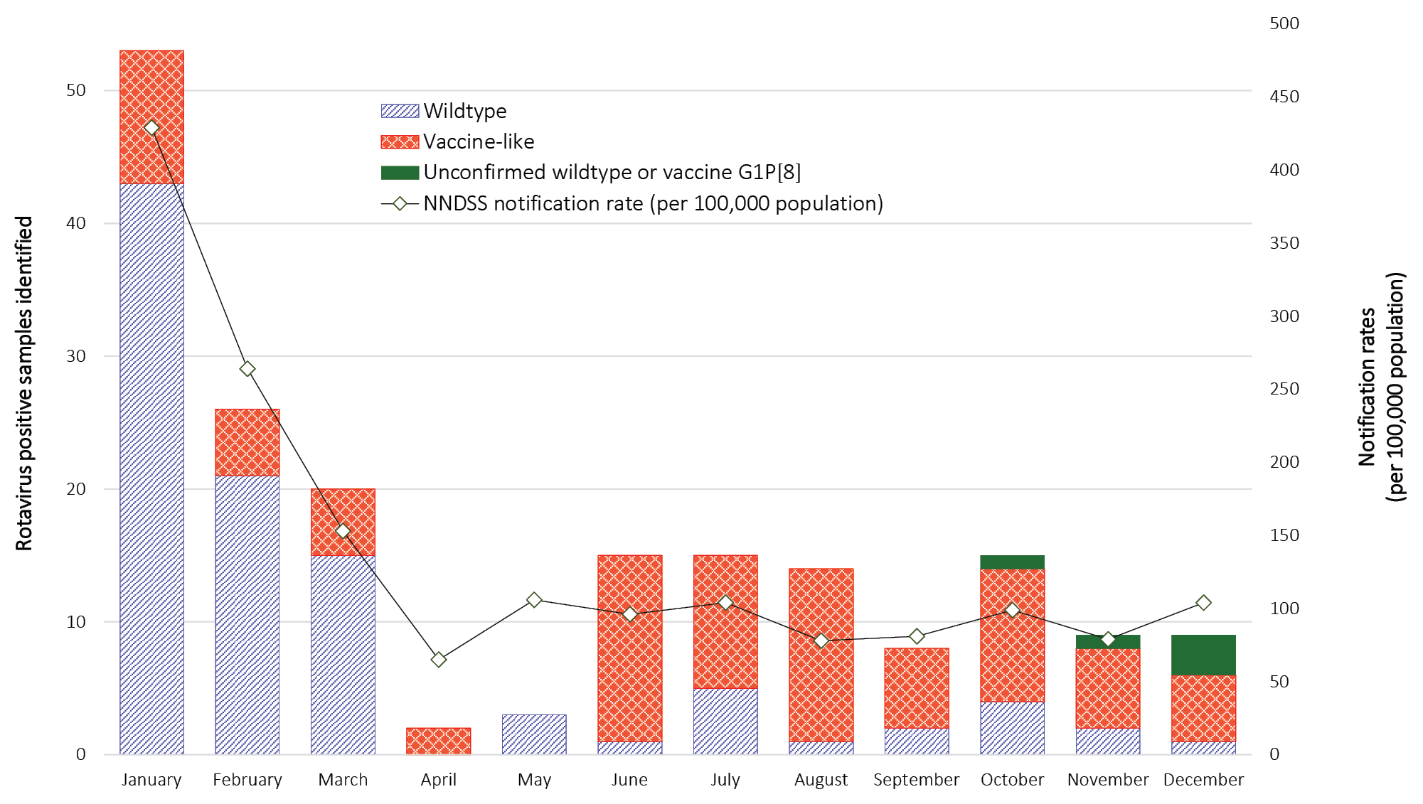

Wildtype rotavirus specimens

Age distribution for wildtype rotavirus infections
From 1 January to 31 December 2020, 50% (n = 49/98) of wildtype rotavirus positive samples were obtained from children < 5 years of age (Table 1). Among children < 5 years of age, the largest numbers of positive samples were obtained from the 13–24 and 25–36 month age groups, accounting for 29% (n = 14/49) and 31% (n = 15/49) of such samples respectively. The remaining 50% (n = 49/98) of wildtype samples were from children ≥ 5 years of age and adults (Table 1). Due to the low number of wildtype positive samples received, limited trends can be deduced from these data.

Table 1: Age distribution of wildtype rotavirus gastroenteritis cases, Australia, 1 January – 31 December 2020ª
Age (months) | Age (years) | n | % of total | % < 5 years of age
0–6 |  | 8 | 8.2 | 16.3
7–12 | ≤ 1 | 7 | 7.1 | 14.3
13–24 | 1–≤ 2 | 14 | 14.3 | 28.6
25–36 | 2–≤ 3 | 15 | 15.3 | 30.6
37–48 | 3–≤ 4 | 5 | 5.1 | 10.2
49–60 | 4–≤ 5 | 0 | – | –
Subtotal |  | 49 | 50.0 | 100
61–120 | 5–≤ 10 | 12 | 12.2
121–240 | 10–≤ 20 | 11 | 11.2
241–960 | 20–≤ 80 | 18 | 18.4
961+ | >80 | 8 | 8.2
Subtotal |  | 49 | 50.0
Unknown age |  | –
Total |  | 98 | 100
a Excludes data from samples from Tasmania as not submitted in 2020.

Wildtype rotavirus genotype distribution
Genotype analysis was performed on all 98 confirmed rotavirus positive samples from children and adults (Table 2). G3P[8] was the most common genotype identified nationally, representing 28% (n = 27/98) of all wildtype specimens analysed. The incidence of G3P[8] was similar between the < 5 years and ≥ 5 years age groups, representing 23% (n = 11/49) and 31% (n = 15/49) respectively. G2P[4] was the second most common genotype identified, representing 21% (n = 20/98) of samples from all ages; however, this genotype was predominantly identified (80%; n = 16/20) in children < 5 years of age, and was the most common genotype ( 33%; n = 16/49 ) identified in children in that age group. The third most prominent genotype identified was equine-like G3P[8], representing 19% (n = 19/98) of all wildtype samples. Of samples of this genotype, 63% (n = 12/19) were from the ≥ 5 years age group.
Overall, 41% of wildtype samples (40/98) exhibited genotype combinations that historically were not routinely seen in Australia, including G3P[4] (n = 3); G8P[8] (n = 1); G9P[4] (n = 9); and zoonotic-like strains, such as equine-like G3P[8] (n = 19); bovine-like G8P[14] (n = 7); and canine-like G3P[3] (n = 1), where both the VP7 and VP4 genes shared high genetic similarity to sequences of canine origin. Of note, detection of zoonotic strains and genotypes such as G8P[8] and G9P[4] have been increasing in frequency in the Australian vaccine era.

Table 2: Rotavirus G and P genotype distribution in infants, children and adults, 1 January – 31 December 2020
State/territory | Age (years) | Total |  | G1P[8] |  |  | G2P[4] |  |  | G3P[4] |  |  | G3P[8] |  |  | G3P[8]ª |  |  | G8P[8] |  |  | G8P[14] |  |  | G9P[4] |  |  | G9P[8] |  | Non-type^{b} |  | Other^{c}
 |  | n | n |  | % | n |  | % | n |  | % | n |  | % | n |  | % | n |  | % | n |  | % | n |  | % | n |  | % | n | % | n | %
NSW | < 5 | 13 | 1 |  | 7.7 |  |  |  | 1 |  | 7.7 | 2 |  | 15.4 | 6 |  | 0.5 |  |  |  | 1 |  | 7.7 | 2 |  | 15.4
 | ≥ 5 | 9 |  |  |  | 1 |  | 11.1 |  |  |  | 1 |  | 11.1 | 6 |  | 66.7 |  |  |  |  |  |  |  |  |  | 1 |  | 11.1
NT | < 5 | 14 |  |  |  | 14 |  | 100
 | ≥ 5 | 4 |  |  |  | 1 |  | 25.0 |  |  |  | 1 |  | 25.0 | 1 |  | 25.0 | 1 |  | 25.0
Qld | < 5 | 9 |  |  |  |  |  |  |  |  |  | 7 |  | 77.8 | 1 |  | 11.1 |  |  |  |  |  |  |  |  |  |  |  |  |  |  | 1 | 11.1
 | ≥ 5 | 12 |  |  |  |  |  |  |  |  |  | 10 |  | 83.3 | 1 |  | 8.3 |  |  |  |  |  |  | 1 |  | 8.3
SA | < 5 | 2 |  |  |  |  |  |  |  |  |  |  |  |  |  |  |  |  |  |  |  |  |  |  |  |  | 2 |  | 100
 | ≥ 5 | 1 |  |  |  |  |  |  | 1 |  | 100
Vic. | < 5 | 8 |  |  |  | 2 |  | 25.0 | 1 |  | 12.5 | 2 |  | 25.0 |  |  |  |  |  |  |  |  |  | 2 |  | 25.0 | 1 |  | 12.5
 | ≥ 5 | 18 |  |  |  |  |  |  | 1 |  | 5.6 | 3 |  | 16.7 | 4 |  | 22.2 |  |  |  | 2 |  | 11.1 | 4 |  | 22.2 | 2 |  | 11.1 | 2 | 11.1
WA | < 5 | 3 |  |  |  |  |  |  |  |  |  |  |  |  |  |  |  |  |  |  | 2 |  | 66.7 |  |  |  |  |  |  | 1 | 33.3
 | ≥ 5 | 5 |  |  |  | 2 |  | 40.0 |  |  |  |  |  |  |  |  |  |  |  |  | 2 |  | 40.0 |  |  |  | 1 |  | 20.0
Subtotal | < 5 | 48 | 1 |  | 2.1 | 16 |  | 33.3 | 1 |  | 2.1 | 11 |  | 22.9 | 7 |  | 14.6 |  |  |  | 3 |  | 6.3 | 4 |  | 8.3 | 3 |  | 6.3 | 1 | 2.1 | 1 | 2.1
 | ≥ 5 | 49 |  |  |  | 4 |  | 8.2 | 2 |  | 4.1 | 15 |  | 30.6 | 12 |  | 24.5 | 1 |  | 2.0 | 4 |  | 8.2 | 5 |  | 10.2 | 4 |  | 8.2 | 2 | 4.1
Total |  | 98 | 1 |  | 1.0 | 20 |  | 20.4 | 3 |  | 3.1 | 27 |  | 27.6 | 19 |  | 19.4 | 1 |  | 1.0 | 7 |  | 7.1 | 9 |  | 9.2 | 7 |  | 7.1 | 3 | 3.1 | 1 | 1.0
a Equine-like G3P[8].
b Specimen where G or P genotype was not determined.
c Canine-like G3P[3].

Vaccine-like rotavirus specimens

Age distribution for rotavirus vaccine samples
All G1P[8] samples (n = 92) were analysed by VP7 sequencing to identify vaccine-like strains. A total of 87 samples were successfully sequenced, of which 86 were Rotarix vaccine-like and one was wildtype. Of the vaccine-like samples, all were from the 0–6 months age group, with most identified in patients of 2 months of age (44%; n = 38/86), followed by 1 month of age (31%; n = 27/86), and 3 months of age (12%; n = 10/86). The remaining samples were from patients aged 4 months (9%; n = 8/86), 5 months (2%; n = 2/86), and 6 months (1%; n = 1/86).

Discussion
This 2020 ARSP report describes the distribution of rotavirus genotypes identified in Australia for the period 1 January to 31 December 2020, three years after the commencement of exclusive use of Rotarix in the NIP. ^{7,14} A substantial reduction in rotavirus notifications was observed during the 2020 COVID-19 pandemic, mirroring that seen for other common gastrointestinal and respiratory infections. ^{23–26} This likely reflects altered healthcare-seeking behaviour as well as a decrease in spread of common infectious diseases within the community, associated with lockdowns, school and day-care centre closures, and increased compliance with hand hygiene. Notably, for the period 1 January – 30 June 2020, there were 50% fewer total notifications reported to the NNDSS than in the same period in 2019, and 20% fewer notifications than the 5-year (2015–2019) average. ²⁶ When specifically comparing rotavirus notifications, there were 18% fewer notifications to NNDSS than in the same period in 2019, and 27% fewer than the 5-year average. ²⁶ The Central Queensland Public Health Unit reported a 91% decrease in rotavirus notifications during the six-month period 1 April – 30 September 2020, when compared to the 5-year average. ²⁷ In Finland, an 11.7% decrease in gastroenteritis-related emergency department visits was reported in the six weeks after implementation of the state of emergency lockdown in response to the COVID-19 pandemic when compared to the 6 weeks prior to the lockdown. ²⁴ These data highlight the effectiveness of public health infection control measures in reducing the incidence of common community infections such as rotavirus.
Prior to 2020, rotavirus seasons in Australia have followed a biennial peak pattern with a high burden year generally followed by a low burden year. For example, the national notifications peaked in 2017 (7,264 patients) and in 2019 (6,177 patients) with lower numbers of notifications in 2016 (2,733 patients) and 2018 (3,139 patients). ²⁶ If this biennial pattern continued in 2020, it might also have contributed to lower rotavirus notifications reported in 2020.
The COVID-19 pandemic had a major impact on the collection and storage of stool samples in participating laboratories and the transporting of samples to the NRRC. The ARSP captured stool samples for 13.8% of all notifications in 2020, a lower proportion than the average of 32.1% for the period 2010–2019. Collaborating diagnostic laboratories reported the need to focus on SARS-CoV-2 testing, with storage of samples to the NRRC not prioritised. Collection and transportation of biological samples during the COVID-19 pandemic was also problematic, with concerns regarding safety and feasibility with border restrictions and disrupted plane flights. The lack of samples submitted to the ARSP from Tasmania in 2020 means that is only possible to infer genotype patterns based on data from other states and territories.
In 2020, the largest number of wildtype specimens received was collected in the month of January. For the third consecutive year, genotype G3P[8] was the most common genotype identified in Australia; this was followed by G2P[4] and equine-like G3P[8]. Differences in distribution of G2P[4] by age group were seen, with 80% of all G2P[4] samples identified in children < 5 years of age. However, caution is required in interpreting these data, as this report was unable to represent data from all states and territories, and is based on relatively low number of wildtype rotavirus positive stool samples.
More than 63% of rotavirus notifications in Australia for 2020 (n = 1,049/1,658) were related to children < 5 years of age; however, further breakdown of this age group is unavailable from the NNDSS public database. ²⁵ A more detailed age breakdown would be of interest, as a high proportion of samples submitted to the ARSP were observed in children aged 0–6 months with a rotavirus vaccine-like component detected on genotype analysis. In children aged < 1 year, a higher proportion of vaccine-like rotavirus was detected (78%; n = 73/93) than was observed in previous years (Appendix A: Figure A.1). However, the proportion of vaccine-like rotavirus is further exaggerated if analysis is restricted to the 0–6 month of age group, occurring in 62–92% of samples during the period 2015 to 2020 (Figure A.1). Detection of rotavirus vaccine-like virus can occur as early as day 1 to 28 days after vaccination, and shedding can persist for longer in children experiencing loose stool post-vaccination than in asymptomatic children. ^{28–30} The overall increase in detection of rotavirus vaccine-like virus in samples observed in recent years through the ARSP is likely to be attributed to the shift in diagnostic techniques from conventional methods to multiplex PCR panels. ^{31,32} In children receiving their first rotavirus vaccine dose (RotaTeq or Rotarix), the positive detection rates of rotavirus increased from 20–30% when analysed using EIA, to 80–90% by real-time RT-qPCR (28). A study from Queensland reported rates of 47–87% RotaTeq detection in healthy infants after each vaccine dose, with more prolonged shedding observed for up to 14 weeks after the third dose. ³³ Therefore, it is important to interpret a rotavirus positive result in children aged 0–8 months with caution, as this result could be due to the receipt of a recent dose of rotavirus vaccine.
Despite the decrease in rotavirus notifications in 2020, two small rotavirus outbreaks were reported in Victoria, and forwarded to the ARSP for further investigation. One outbreak that affected four individuals in May occurred in an aged care facility and was genotyped as G9P[4]. The other reported outbreak occurred in October in a school outdoor education program. This outbreak was initially reported to have affected 10 people; however, further investigation revealed that Astrovirus and Campylobacter was also detected in some of the individuals. Genotype analysis of the rotavirus strains identified a G8P[14] strain; this genotype combination may be of bovine origin. The presence of this strain together with Campylobacter suggests that these students may have been exposed to unfiltered contaminated water, which is possible given that the outdoor education program is based in Victoria’s high country where cattle graze upon farmlands.
In summary, in this 2020 annual surveillance report we describe the incidence of both wildtype and vaccine-like strains of rotavirus circulating in Australia for the period of 1 January – 31 December 2020. There was a dramatic decrease in the number of specimens received by the NRRC. G3P[8] was reported as the most common genotype identified for the third year in a row, followed by G2P[4] and equine-like G3P[8]. Differences in distribution of G2P[4] by age group were seen, with 80% of all G2P[4] samples identified in children < 5 years of age. A large proportion of samples from children < 1 year of age were found to contain vaccine-like rotavirus, which highlights the importance of interpreting diagnostic data together with clinical symptoms and recent vaccination history to ensure accurate clarification of rotavirus disease burden. The Australian Rotavirus Surveillance Network provides a platform where diagnostic laboratories receive quality assurance by gaining more insight to their findings, and genotyping data for both wildtype and vaccine can assist public health unit investigations into adverse effects and outbreak management. Ongoing surveillance is important for public health management and providing insight into the performance of the National Immunisation Program.

Acknowledgements
The Australian Rotavirus Surveillance Program is supported by grants from the Australian Government Department of Health, and GlaxoSmithKline Biologicals SA [Study#209328]. The Murdoch Children’s Research Institute (MCRI) is supported by the Victorian Government’s Operational Infrastructure Support program. GlaxoSmithKline Biologicals SA was provided the opportunity to review a preliminary version of this manuscript for factual accuracy, but the authors are solely responsible for final content and interpretation. The authors received no financial support or other form of compensation related to the development of the manuscript.
Rotavirus positive specimens were collected from numerous centres throughout Australia. We acknowledge and appreciate the significant time and effort involved in the collection, storage, packaging, compiling data and forwarding of specimens by the contributing centres, especially given their outstanding commitment to SARS-CoV-2 testing.

The National Rotavirus Surveillance Group includes:

Australian Rotavirus Surveillance Program Central Laboratory
Mrs Susie Roczo-Farkas: Coordinator Australian Rotavirus Surveillance Program, Research Assistant, Enteric Diseases Group, MCRI
Mrs Sarah Thomas: Research Assistant, Enteric Diseases Group, MCRI
Dr Celeste M Donato: Senior Research Officer, Enteric Diseases Group, MCRI; Department of Paediatrics, University of Melbourne; Department of Microbiology, Biomedicine Discovery Institute, Monash University
Mrs Nada Bogdanovic-Sakran: Research Assistant, Enteric Diseases Group, MCRI
Professor Julie E Bines: Director, Australian Rotavirus Surveillance Program; Leader, Enteric Diseases Group, MCRI.
Department of Paediatrics, University of Melbourne
Department of Gastroenterology and Clinical Nutrition, Royal Children’s Hospital

Australian Capital Territory
Ms. S. Bradbury, Mr P. Patel, and members of the Microbiology Department, Canberra Hospital

New South Wales
Prof W. Rawlinson, Prof. M. Lahra, Ms J. Hanrahan, Mr P. Huntington, and members of the Microbiology Department, SEALS, Prince of Wales Hospital
Dr V. Sintchenko, T. Olma, and members of the Centre for Infectious Disease and Microbiology, Westmead
Dr A. Kesson, Ms I. Tam, and members of the Virology Department, The Children’s Hospital, Westmead
Dr R. Givney, S. Pearce, K. Delves, K. Ross, and members of the Microbiology Department, John Hunter Hospital, Newcastle
Dr D deWit, Ms C. Wright, and members of the Microbiology Department, Central Coast, Gosford
Dr M. Wehrhahn and members of the Douglass Hanly Moir Pathology, New South Wales

Northern Territory
Mr K. Freeman, Mr F. Dakh, and members of Territory Pathology, Royal Darwin Hospital, Tiwi, NT

Queensland
Dr G. Nimmo, Dr C. Bletchly, and department members, Pathology Queensland Central

South Australia
Mr M. Turra, Dr J. Arthur, and members of the Microbiology and Infectious Diseases Laboratory SA Pathology, Adelaide

Tasmania
Dr J. Williamson and members of Molecular Medicine, Pathology Services, Royal Hobart Hospital, Hobart, Tasmania

Victoria
Dr T. Korman, Mrs D. Kotsanas, and members of the Department of Microbiology, Monash Medical Centre, Clayton
Ms K. Rautenbacher, Ms P. Adamopoulos, Serology Department, Royal Children’s Hospital, Parkville
E. Hrysoudis, F. Gray, R. Quach, and members of the Molecular Infectious Department, Australian Clinical Labs, Clayton

Western Australia
Prof Smith, Dr A. Levy, Mrs J. Lang, and members of QEII Microbiology Department, PathWest Laboratory Medicine WA, Perth

Author details
Susie Roczo-Farkas ¹
Sarah Thomas ¹
Dr Celeste M. Donato ^{2,3,4}
Nada Bogdanovic-Sakran ¹
Prof Julie E. Bines ^{3,5,6}
- Research Assistant, Enteric Diseases Group, Murdoch Children’s Research Institute (MCRI)
- Senior Research Officer, Enteric Diseases Group, MCRI
- Department of Paediatrics, University of Melbourne
- Department of Microbiology, Biomedicine Discovery Institute, Monash University
- Group Leader, Enteric Diseases Group, MCRI
- Department of Gastroenterology and Clinical Nutrition, Royal Children’s Hospital

Corresponding Author
Susie Roczo-Farkas
Enteric Diseases Group, Level 5, Murdoch Children’s Research Institute, Royal Children’s Hospital, Flemington Road, Parkville, Victoria, 3052.
Phone: 03 8341 6383
Email: susie.roczofarkas@mcri.edu.au

References
- Troeger C, Khalil IA, Rao PC, Cao S, Blacker BF, Ahmed T et al. Rotavirus vaccination and the global burden of rotavirus diarrhea among children younger than 5 years. JAMA Pediatr . 2018;172(10):958–65.
- Immunization, Vaccines and Biologicals (IVB), World Health Organization (WHO). Vaccine in National Immunization Programme Update . [PowerPoint presentation.] Geneva: WHO; 27 October 2020. Available from: www.who.int/immunization/monitoring_surveillance/VaccineIntroStatus.ppt.
- Buttery JP, Lambert SB, Grimwood K, Nissen MD, Field EJ, Macartney KK et al. Reduction in rotavirus-associated acute gastroenteritis following introduction of rotavirus vaccine into Australia’s National Childhood vaccine schedule. Pediatr Infect Dis J . 2011;30(1 Suppl):S25–9.
- Macartney KK, Porwal M, Dalton D, Cripps T, Maldigri T, Isaacs D et al. Decline in rotavirus hospitalisations following introduction of Australia’s national rotavirus immunisation programme. J Paediatr Child Health . 2011;47(5):266–70.
- Reyes JF, Wood JG, Beutels P, Macartney K, McIntyre P, Menzies R et al. Beyond expectations: post-implementation data shows rotavirus vaccination is likely cost-saving in Australia. Vaccine . 2017;35(2):345–52.
- Roczo-Farkas S, Cowley D, Bines JE, the Australian Rotavirus Surveillance Group. Australian Rotavirus Surveillance Program: Annual Report, 2017. Commun Dis Intell (2018) . 2019;43. doi: https://doi.org/10.33321/cdi.2019.43.28.
- Australian Government Department of Health. Clinical update: ATAGI advice on Rotarix® to replace RotaTeq®. [Internet.] Canberra: Australian Government Department of Health; 20 December 2017. Available from: https://beta.health.gov.au/news-and-events/news/clinical-update-atagi-advice-on-rotarixr-to-replace-rotateqr.
- Desselberger U. Rotaviruses. Virus Res . 2014;190:75–96.
- Bányai K, László B, Duque J, Steele AD, Nelson EA, Gentsch JR et al. Systematic review of regional and temporal trends in global rotavirus strain diversity in the pre rotavirus vaccine era: insights for understanding the impact of rotavirus vaccination programs. Vaccine . 2012;30(Suppl 1):A122–30.
- Dóró R, László B, Martella V, Leshem E, Gentsch J, Parashar U et al. Review of global rotavirus strain prevalence data from six years post vaccine licensure surveillance: is there evidence of strain selection from vaccine pressure? Infect Genet Evol . 2014;28:446–61.
- Matthijnssens J, Ciarlet M, McDonald SM, Attoui H, Bányai K, Brister JR et al. Uniformity of rotavirus strain nomenclature proposed by the Rotavirus Classification Working Group (RCWG). Arch Virol . 2011;156(8):1397–413.
- Matthijnssens J, Ciarlet M, Rahman M, Attoui H, Bányai K, Estes MK, et al. Recommendations for the classification of group A rotaviruses using all 11 genomic RNA segments. Arch Virol . 2008;153(8):1621–9.
- Taniguchi K, Urasawa S. Diversity in rotavirus genomes. Sem Virol . 1995;6(2):123–31.
- Roczo-Farkas S, Kirkwood CD, Cowley D, Barnes GL, Bishop RF, Bogdanovic-Sakran N et al. The impact of rotavirus vaccines on genotype diversity: a comprehensive analysis of 2 decades of Australian surveillance data. J Infect Dis . 2018;218(4):546–54.
- Gómara MI, Cubitt D, Desselberger U, Gray J. Amino acid substitution within the VP7 protein of G2 rotavirus strains associated with failure to serotype. J Clin Microbiol . 2001;39(10):3796–8.
- Simmonds MK, Armah G, Asmah R, Banerjee I, Damanka S, Esona M et al. New oligonucleotide primers for P-typing of rotavirus strains: strategies for typing previously untypeable strains. J Clin Virol . 2008;42(4):368–73.
- Gentsch JR, Glass RI, Woods P, Gouvea V, Gorziglia M, Flores J et al. Identification of group A rotavirus gene 4 types by polymerase chain reaction. J Clin Microbiol . 1992;30(6):1365–73.
- Gouvea V, Glass RI, Woods P, Taniguchi K, Clark HF, Forrester B et al. Polymerase chain reaction amplification and typing of rotavirus nucleic acid from stool specimens. J Clin Microbiol . 1990;28(2):276–82.
- Donato CM, Ch’ng LS, Boniface KF, Crawford NW, Buttery JP, Lyon M et al. Identification of strains of RotaTeq rotavirus vaccine in infants with gastroenteritis following routine vaccination. J Infect Dis . 2012;206(3):377–83.
- Elschner M, Prudlo J, Hotzel H, Otto P, Sachse K. Nested reverse transcriptase-polymerase chain reaction for the detection of group A rotaviruses. J Vet Med B Infect Dis Vet Public Health . 2002;49(2):77–81.
- Cowley D, Donato CM, Roczo-Farkas S, Kirkwood CD. Emergence of a novel equine-like G3P[8] inter-genogroup reassortant rotavirus strain associated with gastroenteritis in Australian children. J Gen Virol . 2016;97(2):403–10.
- Australian Government Department of Health. National Notifiable Diseases Surveillance System. [Webpage.] Canberra: Australian Government Department of Health; 2021. [Accessed on 24 June 2021.] Available from: http://www9.health.gov.au/cda/source/rpt_1_sel.cfm.
- Bruggink LD, Garcia-Clapes A, Tran T, Druce JD, Thorley BR. Decreased incidence of enterovirus and norovirus infections during the COVID-19 pandemic, Victoria, Australia, 2020. Commun Dis Intell (2018) . 2021;45. doi: https://doi.org/10.33321/cdi.2021.45.5.
- Kuitunen I, Ponkilainen VT, Launonen AP, Reito A, Hevonkorpi TP, Paloneva J et al. The effect of national lockdown due to COVID-19 on emergency department visits. Scand J Trauma Resusc Emerg Med . 2020;28(1):114. doi: https://doi.org/10.1186/s13049-020-00810-0.
- Australian Government Department of Health. Notification Rate for Rotavirus, Australia, in the period of 1991 to 2021 and year-to-date notifications for 2020. [Tabulation, updated 24 June 2021.] Canberra; Australian Government Department of Health. Available from: http://www9.health.gov.au/cda/source/rpt_3.cfm.
- Bright A, Glynn-Robinson AJ, Kane S, Wright R, Saul N. The effect of COVID-19 public health measures on nationally notifiable diseases in Australia: preliminary analysis. Commun Dis Intell (2018) . 2020;44. doi: https://doi.org/10.33321/cdi.2020.44.85.
- Adegbija O, Walker J, Smoll N, Khan A, Graham J, Khandaker G. Notifiable diseases after implementation of COVID-19 public health prevention measures in Central Queensland, Australia. Commun Dis Intell (2018) . 2021;45. doi: https://doi.org/10.33321/cdi.2021.45.11.
- Hsieh YC, Wu FT, Hsiung CA, Wu HS, Chang KY, Huang YC. Comparison of virus shedding after lived attenuated and pentavalent reassortant rotavirus vaccine. Vaccine . 2014;32(10):1199–204.
- Bennett A, Pollock L, Jere KC, Pitzer VE, Lopman B, Bar-Zeev N et al. Duration and density of fecal rotavirus shedding in vaccinated Malawian children with rotavirus gastroenteritis. J Infect Dis . 2019;222(12):2035–40.
- Ye S, Whiley DM, Ware RS, Kirkwood CD, Lambert SB, Grimwood K. Multivalent rotavirus vaccine and wild-type rotavirus strain shedding in Australian infants: a birth cohort study. Clin Infect Dis . 2018;66(9):1411–8.
- Hannet I, Engsbro AL, Pareja J, Schneider UV, Lisby JG, Pružinec-Popović B et al. Multicenter evaluation of the new QIAstat Gastrointestinal Panel for the rapid syndromic testing of acute gastroenteritis. Eur J Clin Microbiol Infect Dis . 2019;38(11):2103–12.
- Celma CC, Beard S, Douglas A, Wong S, Osafo NK, Hannah M et al. Retrospective analysis on confirmation rates for referred positive rotavirus samples in England, 2016 to 2017: implications for diagnosis and surveillance. Euro Surveill . 2020;25(43). doi: https://doi.org/10.2807/1560-7917.ES.2020.25.43.1900375.
- Whiley DM, Ye S, Tozer S, Clark JE, Bletchly C, Lambert SB et al. Over-diagnosis of rotavirus infection in infants due to detection of vaccine virus. Clin Infect Dis . 2020;71(5):1324–6.

Appendix A
Figure A.1: Number of rotavirus positive samples in children ≤ 1 year of age by genotype, Australia, 2008 to 2020
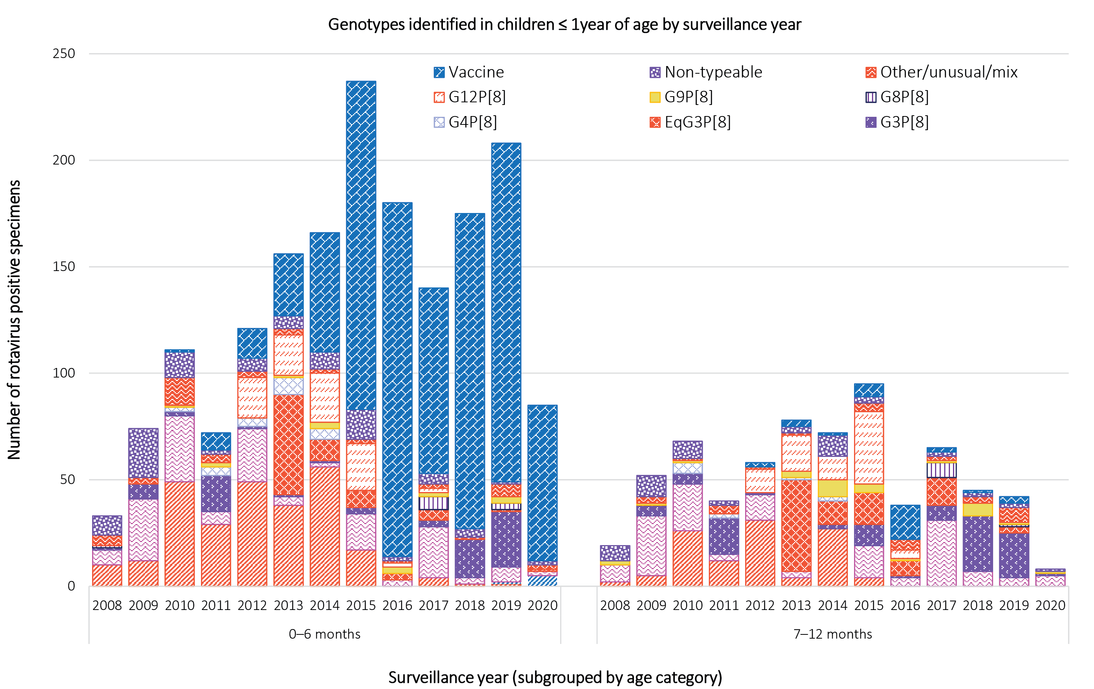
Note: G1P[8]* - Not confirmed by sequencing as wildtype or vaccine-like

Communicable Diseases Intelligence
ISSN: 2209-6051 Online

Communicable Diseases Intelligence (CDI) is a peer-reviewed scientific journal published by the Office of Health Protection and Response, Department of Health. The journal aims to disseminate information on the epidemiology, surveillance, prevention and control of communicable diseases of relevance to Australia.

Editor: Jennie Hood
Deputy Editor: Simon Petrie
Design and Production: Kasra Yousefi
Editorial Advisory Board: David Durrheim, Mark Ferson, John Kaldor, Martyn Kirk and Linda Selvey

Website: http://www.health.gov.au/cdi

Contacts
CDI is produced by the Office of Health Protection and Response, Australian Government Department of Health, GPO Box 9848, (MDP 6) CANBERRA ACT 2601

Email: cdi.editor@health.gov.au

Submit an Article
You are invited to submit your next communicable disease related article to the Communicable Diseases Intelligence (CDI) for consideration. More information regarding CDI can be found at: http://health.gov.au/cdi.
Further enquiries should be directed to: cdi.editor@health.gov.au.

This journal is indexed by Index Medicus and Medline.

Creative Commons Licence - Attribution-NonCommercial-NoDerivatives CC BY-NC-ND
© 2021 Commonwealth of Australia as represented by the Department of Health
This publication is licensed under a Creative Commons Attribution-NonCommercial-NoDerivatives 4.0 International Licence from https://creativecommons.org/licenses/by-nc-nd/4.0/legalcode (Licence). You must read and understand the Licence before using any material from this publication.

Restrictions
The Licence does not cover, and there is no permission given for, use of any of the following material found in this publication (if any):
- the Commonwealth Coat of Arms (by way of information, the terms under which the Coat of Arms may be used can be found at www.itsanhonour.gov.au);
- any logos (including the Department of Health’s logo) and trademarks;
- any photographs and images;
- any signatures; and
- any material belonging to third parties.

Disclaimer
Opinions expressed in Communicable Diseases Intelligence are those of the authors and not necessarily those of the Australian Government Department of Health or the Communicable Diseases Network Australia. Data may be subject to revision.

Enquiries
Enquiries regarding any other use of this publication should be addressed to the Communication Branch, Department of Health, GPO Box 9848, Canberra ACT 2601, or via e-mail to: copyright@health.gov.au

Communicable Diseases Network Australia
Communicable Diseases Intelligence contributes to the work of the Communicable Diseases Network Australia.
http://www.health.gov.au/cdna

http://blast.ncbi.nlm.nih.gov/Blast.cgi.

