Immunisation Coverage Annual Report 2019
Brynley Hull, Alexandra Hendry, Aditi Dey, Kristine Macartney, Frank Beard

Abstract
Australian Immunisation Register data have been analysed for children aged < 5 years, focusing on changes in vaccination coverage at standard age milestones (12, 24 and 60 months) between 2018 and 2019. ‘Fully vaccinated’ coverage in 2019 increased by 0.1–0.4% at the three age milestones to 94.3% at 12 months, 90.2% at 24 months (in the context of additional antigens required at 24 months) and 94.2% at 60 months. Rotavirus vaccine coverage (2 doses) increased from 90.9% in 2018 to 91.9% in 2019. ‘Fully vaccinated’ coverage in Aboriginal and Torres Strait Islander (hereafter respectfully referred to as Indigenous) children increased by 0.5–1.1% in 2019, reaching 92.9% at 12 months, 88.9% at 24 months and 96.9% at the 60 months (2.7 percentage points higher than in children overall). Recorded influenza vaccination coverage in children aged 6 months to < 5 years increased by 11.4 percentage points to 42.7% in Indigenous children in 2019, and by 15.6 percentage points to 41.8% in children overall. Longstanding issues with timeliness of vaccination in Indigenous children persisted, although the disparity between Indigenous and non-Indigenous children in on-time coverage (within 30 days of due date), for vaccines due at 4 months of age, decreased from 10.4–10.7 to 9.6–9.8 percentage points between 2018 and 2019. The timeliness of ‘fully vaccinated’ coverage was also examined at earlier age milestones (3 months after due date of last scheduled vaccine) of 9, 15, 21 and 51 months, by Indigenous status, socioeconomic status and remoteness of area of residence. Coverage in children living in the least-advantaged residential area quintile was 2.6–2.7% lower than that for those living in the most-advantaged quintile at the 9-, 15- and 21-month milestones, although these disparities were 0.5–1.5 percentage points lower than in 2018. Coverage at the earlier milestones in Indigenous children in remote areas was 1.5–6.7% percentage points lower than that for Indigenous children in major cities and regional areas, although there were some improvements since 2018. Importantly, although Indigenous children had lower coverage for the second dose of measles-mumps-rubella vaccine at 24 months (92.7% versus 93.3% overall), coverage increased to 98.8% at 60 months; coverage was also high overall at 96.4%, above the 95% target critical to measles control. In conclusion, this report demonstrates continuing improvements across a range of immunisation indicators in Australia in 2019. However, some issues with timeliness persist, particularly in Indigenous and socioeconomically disadvantaged children. New coverage targets for earlier protection in the first 2 years of life may be indicated, along with a review of current ‘fully vaccinated’ assessment algorithms, particularly at the 60-month age milestone.
Keywords: vaccination coverage, vaccination timeliness, Aboriginal and Torres Strait Islander vaccination coverage, influenza vaccination.

Introduction
This is the thirteenth annual Australian immunisation coverage report, with reports now covering the years 2007–2019.^{1–12} This report complements other reports that provide data on vaccination coverage in Australia^{13–16} by highlighting important trends and their relationship to relevant policy and program changes. The report includes detailed analyses of coverage data for children aged < 5 years for the calendar year 2019, with a particular focus on changes from 2018. It also shows trend data from 2010 onwards.
This report uses the longstanding international practice of reporting at key milestone ages to measure coverage against national targets and to track trends over time. National vaccination coverage and timeliness for 2019 was measured using Australian Immunisation Register (AIR) data as at 31 March 2020. Cohort vaccination status was assessed for ‘fully vaccinated’ and individual vaccines at the standard milestones – 12 months of age (for vaccines due at 6 months), 24 months of age (for vaccines due at 6, 12 and 18 months) and 60 months of age (for vaccines due at 48 months), including by Aboriginal and Torres Strait Islander (hereafter respectfully referred to as Indigenous) status and at small area level (Primary Health Network [PHN] and Australian Bureau of Statistics Statistical Area 3 [SA3]). Coverage for vaccines included on the National Immunisation Program (NIP) for Indigenous children only was also assessed using appropriate milestones/cohorts and for relevant jurisdictions. Timeliness of vaccination was assessed by calculating ‘on-time’ vaccination (within 30 days of recommended age) for selected vaccine doses, by Indigenous status, and ‘fully vaccinated’ coverage at earlier age milestones of 9, 15, 21 and 51 months by socioeconomic status and remoteness of area of residence. A more detailed description of the methods used in this report is provided in the Appendix.
The NIP schedule for children aged < 5 years in 2019 is summarised in Appendix Table A.1. Important recent changes to vaccination policy, to the incentive payment system, and to ‘fully vaccinated’ coverage algorithms are shown in Appendix Box A.1. An important change in relation to this report occurred in July 2018, when the schedule for 13-valent pneumococcal conjugate vaccine (13vPCV) changed from 2, 4 and 6 months of age to 2, 4 and 12 months of age. Consequently, the coverage assessment algorithm for ‘fully vaccinated’ at the 12-month milestone was amended to require either 2 or 3 doses of 13vPCV (rather than 3 doses as before), and for ‘fully vaccinated’ at the 24-month milestone to require 3 doses of 13vPCV (not previously included at this milestone). Also in July 2018, meningococcal ACWY (MenACWY) conjugate vaccine was funded for all children at 12 months of age, replacing the combined Haemophilus influenzae type b (Hib) and meningococcal C (MenC)–containing vaccine, with the Hib component moved to 18 months of age as a monovalent vaccine. Consequently, half the cohort assessed for ‘fully vaccinated’ at the 24-month milestone in this report was scheduled to receive the Hib component at 12 months of age and half at 18 months.
While 2019 represents the third full year of data for the expanded whole-of-life AIR, adult and adolescent vaccination data from AIR are not included in this report. Adult AIR data for 2019 will be presented in a separate future report assessing any improvements in data completeness since a previous exploratory analysis.¹⁷ Adolescent data will be included in the 2020 annual coverage report after transition of human papillomavirus (HPV) vaccination data from the National HPV Vaccination Program Register and state and/or territory school-based systems to AIR is complete.

Results

Coverage at 12, 24 and 60 months of age

‘Fully vaccinated’
‘Fully vaccinated’ coverage (incorporating all vaccines/antigens included in the relevant assessment algorithm – refer to the ‘Detailed methods’ section in Appendix) increased slightly between 2018 and 2019 at 12 months of age (from 93.9% to 94.3%), 24 months of age (from 90.1% to 90.2%) and 60 months (from 94.0% to 94.2%; refer to Table 1). Longer-term trends in ‘fully vaccinated’ coverage are shown in Figure A.1 in the Appendix. ‘Fully vaccinated’ coverage estimates for 2019 at the three age milestones are also provided by PHN in Appendix Table A.3. For the 12-month age milestone, ‘fully vaccinated’ coverage ranged from a low of 89.7% in the North Coast PHN to a high of 96.3% in the Western NSW, Western Victoria, and Australian Capital Territory PHNs. For the 24-month age milestone, ‘fully vaccinated’ coverage ranged from a low of 86.3% in the North Coast PHN to a high of 93.8% in the Western Victoria PHN. For the 60-month age milestone, ‘fully vaccinated’ coverage ranged from a low of 90.9% in the North Coast PHN to a high of 96.8% in the Western NSW PHN.
Table 1. Vaccination coverage estimates (%) by age assessment milestone, vaccine/antigen and Indigenous status, Australia, 2018 versus 2019ª
Vaccine/antigen | Milestone age | Indigenous (%) |  | All children (%)
 |  | 2018 | 2019 | 2018 | 2019
‘Fully vaccinated’^{b} | 12 months^{c} | 92.4 | 92.9 | 93.9 | 94.3
 | 24 months^{d} | 87.8 | 88.9 | 90.1 | 90.2
 | 60 months^{e} | 96.4 | 96.9 | 94.0 | 94.2
Diphtheria, tetanus, acellular pertussis | 12 months^{c} (Dose 3) | 92.5 | 93.2 | 94.7 | 95.0
 | 24 months^{d} (Dose 4) | 90.6 | 91.5 | 92.8 | 93.1
 | 60 months^{e} (Dose 4 or 5) | 96.5 | 97.4 | 94.1 | 94.8
Polio | 12 months^{c} (Dose 3) | 92.5 | 93.1 | 94.6 | 95.0
 | 24 months^{d} (Dose 3) | 97.2 | 97.1 | 96.4 | 96.4
 | 60 months^{e} (Dose 4) | 96.4 | 97.0 | 94.2 | 94.3
Haemophilus influenzae type b | 12 months^{c} (Dose 3) | 92.5 | 93.1 | 94.5 | 94.9
 | 24 months^{d} (Dose 4) | 95.2 | 94.6 | 94.7 | 94.1
 | 60 months^{e} (Dose 4) | 98.3 | 98.9 | 95.9 | 96.6
Hepatitis B | 12 months^{c} (Dose 3) | 92.6 | 93.1 | 94.3 | 94.8
 | 24 months^{d} (Dose 3) | 97.1 | 97.1 | 95.9 | 95.9
 | 60 months^{e} (Dose 3) | 98.5 | 98.7 | 96.4 | 96.4
Measles, mumps, rubella | 12 months^{f} | N/A | N/A | N/A | N/A
 | 24 months^{d} (Dose 1) | 96.6 | 96.6 | 95.4 | 95.3
 | 24 months^{d} (Dose 2) | 91.8 | 92.7 | 93.0 | 93.3
 | 60 months^{e} (Dose 2) | 98.5 | 98.8 | 96.3 | 96.4
Varicella | 12 months^{f} | N/A | N/A | N/A | N/A
 | 24 months^{d} (Dose 1) | 91.1 | 92.0 | 92.8 | 93.0
 | 60 months^{e} (Dose 1) | 97.2 | 97.6 | 95.1 | 95.3
Meningococcal C | 12 months^{f} | N/A | N/A | N/A | N/A
 | 24 months^{d} (Dose 1) | 96.4 | 96.6 | 95.1 | 95.2
 | 60 months^{e} (Dose 1) | 98.5 | 98.9 | 96.4 | 96.7
Meningococcal ACWY | 12 months^{f} | N/A | N/A | N/A | N/A
 | 24 months^{d} (Dose 1) | N/A | 95.0 | N/A | 93.6
 | 60 months^{e} (Dose 1) | N/A | N/A | N/A | N/A
13-valent pneumococcal conjugate | 12 months^{c} (Dose 2 or 3) | 95.8 | 97.0 | 95.7 | 96.1
 | 24 months^{d} (Dose 3) | 96.8 | 96.0 | 95.7 | 95.2
 | 60 months^{e} (Dose 3) | 96.0 | 96.6 | 93.9 | 94.4
Rotavirus | 12 months^{c} (Dose 2) | 86.7 | 87.3 | 90.9 | 91.9
 | 24 months^{f} | N/A | N/A | N/A | N/A
 | 60 months^{f} | N/A | N/A | N/A | N/A
a Source: Australian Immunisation Register, data as at 31 March 2019 for 2018 estimates and 31 March 2020 for 2019 estimates.
b Refer to Appendix for details of ‘fully vaccinated’ assessment algorithms; shaded rows in table represents vaccine doses included in the relevant ‘fully vaccinated’ coverage calculation algorithms. Coverage estimates in this table are calculated using 12-month-wide cohorts and may differ slightly from estimates published elsewhere using rolling annualised cohorts.
c Cohort born 1 January – 31 December 2017 (2018 estimate) and 1 January – 31 December 2018 (2019 estimate).
d Cohort born 1 January – 31 December 2016 (2018 estimate) and 1 January – 31 December 2017 (2019 estimate).
e Cohort born 1 January – 31 December 2013 (2018 estimate) and 1 January – 31 December 2014 (2019 estimate).
f N/A: Not applicable (vaccine either not given prior to this milestone, or contraindicated after previous milestone).

Coverage by individual vaccines/antigens
Coverage for all individual vaccines/antigens at 12 months of age increased between 2018 and 2019, by 0.3–1.0 percentage point (refer to Table 1). Coverage for the second dose of rotavirus vaccine, which is not included in the ‘fully vaccinated’ algorithm, increased one percentage point, from 90.9% to 91.9%. Coverage for the third dose of diphtheria-tetanus-acellular pertussis (DTPa), hepatitis B, polio, and Hib antigens (given together in a hexavalent combination vaccine at 6 months of age) was at or just under 95%, with coverage for 13vPCV at 96.1%. Longer-term trends in individual vaccine/antigen coverage at 12 months of age are shown in Appendix Figure A.2.
Coverage for vaccines/antigens at the 24-month age assessment milestone remained the same in 2019 for antigens due at 6 months of age (third dose of polio and hepatitis B, at 96.4% and 95.9%, respectively), varied for vaccines/antigens due at 12 months (slightly increased for MenC to 95.2%, slightly decreased for first dose of measles-mumps-rubella [MMR] to 95.3%), and slightly increased for those due at 18 months (fourth dose of DTPa to 93.1%, second dose of MMR to 93.3% and varicella to 93.0%; refer to Table 1). Coverage for the third dose of 13vPCV, which half the cohort was scheduled to receive at 6 months of age and half at 12 months because of the July 2018 NIP schedule change, was 95.2% in 2019). Longer-term trends in individual vaccine/antigen coverage at 24 months of age are shown in Appendix Figure A.3.
Coverage for individual vaccines/antigens included in the ‘fully vaccinated’ algorithm at the 60-month age milestone increased between 2018 and 2019: from 94.1 % to 94.8% for the fourth (or fifth) dose of DTPa and from 94.2% to 94.3% for the fourth dose of polio (refer to Table 1). Coverage for vaccines/antigens not included in the ‘fully vaccinated’ algorithm at the 60-month age milestone also increased, reaching 96.4% for hepatitis B, 94.4% for 13vPCV, 96.6% for Hib, 96.4% for MMR and 95.3% for varicella. Longer-term trends in individual vaccine/antigen coverage at 60 months of age are shown in Appendix Figure A.4.

Coverage estimates by Indigenous status

‘Fully vaccinated’
Between 2018 and 2019, ‘fully vaccinated’ coverage for Indigenous children increased from 92.4% to 92.9% at 12 months of age, from 87.8% to 88.9% at 24 months of age, and from 96.4% to 96.9% at 60 months of age (refer to Table 1).
The disparity in ‘fully vaccinated’ coverage between Indigenous and all children at 12 months of age in 2019 remained the same as in 2018 (1.4 percentage points), but decreased at 24 months from 2.3 to 1.3 percentage points (refer to Table 1). Notably, ‘fully vaccinated’ coverage at 60 months of age continues to be higher in Indigenous than in non-Indigenous children (2.7 percentage points in 2019; Table 1).
Trends in ‘fully vaccinated’ coverage estimates by Indigenous status are shown in Appendix Figures A.5, A.6 and A.7.

Coverage by individual vaccines/antigens
Between 2018 and 2019, coverage for all individual vaccines/antigens at the 12-month milestone in Indigenous children increased. Coverage for 13vPCV increased from 95.8% to 97.0% and for rotavirus vaccine from 86.7% to 87.3% (refer to Table 1).
Vaccination coverage at 24 months of age in Indigenous children in 2019 was lower than in all children for the fourth dose of DTPa and the first dose of MMR and varicella vaccines, but higher for polio, Hib, hepatitis B, 13vPCV, MenC-containing and MenACWY vaccines. Coverage at 60 months of age was higher in Indigenous children than in all children for all vaccines/antigens (refer to Table 1) and particularly high for MenC-containing vaccines (98.9%), hepatitis B vaccine (98.7%), second dose of MMR vaccine (98.8%) and Hib vaccine (98.9%).

Hepatitis A vaccine for Indigenous children
Coverage for the second dose of hepatitis A vaccine by 30 months of age, for the combined four jurisdictions where it is funded under the NIP for Indigenous children (the Northern Territory, Queensland, South Australia and Western Australia), decreased slightly from 72.4% in 2018 to 72.2% in 2019. Longer-term trends in hepatitis A vaccine coverage (refer to Appendix Figure A.8) show the highest levels consistently in the Northern Territory (88.2% in the September 2019 quarter).

Pneumococcal vaccine for Indigenous children
Coverage for the additional fourth dose of 13vPCV by 30 months of age, for the combined four jurisdictions where it is funded for Indigenous children (Northern Territory, Queensland, South Australia and Western Australia), decreased from 71.5% in 2018 to 62.0% in 2019. Longer-term trends in 13vPCV fourth dose coverage (refer to Appendix Figure A.9) show the highest levels consistently in the Northern Territory (92.6% in the December 2019 quarter).

Influenza vaccine coverage for children aged 6 months to < 5 years
Overall, national recorded influenza vaccine coverage in children aged 6 months to < 5 years increased markedly between 2018 (26.2%) and 2019 (41.8%) (refer to Figure 1). There was substantial variation in recorded coverage by jurisdiction in 2019, with the Northern Territory the highest at 59.7% and with three other jurisdictions above 50% (the Australian Capital Territory, Western Australia and South Australia at 57.9%, 52.0% and 50.1%, respectively; refer to Figure 1). In Indigenous children aged 6 months to < 5 years, coverage increased from 31.4% in 2018 to 42.7% in 2019 (refer to Figure 2) and varied substantially by jurisdiction, highest in the Northern Territory at 78.0% and with two other jurisdictions above 50% (Western Australia and the Australian Capital Territory, at 53.9%, and 50.3%, respectively; refer to Figure 2).
Figure 1: Recorded coverage of seasonal influenza vaccineª in all children aged 6 months to < 5 years, by jurisdiction, 2018 versus 2019, Australia^{b,c}
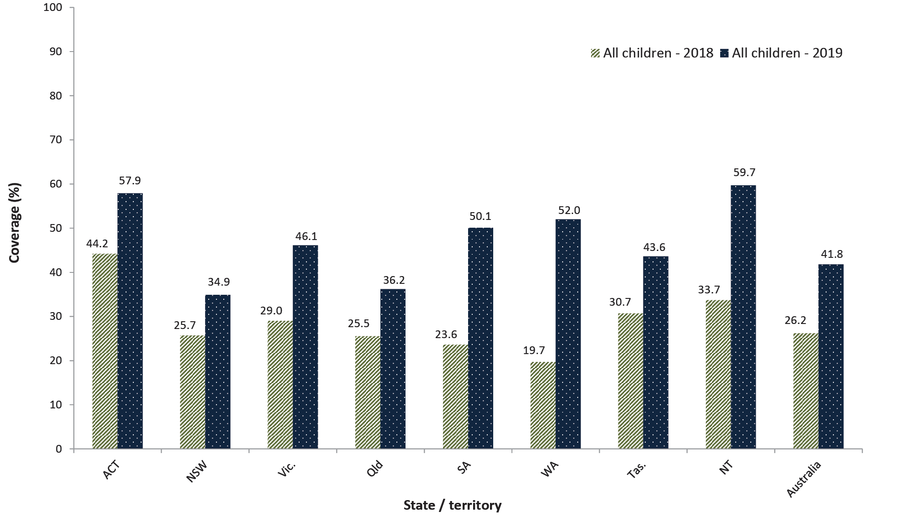
a Any influenza vaccine dose.
b Source: Australian Immunisation Register, data as at 31 March 2020.
c ACT: Australian Capital Territory; NSW: New South Wales; NT: Northern Territory; Qld: Queensland; SA: South Australia; Tas.: Tasmania; Vic.: Victoria; WA: Western Australia.

Figure 2: Recorded coverage of seasonal influenza vaccineª in Indigenous children aged 6 months to < 5 years, by jurisdiction, 2018 versus 2019, Australia^{b,c}
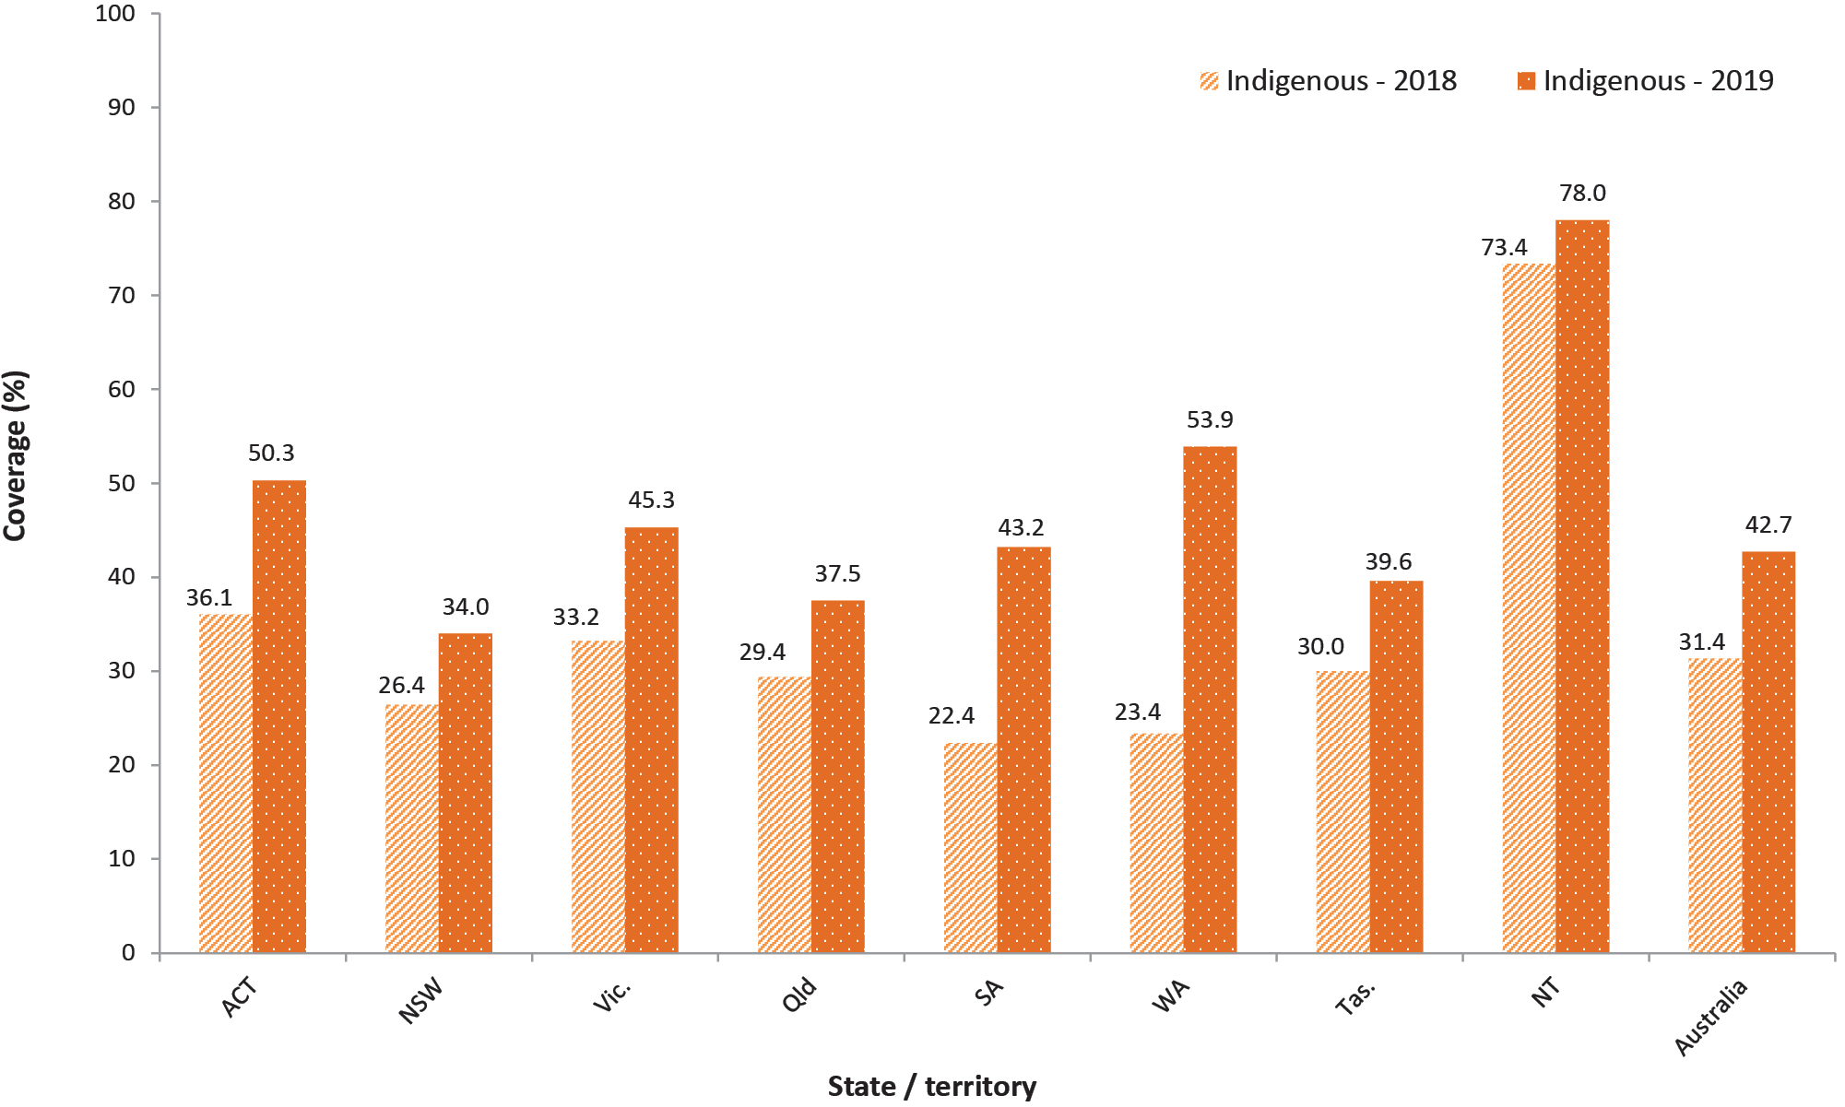
a Any influenza vaccine dose.
b Source: Australian Immunisation Register, data as at 31 March 2020.
c ACT: Australian Capital Territory; NSW: New South Wales; NT: Northern Territory; Qld: Queensland; SA: South Australia; Tas.: Tasmania; Vic.: Victoria; WA: Western Australia.

Timeliness of vaccination
The difference in the percentage of children with on-time receipt (within 30 days of the recommended age) of the second dose of DTPa vaccine between Indigenous and non-Indigenous children was 9.8 percentage points in 2019 (refer to Figure 3). The differential narrows with increasing age, with only a 1.4 percentage point differential at 9 months of age.

Figure 3: Cumulative percentage of children vaccinated with the second dose of DTPa-containing vaccine^{a,b} by age in months and Indigenous status, Australia, 2019^{c}
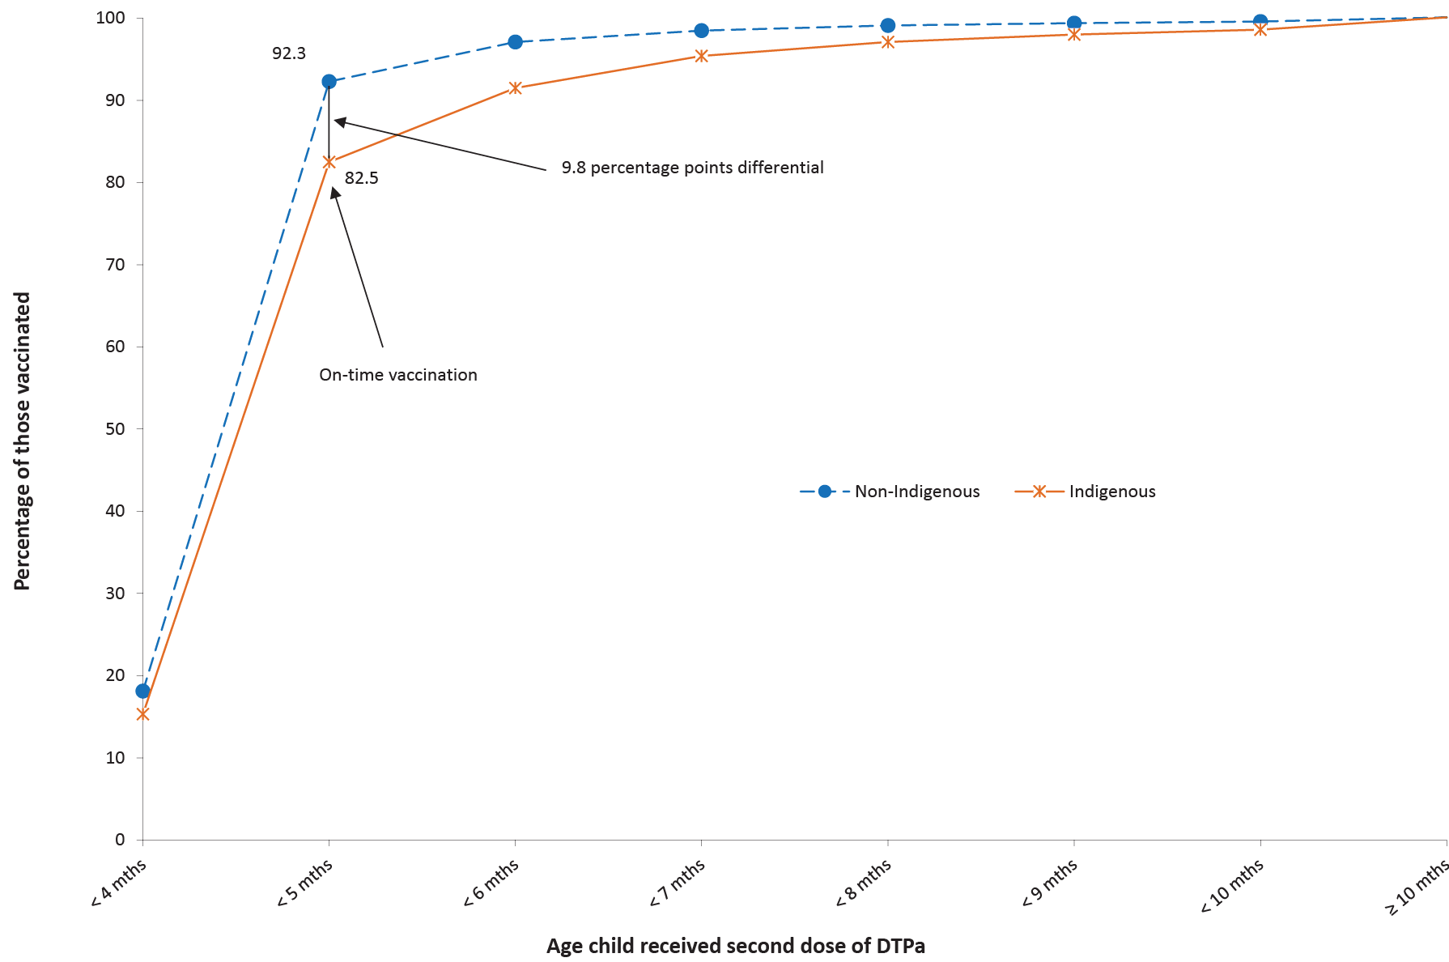
a DTPa: diphtheria (D), tetanus (T) and acellular pertussis (Pa) containing vaccine.
b Shown as cumulative percentage vaccinated (number of children who received vaccine dose at particular age / total number of children who received the vaccine dose, expressed as a percentage).
c Cohort born in 2017.
The on-time vaccination differential for the second dose of 13vPCV between Indigenous and non-Indigenous children in 2019 was 9.6 percentage points, narrowing to a 1.2 percentage point differential at 9 months of age (refer to Figure 4).

Figure 4: Cumulative percentage of children vaccinated with the second dose of 13vPCV^{a,b} by age in months and Indigenous status, Australia, 2019^{c}
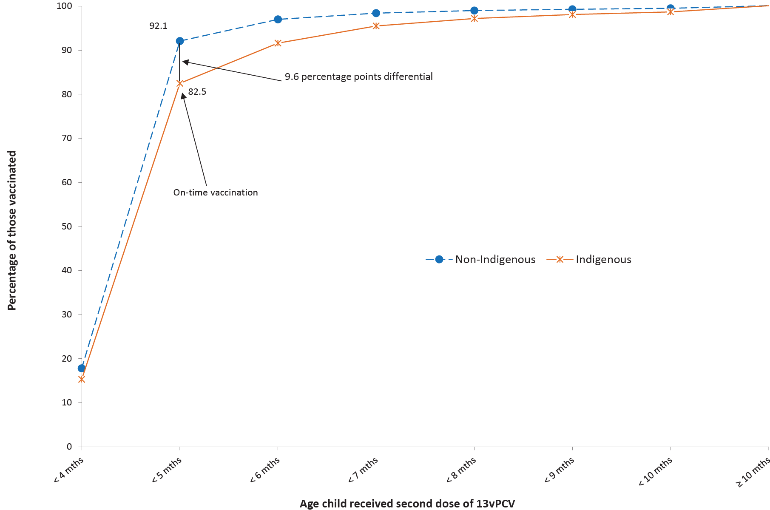
a PCV: pneumococcal conjugate vaccine; 13vPCV: 13-valent pneumococcal conjugate vaccine.
b Shown as cumulative percentage vaccinated (number of children who received vaccine dose at particular age / total number of children who received the vaccine dose, expressed as a percentage).
c Cohort born in 2017.
The on-time vaccination differential for the second dose of rotavirus vaccine, between Indigenous and non-Indigenous children in 2019, was lower than that for DTPa-containing vaccine and 13vPCV at 4.0 percentage points, narrowing with increasing age to only 0.2 percentage points at 6 months of age (refer to Figure 5).

Figure 5: Cumulative percentage of children vaccinated with the second dose of rotavirus vaccineª by age in months and Indigenous status, Australia, 2019^{b}
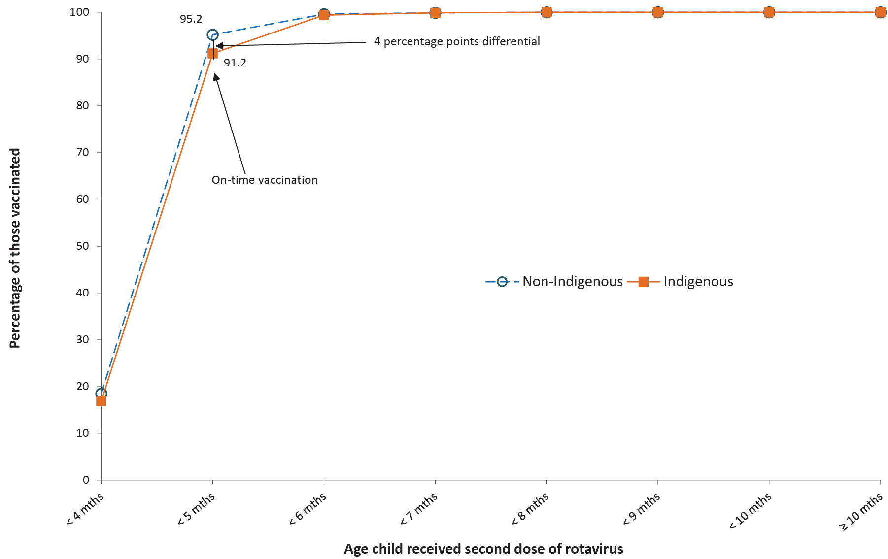
a Shown as cumulative percentage vaccinated (number of children who received vaccine dose at particular age / total number of children who received the vaccine dose, expressed as a percentage).
b Cohort born in 2017.
The on-time vaccination differential for the first dose of MMR vaccine between Indigenous and non-Indigenous children in 2019 was 11.5 percentage points. The differential narrows with increasing age, with a 2.2 percentage point differential at 17 months of age (refer to Figure 6).

Figure 6: Cumulative percentage of children vaccinated with the first dose of measles-mumps-rubella vaccineª by age in months and Indigenous status, Australia, 2019^{b,c}
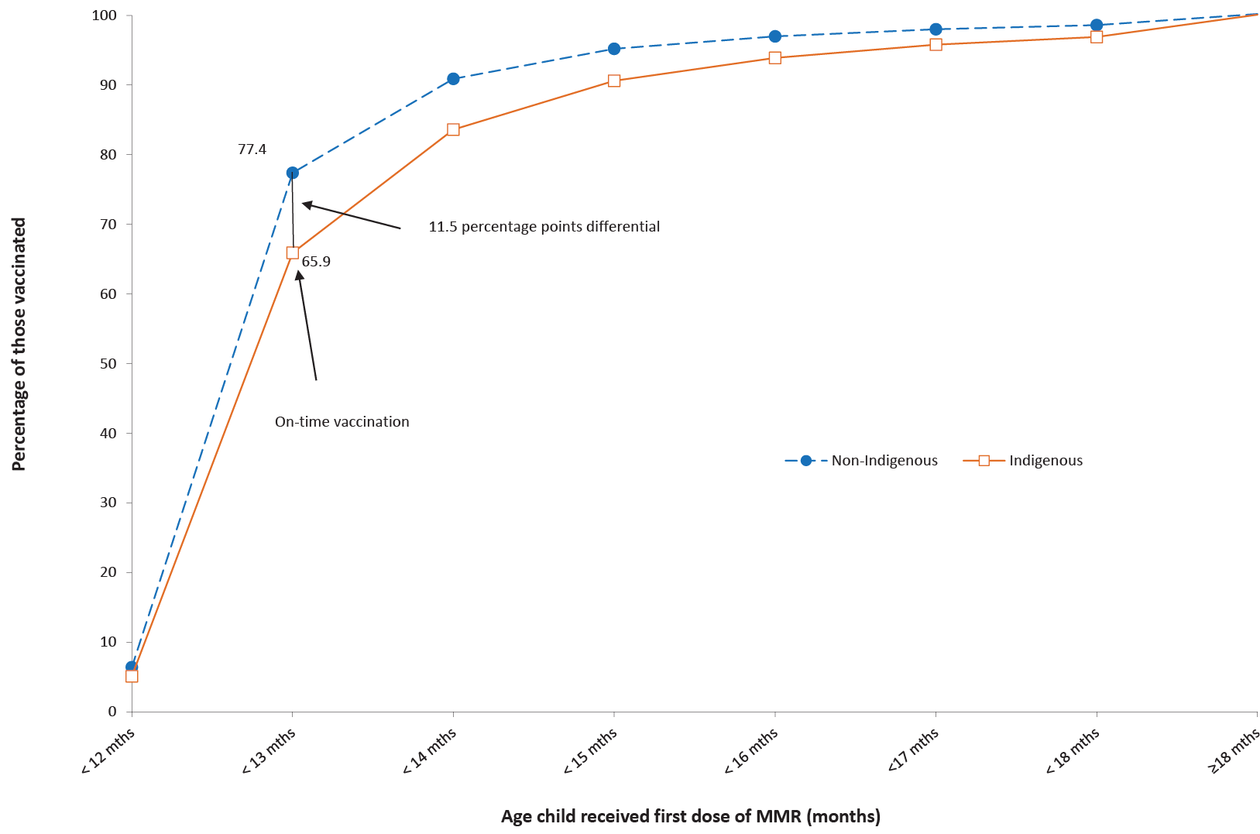
a Shown as cumulative percentage vaccinated (number of children who received vaccine dose at particular age / total number of children who received the vaccine dose, expressed as a percentage).
b MMR: measles, mumps, rubella vaccine.
c Cohort born in 2017.
The on-time vaccination differential for the first dose of MenC-containing vaccine between Indigenous and non-Indigenous children in 2019 was 10.4 percentage points, narrowing to a 1.6 percentage points differential at 17 months of age (refer to Figure 7).

Figure 7: Cumulative percentage of children vaccinated with the first dose of MenC-containing vaccine^{a,b} by age in months and Indigenous status, Australia, 2019
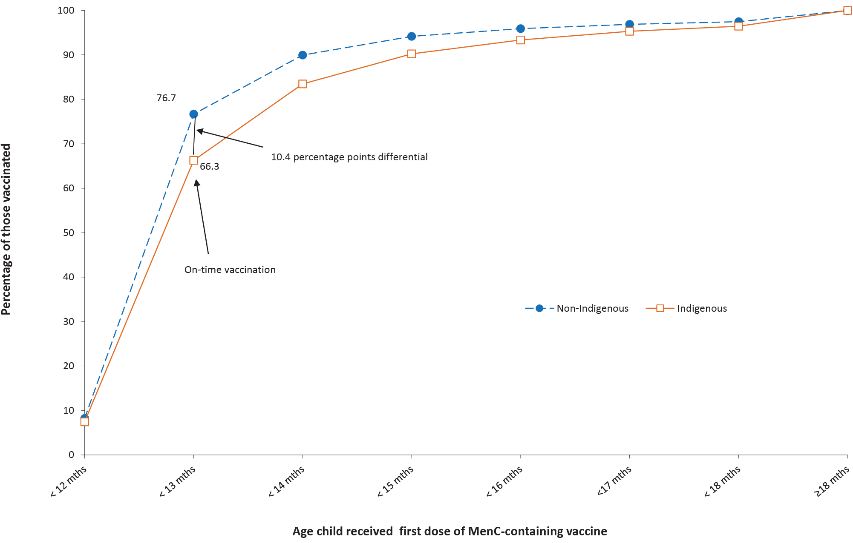
a Shown as cumulative percentage vaccinated (number of children who received vaccine dose at particular age / total number of children who received the vaccine dose, expressed as a percentage).
b Cohort born in 2017.
a Cohort born 1 January – 31 December 2017
The disparity between Indigenous and non-Indigenous children for on-time receipt of vaccines decreased by between 0.8 and 1.8 percentage points for vaccine doses due at 4 months of age (second doses of DTPa-containing vaccine, 13vPCV and rotavirus vaccine; refer to Table 2). For vaccine doses due at 12 months of age, the disparity decreased slightly for MenC-containing vaccine and increased slightly for the first dose of MMR vaccine. Longer-term trend data for on-time receipt of vaccines can be found in our 2017 report.¹¹

Table 2. Disparity in on-time vaccination between Indigenous and non-Indigenous children for selected vaccine doses, Australia, 2018 versus 2019
Vaccine/antigen | Disparity in on-time vaccination (percentage points) |  | Change (2018 versus 2019)
 | 2018 | 2019
Diphtheria, tetanus, acellular pertussis – dose 2 | 10.7 | 9.8 | 0.9
13-valent pneumococcal conjugate – dose 2 | 10.4 | 9.6 | 0.8
Rotavirus – dose 2 | 5.8 | 4.0 | 1.8
Meningococcal C containing | 10.7 | 10.4 | 0.3
Measles-mumps-rubella – dose 1 | 11.0 | 11.5 | -0.5

Tables 3 and 4 present ‘fully vaccinated’ coverage estimates assessed 3 months after the last vaccine dose due, that is, earlier than the standard assessment milestones, to capture aspects of timeliness, along with the standard 12-month, 24-month and 60-month age milestones. For all four of the earlier assessment milestones, ‘fully vaccinated’ coverage in 2019 was lower in Indigenous children residing in remote areas than in those residing in major cities and regional areas, with the greatest coverage differential at 21 months of age (refer to Table 3). In contrast, while ‘fully vaccinated’ coverage for non-Indigenous children was 1.9–2.9 percentage points lower in remote areas at 21 months of age and 1.7–2.6 percentage points lower at 48 months of age than for such children in major cities and regional areas, it was higher at 9 and 15 months of age. ‘Fully vaccinated’ coverage was substantially higher at the standard milestones than at the earlier milestones, most marked for vaccines due at 48 months when assessed at 60 months versus 51 months, for both Indigenous and non-Indigenous children, and across all remoteness categories (refer to Table 3).

Table 3. ‘Fully vaccinated’ coverage estimates assessed at earlier (9, 15, 21, 51) and standard (12, 24, 60 months of age: shaded) milestones,ª by Indigenous status and remoteness of area of residence,^{b} Australia, 2019
Indigenous status | Remoteness category^{b} | 9 mo^{c}  (%)^{d} | 12 mo  (%)^{d} | 15 mo  (%)^{e} | 21 mo  (%)^{e} | 24 mo  (%)^{e} | 51 mo  (%)^{f} | 60 mo  (%)^{f}
Indigenous | Major cities | 86.5 | 92.8 | 85.6 | 81.8 | 88.7 | 83.4 | 96.6
 | Inner and outer regional | 86.1 | 93.3 | 86.2 | 82.1 | 89.8 | 84.5 | 97.1
 | Remote and very remote | 81.7 | 91.9 | 84.1 | 75.1 | 86.6 | 83.0 | 97.3
 | All | 85.6 | 92.9 | 85.6 | 81.0 | 88.9 | 83.8 | 96.9
Non-Indigenous | Major cities | 91.6 | 94.4 | 88.2 | 85.9 | 90.0 | 85.0 | 93.9
 | Inner and outer regional | 91.4 | 94.3 | 89.4 | 86.9 | 91.3 | 85.9 | 94.5
 | Remote and very remote | 91.9 | 95.0 | 88.7 | 84.0 | 90.4 | 83.3 | 93.5
 | All | 91.5 | 94.4 | 88.5 | 86.1 | 90.3 | 85.2 | 94.0
All children | Major cities | 91.4 | 94.3 | 88.1 | 85.7 | 90.0 | 84.9 | 94.0
 | Inner and outer regional | 90.7 | 94.2 | 89.0 | 86.3 | 91.1 | 85.8 | 94.8
 | Remote and very remote | 87.8 | 93.7 | 86.8 | 80.5 | 88.9 | 83.2 | 95.0
 | All | 91.2 | 94.3 | 88.3 | 85.7 | 90.2 | 85.1 | 94.2
a Coverage algorithm used for 9/21/51 month milestones same as for 12/24/60, respectively; algorithm used for 15 months same as that for 24 months but excludes doses due at 18 months; for further detail of algorithms, refer to Table A.2 in Appendix.
b Accessibility/Remoteness Index of Australia (ARIA++).
c mo: months.
d Cohort born 1 January – 31 December 2018.
e Cohort born 1 January – 31 December 2017.
f Cohort born 1 January – 31 December 2014.
When stratified by socioeconomic status of area of residence, children residing in areas included in the most advantaged (fifth) quintile in 2019 had 2.6 percentage points or higher ‘fully vaccinated’ coverage than children in the least advantaged (first) quintile at the youngest three earlier assessment milestones (9, 15 and 21 months), but only 0.9 percentage points higher at the 51-month milestone (refer to Table 4). The disparity between vaccination coverage in the most and least advantaged quintiles at the standard milestones ranged from 2.3 percentage points at 24 month of age to only 0.8 percentage points at 60 months of age.

Table 4. ‘Fully vaccinated’ coverage estimates assessed at earlier (9, 15, 21, 51) and standard (12, 24, 60 months: shaded) age milestones,ª by socio-economic status of area of residence,^{b} Australia, 2019
SEIFA^{b} quintile | 9 mo^{c}  (%)^{d} | 12 mo  (%)^{d} | 15 mo  (%)^{e} | 21 mo  (%)^{e} | 24 mo  (%)^{e} | 51 mo  (%)^{f} | 60 mo  (%)^{f}
First (least advantaged) | 89.6 | 93.5 | 86.7 | 84.0 | 88.8 | 84.5 | 93.9
Second | 90.6 | 94.0 | 88.1 | 85.3 | 90.1 | 84.9 | 94.2
Third | 91.5 | 94.4 | 88.5 | 86.2 | 90.5 | 85.0 | 94.1
Fourth | 91.9 | 94.7 | 89.0 | 86.7 | 90.9 | 85.7 | 94.1
Fifth (most advantaged) | 92.4 | 94.9 | 89.4 | 86.7 | 91.1 | 85.4 | 94.7
All | 91.2 | 94.3 | 88.3 | 85.7 | 90.2 | 85.1 | 94.2
a Coverage algorithm used for 9/21/51 months milestones same as for 12/24/60, respectively; algorithm used for 15 months same as 24 months but excludes doses due at 18 months.
b SEIFA Index of Economic Resources.
c mo: months.
d Cohort born 1 January – 31 December 2018.
e Cohort born 1 January – 31 December 2017.
f Cohort born 1 January – 31 December 2014.
‘Fully vaccinated’ coverage estimates assessed at 9, 15, 21 and 51 months of age in 2019, by PHN, are shown in Table A.3 in the Appendix.

Small area coverage analysis
Vaccination coverage in Australia in 2019 varied within jurisdictions and major capital cities, with coverage in some areas substantially below the national averages, especially the North Coast region of NSW and the Gold Coast region of Queensland (refer to Figures 8–10). Over half of the SA3 areas had coverage of 93% or higher at 24 months of age for the second dose of MMR vaccine (206/329; 62.6%) (refer to Figure 8), the fourth dose of DTPa-containing vaccine (188/329; 57.1%) (refer to Figure 9) and MenACWY vaccine (230/325; 70.8%) (refer to Figure 10).

Figure 8: Coverage of two doses of measles-mumps-rubella (MMR)-containing vaccine at 24 months of ageª by Statistical Area 3, Australia and major capital cities, 2019
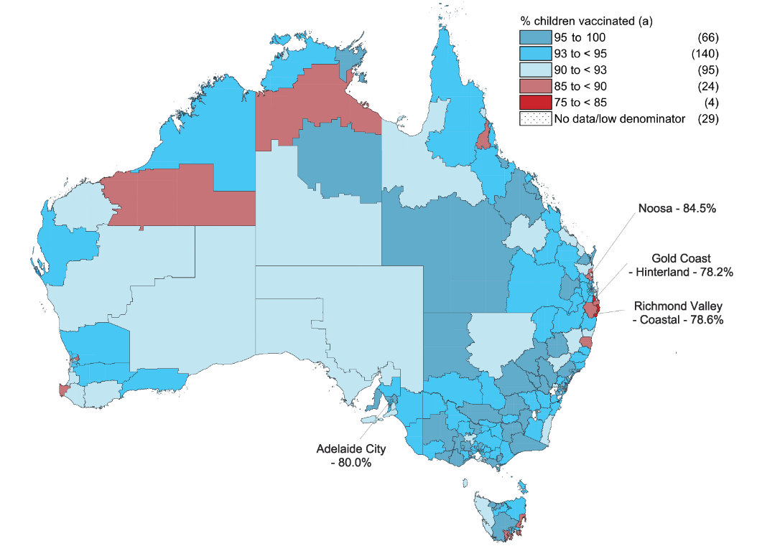
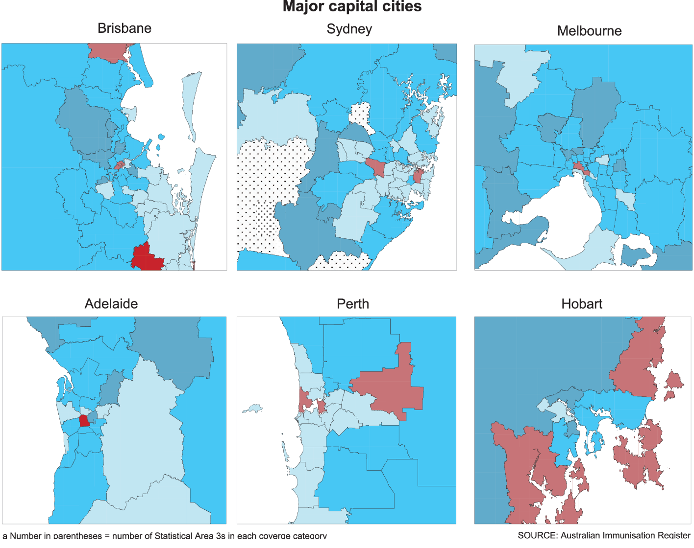
a Cohort born 1 January – 31 December 2017.
Figure 9: Coverage of four doses of diphtheria-tetanus-acellular pertussis (DTPa)-containing vaccine at 24 months of ageª by Statistical Area 3, Australia and major capital cities, 2019
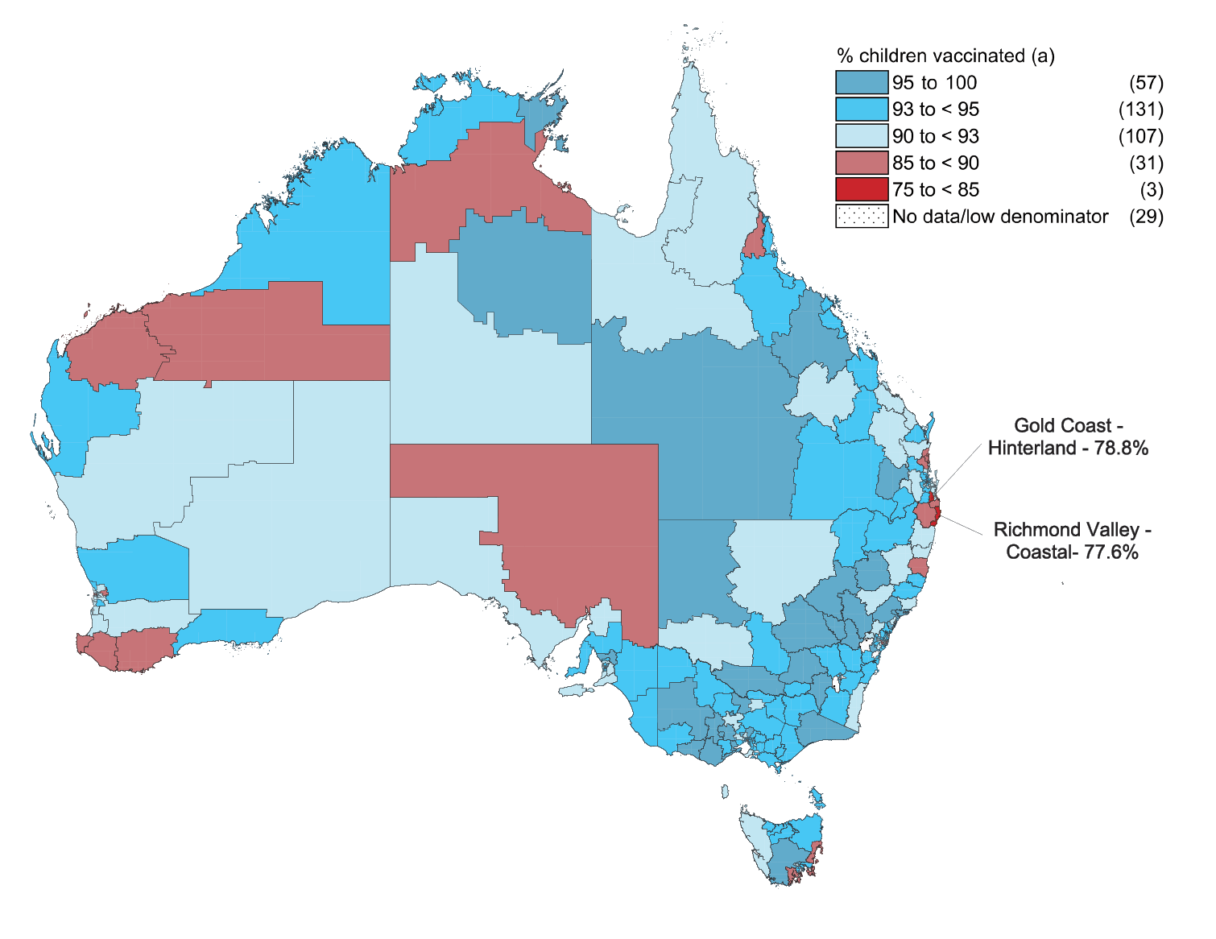
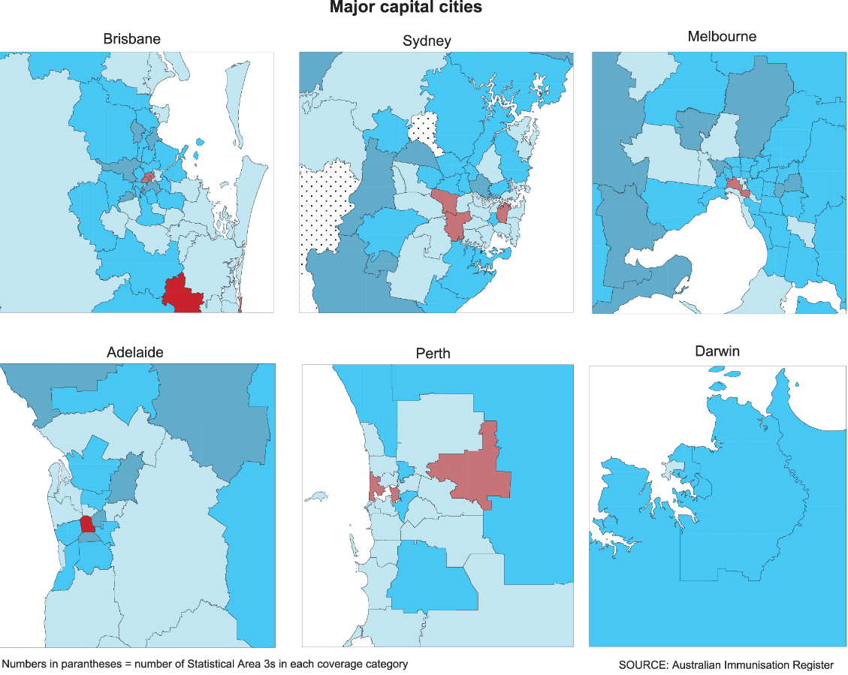
a Cohort born 1 January – 31 December 2017.
Figure 10: Coverage of one dose of meningococcal ACWY vaccine at 24 months of ageª by Statistical Area 3, Australia and major capital cities, 2019
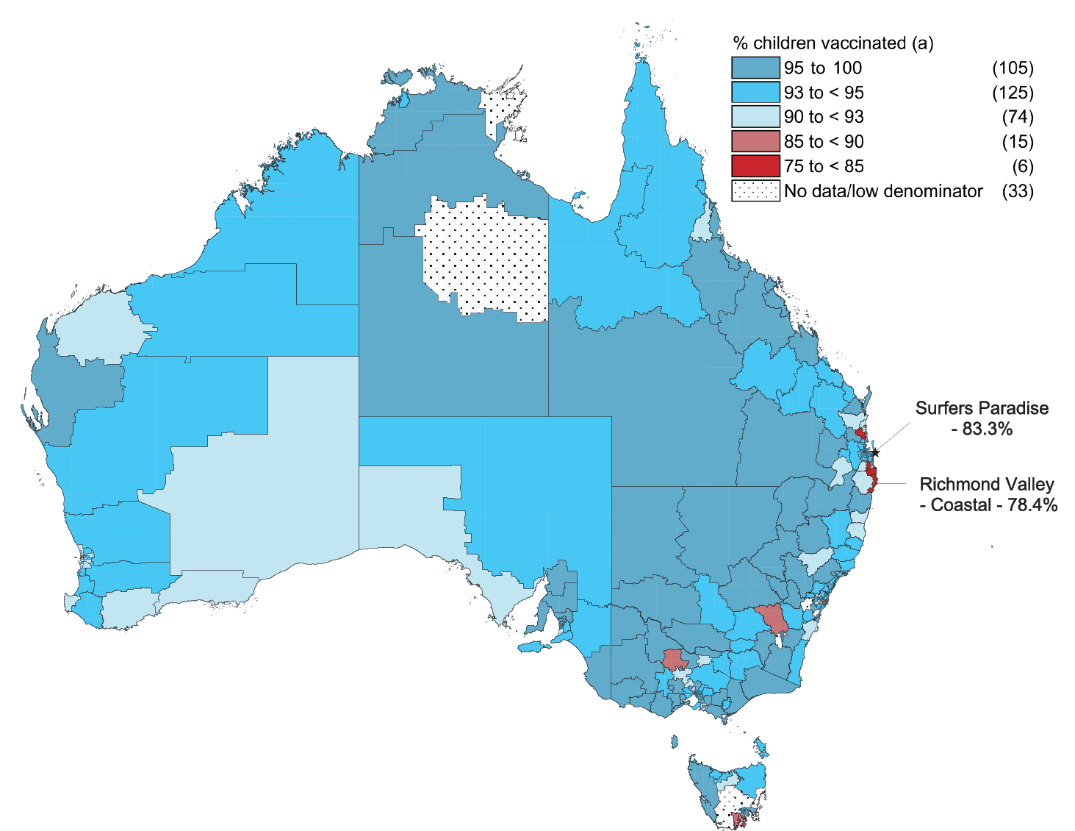
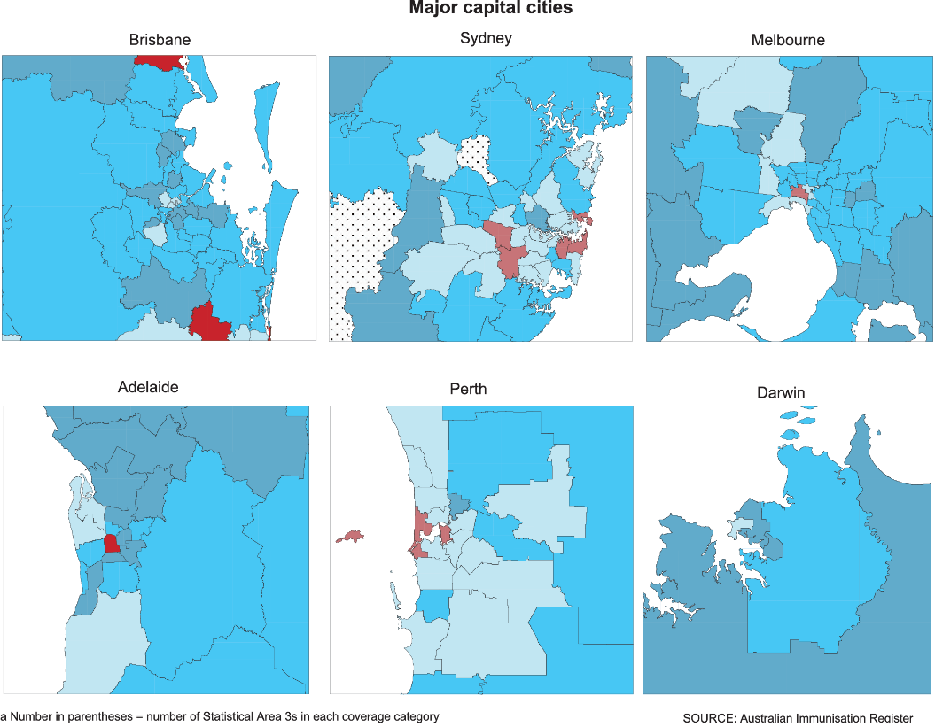
a Cohort born 1 January – 31 December 2017.

Discussion

Overall findings
Our report shows that ‘fully vaccinated’ coverage in Australia increased slightly between 2018 and 2019, by 0.1–0.4 percentage points at the 12-month, 24-month and 60-month age assessment milestones, reaching 94.3%, 90.2% and 94.2%, respectively. True coverage is likely to have been higher, given under-reporting to AIR,^{18,19} probably close to or even slightly above the national coverage target of 95% at the 12- and 60-month age milestones. The increases in coverage at these milestones over recent years have been potentially contributed to by a range of measures, including the federal government ‘No Jab No Pay’ policy (implemented from 1 January 2016) and ‘No Jab No Play’ policies implemented in several states.
‘Fully vaccinated’ coverage at the 24-month milestone is several percentage points below ‘fully vaccinated’ coverage at 12 and 60 months of age. This disparity is most likely due to the increased number of antigens required to be classified as ‘fully vaccinated’ at 24 months, including vaccine doses due at 6 and 12 months as well as the three vaccines (DTPa, Hib and measles-mumps-rubella-varicella [MMRV]) now scheduled at 18 months of age, only 6 months before the assessment time point.⁹ In contrast, only one vaccine (DTPa-polio) is scheduled at 48 months and assessed 12 months later at 60 months. Expansion of the 5-year coverage assessment algorithm, to include a more comprehensive range of vaccines/antigens that should have been received by that age, would be useful to better monitor uptake under the NIP, although this would present communication challenges in managing perceptions of a resultant ‘drop’ in coverage.²⁰

Improvements by individual vaccine
Coverage for individual vaccines/antigens included in the ‘fully vaccinated’ assessment algorithms was generally similar, or slightly higher, in 2019 compared to 2018. The largest increases in coverage were for DTPa-containing vaccine and 13vPCV at 60 months of age, both increasing by 0.7 percentage points. Coverage for rotavirus vaccine at 12 months of age, not included in the ‘fully vaccinated’ algorithm because of the strict upper age limits for vaccine administration, increased by 1.0 percentage point to 91.9% in 2019.⁹
In the context of Australia’s 95% coverage targets, which are particularly critical to measles control, coverage at 24 months of age in 2019 was 95.3% for the first dose of MMR vaccine, and while coverage at this milestone was slightly lower for the second dose of MMR at 93.3%, it increased to 96.4% by 60 months of age.

Comparing coverage for Indigenous and all children
‘Fully vaccinated’ coverage in Indigenous children in 2019 increased by 0.5–1.1% at the three age milestones compared with that in 2018. Coverage at the 12-month milestone in Indigenous children increased to 92.9%, although it remained 1.4 percentage points lower than in children overall. At the 24-month age milestone, ‘fully vaccinated’ coverage in Indigenous children increased by 1.1 percentage points to 88.9%, with the gap to children overall narrowing from 2.3 to 1.3 percentage points, while at the 60-month age milestone, coverage in Indigenous children was 2.7 percentage points higher. This highlights timeliness issues among Indigenous children, as coverage of individual vaccines/antigens due at 6 or 12 months with no further doses (MenC-containing, polio and hepatitis B vaccines) was over 97% at 24 months. Similarly, although coverage in 2019 for the second dose of MMR and varicella (given as MMRV vaccine at 18 months) in Indigenous children was 92–93% at 24 months, it was over 97% at 60 months. This pattern is consistent with long-standing vaccination timeliness issues among Indigenous children.^{1,9}
Coverage for vaccines funded under the NIP only for Indigenous children in 2019, either nationally (influenza) or in certain jurisdictions (hepatitis A vaccine and dose 4 of 13vPCV), remained suboptimal, although coverage in the Northern Territory was substantially higher than in other jurisdictions for all these vaccines. Coverage for hepatitis A vaccine and the fourth dose of 13vPCV in the relevant jurisdictions (South Australia, Northern Territory, Queensland and Western Australia) was 72.2% and 62.0%, respectively. Recorded national influenza vaccination coverage in Indigenous children aged 6 months to < 5 years increased by 11.4 percentage points to 42.7% and in all children by 15.6 percentage points to 41.8% in 2019 compared with that in 2018. State/territory-funded influenza vaccination programs for all children were in place in all jurisdictions in 2019.²¹

A focus on timeliness
We examined a broad range of timeliness indicators in this report. The traditional measure (of vaccination receipt within 30 days of the NIP schedule’s recommended age) showed some improvement in 2019, with the disparity between Indigenous and non-Indigenous children in on-time coverage for the second doses of DTPa-containing vaccine, 13vPCV and rotavirus vaccine decreasing by 1–2 percentage points from 2018. In addition, we examined ‘fully vaccinated’ coverage at earlier milestones 3 months after the due date of the last scheduled vaccine, with a focus on remoteness and socioeconomic status of area of residence. ‘Fully vaccinated’ coverage at the earlier milestones in Indigenous children in remote areas was lower than that for Indigenous children in major cities and regional areas. The differential was highest at the 21-month age assessment milestone, with coverage 6.7 percentage points lower in Indigenous children in remote areas compared to major cities, although this disparity was lower than in 2018 (9.6 percentage points).¹² This disparity is likely due to greater logistic issues in providing and accessing vaccination in remote areas. ‘Fully vaccinated’ coverage at the earlier assessment time points was 0.9–2.8 percentage points lower for children living in areas in the most socioeconomically disadvantaged quintile compared with those in the least disadvantaged quintile, also consistent with access issues.^{22,23} However, the disparity was 0.5–1.5 percentage points lower at the earlier assessment points in 2019 than in 2018.¹² While coverage improved substantially across the board by 60 months of age, the current ‘fully vaccinated’ assessment algorithm at this milestone may not be optimal, given that it includes only the single vaccine due at 48 months.

Conclusions
This report demonstrates continuing improvements across a range of immunisation indicators in Australia in 2019. However, some issues with timeliness persist, particularly in Indigenous and socioeconomically disadvantaged children. As younger children are generally more vulnerable to severe disease, and Indigenous and socioeconomically disadvantaged children even more so, equitable coverage of vaccination at the earliest appropriate age, in line with the NIP schedule, should be a public health goal for countries such as Australia where high levels of overall vaccine coverage at standard milestone ages have been achieved. New coverage targets for earlier protection in the first 2 years of life may be indicated, along with review of current ‘fully vaccinated’ assessment algorithms, particularly at the 60-month age milestone.

Acknowledgements
The National Centre for Immunisation Research and Surveillance is supported by the Australian Government Department of Health, the NSW Ministry of Health and The Children’s Hospital at Westmead. The opinions expressed in this report are those of the authors, and do not necessarily represent the views of these agencies.

Author details
Brynley Hull¹ Alexandra Hendry¹ Aditi Dey¹ Kristine Macartney¹ Frank Beard¹
- National Centre for Immunisation Research and Surveillance

Corresponding author
Brynley Hull
National Centre for Immunisation Research and Surveillance, the Children’s Hospital at Westmead and The University of Sydney, locked Bag 4001, Westmead NSW 2145.
Telephone: +61 2 9845 1435.
Facsimile: +61 2 9845 1418.
Email: brynley.hull@health.nsw.gov.au

References
- Hull B, Deeks S, Menzies R, McIntyre P. Immunisation coverage annual report, 2007. Commun Dis Intell Q Rep. 2009;33(2):170–87.
- Hull BP, Mahajan D, Dey A, Menzies RI, McIntyre PB. Immunisation coverage annual report, 2008. Commun Dis Intell Q Rep. 2010 Sep;34(3):241–58.
- Hull B, Dey A, Mahajan D, Menzies RI, McIntyre PB. Immunisation coverage annual report, 2009. Commun Dis Intell Q Rep. 2011;35(2):132–48.
- Hull B, Dey A, Menzies R, McIntyre P. Annual immunisation coverage report, 2010. Commun Dis Intell Q Rep. 2013;37(1):E21–39.
- Hull BP, Dey A, Menzies RI, Brotherton JM, McIntyre PB. Immunisation coverage annual report, 2011. Commun Dis Intell Q Rep. 2013;37(4):E291–312.
- Hull BP, Dey A, Menzies RI, Brotherton JM, McIntyre PB. Immunisation coverage, 2012. Commun Dis Intell Q Rep. 2014;38(3):E208–31.
- Hull BP, Dey A, Beard FH, Menzies RI, Brotherton JM, McIntyre PB. Immunisation coverage annual report, 2013. Commun Dis Intell Q Rep. 2016;40(1):E146–69.
- Hull BP, Hendry AJ, Dey A, Beard F, Brotherton J, McIntyre P. Immunisation coverage annual report, 2014. Commun Dis Intell Q Rep. 2017;41(1):E68–90.
- Hull B, Hendry A, Dey A, Beard F, Brotherton J, McIntyre P. Immunisation coverage annual report, 2015. Commun Dis Intell (2018). 2019;43. doi: https://doi.org/10.33321/cdi.2019.43.11.
- Hull B, Hendry A, Dey A, Beard F, Brotherton J, McIntyre P. Annual immunisation coverage report, 2016. Commun Dis Intell (2018). 2019;43. doi: https://doi.org/10.33321/cdi.2019.43.44.
- Hull B, Hendry A, Dey A, Brotherton J, Macartney K, McIntyre P. Annual immunisation coverage report 2017. Commun Dis Intell (2018). 2019;43. doi: https://doi.org/10.33321/cdi.2019.43.47.
- Hull B, Hendry A, Dey A, McIntyre P, Macartney K, Beard F. Annual immunisation coverage report 2018. Commun Dis Intell (2018). 2021;45. In press.
- Australian Institute of Health and Welfare (AIHW). National Health Performance Authority. Healthy communities: Immunisation rates for children in 2012–13. [Internet.] Canberra: Australian Government, AIHW; 2014. Available from: https://meteor.aihw.gov.au/content/index.phtml/itemId/564342.
- AIHW. National Health Performance Authority. In Focus: Healthy communities. Immunisation rates for children in 2014–15. Canberra: Australian Government, AIHW; 2016. Available from: https://www.aihw.gov.au/getmedia/9a2ee78b-0f20-4f72-9d80-3bc2fe0effb6/aihw-mhc-nhpa-16-immunisation-rates-children-2014-15-report-february-2016.pdf.
- AIHW. In Focus: Healthy Communities. Immunisation rates for children in 2015–16. Canberra: Australian Government, AIHW; 2017. [Accessed on 9 August 2018.] Available from: https://www.aihw.gov.au/getmedia/40ddbc3e-5238-435a-8469-a83e270836ee/aihw-mhc-hpf-4-immunisation-rates-children-2015-16-in-focus-june-2017.pdf.
- Australian Government Department of Health. Immunisation coverage rates for all children. [Internet.] Canberra: Australian Government Department of Health; 2020. [Accessed on 20 August 2020.] Available from: https://www.health.gov.au/health-topics/immunisation/childhood-immunisation-coverage/immunisation-coverage-rates-for-all-children.
- Hull B, Hendry A, Dey A, Macartney K, McIntyre P, Beard F. Exploratory analysis of the first 2 years of adult vaccination data recorded on AIR. Sydney: National Centre for Immunisation Research and Surveillance; November 2019. [Accessed on 24 June 2020.] Available from: http://ncirs.org.au/sites/default/files/2019-12/Analysis%20of%20adult%20vaccination%20data%20on%20AIR_Nov%202019.pdf.
- Dalton L, Meder K, Beard F, Dey A, Hull B, McIntyre P et al. Australian Immunisation Register Data Transfer Study - Stage 2 Final Report. Sydney: National Centre for Immunisation Research and Surveillance; August 2018. Available from: https://ncirs.org.au/sites/default/files/2018-12/2018%20AIR%20data%20tranfer%20report_FINAL_0.pdf.
- Law C, McGuire R, Ferson MJ, Reid S, Gately C, Stephenson J et al. Children overdue for immunisation: a question of coverage or reporting? An audit of the Australian Immunisation Register. Aust N Z J Public Health. 2019;43(3):214–20.
- Hull B, Dey A, Hendry A, McIntyre P, Macartney K, Beard F. Research report 1: Coverage at the 2-year and 5-year age milestones. Sydney: National Centre for Immunisation Research and Surveillance; 2 April 2020. [Accessed on 28 August 2020.] Available from: http://ncirs.org.au/sites/default/files/2020-07/Coverage%20at%20the%202-year%20age%20milestone_FINAL_15%20July%202020.pdf.
- Beard FH, Hendry AJ, Macartney K. Early success with room for improvement: influenza vaccination of young Australian children. Med J Aust. 2019;210(11):484–6.
- Beard FH, Hull BP, Leask J, Dey A, McIntyre PB. Trends and patterns in vaccination objection, Australia, 2002–2013. Med J Aust. 2016;204(7):275.
- Homel J, Edwards B. Factors associated with delayed infant immunization in a nationally representative cohort study. Child Care Health Dev. 2018;44(4):583–91.
- National Centre For Immunisation Research and Surveillance (NCIRS). History of vaccination in Australia. [Internet.] Sydney: NCIRS; 2018. [Accessed on 19 September 2018.] Available from: http://www.ncirs.edu.au/provider-resources/vaccination-history/.
- Hull BP, McIntyre PB, Heath TC, Sayer GP. Measuring immunisation coverage in Australia: a review of the Australian Childhood Immunisation Register. Aust Fam Physician. 1999;28(1):55–60.
- Australian Digital Health Agency (ADHA). Australian Immunisation Register. [Website.] Canberra: Australian Government, ADHA; 2019. [Accessed on 27 August 2019.] Available from: https://developer.digitalhealth.gov.au/products/australian-immunisation-register.
- O’Brien ED, Sam GA, Mead C. Methodology for measuring Australia’s childhood immunisation coverage. Commun Dis Intell. 1998;22(3):36–7.
- Hull BP, McIntyre PB. Immunisation coverage reporting through the Australian Childhood Immunisation Register – an evaluation of the third-dose assumption. Aust N Z J Public Health. 2000;24(1):17–21.
- Hull BP, Lawrence GL, MacIntyre CR, McIntyre PB. Estimating immunisation coverage: is the ‘third dose assumption’ still valid? Commun Dis Intell Q Rep. 2003;27(3):357–61.
- Hugo Centre for Migration and Population Research. Accessibility/Remoteness Index of Australia - ARIA++(2011). [Internet.] Adelaide: University of Adelaide, Hugo Centre for Migration and Population Research, 2011. [Accessed on 17 November 2017.] Available from: https://www.adelaide.edu.au/hugo-centre/spatial_data/.
- Australian Bureau of Statistics. Socio-Economic Indexes for Areas. [Internet.] Canberra: Australian Bureau of Statistics; 2013. [Accessed on 26 February 2018.] Available from: http://www.abs.gov.au/websitedbs/censushome.nsf/home/seifa.
- Australian Bureau of Statistics. Australian Statistical Geography Standard (ASGS). Canberra: Australian Bureau of Statistics; 2011. [Accessed on 17 November 2014.] Available from: http://www.abs.gov.au/websitedbs/d3310114.nsf/home/australian+statistical+geography+standard+%28asgs%29.
- MapInfo. MapInfo Pro version 15.0. [Software.] Pitney Bowes Software, Stamford, Connecticut, USA; 2015.
- Australian Bureau of Statistics. ASGS Geographic Correspondences (2016). Canberra: Australian Bureau of Statistics; 4 April 2018. [Accessed on 3 August 2020.] Available from: https://data.gov.au/dataset/ds-dga-23fe168c-09a7-42d2-a2f9-fd08fbd0a4ce/details.

Appendix

Vaccine abbreviations
Abbreviations | Description
13vPCV | 13-valent pneumococcal conjugate vaccine
23vPPV | 23-valent pneumococcal polysaccharide vaccine
DTPa | diphtheria-tetanus-acellular pertussis (children aged under 10 years formulation)
Flu | influenza
Hep A | hepatitis A
Hep B | hepatitis B
Hib | Haemophilus influenzae type b
MenACWY | meningococcal ACWY
MenC | meningococcal C
MMR | measles -mumps-rubella
MMRV | measles -mumps-rubella-varicella
PCV | pneumococcal conjugate vaccine
PPV | pneumococcal polysaccharide vaccine
PRP-OMP | Haemophilus influenzae type b conjugate (meningococcal outer membrane conjugate)

Box A.1: Significant changes in childhood immunisation policy, immunisation incentives and coverage calculation algorithms, Australia, 2015 to 2019ª
March 2019 – NT: annual seasonal influenza vaccination program funded for all children aged 6 months to < 5 years.
February 2019 – Aboriginal and Torres Strait Islander children and adolescents aged 5–14 years of age funded for influenza vaccine under NIP.
July 2018 – Schedule for routine childhood vaccination with 13vPCV changed from 2, 4 and 6 months of age to 2, 4 and 12 months of age. Vaccination coverage assessment algorithm for ‘fully vaccinated’ at the 12-month milestone amended to require either 2 or 3 doses of 13vPCV. Vaccination coverage assessment algorithm for ‘fully vaccinated’ at the 24-month milestone amended to require 3 doses of 13vPCV.
Meningococcal ACWY conjugate vaccine funded for all children at 12 months of age, replacing combined Hib and MenC- containing, with the Hib dose moved to 18 months and given as monovalent Hib vaccine.
May 2018 – ACT, NSW, Qld, SA, Tas, Vic: annual seasonal influenza vaccination program funded for all children aged 6 months to < 5 years (in place in WA since 2008).
July 2017 – Queensland, South Australia, Victoria and Western Australia changed from 3-dose RotaTeq® rotavirus vaccine schedule to 2-dose Rotarix® schedule.
Coverage for the second dose of MMR-containing vaccine no longer assessed at 60 months of age.
December 2016 – Vaccination coverage assessment algorithm for ‘fully vaccinated’ at the 24-month milestone amended to require 4 doses of DTPa-containing vaccine.
March 2016 – Booster dose of DTPa vaccine funded at 18 months of age.
January 2016 – New immunisation requirements for federal government family assistance payments (‘No Jab, No Pay’) come into effect. Only parents of children (aged < 20 years, up from < 7 years previously) who are ‘fully vaccinated’ or on a recognised catch-up schedule are eligible to receive the Child Care Benefit, Child Care Rebate and/or the Family Tax Benefit Part A end-of-year supplement. Children with medical contraindications or natural immunity for certain diseases continue to be exempt from the requirements; however, objection on non-medical grounds is no longer a valid exemption.
March 2015 – Seasonal influenza vaccine funded for Aboriginal and Torres Strait Islander children aged 6 months to < 5 years.
a Source: NCIRS History of Vaccination.²⁴

Detailed methods

The Australian Immunisation Register
The Australian Childhood Immunisation Register (ACIR) was established on 1 January 1996 by incorporating demographic data from Medicare on all enrolled children aged < 7 years.²⁵ On 30 September 2016, the ACIR expanded to become the Australian Immunisation Register (AIR) to collect data on vaccinations given from birth to death.²⁶ All people registered with Medicare are automatically added to AIR. Participation in AIR is ‘opt-out’ and so constitutes a nearly complete population register for Australian residents.²⁵ Individuals not enrolled in Medicare can also be added to AIR via a supplementary number. Data are transferred to AIR when a recognised immunisation provider supplies details of an eligible vaccination. This could occur via medical practice management software, through direct data entry on the AIR website or by submitting paper encounter or history forms. High levels of reporting to AIR for child vaccinations are maintained by a system of incentive payments for immunisation providers and carers. These have been discussed in detail elsewhere.^{1,5}

Coverage estimates
This report details national vaccination coverage using AIR data as at 31 March 2020. The cohort method has been used for calculating coverage at the population level (national and state/territory) since the ACIR’s inception.²⁷ Cohort vaccination status was assessed at 12 months of age (for vaccines due at 6 months), 24 months of age (for vaccines due at 6, 12 and 18 months), and 60 months of age (for vaccines due at 48 months). A minimum 3-month lag period was allowed for late notification of vaccinations to AIR, but only vaccines given on or before a child’s first, second or fifth birthday, respectively, were included in coverage calculations.²⁷ If a child’s records indicated receipt of the last dose of a vaccine that required more than one dose to complete the series, it was assumed that earlier vaccines in the sequence had been given. This assumption has been shown to be valid in the past.^{28,29}
Three-month-wide birth cohorts were used for most of the time-trend analyses, with children aged 12 to < 15 months for the 12-month assessment age, children aged 24 to < 27 months for the 24-month assessment age and children aged 60 to < 63 months for the 60-month assessment age. Either 3-month or 12-month wide cohorts were used for all other analyses in this report. The 12-month-wide cohorts used in this report were children born between 1 January and 31 December 2018 for the 12-month milestone; between 1 January and 31 December 2017 for the 24-month milestone; and between 1 January and 31 December 2014 for the 60-month (5 year) milestone.
The proportion of children ‘fully vaccinated’ was calculated using the number of children completely vaccinated with the vaccines of interest by the designated age as the numerator and the total number of children registered on AIR in the relevant age cohort as the denominator. Definitions of ‘fully vaccinated’ coverage are provided in Table A.2 – the definitions for the 12-, 24- and 60-month milestones have been developed by the Commonwealth Department of Health for the purpose of standardised reporting.
Vaccination coverage estimates were also calculated for individual NIP vaccines/antigens, including the three NIP vaccines given in early childhood but not routinely reported on, and not part of, ‘fully vaccinated’ calculations at 12, 24 and 60 months of age. These are: a second dose of rotavirus vaccine by 12 months of age; a second dose of hepatitis A vaccine in Indigenous children by 30 months of age; and a fourth dose of 13vPCV in Indigenous children by 30 months of age. The proportion of children vaccinated with the relevant vaccine/antigen and dose was calculated using the number of children vaccinated with the relevant vaccine/dose by the designated age as the numerator and the total number of children registered on AIR in the relevant age cohort as the denominator. Influenza vaccination coverage for children aged 6 months to < 5 years was calculated by dividing the number of children with at least one dose of influenza vaccine recorded on AIR in a calendar year by the total number of children in the 6 months to < 5 years age group registered on AIR in that year, by Indigenous status and jurisdiction.

Timeliness of vaccination
On-time vaccination was defined as receipt of a scheduled vaccine dose within 30 days of the recommended age. For example, a child who received the first dose of DTPa vaccine (due by 60 days of age under the NIP but recommended from as early as 6 weeks of age) when they were more than 90 days of age was classified as late for that dose. On-time vaccination was measured in 12-month birth cohorts, with children included in the analysis assessed at up to 2 years after doses were due, to allow time for very late vaccinations to be assessed. Therefore, cohorts assessed for timeliness are not the same as those assessed for coverage milestones. The interval between doses was not evaluated. Timeliness of different vaccines and doses was compared by plotting the cumulative percentage receiving each vaccine dose by age in months.
‘Fully vaccinated’ coverage estimates were also assessed at 3 months after last vaccine dose due, that is, earlier than the standard assessment milestones to capture aspects of timeliness, by remoteness and socioeconomic status of area of residence. The definitions of ‘fully vaccinated’ coverage used are provided in Table A.2.

Remoteness status
The area of residence of children was defined as ‘Major cities’, ‘Inner regional’, ‘Outer regional’, ‘Remote’ and ‘Very remote’ using the Accessibility/Remoteness Index of Australia (ARIA++).³⁰ ARIA++ is a continuous varying index with values ranging from 0 (high accessibility) to 15 (high remoteness), and is based on road distance measurements from over 12,000 populated localities to the nearest Service Centres in five categories based on population size. For analysis in this report, we combined the two ‘regional’ categories (‘inner regional’ and ‘outer regional’) into one category and the two ‘remote’ categories (‘remote’ and ‘very remote’) into one category. ARIA Accessibility/Remoteness categories were assigned to each child using their current recorded postcode on AIR.

Socio-economic status
Vaccination coverage and timeliness were assessed by socio-economic status using the ABS Socio Economic Indexes for Areas (SEIFA) Index of Economic Resources.³¹ The SEIFA index category was assigned for each individual using their recorded postcode of residence on AIR. For this analysis we compared vaccination coverage for children living in postcodes classified as being in the top quintile of all postcodes with regard to economic resources with vaccination coverage for children living in postcodes classified as being in the bottom quintile of postcodes with regard to economic resources.

Small area analysis

SA3
Analysis of coverage was undertaken at small area level using the ABS-defined Statistical Area 3 (SA3),³² chosen because each is small enough to show differences within jurisdictions but not too small to render maps unreadable. For both privacy and precision reasons, SA3s with denominators of less than 26 children were not included in any small area analysis. Maps were created using version 15 of the MapInfo mapping software³³ and the ABS Census Boundary Information. As postcode is the only geographical indicator available from AIR, the ABS Postal Area to SA3 Concordance 2016 was used to match AIR postcodes to SA3s.³⁴

PHN
Analysis of coverage was also undertaken at PHN level. PHNs are organisations that work to improve coordination of healthcare in their area, with the boundaries defined by the Australian Government Department of Health. There are 31 PHNs in Australia.

Indigenous status
Aboriginal and Torres Strait Islander status on AIR is recorded as ‘Indigenous’, ‘non-Indigenous’ or ‘unknown’, as reported by the person (or parent/carer) to Medicare. Indigenous status as recorded in provider vaccination notifications to AIR do not override the data on Indigenous status in the Medicare database, emphasising the importance of vaccine recipients or parents/carers ensuring Medicare details are correct. For this report individuals whose Indigenous status was not specified (less than 0.5%) were classified as non-Indigenous for the purposes of analysis. While Indigenous status is available in AIR, other parameters such as country of birth, ethnicity and medical condition (including pregnancy) are not.
Table A.1. Australian NIP Schedule for children aged < 5 years in 2019
Ageª | Vaccine/antigen
Birth | Hep B
2 mo | Hep B | DTPa | Hib | Polio |  |  |  |  | 13vPCV | Rotavirus
4 mo | Hep B | DTPa | Hib | Polio |  |  |  |  | 13vPCV | Rotavirus
6 mo | Hep B | DTPa | Hib | Polio |  |  |  |  | 13vPCV^{b} |  | Flu^{c}
12 mo |  |  |  |  | MMR |  | Men ACWY | Hep A^{d} | 13vPCV |  | Flu^{c}
18 mo |  | DTPa | Hib |  |  | MMRV |  | Hep A^{d} |  |  | Flu^{c}
24 mo |  |  |  |  |  |  |  |  |  |  | Flu^{c}
48 mo |  | DTPa |  | Polio |  |  |  |  | 23vPPVe |  | Flu^{c}
a mo: months.
b Aboriginal and Torres Strait Islander children living in the Northern Territory, Western Australia, Queensland and South Australia, and children with specified underlying medical conditions that predispose them to invasive pneumococcal disease.
c Annual vaccination: all Aboriginal and Torres Strait Islander children aged 6 months to < 5 years, all children aged ≥ 6 months with medical risk factors, Aboriginal and Torres Strait Islander people aged ≥ 15 years, non-Indigenous adults aged ≥ 65 years.
d Aboriginal and Torres Strait Islander children: doses at 12 months and 18 months of age in the Northern Territory, Western Australia, Queensland and South Australia.
e Medically at-risk children.

Table A.2: Vaccinations required to be deemed ‘fully vaccinated’ by each assessment milestone
Milestone | Vaccinationsª
9 months/12 months  (Cohort born 1 January –31 December 2018) | 3rd dose DTPa (given at 6 months)  3rd dose polio (given at 6 months)  3rd dose Hep B (given at 6 months)  3rd dose Hib (given at 6 months)  2nd or 3rd dose 13vPCV (given at 4 or 6 months)
15 months  (Cohort born 1 January –31 December 2017) | 3rd dose DTPa (given at 6 months)  3rd dose polio (given at 6 months)  3rd dose Hep B (given at 6 months)  4th dose Hib (given at 12 months)  3rd dose 13vPCV (given at 6 or 12 months)  1st dose MenACWY (given at 12 months)  1st dose MMR (given at 12 months)
21 months/24 months  (Cohort born 1 January –31 December 2017) | 4th dose DTPa (given at 18 months)  3rd dose polio (given at 6 months)  3rd dose Hep B (given at 6 months)  4th dose Hib (given at 12 or 18 months)  1st dose MenACWY (given at 12 months)  1st dose varicella (given at 18 months)  2nd dose MMR (given at 18 months)  3rd dose 13vPCV (given at 6 or 12 months)
51 months/60 months  (Cohort born 1 January –31 December 2014) | 4th or 5th dose DTPa (given at 48 months)  4th dose polio (given at 48 months)
a DTPa: diphtheria-tetanus-pertussis (acellular) paediatric formulation; Hep B: hepatitis B; Hib: Haemophilus influenzae type b; 13vPCV: 13-valent pneumococcal conjugate vaccine; MenACWY: meningococcal ACWY; MMR: measles-mumps-rubella.

Table A.3. ‘Fully vaccinated’ coverage estimates assessed at standard age milestones (12, 24 and 60 months) and earlier (9, 15, 21, 51 months) milestones,ª by Primary Health Network, 2019
Primary Health Network^{b} | 9 mo^{c} (%)^{d} | 12 mo (%)^{d} | 15 mo (%)^{e} | 21 mo (%)^{e} | 24 mo (%)^{e} | 51 mo (%)^{f} | 60 mo (%)^{f}
Western NSW | 93.1 | 96.3 | 90.6 | 88.9 | 93.5 | 86.8 | 96.8
Western Victoria | 92.7 | 96.3 | 91.2 | 89.8 | 93.8 | 88.9 | 96.7
Gippsland | 91.0 | 94.6 | 89.5 | 88.0 | 92.2 | 88.4 | 96.1
Murray | 90.9 | 94.6 | 89.8 | 88.1 | 92.2 | 88.1 | 96.0
Hunter New England and Central Coast | 93.0 | 95.5 | 90.9 | 88.6 | 92.7 | 87.2 | 95.9
Nepean Blue Mountains | 93.2 | 95.6 | 90.5 | 88.5 | 92.9 | 85.7 | 95.6
South Eastern NSW | 92.8 | 95.1 | 89.9 | 88.2 | 92.0 | 86.3 | 95.6
Western Queensland | 89.5 | 93.8 | 88.3 | 82.2 | 90.6 | 82.0 | 95.6
Eastern Melbourne | 92.1 | 94.9 | 89.3 | 87.5 | 91.1 | 87.3 | 95.3
Murrumbidgee | 93.0 | 95.7 | 91.2 | 89.0 | 92.6 | 88.1 | 95.3
Australian Capital Territory | 94.8 | 96.3 | 91.3 | 89.4 | 92.4 | 87.4 | 95.0
South Western Sydney | 90.0 | 93.5 | 87.2 | 85.1 | 90.0 | 85.3 | 95.0
Tasmania | 91.3 | 94.2 | 89.0 | 85.7 | 90.2 | 87.4 | 95.0
South Eastern Melbourne | 91.1 | 94.6 | 88.5 | 86.7 | 90.5 | 86.6 | 94.9
Darling Downs and West Moreton | 91.3 | 94.4 | 89.5 | 86.7 | 91.6 | 85.6 | 94.7
Northern Queensland | 90.3 | 94.4 | 89.4 | 85.6 | 92.0 | 84.5 | 94.7
North Western Melbourne | 90.6 | 94.1 | 87.6 | 85.8 | 89.7 | 86.5 | 94.5
Adelaide | 91.7 | 94.8 | 89.0 | 85.4 | 90.5 | 84.5 | 94.3
Western Sydney | 90.9 | 93.7 | 86.2 | 84.2 | 88.3 | 85.3 | 94.3
Northern Territory | 88.5 | 93.1 | 87.6 | 83.0 | 89.6 | 80.9 | 94.2
Country WA | 86.9 | 92.6 | 85.9 | 79.8 | 87.3 | 83.7 | 94.1
Brisbane North | 92.5 | 94.7 | 89.8 | 86.9 | 91.6 | 85.2 | 94.0
Country SA | 90.2 | 94.1 | 88.4 | 84.5 | 90.3 | 83.8 | 93.6
Brisbane South | 91.0 | 94.3 | 88.4 | 86.2 | 90.5 | 84.6 | 93.9
Central Queensland, Wide Bay, Sunshine Coast | 89.0 | 92.7 | 87.6 | 84.5 | 89.5 | 84.2 | 93.5
Perth South | 90.3 | 93.8 | 86.3 | 83.0 | 88.1 | 82.9 | 92.9
Perth North | 91.1 | 94.5 | 86.8 | 82.8 | 88.3 | 81.6 | 92.6
Northern Sydney | 92.9 | 94.8 | 88.2 | 85.6 | 89.2 | 82.9 | 92.4
Gold Coast | 89.8 | 92.4 | 86.5 | 84.5 | 89.1 | 82.9 | 91.7
Central and Eastern Sydney | 91.6 | 93.8 | 87.0 | 84.5 | 88.5 | 82.1 | 91.2
North Coast | 86.6 | 89.7 | 83.8 | 81.8 | 86.3 | 81.1 | 90.9
a Coverage algorithm used for 9/21/51 months milestones same as for 12/24/60, respectively; algorithm used for 15 months same as 24 months but excludes doses due at 18 months; for further detail of algorithms, refer to Appendix.
b Data sorted by the ‘60 months’ column (highest to lowest).
c mo: months.
d Cohort born 1 January – 31 December 2018.
e Cohort born 1 January – 31 December 2017.
f Cohort born 1 January – 31 December 2014.

Figure A.1: Trends in ‘fully vaccinated’ coverage estimates by quarter, Australia, 2010 to 2019^{a,b,c}
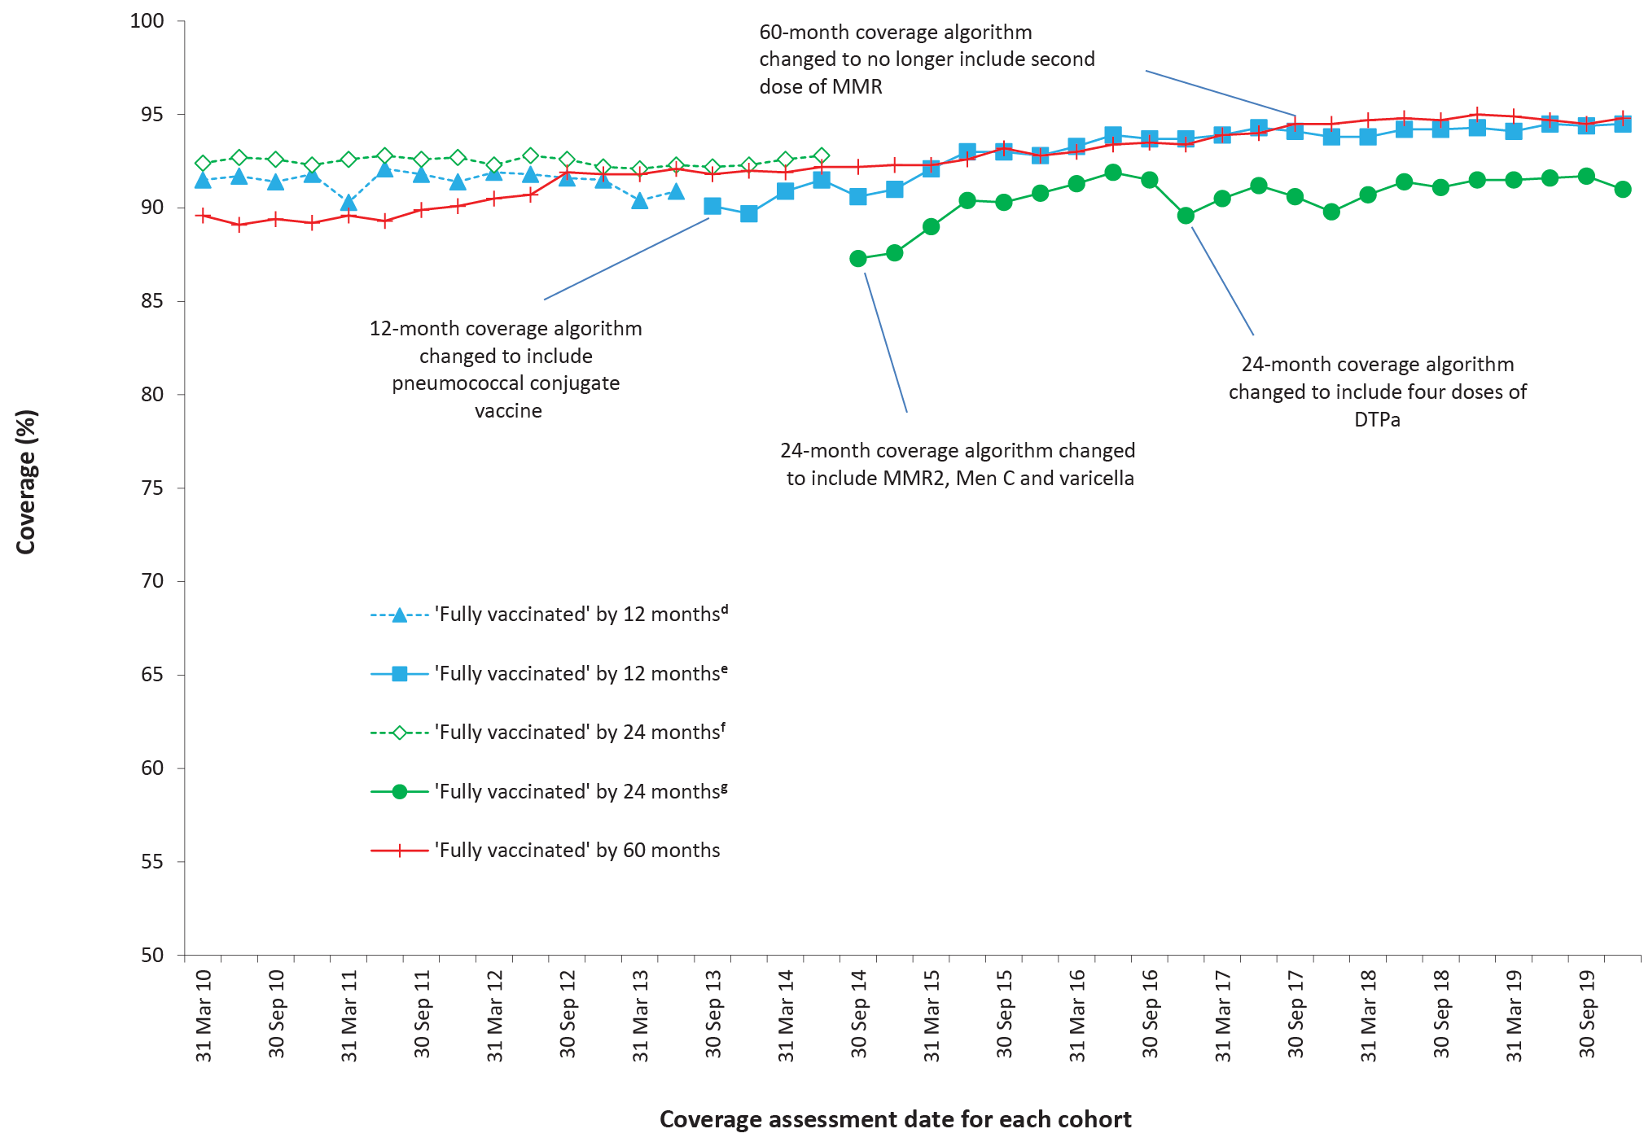
a By 3-month birth cohorts born between 1 January 2009 and 31 December 2018. Coverage assessment date was 12, 24 or 60 months after the last birth date of each cohort. Vaccination coverage estimates are calculated by quarter and may differ slightly from estimates published elsewhere using rolling annualised data.
b Source: Australian Immunisation Register, data as at 31 March 2020.
c MMR2: second dose of MMR vaccine; MenC: meningococcal C-containing; DTPa: diphtheria-tetanus-acellular pertussis.
d Coverage algorithm before 1 July 2013.
e Coverage algorithm from 1 July 2013.
f Coverage algorithm before 1 July 2014.
g Coverage algorithm from 1 July 2014.

Figure A.2: Trends in vaccination coverage estimates at 12 months of age, by vaccine/antigen* and quarter, Australia, 2010 to 2019^{a,b,c,d}
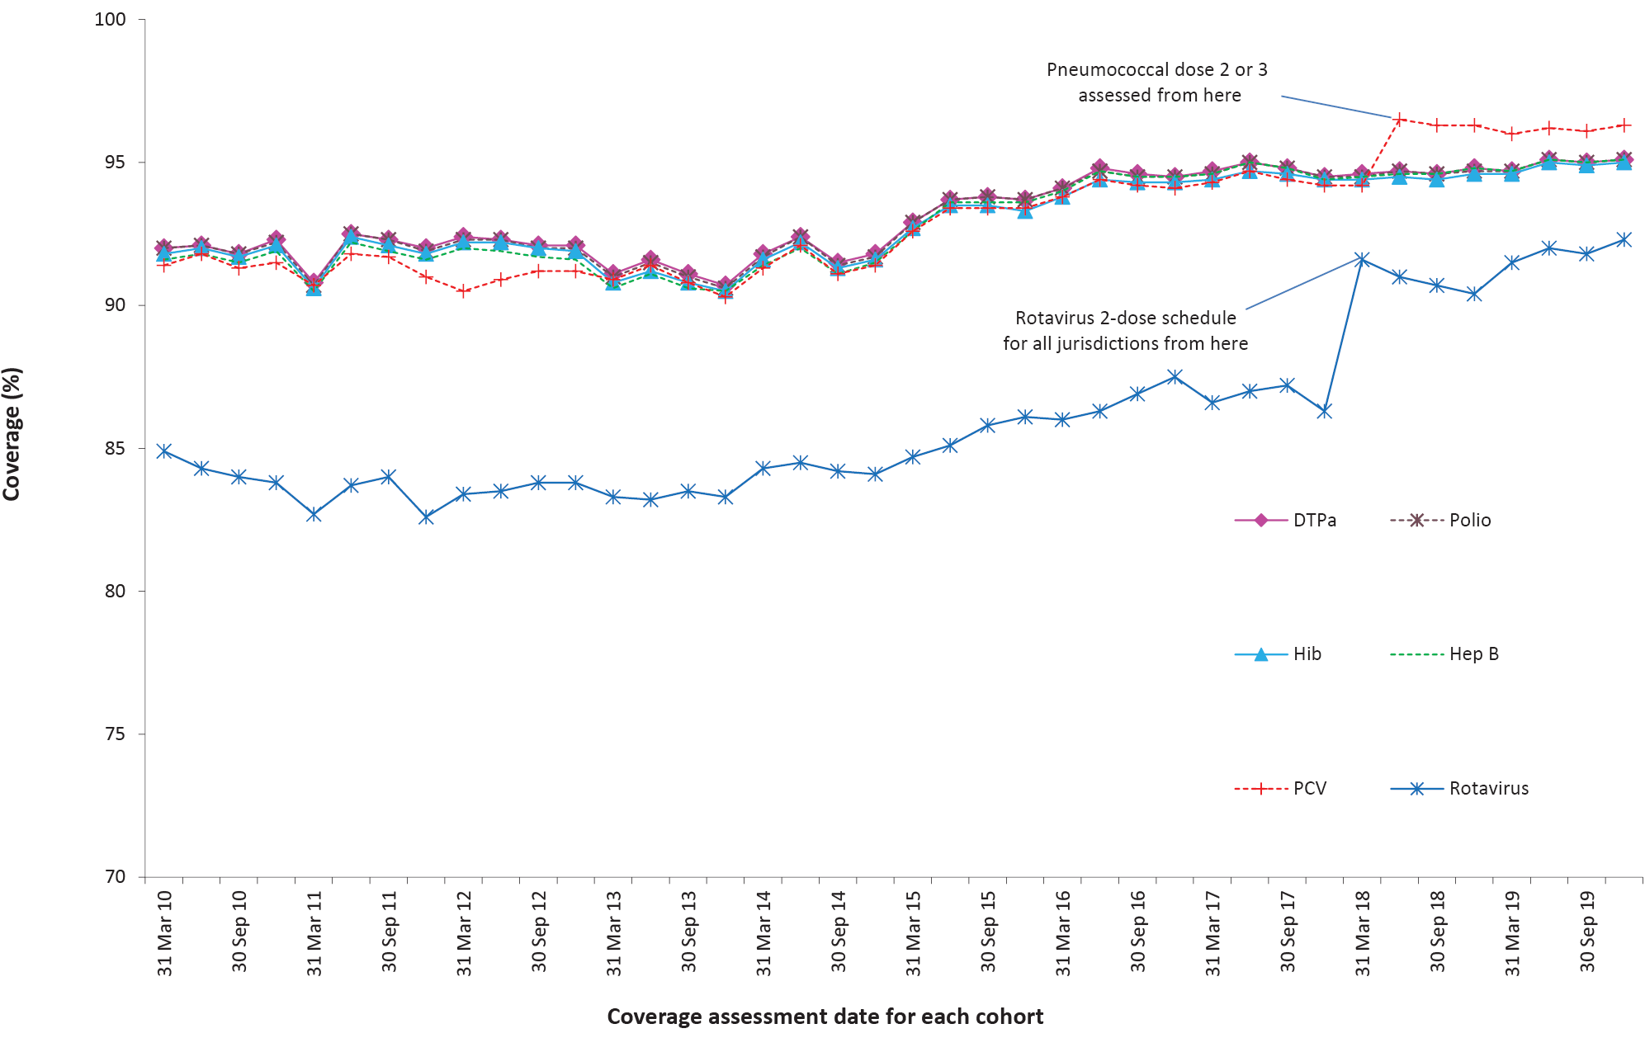
a By 3-month birth cohorts born between 1 January 2009 and 31 December 2018. Coverage assessment date was 12 months after the last birth date of each cohort. Vaccination coverage estimates are calculated by quarter and may differ slightly from estimates published elsewhere using rolling annualised data.
b Source: Australian Immunisation Register, data as at 31 March 2020.
c Third dose of DTPa vaccine, polio vaccine and PCV, second or third dose of Hib and rotavirus vaccines, and third dose of hepatitis B vaccine.
d DTPa = diphtheria-tetanus-acellular pertussis; Hib = Haemophilus influenzae type b; Hep B = hepatitis B; PCV = pneumococcal conjugate vaccine.

Figure A.3: Trends in vaccination coverage estimates at 24 months of age by vaccine/antigen and quarter, Australia, 2010 to 2019^{a,b,c,d}
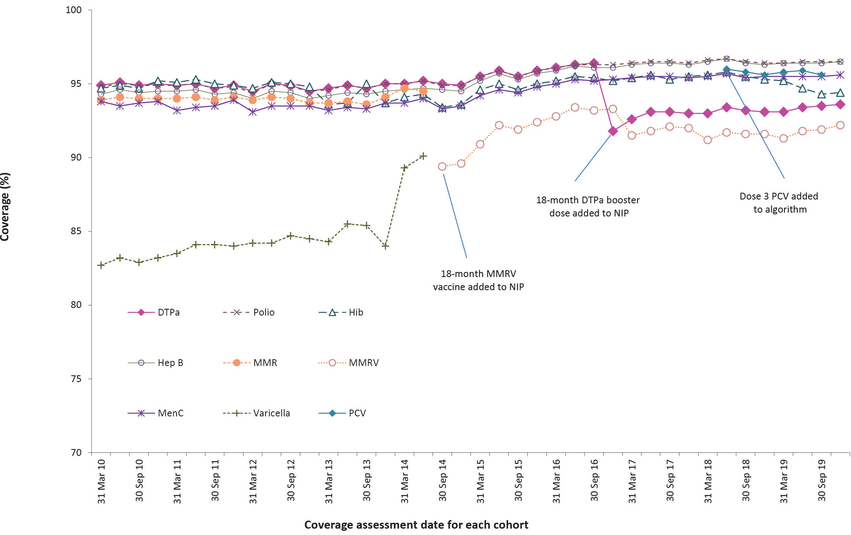
a By 3-month birth cohorts born between 1 January 2008 and 31 December 2017. Coverage assessment date was 24 months after the last birth date of each cohort. Vaccination coverage estimates are calculated by quarter and may differ slightly from estimates published elsewhere using rolling annualised data.
b Source: Australian Immunisation Register, data as at 31 March 2020.
c Fourth dose of DTPa (from October 2016), third dose of polio, third or fourth dose of Hib, third dose of hepatitis B, a dose of varicella, second dose of MMR (from September 2014), and first dose of MenC (MenACWY from July 2018).
d DTPa = diphtheria-tetanus-acellular pertussis; Hib = Haemophilus influenzae type b; Hep B = hepatitis B; MMR = measles-mumps-rubella; MenC = meningococcal C-containing; MMRV = measles-mumps-rubella-varicella; PCV = pneumococcal conjugate vaccine.

Figure A.4: Trends in vaccination coverage estimates at 60 months of age by vaccine/antigen and quarter, Australia, 2010 to 2019^{a,b,c,d}
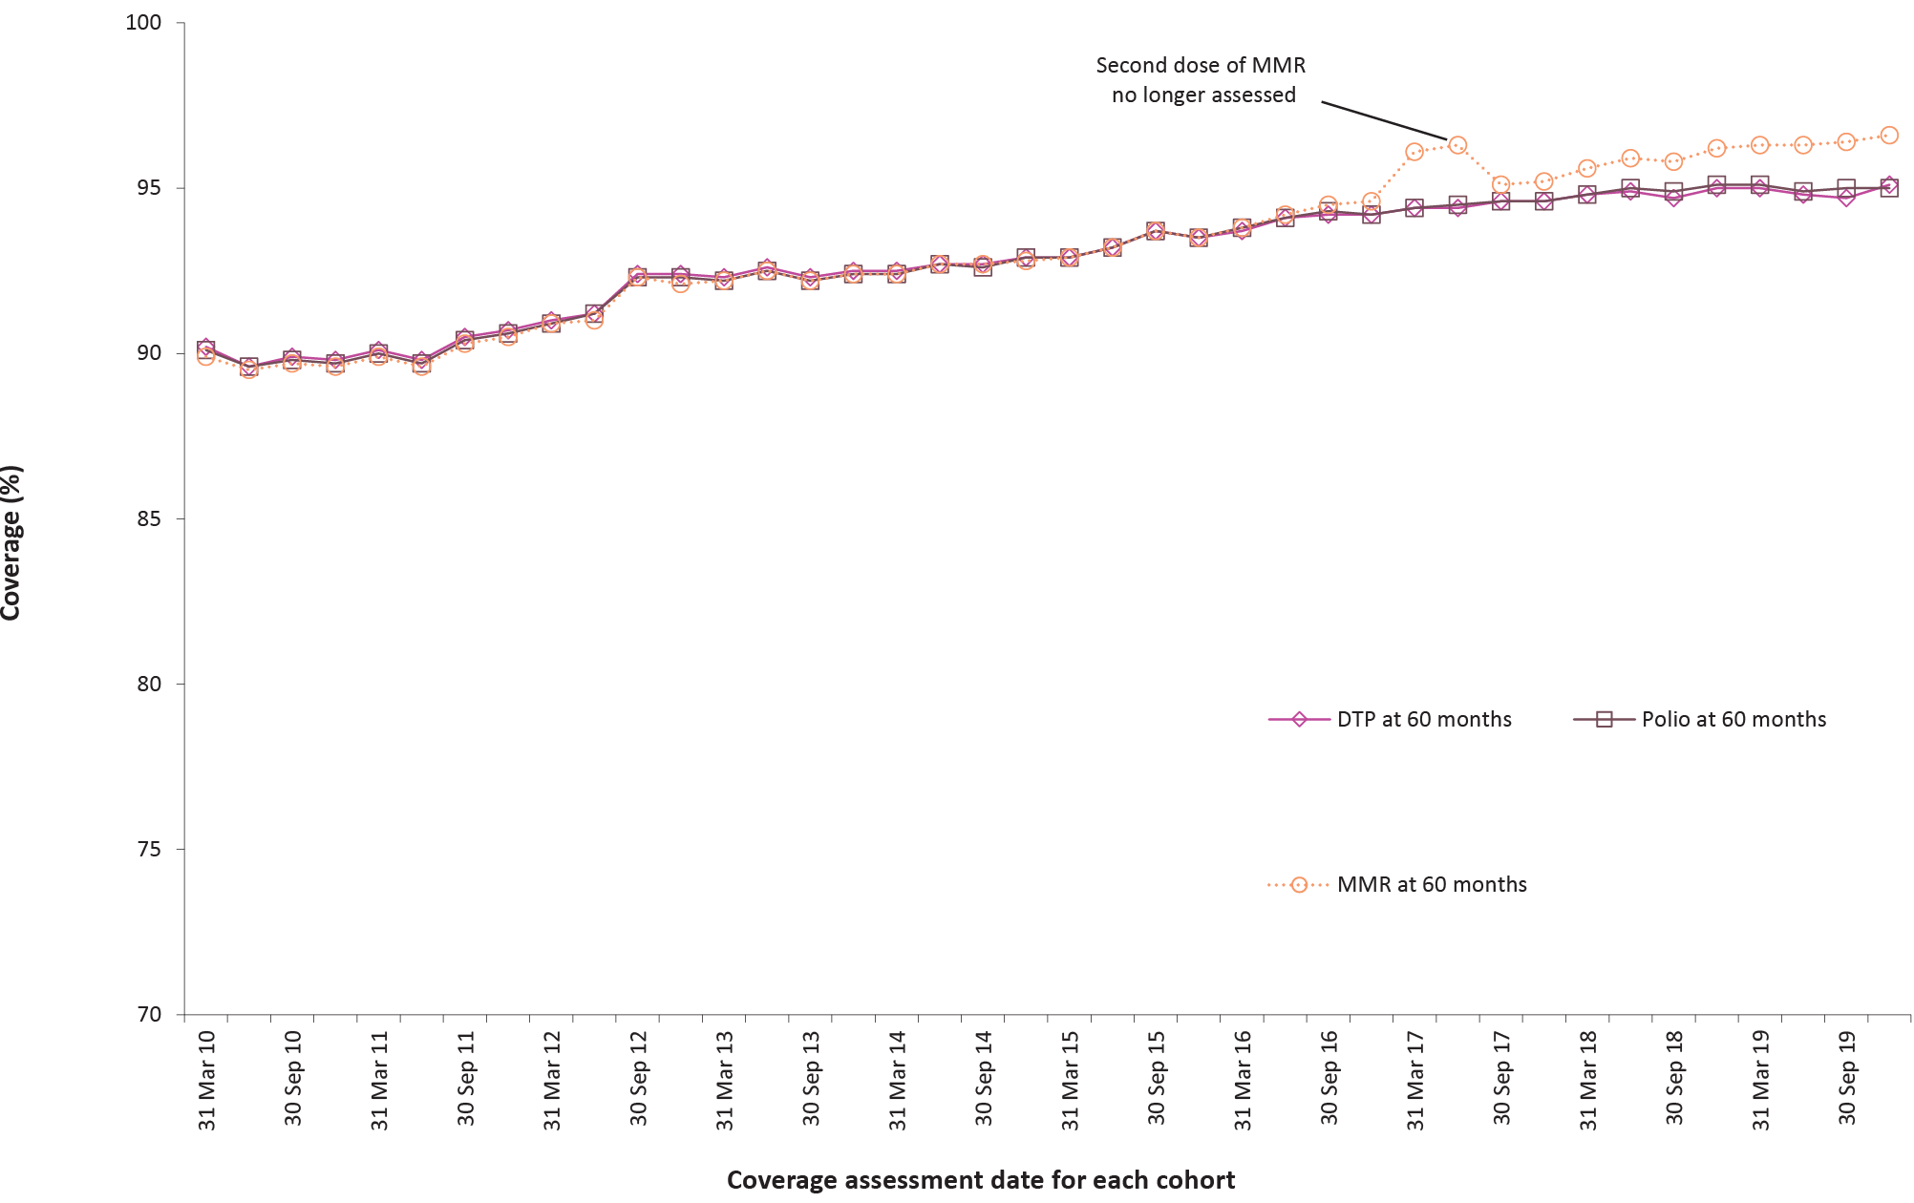
a By 3-month birth cohorts born between 1 January 2005 and 31 December 2014. Coverage assessment date was 60 months after the last birth date of each cohort. Vaccination coverage estimates are calculated by quarter and may differ slightly from estimates published elsewhere using rolling annualised data.
b Source: Australian Immunisation Register, data as at 31 March 2020.
c Fourth or fifth dose of DTPa and fourth dose of polio, second dose of MMR (up until June 2017).
d DTPa = diphtheria-tetanus-acellular pertussis; MMR = measles-mumps-rubella.

Figure A.5: Trends in ‘fully vaccinated’ coverage at 12 months of age by Indigenous status and quarter, Australia, 2010 to 2019^{a,b}
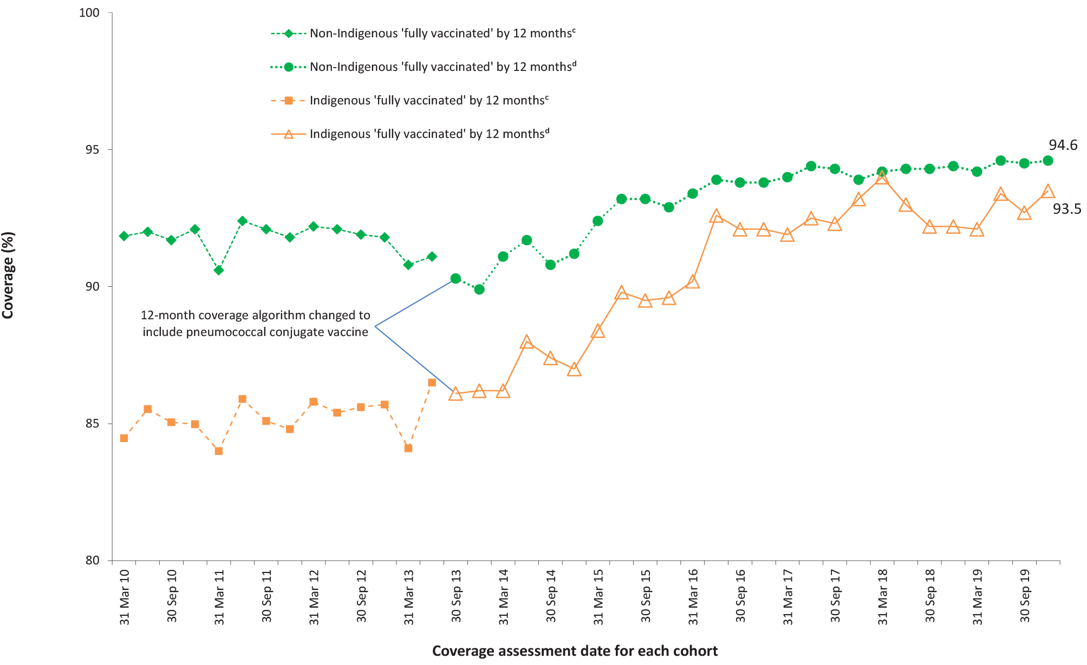
a Vaccination coverage estimates are calculated using 3-month wide birth cohorts by quarter and may differ slightly from estimates published elsewhere using rolling annualised data.
b Source: Australian Immunisation Register, data as at 31 March 2020.
c Coverage algorithm before 1 July 2013.
d Coverage algorithm from 1 July 2013.

Figure A.6: Trends in ‘fully vaccinated’ coverage at 24 months of age by Indigenous status and quarter, Australia, 2010 to 2019^{a,b}
a Vaccination coverage estimates are calculated using 3-month wide birth cohorts by quarter and may differ slightly from estimates published elsewhere using rolling annualised data.
b Source: Australian Immunisation Register, data as at 31 March 2020.
c Coverage algorithm before 1 July 2014.
d Coverage algorithm from 1 July 2014.

Figure A.7: Trends in ‘fully vaccinated’ coverage at 60 months of age by Indigenous status and quarter, Australia, 2010 to 2019^{a,b}
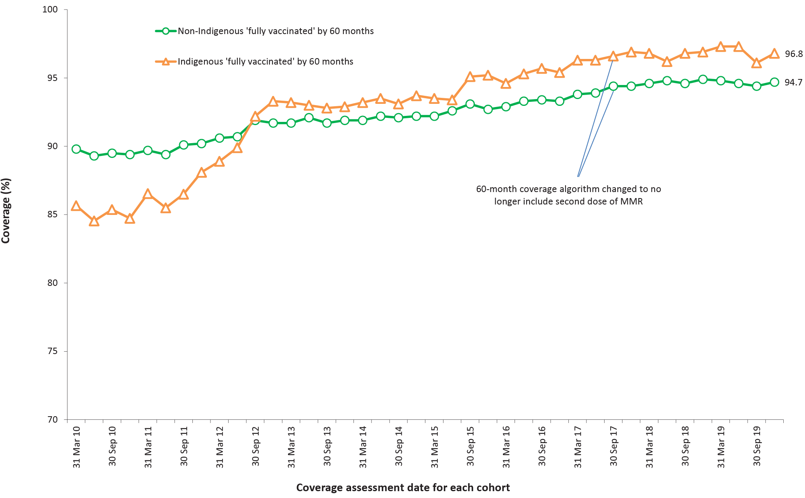
a Vaccination coverage estimates are calculated using 3-month wide birth cohorts by quarter and may differ slightly from estimates published elsewhere using rolling annualised data.
b Source: Australian Immunisation Register, data as at 31 March 2020.

Figure A.8: Trends in coverage estimates for hepatitis A vaccine for Indigenous children by jurisdiction, Australia, 2010 to 2019^{a,b,c,d}
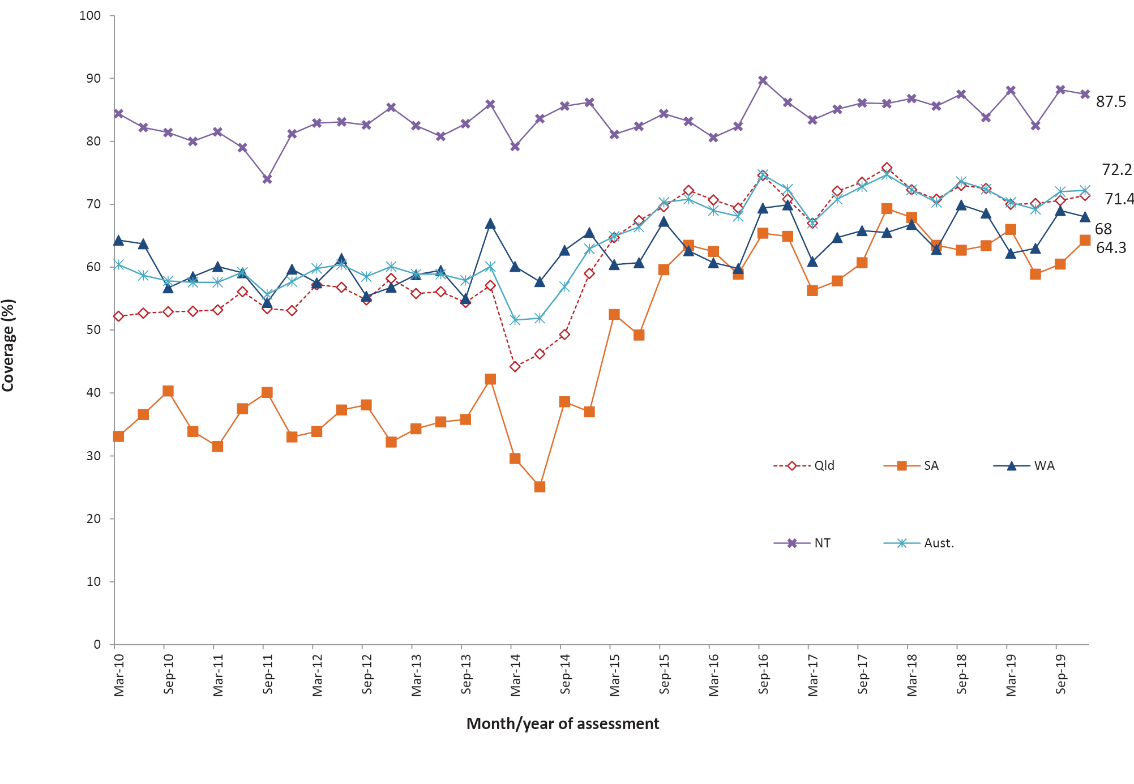
a Vaccination coverage estimates are calculated using 3-month wide birth cohorts by quarter.
b Source: Australian Immunisation Register, data as at 31 March 2020.
c Northern Territory (NT), Queensland (Qld), South Australia (SA) and Western Australia (WA) only. 18-month dose assessed at 30 months of age in all four jurisdictions.
d Aust. = Australia

Figure A.9: Trends in coverage estimates for pneumococcalª vaccine for Indigenous children by jurisdiction, Australia, 2010 to 2019^{b,c,d,e}
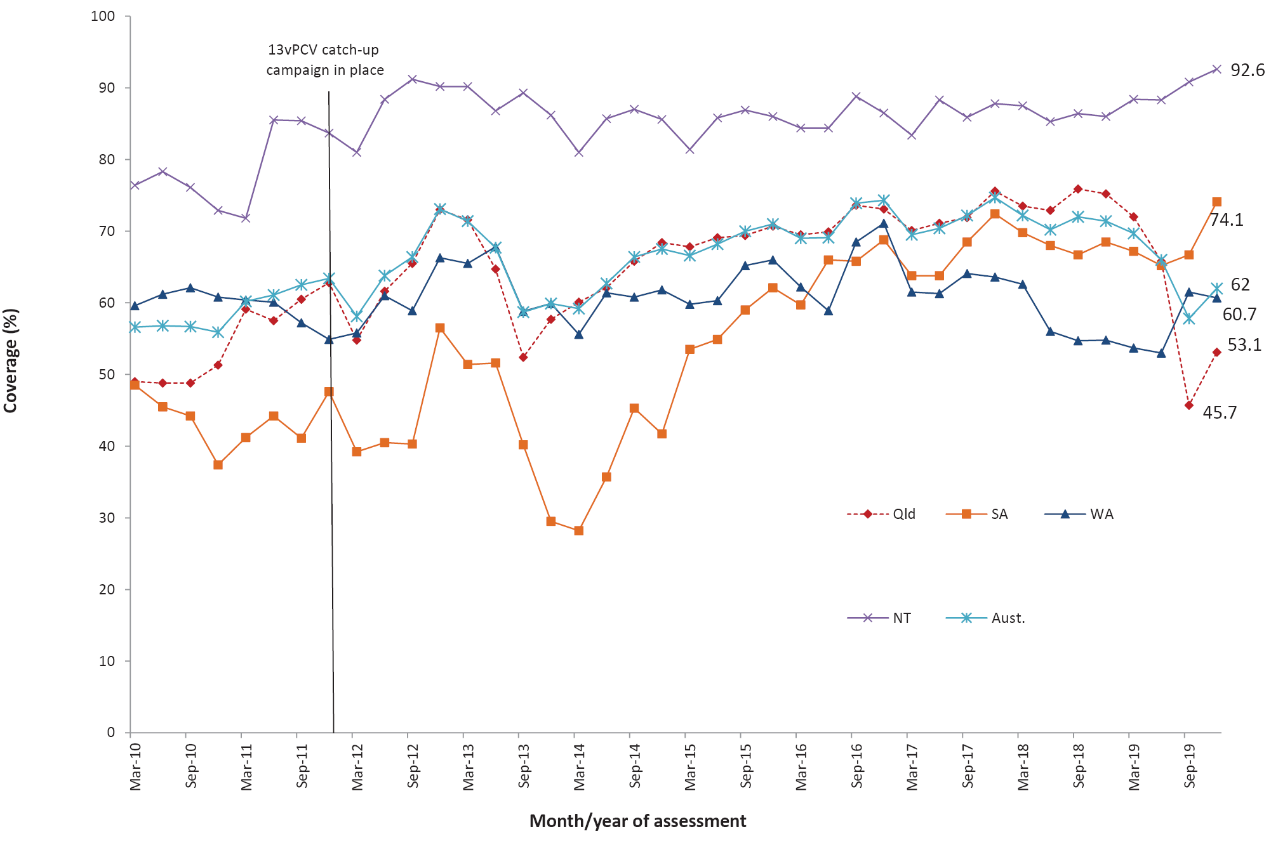
a 13vPCV = 13-valent pneumococcal conjugate vaccine
b Vaccination coverage estimates are calculated using 3-month wide birth cohorts by quarter.
c Source: Australian Immunisation Register, data as at 31 March 2020.
d Northern Territory (NT), Queensland (Qld), South Australia (SA) and Western Australia (WA) only. 12-month booster dose assessed at 30 months of age in all four jurisdictions.
e Aust. = Australia

Communicable Diseases Intelligence
ISSN: 2209-6051 Online

Communicable Diseases Intelligence (CDI) is a peer-reviewed scientific journal published by the Office of Health Protection and Response, Department of Health. The journal aims to disseminate information on the epidemiology, surveillance, prevention and control of communicable diseases of relevance to Australia.

Editor: Jennie Hood
Deputy Editor: Simon Petrie
Design and Production: Kasra Yousefi
Editorial Advisory Board: David Durrheim, Mark Ferson, John Kaldor, Martyn Kirk and Linda Selvey

Website: http://www.health.gov.au/cdi

Contacts
CDI is produced by Environmental Health and Health Protection Policy Branch, Office of Health Protection and Response, Australian Government Department of Health, GPO Box 9848, (MDP 6) CANBERRA ACT 2601

Email: cdi.editor@health.gov.au

Submit an Article
You are invited to submit your next communicable disease related article to the Communicable Diseases Intelligence (CDI) for consideration. More information regarding CDI can be found at: http://health.gov.au/cdi.
Further enquiries should be directed to: cdi.editor@health.gov.au.

This journal is indexed by Index Medicus and Medline.

Creative Commons Licence - Attribution-NonCommercial-NoDerivatives CC BY-NC-ND
© 2021 Commonwealth of Australia as represented by the Department of Health
This publication is licensed under a Creative Commons Attribution-NonCommercial-NoDerivatives 4.0 International Licence from https://creativecommons.org/licenses/by-nc-nd/4.0/legalcode (Licence). You must read and understand the Licence before using any material from this publication.

Restrictions
The Licence does not cover, and there is no permission given for, use of any of the following material found in this publication (if any):
- the Commonwealth Coat of Arms (by way of information, the terms under which the Coat of Arms may be used can be found at www.itsanhonour.gov.au);
- any logos (including the Department of Health’s logo) and trademarks;
- any photographs and images;
- any signatures; and
- any material belonging to third parties.

Disclaimer
Opinions expressed in Communicable Diseases Intelligence are those of the authors and not necessarily those of the Australian Government Department of Health or the Communicable Diseases Network Australia. Data may be subject to revision.

Enquiries
Enquiries regarding any other use of this publication should be addressed to the Communication Branch, Department of Health, GPO Box 9848, Canberra ACT 2601, or via e-mail to: copyright@health.gov.au

Communicable Diseases Network Australia
Communicable Diseases Intelligence contributes to the work of the Communicable Diseases Network Australia.
http://www.health.gov.au/cdna

