Epidemiology of lymphogranuloma venereum in New South Wales, 2006–2015
Damian P Kotevski, Meeyin Lam,^{i} Christine Selvey, David J Templeton, Linda Donovan and Vicky Sheppeard

Abstract

Aim
To describe the epidemiology of lymphogranuloma venereum (LGV) in New South Wales (NSW) from 2006 to 2015.

Methods
LGV notification data between 2006 and 2015 from New South Wales were analysed to describe time trends in counts and rates by gender, age group and area of residence, as well as anatomical sites of infection. A positivity ratio was calculated using the number of LGV notifications per 100 anorectal chlamydia notifications per year. Data linkage was used to ascertain the proportion of LGV cases that were co-infected with HIV.

Results
There were 208 notifications of LGV in NSW from 2006 to 2015; all were among men, with a median age of 42 years, and half were residents of inner-city Sydney. Annual notifications peaked at 57 (1.6 per 100,000 males) in 2010, declined to 16 (0.4 per 100,000 males) in 2014, and then increased to 34 (0.9 per 100,000 males) in 2015. Just under half (47.4%) of LGV cases were determined to be co-infected with HIV.

Conclusion
The number of LGV notifications each year has not returned to the low levels seen prior to the peak in 2010. Continued public health surveillance is important for the management and control of LGV.
Keywords: lymphogranuloma venereum, Chlamydia trachomatis, sexually transmissible infections, gay and bisexual men, New South Wales, epidemiology, surveillance.

Introduction
Lymphogranuloma venereum (LGV) is a sexually transmissible infection (STI) caused by Chlamydia trachomatis serovars L1–L3. The invasive and inflammatory nature of LGV can often lead to severe symptoms and serious sequelae.
LGV is endemic in parts of Africa, Asia, South America and the Caribbean; however, since 2003, LGV has been increasingly recognised and reported in many European countries, North America and Australia among gay and bisexual men (GBM).¹ The United Kingdom (UK),² the Netherlands,^{3,4} Spain⁵ and France⁶ have all experienced an increase in the number of notified LGV cases.
In Australia, only seven cases of LGV were reported between 1991 and 1995. In 2001, LGV was removed from the list of nationally notifiable diseases⁷ after five consecutive years where there were no LGV notifications. However, in New South Wales (NSW) LGV remained notifiable and a small number of LGV cases began to be identified.⁸ Studies in NSW between 2005 and 2012 identified all cases of LGV in GBM were caused by the L2b serovar.^{9–12}
In developed countries, LGV is transmitted primarily through condomless anal intercourse and is commonly associated with HIV, syphilis, gonorrhoea and hepatitis C infections.¹ The use of recreational drugs along with the erectile dysfunction medication sildenafil suggests that certain Australian subgroups of sexually adventurous GBM are at greatest risk of LGV.¹¹ There are few indications of significant spread in heterosexual populations.¹³ Cases of LGV are rarely diagnosed in women, with only a few sporadic female cases having been described.^{14, 15}
Understanding the epidemiology of LGV in NSW is critical for disease prevention, control and appropriate investigation and management of patients with anorectal symptoms presenting to clinical services. Distinguishing LGV from non-LGV chlamydia infection is important due to the more serious clinical consequences and the need for a longer course of antibiotics to cure the infection. Thus, we aimed to describe the epidemiology of LGV in NSW from 2006 to 2015 by examining the demographic and geographic characteristics, anatomical sites of infection and trends in LGV notification.

Methods
In NSW, laboratories are required to notify cases of LGV to public health units under the NSW Public Health Act 2010.¹⁶ Suspected and confirmed cases are entered into the NSW Notifiable Conditions Information Management System (NCIMS), a confidential state-wide database.
Notifications of LGV, and notifications of chlamydia of the rectum, with onset between 1 January 2006 and 31 December 2015 were extracted from NCIMS. We analysed the LGV data by date of onset (earliest of symptom onset, specimen date or notification date), age group, local government area of residence and anatomical site of infection. Rates were calculated using Australian Bureau of Statistics mid-year estimates of the population.¹⁷
Regions in NSW were classified by local government area (LGA) of residence. The Sydney metropolitan region was defined according to the Regional Development Act 2004.¹⁸ For our analysis, the Sydney metropolitan region was divided into the ‘inner Sydney region’, containing the Sydney LGA only, and ‘other Sydney metropolitan region’ consisting of all other LGAs in the Sydney metropolitan region excluding Sydney LGA. LGAs outside the Sydney metropolitan region were classified as ‘other NSW region’.
A positivity ratio was calculated using the number of LGV notifications per 100 anorectal chlamydia notifications in men per year, to examine whether patterns in diagnosis were similar. Guidelines suggest only men who have sex with men are tested for anorectal chlamydia.²²
LGV records from 1 January 2006 to 31 December 2015 were extracted from the Communicable Diseases Register, which has been established by NSW Health under the Public Health and Disease Registers provisions of the NSW Public Health Act 2010. It has been created by linking records from NCIMS and the NSW HIV Dataset (up to the end of 2015) to emergency department visits, hospitalisations and death records. Record linkage was carried out by the Centre for Health Record Linkage (CHeReL), and data linkages were de-identified. A case was classified as having an HIV co-infection if an LGV record matched an HIV notification.
Analyses of data were performed using Microsoft Excel 2010 (Microsoft Corporation, Redmond, WA, USA) and SAS Enterprise Guide 6.1 (SAS Institute Inc., Cary, NC, USA). Notification data were collected under the NSW Public Health Act 2010 (and previously the NSW Public Health Act 1991). As analysis and reporting of aggregated population-based data was considered routine public health surveillance, ethical approval was not sought.

Results
Between 2006 and 2015, 208 notifications of LGV were reported in NSW. Men accounted for all notifications of LGV and the vast majority (96%) of LGV notifications occurred between 2010 and 2015. Notifications increased from one (<1 per 100,000 males) in 2006 to a peak of 57 (1.6 per 100,000 males) in 2010, with a 14-fold increase in notifications from 2009 to 2010. Since the peak in 2010, notifications declined to 16 (0.4 per 100,000 males) in 2014 and then rose to 34 (0.9 per 100,000 males) in 2015 (Figure 1).

Figure 1. Number and rate of LGV notifications in males, NSW, 2006–2015
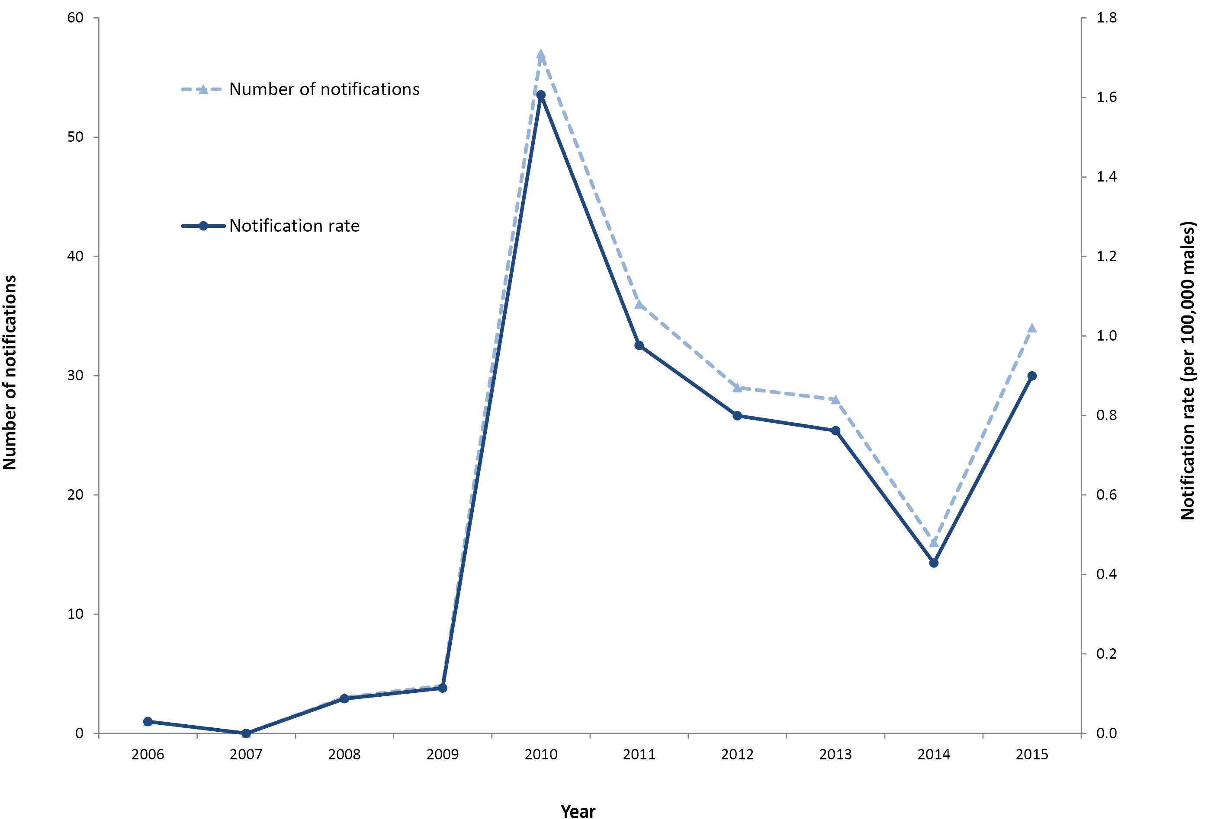

The median age of LGV notifications was 42 years (range 18 to 72 years). Men aged 20 to 49 years accounted for 158 (76%) of all LGV notifications, with men in the 40–49 year age group having the highest number of notifications and the highest age-specific notification rate over the ten year period (Table 1 and Figure 2).
Table 1. Number and rate of LGV notifications in males, by age group, NSW, 2006–2015.
Age group (years) | Number | Mean rate  (per 100,000 males)
<20 | 1 | <0.1
20–29 | 32 | 0.6
30–39 | 58 | 1.1
40–49 | 68 | 1.4
50–59 | 32 | 0.7
≥60 | 17 | 0.2
Total | 208

Figure 2. Age-specific notification rates of LGV in males, by year, NSW, 2006–2015
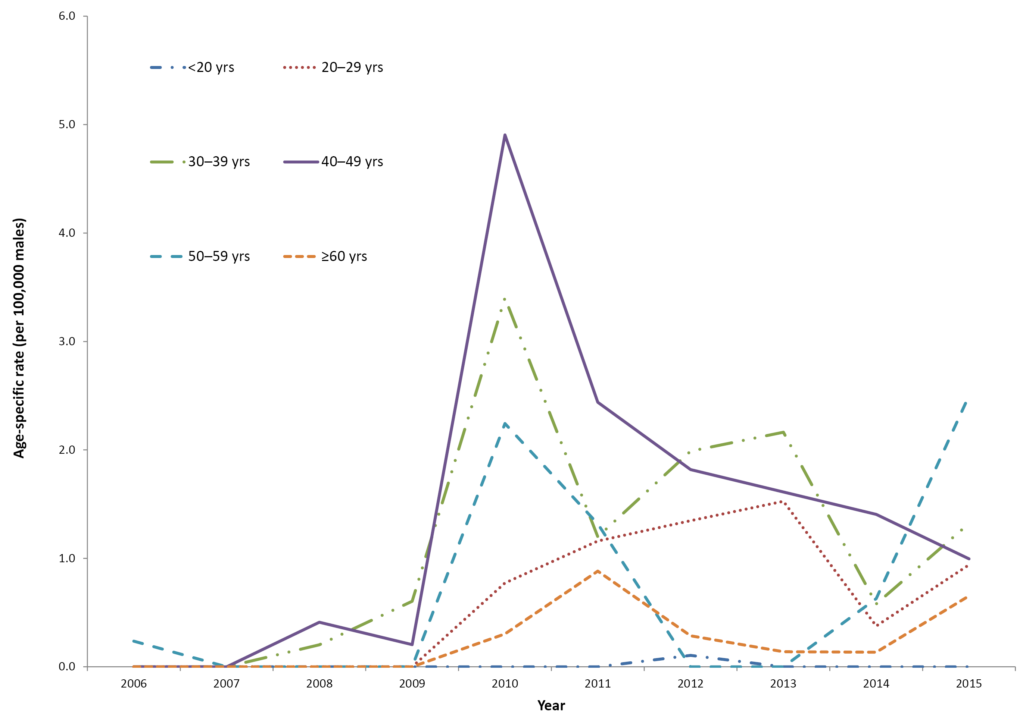

The inner Sydney region and other Sydney metropolitan regions combined accounted for almost all (96.1%) LGV notifications in NSW during the study period (Table 2).
Table 2. LGV notifications by region and age group in males, NSW, 2006–2015.
Region | Age group (years)
 | <20 | 20–29 | 30–39 | 40–49 | 50–59 | ≥60 | Total | %
Inner Sydney | 0 | 16 | 34 | 38 | 14 | 1 | 103 | 49.5%
Other Sydney metropolitan | 1 | 16 | 19 | 29 | 16 | 16 | 97 | 46.6%
Other NSW | 0 | 0 | 5 | 1 | 2 | 0 | 8 | 3.9%
Total | 1 | 32 | 58 | 68 | 32 | 17 | 208 | 100%
The most common site of infection was a single infection of the anorectum. LGV infections were also identified in the genitourinary tract and throat, with a number of patients presenting infection at multiple sites (Table 3).
Table 3. Anatomical sites of LGV infection in males, NSW, 2006–2015.
Site of infection | n | %
Anorectum | 179 | 86.1%
Anorectum and throat | 1 | 0.5%
Genitourinary tract | 8 | 3.8%
Genitourinary tract and anorectum | 9 | 4.3%
Genitourinary tract and other | 1 | 0.5%
Other | 1 | 0.5%
Unknown/missing site | 9 | 4.3%
Total | 208 | 100%

In NSW, the annual number of anorectal chlamydia notifications in men has shown an overall marked increase, rising from 328 (9.8 per 100,000 males) in 2006 to 1335 (35.3 per 100,000 males) in 2015 (Figure 3). The ratio of LGV notifications to the number of anorectal chlamydia notifications peaked at 7.8 (per 100) in 2010 before decreasing to 1.1 (per 100) in 2014. Interestingly, the number of LGV notifications increased in 2015 while the number of anorectal chlamydia notifications declined.
There were 171 records for LGV in the Communicable Disease Register between 2006 and 2015; LGV notification occurred in a known HIV-positive individual among 81 (47.4%).

Figure 3. Number of anorectal chlamydia notifications and LGV positivity ratio in males, NSW, 2006–2015
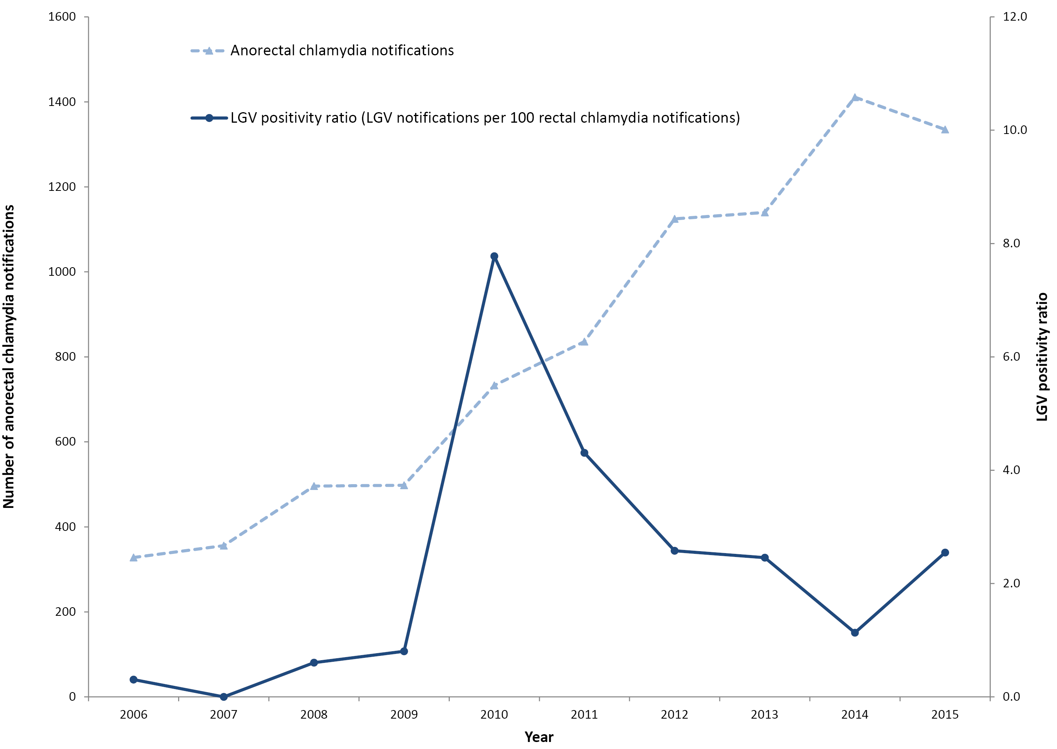

Discussion
We report on the largest study of LGV performed in Australia to date. Annual LGV notifications in NSW increased from one in 2006 to 57 in 2010 and subsequently decreased to 34 in 2015. Analysis of the 208 LGV notifications during this ten-year period found all infections occurred in men. This is consistent with studies in other developed countries.^{2–4,6,9,13,19}
Notifications in NSW have been previously reported.²⁰ We expand on these data and describe the epidemiology of LGV in NSW between 2006 and 2015. Men aged 20–49 years are at highest risk of LGV infection, particularly those aged 40–49 years. Inner Sydney accounted for half of the LGV notifications between 2006 and 2015. This region has been reported to have the highest proportion of GBM residents in NSW.²¹ The high number of notifications of LGV in inner Sydney is consistent with the increasing rates of STIs among GBM being observed in this area.^{22,23}
In Australia and overseas, most notified cases of LGV have been reported as symptomatic.^{9,10,12,24–27} However, evidence indicates the proportion of GBM infected with LGV who are asymptomatic is increasing overseas. Studies in the UK,²⁸ the Netherlands,²⁹ and Germany³⁰ reported 17% to 53% of GBM infected with LGV were asymptomatic. Reinvestigation of a previous UK study²⁴ on LGV reported that asymptomatic cases increased from 6% to 27%.³¹ It is unclear whether the symptomatology of LGV in the UK is changing, or if asymptomatic cases remained untested and were therefore missed. However, the increase in asymptomatic cases may be due to more LGV testing occurring in asymptomatic GBM, or case finding via contact tracing of sexual partners of LGV-infected men.³¹ Despite the relatively high rates of asymptomatic LGV reported in several countries overseas, systematic assessment of anorectal chlamydia infections in Australian GBM has failed to identify such cases.^{9,32}
In this study, we could not ascertain if any men infected with LGV were asymptomatic since information related to symptomatology and reason for testing is not routinely collected for LGV notifications. Clearly, men who are symptomatic are likely to present to their doctor and an LGV test is more likely to be ordered due to the presence of (especially anorectal) symptoms. Conducting enhanced surveillance of cases at the time of notification would improve our understanding of symptomatology.
Our data show that anorectal chlamydia notifications in men are increasing in NSW. Studies in Australia and Europe have found that up to 15% of GBM with anorectal swabs positive for Chlamydia trachomatis are LGV positive.^{3,12,24,28,30,31} In NSW, the increasing number of anorectal chlamydia notifications and relatively low number of LGV notifications between 2006 and 2015 raises the question of whether LGV is less common in NSW, or if LGV infection remains largely undiagnosed. Testing all anorectal chlamydia specimens would be costly and burdensome. Nonetheless, should a sustained increase in LGV notifications be observed, an epidemiological study of LGV on all positive chlamydia infections diagnosed over a defined time-period could provide important information on the prevalence of asymptomatic LGV infections and risk factors for LGV which could inform testing guidelines and health promotion campaigns.
The LGV positivity ratio indicated that LGV notification did not mirror the pattern of anorectal chlamydia notification. As not all positive anorectal specimens were tested for LGV, the differences may be due to undertesting rather than true incidence of infection.
An important limitation of our study is that testing for LGV has changed over the ten-year period, and the number of notifications is likely to be influenced by the number of tests performed. There was probably little referral of samples sent for LGV testing in the early years. During the outbreak in 2010, as a result of public health initiatives and revised protocols, all positive rectal chlamydia specimens were referred for LGV testing, increasing the likelihood of diagnosis. Once the outbreak subsided, the routine testing of LGV was no longer standard practice, and usually relied upon clinician request. A few laboratories, however, continued to refer all positive rectal chlamydia specimens for LGV testing even after the outbreak.
Our study has several other limitations, including the lack of data on sexual contact, sexual history and travel history. This information would be useful to assess how LGV is spread in Australia and determine whether infections are acquired locally or from overseas.
A single infection of the anorectum was reported to be the most common site of infection. This may be partly due to testing bias. Most doctors will only request LGV testing for gay men with symptomatic proctitis as current Australian evidence supports this testing algorithm.
Although most men with LGV presented with infection at the anorectum, anorectal swabs are not specifically mentioned in the NSW surveillance case definition. The case definition for a confirmed case of LGV requires demonstration of Chlamydia trachomatis serovars L1–L3 in fluid aspirated from the fluctuant bubo or from a genital lesion by immunofluorescence (IF), enzyme immunoassay, DNA probe, polymerase chain reaction (PCR), culture or by specific micro-IF serological tests.³⁴ The NSW case definition is currently being revised to explicitly include anorectal swabs to avoid missing any cases.
The Communicable Diseases Register did not reflect the total number of LGV notifications in the time period. This was most likely due to notifications with insufficient information being excluded from the matching process, and delays in notification.
Using linked data, we found that slightly less than half of men with LGV were HIV positive, a much lower proportion than other studies.^{11,25} The epidemiology of LGV may be changing, with a greater proportion of infections among HIV-negative men. However, there are several factors that potentially contributed to underestimating HIV co-infection. Firstly, some men who have been diagnosed with HIV interstate or overseas may not have been notified to NSW Health. Secondly, in NSW, HIV notifications are, by law, de-identified; usually the first two letters of the given name and surname are used, and residential address is restricted to postcode only. Although named notifications are required by law for LGV, laboratories are not able to provide this information when people choose to be tested anonymously or only partially identifiable. It is likely that notifications with insufficient information were unable to be matched accurately during data linkage. HIV-positive men who are concerned about stigma and discrimination may be more likely to remain anonymous than HIV-negative men, leading to a selection bias in our data.

Conclusion
Although there has been a decrease in LGV notifications in NSW between 2010 and 2015, annual numbers have not returned to the low levels seen prior to the peak in 2010. This highlights the importance of continued public health surveillance in NSW. In the absence of national notification, other jurisdictions with large populations of GBM could consider clinic or laboratory surveys to assess whether LGV is affecting their communities.

Conflict of interest
None declared.

Acknowledgements
The authors thank Sheena Adamson for providing advice on the referral and testing procedures of LGV specimens, Tove-Lysa Fitzgerald and Meru Sheel for improving the quality of the surveillance data, and Alex Rosewell for reviewing an early manuscript. The authors acknowledge the role of clinicians and public health units in collecting and reporting LGV notifications data.

Author details
- Mr Damian P. Kotevski, Student, School of Public Health and Community Medicine, UNSW Medicine, University of New South Wales, Sydney, New South Wales
- Ms Meeyin Lam, Epidemiologist, Bloodborne Virus and Sexually Transmitted Infections, Health Protection NSW, NSW Health, North Sydney, New South Wales
- Dr Christine E. Selvey, Medical Epidemiologist, Health Protection NSW, NSW Health, North Sydney, New South Wales
- Professor David J. Templeton, Director of Sexual Health Services, Sydney Local Health District, New South Wales; The Kirby Institute, UNSW Australia, New South Wales; Sydney Medical School, The University of Sydney, Sydney, New South Wales
- Ms Linda G. Donovan, Hospital Scientist, Institute for Clinical Pathology and Medical Research, Westmead Hospital, Westmead, New South Wales
- Dr Vicky Sheppeard, Director, Communicable Diseases Branch, Health Protection NSW, NSW Health, North Sydney, New South Wales

Corresponding author
Ms Meeyin Lam
Communicable Diseases Branch, Health Protection NSW, Locked Mail Bag 961, North Sydney, New South Wales, 2059.
Telephone: +61 2 9391 9644
Email: Meeyin.Lam@health.nsw.gov.au

References
- Simms I, Ward H, Martin I, Alexander S, Ison C. Lymphogranuloma venereum in Australia. Sex Health. 2006;3(3):131–3.
- Childs T, Simms I, Alexander S, Eastick K, Hughes G, Field N. Rapid increase in lymphogranuloma venereum in men who have sex with men, United Kingdom, 2003 to September 2015. Euro Surveill. 2015;20(48):9–12.
- de Vrieze NHN, de Vries HJC. Lymphogranuloma venereum among men who have sex with men. An epidemiological and clinical review. Expert Rev Anti Infect Ther. 2014;12(6):697–704.
- de Vrieze NHN, van Rooijen M, Schim van der Loeff MF, de Vries HJC. Anorectal and inguinal lymphogranuloma venereum among men who have sex with men in Amsterdam, the Netherlands: trends over time, symptomatology and concurrent infections. Sex Transm Infect. 2013;89(7):548–52.
- Rodríguez‐Domínguez M, Puerta T, Menéndez B, González‐Alba J, Rodríguez C, Hellín T et al. Clinical and epidemiological characterization of a lymphogranuloma venereum outbreak in Madrid, Spain: co‐circulation of two variants. Clin Microbiol Infect. 2014;20(3):219–25.
- Savage E, van de Laar M, Gallay A, van der Sande M, Hamouda O, Sasse A et al. Lymphogranuloma venereum in Europe, 2003–2008. Euro Surveill. 2009;14(48):17–21.
- Spencer J, Witteveen D, Della-Porta T, Wright P, Bunn C, Milton A et al. Australia’s notifiable diseases status, 2000. Annual report of the National Notifiable Diseases Surveillance System. Commun Dis Intell Q Rep. 2002;26(2):118–203.
- Health Protection NSW. Year in review: health protection in NSW, 2012. NSW Public Health Bull. 2013;24(3):105–18.
- Templeton DJ, Sharp N, Gryllis S, O’Connor CC, Dubedat SM. Prevalence and predictors of lymphogranuloma venereum among men who have sex with men at a Sydney metropolitan sexual health clinic. Sex Health. 2013;10(2):190–1.
- Templeton DJ, Twin J, Jin F, Grulich AE, Garland SM, Tabrizi SN. Chlamydia trachomatis serovars in community-based HIV-positive and HIV-negative men who have sex with men in Sydney, Australia. Sex Transm Infect. 2011;87(6):501–2.
- Templeton DJ, Ressler K-A, Hope K, Poynten IM. Enhanced surveillance of a lymphogranuloma venereum outbreak in Sydney 2010–2012. Aust N Z J Public Health. 2016;40(4):368–70.
- Stark D, Van Hal S, Hillman R, Harkness J, Marriott D. Lymphogranuloma venereum in Australia: anorectal Chlamydia trachomatis serovar L2b in men who have sex with men. J Clin Microbiol. 2007;45(3):1029–31.
- Heiligenberg M, Verweij SP, Speksnijder AG, Morré SA, de Vries HJ, Schim van der Loeff MF. No evidence for LGV transmission among heterosexuals in Amsterdam, the Netherlands. BMC Res Notes. 2014;7(1):355–59.
- Verweij SP, Ouburg S, de Vries H, Morré SA, van Ginkel CJ, Bos H et al. The first case record of a female patient with bubonic lymphogranuloma venereum (LGV), serovariant L2b. Sex Transm Infect. 2012;88(5):346–7.
- Peuchant O, Baldit C, Le Roy C, Trombert‐Paolantoni S, Clerc M, Bébéar C et al. First case of Chlamydia trachomatis L2b proctitis in a woman. Clin Microbiol Infect. 2011;17(12):E21–3.
- New South Wales Government. Public Health Act 2010 No 127. NSW Government, 2010. [Accessed: 4 August 2016.] Available from: http://www.legislation.nsw.gov.au/#/view/act/2010/127.
- New South Wales Ministry of Health. HealthStats NSW: Population. [Internet.] New South Wales Government, NSW Health, year unknown. [Accessed: 28 July 2016.] Available from: www.healthstats.nsw.gov.au/Indicatorgroup/indicatorViewList?code=dem_pop&topic=topic_pop&name=PopulationTopic.
- New South Wales Government. Regional Development Act 2004 No 58. NSW Government, 2004.[Accessed: 19 August 2016.] Available from: http://www.austlii.edu.au/au/legis/nsw/consol_reg/rdr2012305/s4.html
- Spaargaren J, Schachter J, Moncada J, De Vries HJ, Fennema HS, Peña AS et al. Slow epidemic of lymphogranuloma venereum L2b strain. Emerg Infect Dis. 2005;11(11):1787–8.
- New South Wales Ministry of Health. Health Protection report, NSW-2014 year in review, September 2015. Communicable diseases. [Internet.] New South Wales Government, NSW Health, year unknown. [Accessed: 27 October 2016.] Available from: http://www.health.nsw.gov.au/hpr/Pages/201509-diseases.aspx.
- Madeddu D, Grulich A, Richters J, Ferris J, Grierson J, Smith A et al. Estimating population distribution and HIV prevalence among homosexual and bisexual men. Sex Health. 2006;3(1):37–43.
- Templeton DJ, Read P, Varma R, Bourne C. Australian sexually transmissible infection and HIV testing guidelines for asymptomatic men who have sex with men 2014: a review of the evidence. Sex Health. 2014;11(3):217–29.
- Botham SJ, Ressler K-A, Maywood P, Hope KG, Bourne CP, Conaty SJ et al. Men who have sex with men, infectious syphilis and HIV coinfection in inner Sydney: results of enhanced surveillance. Sex Health. 2013;10(4):291–8.
- Ward H, Alexander S, Carder C, Dean G, French P, Ivens D et al. The prevalence of lymphogranuloma venereum infection in men who have sex with men: results of a multicentre case finding study. Sex Transm Infect. 2009;85(3):173–5.
- Ward H, Martin I, Macdonald N, Alexander S, Simms I, Fenton K et al. Lymphogranuloma venereum in the United Kingdom. Clin Infect Dis. 2007;44(1):26–32.
- Lee DM, Fairley CK, Owen L, Horvath L, Chen MY. Lymphogranuloma venereum becomes an established infection among men who have sex with men in Melbourne. Aust N Z J Public Health. 2009;33(1):94.
- Bissessor M. Characteristics of lymphogranuloma venereum (LGV) infection among homosexual men in Melbourne. Sex Transm Infect. 2011;87(Suppl 1):A139.
- Annan NT, Sullivan AK, Nori A, Naydenova P, Alexander S, McKenna A et al. Rectal chlamydia—a reservoir of undiagnosed infection in men who have sex with men. Sex Transm Infect. 2009;85(3):176–9.
- Spaargaren J, Fennema HS, Morré SA, Vries HJ, Coutinho RA. New lymphogranuloma venereum Chlamydia trachomatis variant, Amsterdam. Emerg Infect Dis. 2005;11(7):1090–2.
- Haar K, Dudareva-Vizule S, Wisplinghoff H, Wisplinghoff F, Sailer A, Jansen K et al. Lymphogranuloma venereum in men screened for pharyngeal and rectal infection, Germany. Emerg Infect Dis. 2013;19(3):488–92.
- Saxon C, Hughes G, Ison C. Asymptomatic lymphogranuloma venereum in men who have sex with men, United Kingdom. Emerg Infect Dis. 2016;22(1):112–6.
- Templeton DJ, Grulich AE, Yew J, Twin J, Jin F, Prestage GP, Donovan B, Tabrizi SN. Lymphogranuloma venereum is rare in Australian community-based samples of men who have sex with men. Sex Transm Dis. 2011;38(1):48–9.
- Australasian Sexual Health Initiative (ASHA). Australian STI management guidelines: MSM—Men who have sex with men. [Internet.] NSW: ASHA, year unknown. [Accessed: 22 August 2016.] Men who have sex with men. Available from: http://www.sti.guidelines.org.au/populations-and-situations/msm.
- NSW Health. Lymphogranuloma control guidelines. [Internet.] New South Wales Government, NSW Health, year unknown. [Accessed: 2 August 2016.] Available from: http://www.health.nsw.gov.au/Infectious/controlguideline/Pages/lymphogranuloma.aspx.

Communicable Diseases Intelligence
ISSN: 2209-6051 Online

Communicable Diseases Intelligence (CDI) is a peer-reviewed scientific journal published by the Office of Health Protection, Department of Health. The journal aims to disseminate information on the epidemiology, surveillance, prevention and control of communicable diseases of relevance to Australia.

Editor: Cindy Toms
Deputy Editor: Simon Petrie
Design and Production: Kasra Yousefi
Editorial Advisory Board: David Durrheim, Mark Ferson, John Kaldor, Martyn Kirk and Linda Selvey

Website: http://www.health.gov.au/cdi

Contacts
Communicable Diseases Intelligence is produced by:
Health Protection Policy Branch, Office of Health Protection, Australian Government Department of Health
GPO Box 9848, (MDP 6) CANBERRA ACT 2601

Email: cdi.editor@health.gov.au

Submit an Article
You are invited to submit your next communicable disease related article to the Communicable Diseases Intelligence (CDI) for consideration. More information regarding CDI can be found at: http://health.gov.au/cdi.
Further enquiries should be directed to: cdi.editor@health.gov.au.

This journal is indexed by Index Medicus and Medline.

Creative Commons Licence - Attribution-NonCommercial-NoDerivatives CC BY-NC-ND
© 2019 Commonwealth of Australia as represented by the Department of Health
This publication is licensed under a Creative Commons Attribution-NonCommercial-NoDerivatives 4.0 International Licence from https://creativecommons.org/licenses/by-nc-nd/4.0/legalcode (Licence). You must read and understand the Licence before using any material from this publication.

Restrictions
The Licence does not cover, and there is no permission given for, use of any of the following material found in this publication (if any):
- the Commonwealth Coat of Arms (by way of information, the terms under which the Coat of Arms may be used can be found at www.itsanhonour.gov.au);
- any logos (including the Department of Health’s logo) and trademarks;
- any photographs and images;
- any signatures; and
- any material belonging to third parties.

Disclaimer
Opinions expressed in Communicable Diseases Intelligence are those of the authors and not necessarily those of the Australian Government Department of Health or the Communicable Diseases Network Australia. Data may be subject to revision.

Enquiries
Enquiries regarding any other use of this publication should be addressed to the Communication Branch, Department of Health, GPO Box 9848, Canberra ACT 2601, or via e-mail to: copyright@health.gov.au

Communicable Diseases Network Australia
Communicable Diseases Intelligence contributes to the work of the Communicable Diseases Network Australia.
http://www.health.gov.au/cdna

first authors

