Australian vaccine preventable disease epidemiological review series: varicella-zoster virus infections, 1998–2015
Meru Sheel, Frank Beard^{I}, Helen Quinn^{II}, Aditi Dey, Martyn Kirk, Ann Koehler Peter Markey, Peter McIntyre, Kristine Macartney

Abstract

Introduction
In 2005, the National Immunisation Program implemented a varicella vaccine for children aged 18 months, and in 2016, a herpes zoster (HZ) vaccine for adults aged 70-79 years. This epidemiological review analyses national trends in varicella and HZ for the years 1998-2015 to examine the impact of a funded varicella vaccine and provide a baseline for monitoring the impact of a funded HZ vaccine.

Methods
Varicella and HZ notifications (2002-2015), hospitalisations (1999-2013) and deaths (1998-2013) were sourced. We stratified analyses by age, sex and Indigenous status, and estimated rates and incidence rate ratios.

Results
Funded varicella vaccine led to a rapid decline in varicella notifications, hospitalisations and deaths. During the post-varicella vaccine period, hospitalisations declined in all age groups <40 years, with greatest reduction of 84% in children aged 18-59 months. Annual HZ hospitalisation rate was 10.8 per 100,000. HZ hospitalisation rates increased with age and were highest in persons aged ≥75 years (87.6 per 100,000). Post-herpetic neuralgia (PHN) was diagnosed in 32.5% HZ hospitalisations with highest hospitalisation rate in persons aged ≥75 years (32.1 per 100,000). Varicella and HZ hospitalisation rates were significantly higher among Indigenous Australians. Twenty one deaths were coded as due to varicella and 340 deaths were coded as due to HZ in persons aged <40 years and ≥40 years, respectively.

Conclusions
The national varicella immunisation program substantially reduced varicella associated morbidity and mortality. Burden of HZ and PHN in Australia is substantial. Following the introduction of a funded HZ vaccine, timely and high quality surveillance will be crucial to assess the impact of the national HZ immunisation program.
Keywords: varicella zoster virus, varicella, herpes zoster, chickenpox, shingles, epidemiology, disease surveillance, immunisation, vaccine preventable disease

Introduction
Varicella-zoster virus (VZV) is a herpes virus and is the aetiological agent for varicella (chickenpox) and herpes zoster (shingles).¹ Varicella is an acute and self-limiting disease with an average incubation period of 14-16 days (range from 10 to 21 days). The disease is highly contagious with a secondary attack rate of 90% in susceptible contacts of persons with varicella.^{1,2} Varicella typically presents as a vesicular rash accompanied by fever and malaise but can occasionally be asymptomatic or have atypical presentations. Complications include secondary skin infections, pneumonia, meningitis and encephalitis. Primary infection with VZV usually provides long lasting immunity.^{2,3} Further episodes of clinical disease are not commonly reported but can occur in immunocompetent individuals.^{4,5}
VZV remains dormant for years in the dorsal root ganglia adjacent to the spinal cord: reactivation of the latent virus can lead to herpes zoster (HZ). Characteristics of HZ include a vesicular rash with a unilateral dermatomal distribution which is usually accompanied with acute pain. Post-herpetic neuralgia (PHN) is the most common complication of HZ, and is defined as pain persisting for 90 days or more from the onset of the rash. PHN is often debilitating and refractory to treatment.⁶⁻⁸
In Australia, varicella vaccine was registered for use in 1999 and included on the National Immunisation Program (NIP) in November 2005 as a single dose at 18 months of age, along with a school-based single cohort catch-up program for 12-13 year olds.^{9,10} Uptake of varicella vaccine assessed at 2 years of age was 76.1% in 2007, and increased to 84.4% in 2012.^{9,11,12} In July 2013, a combination vaccine (measles-mumps-rubella-varicella or MMRV) replaced the monovalent varicella vaccine at age 18 months; following which vaccine uptake increased to 89.6% in 2014.¹³ A vaccine for HZ was registered in Australia in 2005, but was not widely available on private prescription or added onto the NIP until November 2016.¹⁴ Although the vaccine is registered for use in people aged ≥50 years, it is funded on the NIP for people aged 70 years with a 5 year catch-up program for people aged 71-79 years.¹⁴
Early assessment of the impact of inclusion of varicella vaccine on the NIP demonstrated a decline in hospitalisations due to varicella, especially in children less than 4 years of age, along with a reduction in severe outcomes of varicella, including congenital and neonatal varicella.^{11,15,16} Several studies have documented increasing incidence of HZ in Australia, both before and after the introduction of the varicella vaccine.^{17,18} Age-related increases in the risk of HZ are associated with a decline in cellular immunity to VZV, however, the underlying cause of the rising incidence (even after age adjustment) remains unclear.¹⁸
This study aims to review the epidemiology of varicella and HZ in Australia from 1998 to 2015, assess the impact of the national varicella immunisation program and provide a baseline for monitoring the impact of the national HZ immunisation program.

Methods

Data sources

Notification data
The National Notifiable Diseases Surveillance System (NNDSS) receives varicella and HZ notifications from all Australian states and territories (jurisdictions) except New South Wales (Table 1). Varicella and HZ became notifiable as early as 2002 in South Australia and as late as 2009 in Victoria.
Table 1: Proportions (varicella, herpes zoster or not elsewhere classified) of total varicella zoster virus (VZV) related conditions reported through the National Notifiable Diseases Surveillance System (NNDSS), by state or territory, Australia 2002-2015.
Jurisdiction (state or territory) | Year notification commenced | Notified by laboratory | Follow up laboratory notification | VZV-related conditions (percentage of total notifications)
 |  |  |  | Varicella | Herpes zoster | Not elsewhere classified
New South Wales | N/A | N/A | N/A | N/A | N/A | N/A
Victoria | 2009 | Yes | No | 13.2 | 19.8 | 66.9
Queensland | 2006 | Yes | No | 7.1 | 3.8 | 89.1
South Australia | 2002 | Yes | Yes | 24.1 | 66.3 | 9.7
Western Australia | 2006 | Yes | No | 17.1 | 38.9 | 44
Tasmania | 2006 | Yes | No | 11.4 | 63.8 | 24.8
Northern Territory | 2006 | Yes | Yes | 41.9 | 56.4 | 1.8
Australian Capital Territory | 2006 | Yes | No | 12.7 | 26.5 | 60.7
National | 2006 | - | - | 14.1 | 26.3 | 59.6

National case definitions exist for varicella-zoster infection (chickenpox), varicella-zoster infection (shingles) and varicella-zoster infection (not elsewhere classified).¹⁹ For chickenpox and shingles, confirmed and probable cases are required to be notified. Confirmed cases of shingles (HZ) and chickenpox (varicella) require laboratory definitive evidence and clinical evidence. Laboratory confirmation requires detection of VZV from a skin or lesion swab, or VZV-specific IgM in an unvaccinated person (for varicella). In case of varicella, a case is considered confirmed if clinical and epidemiological evidence of disease is available. For probable cases of chickenpox and shingles, clinical evidence of disease is sufficient. Varicella-zoster infection (not elsewhere classified) requires only laboratory confirmed definitive evidence of VZV.¹⁹
Notification data for the years 2006 to 2015 were sourced from the NNDSS database. South Australian notification data for the years 2002 to 2005 were sourced from the South Australian Department for Health and Ageing. Analysis of notification data was restricted to South Australia and Northern Territory, as these are the only jurisdictions that routinely follow up laboratory notifications of VZV infection for clinical and/or epidemiological evidence and had a low proportion of ‘not elsewhere classified’ notifications (Table 1).

Hospitalisation data
We obtained national data from the Australian Institute of Health and Welfare (AIHW) National Hospital Morbidity Database. All hospital admissions (public and private) in Australia are captured through this administrative database which collects demographic and clinical details. All eligible hospitalisations between 1 January 1999 and 31 December 2013 were identified using the International Statistical Classification of Diseases, 10th Revision, Australian Modification (ICD-10-AM) codes B01.0-B01.9 (varicella or its complications), B02.0-B02.9 (HZ or its complications), where listed as the principal or other diagnosis. Cases of PHN were identified using ICD-10-AM codes B02.2 (PHN), G53.0 (PHN under cranial nerve disorders) and G53.1 (multiple cranial nerve palsies in infectious and parasitic diseases classified elsewhere).

Mortality data
Mortality data were obtained from the AIHW’s National Mortality Database (1998-2005) and the Australian Coordinating Registry (2006-2013). We restricted analysis to underlying cause of death (UCOD), which was identified using ICD-10-AM codes B01.0-B01.9 (varicella) and B02.0-B02.9 (herpes zoster). Age-specific analyses were limited due to the small cell size rule applied by the data custodians. In addition, as the positive predictive value for varicella coded deaths is known to be poor and due to issues of misclassification of HZ and varicella,²⁰ we restricted analyses to persons aged <40 and ≥40 years for varicella and HZ associated deaths, respectively.

Population estimates
National, jurisdictional and age-specific mid-year resident population estimates were obtained from the Australian Bureau of Statistics (ABS).

Data analysis
Annual crude and age-specific rates were calculated using ABS mid-year population estimates as the denominator and are expressed as rates per 100,000 total population or population in sex, geographical or Aboriginal and Torres Strait Islander (from here on referred to as Indigenous) subgroups as appropriate. Reported rates refer to hospitalisations where the relevant condition was coded as the principal diagnosis, unless otherwise stated.
We calculated varicella and HZ notification and hospitalisation rates for the period 1999 to 2015. To assess changes in disease epidemiology following introduction of the national varicella immunisation program, we undertook comparative analyses over two time periods: pre-vaccine (1999-2004) and post-vaccine (2007-2015). Analysis of HZ hospitalisation rates for older age groups was restricted to non-Indigenous populations as age-specific counts for Indigenous persons were unavailable for persons aged ≥75 years for the latter years of the study period.
Summary statistics including median and range were calculated for length of hospital stay. P-values were derived using the Wilcoxon-Mann-Whitney test. Incidence rates and 95% confidence intervals (CI) were calculated for the total population, non-Indigenous and Indigenous populations at the national level and relevant jurisdictional groupings, as indicated, assuming a negative binomial distribution. Negative binomial regression was used to analyse yearly trends in rates of hospitalisation and calculate the incidence rate ratios (IRR). All analyses were conducted using Microsoft Excel 2010 and STATA software (version 13.1; StataCorp, College Station, Texas USA).

Indigenous hospitalisation data
We restricted analyses to the four jurisdictions (Queensland, Western Australia, South Australia and Northern Territory) with adequate Indigenous data quality prior to 2007, ²¹ with supplementary analyses incorporating data from New South Wales and Victoria for the years 2007 to 2013. Hospitalisations with missing information on state of residence (<1% of total) were excluded.
Ethics approval was not required as de-identified aggregated population-based data were used for routine public health surveillance purposes only.

Results

Notifications of varicella and herpes zoster

Varicella
Varicella notification rates in South Australia declined from 41.8 per 100,000 (95% CI 38.6–45.2) in 2002 to 26.3 per 100,000 (95% CI 23.4–28.9) in 2015 (Figure 1A). Varicella notification rates in the Northern Territory reduced from 92.3 per 100,000 (95% CI 79.8–106.3) in 2006 to 48.2 per 100,000 (95% CI 39.4–57.8) in 2015.
Figure 1: Notification rates for varicella by jurisdiction [South Australia (SA) and Northern Territory (NT)] (A) and age group (B and C), 2002- 2015
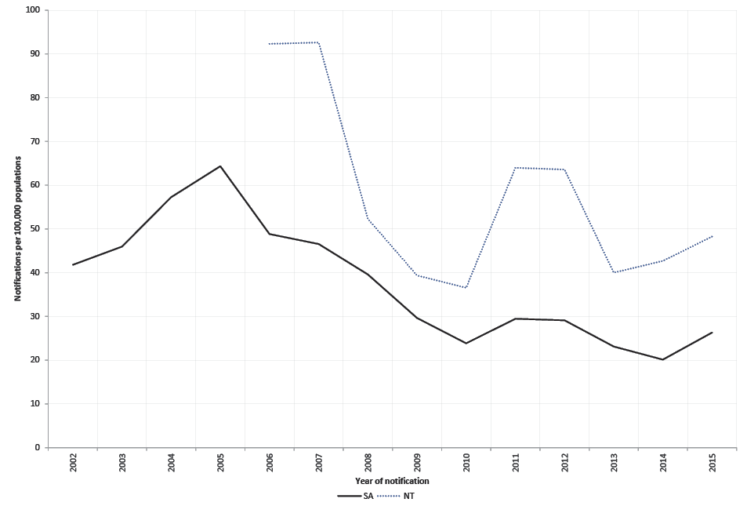
(A)
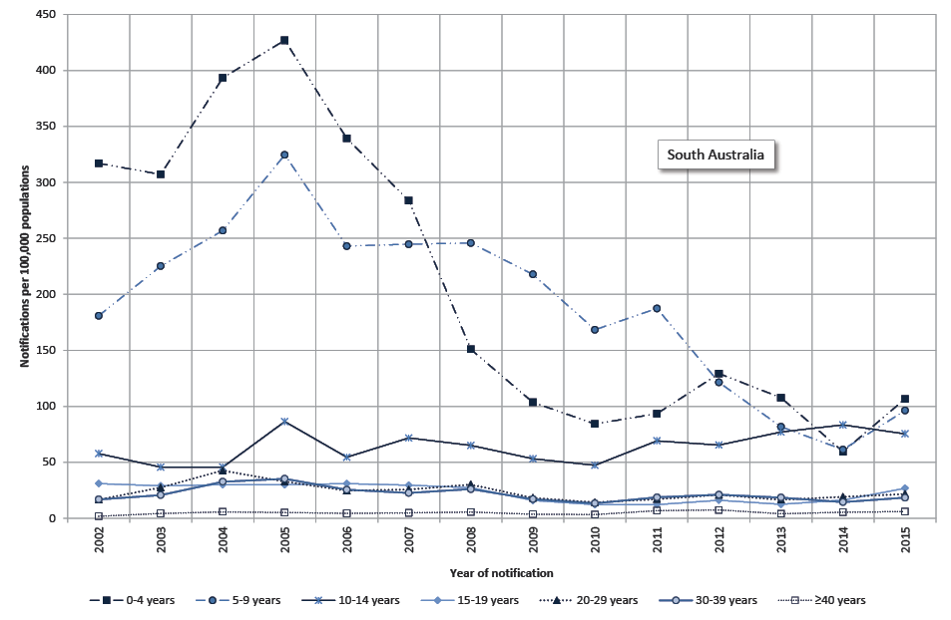
(B)
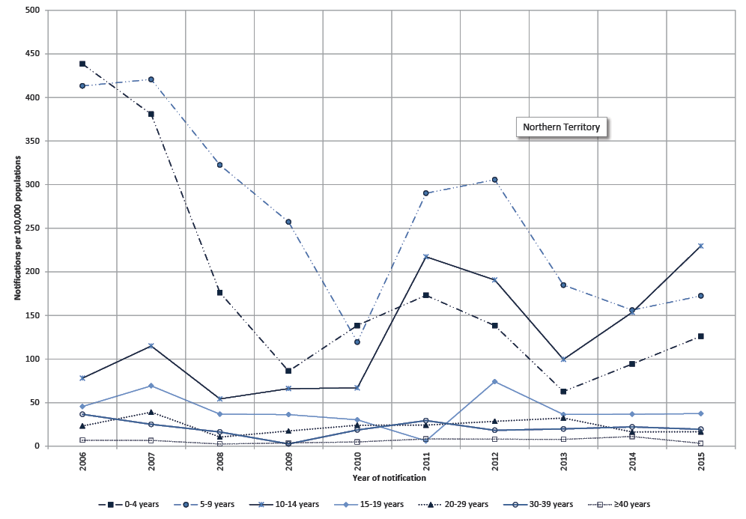
(C)
Declines in age-specific varicella notification rates were observed in both South Australia and the Northern Territory (Figures 1B and 1C). In South Australia, varicella notification rates in persons aged 0-4 years reduced by 63% during the post-vaccine (2007-2015) period (IRR 0.37; 95% CI 0.23-0.59). Reduced varicella notification rates were also observed in other age groups <40 years during the post-vaccine period.

Herpes zoster
In contrast to varicella, HZ notification rates increased over time in both South Australia and in the Northern Territory (Figure 2A). In South Australia, HZ notification rates increased steadily from 23.1 per 100,000 (95% CI 20.7–25.6) in 2002 to 136.9 per 100,000 (95% CI 131.4–142.6) in 2015. In the Northern Territory, HZ notification rates increased from 38.2 per 100,000 (95%CI 30.3–47.6) in 2006 to 148.4 per 100,000 (95% CI 133.5–164.5) in 2015. Similar trends were also observed in age-specific rates with the highest incidence in persons aged ≥70 years, both in South Australia and the Northern Territory (Figures 2B and 2C). Fluctuations in notification rates in the Northern Territory are likely to be associated with its small population size, especially in older age groups.
Figure 2: Notification rates for herpes zoster, by jurisdiction [South Australia (SA) and Northern Territory (NT)] (A) and age group (B and C), 2002- 2015
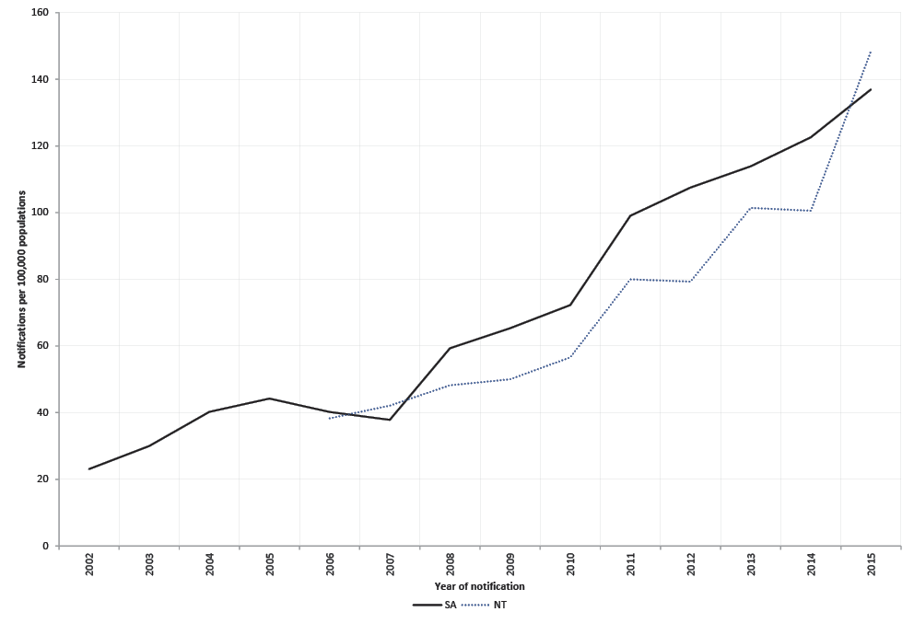
(A)
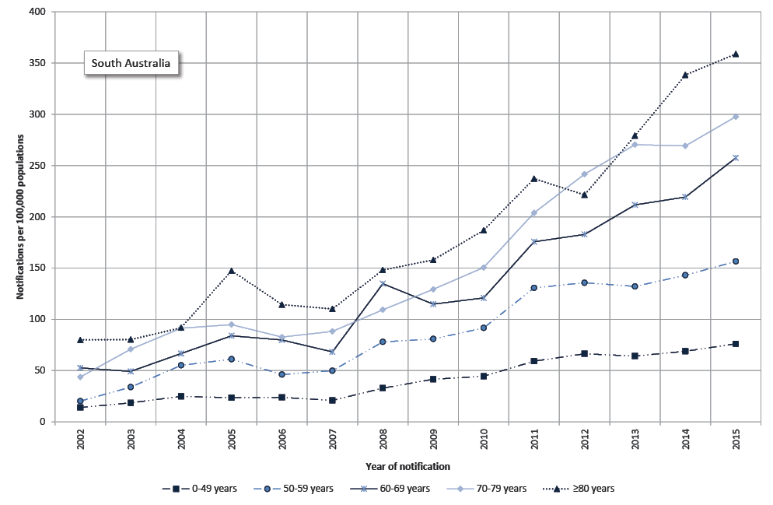
(B)
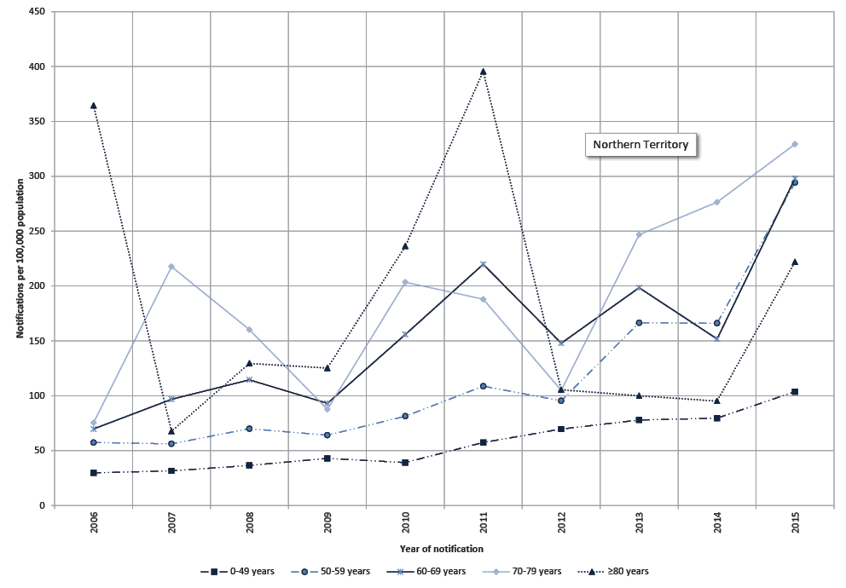
(C)

Varicella and herpes zoster associated hospitalisations

Varicella
There were 18,615 episodes of varicella associated hospitalisation between January 1999 and December 2013, of which 12,824 (68.9%) had a principal diagnosis of varicella. The annual varicella hospitalisation rate reduced from 6.9 per 100,000 (95% CI 6.3–7.1) in 1999 to 2.1 per 100,000 (95% CI 1.9–2.3) in 2013.
The average annual hospitalisation rate for the period 1999-2013 was 4.2 per 100,000 (95% CI 3.4–5.3). Hospitalisation rates were similar in females (3.3 per 100,000; 95% CI 2.6-4.1) and males (4.5 per 100,000; 95% CI 3.5–5.6). There was a rapid decline in hospitalisation rates after the varicella vaccine was added onto the NIP in 2005 (Figure 3A). Hospitalisation rates were 41% lower in 2007 compared to 2005 (IRR 0.59; 95% CI 0.53–0.65).
Figure 3: Varicella hospitalisation rates (A) and varicella hospitalisation (principal diagnosis) by age group (B), Australia, 1999-2013
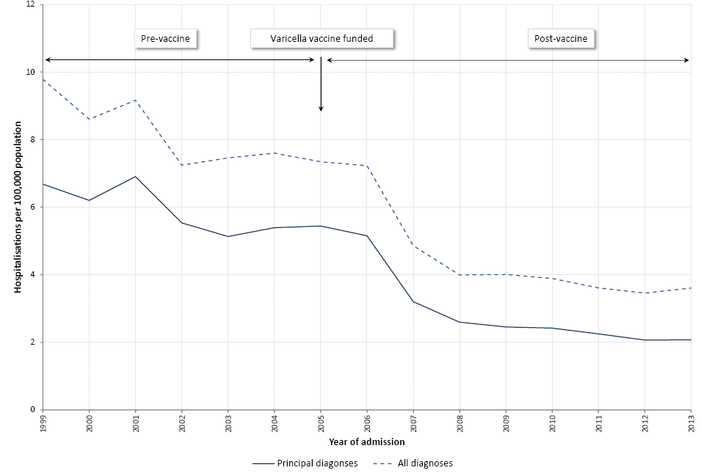
(A)
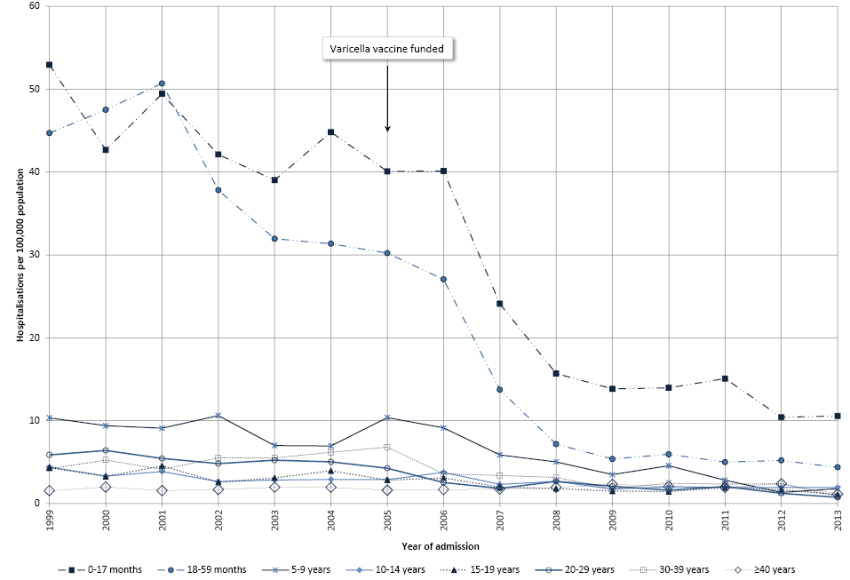
(B)
Age-specific trends in hospitalisation rates are presented in Figure 3B. During 1999-2013, hospitalisation rates were highest in children aged ≤17 months (30.3 per 100,000; 95% CI 23.0–40.0) and lowest in adults aged ≥40 years (1.5 per 100,000; 95% CI 1.4–1.6).
There were significant reductions in hospitalisation rates for all age groups <40 years during the post-vaccine period (2007-2013) compared to the pre-vaccine period (1999-2004) (Table 2). The largest decreases were seen in children aged 18-59 months (IRR 0.16; 95% CI 0.12–0.23), and in those aged ≤17 months (IRR 0.33; 95% CI 0.26–0.40). Despite the rapid decline during the first five years after varicella vaccine was introduced under the NIP, limited additional decline in hospitalisation rates was observed in more recent years (Figure 3A and 3B). Similar findings were observed on analyses of hospitalisations where varicella was recorded in any diagnosis field (Table 2). Trends in hospitalisation rates by jurisdiction were broadly similar (Figure 4).

Figure 4: Varicella hospitalisation rates, by state or territory, Australia, 1999-2013
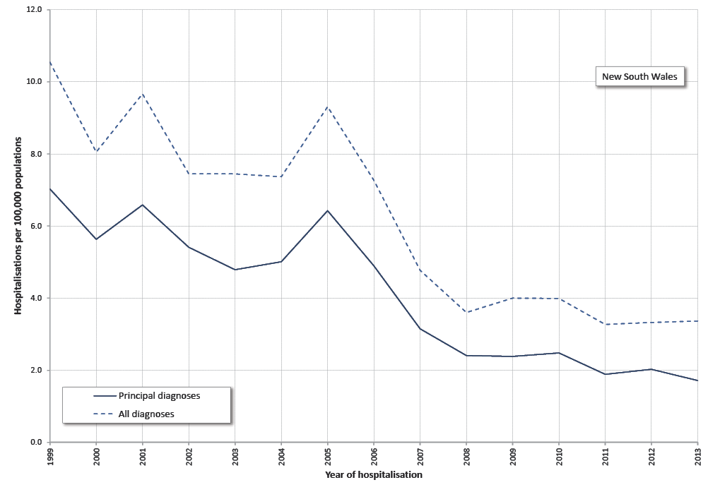
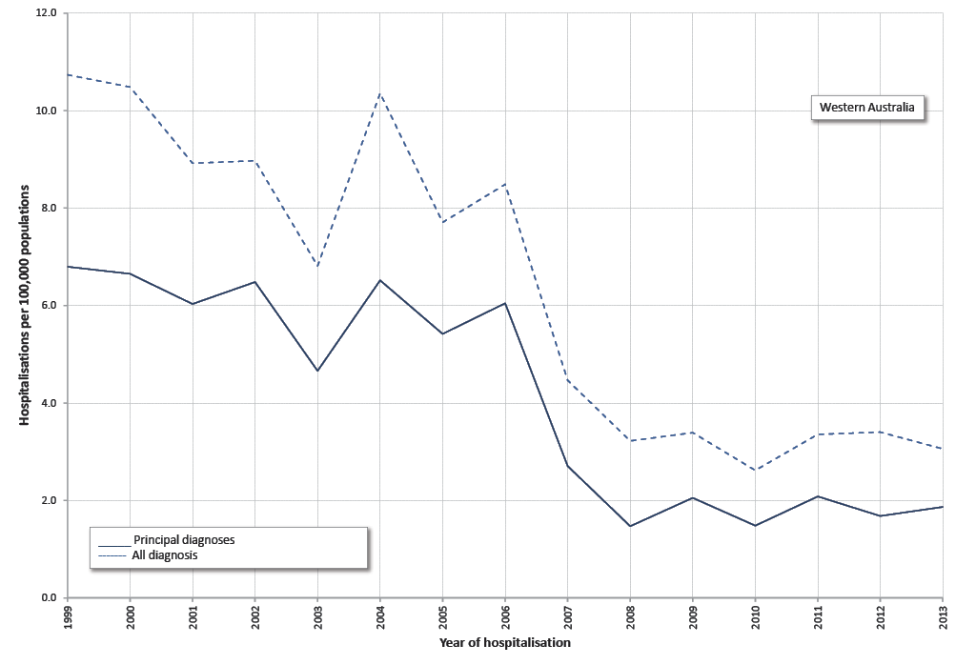
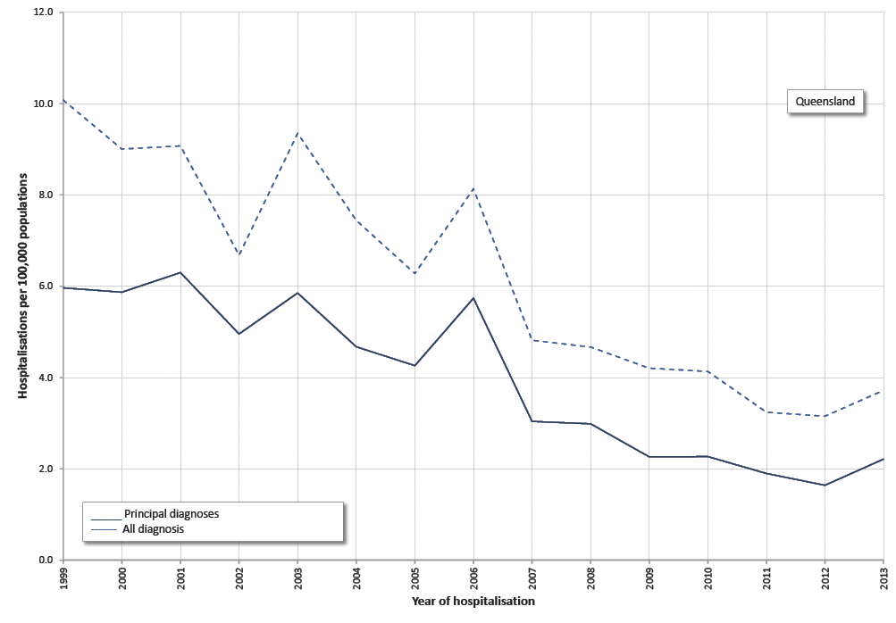
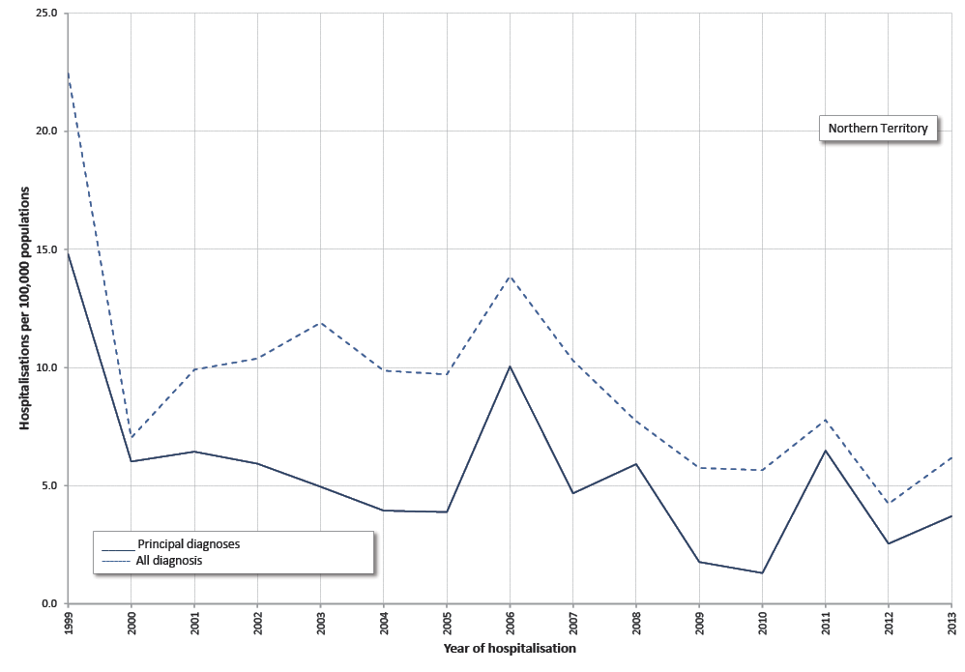
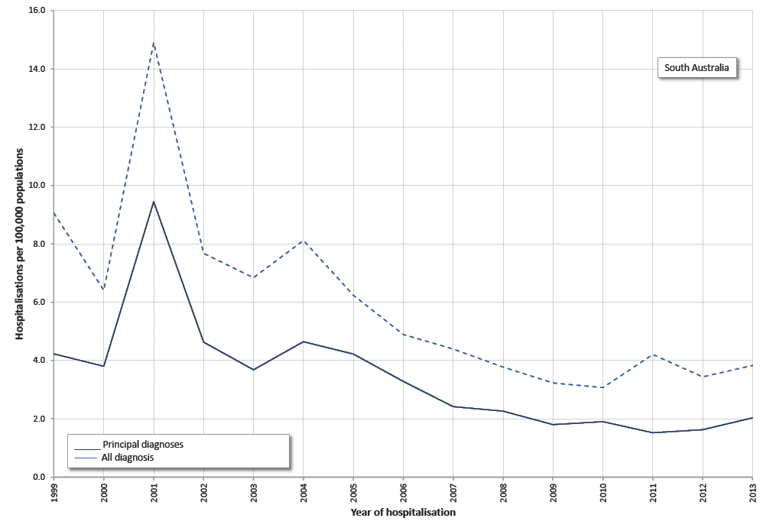
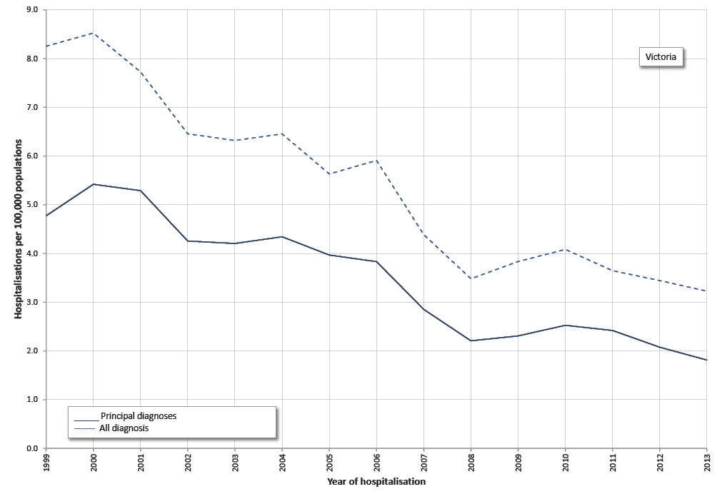
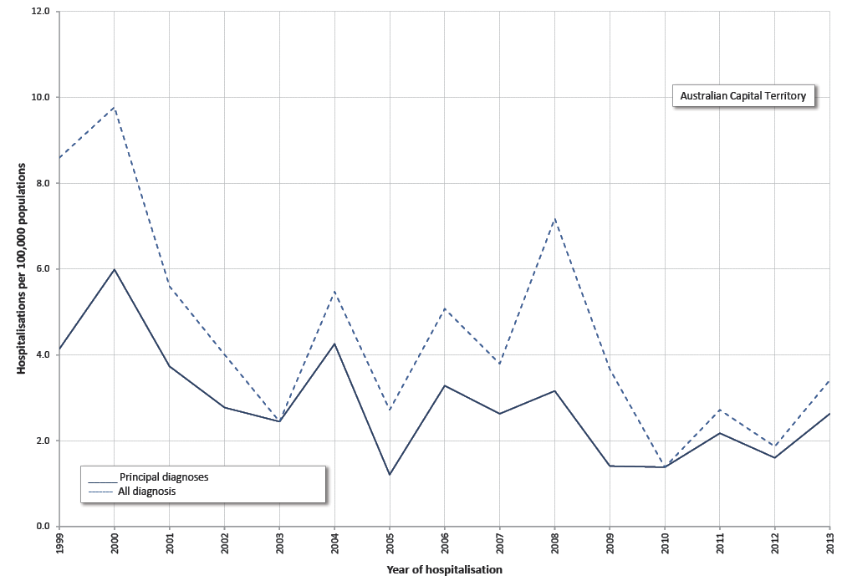
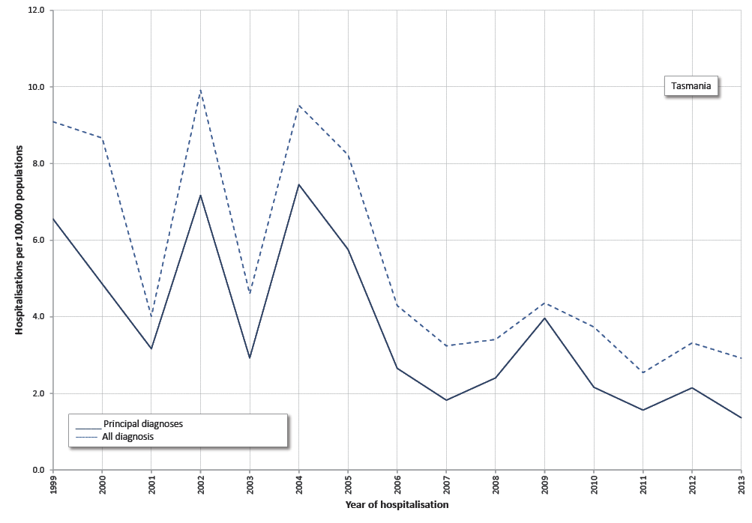

Table 2 Varicella associated hospitalisations, Australia, 1999-2013*
 | Pre-varicella vaccine 1999-2004 |  | Post-varicella vaccine 2007-2013
Age group | Hospitalisations (n) | Rate† (95% CI) | Hospitalisations (n) | Rate‡ (95% CI) | IRR§ (95% CI)
Principal varicella in all Australians
0-17 months | 1,020 | 45.2 (41.6-49.1) | 454 | 14.8 (12.1-18.1) | 0.33 (0.26-0.40)
18-59 months | 2,188 | 40.7 (35.1-47.2) | 458 | 6.7 (5.0-8.9) | 0.16 (0.12-0.23)
5-9 years | 713 | 8.9 (7.82-10.2) | 338 | 3.6 (2.5-5.0) | 0.40 (0.27-0.58)
10-14 years | 269 | 3.3 (2.9-3.9) | 202 | 2.1 (1.8-2.4) | 0.63 (0.52-0.76)
15-19 years | 291 | 3.6 (3.1-4.2) | 165 | 1.6 (1.4-1.9) | 0.45 (0.36-0.56)
20-29 years | 913 | 5.6 (5.2-6.1) | 432 | 2.0 (1.6-2.3) | 0.35 (0.29-0.41)
30-39 years | 850 | 4.8 (4.4-5.3) | 584 | 2.7 (2.3-3.2) | 0.56 (0.46-0.68)
≥40 years | 690 | 1.4 (1.3-1.5) | 1,105 | 1.6 (1.4-1.7) | 1.15 (1.01-1.30)
All ages | 6,934 | 6.0 (5.5-6.5) | 3,738 | 2.4 (2.2-2.7) | 0.41 (0.35-0.47)
All varicella in all Australians
0-17 months | 1,421 | 62.9 (56.8-69.7) | 592 | 19.3 (15.4-24.2) | 0.31 (0.24-0.39)
18-59 months | 2,455 | 45.6 (40.1-52.0) | 529 | 7.7 (5.5-10.1) | 0.17 (0.12-0.25)
5-9 years | 1,129 | 14.1 (12.5-15.9) | 525 | 5.5 (4.0-7.6) | 0.39 (0.27-0.56)
10-14 years | 420 | 5.2 (4.6-5.8) | 302 | 3.1 (2.8-3.9) | 0.60 (0.52-0.69)
15-19 years | 409 | 5.1 (4.2-6.1) | 228 | 2.2 (1.9-2.6) | 0.44 (0.35-0.56)
20-29 years | 1,366 | 8.4 (7.6-9.3) | 648 | 2.9 (2.4-3.5) | 0.35 (0.28-0.43)
30-39 years | 1,205 | 6.8 (6.3-7.4) | 821 | 3.8 (3.4-4.3) | 0.55 (0.48-0.64)
≥40 years | 1,236 | 2.4 (2.3-2.6) | 2,369 | 3.4 (3.0-3.8) | 1.37 (1.18-1.59)
All ages | 9,641 | 8.3 (7.6-9.1) | 6,014 | 3.9 (3.6-4.2) | 0.47 (0.42-0.53)
*Age-specific hospitalisations identified using ICD-10-AM code B01.0-B01.9
†,‡Average annual hospitalisation rate per 100,000 population
§ Incidence rate ratio between hospitalisation rates during pre and post-varicella vaccine periods
Between 1999 and 2013, there were 47,477 bed days recorded for hospitalisations coded as due to varicella. The overall median length of stay was 2 days with length of stay longest in those aged ≥40 years (5 days).

Herpes zoster
There were 80,960 episodes of HZ associated hospitalisations during 1999-2013. Of these, 33,549 (41.4%) episodes had a principal diagnosis of HZ. Over this period, the average annual HZ associated hospitalisation rate was 10.8 per 100,000 (95% CI 10.5–11.1). The HZ hospitalisation rate increased from 9.7 per 100,000 (95%CI 9.2–10.1) in 1999 to 11.4 per 100,000 (95% CI 11.0–11.9) in 2013 (Figure 5A), an average annual increase of 1.0% (IRR 1.01; 95% CI 1.01-1.02). Over this period, the HZ hospitalisation rate for females (30.0 per 100,000; 95% CI 28.7–31.3) was higher than for males (21.8 per 100,000; 95% CI 20.7–22.9). The difference was most pronounced in females ≥75 years with a hospitalisation rate of 95.1 per 100,000 (95% CI 92.6–97.6) compared to males aged ≥75 years (76.4 per 100,000; 95% CI 73.6–79.2).

Figure 5: Herpes zoster hospitalisation rates (A), hospitalisation rates (principal diagnosis) by age group in all Australians (B) and in older non-Indigenous people (C), Australia, 1999-2013 (A)
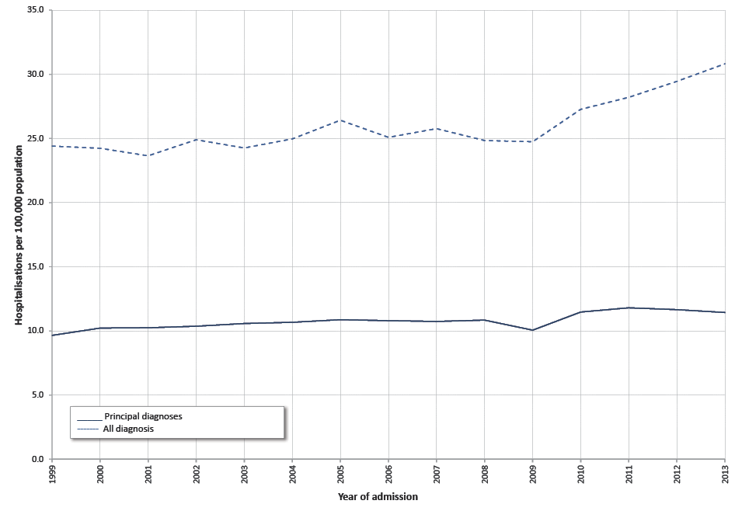
(A)
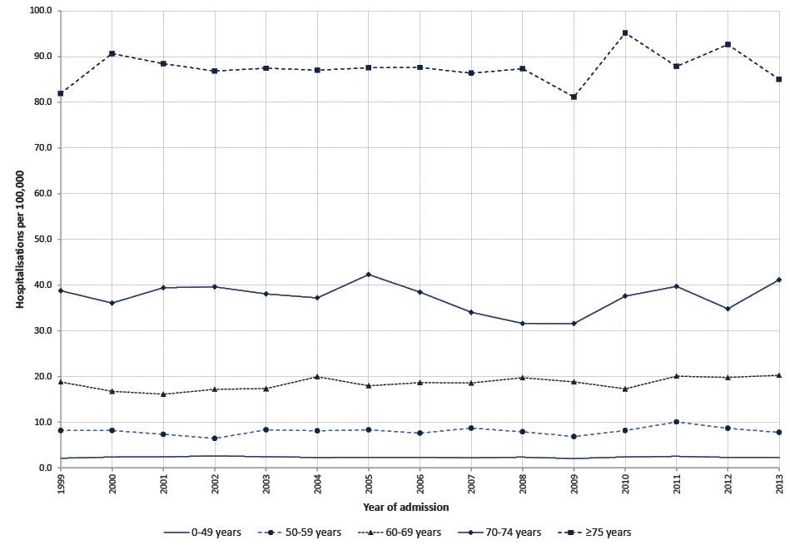
(B)
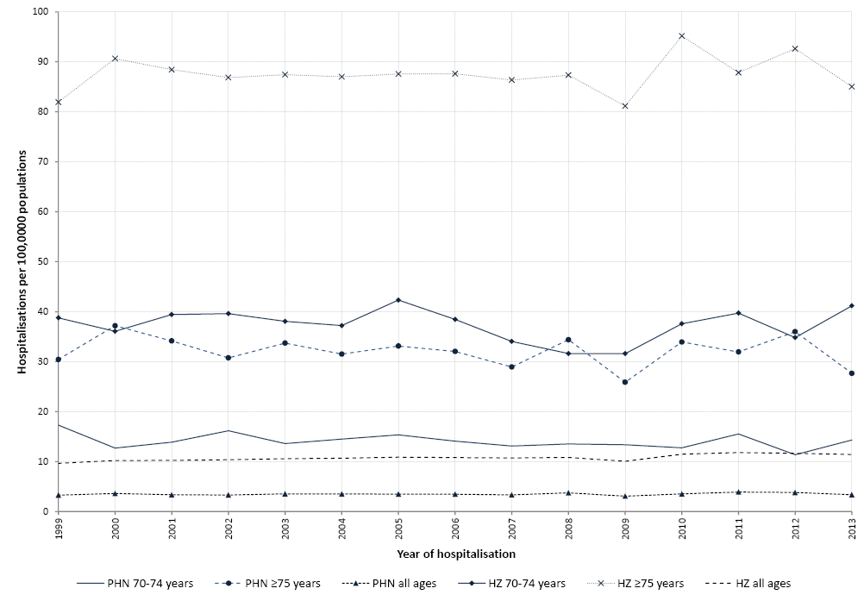
(C)
HZ hospitalisation rates increased with age (Figure 5B). Hospitalisation rates were highest in persons aged ≥75 years (87.6 per 100,000; 95% CI 85.9–89.4), followed by those aged 70-74 years (37.4 per 100,000; 95% CI 35.8–39.0) and lowest in those aged 0-49 years (2.4 per 100,000; 95% CI 2.3–2.4). Amongst non-Indigenous populations, for whom data were available for older age groups (Figure 5C), people aged ≥85 years old had the highest hospitalisation rate of 129.0 per 100,000 (95% CI 124.3–134.0) (Table 3).
Table 3: Herpes zoster associated hospitalisations, Australia, 1999-2013**
 | Study period 1999-2013 |  | Pre-varicella vaccine 1999-2004 |  | Post-varicella vaccine 2007-2013
Age groups | Hospitalisations (n) | Rate†† (95% CI) | Hospitalisations (n) | Rate††(95% CI) | Hospitalisations (n) | Rate††(95% CI) | IRR ‡ ‡ (95% CI)
Principal herpes zoster in all Australians
0-49 years | 5,103 | 2.4 (2.3-2.4) | 1,982 | 2.4 (2.3-2.6) | 2,458 | 2.3 (2.2-2.4) | 0.97 (0.91-1.04)
50-59 years | 3,115 | 8.1 (7.7-8.5) | 1,084 | 7.8 (7.3-8.4) | 1,619 | 8.3 (7.7-9.0) | 1.07 (0.96-1.20)
60-69 years | 5,079 | 18.6 (18.0-19.3) | 1,620 | 17.7 (16.7-18.9) | 2,828 | 19.3 (18.5-20.0) | 1.09 (1.02-1.16)
70-74 years | 3,720 | 37.4 (35.8-39.0) | 1,438 | 38.2 (36.8-39.6) | 1,780 | 35.9 (33.4-38.6) | 0.94 (0.86-1.02)
≥75 years | 16,532 | 87.6 (85.9-89.4) | 5,846 | 87.1 (84.9-89.4) | 8,492 | 87.9 (84.8-91.2) | 1.01 (0.96-1.06)
All ages | 33,549 | 10.8 (10.5-11.1) | 11,970 | 10.3 (10.0-10.6) | 17,177 | 11.1 (10.7-11.6) | 1.08 (1.03-1.14)
All herpes zoster in all Australians
0-49 years | 10,009 | 4.6 (4.5-4.8) | 3,907 | 4.7 (4.6-4.9) | 4,771 | 4.5 (4.3-4.8) | 0.96 (0.89-1.03)
50-59 years | 6,898 | 17.9 (17.2-18.6) | 2,463 | 17.7 (17.0-18.4) | 3,490 | 17.9 (16.7-19.3) | 1.01 (0.93-1.10)
60-69 years | 11,852 | 43.2 (41.4-45.0) | 3,724 | 40.8 (38.7-43.0) | 6,656 | 45.3 (42.8-47.8) | 1.11 (1.03-1.20)
70-74 years | 9,002 | 90.2 (86.3-94.3) | 3,478 | 92.4 (89.4-95.5) | 4,428 | 88.9 (81.6-96.9) | 0.96 (0.87-1.06)
≥75 years | 43,199 | 228.1 (221.9-234.5) | 14,796 | 220.4 (216.9-224.0) | 22,788 | 235.5 (225.4-246.2) | 1.07 (1.01-1.12)
All ages | 80,960 | 25.9 (25.0-27.0) | 28,368 | 24.4 (23.0-24.8) | 42,133 | 27.3 (25.8-28.9) | 1.12 (1.05-1.19)
Principal herpes zoster in non-Indigenous Australians§§
70-74 years | 3,689 | 37.4 (35.8-39.0) | 1,427 | 38.2 (36.3-40.2) | 1,763 | 35.8 (33.3-38.6) | 0.94 (0.88-1.02)
75-79 years | 4,787 | 59.4 (57.4-61.6) | 1,938 | 62.7 (60.0-65.6) | 2,181 | 56.1 (53.8-58.5) | 0.89 (0.84-0.95)
80-84 years | 5,349 | 92.0 (89.0-95.1) | 1,886 | 94.0 (88.8-99.5) | 2,746 | 90.9 (86.6-95.4) | 0.97 (0.90-1.04)
≥85 years | 6,340 | 129.0 (124.3-134.0) | 2,011 | 126.5 (118.5-135.1) | 3,528 | 130.8 (123.7-138.3) | 1.03 (0.95-1.13)
All ages | 33,007 | 10.9 (10.6-11.2) | 11,805 | 10.4 (10.2-10.7) | 16,867 | 11.3 (10.9-11.7) | 1.08 (1.03-1.13)
All herpes zoster in non-Indigenous Australians§§
70-74 years | 8,931 | 90.2 (86.2-94.4) | 3,457 | 92.5 (89.5-95.7) | 4,386 | 88.9 (81.3-97.0) | 0.96 (0.87-1.06)
75-79 years | 12,145 | 150.8 (146.3-155.3) | 4,808 | 155.7 (148.7-163.0) | 5,729 | 147.3 (142.0-152.9) | 0.95 (0.89-1.00)
80-84 years | 13,759 | 236.4 (228.0-245.1) | 4,636 | 231.7 (220.0-243.9) | 7,204 | 238.3 (224.7-252.6) | 1.03 (0.95-1.11)
≥85 years | 17,184 | 348.2 (338.1-358.6) | 5,330 | 335.8 (325.5-346.4) | 9,779 | 361.5 (347.8-375.7) | 1.08 (1.02-1.14)
All ages | 79,874 | 26.4 (25.4-27.4) | 28,069 | 24.8 (24.5-25.2) | 41,487 | 27.7 (26.1-29.4) | 1.12 (1.05-1.19)
**Age-specific hospitalisations identified using ICD-10-AM code B02.0-02.9 ††Average annual hospitalisation rate per 100,000 population ‡ ‡Incidence rate ratio between hospitalisation rates during pre and post-varicella vaccine periods §§Hospitalisations for Indigenous Australians were excluded.

When we compared hospitalisation rates during the post-varicella vaccine period (2007-2013) to the pre-varicella vaccine period (1999-2004) in non-Indigenous people, the IRR was 1.08 (95% CI 1.03–1.13) for all ages, 0.94 (95% CI 0.88–1.02) for those aged 70-74 years, and 0.89 (95% CI 0.84–0.95) for those aged 75-79 years (Table 3).

Post-herpetic neuralgia (PHN)
Almost a third (32.5%) of all hospitalisations (principal) coded as HZ also had a diagnosis of PHN recorded in the diagnostic field (within the first 30 diagnostic fields). The overall rate of PHN hospitalisations remained stable (Figure 6A) for the years 1999-2013 (IRR 1.00; 95% CI 0.99-1.01), with the highest rate in those aged ≥75 years (32.1 per 100,000) followed by people aged 70-74 years (14.1 per 100,000). PHN-associated hospitalisations increased disproportionately with age, where 36.6% HZ hospitalisations in those aged ≥75 years had an episode of PHN compared to 26.7% in those aged 50-59 years (Figure 6B).
Figure 6: Hospitalisation rates for post-herpetic neuralgia [PHN] and herpes zoster [HZ] (A) and by age groups (B), Australia, 1999-2013*
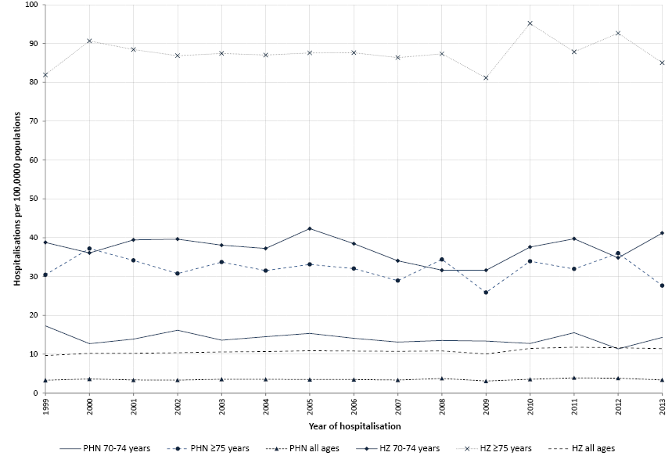
(A)
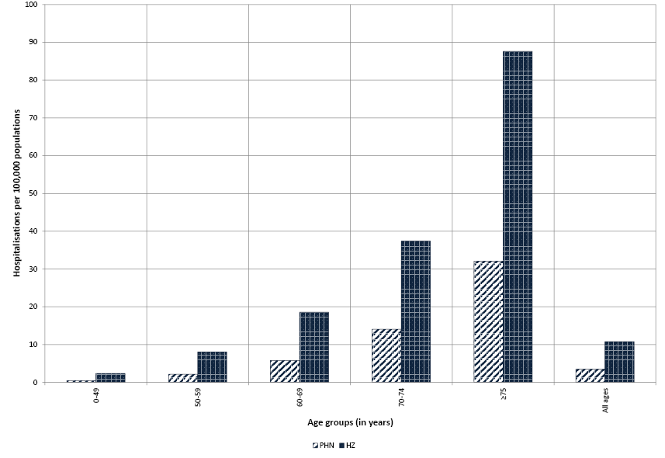
(B)

Between 1999 and 2013, there were 226,276 bed days for hospitalisation coded as due to HZ. The overall median length of stay was 4 days with length of stay increasing with age. Median length of stay per admission was 4 days and 6 days for people aged 70-74 and ≥75 years, respectively. HZ hospitalisations in which a diagnosis for PHN was also recorded were associated with a higher median length of stay (5 days) compared to those not also recorded as having PHN (4 days) (p<0.05).

VZV associated hospitalisations in Indigenous Australians

Varicella
We compared varicella hospitalisation rates in Indigenous people over the pre- and post- vaccine periods using data from four jurisdictions (Queensland, Western Australia, Northern Territory and South Australia). We observed significant decreases in hospitalisation rates in all age groups, with the greatest reduction of 89% (IRR 0.11; 95% CI 0.06-0.22) in children aged 18-59 months (Table 4). Similar findings were observed when we compared varicella hospitalisation rates in children aged 18-59 months from the four jurisdictions for the pre-vaccine period (38.1 per 100,000; 95% CI 29.8-48.7) to hospitalisation rates in Queensland, Western Australia, South Australia, Northern Territory, New South Wales and Victoria for the post-vaccine period (6.3 per 100,000; 95% CI 3.1-12.3).

Table 4: Varicella hospitalisations (principal diagnosis) by age groups and vaccine period in Indigenous populations, Australia, 1999- 2013 ***, †††
 | Pre-varicella vaccine  1999-2004 |  | Post-varicella vaccine  2007-2013
Age group | Hospitalisations (n) | Rate‡‡‡ (95% CI) | Hospitalisations (n) | Rate‡‡‡ (95% CI) | IRR §§§ (95% CI)
0-17 months | 69 | 73.0 (57.7-92.5) | 25 | 21.1 (12.6-35.3) | 0.29 (0.18-0.46)
18-59 months | 64 | 38.1 (29.8-48.7) | 9 | 4.3 (1.7-11.0) | 0.11 (0.06-0.22)
5-9 years | 38 | 15.6 (11.4-21.4) | 11 | 3.5 (1.9-6.2) | 0.22 (0.11-0.43)
10-14 years | 9 | 4.2 (1.7-10.8) | 19 | 6.2 (4.0-10.0) | 1.49 (0.66-3.33)
15-19 years | 4 | 2.2 (0-5.8) | 7 | 2.5 (0-6.6) | 1.17 (0.29-4.71)
20-29 years | 13 | 4.3 (2.5-9.3) | 6 | 1.4 (0-3.0) | 0.32 (0.12-0.84)
30-39 years | 7 | 2.6 (1.2-5.4) | 10 | 2.9 (1.4-6.1) | 1.12 (0.39-3.24)
≥40 years | 8 | 2.9 (1.1-4.4) | 12 | 2.0 (1.0-3.8) | 0.90 (0.36-2.24)
All ages | 212 | 11.5 (10.0-13.1) | 99 | 3.8 (2.7-5.2) | 0.33 (0.25-0.44)
***Analyses restricted to Queensland, South Australia, Western Australia and the Northern Territory
†††Age-specific hospitalisations identified using ICD-10-AM code B02.0-02.9
‡‡‡Average annual hospitalisation rate per 100,000 population
§§§Incidence rate ratio between hospitalisation rates during pre and post-varicella vaccine periods
For Queensland, Western Australia, South Australia and the Northern Territory in the pre-vaccine period, the hospitalisation rate in Indigenous children aged 18-59 months was 36% higher compared to non-Indigenous children (IRR 1.36; 95% CI 1.01–1.83) but similar during the post-vaccine period (IRR 0.91; 95% CI 0.42–1.96). During the pre-vaccine period, Indigenous children aged ≤17 months were hospitalised at significantly higher rates compared to non-Indigenous people (IRR 1.69; 95% CI 1.30-2.19) (Figure 7A). However, during the post-vaccine period, varicella hospitalisation rates in Indigenous people aged ≤17 months were not significantly higher compared to non-Indigenous people (IRR 1.52;95% CI 0.99-2.33). Indigenous Australians had higher varicella hospitalisation rates compared to non-Indigenous Australians in all other age groups (Tables 2 and 4).
Figure 7: Incidence rate ratios for varicella (A)*and herpes zoster (B)**hospitalisation rates between Indigenous and non-Indigenous Australians by age groups, Australia, 1999- 2013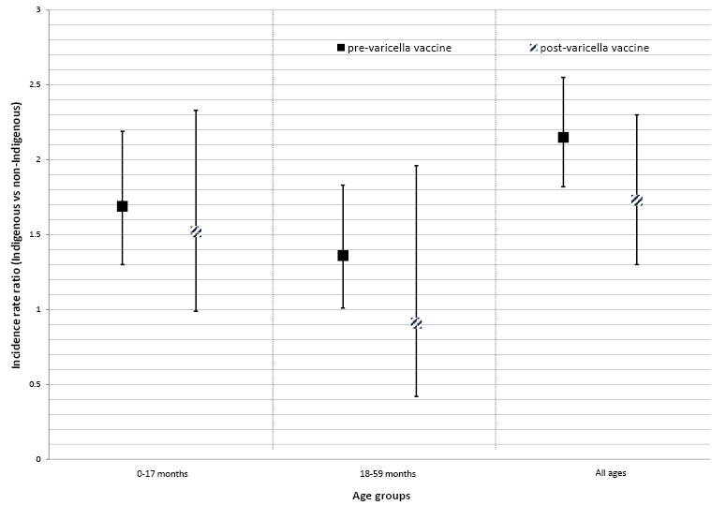
(A)
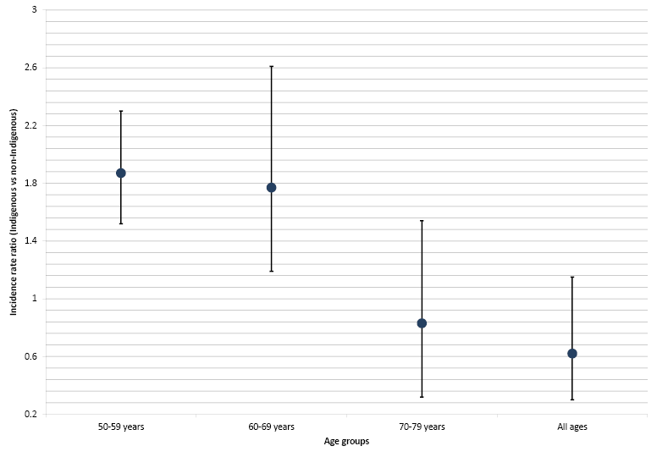
(B)
* Analyses restricted to Queensland, South Australia, Western Australia and the Northern Territory. Pre-varicella vaccine=1999-2004 and post-varicella vaccine=2007-2013.
** Analyses restricted to New South Wales, Victoria, Queensland, South Australia, Western Australia and the Northern Territory for the years 2007-2011.

Herpes zoster
When we analysed data from six jurisdictions (New South Wales, Victoria, Queensland, South Australia, Northern Territory and Western Australia) for the years 2007-2011, we found HZ hospitalisation rates in Indigenous people to be almost double those in non-Indigenous people aged 50-59 years (IRR 1.87; 95% CI 1.29-2.71) and 60-69 years (IRR 1.77; 95% CI 1.27-2.48) (Figure 7B). However, no significant difference was observed in people aged 70-79 years (IRR 0.83; 95% CI 0.51-1.36).

Varicella and herpes zoster associated mortality
During the period 1998-2013, there were 21 deaths with varicella coded as the underlying cause of death (UCOD). In people aged <40 years the number of deaths was two-thirds lower in the post-vaccine period (2007-2013; 5 deaths) compared to the pre-vaccine period (1998-2004; 15 deaths). In children aged <10 years, the number of deaths reduced from 6 deaths in 1998-2004 to <4 deaths in 2007-2013.
During the same period, there were 340 deaths where HZ was coded as the UCOD with an overall crude mortality rate of 0.23 per 100,000 (95% CI 0.21-0.26) in those aged ≥40 years. Of these deaths, 5 (1.5%) were in people 40-59 years of age, 7 (2.1%) in those aged 60-69 years, 40 (11.8%) in those aged 70-79 years and 288 (84.7%) in those aged ≥80 years. The number of HZ-related deaths recorded for females (230, 67.6%) was twice that of males (110, 32.4%).

Discussion
Introduction of the national varicella immunisation program in 2005 for children aged 18 months was associated with a rapid and significant decline in varicella hospitalisation rates in Australia, particularly in children aged ≤10 years. While the varicella vaccine was available through the private market from 2000 and was recommended for use in 2003,² the vaccine did not have significant impact on hospitalisation rates until it was introduced under the NIP in 2005 as a single dose at 18 months of age with no formal catch-up program. According to the 2014 coverage estimates, the uptake of MMRV at 18 months of age measured at 2 years of age was 89.6%.¹³ Previously published data on varicella hospitalisations until 2010 reported 70% and 60% reductions in the age groups of 1-4 year olds and <1 year olds, respectively.¹¹ By December 2013, we found 84% reduction in hospitalisation rates in the post-varicella vaccine period in children aged 18-59 months, most of whom would have received the vaccine. Significant herd effect with 67% reduction in varicella hospitalisation rates was evident in children aged <18 months, who are not eligible for varicella immunisation. In the 20-29 years and 30-39 years age groups, varicella hospitalisation rates also reduced by 65% and 44%, respectively, suggesting that the herd protection effects of universal childhood immunisation also extend to adults of childrearing age, who are susceptible to more severe disease than children.²²⁻²⁴ Similar impacts following one-dose varicella immunisation programs have been documented in other countries including the USA, Canada, Italy, Germany, Taiwan and Uruguay.²⁵ Hospitalisation rates in those aged ≥40 years did not decline during the post-vaccine period (IRR 1.15; 95% CI 1.01–1.30), most likely due to naturally acquired VZV-specific immunity in this age group and possible misclassification of HZ as varicella.^{20,26}
Despite the relatively high vaccine coverage and rapid initial decline in hospitalisation rates, little change in varicella hospitalisation rates was observed from 2010 onwards. Approximately 300 varicella hospitalisations continue to occur each year in those aged <40 years. Two recent Australian studies, one in Queensland and one nationally across all sentinel sites in the Paediatric Active Enhanced Disease Surveillance (PAEDS) network, have shown a single dose of varicella vaccine to have moderate effectiveness against varicella-associated hospitalisations of 81.9% and 64.6%, respectively.^{27,28} Further decreases in hospitalisation rates and interruption of community-wide transmission will likely require a second dose of vaccine.²⁹ In the USA, continuing varicella outbreaks and episodes of breakthrough disease were documented, despite high coverage attained under their one-dose varicella immunisation program, and prompted a switch to a two-dose program in 2006. ³⁰⁻³³ Introduction of a second dose led to a greater than 40% decline in hospitalisations during the years 2006-2010 compared to 2002-2005, as reported from two sentinel surveillance sites, and was accompanied by reduction in severe disease and outbreaks.³⁴⁻³⁶ Similar to the USA, where overall deaths reduced by 66% in the first 6 years following the introduction of the one-dose program,³⁷ we found a 67% reduction in varicella-attributable deaths in people aged <40 years during the post-vaccine period. In 2007, addition of a second dose of varicella vaccine to the NIP was deemed not cost-effective by the Pharmaceutical Benefits Advisory Committee.³⁸ However, our findings suggest that it may be time to re-examine the potential for NIP funding of a second dose in the childhood schedule, if Australia is to achieve any further significant reductions in varicella-associated morbidity and mortality.³⁹
A national HZ immunisation program, using the live attenuated zoster vaccine, was introduced in Australia in November 2016 for people aged 70-79 years. Our report focussed on HZ-related hospitalisations - although only around 3% of HZ cases are hospitalised,⁴⁰ hospitalisation rates are a measure of severe disease posing a significant economic burden on the health system.^{41,42} Consistent with other studies, our results demonstrate higher hospitalisation rates and mortality associated with HZ in older people (associated with immunosenescence) and in females (in whom a different response to latent VZV infection has been identified).^{40,43} We found similar HZ hospitalisation rates between the pre- and post-varicella vaccine periods, including in those aged 70-74 years (IRR 0.94; 95% CI 0.86–1.02) and ≥75 years (IRR 1.01; 95% CI 0.96–1.06), but an increasing trend in the HZ notification rate in South Australia and the Northern Territory. While this increase in notifications may be partly due to increased testing, similar to that seen with influenza and pertussis,⁴⁴ several studies have documented increases in community-based consultations and emergency department presentations for HZ, which may be due to a combination of ageing of the Australian population, greater use of immunosuppressive medications and reduced natural boosting to VZV since the introduction of universal childhood varicella immunisation.^{18,45-48} Similarly, the increase in all herpes zoster associated hospitalisations in the recent years (Figure 5A) might also be influenced by a combination of factors mentioned above.
One third of all hospitalised cases in our study had PHN recorded in a diagnostic field, with the highest hospitalisation rate (32.1 per 100,000) in people aged ≥75 years. In Australia, the economic burden of HZ and PHN are significant, with an estimated total cost of 32.8 million Australian dollars each year to the health care system.⁴² Pain associated with PHN is often refractory to treatment and can have substantial negative impact on the health-related quality of life.^{14,49,50}
During the pre-vaccine period, Indigenous children aged 18-59 months had higher varicella hospitalisation rates compared to their non-Indigenous counterparts. Funded childhood varicella immunisation has contributed towards ‘closing the gap’— during the post-vaccine period, Indigenous children aged 18-59 months had similar varicella hospitalisation rates compared to their non-Indigenous counterparts. However, Indigenous people overall continue to be hospitalised due to varicella and HZ at almost double the rate compared to non-Indigenous people. Our recent work demonstrated that Indigenous Australians aged 60-69 years had higher HZ hospitalisation rates compared to non-Indigenous Australians aged 70-79 years, who are currently eligible for funded HZ immunisation.⁵¹
High quality disease surveillance strategies are imperative for monitoring the population-wide impact of immunisation programs and driving evidence-based policies. Our study highlights a number of limitations of using notification and hospitalisation data for surveillance of varicella and HZ. While varicella and HZ are considered to be nationally notifiable diseases, differences in reporting mechanisms, the inherent challenges in reporting of these diseases (related to reliance on clinical/ epidemiological information rather than solely laboratory diagnosis) and absence of routine reporting from New South Wales to the NNDSS significantly limit interpretation of the data. South Australia and the Northern Territory are the only jurisdictions that routinely follow up laboratory notifications of VZV in order to be able to align cases with national case definitions. Both notification and hospitalisation data considerably underestimate the true burden of varicella and HZ, as both diseases are generally self-limiting and only a small proportion are likely to be tested for, notified and/or hospitalised. Notification data may be influenced by changes in testing practices over time. Surveillance using hospitalisation data is not timely and data may be influenced by access to hospitals over time, coding practices and misclassification between varicella and HZ.^{20,26,52}
Other industrialised countries with national HZ immunisation programs have implemented a variety of surveillance systems targeted at capturing cases of HZ. In the UK, enhanced surveillance using sentinel GP clinics and pain clinics was established to monitor the effectiveness of their HZ immunisation program.^{53,54} Several other European countries conduct active surveillance for HZ including sentinel surveillance. ⁵⁵ In the USA, active sentinel surveillance sites initially established for varicella surveillance were also successful at monitoring the epidemiology of HZ after the introduction of HZ vaccine in 2006.^{56,57} Based on this, Australia will need to adopt a national and unified approach to identify ideal surveillance strategies.
In conclusion, introduction of a national varicella immunisation program in 2005 substantially reduced varicella associated morbidity and mortality in Australia. Minimal decline has been observed during recent years and further reductions in disease incidence will most likely require a second dose of varicella vaccine to be added on the NIP. A vaccine for HZ was introduced under the NIP in 2016. Timely and high quality surveillance, including data on HZ encounters at the primary health care level, along with HZ vaccine coverage data sourced from Australian Immunisation Register, will be crucial to evaluate the population-wide impact of the national HZ immunisation program.

Acknowledgements
We would like to acknowledge Allison Cairns, Vaccine Preventable Diseases Surveillance Section, Department of Health for providing useful comments on a late draft of the manuscript.
We thank the Australian Coordinating Registry, state and territory registries of births, deaths and marriages, state and territory coroners, and the National Coronial Information System, for providing access to cause of death data.
The National Centre for Immunisation Research and Surveillance is supported by the Australian Government Department of Health, the NSW Ministry of Health and The Children’s Hospital at Westmead. The opinions expressed in this paper are those of the authors, and do not necessarily represent the views of these agencies.

Corresponding author
Dr Meru Sheel^{1,2} Epidemiologist
National Centre for Immunisation Research and Surveillance Email: Meru.Sheel@health.nsw.gov.au Phone: 02-98451447

Author details
(I) Dr Frank Beard^{1,3} – Staff Specialist, Public Health Physician - joint co-author
(II) Dr Helen Quinn^{1,3} – Senior Research Fellow - joint co-author
Dr Aditi Dey^{1,3} – Manager, Surveillance, NCIRS
Associate Prof Martyn Kirk² – Convenor, Masters of Philosophy in Applied Epidemiology
Dr Ann Koehler⁴ – Director
Dr Peter Markey⁵ – Head, Disease Surveillance
Prof Peter McIntyre^{1,3} – Director, NCIRS
Associate Prof Kristine Macartney^{1,3} – Deputy Director, NCIRS
¹National Centre for Immunisation Research and Surveillance, Westmead, New South Wales
²National Centre for Epidemiology and Population Health, Australian National University, Acton, Australian Capital Territory
³University of Sydney, Sydney, New South Wales
⁴Communicable Disease Control Branch, South Australia Health, South Australia
⁵Centre for Disease Control, Department of Health, Northern Territory

References
- Heymann DL. Control of Communicable Diseases Manual, 20th Edition: APHA Press; 2015.
- Australian Technical Advisory Group on Immunisation (ATAGI). The Australian immunisation handbook. 10th edn. Canberra: Australian Government Department of Health and Ageing; 2015.
- Macartney KK, Burgess MA. Varicella vaccination in Australia and New Zealand. The Journal of infectious diseases 2008;197 Suppl 2:S191-195.
- Plotkin SA, Orenstein WA, editors. Vaccines. 2nd edn. Philadelphia: WB Saunders; 1994.
- Hall S, Maupin T, Seward J, Jumaan AO, Peterson C, Goldman G, et al. Second varicella infections: are they more common than previously thought? Pediatrics 2002;109:1068-1073.
- Cunningham AL, Breuer J, Dwyer DE, Gronow DW, Helme RD, Litt JC, et al. The prevention and management of herpes zoster. The Medical journal of Australia 2008;188:171-176.
- WHO. Varicella and herpes zoster vaccines: WHO position paper, June 2014; 2014. Accessed on 12/01/2017. Available from: http://www.who.int/wer/2014/wer8925.pdf?ua=1 .
- Cohen JI. Clinical practice: Herpes zoster. The New England journal of medicine 2013;369:255-263.
- Ward K, Dey A, Hull B, Quinn HE, Macartney K, Menzies R. Evaluation of Australia’s varicella vaccination program for children and adolescents. Vaccine 2013;31:1413-1419.
- Department of Health. National Immunisation Program Schedule. 2016. Accessed on 20 December 2016. Available from: http://www.immunise.health.gov.au/internet/immunise/publishing.nsf/Content/national-immunisation-program-schedule
- Heywood AE, Wang H, Macartney KK, McIntyre P. Varicella and herpes zoster hospitalizations before and after implementation of one-dose varicella vaccination in Australia: an ecological study. Bulletin of the World Health Organization 2014;92:593-604.
- Hull BP, Dey A, Menzies RI, Brotherton JM, McIntyre PB. Immunisation coverage, 2012. Communicable diseases intelligence quarterly report 2014;38:E208-231.
- Hull BP, Dey A, Beard FH, Hendry A, Brotherton JM, McIntyre PB. Immunisation coverage annual report, 2014. Commun Dis Intell 2017.
- Department of Health. PBAC Public Summary Documents - November 2014. 2015. Accessed on 12 December 2016. Available from: http://www.pbs.gov.au/pbs/industry/listing/elements/pbac-meetings/psd/11-2014
- Khandaker G, Marshall H, Peadon E, Zurynski Y, Burgner D, Buttery J, et al. Congenital and neonatal varicella: impact of the national varicella vaccination programme in Australia. Archives of Disease in Childhood 2011;96:453-456.
- Marshall HS, McIntyre P, Richmond P, Buttery JP, Royle JA, Gold MS, et al. Changes in patterns of hospitalized children with varicella and of associated varicella genotypes after introduction of varicella vaccine in Australia. Pediatric Infectious Disease Journal 2013;32:530-537.
- Carville KS, Grant KA, Kelly HA. Herpes zoster in Australia. Epidemiology and infection 2012;140:599-600; author reply 600-591.
- MacIntyre R, Stein A, Harrison C, Britt H, Mahimbo A, Cunningham A. Increasing trends of herpes zoster in Australia. PloS one 2015;10:e0125025.
- Communicable Diseases Network Australia. Surveillance case definitions for the Australian National Notifiable Diseases Surveillance System 2017. Accessed on 29 March 2017. Available from: http://www.health.gov.au/casedefinitions
- Galil K, Pletcher MJ, Wallace BJ, Seward J, Meyer PA, Baughman AL, et al. Tracking Varicella Deaths: Accuracy and Completeness of Death Certificates and Hospital Discharge Records, New York State, 1989–1995. American Journal of Public Health 2002;92:1248-1250.
- Australian Institute of Health and Welfare. Indigenous identification in hospital separations data—quality report. Health Services Series no. 35. Cat. no. HSE 85. Canberra; 2010. Available from: http://www.aihw.gov.au/publication-detail/?id=6442468330 .
- Waye A, Jacobs P, Tan B. The impact of the universal infant varicella immunization strategy on Canadian varicella-related hospitalization rates. Vaccine 2013;31:4744-4748.
- Singleton RJ, Holman RC, Person MK, Steiner CA, Redd JT, Hennessy TW, et al. Impact of Varicella Vaccination on Varicella-related Hospitalizations Among American Indian/Alaska Native People. Pediatric Infectious Disease Journal 2014;33:276-279.
- Davis MM, Patel MS, Gebremariam A. Decline in varicella-related hospitalizations and expenditures for children and adults after introduction of varicella vaccine in the United States. Pediatrics 2004;114:786-792.
- Varicella and herpes zoster vaccines: WHO position paper, June 2014. Releve epidemiologique hebdomadaire / Section d’hygiene du Secr 2014;89:265-287.
- Lin F, Hadler JL. Epidemiology of primary varicella and herpes zoster hospitalizations: the pre-varicella vaccine era. The Journal of infectious diseases 2000;181:1897-1905.
- Sheridan SL, Quinn HE, Hull BP, Ware RS, Grimwood K, Lambert SB. Impact and effectiveness of childhood varicella vaccine program in Queensland, Australia. Vaccine 2017;In press.
- Quinn H, Gidding H, Macartney K, Marshall H, Richmond P, Crawford N, et al. Vaccine effectiveness against hospitalised varicella. Presented at: 15th National Immunisation Conference; Brisbane, Australia.
- Gao Z, Gidding HF, Wood JG, MacIntyre CR. Modelling the impact of one-dose vs. two-dose vaccination regimens on the epidemiology of varicella zoster virus in Australia. Epidemiology and infection 2010;138:457-468.
- Chaves SS, Zhang J, Civen R, Watson BM, Carbajal T, Perella D, et al. Varicella disease among vaccinated persons: clinical and epidemiological characteristics, 1997-2005. Journal of Infectious Diseases 2008;197 Suppl 2:S127-S131.
- Marin M, Guris D, Chaves SS, Schmid S, Seward JF, Advisory Committee on Immunization Practices CfDC, et al. Prevention of varicella: recommendations of the Advisory Committee on Immunization Practices (ACIP). MMWR Recommendations and reports : Morbidity and mortality weekly report Recommendations and reports 2007;56:1-40.
- Marin M, Marti M, Kambhampati A, Jeram SM, Seward JF. Global Varicella Vaccine Effectiveness: A Meta-analysis. Pediatrics 2016;137:e20153741.
- Lopez AS, Guris D, Zimmerman L, Gladden L, Moore T, Haselow DT, et al. One dose of varicella vaccine does not prevent school outbreaks: is it time for a second dose? Pediatrics 2006;117:e1070-1077.
- Bialek SR, Perella D, Zhang J, Mascola L, Viner K, Jackson C, et al. Impact of a routine two-dose varicella vaccination program on varicella epidemiology. Pediatrics 2013;132:e1134-1140.
- Lopez AS, Zhang J, Marin M. Epidemiology of Varicella During the 2-Dose Varicella Vaccination Program - United States, 2005-2014. MMWR Morbidity and mortality weekly report 2016;65:902-905.
- Leung J, Lopez AS, Blostein J, Thayer N, Zipprich J, Clayton A, et al. Impact of the US Two-dose Varicella Vaccination Program on the Epidemiology of Varicella Outbreaks: Data from Nine States, 2005-2012. The Pediatric infectious disease journal 2015;34:1105-1109.
- Marin M, Zhang JX, Seward JF. Near elimination of varicella deaths in the US after implementation of the vaccination program. Pediatrics 2011;128:214-220.
- Department of Health. PBAC Public Summary Documents - November 2007. 2007. Accessed on 17 February 2017. Available from: http://www.pbs.gov.au/info/industry/listing/elements/pbac-meetings/psd/2007-11/pbac-psd-measles-nov07
- Macartney K. Prevention of varicella: time for two-dose vaccination. Lancet 2014;383:1276-1277.
- Liu B, Heywood AE, Reekie J, Banks E, Kaldor JM, McIntyre P, et al. Risk factors for herpes zoster in a large cohort of unvaccinated older adults: a prospective cohort study. Epidemiology and infection 2015;143:2871-2881.
- Carapetis JR, Russell DM, Curtis N. The burden and cost of hospitalised varicella and zoster in Australian children. Vaccine 2004;23:755-761.
- Stein AN, Britt H, Harrison C, Conway EL, Cunningham A, Macintyre CR. Herpes zoster burden of illness and health care resource utilisation in the Australian population aged 50 years and older. Vaccine 2009;27:520-529.
- Opstelten W, Van Essen GA, Schellevis F, Verheij TJ, Moons KG. Gender as an independent risk factor for herpes zoster: a population-based prospective study. Annals of epidemiology 2006;16:692-695.
- Kaczmarek MC, Ware RS, Lambert SB. The contribution of PCR testing to influenza and pertussis notifications in Australia. Epidemiology and infection 2016;144:306-314.
- Carville KS, Riddell MA, Kelly HA. A decline in varicella but an uncertain impact on zoster following varicella vaccination in Victoria, Australia. Vaccine 2010;28:2532-2538.
- Nelson MR, Britt HC, Harrison CM. Evidence of increasing frequency of herpes zoster management in Australian general practice since the introduction of a varicella vaccine. Medical Journal of Australia 2010;193:110-113.
- Jardine A, Conaty SJ, Vally H. Herpes zoster in Australia: evidence of increase in incidence in adults attributable to varicella immunization? Epidemiology and infection 2011;139:658-665.
- Kelly HA, Grant KA, Gidding H, Carville KS. Decreased varicella and increased herpes zoster incidence at a sentinel medical deputising service in a setting of increasing varicella vaccine coverage in Victoria, Australia, 1998 to 2012. Euro Surveillance: Bulletin Europeen sur les Maladies Transmissibles = European Communicable Disease Bulletin 2014;19.
- Serpell M, Gater A, Carroll S, Abetz-Webb L, Mannan A, Johnson R. Burden of post-herpetic neuralgia in a sample of UK residents aged 50 years or older: findings from the Zoster Quality of Life (ZQOL) study. Health and quality of life outcomes 2014;12:92.
- Drolet M, Brisson M, Schmader KE, Levin MJ, Johnson R, Oxman MN, et al. The impact of herpes zoster and postherpetic neuralgia on health-related quality of life: a prospective study. CMAJ : Canadian Medical Association journal = journal de l’Association medicale canadienne 2010;182:1731-1736.
- Sheel M, Beard FH, Dey A, Macartney K, McIntyre PB. Rates of hospitalisation for herpes zoster may warrant vaccinating Indigenous Australians under 70. The Medical journal of Australia 2017;207:395-396.
- Wormsbecker AE, Wang J, Rosella LC, Kwong JC, Seo CY, Crowcroft NS, et al. Twenty Years of Medically-Attended Pediatric Varicella and Herpes Zoster in Ontario, Canada: A Population-Based Study. PloS one 2015;10:e0129483.
- Public Health England. Shingles: guidance and vaccination programme. 2013. Accessed on 17 February 2017. Available from: https://www.gov.uk/government/collections/shingles-vaccination-programme
- Public Health England. Herpes zoster (shingles) immunisation programme 2013/14: Report for England. PHE publications gateway number: 2014563; 2014. Available from: https://www.gov.uk/government/uploads/system/uploads/attachment_data/file/383018/ShinglesReport2014.pdf .
- Statens Serum Institut. Surveillance of Varicella and Herpes Zoster in Europe. 2010. Accessed on 17 February 2017. Available from: http://ecdc.europa.eu/en/publications/Publications/varicella_zoster_report_2009_euvacnet.pdf
- Goldman GS, King PG. Review of the United States universal varicella vaccination program: Herpes zoster incidence rates, cost-effectiveness, and vaccine efficacy based primarily on the Antelope Valley Varicella Active Surveillance Project data. Vaccine 2013;31:1680-1694.
- Tseng HF, Harpaz R, Luo Y, Hales CM, Sy LS, Tartof SY, et al. Declining effectiveness of herpes zoster vaccine in adults 60 years and older. The Journal of infectious diseases 2016.
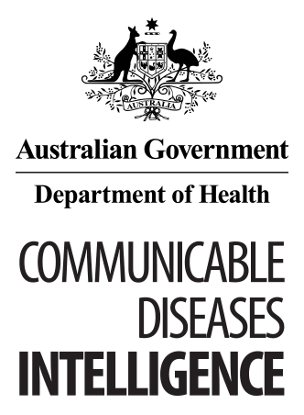
© Commonwealth of Australia 2018 ISSN: 2209-6051 (Online)
This work is copyright. You may download, display, print and reproduce the whole or part of this work in unaltered form for your own personal use or, if you are part of an organisation, for internal use within your organisation, but only if you or your organisation do not use the reproduction for any commercial purpose and retain this copyright notice and all disclaimer notices as part of that reproduction. Apart from rights to use as permitted by the Copyright Act 1968 or allowed by this copyright notice, all other rights are reserved and you are not allowed to reproduce the whole or any part of this work in any way (electronic or otherwise) without first being given the specific written permission from the Commonwealth to do so. Requests and inquiries concerning reproduction and rights are to be sent to the Online, Services and External Relations Branch, Department of Health, GPO Box 9848, Canberra ACT 2601, or by email to copyright@health.gov.au
Communicable Diseases Intelligence aims to disseminate information on the epidemiology and control of communicable diseases in Australia. Communicable Diseases Intelligence invites contributions dealing with any aspect of communicable disease epidemiology, surveillance or prevention and control in Australia. Submissions can be in the form of original articles, short reports, surveillance summaries, reviews or correspondence. Instructions for authors can be found in Commun Dis Intell 2016;40(1):E189–E193.
Communicable Diseases Intelligence contributes to the work of the Communicable Diseases Network Australia.
http://www.health.gov.au/cdna

This journal is indexed by Index Medicus and Medline.
Disclaimer: Opinions expressed in Communicable Diseases Intelligence are those of the authors and not necessarily those of the Australian Government Department of Health or the Communicable Diseases Network Australia. Data may be subject to revision.

Editor: Cindy Toms
Deputy Editor: Phil Wright
Editorial and Production Staff: Leroy Trapani, Kasra Yousefi
Editorial Advisory Board: Peter McIntyre (Chair), David Durrheim, Mark Ferson, John Kaldor, Martyn Kirk
Website: http://www.health.gov.au/cdi
Communicable Diseases Intelligence is produced by Health Protection Policy Branch, Office of Health Protection, Australian Government, Department of Health, GPO Box 9848, (MDP 6) CANBERRA ACT 2601;
Email: cdi.editor@health.gov.au

