Surveillance of adverse events following immunisation in Australia annual report, 2016
Aditi Dey, Han Wang,Helen Quinn, Jane Cook, Kristine Macartney

Abstract
This report summarises Australian passive surveillance data for adverse events following immunisation (AEFI) for 2016 reported to the Therapeutic Goods Administration and describes reporting trends over the 17-year period 1 January 2000 to 31 December 2016. There were 3,407 AEFI records for vaccines administered in 2016; an annual AEFI reporting rate of 14.1 per 100,000 population. There was a 14% increase in the overall AEFI reporting rate in 2016 compared with 2015. This increase in reported adverse events in 2016, compared to the previous year, was mainly attributable to introduction of the booster dose of the diphtheria, tetanus, and acellular pertussis-containing vaccine (DTPa) at 18 months of age in March 2016 and the zoster vaccine for those aged 70–79 years in November 2016. AEFI reporting rates for most other individual vaccines in 2016 were similar to 2015. The most commonly reported reactions were injection site reaction (29%), pyrexia (19%), rash (17%), vomiting (8%) and headache (7%). The majority of AEFI reports (90%) were described as non-serious events and a 24% decline was observed in events classified as ‘serious’ in this reporting period compared to the previous reporting period. There were 2 deaths reported but no clear causal relationship with vaccination found.
Keywords: AEFI, adverse events, vaccines, surveillance, immunisation, vaccine

Introduction
This report summarises national passive surveillance data for adverse events following immunisation (AEFI) reported to the Therapeutic Goods Administration (TGA) by 28th February 2017. The report focuses on AEFI reported for vaccines administered during 2016 and trends in AEFI reporting over the 17-year period 1 January 2000 – 31 December 2016.
An adverse event following immunisation is defined as any untoward medical occurrence which follows immunisation and which does not necessarily have a causal relationship with the usage of the vaccine. ¹ The adverse event may be any unfavourable or unintended sign, abnormal laboratory finding, symptom or disease. ¹
Thus, AEFI may be caused by a vaccine(s) or may be coincidental. Adverse events may also include conditions that occur following the incorrect handling and/or administration of a vaccine(s). The post-marketing surveillance of AEFI is particularly important to detect signals of rare, late onset or unexpected events, which are difficult to detect in pre-registration vaccine trials.
Reports summarising national AEFI surveillance data have been published regularly since 2003. ²⁻¹⁵ Trends in reported adverse events following immunisation are heavily influenced by changes to vaccine funding and availability provided through the National Immunisation Program (NIP). These changes impact on the interpretation of trend data and have been described in detail in reports published since 2003. ²⁻¹⁵ Table 1 shows the chronological listing of the changes.
Table 1: Changes in immunisation policy and the National Immunisation Program (2005–2016) ^{2, 4,5,7,10,12,14,15,37}
Year | Intervention
2016 | From November 2016 – Zoster vaccine (Zostavax®) provided free for people aged 70 years under the National Immunisation Program with a 5 year catch-up program for people aged 71 – 79 years.  From March 2016 – Free booster dose of the diphtheria, tetanus, and acellular pertussis-containing vaccine (DTPa) at 18 months of age.
2015 | From March 2015, seasonal influenza vaccine funded for Aboriginal and Torres Strait Islander children aged 6 months to less than 5 years.  From March to June 2015, the dTpa vaccine for women during the third trimester of pregnancy was funded by New South Wales, South Australia, Western Australia, the Australian Capital Territory, Victoria and Tasmania. The Northern Territory had funded it since September 2013 and Queensland since July 2014.  In March 2015, a booster dose of DTPa recommended at 18 months of age (funded in March 2016).  In April 2015, new immunisation requirements for family assistance payments were announced by the federal government (the ‘No Jab, No Pay’ policy), to come into effect on 1 January 2016. Only parents of children (aged less than 20 years) who are ‘fully immunised’ or on a recognised catch-up schedule remain eligible to receive the Child Care Benefit, Child Care Rebate, and/or the Family Tax Benefit Part A end-of-year supplement.
2014 | 4vHPV catch-up program for males aged 14–15 years ceased in December 2014.  In July 2014, dTpa was funded by Queensland for women during the third trimester of pregnancy.
2013 | From 1 February 2013, 4vHPV was extended to males aged 12–13 years, delivered through a school-based program, with a catch-up program for males aged 14–15 years in 2013 and 2014.  From July 2013, the 2nd dose of MMR vaccine, previously given at 4 years, was brought forward to 18 months of age and delivered as a combination MMRV vaccine.  From July 2013, combined Haemophilus influenzae type b (Hib) and meningococcal serogroup C (MenC) vaccine, Menitorix®, was funded for infants aged 12 months. This combination vaccine replaced the single dose of monovalent meningococcal C conjugate vaccine (MenCCV) and booster dose of monovalent Hib vaccine previously scheduled at 12 months of age.  At the end of December 2013, the secondary school Year 7 hepatitis B vaccine catch-up program ceased, as all younger age cohorts were eligible for infant immunisation under the NIP (commenced 2000).  In September 2013, dTpa funded by NT for women during the third trimester of pregnancy and for parents of infants aged <7 months under cocoon strategy
2012 | From 1 October 2012, a fourth dose of Prevenar 13®, (13vPCV, a 13-valent pneumococcal conjugate vaccine) was listed on the National Immunisation Program (NIP) for Indigenous children, aged 12-18 months, residing in Queensland, South Australia, Western Australia and the Northern Territory. This replaced the booster dose of Pneumovax23®, (23vPPV, a 23-valent pneumococcal polysaccharide vaccine) administered between 18 and 24 months of age for Indigenous children from these jurisdictions.
2011 | From 1 July 2011, Prevenar 13® replaced Prevenar® on the NIP for children at 2, 4 and 6 months of age in all states and territories except the Northern Territory which adopted 13vPCV from 1 October 2011.  1 October 2011 to 30 September 2012 – all children aged between 12 - 35 months who had completed a primary pneumococcal vaccination course with 7vPCV were eligible to receive a free supplementary dose of Prevenar 13®  On 25 March 2011, TGA issued a recall of Batch N3336 of the 23 valent pneumococcal polysaccharide vaccine 23vPPV, Pneumovax® 23. April 2011 - health professionals were advised not to administer a second or subsequent dose of Pneumovax 23 vaccine. December 2011 - Revised recommendations regarding which patients should be re-vaccinated under the NIP were provided.
2010 | Annual vaccination with seasonal trivalent influenza vaccine (TIV, containing 3 influenza strains: A/H1N1, A/H3N2 and B) was funded under the NIP for people aged ≥6 months with medical risk factors (previously subsidised through the Pharmaceutical Benefits Scheme) and all Indigenous people aged ≥15 years (previously all Indigenous adults ≥50 years and 15–49 years with medical risk factors).  On 23 April 2010, the use of the 2010 seasonal TIV in children <5 years of age was suspended by Australia’s Chief Medical Officer due to an increased number of reports of fever and febrile convulsions post vaccination. A subsequent investigation identified that Fluvax® and Fluvax junior® (CSL Biotherapies), but neither of the other 2 available brands registered for use in young children, were associated with an unacceptably high risk of febrile convulsions. The recommendation to resume the use of seasonal influenza vaccine in children aged 6 months to 5 years, using brands other than Fluvax® and Fluvax junior®, was made in August 2010.
2009 | By late 2009, all states and territories were using the single hexavalent DTPa-IPV-Hib-HepB (Infanrix hexa®) vaccine for all children at 2, 4 and 6 months of age, due to an international shortage of Haemophilus influenzae type b (Hib) (PedvaxHib® [monovalent] and Comvax® [Hib-HepB]) vaccines.  Pandemic H1N1 2009 influenza vaccine (Panvax®) was rolled out across Australia from 30 September 2009 for people aged ≥10 years. From December 2009, the pandemic vaccine was made available to children aged 6 months to 10 years.
2008 | Western Australia commenced a seasonal influenza vaccination program for all children aged 6 months to <5 years (born after 1 April 2003).  In March 2008, Queensland, South Australia and Victoria changed from using 2 combination vaccines (quadrivalent DTPa-IPV and Hib-HepB) to the single hexavalent DTPa-IPV-HepB-Hib vaccine.
2007 | From April 2007, funded immunisation against human papillomavirus for all Australian girls aged 12–13 years delivered through a school-based program from April 2007, with a temporary catch-up program through schools or primary care providers for females aged 13–26 years until December 2009.  From July 2007, universal funded immunisation against rotavirus at 2 and 4 months of age (Rotarix®) or at 2, 4 and 6 months of age (Rotateq®).
2005 | From January 2005, universal funded infant 7-valent pneumococcal conjugate vaccine (7vPCV) program replaced the previous targeted childhood program, with a catch-up program for children aged <2 years.  Universal 23-valent pneumococcal polysaccharide vaccine (23vPPV) for adults aged ≥65 years replaced previous subsidy through the Pharmaceutical Benefits Scheme.  From November 2005, universal funded immunisation against varicella at 18 months of age with a school-based catch-up program for children at 10–13 years of age not previously vaccinated and without a history of varicella infection (no funded catch-up for children 2–10 years of age).  IPV was funded to replace OPV, in combination vaccines.
Recent changes that impact on AEFI surveillance data presented in this 2016 report are:
November 2016 – Zoster vaccine (Zostavax®) provided free for people aged 70 years under the NIP with a 5 year catch-up program for people aged 71–79 years.
March 2016 – NIP-funded booster dose of the diphtheria, tetanus, and acellular pertussis-containing vaccine (DTPa) at 18 months of age. This was earlier recommended from March 2015.
April 2015 – New immunisation requirements for family assistance payments were announced by the federal government. With the ‘No Jab, No pay’ policy coming into effect as of 1 January 2016, only parents of children (aged less than 20 years) who are ‘fully immunised’ or on a recognised catch-up schedule will continue to receive the Child Care Benefit, Child Care Rebate, and/or the Family Tax Benefit Part A end-of-year supplement. Children with medical contraindications or natural immunity for certain diseases continue to be exempt from the requirements; however, conscientious objection was no longer a valid exemption from immunisation requirements.
From March to June 2015, the dTpa vaccine for women during the third trimester of pregnancy was funded by New South Wales, South Australia, Western Australia, the Australian Capital Territory, Victoria and Tasmania. The Northern Territory had funded it since September 2013 and Queensland since July 2014.
In March 2015, annual seasonal influenza vaccine was funded for Aboriginal and Torres Strait Islander children aged 6 months to less than 5 years.
To assist readers, at the end of this report there is a glossary of the abbreviations of the vaccines referred to in this report.

Methods
AEFI are notified to the TGA by state and territory health departments, health professionals, vaccine companies and members of the public.^{16,17} All reports are assessed using internationally consistent criteria¹⁸ and entered into the Australian Adverse Drug Reactions System (ADRS) database. Reports are used in data mining and signal detection activities conducted by the TGA. Where there is insufficient information in a report to determine causality for a serious adverse event the TGA will contact the reporter on up to 3 occasions to elicit further information.

AEFI data
De-identified information on all AEFI reported to the TGA from 1 January 2000 to 31 December 2016 and stored in the ADRS database, were released to the National Centre for Immunisation Research and Surveillance (NCIRS) in March 2017. Readers are referred to previous AEFI surveillance reports for description of the surveillance system.^{3,6}
Records contained in the ADRS database were eligible for inclusion in the analysis if a vaccine was recorded as ‘suspected’ of involvement in the reported adverse event and either:
- the vaccination occurred between 1 January 2000 and 31 December 2016; or
- for records where the vaccination date was not recorded, the date of onset of symptoms or signs occurred between 1 January 2000 and 31 December 2016.

Study definitions of AEFI outcomes and reactions
AEFI were defined as ‘serious’ or ‘non-serious’ based on information in the report sent to the TGA and criteria similar to those used by the World Health Organization and the US Vaccine Adverse Events Reporting System.^{18,19} In this report, an AEFI is defined as ‘serious’ if it meets one or more of the following criteria: (1) results in death; (2) is life-threatening; (3) requires inpatient hospitalisation or prolongation of existing hospitalisation; (4) results in persistent or significant disability/incapacity; (5) is a congenital anomaly/birth defect or; (6) is a medically important event or reaction.
Typically, each record lists several reaction terms that are symptoms, signs and/or diagnoses that have been coded by TGA staff from the reporter’s description into standardised terms using the Medical Dictionary for Regulatory Activities (MedDRA®).^{20, 21}
In reports published previously, in order to analyse the data, MedDRA® coding terms were grouped to create a set of reaction categories that were broadly analogous to the reactions listed in previous Australian Immunisation Handbooks.^{16,17} However, the methodological framework of reporting of adverse events was revised in 2014 and an amended format for AEFI analyses using MedDRA® preferred terms (PTs) was adopted.²² For this report, MedDRA® PTs are used for analysis. Grouping of reactions using PTs is more comparable with data from other countries and internationally accepted.²³⁻²⁵ In conjunction with the currently used national vaccine-specific reporting form, ²⁶ the use of PTs allow better reflection of post-marketing surveillance data on vaccines in Australia.

Data analysis
All data analyses were performed using SAS software version 9.4.²⁷ Average annual population-based reporting rates were calculated for each state and territory and by age group using 2016 population estimates obtained from the Australian Bureau of Statistics.²⁸ All rates are presented as average annual rates per 100,000 population. Reporting rates per 100,000 administered doses were estimated where information was available on the number of doses administered. This was done for vaccines funded through the NIP for children aged <7 years. The number of administered doses of each of the vaccines given to this age group was obtained from the Australian Immunisation Register (AIR), a national population-based register.²⁹ From 30 September 2016, the Australian Childhood Immunisation Register (ACIR) became the Australian Immunisation Register (AIR), a national register that records vaccinations given to people of all ages in Australia.³⁰ In the future, as reporting in older age groups (>7 years) becomes more complete, denominator data on vaccine doses administered in older age groups will be analysed for the purposes of AEFI reporting.

Notes on interpretation
Caution is required when interpreting the data presented in this report. Due to reporting delays and late onset of some AEFI, the data are considered preliminary, particularly for the fourth quarter of 2016. Data published in previous reports may differ from that presented in this report for the same period because this report has been updated to include delayed notifications to the TGA that were not included in prior publications. Data can also differ because reports may be updated and recoded when follow up information is received or when vaccine-specific analyses are conducted.
The information collated in the ADRS database is intended primarily for signal detection and hypothesis generation. While reporting rates can be estimated using appropriate denominators, they cannot be interpreted as incidence rates due to under-reporting and biased reporting of suspected events, and the variable quality and completeness of information provided in individual notifications.^{3-14, 31}
It is important to note that this report is based on vaccine information and MedDRA® preferred terms collated in the ADRS database and not on comprehensive clinical notes or case reviews. The reported symptoms, signs and diagnoses in each AEFI record in the ADRS database are temporally associated with vaccination but are not necessarily causally associated with a vaccine or vaccines.

Comparison with online Database of Adverse Events Notifications (DAEN)
In August 2012, the TGA made available to the public on its website a searchable database, the Database of Adverse Event Notifications (DAEN) that contains reports of all adverse event reports for medicines and vaccines. ³² The data in this report have not been downloaded from DAEN. This report uses data sent to NCIRS by the TGA and includes more detailed information than provided by the DAEN. The numbers published in this report may be different to the numbers in the DAEN database, due to different dates of data extraction and amendment to reports where further information has become available. In addition, this report provides several features that are not available from the DAEN database, including long-term trends and population and dose-based reporting rates, described in the context of changes in vaccine policy and utilisation, and reporting practices.

Results
The ADRS database included a total of 3,407 records where the date of vaccination (or onset of adverse event, if vaccination date was not reported) was between 1 January and 31 December 2016. Of these, 55% were females (n=1,869), 44% (n=1,495) males and 1% (n=43) missing data. Also, 2% (n=73) were reported in Aboriginal and Torres Strait Islander people.
In 2016, approximately 80% of AEFI (n=2,737) were reported to the TGA via states and territories, while the rest were reported directly to the TGA by healthcare professionals (11% n=361), members of the public (5% n=166), vaccine companies (3% n=98) and hospitals (1% n=45).

Reporting trends
The overall reporting rate for 2016 was per 14.1 per 100,000 population compared with 12.3 per 100,000 in 2015. The highest peak was observed in 2010 (17.4 per 100,000) predominantly due to reports in children following vaccination with the pandemic and 2010 seasonal trivalent influenza vaccines. ¹²
The vast majority of reported events in 2016 (from all reporter types) were of a non-serious nature similar to the previous years (Figure 1) ^{10,11} Figures 2a, 2b and 2c demonstrate marked variations in reporting levels in association with previous changes to the NIP from 2000 onwards. The increase in reports in 2016 was predominantly associated with the booster dose of DTPa at 18 months of age (Figures 2a and 2b) and also an increase in reports of adverse events following immunisation with zoster vaccine in the elderly (Figure 2c).

Figure 1: Adverse events following immunisation, ADRS database, 2000 to 2016, by quarter of vaccination, by date of vaccination
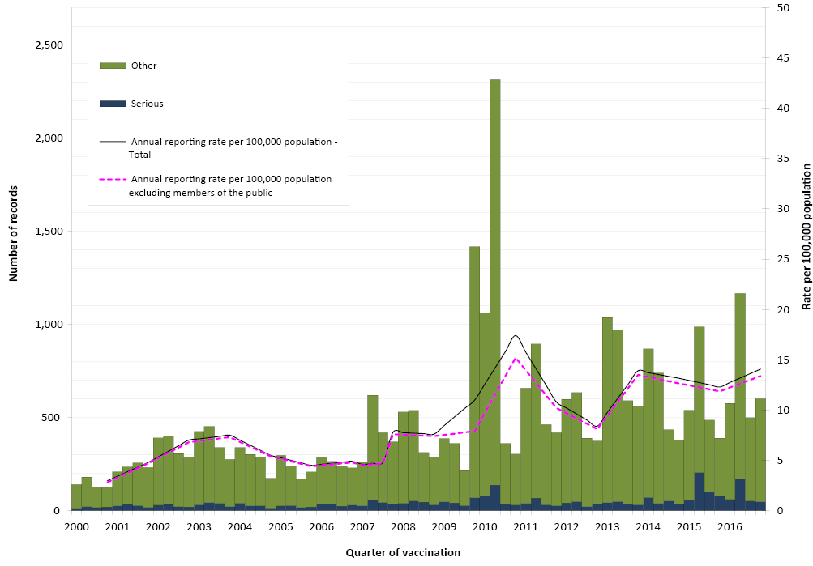
Note: For reports where the date of vaccination was not recorded, the date of onset or date event was reported to TGA was used as a proxy for vaccination date.
A seasonal pattern of AEFI reporting was apparent in 2016 as in previous years, with the highest number of AEFI notifications for vaccinations administered in the first half of the year (Figure 1). This corresponds to the months when influenza vaccine is given and older Australians receive 23vPPV (March to June). However, more AEFI reports following influenza vaccine were received in each of the last 5 years than years prior to 2009 (pre-pandemic era) (Figure 2c).

Figure 2a: Adverse events following immunisation for children aged <1 year, ADRS database, 2000 to 2016, by quarter of vaccination, by date of vaccination 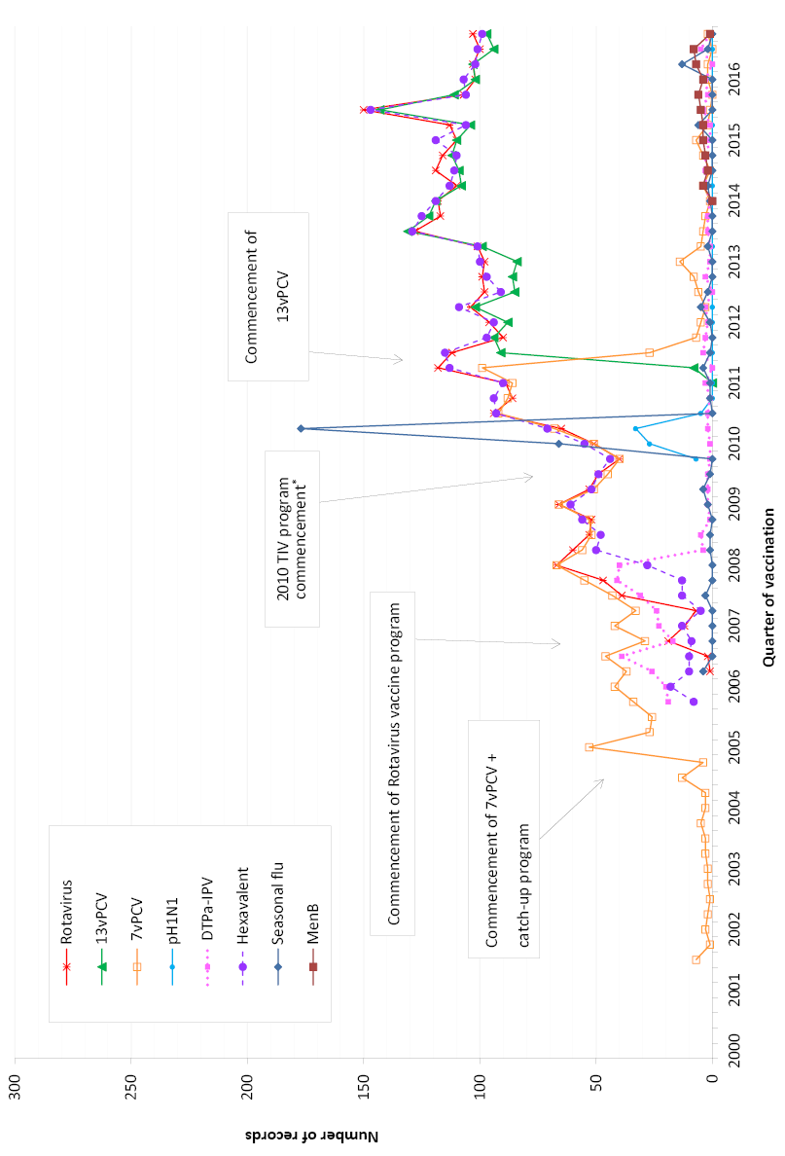
* safety signal for fever and febrile convulsion found to be due to Seqirus (formerly bioCSL) Fluvax 2010 TIV in children
DTPa-IPV and DTPa-IPV-HepB-Hib (hexavalent) vaccines were introduced into the NIP schedule in November 2005; rotavirus (RotaTeq ® and Rotarix ® ) vaccines on 1 July 2007; pH1N1 influenza vaccine for children 6 months to 10 years on December 2009; seasonal trivalent influenza vaccine in 2010 which was an extension of existing adult and Indigenous programs to at risk populations; and the 13-valent pneumococcal conjugate vaccine (13vPCV) on 1 July 2011. Also, MenB vaccine is recommended for use in those with increased risk of invasive meningococcal disease and is not currently funded under the NIP.
Note: For reports where the date of vaccination was not recorded, the date of onset or date event was reported to TGA was used as a proxy for vaccination date.
Figure 2b: Adverse events following immunisation for children aged 1 to <7 years in frequently reported vaccines, ADRS database, 2000 to 2016, by quarter of vaccination, by date of vaccination
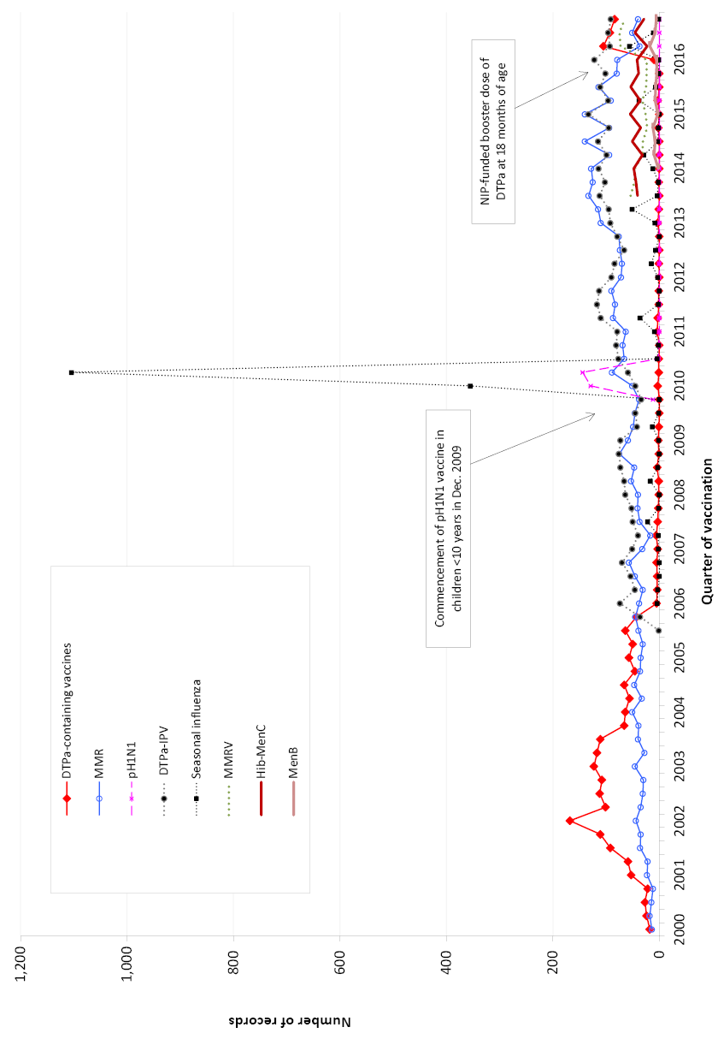
DTPa-IPV was introduced into the NIP schedule in November 2005 replacing DTPa and OPV; seasonal trivalent influenza vaccine in 2010 which was an extension of existing adult and Indigenous programs to at risk populations; MMRV and Hib–MenC vaccines on July 2013, and HPV program extended to boys in February 2013. Also, MenB vaccine is recommended for use in those with increased risk of invasive meningococcal disease and is not currently funded under the NIP. In April 2016 – NIP-funded booster dose of DTPa at 18 months of age.
Note: For reports where the date of vaccination was not recorded, the date of onset or date event was reported to TGA was used as a proxy for vaccination date.
Figure 2c. Adverse events following immunisation for people aged ≥7 years in frequently reported vaccines, ADRS database, 2000–2016, by quarter of vaccination.
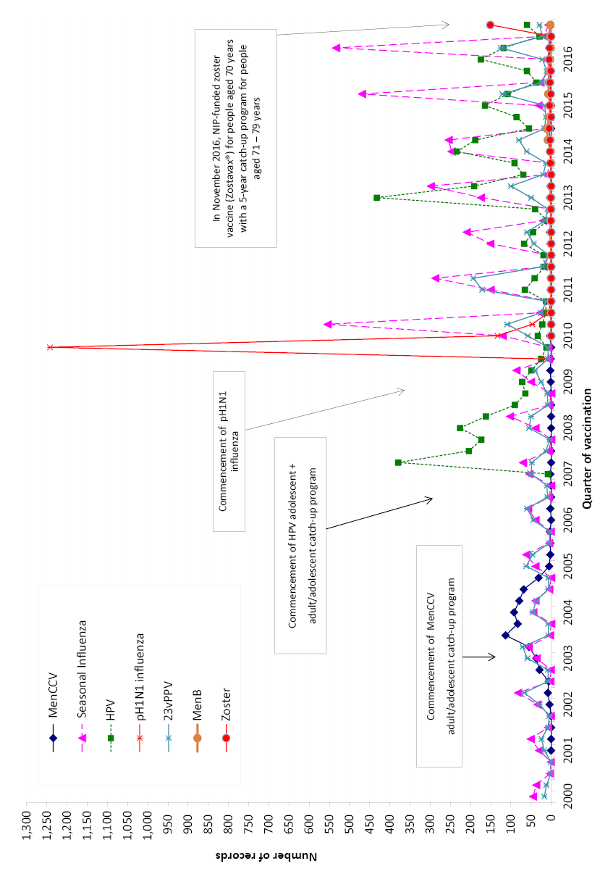
MenCCV was introduced into the NIP schedule on 1 January 2003; pH1N1 influenza vaccine for children 6 months to 10 years on December 2009; pH1N1 vaccination for those ≥10 years commenced on 30 Sep 2009; seasonal trivalent influenza vaccine in 2010 which was an extension of existing adult and Indigenous programs to at risk populations; and HPV program extended to boys in February 2013. Also, MenB vaccine is recommended for use in those with increased risk of invasive meningococcal disease and is not currently funded under the NIP.
In November 2016, zoster vaccine (Zostavax®) was NIP-funded for people aged 70 years with a 5-year catch-up program for people aged 71 – 79 years.
Note: For reports where the date of vaccination was not recorded, the date of onset or date event was reported to TGA was used as a proxy for vaccination date.

Age distribution
The highest population-based AEFI reporting rate per 100,000 population occurred in children aged 1 to <2 years, the age group that received the booster dose of DTPa at 18 months of age (Figure 3). Compared with 2015, AEFI reporting rates in children decreased in the <1 year age group from 193.8 to 167.8. A decline was also observed in the 2 to <7 years and 7 to <20 year age groups, however, there were increases observed in children aged 1 to <2 years and adults aged 65 years and older (Figure 3).
Figure 3: Reporting rates of adverse events following immunisation per 100,000 population, ADRS database, 2000 to 2016, by age group and year of vaccination, by date of vaccination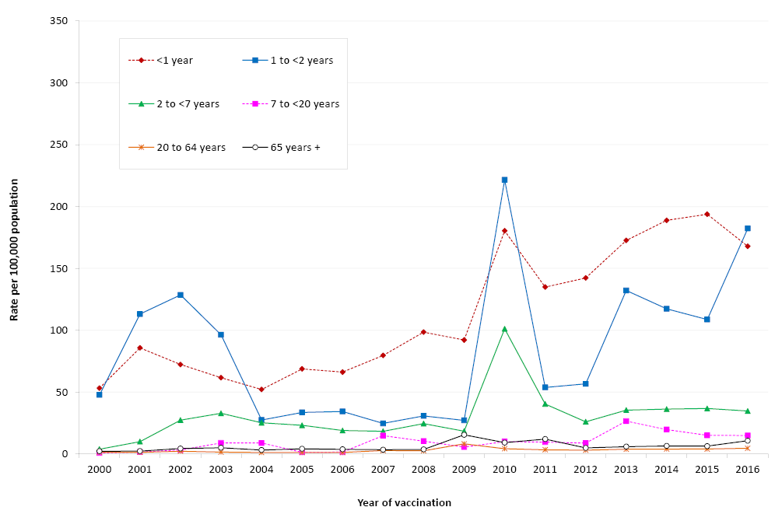
Note: For reports where the date of vaccination was not recorded, the date of onset or date event was reported to TGA was used as a proxy for vaccination date.
There were no significant differences in reporting rates per 100,000 doses for most individual vaccines in 2016 compared to 2015, and noting new additions to the NIP schedule namely DTPa & zoster (Table 2).
Table 2: Vaccine types listed as ‘suspected’ in records of adverse events following immunisation by age groups (<7, 7–17, 18–64 and ≥65 years), ADRS database, 2016
Vaccines* | AEFI records† (n) | Vaccine Doses 2016 ‡ | Reporting rate  per 100,000 doses§ (95% CI)
 |  |  | 2016 | 2015
<7 years |  |  | Rate (95% Confidence Interval)
DTPa-containing vaccines | 1,165 | 1,427,824 | 81.6 (77.0–86.4) | 80.7 (75.7–86.0)
Hexavalent  (DTPa-IPV-HepB-Hib) | 455 | 884,158 | 51.5 (46.8–56.4) | 58.6 (53.6–63.9)
DTPa-IPV | 411 | 310,854 | 132.2 (119.7–145.6) | 142.5 (129.5–156.4)
DTPa | 296 | 232,812 | 127.1 (113.1–142.5) | –
Pneumococcal conjugate -13PCV | 424 | 896,728 | 47.3 (42.9–52.0) | 54.8 (50.0–59.9)
Rotavirus vaccine | 414 | 736,605 | 56.2 (50.9–61.9) | 65.2 (59.4–71.4)
Measles-mumps-rubella-varicella | 243 | 304,329 | 79.8 (70.1–90.5) | 77.0 (70.0–84.5)
Measles-mumps-rubella | 218 | 343,792 | 63.4 (55.3–72.4) | 64.7 (56.0–74.3)
Hib-MenC | 152 | 307,332 | 49.5 (41.9–58.0) | 33.3 (27.1–40.5)
Seasonal influenza | 84 | 77,042 | 109.0 (87.0–135.0) | 64.5 (48.0–84.8)
Meningococcal B | 57 | 32,396 | 175.9 (133.3–228.0) | 210.6 (150.4–286.8)
Varicella | 14 | 11,573 | 121.0 (66.1–203.0) | 76.2 (30.6–157.0)
Hepatitis B | 11 | 45,229 | 24.3 (12.1–43.5) | –
Meningococcal C conjugate | 8 | 8,336 | 96.0 (41.4–189.1) | 140.1 (56.3–288.7)
Haemophilus influenzae type b | 5 | 9,478 | 52.8 (17.1–123.1) | 62.1 (20.2–144.9)
7–17 years
HPV | 373 | n/a | – | –
dTpa | 212 | n/a | – | –
Varicella | 116 | n/a | – | –
Seasonal influenza | 30 | n/a | – | –
Hepatitis B | 23 | n/a | – | –
Measles-mumps-rubella | 22 | n/a | – | –
dTpa_ipv | 17 | n/a | – | –
23vPPV | 17 | n/a | – | –
Measles-mumps-rubella-varicella | 16 | n/a | – | –
Meningococcal C conjugate | 8 | n/a | – | –
Meningococcal B | 4 | n/a | – | –
18–64 years
Seasonal influenza | 412 | n/a | – | –
dTpa | 106 | n/a | – | –
23vPPV | 59 | n/a | – | –
Hepatitis B | 33 | n/a | – | –
MMR | 31 | n/a | – | –
Varicella | 13 | n/a | – | –
Q fever | 8 | n/a | – | –
dTpa_ipv | 4 | n/a | – | –
Meningococcal B | 4 | n/a | – | –
≥65 years
Zoster | 154 | n/a | – | –
23vPPV | 132 | n/a | – | –
Seasonal influenza | 129 | n/a | – | –
dTpa | 14 | n/a | – | –
* Records where at least one of the vaccines shown in the table was suspected of involvement in the reported adverse event.
† Number of AEFI records in which the vaccine was coded as ‘suspected’ of involvement in the reported adverse event and the vaccination was administered between 1 January and 31 December 2016. More than one vaccine may be coded as ‘suspected’ if several were administered at the same time.
‡ Number of vaccine doses recorded on the AIR/ACIR and administered between 1 January and 31 December 2016.
§ The estimated reporting rate per 100,000 vaccine doses recorded.
^{N/A} Not applicable
For children <7 years of age, rates for varicella, Hib and MenC should be interpreted with caution since these monovalent vaccines were replaced by combination vaccines in July 2013 and hence very few doses were recorded in 2016.

Geographical distribution
Population-based reporting patterns varied between states and territories during 2016 (Table 3). Reporting rates were not significantly different (with overlapping confidence intervals) across most jurisdictions in 2016 compared with 2015. ³³
Table 3: Adverse events following immunisation (AEFI) records, ADRS database, January to December 2016, by jurisdiction
State or territory | AEFI records  n | AEFI records  (%) | Annual reporting rate per 100,000 population*
 |  |  | ‘Serious’† | Aged <7 years | Overall Rate | (95% Confidence Interval)
Australian Capital Territory | 87 | (2.6) | 2.7 | 61.5 | 21.6 | (17.3 – 26.6)
New South Wales | 632 | (18.6) | 1.0 | 32.0 | 8.2 | (7.5 – 8.8)
Northern Territory | 57 | (1.7) | 2.4 | 100.5 | 23.2 | (17.6 – 30.1)
Queensland | 647 | (19.0) | 1.3 | 67.2 | 13.3 | (12.3 – 14.4)
South Australia | 279 | (8.2) | 1.1 | 83.6 | 16.3 | (14.4 – 18.3)
Tasmania | 40 | (1.2) | 0.8 | 39.7 | 7.7 | (5.5 – 10.5)
Victoria | 1,303 | (38.2) | 1.8 | 129.1 | 21.1 | (20.0 – 22.3)
Western Australia | 362 | (10.6) | 1.8 | 87.3 | 14.1 | (12.7 – 15.7)
Total | 3,407 |  | 1.4 | 74.7 | 14.1 | (13.6 – 14.6)
* Average annual rates per 100,000 population calculated using mid-2016 population estimates (Australian Bureau of Statistics).
† AEFI records defined as ‘serious’ (i.e. recovery with sequelae, hospitalisation, life-threatening or death).

Vaccines
There were 3,407 AEFI records received in 2016 (Table 4). The percentage of records where only one vaccine was reported as being the suspected vaccine differed by vaccine administered, typically varying according to whether multiple vaccines were routinely co-administered for the patient’s age. There were slight variations in the numbers with outcomes defined as ‘serious’, which have remained low as in previous years.
Table 4: Vaccine types listed as ‘suspected’ in records of adverse events following immunisation (AEFI), ADRS database, 2016
Suspected vaccine type* | AEFI records |  | One suspected vaccine only† |  | ‘Serious’§ |  | Age group|| |  | Age group||
 |  |  |  |  |  |  | <7 years |  | ≥7 years
 | n | (%) | n | (%)¶ | n | (%)¶ | n | (%)¶ | n | (%)¶
Influenza | 700 | (20.5) | 599 | (85.6) | 73 | (10.4) | 84 | (12.0) | 567 | (81.0)
DTPa-IPV-HepB-Hib | 474 | (13.9) | 41 | (8.6) | 86 | (18.1) | 455 | (96.0) | 13 | (2.7)
13vPCV | 436 | (12.8) | 12 | (2.8) | 85 | (19.5) | 424 | (97.2) | 7 | (1.6)
DTPa-IPV | 433 | (12.7) | 376 | (86.8) | 32 | (7.4) | 441 | (101.8) | 8 | (1.8)
Rotavirus | 426 | (12.5) | 48 | (11.3) | 98 | (23.0) | 465 | (109.2) | 0 | –
HPV | 396 | (11.6) | 151 | (38.1) | 34 | (8.6) | 2 | (0.5) | 381 | (96.2)
dTpa | 346 | (10.2) | 136 | (39.3) | 24 | (6.9) | 3 | (0.9) | 332 | (96.0)
DTPa | 310 | (9.1) | 130 | (41.9) | 16 | (5.2) | 296 | (95.5) | 10 | (3.2)
MMR | 276 | (8.1) | 78 | (28.3) | 26 | (9.4) | 443 | (160.5) | 32 | (11.6)
MMRV | 261 | (7.7) | 54 | (20.7) | 24 | (9.2) | 243 | (93.1) | 16 | (6.1)
23vPPV | 217 | (6.4) | 142 | (62.7) | 13 | (6.0) | 12 | (3.8) | 198 | (96.2)
Zoster | 165 | (4.8) | 160 | (97.0) | 7 | (4.2) | 0 | – | 160 | (97.0)
Hib-MenC | 160 | (4.7) | 6 | (3.8) | 14 | (8.8) | 152 | (95.0) | 6 | (3.8)
Varicella | 148 | (4.3) | 41 | (27.7) | 16 | (10.8) | 14 | (9.5) | 129 | (87.2)
Hepatitis B | 71 | (2.1) | 36 | (50.7) | 5 | (7.0) | 11 | (15.5) | 58 | (81.7)
Meningococcal B | 67 | (2.0) | 55 | (82.1) | 6 | (9.0) | 57 | (85.1) | 9 | (13.4)
MenCCV | 28 | (0.8) | 5 | (17.9) | 3 | (10.7) | 8 | (28.6) | 20 | (71.4)
Hepatitis A-Typhoid | 21 | (0.6) | 10 | (47.6) | 1 | (4.8) | 0 | – | 19 | (90.5)
Hepatitis A | 20 | (0.6) | 8 | (40.0) | 1 | (5.0) | 11 | (55.0) | 9 | (45.0)
dT | 19 | (0.6) | 8 | (42.1) | 1 | (5.3) | 0 | – | 19 | (100.0)
Typhoid | 16 | (0.5) | 7 | (43.8) | 4 | (25.0) | 0 | – | 16 | (100.0)
Rabies | 16 | (0.5) | 13 | (81.3) | 2 | (12.5) | 1 | (6.3) | 15 | (93.8)
Yellow fever | 14 | (0.4) | 10 | (71.4) | 2 | (14.3) | 0 | – | 13 | (92.9)
Q fever | 10 | (0.3) | 10 | (100.0) | 1 | (10.0) | 0 | – | 9 | (90.0)
Hib | 7 | (0.2) | 2 | (28.6) | 1 | (14.3) | 5 | (71.4) | 2 | (28.6)
Hepatitis A + B | 4 | (0.1) | 2 | (50.0) | 0 | – | 0 | – | 4 | (100.0)
Cholera | 2 | (0.1) | 1 | (50.0) | 1 | (50.0) | 0 | – | 1 | (50.0)
Japanese encephalitis | 1 | (0.0) | 0 | – | 0 | – | 0 | – | 1 | (100.0)
Total** | 3407 | (100.0) | 2158 | (63.3) | 334 | (9.8) | 1648 | (48.4) | 1642 | (48.2)
* See appendix for abbreviations of vaccine names.
† AEFI records where only one vaccine was suspected of involvement in a reported adverse event.
§ ‘Serious’ is defined in the Methods section.
|| Includes only AEFI records where an age or date of birth has been reported.
¶ Percentages are calculated for the number of AEFI records where the vaccine was suspected of involvement in the AEFI
** Total number of AEFI records analysed, not the total in each column as categories are not mutually exclusive and an AEFI record may list more than one vaccine.
The most frequently reported individual vaccine was seasonal influenza vaccine with 700 records (21%) followed by hexavalent DTPa-IPV-HepB-Hib (n=474; 14%), 13vPCV (n=436; 13%), DTPa-IPV (n= 433; n=13%), rotavirus vaccine (n=426; 13%) and HPV (n=396; 12%) (Table 4).
For the newly funded DTPa vaccine in March 2016, there were 310 reports and 5% of these were coded as serious (Table 4). Of the total reports of DTPa (n=310), 90% of these were in children aged between 1 to 2 years of age in 2016.
Similarly, for the newly funded zoster vaccine in November 2016, there were 165 reports and only 4% of these were coded as serious in 2016.
For seasonal influenza vaccine in 2016, there were 3 reports of Aboriginal and Torres Strait Islander children aged 6 months to 5 years who had an adverse event following an influenza vaccine and these were reported as ‘not serious’.

Reactions
In 2016, out of the 3,407 records, the most frequently reported adverse events were injection site reactions (ISRs) (n=1,001; 29%), pyrexia (n=649; 19%), rash (n=585; 17%), vomiting (n=281; 8%), extensive swelling of vaccinated limb (n=257; 8%) and headache (n=240; 7%) (Table 5, Figure 4). Some of the other reactions of interest were hypotonic-hyporesponsive episode (n=46; 1.4%), convulsions (n=45; 1.3%), intussusception (n=16; 0.5%) and Guillain-Barré Syndrome (n=6; 0.2%) (Table 5). Anaphylaxis (n=8) was reported for 0.2 per cent of AEFI records in 2016.
Figure 4: Selected frequently reported adverse events following immunisation, ADRS database, 2000 to 2016, by quarter of vaccination, by date of vaccination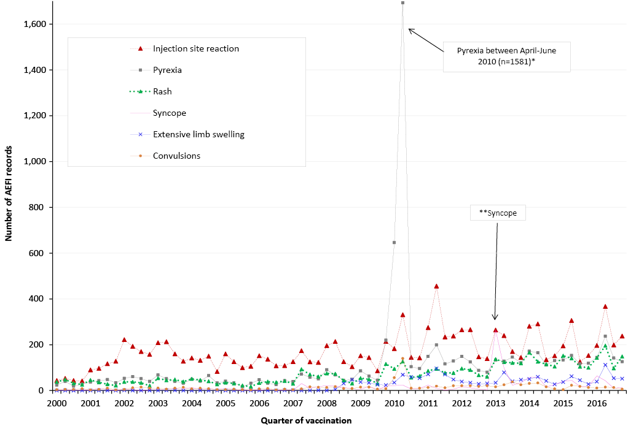
* Associated with administration of Seqirus (formerly bioCSL) Fluvax 2010 TIV and associated stimulated reporting.
** The peak in syncope coincided with the enhanced HPV surveillance program in which there was stimulated reporting of syncope for the first 6 months of 2013.
Note: For reports where the date of vaccination was not recorded, the date of onset or date event was reported to TGA was used as a proxy for vaccination date. Also, grouping for reactions are different for this report though these reactions have been mapped back to 2000 as mentioned in the Methods section.
Table 5: Selected reported adverse events and reactions of interest* classified by MedDRA Preferred Terms in records of adverse events following immunisation (AEFI), ADRS database, 2016 ¥
MedDRA Preferred Terms (Adverse events) | AEFI records | Only reaction reported† |  | ‘Serious’ |  | Age group‡  <7 years |  | Age group‡  ≥7 years
 | N | n | (%)|| | n | (%)|| | n | (%)|| | n | (%)||
Injection site reaction** | 1,001 | 517 | (51.6) | 42 | (4.2) | 512 | (51.1) | 467 | (46.7)
Pyrexia | 649 | 27 | (4.2) | 76 | (11.7) | 415 | (63.9) | 221 | (34.1)
Rash*** | 585 | 203 | (34.7) | 54 | (9.2) | 378 | (64.6) | 191 | (32.6)
Vomiting | 281 | 15 | (5.3) | 32 | (11.4) | 156 | (55.5) | 119 | (42.3)
Extensive limb swelling | 257 | 170 | (66.1) | 9 | (3.5) | 166 | (64.6) | 90 | (35.0)
Headache | 240 | 3 | (1.3) | 18 | (7.5) | 19 | (7.9) | 207 | (86.3)
Pain | 188 | 16 | (8.5) | 12 | (6.4) | 29 | (15.4) | 151 | (80.3)
Diarrhoea | 168 | 14 | (8.3) | 24 | (14.3) | 119 | (70.8) | 48 | (28.6)
Nausea | 163 | 0 | (0.0) | 16 | (9.8) | 6 | (3.7) | 152 | (93.3)
Urticaria | 158 | 64 | (40.5) | 10 | (6.3) | 79 | (50.0) | 74 | (46.8)
Irritability | 143 | 4 | (2.8) | 18 | (12.6) | 136 | (95.1) | 6 | (4.2)
Lethargy | 134 | 0 | (0.0) | 15 | (11.2) | 36 | (26.9) | 72 | (53.7)
Syncope | 131 | 82 | (62.6) | 14 | (10.7) | 12 | (9.2) | 115 | (87.8)
Dizziness | 114 | 3 | (2.6) | 11 | (9.6) | 0 | (0.0) | 111 | (97.4)
Myalgia | 104 | 1 | (1.0) | 5 | (4.8) | 1 | (1.0) | 95 | (91.3)
Injected limb mobility decreased | 76 | 0 | (0.0) | 1 | (1.3) | 11 | (14.5) | 63 | (82.9)
Chills | 73 | 1 | (1.4) | 7 | (9.6) | 12 | (16.4) | 59 | (80.8)
Erythema | 66 | 9 | (13.6) | 5 | (7.6) | 30 | (45.5) | 34 | (51.5)
Fatigue | 65 | 1 | (1.5) | 5 | (7.7) | 12 | (18.5) | 53 | (81.5)
Malaise | 64 | 1 | (1.6) | 8 | (12.5) | 7 | (10.9) | 53 | (82.8)
Paraesthesia | 64 | 3 | (4.7) | 7 | (10.9) | 0 | (0.0) | 61 | (95.3)
Pruritus | 63 | 2 | (3.2) | 2 | (3.2) | 14 | (22.2) | 46 | (73.0)
Abdominal pain | 56 | 4 | (7.1) | 10 | (17.9) | 16 | (28.6) | 39 | (69.6)
Presyncope | 47 | 27 | (57.4) | 3 | (6.4) | 11 | (23.4) | 34 | (72.3)
Cough | 47 | 2 | (4.3) | 8 | (17.0) | 15 | (31.9) | 28 | (59.6)
Hypotonic-hyporesponsive episode | 46 | 36 | (78.3) | 15 | (32.6) | 46 | (100.0) | 0 | (0.0)
Decreased appetite | 46 | 0 | (0.0) | 2 | (4.3) | 31 | (67.4) | 14 | (30.4)
Arthralgia | 46 | 3 | (6.5) | 4 | (8.7) | 2 | (4.3) | 43 | (93.5)
Convulsions**** | 45 | 29 | (64.4) | 17 | (37.8) | 40 | (88.9) | 3 | (6.7)
Dyspnoea | 42 | 2 | (4.8) | 10 | (23.8) | 5 | (11.9) | 36 | (85.7)
Pallor | 36 | 3 | (8.3) | 7 | (19.4) | 21 | (58.3) | 14 | (38.9)
Rhinorrhoea | 29 | 1 | (3.4) | 3 | (10.3) | 18 | (62.1) | 10 | (34.5)
Hyperhidrosis | 28 | 1 | (3.6) | 4 | (14.3) | 0 | (0.0) | 28 | (100.0)
Chest discomfort | 24 | 0 | (0.0) | 5 | (20.8) | 1 | (4.2) | 22 | (91.7)
Tachycardia | 23 | 0 | (0.0) | 11 | (47.8) | 8 | (34.8) | 13 | (56.5)
Oropharyngeal pain | 21 | 0 | (0.0) | 1 | (4.8) | 3 | (14.3) | 15 | (71.4)
Hypoaesthesia | 19 | 3 | (15.8) | 3 | (15.8) | 0 | (0.0) | 19 | (100.0)
Haematochezia | 18 | 6 | (33.3) | 3 | (16.7) | 17 | (94.4) | 1 | (5.6)
Intussusception | 16 | 14 | (87.5) | 15 | (93.8) | 16 | (100.0) | 0 | (0.0)
Somnolence | 14 | 0 | (0.0) | 3 | (21.4) | 9 | (64.3) | 5 | (35.7)
Throat irritation | 12 | 2 | (16.7) | 4 | (33.3) | 0 | (0.0) | 12 | (100.0)
Blister | 9 | 0 | (0.0) | 2 | (22.2) | 4 | (44.4) | 5 | (55.6)
Anaphylactic reaction | 8 | 5 | (62.5) | 4 | (50.0) | 1 | (12.5) | 3 | (37.5)
Gait disturbance | 7 | 0 | (0.0) | 3 | (42.9) | 1 | (14.3) | 5 | (71.4)
Guillain-Barre Syndrome | 6 | 4 | (66.7) | 2 | (33.3) | 0 | (0.0) | 5 | (83.3)
Tremor | 5 | 2 | (40.0) | 0 | (0.0) | 0 | (0.0) | 4 | (80.0)
Lymphadenitis | 1 | 0 | (0.0) | 0 | (0.0) | 1 | (100.0) | 0 | (0.0)
¥ A complete list of adverse reactions as classified by individual Preferred Terms is available on request.
* Selected reported adverse events reported during Jan-Dec 2016. Note: for injection site reaction, rash and convulsions, PT’s were grouped as described below.
** Injection site reaction includes the following MedDRA PTs: injection site reaction, injection site swelling, injection site pain, injection site mass, injection site erythema, injection site cellulitis, injection site rash, injection site induration, injection site abscess, injection site pruritus, injection site nodule, injected limb mobility decreased, injection site urticaria, injection site inflammation, injection site bruising, injection site infection, and injection site warmth.
*** Rash includes the following MedDRA PTs: rash, rash generalised, rash erythematous, rash pruritic, rash maculo-papular, rash macular, rash vesicular, rash papular, rash morbilliform, and rash pustular.
**** Convulsion includes the following MedDRA PTs: febrile convulsion, and convulsion, grand mal convulsion, and partial seizures.
† AEFI records where only one reaction was reported.
§ ‘Serious’ outcomes are defined in the Methods section.
‡ Includes only AEFI records where an age or date of birth has been reported
|| Percentages relate to the number of AEFI records in which the specific reaction term was listed
The number of reports for each reaction has changed over time (Figure 4). The variation in reporting of ISRs is related to changes in the immunisation schedule for vaccines that are known to have higher rates of ISR, including DTPa-containing vaccines, 23vPPV and HPV vaccine. ^{3-14, 34, 35} Increases in reports of fever were largely associated with time periods when new vaccines were added to the NIP in the reporting period, such as 7vPCV and HPV; the extension of seasonal influenza vaccine on the NIP to include persons <65 years at high risk of influenza in 2010; 13vPCV replacing 7vPCV in July 2011; and the extension of HPV to males in 2013.

Severity of outcomes
The majority of reported events in 2016 were defined as ‘non-serious’ (n=3,073; 90.2%). There is a 24% decline in ‘serious’ events in this reporting period compared to the previous reporting period (Figure 1).
Two deaths were reported from NSW as temporally associated with receipt of vaccines in 2016.
A 40 year old male died 2 weeks after receiving a dose of hepatitis A vaccine and a dose of the typhoid vaccine. These vaccines are not included in the NIP. The cause of death was acute disseminated encephalomyelitis (ADEM).
A one year old male died a day after receiving the first dose of the MMR vaccine and a dose of the combined Hib-MenC vaccine. The child presented at hospital with prolonged seizures. There was a history of seizures in the family. The cause of death was noted as status epilepticus. The post mortem findings showed the effects of status epilepticus and cardiopulmonary arrest. After a thorough investigation by the TGA the cause was determined to be coincidental to vaccination.
In addition to the above 2 deaths, 2 fetal deaths in utero were reported in this period:
- A 23 year old female at 35 weeks gestation who presented to the emergency department 5 days post administration of the dTpa vaccine. The patient presented with decreased fetal movement and subsequent fetal death in utero. Third trimester ultrasound demonstrated small for gestational age fetus with declining asymmetric growth, which indicates an underlying problem was affecting the fetus prior to the vaccination.
- A 32 year old female at 36 weeks gestation was given the dTpa vaccine at the antenatal clinic a day before she presented at hospital with lack of fetal movements. Fetal death was confirmed at hospital.
Stillbirth affects around 1 in 200 pregnancies that reach at least 20 weeks gestation in NSW. ³⁶ It is likely that these late fetal deaths were coincidental to vaccination; however, there was not sufficient information available to conduct a causality assessment.
In summary, all deaths following immunisation reported to the TGA were investigated by the TGA and based on the information received from reporters, no clear causal relationship with vaccination was found. In some cases this was because no further information was provided by the reporter to allow an assessment of causality. The TGA encourages all reporters to provide sufficient information to allow the TGA to assess any causal relationship between the administration of a vaccine and the adverse event reported.

Discussion
This report uses a similar methodology of analysis used in the previous 3 annual reports. ^{2,15,33} As per the previous report, this method allows for clearer reporting of adverse events using MedDRA® PTs, as used in the DAEN. This change in methodology needs to be taken into account when comparing with data on specific reaction terms and categories from annual reports prior to 2013.
In 2016, there appeared to be a 14% increase in the AEFI reporting rate compared with the previous year. This increase in reported adverse events in 2016, compared to the previous year, was mainly attributable to introduction of the booster dose of the DTPa at 18 months of age in April 2016 and the zoster vaccine for those aged 70- 79 years in November 2016. There is usually an increase in reporting of adverse events when a program is newly rolled out. Previous data have shown early increase in AEFI reporting occur each time a new vaccine is introduced, as immunisation providers are more likely to report milder, less serious AEFIs for vaccines they are not as familiar with. A reduction and stabilisation of reporting rates over time occurs thereafter. ^{2,4,5,7,10,12-15,33,37} During this first year of implementation of the DTPa at 18 months national program, there were 310 AEFI reports though majority (95%) of the reactions were mild reactions and not serious. Also, for those adults who had received the zoster vaccine, there were 165 AEFI reports though majority (96%) of the reactions were mild reactions and not serious.
Also in 2016, the second year of implementation of the season influenza vaccine program for all Aboriginal and Torres Strait Islander children aged 6 months to 5 years, an adverse event following seasonal influenza vaccine was reported in 3 Aboriginal and Torres Strait Islander child aged 6 months to 5 years and was reported as not serious.
These findings are similar to national vaccine safety data from AusVaxSafety, that currently monitors the safety of pertussis, zoster and influenza vaccines via participants recruited in 156 sentinel surveillance sites nationwide where there was no safety signals observed for these vaccines during this reporting period.³⁸
Overall, in Australia, injection site reaction, pyrexia, rash, vomiting and headache were the most commonly reported reactions in 2016. AEFI reporting rates for most individual vaccines in 2016 were similar to 2015.
The majority of AEFI reports (90%) were described as non-serious events. There were 2 deaths reported with causal relationship unable to be determined.

Conclusion
The reported AEFIs increased in 2016 compared with 2015 though the majority of AEFIs reported to the TGA were mild transient events. The data reported here are consistent with an overall high level of safety for vaccines included in the NIP schedule.

Acknowledgments
We thank Alexandra Hendry, NCIRS, for providing vaccine dose data from the Australian Immunisation Register.
The National Centre for Immunisation Research and Surveillance of Vaccine Preventable Diseases is supported by the Australian Government Department of Health, the New South Wales Department of Health and The Children’s Hospital at Westmead, Australia.

Author details
Aditi Dey, ^{1*} Han Wang, ¹ Helen Quinn, ¹ Jane Cook, ² Kristine Macartney ¹
- National Centre for Immunisation Research and Surveillance of Vaccine Preventable Diseases, University of Sydney and The Children’s Hospital at Westmead, Sydney, Australia
- Pharmacovigilance and Special Access Branch, Therapeutic Goods Administration, Canberra, Australia
* Corresponding author: Dr Aditi Dey - National Centre for Immunisation Research and Surveillance Locked Bag 4001 Westmead NSW 2145 Phone: (02) 9845 1416 Fax: (02) 9845 1418 Email: aditi.dey@health.nsw.gov.au

References
- Council for International Organizations of Medical Sciences (CIOMS) c/o World Health Organization. Definition and Application of Terms for Vaccine Pharmacovigilance: Report of CIOMS/WHO Working Group on Vaccine Pharmacovigilance. 2012.
- Dey A, Wang H, Quinn H, Hill R, Macartney K. Surveillance of adverse events following immunisation in Australia annual report, 2014. Communicable Diseases Intelligence 2016;40:E377–E390.
- Lawrence G, Boyd I, McIntyre P, Isaacs D. Surveillance of adverse events following immunisation: Australia 2002 to 2003. Commun Dis Intell 2004;28:324-338.
- Lawrence G, Boyd I, McIntyre P, Isaacs D. Annual report: surveillance of adverse events following immunisation in Australia, 2005. Commun Dis Intell 2006;30:319-333.
- Lawrence G, Gold MS, Hill R, Deeks S, Glasswell A, McIntyre PB. Annual report: surveillance of adverse events following immunisation in Australia, 2007. Commun Dis Intell 2008;32:371-387.
- Lawrence G, Menzies R, Burgess M, McIntyre P, Wood N, Boyd I, et al. Surveillance of adverse events following immunisation: Australia, 2000–2002. Commun Dis Intell 2003;27:307-323.
- Lawrence GL, Aratchige PE, Boyd I, McIntyre PB, Gold MS. Annual report on surveillance of adverse events following immunisation in Australia, 2006. Commun Dis Intell 2007;31:269-282.
- Lawrence GL, Boyd I, McIntyre PB, Isaacs D. Annual report: surveillance of adverse events following immunisation in Australia, 2004 Commun Dis Intell 2005;29:248-262.
- Mahajan D, Cook J, Dey A, Macartney K, Menzies R. Supplementary report: surveillance of adverse events following immunisation among children aged less than seven years in Australia, 1 January to 30 June 2012. Commun Dis Intell 2013;37:E130-134.
- Mahajan D, Cook J, Dey A, Macartney K, Menzies RI. Annual report: surveillance of adverse events following immunisation in Australia, 2011. Commun Dis Intell 2012;36:E315-332.
- Mahajan D, Cook J, McIntyre P, Macartney K, Menzies R. Supplementary report: surveillance of adverse events following immunisation among children aged less than seven years in Australia, 1 January to 30 June 2011. Commun Dis Intell 2012;36:114-119.
- Mahajan D, Cook J, McIntyre PB, Macartney K, Menzies RI. Annual report: surveillance of adverse events following immunisation in Australia, 2010. Commun Dis Intell 2011;35:263-280.
- Mahajan D, Roomiani I, Gold MS, Lawrence GL, McIntyre PB, Menzies RI. Annual report: surveillance of adverse events following immunisation in Australia, 2009. Commun Dis Intell 2010;34:259-276.
- Menzies R, Mahajan D, Gold MS, Roomiani I, McIntyre P, Lawrence G. Annual report: surveillance of adverse events following immunisation in Australia, 2008. Commun Dis Intell 2009;33:365-381.
- Mahajan D, Dey A, Cook J, Harvey B, Menzies R, Macartney K. Surveillance of adverse events following immunisation in Australia annual report, 2013. Commun Dis Intell 2015;39:E369–E386.
- National Health and Medical Research Council. The Australian Immunisation Handbook. 8th edn. Canberra: Australian Government Department of Health and Ageing; 2003.
- National Health and Medical Research Council. The Australian Immunisation Handbook. 9th edn. Canberra: Australian Government Department of Health and Ageing; 2008.
- Uppsala Monitoring Centre. WHO Collaborating Centre for International Drug Monitoring. Accessed on 9 July 2014. Available from: http://www.who-umc.org/
- Zhou W, Pool V, Iskander JK, English-Bullard R, Ball R, Wise RP, et al. Surveillance for safety after immunization: Vaccine Adverse Event Reporting System (VAERS)--United States, 1991-2001. [erratum appears in MMWR Morb Mortal Wkly Rep. 2003 Feb 14;52(06):113]. MMWR Surveill Summ 2003;52:1-24.
- Brown EG. Using MedDRA: implications for risk management. Drug Saf 2004;27:591-602.
- Brown EG, Wood L, Wood S. The medical dictionary for regulatory activities (MedDRA). Drug Saf 1999; 20:109-117.
- Mahajan D, Dey A, Hill R, Harvey B, Menzies R, McIntyre P, et al. Methodological framework for reporting of adverse events following immunisation (AEFI) In: PHAA National Immunisation Conference, 17-19 June, 2014; Melbourne, Australia.
- Leroy Z, Broder K, Menschik D, Shimabukuro T, D. M. Febrile seizures after 2010-2011 influenza vaccine in young children, United States: a vaccine safety signal from the vaccine adverse event reporting system. Vaccine 2012;30:2020-2023.
- Moro PL, Broder K, Zheteyeva Y, Revzina N, Tepper N, Kissin D, et al. Adverse events following administration to pregnant women of influenza A (H1N1) 2009 monovalent vaccine reported to the Vaccine Adverse Event Reporting System. Am J Obstet Gynecol 2011;205:e1-9.
- Zheteyeva Y, Moro PL, Yue X, K. B. Safety of meningococcal polysaccharide-protein conjugate vaccine in pregnancy: a review of the Vaccine Adverse Event Reporting System. Am J Obstet Gynecol 2013;208:e1-6.
- Australian Government Department of Health, Therapeutic Goods Administration. National Adverse Events Following Immunisation (AEFI) reporting form. Accessed on 26 March 2013. Available from: http://www.tga.gov.au/safety/problem-medicine-aefi.htm
- SAS Institute Inc. The SAS system for Windows [computer program]. Version 9.4. Cary, N.C. 2012.
- Australian Bureau of Statistics. Australian Demographic Statistics. 2015. http://www.abs.gov.au/AUSSTATS/abs@.nsf/DetailsPage/3101.0Jun%202015?OpenDocument#Time
- Australian Government Department of Human Services. Australian Immunisation Register. Accessed on 21 October 2016. Available from: https://www.humanservices.gov.au/customer/services/medicare/australian-immunisation-register
- Australian Government Department of Health. UPDATE: Expansion of Australia’s Immunisation Registers. Accessed on 21 October 2016. Available from: http://www.immunise.health.gov.au/internet/immunise/publishing.nsf/Content/67D8681A67167949CA257E2E000EE07D/$File/Factsheet-%20Immunisation-Registers-Expansion-23102015.pdf
- Varricchio F, Iskander J, DeStefano F, Ball R, Pless R, Braun M, et al. Understanding vaccine safety information from the Vaccine Adverse Event Reporting System. Pediatr Infect Dis J 2004;23:287-294.
- Australian Government Department of Health, Therapeutic Goods Administration. Database of Adverse Event Notifications. Accessed on 26 March 2013. Available from: http://www.tga.gov.au/safety/daen.htm
- Dey A, Wang H, Quinn H, Cook J, Macartney K. Surveillance of adverse events following immunisation in Australia annual report, 2015. Communicable Diseases Intelligence In press 2017.
- Simon LS. Pharmacovigilance: towards a better understanding of the benefit to risk ratio. Ann Rheum Dis 2002;61(Suppl II):ii88-89.
- Reisinger KS, Block SL, Lazcano-Ponce E, Samakoses R, Esser MT, Erick J, et al. Safety and persistent immunogenicity of a quadrivalent human papillomavirus types 6, 11, 16, 18 L1 virus-like particle vaccine in preadolescents and adolescents: a randomized controlled trial. Pediatr Infect Dis J 2007;26:201-209.
- NSW Health. Mothers and babies reports. Accessed on 20 July 2018. Available from: http://www.health.nsw.gov.au/hsnsw/Pages/mothers-and-babies-reports.aspx
- Mahajan D, Dey A, Cook J, Harvey B, Menzies R, Macartney K. Surveillance of adverse events following immunisation in Australia annual report, 2012. Commun Dis Intell 2014;38:E232– E246.
- National Centre for Immunisation Research and Surveillance. AusVaxSafety. Accessed on 20 September 2017. Available from: http://www.ncirs.edu.au/vaccine-safety/ausvaxsafety/
Abbreviations of vaccine types
BCG | Bacille Calmette-Guérin (i.e. tuberculosis)
dT | diphtheria-tetanus – adolescent and adult formulation
DTPa | diphtheria-tetanus-pertussis (acellular) – paediatric formulation
dTpa | diphtheria-tetanus-pertussis (acellular) – adolescent and adult formulation
DTPa-IPV | combined diphtheria-tetanus-pertussis (acellular) and inactivated poliovirus (quadrivalent)
DTPa-IPV-HepB-Hib | combined diphtheria-tetanus-pertussis (acellular), inactivated poliovirus, hepatitis B and Haemophilus influenzae type b vaccine (hexavalent)
HepB | hepatitis B
Hib | Haemophilus influenzae type b
Hib-HepB | combined Haemophilus influenzae type b and hepatitis B
Hib-MenC | combined Haemophilus influenzae type b and meningococcal C conjugate vaccine
HPV | human papillomavirus
MenB | meningococcal B vaccine
MenCCV | meningococcal C conjugate vaccine
MMR | measles-mumps-rubella
MMRV | measles-mumps-rubella-varicella
pH1N1 | pandemic H1N1 influenza 2009
7vPCV | 7-valent pneumococcal conjugate vaccine
13vPCV | 13-valent pneumococcal conjugate vaccine
23vPPV | 23-valent pneumococcal polysaccharide vaccine

© Commonwealth of Australia 2018 - ISSN: 2209-6051 (Online)
This work is copyright. You may download, display, print and reproduce the whole or part of this work in unaltered form for your own personal use or, if you are part of an organisation, for internal use within your organisation, but only if you or your organisation do not use the reproduction for any commercial purpose and retain this copyright notice and all disclaimer notices as part of that reproduction. Apart from rights to use as permitted by the Copyright Act 1968 or allowed by this copyright notice, all other rights are reserved and you are not allowed to reproduce the whole or any part of this work in any way (electronic or otherwise) without first being given the specific written permission from the Commonwealth to do so. Requests and inquiries concerning reproduction and rights are to be sent to the Online, Services and External Relations Branch, Department of Health, GPO Box 9848, Canberra ACT 2601, or by email to copyright@health.gov.au
Communicable Diseases Intelligence aims to disseminate information on the epidemiology and control of communicable diseases in Australia. Communicable Diseases Intelligence invites contributions dealing with any aspect of communicable disease epidemiology, surveillance or prevention and control in Australia. Submissions can be in the form of original articles, short reports, surveillance summaries, reviews or correspondence. Instructions for authors can be found in Commun Dis Intell 2016;40(1):E189–E193.
Communicable Diseases Intelligence contributes to the work of the Communicable Diseases Network Australia
http://www.health.gov.au/cdna

This journal is indexed by Index Medicus and Medline
Disclaimer: Opinions expressed in Communicable Diseases Intelligence are those of the authors and not necessarily those of the Australian Government Department of Health or the Communicable Diseases Network Australia. Data may be subject to revision.

Editor: Cindy Toms
Deputy Editor: Phil Wright
Editorial and Production Staff: Leroy Trapani, Kasra Yousefi
Editorial Advisory Board: Peter McIntyre (Chair), David Durrheim, Mark Ferson, John Kaldor, Martyn Kirk
Website: http://www.health.gov.au/cdi
Communicable Diseases Intelligence is produced by Health Protection Policy Branch, Office of Health Protection, Australian Government, Department of Health, GPO Box 9848, (MDP 6) CANBERRA ACT 2601;
Email: cdi.editor@health.gov.au

Diphtheria toxoid is available in Australia only in combination with tetanus, with or without other antigens such as pertussis, inactivated poliomyelitis, hepatitis B and Haemophilus influenzae type b. The acronym DTPa, using capital letters, signifies child formulations of diphtheria, tetanus and acellular pertussis-containing vaccines. The acronym dTpa is used for formulations that contain substantially lesser amounts of diphtheria toxoid and pertussis antigens than child (DTPa-containing) formulations; dTpa vaccines are usually used in adolescents and adults. Source: The Australian Immunisation Handbook 10Th Edition (http://www.immunise.health.gov.au/internet/immunise/publishing.nsf/Content/Handbook10-home~handbook10part4~handbook10-4-2)

