Wave of COVID-19 outbreaks in Gold Coast residential aged care facilities after easing travel restrictions into Queensland
Candice Colbran, Fiona May, Fiona Vosti, Tracy Bladen, Andre Wattiaux, Vicki Slinko

Abstract

Objective
This paper describes outbreaks of coronavirus disease 2019 (COVID-19) in Gold Coast residential aged care facilities (RACFs), in the two months following the easing of travel restrictions at Queensland’s domestic border on 13 December 2021.

Methods
This audit reviewed all RACF COVID-19 outbreaks notified to the Gold Coast Public Health Unit between 13 December 2021 and 12 February 2022. An outbreak was defined by the Communicable Diseases Network Australia guidelines current at the time.

Results
There were 60 COVID-19 outbreaks across 57 RACFs during this period. In 44 outbreaks (73.3%), a staff member was identified as the primary or co-primary case. Transmission amongst residents occurred in 48 outbreaks (80.0%). The attack rates in staff and residents were 17.0% (n = 1,060) and 11.7% (n = 645) respectively. A higher number of males were hospitalised (n = 39: 57.4%) or died (n = 28: 66.7%) than were females (n = 29: 42.6%; n = 14: 33.3% respectively). Most resident cases (n = 565: 87.6%) had received two or more doses of a COVID-19 vaccine. In resident cases who were under-vaccinated (n = 76), twenty (26.3%) required hospitalisation and nine (11.8%) died. In resident cases who received two doses of vaccine (n = 484), forty-three (8.9%) were hospitalised and 27 (5.8%) died. In resident cases who had received three doses (n = 80), four (5.0%) were hospitalised and five (6.3%) died.

Conclusions
COVID-19 caused significant morbidity and mortality in Gold Coast RACFs following the easing of border restrictions. Higher rates of hospitalisation and death occurred in males than in females, and in under-vaccinated resident cases than in those vaccinated with at least two doses of a COVID-19 vaccine.

Implications for public health
These data support the need for up-to-date COVID-19 vaccination of residents in RACFs, continued surveillance and timely and appropriate implementation of public health guidelines to manage COVID-19 outbreaks in RACFs.
Keywords: Coronavirus, SARS-CoV-2, residential aged care facilities, outbreak, restrictions

Introduction
Residents of residential aged care facilities (RACFs) have an increased vulnerability to serious complications of SARS-CoV-2 infection, including death, due to advanced age and comorbidities, in addition to the likely increased risk of infection¹ because of the congregate nature of RACFs. The coronavirus disease 2019 (COVID-19) elimination strategy pursued by Queensland until 13 December 2021 meant there were only two RACF outbreaks of COVID-19 notified to the Gold Coast Public Health Unit (GCPHU) prior to the easing of border restrictions on that date. Both were contained by the public health and RACF responses without further transmission beyond the index case.
From early 2020, the Australian Government required all overseas travellers returning to Australia to quarantine for 14 days to reduce the risk of COVID-19 entering the community: this was designated to each jurisdiction to enforce. When COVID-19 cases in New South Wales and Victoria were increasing in 2020–2021, Queensland required interstate travellers to quarantine for 14 days either in specified quarantine hotels or at home, depending on their vaccination status. These ‘border restrictions’ were lifted on 13 December 2021, when Queensland reached a COVID-19 double vaccination rate of 80%. From then, most people entering Queensland from interstate would be permitted to travel into Queensland without quarantine.²
From 13 December 2021, the GCPHU management of COVID-19 outbreaks in RACFs, including case, contact and visitor management, was contingent on Australian Health Protection Principal Committee (AHPPC) recommendations, ministerial announcements,³ the Communicable Disease Network Australia (CDNA) Guidelines for COVID-19 Outbreaks in Residential Care Facilities (CDNA Guidelines),⁴ current Queensland Chief Health Officer Directions,^{2,5–15} and Gold Coast Public Health Physician input. The changing of recommendations and guidelines was frequent and resulted in a complex process for outbreak management, the description of which is out of scope for this report. In summary for GCPHU, isolation and quarantine periods for cases and contacts ranged from seven to ten days; there were no caps on visitor numbers; visitors needed to wear a mask, undergo health screening, be vaccinated (with some exceptions), and could not visit a facility within seven to 14 days of testing positive for COVID19 (after completing isolation).^{2,4–15}
Following the easing of border restrictions, there was a surge of COVID-19 cases in Queensland;¹⁶ GCPHU identified a significant rise in RACF cases and outbreak notifications. GCPHU was required to report details of RACF outbreaks to the State Health Emergency Coordination Centre daily. This paper describes RACF COVID-19 outbreaks notified to GCPHU in the two months after the easing of border restrictions.

Methods
As part of continuous quality improvement (CQI), a review was conducted of COVID-19 outbreaks reported by facilities to the GCPHU. The CDNA Guidelines, current until 15 February 2022, defined an RACF outbreak of COVID-19 as ‘a single confirmed case of COVID-19 in a resident, staff member or attendee’,⁴ with RACF staff required to notify outbreaks to their local public health unit. Outbreaks notified to the GCPHU in the two months from 13 December 2021 to 12 February 2022 were included in the review. The RACF initially provided baseline information about the number of staff and residents at the facility (excluding gender or vaccination status), then emailed case line lists daily to allow monitoring of outbreak management. Line lists of cases (residents, staff and visitors) provided by RACF to GCPHU as part of outbreak management were audited and we undertook simple analysis of the information given.
Baseline data for vaccination and gender for all residents was not available. Vaccination data was only available for cases from information provided by the RACF. Gender data, although not available for all cases, was available for COVID-19 cases who were hospitalised and/or died. These data were provided as part of the COVID-19 response by the Gold Coast Health Emergency Operations Centre (HEOC) and RACF, respectively.
Cases were identified to the GCPHU directly by the facility and were included in the line list if they had been diagnosed with COVID-19 by either polymerase chain reaction (PCR) or rapid antigen test (RAT). Data were not cross-checked with the Queensland Notifiable Conditions System (NoCS), the repository for PCR-positive cases at the time. Demographic information was restricted to that provided by the RACF or HEOC.
Transmission within the facility was defined to have occurred when there was more than one resident case, diagnosed by either RAT or PCR.
All cases who were hospitalised and/or died with COVID-19, as reported by the facility to GCPHU while the outbreak was considered active, were included in the dataset regardless of cause of death and/or hospitalisation. Antiviral distribution to RACF only commenced from 6 February 2022,¹⁷ so no analysis was conducted to assess the impact of antivirals.
Vaccination status of cases was defined as per Box 1. Booster doses for persons aged 18 and over were approved by the Therapeutic Goods Administration on 26 October 2021.¹⁸
Box 1: Definitions of vaccination status
Under-vaccinated: a person who had received either zero or one dose of an approved COVID-19 vaccine.
Fully vaccinated: a person who had received two doses of an approved COVID-19 vaccine.
Boosted: a person who had received three doses of an approved COVID-19 vaccine.
Unknown: a person whose vaccine status was unknown.
An outbreak was declared over when there were no new cases for 14 days from the date of isolation of the most recent case.
Data were collated into a Microsoft Excel spreadsheet for analysis. Rates of hospitalisation for cases were the number of cases hospitalised from each facility as a proportion of the total number of resident cases from that facility notified to GCPHU during the outbreak. Case fatality rates were the number of COVID-19 cases who died as a proportion of the total number of cases.
As an audit, statistics were deliberately confined to rates, ranges, and/or percentages.
The audit proposal was reviewed by the Chair’s Delegate of the Gold Coast Hospital and Health Service Human Research Ethics Committee (HREC) and deemed not requiring HREC review on the basis that it was an audit: HREC reference EX/2022/QGC/85001.
This project required no funding as it was a CQI activity as part of the usual public health response.

Results
The first outbreaks (n = 2) were notified to GCPHU on 29 December 2021. By 12 February 2022, sixty outbreaks of COVID-19 in RACFs had been reported to GCPHU. Fifty-seven of the 59 facilities in Gold Coast (97%) were affected, with three facilities each notifying two outbreaks. An epidemic curve of the RACF outbreaks by date of notification to the GCPHU is shown in Figure 1.

Figure 1: Notifications of COVID-19 outbreaks in RACFs, Gold Coast, 13 December 2021 – 12 February 2022
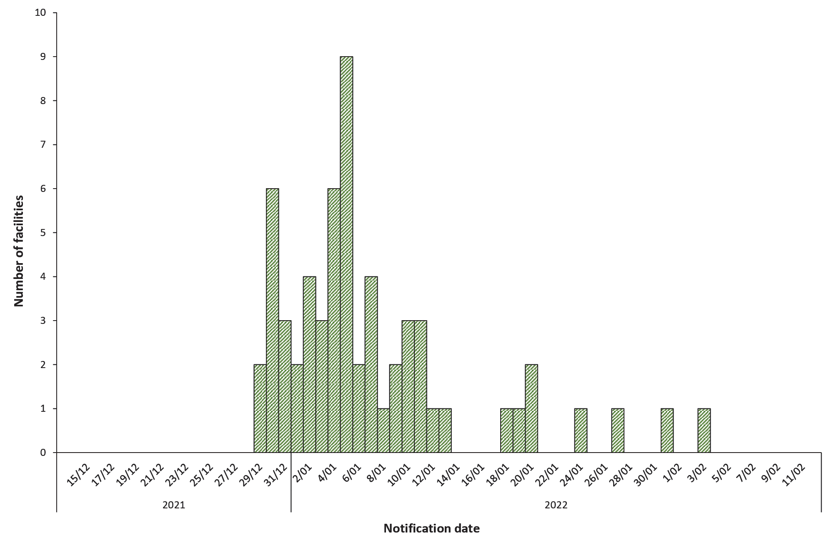
There were 5,518 residents at risk across the 60 outbreaks. During the study period, there were 644 resident cases of COVID-19. The first resident case had a specimen collection date of 25 December 2021, twelve days after the borders opened. The median age of cases was 86 years (range: 51–106 years). An epidemic curve of RACF resident cases is shown in Figure 2.
Hospitalisation rates for resident cases in all outbreaks of COVID-19 were 10.6% (n = 68; see Table 1). This included 39 males and 29 females (respectively 57.4% and 42.6% of hospitalisations) with a median age of 86 years (range: 56–96 years). The proportions of male and female cases who were hospitalised could not be calculated, as gender data were not available for non-hospitalised cases.
The case fatality rate for resident cases in all COVID-19 outbreaks was 6.5% (n = 42). Twice as many men (n = 28: 66.7%) died as did women (n = 14: 33.3%). However, due to missing gender information for most cases, it is unclear whether this was due to higher rates of COVID-19 infection in men or to increased disease severity (or other confounders) resulting in death. The median age of cases who died was 86 years (range: 71–103 years). The death rate (deaths against all residents) was 7.6 per 1,000 residents (0.76%). Not all who died were hospitalised. A summary of the outbreaks is provided in Table 1.
Table 2 outlines the variation in case numbers, hospitalisations and deaths in residents, based on vaccination status.

Table 1: Summary of RACF COVID-19 outbreaks, reported to Gold Coast Public Health Unit, Queensland, 13 December 2021 – 12 February 2022
Characteristic | Number | Percentage | Range
Total number of outbreaks | 60
Outbreaks involving ≥ 1 resident case | 55 | 91.7
Transmission amongst residents (> 1 resident case) | 48 | 80.0
> 1 wing affected | 43 | 71.7
First case
Staff | 40 | 66.7
Resident | 13 | 21.7
Staff / resident same day | 4 | 6.7
Visitor | 1 | 1.7
Unknown | 2 | 3.3
Residents | 5,518
Total number of resident cases | 644 | 11.7
Median RACF case rate / 100 residents | 8.1 |  | 0–68.2
Hospitalisations | 68/644 | 10.6
Median RACF case hospitalisation rate / 100 cases | 0 |  | 0–60.0
Deaths | 42/644 | 6.5
Median RACF case fatality rate / 100 cases | 0 |  | 0–20.0
Staff | 6,240
Total number of staff cases | 1,060 | 17.0
Total number of staff deaths | 0 | 0.0

Figure 2: Cases of COVID-19 in RACF residents by initial specimen collection date, Gold Coast, 13 December 2021 – 12 February 2022
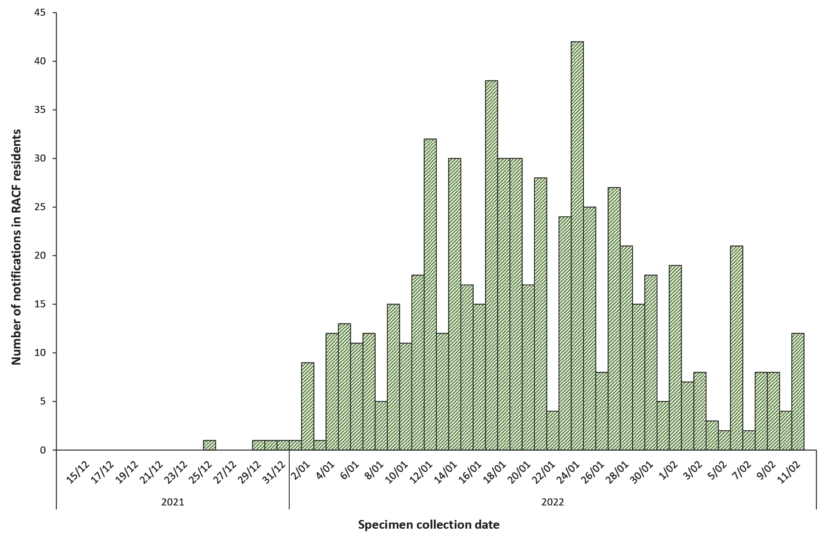

Table 2: Selected characteristics of cases of COVID-19 in RACF residents (N = 641), by vaccination status, Gold Coast Hospital and Health Service, Queensland, 13 December 2021 – 12 February 2022ª
Characteristic |  | Vaccination status
 |  | Under-vaccinated |  | Fully vaccinated without booster |  | Fully vaccinated with booster
 |  | n | %^{b} | n | %^{b} | n | %^{b}
Total number of cases |  | 77/641 | 12.0^{c} | 484/641 | 75.5^{c} | 80/641 | 12.5^{c}
Median age in years |  | 83 | 56–98^{d} | 86 | 51–106^{d} | 86 | 63–101^{d}
50–59 |  | 2 | 2.6 | 6 | 1.2 | 0 | 0.0
60–69 |  | 6 | 7.8 | 20 | 4.1 | 2 | 2.5
70–79 |  | 20 | 26.0 | 97 | 20.0 | 21 | 26.3
80–89 |  | 30 | 39.0 | 223 | 46.1 | 30 | 37.5
90–99 |  | 19 | 24.7 | 132 | 27.3 | 24 | 30.0
100–109 |  | 0 | 0.0 | 6 | 1.2 | 3 | 3.8
Hospitalised^{e} |  | 21/77 |  | 43/484 | 8.9 | 4/80 | 5.0
Sex | Female | 9 | 42.9 | 18 | 41.9 | 2 | 50.0
 | Male | 12 | 57.1 | 25 | 58.1 | 2 | 50.0
Died^{f} |  | 9/77 | 11.7 | 28/484 | 5.8 | 5/80 | 6.3
Sex | Female | 3 | 33.3 | 9 | 32.1 | 2 | 40.0
 | Male | 6 | 66.7 | 19 | 67.9 | 3 | 60.0
a Three cases with unknown vaccination status have been excluded.
b Column percentage values, unless otherwise indicated.
c Percentage of total cases.
d Range.
e Hospitalised with (not from) COVID-19.
f Died with (not from) COVID-19.

Discussion
Across the Gold Coast, this wave of COVID-19 RACF outbreaks resulted in considerable morbidity, with 10.6 % of resident cases hospitalised. However, these rates are lower than hospitalisation rates earlier in the pandemic in other jurisdictions, where an estimated 37% of RACF resident cases were hospitalised.¹ Additionally, this review showed a predominance of male cases hospitalised in these outbreaks. This is unexpected since two-thirds of RACF residents in Queensland are female.¹⁹ The reasoning behind this could not be established and may be due to other factors such as comorbidities.
The mortality rate during this review varied compared with other available data. The case fatality rate of 6.5% in Gold Coast RACFs was lower than the estimated case fatality rate that Australian RACFs had been experiencing throughout the pandemic (9.6% until 17 February 2022),¹⁷ and lower than case fatality rates experienced in RACFs internationally (estimated to be 23% in 2020 and 2021).¹ The death rate (deaths against all residents) during the review period was similar to the Australian death rate up until 17 February 2022 (7.6 per 1,000 beds and 7.8 per 1,000 beds, respectively).¹⁷ Again, a higher proportion of men died with COVID-19than did women. Further studies would be recommended to investigate potential causes.
In two-thirds of the outbreaks notified to GCPHU, the initial case identified was in a staff member. It was not possible to determine if the initial case identified was the index case of the outbreak, because there could have been another unidentified asymptomatic case at the RACF, given the high number of cases circulating in the community at the time.
Compared with no dose or one dose of COVID-19 vaccine, two doses of vaccine considerably reduced the rates of hospitalisation (27.3% to 8.9%) and death (11.7% to 5.8%) in RACF resident cases. A booster dose of vaccine for RACF residents was recommended by the Australian Technical Advisory Group on Immunisation (ATAGI) on 28 October 2021.²⁰ Actual numbers of residents in RACFs who were offered the booster were unknown, but thought to be sub-optimal. Only small numbers of resident cases in the review had received the booster (12.5%) before infection, with rates of hospitalisation and death for this cohort lower than those who were under-vaccinated. The low number of cases in this category makes it difficult to draw any conclusions about the effect of the booster.
The outbreak definition current at the time required only one COVID-19 case in a facility during their infectious period to trigger an outbreak response. This may have been appropriate for an elimination strategy; but with the surge in community cases and the emergence of the Omicron variant of concern, this response was not sustainable. In the new CDNA guidelines released on 15 February 2022 (following the completion of this audit), one infectious case was only considered an exposure and an outbreak response was triggered if two residents were positive within five days or if five or more staff, visitors and/or residents were positive within the past seven days.²¹
The review had several limitations. No data on gender or Aboriginal and Torres Strait Islander status of cases were provided in the RACF line list. Gender was available if a case was hospitalised or died. As part of the CQI process, gender and Aboriginal and Torres Strait Islander status have since been added to the data collected from RACFs. Vaccination status reported by the RACF was not verified from the Australian Immunisation Register, so there may be classification bias in vaccination rates for resident cases. Cases were detected by RAT as well as PCR. Use of RAT may underestimate true incidence of cases, given some RATs available in Australia have a sensitivity as low as 80%.²² Confounding factors were not assessed in the audit and may have biased the results. Such factors could include comorbidities; end-of-life planning; time since COVID-19 vaccination; and outbreak management in the RACF, including the impact of infection control practices on attack rates or the effect of antivirals on rates of hospitalisations or death.¹⁷ Hospitalisations and deaths were also ‘with’ COVID-19 and not necessarily ‘because of’ COVID-19.
The easing of domestic border restrictions to Queensland resulted in a wave of outbreaks in RACFs across the Gold Coast region that caused considerable morbidity and mortality, with staff shortages and fatigue at RACFs and GCPHU. More male than female residents in RACFs were hospitalised or died with COVID19. A higher proportion of under-vaccinated cases were hospitalised or died compared to those who had received at least two doses of vaccine. Due to a small number of deaths in resident cases who received booster vaccination, the impact of the booster could not be adequately assessed but two doses of vaccine appeared to have reduced morbidity and mortality for RACF residents in the two months of this review.

Acknowledgements
The authors would like to acknowledge staff within the Gold Coast Public Health Unit who contributed to the ongoing management of COVID-19 outbreaks in RACF. This included nursing staff, public health medical officers, epidemiologists, a data team, environmental health officers and administration support.

Author details
Dr Candice Colbran¹
Dr Fiona May¹
Fiona Vosti¹
Tracy Bladen¹
Dr Andre Wattiaux¹
Dr Vicki Slinko¹
- Gold Coast Public Health Unit, Gold Coast Hospital and Health Service

Corresponding author
Dr Candice Colbran
Address: Gold Coast Public Health Unit, Gold Coast Health, Carrara, Queensland
Phone: 07 5667 3200
Email: Candice.Colbran@health.qld.gov.au

References
- Hashan MR, Smoll N, King C, Ockenden-Muldoon H, Walker J, Wattiaux A et al. Epidemiology and clinical features of COVID-19 outbreaks in aged care facilities: a systematic review and meta-analysis. EClinicalMedicine. 2021;33:100771. doi: https://doi.org/10.1016/j.eclinm.2021.100771.
- Queensland Government Department of Health (Queensland Health). Border Restrictions Direction (No. 56). [Internet.] Brisbane: Queensland Health; 9 December 2021. Available from: https://www.health.qld.gov.au/system-governance/legislation/cho-public-health-directions-under-expanded-public-health-act-powers/revoked/border-restrictions-56.
- Prime Minister Scott Morrison. National Cabinet Statement. [Transcript.] Canberra: Australian Government Department of the Prime Minister and Cabinet; 30 December 2021. Available from: https://pmtranscripts.pmc.gov.au/release/transcript-44146.
- Australian Government Department of Health and Aged Care. Coronavirus disease 2019 (COVID-19) outbreaks in residential care facilities: CDNA national guidelines for the prevention, control and public health management of COVID-19 outbreaks in residential care facilities in Australia (version 4.0). Canberra: Australian Government Department of Health and Aged Care; 15 March 2021.
- Queensland Health. Residential Aged Care Direction (No. 11). [Internet.] Brisbane: Queensland Health; 11 December 2021. Available from: https://www.health.qld.gov.au/system-governance/legislation/cho-public-health-directions-under-expanded-public-health-act-powers/revoked/residential-aged-care-11.
- Queensland Health. Isolation for Diagnosed Cases of COVID-19 Direction. [Internet.] Brisbane: Queensland Health; 21 December 2021. Available from: https://www.health.qld.gov.au/system-governance/legislation/cho-public-health-directions-under-expanded-public-health-act-powers/revoked/isolation-for-diagnosed-cases-of-covid-19-direction.
- Queensland Health. Isolation for Diagnosed Cases of COVID-19 and Management of Close Contacts Direction. [Internet.] Brisbane: Queensland Health; 31 December 2021. Available from: https://www.health.qld.gov.au/system-governance/legislation/cho-public-health-directions-under-expanded-public-health-act-powers/revoked/isolation-for-diagnosed-cases-of-covid-19-and-management-of-close-contacts-direction.
- Queensland Health. Residential Aged Care Direction (No.12). [Internet.] Brisbane: Queensland Health; 15 January 2022. Available from: https://www.health.qld.gov.au/system-governance/legislation/cho-public-health-directions-under-expanded-public-health-act-powers/revoked/aged-care5.
- Queensland Health. Residential Aged Care Direction (No. 13). [Internet.] Brisbane: Queensland Health; 10 February 2022. Available from: https://www.health.qld.gov.au/system-governance/legislation/cho-public-health-directions-under-expanded-public-health-act-powers/revoked/residential-aged-care-13.
- Queensland Health. Residential Aged Care Visitor Direction. [Internet.] Brisbane: Queensland Health; 12 March 2022. Available from: https://www.health.qld.gov.au/system-governance/legislation/cho-public-health-directions-under-expanded-public-health-act-powers/revoked/aged-care-visitor-1.
- Queensland Health. Residential Aged Care Visitor Direction (No. 2). [Internet.] Brisbane: Queensland Health; 13 May 2022. Available from: https://www.health.qld.gov.au/system-governance/legislation/cho-public-health-directions-under-expanded-public-health-act-powers/revoked/aged-care-visitor-2.
- Queensland Health. Isolation for Diagnosed Cases of COVID-19 and Management of Close Contacts Direction (No. 2). [Internet.] Brisbane: Queensland Health; 3 January 2022. Available from: https://www.health.qld.gov.au/system-governance/legislation/cho-public-health-directions-under-expanded-public-health-act-powers/revoked/isolation-for-diagnosed-cases-and-management-of-close-contacts-2.
- Queensland Health. Isolation for Diagnosed Cases of COVID-19 and Management of Close Contacts Direction (No. 3). [Internet.] Brisbane: Queensland Health; 10 January 2022. Available from: https://www.health.qld.gov.au/system-governance/legislation/cho-public-health-directions-under-expanded-public-health-act-powers/revoked/isolation-for-diagnosed-cases-and-management-of-close-contacts3.
- Queensland Health. Isolation for Diagnosed Cases of COVID-19 and Management of Close Contacts Direction (No. 4). [Internet.] Brisbane: Queensland Health; 24 January 2022. Available from: https://www.health.qld.gov.au/system-governance/legislation/cho-public-health-directions-under-expanded-public-health-act-powers/revoked/isolation-for-diagnosed-cases-and-management-of-close-contacts4.
- Queensland Health. Isolation for Diagnosed Cases of COVID-19 and Management of Close Contacts Direction (No. 5). [Internet.] Brisbane: Queensland Health; 31 January 2022. Available from: https://www.health.qld.gov.au/system-governance/legislation/cho-public-health-directions-under-expanded-public-health-act-powers/revoked/isolation-for-diagnosed-cases-and-management-of-close-contacts-5.
- Queensland Health. Queensland COVID-19 data and resources. [Webpage.] Brisbane: Queensland Health; 2022. [Accessed on 30 December 2022.] Available from: https://www.data.qld.gov.au/article/news-and-events/queensland-covid-19-data-and-resources.
- Australian Government Department of Health and Aged Care. COVID-19 outbreaks in Australian residential aged care facilities. [Webpage.] Canberra: Australian Government Department of Health and Aged Care; 2022. Available from: https://www.health.gov.au/resources/collections/covid-19-outbreaks-in-australian-residential-aged-care-facilities.
- Australian Government Department of Health and Aged Care. Comirnaty (Pfizer). [Internet.] Canberra: Australian Government Department of Health and Aged Care; 14 September 2022. [Accessed on 20 September 2022.] Available from: https://www.health.gov.au/our-work/covid-19-vaccines/approved-vaccines/pfizer#:~:text=26%20October%202021%20(booster%20%E2%80%93%20for,for%2012%20years%20and%20over).
- Australian Institute of Health and Welfare (AIHW). Aged care data snapshot—2021—second release. [Database]. Canberra: Australian Government, AIHW; 2021. Available from: https://www.gen-agedcaredata.gov.au/Resources/Access-data/2021/October/Aged-care-data-snapshot%E2%80%942021.
- Australian Government Department of Health and Aged Care. ATAGI statement on the Omicron variant and timing of COVID-19 booster vaccination. [Internet.] Canberra: Australian Government Department of Health and Aged Care; 12 December 2021. Available from: https://www.health.gov.au/news/atagi-statement-on-the-omicron-variant-and-timing-of-covid-19-booster-vaccination.
- Australian Government Department of Health and Aged Care. Coronavirus disease 2019 (COVID-19) outbreaks in residential care facilities: CDNA national guidelines for the prevention, control and public health management of COVID-19 outbreaks in residential care facilities in Australia (version 5.0). Canberra: Australian Government Department of Health and Aged Care; 15 February 2022. Available from: https://www.health.gov.au/sites/default/files/documents/2022/02/cdna-national-guidelines-for-the-prevention-control-and-public-health-management-of-covid-19-outbreaks-in-residential-care-facilities-in-australia.pdf.
- Therapeutic Goods Administration (TGA). Post-market review of antigen and rapid antigen tests. [Internet.] Canberra: Australian Government Department of Health and Aged Care, TGA; 2022. [Accessed on 2 September 2022.] Available from: https://www.tga.gov.au/products/covid-19/covid-19-tests/post-market-review-antigen-and-rapid-antigen-tests.

Communicable Diseases Intelligence
ISSN: 2209-6051 Online

Communicable Diseases Intelligence (CDI) is a peer-reviewed scientific journal published by the Office of Health Protection, Department of Health and Aged Care. The journal aims to disseminate information on the epidemiology, surveillance, prevention and control of communicable diseases of relevance to Australia.

Editor: Noel Lally
Deputy Editor: Simon Petrie
Design and Production: Kasra Yousefi
Editorial Advisory Board: David Durrheim, Mark Ferson, Clare Huppatz, John Kaldor, Martyn Kirk, Meru Sheel and Steph Williams

Website: http://www.health.gov.au/cdi

Contacts
CDI is produced by the Office of Health Protection, Australian Government Department of Health and Aged Care, GPO Box 9848, (MDP 6) CANBERRA ACT 2601

Email: cdi.editor@health.gov.au

Submit an Article
You are invited to submit your next communicable disease related article to the Communicable Diseases Intelligence (CDI) for consideration. More information regarding CDI can be found at: http://health.gov.au/cdi.
Further enquiries should be directed to: cdi.editor@health.gov.au.

This journal is indexed by Index Medicus and Medline.

Creative Commons Licence - Attribution-NonCommercial-NoDerivatives CC BY-NC-ND
© 2023 Commonwealth of Australia as represented by the Department of Health and Aged Care
This publication is licensed under a Creative Commons Attribution-NonCommercial-NoDerivatives 4.0 International Licence from https://creativecommons.org/licenses/by-nc-nd/4.0/legalcode (Licence). You must read and understand the Licence before using any material from this publication.

Restrictions
The Licence does not cover, and there is no permission given for, use of any of the following material found in this publication (if any):
- the Commonwealth Coat of Arms (by way of information, the terms under which the Coat of Arms may be used can be found at www.itsanhonour.gov.au);
- any logos (including the Department of Health and Aged Care’s logo) and trademarks;
- any photographs and images;
- any signatures; and
- any material belonging to third parties.

Disclaimer
Opinions expressed in Communicable Diseases Intelligence are those of the authors and not necessarily those of the Australian Government Department of Health and Aged Care or the Communicable Diseases Network Australia. Data may be subject to revision.

Enquiries
Enquiries regarding any other use of this publication should be addressed to the Communication Branch, Department of Health and Aged Care, GPO Box 9848, Canberra ACT 2601, or via e-mail to: copyright@health.gov.au

Communicable Diseases Network Australia
Communicable Diseases Intelligence contributes to the work of the Communicable Diseases Network Australia.
http://www.health.gov.au/cdna

