COVID-19 Australia: Epidemiology Report 66
Reporting period ending 25 September 2022
COVID-19 Epidemiology and Surveillance Team

Summary

Four-week reporting period (29 August – 25 September 2022)

As of report 62 onward, the case data provided in this report includes both confirmed and probable cases reported to the National Notifiable Diseases Surveillance System (NNDSS), unless otherwise specified. Case definitions for confirmed and probable cases are in accordance with the coronavirus disease 2019 (COVID-19) Series of National Guidelines for Public Health Units (SoNG).
At the time of extraction, probable cases were not yet available from Tasmania; and were incomplete from Victoria since 29 July 2022 and the Northern Territory since 8 September 2022. At the time of extraction, Queensland was only reporting cases where testing was conducted in a clinical setting; probable cases with self-administered testing were not reported to NNDSS.
Trends – Nationally, weekly case numbers have decreased since the week ending 24 July 2022. In the reporting period 29 August – 25 September 2022, there were 67,160 confirmed and 102,883 probable cases of COVID-19 reported in Australia to NNDSS. In the latter fortnight (12–25 September 2022) of the reporting period, 67,341 confirmed and probable cases were notified (an average of 4,810 cases per day), compared to 102,702 in the previous fortnight (7,336 cases per day); together, these mark the lowest case numbers observed in a reporting period during 2022.
Age group – In the reporting period 29 August – 25 September 2022, the highest case rate was observed among adults aged 90 years and over, whilst the lowest rate was among children aged 0 to 17 years. Case rates decreased continuously across all age groups throughout the reporting period. For the entire Omicron wave to date (15 December 2021 – 25 September 2022), the highest case rate has been in adults aged 18 to 29 years.
Aboriginal and Torres Strait Islander persons – In the reporting period 29 August – 25 September 2022, there were 8,262 new cases notified in Aboriginal and Torres Strait Islander people. In the current Omicron wave (15 December 2021 – 25 September 2022) there have been 293,788 cases of COVID-19 notified in Aboriginal and Torres Strait Islander people, representing 3.4% (293,788/8,649,979) of all COVID-19 cases in the Omicron wave to date.
Severity – The overall crude case fatality rate in the current BA.5 wave is 0.20%, which is higher than the rates observed during the BA.1 (0.14%) and BA.2 (0.10%) waves, and notably less than that observed during the Delta (0.70%) wave. In the current reporting period, there was one notified case of paediatric inflammatory multisystem syndrome temporally associated with SARS-CoV-2 (PIMS-TS).
Virology – For samples collected in the four-week period 29 August – 25 September 2022, all 6,617 were assigned against Omicron or recombinants consisting of two Omicron lineages, with BA.5 constituting 80.4% of sequences collected in the reporting period and available for analysis in AusTrakka. Of the Omicron sequences in AusTrakka to date, 28.65% are BA.1; 44.8% are BA.2; 0.001% are BA.3; 4.1% are BA.4 and 22.4% are BA.5.

Keywords: SARS-CoV-2; novel coronavirus; 2019-nCoV; coronavirus disease 2019; COVID-19; acute respiratory disease; epidemiology; Australia
International situation – According to the World Health Organization (WHO), cumulative global COVID-19 cases stood at over 612 million COVID-19 cases and approximately 6.5 million deaths reported globally, as of 25 September 2022. For the South East Asian and Western Pacific regions combined, there were 6,377,117 newly-confirmed cases and 13,362 deaths in the four-week period to 25 September 2022. Compared to the previous four-week reporting period, new cases and new deaths decreased in both the Western Pacific and South East Asia regions. In total, since the start of the pandemic, over 149 million cases and over one million deaths have been reported in the two regions.
This reporting period covers the four-week period of 29 August – 25 September 2022. Within this period, data for each week is compared. The previous reporting period was the preceding four weeks (1–28 August 2022).¹ The focus of this report is on the epidemiological situation in Australia since the beginning of the current Omicron wave. For the purposes of this report, 15 December 2021 is used as a proxy for the beginning of this wave. This date was chosen as, from this date onward, the majority of sequenced strains from cases were Omicron. Readers are encouraged to consult prior reports in this series for information on the epidemiology of coronavirus disease 2019 (COVID-19) in Australia.
From report 46 onward, and unless otherwise specified, tabulated data and data within the text, except those relating to severity, are extracted from the National Notifiable Diseases Surveillance System (NNDSS) based on ‘notification received date’ rather than ‘diagnosis date’ (see the Technical Supplement for definitions).² As a case’s diagnosis date can be several days prior to the date of its notification, there is potential for newly-notified cases to be excluded from the case count in the current reporting period when reporting by ‘diagnosis date’. Using ‘notification received date’ ensures that the case count for the reporting period better reflects the number of newly-notified cases. From report 64 onward, all figures, apart from those relating to severity, are also based on ‘notification received date’ to better reflect the current reported trends in local transmission and to match data within the text. All tables and figures related to severity data extracted from NNDSS are based on ‘diagnosis date’ to better capture the true onset of severe illness and to enable a more accurate understanding of infection risk and disease severity.
From report 59 onward, cases are no longer separated into ‘locally acquired’ or ‘overseas acquired’. This change in reporting practice has been applied due to high levels of community transmission within Australia and limited follow-up of cases to determine sources of infection. Accordingly, from report 59 onward, all case numbers should be interpreted as the aggregate of all places of acquisition.
As of report 62 onward, the case data provided includes both confirmed cases and probable cases reported to the NNDSS. In accordance with the COVID-19 series of national guidelines (SoNG), a confirmed case requires laboratory definitive evidence which includes the detection of severe acute respiratory syndrome coronavirus 2 (SARS-CoV-2) by nucleic amplification acid testing (including by polymerase chain reaction), by cell culture or by seroconversion or a four-fold or greater increase in SARS-CoV-2 antibodies of any immunoglobulin subclass in the absence of vaccination. In accordance with the COVID-19 SoNG, a probable case requires laboratory suggestive evidence, which is the detection of SARS-CoV-2 by rapid antigen testing. For the purposes of this report, only probable cases from 5 January 2022 are included.
Due to the dynamic nature of data in the NNDSS, numbers may be subject to revision and may vary from numbers previously reported and from case notifications released by states and territories.

Background and data sources
See the Technical Supplement for general information on COVID-19 including modes of transmission, common symptoms, and severity.²

Activity

COVID-19 trends

(NNDSS and jurisdictional reporting to the National Incident Centre)
Cumulatively, from the beginning of the pandemic to 25 September 2022, jurisdictions within Australia have reported 10,216,959 COVID-19 cases to the National Incident Centre (Table 1). In the same time period, there were 4,831,104 confirmed and 4,053,753 probable cases of COVID-19 reported to NNDSS nationally. The difference in these case numbers arises because probable cases are not yet systematically reported by all jurisdictions to NNDSS. The analyses in this report include both confirmed and probable cases reported to the NNDSS, unless otherwise specified.
Table 1: Confirmed and probable COVID-19 cases by jurisdiction, 1 January 2020 – 25 September 2022^{a,b}
 | Australia (total) | ACT | NSW | NT | Qld | SA | Tas. | Vic. | WA
Cases – PCR confirmed | 4,848,996 | 121,505 | 1,923,574 | 21,359 | 637,428 | 457,973 | 56,674 | 1,151,037 | 479,446
Cases – RAT probable | 5,367,963 | 83,894 | 1,576,316 | 75,858 | 1,001,266 | 309,350 | 192,530 | 1,456,362 | 672,387
Cases – total | 10,216,959 | 205,399 | 3,499,890 | 97,217 | 1,638,694 | 767,323 | 249,204 | 2,607,399 | 1,151,833
a Source: jurisdictional reporting to the National Incident Centre.
b ACT: Australian Capital Territory; NSW: New South Wales; NT: Northern Territory; Qld: Queensland; SA: South Australia; Tas.: Tasmania; Vic.: Victoria; WA: Western Australia.
In the four-week period 29 August – 25 September 2022, there were 67,160 confirmed and 102,883 probable cases of COVID-19 reported in Australia to NNDSS. In the most recent reporting fortnight, a total of 67,341 confirmed and probable cases were notified (an average of 4,810 cases per day), compared to 102,702 in the previous fortnight (7,336 cases per day); together, these mark the lowest case numbers observed in a reporting period during 2022. In the week ending 25 September 2022, case rates were highest in Western Australia at 217 per 100,000 population per week, followed by South Australia (172 per 100,000 population per week).
Since the emergence of the Omicron variant in Australia, there have so far been three distinct waves of transmission, defined by the predominant Omicron subvariant circulating. The first wave, driven by the BA.1 subvariant, occurred from mid-December 2021 to February 2022, with a peak in cases observed in early January 2022. From March 2022, the BA.2 subvariant was the predominant strain; in this second Omicron wave, there was a primary peak in early April and a secondary peak in late May 2022. In early July 2022, BA.5 (including sub-lineages) became the predominant subvariant detected in Australia, driving a third wave of transmission which peaked in the week ending 24 July 2022. Since then, cases have continued to decrease and, throughout this reporting period, have become the lowest observed since December 2021.
Case numbers since January 2022 are an underestimate, as probable cases are not yet systematically reported from all jurisdictions.
Table 2: Confirmed and probable COVID-19 cases by jurisdiction and date of notification, Australia, 15 December 2021 – 25 September 2022^{a,b}
Jurisdiction | Reporting period |  |  |  |  |  | Current Omicron wave
 | 29 August – 11 September 2022 |  |  | 12–25 September 2022 |  |  | 15 December 2021 – 25 September 2022
 | Confirmed | Probable | Total | Confirmed | Probable | Total | Confirmed | Probable | Total
ACT | 1,100  (52.3%) | 1,002  (47.7%) | 2,102 | 688  (46.7%) | 784  (53.3%) | 1,472 | 120,360  (58.6%) | 84,931  (41.4%) | 205,291
NSW | 21,618  (46.5%) | 24,876  (53.5%) | 46,494 | 11,842  (40.4%) | 17,441  (59.6%) | 29,283 | 1,835,082  (56.8%) | 1,396,216  (43.2%) | 3,231,298
NT^{c} | 190  (20.2%) | 749  (79.8%) | 939 | 130  (100.0%) | 0  (0.0%) | 130 | 20,104  (21.0%) | 75,420  (79.0%) | 95,524
Qld^{c} | 3,056  (57.4%) | 2,270  (42.6%) | 5,326 | 1,799  (65.0%) | 970  (35.0%) | 2,769 | 632,409  (90.2%) | 68,736  (9.8%) | 701,145
SA | 3,646  (44.0%) | 4,641  (56.0%) | 8,287 | 2,776  (41.3%) | 3,946  (58.7%) | 6,722 | 458,024  (59.0%) | 318,708  (41.0%) | 776,732
Tas.^{c} | 422  (100.0%) | 0  (0.0%) | 422 | 269  (100.0%) | 0  (0.0%) | 269 | 56,542  (100.0%) | 0  (0.0%) | 56,542
Vic.^{c} | 7,088  (28.8%) | 17,526  (71.2%) | 24,614 | 4,381  (29.7%) | 10,349  (70.3%) | 14,730 | 1,003,295  (41.2%) | 1,429,785  (58.8%) | 2,433,080
WA | 4,101  (28.2%) | 10,417  (71.8%) | 14,518 | 4,054  (33.9%) | 7,912  (66.1%) | 11,966 | 470,410  (40.9%) | 679,957  (59.1%) | 1,150,367
Australia | 41,221  (40.1%) | 61,481  (59.9%) | 102,702 | 25,939  (38.5%) | 41,402  (61.5%) | 67,341 | 4,596,226  (53.1%) | 4,053,753  (46.9%) | 8,649,979
a Source: NNDSS extract from 27 September 2022 for notifications from 15 December 2021 to 25 September 2022.
b ACT: Australian Capital Territory; NSW: New South Wales; NT: Northern Territory; Qld: Queensland; SA: South Australia; Tas.: Tasmania; Vic.: Victoria; WA: Western Australia.
c At the time of extraction, probable cases were not yet available from Tasmania; and were incomplete from Victoria since 29 July 2022 and the Northern Territory since 8 September 2022. At the time of extraction, Queensland was only reporting cases where testing was conducted in a clinical setting; probable cases with self-administered testing were not reported to NNDSS.

Figure 1: Confirmed and probable weekly COVID-19 notified cases by notification date, Australia, 29 November 2021 – 25 September 2022ª
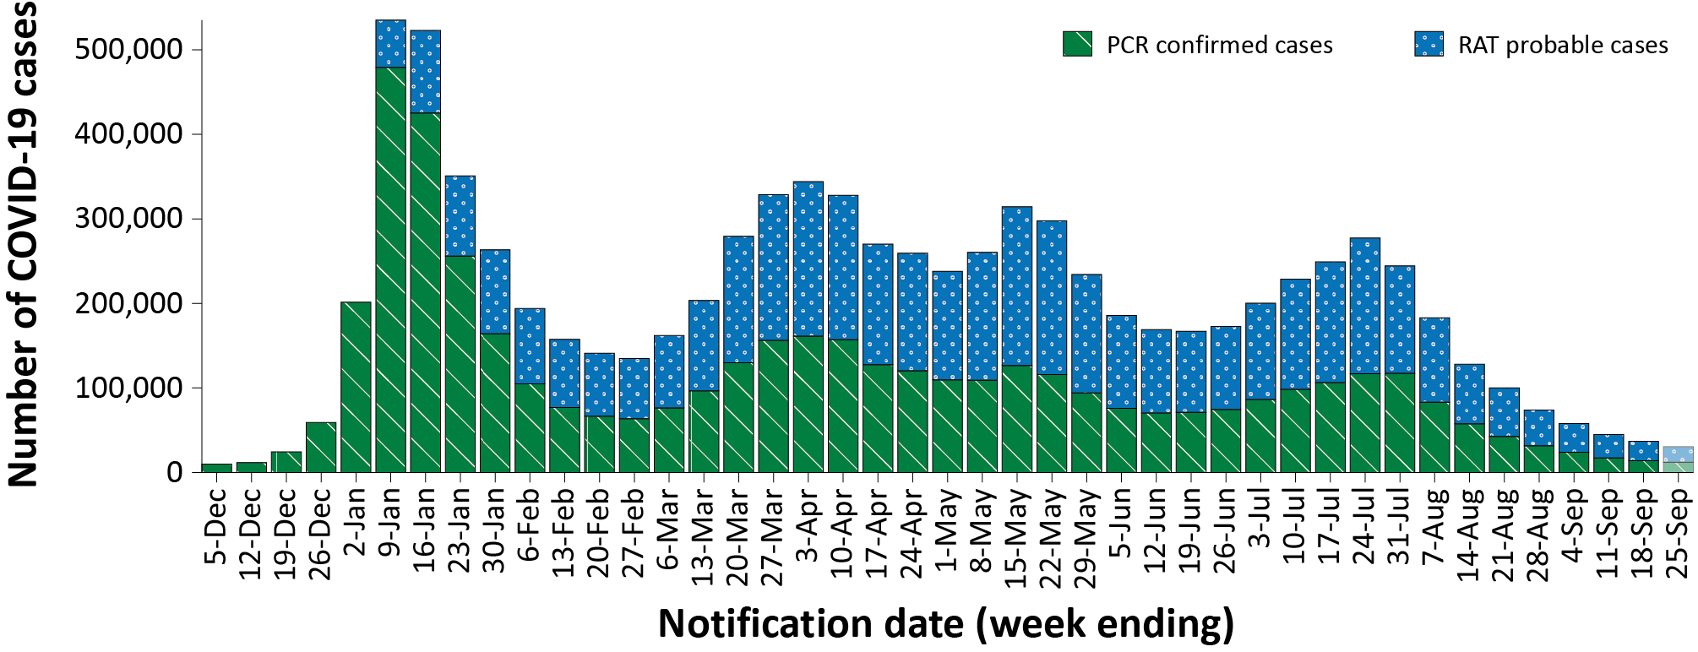
a Source: NNDSS extract from 27 September 2022 for notifications from 29 November 2021 to 25 September 2022. At the time of extraction, probable cases were not yet available from Tasmania; and were incomplete from Victoria since 29 July 2022 and the Northern Territory since 8 September 2022. At the time of extraction, Queensland was only reporting cases where testing was conducted in a clinical setting; probable cases with self-administered testing were not reported to NNDSS.

Demographic features

(NNDSS)
In the reporting period 29 August – 25 September 2022, the highest case rate was observed among adults aged 90 years and over, whilst the lowest rate was among children aged 0 to 17 years (Appendix A, Table A.1). Case rates declined across all age groups during the reporting period. (Figure 2). For the entire Omicron wave to date (15 December 2021 – 25 September 2022), the highest case rate has been in adults aged 18 to 29 years. For this age group, the weekly notification rate peaked in the week ending 9 January 2022 at 5,605 cases per 100,000 population (not depicted). Cases rates have been comparable across all paediatric age groups since late August 2022, with rates continuing to decline throughout this reporting period (Figure 2).

Figure 2: Confirmed and probable COVID-19 case rates for (a) all ages and (b) children, by age group by notification week, Australia, 27 February – 25 September 2022ª
a
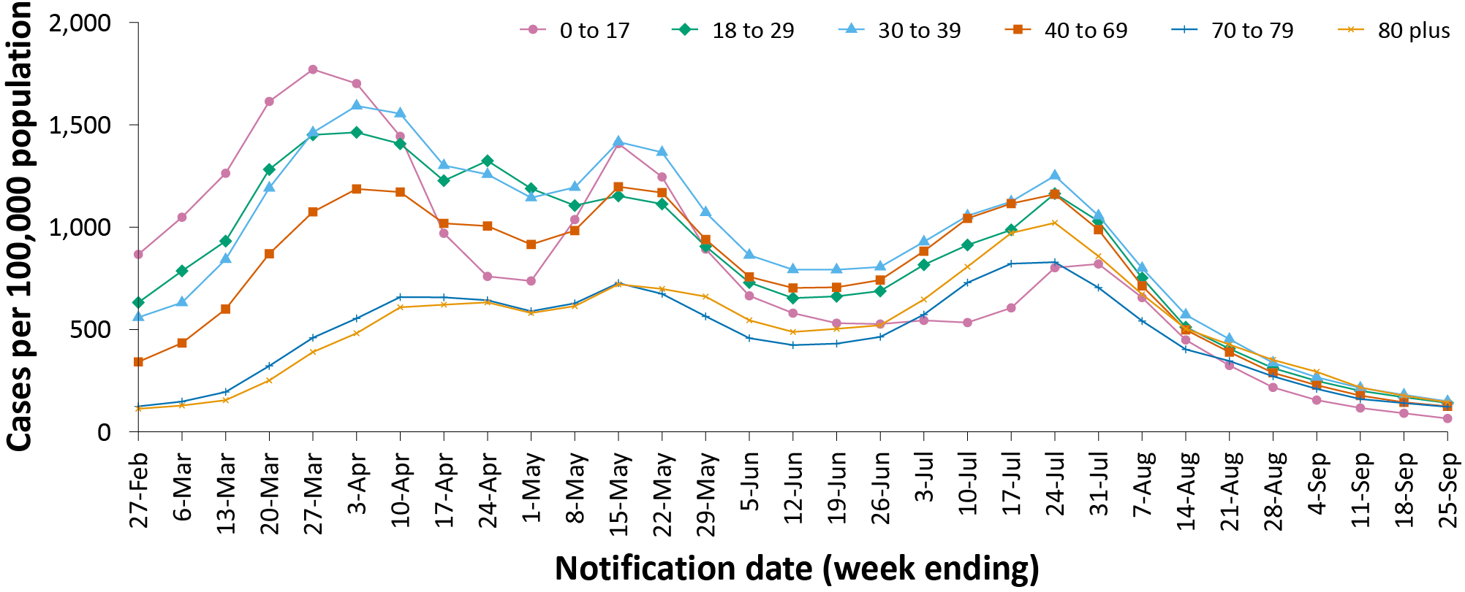
b
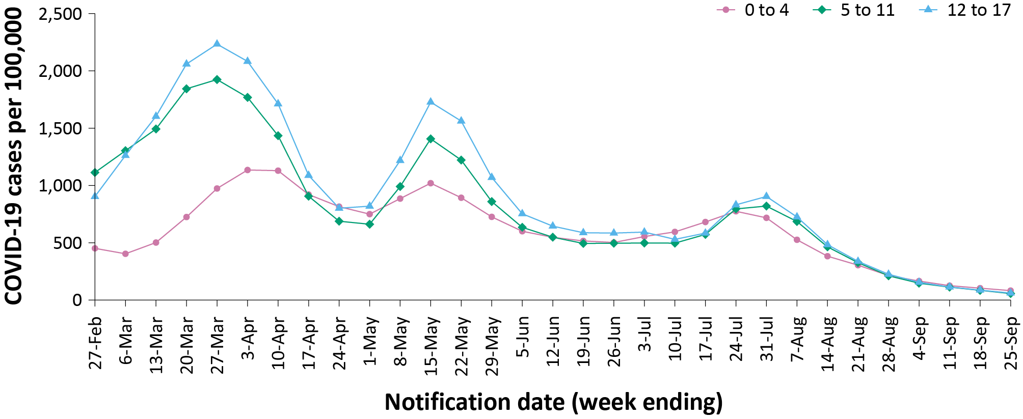
a Source: NNDSS extract from 27 September 2022 for notifications from 21 February to 25 September 2022. At the time of extraction, probable cases were not yet available from Tasmania; and were incomplete from Victoria since 29 July 2022 and the Northern Territory since 8 September 2022. At the time of extraction, Queensland was only reporting cases where testing was conducted in a clinical setting; probable cases with self-administered testing were not reported to NNDSS.

Aboriginal and Torres Strait Islander persons

(NNDSS)
Overall, since the start of the pandemic, Indigenous status is unknown for approximately 13% of COVID-19 cases. Therefore, the number of cases classified as Aboriginal and Torres Strait Islander people is likely an under-representation. During the reporting period, there were 8,262 new COVID-19 cases notified in Aboriginal and Torres Strait Islander people (Table 3). In the current Omicron wave (15 December 2021 – 25 September 2022) there have been 293,788 cases of COVID-19 notified in Aboriginal and Torres Strait Islander people, representing 3.4% (293,788/8,649,979) of all COVID-19 cases in the Omicron wave to date.
Table 3: Confirmed and probable cases of COVID-19 among Aboriginal and Torres Strait Islander peoples by jurisdiction and date of notification, Australia, 15 December 2021 – 25 September 2022ª
Jurisdiction | 29 August – 4 September 2022 | 5–11 September 2022 | 12–18 September 2022 | 19–25 September 2022 | 15 December 2021 – 25 September 2022 (Omicron wave)
Australian Capital Territory | 18 | 17 | 21 | 15 | 3,605
New South Wales | 1,409 | 1,173 | 1,065 | 949 | 119,263
Northern Territory^{b} | 148 | 95 | 32 | 11 | 23,395
Queensland^{b} | 386 | 284 | 226 | 130 | 39,274
South Australia | 110 | 117 | 105 | 76 | 20,984
Tasmania^{b} | 9 | 6 | 2 | 3 | 1,892
Victoria^{b} | 303 | 271 | 184 | 130 | 31,350
Western Australia | 244 | 186 | 226 | 311 | 54,025
Total | 2,627 | 2,149 | 1,861 | 1,625 | 293,788
a Source: NNDSS extract from 27 September 2022 for notifications from 15 December 2021 to 25 September 2022.
b At the time of extraction, probable cases were not yet available from Tasmania; and were incomplete from Victoria since 29 July 2022 and the Northern Territory since 8 September 2022. At the time of extraction, Queensland was only reporting cases where testing was conducted in a clinical setting; probable cases with self-administered testing were not reported to NNDSS.
Of the COVID-19 cases notified in Aboriginal and Torres Strait Islander people from 15 December 2021 to date, and where location of residence was known, 54% (157,235/291,947) lived in a regional or remote area (Table 4). The majority of cases reported in outer regional and remote areas since the start of the Omicron wave were diagnosed using RATs, at 62% and 71%, respectively. It should be noted that the reliance on RATs for diagnosing COVID-19 is greater in regional and remote areas than in major cities, resulting in a larger under-representation of cases in regional and remote areas than in major cities, due to the incomplete capture of probable cases in NNDSS.
Nationally, there have been 268 COVID-19 associated deaths reported in Aboriginal and Torres Strait Islander people from the start of the pandemic to 25 September 2022. This comprises 89 from New South Wales, 80 from Queensland, 37 from the Northern Territory, 31 from Western Australia, 19 from South Australia, 10 from Victoria and two from the Australian Capital Territory. An additional 515 Aboriginal and Torres Strait Islander cases have been admitted to intensive care units (ICU) nationally. During the Omicron wave to date, the overall notification rate, to NNDSS, of severe cases (measured as those who were admitted to ICU or died) in Aboriginal and Torres Strait Islander people was 74.3 per 100,000 population, compared to 16.5 per 100,000 population during the Delta wave (Table 5). The higher rates of severe illness during the Omicron wave may be attributed to the significantly higher levels of disease transmission in the community during the Omicron wave, rather than the Omicron variant inherently causing more severe illness compared to the Delta variant. Note that ICU status in NNDSS is likely incomplete.
Table 4: COVID-19 cases among Aboriginal and Torres Strait Islander people by area of remoteness, Australia, 15 December 2021 – 25 September 2022ª
Jurisdiction^{b,c} | Major city | Inner regional | Outer regional | Remote^{d}
ACT | 3,534 | 30 | 10 | 1
NSW | 63,958 | 38,621 | 13,287 | 2,747
NT^{e} | 56 | 17 | 7,324 | 15,591
Qld^{e} | 9,985 | 6,056 | 16,535 | 6,637
SA | 11,243 | 2,246 | 4,465 | 2,929
Tas.^{e} | 17 | 1,295 | 557 | 13
Vic.^{e} | 17,888 | 10,065 | 3,350 | 13
WA | 28,031 | 3,858 | 6,687 | 14,901
Australia | 134,712 | 62,188 | 52,215 | 42,832
a Source: NNDSS extract from 27 September 2022 for notifications from 15 December 2021 to 25 September 2022. Excludes cases with an overseas place of residence, and where place of residence is unknown.
b ACT: Australian Capital Territory; NSW: New South Wales; NT: Northern Territory; Qld: Queensland; SA: South Australia; Tas.: Tasmania; Vic.: Victoria; WA: Western Australia.
c Cases are classified based on jurisdiction of notification not jurisdiction of residence. Some cases are notified to a different jurisdiction to their location of residence.
d ‘Remote’ here also includes areas classified as ‘very remote’.
e At the time of extraction, probable cases were not yet available from Tasmania; and were incomplete from Victoria since 29 July 2022 and the Northern Territory since 8 September 2022. At the time of extraction, Queensland was only reporting cases where testing was conducted in a clinical setting; probable cases with self-administered testing were not reported to NNDSS.
Table 5: Confirmed and probable COVID-19 cases in Aboriginal and Torres Strait Islander people by age and highest level of illness severity, Australia, 1 January 2020 to 25 September 2022
Age group (years) | 15 December 2021  – 25 September 2022  (Omicron wave) |  |  |  | 16 June 2021  – 14 December 2021  (Delta wave) |  |  |  | 1 January 2020  – 25 September 2022  (Pandemic to date)
 | ICUª | Diedª | ICU or diedª | Rate ICU or died^{b} | ICUª | Diedª | ICU or diedª | Rate ICU or died^{b} | ICUª | Diedª | ICU or diedª | Rate ICU or died^{b}
0–17 | 52 | 1 | 52 | 16.0 | 8 | 0 | 8 | 2.5 | 60 | 1 | 60 | 18.5
18–59 | 221 | 76 | 285 | 68.3 | 85 | 11 | 89 | 21.3 | 307 | 87 | 375 | 89.9
60+ | 118 | 165 | 256 | 453.6 | 28 | 15 | 35 | 62.0 | 148 | 180 | 293 | 519.2
All | 391 | 242 | 593 | 74.3 | 121 | 26 | 132 | 16.5 | 515 | 268 | 728 | 91.2
a ‘ICU’ and ‘died’ are not mutually exclusive categories; ‘died’ can include cases who died with or without prior admission to ICU. Therefore, the number of cases admitted to ICU or having died will not equal the sum of cases in ICU or died.
b Rate per 100,000 population for the given time period.

Figure 3: COVID-19 cases, deaths and ICU admissions, Australia, by date of onset, Australia, 31 May 2021 to 25 September 2022^{a,b}

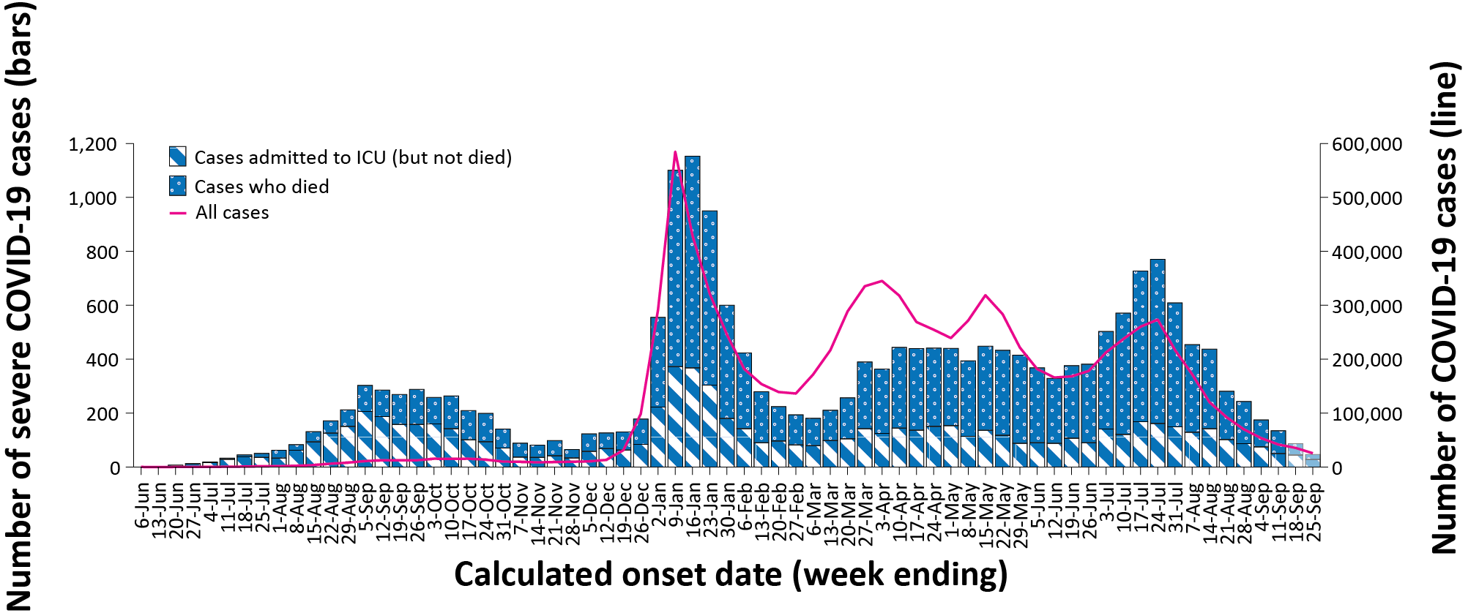
a Source: NNDSS extract from 27 September 2022 for notifications to 25 September 2022. At the time of extraction, probable cases were not yet available from Tasmania; and were incomplete from Victoria since 29 July 2022 and the Northern Territory since 8 September 2022. At the time of extraction, Queensland was only reporting cases where testing was conducted in a clinical setting; probable cases with self-administered testing were not reported to NNDSS.
b The shaded bars at the right represent the most recent two reporting weeks and should be interpreted with caution, as cases with an illness onset in these weeks may not have yet developed severe disease.

Severity

(NNDSS, FluCAN)
Given the delay between illness onset and severe illness, and so as to provide a more accurate assessment of severity, cases with an onset in the last two weeks have been excluded from analyses on the weekly rate of cases with severe illness (defined as cases admitted to ICU or died) and on the proportion of cases admitted to ICU or died.
In the Omicron wave, the notification rate of cases with severe illness peaked in the week ending 16 January 2022, at approximately 4.5 severe cases per 100,000 population per week (Figure 3). Coinciding with overall case trends, there was an increase in severe cases during the BA.5 wave from late June 2022, with a peak occurring during the week ending 24 July 2022. The incidence of severe cases continued to decline throughout the reporting period. Rates of severe cases continue to be greater in older age groups; in the BA.5 wave, those aged 80 years and over experienced a notable peak in severe rates during the week ending 24 July 2022, while this trend was not observed in the other age groups (Figure 4).

Figure 4: Age-specific rates of COVID-19 cases admitted to ICU or died, by date of diagnosis, Australia, 31 May 2021 to 11 September 2022ª
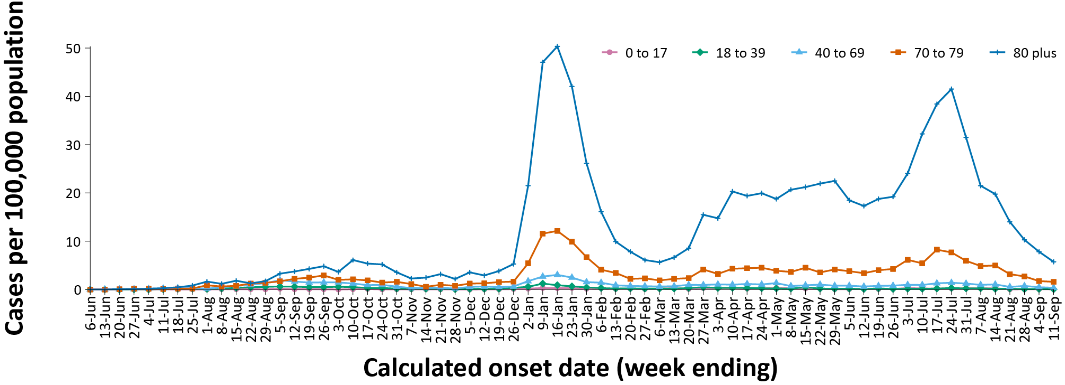
a Source: NNDSS extract from 27 September 2022 for notifications to 25 September 2022. Includes cases with an illness onset from 31 May 2021 to 11 September 2022; cases with an illness onset in the last two weeks (12–25 September 2022) were excluded to account for the delay between onset and development of severe illness.

Hospitalisation and ICU admissions
Between 15 December 2021 and 25 September 2022, there were 8,888 hospital admissions with confirmed COVID-19 reported at Influenza Complications Alert Network (FluCAN) sentinel sites, including 6% (548/8,888) admitted directly to ICU. In the current reporting period to 25 September 2022, there were 141 admissions with COVID-19 reported, including 2% (3/141) who were admitted directly to ICU.
Since 15 December 2021, for patients admitted to FluCAN sentinel sites with confirmed COVID-19, the median length of stay was 3 days (interquartile range, IQR: 1–7); mean (standard deviation, SD) = 5.7 days (12.3). This is lower than the median length of stay observed during the Delta wave, which was 6 days (IQR: 3–10); mean (SD) = 7.8 days (9.3).

PIMS-TS

(PAEDS)
Since the start of the pandemic to 25 September 2022, there have been 154 cases of paediatric inflammatory multisystem syndrome temporally associated with SARS-CoV-2 (PIMS-TS) reported to Paediatric Active Enhanced Disease Surveillance (PAEDS), including 119 cases reported in 2022 and one in the current reporting period (Figure 5). The majority of PIMS-TS cases to date have occurred in those aged 5 to < 12 years (52%; 80/154), followed by those aged 6 months to < 5 years (27%; 42/154). To date, there have been no PIMS-TS associated deaths.

COVID-19 deaths
There were 530 COVID-19-associated deaths among COVID-19 cases notified during the reporting period (29 August – 25 September 2022). This brings the total number of COVID-19-associated deaths reported in NNDSS to 14,171 (Table 6). The overall crude case fatality rate in the current BA.5 wave is 0.20%, which is higher than the rate observed during the BA.1 (0.14%) and BA.2 (0.10%) waves, and notably less than observed during the Delta (0.70%) wave (Table 6).

Figure 5: PIMS-TS cases reported to PAEDS, by sample month and level of care required, Australia, 1 June 2020 – 25 September 2022
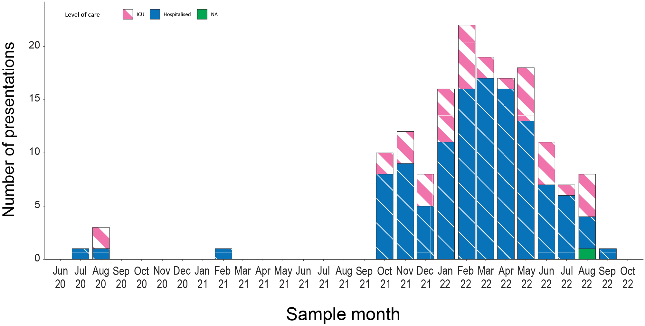
Table 6: Deaths associated with COVID-19 by reporting period, Australia, 1 January 2020 – 25 September 2022^{a,b}
Jurisdiction^{c} | 29 August – 4 September 2022 | 5–11 September 2022 | 12–18 September 2022 | 19–25 September 2022 | 15 December 2021 –  25 September 2022  (Omicron wave) | 1 January 2020 –  25 September 2022  (Pandemic to date)
ACT | 2 (1.0%) | 0 (0.0%) | 0 (0.0%) | 0 (0.0%) | 112 (0.9%) | 138 (1.0%)
NSW | 79 (38.9%) | 76 (44.4%) | 33 (34.0%) | 28 (47.5%) | 4,557 (38.3%) | 5,257 (37.1%)
NT^{d} | 0 (0.0%) | 0 (0.0%) | 0 (0.0%) | 0 (0.0%) | 70 (0.6%) | 71 (0.5%)
Qld^{d} | 34 (16.7%) | 17 (9.9%) | 8 (8.2%) | 0 (0.0%) | 2,200 (18.5%) | 2,207 (15.6%)
SA | 3 (1.5%) | 4 (2.3%) | 9 (9.3%) | 1 (1.7%) | 930 (7.8%) | 934 (6.6%)
Tas.^{d} | 0 (0.0%) | 1 (0.6%) | 0 (0.0%) | 0 (0.0%) | 38 (0.3%) | 64 (0.5%)
Vic.^{d} | 74 (36.5%) | 65 (38.0%) | 44 (45.4%) | 29 (49.2%) | 3,358 (28.2%) | 4,853 (34.2%)
WA | 11 (5.4%) | 8 (4.7%) | 3 (3.1%) | 1 (1.7%) | 647 (5.4%) | 647 (4.6%)
Total | 203 (100.0%) | 171 (100.0%) | 97 (100.0%) | 59 (100.0%) | 11,912 (100.0%) | 14,171 (100.0%)
a Source: NNDSS, extract from 27 September 2022 for deaths to 25 September 2022.
b Deaths are categorised into time periods using date of death. Deaths with a missing date of death are classified using date of illness onset.
c ACT: Australian Capital Territory; NSW: New South Wales; NT: Northern Territory; Qld: Queensland; SA: South Australia; Tas.: Tasmania; Vic.: Victoria; WA: Western Australia.
d At the time of extraction, probable cases were not yet available from Tasmania; and were incomplete from Victoria since 29 July 2022 and the Northern Territory since 8 September 2022. At the time of extraction, Queensland was only reporting cases where testing was conducted in a clinical setting; probable cases with self-administered testing were not reported to NNDSS.
Table 7: COVID-19 associated case fatality rates, among cases notified to NNDSS, by age group and date of onset, 1 January 2020 to 11 September 2022^{a,b}
Age group | BA.5  15 June – 11 September 2022 | BA.2  1 March – 14 June 2022 | BA.1  15 December 2021 – 28 February 2022 | Omicron  15 December 2021 – 11 September 2022 | Delta  16 June – 14 December 2021 | Pandemic  1 January 2020 – 11 September 2022
0–4 | < 0.05% | < 0.05% | < 0.05% | < 0.05% | 0.00% | < 0.05%
5–11 | 0.00% | 0.00% | < 0.05% | < 0.05% | < 0.05% | < 0.05%
12–15 | < 0.05% | 0.00% | < 0.05% | < 0.05% | < 0.05% | < 0.05%
16–17 | 0.00% | < 0.05% | 0.00% | < 0.05% | 0.00% | < 0.05%
18–29 | < 0.05% | < 0.05% | < 0.05% | < 0.05% | < 0.05% | < 0.05%
30–39 | < 0.05% | < 0.05% | < 0.05% | < 0.05% | 0.06% | < 0.05%
40–49 | < 0.05% | < 0.05% | < 0.05% | < 0.05% | 0.19% | < 0.05%
50–59 | < 0.05% | < 0.05% | 0.05% | < 0.05% | 0.66% | 0.05%
60–69 | 0.13% | 0.11% | 0.25% | 0.15% | 1.94% | 0.19%
70–79 | 0.64% | 0.47% | 1.18% | 0.67% | 6.21% | 0.81%
80–89 | 2.38% | 2.11% | 5.10% | 2.76% | 14.92% | 3.21%
90+ | 6.26% | 5.94% | 10.93% | 6.93% | 27.92% | 7.77%
Unknown | 0.00% | 0.00% | 0.00% | 0.00% | 0.00% | 0.00%
Total | 0.20% | 0.10% | 0.14% | 0.14% | 0.70% | 0.16%
a Source: NNDSS, extract from 27 September 2022 for deaths to 25 September 2022. At the time of extraction, probable cases were not yet available from Tasmania; and were incomplete from Victoria since 29 July 2022 and the Northern Territory since 8 September 2022. At the time of extraction, Queensland was only reporting cases where testing was conducted in a clinical setting; probable cases with self-administered testing were not reported to NNDSS.
b To account for the lag between illness onset and the development of severe illness, cases with an onset date in the last two weeks have been excluded from calculations of the case fatality rate.

Genomic surveillance and virology

(Communicable Disease Genomics Network, AusTrakka and jurisdictional sequencing laboratories)
Nationally, 2.92% of COVID-19 cases have been sequenced since the start of the pandemic in January 2020, based on jurisdictional reporting of confirmed cases (Table 8). Case numbers and sequencing proportion are based on PCR results only, as rapid antigen tests do not allow for sequencing. The very large case numbers reported nationally across 2022 to date have required jurisdictional laboratories to move towards sequencing for surveillance purposes during this time, resulting in a drop in the overall sequencing proportion. However, overall output of number of cases sequenced remains similar to, or higher than, previous periods (Figure 6).

Figure 6: Samples in AusTrakka from 21 March 2022 to 25 September 2022, by lineage and date of collectionª
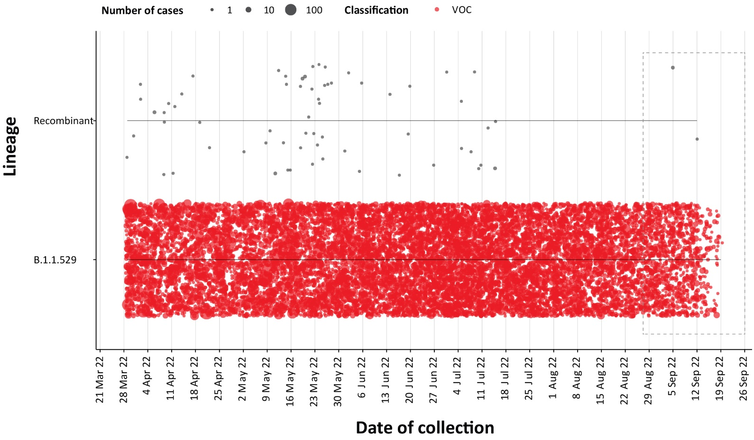
a The current reporting period (29 August to 25 September 2022) is marked by the dashed lines, and variant of concern samples are coloured red. The size of the circle is proportional to the number of samples in the lineage at each time point.

Variants of concern (VOC)
AusTrakka³ is actively monitoring and reporting on one lineage currently designated as a Variant of Concern (VOC) by international organisations, including the World Health Organization (WHO): Omicron (B.1.1.529). The Omicron variant displays a characteristic set of mutations, including a number of variations in the genomic region encoding the spike protein thought to have the potential to increase transmissibility and/or immune evasion. The CDGN VOC working group demoted four previously designated VOCs (Alpha (B.1.1.7), Beta (B.1.351), Gamma (P.1) and Delta (B.1.617)) due to the sustained absence of any cases in Australia, and very limited prevalence globally. Further information on variants is available in the Technical Supplement.²
All 6,617 sequences from samples collected within the reporting period were assigned to Omicron or to recombinants consisting of two Omicron lineages. BA.5 is currently the predominant sub-lineage being sequenced, representing 80.4% of sequences collected in the reporting period and available for analysis in AusTrakka (Figure 7). Of the Omicron sequences in AusTrakka to date (n = 91,514), 28.65% are BA.1; 44.8% are BA.2; 0.001% are BA.3; 4.1% are BA.4 and 22.4% are BA.5. All sub-sub-lineages have been collapsed into their respective major sub-lineage.

Figure 7: Sequences in AusTrakka by Omicron sub-lineage and collection date, 1 August to 25 September 2022ª
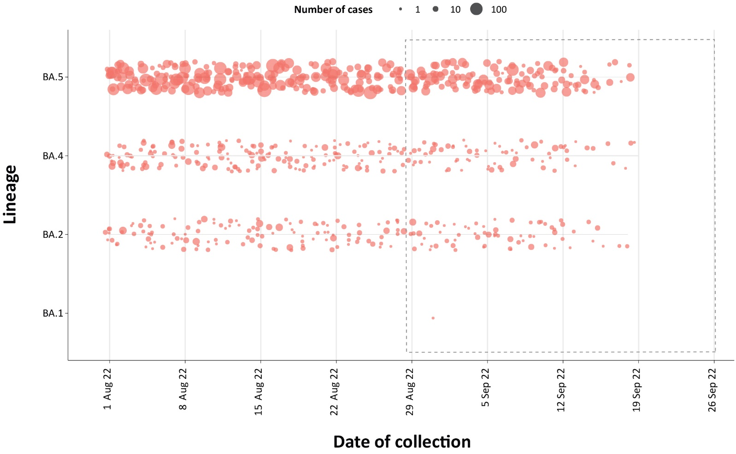
a The current reporting period (29 August to 25 September 2022) is marked by the dashed lines. The size of the dots are proportional to the number of sequences observed in each jurisdiction each day.
Table 8: Australian SARS-CoV-2 genome sequences and proportion of positive cases sequenced, 29 August – 25 September 2022 and cumulative to date
Measure | Reporting period  29 August –25 September 2022 | Cumulative  23 January 2020 – 31 August 2022
SARS-CoV-2 cases sequencedª | 6,617 | 143,684
Percentage of positive cases sequenced^{b,c} | 8.87% | 2.92%
a Total SARS-CoV-2 case numbers as reported by jurisdictional laboratories based on PCR results only. Cases identified via rapid antigen testing are reported differently by each jurisdiction and cannot be followed up for sequencing. They are therefore not included in the sequencing proportions reported here. Sequencing of samples from cases identified in the reporting period may be in process at the time of reporting. Remaining unsequenced samples may be due to jurisdictional sequencing strategy, or where samples have been deemed unsuitable for sequencing (typically because viral loads were too low for sequencing to be successful).
b Based on individual jurisdictional reports of sequences and case numbers. Calculations of the percentage of cases sequenced based on the number of sequences available in AusTrakka may not always be up-to-date, since this may include duplicate samples from cases and may not represent all available sequence data.
c Updated data for September was not available from Western Australia at time of submission.

Testing

(State and territory reporting)
From the commencement of the pandemic to 25 September 2022, over 79 million PCR tests for SARS-CoV-2 have been conducted nationally. Jurisdictional PCR testing rates are driven by current case numbers, testing policies and numbers of people experiencing symptoms. The number, rates and percent positivity of RATs cannot be calculated, as there is currently no reporting of negative RATs.
During the four-week reporting period (29 August – 25 September 2022), PCR testing rates decreased or remained stable across all jurisdictions except Queensland, which saw an increase in testing rates in the week ending 25 September 2022. Percent positivity decreased across all jurisdictions over the reporting period, with the exception of Western Australia where percent positivity increased. In the week ending 25 September 2022, the highest PCR percent positivity was observed in Western Australia at 15% (Figure 8).

Figure 8: SARS-CoV-2 polymerase chain reaction (PCR) testing rates per 1,000 population and percent positivity by jurisdiction and date of notification, 13 December 2021 – 25 September 2022ª

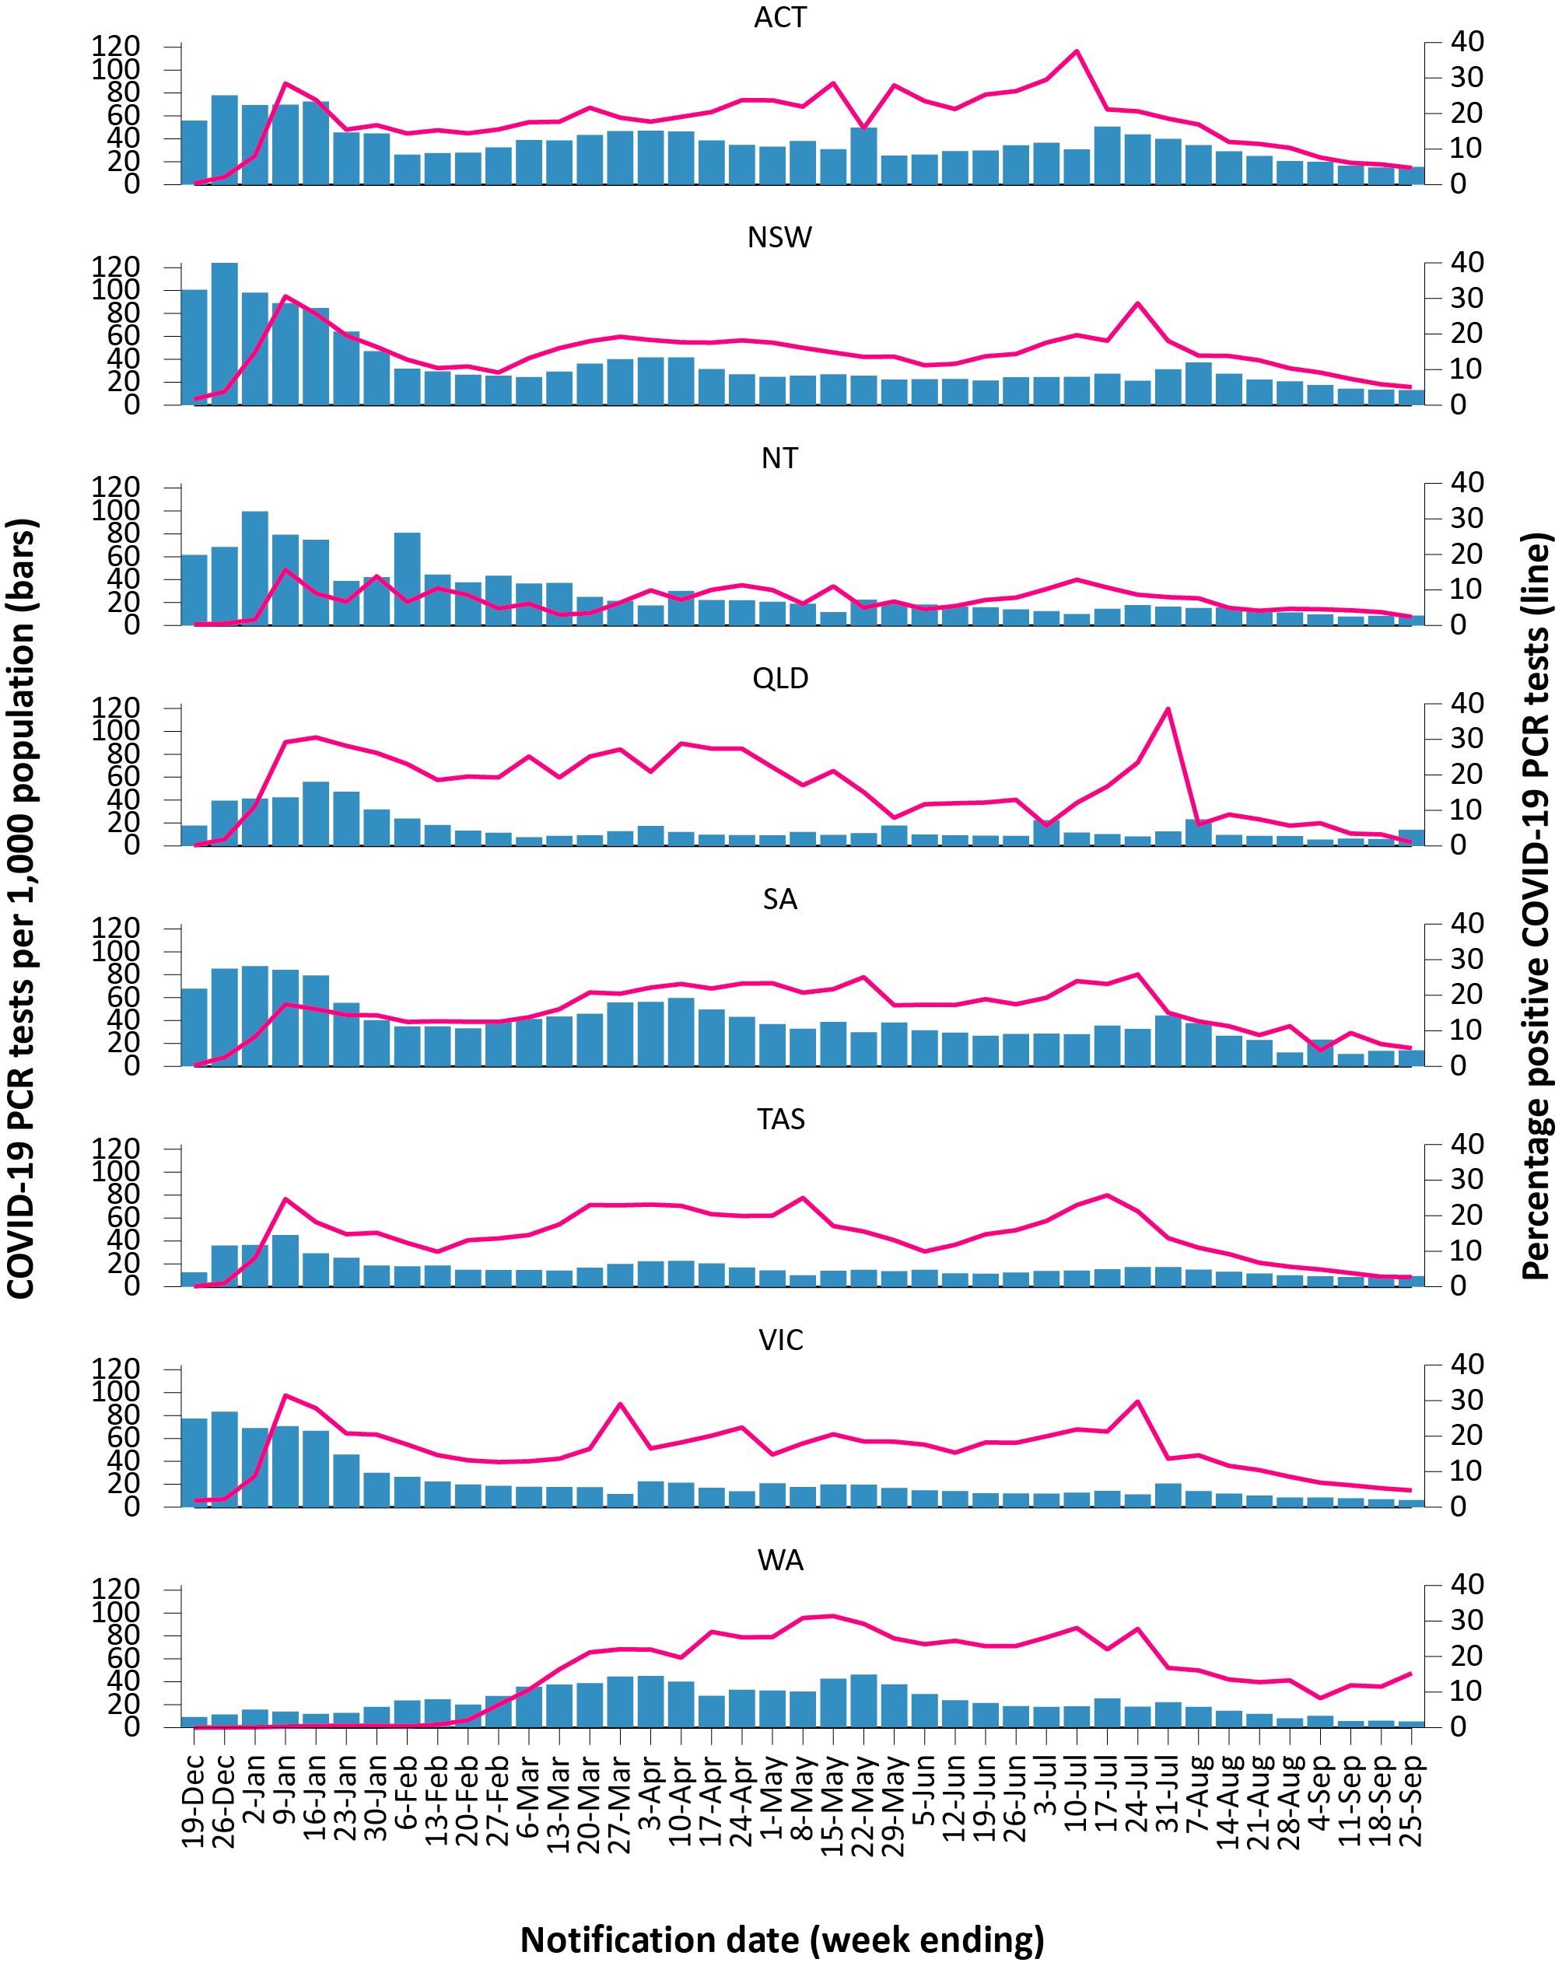
a Source: testing data provided by jurisdictions to the NIR daily, current to 25 September 2022; case data extracted from NNDSS on 27 September 2022 for cases with a notification date up to 25 September 2022; population data based on Australian Bureau of Statistics (ABS) Estimated Resident Population (ERP) as at June 2021.

Acute respiratory illness

(FluTracking, ASPREN, and Commonwealth Respiratory Clinics)
Based on self-reported FluTracking data,⁴ the prevalence of fever and cough in the community over this reporting period fluctuated, with an increasing trend in the first three weeks of the reporting period, followed by a decrease in the last week of the reporting period (Figure 9). The prevalence of runny nose and sore throat symptoms remained stable at approximately 1.3% throughout the reporting period (Figure 10).
Figure 9: Weekly trends in fever and cough amongst FluTracking survey participants (age-standardised) compared to the average of the previous five years, Australia, 1 January 2020 – 25 September 2022ª
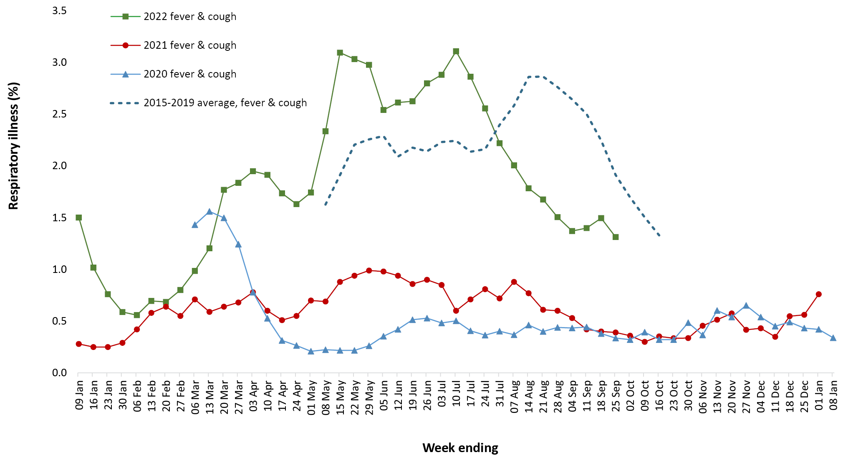
a In years prior to 2020, FluTracking was activated during the main Influenza season from May to October. A historical average beyond the week ending 11 October is therefore not available. In 2020, FluTracking commenced ten weeks early to capture data for COVID-19.

Figure 10: Weekly trends in runny nose and sore throat symptoms amongst FluTracking survey participants (age-standardised), Australia, 29 March 2020 – 25 September 2022ª
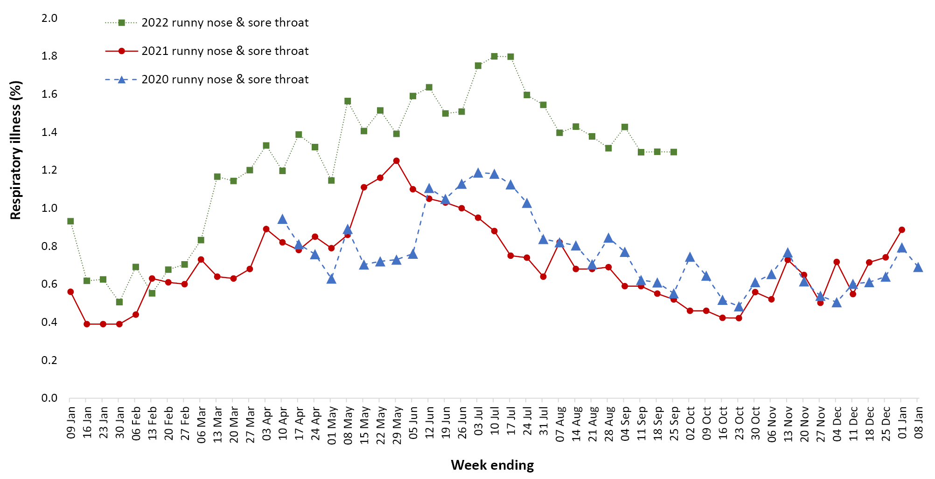
a Data on runny nose and sore throat were only collected systematically after 29 March 2020, therefore a historical average for this symptom profile is unavailable.
Over the reporting period, FluTracking data indicated that 26% of participants with ‘fever and cough’ were tested for SARS-CoV-2 with a PCR test and 77% were tested using a RAT (noting that in some instances RATs will be followed up by a PCR test for the same case). Of those with runny nose and sore throat, 9% were tested for SARS-CoV-2 using a PCR test and 62% were tested using a RAT. In the current reporting period, the percent positivity for fever and cough symptoms decreased by 12% compared to the previous reporting period for both PCR and RAT to 23% for both testing methods. For runny nose and sore throat symptoms, the percent positivity decreased for both testing methods, at 8% for PCR and 3% for RAT. Note that participants with one set of symptoms are not excluded from having the other. It is important to acknowledge that there may be legitimate reasons why people did not get tested, including barriers to accessing testing. Symptoms reported to FluTracking are not specific to COVID-19 and may also be due to infections with other respiratory pathogens and to chronic diseases, such as asthma.
From 29 August to 25 September 2022, of presentations to Commonwealth Respiratory Clinics that were tested for SARS-CoV-2, 4.5% (2,013/44,319) were found to be positive. The most commonly reported symptom amongst presentations that tested positive for COVID-19 was sore throat (56.5%), followed by cough (55.6%) and tiredness (43.9%).
Since the start of 2022, of those presenting to sentinel ASPREN sites with influenza-like illness who were tested for respiratory viruses, 56% (470/834) tested positive. Among those positive, the most common virus detected was influenza A (34%; 161/470), followed by rhinovirus (25%; 115/470); of those testing positive, 13% (60/470) were positive for SARS-CoV-2.

Countries and territories in Australia’s near region
According to WHO, countries and territories in the South East Asian and Western Pacific regions reported 6,377,117 newly-confirmed cases and 13,362 deaths in the four-week period to 25 September 2022. Compared to the previous four-week reporting period, new cases and new deaths decreased in both the Western Pacific and South East Asia regions.⁵ In total, since the start of the pandemic, over 149 million cases and over one million deaths have been reported in the two regions.⁶
Table 9 outlines new cases and deaths in the four-week period to 25 September 2022 and cumulative cases and deaths for the pandemic in selected countries with the highest number of new cases in the South East Asian region and the Western Pacific region.
Table 9: Cumulative cases and deaths, and new cases and deaths reported in the four-week period to 25 September 2022 for selected countries in Australia’s near region according to WHOª
Country | Cumulative cases | New cases reported in the last 4 weeks | Change in new cases in the last 4 weeks^{b} | Cumulative deaths | New deaths reported in the last 4 weeks | Change in new deaths in the last 4 weeks^{b}
South East Asian region
India | 44,568,114 | 159,982 | -59% | 528,510 | 756 | -46%
Indonesia | 6,422,529 | 76,225 | -45% | 158,014 | 514 | +1%
Thailand | 4,678,352 | 31,940 | -43% | 32,718 | 496 | -41%
Bangladesh | 2,021,690 | 10,373 | 71% | 29,353 | 30 | -6%
Myanmar | 621,402 | 6,440 | 640% | 19,455 | 18 | +500%
Western Pacific region
Japan | 21,023,814 | 2,843,389 | -49% | 44,331 | 5,561 | -11%
Republic of Korea | 24,620,128 | 1,636,310 | -49% | 28,213 | 1,644 | +8%
China | 7,404,545 | 1,091,501 | 57% | 26,132 | 1,433 | +34%
Australia | 10,191,312 | 214,730 | -67% | 14,853 | 1,205 | -39%
Viet Nam | 11,471,340 | 69,743 | -89% | 43,146 | 36 | +100%
a Source: World Health Organization Coronavirus (COVID-19) Dashboard, accessed 11 October 2022.
b Percent change in the number of newly confirmed cases/deaths in the most recent four-week period compared to the four weeks prior.
As of 25 September 2022, over 612 million COVID-19 cases and approximately 6.5 million deaths have been reported globally since the start of the pandemic, with a global case fatality rate (CFR) of approximately 1.1%. The two regions reporting the largest burden of disease over the past four weeks were the Western Pacific region (43% of total cases) and the European region (36% of total cases).

Acknowledgements
We thank public health staff from incident emergency operations centres and public health units in state and territory health departments, and the Australian Government Department of Health and Aged Care, along with state and territory public health laboratories. We thank those who have provided data from surveillance systems, such as Commonwealth respiratory clinics, ASPREN, FluTracking, FluCAN, SPRINT-SARI, Communicable Disease Genomics Network, AusTrakka and jurisdictional sequencing laboratories.

Author details

Corresponding author
COVID-19 National Incident Centre Surveillance Team
Australian Government Department of Health and Aged Care, GPO Box 9484, MDP 14, Canberra, ACT 2601.
Email: epi.coronavirus@health.gov.au

References
- COVID-19 National Incident Room Surveillance Team. COVID-19 Australia: Epidemiology Report 65: Reporting period ending 28 August 2022. Commun Dis Intell (2018). 2022;46. doi: https://doi.org/10.33321/cdi.2022.46.57.
- COVID-19 National Incident Room Surveillance Team. Technical supplement. COVID-19 Australia: Epidemiology reporting. Commun Dis Intell (2018). 2021;45. doi: https://doi.org/10.33321/cdi.2021.45.2.
- Communicable Diseases Genomics Network (CDGN). AusTrakka. [Website.] Melbourne: CDGN; 2020. Available from: https://www.cdgn.org.au/austrakka.
- Dalton C, Durrheim D, Fejsa J, Francis L, Carlson S, d’Espaignet ET et al. Flutracking: a weekly Australian community online survey of influenza-like illness in 2006, 2007 and 2008. Commun Dis Intell Q Rep. 2009;33(3):316–22.
- World Health Organization (WHO). Weekly epidemiological update on COVID-19 – 28 September 2022. [Internet.] Geneva: WHO; 28 September 2022. [Accessed on 11 October 2022.] Available from: https://www.who.int/publications/m/item/weekly-epidemiological-update-on-covid-19---28-september-2022.
- WHO. WHO Coronavirus Disease (COVID-19) dashboard. [Internet.] Geneva: WHO; 2021. Available from: https://covid19.who.int/.

Appendix A: Supplementary figures and tables
Table A.1: COVID-19 cases and rates per 100,000 population, by age group, sex, and notification received date, Australia, 15 December 2021 – 25 September 2022^{a,b}
Age group | Four-week reporting period |  |  |  |  |  | Current ‘Omicron’ wave
 | 29 August – 25 September 2022 |  |  |  |  |  | 15 December 2021 – 25 September 2022
 | Cases |  |  | Rate per 100,000 population |  |  | Cases |  |  | Rate per 100,000 population
 | Male | Female | People | Male | Female | People | Male | Female | People | Male | Female | People
0–4 | 3,527 | 3,182 | 7,274 | 450.7 | 431.0 | 478.3 | 184,303 | 175,304 | 393,856 | 23,551.5 | 23,742.1 | 25,895.9
5–11 | 4,346 | 4,276 | 9,211 | 370.1 | 384.0 | 402.6 | 363,475 | 345,609 | 782,394 | 30,949.2 | 31,034.2 | 34,194.6
12–15 | 2,371 | 2,251 | 4,986 | 363.1 | 363.9 | 392.1 | 212,148 | 214,149 | 475,094 | 32,487.9 | 34,620.7 | 37,362.9
16–17 | 1,191 | 1,376 | 2,787 | 392.5 | 480.5 | 472.5 | 96,170 | 110,077 | 224,770 | 31,690.2 | 38,442.5 | 38,108.8
18–29 | 12,950 | 15,969 | 30,844 | 625.2 | 802.7 | 759.5 | 758,762 | 883,420 | 1,749,153 | 36,630.6 | 44,405.0 | 43,073.6
30–39 | 12,857 | 15,735 | 30,680 | 689.6 | 821.1 | 811.5 | 645,533 | 764,163 | 1,520,855 | 34,625.1 | 39,878.3 | 40,228.0
40–49 | 9,946 | 12,347 | 24,017 | 609.2 | 742.8 | 728.9 | 525,101 | 629,210 | 1,249,805 | 32,161.2 | 37,851.8 | 37,930.2
50–59 | 8,437 | 11,196 | 21,225 | 549.7 | 695.9 | 675.2 | 413,633 | 482,006 | 963,969 | 26,950.5 | 29,959.2 | 30,663.9
60–69 | 6,937 | 8,508 | 16,616 | 523.0 | 602.7 | 606.9 | 283,810 | 311,786 | 636,385 | 21,399.3 | 22,087.2 | 23,243.7
70–79 | 5,578 | 6,010 | 12,358 | 589.7 | 597.0 | 632.9 | 166,377 | 165,075 | 348,793 | 17,588.9 | 16,397.5 | 17,862.7
80–89 | 2,946 | 3,294 | 6,593 | 760.2 | 673.9 | 752.3 | 71,480 | 79,327 | 156,681 | 18,444.3 | 16,229.5 | 17,879.3
90 + | 859 | 1,600 | 2,550 | 1,104.3 | 1,109.9 | 1,148.9 | 18,010 | 32,693 | 52,130 | 23,152.7 | 22,678.9 | 23,487.9
a Source: NNDSS, extract from 27 September 2022 for notifications to 25 September 2022. At the time of extraction, probable cases were not yet available from Tasmania; and were incomplete from Victoria since 29 July 2022 and the Northern Territory since 8 September 2022. At the time of extraction, Queensland was only reporting cases where testing was conducted in a clinical setting; probable cases with self-administered testing were not reported to NNDSS.
b Population data based on Australian Bureau of Statistics (ABS) Estimated Resident Population (ERP) as at June 2021.

Communicable Diseases Intelligence
ISSN: 2209-6051 Online

Communicable Diseases Intelligence (CDI) is a peer-reviewed scientific journal published by the Office of Health Protection and Response, Department of Health and Aged Care. The journal aims to disseminate information on the epidemiology, surveillance, prevention and control of communicable diseases of relevance to Australia.

Editor: Noel Lally
Deputy Editor: Simon Petrie
Design and Production: Kasra Yousefi
Editorial Advisory Board: David Durrheim, Mark Ferson, John Kaldor, Martyn Kirk and Linda Selvey

Website: http://www.health.gov.au/cdi

Contacts
CDI is produced by the Office of Health Protection and Response, Australian Government Department of Health and Aged Care, GPO Box 9848, (MDP 6) CANBERRA ACT 2601

Email: cdi.editor@health.gov.au

Submit an Article
You are invited to submit your next communicable disease related article to the Communicable Diseases Intelligence (CDI) for consideration. More information regarding CDI can be found at: http://health.gov.au/cdi.
Further enquiries should be directed to: cdi.editor@health.gov.au.

This journal is indexed by Index Medicus and Medline.

Creative Commons Licence - Attribution-NonCommercial-NoDerivatives CC BY-NC-ND
© 2022 Commonwealth of Australia as represented by the Department of Health and Aged Care
This publication is licensed under a Creative Commons Attribution-NonCommercial-NoDerivatives 4.0 International Licence from https://creativecommons.org/licenses/by-nc-nd/4.0/legalcode (Licence). You must read and understand the Licence before using any material from this publication.

Restrictions
The Licence does not cover, and there is no permission given for, use of any of the following material found in this publication (if any):
- the Commonwealth Coat of Arms (by way of information, the terms under which the Coat of Arms may be used can be found at www.itsanhonour.gov.au);
- any logos (including the Department of Health and Aged Care’s logo) and trademarks;
- any photographs and images;
- any signatures; and
- any material belonging to third parties.

Disclaimer
Opinions expressed in Communicable Diseases Intelligence are those of the authors and not necessarily those of the Australian Government Department of Health and Aged Care or the Communicable Diseases Network Australia. Data may be subject to revision.

Enquiries
Enquiries regarding any other use of this publication should be addressed to the Communication Branch, Department of Health and Aged Care, GPO Box 9848, Canberra ACT 2601, or via e-mail to: copyright@health.gov.au

Communicable Diseases Network Australia
Communicable Diseases Intelligence contributes to the work of the Communicable Diseases Network Australia.
http://www.health.gov.au/cdna

