Communicable Diseases Intelligence, Year 2023, Volume 47
https://doi.org/10.33321/cdi.2023.47.25
Publication date: 17/5/2023
http://health.gov.au/cdi

COVID-19 Australia: Epidemiology Report 73
Reporting period ending 9 April 2023
COVID-19 Epidemiology and Surveillance Team

Summary

Four-week reporting period (13 March – 9 April 2023)
Case definitions for confirmed and probable cases are in accordance with the coronavirus disease 2019 (COVID-19) Series of National Guidelines for Public Health Units (SoNG).
Trends – Nationally, following a relatively low and stable period of COVID-19 transmission from late January to late February 2023, there has been a gradual increase in case notifications since early March 2023. In the four-week period 13 March – 9 April 2023, there were 32,997 confirmed and 69,314 probable cases of COVID-19 reported in Australia to the National Notifiable Diseases Surveillance System (NNDSS). In the most recent reporting fortnight, a total of 53,926 confirmed and probable cases were notified (an average of 3,852 cases per day), compared to 48,385 in the previous fortnight (an average of 3,456 cases per day).
Age group – Since early March 2023, notification rates have increased slightly across all age groups. In the current reporting period 13 March – 9 April 2023, the highest notification rate was observed among adults aged 80 years and over, whilst the lowest rates were among people aged nine years or less. For the entire Omicron wave to date (15 December 2021 – 9 April 2023), the highest notification rate has been in adults aged 20 to 29 years.
Aboriginal and Torres Strait Islander people – In the reporting period 13 March – 9 April 2023, there were 2,846 new cases notified in Aboriginal and Torres Strait Islander people. In the Omicron wave to date (15 December 2021 – 9 April 2023), there have been 407,452 cases notified in Aboriginal and Torres Strait Islander people, representing 3.7% (407,452/10,956,477) of all cases during this period.
Severity – The notification rate of cases with severe illness (defined as those admitted to ICU or died) has remained relatively low and stable since mid-February 2023. The overall crude case fatality rate since 1 March 2023 is 0.24%, which is higher than the third (0.21%) and lower than the fourth (0.32%) Omicron waves. The current case fatality rate is likely overestimated due to changes in case ascertainment and underreporting of non-severe cases. Since the start of the pandemic to 9 April 2023, there have been 175 cases of paediatric inflammatory multisystem syndrome temporally associated with SARS-CoV-2 (PIMS-TS) reported to PAEDS, with none in the current reporting period and two new cases from the previous reporting period.
Virology – For samples collected in the four-week period 13 March – 9 April 2023, all 4,432 samples were assigned against Omicron or recombinants consisting of Omicron lineages. There is currently significant diversity in the range of sub- and sub-sub-lineages circulating within Australia. During the reporting period, more than 200 unique lineages have been identified. Recombinant lineages represent the majority (76.0%) of sequences collected during 13 March – 9 April 2023 and available for analysis in AusTrakka. In the same period, BA.2 (now predominantly represented by the BA.2.75 sub-lineage) and BA.5 made up 20.5% and 3.4%, respectively, of sequences identified. Of the Omicron sequences in AusTrakka to date, 18.7% are BA.1; 29.6% are BA.2 (excluding BA.2.75); 8.7% are BA.2.75; <0.001% are BA.3; 3.6% are BA.4, and 30.6% are BA.5. All sub-lineages have been collapsed into respective major sub-lineages. Recombinants make up 8.8% of all Omicron sequences to date.
Acute respiratory illness – Based on self-reported FluTracking data, there has been an overall increase in the prevalence of ‘fever and cough’ and ‘runny nose and sore throat’ symptoms in the community since late January 2023. Over the current reporting period, the rate of ‘fever and cough’ has been slightly less than the rates observed during the same period in 2022. The rate of ‘runny nose and sore throat’ symptoms has increased considerably over the current reporting period, surpassing the rates observed during the same period in previous years.
International situation – According to the World Health Organization (WHO), cumulative global COVID-19 cases stood at over 762 million COVID-19 cases and over 6.8 million deaths as of 9 April 2023. For the South-East Asia and Western Pacific regions combined, there were 799,054 new cases and 2,328 deaths in the four-week period to 9 April 2023. Compared with the previous four-week reporting period, new cases and deaths increased considerably in the South-East Asia Region, while new cases and deaths decreased in the Western Pacific region. In total, since the start of the pandemic, approximately 263 million cases and over 1.2 million deaths have been reported in the two regions.
Keywords: SARS-CoV-2; novel coronavirus; 2019-nCoV; coronavirus disease 2019; COVID-19; acute respiratory disease; epidemiology; Australia
This reporting period covers the four-week period of 13 March – 9 April 2023. Within this period, data for each week is compared. The previous reporting period was the preceding four weeks (13 February – 12 March 2023).¹ The focus of this report is on the epidemiological situation in Australia since the beginning of the Omicron wave. For the purposes of this report, 15 December 2021 is used as a proxy for the beginning of this wave. This date was chosen as from this date onwards, most sequenced strains from cases were Omicron. Readers are encouraged to consult prior reports in this series for information on the epidemiology of coronavirus disease 2019 (COVID-19) in Australia.
Methods of data analysis in these reports have periodically changed over the course of this reporting series to date. Please refer to the Technical Supplement for details of such changes, and for definitions of terminology.²
From Report #72 onward, and unless specified otherwise, all data from the National Notifiable Diseases Surveillance System (NNDSS) have been extracted using ‘diagnosis date’ rather than ‘notification received date’ (see the Technical Supplement for definitions). Due to COVID-19 reporting changes in several states and territories, the use of ‘diagnosis date’ now provides a more consistent and accurate method for describing transmission trends in Australia.
The case data provided includes both confirmed cases and probable cases reported to the NNDSS, as defined in accordance with the COVID-19 series of national guidelines (SoNG).³ For the purposes of this report, only probable cases from 5 January 2022 are included.
From Report #71 onward, population data for Aboriginal and Torres Strait Islander people was updated (from 2016) and is now based on Australian Bureau of Statistics (ABS) Estimated Resident Population (ERP) as at 2021. There has been an increase of 185,600 Aboriginal and Torres Strait Islander people (23.2%) since the previous ERP (June 2016). Therefore, notification rate comparisons with reports prior to #71 should be undertaken with caution.
Several jurisdictions have stopped reporting SARS-CoV-2 polymerase chain reaction (PCR) denominator testing data, therefore testing rates and percent positivity calculations are no longer included in this report.
Due to the dynamic nature of data in the NNDSS, numbers may be subject to revision and may vary from numbers previously reported and from case notifications released by states and territories.

Background and data sources
See the Technical Supplement for general information on COVID-19 including modes of transmission, common symptoms, and severity.²

Activity

COVID-19 trends

(NNDSS and jurisdictional reporting to the National Incident Centre)
Cumulatively, from the beginning of the pandemic to 9 April 2023, jurisdictions within Australia have reported 11,199,850 COVID-19 cases to the NNDSS. Nationally, following a relatively low and stable period of COVID-19 transmission from late January to late February 2023, there has been a gradual increase in case notifications since early March. In the four-week period 13 March – 9 April 2023, there were 32,997 confirmed and 69,314 probable cases of COVID-19 reported in Australia to NNDSS (Table 1). In the most recent reporting fortnight, a total of 53,926 confirmed and probable cases were notified (an average of 3,852 cases per day), compared to 48,385 in the previous fortnight (an average of 3,456 cases per day).
Since the emergence of the Omicron variant in Australia, there have been four distinct waves of transmission, defined by the predominant Omicron subvariant circulating (Figure 1). The first wave, driven by the BA.1 subvariant, occurred from mid-December 2021 to February 2022, with a peak in cases observed in early January 2022. From March 2022, the BA.2 subvariant was the predominant strain; in this second Omicron wave, there was a primary peak in early April and a secondary peak in late May 2022 (Figure 1). In early July 2022, BA.5 (including sub-lineages) became the predominant subvariant detected in Australia, driving a third wave of transmission which peaked in the week ending 24 July 2022. A fourth wave of transmission commenced in late October 2022, driven by a combination of existing and newly emerging Omicron subvariants. This wave peaked during the week ending 11 December 2022. Nationally, since early March 2023, there has been a gradual increasing trend in case notifications (Figure 1).
Due to a reduction in case ascertainment in all jurisdictions, including changes in testing and reporting requirements, reported case numbers are an underestimate of disease incidence in the community.

Figure 1: Confirmed and probable weekly COVID-19 notified cases by date of onset, Australia, 29 November 2021 – 9 April 2023 ª
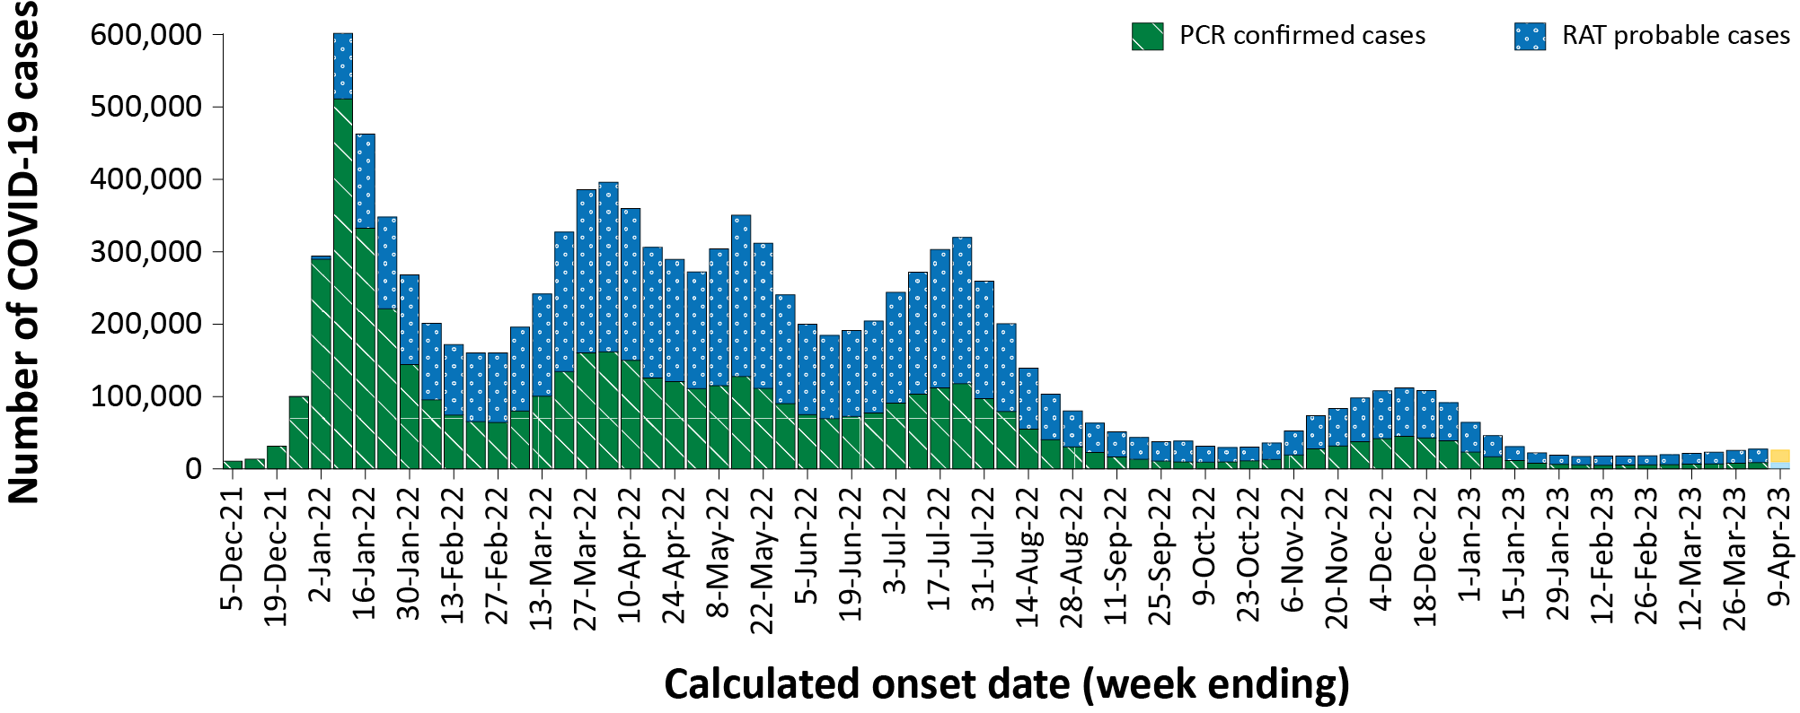
a Source: NNDSS extract from 19 April 2023 for cases with an illness onset from 29 November 2021 to 9 April 2023.
Table 1: Confirmed and probable COVID-19 cases by jurisdiction and date of illness onset, Australia, 15 December 2021 – 9 April 2023 ^{a,b,c}
Jurisdiction | Reporting period |  |  |  |  |  | Current Omicron wave
 | 13–26 March 2023 |  |  | 27 March – 9 April 2023 |  |  | 15 December 2021 – 9 April 2023
 | Confirmed | Probable | Total | Confirmed | Probable | Total | Confirmed | Probable | Total
ACT | 210  (19.3%) | 879  (80.7%) | 1,089 | 279  (26.5%) | 774  (73.5%) | 1,053 | 130,564  (55.8%) | 103,237  (44.2%) | 233,801
NSW | 8,717  (49.8%) | 8,791  (50.2%) | 17,508 | 10,091  (53.7%) | 8,711  (46.3%) | 18,802 | 2,084,976 (56.6%) | 1,598,956 (43.4%) | 3,683,932
NT | 100  (30.0%) | 233  (70.0%) | 333 | 143  (34.7%) | 269  (65.3%) | 412 | 22,733  (21.6%) | 82,333  (78.4%) | 105,066
Qld | 1,711  (24.9%) | 5,149  (75.1%) | 6,860 | 2,268  (30.0%) | 5,280  (70.0%) | 7,548 | 673,689  (40.2%) | 1,001,985 (59.8%) | 1,675,674
SA | 1,940  (32.7%) | 3,998  (67.3%) | 5,938 | 2,199  (34.4%) | 4,189  (65.6%) | 6,388 | 516,109  (57.4%) | 382,981  (42.6%) | 899,090
Tas. | 175  (11.5%) | 1,351  (88.5%) | 1,526 | 200  (11.0%) | 1,610  (89.0%) | 1,810 | 65,183  (22.4%) | 226,115  (77.6%) | 291,298
Vic. | 1,516  (16.9%) | 7,429  (83.1%) | 8,945 | 2,185  (19.3%) | 9,164  (80.7%) | 11,349 | 1,078,295 (39.1%) | 1,681,235 (60.9%) | 2,759,530
WA | 533  (8.6%) | 5,653  (91.4%) | 6,186 | 730  (11.1%) | 5,834  (88.9%) | 6,564 | 495,426  (37.9%) | 812,660  (62.1%) | 1,308,086
Australia | 14,902 (30.8%) | 33,483 (69.2%) | 48,385 | 18,095 (33.6%) | 35,831 (66.4%) | 53,926 | 5,066,975 (46.2%) | 5,889,502 (53.8%) | 10,956,477
a Source: NNDSS extract from 19 April 2023 for cases with an illness onset from 15 December 2021 to 9 April 2023.
b ACT: Australian Capital Territory; NSW: New South Wales; NT: Northern Territory; Qld: Queensland; SA: South Australia; Tas.: Tasmania; Vic.: Victoria; WA: Western Australia.
c Cases are classified based on jurisdiction of notification not jurisdiction of residence. Some cases are notified to a different jurisdiction than their location of residence.

Demographic features

(NNDSS)
Since early March 2023, notification rates have increased slightly across all age groups (Figure 2). The highest notification rates continue to be among adults aged 40 years and over (Figure 2). In the current reporting period, 13 March – 9 April 2023, the highest notification rate was observed among adults aged 80 years and over, whilst the lowest rates were among people aged nine years or less (Appendix A, Table A.1). For the entire Omicron wave to date (15 December 2021 – 9 April 2023), the highest notification rate has been in adults aged 20 to 29 years (Appendix A, Table A.1). For this age group, the weekly notification rate peaked in the week ending 9 January 2022 at approximately 5,800 cases per 100,000 population (not depicted).
Figure 2: Confirmed and probable COVID-19 notification rates for ten-year age groups by date of onset, Australia, 27 June 2022 – 9 April 2023 ^{a,b}
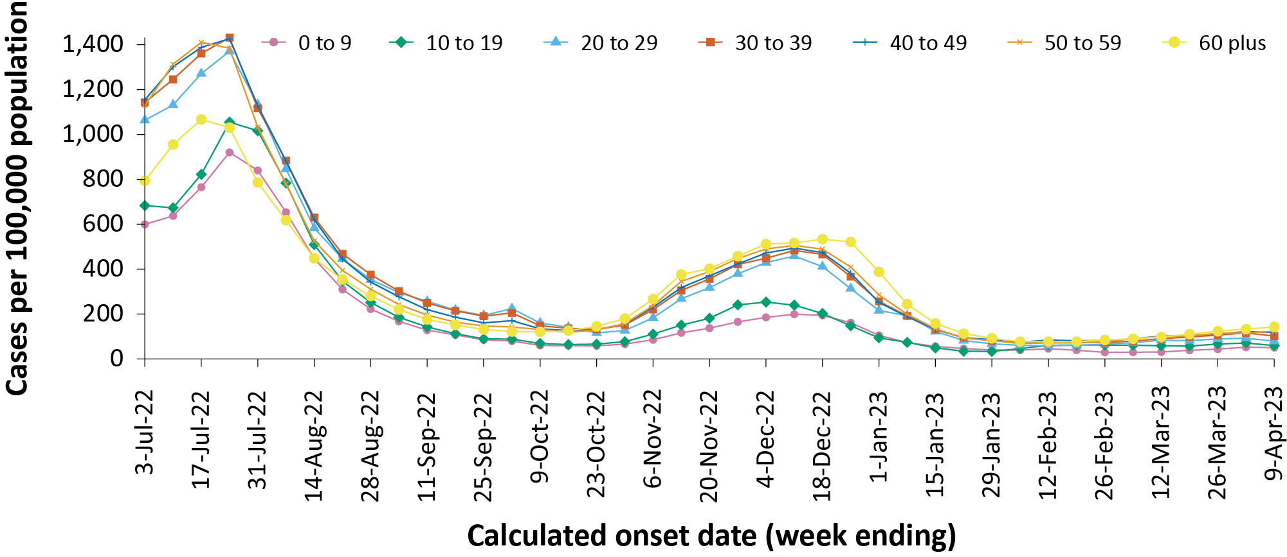
a Source: NNDSS extract from 19 April 2023 for cases with an illness onset from 27 June 2022 to 9 April 2023.
b Population data based on Australian Bureau of Statistics (ABS) Estimated Resident Population (ERP) as at June 2022.

Aboriginal and Torres Strait Islander persons

(NNDSS)
Overall, since the start of the pandemic, Indigenous status is unknown for approximately 13.0% of COVID-19 cases in NNDSS. Therefore, the number of cases classified as Aboriginal and Torres Strait Islander people is likely an under-representation. During the reporting period, there were 2,846 new cases notified among Aboriginal and Torres Strait Islander people (Table 2). In the Omicron wave (15 December 2021 – 9 April 2023) there have been 407,452 cases notified among Aboriginal and Torres Strait Islander people, representing 3.7% (407,452/10,956,477) of all cases in the Omicron wave to date.

Table 2: Confirmed and probable cases of COVID-19 among Aboriginal and Torres Strait Islander peoples by jurisdiction and date of onset, Australia, 15 December 2021 – 9 April 2023 ^{a,b,c}
Jurisdiction | 13–19 March 2023 | 20–26 March 2023 | 27 March – 2 April 2023 | 3–9 April 2023 | 15 December 2021 –  9 April 2023 (Omicron wave)
ACT | 7 | 12 | 13 | 4 | 4,143
NSW | 219 | 279 | 297 | 276 | 133,842
NT | 15 | 20 | 35 | 33 | 25,582
Qld | 151 | 199 | 210 | 163 | 108,955
SA | 51 | 44 | 46 | 58 | 23,414
Tas. | 25 | 44 | 46 | 31 | 16,723
Vic. | 36 | 48 | 51 | 60 | 35,469
WA | 86 | 108 | 99 | 80 | 59,324
Australia | 590 | 754 | 797 | 705 | 407,452
a Source: NNDSS extract from 19 April 2023 for cases with an illness onset from 15 December 2021 to 9 April 2023.
b ACT: Australian Capital Territory; NSW: New South Wales; NT: Northern Territory; Qld: Queensland; SA: South Australia; Tas: Tasmania; Vic: Victoria; WA: Western Australia.
c Cases are classified based on jurisdiction of notification not jurisdiction of residence. Some cases are notified to a different jurisdiction than their location of residence.
Of the COVID-19 cases notified among Aboriginal and Torres Strait Islander people from 15 December 2021 to date, and where location of residence was known, 55.0% (222,474/404,671) lived in a regional or remote area (Table 3). Most cases reported in outer regional and remote areas since the start of the Omicron wave were diagnosed using RATs, at 71.5% (53,907/73,357) and 73.3% (36,905/50,334), respectively. It should be noted that the reliance on RATs for diagnosing COVID-19 is greater in regional and remote areas than in major cities, resulting in a larger under-representation of cases in regional and remote areas than in major cities, due to the changes in reporting requirements of positive RATs.
Nationally, there have been 361 COVID-19 associated deaths reported in Aboriginal and Torres Strait Islander people from the start of the pandemic to 9 April 2023 (Table 4). This comprises 116 from New South Wales; 114 from Queensland; 49 from the Northern Territory; 42 from Western Australia; 22 from South Australia; 14 from Victoria; and two each from the Australian Capital Territory and Tasmania. Additionally, 624 Aboriginal and Torres Strait Islander cases have been admitted to intensive care units (ICU) nationally. During the fourth Omicron wave, the notification rate, to NNDSS, of severe cases (measured as those who were admitted to ICU or died) in Aboriginal and Torres Strait Islander people was 12.3 per 100,000 population, compared to 19.4 per 100,000 population during the third wave (Table 4). It should be noted that ICU status in NNDSS is likely incomplete.

Table 3: COVID-19 cases among Aboriginal and Torres Strait Islander people by area of remoteness, Australia, 15 December 2021 – 9 April 2023 ª
Jurisdiction ^{b,c} | Major city | Inner regional | Outer regional | Remote ^{d}
ACT | 4,093 | 36 | 12 | 1
NSW | 71,926 | 43,292 | 14,867 | 3,029
NT | 68 | 18 | 7,971 | 16,537
Qld | 42,094 | 25,004 | 30,561 | 11,154
SA | 12,684 | 2,515 | 4,897 | 3,189
Tas. | 206 | 10,197 | 5,884 | 291
Vic. | 20,207 | 11,450 | 3,756 | 18
WA | 30,919 | 4,271 | 7,409 | 16,115
Australia | 182,197 | 96,783 | 75,357 | 50,334
a Source: NNDSS extract from 19 April 2023 for cases with an illness onset from 15 December 2021 to 9 April 2023. Excludes cases with an overseas place of residence, and where place of residence is unknown.
b ACT: Australian Capital Territory; NSW: New South Wales; NT: Northern Territory; Qld: Queensland; SA: South Australia; Tas.: Tasmania; Vic.: Victoria; WA: Western Australia.
c Cases are classified based on jurisdiction of notification not jurisdiction of residence. Some cases are notified to a different jurisdiction than their location of residence.
d ‘Remote’ here also includes areas classified as ‘very remote’.
Table 4: Confirmed and probable COVID-19 cases in Aboriginal and Torres Strait Islander people by age and highest level of illness severity, Australia, 1 January 2020 to 9 April 2023 ^{a,b,c}
Age group (years) | 1 March – 9 April 2023 |  |  |  | Fourth Omicron wave  24 October 2022 – 28 February 2023 |  |  |  | Third Omicron wave  15 June – 23 October 2022 |  |  |  | Omicron wave to date  15 December 2021  – 9 April 2023 |  |  |  | Pandemic to date  1 January 2020  – 9 April 2023
 | ICU ^{a,c} | Died ª | ICU or died ^{a,c} | Rate ICU or died ^{b,c} | ICU ^{a,c} | Died ª | ICU or died ^{a,c} | Rate ICU or died ^{b,c} | ICU ^{a,c} | Died ª | ICU or died ^{a,c} | Rate ICU or died ^{b,c} | ICU ^{a,c} | Died ª | ICU or died ª | Rate ICU or died ^{b} | ICU ^{a,c} | Died ª | ICU or died ^{a,c} | Rate ICU or died ^{b,c}
0 to 9 | 1 | 0 | 1 | 0.5 | 7 | 0 | 7 | 3.3 | 10 | 1 | 11 | 5.1 | 38 | 2 | 39 | 18.2 | 40 | 2 | 41 | 19.1
10 to 19 | 0 | 0 | 0 | 0.0 | 3 | 0 | 3 | 1.4 | 6 | 0 | 6 | 2.9 | 35 | 0 | 35 | 16.9 | 45 | 0 | 45 | 21.7
20 to 29 | 1 | 0 | 1 | 0.6 | 5 | 0 | 5 | 3.0 | 7 | 0 | 7 | 4.2 | 61 | 0 | 61 | 36.9 | 76 | 0 | 76 | 46.0
30 to 39 | 1 | 0 | 1 | 0.8 | 7 | 2 | 8 | 6.4 | 9 | 2 | 11 | 8.9 | 41 | 11 | 51 | 41.1 | 60 | 11 | 70 | 56.4
40 to 49 | 2 | 0 | 2 | 2.0 | 8 | 0 | 8 | 8.1 | 9 | 5 | 12 | 12.1 | 64 | 27 | 84 | 84.7 | 86 | 32 | 107 | 107.9
50 to 59 | 2 | 0 | 2 | 2.3 | 18 | 6 | 24 | 27.3 | 30 | 20 | 45 | 51.3 | 98 | 54 | 144 | 164.1 | 126 | 60 | 175 | 199.4
60 plus | 4 | 3 | 7 | 8.2 | 24 | 44 | 66 | 76.9 | 37 | 68 | 99 | 115.4 | 160 | 241 | 371 | 432.4 | 191 | 256 | 409 | 476.7
All | 11 | 3 | 14 | 1.4 | 72 | 52 | 121 | 12.3 | 108 | 96 | 191 | 19.4 | 497 | 335 | 785 | 79.8 | 624 | 361 | 923 | 93.8
a ‘ICU’ and ‘died’ are not mutually exclusive categories; ‘died’ can include cases who died with or without prior admission to ICU. Therefore, the number of cases admitted to ICU or having died will not equal the sum of cases in ICU or died.
b Rate per 100,000 population for the given time period. Aboriginal and Torres Strait Islander population data is based on the Australian Bureau of Statistics (ABS) Estimated Resident Population (ERP) as at 2021.
c The Australian Capital Territory did not supply hospitalisation data from 12 November to 24 November 2022 due to technical reasons.

Severity

(NNDSS, FluCAN, SPRINT-SARI)
Given the delay between illness onset and severe illness, and to provide a more accurate assessment of severity, cases with an onset in the last two weeks have been excluded from analyses on the weekly rate of cases with severe illness (defined as cases admitted to ICU or died) and on the proportion of cases admitted to ICU or died.
Following the emergence of the Omicron wave, the notification rate of cases with severe illness peaked in mid-January 2022, at approximately 1,200 severe cases per week (not depicted). The peaks observed in the two most recent Omicron waves have been considerably less than this, at 893 severe cases during the third Omicron wave (week ending 24 July) and 478 severe cases in the fourth wave (week ending 18 December 2022; Figure 3).
Figure 3: COVID-19 cases, deaths and ICU admissions, Australia, by date of onset, Australia, 27 June 2022 to 9 April 2023 ^{a,b}
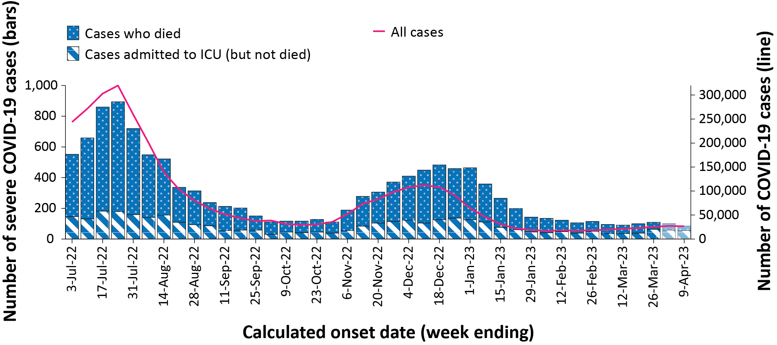
a Source: NNDSS extract from 19 April 2023 for cases with an illness onset from 27 June 2022 to 9 April 2023. The Australian Capital Territory did not supply hospitalisation data from 12 November to 24 November 2022 due to technical reasons.
b The shaded bars at the right represent the most recent two reporting weeks and should be interpreted with caution, as cases with an illness onset in these weeks may not have yet developed severe disease.
Rates of severe illness continue to be greater in older age groups, with the highest rates among those aged 60 years and older (Figure 4). Among this age group, there have been three notable peaks in severe illness since the emergence of Omicron: in the week ending 16 January 2022 (17.2 cases per 100,000 population; not depicted), in the week ending 24 July 2022 (13.3 cases per 100,000 population) and in the week ending 18 December 2022 (7.0 cases per 100,000 population; Figure 4). In comparison, rates of severe illness in younger age groups have remained relatively low and stable throughout the Omicron waves, not surpassing three cases per 100,000 population per week over that period (Figure 4).

Figure 4: Age-specific rates of COVID-19 cases admitted to ICU or died, by date of onset, Australia, 27 June 2022 to 26 March 2023 ^{a,b}
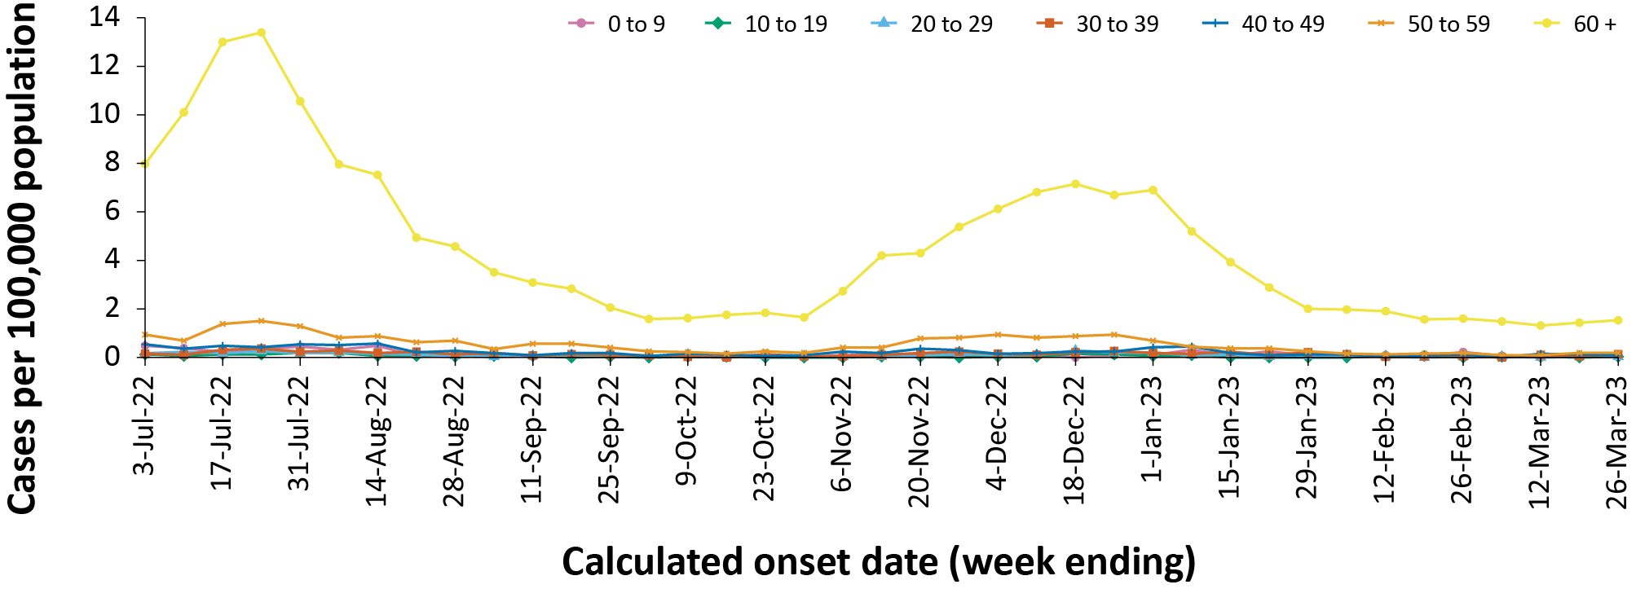
a Source: NNDSS extract from 19 April 2023 for cases with an illness onset from 27 June 2022 to 26 March 2023; cases with an illness onset in the last two weeks (27 March–9 April 2023) were excluded to account for the delay between onset and development of severe illness. The Australian Capital Territory did not supply hospitalisation data from 12 November to 24 November 2022 due to technical reasons.
b Population data based on Australian Bureau of Statistics (ABS) Estimated Resident Population (ERP) as at June 2022.

Hospitalisation and ICU admissions

Influenza Complications Alert Network—FluCAN
Between 15 December 2021 and 9 April 2023, there were 13,841 hospital admissions with confirmed COVID-19 reported at Influenza Complications Alert Network (FluCAN) sentinel sites, including 6% (766/13,841) admitted directly to ICU. During the four-week reporting period (13 March – 9 April 2023) there were 132 admissions with COVID-19 reported at FluCAN sentinel sites, with 3% (4/132) admitted directly to ICU.
Since the start of the fourth Omicron wave (24 October 2022), for patients admitted to FluCAN sentinel sites with confirmed COVID-19, the median length of stay was 3 days (interquartile range, IQR: 2–7 days); mean = 5.6 days (standard deviation, SD: 27.2). This is on par with the median length of stay observed during the third Omicron wave (3 days [IQR: 2–7 days]; mean = 6.4 days [SD: 14.0]).

Short Period Incidence Study of Severe Acute Respiratory Infection—SPRINT-SARI
Between 15 December 2021 and 9 April 2023, there were 5,166 COVID-19 cases admitted to ICUs participating in the sentinel surveillance system—Short Period Incidence Study of Severe Acute Respiratory Infection (SPRINT-SARI)⁴ (Table 5). During this time, 61.4% of patients (3,171/5,166) were discharged home; 13.5% (695/5,166) died in ICU; and 12.9% of patients (665/5,166) were receiving ongoing care, either in ICU or in hospital wards. In the four-week reporting period (13 March – 9 April 2023), there were 72 adult patients with COVID-19 admitted to ICU reported at SPRINT-SARI sentinel sites (Table 5).
Since the start of the Omicron wave (15 December 2021) to 9 April 2023, for patients admitted to SPRINT-SARI sentinel sites with COVID-19 (n = 5,166), the median length of stay in ICU was 3.3 days (range: 0–372 days); mean = 6.6 days (standard deviation, SD: 13.4), the median length of stay in hospital was 11.0 days (range: 0.1–424 days); mean = 17.7 days [SD: 25.5]) and the median duration of mechanical ventilation was 4.2 days (range: < 0.01–190 days); mean = 7.8 days [SD: 11.2]). During the four-week reporting period (13 March –9 April 2023) the median length of stay in ICU was 3.0 days (range: 0.4–19.8 days); mean = 4.5 days [SD: 4.3]), the median length of stay in hospital was 6.1 days (range: 0.7–194 days); mean = 13.4 days [SD: 30.0]) and the median duration of mechanical ventilation was 6.1 days (range: 0.06–18.6 days); mean = 7.4 days [SD: 6.0]).
Table 5: Patient outcomes for adult COVID-19 cases (aged greater than or equal to 18 years), Australia, 15 December 2021 – 9 April 2023 ª
Outcomes | Current reporting period  13 March – 9 April 2023 (n = 72) | Omicron wave to date  15 December 2021–9 April 2023 (n = 5,166)
Patient status
Ongoing care in ICU | 13 (18.1%) | 41 (0.8%)
Ongoing care in hospital ward | 24 (33.3%) | 624 (12.1%)
Transfer to other hospital/facility | 0 (0%) | 112 (2.2%)
Transfer to rehabilitation | 0 (0%) | 199 (3.9%)
Discharged home | 27 (37.5%) | 3,171 (61.4%)
Mortality - ICU | 8 (11.1%) | 695 (13.5%)
Mortality - hospital ward | 0 (0%) | 274 (5.3%)
Unknown | 0 (0%) | 44 (0.9%)
Incomplete | 0 (0%) | 6 (0.1%)
a Source: SPRINT-SARI.⁴

Risk factors for severe disease
Comorbidity data extracted from SPRINT-SARI reflect the sickest patients with COVID-19 who are managed in ICU; data are therefore not generalisable to all cases. In adult patients admitted to ICU with COVID-19 since 15 December 2021 to 12 March 2023, where comorbidity information was available, the most prevalent comorbidity was diabetes, followed by cardiac disease and past use of an Angiotensin-converting enzyme (ACE) inhibitor or Alpha-2 (A2) blocker (Figure 5). Of those adult patients admitted to ICU since 15 December 2021 to 12 March 2023, for whom comorbidity data was known, 41% of adult ICU patients had three or more comorbidities, with the most frequently reported combination of comorbidities being diabetes, cardiac disease, and ACE inhibitor or A2 blocker (n = 78).

Figure 5: Prevalence of comorbidities for COVID-19 cases among admitted adult ICU patients (aged greater than or equal to 18 years), Australia, 15 December 2021 – 9 April 2023 ª
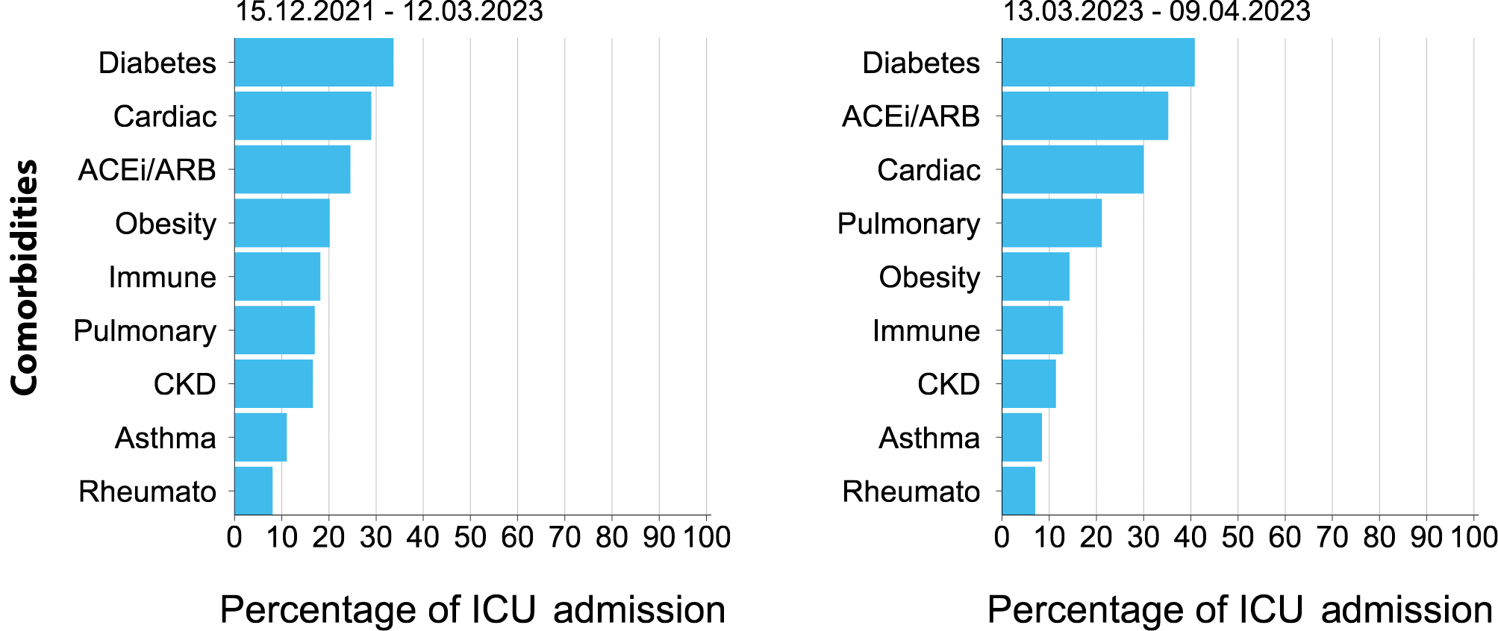
a Source: SPRINT-SARI. Only includes adult cases (≥ 18 years old) and excludes those with missing data on comorbidities or where comorbidity is unknown.
Figure 6: PIMS-TS cases reported to PAEDS, by sample month and level of care required, Australia, 1 June 2021 – 9 April 2023 ª
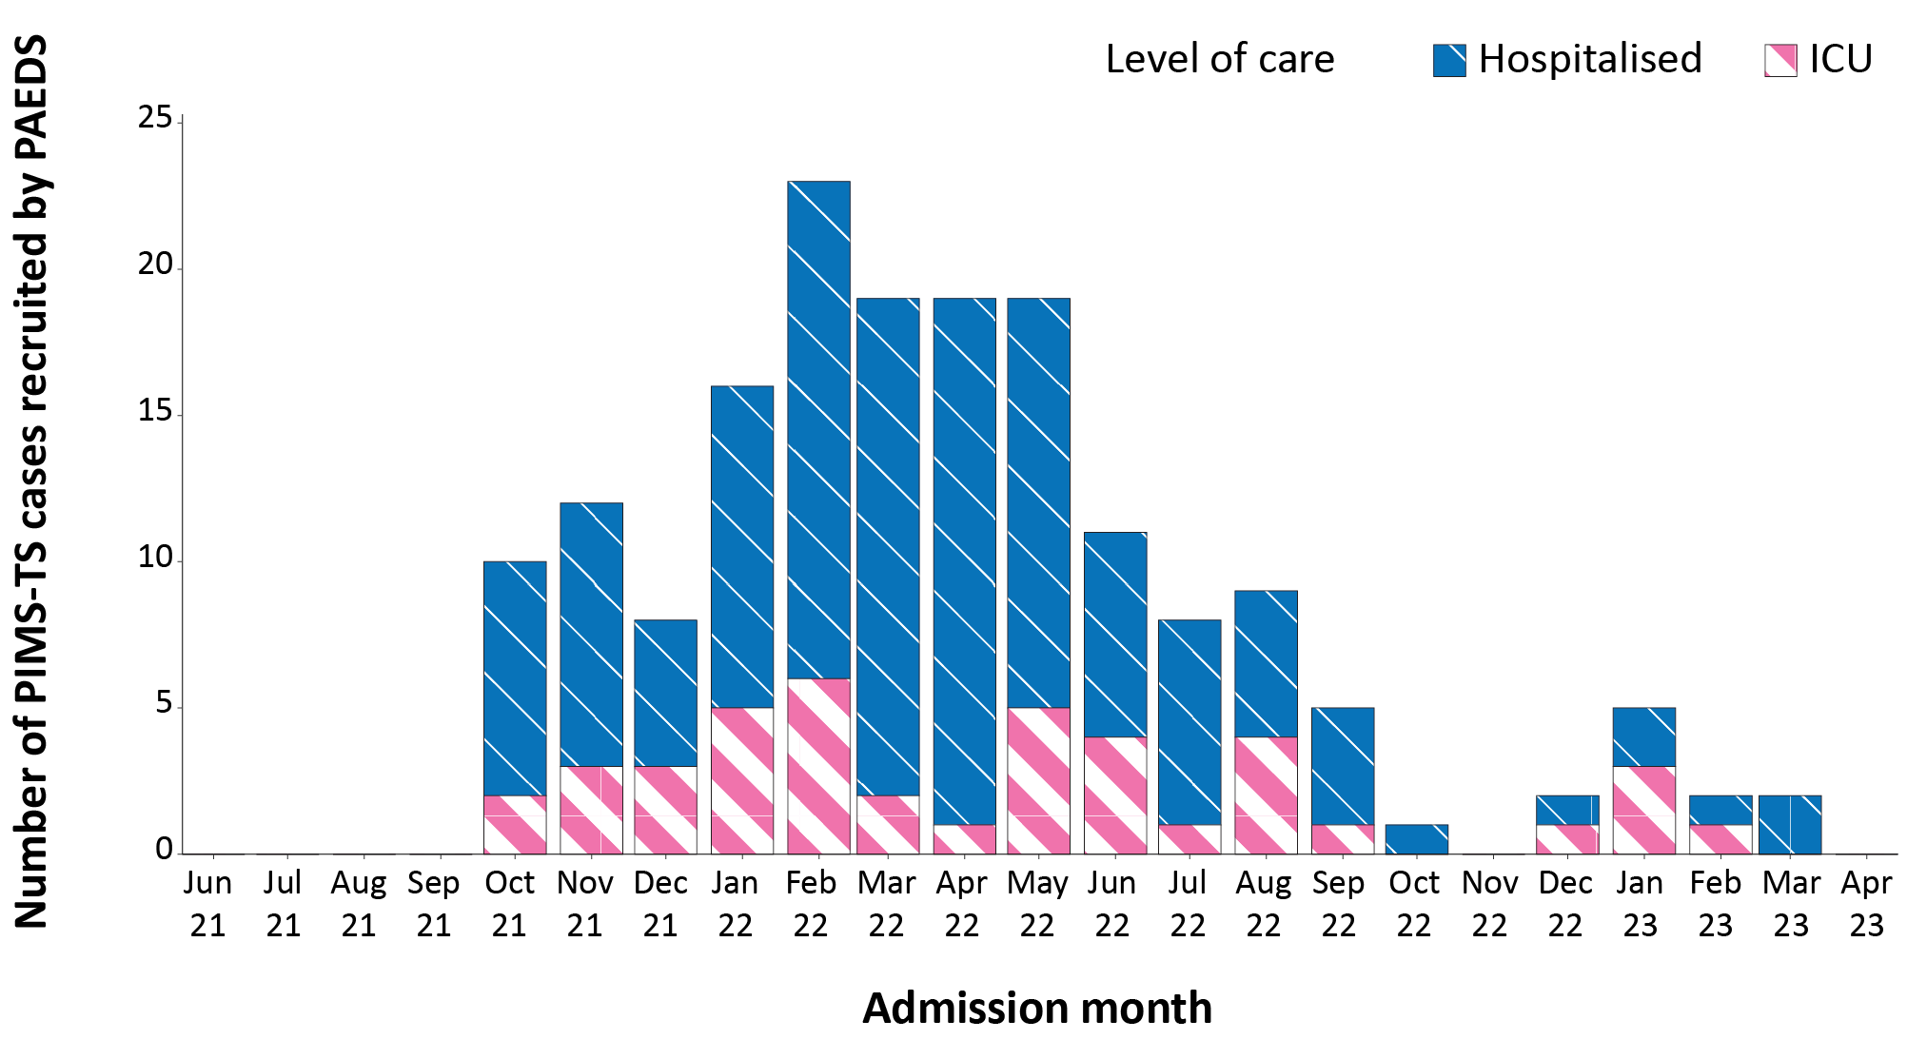
a Source: PAEDS.

Paediatric Inflammatory Multisystem Syndrome - Temporally Associated with SARS-CoV-2

Paediatric Active Enhanced Disease Surveillance
Since the start of the pandemic to 9 April 2023, there have been 175 cases of paediatric inflammatory multisystem syndrome - temporally associated with SARS-CoV-2 (PIMS-TS) reported to the Paediatric Active Enhanced Disease Surveillance network (PAEDS), with none in the current reporting period and two new cases from the previous reporting period. The majority of PIMS-TS cases to date have occurred in those aged 5 to < 12 years (52%; 91/175), followed by those aged 6 months to < 5 years (28%; 49/175). To date, there have been no PIMS-TS-associated deaths.

COVID-19 deaths
There were 380 COVID-19-associated deaths notified between 1 March and 9 April 2023. In total there have been 20,085 COVID-19-associated deaths reported in NNDSS since the start of the pandemic (Table 6). The overall crude case fatality rate since 1 March 2023 is 0.24%, which is higher than the third Omicron wave (0.21%) and lower than the fourth Omicron wave (0.32%) (Table 7). It should be noted that the current case fatality rate is likely to be overestimated due to changes in case ascertainment and underreporting of non-severe cases.
Table 6: Deaths associated with COVID-19 by reporting period, Australia, 1 January 2020 – 9 April 2023 ^{a,b,c}
Jurisdiction ^{c} | 1 March – 9 April 2023) | Fourth Omicron wave  24 October 2022 –  28 February 2023 | Third Omicron wave  15 June –  23 October 2022 | 15 December 2021 –  9 April 2023  (Omicron wave) | 1 January 2020 –  9 April 2023  (Pandemic to date)
ACT | 1 (0.3%) | 37 (1.0%) | 83 (1.4%) | 207 (1.2%) | 222 (1.1%)
NSW | 109 (28.7%) | 1,059 (29.3%) | 1,970 (32.3%) | 5,961 (33.5%) | 6,661 (33.2%)
NT | 0 (0.0%) | 13 (0.4%) | 22 (0.4%) | 91 (0.5%) | 92 (0.5%)
Qld | 71 (18.7%) | 506 (14.0%) | 1,079 (17.7%) | 2,885 (16.2%) | 2,893 (14.4%)
SA | 36 (9.5%) | 316 (8.8%) | 490 (8.0%) | 1,406 (7.9%) | 1,414 (7.0%)
Tas. | 12 (3.2%) | 63 (1.7%) | 101 (1.7%) | 249 (1.4%) | 263 (1.3%)
Vic. | 129 (33.9%) | 1,341 (37.2%) | 1,992 (32.7%) | 5,973 (33.6%) | 7,512 (37.4%)
WA | 22 (5.8%) | 274 (7.6%) | 354 (5.8%) | 1,016 (5.7%) | 1,028 (5.1%)
Australia | 380 (100.0%) | 3,609 (100.0%) | 6,091 (100.0%) | 17,788 (100.0%) | 20,085 (100.0%)
a Source: NNDSS, extract from 19 April 2023 for deaths to 9 April 2023.
b Deaths are categorised into time periods using date of death. Deaths with a missing date of death are classified using date of illness onset.
c ACT: Australian Capital Territory; NSW: New South Wales; NT: Northern Territory; Qld: Queensland; SA: South Australia; Tas.: Tasmania; Vic.: Victoria; WA: Western Australia.

Table 7: COVID-19 associated case fatality rates, among cases notified to NNDSS, by age group and date of onset, 1 January 2020 to 26 March 2023 ^{a,b,c,d}
Age group | 1 March – 26 March 2023 | Fourth Omicron wave  24 October 2022 –  28 February 2023 | Third Omicron wave  15 June –  23 October 2022 | Omicron  15 December 2021 –  26 March 2023 | Delta  16 June – 14 December 2021 | Pandemic  1 January 2020 –  26 March 2023
0–9 | 0.00% | 0.00% | <0.05% | <0.05% | <0.05% | <0.05%
10–19 | <0.05% | <0.05% | <0.05% | <0.05% | <0.05% | <0.05%
20–29 | 0.00% | <0.05% | <0.05% | <0.05% | <0.05% | <0.05%
30–39 | <0.05% | <0.05% | <0.05% | <0.05% | 0.06% | <0.05%
40–49 | <0.05% | <0.05% | <0.05% | <0.05% | 0.18% | <0.05%
50–59 | <0.05% | 0.05% | <0.05% | <0.05% | 0.65% | 0.05%
60 + | 0.86% | 1.04% | 1.04% | 1.00% | 6.13% | 1.12%
Australia | 0.24% | 0.32% | 0.21% | 0.16% | 0.71% | 0.18%
a Source: NNDSS, extract from 19 April 2023 for deaths to 26 March 2023.
b To account for the lag between illness onset and the development of severe illness, cases with an onset date in the last two weeks have been excluded from calculations of the case fatality rate.
c A value of 0.00% indicates that no COVID-19 associated fatalities occurred during the indicated period for the specified age group.
d Crude case fatality rates which reflect number of deaths as a proportion of reported COVID-19 cases during specific periods, noting these rates are likely overestimated due to underreporting of cases.

Genomic surveillance and virology

(Communicable Disease Genomics Network, AusTrakka and jurisdictional sequencing laboratories)
Nationally, 3.0% of COVID-19 cases have been sequenced since the start of the pandemic in January 2020, based on jurisdictional reporting (Table 8). Case numbers and sequencing proportion are based on polymerase chain reaction (PCR) results only, as rapid antigen tests (RAT) do not allow for sequencing. Where jurisdictions are unable to separate PCR confirmed and RAT only cases, proportions are an estimate only. Case numbers have been dropping since late 2022, and referrals of positive PCR samples to some sequencing laboratories have decreased significantly, resulting in changes to sequencing strategies across the country. However, the proportion of cases sequenced each reporting period has risen over the past few months. Changes in case numbers and availability of testing may cause these proportions to fluctuate over the coming months.

Table 8: Australian SARS-CoV-2 genome sequences and proportion of positive cases sequenced, 13 March – 9 April 2023 and cumulative to date ^{a,b,c}
Measure | Reporting period  13 March – 9 April 2023 | Cumulative  23 January 2020 – 9 April 2023
SARS-CoV-2 cases sequenced ª | 4,432 | 188,265
Percentage of positive cases sequenced ^{b} | 8.4% | 3.0%
a Total SARS-CoV-2 case numbers as reported by jurisdictional laboratories based on PCR results only. Cases identified via rapid antigen testing are reported differently by each jurisdiction and cannot be followed up for sequencing. They are therefore not included in the sequencing proportions reported here. Sequencing of samples from cases identified in the reporting period may be in process at the time of reporting. Remaining unsequenced samples may be due to jurisdictional sequencing strategy, or where samples have been deemed unsuitable for sequencing (typically because viral loads were too low for sequencing to be successful).
b Based on individual jurisdictional reports of sequences and case numbers. Calculations of the percentage of cases sequenced based on the number of sequences available in AusTrakka may not always be up to date, since this may include duplicate samples from cases and may not represent all available sequence data.
c Changes to reporting of case numbers in some jurisdictions have impacted the ability of laboratories to calculate proportion of sequenced case numbers for specified reporting periods.
Figure 7: Omicron sub-lineage proportions in Australia since 1 January 2022 by sample collection date ^{a,b,c}
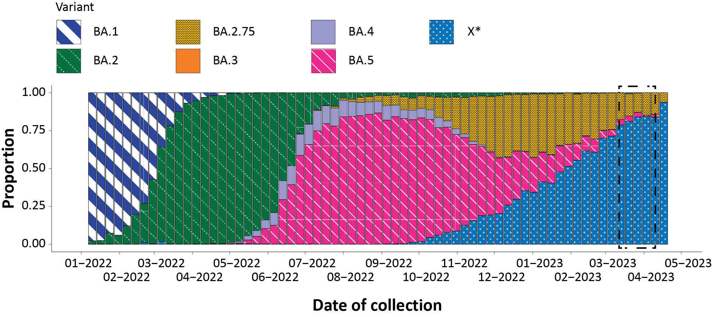
a Sequences in AusTrakka; aggregated by week.
b The current reporting period (13 March to 9 April 2023) is marked by the dashed lines.
c Proportions in the figure may not be representative when sequence numbers are small. Data may change week-to-week as sequences with older collection dates are uploaded. These numbers are not equivalent to number of cases, as there may be duplicates in the AusTrakka data. Newly designated Omicron sub-lineages have been collapsed into parent lineages BA.1, BA.2 (except BA.2.75, displayed separately), BA.3, BA.4 and BA.5; recombinants are designated by X*.

Figure 8: Samples in AusTrakka since 19 September 2022, by lineage and date of collection ^{a,b}
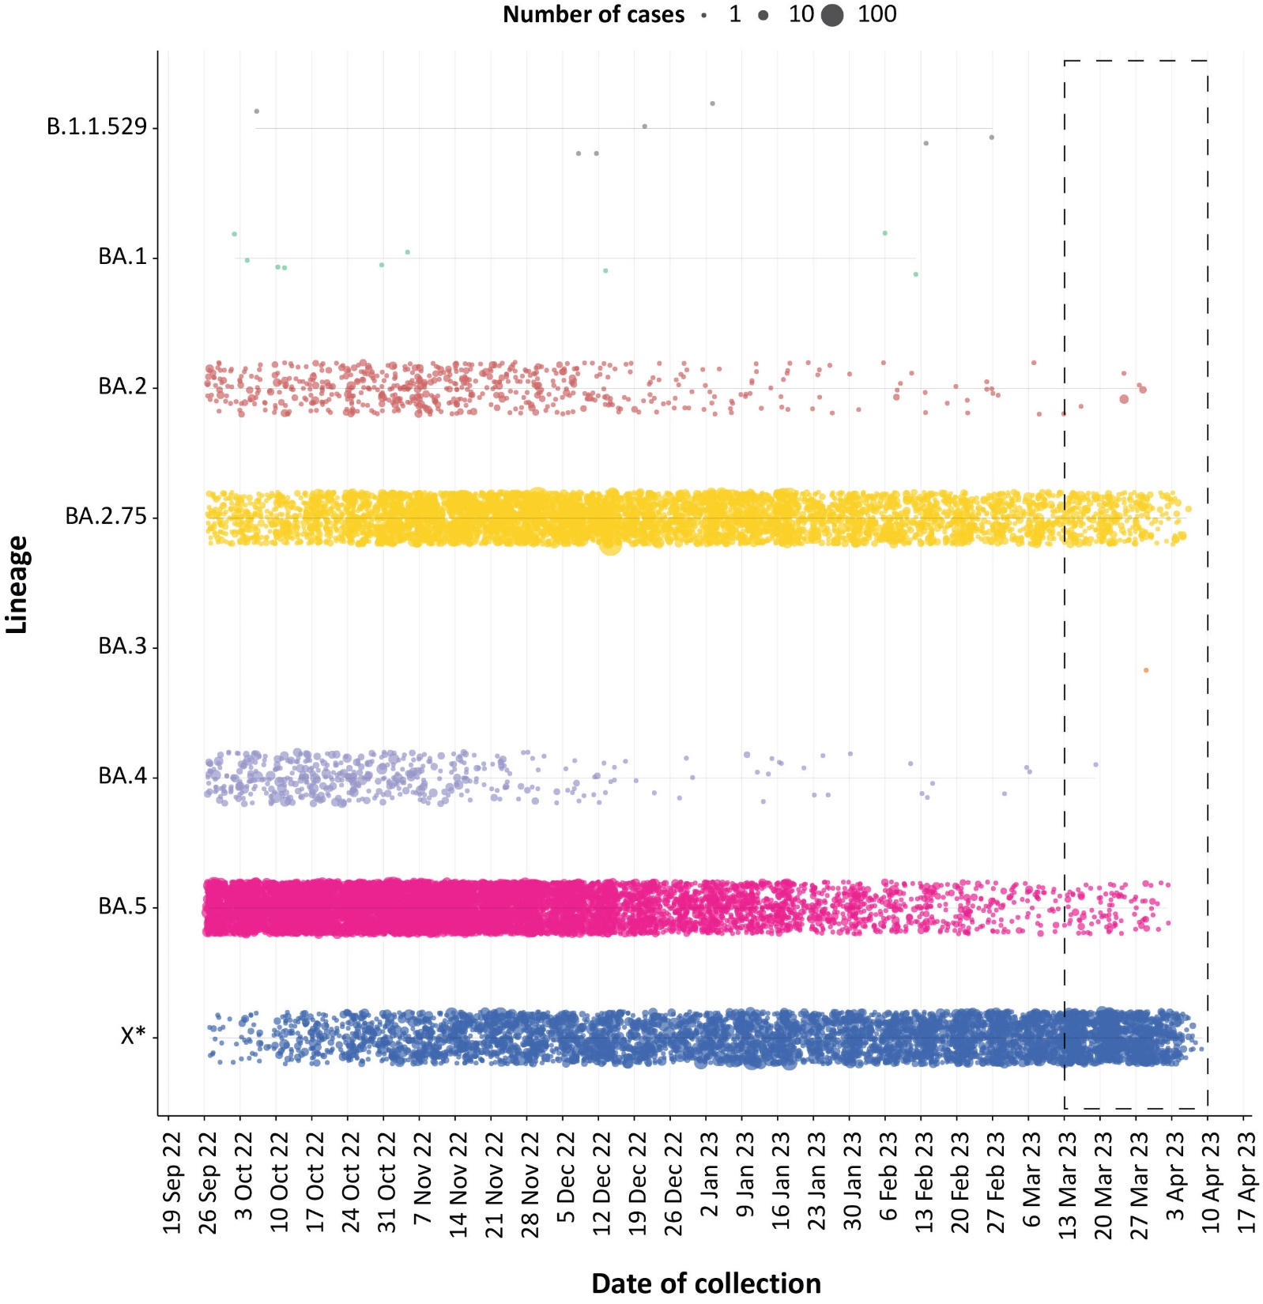
a The current reporting period (13 March to 9 April 2023) is marked by the dashed lines. The size of each dot is proportional to the number of sequences observed in each jurisdiction each day.
b Newly designated Omicron sub-lineages have been collapsed into parent lineages BA.1, BA.2 (except BA.2.75, displayed separately), BA.3, BA.4 and BA.5; recombinants are designated by X*.

Variants of concern (VOC)
AusTrakka⁵ is actively monitoring and reporting on one lineage and its associated sub- and sub-sub-lineages, currently designated as a Variant of Concern (VOC) by international organisations, including the World Health Organization (WHO): Omicron (B.1.1.529). The Omicron variant displays a characteristic set of mutations, including a number of variations in the genomic region encoding the spike protein thought to have the potential to increase transmissibility and/or immune evasion.^{6,7} The Communicable Diseases Genomics Network (CDGN) VOC Working Group demoted four previously designated VOC (Alpha (B.1.1.7); Beta (B.1.351), Delta (B.1.617) Gamma (P.1)) due to the sustained absence of any cases in Australia, and very limited prevalence globally. Further information on variants is available in the Technical Supplement.²
Unlike previous periods in Australia’s COVID-19 waves, where one or two dominant lineages were the main driver of disease, there is currently significant diversity in the range of sub-sub-lineages circulating within Australia. During this reporting period, more than 200 unique lineages have been identified, and it is likely that there are more that are not being characterised through whole genome sequencing. This diversity of circulating lineages has sometimes been referred to as a ‘variant soup’. Many of these circulating lineages will die out without causing a significant disease burden, but others appear to have stronger growth potential. Lineages such as BQ.1 (sub-sub-lineage of BA.5), BA.2.75 and associated sub-lineages such as BR, XBB (recombinant of BJ.1 [BA.2.10] and BM.1.1.1 [BA.2.75.3]), including the sub-lineage XBB.1.5 which is showing significant growth in the United States of America, have emerged with strong signals both within and across different jurisdictions and are being monitored by AusTrakka and the CDGN VOC Working Group due to their increasing prevalence.
All 4,003 sequences from samples collected within the reporting period and available for analysis in AusTrakka were assigned to Omicron or recombinants consisting of Omicron lineages. There have been five major sub-lineages defined under B.1.1.529: BA.1, BA.2, BA.3, BA.4 and BA.5, and a large number of sub-lineages, including recombinants, under these; all are designated Omicron. Recombinant lineages made up the majority of sequences collected between the 13 March and 9 April 2023 and available for analysis in AusTrakka, with 76.0% of sequences classified as recombinants. BA.2 (now predominantly represented by the BA.2.75 sub-lineage) and BA.5 made up 20.5% and 3.4%, respectively, of sequences identified in the same period.
The sub-lineage breakdown of all Omicron sequences uploaded to AusTrakka since first identification in November 2021 to date: 18.7% are BA.1; 29.6% are BA.2 (excluding BA.2.75); 8.7% are BA.2.75; <0.001% are BA.3; 3.6% are BA.4, and 30.6% are BA.5. All sub-sub-lineages have been collapsed into respective major sub-lineages. Recombinants make up 8.8% of all Omicron sequences to date.

Acute respiratory illness

(FluTracking, ASPREN)
Based on self-reported FluTracking data,⁸ there has been an overall increase in the prevalence of ‘fever and cough’ and ‘runny nose and sore throat’ symptoms in the community since late January 2023. Over the current period, the rate of ‘fever and cough’ has been slightly less than the rates observed during the same period in 2022 (Figure 9). The rate of ‘runny nose and sore throat’ symptoms has increased considerably over the current reporting period, surpassing the rates observed during the same period in previous years (Figure 10).

Figure 9: Weekly trends in fever and cough amongst FluTracking survey participants (age-standardised) compared to the average of the previous five years, Australia, 1 January 2020 – 9 April 2023 ª
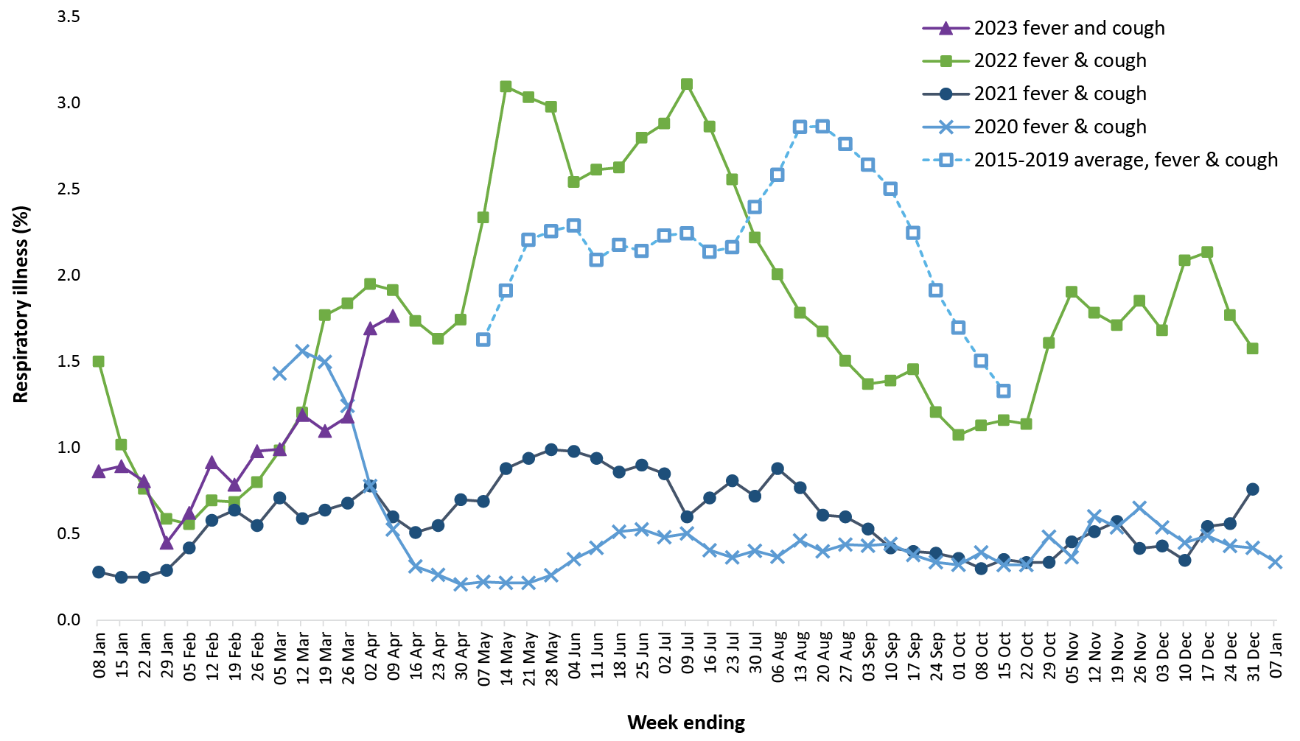
a In years prior to 2020, FluTracking was activated during the main Influenza season from May to October. A historical average beyond the week ending 11 October is therefore not available. In 2020, FluTracking commenced ten weeks early to capture data for COVID-19.

Figure 10: Weekly trends in runny nose and sore throat symptoms amongst FluTracking survey participants (age-standardised), Australia, 29 March 2020 – 9 April 2023 ª
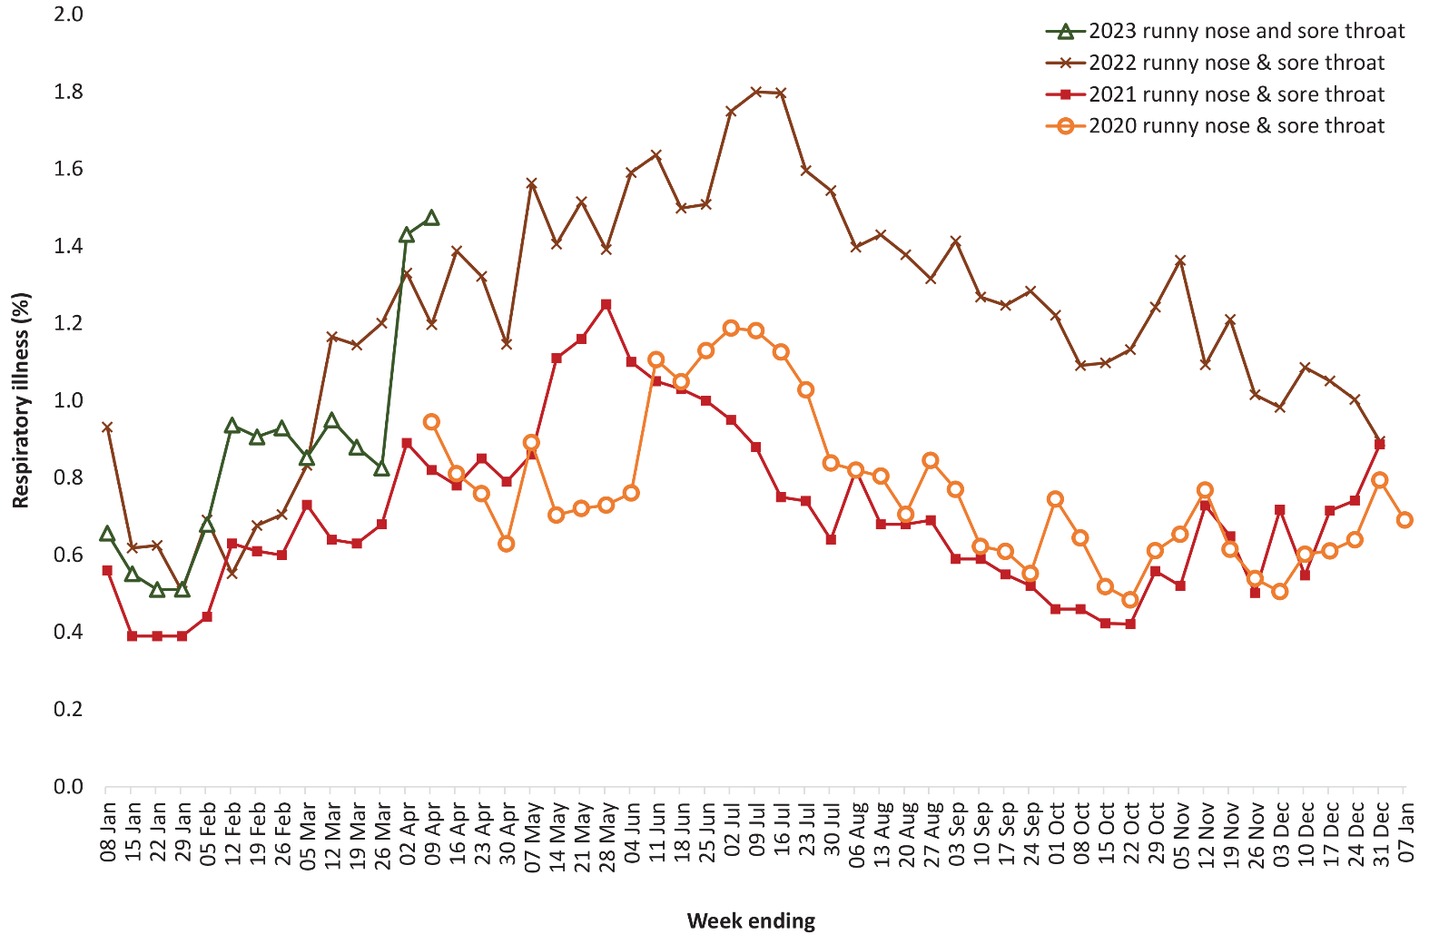
a Data on runny nose and sore throat were only collected systematically after 29 March 2020, therefore a historical average for this symptom profile is unavailable.
Over the reporting period, FluTracking data indicated that 11.4% of participants with ‘fever and cough’ were tested for SARS-CoV-2 with a PCR test and 79.9% were tested using a RAT (noting that in some instances RATs will be followed up by a PCR test for the same case). Of those with ‘runny nose and sore throat’, 3.5% were tested for SARS-CoV-2 using a PCR test and 58.1% were tested using a RAT. In the current reporting period, the percent positivity for ‘fever and cough’ symptoms decreased for PCR (34.8%) and increased for RAT (45.0%) compared to the previous reporting period. For ‘runny nose and sore throat’ symptoms, the percent positivity increased for both PCR and RAT to 10.9% and 6.2%, respectively. Note that participants with one set of symptoms are not excluded from having the other. It is important to acknowledge that there may be legitimate reasons why people did not get tested, including barriers to accessing testing. Symptoms reported to FluTracking are not specific to COVID-19 and may also be due to infections with other respiratory pathogens and to chronic diseases, such as asthma.
Since the start of 2023 to 9 April 2023, of those presenting to sentinel ASPREN sites with influenza-like illness who were tested for respiratory viruses, 57.3% (94/164) tested positive. Among those positive, the most common viruses detected were rhinovirus (40.4%; 38/94) and SARS-CoV-2 (18.1%; 17/94), followed by influenza A (14.9%; 14/94).

Countries and territories in Australia’s near region
According to WHO, countries and territories in the South-East Asia and Western Pacific regions reported 799,054 new cases and 2,328 deaths in the four-week period to 9 April 2023.⁹ Compared with the previous four-week reporting period, new cases and deaths increased considerably in the South-East Asia Region and decreased in the Western Pacific region.⁹ In total, since the start of the pandemic, approximately 263 million cases and over 1.2 million deaths have been reported in the two regions.⁹
In the four-week period 13 March to 9 April 2023, changes in COVID-19 cases and deaths are highlighted in selected countries in the South-East Asia region and the Western Pacific region (Table 9). In the previous four weeks, at the country level, the highest number of new cases was reported from the Republic of Korea (n = 275,126) , followed by Japan (n = 193,326) (Table 9), while the highest number of new deaths was reported from Japan (n = 882), followed by China (n = 393). Nepal reported the greatest proportional increase in new cases (+1,198%), followed by India (+937%) compared with the previous four weeks (Table 9).
As of 9 April 2023, over 762 million COVID-19 cases and over 6.8 million deaths have been reported globally since the start of the pandemic, with a global case fatality rate (CFR) of approximately 0.90%. The two regions reporting the largest burden of disease over the past four weeks were Europe (42% of total cases) and the Americas (29% of total cases).⁹
Table 9: Cumulative cases and deaths, and new cases and deaths reported in the four-week period to 9 April 2023 for selected countries in Australia’s near region according to WHO ^{a,b}
Country | Cumulative cases | New cases reported in the last 4 weeks | Change in new cases in the last 4 weeks ^{b} | Cumulative deaths | New deaths reported in the last 4 weeks | Change in new deaths in the last 4 weeks ^{b}
South-East Asia region
India | 44,756,616 | 66,124 | +937% | 530,965 | 184 | +494%
Indonesia | 6,751,168 | 12,101 | +93% | 161,052 | 104 | +24%
Thailand | 4,728,967 | 663 | -2% | 33,940 | 16 | -47%
Nepal | 1,001,800 | 636 | +1,198% | 12,020 | 0 | –
Bangladesh | 2,038,078 | 156 | -36% | 29,446 | 1 | 0%
Western Pacific region
Republic of Korea | 30,914,055 | 275,126 | -3% | 34,317 | 202 | -45%
Japan | 33,516,848 | 193,326 | -48% | 74,081 | 882 | -65%
China | 99,239,140 | 70,814 | -81% | 120,903 | 393 | -75%
Singapore | 2,314,707 | 69,359 | +197% | 1,722 | 0 | –
Australia | 11,178,368 | 100,737 | +34% | 19,906 | 218 | -60%
a Source: World Health Organization Coronavirus (COVID-19) Dashboard, accessed 20 April 2023, for data until 9 April 2023.
b Percent change in the number of newly confirmed cases/deaths in the most recent four-week period compared to the four weeks prior.

Acknowledgements
We thank public health staff from incident emergency operations centres and public health units in state and territory health departments, and the Australian Government Department of Health and Aged Care, along with state and territory public health laboratories. We thank those who have provided data from surveillance systems, such as Commonwealth respiratory clinics, ASPREN, FluTracking, FluCAN, SPRINT-SARI, Communicable Disease Genomics Network, AusTrakka and jurisdictional sequencing laboratories.

Author details

Corresponding author
COVID-19 Epidemiology and Surveillance Team
Australian Government Department of Health and Aged Care, GPO Box 9484, MDP 14, Canberra, ACT 2601.
Email: epi.coronavirus@health.gov.au

References
- COVID-19 National Incident Room Surveillance Team. COVID-19 Australia: Epidemiology Report 72: Reporting period ending 12 March 2023. Commun Dis Intell (2018). 2023;47. doi: https://doi.org/10.33321/cdi.2023.47.19.
- COVID-19 National Incident Room Surveillance Team. Technical supplement. COVID-19 Australia: Epidemiology reporting. Commun Dis Intell (2018). 2021;45. doi: https://doi.org/10.33321/cdi.2021.45.2.
- Australian Government Department of Health and Aged Care. Coronavirus (COVID-19) – CDNA National Guidelines for Public Health Units. [Internet.] Canberra: Australian Government Department of Health and Aged Care; 14 October 2022. [Accessed on 9 November 2022.] Available from: https://www.health.gov.au/resources/publications/coronavirus-covid-19-cdna-national-guidelines-for-public-health-units.
- Australian and New Zealand Intensive Care Research Centre (ANZIC-RC). SPRINT-SARI: Short period incidence study of severe acute respiratory infection. [Internet.] Melbourne: Monash University, ANZIC-RC; 2020. Available from: https://www.monash.edu/medicine/sphpm/anzicrc/research/sprint-sari.
- Communicable Diseases Genomics Network (CDGN). AusTrakka. [Website.] Melbourne: CDGN; 2020. Available from: https://www.cdgn.org.au/austrakka.
- World Health Organization (WHO). Coronavirus disease (COVID-19) Weekly Epidemiological Updates and Monthly Operational Updates. [Internet.] Geneva: WHO; January 2023. [Accessed on 30 January 2023.] Available from: https://www.who.int/emergencies/diseases/novel-coronavirus-2019/situation-reports/ .
- Allen H, Vusirikala A, Flannagan J, Twohig KA, Zaidi A, Groves N et al. Increased household transmission of COVID-19 cases associated with SARS-CoV-2 Variant of Concern B.1.617.2: a national case-control study. Knowledge Hub (khub); 2021. [Accessed on 30 January 2023.] Available from: https://khub.net/documents/135939561/405676950/Increased+Household+Transmission+ of+COVID-19+Cases+-+national+case+study.pdf/7f7764fb-ecb0-da31-77b3-b1a8ef7be9aa.
- Dalton C, Durrheim D, Fejsa J, Francis L, Carlson S, d’Espaignet ET et al. Flutracking: a weekly Australian community online survey of influenza-like illness in 2006, 2007 and 2008. Commun Dis Intell Q Rep. 2009;33(3):316–22.
- WHO. Weekly epidemiological update on COVID-19 – 13 April 2023. [Internet.] Geneva: WHO; 13 April 2023. [Accessed on 20 April 2023.] Available from: https://www.who.int/publications/m/item/weekly-epidemiological-update-on-covid-19---13-april-2023.
- WHO. WHO Coronavirus Disease (COVID-19) dashboard. [Internet.] Geneva: WHO; 2021. Available from: https://covid19.who.int/.

Appendix A: Supplementary figures and tables
Table A.1: COVID-19 cases and rates per 100,000 population, by age group, sex, and date of onset, Australia, 15 December 2021 – 9 April 2023 ^{a,b,c,d}
Age group | Four-week reporting period |  |  |  |  |  | Current ‘Omicron’ wave
 | 13 March – 9 April 2023 |  |  |  |  |  | 15 December 2021 – 9 April 2023
 | Cases |  |  | Rate per 100,000 population |  |  | Cases |  |  | Rate per 100,000 population
 | Male | Female | People ^{d} | Male | Female | People ^{d} | Male | Female | People ^{d} | Male | Female | People ^{d}
0–9 | 2,867 | 2,660 | 5,814 | 178.6 | 175.5 | 186.3 | 504,367 | 479,206 | 1,102,876 | 31,422.8 | 31,609.2 | 35,335.7
10–19 | 3,695 | 4,118 | 8,102 | 226.4 | 267.6 | 255.5 | 637,482 | 677,263 | 1,449,796 | 39,057.9 | 44,005.8 | 45,717.9
20–29 | 3,943 | 7,459 | 11,855 | 223.9 | 442.0 | 343.8 | 778,050 | 941,769 | 1,844,313 | 44,174.9 | 55,810.8 | 53,478.1
30–39 | 5,656 | 9,876 | 16,075 | 300.6 | 515.0 | 423.1 | 794,618 | 980,183 | 1,920,030 | 42,233.1 | 51,111.7 | 50,537.3
40–49 | 5,393 | 9,313 | 15,075 | 328.3 | 554.0 | 453.5 | 656,168 | 820,484 | 1,596,097 | 39,941.8 | 48,808.9 | 48,019.9
50–59 | 5,385 | 8,827 | 14,577 | 343.5 | 545.2 | 457.4 | 529,413 | 648,381 | 1,263,634 | 33,769.0 | 40,047.0 | 39,652.2
60–69 | 5,443 | 7,455 | 13,243 | 402.3 | 517.1 | 473.9 | 379,885 | 435,824 | 868,028 | 28,078.1 | 30,230.6 | 31,060.6
70–79 | 4,672 | 4,814 | 9,715 | 481.5 | 459.5 | 481.4 | 238,300 | 242,532 | 505,116 | 24,557.2 | 23,148.2 | 25,029.0
80–89 | 2,430 | 2,683 | 5,274 | 603.8 | 538.6 | 585.6 | 104,480 | 117,362 | 230,918 | 25,961.2 | 23,561.6 | 25,641.8
90 + | 669 | 1,291 | 2,019 | 882.2 | 929.4 | 940.2 | 26,203 | 48,404 | 77,029 | 34,552.2 | 34,846.1 | 35,870.2
a Source: NNDSS, extract from 19 April 2023 for notifications to 9 April 2023.
b Population data based on Australian Bureau of Statistics (ABS) Estimated Resident Population (ERP) as at June 2022.
c Excludes cases where age was unknown.
d Total cases includes those where sex was unknown and those classified as X, i.e., persons who reported their sex as another term, other than male or female.

Communicable Diseases Intelligence
ISSN: 2209-6051 Online

Communicable Diseases Intelligence (CDI) is a peer-reviewed scientific journal published by the Office of Health Protection, Department of Health and Aged Care. The journal aims to disseminate information on the epidemiology, surveillance, prevention and control of communicable diseases of relevance to Australia.

Editor: Christina Bareja
Deputy Editor: Simon Petrie
Design and Production: Kasra Yousefi
Editorial Advisory Board: David Durrheim, Mark Ferson, Clare Huppatz, John Kaldor, Martyn Kirk, Meru Sheel and Steph Williams

Website: http://www.health.gov.au/cdi

Contacts
CDI is produced by the Office of Health Protection, Australian Government Department of Health and Aged Care, GPO Box 9848, (MDP 6) CANBERRA ACT 2601

Email: cdi.editor@health.gov.au

Submit an Article
You are invited to submit your next communicable disease related article to the Communicable Diseases Intelligence (CDI) for consideration. More information regarding CDI can be found at: http://health.gov.au/cdi.
Further enquiries should be directed to: cdi.editor@health.gov.au.

This journal is indexed by Index Medicus and Medline.

Creative Commons Licence - Attribution-NonCommercial-NoDerivatives CC BY-NC-ND
© 2023 Commonwealth of Australia as represented by the Department of Health and Aged Care
This publication is licensed under a Creative Commons Attribution-NonCommercial-NoDerivatives 4.0 International Licence from https://creativecommons.org/licenses/by-nc-nd/4.0/legalcode (Licence). You must read and understand the Licence before using any material from this publication.

Restrictions
The Licence does not cover, and there is no permission given for, use of any of the following material found in this publication (if any):
- the Commonwealth Coat of Arms (by way of information, the terms under which the Coat of Arms may be used can be found at www.itsanhonour.gov.au);
- any logos (including the Department of Health and Aged Care’s logo) and trademarks;
- any photographs and images;
- any signatures; and
- any material belonging to third parties.

Disclaimer
Opinions expressed in Communicable Diseases Intelligence are those of the authors and not necessarily those of the Australian Government Department of Health and Aged Care or the Communicable Diseases Network Australia. Data may be subject to revision.

Enquiries
Enquiries regarding any other use of this publication should be addressed to the Communication Branch, Department of Health and Aged Care, GPO Box 9848, Canberra ACT 2601, or via e-mail to: copyright@health.gov.au

Communicable Diseases Network Australia
Communicable Diseases Intelligence contributes to the work of the Communicable Diseases Network Australia.
http://www.health.gov.au/cdna

