2024 • Volume 48 • https://doi.org/10.33321/cdi.2024.48.11 • Electronic publication date: 23/04/2024

COVID-19 Australia: Epidemiology Report 85 Reporting period ending 10 March 2024
Viral Respiratory Diseases Epidemiology and Surveillance Section
COVID-19 Australia: Epidemiology Report 85 is the last instalment in the Viral Respiratory Diseases Epidemiology and Surveillance Section’s dedicated reporting on COVID-19 epidemiology within Australia, and the last such report to appear in CDI. Ongoing reporting from these authors, describing the epidemiology of COVID-19, influenza and respiratory syncytial virus (RSV) in Australia, appears in the Australian Respiratory Surveillance Report, which will be published at www.health.gov.au/resources/collections/arsr each fortnight from 12 April 2024.
The authors of COVID-19 Epidemiology Report 85 wish to thank all former contributors to this reporting series.

Summary
Four-week reporting period (12 February – 10 March 2024)
Case definitions for confirmed and probable cases are in accordance with the coronavirus disease 2019 (COVID-19) CDNA National Guidelines for Public Health Units.
Trends – Nationally, case notifications increased from early October 2023, and appeared to have gradually declined since the first week of January 2024. In the four-week period 12 February – 10 March 2024, there were 19,434 confirmed and 7,029 probable cases of COVID-19, a total of 26,463 COVID-19 cases reported in Australia to the National Notifiable Diseases Surveillance System (NNDSS). In the most recent reporting fortnight, a total of 11,989 confirmed and probable cases were notified (an average of 856 cases per day), compared to 14,474 in the previous fortnight (an average of 1,034 cases per day), representing a 17.2% fortnight-on-fortnight decrease.
Age group – Since the start of the sixth Omicron wave in mid-August 2023, the notification rates among most age groups have stabilised, except among adults aged 70 years and over where rates have slowly increased and subsequently reached an apparent peak in early January 2024. In the overall Omicron wave to date, the highest notification rate was observed among adults aged 20–29 years, whilst the lowest rate was among older adults aged 70–79 years.
Aboriginal and Torres Strait Islander people – In the reporting period 12 February – 10 March 2024, there were 848 new cases notified in Aboriginal and Torres Strait Islander people, accounting for 3.2% of all notified cases (848/26,463) during this time. In the Omicron wave to date (15 December 2021 – 10 March 2024), notifications among Aboriginal and Torres Strait Islander people have comprised 3.8% of all cases (438,126/11,586,474).
Severity – Since the emergence of the Omicron variant, there has been a consistent decrease in the incidence of severe illness, with a smaller severe-illness peak observed with each subsequent Omicron wave. Decreasing incidence may be due to high COVID-19 vaccination coverage, hybrid immunity and access to oral antiviral treatments. Since the start of the sixth Omicron wave, the weekly number of cases with severe illness reached an apparent peak in mid-November 2023. The crude case fatality rate from the start of the Omicron wave to date was 0.19%, which was lower than the crude rate during the Delta wave (0.71%).
Virology – For samples collected in the four-week period 12 February – 10 March 2024, all sequences uploaded to AusTrakka were assigned as Omicron strains or as recombinants consisting of Omicron lineages. There were 582 sequences uploaded to AusTrakka during 12 February – 10 March 2024. In this reporting period, most of the sequences analysed (92.3%) were BA.2 sub-sub lineages; 7.7% were recombinant or recombinant sub-lineages.
Acute respiratory illness – Based on self-reported FluTracking data, over the current four-week period, the weekly average proportions of ‘fever and cough’ (1.3%) and ‘runny nose and sore throat’ symptoms (1.2%) were both above the proportions observed during the same period in 2023.
International situation – According to the World Health Organization (WHO), as of 3 March 2024, over 774 million COVID-19 cases and over 7 million deaths have been reported globally since the start of the pandemic, with a global case fatality rate (CFR) of approximately 0.91%.
Keywords: SARS-CoV-2; novel coronavirus; coronavirus disease 2019; COVID-19; acute respiratory disease; epidemiology; Australia
This reporting period covers the four-week period 12 February – 10 March 2024. Within this period, data for each fortnight is compared. The previous reporting period was the preceding four weeks (15 January – 11 February 2024).¹ The focus of this report is on the epidemiological situation in Australia since the beginning of the Omicron wave. For the purposes of this report, 15 December 2021 is used as a proxy for the beginning of the Omicron wave. This date was chosen as, from this date onward, most sequenced strains from cases were Omicron. Readers are encouraged to consult prior reports in this series for information on the epidemiology of coronavirus disease 2019 (COVID-19) in Australia.
Methods of data analysis in these reports have changed over the course of this reporting series to date. Please refer to the Technical Supplement for details of such changes, and for definitions of terminology.²
From Report #72 onward, and unless specified otherwise, all data from the National Notifiable Diseases Surveillance System (NNDSS) have been extracted using ‘diagnosis date’ rather than ‘notification received date’ (see the Technical Supplement for definitions). Due to COVID-19 reporting changes in several states and territories, the use of ‘diagnosis date’ now provides a more consistent and accurate method for describing transmission trends in Australia.
The case data provided includes both confirmed cases and probable cases reported to the NNDSS, as defined in accordance with the COVID-19 Communicable Diseases Network Australia (CDNA) National Guidelines for Public Health Units.³ For the purposes of this report, only probable cases from 5 January 2022 were included. Six jurisdictions have ceased collecting and reporting data on probable COVID-19 cases: Victoria ceased collection on 1 July 2023; Queensland on 1 September 2023;
New South Wales on 1 October 2023; Western Australia on 9 October 2023; the Northern Territory on 21 October 2023; and the Australian Capital Territory on 22 December 2023. Rapid antigen tests (RATs) administered in healthcare or aged care settings continue to be reported to the NNDSS by some jurisdictions.
From Report #71 onward, population data for Aboriginal and Torres Strait Islander people was updated (from 2016) and is now based on the Australian Bureau of Statistics (ABS) Estimated Resident Population (ERP) as at 2021. There has been an increase of 185,600 Aboriginal and Torres Strait Islander people (23.2%) since the previous ERP (June 2016). Therefore, notification rate comparisons with reports prior to #71 should be undertaken with caution.
Due to the dynamic nature of data in the NNDSS, numbers may be subject to revision and may vary from numbers previously reported and from case notifications released by states and territories.

Background and data sources
See the Technical Supplement for general information on COVID-19 including modes of transmission, common symptoms, and severity.2

Activity

COVID-19 trends

(NNDSS)
Since the beginning of the pandemic to 10 March 2024, jurisdictions in Australia have reported 11,586,474 COVID-19 cases to the NNDSS. Nationally, case notifications have followed a decreasing trend since early January 2024 (Figure 1).
Figure 1: Confirmed and probable COVID-19 cases notified to the NNDSS by date of onset, Australia, 27 February 2023 – 10 March 2024a,b
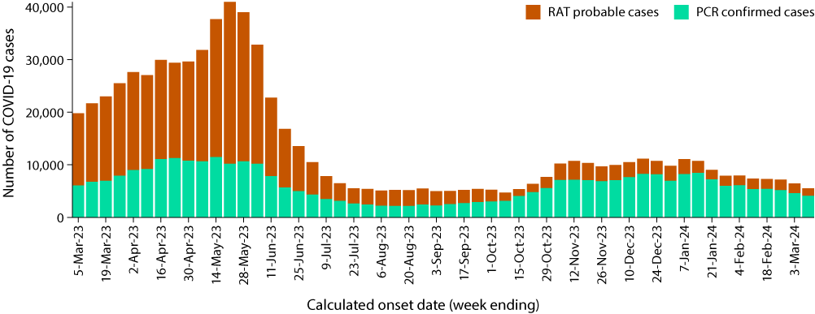
a Source: NNDSS, extracted on 13 March 2024 for cases with an illness onset from 27 February 2023 to 10 March 2024.
b Since 1 July 2023, several jurisdictions have progressively ceased collecting and reporting data on probable COVID-19 cases.
Table 1: Confirmed and probable COVID-19 cases notified to the NNDSS by jurisdiction and date of illness onset, Australia, 15 December 2021 – 10 March 2024a,b,c
 | Reporting period |  |  |  |  |  | Omicron wave to date
 | 12–25 February 2024 |  |  | 26 February – 10 March 2024 |  |  | 15 December 2021 –  10 March 2024
Jurisdiction | Confirmed | Probable | Total | Confirmed | Probable | Total | Confirmed | Probable | Total
ACTd | 183  (100.0%) | 0  (0.0%) | 183 | 129  (100.0%) | 0  (0.0%) | 129 | 135,033  (53.9%) | 115,271  (46.1%) | 250,304
NSWd | 4,336  (93.5%) | 301  (6.5%) | 4,637 | 3,321  (91.9%) | 292  (8.1%) | 3,613 | 2,211,375  (56.7%) | 1,687,419  (43.3%) | 3,898,794
NTd | 148  (100.0%) | 0  (0.0%) | 148 | 91  (100.0%) | 0  (0.0%) | 91 | 26,691  (24.1%) | 84,181  (75.9%) | 110,872
Qldd | 2,905  (93.0%) | 219  (7.0%) | 3,124 | 2,323  (95.9%) | 99  (4.1%) | 2,422 | 731,701  (41.2%) | 1,042,475  (58.8%) | 1,774,176
SA | 84  (28.7%) | 2,093 (71.3%) | 2,935 | 853  (31.3%) | 1,871  (68.7%) | 2,724 | 542,390  (55.5%) | 434,640  (44.5%) | 977,030
Tas. | 248  (17.0%) | 1,215 (83.0%) | 1,463 | 218  (19.0%) | 932  (81.0%) | 1,150 | 69,773  (21.6%) | 252,741  (78.4%) | 322,514
Vic.d | 1,491  (99.9%) | 1  (0.1%) | 1,492 | 1,425  (99.6%) | 6  (0.4%) | 1,431 | 1,128,425  (39.4%) | 1,737,784  (60.6%) | 2,866,209
WAd | 492  (100.0%) | 0  (0.0%) | 492 | 429  (100.0%) | 0  (0.0%) | 429 | 511,740  (36.9%) | 874,835  (63.1%) | 1,386,575
Australia | 10,645  (73.5%) | 3,829 (26.5%) | 14,474 | 8,789  (73.3%) | 3,200  (26.7%) | 11,989 | 5,357,128  (46.2%) | 6,229,346  (53.8%) | 11,586,474
a Source: NNDSS, extracted on 13 March 2024 for cases with an illness onset from 15 December 2021 to 10 March 2024.
b ACT: Australian Capital Territory; NSW: New South Wales; NT: Northern Territory; Qld: Queensland; SA: South Australia; Tas.: Tasmania; Vic.: Victoria; WA: Western Australia.
c Since 1 July 2023, cases are classified based on jurisdiction of residence. This does not necessarily reflect the place where the disease was acquired or where the case presented. Please note prior to this, cases were classified based on the jurisdiction in which they tested positive.
d Six jurisdictions have ceased collecting and reporting data on probable COVID-19 cases: Victoria ceased collection on 1 July 2023; Queensland on 1 September 2023; New South Wales on 1 October 2023; Western Australia on 9 October 2023; the Northern Territory on 21 October 2023; and the Australian Capital Territory on 22 December 2023. Rapid antigen tests (probable COVID-19 cases) administered in healthcare or aged care settings continue to be reported to the NNDSS by some of these jurisdictions.
In the four-week period 12 February – 10 March 2024, there were 19,434 confirmed and 7,029 probable cases of COVID-19 reported in Australia to the NNDSS (Table 1). In the most recent reporting fortnight, a total of 11,989 confirmed and probable cases were notified (an average of 856 cases per day), compared to 14,474 in the previous fortnight (an average of 1,034 cases per day), representing a 17.2% fortnight-on-fortnight decrease.
As the pandemic has progressed, the proportion of cases reported through traditional surveillance has decreased and there are many different sub-lineages of virus circulating simultaneously. Additionally, increases in other measures of disease activity, such as the numbers of people admitted to hospital, to intensive care units (ICU), or having died, often lag weeks behind increases in infections in the community. This has made defining the start of a new wave more complex, with the determination often now only possible several weeks after the wave has commenced.
Since the emergence of the Omicron variant in Australia, there have been six distinct waves of transmission, defined either by the predominant Omicron subvariant circulating, or a combination of existing and newly emerging Omicron subvariants. The first wave of the BA.1 subvariant occurred from mid-December 2021 to February 2022, with a peak in cases observed in early January 2022. From March 2022, the BA.2 subvariant was the predominant strain; in this second Omicron wave, there was a primary peak in early April and a secondary peak in late May 2022. In early July 2022, BA.5 (including sub-lineages) became the predominant subvariant detected in Australia, driving a third wave of transmission which peaked in the week ending 24 July 2022. A fourth wave of transmission commenced in late October 2022, driven by a combination of existing and newly emerging Omicron subvariants. This wave peaked during the week ending 11 December 2022. A fifth Omicron wave of transmission, similarly driven by a combination of existing and newly emerging recombinant Omicron subvariants, commenced in early March 2023 and led to a peak in case notifications in the week ending 21 May 2023 (Figure 1). The most recent sixth wave of transmission, also driven by a combination of existing and newly emerging recombinant Omicron subvariants (XBB*), commenced in late August 2023, signalled by an increasing trend in several surveillance indicators (Figures 1, 3 and 5). Holiday-related population mixing, the Omicron BA.2.86.1.1 (JN.1) sub-lineage and waning of hybrid immunity may explain the prolonged sixth Omicron wave continuing into March 2024.
Due to a reduction in case ascertainment in all jurisdictions, including changes in testing and reporting requirements, reported case numbers underestimate disease incidence in the community.

Demographic features

(NNDSS)
Following the start of the sixth Omicron wave in mid-August 2023, notification rates among most age groups have remained relatively low and stable, except among adults aged 70 years and over where rates slowly increased until late January 2024. Notification rates in adults aged 70 years and over remain the highest notification rates among all age groups (Figure 2). This is likely a reflection of higher case ascertainment due to targeted testing in this age group that is at higher risk of severe disease. In the current reporting period, 12 February – 10 March 2024, the highest notification rate was observed among adults aged 70 years and over (Figure 2). In the Omicron wave to date, the highest notification rate was observed among adults aged 20–29 years, whilst the lowest rate was among older adults aged 70–79 years (Appendix A, Table A.1).
Figure 2: Confirmed and probable COVID-19 crude notification rates for ten-year age groups by date of onset, Australia, 27 February 2023 – 10 March 2024a,b
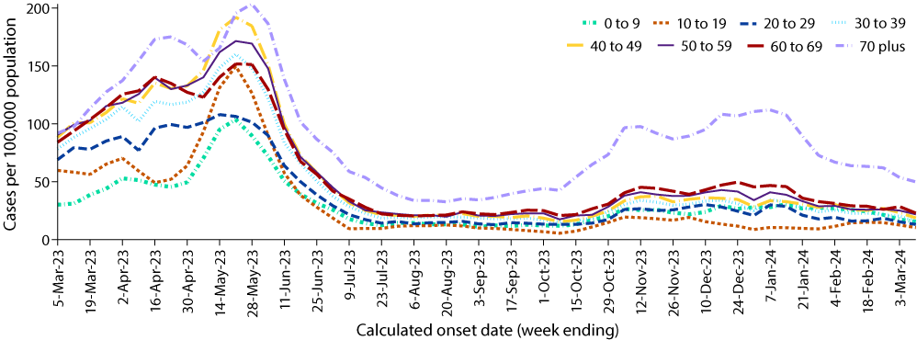
a Source: NNDSS, extracted on 13 March 2024 for cases with an illness onset from 27 February 2023 to 10 March 2024.
b Population data based on Australian Bureau of Statistics (ABS) Estimated Resident Population (ERP) as at June 2023.

Aboriginal and Torres Strait Islander persons

(NNDSS)
Overall, since the start of the pandemic, Aboriginal and Torres Strait Islander status is unknown for approximately 13.5% of COVID-19 notifications in NNDSS. Therefore, the number of cases classified as Aboriginal and Torres Strait Islander people is likely an under-representation. During the reporting period, there were 848 new cases notified among Aboriginal and Torres Strait Islander people (Table 2). In the Omicron wave to date (15 December 2021 – 10 March 2024), notifications among Aboriginal and Torres Strait Islander people comprised 3.8% (438,126/11,586,474) of all cases.
Table 2: Confirmed and probable COVID-19 cases among Aboriginal and Torres Strait Islander people notified to the NNDSS by jurisdiction and date of onset, Australia, 1 January 2020 – 10 March 2024a,b,c
Jurisdictionb,c | Reporting period  12 February – 10 March 2024 | Omicron wave to date  15 December 2021 –  10 March 2024 | Delta wave  16 June –  14 December 2021 | Pandemic to date  1 January 2020 –  10 March 2024
ACT^{d} | 3 | 4,324 | 240 | 4,568
NSW^{d} | 198 | 140,498 | 7,709 | 148,278
NT^{d} | 117 | 27,366 | 94 | 27,461
Qld^{d} | 285 | 114,825 | 19 | 114,867
SA | 67 | 24,411 | 4 | 24,420
Tas. | 108 | 18,055 | 1 | 18,068
Vic.^{d} | 15 | 36,522 | 1,939 | 38,557
WA^{d} | 55 | 61,905 | - | 61,907
Australia | 848 | 427,906 | 10,006 | 438,126
a Source: NNDSS, extracted on 13 March 2024 for cases with an illness onset from 1 January 2020 to 10 March 2024.
b ACT: Australian Capital Territory; NSW: New South Wales; NT: Northern Territory; Qld: Queensland; SA: South Australia; Tas: Tasmania; Vic: Victoria; WA: Western Australia.
c Since 1 July 2023, cases are classified based on jurisdiction of residence. This does not necessarily reflect the place where the disease was acquired or where the case presented. Please note that, prior to this, cases were classified based on the jurisdiction in which they tested positive.
d Six jurisdictions have ceased collecting and reporting data on probable COVID-19 cases: Victoria ceased collection on 1 July 2023; Queensland on 1 September 2023; New South Wales on 1 October 2023; Western Australia on 9 October 2023; the Northern Territory on 21 October 2023; and the Australian Capital Territory on 22 December 2023. Rapid antigen tests (probable COVID-19 cases) administered in healthcare or aged care settings continue to be reported to the NNDSS by some of these jurisdictions.
Table 3: Confirmed and probable cases of COVID-19 among Aboriginal and Torres Strait Islander people notified to the NNDSS by area of remoteness, Australia, 15 December 2021 – 10 March 2024a
Jurisdictionb,c | Major city | Inner regional | Outer regional | Remoted
ACT^{e} | 4,275 | 35 | 12 | 1
NSW^{e} | 75,382 | 45,414 | 15,686 | 3,191
NT^{e} | 74 | 21 | 8,543 | 17,785
Qld^{e} | 44,808 | 26,358 | 31,741 | 11,755
SA | 13,273 | 2,626 | 5,086 | 3,271
Tas. | 206 | 11,067 | 6,323 | 312
Vic.^{e} | 20,826 | 11,757 | 3,877 | 19
WA^{e} | 32,327 | 4,473 | 7,748 | 16,687
Australia | 191,171 | 101,751 | 79,016 | 53,021
a Source: NNDSS, extracted on 13 March 2024 for cases with an illness onset from 15 December 2021 to 10 March 2024. Excludes cases with an overseas place of residence, and where place of residence is unknown.
b ACT: Australian Capital Territory; NSW: New South Wales; NT: Northern Territory; Qld: Queensland; SA: South Australia; Tas.: Tasmania; Vic.: Victoria; WA: Western Australia.
c Since 1 July 2023, cases are classified based on jurisdiction of residence. This does not necessarily reflect the place where the disease was acquired or where the case presented. Please note that, prior to this, cases were classified based on the jurisdiction in which they tested positive.
d ‘Remote’ here also includes areas classified as ‘very remote’.
e Six jurisdictions have ceased collecting and reporting data on probable COVID-19 cases: Victoria ceased collection on 1 July 2023; Queensland on 1 September 2023; New South Wales on 1 October 2023; Western Australia on 9 October 2023; the Northern Territory on 21 October 2023; and the Australian Capital Territory on 22 December 2023. Rapid antigen tests (probable COVID-19 cases) administered in healthcare or aged care settings continue to be reported to the NNDSS by some of these jurisdictions.
Of the COVID-19 cases notified among Aboriginal and Torres Strait Islander people from 15 December 2021 to date, and where location of residence was known, 55.0% (233,788/424,959) lived in a regional or remote area (Table 3).
Nationally, there have been 451 COVID-19-related deaths among Aboriginal and Torres Strait Islander people notified to the NNDSS from the start of the pandemic to 10 March 2024. This comprises 144 (31.9%) from New South Wales; 136 (30.2%) from Queensland; 65 (14.4%) from Western Australia; 58 (12.9%) from the Northern Territory; 25 (5.5%) from South Australia; 19 (4.2%) from Victoria; and two (0.4%) each from the Australian Capital Territory and Tasmania. Nationally, there have been 797 COVID-19-associated intensive care admissions among Aboriginal and Torres Strait Islander people notified to the NNDSS from the start of the pandemic to 10 March 2024. In the Omicron wave to date, the rate of severe illness increased with higher age, with the highest rate observed among those aged 70 years and over (Table 4). It should be noted that ICU status in NNDSS is likely incomplete.
Table 4: Notification rate of COVID-19 cases admitted to intensive care or died among Aboriginal and Torres Strait Islander people notified to the NNDSS by ten-year age groups, Australia, 1 January 2020 to 10 March 2024a
Age group (years) | Sixth Omicron wave to date 14 August 2023 – 10 March 2024 | Fifth Omicron wave  1 March –  13 August 2023 | Fourth Omicron wave  24 October 2022 –  28 February 2023 | Omicron wave to date  15 December 2021 –  10 March 2024 | Pandemic  to date  1 January 2020 –  10 March 2024
0–9 | 1.9 | 0.9 | 5.1 | 23.7 | 24.7
10–19 | 0.5 | 3.4 | 1.9 | 21.3 | 26.1
20–29 | 2.4 | 3.0 | 3.0 | 46.0 | 55.1
30–39 | 0.8 | 3.2 | 11.3 | 52.4 | 67.7
40–49 | 10.1 | 7.1 | 10.1 | 113.0 | 135.2
50–59 | 17.1 | 29.6 | 29.6 | 221.0 | 256.3
60–69 | 32.5 | 56.0 | 41.6 | 397.6 | 433.7
70 + | 59.1 | 131.3 | 170.7 | 899.6 | 958.7
All | 7.2 | 12.4 | 14.7 | 105.3 | 119.2
a Rate per 100,000 population for the given time period. Aboriginal and Torres Strait Islander population data is based on the Australian Bureau of Statistics (ABS) Estimated Resident Population (ERP) as at 2021.

Severity

(NNDSS, FluCAN, SPRINT-SARI)
To provide a more accurate assessment of severity (defined as those admitted to ICU and/or died), cases with an illness onset in the last two weeks of the reporting period have been excluded from the analyses, given the delay between illness onset and development of severe illness.
Since the emergence of the Omicron variant, the number of cases with severe illness peaked in mid-January 2022, at over 1,260 severe cases per week (data not shown). Since this time there has been a consistent decrease in the incidence of severe illness, with a smaller peak observed with each subsequent Omicron wave. This is likely due to a combination of factors such as high COVID-19 vaccination coverage, hybrid immunity and access to oral antiviral treatments. Since the start of the sixth Omicron wave, the incidence of severe illness gradually increased and reached an apparent peak at approximately 200 severe cases in the week ending 12 November 2023 (Figure 3). Since mid-November 2023, there has been an overall decreasing trend in the number of cases developing severe illness; however, week-on-week increases have been observed.
Figure 3: Confirmed and probable COVID-19 cases, intensive care admissions and deaths notified to the NNDSS by date of onset, Australia, 27 February 2023 – 10 March 2024a,b
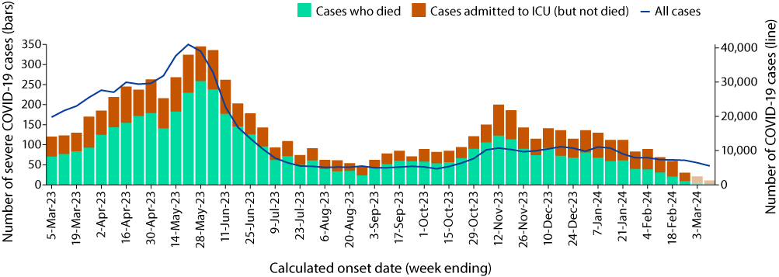
a Source: NNDSS, extracted on 13 March 2024 for cases with an illness onset from 27 February 2023 to 10 March 2024.
b Shaded bars at the right represent the most recent two reporting weeks and should be interpreted with caution, as cases with an illness onset in these weeks may not have yet developed severe disease.
Similar to previous transmission waves, rates of severe illness during the Omicron waves remain highest in older age groups, particularly those aged 70 years and older (Figure 4). The rate of severe illness in this age group has increased gradually since the start of the sixth Omicron wave and subsequently reached an apparent peak in mid-November 2023 at just above 4 cases per 100,000 population per week. In comparison, rates of severe illness in younger age groups have remained relatively low and stable throughout the current sixth Omicron wave and earlier Omicron waves, not surpassing 1.3 cases per 100,000 population per week since the start of the fifth Omicron wave (Figure 4).
Figure 4: Notification rates of COVID-19 cases admitted to intensive care or died for ten-year age groups by date of onset, Australia, 27 February 2023 to 25 February 2024a,b
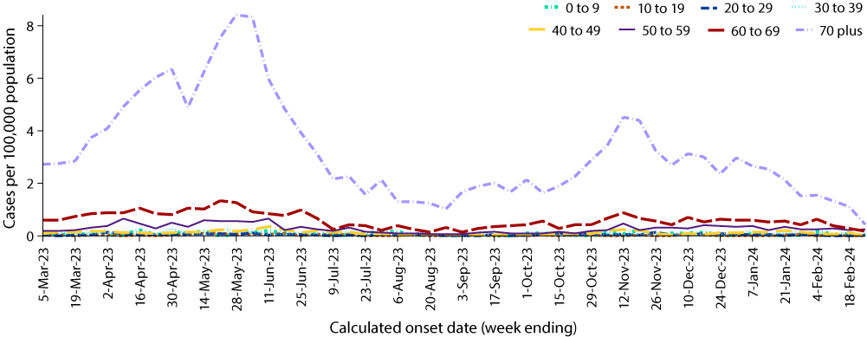
a Source: NNDSS, extracted on 13 March 2024 for cases with an illness onset from 27 February 2023 to 25 February 2024; cases with an illness onset in the last two weeks (26 February – 10 March 2024) were excluded to account for the delay between onset and development of severe illness.
b Population data based on Australian Bureau of Statistics (ABS) Estimated Resident Population (ERP) as at June 2023.

Hospitalisation and ICU admissions

Influenza Complications Alert Network—FluCAN
Between 15 December 2021 and 10 March 2024, there were 20,945 hospital admissions with confirmed COVID-19 reported at Influenza Complications Alert Network (FluCAN) sentinel sites, including 5.7% (1,194/20,945) admitted directly to ICU. Since the start of the fifth Omicron wave, there were 6,146 hospital admissions with confirmed COVID-19 reported at FluCAN sentinel sites, including 6.0% (370/6,146) admitted directly to ICU (Figure 5). During the latest four-week reporting period (12 February – 10 March 2024), there were 319 hospital admissions with COVID-19 reported at FluCAN sentinel sites, with 6.3% (20/319) admitted directly to ICU. The proportion of COVID-19 ICU admissions in the year to date (1 January to 10 March 2024) was 6.2% (66/1,059), slightly higher than the proportion for the same period in 2023 (5.6%; 65/1,153).
Figure 5: Weekly trends for patients admitted with confirmed COVID-19 to FluCAN sentinel hospitals, Australia, 27 February 2023 – 10 March 2024a
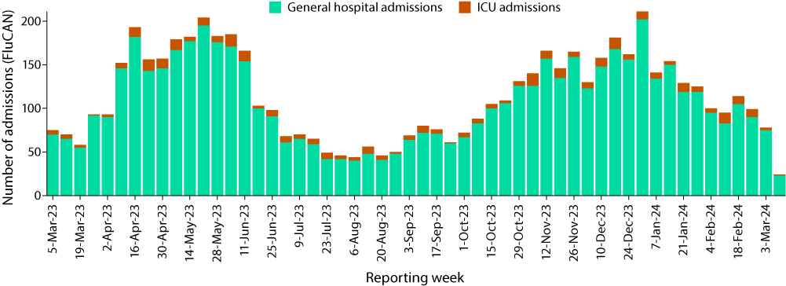
a Source: FluCAN.4

Short Period Incidence Study of Severe Acute Respiratory Infection—SPRINT-SARI (last updated 11 February 2024)
Between 15 December 2021 and 11 February 2024, there were 6,974 COVID-19 cases admitted to ICUs participating in the sentinel surveillance system, Short Period Incidence Study of Severe Acute Respiratory Infection (SPRINT-SARI)⁵ (Table 5). Most patients (62.6%; 4,363/6,974) were discharged home. Thirteen percent (887/6,974) died in ICU and 5.2% (365/6,974) died within the general hospital ward, with an overall in-hospital mortality rate of 18.0% (1,252/6,974).
Since the start of the Omicron wave (15 December 2021 to 11 February 2024), for patients admitted to SPRINT-SARI sentinel sites with COVID-19 (n = 6,974), the median duration of mechanical ventilation was 4.0 days (interquartile range [IQR]: 1.6–9.0 days); the median length of stay in ICU was 3.4 days (IQR: 1.7–7.2 days); and the median length of stay in hospital was 11.0 days (IQR: 6.0–20.0 days).
In the four-week period (15 January to 11 February 2024), there were 52 adult patients with COVID-19 (34 males, 18 females; median age: 70 years; IQR: 58.3–78.3 years) admitted to ICU reported at contributing SPRINT-SARI sentinel sites (Table 5). The median duration of mechanical ventilation for these patients was 0.83 days (IQR: 0.55–3.9 days); the median length of stay in ICU was 2.3 days (IQR: 1.4–4.0 days); and the median length of stay in hospital was 6.2 days (IQR: 4.6–9.7 days).
Table 5: Patient outcomes for adult COVID-19 cases (aged greater than or equal to 18 years), Australia, 15 December 2021 – 11 February 2024a
Outcomes | Reporting period  15 January – 11 February 2024  (n = 52) | Omicron wave to date  15 December 2021 – 11 February 2024  (n = 6,974)
Patient status
Ongoing care in ICU | 13 (25.0%) | 30 (0.4%)
Ongoing care in hospital wardb | 15 (28.8%) | 33 (0.5%)
Transfer to other hospital/facility | 0 (0%) | 516 (7.4%)
Transfer to rehabilitation | 0 (0%) | 678 (9.7%)
Discharged home | 15 (28.8%) | 4,363 (62.6%)
Mortality – ICU | 6 (11.5%) | 887 (12.7%)
Mortality – hospital ward | 2 (3.8%) | 365 (5.2%)
Unknown | 0 (0%) | 71 (1.0%)
Missingc | 1 (1.9%) | 31 (0.4%)
a Source: SPRINT-SARI.5
b Patients who were admitted in ICU/hospital wards with no discharge information for less than 90 days were assumed to have ongoing care in the hospital.
c Patients who were admitted to ICU/hospital wards for more than 90 days with no discharge information were treated as ‘missing data’.

Risk factors for severe disease
Comorbidity data extracted from SPRINT-SARI reflect the sickest patients with COVID-19 who are managed in ICU; data are therefore not generalisable to all cases. Figure 6 shows the most prevalent comorbidities among adult patients admitted to SPRINT-SARI sentinel ICUs with COVID-19 during the four-week period 15 January – 11 February 2024, where comorbidity information was available. Of those adult patients admitted to sentinel ICUs during the four-week period, for whom comorbidity data was known, 46.2% (24/52) had three or more comorbidities (data not shown).
Figure 6: Prevalence of comorbidities for COVID-19 cases among admitted adult ICU patients (aged greater than or equal to 18 years), Australia, 15 January 2024 – 11 February 2024a,b
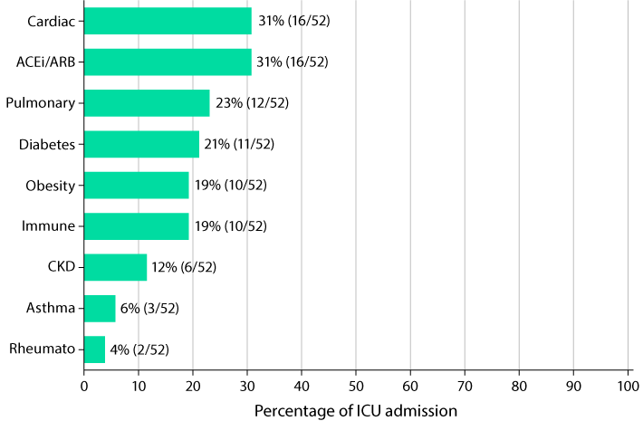
a Source: SPRINT-SARI. Only includes adult cases (≥ 18 years old) and excludes those with missing data on comorbidities or where comorbidity is unknown.
b Abbreviated comorbidities defined as: Cardiac: chronic cardiac disease; ACEi/ARB: past use of ACE inhibitor or A2 Blocker; CKD: chronic kidney disease; Immune: chronic immunosuppression; Pulmonary: chronic pulmonary disease (not including asthma); and Rheumato: rheumatologic disorder.

Paediatric Inflammatory Multisystem Syndrome – Temporally Associated with SARS-CoV-2

Paediatric Active Enhanced Disease Surveillance
Since the start of the pandemic to 10 March 2024, there have been 194 cases of paediatric inflammatory multisystem syndrome – temporally associated with SARS-CoV-2 (PIMS-TS) reported to the Paediatric Active Enhanced Disease Surveillance network (PAEDS), including 4 PIMS-TS cases reported in 2024. There was one case during the current reporting period and three new cases from previous reporting periods (Figure 7). The majority of PIMS-TS cases to date have occurred in those aged 5 to < 12 years (52.5%; 102/194), followed by those aged 6 months to < 5 years (28.4%; 55/194). To date, there have been no PIMS-TS associated deaths.
Figure 7: PIMS-TS cases reported to PAEDS, by admission month and level of care required, Australia, 1 June 2021 – 10 March 2024a
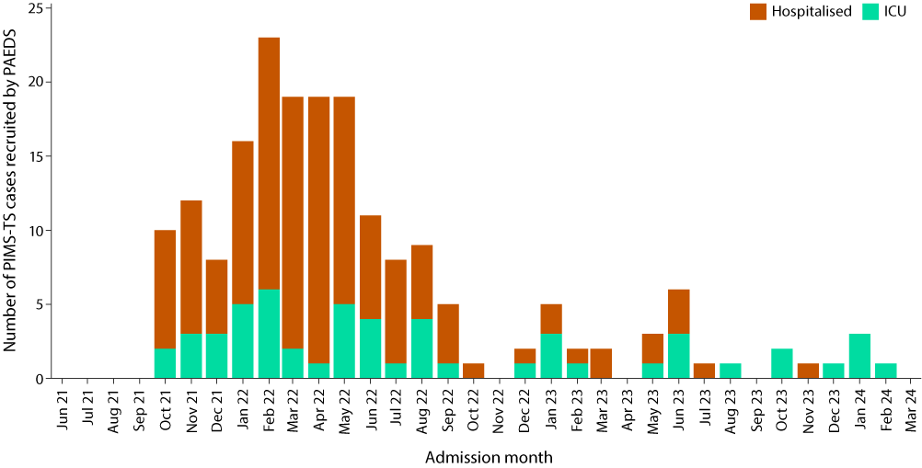
a Source: PAEDS.

COVID-19 deaths
Since the beginning of the pandemic to 10 March 2024, there have been 24,872 COVID-19 related deaths reported to the NNDSS, with 1,867 COVID-19 related deaths notified in the sixth Omicron wave to date (Table 6). The crude case fatality rate from the start of the overall Omicron wave to date is 0.19%, which is lower than the crude case fatality rate for the Delta wave (0.71%) (Table 7).

Table 6: COVID-19 related deaths in cases notified to NNDSS, by jurisdiction and date of death, Australia, 1 January 2020 – 10 March 2024a,b,c
Jurisdiction c | Sixth Omicron wave to date  14 August 2023 –  10 March 2024 | Fifth Omicron wave  1 March –  13 August 2023 | Fourth Omicron wave  24 October 2022 – 28 February 2023 | Omicron wave to date  15 December 2021 – 10 March 2024 | Pandemic to date  1 January 2020 –  10 March 2024
ACT^{d} | 30 (1.6%) | 46 (1.4%) | 38 (1.0%) | 290 (1.3%) | 305 (1.2%)
NSW^{d} | 284 (15.2%) | 1,078 (33.9%) | 1,065 (29.0%) | 7,229 (32.0%) | 7,929 (31.9%)
NT^{d} | 10 (0.5%) | 14 (0.4%) | 18 (0.5%) | 120 (0.5%) | 121 (0.5%)
Qld^{d} | 351 (18.8%) | 521 (16.4%) | 510 (13.9%) | 3,692 (16.3%) | 3,699 (14.9%)
SA | 76 (4.1%) | 254 (8.0%) | 323 (8.8%) | 1,736 (7.7%) | 1,741 (7.0%)
Tas. | 44 (2.4%) | 54 (1.7%) | 63 (1.7%) | 335 (1.5%) | 348 (1.4%)
Vic.^{d} | 931 (49.9%) | 973 (30.6%) | 1,354 (36.8%) | 7,758 (34.3%) | 9,280 (37.3%)
WA^{d} | 141 (7.6%) | 240 (7.5%) | 304 (8.3%) | 1,440 (6.4%) | 1,449 (5.8%)
Australia | 1,867 (100.0%) | 3,180 (100.0%) | 3,675 (100.0%) | 22,600 (100.0%) | 24,872 (100.0%)
a Source: NNDSS, extracted on 13 March 2024 for deaths with an illness onset date to 10 March 2024.
b Deaths are categorised into time periods using date of death. Deaths with a missing date of death are classified using date of illness onset.
c ACT: Australian Capital Territory; NSW: New South Wales; NT: Northern Territory; Qld: Queensland; SA: South Australia; Tas.: Tasmania; Vic.: Victoria; WA: Western Australia.
d Six jurisdictions have ceased collecting and reporting data on probable COVID-19 cases: Victoria ceased collection on 1 July 2023; Queensland on 1 September 2023; New South Wales on 1 October 2023; Western Australia on 9 October 2023; the Northern Territory on 21 October 2023; and the Australian Capital Territory on 22 December 2023. Rapid antigen tests (probable COVID-19 cases) administered in healthcare or aged care settings continue to be reported to the NNDSS by some of these jurisdictions.
Table 7: COVID-19 associated case fatality rates among cases notified to NNDSS, by age group and date of onset, 1 January 2020 to 25 February 2024a,b,c
Age group (years) | Omicron wave to date  15 December 2021 –  25 February 2024 | Delta wave  16 June – 14 December 2021 | Pandemic to date  1 January 2020 –  25 February 2024
0–9 | 0–9 | < 0.05% | < 0.05%
10–19 | 10–19 | < 0.05% | < 0.05%
20–29 | 20–29 | < 0.05% | < 0.05%
30–39 | 30–39 | < 0.05% | 0.06%
40–49 | 40–49 | < 0.05% | 0.18%
50–59 | 50–59 | < 0.05% | 0.65%
60 + | 60–69 | 0.18% | 1.97%
70+ | 70+ | 2.06% | 10.91%
Australia | Australia | 0.19% | 0.71%
a Source: NNDSS, extracted on 13 March 2024 for deaths with an illness onset date to 25 February 2024.
b To account for the lag between illness onset and the development of severe illness, cases with an onset date in the last two weeks have been excluded from calculations of the case fatality rate.
c Crude case fatality rates which reflect number of deaths as a proportion of reported COVID-19 cases during specific periods. Note, the current crude case fatality rates are likely overestimated due to changes in case ascertainment and increased underreporting of non-severe cases.

Genomic surveillance and virology

(Communicable Disease Genomics Network, AusTrakka and jurisdictional sequencing laboratories)

Variants of concern (VOC)
AusTrakka⁶ is actively monitoring and reporting on one lineage and its associated sub- and sub-sub-lineages, currently designated as a variant of concern (VOC) by international organisations, including the World Health Organization (WHO): Omicron (B.1.1.529). The Omicron variant displays a characteristic set of mutations which differentiate the lineage from previously circulating VOCs. Further information on variants and their mutations is available in the Technical Supplement.²
There have been five major sub-lineages defined under B.1.1.529: BA.1, BA.2, BA.3, BA.4 and BA.5, and a large number of sub-lineages, including recombinants, under these; all are designated Omicron. Unlike previous periods in Australia’s COVID-19 waves, where one or two dominant lineages were the main driver of disease, there is currently significant diversity in the range of sub-sub-lineages circulating within Australia. During this period, more than 200 unique lineages have been identified, and it is likely that there are more that are not being characterised through whole genome sequencing. This diversity of circulating lineages has sometimes been referred to as a ‘variant soup’. Many of these circulating lineages will die out without causing a significant disease burden, but others appear to have stronger growth potential.

Variants of interest and variants under monitoring
The Communicable Diseases Genomics Network (CDGN) VOC working group tracks notable SARS-CoV-2 variants, including:
- variants of interest (VOI): XBB.1.5, XBB.1.16, EG.5, BA.2.86*, JN.1; and
- the following variants under monitoring (VUM) and their descendent lineages: BA.2.75 and BA.2.75.2 (including CH*), and recombinants XBB* (in particular XBB.1.9.1* and XBB.1.9.2*), and XBF*.
This report uses the VOI classification for lineages with possible evidence for epidemiological, pathological or immunological features of concern. This is consistent with CDGN usage and with the WHO use of the term.^{7,8} VUMs are other lineages with early observations of potential significance, but little to no evidence of current concern. In this report, details are included of Omicron subvariants under monitoring as designated by the WHO.

AusTrakka SARS-CoV-2 genomic epidemiology
From 12 February to 10 March 2024, there were 582 sequences uploaded to AusTrakka. This represents a 42% increase in the number of sequences compared to the previous reporting period. All sequences uploaded during this reporting period have been assigned to sub-lineages within B.1.1.529 (Omicron) or to recombinants consisting of one or more Omicron sub-lineages.
Of the 582 sequences uploaded to AusTrakka between 12 February and 10 March 2024:
- 7.7% (45/582) were recombinant or recombinant sub-lineages; and
- 92.3% (537/582) were BA.2 sub-sub-lineages.
No BA.1, BA.3, BA.4 or BA.5 Omicron sub-lineages were identified.
From 1 July 2023, jurisdictional sequencing strategies for SARS-CoV-2 have changed. Some jurisdictions have ceased SARS-CoV-2 sequencing, while other jurisdictions have reduced the number of SARS-CoV-2 cases being sequenced. For jurisdictions which are continuing SARS-CoV-2 genomic surveillance, SARS-CoV-2 cases which are likely to be prioritised for sequencing include ICU or hospitalised cases, high-risk cases, or cases of clinical significance. As a result, these changes are likely to affect the representativeness of the distribution of sequenced SARS-CoV-2 sub-lineages across Australia.
Case numbers and sequencing proportion are primarily based on polymerase chain reaction (PCR) results only, as RATs do not allow for sequencing. Since late 2022, the rates of PCR for testing and subsequent referrals of positive PCR samples to sequencing laboratories have decreased significantly, resulting in changes to sequencing strategies across the country.
The Australian SARS-CoV-2 genome sequences in AusTrakka identified as VOC, VOI or VUM are highlighted in Table 8. The VOI and VUM where the proportion has increased compared to the previous reporting period are highlighted in orange, those that have remained stable are highlighted in blue, while those where proportions have decreased are highlighted in green.
In the reporting period to 10 March 2024, the proportion of recombinant sublineages has continued to drop, now accounting for less than ten percent of all sequences in this reporting period. This change in the dominant lineage is still being driven by BA.2, which made up the remaining 92.3% of all samples. As previously reported, the rise in BA.2 is due to the continually increasing proportion of JN.1 (a sub-lineage of BA.2.86), which made up 90% of all sequences and 97.6% (524/537) of all BA.2 sequences seen in this reporting period. This is up from the previous reporting period (Table 8) and a rapid increase from the 16.3% noted in Report 82.⁹ In contrast, all other lineages have continued to decline. The EG.5 lineage (XBB.1.9.2.5) is down to 6.5% of samples uploaded in this reporting period, while the remaining VOIs (XBB.1.16 and XBB.1.5) now appear uncommon, with none uploaded in this reporting period (Table 8). This change to a dominance of JN.1 is in line with international reports and sequencing databases.¹⁰

Figure 8: Omicron sub-lineage in Australia since 1 January 2023 by sample collection date, showing (A) proportions and (B) count per weeka,b,c
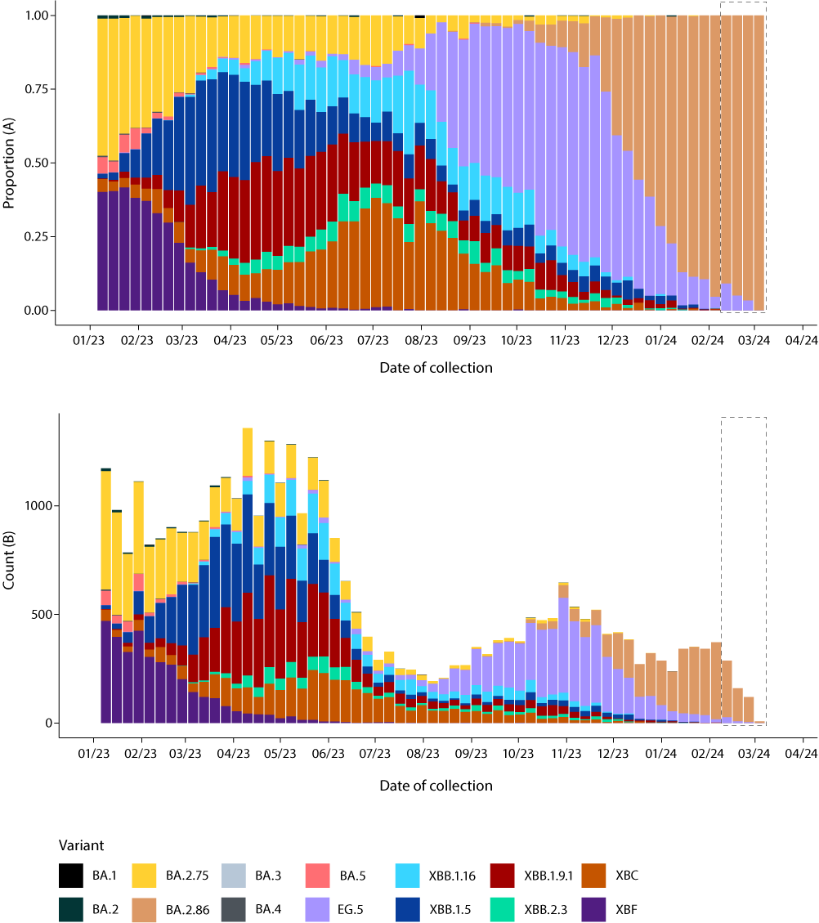
a Sequences in AusTrakka aggregated by epidemiological week.
b The dashed box indicates the distribution of sequences collected within the reporting period.
c Proportions in Figure 8A may not be representative when sequence numbers are small; refer to Figure 8B. Data for earlier epidemiological weeks may change between reporting periods as sequences with older collection dates are uploaded. These numbers are not equivalent to number of cases, as there are many cases which may not be sequenced. Non-VOI and non-VUM Omicron sub-lineages have been collapsed into parent lineages BA.1, BA.2, BA.3, BA.4 and BA.5.

Table 8: Australian SARS-CoV-2 genome sequences in AusTrakka, identified as variants of concern, variants of interest or variants under monitoring and proportion of positive cases sequenced for the current and previous reporting periods, and since 23 January 2020a,b,c
Variant category | Measure | Reporting period  12 February 2024 –  10 March 2024 | Previous reporting period  15 January 2024 –  11 February 2024 | Total sequences  to date  23 January 2020 –  10 March 2024
Variants of concern (VOC) | BA.1 | 0 (0%) | 0 (0%) | 26,272 (18.2%)
 | BA.2 (excluding BA.2.75) | 537 (92.3%) | 349 (85.3%) | 45,000 (31.2%)
 | BA.2.75 | 0 (0%) | 1 (0.2%) | 14,581 (10.1%)
 | BA.3 | 0 (0%) | 0 (0%) | 3 (<0.1%)
 | BA.4 | 0 (0%) | 0 (0%) | 5,052 (3.5%)
 | BA.5 | 0 (0%) | 0 (0%) | 43,134 (29.9%)
 | Total recombinants | 45 (7.7%) | 59 (14.4%) | 36,397 (25.3%)
 | Total VOC | 582 (100%) | 409 (100%) | 170,439 (100%)
Variants of interest (VOI) | XBB.1.5 + sub-lineages | 0 (0%) | 4 (1.0%) | 5,839 (4.0%)
 | XBB.1.16 | 0 (0%) | 0 (0%) | 4,579 (3.2%)
 | EG.5 (XBB.1.9.2.5) | 38 (6.5%) | 39 (9.5%) | 5,020 (3.5%)
 | JN.1 (BA.2.86.1.1) | 524 (90.0%) | 313 (76.5%) | 2,779 (1.9%)
 | BA.2.86 + sub-lineages (incl. JN) | 537 (92.3%) | 349 (85.3%) | 3,337 (2.3%)
Variants under  monitoring (VUM) | XBB + all sub-lineages | 38 (6.5%) | 50 (12.2%) | 24,686 (17.1%)
 | XBB.1.9.1, XBB.1.9.2  + sub-lineages | 38 (6.5%) | 44 (10.8%) | 10,448 (7.2%)
 | XBB.2.3 | 0 (0%) | 2 (0.5%) | 1,423 (1.0%)
 | XBF | 0 (0%) | 0 (0%) | 6,437 (4.5%)
 | XBC | 1 (0.2%) | 4 (1.0%) | 4,571 (3.2%)
 | DV.7 (CH.1.1.1) | 0 (0%) | 1 (0.2%) | 123 (< 0.1%)
Omicron BA.2 | BA.2.75 + sub-lineages | 0 (0%) | 1 (0.2%) | 14,581 (10.1%)
 | CH.1.1 + sub-lineages (BA.2.75.1.1) | 0 (0%) | 1 (0.2%) | 4,469 (3.1%)
a All lineages have been designated as variants of concern (VOC), variants of interest (VUI) or variants under monitoring (VUM) in Australia, by the CDGN VOC working group.
b Based on individual jurisdictional reports of sequences and case numbers. Calculations of the percentage of cases sequenced based on the number of sequences available in AusTrakka may not always be up-to-date, since this may include duplicate samples from cases and may not represent all available sequence data. Total SARS-CoV-2 case numbers as reported by jurisdictional laboratories based on PCR results only. Cases identified via rapid antigen testing are reported differently by each jurisdiction and cannot be followed up for sequencing. They are therefore not included in the sequencing proportions reported here. Sequencing of samples from cases identified in the reporting period may be in process at the time of reporting. Remaining unsequenced samples may be due to jurisdictional sequencing strategy, or where samples have been deemed unsuitable for sequencing (typically because viral loads were too low for sequencing to be successful).
c Proportional changes compared to the previous 28-day period are highlighted by the following colours: green boxes indicate a decrease and orange boxes indicate an increase.

Acute respiratory illness

(FluTracking, ASPREN)
Based on self-reported FluTracking data,¹¹ the incidence of ‘fever and cough’ symptoms increased from approximately 1.2% in mid-October 2023 to approximately 1.5% in early December 2023, but has decreased in recent weeks. The average proportion in the current four-week reporting period (12 February – 10 March 2024) remains higher than the proportion observed during the same period in 2023, at 1.3% (Figure 9).
Figure 9: Weekly trends in fever and cough amongst FluTracking survey participants (age-standardised) compared to the average of 2017–2019 & 2022–2023, Australia, 1 January 2021 – 10 March 2024a
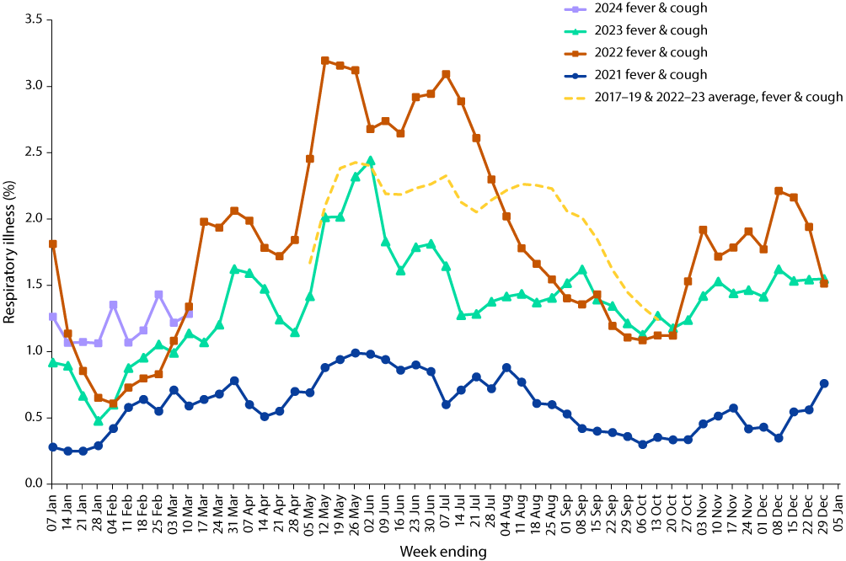
a In years prior to 2020, FluTracking was activated during the main Influenza season from May to October. A historical average beyond the week ending 13 October is therefore not available.
Week-on-week increases were observed in the incidence of ‘runny nose and sore throat’ symptoms since early February 2024. In the current four-week reporting period, the average proportion of ‘runny nose and sore throat’ symptoms remains slightly higher than the proportion observed during the same period in 2023, at 1.2% (Figure 10).
Over the reporting period, FluTracking data indicated that 8.3% of participants with ‘fever and cough’ were tested for SARS-CoV-2 with a PCR test and 78.2% were tested using a RAT (noting that in some instances RATs will be followed up by a PCR test for the same case). Of those with ‘runny nose and sore throat’, 2.7% were tested for SARS-CoV-2 using a PCR test and 49.4% were tested using a RAT. In the current reporting period, the percent positivity for ‘fever and cough’ symptoms decreased for both PCR (23.7%) and RAT (47.7%) compared to the previous reporting period. For ‘runny nose and sore throat’ symptoms, similar trends in percent positivity were observed. The percent positivity decreased for both PCR (4.5%) and RAT (7.4%). Note that participants with one set of symptoms are not excluded from having the other. It is important to acknowledge that there may be legitimate reasons why people did not get tested, including barriers to accessing testing. Symptoms reported to FluTracking are not specific to COVID-19 and may also be due to infections with other respiratory pathogens and to chronic diseases, such as asthma.
In the current reporting period, of those presenting to sentinel ASPREN sites with influenza-like illness who were tested for respiratory viruses, 72.6% (77/106) tested positive for a respiratory virus. Among those positive, the most common viruses detected were rhinovirus (40.3%; 31/77) followed by SARS-CoV-2 (18.2%; 14/77), parainfluenza (10.4%, 8/77) and metapneumovirus (10.4%; 8/77).
Figure 10: Weekly trends in runny nose and sore throat symptoms amongst FluTracking survey participants (age-standardised), Australia, 1 January 2021 – 10 March 2024a
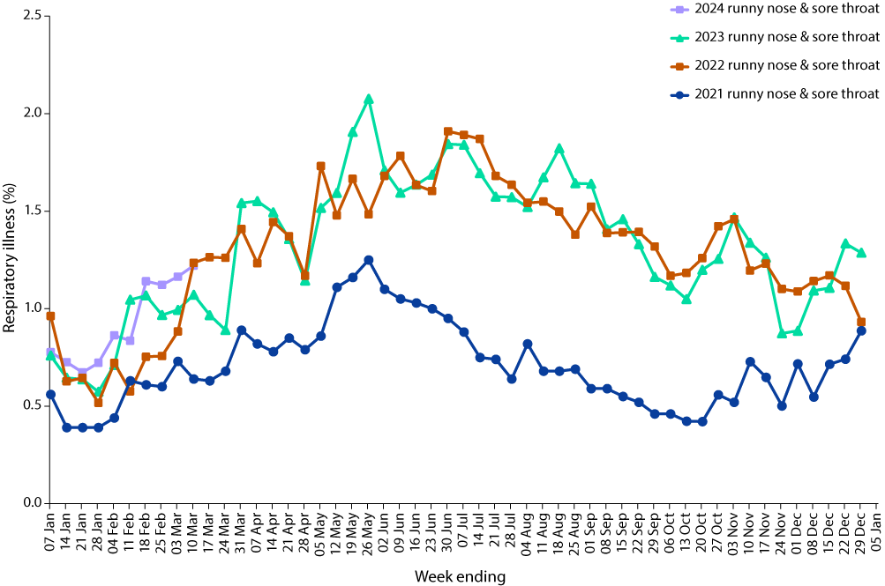
a Data on runny nose and sore throat were only collected systematically after 29 March 2020, therefore a historical average for this symptom profile is unavailable.

COVID-19 trends by WHO region
As of 3 March 2024, over 774 million COVID-19 cases and over 7 million deaths have been reported globally since the start of the pandemic, with a global case fatality rate (CFR) of approximately 0.91%.¹² Current trends in reported COVID-19 cases are an underestimate of the true number of global infections due to the reduction in testing and reporting in many countries. For more information, please refer to the WHO monthly COVID-19 epidemiological update.¹³

Acknowledgements
We thank public health staff from incident emergency operations centres and public health units in state and territory health departments, and the Australian Government Department of Health and Aged Care, along with state and territory public health laboratories. We thank those who have provided data from surveillance systems, such as ASPREN, FluTracking, FluCAN, PAEDS, SPRINT-SARI, the Communicable Disease Genomics Network, AusTrakka and jurisdictional sequencing laboratories.
COVID-19 Australia: Epidemiology Report 85 is the last instalment in the Viral Respiratory Diseases Epidemiology and Surveillance Section’s dedicated reporting on COVID-19 epidemiology within Australia, and the last such report to appear in CDI. Ongoing reporting from these authors, describing the epidemiology of COVID-19, influenza and respiratory syncytial virus (RSV) in Australia, appears in the Australian Respiratory Surveillance Report, which will be published at https://www.health.gov.au/resources/collections/arsr each fortnight from 12 April 2024.
The authors of COVID-19 Epidemiology Report 85 wish to thank all former contributors to this reporting series.

Author details
Corresponding author
Viral Respiratory Diseases Epidemiology and Surveillance Section
Interim Australian Centre for Disease Control, Australian Government Department of Health and Aged Care
GPO Box 9484, MDP 14,
Canberra, ACT 2601.
Email: respiratory.surveillance@health.gov.au

References
- COVID-19 National Incident Room Surveillance Team. COVID-19 Australia: Epidemiology Report 84: Reporting period ending 11 February 2024. Commun Dis Intell (2018). 2024;48. doi: https://doi.org/10.33321/cdi.2024.48.10.
- COVID-19 National Incident Room Surveillance Team. Technical supplement. COVID-19 Australia: Epidemiology reporting. Commun Dis Intell (2018). 2021;45. doi: https://doi.org/10.33321/cdi.2021.45.2.
- Australian Government Department of Health and Aged Care. Coronavirus (COVID-19) – CDNA National Guidelines for Public Health Units. [Internet.] Canberra: Australian Government Department of Health and Aged Care; 14 October 2022. [Accessed on 9 November 2022.] Available from: https://www.health.gov.au/resources/publications/coronavirus-covid-19-cdna-national-guidelines-for-public-health-units.
- FluCAN (The Influenza Complications Alert Network). FluCAN (Influenza surveillance). [Webpage.] Melbourne: Monash Health, FluCAN. [Accessed on 30 June 2023.] Available from: https://monashhealth.org/services/monash-infectious-diseases/research/influenza-research/flucan-influenza-surveillance-2/.
- Australian and New Zealand Intensive Care Research Centre (ANZIC-RC). SPRINT-SARI: Short period incidence study of severe acute respiratory infection. [Internet.] Melbourne: Monash University, ANZIC-RC; 2020. Available from: https://www.monash.edu/medicine/sphpm/anzicrc/research/sprint-sari.
- Communicable Diseases Genomics Network (CDGN). AusTrakka. [Website.] Melbourne: CDGN; 2020. Available from: https://www.cdgn.org.au/austrakka.
- World Health Organization (WHO). Updated working definitions and primary actions for SARS-CoV-2 variants. Geneva: WHO; 15 March 2023. [Accessed on 11 October 2023.] Available from: https://www.who.int/publications/m/item/updated-working-definitions-and-primary-actions-for--sars-cov-2-variants.
- WHO. Tracking SARS-CoV-2 variants. [Webpage.] Geneva: WHO; 17 August 2023. [Accessed on 23 August 2023.] Available from: https://www.who.int/activities/tracking-SARS-CoV-2-variants.
- COVID-19 National Incident Room Surveillance Team. COVID-19 Australia: Epidemiology Report 82: Reporting period ending 17 December 2023. Commun Dis Intell (2018). 2024;48. doi: https://doi.org/10.33321/cdi.2024.48.5.
- Centers for Disease Control and Prevention (CDC). COVID-19 Activity Increases as Prevalence of JN.1 Variant Continues to Rise. [Webpage.] Atlanta: United States Department of Health and Human Services, CDC; 5 January 2024. [ Accessed on 12 February 2024.] Available from: https://www.cdc.gov/respiratory-viruses/whats-new/JN.1-update-2024-01-05.html.
- Dalton C, Durrheim D, Fejsa J, Francis L, Carlson S, d’Espaignet ET et al. Flutracking: a weekly Australian community online survey of influenza-like illness in 2006, 2007 and 2008. Commun Dis Intell Q Rep. 2009;33(3):316–22.
- WHO. COVID-19 epidemiological update – 15 March 2024. [Internet.] Geneva: WHO; 15 March 2024. Available from: https://www.who.int/publications/m/item/covid-19-epidemiological-update-15-march-2024.
- WHO. Coronavirus disease (COVID-19) Weekly Epidemiological Updates and Monthly Operational Updates. [Webpage.] Geneva: WHO; 2024. Available from: https://www.who.int/emergencies/diseases/novel-coronavirus-2019/situation-reports.

Appendix A: Supplementary figures and tables
Table A.1: COVID-19 cases and rates per 100,000 population, by age group, sex, and date of onset, Australia, 15 December 2021 – 10 March 2024a,b,c,d
 | Four-week reporting period |  |  |  |  |  | Omicron wave to date
 | 12 February – 10 March 2024 |  |  |  |  |  | 15 December 2021 – 10 March 2024
Age group (years) | Cases |  |  | Rate per 100,000 population |  |  | Cases |  |  | Rate per 100,000 population
 | Male | Female | Peopled | Male | Female | Peopled | Male | Female | Peopled | Male | Female | Peopled
0–9 | 1,319 | 1,135 | 2,461 | 82.1 | 74.7 | 78.7 | 533,557 | 505,905 | 1,160,201 | 33,212.4 | 33,285.3 | 37,109.8
10–19 | 866 | 851 | 1,722 | 51.5 | 53.7 | 52.7 | 664,966 | 706,475 | 1,507,938 | 39,526.1 | 44,604.6 | 46,167.8
20–29 | 776 | 1,530 | 2,313 | 41.5 | 85.8 | 63.3 | 806,144 | 990,220 | 1,922,047 | 43,084.1 | 55,552.6 | 52,607.2
30–39 | 1,073 | 2,077 | 3,155 | 55.2 | 105.1 | 80.5 | 833,179 | 1,045,776 | 2,025,946 | 42,854.1 | 52,917.6 | 51,676.3
40–49 | 1,111 | 2,092 | 3,207 | 66.2 | 122.0 | 94.5 | 692,568 | 882,367 | 1,696,540 | 41,245.4 | 51,442.2 | 49,980.5
50–59 | 1,258 | 1,913 | 3,173 | 79.9 | 117.4 | 99.0 | 564,340 | 704,147 | 1,356,414 | 35,833.5 | 43,225.9 | 42,336.5
60–69 | 1,326 | 1,699 | 3,025 | 96.4 | 115.7 | 106.4 | 413,175 | 480,409 | 947,118 | 30,033.7 | 32,726.5 | 33,306.4
70–79 | 1,593 | 1,592 | 3,187 | 159.4 | 146.5 | 152.8 | 270,575 | 276,154 | 571,490 | 27,081.1 | 25,407.7 | 27,396.2
80–89 | 1,387 | 1,506 | 2,902 | 333.1 | 293.5 | 312.2 | 127,850 | 145,394 | 282,744 | 30,705.4 | 28,334.3 | 30,418.5
90 + | 471 | 829 | 1,303 | 617.9 | 599.9 | 607.7 | 34,157 | 63,470 | 100,347 | 44,806.6 | 45,930.5 | 46,799.5
a Source: NNDSS, extracted on 13 March 2024 for notifications to 10 March 2024.
b Population data based on Australian Bureau of Statistics (ABS) Estimated Resident Population (ERP) as at June 2023.
c Excludes cases where age was unknown.
d Total cases includes those where sex was unknown and those classified as X, i.e., persons who reported their sex as another term, other than male or female.

Communicable Diseases Intelligence
Communicable Diseases Intelligence (CDI) is a peer-reviewed scientific journal published by the Health Protection Policy & Surveillance Division, Department of Health and Aged Care. The journal aims to disseminate information on the epidemiology, surveillance, prevention and control of communicable diseases of relevance to Australia.
© 2024 Commonwealth of Australia as represented by the Department of Health and Aged Care
ISSN: 2209-6051 Online
This journal is indexed by Index Medicus and Medline.
This publication is licensed under a Creative Commons Attribution-NonCommercial-NoDerivatives 4.0 International Licence (CC BY-NC-ND) available from https://creativecommons.org/licenses/by-nc-nd/4.0/legalcode (Licence). You must read and understand the Licence before using any material from this publication.
Restrictions
The Licence does not cover, and there is no permission given for, use of any of the following material found in this publication (if any):
- the Commonwealth Coat of Arms (by way of information, the terms under which the Coat of Arms may be used can be found at www.pmc.gov.au/resources/commonwealth-coat-arms-information-and-guidelines);
- any logos (including the Department of Health and Aged Care’s logo) and trademarks;
- any photographs and images;
- any signatures; and
- any material belonging to third parties.
Disclaimer
Opinions expressed in Communicable Diseases Intelligence are those of the authors and not necessarily those of the Australian Government Department of Health and Aged Care or the Communicable Diseases Network Australia. Data may be subject to revision.
Enquiries
Enquiries regarding any other use of this publication should be addressed to the CDI Editor at: cdi.editor@health.gov.au
Communicable Diseases Network Australia
Communicable Diseases Intelligence contributes to the work of the Communicable Diseases Network Australia. www.health.gov.au/cdna
Editor: Christina Bareja • Deputy Editor: Simon Petrie • Design and Production: Lisa Thompson
Editorial Advisory Board: David Durrheim, Mark Ferson, Clare Huppatz, John Kaldor, Martyn Kirk, Meru Sheel and Stephanie Williams
Contacts
CDI is produced by:
Health Protection Policy & Surveillance Division, Australian Government Department of Health and Aged Care,
GPO Box 9848, (MDP 6) CANBERRA ACT 2601
Website: www.health.gov.au/cdi
Email: cdi.editor@health.gov.au
Submit an Article
You are invited to submit your next communicable disease related article to the Communicable Diseases Intelligence (CDI) for consideration. More information regarding CDI can be found at: www.health.gov.au/cdi.
Further enquiries should be directed to: cdi.editor@health.gov.au.

