An evaluation of enhanced surveillance of hospitalised COVID-19 patients to inform the public health response in Victoria
Stephanie J Curtis, Zoe Cutcher, Judith A Brett, Simon Burrell, Michael J Richards, Daneeta Hennessy, Rebecca F Gang, Colleen L Lau, Stacey L Rowe

Abstract

Background
Public health surveillance is crucial for supporting a rapid and effective response to public health emergencies. In response to the coronavirus disease (COVID-19) pandemic, an enhanced surveillance system of hospitalised COVID-19 patients was established by the Victorian Department of Health and Human Services (DHHS) and the Victorian Healthcare Associated Infection Surveillance System Coordinating Centre. The system aimed to reduce workforce capacity constraints and increase situational awareness on the status of hospitalised patients.

Methods
The system was evaluated, using guidelines from the United States Centers for Disease Control and Prevention, against eight attributes: acceptability; data quality; flexibility; representativeness; simplicity; stability; timeliness; and usefulness. Evidence was generated from stakeholder consultation, participant observation, document review, systems review, issues log review and audits. Data were collected and analysed over a period of up to three months, covering pre- and post-implementation from March to June 2020.

Results
This system was rapidly established by leveraging established relationships and infrastructure. Stakeholders agreed that the system was important but was limited by a reliance on daily manual labour (including weekends), which impeded scalability. The ability of the system to perform well in each attribute was expected to shift with the severity of the pandemic; however, at the time of this evaluation, when there were an average 23 new cases per day (0.3 cases per 100,000 population per day), the system performed well.

Conclusion
This enhanced surveillance system was useful and achieved its key DHHS objectives during the COVID-19 public health emergency in Victoria. Recommendations for improvement were made to the current and future systems, including the need to plan alternatives to improve the system’s scalability and to maintain stakeholder acceptability.
Keywords: coronavirus, emergency response, evaluation, hospitalisations, pandemic, surveillance

Introduction
Coronavirus disease (COVID-19) is a significant public health problem that is resource-intensive for healthcare systems. A key concern regarding COVID-19 is the pressure on hospitals to support people affected with severe forms of the disease, including the availability of Intensive Care Unit (ICU) beds, critical care devices, and staffing levels; and the ability to appropriately isolate cases. Early in the pandemic, modelling in Australia estimated that 6% of cases would require hospitalisation; 30% of these hospitalised cases would require admission to ICU; and 70% of these ICU admissions would require invasive ventilation.¹ In Australia, at the time of this evaluation in June 2020, 15% of cases were admitted to hospital; 19% of these hospitalised cases were admitted to ICU; and 28% of these ICU admissions were ventilated.² The case fatality rate was 1.4% in all cases; 7.9% in hospitalised cases; and 13.6% in cases admitted to ICU.² Public health surveillance can be used to comprehensively capture the severity of disease among COVID-19 cases and to monitor hospital utilisation, to inform public health interventions and hospital pandemic planning and operational response.^{3,4}
On 28 January 2020, COVID-19 became a notifiable condition in Victoria and, under the Public Health and Wellbeing Regulations (2019), medical practitioners and laboratories were required to urgently notify the Victorian Department of Health and Human Services (DHHS) of all suspected and confirmed cases of COVID-19. This passive surveillance system, which underpins communicable disease prevention and control efforts in Victoria, was augmented by an enhanced hospital-based surveillance system to comprehensively capture the status of hospitalised COVID-19 cases during the pandemic. There were three key objectives of the system. Firstly, to reduce the time required by the DHHS Existing Cases Team to make daily phone calls to hospital staff to record the status of hospitalised patients with confirmed COVID-19. Secondly, to enable the DHHS to record and report hospitalised patients with confirmed COVID-19 with increased accuracy and timeliness, including their ICU and ventilation status. Thirdly, to enable hospitals to have a simple-to-use platform with which to report on their current situation of COVID-19 inpatients.
The Victorian Healthcare Associated Infection Surveillance System (VICNISS) Coordinating Centre agreed to assist the DHHS to use VICNISS’s existing operations to implement this enhanced surveillance system. VICNISS was established by the DHHS in 2002 to coordinate standardised surveillance of healthcare-associated infections in Victorian healthcare facilities; however, its scope of work has since expanded to the prevention of healthcare-associated infections in outpatient and community settings, including residential aged care facilities. Data from VICNISS surveillance activities have been used to support safety and quality improvement processes at health services across Victoria.
Enhanced surveillance has been a core component of the Victorian public health response to COVID-19. The evaluation of these systems can facilitate improvements in the systems’ performance and the overall public health response. Here, we evaluate Victoria’s hospital-based enhanced surveillance system for COVID-19; we provide recommendations for improvement of the current system; and we use our findings to inform the planning and implementation of future enhanced surveillance activities relating to communicable diseases of public health importance.

Methods
The framework for this evaluation was adapted from the United States Centers for Disease Control and Prevention’s (CDC) updated guidelines for the evaluation of public health surveillance systems.⁵ The surveillance system was assessed against eight attributes identified in the CDC framework (Table 1). Evidence was generated through mixed methods, including participant observation; stakeholder consultation (survey and/or interview); document review; systems review; issues log review; and audits. Data were collected and analysed over a period of up to three months from March to June 2020, with the stakeholder consultation occurring in June 2020.

Table 1. The surveillance system attributes and definition for the evaluation
Attribute | Definition
Usefulness | The ability to achieve the three defined objectives.
Simplicity | The ease of the systems to be operated and its integration with existing systems.
Acceptability | The willingness of users to participate in the surveillance system.
Flexibility | The ability of the system to adapt to changing information needs and/or operating conditions without significant changes in time, staff contribution or funding.
Timeliness | The timely entry, cleaning, analysis, and reporting of data by all users.
Data quality | The accuracy, completeness, and reliability of data captured.
Stability | The reliability to maintain confidentiality and perform without failure, including during adaptation.
Representativeness | The coverage of hospital reporting by geographical location and sector.
Stakeholders from the DHHS were asked to assess each system attribute using a Likert Scale through an electronic survey using the Research Electronic Data Capture (REDCap) system, hosted at the Australian National University.^{6,7} Respondents identified their role in the system, but remained anonymous unless they were willing to further discuss their survey responses. Stakeholders from VICNISS and hospital Infection Prevention Control departments were consulted face-to-face or online. Interview notes from consultations were recorded on a structured interview template according to each attribute and inductively coded into themes within each attribute in Microsoft Excel.
Documents and systems were reviewed, encompassing: letters issued by the Chief Health Officer; standard operating procedures; educational materials; and an issues log generated through a review of all emails exchanged during the implementation and management of the system from 19 March to 6 June 2020. Participant observation and four audits which assessed the system’s timeliness and data quality also occurred during this period. A pre-system-implementation reporting audit and post-system-implementation data accuracy audit compared random samples of 20 records from Victoria’s notifiable diseases database, the Public Health Event Surveillance System (PHESS), and from the VICNISS database. A reporting error audit was performed through reviewing email correspondence of all data discrepancies identified by the DHHS during daily data processing and cleaning. A reporting bias audit compared the number and type of patient updates that occurred on each day of the week in the VICNISS database.

Results
A total of 24 stakeholders were included in this evaluation; 18 completed the electronic survey, and six were consulted face-to-face or online. The stakeholders were involved in a variety of stages of the surveillance system, including design (3/24; 13%), implementation (16/24; 62%), and post-implementation (22/24; 92%). Table 2 presents the number and type of stakeholders that contributed to the evaluation and the estimated number of stakeholders that contributed to the system over the evaluation period.

Table 2. The number of stakeholders that participated in the evaluation and the number of stakeholders involved in the system, by group
Stakeholder group | Number involved in the system | Number involved in the evaluation (%)
Managers, Leads and Supervisors, Intelligence Team, DHHS | 8 | 4 (50%)
Development, Intelligence Team, DHHS | 5 | 3 (60%)
Data and Reporting Team, Intelligence Team, DHHS | 20 | 6 (30%)
Existing Cases Team Lead, Case Contact and Outbreak Management, DHHS | 4 | 2 (50%)
Existing Cases Public Health Officer, Case Contact and Outbreak Management, DHHS | 12 | 3 (25%)
VICNISS Coordinating Centre | 8 | 3 (37.5%)
Hospital Infection Prevention Control Departments | 217 | 3ª
Total | 57^{b} | 24
a Three stakeholders from one health service that report to the surveillance system for three hospitals.
b Excluding the number of Hospital Infection Prevention Control Departments.

Systems operation
This enhanced surveillance activity was initiated in February 2020 and implemented in mid-March. Prior to this system, the DHHS contacted each COVID-19 case or their doctor daily to determine clinical status and whether the case was in hospital. This workflow was anticipated to become unmanageable if case numbers increased largely. When the system planning commenced, there had only been three confirmed COVID-19 cases in Victoria and no additional burden on health services; however, the impact of the pandemic had been seen in other high-income countries.⁸ During the system’s implementation in March, there was an average of 50 cases per day (0.8 cases per 100,000 population per day), and immediately post-implementation, an average of 15 cases per day in April (0.3 cases per 100,000 population per day), 9 cases per day in May (0.1 cases per 100,000 population per day) and 17 cases per day in June (0.3 cases per 100,000 population per day).
A simple representation of the system is provided in Figure 1. The system’s operation relied on the contributions of three distinct stakeholder groups: hospital staff; VICNISS staff; and the DHHS. Delegated staff at each hospital reported data in an online database established and maintained by VICNISS. The status of hospitalised patients with COVID-19, including the location, ward or ICU, and ventilation status, were updated daily in the VICNISS database until death, discharge, or DHHS clearance from isolation. Data were accessed, processed and cleaned by the DHHS, then used to inform public health follow-up of confirmed cases, reporting and planning. VICNISS liaised between representatives from hospitals and the DHHS, to support and promote the operation of the system. Each hospital also submitted a weekly report on Tuesdays if there were no hospitalised COVID-19 cases, to distinguish between hospitals who had no patients with COVID-19 and those who did not submitted any reports. The system used the COVID-19 case definition from the Communicable Disease Network Australia Series of National Guidelines at the time of data collection.⁹ The system captured cases that were admitted to hospital with symptoms, or which developed symptoms whilst in hospital, along with high-quality data on the patient’s status not usually obtained through passive surveillance.

Figure 1. A simplified representation of the surveillance system components and operation
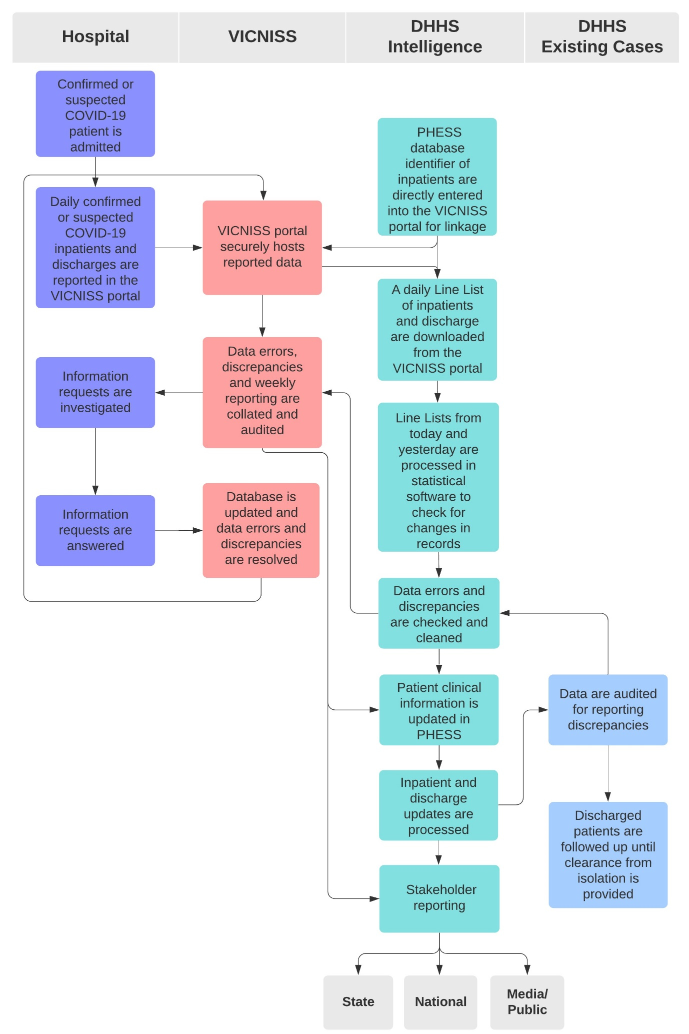

Evaluation

Usefulness
The system was useful and achieved its two objectives for DHHS, but it was less useful for hospitals. Most survey respondents (17/18; 94%) agreed the system detected changes in hospitalisations with COVID-19 and reduced staff time for DHHS to follow up with hospitals about inpatients with COVID-19. The system also provided a systematic method of capturing data required for stakeholder reporting, including the daily Victorian State Situational Report, and weekday reporting to the Australian Institute of Health and Welfare. The system was unlikely to achieve its third objective of providing a reporting platform for hospital departments to report on their situation of COVID-19 patients. Stakeholders noted that they were unaware of the ability to request this report, and that existing reporting processes were already established. Furthermore, the system utilised the DHHS definition of clearance from isolation as a point for where reporting updates were no longer required, whereas hospitals commonly isolated patients until discharge.

Acceptability
All stakeholders agreed that the system was of public health importance; however, the willingness of users to participate in the surveillance system varied. Acceptability was high for VICNISS, high for most DHHS staff, and neutral for hospital staff. The key limitation to acceptability was the reliance on daily reporting by hospitals, including at weekends, which may not have been feasible for hospitals with staffing resource constraints. Additionally, hospitals’ users reported that the system duplicated other DHHS reporting requirements, such as the passive surveillance system of medical practitioners required to urgently notify of all suspected and confirmed cases of COVID-19.

Simplicity
The system was simple and integrated well for VICNISS and hospitals, but less so for the DHHS. The system used an online platform regularly used by hospitals for other VICNISS reporting, and communication was done between organisations and individuals with established relationships. The usual relationship managers of VICNISS are Safer Care Victoria; however, the partnership between the DHHS Health Protection Branch integrated well. Data entry for hospitals was simple, requiring completion of 12 mandatory fields during the patient’s admission, and one field which was updated daily. These data fields are readily available in hospital electronic medical record systems.
The system required a high degree of manual labour and high person-time contribution at the DHHS. Data entry required one field into the VICNISS database; a minimum of five mandatory fields in the PHESS database; and additional fields if the patient moved throughout the hospital or if their ventilation status changed. Despite the minimal data, complexities arose from a series of data entry rules specified in the system’s Standard Operating Procedures. These rules were rigorous and required an intricate knowledge of the PHESS database as they determined information flows between teams in the public health response and reporting requirements. Additionally, the PHESS database was used by many teams in the public health response and required daily checking to ensure no incorrect alterations had been made. Participant observation supported that the systems data entry rules were complex, as they commonly required clarification, and the impact on information flows across the DHHS COVID-19 response was unclear.
Additionally, this system does not integrate with other hospital-based enhanced surveillance activities that were concurrently utilised nationally and in Victoria. The Australian and New Zealand Intensive Care Society (ANZICS), the Critical Health Resource Information System (CHRIS), the Influenza Complications Alert Network (FluCAN) and the Short PeRiod IncideNce sTudy of Severe Acute Respiratory Infection (SPRINT-SARI) are sentinel surveillance systems which also collect data on COVID-19 inpatients, resulting in some overlap with this system.

Flexibility
The system was able to adapt to changing information needs; however, it could not adapt well to changing operating conditions. Data capture could be expanded without system interruptions; however, hospital stakeholders’ acceptability and simplicity were prioritised when considering changes. The PHESS database has capacity to receive information directly through data uploads, and this was the intention of the system, however the system’s data entry into PHESS was unable to be automated due to the complex data entry rules. This limited flexibility was reflected in survey responses. Half of the survey respondents were undecided/neutral about whether the system could rapidly adapt to changing information (9/18; 50%); seven strongly agreed or agreed (39%); and two disagreed (11%). More respondents strongly agreed or agreed (12/18; 67%) that the system could rapidly adapt to changing operating conditions; however, four were undecided/neutral (22%); and two disagreed (11%). Several stakeholders noted that a key limitation was the lack of automation of data entry into PHESS.

Data quality
The system consisted of multiple layers of data checking and cleaning, which resulted in an improvement in data quality compared to the system used pre-implementation. In the pre-implementation audit (5–25 April), demographic and facility information were entered correctly; however, three-quarters of records had different dates recorded in the PHESS database than in the VICNISS database. In the post-implementation audit (26 April – 6 June), most records were entered correctly (17/20; 85%), however there were three admission or discharge dates entered as either a day later or earlier. In the audit of reporting errors by hospital staff (5 April – 6 June), twenty percent of admissions entered (16/81) were reported with an error. The most common errors were date of birth (10/16; 63%), sex (3/16; 19%) and discrepancies in isolation definitions (3/16; 19%). Half of the respondents reported that the system was vulnerable to data quality errors (9/18; 50%); however, only one agreed that the system often had data quality errors (1/18; 5%). More than half of respondents disagreed with the statement that the system often had data quality errors (10/18; 56%) and others were undecided/neutral (7/18; 39%). Stakeholders expressed the view that the multiple layers of data checking and cleaning maintained data quality; however, a recurring concern for data quality was the timeliness of data on weekends.

Timeliness
The system was timely for data entry, cleaning, analysis, and reporting, as this process occurred daily; however, it was vulnerable to delays in weekend reporting. Stakeholder consultation and participant observation highlighted two issues with timeliness. Firstly, reporting was performed at a point in time rather than real-time, resulting in a lag for public health follow-up of up to 24 hours pre- and post-admission. Secondly, reporting updates were not always provided on weekends and public holidays. In the audit of reporting bias, there were 564 location record updates from 19 March to 6 June, and the fewest updates occurred on Saturday (12%) and Sunday (10%) (Figure 2). This lower number of updates over the weekend was consistent across all categories (ICU; ventilation; ward; and discharge) and was therefore unlikely to be due to common hospital admission patterns (e.g. higher admissions post-weekend or discharges pre-weekend). The highest number of updates occurred on a Tuesday, the day on which hospitals were required to submit a weekly report as to whether they had a hospitalised COVID-19 case or not. When this report was not submitted, VICNISS contacted each hospital for follow-up, which was likely to improve data quality and uptake of the system overall.

Figure 2. The number of records for hospitalised patients with COVID-19 updated for each day of the week from March 19 to June 6, 2020, by the patients most recent location status
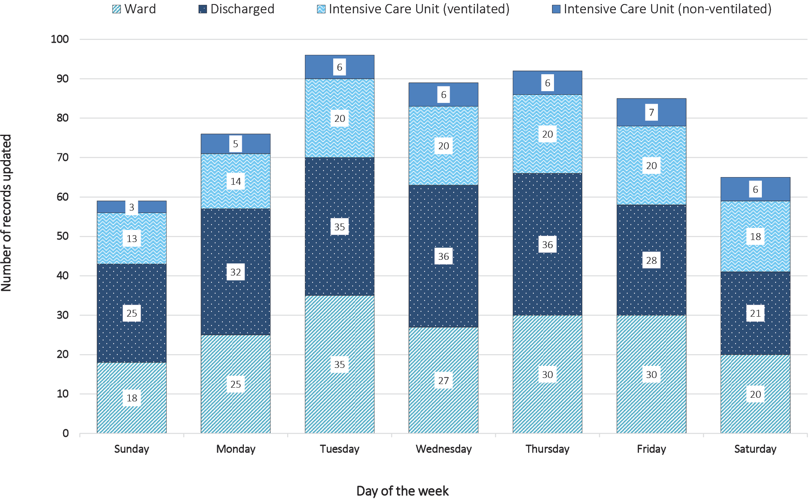

Stability
The system was reliable to perform without failure but was unlikely to be stable if daily case numbers were to increase largely, which would increase the workload of all stakeholders. The system was not intended to be largely scalable; however, this was not well-communicated to stakeholders, who expressed concerns regarding the system’s capacity if a large increase in cases were to occur. Additionally, the point at which the system would no longer become scalable or feasible was not yet defined. The system’s databases and information flows were technologically stable, with little-to-no failure or adverse impact on operations reported. Finally, the system’s databases and information flows maintained patient confidentiality through secure encrypted servers and comprehensive authentication processes to restrict data access.

Representativeness
Stakeholders reported that the system accurately described inpatients in Victoria with COVID-19 by person, place, and time through combining data from the VICNISS and PHESS databases. The system was highly representative, with around 95% of hospitals consistently contributing to the system. Stakeholders reported that small, rural, and private hospitals were most vulnerable to poor reporting due to staffing resource constraints.

Discussion
This rapidly deployed surveillance system was an important enhancement to existing passive and other surveillance mechanism used in Victoria, to help guide the local public health response. At the time of this evaluation, the system performed well in each attribute; however, if large increases in case numbers were to occur, the system could become unstable. There were two key limitations of this system which restricted the scalability. Firstly, the reliance on hospital staff to report daily, which may not have been feasible within resource capacity, and which may have resulted in untimely data, particularly on weekends. Secondly, the DHHS reliance on manual labour and the inability to automate the daily data entry into the PHESS database. Further consultation with hospital staff could enable an understanding of the ongoing feasibility of the system. Key recommendations to the system are listed in Box 1.
Box 1. Key recommendations for the current and future enhanced surveillance systems
- To provide ongoing consultation with hospitals about their reporting capacity and to discuss alternatives to weekend reporting to improve acceptability, data quality and timeliness, prioritising hospitals that are at risk of reduced reporting capacity.
- To develop a detailed plan for how the system could be scaled back, in consultation with stakeholders.
- To perform a comprehensive review of existing enhanced hospital surveillance systems to see opportunities to integrate, restructure, or dismantle systems, and potentially facilitate the above recommendations.
- To explore opportunities that reduce the manual data handling in the system, such as limiting its use only to deal with electronic data transfer errors.
- To consider additional data specifications in the VICNISS database that could facilitate the public health response, such as the inclusion of whether the inpatient normally resides in a residential aged care facility.
- To enhance the reporting process for hospitals through specified VICNISS platform alterations.
- To continue dialogue between the DHHS Health Protection Branch, Safer Care Victoria and VICNISS to better integrate Infection Prevention Control activities after the COVID-19 epidemic in Victoria.
- To utilise the partnership between the DHHS Health Protection Branch and VICNISS to deploy future enhanced surveillance systems, as required.
- To increase engagement with all stakeholders during conceptualisation for future systems, particularly with hospital representatives for hospital-based surveillance systems.

The strengths and limitations of this evaluation should be considered in the interpretation of results and recommendations. The evaluation was performed by an internal evaluator, which enabled a strong understanding of the system, an extended period of participant observation, and the ability to make ongoing improvements throughout the implementation; however, this may have inhibited the ability to act purely as an intermediary. The evaluation was performed during an emergency response, which may have reduced stakeholder participation and which resulted in limited representativeness from hospitals. Finally, this evaluation represents a discrete time point, prior to a large surge in hospitalised cases in Victoria, and may not be extrapolated to the system’s functionality under surge pressure.

Conclusion
This enhanced surveillance system was useful for Victoria’s response to the COVID-19 public health emergency. The series of proposed recommendations focus on the need to plan alternatives when there is no clear end date to the public health problem of interest, to maintain stakeholder acceptability, and to improve the system’s scalability.

Ethics
The enhanced surveillance activities were conducted for and on behalf of the DHHS under the Public Health and Wellbeing Act 2008. The evaluation was approved by the Australian National University Human Research Ethics Committee [HREC/17/ANU/909].

Acknowledgements
We thank members of the DHHS, VICNISS, and hospitals who contributed to this evaluation and those who work to support the daily function of this surveillance system.

Funding
SC is funded by the Master of Philosophy (Applied Epidemiology) Scholarship at the Australian National University.

Author details
Stephanie Curtis^{1,2}
Dr Zoe Cutcher²
Judith Brett³
Simon Burrell³
Professor Michael Richards³
Daneeta Hennessy²
Dr Rebecca Gang²
Associate Professor Colleen Lau⁴
Stacey Rowe²
- National Centre for Epidemiology and Population Health, the Australian National University, Australia Capital Territory, Australia
- Department of Health and Human Services, Victoria, Australia
- Victorian Healthcare Associated Infection Surveillance System Coordinating Centre, the Peter Doherty Institute for Infection and Immunity, Victoria, Australia
- Department of Global Health, the Australian National University, Australia Capital Territory, Australia

Corresponding author
Ms Stephanie J Curtis Address: 50 Lonsdale Street, Melbourne, Victoria, Australia Phone: 0438394360 Email: stephanie.curtis@dhhs.vic.gov.au

References
- Moss R, Wood J, Brown D, Shearer FM, Black AJ, Glass K et al. Coronavirus disease model to inform transmission reducing measures and health system preparedness, Australia. Emerg Infect Dis. 2020;26(12). doi: https://doi.org/10.3201/eid2612.202530.
- COVID-19 National Incident Room Surveillance Team. COVID-19, Australia: epidemiology report 19: fortnightly reporting period ending 21 June 2020. Commun Dis Intell (2018). 2020;44. doi: https://doi.org/10.33321/cdi.2020.44.54.
- Victorian State Government Health and Human Services (DHHS). COVID-19 pandemic plan for the Victorian Health Sector: version 1.0. Melbourne: Victorian State Government DHHS; 10 March 2020. Available from: https://www2.health.vic.gov.au/about/publications/researchandreports/covid-19-pandemic-plan-for-vic.
- Australian Government Department of Health. Australian health sector emergency response plan for novel coronavirus (COVID-19). (Publications number: 12723.) Canberra: Australian Government Department of Health; 18 February 2020. Available from: https://www.health.gov.au/resources/publications/australian-health-sector-emergency-response-plan-for-novel-coronavirus-covid-19.
- German RR, Horan JM, Lee LM, Milstein B, Pertowski CA, Waller MN et al. Updated guidelines for evaluating public health surveillance systems; recommendations from the Guidelines Working Group. MMWR Recomm Rep. 2001;50(RR-13):1–35.
- Harris PA, Taylor R, Minor BL, Elliott V, Fernandez M, O’Neal L et al. The REDCap consortium: building an international community of software platform partners. J Biomed Inform. 2019;95:103208.
- Harris PA, Taylor R, Thielke R, Payne J, Gonzalez N, Conde JG. Research electronic data capture (REDCap)—a metadata-driven methodology and workflow process for providing translational research informatics support. J Biomed Inform. 2009;42(2):377–81.
- Livingston E, Bucher K. Coronavirus disease 2019 (COVID-19) in Italy. JAMA. 2020;323(14):1335.
- Australian Government Department of Health, Communicable Diseases Network Australia (CDNA). Coronavirus disease 2019 (COVID-19): CDNA national guidelines for public health units. Canberra: Australian Government Department of Health; 2020. Available from: https://www1.health.gov.au/internet/main/publishing.nsf/Content/cdna-song-novel-coronavirus.htm.

Communicable Diseases Intelligence
ISSN: 2209-6051 Online

Communicable Diseases Intelligence (CDI) is a peer-reviewed scientific journal published by the Office of Health Protection, Department of Health. The journal aims to disseminate information on the epidemiology, surveillance, prevention and control of communicable diseases of relevance to Australia.

Editor: Tanja Farmer
Deputy Editor: Simon Petrie
Design and Production: Kasra Yousefi
Editorial Advisory Board: David Durrheim, Mark Ferson, John Kaldor, Martyn Kirk and Linda Selvey

Website: http://www.health.gov.au/cdi

Contacts
Communicable Diseases Intelligence is produced by:
Health Protection Policy Branch, Office of Health Protection, Australian Government Department of Health
GPO Box 9848, (MDP 6) CANBERRA ACT 2601

Email: cdi.editor@health.gov.au

Submit an Article
You are invited to submit your next communicable disease related article to the Communicable Diseases Intelligence (CDI) for consideration. More information regarding CDI can be found at: http://health.gov.au/cdi.
Further enquiries should be directed to: cdi.editor@health.gov.au.

This journal is indexed by Index Medicus and Medline.

Creative Commons Licence - Attribution-NonCommercial-NoDerivatives CC BY-NC-ND
© 2020 Commonwealth of Australia as represented by the Department of Health
This publication is licensed under a Creative Commons Attribution-NonCommercial-NoDerivatives 4.0 International Licence from https://creativecommons.org/licenses/by-nc-nd/4.0/legalcode (Licence). You must read and understand the Licence before using any material from this publication.

Restrictions
The Licence does not cover, and there is no permission given for, use of any of the following material found in this publication (if any):
- the Commonwealth Coat of Arms (by way of information, the terms under which the Coat of Arms may be used can be found at www.itsanhonour.gov.au);
- any logos (including the Department of Health’s logo) and trademarks;
- any photographs and images;
- any signatures; and
- any material belonging to third parties.

Disclaimer
Opinions expressed in Communicable Diseases Intelligence are those of the authors and not necessarily those of the Australian Government Department of Health or the Communicable Diseases Network Australia. Data may be subject to revision.

Enquiries
Enquiries regarding any other use of this publication should be addressed to the Communication Branch, Department of Health, GPO Box 9848, Canberra ACT 2601, or via e-mail to: copyright@health.gov.au

Communicable Diseases Network Australia
Communicable Diseases Intelligence contributes to the work of the Communicable Diseases Network Australia.
http://www.health.gov.au/cdna

