COVID-19, Australia: Epidemiology Report 18:
Fortnightly reporting period ending 7 June 2020
COVID-19 National Incident Room Surveillance Team
Notified cases of COVID-19 and associated deaths reported to the National Notifiable Diseases Surveillance System (NNDSS) to 7 June 2020.
Confirmed cases in Australia notified up to 7 June 2020
Notifications | 7,277
Deaths | 102

Summary
Over the past fortnightly reporting period:
- The number of new cases in all jurisdictions continues to decline, or remain very low; and
- Testing rates continue to be high across all jurisdictions, with the positivity rate remaining very low at less than 0.1%.
The incidence of COVID-19 has markedly reduced since a peak in mid-March. A combination of early case identification, physical distancing, public health measures and a reduction in international travel have been effective in slowing the spread of disease in Australia.
Of the 147 cases notified between 25 May and 7 June, 63% acquired their infection overseas. The proportion of cases locally acquired has dropped substantially to 28% of new cases this period compared with 50% and greater observed since 30 March 2020. Of the cases considered to be locally-acquired over this period, most were associated with contacts of confirmed cases or were associated with known outbreaks.
A small proportion of overall cases have experienced severe disease, requiring hospitalisation or intensive care with some fatalities. The crude case fatality rate amongst Australian cases is 1.4%. People who are older and have one or more comorbidities are more likely to experience severe disease.
The highest rate of COVID-19 continues to be among people aged 65–79 years. Three-quarters of all cases in this age group have been associated with overseas travel, including several outbreaks linked to cruise ships. The lowest rate of disease is in children under 18 years, a pattern reflected in international reports.
Internationally, as of 7 June 2020, the largest numbers of both cases and deaths have been reported in the United States. Of the confirmed cases reported globally, the case fatality rate is approximately 5.8%. Countries in South America are seeing rapid growth in case numbers, while the United States is seeing a steady decline in its daily new case numbers. Case numbers in Europe remain relatively steady, with several countries in Eastern Europe experiencing rapid growth. In the South East Asia region, India and Bangladesh are seeing accelerating epidemics, compounded by the recovery from Cyclone Amphan. Reported cases are increasing in Africa, although the numbers are much smaller. In the Pacific there are few new cases reported daily.
Keywords: SARS-CoV-2; novel coronavirus; 2019-nCoV; coronavirus disease 2019; COVID-19; acute respiratory disease; epidemiology; Australia
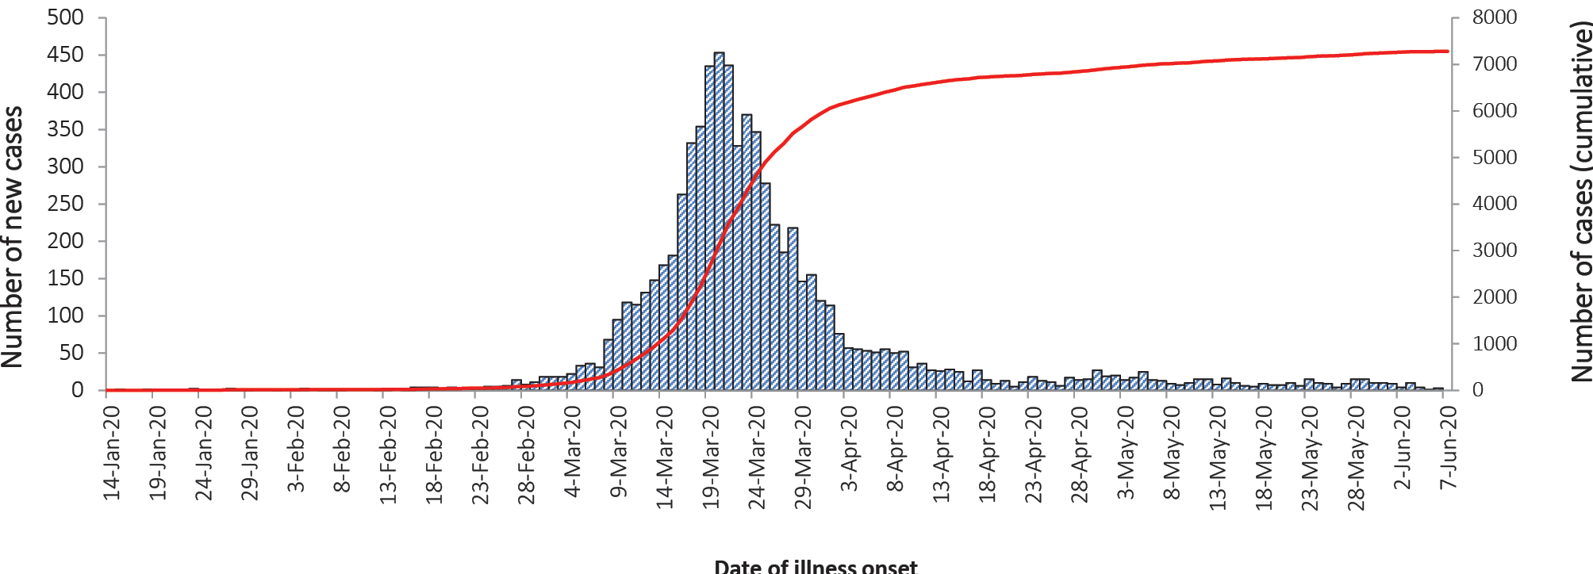
Source: NNDSS

Australian cases: descriptive epidemiology

National trends
The incidence of COVID-19 continues to be low with very few cases reported by most jurisdictions, indicative of a steady reduction in transmission (Figure 1). Compared with the previous fortnight, the number of cases notified to the NNDSS increased slightly from 134 (11 to 24 May) to 147 (25 May to 7 June).
Since the epidemic began, the highest cumulative rates of COVID-19 per 100,000 population have been reported from NSW and Tasmania (Table 1). This appears to be driven by the cruise-ship-related outbreaks in NSW and by a large outbreak in hospitals in North West Tasmania.

Figure 1: Fortnightly COVID-19 new case notifications per 100,000 population,ª as at 7 June 2020, by jurisdiction
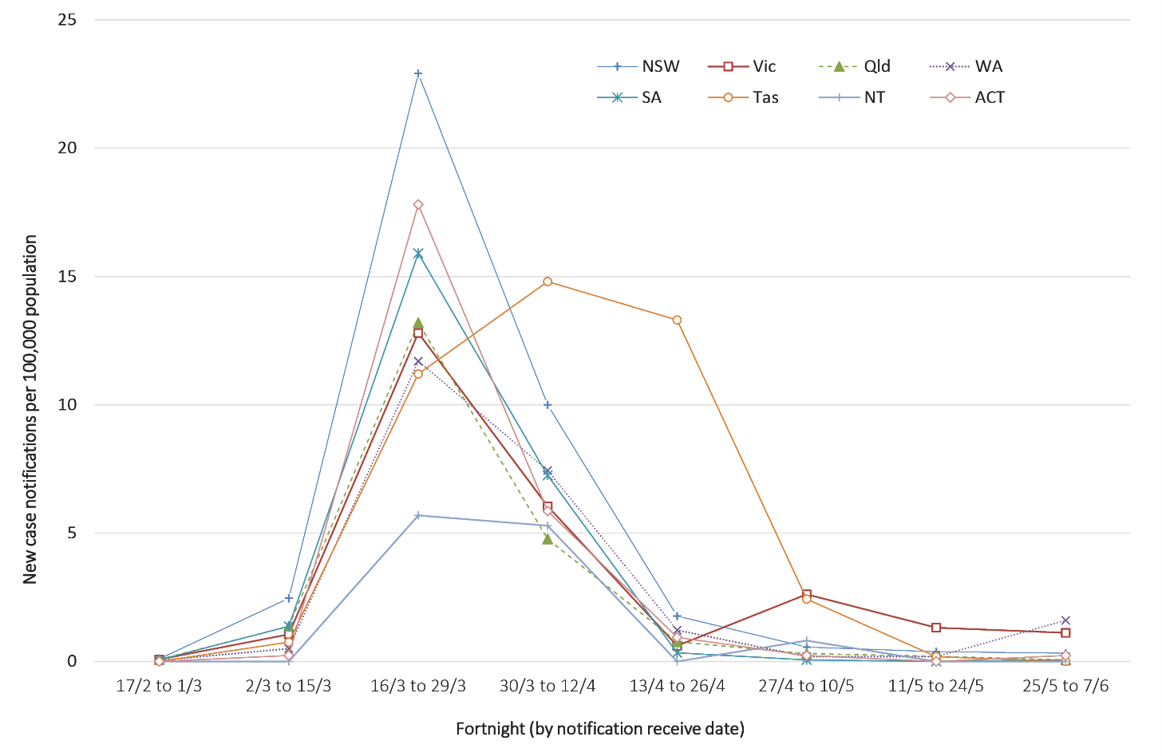
a Source: NNDSS.
Table 1: Fortnightly notifications and cumulative total cases of COVID-19,ª Australia, by jurisdiction
Jurisdiction | New cases^{b} |  | Total cases
 | 11 – 24 May | 25 May – 7 June | Number of cases | Rates per 100,000 population
NSW | 31 | 26 | 3,119 | 38.6
Vic | 87 | 74 | 1,693 | 25.7
Qld | 10 | 3 | 1,061 | 20.8
WA | 5 | 42 | 599 | 22.8
SA | 0 | 1 | 440 | 25.1
Tas | 1 | 0 | 228 | 42.7
NT | 0 | 0 | 29 | 11.8
ACT | 0 | 1 | 108 | 25.3
Australia | 134 | 147 | 7,277 | 28.7
a Source: NNDSS.
b New cases notified to NNDSS within each fortnightly period.

Testing
The Series of National Guidelines recommendation for testing criteria has been modified in the past month.¹ The modifications were mainly to the clinical criteria for testing, which now include the presence of fatigue as well as a decrease in the fever threshold from 38ºC to 37.5ºC. In addition, jurisdictions may also test asymptomatic international or interstate travellers.
At the conclusion of the reporting period, a total of 1,617,462 tests had been conducted in Australia. High rates of testing continued across the country with the cumulative proportion of positive tests remaining low at less than 1% in each jurisdiction (Table 2). Between 25 May and 7 June, 392,667 tests were conducted nationally, with a positivity rate of less than 0.1%. The low positivity rate is a good indication of widespread testing in the community and supports the low levels of disease being observed.
Table 2: Diagnostic tests performed as at 7 June 2020, Australia, by jurisdictionª
Jurisdiction | Tests performed  11 – 24 May |  | Tests performed  25 May – 7 June |  | Cumulative tests performed to 7 June
 | n | positivity (%) | n | positivity (%) | n | positivity (%) | per 100,000 population ^{b}
NSW | 113,963 | 0.03 | 146,736 | 0.02 | 565,163 | 0.55 | 6,986
Vic | 193,357 | 0.06 | 119,710 | 0.07 | 539,956 | 0.31 | 8,186
Qld | 38,058 | 0.02 | 45,558 | 0.01 | 219,422 | 0.48 | 4,307
WA | 20,886 | 0.04 | 38,863 | 0.11 | 115,507 | 0.52 | 4,406
SA | 19,268 | 0.00 | 26,303 | 0.00 | 114,749 | 0.38 | 6,550
Tas | 5,646 | 0.02 | 8,533 | 0.00 | 32,724 | 0.70 | 6,123
NT | 1,722 | 0.00 | 2,237 | 0.00 | 9,454 | 0.31 | 3,844
ACT | 4,023 | 0.00 | 4,727 | 0.02 | 20,487 | 0.53 | 4,801
Australia | 396,923 | 0.04 | 392,667 | 0.04 | 1,617,462 | 0.45 | 6,377
a Data in this table are based on reports of notification by states and territories.
b Population data based on Australian Bureau of Statistics (ABS) Estimated Resident Population (ERP) as at 30 June 2019.

Comparison with international data
When comparing Australia’s epidemic scale and trajectory it is most similar to New Zealand, Republic of Korea, Malaysia, Thailand, Austria and Norway, which also experienced a phase of exponential growth, followed by a flattening with few new cases now reported each day. Currently, the majority of these countries are now reporting small outbreaks after implementing a phased reopening, and a distinct second wave of the epidemic has not been experienced.

Source of acquisition
For the period 25 May – 7 June, 63% of cases acquired their infection overseas, which is higher than in the previous fortnight (11 – 24 May [46%]). Most overseas-acquired cases in the last four weeks have been from Southern and Central Asia, followed by North Africa and the Middle East.
For the period 25 May – 7 June, 27% of cases were locally acquired, which is lower than in the previous fortnight (11 – 24 May [50%]). The proportion of cases acquired locally continues to decline after peaking at 50% or more from 30 March through to 24 May 2020.
Of the total 7,277 cases, approximately two-thirds (62%) are considered to have acquired their infection overseas (Figure 2). Cruise-ship-related travel and travel history to the European region have accounted for the majority of overseas-acquired infections overall.
Over a quarter of cases (28%) are considered to be locally-acquired and linked to a confirmed case. Many locally-acquired cases are associated with large interconnected clusters, with a small proportion (10%) unable to be linked to contact with a confirmed case. At the time of this report, approximately 1% of cases are under investigation, or are missing data on source of acquisition.
Figure 2: Number of new case notifications in Australia, by source of acquisitionª
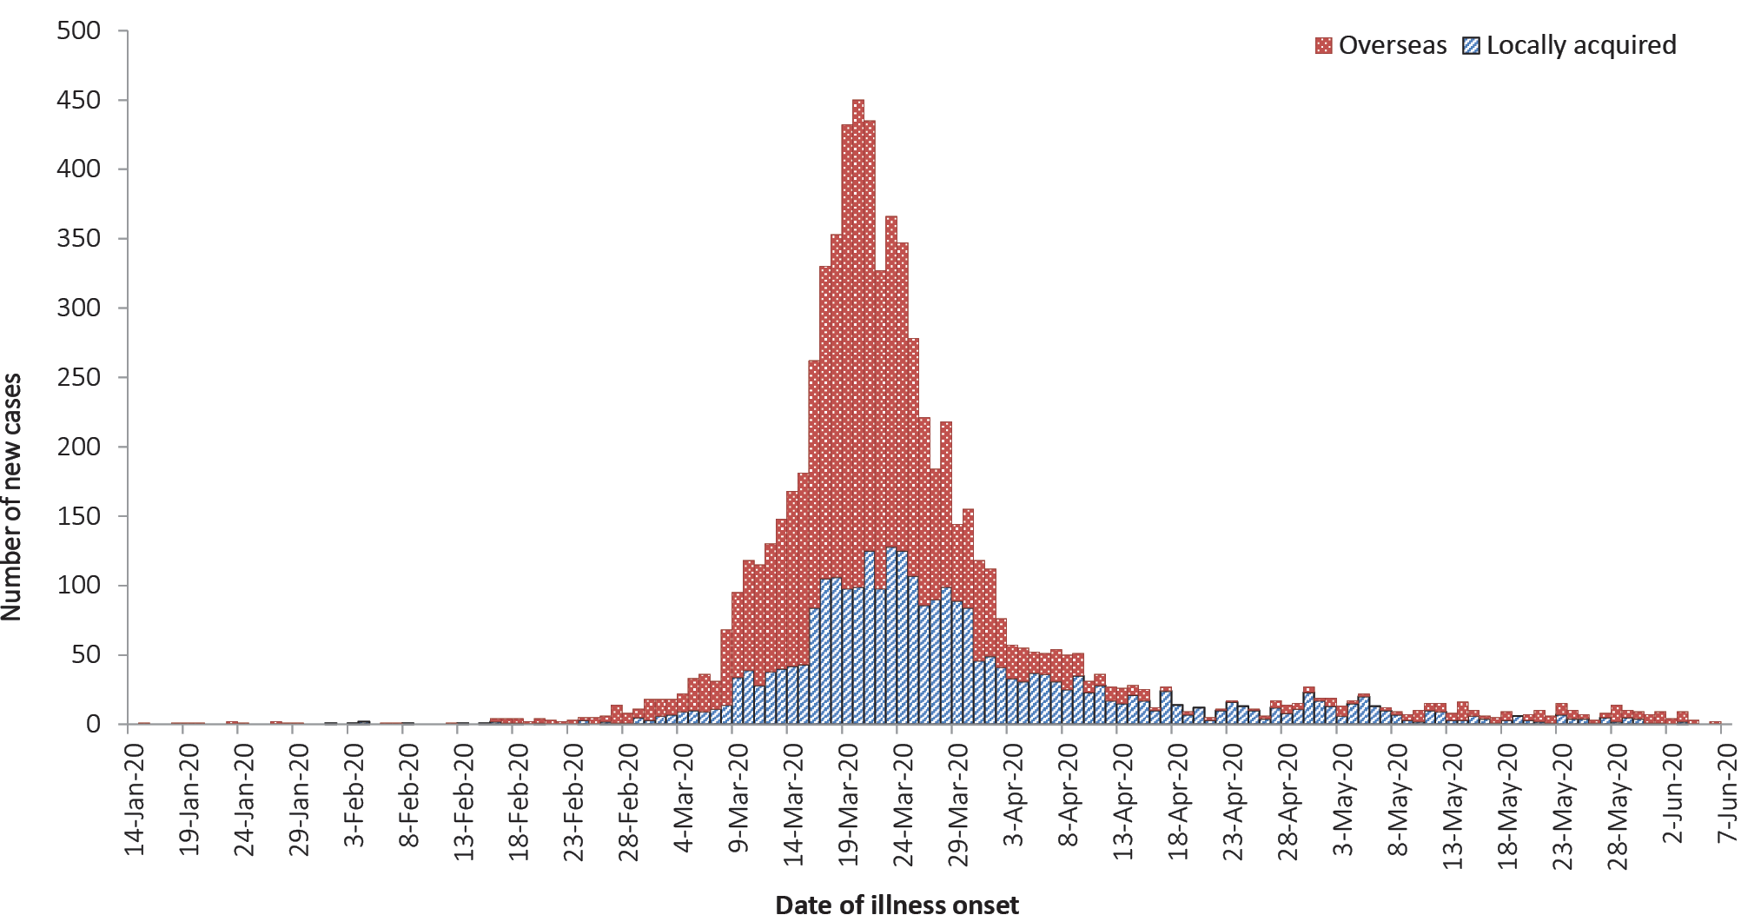
a Source: NNDSS. ‘Locally-acquired’ comprises all cases without an overseas place of acquisition.

Demographics of cases
The highest rate of disease is among those in the 65–79 years age group, with 42.7 cases per 100,000 population (see Appendix B, Figure B.1). The higher rate of cases in this age group is largely driven by outbreaks on cruise ships and by overseas travel, with 75% of cases in this age group acquiring their infection outside Australia (44% at sea, 31% in other countries).
Notifications are similar by gender among those aged under 65 years; however, among those aged 65 years and over, there is a higher rate of cases for males than for females (Table B.1).
The lowest rate of disease is among children and young adults, with 4.0 cases per 100,000 population aged 5–17 and 4.5 cases per 100,000 aged under 5 years. This is consistent with international reports from China and the United States of America, which indicate a low rate of infection among children. A similar pattern has been observed with other coronaviruses such as SARS and MERS, with low rates of infection in children.

Severity
Higher disease severity, as indicated by hospitalisation, admission to ICU, and death, has been associated with increased age and comorbidities.⁴ The median age of cases who have been hospitalised (61 years, interquartile range (IQR): 43–72 years), admitted to ICU (64 years, IQR: 53–72) and died (80 years, IQR: 74–86) is higher than for cases overall (47 years, IQR: 29–62). Of total cases notified in Australia, 1,110 (15%) were admitted to hospital, compared with 16% of cases reported as requiring hospitalisation in Canada⁵ and 32% of cases in the EU/EEA.⁶ It is noted that the higher proportion reported by EU/EEA is affected by each country’s testing strategies, with some European countries now only testing hospitalised individuals for COVID-19.⁶ The crude case fatality rate (CFR) and the proportion of cases requiring hospitalisation in Australia both remain substantially lower than the corresponding values reported from many other comparable high-income countries.
Of the hospitalised COVID-19 cases, 18% (n = 205) were admitted to ICU, with 55 cases requiring ventilation. Fewer than 2% of hospitalised cases were aged under 18 years. Canada has reported similar proportions, with 22% of those hospitalised being admitted to ICU and fewer than 3% of hospitalised cases aged under 20.⁷
Within the European region, the overall severe hospitalisation rate (cases admitted to ICU and/or requiring respiratory support) from all hospitalised cases was approximately 11% across 14 countries; however large variation was seen between these countries.⁸ The European region also reported a decrease in both the hospitalisation and severe hospitalisation rate with increasing age beyond 70 years, which is not seen in the Australian data.
Among Australian cases, the CFR for males aged 65–79 years is slightly elevated compared with females of the same age (Table 3). However, this is reversed in the population aged 80 years and over. Overall fatality rates by age group are similar to those observed in China and Italy as of 17 March 2020,^{9,10} but lower than those observed for the European region when aggregated.⁸ The CFR for males aged 80 years and over in the ICU is high at 75.0% (6 deaths from 8 cases in ICU). By comparison, the CFR for Canadian males meeting the same criteria was 46.3% (19 deaths from 41 cases in ICU), based on data up until 13 May 2020 (30,500 cases).⁷ Australian results are based on small numbers of cases and therefore may not be directly comparable to results from other countries.
Table 3: Number and Case Fatality Rate (CFR) for all cases, hospitalised cases and cases admitted to ICU,ª by age group and gender, Australia
 | All cases |  |  | Hospitalisation |  |  | ICU
 | Male | Female | Persons | Male | Female | Persons | Male | Female | Persons
 | Number
Total | 3,696 | 3,581 | 7,277 | 596 | 514 | 1,110 | 130 | 75 | 205
 | Case Fatality Rate (%)
Under 50 | 0.05 | 0 | 0.03 | 0.6 | 0 | 0.3 | 0 | 0 | 0
50–64 | 0.5 | 0.3 | 0.4 | 2.7 | 1.9 | 2.3 | 11.4 | 0.0 | 6.8
65–79 | 3.6 | 2.6 | 3.1 | 10.4 | 9.3 | 9.9 | 17.5 | 13.8 | 16.3
80 and over | 21.9 | 24.1 | 23.0 | 32.3 | 38.0 | 34.8 | 75.0 | 33.3 | 57.1
All age groups | 1.6 | 1.3 | 1.4 | 7.9 | 6.8 | 7.4 | 15.4 | 8.0 | 12.7
a Source: NNDSS.

Comorbidities
As at 24 May 2020 (not updated for this reporting period)
Of all cases, 29% reported one or more comorbid conditions. The proportion of COVID-19 cases who reported one or more comorbid conditions increased with disease severity. Having one or more comorbid conditions was found to be significantly associated with increased odds of hospitalisation and death among COVID-19 cases aged 50 and over.
Cardiac disease, diabetes and chronic respiratory conditions are the most common comorbid conditions among COVID-19 cases (Table 4). Asthma is the most commonly reported comorbidity across all cases, but shows little correlation with increasing disease severity.
Table 4: COVID-19 comorbidities for all cases, hospitalised cases, cases admitted to ICU and deaths (number of cases, proportion of cases),ª Australia
Rank | All cases  (n=5,354) | Hospitalised cases  (n=682) | ICU cases  (n=162) | Deaths  (n=80)
 | Common comorbidities
1 | Asthma  (451, 8%) | Cardiac disease^{b}  (128, 19%) | Diabetes  (39, 24%) | Cardiac disease^{b}  (28, 35%)
2 | Cardiac disease^{b}  (435, 8%) | Diabetes  (119, 17%) | Cardiac disease^{b}  (32, 20%) | Diabetes  (21, 26%)
3 | Diabetes  (381, 7%) | Chronic respiratory condition^{c}  (84, 12%) | Obesity  (19, 12%) | Chronic respiratory condition^{c}  (17, 21%)
4 | Obesity  (202, 4%) | Asthma  (64, 12%) | Chronic respiratory condition^{c}  (18, 11%) | Immunosuppressive condition/therapy  (16, 20%)
5 | Chronic respiratory condition^{c}  (190, 4%) | Obesity  (46, 7%) | Immunosuppressive condition/therapy  (17, 10%) | Neurological disorder  (14, 18%)
6 | Immunosuppressive condition/therapy  (155, 3%) | Immunosuppressive condition/therapy  (43, 6%) | Asthma  (13, 8%) | Obesity  (6, 8%)
7 | Neurological disorder  (92, 2%) | Renal disease  (27, 4%) | Renal disease  (11, 7%) | Asthma  (5, 6%)
8 | Renal disease  (62, 1%) | Neurological disorder  (20, 3%) | Neurological disorder  (6, 4%) | Renal disease  (5, 6%)
9 | Liver disease  (41, 1%) | Liver disease  (11, 2%) | Liver disease  (2, 1%) | Liver disease  (2, 3%)
 | No comorbidities
 | 2,951 (55%) | 198 (29%) | 40 (25%) | 7 (9%)
 | One or more specified comorbidities^{d}
 | 1,556 (29%) | 375 (55%) | 101 (62%) | 78%)
a Source: NNDSS. Excludes those with missing data on comorbidities or where comorbidity is unknown.
b Excluding hypertension.
c Excluding asthma.
d Includes asthma, chronic respiratory conditions (excluding asthma), cardiac disease (excluding hypertension), immunosuppressive condition/therapy, diabetes, obesity, liver disease, renal disease and neurological disorder.

Comorbidity information on cases hospitalised in Australia is also available through the Influenza Complications Alert Network (FluCAN).⁴ FluCAN found a greater prevalence of comorbid conditions in a sample of hospitalised COVID-19 patients aged 16 years and over (n = 73) compared to the NNDSS. This difference is most likely due to more comprehensive data being available from patient medical records assessed as part of FluCAN.⁴
Amongst FluCAN cases with at least one reported comorbidity, the most common comorbidities were obesity (37%), diabetes (34%), cardiac disease (32%) and chronic respiratory illness (30%). A history of smoking (current or past smoker) was identified in 36% of FluCAN cases.
Australian data on comorbidities are similar to results reported internationally. This includes findings from the United States CDC which published comorbidity data for a small proportion of cases where a complete chart review was available.¹¹ In the CDC report, the most common comorbidities found for hospitalised adults with at least one reported comorbidity were hypertension (58%), obesity (50%), metabolic disease (42%) and cardiovascular disease (44%). Amongst all cases included in the CDC report, only 8.3% reported no known comorbidity.
Within the European region, analysis of comorbidities of hospitalised patients has shown 39% had no known or reported comorbidity. The most common comorbidities for hospitalised cases with at least one reported comorbidity were cardiac disorder (excluding hypertension) (13%), diabetes (12%) and chronic lung disease (9%). These findings are similar to the level of comorbidity seen for hospitalised cases in Australia.⁸

Symptom profile
As at 24 May 2020 (not updated for this reporting period)
The symptoms reported by COVID-19 cases in Australia are consistent with a mild respiratory infection in the majority of cases. The most common symptoms reported (see Appendix B, Figure B.2) were cough (69%), fever (47%), sore throat (40%) and headache (36%). Loss of smell or taste was reported in 12% of cases, noting that this is currently not a standard field in NNDSS, and is likely to under-represent those presenting with these symptoms. A small number of cases reported more severe symptoms, with pneumonia and/or acute respiratory disease (ARD) reported in 3% of cases with symptoms.
Adults and children reported similar symptoms, with cough and fever the most commonly reported symptoms across all age groups. Shortness of breath was more commonly reported among older cases, particularly those aged 80 and over (32%).
The symptom profile of Australian cases is broadly similar to the symptoms reported by COVID-19 cases internationally. Among EU/EEA countries and the UK, fever/chills and dry or productive cough were the most commonly reported symptoms.¹² Cough, headaches and fever and chills were the most commonly reported symptoms among cases in Canada.¹³ Differences in reported symptoms will be influenced by differences in surveillance strategies and symptom reporting across countries.

Populations of Interest

Aboriginal and Torres Strait Islander persons
Sixty cases (0.8%) have been reported in Aboriginal and Torres Strait Islander persons since the start of the epidemic in Australia. Half of these cases acquired their infection overseas. Of locally-acquired cases, the majority were reported in areas classified ‘Major cities of Australia’ based on the case’s usual place of residence (Table 5). No cases among Aboriginal and Torres Strait Islander persons have been notified from remote or very remote areas of Australia.

Table 5: COVID-19 cases,ª notified among Aboriginal and Torres Strait Islander persons by remoteness classification and source of acquisition
Locally-acquired^{b} |  |  |  | Overseas-acquired | Total
Major cities of Australia | Inner regional Australia | Outer regional Australia | Remote/very remote Australia
20 | 4 | 6 | 0 | 30 | 60
a Source: NNDSS.
b ‘Locally-acquired’ comprises all cases without an overseas place of acquisition.

Across all Australian cases, completeness of the Indigenous status field was approximately 95%.
The median age of COVID-19 cases among Aboriginal and Torres Strait Islander persons is 33 years (IQR: 22.5–55 years), which is lower than the median age of non-Indigenous COVID-19 cases (46, IQR: 29–62 years).
Of the cases notified amongst Aboriginal and Torres Strait Islander persons, 12% were admitted to hospital, which is similar to the proportion of all cases hospitalised (15%). Of cases in Aboriginal and Torres Strait Islander persons, no cases were reported as being admitted to ICU or requiring ventilation and no fatalities have been reported.

School-aged children and older populations
Similar to the wider population, the peak period of illness onset for COVID-19 cases among school-aged children and older populations in Australia was between 16 and 29 March 2020. The epidemic curves for these two groups (Figures 3 and 4) show new cases declining in the following fortnight after the introduction of overseas travel restrictions, implemented on 20 March 2020. This decline in new cases indicates that the measures were effective in preventing the spread of COVID-19 in Australia.
There have been 160 case notifications in total among school-aged children (5–17 years old), accounting for 2.0% of all cases. Fourteen new cases within this age group were reported in this reporting period. Of the 160 cases, 70% reported no recent overseas travel history (Figure 3).

Figure 3: Number of COVID-19 case notifications in Australia by date of illness onset for school-aged children (5 to 17), from 13 January to 7 June, by source of acquisitionª
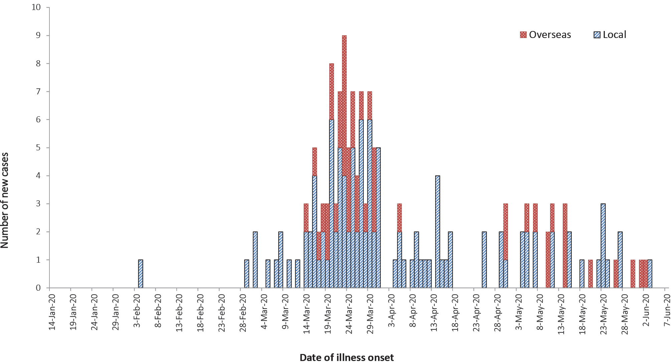
a Source: NNDSS. Locally-acquired comprises all cases without an overseas place of acquisition.
Figure 4: Number of COVID-19 case notifications in Australia by date of illness onset for persons 65 and over, from 13 January to 7 June, by source of acquisitionª
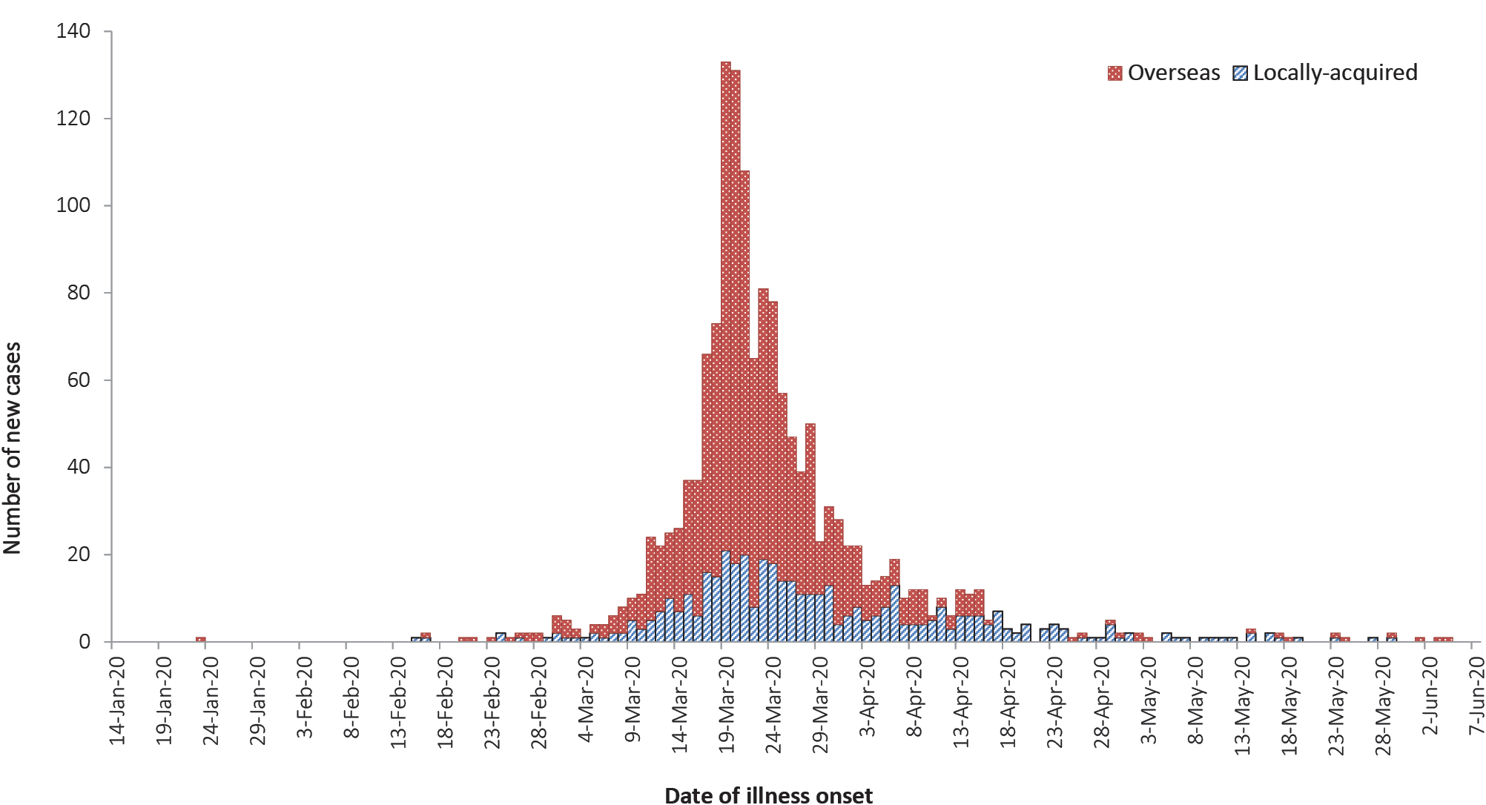
a Source: NNDSS. Locally-acquired comprises all cases without an overseas place of acquisition.
Older people aged 65 years and over are at an increased risk for severe disease from COVID-19. In Australia, there have been 1,533 cases notified among older people. The majority of these cases (71%) reported recent overseas travel history. Of the overseas-acquired infection cases in older populations, cruise-ship-acquired infection makes up 62% of the cases, with approximately 1 in 2 of the cruise-ship-acquired cases among those aged 70–79 years old.

Cluster and outbreak investigations
To date the largest outbreaks of COVID-19 in Australia have been associated with cruise ships, with some other large domestic clusters associated with aged care and healthcare facilities, workplaces and private functions.
Cluster
- The term ‘cluster’ in relation to COVID-19 refers to two or more cases (who do not reside in the same household) that are epidemiologically related in time, place or person where a common source (such as an event or within a community) of infection is suspected but not yet established.
Outbreak
- The term ‘outbreak’ in relation to COVID-19 refers to two or more cases (who do not reside in the same household) among a specific group of people and/or over a specific period of time where illness is associated with a common source (such as an event or within a community). Some states and territories may report a single case associated with a residential aged care facility as an outbreak.
In the week ending 7 June 2020, states and territories reported eight open clusters and outbreaks of COVID-19, a decrease compared to the preceding week ending 31 May 2020. Open clusters and outbreaks are defined as those where a new case was identified in the last 14 days as at the end of the reporting period. Of the open clusters and outbreaks, four were in residential aged care facilities and four were associated with various other settings comprising a livestock carrier, a quarantine hotel, a fast food restaurant and a family. The number of open clusters and outbreaks may be revised as a result of ongoing investigations in states and territories.
Residents of aged care facilities are at increased risk of COVID-19 infection due to the environment of communal living facilities and are more vulnerable to serious complications if they do become infected. As of 7 June 2020, there have been 133 cases of COVID-19 associated with 32 residential aged care facilities, with 98 recoveries and 27 deaths. Sixty-seven of these cases occurred in aged care residents, with the remaining 66 cases occurring in care staff. In addition, there have been 42 cases associated with 30 in-home Commonwealth funded aged care services providing support to older Australians who live at home, with 38 recoveries and 3 deaths. Thirty-one of these cases occurred in care recipients, with the remaining 11 cases occurring in care staff. The Commonwealth is actively supporting services with reported incidents and outbreaks of COVID-19, providing access to personal protective equipment and additional staffing resources where required. Advice and guidelines¹⁴ have been provided to aged care services, including the release of an outbreak management guide.¹⁵

Public health response measures
Since COVID-19 first emerged internationally, Australia has implemented public health measures in response to the disease’s epidemiology, both overseas and in Australia (Figure 5). Key aspects of Australia’s evolving public health response are summarised in previous reports.
On Friday 8 May, the Australian Government announced a three-step framework for easing COVID-19 restrictions, with states and territories easing restrictions at their own pace depending on the current public health situation and local epidemiology. Within this reporting period, two jurisdictions have progressed to step three within this framework. A summary of the restrictions that have been eased is listed at Table 6.

Figure 5: COVID-19 notifications in Australia by date of illness onset, from 13 January to 7 June 2020ª with timing of key public health measures
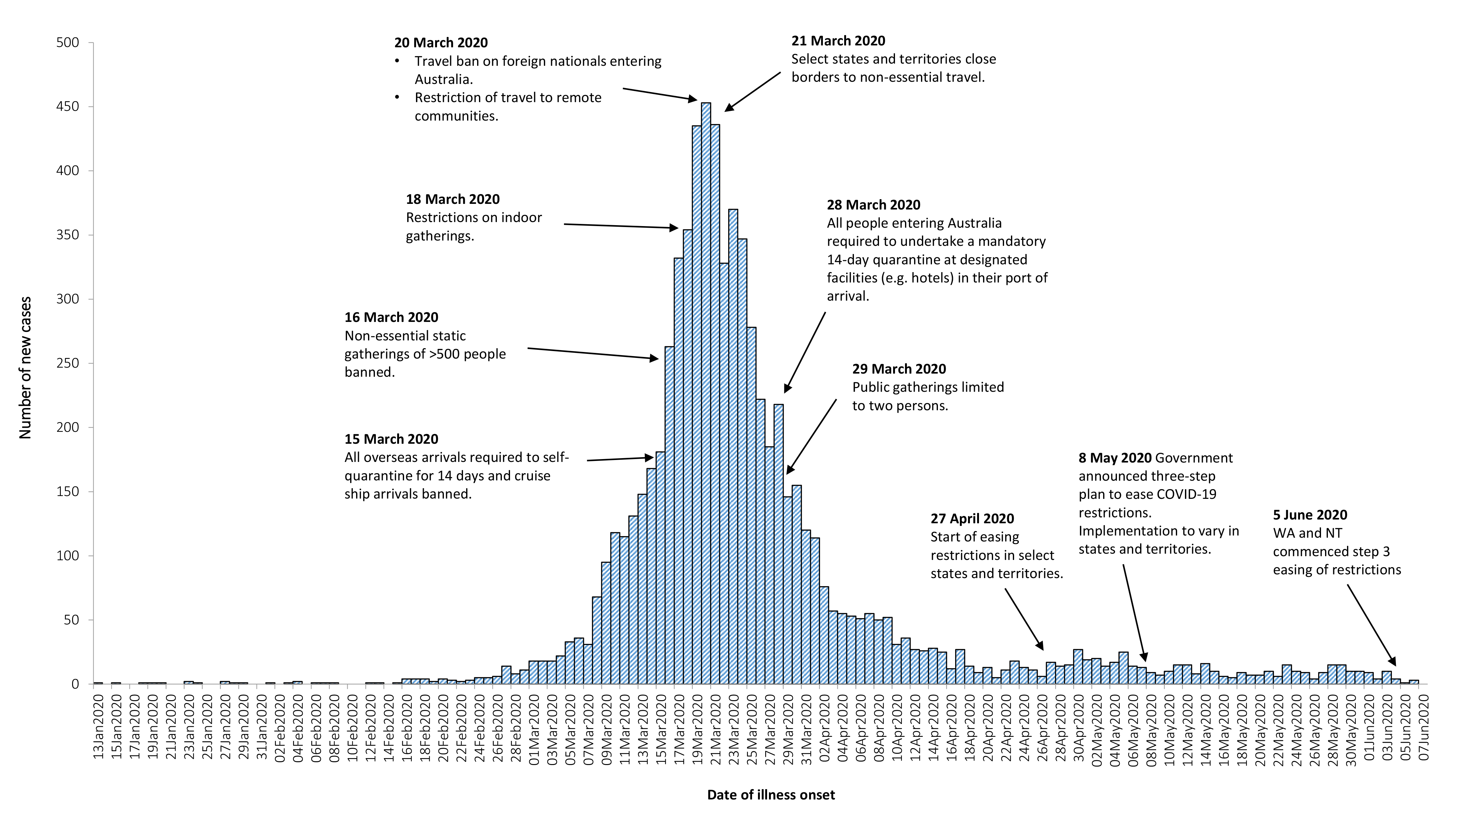
a Source: NNDSS. Due to reporting delays, interpret the latest days’ new cases with caution.

Table 6: State and territory actions for easing COVID-19 restrictions, from 25 May to 7 June 2020
Jurisdiction | Summary of restrictions which have been eased
New South Wales | Step 2: from 1 June the following restrictions were eased:¹⁶  - Travel to regional NSW for holidays permitted; caravan and camping grounds to open  - Restrictions on funerals further eased  - Pubs, clubs, cafes and restaurants permitted to have up to 50 customers  - Cultural buildings, libraries, galleries and museums open with restrictions  - Childcare, schools, universities and TAFE open  - Hairdressers and beauty salons open with restrictions
Victoria | Step 2: from 1 June the following restrictions were eased:¹⁷  - Gatherings of up to 20 people permitted in households and public places  - Restaurants, cafes and community services permitted to open for up to 20 patrons  - Tourist accommodation including caravan and camping grounds to open  - From 26 May - Primary and high schools to commence a staged return of face-to-face learning
Queensland | Step 2: from 1 June the following restrictions were eased:¹⁸  - Intrastate restrictions eased to allow travel and overnight stays for all of Queensland  - Gatherings of up to 20 people permitted in households and public places  - Pubs, clubs, cafes and restaurants permitted to have up to 20 customers  - Restrictions on funerals further eased
Western Australia | Step 3: from 5 June the following restrictions were eased:¹⁹  - Indoor and outdoor gatherings of up to 100 people permitted  - All venues can fully reopen with up to 300 customers (no more than 100 in an undivided space)  - All venues must comply with a 2 square metre rule for customers
South Australia | Step 2: from 1 June the following restrictions were eased:^{20,21}  - Venues and public gatherings can reopen with up to 80 people (no more than 20 in a separate room, area or shop)  - Restrictions on funerals further eased  - Gyms and indoor fitness open for up to 10 people per group class  - Beauty salons open with restrictions
Tasmania | Step 2: from 5 June the following restrictions were eased:²²  - Gatherings of up to 20 people permitted in public places and in most businesses  - Gatherings of up to 10 people permitted in households  - Pubs, clubs, cafes and restaurants permitted to have up to 40 customers  - Restrictions on weddings, funerals and religious ceremonies eased  - Tourist accommodation including caravan and camping grounds to open
Australian Capital Territory | Step 2: from 29 May the following restrictions were eased:^{23,24}  - Public gatherings of up to 20 people permitted in households, public places and businesses  - Restrictions on funerals further eased  - Public schools to progressively reopen over a four week period commencing 18 May
Northern Territory | Step 3: from 5 June the following restrictions were eased:²⁵  - Businesses including cinemas, theatres, amusement parks, and beauty services permitted to reopen  - A COVID-19 safety plan is required for gatherings of more than 500 people  - All parks and reservations reopen for travel

International situation²⁶

Global
As at 7 June 2020, more than 216 countries, regions and areas had reported 6,789,968 COVID-19 cases and 397,375 deaths to WHO.²⁶ Europe and the United States of America continue to be the epicentres of the pandemic. However, some South American countries and India are emerging as hotspots (Figure 6). By region, approximately 48% of all global cases and 45% of all global deaths are from the Americas, while 33% of cases and 46% of deaths are from the European Region. By country, the largest numbers of cases are from the United States of America, Brazil and the Russian Federation and the largest numbers of deaths are from the United States of America, the United Kingdom and Brazil. The global case fatality rate (CFR) is approximately 5.8%. The differing epidemics being experienced by each country are aligned to the phase of the epidemic that they are currently in and the relevant local public health responses, as well as broader health system capacity.

Figure 6: Number of COVID-19 cases (logarithmic scale) by selected country and days since passing 100 cases, up to 7 June 2020
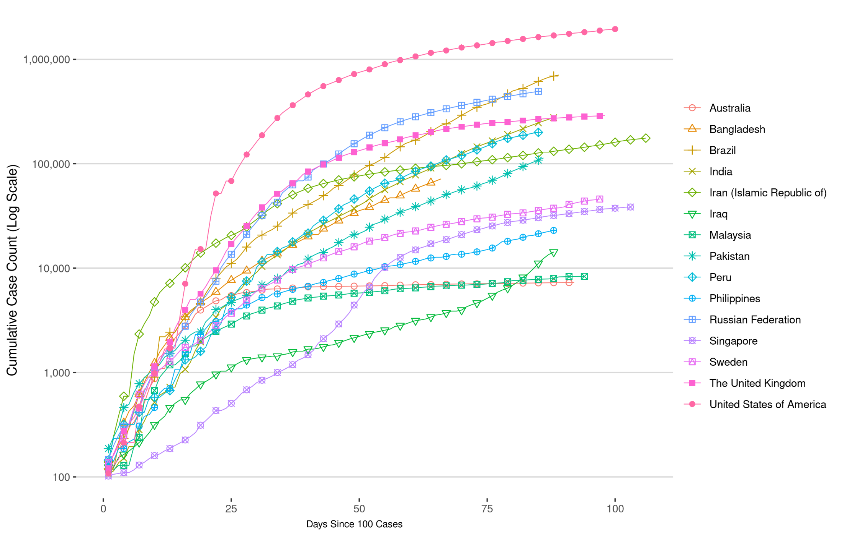

Americas
The United States of America (USA) has reported almost 1.9 million cases (28% of global cases) and is experiencing a steady decline in new daily case numbers. Despite this, the number of new cases over the previous week was the second highest in the world, with Brazil reporting the highest. Currently, USA is experiencing large outbreaks in several workplace and community settings, such as animal processing plants, correctional facilities and residential aged care facilities.
Brazil’s epidemic continues to accelerate (Figure 6), with the country reporting over 645,000 cases with an average of 26,000 new cases reported daily over the past week. The situation in Peru is also rapidly worsening (Figure 6), with the country reporting 39,000 new cases over the past week (21% of their cumulative cases). Despite early success against the virus through mandatory self-quarantine and border closures, the current epidemic may be attributed to a limited ability by the population to adhere to public health measures.

Europe
Russia has the greatest number of COVID-19 cases in Europe, accounting for 1 in 5 European cases. Its epidemic appears to be slowing (seen in the flattening on the curve in Figure 6). Whilst it has one of the lowest CFRs in the world (1.3%), this is likely because it is reporting only deaths that are considered to be exclusively due to COVID-19. Following the easing of restrictions across the majority of the Russian landmass, the trend in new daily cases is steady (approximately 8,800 cases). Moscow, which has delayed reopening, plans to ease restrictions in the coming weeks. Turkey, currently reporting more than 169,000 cases, also has a lower CFR than most European countries (2.8%).²⁷ This may be related to underreporting of COVID-19 deaths, as the country is reporting an increased number of deaths due to other causes during the pandemic period.²⁸
The number of new daily cases continue to decline in many of the other significantly affected European nations, with Sweden and the United Kingdom the main exceptions. Several countries in eastern Europe,²⁹ including Azerbaijan, Kazakhstan, and Armenia, are showing strong growth in the number of new cases. Many countries are planning to allow cross-border travel in the coming months; some countries are negotiating ‘travel bubbles’, with Estonia, Latvia and Lithuania one example.

Eastern Mediterranean
Saudi Arabia passed its initial epidemic peak and now appear to be seeing a resurgence, reporting an average of 2,200 new cases per day over the past week. Saudi Arabia intends to fully lift restrictions by 21 June 2020. The Islamic Republic of Iran is experiencing a resurgence of the epidemic,³⁰ and on 23 May 2020 announced additional measures against the outbreak. Iraq is experiencing strong growth in the number of new cases, reporting 44% of its cumulative cases in the past 7 days (total cases = 11,098).
A large majority of the outbreaks in Arab countries have been within the migrant worker and prison populations. Population migration, as a result of jobless workers returning to their home countries, has spread the disease and the true scale of the epidemic may be masked by the restricted testing capacity of several countries in the region. Most countries in the region are reporting a CFR lower than the global average. However, Yemen is reporting a CFR of approximately 23%.

Africa
Of cases in the African region (1.9% of global cases), more than one third have been from South Africa (35%); almost a third of deaths in this region have also occurred in South Africa (30%). Nigeria, Algeria and Ghana have also reported high case numbers for the region. COVID testing is available in more than 50 African countries,³¹ with essentially one laboratory per country. However, obtaining test kits has proven problematic for smaller African nations. To assist, Africa CDC is coordinating bulk orders of testing supplies.

South East Asia
This region continues to report the highest week-on-week proportional increase of newly reported cases globally. Case numbers in India and Bangladesh are accelerating with the virus circulating in the poorest most vulnerable populations (seen in Figure 6). India recently increased its testing capacity and has conducted over 100,000 tests per day since at least 20 May 2020. Media reports that the Indian Government plans to conduct 200,000 tests per day in the near future. However, shortages in essential supplies for testing may impact on this plan.³² Over the past week, India reported a testing positivity rate of approximately 8%, suggesting there are cases in the community not being detected.^{33–35} Malaysia, Vietnam and Thailand all have a very low positivity rate and have likely contained the outbreak in their respective countries. Malaysia’s cumulative case trajectory is shown in Figure 5. Timor-Leste has not reported a case for over a month.

Pacific
The number of new cases observed in the previous week has not increased substantially from that observed two weeks prior, suggesting that the epidemic is not accelerating in the region. The Philippines and Singapore account for 83% of the new cases in the area. Their epidemic trajectories are shown in Figure 6. In Singapore, approximately 94% of all cases are dormitory workers with 11% of the dormitory worker population diagnosed with COVID-19. The Philippines testing data shows a positivity rate of approximately 7%, suggesting there are undetected cases in the community.³⁶ No new cases or deaths have been reported in Fiji, French Polynesia or Papua New Guinea in over a month. The Commonwealth of the Northern Mariana Islands and New Caledonia each recorded new cases on 5 June 2020.

Background
As at 24 May 2020 (not updated for this reporting period)
The current estimates on epidemiological parameters including severity, transmissibility and incubation period are uncertain. Estimates are likely to change as more information becomes available.

Transmission
Human-to-human transmission of SARS-CoV-2 is via droplets and fomites from an infected person to a close contact.³⁷ Several studies have detected that viral RNA levels peak in the first week of illness, suggesting transmission is most likely to occur early in the illness with infectivity gradually decreasing over time.³⁸ In a Taiwanese study examining over 2,500 close contacts of 100 patients with COVID-19, all 22 secondary cases had their first exposure to the index case within six days of symptom onset. No infections were documented in the 850 contacts whose exposure was after six days.³⁹
Viral RNA has been identified in respiratory track specimens 1–2 days prior to symptom onset, and has been observed after symptom cessation.³⁸ In 50% of the patients, seroconversion occurred after seven days with a range of up to 14 days; this seroconversion was not followed by a rapid decline in viral load.³⁸ However, the detection of viral RNA does not always correlate with transmission risk. A study of nine patients with mild COVID-19 infection found infectious virus was not able to be isolated from naso/oropharyngeal and sputum samples after the first 8 days of illness, despite continued high viral RNA levels.³⁸ Recent analysis from the Korea Centres for Disease Control and Prevention of cases who tested positive after previously being cleared from isolation found live virus was unable to be cultured from any cases selected for testing (n = 108).⁴⁰
Several studies suggests that children do not play a key role in transmission and are unlikely to be the primary source of infections.⁴¹ Studies out of the EU have suggested that child to adult transmission is uncommon.^{42,43}
Current evidence does not support airborne or faecal-oral spread as major factors in transmission.³⁷

Incubation period
Estimates of median incubation period, based on seven published studies, are 5 to 6 days (ranging from 1 to 14 days). Patients with long incubation periods do occasionally occur; however, they are likely to be ‘outliers’ who should be studied further but who are unlikely to represent a change in epidemiology of the virus.^{44,45}

Molecular epidemiology
Since December 2019, the virus has diversified into multiple lineages as it has spread globally, with some degree of geographical clustering. The whole genome sequences currently available from Australian cases are dispersed across these lineages, reflecting multiple concurrent introductions into Australia.^{46–48} Multiple genomic clusters, closely related sequences reflecting local transmission chains, have also been identified in Australia.^{46,47} Genomic epidemiology has successfully been used to link many cases that were epidemiologically classified as ‘locally-acquired – contact not identified’ to known genomic clusters, highlighting the utility of virus sequencing to informing the public health response.^{46,47}

Clinical features
COVID-19 presents as mild illness in the majority of cases, with cough and fever being the most commonly reported symptoms. Severe or fatal outcomes are more likely to occur in the elderly or those with comorbid conditions.^{37,49}
Some COVID-19 patients show neurological signs such as headache, nausea and vomiting. There is evidence that SARS-CoV-2 viruses are not always confined to the respiratory tract and may invade the central nervous system inducing neurological symptoms. As such, it is possible that invasion of the central nervous system is partially responsible for the acute respiratory failure of COVID-19 patients.⁵⁰
There is some evidence to suggest that impairment or loss of the sense of smell (hyposmia/anosmia) or taste (hypoguesia/aguesia) is associated with COVID-19.^{51,52} This is supported by research finding a biological mechanism for the SARS-CoV-2 virus to cause olfactory dysfunction.^{53,54}
Several studies have identified cardiovascular implications resulting from COVID-19.^{55–57} Vascular inflammation has been observed in a number of cases and may be a potential mechanism for myocardial injury which can result in cardiac dysfunction and arrhythmias.
COVID-19 disease in children is more likely to be mild and self-limiting, compared to adults. Internationally, children make up a small proportion of confirmed COVID-19 cases, with those shown to be infected either presenting with milder symptoms than adults or remaining asymptomatic, a similar pattern has been observed with SARS and MERS. However, the greater likelihood of mild clinical presentation in children may result in lower testing and case detection in this cohort. Studies have also shown that hospital admission is inversely related to age. From European reporting, death associated with COVID-19 has been rare among those aged less than 15 years, with 4 deaths reported from 44,695 cases, as at 13 May 2020.
There have been reports of a rare clinical presentation of paediatric inflammatory multisystem syndrome resembling Kawasaki disease temporally associated with SARS-CoV-2 infection in children. However, evidence of the association between COVID-19 and the development of a Kawasaki like disease is currently inconclusive and further investigation is needed due to variability in clinical presentations in reported paediatric cases.^{58,59}

Treatment
Current clinical management of COVID-19 cases focuses on early recognition, isolation, appropriate infection control measures and provision of supportive care.⁶⁰ Whilst there is no specific antiviral treatment currently recommended for patients with suspected or confirmed SARS-CoV-2 infection, multiple clinical trials are underway to evaluate a number of therapeutic agents, including remdesivir, lopinavir/ritonavir, and chloroquine or hydroxychloroquine. ^{61,62}
An open-label randomised controlled trial did not find a significant impact of hydroxychloroquine treatment on disease progression for hospitalised patients with mild to moderate COVID-19, with those receiving treatment also reporting a higher number of adverse events.⁶³ Similarly, an open-label randomised controlled trial of lopinavir/ritonavir among hospitalised patients found no benefit for time to clinical improvement.⁶⁴
Results for remdesivir treatment have been mixed, with one randomised double-blind placebo-controlled trial finding patients recovered 31% faster and a lower mortality rate (8.0% compared with 11.6% among placebo patients),⁶⁵ while another found no effect.⁶⁶ Taiwan Food and Drug Administration (TFDA) has recently approved remdesivir for the treatment of patients with severe SARS-CoV-2 infection based on preliminary evidence on its safety and effectiveness. Further trials are required to assess the effectiveness of these treatments on COVID-19. Multiple COVID-19 vaccines have commenced clinical trials.

Data considerations
Data were extracted from the NNDSS on 9 June 2020 for notifications received up to 7 June 2020. Due to the dynamic nature of the NNDSS, numbers presented in this report are subject to revision and may vary from numbers previously reported and from case notifications released by states and territories.
Definitions
‘Date of illness onset’ is derived from data collected by the NNDSS and represents the diagnosis date, or reported true onset of disease date. If unknown, the earliest of specimen collection date, notification date or notification receive date is used.
‘Notification received date’ is reported in the NNDSS and represents the date the case is first notified on the NNDSS. As notification can only occur after testing is completed and information processed, counts for a defined period will vary according to the date type used.

Acknowledgements
This report represents surveillance data reported through CDNA as part of the nationally-coordinated response to COVID-19. We thank public health staff from incident emergency operations centres in state and territory health departments, and the Australian Government Department of Health, along with state and territory public health laboratories.

Author details

Corresponding author
COVID-19 National Incident Room Surveillance Team, Australian Government Department of Health, GPO Box 9484, MDP 14, Canberra, ACT 2601. Email: epi.coronavirus@health.gov.au

References
- Australian Government Department of Health. Series of National Guidelines (SoNGs): Coronavirus Disease 2019 (COVID-19). CDNA National guidelines for public health units. [Internet.] Canberra: Australian Government Department of Health; 29 May 2020. [Accessed on 2 June 2020.] Available from: https://www1.health.gov.au/internet/main/publishing.nsf/Content/cdna-song-novel-coronavirus.htm.
- Government of the United Kingdom. Guidance: Coronavirus (COVID-19): getting tested. [Internet.] London: Government of the United Kingdom; 15 April 2020. [Accessed on 1 June 2020.] Available from: https://www.gov.uk/guidance/coronavirus-covid-19-getting-tested.
- New Zealand Government. COVID-19 testing: Information about COVID-19 testing in New Zealand. [Internet.] Wellington: New Zealand Government; 18 April 2020. [Accessed on 1 June 2020.] Available from: https://covid19.govt.nz/covid-19/about-covid-19/covid-19-testing/.
- COVID-19 National Incident Room Surveillance Team. COVID-19, Australia: Epidemiology Report 16: Reporting week ending 23:59 AEST 17 May 2020. Commun Dis Intell (2018). 2020;44. doi: https://doi.org/10.33321/cdi.2020.44.45.
- Public Health Agency of Canada (PHAC). Coronavirus disease 2019 (COVID-19). Epidemiology update. Updated: 11 June 2020, 7 pm EDT. [Internet.] Ottawa: Government of Canada, PHAC; 2020. [Accessed on 12 June 2020.] Available from: https://health-infobase.canada.ca/covid-19/epidemiological-summary-covid-19-cases.html.
- European Centre for Disease Prevention and Control (ECDC) COVID-19 surveillance report: Week 23, 2020. [Internet.] Solna: ECDC; 11 June 2020. [Accessed on 12 June 2020.] Available from: https://covid19-surveillance-report.ecdc.europa.eu/.
- Statistics Canada. Table 13-10-0775-01. Detailed preliminary information on cases of COVID-19: 4 Dimensions (Aggregated data), Public Health Agency of Canada. [Internet.] Ottawa: Statistics Canada; 2020. [Accessed on 3 June 2020.] Available from: https://www150.statcan.gc.ca/t1/tbl1/en/tv.action?pid=1310077501.
- ECDC. COVID-19 surveillance report: Week 21, 2020. [Internet.] Solna: ECDC; 2 June 2020. [Accessed on 3 June 2020.] Available from: https://covid19-surveillance-report.ecdc.europa.eu/.
- Zheng Z, Peng F, Xu B, Zhao J, Liu H, Peng J et al. Risk factors of critical & mortal COVID-19 cases: a systematic literature review and meta-analysis. J Infect. 2020. doi: https://doi.org/10.1016/j.jinf.2020.04.021.
- Onder G, Rezza G, Brusaferro S. Case-fatality rate and characteristics of patients dying in relation to COVID-19 in Italy. JAMA. 2020;323(18):1775-1776. doi: https://doi.org/10.1001/jama.2020.4683.
- Centers for Disease Control and Prevention (CDC). COVID-Net: a weekly summary of U.S. COVID-19 hospitalization data. COVID-19 laboratory-confirmed hospitalizations: preliminary data as of May 23, 2020. [Internet.] Atlanta: United States Government Department of Health and Human Services, CDC; 2020. [Accessed on 3 June 2020.] Available from: https://gis.cdc.gov/grasp/COVIDNet/COVID19_5.html.
- ECDC. COVID-19 surveillance report: Week 2020-19. 6: Other epidemiological characteristics. [Internet.] Solna: ECDC; 14 May 2020. [Accessed on 19 May 2020.] Available from: https://covid19-surveillance-report.ecdc.europa.eu/#6_other_epidemiological_characteristics.
- Government of Canada. Epidemiological summary of COVID-19 cases in Canada: last data update May 19, 2020, 11:00 ET. [Internet.] Ottawa: Government of Canada; 2020. [Accessed on 19 May 2020.] Available from: https://health-infobase.canada.ca/covid-19/epidemiological-summary-covid-19-cases.html.
- Australian Government Department of Health. Coronavirus (COVID-19) advice for the health and aged care sector. [Internet.] Canberra: Australian Government Department of Health; 2020. [Accessed 3 June 2020.] Available from: https://www.health.gov.au/news/health-alerts/novel-coronavirus-2019-ncov-health-alert/coronavirus-covid-19-advice-for-the-health-and-aged-care-sector.
- Communicable Diseases Network Australia (CDNA). Coronavirus disease 2019 (COVID-19) outbreaks in residential care facilities: CDNA national guidelines for the prevention, control and public health management of COVID-19 outbreaks in residential care facilities in Australia. Canberra: Australian Government Department of Health, CDNA; 13 March 2020. [Accessed on 3 June 2020.] Available from: https://www.health.gov.au/sites/default/files/documents/2020/03/coronavirus-covid-19-guidelines-for-outbreaks-in-residential-care-facilities.pdf.
- Government of New South Wales. Answers to your questions about the rules: FAQs about changes to the rules, effective from Monday 1 June. [Internet.] Sydney: Government of New South Wales; 2020. [Accessed on 11 June 2020.] Available from: https://www.nsw.gov.au/covid-19/what-you-can-and-cant-do-under-rules/changes#what-has-changed-from-monday-1-june.
- Department of Health and Human Services (DHHS). Victoria’s restriction levels. [Internet.] Melbourne: Victoria State Government, DHHS; 2020. [Accessed on 11 June 2020.] Available from: https://www.dhhs.vic.gov.au/victorias-restriction-levels-covid-19.
- Queensland Government. Roadmap to easing restrictions. [Internet.] Brisbane: Queensland Government; 2020. [Accessed on 11 June 2020.] Available from: https://www.covid19.qld.gov.au/government-actions/roadmap-to-easing-queenslands-restrictions.
- Government of Western Australia. Phase 3 - Easing of restrictions - frequently asked questions. [Internet.] Perth: Government of Western Australia; 2020. [Accessed on 11 June 2020.] Available from: https://www.wa.gov.au/government/publications/phase-3-easing-of-restrictions-frequently-asked-questions.
- Government of South Australia. South Australian roadmap for easing COVID-19 restrictions. Adelaide: Government of South Australia; 2020. [Accessed on 20 May 2020.] Available from: https://www.covid-19.sa.gov.au/__data/assets/pdf_file/0012/195879/200059.4-COVID-19-RoadMap_FINAL.PDF.
- Government of South Australia. Recovery from COVID-19. [Internet.] Adelaide: Government of South Australia; 2020. [Accessed on 11 June 2020.] Available from: https://www.covid-19.sa.gov.au/recovery.
- Tasmanian Government. Roadmap to recovery. [Internet.] Hobart: Tasmanian Government; 2020. [Accessed on 11 June 2020.] Available from: https://coronavirus.tas.gov.au/families-community/roadmap-to-recovery.
- Australian Capital Territory Government. FAQs changes to restrictions. [Internet.] Canberra: Australian Capital Territory Government; 2020. [Accessed on 11 June 2020.] Available from: https://www.covid19.act.gov.au/faqs/faqs-changes-to-restrictions.
- Australian Capital Territory Government (ACT Government). Canberra's recovery plan: COVID-19 easing of restrictions roadmap. Canberra: ACT Government; 26 May 2020. [Accessed on 29 May 2020.] Available from: https://www.covid19.act.gov.au/__data/assets/pdf_file/0007/1551778/CV_Roadmap_Recovery-plan_ease-of-restrictions_0.4.1.pdf.
- Northern Territory Government. Roadmap to the new normal. Stage 3 – Friday 5 June (current). [Internet.] Darwin: Northern Territory Government; 2020. [Accessed on 11 June 2020.] Available from: https://coronavirus.nt.gov.au/roadmap-new-normal#/stage_3_friday_5_june_current.
- World Health Organization (WHO). Coronavirus disease 2019 (COVID-19) situation report – 139. [Internet.] Geneva: WHO; 2020. [Accessed on 12 June 2020.] Available from: https://www.who.int/docs/default-source/coronaviruse/situation-reports/20200607-covid-19-sitrep-139.pdf.
- Gall C. Istanbul death toll hints Turkey is hiding a wider coronavirus calamity. [Internet.] New York: The New York Times; 20 April 2020. [Accessed on 1 June 2020.] Available from: https://www.nytimes.com/2020/04/20/world/middleeast/coronavirus-turkey-deaths.html.
- Wu J, McCann A, Katz J, Peltier E. 87,000 missing deaths: tracking the true toll of the coronavirus outbreak. [Internet.] New York: The New York Times; 21 April 2020. [Accessed on 1 June 2020.] Available from: https://www.nytimes.com/interactive/2020/04/21/world/coronavirus-missing-deaths.html.
- WHO. COVID-19 sitation in the WHO European Region. [Internet.] Geneva: WHO; 2020. [Accessed on 1 June 2020.] Available from: https://who.maps.arcgis.com/apps/opsdashboard/index.html#/ead3c6475654481ca51c248d52ab9c61.
- United Nations Office for the Coordination of Humanitarian Affairs (OCHA). Islamic Republic of Iran: flash update - as of 28 May 2020. [Internet.] New York: United Nations, OCHA; 28 May 2020. [Accessed on 1 June 2020.] Available from: https://reliefweb.int/report/iran-islamic-republic/islamic-republic-iran-flash-update-28-may-2020.
- African Centres for Disease Control and Prevention (Africa CDC). Home / Outbreak Briefs. Outbreak Brief 20: COVID-19 Pandemic – 2 June 2020. [Internet.] Addis Ababa: African Union, Africa CDC; 2020. [Accessed on 10 June 2020.] Available from: https://africacdc.org/download/outbreak-brief-19-covid-19-pandemic-26-may-2020-2/.
- Yadav P, Mehndiratta A, Chalkidou K, Rupani S, Reddy K. India’s COVID-19 testing capacity must grow by a factor of 10: here’s how that can happen. [Internet.] Washington, DC: Center for Global Development; 4 June 2020. [Accessed on 10 June 2020.] Available from: https://www.cgdev.org/publication/indias-covid-19-testing-capacity-must-grow-factor-10-heres-how-can-happen.
- Indian Council of Medical Research (ICMR). SARS-CoV-2 (COVID-19) testing: status update. 01 June 2020, 09:00 AM IST. New Delhi: Government of India, Ministry of Health and Family Welfare, Department of Health Research, ICMR; 1 June 2020. [Accessed on 10 June 2020.] Available from: https://www.icmr.gov.in/pdf/covid/update/ICMR_testing_update_01June2020_9AM_IST.pdf.
- ICMR. SARS-CoV-2 (COVID-19) testing: status update. 07 June 2020, 09:00 AM IST. New Delhi: Government of India, Ministry of Health and Family Welfare, Department of Health Research, ICMR; 7 June 2020. [Accessed on 10 June 2020.] Available from: https://www.icmr.gov.in/pdf/covid/update/ICMR_testing_update_07June2020_9AM_IST.pdf.
- WHO. WHO Coronavirus Disease (COVID-19) dashboard. [Internet.] Geneva: WHO; 2020. [Accessed on 10 June 2020.] Available from: https://covid19.who.int/.
- Philippines Department of Health. COVID-19 case tracker. [Internet.] Manila: Republic of the Philippines, Department of Health; 2020. [Accessed on 10 June 2020.] Available from: https://www.doh.gov.ph/covid-19/case-tracker.
- WHO. Report of the WHO-China joint mission on coronavirus disease 2019 (COVID-19). [Internet.] Geneva: WHO; 2020. [Accessed 1 Mar 2020.] Available from: https://www.who.int/docs/default-source/coronaviruse/who-china-joint-mission-on-covid-19-final-report.pdf.
- Wölfel R, Corman VM, Guggemos W, Seilmaier M, Zange S, Müller MA et al. Virological assessment of hospitalized patients with COVID-2019. Nature. 2020. doi: https://doi.org/10.1038/s41586-020-2196-x.
- Cheng HY, Jian SW, Liu DP, Ng TC, Huang WT, Lin HH. Contact tracing assessment of COVID-19 transmission dynamics in Taiwan and risk at different exposure periods before and after symptom onset. JAMA Intern Med. 2020. doi: https://doi.org/10.1001/jamainternmed.2020.2020.
- Korea Centers for Disease Control and Prevention (KCDC). Division of risk assessment and international cooperation. Findings from investigation and analysis of re-positive cases. [Internet.] Cheongju: Government of South Korea, KCDC; 2020. [Accessed on 24 May 2020.] Available from: https://www.cdc.go.kr/board/board.es?mid=a30402000000&bid=0030&act=view&list_no=367267&nPage=1.
- Zhu Y, Bloxham CJ, Hulme KD, Sinclair JE, Tong ZW, Steele LE et al. Children are unlikely to have been the primary source of household SARS-CoV-2 infections. medRxiv. 2020. doi: https://doi.org/10.1101/2020.03.26.20044826.
- Gudbjartsson DF, Helgason A, Jonsson H, Magnusson OT, Melsted P, Norddahl GL et al. Spread of SARS-CoV-2 in the Icelandic population. N Engl J Med. 2020. doi: https://doi.org/10.1056/NEJMoa2006100.
- European Centre for Disease Prevention and Control (ECDC). Rapid risk assessment: Paediatric inflammatory multisystem syndrome and SARS-CoV-2 infection in children – 15 May 2020. Solna: ECDC; 2020. [Accessed on 19 May 2020.] Available from: https://www.ecdc.europa.eu/sites/default/files/documents/covid-19-risk-assessment-paediatric-inflammatory-multisystem-syndrome-15-May-2020.pdf.
- WHO. Coronavirus disease 2019 (COVID-19) situation report – 29. [Internet.] Geneva: WHO; 2020. [Accessed 22 Feb 2020.] Available from: https://www.who.int/docs/default-source/coronaviruse/situation-reports/20200218-sitrep-29-covid-19.pdf.
- Pung R, Chiew CJ, Young BE, Chin S, Chen M, Clapham HE. Investigation of three clusters of COVID-19 in Singapore: implications for surveillance and response measures. Lancet. 2020;395(10229):1039–46.
- Rockett RJ, Arnott A, Lam C, Sadsad R, Timms V, Gray KA et al. Revealing COVID-19 transmission by SARS-CoV-2 genome sequencing and agent based modelling. bioRxiv. doi: https://doi.org/10.1101/2020.04.19.048751.
- Nextstrain team. Genomic epidemiology of novel coronavirus – Oceania-focused subsampling. [Internet.] [Accessed on 5 May 2020.] Available online: https://nextstrain.org/ncov/oceania?c=division&f_country=Australia&l=radial.
- Seemann T, Lane C, Sherry N, Duchene S, Goncalves da Silva A, Caly L et al. Tracking the COVID-19 pandemic in Australia using genomics. medRxiv. 2020 doi: https://doi.org/10.1101/2020.05.12.20099929.
- Sun P, Qiu S, Liu Z, Ren J, Xi JJ. Clinical characteristics of 50466 patients with 2019-nCoV infection. medRxiv. 2020. doi: https://doi.org/10.1101/2020.02.18.20024539.
- Li B, Bai W, Hashikawa T. The neuroinvasive potential of SARS-CoV-2 may be at least partially responsible for the respiratory failure of COVID-19 patients. J Med Virol. 2020. doi: https://doi.org/10.1002/jmv.25728.
- Mao L, Jin H, Wang M, Hu Y, Chen S, He Q et al. Neurological manifestations of hospitalized patients with coronavirus disease 2019 in Wuhan, China. JAMA Neurol. 2020;e201127. doi: https://doi.org/10.1001/jamaneurol.2020.1127.
- Drew DA, Nguyen LH, Steves CJ, Wolf J, Spector TC, Chan AT. Rapid implementation of mobile technology for real-time epidemiology of COVID-19. medRxiv. 2020. doi: https://doi.org/10.1101/2020.04.02.20051334.
- Venkatakrishnan AJ, Puranik A, Anand A, Zemmour D, Yao X, Wu X et al. Knowledge synthesis from 100 million biomedical documents augments the deep expression profiling of coronavirus receptors. bioRxiv. 2020. doi: https://doi.org/10.1101/2020.03.24.005702.
- Brann DH, Tsukahara T, Weinreb C, Logan DW, Datta SR. Non-neural expression of SARS-CoV-2 entry genes in the olfactory epithelium suggests mechanisms underlying anosmia in COVID-19 patients. bioRxiv. 2020. doi: https://doi.org/10.1101/2020.03.25.009084.
- Inciardi RM, Lupi L, Zaccone G, Italia L, Raffo M, Tomasoni D et al. Cardiac involvement in a patient with coronavirus disease 2019 (COVID-19). JAMA Cardiol. 2020. doi: https://doi.org/10.1001/jamacardio.2020.1096.
- Guo T, Fan Y, Chen M, Wu X, Zhang L, He T et al. Cardiovascular implications of fatal outcomes of patients with coronavirus disease 2019 (COVID-19). JAMA Cardiol. 2020. doi: https://doi.org/10.1001/jamacardio.2020.1017.
- Madjid M, Safavi-Naeini P, Solomon SD, Vardeny O. Potential effects of coronaviruses on the cardiovascular system: a review. JAMA Cardiol. 2020. doi: https://doi.org/10.1001/jamacardio.2020.1286.
- Riphagen S, Gomez X, Gonzalez-Martinez C, Wilkinson N, Theocharis P. Hyperinflammatory shock in children during COVID-19 pandemic. Lancet. 2020. doi: https://doi.org/10.1016/S0140-6736(20)31094-1.
- Morand A, Urbina D, Fabre A. COVID-19 and Kawasaki like disease: the known-known, the unknown-known and the unknown-unknown. Preprints. 2020;2020050160. doi: https://doi.org/10.20944/preprints202005.0160.v1.
- WHO. Clinical management of severe acute respiratory infection when novel coronavirus (nCoV) infection is suspected. [Internet.] Geneva: WHO; 2020. [Accessed 23 Feb 2020.] Available from: https://www.who.int/publications-detail/clinical-management-of-severe-acute-respiratory-infection-when-novel-coronavirus-(ncov)-infection-is-suspected.
- Harrison C. Coronavirus puts drug re-purposing on the fast track. Nat Biotechnol. 2020. doi: https://doi.org/10.1038/d41587-020-00003-1.
- Wang M, Cao R, Zhang L, Yang X, Liu J, Xu M et al. Remdesivir and chloroquine effectively inhibit the recently emerged novel coronavirus (2019-nCoV) in vitro. Cell Research. 2020;30;269–71.
- Tang W, Cao Z, Han M, Wang Z, Chen W, Sun W et al. Hydroxychloroquine in patients with mainly mild to moderate coronavirus disease 2019: open label, randomised controlled trial. BMJ. 2020. doi: https://doi.org/10.1136/bmj.m1849.
- Cao B, Wang Y, Wen D, Liu W, Wang J, Fan G et al. A trial of lopinavir–ritonavir in adults hospitalized with severe Covid-19. N Engl J Med. 2020;382:1787–99.
- National Institute of Allergy and Infectious Diseases (NIAID). NIH Clinical Trial Shows Remdesivir Accelerates Recovery from Advanced COVID-19. [Internet.] Bethesda: Government of the United States of America, National Institutes of Heath, NIAID; 2020. [Accessed on 19 May 2020.] Available from: https://www.niaid.nih.gov/news-events/nih-clinical-trial-shows-remdesivir-accelerates-recovery-advanced-covid-19.
- Wang Y, Zhang D, Du G, Du R, Zhao J, Jin Y et al. Remdesivir in adults with severe COVID-19: a randomised, double-blind, placebo-controlled, multicentre trial. Lancet. 2020;395(10236);1569–78.

Appendix A: Frequently asked questions
Q: Can I request access to the COVID-19 data behind your CDI fortnightly reports?
A: National notification data on COVID-19 confirmed cases is collated in the National Notifiable Disease Surveillance System (NNDSS) based on notifications made to state and territory health authorities under the provisions of their relevant public health legislation.
Normally, requests for the release of data from the NNDSS requires agreement from states and territories via the Communicable Diseases Network Australia, and, depending on the sensitivity of the data sought and proposed, ethics approval may also be required.
Due to the COVID-19 response, unfortunately, specific requests for NNDSS data have been put on hold. We are currently looking into options to be able to respond to data requests in the near future.
We will continue to publish regular summaries and analyses of the NNDSS dataset and recommend the following resources be referred to in the meantime:
- NNDSS summary tables: http://www9.health.gov.au/cda/source/cda-index.cfm
- Daily case summary of cases: https://www.health.gov.au/news/health-alerts/novel-coronavirus-2019-ncov-health-alert/coronavirus-covid-19-current-situation-and-case-numbers
- Communicable Diseases Intelligence COVID-19 epidemiology report: https://www1.health.gov.au/internet/main/publishing.nsf/Content/novel_coronavirus_2019_ncov_weekly_epidemiology_reports_australia_2020.htm
- State and territory public health websites.
Q: Why have the reports changed from weekly to fortnightly?
A: With the number of new cases in Australia slowing, this report has moved from a weekly to a fortnightly reporting schedule. The change to fortnightly reporting is to allow more time for an in-depth analysis of the NNDSS data, therefore enhancing the contents of the report.
Q: Can I request access to data at post-code level of confirmed cases?
A: Data at this level cannot be released without ethics approval and permission would need to be sought from all states and territories via the Communicable Diseases Network Australia. As noted above, specific requests for NNDSS data are currently on hold.
Where current or recent reported case numbers are high enough to justify it, a GIS/mapping analysis of cases will be included in the Communicable Diseases Intelligence COVID-19 epidemiology report. In order to protect privacy of confirmed cases, data in this map will be presented at SA3 level.
Q: Where can I find more detailed data on COVID-19 cases?
A: We are currently looking into ways to provide more in-depth epidemiological analyses of COVID-19 cases, with regard to transmission and severity, including hospitalisation. These analyses will continue to be built upon in future iterations of the Communicable Diseases Intelligence report.

Appendix B: Supplementary figures and tables
Table B.1: COVID-19 case notifications and rate per 100,000 population in Australia as at 7 June 2020,ª by age group and gender
 |  |  | Cases^{b} |  |  | Rate (per 100,000 population)^{b}
 | Male | Female |  | Persons | Male |  | Female | Persons
Under 5 | 38 | 33 |  | 71 | 4.7 |  | 4.3 | 4.5
5 to 17 | 83 | 77 |  | 160 | 4.0 |  | 3.9 | 4.0
18 to 64 | 2,747 | 2,766 |  | 5,513 | 35.2 |  | 35.0 | 35.1
65 to 79 | 700 | 589 |  | 1,289 | 47.8 |  | 38.0 | 42.7
80 and over | 128 | 116 |  | 244 | 30.0 |  | 19.5 | 23.9
- The age group 5–17 years was selected to broadly represent school students in Australia. The cut-off of 17 years was selected due to a sharp increase in cases seen among those aged 18 and 19 that is associated with overseas travel and likely to be people who have left school.
- Cases and rates for persons include 68 cases with unknown gender.
Figure B.1: COVID-19 rates per 100,000 population of all cases notified in Australia as at 7 June 2020, by age group and gender
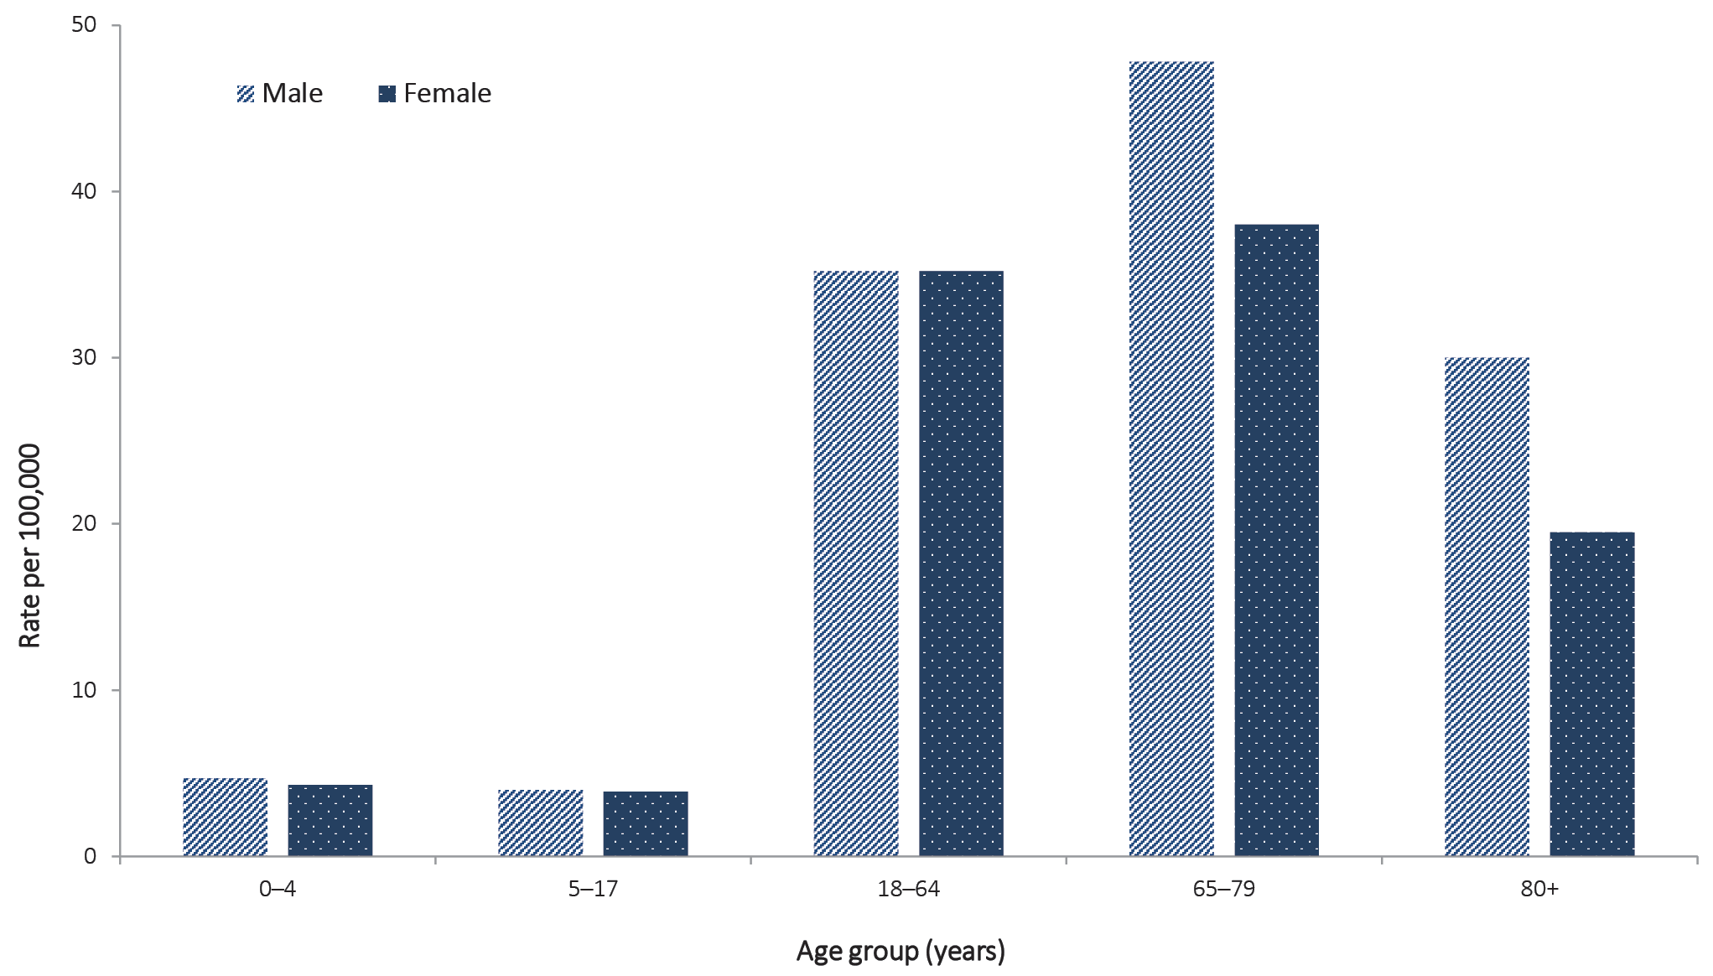

Figure B.2: Variation in combinations of COVID-19 symptoms in confirmed cases as at 24 May 2020, Australiaª
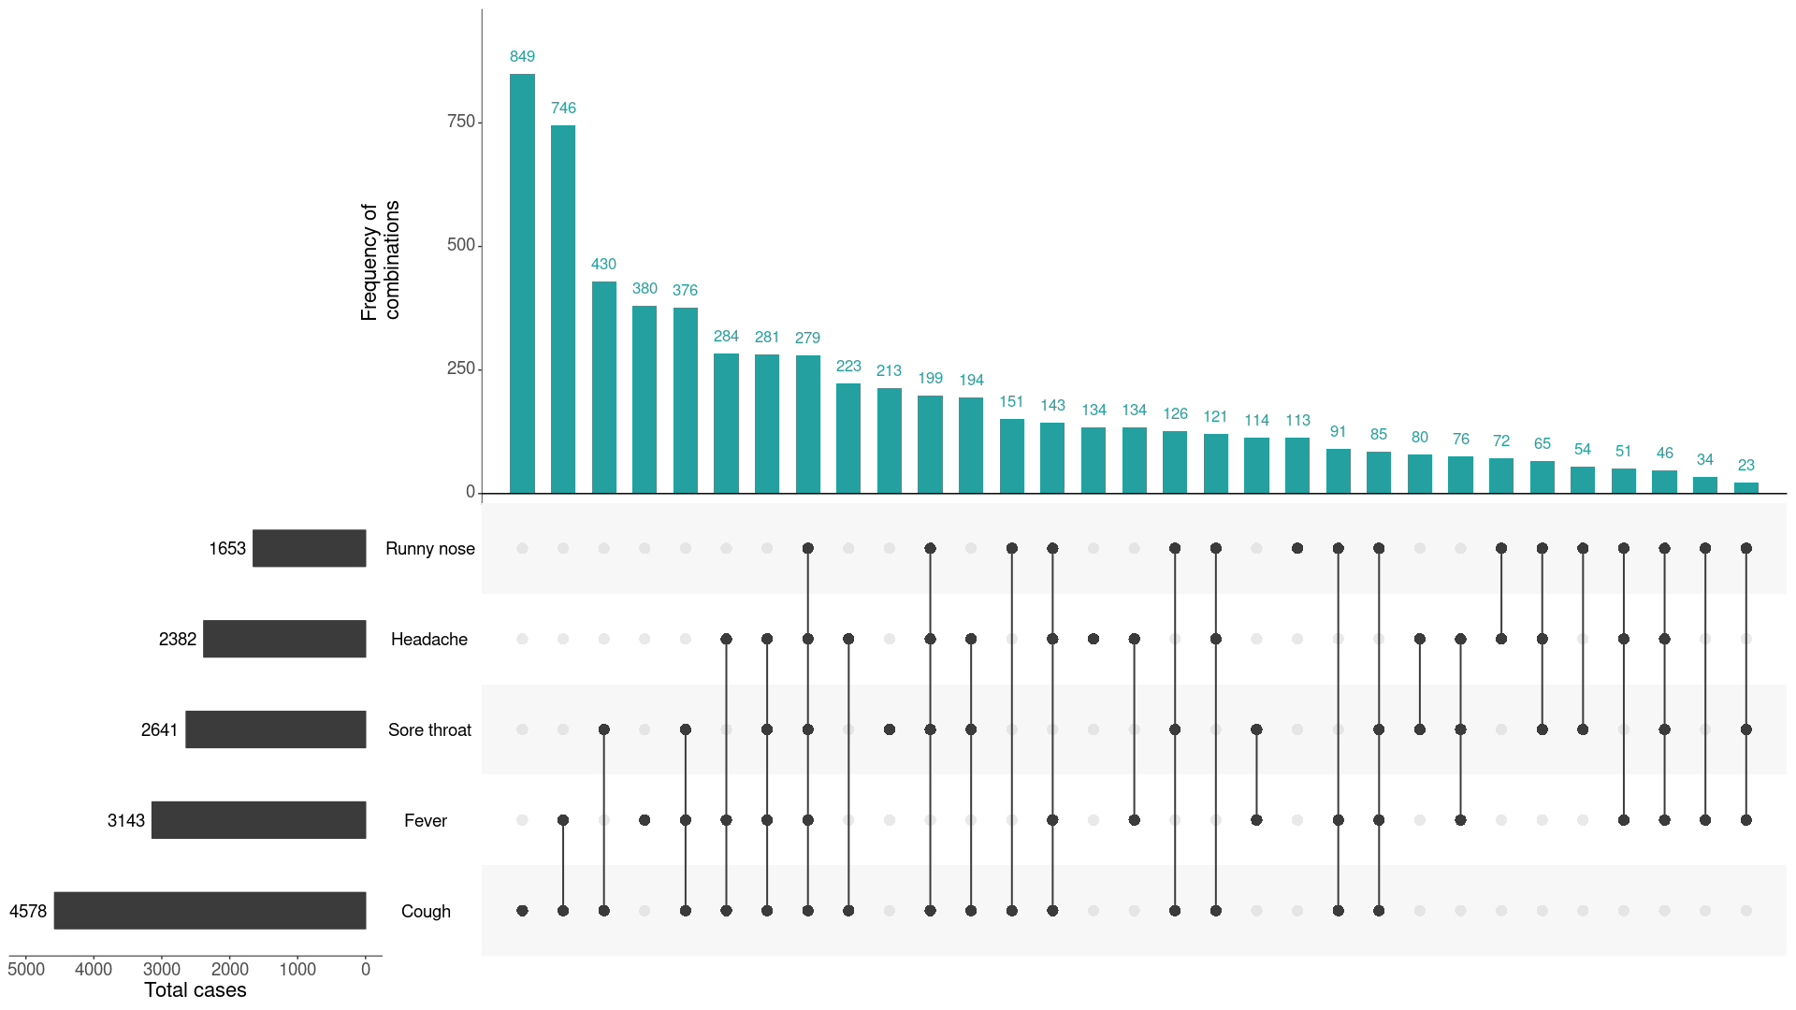
a This figure shows the variation in combinations of symptoms observed in reported cases (n = 6,657) for the five most frequently observed symptoms (cough, fever, sore throat, headache, runny nose). The horizontal bars on the left show the frequency of symptom occurrence in any combination with other symptoms. The circles and lines indicate particular combinations of symptoms observed in individual patients. The vertical green bars indicate the frequency of occurrence of the corresponding combination of symptoms.
Communicable Diseases Intelligence
ISSN: 2209-6051 Online

Communicable Diseases Intelligence (CDI) is a peer-reviewed scientific journal published by the Office of Health Protection, Department of Health. The journal aims to disseminate information on the epidemiology, surveillance, prevention and control of communicable diseases of relevance to Australia.

Editor: Tanja Farmer
Deputy Editor: Simon Petrie
Design and Production: Kasra Yousefi
Editorial Advisory Board: David Durrheim, Mark Ferson, John Kaldor, Martyn Kirk and Linda Selvey

Website: http://www.health.gov.au/cdi

Contacts
Communicable Diseases Intelligence is produced by:
Health Protection Policy Branch, Office of Health Protection, Australian Government Department of Health
GPO Box 9848, (MDP 6) CANBERRA ACT 2601

Email: cdi.editor@health.gov.au

Submit an Article
You are invited to submit your next communicable disease related article to the Communicable Diseases Intelligence (CDI) for consideration. More information regarding CDI can be found at: http://health.gov.au/cdi.
Further enquiries should be directed to: cdi.editor@health.gov.au.

This journal is indexed by Index Medicus and Medline.

Creative Commons Licence - Attribution-NonCommercial-NoDerivatives CC BY-NC-ND
© 2020 Commonwealth of Australia as represented by the Department of Health
This publication is licensed under a Creative Commons Attribution-NonCommercial-NoDerivatives 4.0 International Licence from https://creativecommons.org/licenses/by-nc-nd/4.0/legalcode (Licence). You must read and understand the Licence before using any material from this publication.

Restrictions
The Licence does not cover, and there is no permission given for, use of any of the following material found in this publication (if any):
- the Commonwealth Coat of Arms (by way of information, the terms under which the Coat of Arms may be used can be found at www.itsanhonour.gov.au);
- any logos (including the Department of Health’s logo) and trademarks;
- any photographs and images;
- any signatures; and
- any material belonging to third parties.

Disclaimer
Opinions expressed in Communicable Diseases Intelligence are those of the authors and not necessarily those of the Australian Government Department of Health or the Communicable Diseases Network Australia. Data may be subject to revision.

Enquiries
Enquiries regarding any other use of this publication should be addressed to the Communication Branch, Department of Health, GPO Box 9848, Canberra ACT 2601, or via e-mail to: copyright@health.gov.au

Communicable Diseases Network Australia
Communicable Diseases Intelligence contributes to the work of the Communicable Diseases Network Australia.
http://www.health.gov.au/cdna

This report has been prepared ahead of usual reporting timelines in order to ensure departmental publications using the same fortnightly reporting periods are published in a timely manner. In advancing the availability of these data, reporting periods for departmental outputs align and may be used to provide a comprehensive overview of the health response to the COVID-19 pandemic. This condensed production timeline has resulted in a succinct report that includes sections that have not been updated for this data collection period. Where applicable, these sections are clearly marked. The next fortnightly report (Report 19) will provide the usual comprehensive analysis.

