COVID-19 Australia: Epidemiology Report 35
Reporting period ending 14 February 2021
COVID-19 National Incident Room Surveillance Team

Summary
Trends – Australia continues to report low numbers of COVID-19 cases. The daily average number of cases for this reporting period was five compared to an average of six cases per day in the previous fortnight. There were 69 cases of COVID-19 and no deaths this fortnight, bringing the cumulative case count to 28,868 with 909 deaths.
Demographics – Demographic trends have remained consistent this reporting period: persons aged ≥ 90 years have the highest cumulative rate of infection; children aged 0–9 years have the lowest rate of infection; and cases in Aboriginal and Torres Strait Islander persons account for less than 1% of all confirmed cases.
Local cases – There were 14 locally-acquired cases reported in Australia this fortnight, all of which were reported in Victoria. These cases were linked to a cluster of cases associated with hotel quarantine settings. One further case in Victoria was reported as under investigation.
Overseas cases – There were 54 overseas-acquired cases this reporting period. Of these, 39% (21/54) were from New South Wales, with the remainder dispersed across all jurisdictions.
Testing – Testing rates increased by 26% compared to the previous fortnight, likely in response to the increase in locally-acquired cases. The cumulative positivity rate remains low at 0.2%.
Virology – Since 30 November 2020, there have been 93 sequences of the UK variant of concern (B.1.1.7 lineage), 18 sequences of the South African variant (B.1.351 lineage) and no cases of the Brazilian variant (P.1 lineage) uploaded to GISAID in Australia as at the end of the reporting period.
This reporting period covers the last two weeks (1–14 February 2021). The previous reporting period is the preceding two weeks (18–31 January 2021). As Australia continues to experience low numbers of COVID-19 cases, this report is transitioning to a brief update on case numbers each fortnight and a more detailed analysis every four weeks. Acute respiratory illness, severity, clusters and outbreaks, public health response measures and the international situation are reported in detail on a four-weekly basis and are not included in this report. The latest information on these topics can be found in Epidemiology Report 34,¹ state and territory health websites, the World Health Organization’s weekly situation reports and the Department of Health’s current situation and case numbers webpage.
Keywords: SARS-CoV-2; novel coronavirus; 2019-nCoV; coronavirus disease 2019; COVID-19; acute respiratory disease; epidemiology; Australia

Background and data sources
See the Technical Supplement for information on coronavirus disease 19 (COVID-19) including modes of transmission, common symptoms and severity.²

Activity

Transmission trends of confirmed COVID-19

(NNDSS and jurisdictional reporting to NIR)
As at 14 February 2021, there were 28,868 COVID-19 cases including 909 deaths reported nationally, with two distinct peaks in March and July (Figure 1). In this reporting period, there were 69 cases and no deaths reported. On average, five cases were notified each day over this reporting period, a decrease from the average of six cases reported per day over the previous reporting period. The largest number of cases diagnosed this fortnight was from Victoria (33%; 23/69), followed by New South Wales (30%; 21/69) (Table 1).
Figure 1: COVID-19 notified cases by source of acquisition and diagnosis date, Australia, week ending 14 February 2021ª
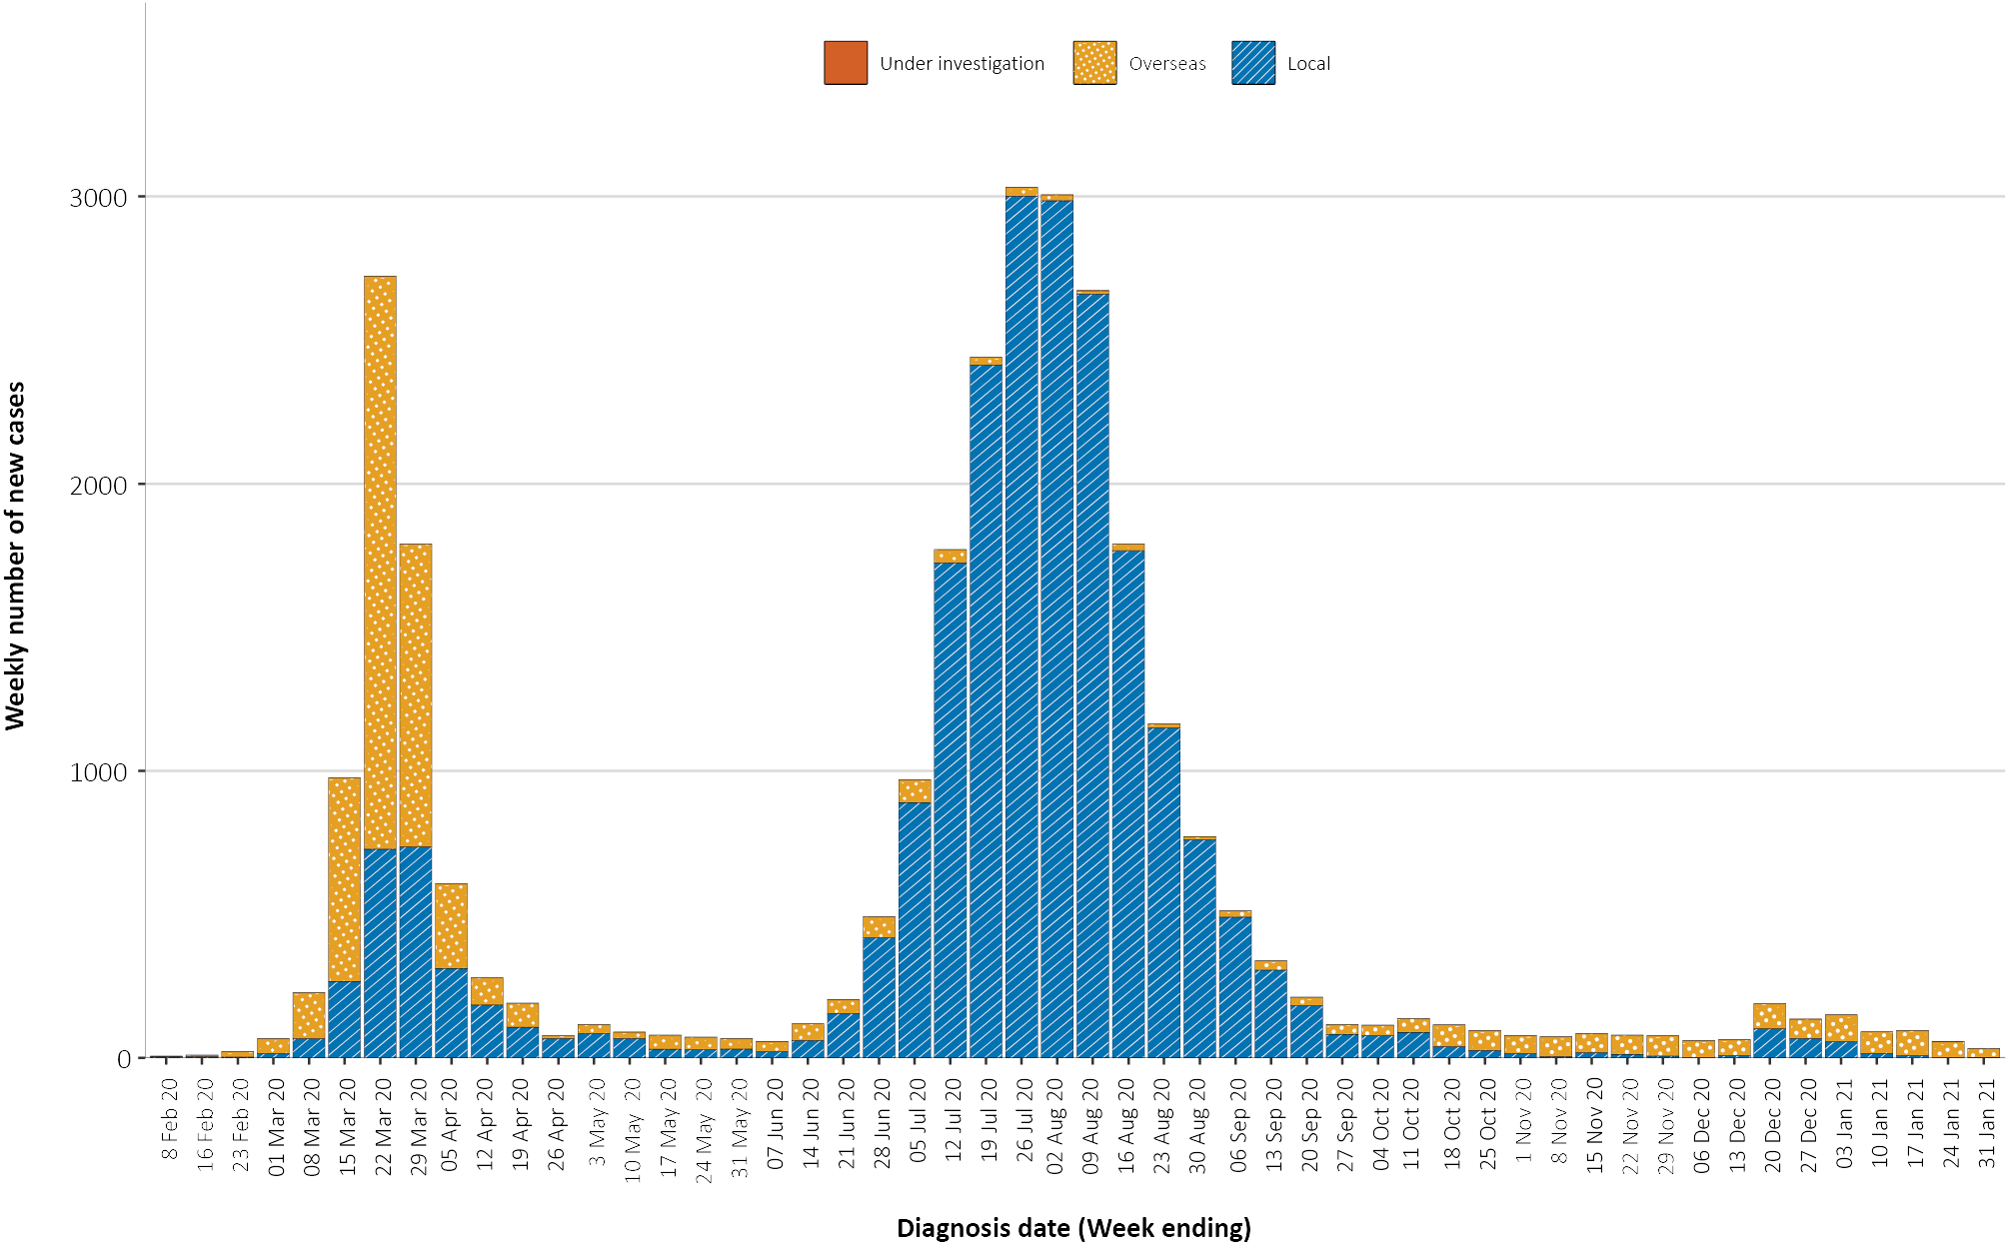
a Source: NNDSS.

Source of acquisition

(NNDSS)
In this reporting period, the majority of cases were reported as overseas acquired (78%; 54/69). Locally-acquired cases accounted for 20% (14/69) of cases this fortnight, an increase from the previous reporting period. At the end of this reporting period, one case linked to a hotel quarantine setting in Victoria was under investigation (Table 1).
Table 1: COVID-19 notifications by jurisdiction and source of acquisition, Australia, 1–14 February 2021
Source | NSW | Vic. | Qld | WA | SA | Tas. | NT | ACT | Australia
Overseas | 21 | 8 | 7 | 4 | 10 | 0 | 4 | 0 | 54
Local — source known | 0 | 14 | 0 | 0 | 0 | 0 | 0 | 0 | 14
Local — source unknown | 0 | 0 | 0 | 0 | 0 | 0 | 0 | 0 | 0
Local — interstate | 0 | 0 | 0 | 0 | 0 | 0 | 0 | 0 | 0
Under investigation | 0 | 1 | 0 | 0 | 0 | 0 | 0 | 0 | 1
Total | 21 | 23 | 7 | 4 | 10 | 0 | 4 | 0 | 69
Cumulatively, the infection rate for all locally-acquired cases is highest in Victoria with 294 infections per 100,000 population (Table 2). The rate of infection in Tasmania is 27.9 infections per 100,000 population, largely as a result of an outbreak in North West Tasmanian hospitals in April 2020, which represented half of all their cases. Nationally, it has been 30 days since there was a locally-acquired case of unknown source (Table 3).
Table 2: Locally-acquired COVID-19 case numbers and rates per 100,000 population by jurisdiction and reporting period, Australia, 14 February 2021
Jurisdiction | Reporting period  18–31 January 2021 |  | Reporting period  1–14 February 2021 | Cumulative cases  23 January 2020 – 14 February 2021
 | Number of cases | Number of cases | Number of cases | Rate per 100,000 population
NSWª | 1 | 0 | 2,176 | 26.9
Vic. | 2 | 14 | 19,404 | 294.3
Qld | 0 | 0 | 302 | 5.9
WA | 1 | 0 | 99 | 3.8
SA | 0 | 0 | 184 | 10.5
Tas. | 0 | 0 | 149 | 27.9
NT | 0 | 0 | 4 | 1.6
ACT | 0 | 0 | 29 | 6.8
Australia | 4 | 14 | 22,347 | 88.1
a The most recent NSW locally-acquired case was notified on 11 January 2021, linked to a known cluster of cases at the time. Though notified on 11 January, the case had a true onset date of 18 January 2021 and hence is presented in the previous fortnight’s reporting period.
Table 3: Days since last locally-acquired COVID-19 case (source known and source unknown), by jurisdiction, reported by notification received date, 14 February 2021ª
Jurisdiction | Locally acquired — source unknown |  | Locally acquired — source known
 | Date of last case | Days since last case | Date of last case | Days since last case
NSW | 15 January 2021 | 30 | 5 February 2021 | 9
Vic. | 5 January 2021 | 40 | 14 February 2021 | 0
Qld | 26 August 2020 | 172 | 12 January 2021 | 33
WA | 12 April 2020 | 308 | 1 February 2021 | 13
SA | 15 April 2020 | 305 | 29 November 2020 | 77
Tas. | 11 August 2020 | 187 | 6 May 2020 | 284
NT^{b} | NA | NA | 4 April 2020 | 316
ACT | 28 March 2020 | 323 | 9 July 2020 | 220
a Apparent mismatches between case numbers per reporting fortnight in Table 2 and dates of most recent cases in Table 3 can arise through the use of onset dates for Table 2 versus notification received dates in Table 3.
b The Northern Territory has not reported any locally-acquired cases with an unknown source of infection.
Figure 2: Cumulative COVID-19 cases, by age group and sex, Australia, 23 January 2020 to 14 February 2021
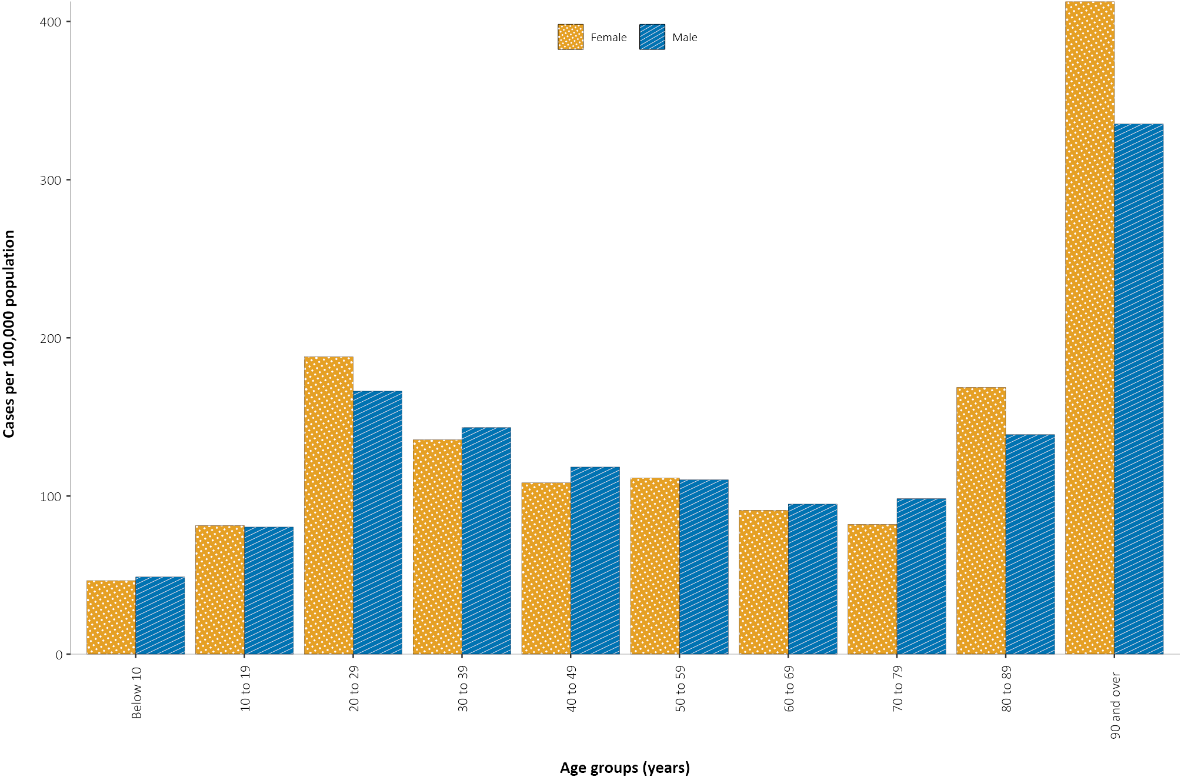
In this reporting period, the largest number of overseas-acquired cases was reported in New South Wales (39%; 21/54). The higher number of overseas-acquired cases reported in New South Wales reflects the number of managed international arrivals there.

Demographic features

(NNDSS)
In this reporting period, the largest number of cases occurred in those aged 30 to 39 years (23/69 cases). For all notifications to date, the highest rate of infection is in those aged 90 and over with a rate of 386.8 per 100,000 population (Appendix A, Table A.1). Children under 10 years old have the lowest rate of infection (47.4 cases per 100,000 population).
Cumulatively, the male-to-female rate ratio of cases is approximately 1:1 in most age groups. Notification rates are higher among females than among males in the 20–29 years age group and those aged ≥ 80 years old, and higher among males than among females in the 70–79 years age group (Figure 2). The largest difference in cumulative rates is in the 90 years and over age group, where the cumulative rate among males is 333.7 cases per 100,000 population and among females 412.6 cases per 100,000 population (Appendix A, Table A.1).
Since the beginning of the epidemic in Australia, the median age of all cases is 37 years (interquartile range, IQR: 25–56) which has not changed since the beginning of August. Prior to 1 June 2020, COVID-19 cases were slightly older, with a median age of 46 years (IQR: 29–62), associated with a high proportion of cases having a recent travel history or acquisition on a cruise ship. In cases reported after 1 June 2020, the median age is 34 years (IQR: 23–53) reflecting transmission in the community and across a range of settings, especially in Victoria. The median age of cases in this reporting period was 34 years (IQR: 28–42).

Aboriginal and Torres Strait Islander persons

(NNDSS)
There have been 149 confirmed cases of COVID-19 notified in Aboriginal and Torres Strait Islander people since the beginning of the epidemic. This represents approximately 0.5% (149/28,868) of all confirmed cases. Since the last reporting period, two Aboriginal and Torres Strait Islander cases were officially de-notified. Table 4 compares the remoteness of cases in Aboriginal and Torres Strait Islander people with those in the non-Indigenous population.
Table 4: COVID-19 notifications by Aboriginal and Torres Strait Islander status by jurisdiction, source of acquisition and remoteness classification, Australia, 14 February 2021
 | Locally acquired |  |  |  | Interstate acquiredª | Overseas acquired | Unknown^{b} | Total
 | Major Cities of Australia | Inner Regional Australia | Outer Regional Australia | Remote / Very Remote Australia
Aboriginal and  Torres Strait Islander | 88 | 14 | 6 | 1 | 2 | 33 | 5 | 149
Non-Indigenous | 19,574 | 859 | 214 | 16 | 147 | 6,511 | 1,398 | 28,719
a This reporting period, two interstate Aboriginal and Torres Strait Islander cases were officially de-notified.
b Includes 26 non-Indigenous cases classified as overseas residents who were diagnosed in Australia.
The median age of COVID-19 cases in Aboriginal and Torres Strait Islander people is 31 years old (IQR: 21–49), which is younger than for non-Indigenous cases where the median age is 37 years old (IQR: 25–56).
The notification rate across all age groups remains higher in non-Indigenous people than in Aboriginal and Torres Strait Islander people (Figure 3). The age-standardised Aboriginal and Torres Strait Islander:non-Indigenous notification rate ratio is 0.2, indicating that the Aboriginal and Torres Strait Islander population has a lower COVID-19 case rate than the non-Indigenous population after accounting for differences in age structure. Amongst Aboriginal and Torres Strait Islander cases, the highest notification rate is in those aged 70–79 years (36.0 cases per 100,000 population), followed by the 60–69 years age group (34.4 cases per 100,000 population). Similar to non-Indigenous cases, children aged 0–9 years have the lowest notification rate among Aboriginal and Torres Strait Islander cases (6.9 cases per 100,000 population).
Figure 3: National COVID-19 notification rate per 100,000 population by age group, Aboriginal and Torres Strait Islander people and non-Indigenous people, Australia, 23 January 2020 – 14 February 2021
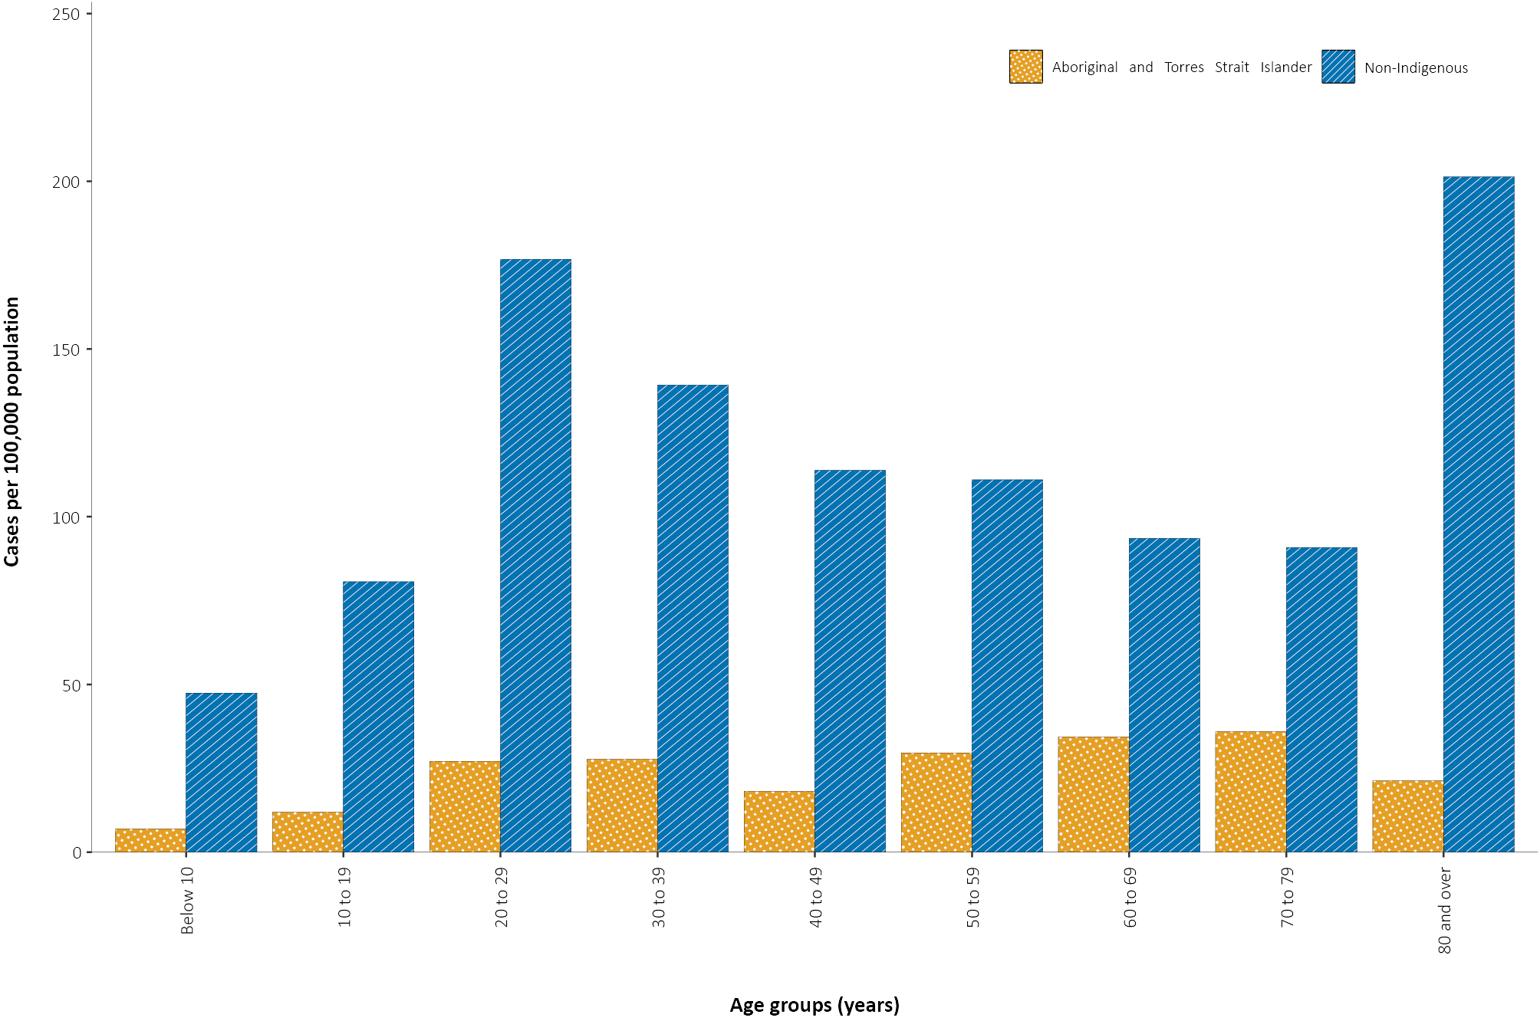

Testing

(State and territory reporting)
As at 14 February 2021, a cumulative total of 13,638,907 tests have been conducted in Australia. The cumulative nationwide proportion of positive tests remains low at 0.2% (Table 5). With the exception of Victoria, the cumulative testing positivity in individual jurisdictions is < 0.2%.

Table 5: Diagnostic tests performed, by jurisdiction, Australia, 14 February 2021
Jurisdiction | Tests performed  18–31 January |  |  | Tests performed  1–14 February |  |  | Cumulative tests performed  to 14 February
 | n | Positivity (%) | Per 1,000 populationª | n | Positivity (%) | Per 1,000 populationª | n | Positivity (%) | Per 1,000 populationª
NSW | 156,936 | 0.03 | 19.4 | 164,862 | 0.02 | 20.4 | 4,794,714 | 0.11 | 593.0
Vic | 205,001 | 0.01 | 31.1 | 236,997 | 0.01 | 35.9 | 4,694,136 | 0.44 | 711.9
Qld | 83,079 | 0.02 | 16.3 | 90,811 | 0.01 | 17.8 | 1,855,311 | 0.07 | 364.3
WA | 38,637 | 0.04 | 14.7 | 101,015 | 0.01 | 38.5 | 822,974 | 0.11 | 313.9
SA | 43,451 | 0.01 | 24.8 | 69,911 | 0.01 | 39.9 | 1,031,611 | 0.06 | 588.7
Tas | 5,648 | 0.00 | 10.6 | 6,313 | 0.00 | 11.8 | 165,399 | 0.14 | 309.4
NT | 8,498 | 0.06 | 34.5 | 9,818 | 0.05 | 39.9 | 111,590 | 0.09 | 453.4
ACT | 4,572 | 0.00 | 10.7 | 7,404 | 0.00 | 17.4 | 163,172 | 0.07 | 382.9
Australia | 545,822 | 0.02 | 21.5 | 687,131 | 0.01 | 27.1 | 13,638,907 | 0.21 | 537.9
a Population data based on Australian Bureau of Statistics (ABS) Estimated Resident Population (ERP) as at 30 December 2019.

During this reporting period, 687,131 tests were conducted nationally, with a positivity rate of 0.01%. This represented a 26% increase in tests conducted compared to the previous two-week reporting period; this increase was consistent across all jurisdictions. Testing rates increased to an average of 27.1 tests per 1,000 population per week during this reporting period, consistent with an increase in locally-acquired cases this period. Jurisdictional testing rates are driven by both current case numbers and numbers of people experiencing symptoms. All states reported a positivity rate of < 0.1% in this reporting period. The low national positivity rate, along with high rates of testing, indicates a low prevalence of COVID-19 nationally.
For the two-week period ending 14 February 2021, testing rates increased in the most recent week among all age groups (Figure 4). Testing rates were highest in major cities and urban areas of Australia; lower testing rates, with little variation between classification areas, were seen across regional and remote areas across Australia.
Figure 4: SARS-CoV-2 polymerase chain reaction (PCR) testing rates per 1,000 population per week by age group, Australia, 1 May 2020 – 12 February 2021^{a,b}
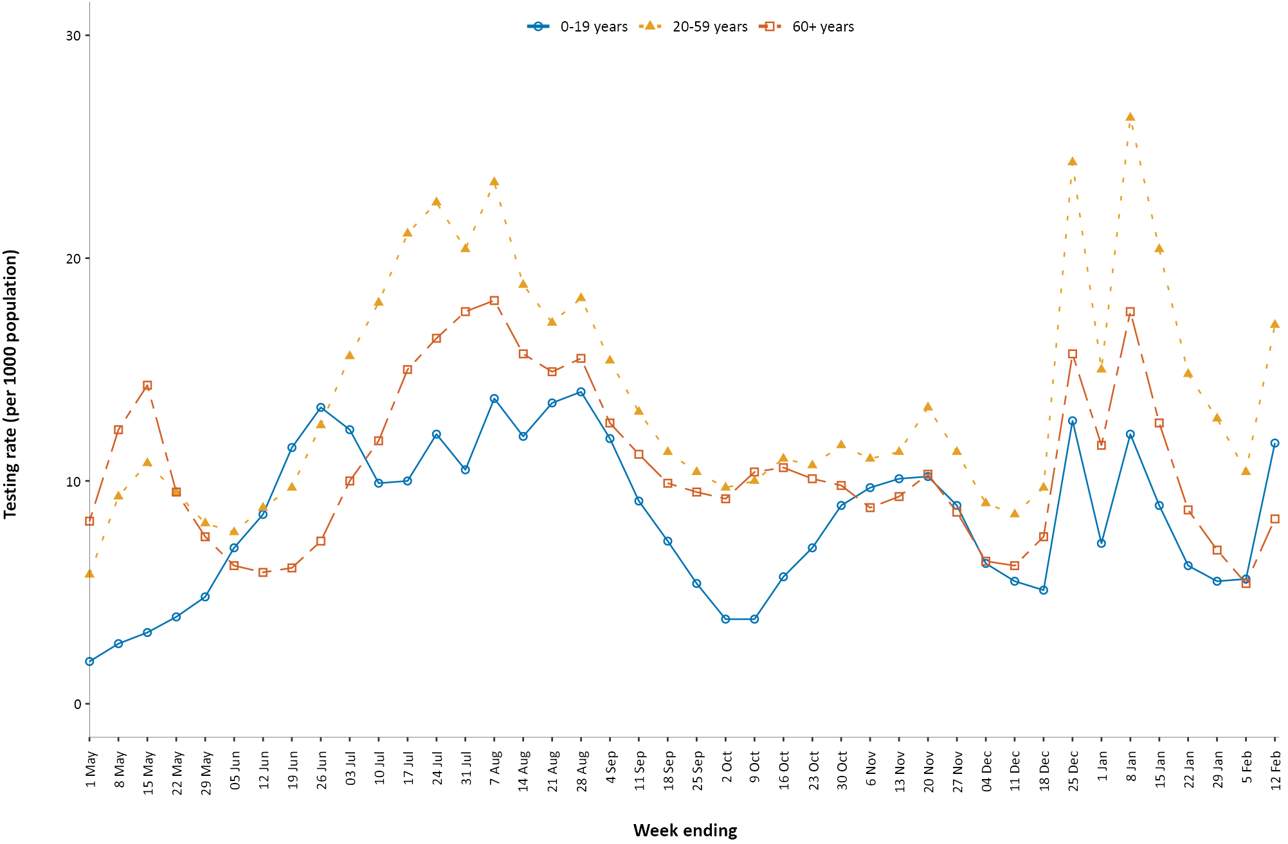
a Data provided by jurisdictions to the NIR weekly.
b The jurisdictions reporting each week (i.e. the denominator population) may vary.

Virology

(GISAID)
At the time of this report, there were 17,368 SARS-CoV-2 genome sequences available from Australian cases on the global sequence repository, GISAID.³ These sequences were dispersed throughout the global lineages, reflecting multiple concurrent introductions into Australia.^{4–6} In this fortnight, there were 11 new Australian sequences uploaded to GISAID, which was a decrease from the previous fortnight (64), noting that sequences are uploaded retrospectively. Uploads to GISAID this fortnight were from Victoria (6), with the remaining 5 sequences not classified by jurisdiction. Around 73% (8/11) of all sequences on GISAID this fortnight were of the United Kingdom (UK) variant of concern (B.1.1.7 lineage).
Since variants of concern were first identified on 30 November 2020, there have been 93 sequences of this lineage uploaded to GISAID. There have been 18 sequences of the South African variant of concern (B.1.351) uploaded to GISAID since 30 November. It is important to note that there may be delays between jurisdictional reporting and uploads. All cases of these variants of concern have been linked to overseas arrivals in mandatory hotel quarantine. Australia has reported no cases of the P.1 Brazilian variant of concern. National genomic surveillance of SARS-CoV-2 has been implemented and laboratories across Australia are routinely monitoring sequences for variant strains.

Acknowledgements
We thank public health staff from incident emergency operations centres and public health units in state and territory health departments, and the Australian Government Department of Health, along with state and territory public health laboratories. We thank those who have provided data from surveillance systems, such as Commonwealth respiratory clinics, Flutracking, and FluCAN.

Author details

Corresponding author
COVID-19 National Incident Room Surveillance Team Australian Government Department of Health, GPO Box 9484, MDP 14, Canberra, ACT 2601.
Email: epi.coronavirus@health.gov.au

References
- COVID-19 National Incident Room Surveillance Team. COVID-19 Australia: Epidemiology Report 34: Fortnightly reporting period ending 31 January 2021. Commun Dis Intell (2018). 2021;45. doi: https://doi.org/10.33321/cdi.2021.45.8.
- COVID-19 National Incident Room Surveillance Team. Technical supplement: COVID-19 Australia: epidemiology reporting. Commun Dis Intell (2018). 2021;45. doi: https://doi.org/10.33321/cdi.2021.45.2.
- Global Initiative on Sharing All Influenza Data (GISAID). [Website.] Berlin: Federal Republic of Germany, Freunde von GISAID e.V.; 2020. [Accessed on 20 January 2021.] Available from: https://www.gisaid.org/.
- Rockett RJ, Arnott A, Lam C, Sadsad R, Timms V, Gray KA et al. Revealing COVID-19 transmission in Australia by SARS-CoV-2 genome sequencing and agent-based modeling. Nat Med. 2020. doi: https://doi.org/10.1038/s41591-020-1000-7.
- Seemann T, Lane CR, Sherry NL, Duchene S, Goncalves da Silva A, Caly L et al. Tracking the COVID-19 pandemic in Australia using genomics. Nat Commun. 2020;11(1):4376. doi: https://doi.org/10.1038/s41467-020-18314-x.
- Eden JS, Rockett R, Carter I, Rahman H, de Ligt J, Hadfield J et al. An emergent clade of SARS-CoV-2 linked to returned travellers from Iran. Virus Evol. 2020;6(1):veaa027. doi: https://doi.org/10.1093/ve/veaa027.

Appendix A: Supplementary figures and tables
Table A.1: COVID-19 case notifications and rates per 100,000 population, by age group and sex, Australia, 14 February 2021
Age group | This reporting period  1–14 February 2021 |  |  |  |  |  | Cumulative  23 January 2020 – 14 February 2021
 | Cases |  |  | Rate per 100,000 population |  |  | Cases |  |  | Rate per 100,000 population
 | Male | Female | People | Male | Female | People | Male | Female | People | Male | Female | People
0 to 9 | 4 | 3 | 7 | 0.2 | 0.2 | 0.2 | 798 | 719 | 1,517 | 48.8 | 46.4 | 47.6
10 to 19 | 2 | 1 | 3 | 0.1 | 0.1 | 0.1 | 1,262 | 1,207 | 2,469 | 80.4 | 81.3 | 80.8
20 to 29 | 7 | 9 | 16 | 0.4 | 0.5 | 0.4 | 3,089 | 3,384 | 6,495 | 166.3 | 187.9 | 177.5
30 to 39 | 12 | 11 | 23 | 0.7 | 0.6 | 0.6 | 2,607 | 2,514 | 5,136 | 143.3 | 135.5 | 139.8
40 to 49 | 11 | 0 | 11 | 0.7 | 0.0 | 0.3 | 1,915 | 1,794 | 3,737 | 118.3 | 108.3 | 114.1
50 to 59 | 2 | 5 | 7 | 0.1 | 0.3 | 0.2 | 1,658 | 1,751 | 3,416 | 110.0 | 111.3 | 110.9
60 to 69 | 1 | 0 | 1 | 0.1 | 0.0 | 0.0 | 1,206 | 1,222 | 2,430 | 94.8 | 91.0 | 92.9
70 to 79 | 0 | 1 | 1 | 0.0 | 0.1 | 0.1 | 855 | 757 | 1,612 | 98.3 | 82.1 | 90.0
80 to 89 | 0 | 0 | 0 | 0.0 | 0.0 | 0.0 | 496 | 778 | 1,274 | 138.8 | 168.7 | 155.6
90 and over | 0 | 0 | 0 | 0.0 | 0.0 | 0.0 | 230 | 551 | 782 | 335.2 | 412.6 | 386.8

Communicable Diseases Intelligence
ISSN: 2209-6051 Online

Communicable Diseases Intelligence (CDI) is a peer-reviewed scientific journal published by the Office of Health Protection and Response, Department of Health. The journal aims to disseminate information on the epidemiology, surveillance, prevention and control of communicable diseases of relevance to Australia.

Editor: Tanja Farmer
Deputy Editor: Simon Petrie
Design and Production: Kasra Yousefi
Editorial Advisory Board: David Durrheim, Mark Ferson, John Kaldor, Martyn Kirk and Linda Selvey

Website: http://www.health.gov.au/cdi

Contacts
CDI is produced by Environmental Health and Health Protection Policy Branch, Office of Health Protection and Response, Australian Government Department of Health, GPO Box 9848, (MDP 6) CANBERRA ACT 2601

Email: cdi.editor@health.gov.au

Submit an Article
You are invited to submit your next communicable disease related article to the Communicable Diseases Intelligence (CDI) for consideration. More information regarding CDI can be found at: http://health.gov.au/cdi.
Further enquiries should be directed to: cdi.editor@health.gov.au.

This journal is indexed by Index Medicus and Medline.

Creative Commons Licence - Attribution-NonCommercial-NoDerivatives CC BY-NC-ND
© 2021 Commonwealth of Australia as represented by the Department of Health
This publication is licensed under a Creative Commons Attribution-NonCommercial-NoDerivatives 4.0 International Licence from https://creativecommons.org/licenses/by-nc-nd/4.0/legalcode (Licence). You must read and understand the Licence before using any material from this publication.

Restrictions
The Licence does not cover, and there is no permission given for, use of any of the following material found in this publication (if any):
- the Commonwealth Coat of Arms (by way of information, the terms under which the Coat of Arms may be used can be found at www.itsanhonour.gov.au);
- any logos (including the Department of Health’s logo) and trademarks;
- any photographs and images;
- any signatures; and
- any material belonging to third parties.

Disclaimer
Opinions expressed in Communicable Diseases Intelligence are those of the authors and not necessarily those of the Australian Government Department of Health or the Communicable Diseases Network Australia. Data may be subject to revision.

Enquiries
Enquiries regarding any other use of this publication should be addressed to the Communication Branch, Department of Health, GPO Box 9848, Canberra ACT 2601, or via e-mail to: copyright@health.gov.au

Communicable Diseases Network Australia
Communicable Diseases Intelligence contributes to the work of the Communicable Diseases Network Australia.
http://www.health.gov.au/cdna

