COVID-19 Australia: Epidemiology Report 42
Reporting period ending 23 May 2021
COVID-19 National Incident Room Surveillance Team

Summary
Two-week reporting period:
Trends – The number of coronavirus disease 2019 (COVID-19) cases reported in Australia remains very low, especially in this reporting period when the daily average number of cases was four, compared to an average of eleven cases per day in the previous fortnight. There were 50 cases of COVID-19 this fortnight, bringing the cumulative case count to 29,757.
Local cases – There were no locally-acquired cases reported in Australia this fortnight, and no cases remained under investigation at the end of this reporting period.
Overseas cases – There were 50 overseas-acquired cases this reporting period. Of these, 40% (20/50) were reported from New South Wales, 26% (13/50) from Queensland and 24% (12/50) from Victoria.
Vaccinations – As at 25 May 2021, there have been 3,795,280 doses of COVID-19 vaccine administered in Australia.
Four-week reporting period:
Virology – Nationally, SARS-CoV-2 strains from 59% of COVID-19 cases have been sequenced during the pandemic. During 2021, there has been an increase in the number of cases infected with SARS-CoV-2 variants of concern (VOC) in Australia. AusTrakka is actively monitoring and reporting on these variants and has so far identified 431 samples of B.1.1.7; 74 samples of B.1.351; seven samples of P.1; 37 samples of B.1.617.1; and 122 samples of B.1.617.2 in Australia.
Testing – Over one million individuals were tested nationally during this four-week reporting period. Testing rates were slightly higher in the last two weeks of the reporting period compared to the first two weeks, in all jurisdictions except Western Australia. The cumulative positivity rate remains low at 0.02%.
Severity – In 2021 to date, an estimated 5% of COVID-19 cases have been admitted to hospital. Australia’s case fatality rate has remained stable at 3.1%. No new COVID-19 related deaths occurred in the past four weeks.
Public health measures – Extra restrictions were put in place during this reporting period, to minimise the risk associated with locally-acquired cases in New South Wales, Victoria and Western Australia.
International situation – Cumulative global COVID-19 cases are now approaching 166 million, with 3.4 million deaths reported globally. India reported almost ten million new cases in this four-week reporting period. The highest numbers of both new cases and deaths were reported in India, Brazil and the United States of America in this reporting period.

This reporting period covers the last two weeks (10–23 May 2021), with data for this period compared to that from the previous two-week reporting period (26 April – 9 May 2021).¹ As Australia continues to experience low numbers of coronavirus disease 2019 (COVID-19) cases, this report has transitioned to a brief update on case numbers each fortnight and a more detailed analysis every four weeks. The focus of this report is now on the epidemiological situation in Australia since the beginning of this year, 2021. Readers are encouraged to consult prior reports for information on the epidemiology of cases in Australia in 2020. Included in this report with a reporting period of four weeks are sections on genomic surveillance and virology, acute respiratory illness, severity, testing, public health response measures, and the international situation. The reporting period for these topics covers 26 April – 23 May 2021. For comparability, the previous reporting period is the preceding four weeks (29 March – 25 April 2021).
Keywords: SARS-CoV-2; novel coronavirus; 2019-nCoV; coronavirus disease 2019; COVID-19; acute respiratory disease; epidemiology; Australia

Two-week reporting period (10–23 May 2021):

Background and data sources
See the Technical Supplement for general information on COVID-19 including modes of transmission, common symptoms and severity.²

Activity

COVID-19 trends

(NNDSS and jurisdictional reporting to NIR)
There were 50 cases with a diagnosis date within this two-week reporting period, from 10 to 23 May 2021. This averages to four cases diagnosed per day over this reporting period, which is fewer than the average daily cases (11) diagnosed during the previous reporting period. Of all states and territories, the largest number of cases diagnosed this fortnight was from New South Wales (40% of all cases; 20/50), followed by Queensland (26%; 13/50) and then Victoria (24%; 12/50) (Table 1).

Table 1: COVID-19 notifications by jurisdiction and source of acquisition, 10–23 May 2021ª
Source | ACT | NSW | NT | Qld | SA | Tas. | Vic. | WA | Australia
Overseas | 0 | 20 | 2 | 13 | 2 | 0 | 12 | 1 | 50
Local | 0 | 0 | 0 | 0 | 0 | 0 | 0 | 0 | 0
source known | 0 | 0 | 0 | 0 | 0 | 0 | 0 | 0 | 0
source unknown | 0 | 0 | 0 | 0 | 0 | 0 | 0 | 0 | 0
interstate, source known | 0 | 0 | 0 | 0 | 0 | 0 | 0 | 0 | 0
interstate, source unknown | 0 | 0 | 0 | 0 | 0 | 0 | 0 | 0 | 0
investigation ongoing | 0 | 0 | 0 | 0 | 0 | 0 | 0 | 0 | 0
Under initial investigation | 0 | 0 | 0 | 0 | 0 | 0 | 0 | 0 | 0
Missing source of acquisition | 0 | 0 | 0 | 0 | 0 | 0 | 0 | 0 | 0
Total | 0 | 20 | 2 | 13 | 2 | 0 | 12 | 1 | 50
a Source: National Notifiable Diseases Surveillance System (NNDSS), extract from 25 May 2021, based on diagnosis date.
In the year to date, from 1 January 2021 to the end of this reporting period 23 May 2021, there have been 1,288 COVID-19 cases reported nationally. Cases diagnosed weekly have generally remained low and have returned to low numbers in this fortnightly reporting period, after reaching a peak of 128 cases in the week ending 25 April 2021. (Figure 1). These low case numbers are in contrast to the two distinct peaks experienced in March and July of 2020, when weekly notifications reached approximately 2,700 and 3,000 respectively (Figure 2). Cumulatively, since the beginning of the epidemic in Australia, there have been 29,757 COVID-19 cases reported in Australia.

Figure 1: COVID-19 notified cases by source of acquisition and diagnosis date, 28 December 2020 – 23 May 2021ª
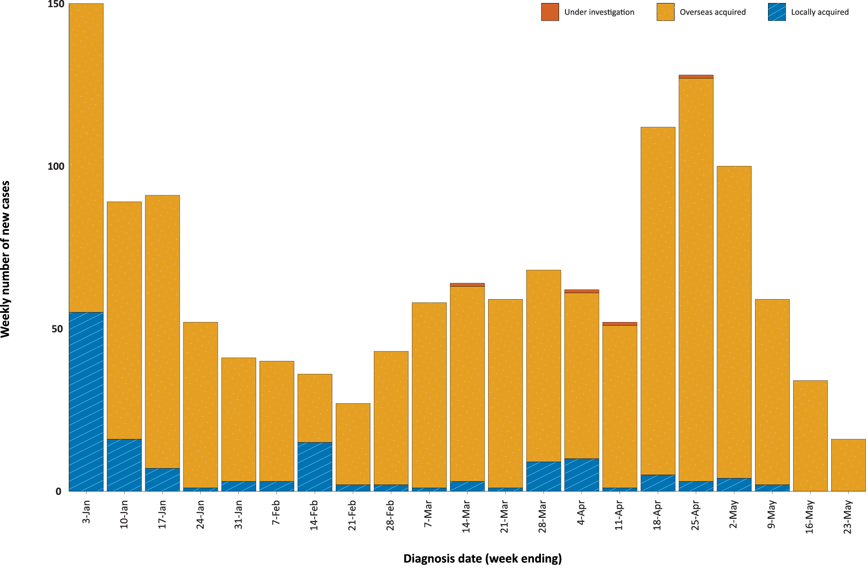
a Source: NNDSS, extract from 25 May 2021, based on diagnosis date.

Figure 2: Cumulative COVID-19 notified cases by source of acquisition and diagnosis date,
2 March 2020 – 23 May 2021ª
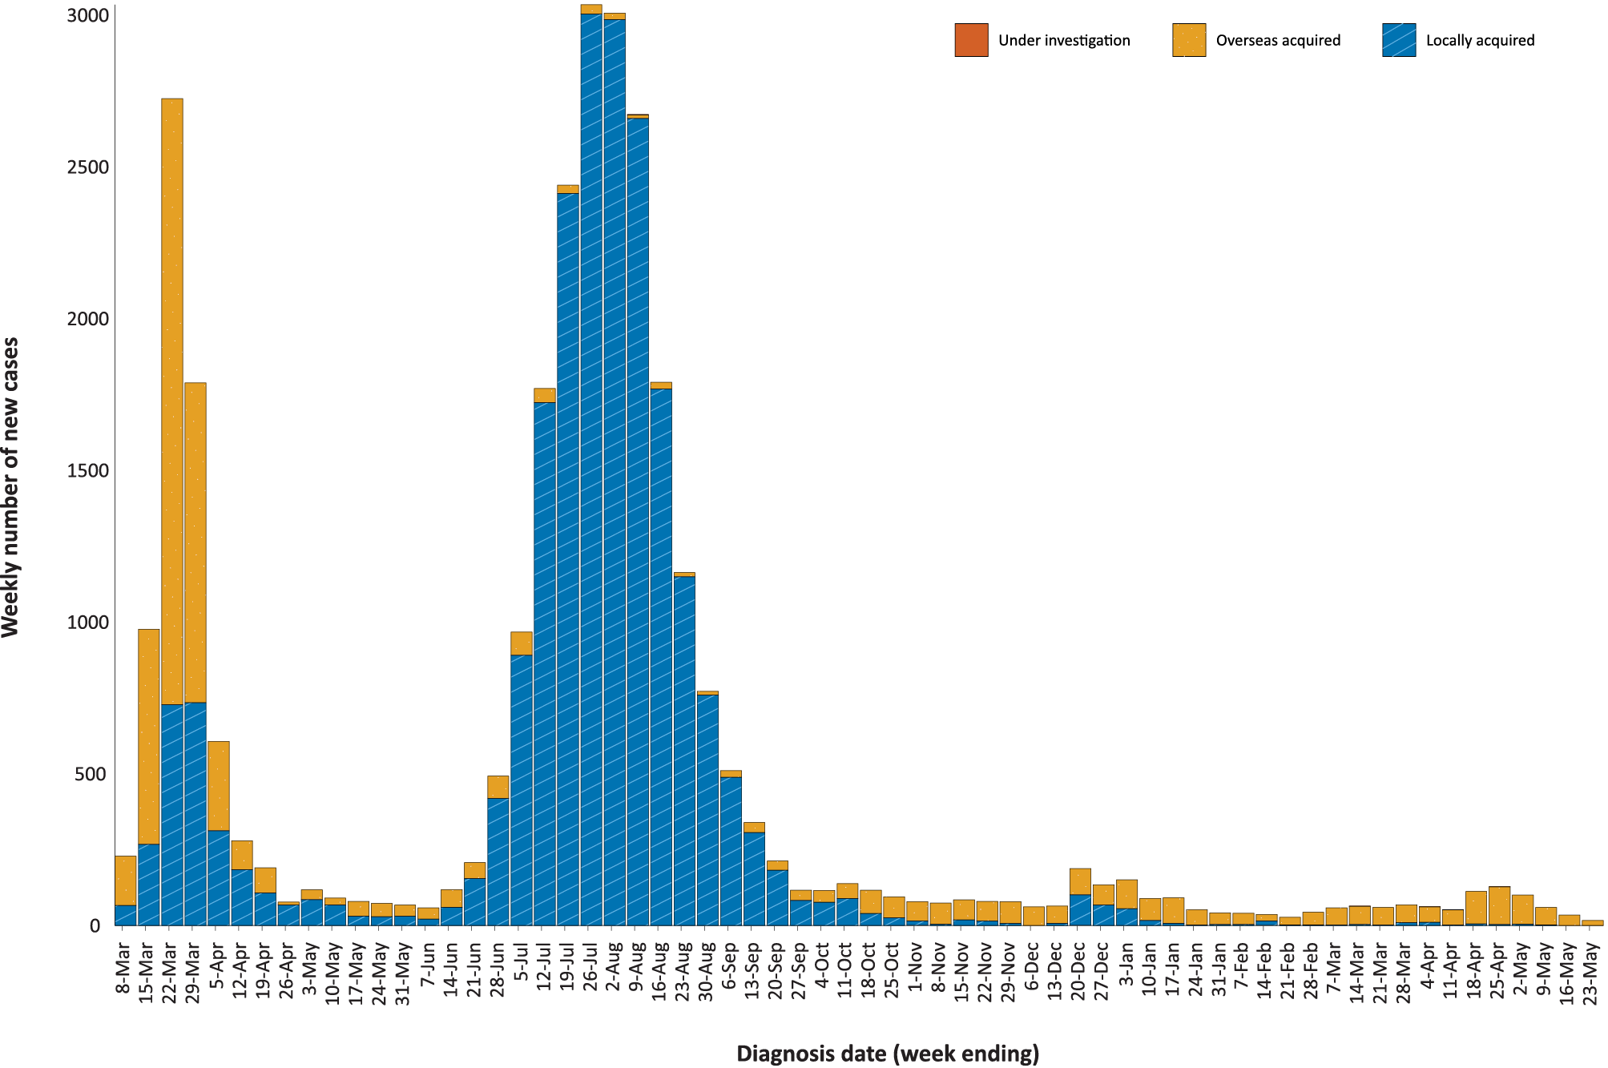
a Source: NNDSS, extract from 25 May 2021, based on diagnosis date.

Source of acquisition

(NNDSS)
In this reporting period, 100% (50/50) of cases were acquired overseas. There were no locally-acquired cases in this reporting period (Table 2). At the end of this reporting period, there were no cases under investigation (Table 1).
Table 2: Locally-acquired COVID-19 case numbers and rates per 100,000 population by jurisdiction and reporting period, Australia, 1 January to 23 May 2021ª
Jurisdiction | Reporting period  10–23 May 2021 |  | Reporting period  26 April – 9 May 2021 |  | Cases this year  1 January – 23 May 2021^{b}
 | Number of cases^{b} | Number of cases^{b} |  | Number of cases^{b} |  | Rate per 100,000 population^{c}
ACT | 0 | 0 |  | 0 |  | —
NSW | 0 | 2 |  | 36 |  | 0.44
NT | 0 | 0 |  | 0 |  | —
Qld | 0 | 0 |  | 25 |  | 0.48
SA | 0 | 0 |  | 0 |  | —
Tas. | 0 | 0 |  | 0 |  | —
Vic. | 0 | 1 |  | 36 |  | 0.54
WA | 0 | 3 |  | 8 |  | 0.30
Australia | 0 | 6 |  | 105 |  | 0.41
a Source: NNDSS, extract from 25 May 2021, based on diagnosis date.
b This total does not include cases that are under investigation.
c Population data based on Australian Bureau of Statistics (ABS) Estimated Resident Population (ERP) as at June 2020.

The largest number of overseas-acquired cases was reported in New South Wales (40% of all cases; 20/50), followed by Queensland (26%; 13/50) and then Victoria (24%; 12/50). In this fortnight, 10 percent of overseas-acquired cases (5/50) reported an unknown country of acquisition. Of those overseas-acquired cases that did report a country of acquisition, Afghanistan and Iran were the most frequently-reported countries (11%; 5/45 cases each), followed by Saudi Arabia (9%; 4/45). The number of cases by country is influenced by travel patterns of returning Australians, by restrictions on travel enforced by the Australian government, and also by the prevalence of COVID-19 in the country the person arrived from.
In 2021, Victoria has the highest infection rate for locally-acquired cases with 0.54 infections per 100,000 population, followed by Queensland with a rate of 0.48 infections per 100,000 population (Table 2). At the end of this reporting period, there had been 15 days since the last locally-acquired case of known source (Table 3).

Table 3: Days since last locally-acquired COVID-19 case (source unknown and source known), by jurisdiction, 23 May 2021ª
Jurisdiction | Locally acquired — source unknown |  | Locally acquired — source known
 | Date of last case | Days since last case | Date of last case | Days since last case
ACT | 21 March 2020 | 428 | 7 July 2020 | 320
NSW | 2 May 2021 | 21 | 5 May 2021 | 18
NT | NA^{b} | NA^{b} | 3 April 2020 | 415
Qld | 23 August 2020 | 273 | 3 April 2021 | 50
SA | 24 March 2020 | 425 | 27 November 2020 | 177
Tas. | 9 August 2020 | 287 | 24 April 2020 | 394
Vic. | 30 December 2020 | 144 | 8 May 2021 | 15
WA | 3 Apr 2020 | 415 | 1 May 2021 | 22
a Source: NNDSS, extract from 25 May 2021, based on diagnosis date.
b NA: not applicable. The Northern Territory has not reported any locally-acquired cases with an unknown source of infection.

Demographic features

(NNDSS)
In this reporting period, the largest number of cases occurred in those aged 30 to 39 years (24%; 12/50 cases). For notifications this year, the highest rate of infection is in those aged 30 to 39 years with a rate of 9.4 infections per 100,000 population (Figure 3; Appendix A, Table A.1). Adults over 80 years of age have the lowest rate of infection this year.

Figure 3: Cumulative COVID-19 cases for the calendar year to date, by age group and sex, Australia, 1 January 2021 to 23 May 2021ª
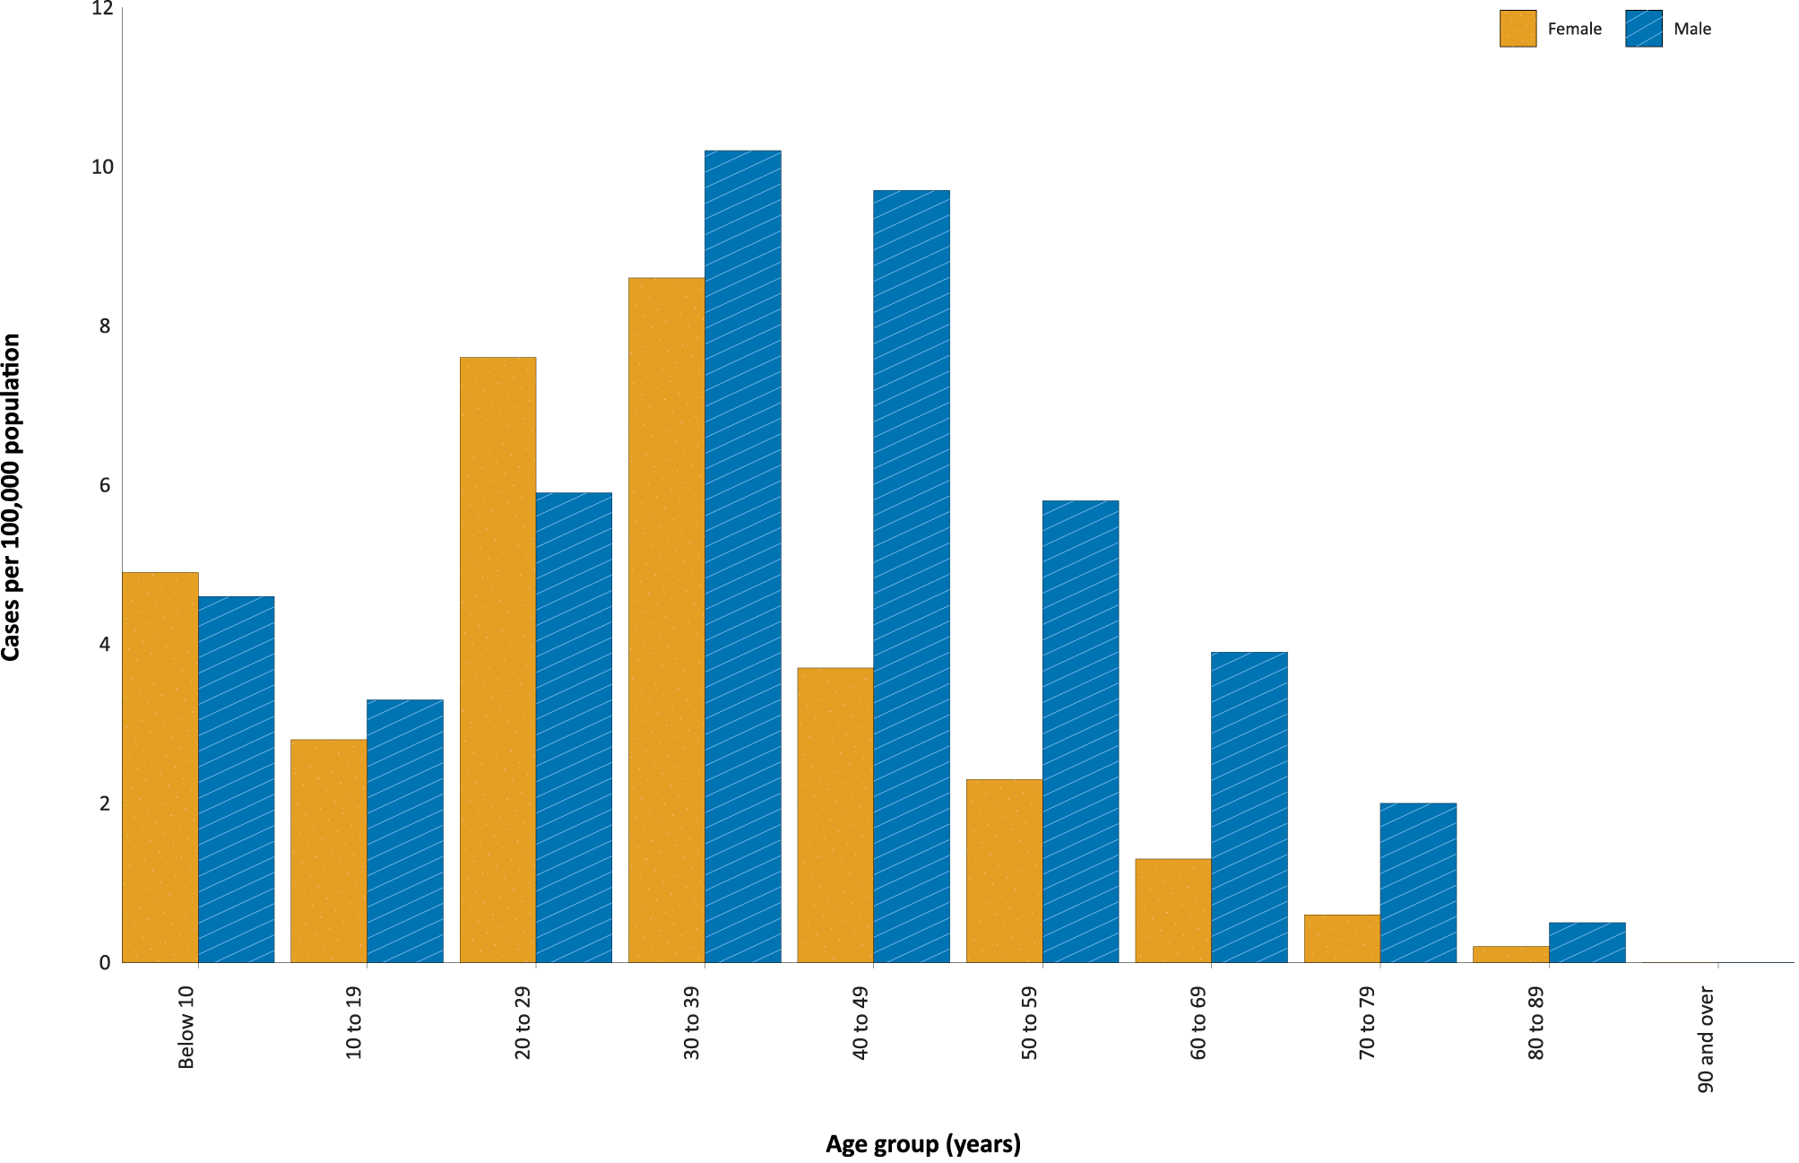
a Source: NNDSS, extract from 25 May 2021, based on diagnosis date.
Focusing on cases in this year only, there is a difference in notification rates between males and females in most age groups. The notification rate is higher in males than females in all age groups over 30 years old (Figure 3). The largest difference in rates this year is in the 40 to 49 years age group, where the cumulative rate among males is 9.7 cases per 100,000 population and among females is 3.7 cases per 100,000 population (Appendix A, Table A.1). The median age of cases in this reporting period is 32 years (range: 1 to 73).

Aboriginal and Torres Strait Islander persons

(NNDSS)
There have been five confirmed cases of COVID-19 notified in Aboriginal and Torres Strait Islander people since the beginning of 2021. No new Aboriginal and Torres Strait Islander cases were notified with a diagnosis date within this reporting period. Overall, Aboriginal and Torres Strait Islander people represent approximately 0.4% (5/1,256) of all confirmed cases with Indigenous status known this year. The Indigenous status is unknown for 2.5% (32/1,288) of all cases reported this year. The majority of cases in Aboriginal and Torres Strait Islander people in 2021 have been overseas-acquired (80%; 4/5). The age range of COVID-19 cases in Aboriginal and Torres Strait Islander people in 2021 is 20 to 65 years.

Vaccinations

(Department of Health)
As of 25 May 2021, a total of 3,795,280 doses of COVID-19 vaccine have been administered (Table 4), including 333,026 doses provided to aged care and disability residents.
Table 4: Total number of vaccinations administered, by jurisdiction, Australia, 25 May 2021ª
Jurisdiction | Total number of doses administered
ACT | 45,324
NSW | 371,117
NT | 29,445
Qld | 198,598
SA | 97,327
Tas. | 60,801
Vic. | 385,320
WA | 154,879
Aged care and disability facilities^{b} | 333,026
Primary care^{c} | 2,119,443
Total | 3,795,280
a Source: Australian Government Department of Health website.³
b Commonwealth vaccine doses administered in aged care and disability facilities.
c Commonwealth vaccine doses administered in primary care settings.
Recent rare occurrences of thrombosis (blood clotting) and thrombocytopenia (low blood platelet count), in patients who had received the AstraZeneca COVID-19 vaccine, led to temporary suspensions of the vaccine program in Australia to allow for investigation by regulatory bodies. It is now recommended that the Pfizer vaccine is the preferred COVID-19 vaccine for adults aged under 50 years.⁴

Clusters and outbreaks
For the two-week reporting period ending 23 May 2021, no new clusters or outbreaks were reported in Australia.

Four-week reporting period (26 April – 23 May 2021):

Genomic surveillance and virology

(Communicable Disease Genomics Network, AusTrakka and jurisdictional sequencing laboratories)
Nationally, 59% of COVID-19 cases have had their SARS-CoV-2 genomes sequenced over the duration of the pandemic, based on jurisdictional reporting (Table 5, Figure 4).
Figure 4: Samples in AusTrakka since 4 January 2021, by lineage and date of collectionª
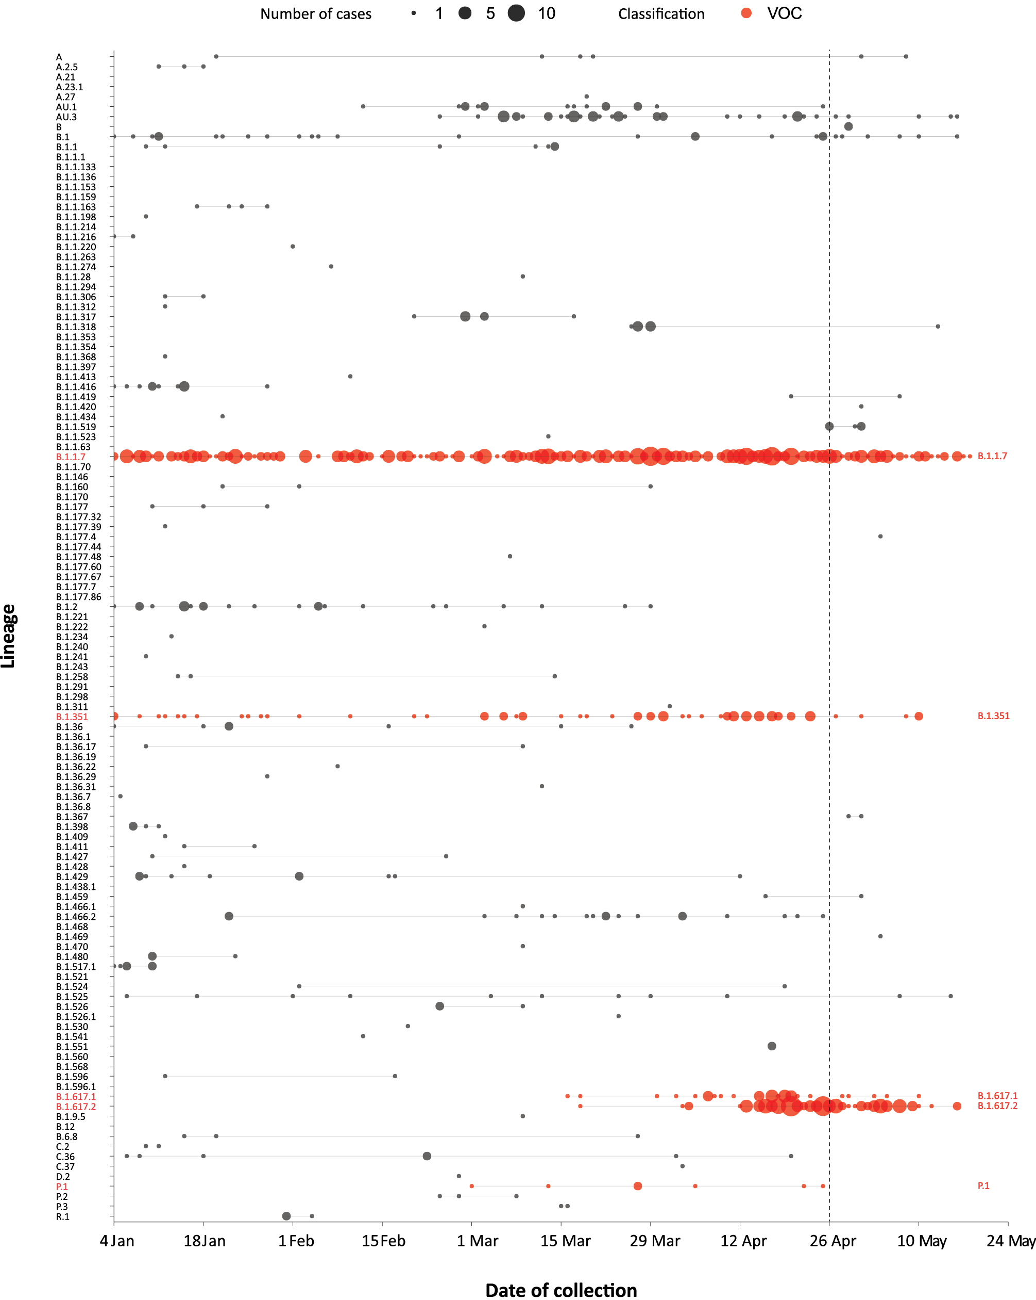
a The start of the current reporting period (26 April – 23 May 2021) is marked by the dotted line, and variant-of-concern samples are coloured red. The size of the circle is proportional to the number of samples in the lineage at each time point.
Table 5: Australian SARS-CoV-2 genome sequences and proportion of positive cases sequenced, 26 April – 23 May 2021 and cumulative to date
Measure | Reporting period  26 April – 23 May 2021 | Cumulative  23 January 2020 – 23 May 2021
SARS-CoV-2 cases sequencedª | 162 | 17,694
Percentage of positive cases sequenced^{b} | 49% | 59%
a Based on individual jurisdictional reports of sequences and case numbers. Calculations of the percentage of cases sequenced based on the number of sequences available in AusTrakka may not always be up-to-date, since this may include duplicate samples from cases and may not represent all available sequence data.
b In most jurisdictions, sequencing has been attempted on all suitable samples (one sample per case). Sequencing of samples from cases identified in the reporting period may be in process at the time of reporting. Remaining unsequenced samples may be due to jurisdictional sequencing strategy, or where samples have been deemed unsuitable for sequencing (typically, because viral loads were too low for sequencing to be successful).

Variants of concern
AusTrakka is actively monitoring and reporting on the three lineages designated Variants of Concern (VOC) by international organisations, including the World Health Organization: B.1.1.7; B.1.351; P.1; as well as the newly assigned VOC B.1.617 (and sublineages B.1.617.1, B.1.617.2 and B.1.617.3) (Table 6). These variants all display characteristic sets of mutation, including a number of variations in the genomic region encoding the spike protein thought to have the potential to increase transmissibility and/or immune evasion.⁶ Further information on variants is available in the Technical Supplement.²
Table 6: Australian SARS-CoV-2 genome sequences in AusTrakka, identified as variants of concern to 23 May 2021
VOC lineage | Number of samples
B.1.1.7 | 431
B.1.351 | 74
P.1 | 7
B.1.617.1 | 37
B.1.617.2 | 122

Testing

(State and territory reporting)
As at 21 May 2021, a cumulative total of 5,315,039 individuals have undergone diagnostic testing for SARS-CoV-2 in Australia this year since 1 January 2021. The cumulative nationwide proportion of positive tests for 2021 remains low at 0.02% (Table 7).

Table 7: Individuals undergoing diagnostic tests for SARS-CoV-2,ª by jurisdiction and reporting period, 1 January – 21 May 2021
Jurisdiction | Individuals tested  8–21 May 2021 |  |  | Individuals tested  24 April – 7 May 2021 |  |  | Cumulative individuals tested  in 2021 to 21 May
 | n | Positivity (%) | Per 1,000 population^{b} | n | Positivity (%) | Per 1,000 population^{b} | n | Positivity (%) | Per 1,000 population^{b}
ACT | 6,605 | – | 15.3 | 5,197 | 0.02 | 12.1 | 75,616 | < 0.01 | 175.4
NSW | 201,423 | 0.01 | 24.7 | 170,747 | 0.05 | 20.9 | 1,805,503 | 0.03 | 221.2
NT | 7,584 | 0.05 | 30.8 | 7,014 | 0.07 | 28.5 | 77,556 | 0.11 | 315.3
Qld | 58,893 | 0.02 | 11.3 | 45,140 | 0.06 | 8.7 | 358,524 | 0.08 | 69.3
SA | 33,620 | 0.01 | 19.0 | 33,411 | 0.07 | 18.9 | 405,783 | 0.03 | 229.3
Tas. | 8,104 | – | 15.0 | 7,275 | – | 13.5 | 75,190 | – | 139.1
Vic. | 205,252 | 0.01 | 30.7 | 194,056 | 0.01 | 29.0 | 2,104,543 | < 0.01 | 314.4
WA | 29,755 | 0.01 | 11.2 | 92,905 | 0.02 | 34.9 | 412,324 | 0.03 | 154.9
Australia | 550,736 | 0.01 | 21.4 | 555,745 | 0.03 | 21.6 | 5,315,039 | 0.02 | 206.9
a In order to more accurately reflect positivity rates, numbers of individuals tested is presented rather than total number of tests.
b Population data based on Australian Bureau of Statistics (ABS) Estimated Resident Population (ERP) as at June 2020.
During this four-week reporting period, over one million individuals were tested nationally, with a positivity rate of 0.02%. Jurisdictional testing rates are driven by both current case numbers and numbers of people experiencing symptoms. The low national positivity rate, along with high rates of testing, indicates a low incidence of COVID-19 nationally.
Testing rates increased in those aged under 80 to the week ending 30 April 2021. Only the youngest age group continued this trend of increased testing over the four-week reporting period, with declines in recent weeks in testing in those aged 20 to 79 (Figure 5). Testing rates were fairly steady and remained low in the 80+ age group during this reporting period, while rates among the 20–39 year age group have remained high both in this period and throughout 2021.

Figure 5: SARS-CoV-2 polymerase chain reaction (PCR) testing rates per 1,000 population per week by age group, Australia, 26 December 2020 – 21 May 2021^{a,b}
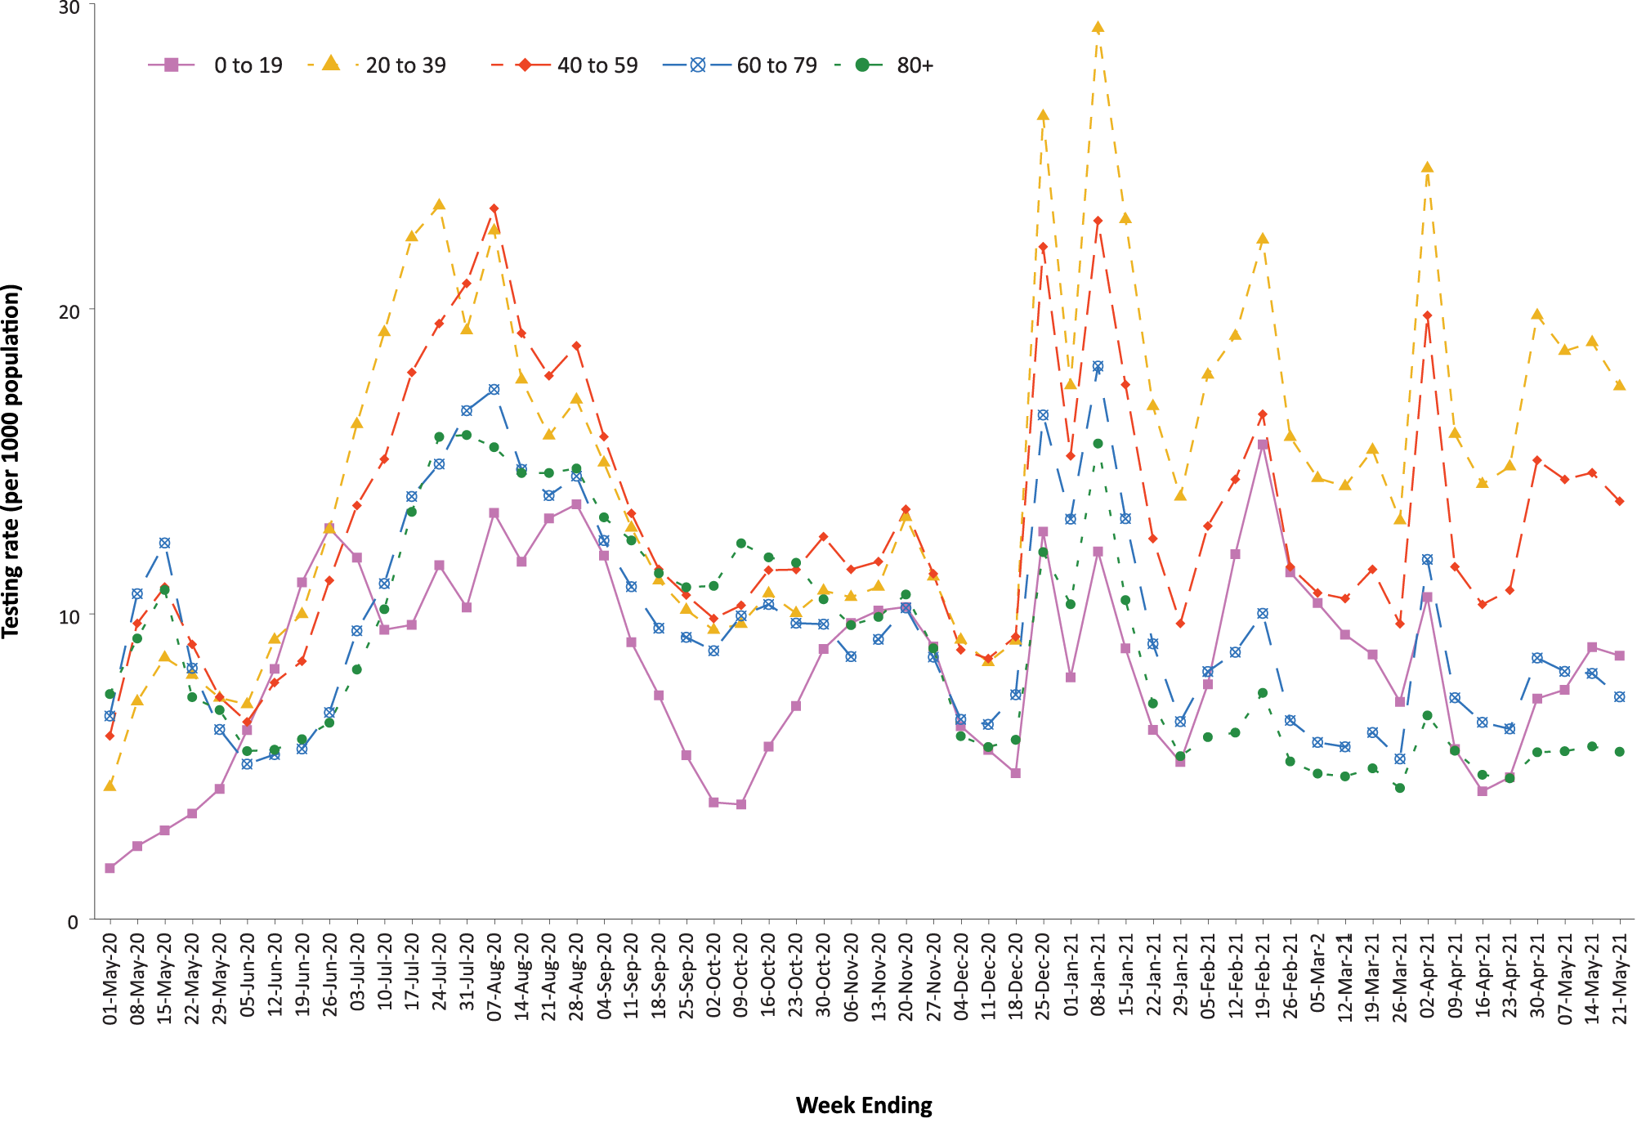
a Source: Data provided by jurisdictions to the NIR weekly, current up to 21 May 2021.
b The jurisdictions reporting each week (i.e. the denominator population) may vary.

Acute respiratory illness

(FluTracking and Commonwealth Respiratory Clinics)
Based on self-reported FluTracking data,⁷ prevalence of fever and cough in the community continues to be low nationally, remaining under 1%, despite an increasing trend in this four-week reporting period (Figure 6). Runny nose and sore throat symptoms in the community increased again during this reporting period compared to the previous four weeks; however, the prevalence in the community remains low at less than 1.3%.

Figure 6: Weekly trends in respiratory illness amongst FluTracking survey participants (age-standardised) compared to the average of the previous five years, Australia, 1 March 2020 – 23 May 2021ª
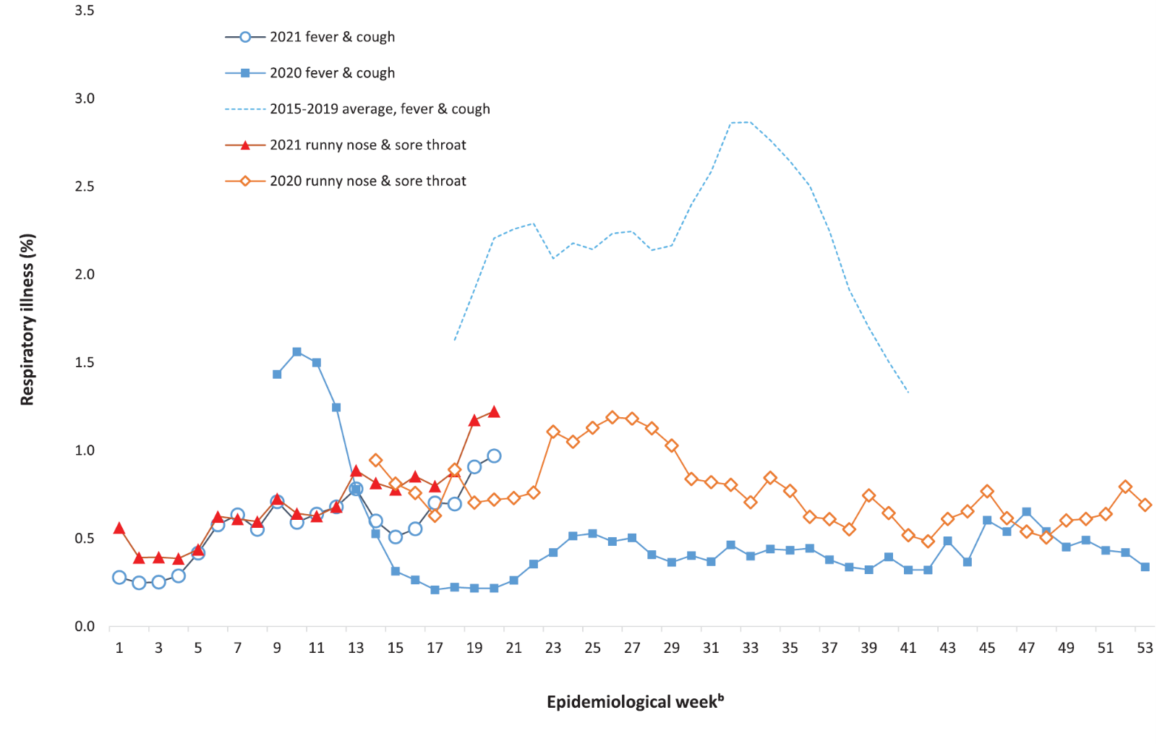
a In years prior to 2020, FluTracking was activated during the main Influenza season from May to October. A historical average beyond the week ending 11 October is therefore not available. In 2020, FluTracking commenced 10 weeks early to capture data for COVID-19. Data on runny nose and sore throat were only collected systematically after 29 March 2020, therefore a historical average for this symptom profile is unavailable.
b Epidemiological weeks are a standardised method for numbering weeks across years, with the first epidemiological week of any year ending on the first Saturday in January.

Table 8: Number (proportion) of COVID-19 cases hospitalised, admitted to ICU and who have died due to COVID-19 January 2020 – 23 May 2021^{a,b}
Age group | Cases |  | Hospitalisations |  | ICU admission |  | Deaths
 | Total | Cases (with hospital data) | n | Cases hospitalised (%) | n | Cases admitted to ICU (%) | n | Crude CFR (%)
Under 50 | 17,994 | 17,389 | 722 | 4.15 | 112 | 0.62 | 4 | 0.02
50 and over | 8,375 | 8,186 | 2,325 | 28.40 | 361 | 4.31 | 886 | 10.58
0-9 | 1,486 | 1,441 | 42 | 2.91 | 3 | 0.2 | 0 | 0
10-19 | 2,390 | 2,333 | 32 | 1.37 | 4 | 0.17 | 0 | 0
20-29 | 5,990 | 5,811 | 173 | 2.98 | 20 | 0.33 | 1 | 0.02
30-39 | 4,719 | 4,538 | 211 | 4.65 | 35 | 0.74 | 2 | 0.05
40-49 | 3,409 | 3,266 | 264 | 8.08 | 50 | 1.47 | 1 | 0.03
50-59 | 3,011 | 2,930 | 374 | 12.76 | 107 | 3.55 | 15 | 0.53
60-69 | 2,008 | 1,956 | 432 | 22.09 | 115 | 5.73 | 34 | 1.82
70-79 | 1,344 | 1,313 | 511 | 38.92 | 104 | 7.74 | 148 | 11.7
80-89 | 1,230 | 1,216 | 652 | 53.62 | 33 | 2.68 | 374 | 31.04
90+ | 782 | 771 | 356 | 46.17 | 2 | 0.26 | 315 | 40.54
Total | 26,369 | 25,575 | 3,047 | 11.91 | 473 | 1.79 | 890 | 3.38
a Source: NNDSS, extract from 25 May 2021, based on diagnosis date.
b Data included from four states/territories with the most reliable data across both hospital and ICU data fields: ACT, NSW, Tas. and Vic.
In this reporting period, acute respiratory illness was highest in those aged under 10 years old, based on both self-reported FluTracking data and presentations to Commonwealth Respiratory Clinics. Females reported respiratory illness more frequently than males. Rates of fever and cough by jurisdiction ranged from 4.8/1,000 FluTracking participants in Western Australia to 8.6/1,000 participants in the Northern Territory.
FluTracking data indicated that 41.4% of those in the community with ‘fever and cough’ and 15.0% of those with ‘runny nose and sore throat’ were tested for SARS-CoV-2. This represented a slight decrease in SARS-CoV-2 testing for both ‘fever and cough’ and ‘sore throat and runny nose’ since the previous reporting period. Testing rates varied by jurisdiction and symptom. For fever and cough, testing rates were lowest in Western Australia for the four-week reporting period and highest in Tasmania. For runny nose and sore throat, rates were lowest in the Northern Territory and highest in New South Wales. It is important to acknowledge that there may be legitimate reasons why people did not get tested, including barriers to accessing testing. Symptoms reported to Flutracking were not specific to COVID-19 and may also be due to chronic diseases.
During this reporting period, there were 65,751 assessments at Commonwealth Respiratory Clinics with 90.7% tested for SARS-CoV-2. There were no cases reported at these clinics in this reporting period.
In patients experiencing influenza-like illness in this reporting period who were tested through the Australian Sentinel Practice Research Network (ASPREN) and Victorian Sentinel Practice Influenza Network (VicSPIN) general practitioner (GP) sentinel surveillance systems, the most frequent respiratory viruses detected were rhinoviruses.

Severity

(NNDSS, FluCAN, SPRINT-SARI)

Hospitalisation
For COVID -19 cases diagnosed to date in 2021 and with hospitalisation status known, the estimated hospitalisation rate is 4.8% (15/313). For this calculation, we use data from four states/territories that do not hold policies that all cases be routinely hospitalised for isolation purposes and have hospitalisation data that is more than 90% complete (the Australian Capital Territory, Tasmania, Victoria and Western Australia). In 2020, approximately 12.5% (2,680/21,482) of cases were hospitalised in these jurisdictions. The difference in the proportion between years is likely due to the fact that cases diagnosed in 2021 (92% of whom acquired their infection overseas and were managed in hotel quarantine) were younger and healthier than the2020 cohort.

Intensive care admission
The proportion of those hospitalised who were admitted to an intensive care unit (ICU) has been estimated from Influenza Complications Alert Network (FluCAN)⁸sentinel surveillance system data at 19% (data for those hospitalised between 29 February 2020 and 28 February 2021).
In the year to date (to 23 May 2021), there have been 16 COVID-19 cases admitted to ICUs participating in the sentinel surveillance system, Short Period Incidence Study of Severe Acute Respiratory Infection (SPRINT-SARI),⁹ with three of these admitted during this reporting period (25 April – 23 May 2021).

Risk factors for severe disease
The hospitalisation rate for COVID-19 cases in the epidemic to date has generally increased with advancing 10-year age bracket, with the exception of those over the age of 90 years. The management of some cases in residential aged care facilities may be an explanation for the lower rate of hospitalisation in the most elderly.

COVID-19 deaths
In the past four weeks, there have been no deaths due to COVID-19 across Australia (Table 9). Overall, the crude case fatality rate (CFR) remains stable at 3.1%. The ratio of deaths to cases in the year to date has decreased in comparison to this time last year, noting substantially lower case numbers.
Table 9: Deaths due to COVID-19 as count and case fatality rates by reporting period, Australia, 1 January 2020 to 23 May 2021ª
 | Number of deaths^{b} | Crude case fatality rate
Reporting period 29 March–23 May 2021 | 0/209 | 0.0%
Year to date (2021) 1 January – 23 May 2021 | 1/1,288 | 0.1%
Year to date (2020) 1 January – 23 May 2020 | 104/7,335 | 1.4%
Epidemic to date 1 January 2020 – 23 May 2021 | 910/29,757 | 3.1%
a Source: NNDSS, extract from 25 May 2021, based on diagnosis date.
b Expressed as deaths/case numbers.

Public health response measures
Since COVID-19 first emerged internationally, Australia has implemented public health measures informed by the disease’s epidemiology (Figure 7). States and territories have decision making authority in relation to public health measures and have implemented or eased restrictions at their own pace, depending on the local public health and epidemiological situation, and in line with the ‘Framework for National Reopening’.¹⁰ Nationwide requirements involving air travel remain. These include pre-flight testing for travellers entering Australia and requirements to wear face masks when flying domestically or internationally remain in place. During the current four-week reporting period, there were community transmission cases in New South Wales, Victoria and Western Australia.

Figure 7: COVID-19 notifications in Australia by week of diagnosis and jurisdiction, 1 January – 23 May 2021,ª with timing of key public health measures
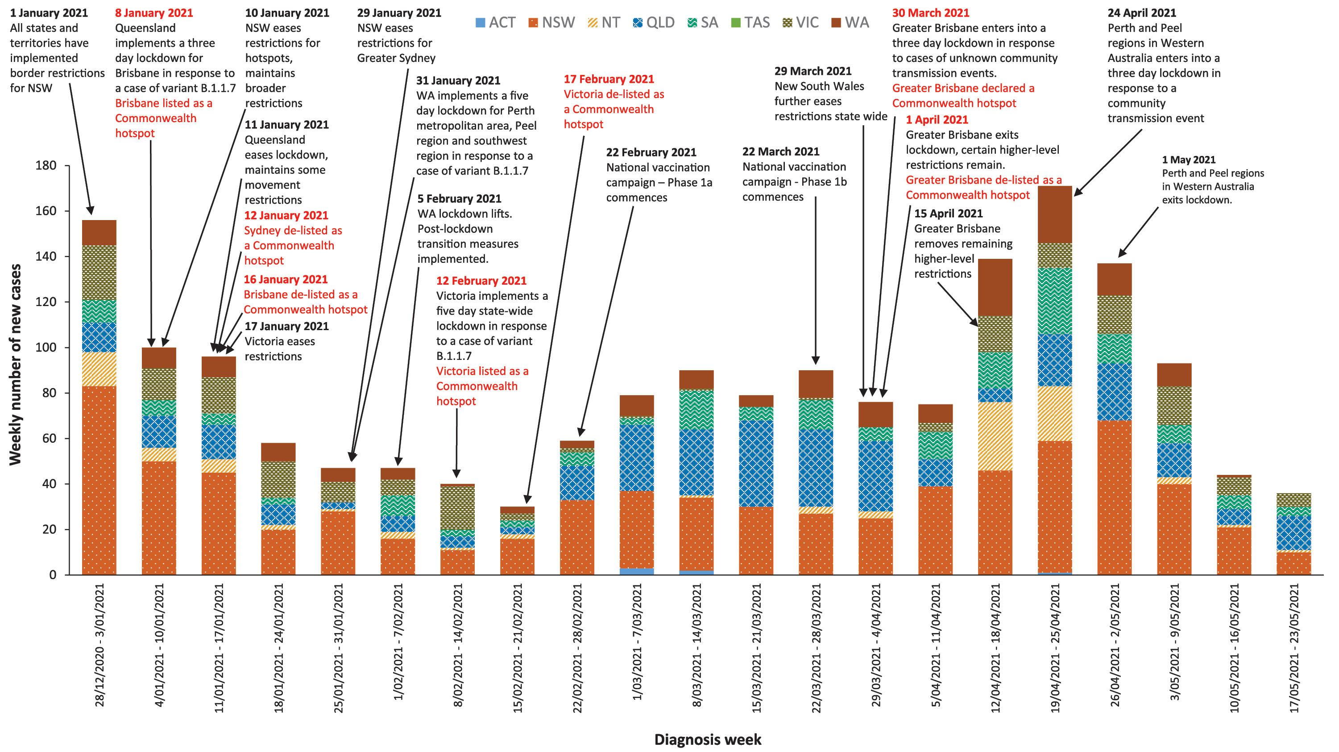

Table 10: State and territory changes to COVID-19 restrictions, Australia, 26 April to 23 May 2021
Jurisdiction | Summary of changes to COVID-19 restrictions
Australian Capital Territory | From 27 April, Australian Capital Territory lifted its stay-at-home requirements for travellers who have spent time in the Perth metropolitan area and Peel regions.¹¹
New South Wales | From 6 May, New South Wales imposed a period of higher level restrictions for the Greater Sydney region:¹²  - Visitors to households limited to 20 guests,  - Masks are compulsory on public transport and in all public indoor venues,  - Drinking while standing up at indoor venues is not allowed,  - Singing by audiences at indoor venues is not allowed,  - Dancing is not allowed at indoor hospitality venues or nightclubs, excluding weddings where 20 people are allowed on the dancefloor at once,  - Visitors to aged care facilities limited to two people.
Northern Territory | From 27 April, Northern Territory lifted directions for individuals who have travelled through the Perth metropolitan areas and Peel regions.¹³
Queensland | From 27 April, Queensland declared that the Perth and Peel regions of Western Australia are no longer declared COVID-19 hotspots.¹⁴ Those currently in quarantine from these regions can leave if they meet all criteria:  - Have returned at least one negative COVID-19 test,  - Have not attended any venues listed as linked to the WA cases,  - Provide contact details,  - Agree to immediately test and isolate if symptoms develop.  From 28 April, Queensland-based Australian Defence Force or international air crew who are identified as a close contact are allowed to leave Queensland before completing their quarantine, if they meet all of the requirements.¹⁵  From 30 April, Queensland implemented a new interstate exposure venues direction:¹⁶  - If entering Queensland and have been to an interstate exposure venue during the specified exposure period, you will be directed to quarantine for 14 days in government arranged accommodation,  - If already in Queensland and have been to an interstate exposure venue during the specified exposure period, you must notify officials through 13 HEALTH and immediately travel by private transport to your home or accommodation and quarantine until further instructions are provided.  From 1 May, Queensland mandated the Check In QLD app for all hospitality businesses.¹⁷
South Australia | From 7 May, South Australia stated that individuals that had been to exposure sites in New South Wales are not permitted to enter the state, if they are already within South Australia they must immediately get tested and enter into quarantine for 14 days.¹⁸  From 12 May, South Australia stated that individuals that had been to exposure sites in Victoria are not permitted to enter the state, if they are already within South Australia they must immediately get tested and enter into quarantine for 14 days.¹⁹  From 18 May, South Australia lifted the border restrictions in place for New South Wales arrivals.¹⁹  From 21 May, South Australia:  - Lifted the border restrictions in place for Victoria,  - Directed all employees, contractors and volunteers of Residential Aged Care Facility’s must notify the operator of the facility of any COVID-19 vaccinations they have received if the vaccination was not conducted onsite or by the facility.
Tasmania | From 28 April, Tasmania lifted quarantine orders for individuals who had entered the state from the Perth metropolitan areas or Peel region.²⁰  From 1 May, the following restrictions were lifted:²¹  - Large indoor seated gatherings can increase audience capacity to 100% or 250 people, whichever is fewer,  - Large outdoor gatherings can increase audience capacity to 100% in seated areas or follow the 1 person per 2 sqm density restriction for unseated areas,  - Employees and attendants do not count towards audience numbers.
Victoria | From 28 April, Victoria declared that the Perth metropolitan area and the Peel region will be designated as orange zones under Victoria’s travel permit system.²² Those who entered the state while these regions were classified as red zones can leave isolation, once a negative test is received.  From 10 May, Victoria declared that the Perth metropolitan area and the Peel region will be designated as green zones.²³
Western Australia | From 27 April, Western Australia lifted certain higher level restrictions for Perth and Peel:²⁴  - Individuals can now leave their residence for any purpose,  - Masks are still required while at work and on public transport,  - 20 person cap for private indoor and outdoor gatherings,  - 20 person cap and 1 person per 4 sqm rule applies for:  - Cafes, restaurants, bars and pubs for seated food and drink service only,  - Beauty salons, hairdressers and barbers,  - Recreation centres, outdoor playgrounds, museums and swimming pools,  - Places of worship,  - Entertainment venues.  - No visitors to aged and disability care facilities and hospitals,  - Weddings and funerals can proceed with up to 100 guests, but require an exemption,  - Professional and community sports permitted but without spectators,  - Universities open for online learning only,  - Fitness clubs, gyms, casinos and nightclubs remain closed.  From 1 May, Western Australia eased transitional restrictions:²⁵  - 30 person cap for private indoor and outdoor gatherings,  - Nightclubs can open subject to 1 person per 4 sqm rules with mandatory masks,  - Indoor and outdoor community sport can resume with spectators,  - Indoor weddings and funerals permitted for up to 200 guests without an exemption,  - Outdoor gatherings can take place with up to 500 people without a COVID event plan,  - A hospital or resident of an aged care or disability facility can have one visitor per day,  - Major stadiums can operate at 75% capacity.  - 1 person per 2 sqm rules applies for:  - Gyms, fitness centres, dance studios,  - Beauty salons, hairdressers,  - Public venues: community centres, libraries, museums  - Seated hospitality venues, or 75% capacity whichever is greater.  - Indoor and outdoor entertainment venues with fixed seating can operate at 100% capacity.  From 2 May, Western Australia re-implemented the following restrictions in the Perth and Peel regions:^{26,27}  - A mask must be worn at all times when inside or outside,  - Nightclubs and casino gaming floors have been closed.  From 15 May, Western Australia eased the following restrictions:  - Entertainment and community venues, including nightclubs and casino gaming floors, can operate following the 1 person per 2 sqm density restriction.

Countries and territories in Australia’s near region
According to the World Health Organization (WHO), countries and territories in the South East Asian (SEARO) and Western Pacific (WPRO) regions reported 11,142,086 newly-confirmed cases and 133,289 deaths in the four-week period up to 23 May 2021, bringing the cumulative cases in the two regions to almost 33 million, and cumulative deaths to 415,335.²⁸ In the Western Pacific, case numbers and deaths both increased in comparison to the previous four-week period (556,112 new cases and 7,179 new deaths). In South East Asia, new cases and new deaths rose sharply (10,585,974 new cases and 126,110 new deaths) compared to the preceding four-week period. Countries and territories that experienced the greatest rate of increase in new cases were India, Nepal, Indonesia, the Philippines and Japan.²⁹
Increasing trends in new cases and deaths reported in the South East Asia and the Western Pacific regions are due to ongoing outbreaks occurring in India and the Philippines, and emerging outbreaks in Japan and Malaysia. Fifteen Pacific Island countries reported no new cases in the past month.
Table 11 outlines the current transmission classification set by WHO for Australia’s near region. Under WHO’s classification, Australia’s transmission classification remains at ‘clusters of cases’.

Table 11: Transmission patterns for countries in Australia’s near region according to WHO, 23 May 2021^{a,b}
Category | Country
No cases  Countries/territories/areas with no cases | American Samoa, Cook Islands, Democratic People’s Republic of Korea, Kiribati, Marshall Islands, Federated States of Micronesia, Nauru, Niue, Palau, Pitcairn Islands, Samoa, Solomon Islands, Tokelau, Tonga, Tuvalu and Vanuatu
Sporadic cases  Countries/territories/areas with one or more cases, imported or locally detected | Brunei Darussalam, Cambodia, Fiji, French Polynesia, Lao PDR, New Caledonia, New Zealand, Singapore, Wallis and Futuna
Clusters of cases  Countries/territories/areas experiencing cases, clustered in time, geographic location and/or by common exposures | Australia, Bhutan, China, Guam, India, Japan, Maldives, Mongolia, Myanmar, Republic of Korea, Sri Lanka, Thailand and Vietnam
Community transmission  Countries /territories/areas experiencing larger outbreaks of local transmission defined through an assessment of factors including, but not limited to:  - large numbers of cases not linkable to transmission chains  - large numbers of cases from sentinel lab surveillance or increasing positive tests through sentinel samples (routine systematic testing of respiratory samples from established laboratories)  - multiple unrelated clusters in several areas of the country/territory/area. | Bangladesh, Indonesia, Malaysia, Nepal, Papua New Guinea, the Philippines and Timor-Leste
a Source: World Health Organization Coronavirus (COVID-19) Dashboard, accessed 26 May 2021.
b Classifications according to WHO.

As of 23 May 2021, almost 166 million COVID-19 cases and 3.4 million deaths have been reported globally, with a global case fatality rate (CFR) of 2.1%. The three regions reporting the largest burden of disease over the past four weeks were South East Asia (50.1% of all new cases reported), the Region of the Americas (25.0%) and Europe (16.2%).
The highest numbers of newly-reported cases in the four-week period 26 April to 23 May 2021 were in:
- India – experiencing clusters of cases (reported 9,988,702 new cases);
- Brazil – experiencing community transmission (reported 1,846,180 new cases);
- The United States of America – experiencing community transmission (reported 1,104,584 new cases);
- Argentina – experiencing community transmission (reported 714,832 new cases); and
- Turkey – experiencing community transmission (reported 602,594 new cases).
The Region of the Americas accounted for 37.5% of new deaths reported in the four-weekly period, followed by South East Asia at 33.6%. The highest numbers of deaths from COVID-19 in the last four weeks were reported in:
- India (114,920 deaths);
- Brazil (62,652 deaths);
- The United States (18,516 deaths);
- Colombia (14,278 deaths); and
- Argentina (12,887 deaths).
For many countries, vaccine rollout began in December 2020 but global distribution remains significantly uneven and well below 50% coverage in countries of high transmission. Israel has fully vaccinated the largest proportion of citizens so far (59.2%) followed by Bahrain (42.1%) and Chile (40.8%).³⁰ The COVAX facility has shipped over 71 million COVID-19 vaccines to 125 participating countries to date, as part of the Access to COVID-19 Tools (ACT) Accelerator collaboration between WHO, the Coalition for Epidemic Preparedness Innovations and the Gavi Vaccine Alliance.³¹ Public health prevention measures and periods of restriction of community mobility remain the primary means to reduce transmission, particularly as new strains emerge and circulate simultaneously.³² An international summary by WHO Region can be found in the WHO Epidemiological Update dated 25 May 2021.³³

Acknowledgements
We thank public health staff from incident emergency operations centres and public health units in state and territory health departments, and the Australian Government Department of Health, along with state and territory public health laboratories. We thank those who have provided data from surveillance systems, such as Commonwealth respiratory clinics, ASPREN, Flutracking, FluCAN, Communicable Disease Genomics Network, AusTrakka and jurisdictional sequencing laboratories.

Author details

Corresponding author
COVID-19 National Incident Room Surveillance Team
Australian Government Department of Health, GPO Box 9484, MDP 14, Canberra, ACT 2601.
Email: epi.coronavirus@health.gov.au

References
- COVID-19 National Incident Room Surveillance Team. COVID-19 Australia: Epidemiology Report 41: Reporting period ending 9 May 2021. Commun Dis Intell (2018). 2021;45. doi: https://doi.org/10.33321/cdi.2021.45.26.
- COVID-19 National Incident Room Surveillance Team. Technical supplement. COVID-19 Australia: Epidemiology reporting. Commun Dis Intell (2018). 2021;45. doi: https://doi.org/10.33321/cdi.2021.45.2.
- Australian Government Department of Health. Getting vaccinated for COVID-19: Australia’s vaccine rollout. [Internet.] Canberra: Australian Government Department of Health; 2021. [Accessed on 26 May 2021.] Available from: https://www.health.gov.au/initiatives-and-programs/covid-19-vaccines/getting-vaccinated-for-covid-19#australias-vaccine-rollout.
- Australian Government Department of Health. ATAGI statement on AstraZeneca vaccine in response to new vaccine safety concerns. [Internet.] Canberra: Australian Government Department of Health, Australian Technical Advisory Group on Immunisation; 8 April 2021. [Accessed 29 April 2021.] Available from: https://www.health.gov.au/news/atagi-statement-on-astrazeneca-vaccine-in-response-to-new-vaccine-safety-concerns.
- Communicable Diseases Genomics Network (CDGN). AusTrakka. [Website.] Melbourne: CDGN; 2020. Available from: https://www.cdgn.org.au/austrakka.
- WHO. Coronavirus disease (COVID-19) weekly epidemiological update and weekly operational update. [Internet.] Geneva: WHO; 11 May 2021. [Accessed on 11 May 2021.] Available from: https://www.who.int/publications/m/item/weekly-epidemiological-update-on-covid-19---11-may-2021.
- Dalton C, Durrheim D, Fejsa J, Francis L, Carlson S, d’Espaignet ET et al. Flutracking: a weekly Australian community online survey of influenza-like illness in 2006, 2007 and 2008. Commun Dis Intell Q Rep. 2009;33(3):316–22.
- Monash Health. FluCAN (Influenza surveillance): FluCAN (The Influenza Complications Alert Network). [Internet.] Melbourne: Monash Health; 2020. Available from: https://monashhealth.org/services/monash-infectious-diseases/research/influenza-research/flucan-influenza-surveillance-2/.
- Australian and New Zealand Intensive Care Society (ANZICS). SPRINT-SARI: Short period incidence study of severe acute respiratory infection. [Internet.] Camberwell: ANZICS; 2020. Available from: https://www.anzics.com.au/current-active-endorsed-research/sprint-sari/.
- Australian Government Department of Health. Framework for national reopening – October 2020. [Internet.] Canberra: Australian Government Department of Health; 23 October 2020. [Accessed on 10 November 2020.] Available from: https://www.health.gov.au/resources/publications/framework-for-national-reopening-october-2020.
- Australian Capital Territory Government. COVID-19: Declarations and exemptions continue as ACT travel restrictions ease. [Internet.] Canberra: Australian Capital Territory Government; 28 April 2021. [Accessed on 26 May 2021.] Available from: https://www.covid19.act.gov.au/news-articles/declarations-and-exemptions-continue-as-act-travel-restrictions-ease.
- Government of New South Wales. COVID-19 restrictions update 6 May. [Internet.] Sydney: Government of New South Wales; 6 May 2021. [Accessed on 7 May 2021.] Available from: https://www.nsw.gov.au/media-releases/covid-19-restrictions-update-6-may.
- Northern Territory Government. Coronavirus (COVID-19): COVID-19 Update: WA Hotspots Revoked. [Internet.] Darwin: Northern Territory Government; 27 April 2021. [Accessed on 26 May 2021.] Available from: https://coronavirus.nt.gov.au/updates/items/2021-04-27-covid-19-update-wa-hotspots-revoked.
- Queensland Health. Queensland eases restrictions as WA ends hard lockdown. [Internet.] Brisbane: Queensland Government, Queensland Health; 26 April 2021. [Accessed on 3 May 2021.] Available from: https://www.health.qld.gov.au/news-events/doh-media-releases/releases/queensland-eases-restrictions-as-wa-ends-hard-lockdown.
- Queensland Government. Management of close contacts: What’s changed from 28 April 2021. [Internet.] Brisbane: Queensland Government; 28 April 2021. [Accessed on 3 May 2021.] Available from: https://www.qld.gov.au/health/conditions/health-alerts/coronavirus-covid-19/current-status/public-health-directions/management-of-close-contacts.
- Queensland Health. Queensland Health implements new Interstate Exposure Venues Direction. [Internet.] Brisbane: Queensland Government, Queensland Health; 30 April 2021. [Accessed on 3 May 2021.] Available from: https://www.health.qld.gov.au/news-events/doh-media-releases/releases/queensland-health-implements-new-interstate-exposure-venues-direction.
- Queensland Government. Check In Qld app. [Webpage.] Brisbane: Queensland Government; 2021. [Accessed on 3 May 2021.] Available from: https://www.covid19.qld.gov.au/check-in-qld.
- SA Health. COVID-19 update 256. [Internet.] Adelaide: Government of South Australia, SA Health; 7 May 2021. [Accessed on 26 May 2021.] Available from: https://www.sahealth.sa.gov.au/wps/wcm/connect/public+content/sa+health+internet/conditions/infectious+diseases/covid-19/about+covid-19/latest+updates/covid-19+round+up+reports/covid-19+update+256.
- SA Health. COVID-19 update 259. [Internet.] Adelaide: Government of South Australia, SA Health; 12 May 2021. [Accessed on 26 May 2021.] Available from: https://www.sahealth.sa.gov.au/wps/wcm/connect/public+content/sa+health+internet/conditions/infectious+diseases/covid-19/about+covid-19/latest+updates/covid-19+round+up+reports/covid-19+update+259.
- Tasmanian Government. Coronavirus disease (COVID-19). Media releases: Western Australian restrictions to be lifted. [Internet.] Hobart: Tasmanian Government; 28 April 2021. [Accessed on 26 May 2021.] Available from: https://coronavirus.tas.gov.au/media-releases/western-australian-restrictions-to-be-lifted.
- Tasmanian Government. Coronavirus disease (COVID-19). Important community updates: Changes to allow increased gathering numbers at indoor and outdoor events from 1 May. [Internet.] Hobart: Tasmanian Government; 23 April 2021. [Accessed on 26 May 2021.] Available from: https://coronavirus.tas.gov.au/facts/important-community-updates.
- Victoria State Government Department of Health and Human Services (DHHS). Coronavirus update for Victoria - 28 April 2021. [Internet.] Melbourne: Victoria State Government, DHHS; 28 April 2021. [Accessed on 3 May 2021.] Available from: https://www.dhhs.vic.gov.au/coronavirus-update-victoria-28-april-2021.
- DHHS. Coronavirus update for Victoria - 10 May 2021. [Internet.] Melbourne: Victoria State Government, DHHS; 10 May 2021. [Accessed on 26 May 2021.] Available from: https://www.dhhs.vic.gov.au/coronavirus-update-victoria-10-may-2021.
- Government of Western Australia. End of lockdown in Perth and Peel. [Internet.] Perth: Government of Western Australia; 26 April 2021. [Accessed on 3 May 2021.] Available from: https://www.wa.gov.au/government/announcements/end-of-lockdown-perth-and-peel.
- Government of Western Australia. Perth and Peel lockdown restrictions to ease further. [Internet.] Perth: Government of Western Australia; 29 April 2021. [Accessed on 3 May 2021.] https://www.wa.gov.au/government/announcements/perth-and-peel-lockdown-restrictions-ease-further.
- Government of Western Australia. New COVID-19 cases in Perth. [Internet.] Perth: Government of Western Australia; 1 May 2021. [Accessed on 3 May 2021.] Available from: https://www.wa.gov.au/government/announcements/new-covid-19-cases-perth.
- Government of Western Australia. New measures for Perth and Peel based on latest public health advice. [Internet.] Perth: Government of Western Australia; 2 May 2021. [Accessed on 3 May 2021.] Available from: https://www.wa.gov.au/government/announcements/new-measures-perth-and-peel-based-latest-public-health-advice.
- World Health Organization (WHO). WHO Coronavirus Disease (COVID-19) dashboard. [Internet.] Geneva: WHO; 2021. Available from: https://covid19.who.int/.
- Our World in Data. Statistics and research: Coronavirus Pandemic (COVID-19). [Internet.] Oxford: University of Oxford, Our World in Data; 2021. [Accessed on 28 May 2021.] Available from: https://ourworldindata.org/coronavirus.
- Our World in Data. Statistics and research: coronavirus (COVID-19) vaccinations. [Internet.] Oxford: University of Oxford, Our World in Data; 2021. [Accessed on 29 April 2021.] Available from: https://ourworldindata.org/covid-vaccinations.
- Gavi, the Vaccine Alliance. COVAX vaccine roll-out: country updates. [Website.] Geneva: the Global Alliance for Vaccines and Immunization; 2021. [Accessed on 26 May 2021.] Available from: https://www.gavi.org/covax-vaccine-roll-out.
- Public Health England. Impact of COVID-19 vaccines on mortality in England: December 2020 to February 2021. London: Public Health England; 2021. [Accessed on 30 March 2021.] Available from: https://assets.publishing.service.gov.uk/government/uploads/system/uploads/attachment_data/file/972592/COVID-19_vaccine_impact_on_mortality_240321.pdf.
- WHO. Weekly epidemiological update on COVID-19 – 25 May 2021. [Internet.] Geneva: WHO; 26 May 2021. [Accessed on 26 May 2021.] Available from: https://www.who.int/publications/m/item/weekly-epidemiological-update-on-covid-19---25-may-2021.

Appendix A: Supplementary figures and tables
Table A.1: COVID-19 case notifications and rates per 100,000 population, by age group and sex, Australia, 23 May 2021^{a,b}
Age group | This reporting period  10–23 May 2021 |  |  |  |  |  | This year only^{c}  1 January 2021 – 23 May 2021
 | Cases |  |  | Rate per 100,000 population |  |  | Cases |  |  | Rate per 100,000 population
 | Male | Female | People | Male | Female | People | Male | Female | People | Male | Female | People
0 to 9 | 6 | 4 | 10 | 0.4 | 0.3 | 0.3 | 75 | 76 | 151 | 4.6 | 4.9 | 4.7
10 to 19 | 3 | 2 | 5 | 0.2 | 0.1 | 0.2 | 52 | 42 | 94 | 3.3 | 2.8 | 3.0
20 to 29 | 3 | 3 | 6 | 0.2 | 0.2 | 0.2 | 109 | 136 | 245 | 5.9 | 7.6 | 6.8
30 to 39 | 6 | 6 | 12 | 0.3 | 0.3 | 0.3 | 190 | 163 | 353 | 10.2 | 8.6 | 9.4
40 to 49 | 8 | 2 | 10 | 0.5 | 0.1 | 0.3 | 159 | 61 | 220 | 9.7 | 3.7 | 6.7
50 to 59 | 1 | 2 | 3 | 0.1 | 0.1 | 0.1 | 89 | 36 | 125 | 5.8 | 2.3 | 4.0
60 to 69 | 2 | 1 | 3 | 0.2 | 0.1 | 0.1 | 51 | 18 | 69 | 3.9 | 1.3 | 2.6
70 to 79 | 1 | 0 | 1 | 0.1 | 0.0 | 0.1 | 18 | 6 | 24 | 2.0 | 0.6 | 1.3
80 to 89 | 0 | 0 | 0 | 0.0 | 0.0 | 0.0 | 2 | 1 | 3 | 0.5 | 0.2 | 0.4
90 and over | 0 | 0 | 0 | 0.0 | 0.0 | 0.0 | 0 | 0 | 0 | 0.0 | 0.0 | 0.0
a Source: NNDSS, extracted on 25 May 2021.
b Population data based on Australian Bureau of Statistics (ABS) Estimated Resident Population (ERP) as at June 2020.
c Note the change to focus on rates in this year only. For cumulative rates since the beginning of the epidemic in Australia, readers are encouraged to consult previous reports.

Communicable Diseases Intelligence
ISSN: 2209-6051 Online

Communicable Diseases Intelligence (CDI) is a peer-reviewed scientific journal published by the Office of Health Protection and Response, Department of Health. The journal aims to disseminate information on the epidemiology, surveillance, prevention and control of communicable diseases of relevance to Australia.

Editor: Jennie Hood
Deputy Editor: Simon Petrie
Design and Production: Kasra Yousefi
Editorial Advisory Board: David Durrheim, Mark Ferson, John Kaldor, Martyn Kirk and Linda Selvey

Website: http://www.health.gov.au/cdi

Contacts
CDI is produced by Environmental Health and Health Protection Policy Branch, Office of Health Protection and Response, Australian Government Department of Health, GPO Box 9848, (MDP 6) CANBERRA ACT 2601

Email: cdi.editor@health.gov.au

Submit an Article
You are invited to submit your next communicable disease related article to the Communicable Diseases Intelligence (CDI) for consideration. More information regarding CDI can be found at: http://health.gov.au/cdi.
Further enquiries should be directed to: cdi.editor@health.gov.au.

This journal is indexed by Index Medicus and Medline.

Creative Commons Licence - Attribution-NonCommercial-NoDerivatives CC BY-NC-ND
© 2021 Commonwealth of Australia as represented by the Department of Health
This publication is licensed under a Creative Commons Attribution-NonCommercial-NoDerivatives 4.0 International Licence from https://creativecommons.org/licenses/by-nc-nd/4.0/legalcode (Licence). You must read and understand the Licence before using any material from this publication.

Restrictions
The Licence does not cover, and there is no permission given for, use of any of the following material found in this publication (if any):
- the Commonwealth Coat of Arms (by way of information, the terms under which the Coat of Arms may be used can be found at www.itsanhonour.gov.au);
- any logos (including the Department of Health’s logo) and trademarks;
- any photographs and images;
- any signatures; and
- any material belonging to third parties.

Disclaimer
Opinions expressed in Communicable Diseases Intelligence are those of the authors and not necessarily those of the Australian Government Department of Health or the Communicable Diseases Network Australia. Data may be subject to revision.

Enquiries
Enquiries regarding any other use of this publication should be addressed to the Communication Branch, Department of Health, GPO Box 9848, Canberra ACT 2601, or via e-mail to: copyright@health.gov.au

Communicable Diseases Network Australia
Communicable Diseases Intelligence contributes to the work of the Communicable Diseases Network Australia.
http://www.health.gov.au/cdna

Reporting periods for vaccinations (to 25 May 2021) and SARS-CoV-2 testing (to 21 May 2021) do not align precisely with the epidemiology report's stated effective date, consistent with the regular reporting arrangements for those data sources.
These data are provided by the national pathogen genomic sequence and analysis platform, AusTrakka,5 and from jurisdictional pathogen sequencing laboratories to summarise the genomic epidemiology of SARS-CoV-2 in Australia. Numbers are subject to change retrospectively and sequences are not able to be obtained from all samples (see Technical Supplement).²

