Creutzfeldt-Jakob disease surveillance in Australia: update to December 2016
Genevieve M Klug, Shannon Sarros, Christiane Stehmann, Marion Simpson, Catriona McLean, Colin L Masters and Steven J Collins

Abstract
Nation-wide surveillance of human transmissible spongiform encephalopathies (TSE, also known as prion diseases), the most common being Creutzfeldt-Jakob disease, is performed by the Australian National Creutzfeldt-Jakob disease Registry, based at the University of Melbourne. Prospective surveillance has been undertaken since 1993 and over this dynamic period in transmissible spongiform encephalopathy research and understanding, the unit has evolved and adapted to changes in surveillance practices and requirements concomitant with the delineation of new disease subtypes, improvements in diagnostic capabilities and the overall heightened awareness of prion diseases in the health care setting. In 2016, routine national surveillance continued and this brief report provides an update of the cumulative surveillance data collected by the Australian National Creutzfeldt-Jakob disease Registry prospectively from 1993 to December 2016, and retrospectively to 1970.
Keywords: Creutzfeldt-Jakob disease, prion disease, transmissible spongiform encephalopathy, disease surveillance

Introduction
In 1993, the Allars’ inquiry¹ into the use of cadaver-derived pituitary hormones under the Australian Human Pituitary Hormone Program and the association with 4 medically acquired (iatrogenic) Creutzfeldt-Jakob disease (CJD) deaths recommended broadening of the responsibilities of the nascent Australian surveillance unit while monitoring for further cases of iatrogenic CJD in Australia. The Australian National Creutzfeldt-Jakob disease Registry (ANCJDR) was established in October 1993 at the University of Melbourne. The monitoring of further Australian iatrogenic CJD cases related to cadaveric pituitary hormone treatment for infertility or short stature and contaminated dura mater grafts remains one of the core objectives of the ANCJDR; however, the ANCJDR’s activities have evolved to encompass the surveillance of all types of CJD, including sporadic, genetic and variant CJD and other transmissible spongiform encephalopathies or prion diseases such as Gerstmann Sträussler-Scheinker syndrome and fatal familial insomnia.
As described previously², human prion disease can arise sporadically or from genetic or iatrogenic aetiologies. Detailed evaluation of each suspected case added to the register is undertaken to determine whether a case can be excluded from suspicion or classified as a definite, probable or possible prion disease case according to World Health Organization (WHO) diagnostic criteria.³ CJD was made a notifiable disease in all states and territories of Australia as of June 2006. Most initial notifications to the ANCJDR arise through diagnostic testing available through the Registry and this occurs prior to Health department notification.
The global incidence of CJD is commonly reported to be one case per million per year; however, in most countries with long-standing surveillance systems in place such as France and Switzerland, annual incidence rates have been consistently reported above this quoted figure.⁴ Incidence rates as high as 2.4-2.6 cases per million per year have been reported.⁴ Temporally, human prion disease incidence rates have increased in most countries, including Australia, as surveillance mechanisms evolved and diagnostic testing capabilities improved, in parallel with a generally greater awareness of this rare disease in the health care setting.
In 2016, national surveillance of prion disease continued with improved levels of case confirmations and overall, a stabilization of annual incidence rates of prion disease in Australia at expected levels. In this report, updated surveillance figures to 31st December 2016 are provided for all retrospective (to 1970) and prospective (from 1993) cases ascertained, including discussion on case notifications, classifications and overall incidence.

Methods
Patients with a suspected human prion disease are prospectively notified to the ANCJDR predominantly through referral for diagnostic CSF 14-3-3 protein detection. Other mechanisms include or have included personal communications from clinicians, families, hospitals and CJD-related groups, as well as health record searches through hospitals or health departments. Once notified to the ANCJDR, referrals are assessed and if the suspicion of prion disease is supported, the case will be added to the register as a formally notified suspected case for continued investigation with the aim of exclusion or classification according to World Health Organization diagnostic criteria. Investigation of register cases can be prolonged as the ANCJDR requires next-of-kin consent to access and compile the appropriate clinical information from various health information sources for comprehensive evaluation. Response times can vary as the information can be extensive or sources numerous. Medico-demographic questionnaires are offered and forwarded to families if they are willing to contribute, providing valuable information for analysis and evaluation.
The classification of register cases remains as “incomplete” until all known available information is gathered and reviewed or a definitive result from neuropathological assessment is obtained. Cases may be excluded from the register on the basis of neuropathological examination or after thorough clinical evaluation. A “definite” classification requires brain tissue examination, including immunohistochemically, and “probable” and “possible” cases are reliant on specific clinical profile and diagnostic test outcomes being met as previously described.³ In this report, the total number of confirmed prion disease cases includes those that have been classified as definite or probable cases during 2016.
In conjunction with the ANCJDR’s surveillance responsibilities, the Registry provides diagnostic platforms for ante-and post-mortem diagnostic testing for human prion diseases. The testing of cerebrospinal fluid for the presence of a family of low molecular weight proteins called “14-3-3” is performed weekly by the ANCJDR. This test, first introduced in 1997, has been readily utilised by the health community and referrals have increased substantially since its introduction to > 400 referrals each year. As described previously, the test provides an increasingly larger proportion of initial notifications of suspected human prion disease to the ANCJDR each year. The ANCJDR also undertakes Western blot analysis for misfolded, protease-resistant prion protein in tonsil and brain tissue from biopsies or autopsies to supplement immunohistochemical assessment. Previously, the ANCJDR performed prion protein gene testing as appropriate; however, from 1st September 2015, this service was ceased and is now undertaken by an external, independent provider. The ANCJDR actively promotes all diagnostic tests so that these options are available to clinicians and families to achieve the most accurate diagnosis and classification of persons suspected to have prion disease.
Annual human prion disease incidence rates are calculated using direct age-standardisation, based on the Australian Bureau of Statistics 1970-2016 estimated resident population for Australia and for each state and territory⁵⁻¹³ and standardized to 2000 population estimates.¹⁴ Population based rates of post-mortem examination in suspected human prion disease were calculated using the Australian Bureau of Statistics 1993-2016 estimated resident population for specific states and territories.⁵⁻¹² Health information is collected through a combination of public health and surveillance responsibilities, based on the national notification of communicable diseases. ANCJDR surveillance activities for the period reported were approved by the University of Melbourne Human Research Ethics Committee.
Statistical analysis (Log-Rank test) was performed using Stata (Intercooled Stata 7, Stata Corporation, College Station, TX).

Results
Seventy-one persons with suspected human prion disease were added to the CJD surveillance register in 2016. Cases were initially notified via request for CSF 14-3-3 protein testing (55 cases), personal communication from clinicians (10 cases), the CJD Support Group Network (3 cases), direct health department notification (1 case), family (1 case) and the Victorian Brain Bank Network (1 case). The proportions of the initial notification sources of the 71 cases are consistent with those in previous years and the overall trends for all register cases (Table 1).
Table 1: Source of initial notification of suspected prion disease cases ascertained between 1993 and 2016
Method | Register cases* (%) | Cases removed from the register† (%) | Overall
CSF 14-3-3 Protein Test Request  (Since September 1997) | 55.4 | 51.0 | 53.7
Personal Communications
Neurologists | 13.0 | 11.8 | 12.5
Neurologists (mail-out reply cards) | 2.4 | 1.7 | 2.1
Neuropathologists | 7.4 | 8.5 | 7.8
Neuropathologists (mail-out reply cards) | 0.5 |  | 0.3
Pituitary Hormones Task Force | 1.6 | 2.9 | 2.1
Family | 2.7 | 2.4 | 2.6
Funeral Directors | 0.1 |  | 0.1
Molecular biologist | 0.1 |  | 0.1
Hospital | 0.5 | 1.4 | 0.8
Death Certificates | 8.7 | 5.2 | 7.3
Hospital and Health Dept Searches
Hospital Medical Records | 2.9 | 7.2 | 4.6
Health Dept Search/State Morbidity Data | 1.3 | 3.3 | 2.0
Direct Health Dept Notification | 1.3 | 0.6 | 1.0
CJD Support Group Network | 0.9 | 0.4 | 0.8
Combined CSF/Genetic Test Request | 0.3 | 0.8 | 0.5
CJD Counseling Service | 0.2 | 0.6 | 0.3
Genetic Test Request | 0.2 | 1.5 | 0.8
Victorian Brain Bank network | 0.2 | 0.3 | 0.2
Coroner’s PM request | 0.1 | 0.4 | 0.2
Press | 0.1 |  | 0.1
UK Surveillance Unit | 0.1 |  | 0.1
 | 100 | 100 | 100
* Registry cases; includes all cases currently on the register as classified cases or cases still under investigation † Cases removed by the registry; includes all suspected cases excluded from the register after detailed investigation including neuropathological investigation.
Of the 71 cases that were added to register in 2016, 4 cases were known to the ANCJDR prior to 2016 via the CSF 14-3-3 protein test (3 cases) and the CJD Support Group Network (1 case). At the time of referral, these cases were not added to the register due to a low level of suspicion for prion disease after assessment. Further information ascertained in 2016, increased the likelihood of prion disease resulting in formal notification and addition of the cases to the register. The number of case additions to the register in 2016 is higher than the previous year (66 cases) and the average annual number for the years 2004 to 2015 (66 cases).
By state and territory, only modest fluctuations in the number of suspected case notifications compared to the previous year were observed in 2016 (Figure 1). Between 2012 and 2014, the number of suspected case notifications from Western Australia has been lower than the 1993-2015 long-term average (8 cases per year). In 2016, notifications increased and are more closely aligned with the long-term average.
Figure 1: Prospective notifications of suspected prion disease cases to the ANCJDR, 1997 to 2016, by state or territory and year
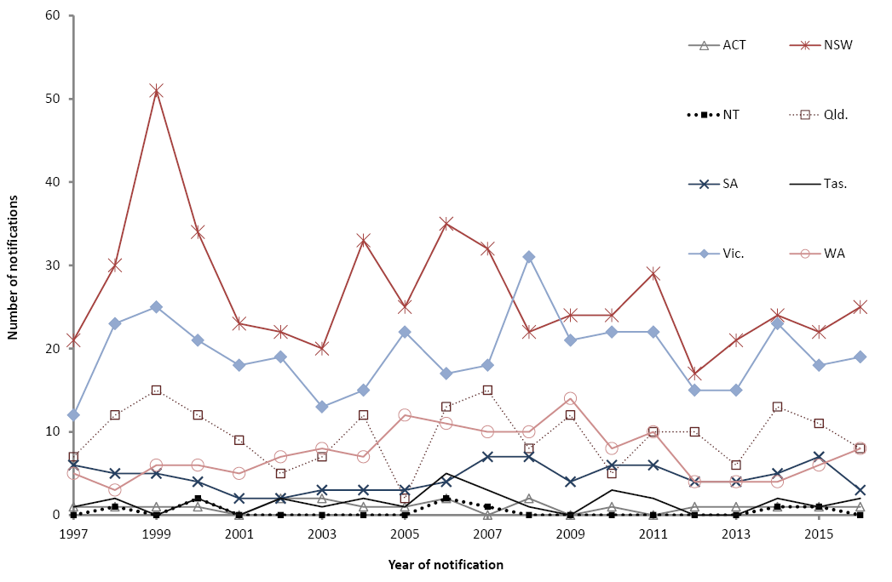
As of 31 December 2016, the majority of the 71 suspected cases added to the register in 2016 were classified as incomplete (45 cases). Six cases were excluded by either detailed clinical follow-up (1 case) or neuropathological examination (5 cases); 16 cases were classified as definite and 3 as probable prion disease. The remaining suspect case was initially treated in Australia; however, the patient subsequently returned overseas and was therefore unable to be investigated further. This person was thereby excluded from the overall analysis of Australian prion disease cases.
Excluding the prion disease-related post-mortem rate in 2016, wherein figures are still provisional, the average proportion of suspected prion disease cases on the register and who died between 1993 and 2015 and underwent post-mortem examination is 60%. Over this period, this proportion has steadily increased from 38% in 1993 to a peak of 80% in 2008. Since 2008, the proportion has stabilized at around 60-65%.
Based on the Australian population, the average crude rate of prion disease-related post-mortems between 1993 and 2016 is 1.4 post-mortems per million per year (range, 0.6-2.0), which is considerable given prion disease is particularly rare. By state and territory and for the same period, the lowest rates of suspected prion disease post-mortems performed annually were in the Australian Capital Territory, Tasmania and Northern Territory (1.0, 0.9 and 0.8 per million per year, respectively) while the highest rates are in Victoria and New South Wales (1.6 per million per year). Despite the smaller populations in Australian Capital Territory, Tasmania and Northern Territory, the post-mortem rates are not substantially lower than the rates of more populous states and provide a level of confidence that suspected case deaths in these states and territories have a similar likelihood of undergoing post-mortem examination.
In New South Wales and Victoria, there has been an overall temporal increase in post-mortem rates between 1993 and 2016 (Figure 2a). Previously, the rate of prion-disease-related post-mortems in New South Wales was reported to have declined sharply in 2014 and this was related to the deferral of analyses by neuropathological laboratory services during this time. As anticipated, upon completion of these analyses in 2015, post-mortem rates for 2014 returned to an expected level in New South Wales.
Figure 2a,b: Rates of post-mortem examination* in suspected prion disease case deaths per million population, by state and territory and year†
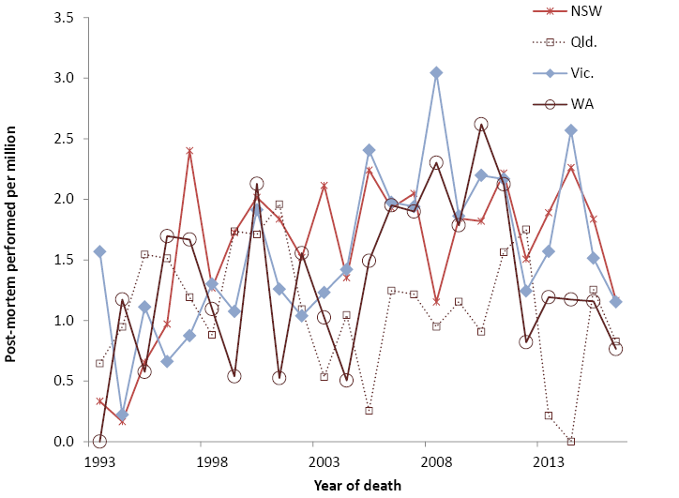
*Post-mortem examination rates were calculated using the Australian Bureau of Statistics 1993-2016 estimated resident population for Australia for each state and territory.
†Cases with neuropathology examination results pending are not included in the analyses.
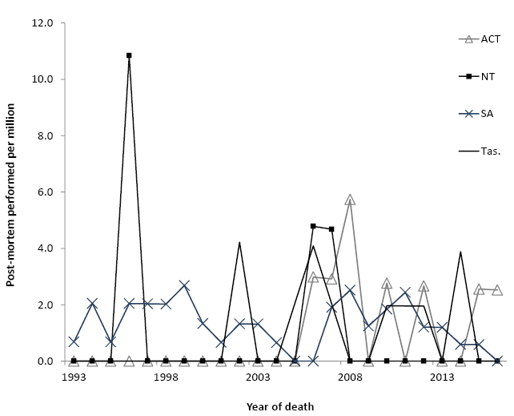
*Post-mortem examination rates were calculated using the Australian Bureau of Statistics 1993-2016 estimated resident population for Australia for each state and territory.
†Cases with neuropathology examination results pending are not included in the analyses.
In Queensland, South Australia and Western Australia, variability in post-mortem rates has been observed especially in recent years. In Queensland, the post-mortem rates in 2013 and 2014 were substantially diminished (0.2 and 0.0 post-mortems per million per year respectively) compared to long-term average for Queensland of 1.2 post-mortems per million per year between 1993 and 2012 and this is directly related to the interruption to routine autopsy services in this state during 2013-2014. In 2015, 5 post-mortems were completed and the post-mortem rate returned to expected levels (1.0 post-mortem per million per year) (Figure 2a) and this trend has continued in 2016. In South Australia and Western Australia, a sustained decrease in the post-mortem examination rate has been observed since 2010-2011. In South Australia, there were a number of suspected prion disease deaths in 2010, 2014, 2015 and 2016 where neuropathological examination remains pending. Once finalised, the post-mortem rates for these years is predicted to return to an expected level but will not change the lower rates in 2012 and 2013. In Western Australia, outstanding post-mortems have been completed, but rates continue to be lower than rates observed prior to 2012 (Figure 2a).
As of 31 December 2016, there were 1,142 cases on the register with 860 of these being classified as probable or definite prion disease cases. An additional definite iatrogenic case who was treated in Australia, and died in the UK is included in Table 2; however, this case is not classified as an Australian case due to the location at death and is thereby excluded from the overall statistical analysis of Australian prion disease cases. Since the start of surveillance, 719 suspected prion disease cases have been excluded from the register after detailed follow-up, with 21 of these being excluded in 2016 (7 after neuropathological examination).
Table 2: Classification of Australian National Creutzfeldt-Jakob disease Register cases, 1970 to 2016
Classification | Sporadic | Familial | Iatrogenic | Variant CJD | Unclassified | Total
Definite | 519 | 53 | 5* | 0 | 0 | 577
Probable | 267 | 13 | 4 | 0 | 0 | 284
Possible | 14 | 0 | 1 | 0 | 0 | 15
Incomplete |  |  |  |  | 266† | 266
Total | 800 | 66 | 10 | 0 | 266 | 1,142
* includes one definite iatrogenic case who received pituitary hormone treatment in Australia but disease onset and death occurred while a resident of the United Kingdom. This case is not included in statistical analysis since morbidity and mortality did not occur within Australia.
† includes 135 living cases
In 2016, 31 cases were re-classified from incomplete to definite prion disease and 12 cases to probable prion disease and there were no further cases of possible prion disease classified. The total number of possible cases remains at 15 of which 14 of these cases were sporadic and 1 iatrogenic CJD (Table 2). Of the 266 incomplete cases, 135 are presently alive. In 2016, the total number of incomplete cases under evaluation was only marginally higher than the number in 2015 (259 cases), but still remains significantly higher than the number in 2012 (214 cases) and 2013 (216 cases).
Age-standardised mortality rates show that the rate of human prion disease mortality in Australia during the period of 1970 to 2016 is generally increasing, with the exception of 2016, where case evaluation is pending for the majority of deaths (Figure 3) and incidence is therefore provisional. In 2016, the age-adjusted mortality rate was 0.82 deaths per million per year and this would be expected to increase after further investigation and classification of incomplete cases. The mean annual age-adjusted mortality rate during the period from 1970 – 2015 was 1.0 death per million (range, 0.1-1.8). For the prospective surveillance period of 1993 to 2015, the mean annual rate is 1.3 deaths per million (range, 0.7-1.8). By state and territory, the majority of regions in Australia have a mean age-adjusted mortality rate above 1 case per million per year between 1993 and 2015 (range, 1.0-1.5). The exceptions are Tasmania and the Northern Territory with 0.7 and 0.8 deaths per million per year, respectively. Restriction of the surveillance data to the period between 2003 and 2015 allows comparisons between states and territories during a time-frame of relatively consistent surveillance practices, diagnostic capabilities and utility with the exception of MRI diagnostics (Table 3). During this period, Tasmania and Queensland have lower than expected mean mortality rates, while Western Australia and Victoria have the highest prion disease mortality in Australia.

Figure 3: Number of definite and probable prion disease cases and age-standardised mortality rate*, Australia, 1970 to 2016, by classification and year
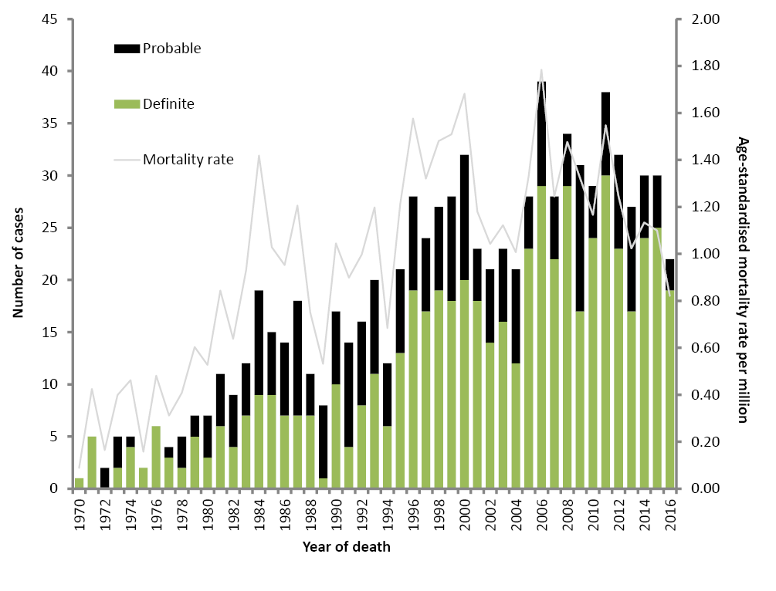
*Age-standardised mortality rates were calculated using the Australian Bureau of Statistics 2000 estimated resident population for Australia

Table 3: Prion disease deaths and age-adjusted mortality rates, 2003 to 2016, by year and state or territory
Year | 03 | 04 | 05 | 06 | 07 | 08 | 09 | 10 | 11 | 12 | 13 | 14 | 15 | 16* | Total | Mean age-adjusted mortality rate† (deaths/million/year)
ACT |  | 1 |  | 1 |  | 2 |  | 1 |  |  | 1 | 1 |  |  | 7 | 1.5
NSW | 7 | 11 | 10 | 12 | 10 | 6 | 11 | 5 | 14 | 7 | 11 | 11 | 11 | 9 | 135 | 1.3
NT |  |  |  | 2 | 1 |  |  |  |  |  |  |  | 1 |  | 4 | 1.0
Qld | 3 |  |  | 7 | 2 | 4 | 4 | 2 | 5 | 6 | 3 |  | 7 | 4 | 47 | 0.7
SA | 1 | 2 | 1 | 1 | 3 | 5 | 2 | 4 | 4 | 2 | 2 | 1 | 2 |  | 30 | 1.3
Tas |  |  | 1 | 2 |  |  |  |  | 1 | 1 |  | 2 |  |  | 7 | 0.8
Vic. | 9 | 5 | 11 | 10 | 6 | 13 | 9 | 13 | 9 | 13 | 8 | 13 | 6 | 7 | 132 | 1.7
WA | 3 | 2 | 5 | 4 | 6 | 4 | 5 | 4 | 5 | 3 | 2 | 2 | 3 | 2 | 50 | 1.6
Aus. | 23 | 21 | 28 | 39 | 28 | 34 | 31 | 29 | 38 | 32 | 27 | 30 | 30 | 22 | 412 | 1.27
* Provisional figures
† Age-standardised mortality rates (2003-2015) were calculated using the Australian Bureau of Statistics 2000 estimated resident population for Australian states and territories. Does not include 2016 provisional figures.
The proportions of human prion disease aetiologies represented on the register have remained similar to previous years (Figure 4). Previously we have reported that the annual number of genetic prion disease cases had declined in recent years² although this changed with the classification of 6 confirmed genetic prion disease cases during 2013, 3 in 2015 and 3 in 2016. Overall, the vast majority of human prion disease cases are sporadic (91%) while genetic and iatrogenic cases represent 8 and 1% respectively of all definite and probable cases.
Figure 4: Definite and probable human prion disease cases, 1970 to 2016, by aetiology and year
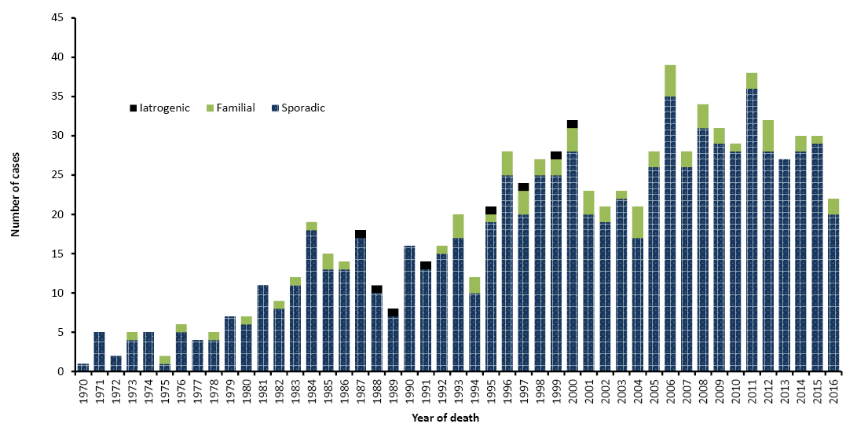
Based on 860 definite and probable human prion disease cases, 54% per cent were female. Similar proportions for gender exist for all human prion disease aetiologies. Median ages at death for the overall case group or by specific aetiology are largely unchanged from the previous reporting period. Sixty-seven years is the median age at death for all cases overall and only a single year difference between males (66 years) and females (67 years). For sporadic cases, 67 years is the median age at death both overall and for males, but a year older in females (68 years). For genetic prion disease, there is a 4 year age difference between males (58 years) and females (62 years) and overall the median age of death from genetic prion disease is 61 years. As there have been no further iatrogenic cases identified since the last reporting period at 31 December 2015, there has been no change to the previously reported median age at death for iatrogenic cases.²
Duration of illness is typically short for human prion disease, especially sporadic CJD, with the median length of illness duration for all cases combined being 4 months. By aetiology, median duration was found to be 3.7 months for sporadic cases (range, 0.9-60 months), 6.25 months for iatrogenic cases (range, 2-25 months) and 6 months for genetic cases (range, 1.25-192 months). Within 6 months of disease onset, 70% of all prion disease cases were deceased. By aetiology, 71% of sporadic, 52% of genetic and 56% of iatrogenic human prion disease were deceased 6 months after the onset of symptoms. Survival is significantly shorter in sporadic CJD than the genetic form (p<0.0001 by Log Rank Test).
Between 1 January and 31 December 2016, no variant CJD or further iatrogenic prion disease cases were identified in Australia. The most recent human-derived pituitary gonadotrophin-related CJD death occurred in 1991, while the most recent Lyodura-related CJD death occurred in 2000.

Discussion
In 2016, the number of suspected prion disease notifications was slightly greater than the long-term average for the previous 11 years of surveillance (2004 to 2015), however the number does contribute to a period of stability in notifications since 2013. During 2012 and 2013, reduced numbers of notifications were attributed to several possible factors including the temporary interruption of the Queensland suspected prion disease autopsy service, changes to the approach to adding cases to the register for investigation by the ANCJDR and natural fluctuations.
By state and territory, only modest fluctuations in the number of suspected case notifications compared to the previous year were observed in 2016 and are within previously observed ranges. Sizeable relative fluctuations are not surprising with annual CJD notifications given the small absolute case numbers involved; however, it should be noted that since 2009, notifications have been consistently declining in Western Australia. Previous evidence that elevated CSF referrals correspond with elevated suspected prion disease notifications¹⁵ led to speculation that lower CSF referrals may be influencing this downward trend in suspected case notifications. CSF referrals from Western Australia have increased annually since the test’s introduction in 1997 to a peak level in 2012. Since 2012, referrals appeared to be trending downward but overall were consistent with pre-2012 levels. The exception was in 2014, where there was a marked decline in CSF referrals. This may explain the lower notifications of suspected cases in 2014, although it does not explain the lower suspect case notifications that have been observed for the remaining years with lower notifications since 2012. As previously discussed, Western Australian health services are relied upon to manage case investigations following notifications and manage autopsy referrals. Changes to the role of the ANCJDR in Western Australia during these years may limit the ANCJDR’s capacity to ascertain the true level of clinical suspicion for CJD, which may have contributed to a reduced number of formal notifications and subsequently, confirmed cases reported by the ANCJDR. In 2016, the decline in notifications appears to have ceased with the number returning to pre-2012 levels and this has coincided with a higher number of CSF referrals. Presently, the number of TSE cases confirmed in 2016 still remains lower than before 2012, however this may change after case investigations of 2016 notifications are completed. The ANCJDR, in partnership with the Western Australian Department of Health, will continue working towards optimal prion disease ascertainment in Western Australia.
The proportion of prion disease-related post-mortems being performed in suspected prion disease cases remains high (60% of all case deaths between 1993 and 2015). This contrasts with the findings of an Australian healthcare setting survey where the national hospital post-mortem rate was 12% in 2002-2003¹⁶ and more recently, a major Australian tertiary centre audit of hospital autopsy data was published and described an autopsy rate of 6.6% in 2011-2013.¹⁷ The high suspected prion disease-related post-mortem proportion underpins the high and consistent number of confirmed Australian human prion disease cases recorded over the more recent time period and provides confident understanding of the cause of death in suspected cases ultimately determined as non-prion disease.
In recent years, interruptions to the routine autopsy services in both New South Wales and Queensland have impacted on the number and timing of post-mortems being completed. From January 2013 to September 2014, a temporary, but practical interruption to brain-only autopsies was in place due to difficulties with a reliable on-call service in Queensland. During this period, no TSE-related autopsies were performed and this was reflected by the significantly lower post-mortem number during this time. Since the current routine service through the Royal Brisbane Hospital became operational towards the end of 2014, expected rates of prion disease-related post-mortems have been observed. In New South Wales, the closure of the neuropathology laboratory for refurbishment extended the time required for reporting during 2013 and 2014. As expected, post-mortem rates slowed in 2014 due to reporting delays; these figures have now returned to an expected level now that the laboratory is fully operational.
Rates of post-mortems appear to be slowing in some regions, notably South Australia and Western Australia. In South Australia, this is most likely due to post-mortems not being completed rather than post-mortems not being performed. In Western Australia, a sustained reduction in the number of post-mortems being performed is evident since 2011. Despite notifications and CSF referrals returning to expected levels during 2015/6 in Western Australia, post-mortem rates are still low in this state and the reason for this remains unclear.
The number of cases classified as definite and probable prion disease in 2016 was higher than the long-term average number classified annually between 2004 and 2015. In comparison with the previous reporting period, there were 50% more probable cases and 10% more definite cases classified in 2016 than the previous year. This was a result of concerted efforts to evaluate and classify case deaths based upon clinical post-mortems and an increased number of post-mortems being both performed and importantly, completed in 2016. Sixty percent of all post-mortems performed in 2016 were completed by 31st December 2016. This can be attributed in part to the timing of when post-mortems were performed during the year but is also a reflection of efficient post-mortem service provision in Australian states and territories. The higher number of case classifications in 2016 has continued to align prion disease incidence in Australia with previously observed levels and contributes to a period of stable case ascertainment. The heightened case classification number has also contributed to stabilizing the level of incomplete cases currently under investigation. In previous years, there has been an inflation of this case group due to imbalances with the addition of new suspect cases and fully evaluated cases with an outcome. Signs of improvement were evident in 2015, with more case classifications being made in addition to equivalent numbers of suspect cases added and removed from the register after evaluation. This trend has continued in 2016 and will remain an area of focus in 2017.

Acknowledgements
The ANCJDR wishes to thank families, as well as medical practitioners and associated staff for their generous support of Australian CJD surveillance. The ANCJDR also thanks Associate Professor Handan Wand, Professor Matthew Law and Professor John Kaldor (The Kirby Centre; formerly the National Centre in HIV Epidemiology and Clinical Research at the University of New South Wales) for their expert ad hoc epidemiological and statistical support, as well as the CJD Support Group Network for their assistance in surveillance activities.

Author details
Ms Genevieve M Klug – Research Assistant, Australian National Creutzfeldt-Jakob Disease Registry, Department of Medicine, The University of Melbourne, Victoria, 3010, Australia
Ms Shannon Sarros – Research Assistant, Australian National Creutzfeldt-Jakob Disease Registry,
The Florey Institute of Neurosciences and Mental Health, The University of Melbourne, Victoria, 3010, Australia
Dr Christiane Stehmann– Administrative Assistant, Australian National Creutzfeldt-Jakob Disease Registry, The Florey Institute of Neurosciences and Mental Health, The University of Melbourne, Victoria, 3010, Australia
Dr Marion Simpson – Neurologist, Australian National Creutzfeldt-Jakob Disease Registry, Department of Medicine, The University of Melbourne, Victoria, 3010, Australia
Prof. Catriona A McLean – Neuropathologist, Australian National Creutzfeldt-Jakob Disease Registry, The Florey institute of Neurosciences and Mental Health, The University of Melbourne, Victoria, 3010, Australia and The Alfred Hospital, Department of Anatomical Pathology, 55 Commercial Rd, Melbourne Vic 3004 Australia
Prof. Colin L Masters – Director, Australian National Creutzfeldt-Jakob Disease Registry, The Florey Institute of Neurosciences and Mental Health, The University of Melbourne, Victoria, 3010, Australia
Prof. Steven J Collins – Director, Australian National Creutzfeldt-Jakob Disease Registry, Department of Medicine, The University of Melbourne, Victoria, 3010, Australia

Corresponding Author
Prof Steven Collins, Australian National Creutzfeldt-Jakob Disease Registry, Department of Medicine, The University of Melbourne, Victoria, 3010, Australia. Telephone: +61 8344 1949. Facsimile: +61 9349 5105. Email: stevenjc@unimelb.edu.au

References
- Allars M. Report of the inquiry into the use of pituitary derived hormones in Australia and Creutzfeldt-Jakob disease. Canberra: AGPS, 1994.
- Klug GM, Boyd A, Zhao T, Stehmann C, Simpson M, McLean CA, et al. Surveillance for Creutzfeldt-Jakob disease in Australia: update to December 2012. Commun Dis Intell Q Rep. 2013 Jun 30; 37(2):E115-20.
- World Health Organization. WHO manual for surveillance of human transmissible spongiform encephalopathies including variant Creutzfeldt-Jakob disease, 2003 [Internet]. Accessed on 16 February 2017. Available from: http://apps.who.int/iris/handle/10665/42656
- EUROCJD, European Creutzfeldt-Jakob Disease Surveillance Network: EUROCJD Surveillance Data. [Internet] Accessed on 16 February 2017. Available from: http://www.eurocjd.ed.ac.uk/surveillance%20data%201.html
- Australian Bureau of Statistics. 3101.0 Australian Demographic Statistics – Jun 2016 Table 51. Estimated Resident Population By Single Year Of Age, New South Wales. [Internet] Accessed 16 February 2017. Available from: http://www.abs.gov.au/AUSSTATS/abs@.nsf/DetailsPage/3101.0Jun%202016?OpenDocument
- Australian Bureau of Statistics. 3101.0 Australian Demographic Statistics Table 52. – Estimated Resident Population By Single Year Of Age, Victoria. [Internet] Accessed 16 February 2017. Available from: http://www.abs.gov.au/AUSSTATS/abs@.nsf/DetailsPage/3101.0Jun%202016?OpenDocument
- Australian Bureau of Statistics. 3101.0 Australian Demographic Statistics – Table 53. Estimated Resident Population By Single Year Of Age, Queensland. [Internet] Accessed 16 February 2017. Available from: http://www.abs.gov.au/AUSSTATS/abs@.nsf/DetailsPage/3101.0Jun%202016?OpenDocument
- Australian Bureau of Statistics. 3101.0 Australian Demographic Statistics Table 54. – Estimated Resident Population By Single Year Of Age, South Australia. [Internet] Accessed 16 February 2017. Available from: http://www.abs.gov.au/AUSSTATS/abs@.nsf/DetailsPage/3101.0Jun%202016?OpenDocument
- Australian Bureau of Statistics. 3101.0 Australian Demographic Statistics – Table 55. Estimated Resident Population By Single Year Of Age, Western Australia. [Internet] Accessed 16 February 2017. Available from: http://www.abs.gov.au/AUSSTATS/abs@.nsf/DetailsPage/3101.0Jun%202016?OpenDocument
- Australian Bureau of Statistics. 3101.0 Australian Demographic Statistics – Table 56. Estimated Resident Population By Single Year Of Age, Tasmania. [Internet] Accessed 16 February 2017. Available from: http://www.abs.gov.au/AUSSTATS/abs@.nsf/DetailsPage/3101.0Jun%202016?OpenDocument
- Australian Bureau of Statistics. 3101.0 Australian Demographic Statistics – Table 57. Estimated Resident Population By Single Year Of Age, Northern Territory. [Internet] Accessed 16 February 2017. Available from: http://www.abs.gov.au/AUSSTATS/abs@.nsf/DetailsPage/3101.0Jun%202016?OpenDocument
- Australian Bureau of Statistics. 3101.0 Australian Demographic Statistics – Table 58. Estimated Resident Population By Single Year Of Age, Australian Capital Territory. [Internet] Accessed 16 February 2017. Available from: http://www.abs.gov.au/AUSSTATS/abs@.nsf/DetailsPage/3101.0Jun%202016?OpenDocument
- Australian Bureau of Statistics. 3101.0 Australian Demographic Statistics – Table 59. Estimated Resident Population By Single Year Of Age, Australia. [Internet] Accessed 16 February 2017. Available from: http://www.abs.gov.au/AUSSTATS/abs@.nsf/DetailsPage/3101.0Jun%202016?OpenDocument
- Australian Bureau of Statistics. 3201.0 – Population by Age and Sex, Australian States and Territories, Jun 2000. [Internet] Accessed 16 February 2017. Available from: http://www.abs.gov.au/AUSSTATS/abs@.nsf/DetailsPage/3201.0Jun%202000?OpenDocument
- Klug GM, Wand H, Boyd A, Law M, Whyte S, Kaldor J, et al. Enhanced geographically restricted surveillance simulates sporadic Creutzfeldt-Jakob disease cluster. Brain. 2009 Feb; 132(Pt 2):493-501.
- The Royal College of Pathologists of Australasia Autopsy Working Party. The decline of the hospital autopsy: a safety and quality issue for healthcare in Australia. Med J Aust. 2004 Mar 15; 180(6):281-5. Review.
- Jackett, L and McLean, C. Hospital autopsy audit: discordant primary clinical diagnoses are found in 20% of cases in a reducing autopsy case load. Selection bias or significant findings? Pathology. 2015 Oct;47(6):499-502
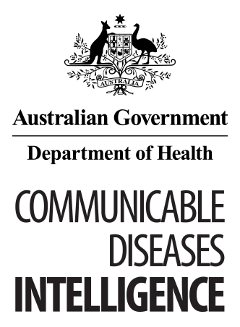
© Commonwealth of Australia 2018 - ISSN: 2209-6051 (Online)
This work is copyright. You may download, display, print and reproduce the whole or part of this work in unaltered form for your own personal use or, if you are part of an organisation, for internal use within your organisation, but only if you or your organisation do not use the reproduction for any commercial purpose and retain this copyright notice and all disclaimer notices as part of that reproduction. Apart from rights to use as permitted by the Copyright Act 1968 or allowed by this copyright notice, all other rights are reserved and you are not allowed to reproduce the whole or any part of this work in any way (electronic or otherwise) without first being given the specific written permission from the Commonwealth to do so. Requests and inquiries concerning reproduction and rights are to be sent to the Online, Services and External Relations Branch, Department of Health, GPO Box 9848, Canberra ACT 2601, or by email to copyright@health.gov.au
Communicable Diseases Intelligence aims to disseminate information on the epidemiology and control of communicable diseases in Australia. Communicable Diseases Intelligence invites contributions dealing with any aspect of communicable disease epidemiology, surveillance or prevention and control in Australia. Submissions can be in the form of original articles, short reports, surveillance summaries, reviews or correspondence. Instructions for authors can be found in Commun Dis Intell 2016;40(1):E189–E193.
Communicable Diseases Intelligence contributes to the work of the Communicable Diseases Network Australia
http://www.health.gov.au/cdna

This journal is indexed by Index Medicus and Medline
Disclaimer: Opinions expressed in Communicable Diseases Intelligence are those of the authors and not necessarily those of the Australian Government Department of Health or the Communicable Diseases Network Australia. Data may be subject to revision.

Editor: Cindy Toms
Deputy Editor: Phil Wright
Editorial and Production Staff: Leroy Trapani, Kasra Yousefi
Editorial Advisory Board: Peter McIntyre (Chair), David Durrheim, Mark Ferson, John Kaldor, Martyn Kirk
Website: http://www.health.gov.au/cdi
Communicable Diseases Intelligence is produced by Health Protection Policy Branch, Office of Health Protection, Australian Government, Department of Health, GPO Box 9848, (MDP 6) CANBERRA ACT 2601;
Email: cdi.editor@health.gov.au

