Interrupted time series segmented regression analysis for detecting waterborne disease outbreaks by syndromic surveillance
Aidan Yuen, Davoud Pourmarzi, Suzie Sarkis, Carmela Luisetto, Kamal Khatri, Angie Bone, Jim Black

Abstract

Introduction
Pathogens can enter the drinking water supply and cause gastroenteritis outbreaks. Such events can affect many people in a short time, making them a high risk for public health. In Australia, the Victoria State Government Department of Health is deploying a syndromic surveillance system for drinking water contamination events. We assessed the utility of segmented regression models for detecting such events and determined the number of excess presentations needed for such methods to signal a detection.

Methods
The study involved an interrupted time series study of a past lapse in water treatment. The baseline period comprised the four weeks before the minimum incubation period of suspected pathogens, set at two days post-event. The surveillance period comprised the week after. We used segmented linear regression to compare the count of gastroenteritis presentations to public hospital emergency departments (EDs) between the surveillance and baseline periods. We then simulated events resulting in varying excess presentations. These were superimposed onto the ED data over fifty different dates across 2020. Using the same regression, we calculated the detection probability at p < 0.05 for each outbreak size.

Results
In the retrospective analysis, there was strong evidence for an increase in presentations shortly after the event. In the simulations, with no excess presentations (i.e., with the ED data as is) the models signalled 8% probability of detection. The models returned 50% probability of detection with 28 excess presentations and 100% probability of detection with 78 excess presentations.

Conclusions
The transient increase in presentations after the event may be attributed to microbiological hazards or increased health-seeking behaviour following the issuing of boil water advisories. The simulations demonstrated the ability for segmented regressions to signal a detection, even without a large excess in presentations. The approach also demonstrated high specificity and should be considered for informing Victoria’s syndromic surveillance system.
Keywords: Drinking water contamination; syndromic surveillance; waterborne disease outbreaks.

Introduction
In drinking water contamination events, pathogens, such as Shiga toxin-producing Escherichia coli (STEC) and Cryptosporidium, can cause outbreaks of acute gastroenteritis.^{1–3} Such outbreaks can affect many people in a short time, making them a high risk for public health.⁴ Recognising and responding to such outbreaks quickly can therefore mitigate downstream morbidity and mortality, and associated costs.^{5,6} In the cryptosporidiosis outbreak in Milwaukee, Wisconsin in 1993, for example, up to 85% of the 403,000 cases could have been avoided had surveillance systems detected it earlier.⁷
One avenue for early detection is syndromic surveillance. Syndromic surveillance uses pre-clinical and clinical pre-diagnostic data, and proxy measures, such as hospital admission reports and over-the-counter pharmaceutical sales, to identify potential outbreaks.^{8–11} Syndromic surveillance can therefore detect outbreaks earlier than surveillance systems that rely on laboratory-confirmed cases.^{5,6} In the Milwaukee outbreak, for example, calls to nurse hotlines reported a fourfold increase in diarrhoeal disease; this was observed one day before local pharmacists noticed that over-the-counter anti-diarrhoeal drugs were selling out, and five days before the local public health unit was notified of a potential outbreak.^{12,13} Although the impetus for the initial expansion of syndromic surveillance was for bioterrorism preparedness, the Milwaukee event demonstrated the utility of the approach for detecting waterborne disease outbreaks.¹⁴
In Australia, reports of waterborne gastroenteritis outbreaks are rare.¹⁵ Most Australians are supplied with potable water by retail water corporations. This water is often disinfected, which, together with filtration, is credited with substantial reductions in waterborne disease.¹⁶ Disinfection reduces the risk of microbial contaminants that may enter the supply through point sources of pollution (e.g., human and industrial waste discharges) and diffuse sources (e.g., agricultural and animal husbandry activities).¹⁷
In Victoria, water agencies are required to notify the Victorian State Government Department of Health of any known or suspected contamination events pursuant to Sections 18 or 22 of the Safe Drinking Water Act 2003 (Victoria). Following such events, the Victorian Department of Health may issue boil water advisories; these are public announcements advising that drinking water should be boiled (or otherwise disinfected) prior to consumption until the issue is rectified.¹⁷
One example of a drinking water contamination event occurred in 2020, when a storm caused a power outage, which then caused a generator to fail. Undisinfected water subsequently entered the water distribution zones of the two affected water agencies, resulting in the issuing of boil water advisories. Although there is little evidence that this event, or any other recent events, resulted in outbreaks, preparedness for future outbreaks is important to avoid situations like the Milwaukee event.
Given this, the Victorian Department of Health is building its capacity for the syndromic surveillance of such events by using rapidly acquired but non-specific information on gastroenteritis presentations to public hospital emergency departments (EDs). This system will consider incorporating inferential statistics to help signal the occurrence of potential outbreaks. One potential analytical approach is interrupted time series segmented regression analysis, a powerful statistical method typically used to evaluate policy interventions.¹⁸ In this paper, we adapted this approach to the study of drinking water contamination events, which can similarly affect a large population.
By retrospectively analysing the 2020 event, we aimed to answer the following question: What is the utility of applying interrupted time series segmented regression analysis for detecting excess gastroenteritis presentations to public hospital EDs following a drinking water contamination event?
Given there is little evidence of recent events resulting in outbreaks, we then simulated outbreaks of various sizes to answer the following question: What number of excess presentations to public hospital EDs are needed for such methods to statistically signal a detection?

Methods

Study design
This study involved an ecological time series study of secondary panel data stratified by postcode and days.

Study setting
The study population included all people resident in the affected Victorian postcodes for the period from 1 January 2020 to 31 December 2020.

Data sources and measurements
Shapefiles of the various water distribution zones were provided by each water agency. By layering these zones over Victorian postcodes, we determined which postcodes are served by which agencies (Figure 1). Because some postcodes are served by multiple agencies, or only partially served by an agency, we defined two different analyses:
- An ‘inclusive’ option, where postcodes are considered part of a zone if they are served at least in part by a water agency; and
- A ‘core’ option, where postcodes are considered part of a zone if they are only served by a water agency, and wholly served by that agency.
Of note, not all postcodes are served by a water agency. And of those that are, not all areas in that postcode are connected to the network. Unserved populations commonly access their drinking water from bores, wells, and rainwater collections.
ED presentations were retrieved from the Victorian Emergency Minimum Dataset (VEMD), which is updated daily by health services and includes de-identified demographic, administrative and clinical data detailing presentations at Victorian public hospital EDs. VEMD data are subject to a validation process, which includes checks for valid values and compliance with VEMD business rules. The Victorian Department of Health also performs monthly data quality checks on ED-only admissions, overlapping ED presentation times and admission times, and VEMD length of stays of over 24 hours. Health services are required to correct the data where anomalies are detected.
Residential addresses for each VEMD presentation were mapped to their corresponding water distributions zones. Gastroenteritis presentations were identified using diagnosis fields that included an ICD-10 code with the prefix ‘A0’, which were assigned by clinical coders at each health service.

Figure 1: Water distribution zones of water agencies overlaying Victorian postcodesª
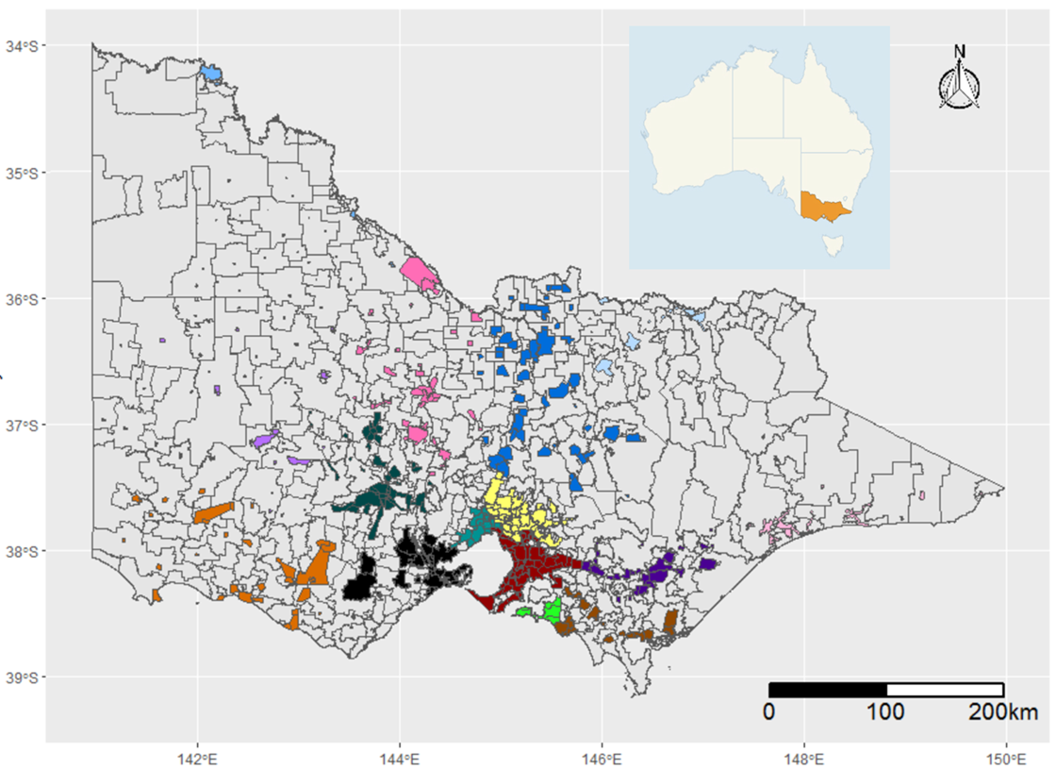
a Postcodes are shown in grey borders. Each colour represents the area served by one of fifteen different water agencies included in the reported modelling. Inset shows the Australian state of Victoria highlighted.

Interrupted time series analysis

Suspected contamination event
The dataset was restricted to those postcodes served by the affected water agencies for both the ‘inclusive’ and ‘core’ definitions described above.
The baseline period was defined as the four weeks before the minimum incubation period of pathogens commonly implicated in such events, like Cryptosporidium and STEC;^{19,20} this was set at two days post-event. The surveillance period was defined as the week after that minimum incubation period. Interrupted time series analysis was used to test the hypothesis that the count of gastroenteritis presentations was different between the baseline and surveillance periods. The following segmented linear regression model was used for our interrupted time series analysis:
Y_{t} = β₀ + β₁T + β₂X_{t} + β₃TX_{t}
This model required three key variables:
- T: the days since the start of the study period.
- X_{t}: a dummy variable indicating the baseline (coded 0) and surveillance (coded 1) periods.
- Y_{t}: the outcome at time t, i.e., gastroenteritis presentations to public hospital EDs.
Upon entering these variables into the model, we retrieved the following coefficients for analysis:
- β₀: the constant, i.e., the value at which the regression crosses the y-axis.
- β₁: the baseline trend, i.e., the change in presentations with a time unit increase in the baseline period.
- β₂: the level change, i.e. the immediate change in presentations in the surveillance period compared to the baseline period; this coefficient can signal a point-source outbreak.
- β₃: the slope change, i.e. the change in the regression gradient of the surveillance period compared to the baseline period; this coefficient can signal a continuous-source outbreak.

Simulated outbreaks
To help interpret negative and positive results of future analyses, we simulated single-day water contamination events causing point-source outbreaks of log-normal distribution, resulting in varying numbers of excess gastroenteritis presentations to public hospital EDs (Figure 2). Given there is little evidence of recent events leading to outbreaks, these excess presentations were then superimposed onto the existing VEMD data for the same postcodes as in the previous analysis, but over a different date. We reran the same segmented regression model and used p < 0.05 for the β₂ coefficient to signal a detection. We repeated this process for 50 different dates across 2020 and calculated the proportion of positive detections for each outbreak size simulated in Figure 2.

Figure 2: Simulated point-source outbreaks of Shiga-toxin producing Escherichia coli following a single-day water contamination event resulting in excess gastroenteritis presentations to public hospital emergency departmentsª
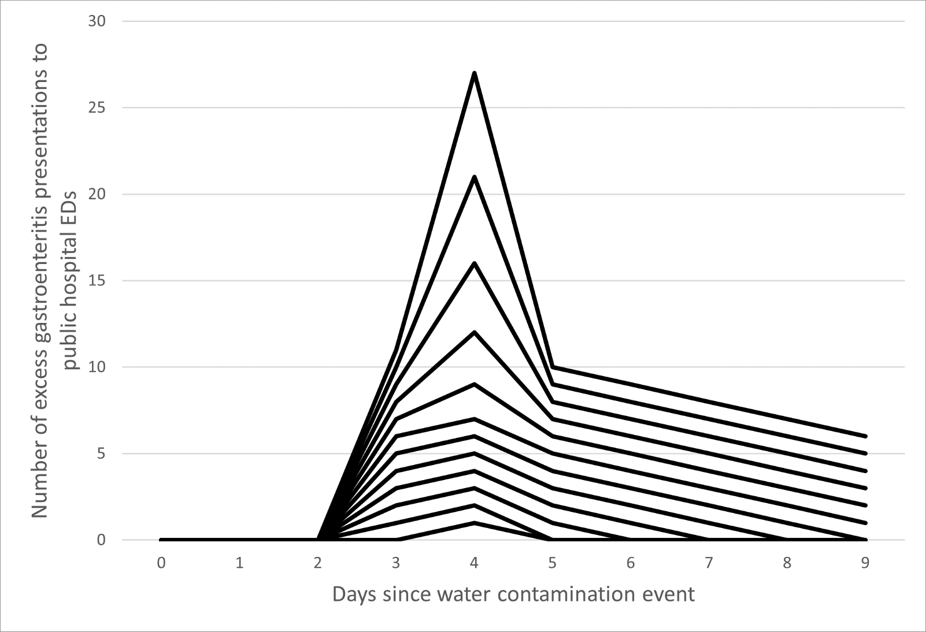
a Each line represents a different simulation. In ascending order, the number of excess presentations in each simulation are: 1, 3, 6, 10, 15, 21, 28, 36, 45, 55, 66 and 78.

Results

Suspected contamination event
The ‘inclusive’ analysis included 237 postcodes and 521 gastroenteritis presentations over the study period, with a median of 14 (and a range of eight to 24) presentations per day. In the regression, there were approximately 15 presentations at the beginning of the study (β₀ = 15.52, p < 0.001), with little evidence for a change in rate across the baseline period (β₁ = −0.08, p = 0.33). There was very strong evidence for a level change in approximately 11 additional presentations immediately following the minimum incubation period of suspected pathogens (β₂ = 10.94, p < 0.001), with strong evidence showing a subsequent decrease in presentations over the surveillance week (β₃ = −1.67, p = 0.02) (Figure 3).
The ‘core’ analysis included 97 postcodes and 234 presentations over the study period, with a median of six (and a range of two to 17) presentations per day. In the regression, the start of the study period saw approximately seven presentations (β₀ = 6.56, p < 0.001), with little evidence for a change in rate across the baseline period (β₁ = −0.03, p = 0.68). There was strong evidence for an immediate increase in presentations following the minimum incubation period of suspected pathogens (β₂ = 7.39, p = 0.01), and some evidence to show a subsequent decrease in presentations over the surveillance week (β₃ = −1.04, p = 0.07) (Figure 3).

Simulated outbreaks
Over fifty runs of the simulated outbreaks for the ‘inclusive’ analysis, with no excess presentations (i.e., with the ED data as is) the models signalled a detection 8% of the time. With 28 excess presentations, the models returned detections 50% of the time; with 78 excess presentations, detections were returned 100% of the time (Table 1). For the ‘core’ analysis, with no excess presentations, the models signalled a detection 6% of the time. The models returned over 50% detections with 21 excess presentations, and 100% detections with 45 excess presentations (Table 1).
Table 1: Probability of detection in an interrupted time series study of gastroenteritis presentations to public hospital emergency departments (EDs) before and after simulated outbreaks of various sizes in affected postcodes in Victoria, Australia, 2020ª
Excess presentations to public hospital EDs (n) | 0 | 1 | 3 | 6 | 10 | 15 | 21 | 28 | 36 | 45 | 55 | 66 | 78
Proportion detected for the ‘inclusive’ analysis^{b} | 8% | 8% | 10% | 18% | 24% | 32% | 44% | 50% | 58% | 76% | 88% | 94% | 100%
Proportion detected for the ‘core’ analysis^{c} | 6% | 10% | 14% | 20% | 36% | 44% | 60% | 78% | 88% | 100% | 100% | 100% | 100%
a Details of the simulated outbreaks and resultant excess presentations are given in Figure 2.
b Includes postcodes that are served at least in part by the affected sources.
c Includes postcodes that are only served, and wholly served, by the affected sources.

Figure 3: Interrupted time series study of gastroenteritis presentations to public hospital emergency departments (EDs) before and after a suspected contamination event in affected postcodes in Victoria, Australia, 2020, showing (A) the ‘inclusive’ and (B) the ‘core’ analysisª
A
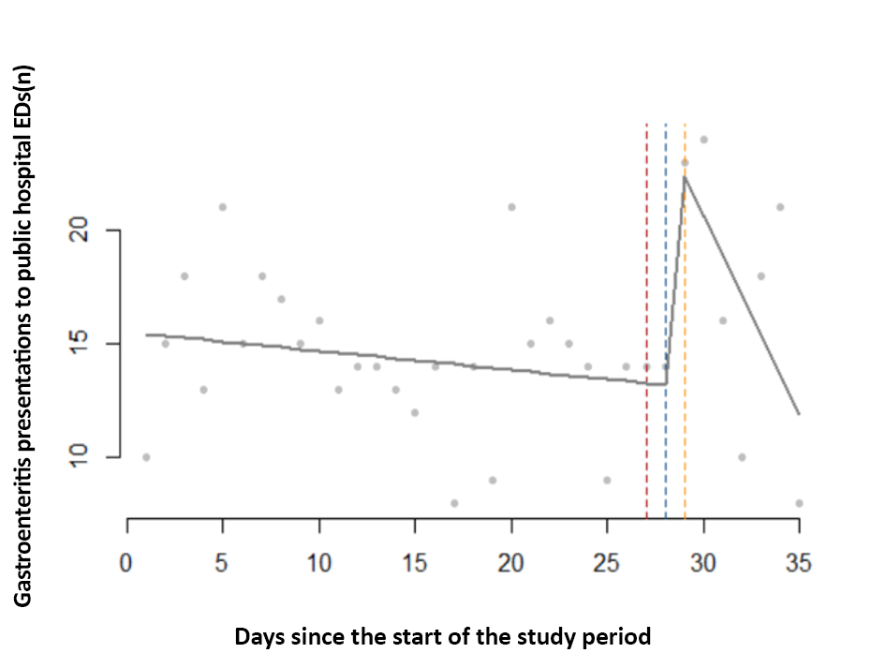
B
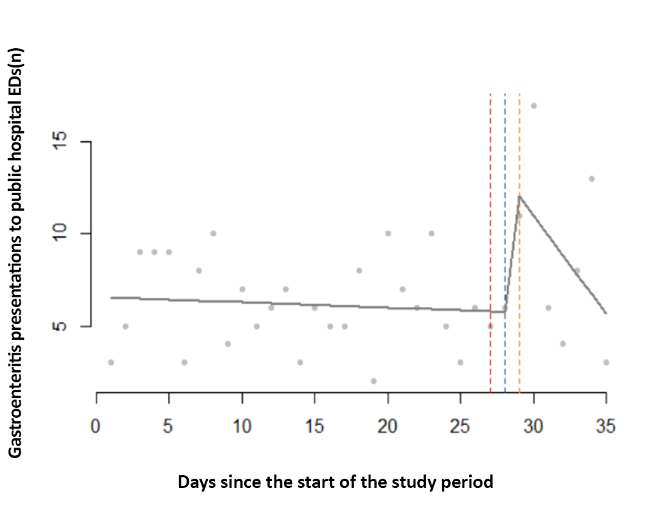
a The ‘inclusive’ model includes postcodes that are served at least in part by the affected source; the ‘core’ model includes postcodes that are only served, and wholly served, by the affected source.

Discussion
This study demonstrated the utility of applying segmented regression analysis to an interrupted time series study of gastroenteritis presentations to public hospital EDs before and after a suspected drinking water contamination event. We also simulated outbreaks of various sizes given the absence of recent events leading to outbreaks, and demonstrated the ability of segmented regressions to statistically signal a detection, even without a large excess in presentations. Our study therefore supports the use of interrupted time series analysis for informing Victoria’s syndromic surveillance system for such events in conjunction with timely public hospital ED data.
In this study, the suspected contamination event saw a transient increase in presentations, but indicator microorganisms were undetected in samples taken from the affected waterbodies. We recognise there are limitations to monitoring extensively for specific pathogens in large water distribution networks, like those implicated in this event. It therefore remains possible that this increase in presentations was the result of to microbiological hazards. Alternatively, our findings may be ascribed to increased health-seeking behaviour following the issuing of boil water advisories.³
In our simulations, the segmented regressions also signalled detections when applied to other dates in the VEMD, a likely consequence of random error.²¹ Reassuringly, the false-positive rate was less than 10% for both the ‘inclusive’ and ‘core’ analyses. Given its high specificity, a positive detection is therefore likely suggestive of a waterborne disease outbreak. Its sensitivity, i.e., its true-positive detection rate, was dose-dependent. This is consistent with other syndromic surveillance approaches that use health insurance data, telephone triage and over-the-counter pharmacy sales.^{8,22}
Of note, our study period occurred during the COVID-19 pandemic. ED presentations likely fluctuated with stay-at-home orders, which may have introduced additional noise to the rates of gastroenteritis presentations. By restricting the baseline period to four weeks, we were able to retain sufficient data to establish a robust baseline, while minimising the impact of variable lockdowns and seasonal variability.
We also want to highlight that our analyses focused on p-values to signal a detection. We note that a statistical signal at p < 0.05 may not have public health significance. Such analyses should therefore be used in conjunction with microbiological testing and consultation with key stakeholders (including waterborne and foodborne disease experts) to inform public health decision making.
Our analyses did have some limitations. Firstly, gastroenteritis syndromes were identified using ICD-10 codes, which can be subject to misclassification. Similarly, there is likely misclassification in how we determined which postcodes are served by which water sources. The ‘inclusive’ definition will have captured all affected postcodes, with the drawback being the inclusion of unaffected populations in sections served by other zones. The ‘core’ definition has the advantage of restricting analyses to postcodes completely affected by the event, at the expense of excluding affected postcodes served additionally by other zones. The misclassification in ICD-10 codes and postcodes are likely non-differential between the baseline and surveillance periods, thus biasing the effect estimates towards the null. As such, the sensitivity estimates of our models are likely minimum estimates of the true value.
Furthermore, some people may have ingested water in the affected postcodes, but may have become ill in another, thereby reducing case ascertainment. This was minimised by the presence of stay-at-home orders during the study period. We recognise that this remains a limitation if used for syndromic surveillance during non-lockdown contexts.
Our simulation was also run over 50 different dates across 2020; the results may therefore lack precision and may benefit from additional runs. Furthermore, all simulations were modelled after single-day water contamination events leading to point-source outbreaks of STEC. Therefore, our findings may not be generalisable to outbreaks with different characteristics. Future simulations could incorporate other pathogens and other outbreak types, including continuous-source outbreaks, to better assess the model’s sensitivity and specificity. Future studies could also explore the utility of interrupted times series analysis applied to other outcome data, such as telephone triage, web-based queries, and over-the-counter pharmaceutical sales.⁸
In closing, this study demonstrated the utility of interrupted time series analysis for the early detection of waterborne disease outbreaks when used in conjunction with timely public hospital ED data. This approach should therefore be considered for informing Victoria’s syndromic surveillance system for monitoring and evaluating such events.

Ethical statement
Ethical approval was obtained from the State Government of Victoria’s Department of Health and Department of Families, Fairness and Housing Human Research Ethics Committee (ref: HREC/80437/DOH-2021-294619).

Funding statement
This research did not receive any specific funding.

Data availability
Data requests can be directed to the corresponding author.

Conflict of interest
We declare no known competing interests that could have influenced this work.

Acknowledgements
The authors acknowledge the contributions of the staff at the State Government of Victoria’s Department of Health and the Victorian water agencies.

Author details
Mr Aidan Yuen^{1,2,3}
Dr Davoud Pourmarzi¹
Ms Suzie Sarkis²
Ms Carmela Luisetto²
Mr Kamal Khatri²
Dr Angie Bone²
Dr Jim Black²
- National Centre for Epidemiology and Population Health, Australian National University, Canberra, Australian Capital Territory 2600, Australia
- Department of Health, State Government of Victoria, Melbourne, Victoria 3000, Australia
- http://orcid.org/ 0000-0002-8642-8619

Corresponding author
Aidan Yuen
National Centre for Epidemiology and Population Health, Australian National University, Canberra, Australian Capital Territory 2600, Australia
Email: aidan.yuen@anu.edu.au

References
- Pignata C, Bonetta S, Bonetta S, Cacciò SM, Sannella AR, Gilli G et al. Cryptosporidium oocyst contamination in drinking water: a case study in Italy. Int J Environ Res Public Health. 2019;16(11):2055. doi: https://doi.org/10.3390/ijerph16112055.
- Reynolds C, Checkley S, Chui L, Otto S, Neumann NF. Evaluating the risks associated with Shiga-toxin-producing Escherichia coli (STEC) in private well waters in Canada. Can J Microbiol. 2020;66(5):337–50. doi: https://doi.org/10.1139/cjm-2019-0329.
- Lin CJ, Richardson DB, Hilborn ED, Weinberg H, Engel LS, Wade TJ. Emergency department visits for acute gastrointestinal illness after a major water pipe break in 2010. Epidemiology. 2019;30(6):893–900. doi: https://doi.org/10.1097/EDE.0000000000001083.
- Mac Kenzie WR, Hoxie NJ, Proctor ME, Gradus MS, Blair KA, Peterson DE et al. A massive outbreak in Milwaukee of cryptosporidium infection transmitted through the public water supply. N Engl J Med. 1994;331(3):161–7. doi: https://doi.org/10.1056/NEJM199407213310304.
- Paterson BJ, Durrheim DN. The remarkable adaptability of syndromic surveillance to meet public health needs. J Epidemiol Glob Health. 2013;3(1):41–7. doi: https://doi.org/10.1016/j.jegh.2012.12.005.
- Nygård K, Schimmer B, Søbstad Ø, Walde A, Tveit I, Langeland N et al. A large community outbreak of waterborne giardiasis—delayed detection in a non-endemic urban area. BMC Public Health. 2006;6(1):141. doi: https://doi.org/10.1186/1471-2458-6-141.
- Eisenberg JN, Seto EY, Colford JM, Olivieri A, Spear RC. An analysis of the Milwaukee cryptosporidiosis outbreak based on a dynamic model of the infection process. Epidemiology. 1998;9(3):255–63.
- Andersson T, Bjelkmar P, Hulth A, Lindh J, Stenmark S, Widerström M. Syndromic surveillance for local outbreak detection and awareness: evaluating outbreak signals of acute gastroenteritis in telephone triage, web-based queries and over-the-counter pharmacy sales. Epidemiol Infect. 2014;142(2):303–13. doi: https://doi.org/10.1017/S0950268813001088.
- Groeneveld GH, Dalhuijsen A, Kara-Zaïtri C, Hamilton B, de Waal MW, van Dissel JT et al. ICARES: a real-time automated detection tool for clusters of infectious diseases in the Netherlands. BMC Infect Dis. 2017;17(1):201. doi: https://doi.org/10.1186/s12879-017-2300-5.
- Shortridge JE, Guikema SD. Public health and pipe breaks in water distribution systems: analysis with internet search volume as a proxy. Water Res. 2014;53:26–34. doi: https://doi.org/10.1016/j.watres.2014.01.013.
- Pivette M, Mueller JE, Crépey P, Bar-Hen A. Drug sales data analysis for outbreak detection of infectious diseases: a systematic literature review. BMC Infect Dis. 2014;14(1):604. doi: https://doi.org/10.1186/s12879-014-0604-2.
- Proctor ME, Blair KA, Davis JP. Surveillance data for waterborne illness detection: an assessment following a massive waterborne outbreak of Cryptosporidium infection. Epidemiol Infect. 1998;120(1):43–54. doi: https://doi.org/10.1017/s0950268897008327.
- Rodman JS, Frost F, Jakubowski W. Using nurse hot line calls for disease surveillance. Emerg Infect Dis. 1998;4(2):329–32. doi: https://doi.org/10.3201/eid0402.980226.
- Berger M, Shiau R, Weintraub JM. Review of syndromic surveillance: implications for waterborne disease detection. J Epidemiol Community Health. 2006;60(6):543–50. doi: https://doi.org/10.1136/jech.2005.038539.
- Dale K, Kirk M, Sinclair M, Hall R, Leder K. Reported waterborne outbreaks of gastrointestinal disease in Australia are predominantly associated with recreational exposure. Aust N Z J Public Health. 2010;34(5):527–30. doi: https://doi.org/10.1111/j.1753-6405.2010.00602.x.
- Cutler D, Miller G. The role of public health improvements in health advances: the twentieth-century United States. Demography. 2005;42(1):1–22. doi: https://doi.org/10.1353/dem.2005.0002.
- National Health and Medical Research Council (NHMRC), National Resource Management Ministerial Council (NRMMC). National Water Quality Management Strategy: Australian Drinking Water Guidelines 6: 2011. [Internet]. Canberra: Australian Government, NHMRC, NRMMC; October 2017. Available from: https://www.nhmrc.gov.au/sites/default/files/documents/reports/aust-drinking-water-guidelines.pdf
- Schober P, Vetter TR. Segmented regression in an interrupted time series study design. Anesth Analg. 2021;132(3):696–7. doi: https://doi.org/10.1213/ANE.0000000000005269.
- Onyango LA, Quinn C, Tng KH, Wood JG, Leslie G. A study of failure events in drinking water systems as a basis for comparison and evaluation of the efficacy of potable reuse schemes. Environ Health Insights. 2016;9(Suppl 3):11–8. doi: https://doi.org/10.4137/EHI.S31749.
- Motlagh AM, Yang Z. Detection and occurrence of indicator organisms and pathogens. Water Environ Res. 2019;91(10):1402–8. doi: https://doi.org/10.1002/wer.1238.
- Hyllestad S, Amato E, Nygård K, Vold L, Aavitsland P. The effectiveness of syndromic surveillance for the early detection of waterborne outbreaks: a systematic review. BMC Infect Dis. 2021;21(1):696. doi: https://doi.org/10.1186/s12879-021-06387-y.
- Mouly D, Goria S, Mounié M, Beaudeau P, Galey C, Gallay A, et al. Waterborne disease outbreak detection: a simulation-based study. Int J Environ Res Public Health. 2018;15(7):1505. doi: https://doi.org/10.3390/ijerph15071505.

Communicable Diseases Intelligence
ISSN: 2209-6051 Online

Communicable Diseases Intelligence (CDI) is a peer-reviewed scientific journal published by the Office of Health Protection, Department of Health and Aged Care. The journal aims to disseminate information on the epidemiology, surveillance, prevention and control of communicable diseases of relevance to Australia.

Editor: Noel Lally
Deputy Editor: Simon Petrie
Design and Production: Kasra Yousefi
Editorial Advisory Board: David Durrheim, Mark Ferson, Clare Huppatz, John Kaldor, Martyn Kirk, Meru Sheel and Steph Williams

Website: http://www.health.gov.au/cdi

Contacts
CDI is produced by the Office of Health Protection, Australian Government Department of Health and Aged Care, GPO Box 9848, (MDP 6) CANBERRA ACT 2601

Email: cdi.editor@health.gov.au

Submit an Article
You are invited to submit your next communicable disease related article to the Communicable Diseases Intelligence (CDI) for consideration. More information regarding CDI can be found at: http://health.gov.au/cdi.
Further enquiries should be directed to: cdi.editor@health.gov.au.

This journal is indexed by Index Medicus and Medline.

Creative Commons Licence - Attribution-NonCommercial-NoDerivatives CC BY-NC-ND
© 2023 Commonwealth of Australia as represented by the Department of Health and Aged Care
This publication is licensed under a Creative Commons Attribution-NonCommercial-NoDerivatives 4.0 International Licence from https://creativecommons.org/licenses/by-nc-nd/4.0/legalcode (Licence). You must read and understand the Licence before using any material from this publication.

Restrictions
The Licence does not cover, and there is no permission given for, use of any of the following material found in this publication (if any):
- the Commonwealth Coat of Arms (by way of information, the terms under which the Coat of Arms may be used can be found at www.itsanhonour.gov.au);
- any logos (including the Department of Health and Aged Care’s logo) and trademarks;
- any photographs and images;
- any signatures; and
- any material belonging to third parties.

Disclaimer
Opinions expressed in Communicable Diseases Intelligence are those of the authors and not necessarily those of the Australian Government Department of Health and Aged Care or the Communicable Diseases Network Australia. Data may be subject to revision.

Enquiries
Enquiries regarding any other use of this publication should be addressed to the Communication Branch, Department of Health and Aged Care, GPO Box 9848, Canberra ACT 2601, or via e-mail to: copyright@health.gov.au

Communicable Diseases Network Australia
Communicable Diseases Intelligence contributes to the work of the Communicable Diseases Network Australia.
http://www.health.gov.au/cdna

