Communicable Diseases Intelligence, Year 2023, Volume 47
https://doi.org/10.33321/cdi.2023.47.56
Publication date: 21/09/2023
http://health.gov.au/cdi

The impact of the National Shingles Vaccination Program on the epidemiology of herpes zoster among adults ≥ 60 years in Victoria, Australia
Madeleine J Marsland, Anna Glynn-Robinson, Rebecca F Gang, Janet Strachan

Abstract

Introduction
In November 2016, Australia recommended herpes zoster (HZ) vaccination for adults aged ≥ 60 years and implemented a National Shingles Vaccination Program (NSVP) offering free HZ vaccination to adults aged 70–79 years. This study investigated trends in HZ epidemiology among Victorian adults aged ≥ 60 years and the impact of the NSVP in this population.

Methods
We conducted epidemiological analyses of routinely collected HZ surveillance data for Victorian adults aged ≥ 60 years who were notified as having a HZ illness or vaccination between 2012 and 2021. Annual incidence rates are presented for vaccinations, case notifications, emergency department presentations, hospitalisations and deaths by five-year age groups. Age-specific incidence rate ratios are calculated comparing the period prior to (1 January 2012 to 31 October 2016) and following (1 November 2016 to 31 December 2021) NSVP implementation.

Results
HZ vaccination rates were highest among those eligible to receive free vaccination (70–79 years), but appear to have plateaued across all age groups and remained below full coverage. Incidence rate ratios showed a statistically significant increase (p < 0.01) in HZ notifications across all age-groups. Emergency presentations and hospitalisations showed a statistically significant decline (p < 0.05) among the 70–79 year old age groups; however, these rates remained consistent or increased among other age groups for whom vaccination is recommended. Mortality rates declined, particularly among those aged 85+ years.

Discussion
HZ continues to cause significant disease among the older adult population in Victoria. The findings of this study suggest the NSVP has led to some changes in the epidemiology of HZ among the 70–79 years old age group in Victoria; however, there is less evidence that it has influenced other age groups for whom vaccination is recommended. An evaluation of the NSVP and epidemiology of HZ at a national level is required to identify strategies to improve vaccination coverage among the target populations.
Keywords: Herpes zoster; herpes zoster vaccine; vaccine-preventable diseases; epidemiology

Introduction
Herpes zoster (HZ), commonly known as shingles, is a reactivation of varicella zoster virus (VZV) infection. The incidence of HZ is increasing globally among unvaccinated populations.¹ The lifetime risk of HZ is approximately one in three,^{2,3} with incidence and complication rates highest amongst older adults.^{1,2}
There are two HZ vaccines approved for use within Australia: Zostavax, a live-attenuated single-dose HZ vaccine, and Shingrix, a recombinant vaccine containing VZV glycoprotein E antigen given as a two-dose schedule two to six months apart.^{2,4} Zostavax has been available in Australia since 2006, whilst Shingrix was registered for use in the private market in 2021.^{2,4} Shingrix has greater effectiveness across all age groups, particularly among older adults aged ≥ 80 years, for whom Zostavax has very poor effectiveness.^{3–5} Shingrix is also considered a safer vaccine and is recommended for immunocompromised individuals.³ Protection from Shingrix is thought to last for at least 10 years, whereas Zostavax effectiveness wanes within 5–10 years.³
In November 2016, Australia implemented a National Shingles Vaccination Program (NSVP). The Australian Technical Advisory Group on Immunisation recommended HZ vaccination for all adults aged ≥ 60 years, with Zostavax to be provided free-of-charge under the National Immunisation Program (NIP) to adults aged 70 years, and a time-limited catch-up program implemented for adults aged 71–79 years (until October 2023).^{3,6,7} In 2022, HZ vaccine recommendations were expanded to include immunocompetent adults aged ≥ 50 years and severely immunocompromised individuals aged ≥ 18 years.³ In 2023, the Australian Government announced that Shingrix would replace Zostavax on the NIP, with funded vaccination for all adults aged 70 years, for Aboriginal and Torres Strait Islanders aged 50 years and over, and for severely immunocompromised adults aged ≥ 18 years meeting specified criteria.⁸
To date, few studies have examined the impact of the NSVP in Australia.^{9–16} Early studies found a significant decline in the incidence of HZ in the first two to three years following implementation.^{10,12,13} However, these studies also suggested waning immunity may impact vaccine effectiveness and noted the need for further evaluations.^{10,12,13} There remains limited evidence regarding the long term impact of the NSVP.⁴
We investigated trends in HZ epidemiology among Victorian adults aged ≥ 60 years before and after implementation of the NSVP.

Methods
Data from 2012–2021 were extracted for persons aged ≥ 60 years, with those aged 70–79 years considered ‘NIP-eligible’. This included 58 months of data prior to implementation of the NSVP (1 January 2012 to 31 October 2016: ‘pre-NSVP’) and 62 months of data following implementation (1 November 2016 to 31 December 2021: ‘post-NSVP’).
De-identified individual vaccination data were sourced from the Australian Immunisation Register (AIR) for both Zostavax and Shingrix vaccinations. Data on vaccines distributed under the NIP were sourced from internal Victorian Department of Health data. Analysis of vaccination data is focussed on the post-NSVP period, as there was low vaccine uptake and poor data quality during the pre-NSVP period.
De-identified HZ case notifications were sourced from the Victorian Public Health Event Surveillance System (PHESS) and included ‘probable’ (clinical evidence only) and ‘confirmed’ (clinical and laboratory evidence) varicella zoster (shingles) notifications,¹⁷ and varicella (unspecified) notifications.¹⁸ Zoster is a routine notifiable condition in Victoria, with notification required by medical practitioners and pathology services within five days of diagnosis.¹⁹ By including varicella unspecified cases (i.e. notifications based on laboratory evidence without clinical notification), there is a risk of including chickenpox cases in the analysis. However, as few people in the age groups investigated would have been experiencing their primary varicella infection, excluding this varicella classification would have led to an undercount of case notifications. HZ testing data were sourced from internal Victorian Department of Health data by surveying Victorian public and private laboratories.
De-identified data on emergency department (ED) presentations and hospitalisations were sourced from the Victorian Emergency Minimum Dataset (VEMD) and the Victorian Admitted Episodes Database (VAED) using the International Statistical Classification of Diseases and Related Health Problems, tenth revision, Australian Modification (ICD-10-AM) code B02 (Zoster). Mortality data were sourced from the Registry of Births, Deaths and Marriages Victoria – Victorian Deaths Index (VDI) using the search terms ‘varicella OR shingles OR zoster OR herpes OR herpetic OR VZV (excluding records with simplex)’ as cause of death. Individuals were considered to have presented or died ‘due to’ HZ if their coded primary diagnosis or direct cause of death was HZ-related, and ‘with’ HZ if the ‘other’ or ‘antecedent’ listed condition or cause of death was HZ-related.
Age, sex and locality (Local Government Area or postcode) were extracted from all datasets, except vaccine distributions and laboratory testing survey data. Where age or confirmation of Victorian residence (locality) was not available, data were excluded. Data analyses were undertaken using Stata v.16 ²⁰ and Microsoft Excel (2022). All datasets were descriptively analysed to identify changes over time and to produce summary statistics, including medians and interquartile ranges (IQRs).
Age-specific rates were calculated for each year (2012–2021) using mid-year Estimated Resident Populations (ERPs) from the Australian Bureau of Statistics (ABS)²¹ and expressed as rates per 100,000 population per year. Rates and incidence rate ratios (IRRs) with 95% confidence intervals (CI) were calculated using Poisson regression to compare the pre-NSVP period to the post-NSVP period and expressed as rates per 100,000 person-years by age group. P values were derived using the chi-square test. Crude test positivity rates were calculated by dividing the number of case notifications (PHESS) by the total HZ tests per year. Direct age standardisation was used to compare rates by sex using the Australian standard population 2001.²¹
Ethics approval was granted by the Australian National University Human Research Ethics Committee (protocol 2022/266).

Results

Vaccinations
There were 302,667 individuals with HZ vaccinations recorded in the AIR, most (99.2%) of which occurred post-NSVP (Table 1). Vaccination rates (VRs) pre-NSVP were negligible (Table 2).
Following the NSVP implementation, VRs increased across all age groups. However, VRs were consistently substantially higher in the NIP-eligible population (Figure 1A) than in the NIP-ineligible population (Figure 1B). Overall, females had a slightly higher age-standardised VR than did males, with VRs of, respectively, 2,529 and 2,325 per 100,000 population over the study period.
In 2016, VRs were highest in the 75–79 years age group, particularly those aged 78 and 79 years (Figure 1A; Table 3). From 2017, VRs were highest in the 70–74 years age group, with the highest VR in those aged 70 years (Table 3). VRs declined across all age groups from 2017 to 2020 before slightly increasing in 2021 (Figure 1A; Table 3; Figure 1B). VRs appear to have plateaued and remain low across all age groups, and are consistently lower among the age groups recommended to be vaccinated but not NIP-eligible (Figure 1B).
Across July–December 2021, the count of individuals vaccinated with Shingrix gradually increased. Zostavax predominated, particularly among those aged 70–74 (96.9% Zostavax, 3.1% Shingrix) and 75–79 years (93.8% Zostavax, 6.2% Shingrix). There was higher uptake of Shingrix among other age groups, particularly among those aged 60–64 years (50.2% Zostavax, 49.8% Shingrix) and 65–69 years (58.2% Zostavax, 41.8% Shingrix).
Table 1: Counts and characteristics of herpes zoster related cases, emergency department presentations, hospitalisations, deaths and vaccinations, prior to and following implementation of the National Shingles Vaccination Program (NSVP)
Category | Value | Notified casesª |  | ED presentations^{a,b} |  | Hospitalisations^{a,b,c} |  | Deaths^{a,d,e} |  | Persons vaccinated^{a,f}
 |  | Pre-NSVP | Post-NSVP | Pre-NSVP | Post-NSVP | Pre-NSVP | Post-NSVP | Pre-NSVP | Post-NSVP | Pre-NSVP | Post-NSVP
Age group (years) | 60–64 | 2,335 | 4,598 | 923 | 1,330 | 248 | 351 | ≤ 5 | ≤ 5 | 370 | 7,486
 | 65–69 | 2,288 | 2,702 | 931 | 1,394 | 335 | 444 | ≤ 5 | ≤ 5 | 621 | 11,744
 | 70–74 | 1,732 | 3,112 | 851 | 1,029 | 348 | 394 | ≤ 5 | 7 | 549 | 187,614
 | 75–79 | 1,474 | 2,099 | 784 | 774 | 411 | 435 | 14 | 6 | 692 | 82,160
 | 80–84 | 1,089 | 1,825 | 645 | 743 | 513 | 512 | 12 | 13 | 158 | 6,845
 | 85+ | 1,283 | 2,572 | 710 | 896 | 759 | 1,122 | 69 | 57 | 129 | 4,299
Sex | Male | 4,366 | 7,896 | 2,219 | 2,755 | 1,079 | 1,249 | 37 | 36 | 982 | 137,196
 | Female | 5,814 | 10,961 | 2,625 | 3,411 | 1,535 | 2,009 | 64 | 52 | 1,537 | 162,941
 | Not specified | 21 | 51 | 0 | 0 | 0 | 0 | 0 | 0 | 0 | 11
Total |  | 10,201 | 18,908 | 4,844 | 6,166 | 2,614 | 3,258 | 101 | 88 | 2,519 | 300,148
a Pre-NSVP: pre-implementation of the National Shingles Vaccination Program (NSVP), 1 January 2012 to 31 October 2016; Post-NSVP: post-implementation of the NSVP, 1 November 2016 to 31 December 2021.
b Notification where HZ listed as a primary reason for presentation.
c Mandatory reporting for public and private hospitals came into effect in September 2013.
d Counts of ≤ 5 were withheld to protect individual privacy.
e Notification where HZ listed as a primary cause of death.
f Based on first dose of HZ vaccine given.

Table 2: Crude notification incidence rates, emergency department presentation rates, hospitalisation rates, mortality rates and vaccination rates per 100,000 population per year for adults aged ≥ 60 years in Victoria, 2012 to 2021
Year | Crude rate per 100,000 population per year for adults ≥ 60 years
 | Notification incidence rate | Emergency department presentation rate | Hospitalisation rate | Mortality rate | Vaccination rate
2012 | 139.4 | 91.7 | 52.2 | 1.7 | 2.0
2013 | 159.2 | 84.5 | 42.8 | 2.4 | 5.2
2014 | 177.8 | 81.9 | 44.3 | 2.0 | 26.0
2015 | 189.7 | 86.2 | 45.2 | 1.2 | 47.5
2016 | 233.6 | 84.1 | 45.6 | 1.8 | 2,270.5
2017 | 244.7 | 79.9 | 47.3 | 1.8 | 8,120.0
2018 | 261.9 | 85.6 | 51.3 | 1.3 | 3,879.8
2019 | 270.5 | 88.2 | 47.5 | 0.8 | 2,927.2
2020 | 270.1 | 85.8 | 44.2 | 1.1 | 2,384.8
2021 | 293.4 | 94.7 | 41.0 | 1.2 | 2,976.1
Table 3: Age specific vaccination rates per 100,000 population per year for 70–79 year-olds (NIP- eligible population) in Victoria, 2016 to 2021
Age (years) | Vaccination rate per 100,000 population per year
 | 2016 | 2017 | 2018 | 2019 | 2020 | 2021
70 | 4,713 | 31,119 | 28,485 | 28,852 | 26,549 | 28,759
71 | 4,954 | 22,247 | 10,004 | 8,976 | 8,251 | 12,107
72 | 5,191 | 22,212 | 7,882 | 5,205 | 4,809 | 7,127
73 | 5,676 | 22,101 | 7,487 | 4,314 | 3,334 | 4,726
74 | 5,780 | 22,272 | 6,983 | 4,227 | 2,550 | 3,277
75 | 6,383 | 22,850 | 7,744 | 4,795 | 2,779 | 3,032
76 | 6,804 | 22,314 | 6,721 | 4,025 | 2,480 | 2,668
77 | 7,764 | 21,566 | 6,674 | 3,430 | 2,210 | 2,333
78 | 10,157 | 22,020 | 6,807 | 3,416 | 2,075 | 2,328
79 | 15,654 | 21,068 | 7,198 | 4,091 | 2,304 | 2,484

AIR data indicated most persons only received one HZ vaccine dose (n = 296,174), with 294,027 receiving a single Zostavax, and 2,147 receiving a single Shingrix. Of those who received multiple HZ vaccine doses (n = 6,493), the most common combination was two doses of Zostavax (n = 5,545), with other combinations far less frequent: two doses of Shingrix (n = 566), Zostavax followed by Shingrix (n = 258), Zostavax followed by two doses of Shingrix (n = 59), and three doses of Zostavax (n = 54). Other dose combinations, while reported, accounted for less than 0.2% of recipients (11/6,493). Of the 3,041 who received Shingrix, 1,595 were eligible to receive a second dose during the study period (first dose received more than two months before study conclusion), and 627 (39.3%) were fully vaccinated. The recommended time interval between Shingrix doses is two to six months. The median time interval between doses was 70 days (IQR: 63–84 days).
Internal vaccine distribution data, for vaccines intended for use by the NIP-eligible population, were compared with AIR vaccination data. Across 2016 and 2017, approximately double the number of herpes zoster doses recorded in AIR (n = 276,159) were distributed across Victoria (n = 525,035). However, the discrepancies between these two datasets have narrowed in subsequent years (2018 to 2021).
Figure 1: Age-specific rates of HZ vaccinations aged 60 years and over by 5-year age groups, Victoria, Australia 2016–2021
A: NIP-eligible age groups, ages 70–79 years
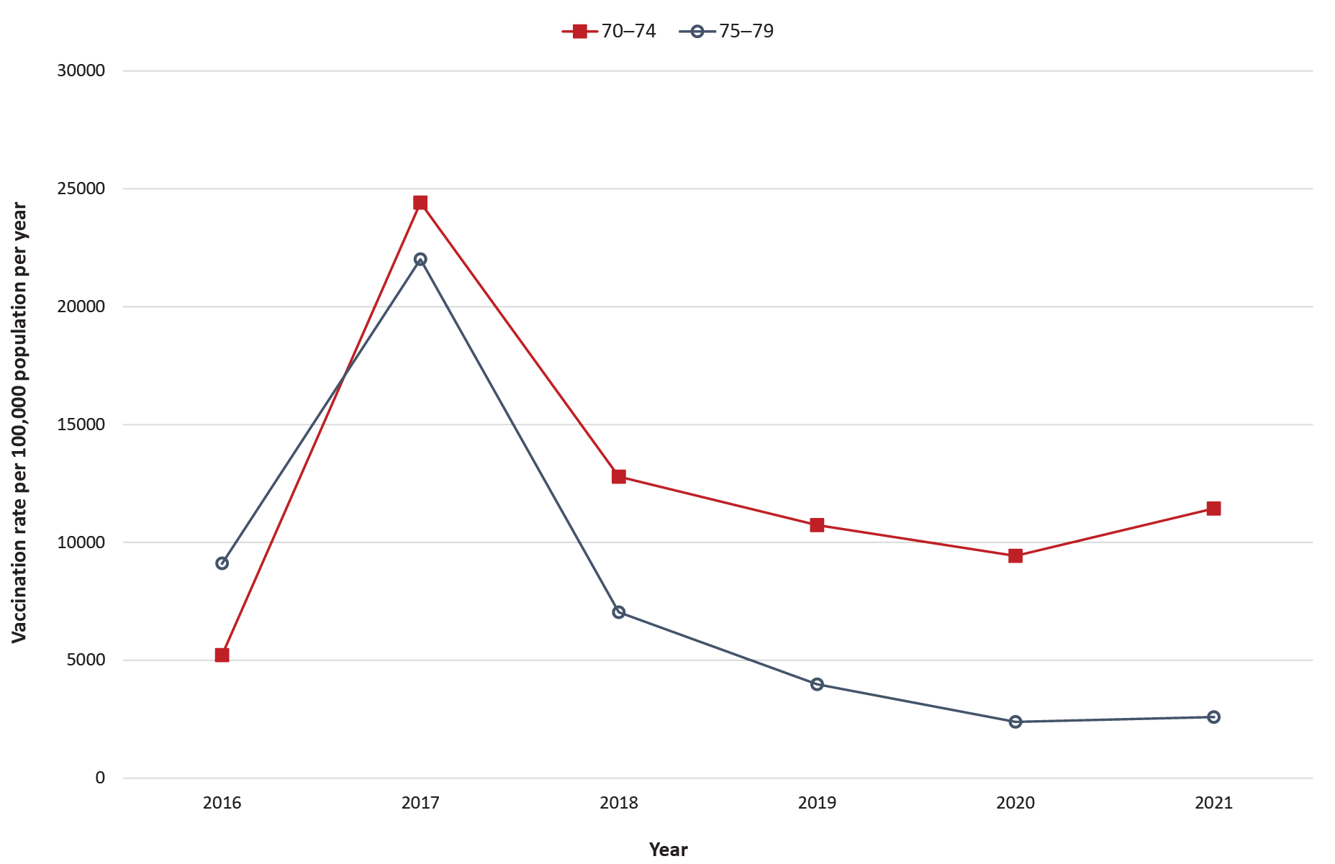
B: NIP-ineligible age groups, ages 60–69 and 80+ years
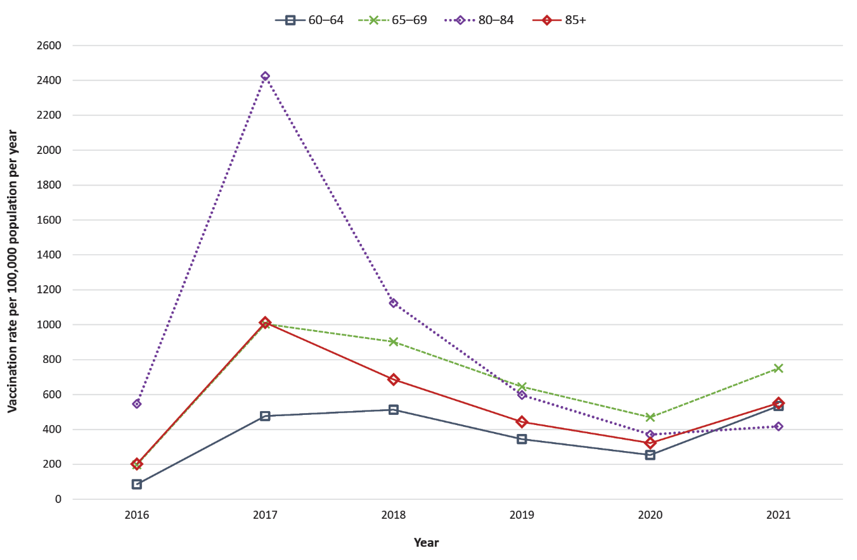

Case notifications
There were 29,109 cases notified over the period (Table 1): 27.4% (7,985/29,109) were ‘varicella herpes zoster’ and 72.6% (21,124/29,109) were ‘varicella unspecified’. Age-standardised rates showed females had a slightly higher average notification incidence rate (NIR) than males, 239.0 compared with 202.7 per 100,000 population over the study period.
Annual crude NIRs increased between 2012 and 2021 from 139.4 to 293.4 per 100,000 per year (Table 2). Age-specific NIRs steadily increased among most age groups under investigation and were highest amongst adults aged 85+ years (Figure 2). However, NIRs for the 70–74 and 75–79 years age groups both declined between 2016 and 2018, from 242.2 to 205.9 per 100,000 population per year and from 237.2 to 198.8 per 100,000 population per year respectively, and remained below 2016 levels before rising and peaking in 2021 (Figure 2). When comparing NIRs between the pre-NSVP and post-NSVP periods, there was a statistically significant increase in zoster notifications post-NSVP in all age groups (p < 0.001) (Table 4).
The total number of HZ tests performed in Victoria rose between 2012 and 2021, with a peak in testing occurring in 2019 (Figure 3). The crude test positivity also rose during this period.

Emergency department presentations
There were 11,825 HZ-related ED presentations recorded, of which 11,010 (93.1%) were coded as presenting due to HZ (primary illness) (Table 1). Age-standardised rates comparing sex were similar for females and males, respectively at 84.7 and 87.3 per 100,000 population over the study period.
Crude ED rates remained consistent over the study period (Table 2), with age-specific ED rates declining among the 70–74, 75–79 and 80–84 years age groups but increasing among the 60–64 and 65–69 years age groups (Figure 4). Incidence rate ratios comparing the pre-NSVP to the post-NSVP period showed statistically significant decreases for the 70–74 and 75–79 years age groups, and statistically significant increases for the 60–64 and 65–69 years age groups (Table 4).

Table 4: Rates and incidence rate ratios comparing prior to and following implementation of the National Shingles Vaccination Program (NSVP) for cases, emergency department presentations and hospitalisations by five-year age groups
Category | Age group (years) | Pre-NSVP incidence rate^{a,b} | Post-NSVP incidence rate^{a,b} | Comparison
 |  |  |  | IRR^{c} | 95% CI^{d} | p value
Case notifications | 60–64 | 155.9 | 255.9 | 1.64 | 1.56–1.73 | < 0.001
 | 65–69 | 173.3 | 297.4 | 1.72 | 1.63–1.80 | < 0.001
 | 70–74 | 176.7 | 231.5 | 1.31 | 1.23–1.39 | < 0.001
 | 75–79 | 195.9 | 219.3 | 1.12 | 1.05–1.20 | 0.002
 | 80–84 | 193.0 | 269.1 | 1.39 | 1.29–1.50 | < 0.001
 | 85+ | 224.6 | 364.3 | 1.62 | 1.52–1.73 | < 0.001
 | Total | 179.4 | 267.7 | 1.49 | 1.46–1.53 | < 0.001
ED presentations^{e} | 60–64 | 61.6 | 74.0 | 1.20 | 1.10–1.31 | < 0.001
 | 65–69 | 70.5 | 88.2 | 1.25 | 1.15–1.36 | < 0.001
 | 70–74 | 86.8 | 76.5 | 0.88 | 0.80–0.97 | 0.007
 | 75–79 | 104.2 | 80.9 | 0.78 | 0.70–0.86 | < 0.001
 | 80–84 | 114.3 | 109.6 | 0.96 | 0.86–1.07 | 0.432
 | 85+ | 124.3 | 126.9 | 1.02 | 0.93–1.13 | 0.677
 | Total | 85.2 | 87.3 | 1.02 | 0.99–1.06 | 0.204
Hospitalisations | 60–64 | 16.6 | 19.5 | 1.18 | 1.00–1.39 | 0.046
 | 65–69 | 25.4 | 28.1 | 1.11 | 0.96–1.28 | 0.160
 | 70–74 | 35.5 | 29.3 | 0.83 | 0.71–0.95 | 0.009
 | 75–79 | 54.6 | 45.5 | 0.83 | 0.73–0.95 | 0.008
 | 80–84 | 90.9 | 75.5 | 0.83 | 0.73–0.94 | 0.003
 | 85+ | 132.9 | 158.9 | 1.20 | 1.09–1.31 | < 0.001
 | Total | 46.0 | 46.1 | 1.00 | 0.95–1.06 | 0.900
a Rate per 100,000 person-years.
b Pre-NSVP: pre-implementation of the National Shingles Vaccination Program (NSVP), 1 January 2012 to 31 October 2016; Post-NSVP: post-implementation of the NSVP, 1 November 2016 to 31 December 2021.
c IRR: incidence rate ratio.
d 95% CI: 95% confidence interval.
e ED: emergency department.

Figure 2: Age-specific rates of HZ notified cases aged 60 years and over by 5-year age groups, Victoria, Australia 2012–2021
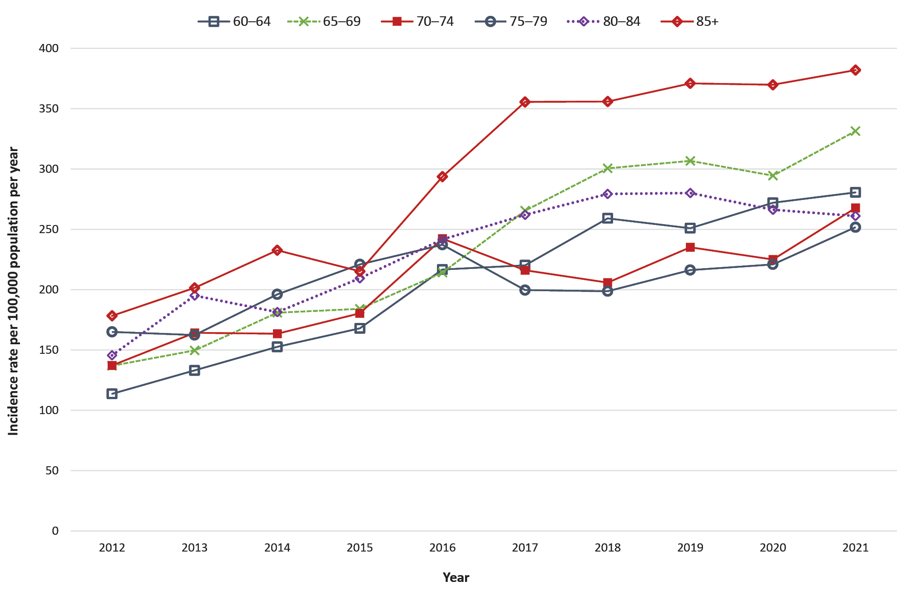
Figure 3: HZ tests conducted by Victorian laboratories and crude test positivity rate, 2012 to 2021
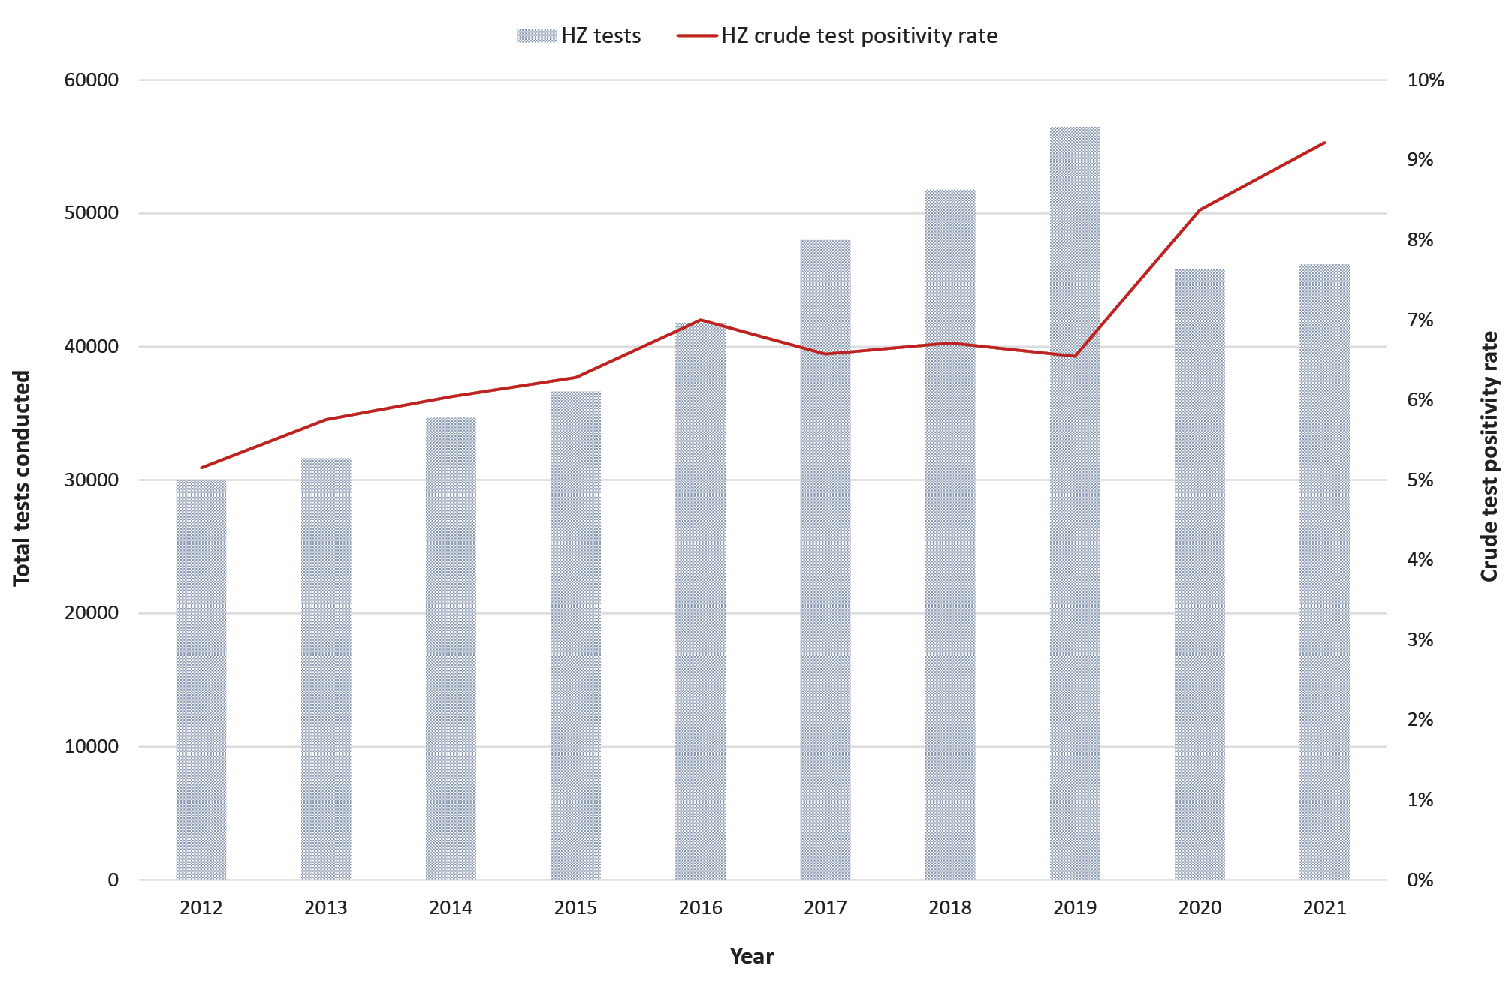
Figure 4: Age-specific rates of emergency department presentations due to HZ aged 60 years and over by five-year age groups, Victoria, Australia 2012–2021
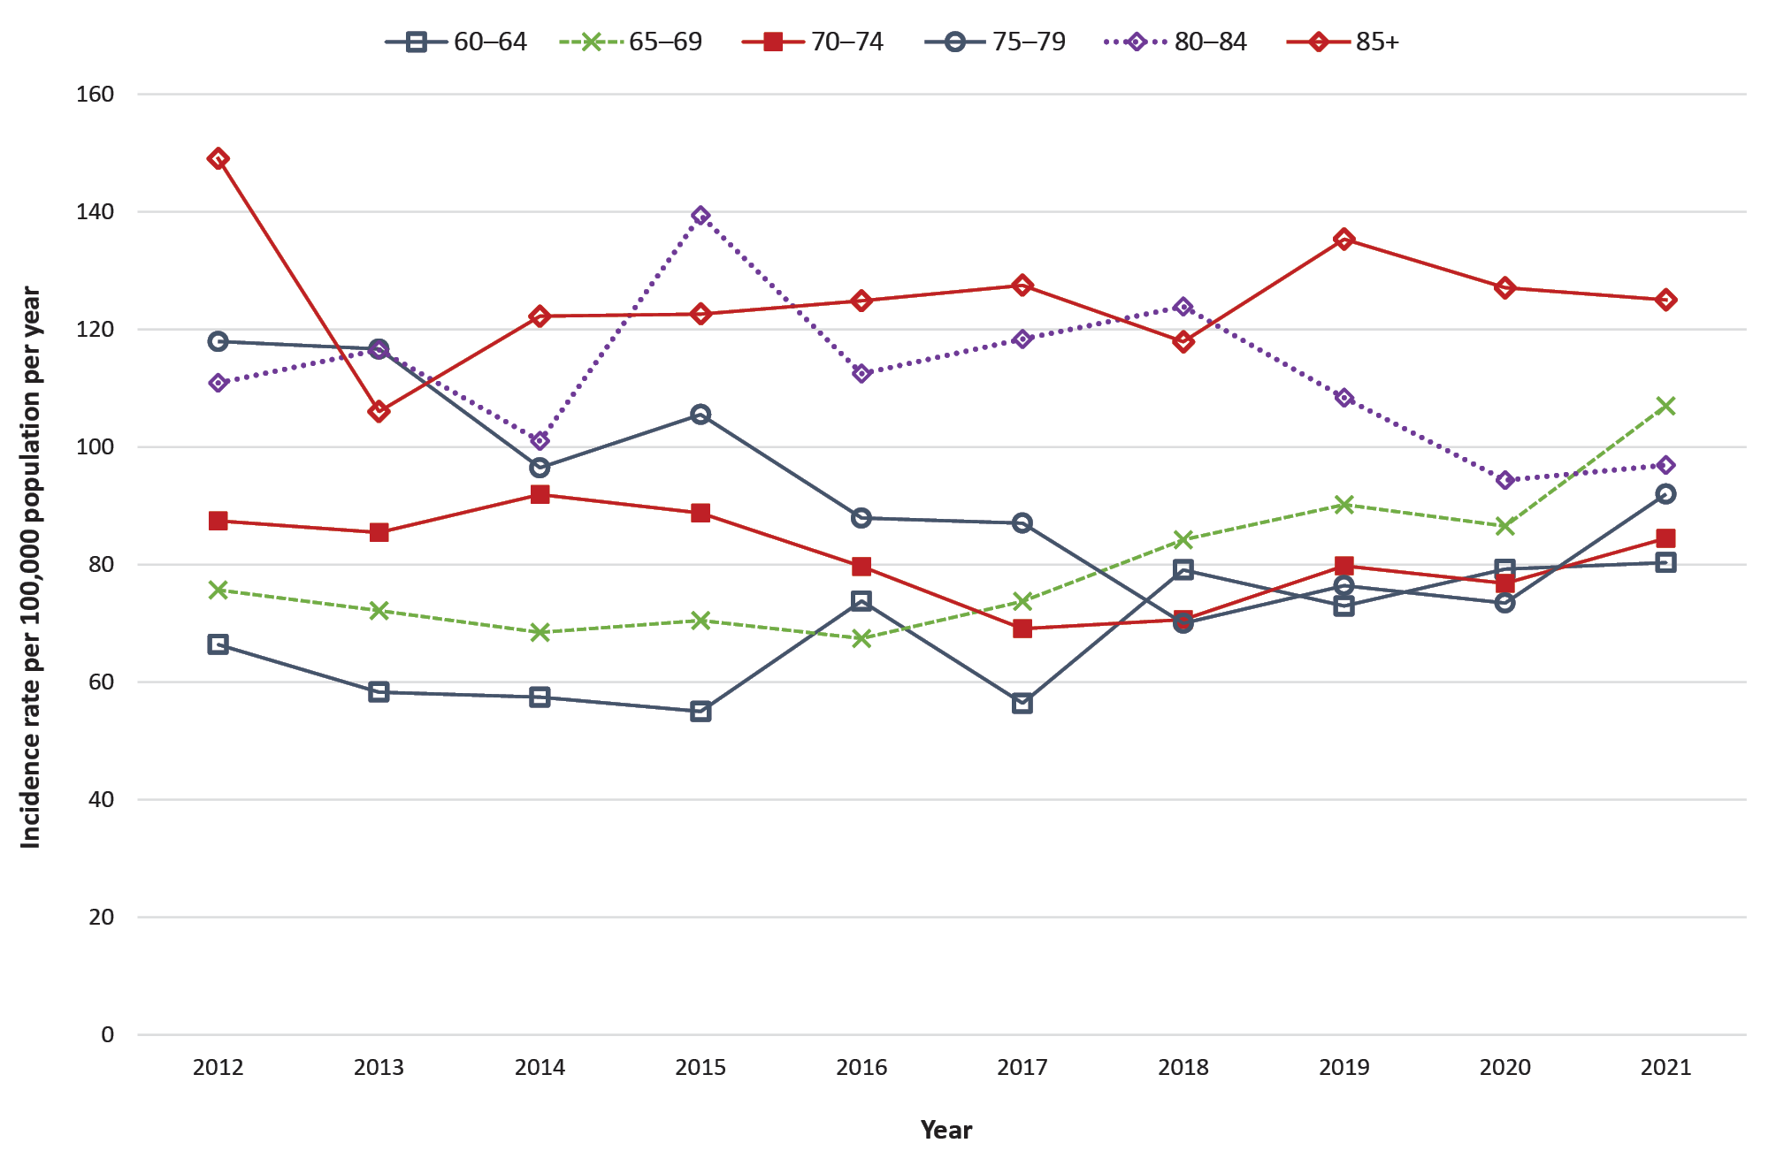

Hospitalisations
There were 15,797 HZ-related hospitalisations recorded, of which 5,872 (37.2%) were coded as hospitalised due to HZ (primary illness) (Table 1). Among those hospitalised due to HZ, the median length of stay was 4 days (IQR: 1–9 days), and 66 (1.1%) required intensive care unit admission. Females had a slightly higher age-standardised hospitalisation rate (HR) than males, with respectively 48.3 and 40.6 hospitalisations per 100,000 population over the study period.
For those with a HZ-primary illness, crude HRs remained relatively stable (Table 2). From 2012 to 2021, age-specific HRs declined for the age groups 70–74, 75–79, and 80–84 years, but increased and remained highest among those aged 85+ years (Figure 5). IRRs comparing pre-NSVP to post-NSVP showed a statistically significant decline in hospitalisations for the 70–74, 75–79, and 80–84 years age groups, but a statistically significant increase for the 60–64 and 85+ years age groups (Table 4).

Figure 5: Age-specific rates of hospitalisations due to HZ aged 60 years and over by five-year age groups, Victoria, Australia 2012–2021
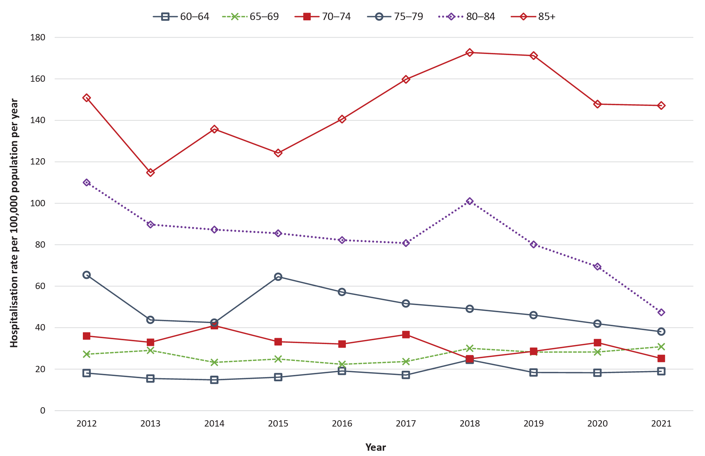

Deaths
A total of 341 death certificates indicated a HZ-related cause-of-death, with 189 (55.4%) listing a HZ-related primary cause. Most deaths occurred in the 85+ years age group and the majority were female (Table 1). The crude mortality rate associated with HZ declined between 2012 and 2021 (Table 2). The age-specific mortality rate for adults 85+ years declined from 12.1 (pre-NSVP) to 8.1 (post-NSVP) per 100,000 person-years.

Discussion
We hypothesised that cases, ED presentations, hospitalisations and deaths would all decline following NSVP implementation. However, we found that HZ continues to cause significant disease among those aged ≥ 60 years. Vaccination uptake remains low, and is substantially lower among those for whom vaccination is recommended but who are not eligible for NIP-funded vaccine. Further work is needed to improve vaccination rates to reduce the burden of HZ in Victoria.
Whilst NIRs initially declined amongst the NIP-eligible population as described in the literature,^{10,12,13} these gains have not been sustained. This may be associated with waning vaccine effectiveness.^{10,12,13} However, previously published incidence rates of HZ are higher than we observed,^{1,3} suggesting under-ascertainment of cases in our study. Individuals experiencing HZ may not present to healthcare settings or may not be tested for HZ. Although varicella is a notifiable condition in Victoria, the majority of notifications (72.6%) were for varicella unspecified, suggesting there may be underreporting of cases by medical practitioners. Testing data suggests that the increasing NIRs we observed may be associated with increased testing, and consequently higher case ascertainment over time, particularly as there is a reliance on notifications through laboratories rather than through clinical channels. Changes in case ascertainment may impact the use of notification data to accurately evaluate the NSVP and other HZ-related interventions.
Other investigations of the NSVP have used data sources such as antiviral prescription^{10,16} and general practice data^{12,13} as proxies for disease incidence. Each of these approaches has strengths and limitations, with notification data capturing a wider range of health settings but likely providing an underestimate due to underreporting and a reliance on laboratory notifications. Using a combination of datasets would better support our understanding of the impact of the NSVP on disease incidence.
As the NSVP aims to reduce the severe complications of HZ, ED presentation and hospitalisation rates are important for assessing impact. Our study found that rates for both hospitalisation and ED presentations have fallen among the NIP-eligible (70–79 years) and 80–84 years age groups, who were NIP-ineligible at the time of diagnosis, but may have potentially been vaccinated when they were in the NIP-eligible age groups. This suggests the NSVP has contributed to a decline in severe complications among these age groups. However, annual hospitalisation rates demonstrate that this decline commenced prior to the NSVP when vaccination uptake remained very low, suggesting factors other than the NSVP may have also contributed to this decline. In contrast, ED presentation and hospitalisation rates have risen among the younger (60–69 years) and older (85+ years) age groups. Further work is needed to investigate reasons for both lower vaccination uptake and increased ED and hospitalisation rates within these groups.
We found that the older age groups (80+ years), who are not eligible for NIP-funded HZ vaccination, had both the highest hospitalisation and highest death rates due to HZ. Death rates fell between the pre-NSVP and post-NSVP periods, with the greatest decline seen amongst those aged 85+ years. However, as vaccination uptake among this age group was very low,²² this decline may be due to factors unrelated to the NSVP. The data suggest that while the number of deaths where HZ was listed as the primary cause decreased over the study period, the number of deaths where HZ was listed as an antecedent cause increased. Death due to HZ is rare,²² and it is possible the rates observed were overestimated due to HZ being misclassified as a primary cause of death rather than an antecedent condition contributing to death.
Improving vaccination rates in the target population should ideally lead to reduced levels of HZ disease, hospitalisations, and deaths. Several factors may be contributing to poor vaccination uptake; however, the cost associated with vaccination in the NIP-ineligible age groups is likely a key barrier. Targeted interventions^{11,14} to increase vaccination uptake across all recommended age groups and consideration of expanding funded vaccine eligibility criteria are likely to be required into the future.
In the initial six months following introduction of Shingrix to the private market, there was reasonable uptake among the NIP-ineligible Victorian populations despite the greater cost involved, with around half of younger age groups (60–69 years) utilising Shingrix rather than Zostavax. However, this was not consistent across the entire study population, with the overall uptake of Shingrix vaccination remaining low. With the Australian Government recently announcing Shingrix would replace Zostavax on the NIP,⁸ further investigation is required to understand how this will affect vaccination uptake, particularly given immunocompromised adults aged ≥ 18 years are recommended to receive Shingrix.³ Furthermore, with most individuals only receiving a first dose during the study period, there is a need to reinforce the importance of completing vaccinations within the recommended timeframe.
The COVID-19 pandemic may have influenced 2020 and 2021 data. Emerging evidence suggests that COVID-19 infection increases the risk of developing HZ, which may have led to increases in notification, ED presentation and hospitalisation rates.²³ However, cases may alternatively have been less likely to present for mild infections due to restricted access and availability of medical care, as observed among other populations.²⁴ Our results and prior research show a slight decline in VRs in 2020,^{24–26} which may be associated with deferred vaccinations or COVID-19 related vaccine hesitancy.²⁵ As mandatory reporting of all NIP-listed vaccines only took effect from 1 July 2021, it is difficult to ascertain what factors influenced vaccination uptake for HZ prior to the pandemic.
This study utilised routinely collected surveillance data, with several limitations. Though unlikely, some varicella zoster ‘unspecified’ cases may have been chickenpox, leading to an overcount of cases. As discussed, there are limitations in interpreting the notification and testing data. In particular, testing data were limited by gaps in laboratory records and by the use of multiplex testing, as some tests were conducted for other illnesses, and age analyses were not available. Changes to coding and reporting over time can impact on administrative datasets, for example hospitalisation rates in 2012 and 2013 may have been underreported as mandatory reporting for all conditions from both public and private hospitals only came into effect from September 2013.²⁷ The use of ERPs to calculate annual vaccination rates poses limitations, as individuals previously vaccinated are included in the total estimated population, even when they are not recommended for additional vaccinations, and the population may change due to immigration and emigration from Victoria. Mandatory reporting to the AIR for all NIP vaccines only commenced in July 2021. The data suggests that, consistent with prior research,²⁸ a substantial undercount of vaccinations likely occurred during the early years of the NSVP (i.e. 2016 and 2017). The introduction of mandatory reporting may be associated with the slight increase in VRs observed in 2021, and will likely enable more accurate analysis of AIR data in the coming years.
Despite these limitations, this analysis furthers our understanding of the possible impacts the NSVP has had on the epidemiology of HZ. Whilst this study focussed on Victoria, the NSVP is a national vaccination program and the results may be generalizable to other Australian states and territories. Our results suggest the NSVP may have led to a decline in severe complications of HZ amongst those eligible for funded vaccination. However, the burden of this disease may be increasing among those age groups recommended to be vaccinated but ineligible for NIP-funded vaccines. It will be important to increase vaccination coverage across all target populations to further reduce the burden of HZ in Victoria. The addition of Shingrix to the NIP is an important step, given evidence suggests it is both more effective and provides longer protection.³ Although the age groups recommended for HZ vaccination have recently been expanded,³ eligibility for funded vaccination remains limited. Our results suggest the burden of disease is unlikely to decrease unless vaccination coverage increases. Consideration should be given to expanding the age groups eligible for NIP-funded HZ vaccination. Future evaluations need to be planned and implemented at a national level to better understand the impact of expanding NIP eligibility and to inform future decisions around funding for HZ vaccination. These evaluations would benefit from investigating HZ using linked datasets to analyse the role of vaccine effectiveness and its impacts on HZ epidemiology.

Acknowledgement
We wish to acknowledge the medical practitioners and pathology services who diagnosed and notified cases to the Department of Health, Victoria. We also acknowledge the public health officers, medical officers, epidemiologists and systems specialists in the statewide teams who, as part of Victoria’s new statewide Public Health network, have also contributed to the collection and curation of this dataset.
Madeleine Marsland is a Master of Philosophy in Applied Epidemiology (MAE) Scholar with the Australian National University and is supported by a MAE scholarship funded by the Department of Health, Victoria.

Author details
Dr Madeleine J Marsland,^{1, 2} Ms Anna Glynn-Robinson,² Dr Rebecca F Gang,¹ Ms Janet Strachan¹
- Public Health Division, Department of Health, Victoria.
- National Centre for Epidemiology & Population Health, Australian National University.

Corresponding author
Dr Madeleine J Marsland
Address: Victoria Department of Health, 50 Lonsdale Street, Melbourne, Victoria, 3000
Phone: 03 8850 7484
Email: madeleine.marsland@health.vic.gov.au; madeleine.marsland@anu.edu.au

References
- MacIntyre R, Stein A, Harrison C, Britt H, Mahimbo A, Cunningham A. Increasing trends of herpes zoster in Australia. PLoS One. 2015;10(4):e0125025. doi: https://doi.org/10.1371/journal.pone.0125025.
- National Centre for Immunisation Research and Surveillance (NCIRS). Zoster vaccines for Australian adults. Sydney: NCIRS; July 2021. Available from: https://www.ncirs.org.au/sites/default/files/2021-07/Zoster%20vaccine%20for%20Australian%20adults%20fact%20sheet_19%20July%202021_Final.pdf.
- Australian Government Department of Health and Aged Care, Australian Immunisation Handbook. Zoster (herpes zoster). [Webpage.] Canberra: Australian Government Department of Health and Aged Care; 7 December 2022. [Accessed on May 7 2023.] Available from: https://immunisationhandbook.health.gov.au/vaccine-preventable-diseases/zoster-herpes-zoster.
- Jayasinghe S, Sheridan S, Macartney K. Herpes zoster vaccination in Australia: what’s available and who benefits? Aust Prescr. 2020;43(1):2–6. doi: https://doi.org/10.18773/austprescr.2020.001.
- Cunningham AL, Heineman TC, Lal H, Godeaux O, Chlibek R, Hwang SJ et al. Immune responses to a recombinant glycoprotein E herpes zoster vaccine in adults aged 50 years or older. J Infect Dis. 2018;217(11):1750–60. doi: https://doi.org/10.1093/infdis/jiy095.
- Australian Government Department of Health and Aged Care. Shingles (herpes zoster) vaccine. [Internet.] Canberra: Australian Government Department of Health and Aged Care; 28 September 2022. Available from: https://www.health.gov.au/topics/immunisation/vaccines/shingles-herpes-zoster-immunisation-service.
- Australian Government Department of Health and Aged Care. National Immunisation Program: Shingles vaccination catch-up program extended. [Internet.] Canberra: Australian Government Department of Health and Aged Care; 15 October 2021. Available from: https://www.health.gov.au/news/national-immunisation-program-shingles-vaccination-catch-up-program-extended.
- Services Australia. Budget 2023-24. National Immunisation Program. Canberra: Services Australia; 9 May 2023. [Accessed on 5 June 2023.] Available from: https://www.servicesaustralia.gov.au/sites/default/files/2023-05/budget-2023-24-may-health-and-disability-9.pdf.
- Lin J, Wood JG, Bernardo C, Stocks NP, Liu B. Herpes zoster vaccine coverage in Australia before and after introduction of a national vaccination program. Vaccine. 2020;38(20):3646–52. doi: https://doi.org/10.1016/j.vaccine.2020.03.036.
- Litt J, Booy R, Bourke D, Dwyer DE, Leeb A, McCloud P et al. Early impact of the Australian national shingles vaccination program with the herpes zoster live attenuated vaccine. Hum Vaccin Immunother. 2020;16(12):3081–9. doi: https://doi.org/10.1080/21645515.2020.1754702.
- Rashid H, Dey A, Manocha R, Tashani M, Macartney K, Beard F. Australia’s national zoster vaccination program: knowledge, attitudes and behaviour of general practitioners. Commun Dis Intell (2018). 2020;44. doi: https://doi.org/10.33321/cdi.2020.44.59.
- Lin J, Dobbins T, Wood JG, Bernardo C, Stocks NP, Liu B. Effectiveness of the live-attenuated herpes zoster vaccine 2 years after its introduction in Australia. Vaccine. 2021;39(10):1493–8. doi: https://doi.org/10.1016/j.vaccine.2021.01.067.
- Lin J, Dobbins T, Wood JG, Bernardo C, Stocks NP, Liu B. Impact of a national immunisation program on herpes zoster incidence in Australia. J Infect. 2022;84(4):537–41. doi: https://doi.org/10.1016/j.jinf.2022.01.011.
- Lin J, Dobbins T, Wood JG, Hall JJ, Liu B. Impact of a structured older persons health assessment on herpes zoster vaccine uptake in Australian primary care. Prev Med. 2022;155:106946. doi: https://doi.org/10.1016/j.ypmed.2021.106946.
- NCIRS. Evaluation of the National Shingles Vaccination Program Process and early impact evaluation. Final Report. Sydney: NCIRS; 1 March 2019.Available from: https://ncirs.org.au/sites/default/files/2019-04/Shingles%20Program%20Evaluation%20Report_1%20March%202019_Final%20for%20web.pdf.
- Phakey S, Rogers SL, Hall AJ, Lim LL. Reduction in herpes zoster antiviral use since the introduction of the live-attenuated zoster vaccine on Australia’s National Immunisation Program: a population-based study from 1994 to 2019. Infect Dis Ther. 2023;12(2):711–26. doi: https://doi.org/10.1007/s40121-022-00749-y.
- Communicable Diseases Network Australia (CDNA). Varicella-zoster (shingles). Australian national notifiable diseases case definition. Canberra: Australian Government Department of Health and Aged Care, CDNA; 1 January 2018. [Accessed on 13 October 2022.] Available from: https://www.health.gov.au/sites/default/files/documents/2022/06/varicella-zoster-shingles-surveillance-case-definition.pdf.
- CDNA. Varicella zoster (unspecified). Australian national notifiable diseases case definition. Canberra: Australian Government Department of Health and Aged Care, CDNA; 1 January 2018. [Accessed on 13 October 2022.] Available from: https://www.health.gov.au/sites/default/files/documents/2022/06/varicella-zoster-unspecified-surveillance-case-definition.pdf.
- Victoria State Government Department of Health. Notifiable infectious diseases, conditions and micro-organisms. [Webpage.] Melbourne: Victoria State Government Department of Health; 27 July 2023. [Accessed on 27 July 2023.] Available from: https://www.health.vic.gov.au/infectious-diseases/notifiable-infectious-diseases-conditions-and-micro-organisms.
- StataCorp LLC. STATA statistical software: release 17. [Software.] College Station: StataCorp LLC; 2021. Available from: https://www.stata.com/company/.
- Australian Bureau of Statistics. National, state and territory population. Reference period: March 2022. [Webpage.] Canberra: Australian Bureau of Statistics; 21 September 2022. [Accessed on 13 October 2022.] Available from: https://www.abs.gov.au/statistics/people/population/national-state-and-territory-population/mar-2022.
- NCIRS. Herpes zoster. Zoster vaccine for Australian adults: information for immunisation providers. Sydney: NCIRS; August 2017. [Accessed on 19 September 2022.] Available from: https://www.ncirs.org.au/sites/default/files/2018-12/zoster-vaccine-fact-sheet.pdf.
- Bhavsar A, Lonnet G, Wang C, Chatzikonstantinidou K, Parikh R, Brabant Y et al. Increased risk of herpes zoster in adults ≥ 50 years old diagnosed with COVID-19 in the United States. Open Forum Infect Dis. 2022;9(5):ofac118. doi: https://doi.org/10.1093/ofid/ofac118.
- Kadambari S, Abo YN, Phuong LK, Osowicki J, Bryant PA. Decrease in infection-related hospital admissions during COVID-19: why are parents avoiding the doctor? Pediatr Infect Dis J. 2020;39(11):e385–6. doi: https://doi.org/10.1097/INF.0000000000002870.
- de Albuquerque Veloso Machado M, Roberts B, Wong BLH, van Kessel R, Mossialos E. The relationship between the COVID-19 pandemic and vaccine hesitancy: a scoping review of literature until August 2021. Front Public Health. 2021;9:747787. doi: https://doi.org/10.3389/fpubh.2021.747787.
- Hull BP, Hendry AJ, Dey A, Bryant K, Radkowski C, Pellissier S et al. The impact of the COVID-19 pandemic on routine vaccinations in Victoria. Med J Aust. 2021;215(2):83–4. doi: https://doi.org/10.5694/mja2.51145.
- Victoria State Government. Health Services (Health Service Establishments) Regulations 2013. [Legislation.] Melbourne: Victoria State Government; 1 July 2018. [Accessed on 17 October 2022.] Available from: https://www.health.vic.gov.au/sites/default/files/migrated/files/collections/policies-and-guidelines/h/health-service-establishments-regulations-2013.pdf.
- Hull B, Hendry AJ, Dey A, Macartney K, McIntyre P, Beard F. Exploratory analysis of the first 2 years of adult vaccination data recorded on AIR. Sydney: NCIRS; November 2019. Available from: https://ncirs.org.au/sites/default/files/2019-12/Analysis%20of%20adult%20vaccination%20data%20on%20AIR_Nov%202019.pdf.

Communicable Diseases Intelligence
ISSN: 2209-6051 Online

Communicable Diseases Intelligence (CDI) is a peer-reviewed scientific journal published by the Office of Health Protection, Department of Health and Aged Care. The journal aims to disseminate information on the epidemiology, surveillance, prevention and control of communicable diseases of relevance to Australia.

Editor: Christina Bareja
Deputy Editor: Simon Petrie
Design and Production: Kasra Yousefi
Editorial Advisory Board: David Durrheim, Mark Ferson, Clare Huppatz, John Kaldor, Martyn Kirk, Meru Sheel and Steph Williams

Website: http://www.health.gov.au/cdi

Contacts
CDI is produced by the Office of Health Protection, Australian Government Department of Health and Aged Care, GPO Box 9848, (MDP 6) CANBERRA ACT 2601

Email: cdi.editor@health.gov.au

Submit an Article
You are invited to submit your next communicable disease related article to the Communicable Diseases Intelligence (CDI) for consideration. More information regarding CDI can be found at: http://health.gov.au/cdi.
Further enquiries should be directed to: cdi.editor@health.gov.au.

This journal is indexed by Index Medicus and Medline.

Creative Commons Licence - Attribution-NonCommercial-NoDerivatives CC BY-NC-ND
© 2023 Commonwealth of Australia as represented by the Department of Health and Aged Care
This publication is licensed under a Creative Commons Attribution-NonCommercial-NoDerivatives 4.0 International Licence from https://creativecommons.org/licenses/by-nc-nd/4.0/legalcode (Licence). You must read and understand the Licence before using any material from this publication.

Restrictions
The Licence does not cover, and there is no permission given for, use of any of the following material found in this publication (if any):
- the Commonwealth Coat of Arms (by way of information, the terms under which the Coat of Arms may be used can be found at www.itsanhonour.gov.au);
- any logos (including the Department of Health and Aged Care’s logo) and trademarks;
- any photographs and images;
- any signatures; and
- any material belonging to third parties.

Disclaimer
Opinions expressed in Communicable Diseases Intelligence are those of the authors and not necessarily those of the Australian Government Department of Health and Aged Care or the Communicable Diseases Network Australia. Data may be subject to revision.

Enquiries
Enquiries regarding any other use of this publication should be addressed to the Communication Branch, Department of Health and Aged Care, GPO Box 9848, Canberra ACT 2601, or via e-mail to: copyright@health.gov.au

Communicable Diseases Network Australia
Communicable Diseases Intelligence contributes to the work of the Communicable Diseases Network Australia.
http://www.health.gov.au/cdna

