2024 • Volume 48 • https://doi.org/10.33321/cdi.2024.48.16 • Electronic publication date: 10/04/2024

A brief description of the epidemiology of dengue in Dili, Timor-Leste, 2018–2022
Filipe de Neri Machado, Anthony DK Draper, Frederico Bosco Alves dos Santos, Marcelo Amaral Mali, Ari J Pereira Tilman, Endang Soares da Silva, Noel Gama Soares, Nevio Sarmento, Maria AV Niha, Ana Fatima Soares, Abdoulie Taal, Joshua R Francis, Jennifer Yan, Megge Miller, James Flint

Abstract
Dengue virus (DENV) infection causes 390 million infections per year and 40,000 deaths globally. It is endemic in many countries in Asia, Africa, the Americas, the Caribbean, and Oceania. Dengue is endemic in Timor-Leste year-round, but peak transmission occurs during the rainy season. We briefly describe the epidemiology of DENV in the Municipality of Dili between 2018 and 2022. There were 6,234 cases notified, with a mean annual incidence rate of 330 cases per 100,000 population. There were 55 deaths (case fatality rate 0.9%). The peak annual incidence (3,904 cases) occurred in 2022 after an outbreak was declared in January of that year; this outbreak included 760 cases of dengue haemorrhagic fever and 35 deaths. The number of outbreak cases requiring hospital treatment exceeded the usual capacity, but facilities established for coronavirus disease 2019 (COVID-19) isolation and treatment were repurposed to meet this demand. Existing strategies of vector control, minimising breeding sites and promoting early presentation for treatment should continue, as should the utilisation of surveillance systems and treatment facilities established during the COVID-19 pandemic. However, DENV incidence remains high, and other DENV control strategies—including the deployment of Wolbachia-infected mosquitoes—should be considered in Timor-Leste.
Keywords: dengue virus; arbovirus; mosquito borne disease; surveillance; Timor-Leste; low-resource setting

Background
Timor-Leste is a small Southeast Asian nation with a population of 1.3 million,1 which shares a land border with Indonesia and is 550 kilometres from Darwin, Australia.2 Timor-Leste achieved independence for the second time in 2002 and, although there has been significant development, high levels of poverty remain.1 Timor-Leste consists of 13 municipalities, with the most populous being the Municipality of Dili which includes the capital Dili’s greater urban area. The Municipality of Dili is divided into six Administrative Posts: Atauro, Cristo-Rei, Dom Aleixo, Metinaro, Nain Feto and Vera Cruz (Figure 1).3
Figure 1: Map of the Municipality of Dili,a showing the six Administrative Posts
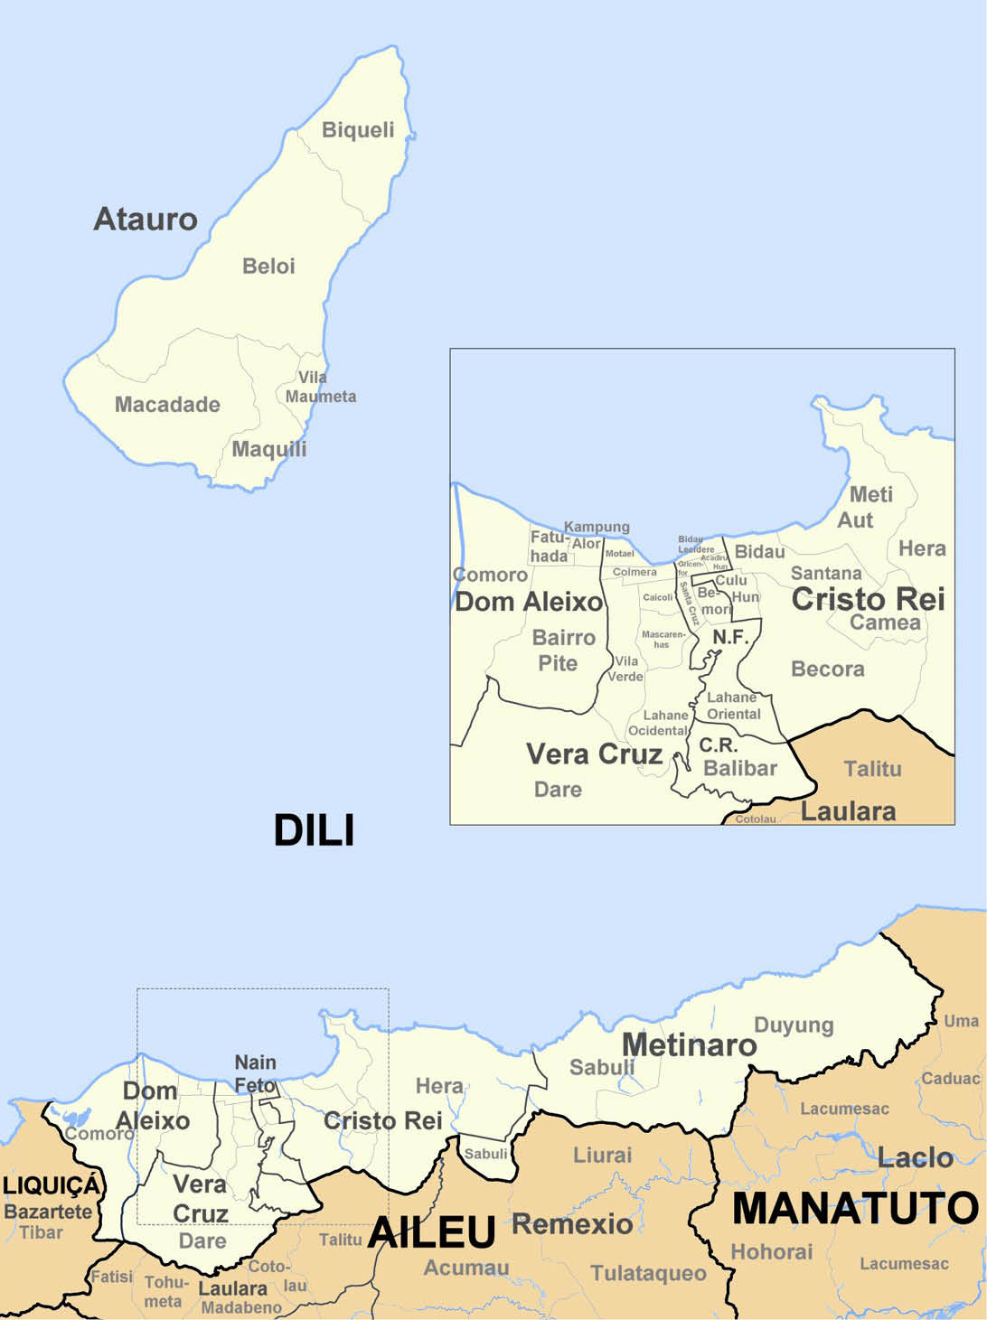
a Map credit: J Patrick Fischer, distributed under a CC BY-SA 3.0 licence.
Timor-Leste experiences a tropical climate with a dry season (May–November) and a rainy season (December–April).4 This provides ideal breeding conditions for the mosquitoes that transmit dengue virus (DENV) to humans; Aedes aegypti and Ae. albopictus.5
Dengue virus infection is caused by one or more of the DENV serotypes (DENV1–DENV4). The World Health Organization (WHO) estimates that there are 390 million infections per year, with 96 million people experiencing symptoms.6,7 The United States Centers for Disease Control and Prevention estimate that there are up to 40,000 deaths globally each year due to DENV.8 The disease is endemic in many countries in tropical and subtropical parts of Asia, Africa, the Americas, the Caribbean and Oceania.9 In Timor-Leste, DENV is endemic year-round, but peak transmission occurs during the rainy season, where mosquitoes can reproduce in various water-holding containers (natural and manmade), particularly in the urban and semi-urban environment.5,10,11 Each wet season, DENV causes considerable morbidity, mortality and burden on the health system in Timor-Leste.

Aim
We aim to briefly describe the epidemiology of DENV in the Municipality of Dili, Timor-Leste from 2018 to 2022.

Methods
We included all cases of DENV notified in the Municipality of Dili, Timor-Leste between 2018 and 2022; a case was defined as any person who tested positive to DENV by polymerase chain reaction (PCR); or where detection of DENV non-structural protein 1 (NS1) antigen or dengue-specific immunoglobulin M [IgM] antibody (using rapid diagnostic tests) occurred.12 Dengue haemhorragic fever was defined as per local surveillance case definitions.12 Case demographic information was entered into an online epidemiological database developed for dengue surveillance in Timor-Leste. Descriptive analysis and graphs were produced using Microsoft Excel 2016 (Microsoft, United States of America).
Ethics approval was not required as activities were conducted under the auspices of routine communicable disease surveillance and response activity.

Results
There were 6,234 cases of DENV notified in Dili, Timor-Leste between 2018 and 2022 (Figure 2) with a mean annual incidence rate of 330 cases per 100,000 population, and peak annual incidence (3,904 cases) occurring in 2022 after an outbreak was declared in January of that year. There was no significant decrease in cases during 2020 and 2021 during the height of the coronavirus disease 2019 (COVID-19) pandemic. All cases were detected using rapid detection kits; none were detected by PCR, as PCR and thus serotyping was not performed. The largest number of cases (41%) were in the 15–24 years age group, followed by the 5–14 years age group (39%). Females represented 51% of cases.
The majority of cases (3,356; 54%) and the largest proportion of deaths (27; 49%) occurred in the Administrative Post of Dom Aleixo. The highest mean annual incidence rate occurred in Metinaro (408 cases per 100,000 population), followed by Dom Aleixo (379 cases per 100,000 population) and Nain Feto (355 cases per 100,000 population). The highest incidence rate during the 2022 outbreak occurred in Dom Aleixo with an incidence rate of 1,291 cases per 100,000 population. This was 9.2 times higher than the mean incidence rate in Dom Alexio over the previous four-year period and represented the greatest increase in incidence rate amongst the six Administrative Posts of Dili over the five-year period.
Between 2018 and 2021, there was a mean of 116 cases of dengue haemorrhagic fever (DHF) per year, with hospital supervised treatment recommended. In 2022, this increased to 760 cases of DHF, exceeding the capacity of the national hospital in Dili. In order to accommodate the increased demand, the facilities previously established for COVID-19 isolation and treatment were repurposed for those requiring or seeking treatment during the DENV outbreak. There were 55 deaths (case fatality rate = 0.9%) during the study period, with 35 deaths occurring during 2022 alone.
Figure 2: Epidemic curve of dengue virus infection cases notified in Dili, Timor-Leste between 1 January 2018 and 31 December 2022
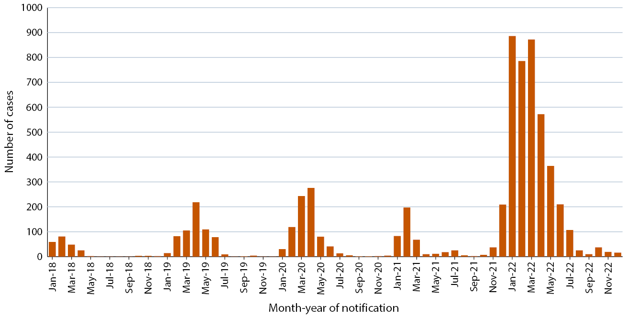

Discussion
Despite the declaration of a ‘State of Calamity’ in April 2021, after the devastating higher-than-expected rainfall and floods that occurred in Dili as a result of Cyclone Seroja,13 a large expected increase in DENV cases and presentations to health facilities did not eventuate. During this period, local transmission of COVID-19 was occurring and it was observed that presentations to health centres and hospitals for all health conditions decreased. This may have been due to a fear of testing positive for COVID-19, and of having to subsequently undergo isolation in COVID-19 treatment or hospital facilities, which was the policy at the time.14,15 It is likely that the true incidence of DENV in 2021 was much higher. Conversely, in 2022 the case ascertainment and reporting was likely much higher, due to the ready availability of DENV rapid test kits at health posts and health centres, and to the use of a new online DENV surveillance database, similar to that implemented during the COVID-19 pandemic. This, combined with a significant outbreak associated with high case numbers of DHF and a high death rate, resulted in the highest incidence of dengue on record in Dili. Dom Aleixo saw the greatest increase in incidence of DENV, and was also the Administrative Post which experienced the highest level of population growth during the five-year period, mostly due to urban migration. Unplanned urbanisation is recognised as being associated with increased dengue transmission due to water storage practices, waste disposal, increased population density, and people’s often-limited access to reliable water sources.7 Under-reporting of cases of dengue, particularly those with minor symptoms, was likely over the study period, as we describe only those cases who reported to health centres and who were subsequently tested and notified to the surveillance department.
Strategies for DENV control in Dili currently focus on vector control including fogging and applying larvicides around locations where cases are notified. Public health messaging also occurs to encourage the community to reduce breeding sites and larval habitats by encouraging people to discard rubbish and other items that can pool water such as old tyres, cans, bottles, etc.16 This can be done at the household level but also occurs at an organised level each Friday morning as ‘limpeza’ whereby some government agencies, private companies and other volunteer groups regularly collect rubbish in public spaces.17 Public health messaging also focuses on: covering up, especially during the day-time biting hours of the mosquito; looking for water reservoirs around the home and tipping them out to prevent breeding sites; and covering containers and other places where adult mosquitoes may inhabit.16
Despite constant vector control and sanitation efforts, the incidence of DENV-related morbidity and mortality remains high in Dili, Timor-Leste. Alternative strategies to reduce the devastating effects of DENV should be investigated immediately. These include the introduction of Wolbachia-infected Ae. aegypti mosquitoes which have a reduced ability to transmit diseases such as DENV, Zika and chikungunya. Deployments of Wolbachia-infected mosquitoes have resulted in significant reductions in local DENV transmission in endemic areas such as Townsville, Australia18 and in Yogyakarta, Indonesia.19,20 In Yogyakarta, the deployment of Wolbachia-infected mosquitoes was achieved by the Indonesian Ministry of Health with significant local community involvement; over 12,000 volunteers were involved in trapping and releasing mosquitoes as well as promoting the project in their local community.20 The deployment of Wolbachia-infected mosquitoes in Timor-Leste would also require government support and community engagement. The vaccine Dengvaxia® is another alternative strategy; however, this vaccine is only recommended for people aged 9–16 years who have previously been infected with DENV and who live in areas where dengue is endemic.21,22 In Timor-Leste, it may be difficult to ascertain whether people have had a previous confirmed infection, as limitations on access to diagnostic testing and care contribute to under-detection and under-reporting of cases. Similarly, the live-attenuated quadrivalent dengue vaccine developed by Takeda (TAK-003)23 could be considered for children aged 6–16 years in dengue-endemic areas with high transmission. However, neither of these vaccines protects those in younger age groups. These vaccines could provide some population-wide benefit by reducing the amount of circulating virus in the population, but the large problem of endemic Ae. aegypti mosquitoes remains and could be addressed by the deployment of Wolbachia-infected mosquitoes to limit the transmission of DENV, chikungunya and Zika virus.

Conclusion
Dengue is endemic in Dili, Timor-Leste and is a significant source of morbidity and mortality, particularly during annual wet season outbreaks. Conditions in Dili provide favourable breeding sites and rapid urban migration possibly accentuates this. Health promotion messages which encourage people with suspected DENV infection to present early for treatment should continue, as should accessibility to rapid tests. The health infrastructure gained during the COVID-19 pandemic, including treatment facilities, online surveillance databases and trained surveillance staff, should all be utilised to improve surveillance and response activities. Existing strategies of vector control and minimising breeding sites may have some effect on risk mitigation; however, the incidence and burden on the health system remains high. The investigation of other DENV control strategies, including deployment of Wolbachia-infected mosquitoes, should be considered in Timor-Leste, particularly in Dili.

Acknowledgements
We acknowledge the workers in the Timor-Leste Ministry of Health.

Author details
Filipe de Neri Machado,1
Anthony DK Draper,2,3,4
Frederico Bosco Alves dos Santos,1
Marcelo Amaral Mali,1
Ari J Pereira Tilman,5
Endang Soares da Silva,5
Noel Gama Soares,6
Nevio Sarmento,2
Maria AV Niha,7,8
Ana Fatima Soares,7
Abdoulie Taal,9
Joshua R Francis,2
Jennifer Yan,2
Megge Miller,10
James Flint10
- Instituto Nacional de Saúde Pública de Timor-Leste, Comoro, Timor-Leste
- Menzies School of Health Research, Charles Darwin University, Dili, Timor-Leste
- National Centre for Epidemiology and Population Health, Australian National University, Canberra, Australia
- Centre for Disease Control, Public Health Unit, Top End Health Service, Northern Territory Government Department of Health, Darwin, Northern Territory, Australia
- Laboratorio Nacional da Saude, Bidau, Timor-Leste
- Surveillance Department, Municipality of Dili, Ministry of Health, Bairo Central, Timor-Leste
- Surveillance Department, Ministry of Health, Caicoli, Timor-Leste
- World Health Organization, Timor-Leste Office, Caicoli, Timor-Leste
- STOP Program, World Health Organization, Dili, Timor-Leste
- Field Epidemiology In Action, School of Medicine and Public Health, University of Newcastle, Callaghan, Australia
Corresponding author
Anthony Draper
Centre for Disease Control, Public Health Division, Northern Territory Government Department of Health, PO Box 45096, Casuarina NT 0811.
Telephone: +61 8 8922 7635.
Facsimile: +61 8 8922 8310.
Email: anthony.draper@nt.gov.au

References
- World Bank. The World Bank in Timor-Leste: Overview. [Internet.] Washington DC: World Bank; April 2022. Available from: https://www.worldbank.org/en/country/timor-leste/overview.
- Government of Timor-Leste. About Timor-Leste. [Internet.] Dili: Government of Timor-Leste; 2022. Available from: http://timor-leste.gov.tl/?p=547&lang=en.
- Government of Timor-Leste. Administrative Division. [Internet.] Dili: Government of Timor-Leste; 2022. Available from: http://timor-leste.gov.tl/?p=91&lang=en.
- Government of Timor-Leste. About Timor-Leste: Geography and Climate. [Webpage.] Dili: Government of Timor-Leste; 2023. Available from https://www.timorleste.tl/east-timor/about/geography-climate.
- Wangdi K, Clements ACA, Du T, Nery SV. Spatial and temporal patterns of dengue infections in Timor-Leste, 2005–2013. Parasit Vectors. 2018;11(1):9. doi: https://doi.org/10.1186/s13071-017-2588-4.
- Brady OJ, Gething PW, Bhatt S, Messina JP, Brownstein JS, Hoen AG et al. Refining the global spatial limits of dengue virus transmission by evidence-based consensus. PLoS Negl Trop Dis. 2012;6(8): e1760. doi: https://doi.org/10.1371/journal.pntd.0001760.
- World Health Organization (WHO). Dengue and severe dengue. [Webpage.] Geneva: WHO; 17 March 2023. Available from: https://www.who.int/news-room/fact-sheets/detail/dengue-and-severe-dengue.
- Centers for Disease Control and Prevention (CDC). About dengue: what you need to know. [Webpage.] Atlanta: Government of the United States of America, Department of Health and Human Services, CDC; 14 June 2023. Available from https://www.cdc.gov/dengue/about/index.html.
- Wilder-Smith A. Dengue. In Heymann DL, ed. Control of Communicable Diseases Manual. 20th ed. Fort Worth: American Public Health Association, APHA Press, 2015.
- Quintero J, Brochero H, Manrique-Saide P, Barrera-Pérez M, Basso C, Romero S et al. Ecological, biological and social dimensions of dengue vector breeding in five urban settings of Latin America: a multi-country study. BMC Infect Dis. 2014;14:38. doi: https://doi.org/10.1186/1471-2334-14-38.
- García-Betancourt T, Higuera-Mendieta DR, González-Uribe C, Cortés S, Quintero J. Understanding water storage practices of urban residents of an endemic dengue area in Colombia: perceptions, rationale and socio-demographic characteristics. PLoS One. 2015;10(6):e0129054. doi: https://doi.org/10.1371/journal.pone.0129054.
- Timor-Leste Ministry of Health. Integrated Disease Surveillance and Response. A guideline for implementation in Timor-Leste. Dili: Government of Timor-Leste Ministry of Health; September 2022. Available from: https://apps.ms.gov.tl/moh2/idsr.php?lan=eng&p1=003&p2=007&p3=008&p4=009&p5=010.
- Government of Timor-Leste Office of the Prime Minister. Timor-Leste declares the State of Calamity. [Webpage.] Dili: Government of Timor-Leste Office of the Prime Minister; 2022. Accessed from: https://www.gpm.gov.tl/en/timor-leste-iha-estadu-kalamidade/.
- Timor-Leste Ministry of Health. National Guidance on Surveillance and Contact Management of COVID-19 for Timor-Leste. Dili: Government of Timor-Leste, Ministry of Health; 2020.
- Government of Timor-Leste. Jornal da República – Publicação Oficial da República Democrática de Timor-Leste. Numero Extraordinario. Diploma Ministerial N.º 42 /2021 de 12 de Julho. Define as regras de cumprimento do isolamento terapêutico obrigatório na residência. Dili: Government of Timor-Leste; 12 July 2021. Available from: http://timor-leste.gov.tl/wp-content/uploads/2021/07/SERIE-I-N.-28-C1.pdf
- Government of Timor-Leste. National Guidelines for Clinical Management of DENGUE 2022. Dili: Government of Timor-Leste Ministry of Health; 12 December 2022. Available from: https://cdn.who.int/media/docs/default-source/2021-dha-docs/5_national-clinical-guideline-of-dengue-timor-leste_clean_final-12-dec-2022.pdf.
- Government of Timor-Leste. Inisiativa limpeza jerál mantein no hala’o nafatin kada sexta-feira (General cleaning initiative continues and will now take place every Friday). [Media release.] Dili: Government of Timor-Leste; 3 February 2022. Available from: http://timor-leste.gov.tl/?p=30047&lang=en.
- O’Neill SL, Ryan PA, Turley AP, Wilson G, Retzki K, Iturbe-Ormaetxe I et al. Scaled deployment of Wolbachia to protect the community from dengue and other Aedes transmitted arboviruses. Gates Open Res. 2019;2:36. doi: https://doi.org/10.12688/gatesopenres.12844.3.
- Utarini A, Indriani C, Ahmad RA, Tantowijoyo W, Arguni E, Ansari MR et al. Efficacy of Wolbachia-infected mosquito deployments for the control of dengue. N Engl J Med. 2021;384(23):2177–86. doi: https://doi.org/10.1056/NEJMoa2030243.
- World Mosquito Program (WMP). Global Progress – Yogyakarta. [Webpage.] Melbourne: Monash University, WMP; 2023. Available from: https://www.worldmosquitoprogram.org/en/global-progress/indonesia/yogyakarta-city.
- CDC. Dengue Vaccine Information Statement (VIS). Atlanta: Government of the United States of America, Department of Health and Human Services, CDC; 17 December 2021. Available from: https://www.cdc.gov/vaccines/hcp/vis/vis-statements/dengue.html.
- WHO. Dengue vaccine safety update. [Webpage.] Geneva: WHO; 19 January 2018. Available from: https://www.who.int/groups/global-advisory-committee-on-vaccine-safety/topics/dengue-vaccines/safety-update.
- Takeda. Takeda’s dengue vaccine recommended by World Health Organization advisory group for introduction in high dengue burden and transmission areas in children ages six to 16 years. [Internet.] Tokyo: Takeda Pharmaceutical Company Limited; 3 October 2023. Available from: https://www.takeda.com/newsroom/newsreleases/2023/Takeda-Dengue-Vaccine-Recommended-by-World-Health-Organization-Advisory-Group-for-Introduction-in-High-Dengue-Burden-and-Transmission-Areas-in-Children-Ages-Six-to-16-Years/.

Communicable Diseases Intelligence
Communicable Diseases Intelligence (CDI) is a peer-reviewed scientific journal published by the Health Protection Policy & Surveillance Division, Department of Health and Aged Care. The journal aims to disseminate information on the epidemiology, surveillance, prevention and control of communicable diseases of relevance to Australia.
© 2024 Commonwealth of Australia as represented by the Department of Health and Aged Care
ISSN: 2209-6051 Online
This journal is indexed by Index Medicus and Medline.
This publication is licensed under a Creative Commons Attribution-NonCommercial-NoDerivatives 4.0 International Licence (CC BY-NC-ND) available from https://creativecommons.org/licenses/by-nc-nd/4.0/legalcode (Licence). You must read and understand the Licence before using any material from this publication.
Restrictions
The Licence does not cover, and there is no permission given for, use of any of the following material found in this publication (if any):
- the Commonwealth Coat of Arms (by way of information, the terms under which the Coat of Arms may be used can be found at www.pmc.gov.au/resources/commonwealth-coat-arms-information-and-guidelines);
- any logos (including the Department of Health and Aged Care’s logo) and trademarks;
- any photographs and images;
- any signatures; and
- any material belonging to third parties.
Disclaimer
Opinions expressed in Communicable Diseases Intelligence are those of the authors and not necessarily those of the Australian Government Department of Health and Aged Care or the Communicable Diseases Network Australia. Data may be subject to revision.
Enquiries
Enquiries regarding any other use of this publication should be addressed to the CDI Editor at: cdi.editor@health.gov.au
Communicable Diseases Network Australia
Communicable Diseases Intelligence contributes to the work of the Communicable Diseases Network Australia. www.health.gov.au/cdna
Editor: Christina Bareja • Deputy Editor: Simon Petrie • Design and Production: Lisa Thompson
Editorial Advisory Board: David Durrheim, Mark Ferson, Clare Huppatz, John Kaldor, Martyn Kirk, Meru Sheel and Stephanie Williams
Contacts
CDI is produced by:
Health Protection Policy & Surveillance Division, Australian Government Department of Health and Aged Care,
GPO Box 9848, (MDP 6) CANBERRA ACT 2601
Website: www.health.gov.au/cdi
Email: cdi.editor@health.gov.au
Submit an Article
You are invited to submit your next communicable disease related article to the Communicable Diseases Intelligence (CDI) for consideration. More information regarding CDI can be found at: www.health.gov.au/cdi.
Further enquiries should be directed to: cdi.editor@health.gov.au.

