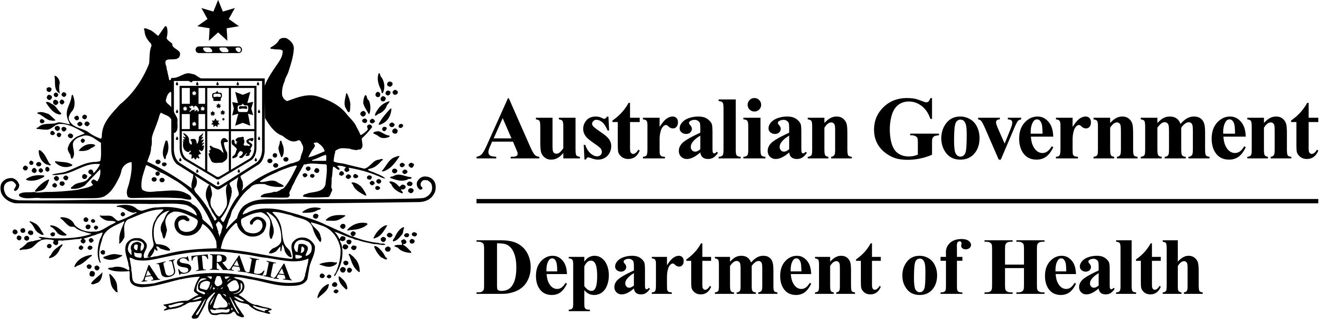

Medicare Benefits Schedule (MBS)
Health Assessments
MBS Items 701, 703, 705 and 707
Fact Sheet

Health Assessments
There are four time-based MBS health assessment items: 701 (brief), 703 (standard),
705 (long) and 707 (prolonged). The following categories of health assessments may be undertaken by a medical practitioner (other than a specialist or consultant physician) under these items:
- a health assessment for people aged 45-49 years who are at risk of developing chronic disease
- a type 2 diabetes risk evaluation for people aged 40-49 years with a high risk of developing type 2 diabetes as determined by the Australian Type 2 Diabetes Risk Assessment Tool
- a health assessment for people aged 75 years and older
- a comprehensive medical assessment for permanent residents of residential aged care facilities
- a health assessment for people with an intellectual disability
- a health assessment for refugees and other humanitarian entrants
The decision to use any one of these four MBS health assessment items to carry out a health assessment will depend on the practitioner’s clinical judgement based on the complexity of the presentation and the type of health assessment used.

Health Assessment for Aboriginal and Torres Strait Islander People – MBS Item 715
Medical practitioners providing a health assessment for Aboriginal and Torres Strait Islander people should use MBS Item 715. This MBS health assessment item has no designated time or complexity requirements. The length of the health assessment will be at the medical practitioner’s discretion. MBS Item 715 should be used for health assessments for the following age groups:
- Aboriginal and Torres Strait Islander children who are less than 15 years old
- Aboriginal and Torres Strait Islander adults who are aged 15 years and over but under the age of 55 years
- Aboriginal and Torres Strait Islander older people who are aged 55 years and over

Components of a health assessment
Health assessments are generally made up of the following elements:
- information collection, including taking a patient history and undertaking or arranging examinations and investigations as required;
- making an overall assessment of the patient;
- recommending appropriate interventions;
- providing advice and information to the patient;
- keeping a record of the health assessment, and offering the patient a written report about the health assessment, with recommendations about matters covered by the health assessment; and
- offering the patient’s carer (if any, and if the medical practitioner considers it appropriate and the patient agrees) a copy of the report or extracts of the report relevant to the carer.

Patient consent
The patient or their parent/guardian must be given an explanation of the health assessment process and its likely benefits, and must be asked by the medical practitioner, practice nurse or Aboriginal and Torres Strait Islander health practitioner whether they consent to the health assessment being performed. Consent must be noted on the patient record.

‘Usual Doctor’ and other health professionals
A MBS health assessment item may only be claimed by a medical practitioner, including a general practitioner but not including a specialist or consultant physician. A health assessment should generally be undertaken by the patient’s ‘usual doctor’, that is, the medical practitioner (or medical practitioner in the same practice) who has provided the majority of services to the patient in the past 12 months, and/or is likely to provide the majority of services in the following 12 months.
Should a medical practitioner other than the patient’s ‘usual doctor’ or practice nurse undertake the health assessment, a copy of the health assessment record should be forwarded to the patient’s ‘usual doctor’ or practice, subject to the agreement of the patient or their parent/guardian.
The medical practitioner is expected to take a primary role in the following activities when providing a health assessment:
- reviewing and analysing the information collected;
- making an overall assessment of the patient;
- undertaking and arranging investigations;
- making referrals and identifying appropriate follow-up; and
- providing advice to the patient.
Practice nurses and Aboriginal and Torres Strait Islander health practitioners may assist medical practitioners in performing a health assessment, in accordance with accepted medical practice and under the supervision of the medical practitioner. This may include activities associated with:
- information collection; and
- providing patients with information about recommended interventions at the direction of the medical practitioner.
All other components of the health assessment must include a personal attendance by a doctor.

Restrictions on providing a MBS health assessment item
A health assessment should not take the form of a health screening service.
The MBS health assessment items are not available to in-patients of a hospital or care recipients in a residential aged care facility. The exception to this is a comprehensive medical assessment, which is available to a care recipient in a residential aged care facility.
Any ongoing conditions that are identified in the course of a health assessment should be managed using existing MBS general practice attendance items or the MBS follow-up items provided by practice nurses, registered Aboriginal and Torres Strait Islander health practitioners or allied health professionals.

Medical practitioners should not conduct a separate consultation in conjunction with a MBS health assessment item unless it is clinically necessary (ie. the patient has an acute problem that needs to be managed separately from the assessment). The only exceptions are:
- the Healthy Kids Check, where a consultation associated with the four year old immunisation can be conducted on the same occasion; and
- the comprehensive medical assessment, where, if this health assessment is undertaken during the course of a consultation for another purpose, the health assessment item and the relevant item for the other consultation may both be claimed.
MBS Items 701, 703, 705, 707, 715 and 10986 do not apply for services that are provided by any other Commonwealth or State funded services. However, where an exemption under subsection 19(2) of the Health Insurance Act 1973 has been granted to an Aboriginal Community Controlled Health Service or State/Territory Government health clinic, MBS Items 701, 703, 705, 707, 715 and 10986 can be claimed for services provided by medical practitioners, practice nurses or Aboriginal and Torres Strait Islander health practitioners salaried by or contracted to, the service or health clinic. All requirements of the MBS items must be met.
Where the patient is a Commonwealth concession cardholder or a child under 16 years of age and the service is bulk billed, the GP can also claim a bulk billing incentive payment (MBS Items 10990 and 10991).

Questions and Answers
Can a practice nurse or Aboriginal and Torres Strait Islander health practitioner assist with a health assessment?
Yes. A practice nurse or Aboriginal and Torres Strait Islander health practitioner can assist the medical practitioner by undertaking the information collection of a health assessment and by providing patients with information about recommended interventions (at the direction of the medical practitioner).

Who can receive a health assessment?
The four time-based health assessment items consist of brief, standard, long and prolonged consultations. Medical practitioners may select one of the MBS health assessment items to provide a health assessment service to a member of the target groups that are eligible for a health assessment. The health assessment requirements for each target group can be found in the Explanatory Notes at MBS Online.
The Fact Sheets for each target group are available on the Department of Health website.
Are proformas available for the health assessments?
Yes. Proformas are available to assist you in completing the health assessments. These can be found on the Department of Health website.
When should I use MBS Item 715?
The Aboriginal and Torres Strait Islander peoples health assessment item is specifically intended to provide Indigenous people with a culturally sensitive health assessment service. The health assessment covers a wide range of conditions and factors that may affect the health of Indigenous people, across the full span of life. MBS Item 715 is particularly recommended for Indigenous children of pre-school age, as it provides a more comprehensive survey of a child’s health than the more general Healthy Kids Check.
Guidelines and Resources
For more detailed information about MBS item descriptors and explanatory notes visit
MBS Online or phone the Department of Human Services (Medicare) provider enquiry line on 132 150 or the patient enquiry line on 132 011.

