HIV risk and gonococcal genotype: Opportunities to improve passive surveillance for prompt identification of syndemics?
Sara FE Bell, Stephen B Lambert, Amy V Jennison, Christine JD Guglielmino, Robert S Ware, David M Whiley
To understand the risk of HIV associated with gonococcal genotypes, we analysed linked Queensland datasets of genotyped Neisseria gonorrhoeae isolates with phenotypic resistance data with HIV notifications. Further research into the association of gonococcal genotypes and risk of HIV acquisition may be helpful to develop targeted public health interventions.
Keywords: Neisseria gonorrhoeae, genotype, HIV, Queensland
Syndemics arise when health conditions act together, increasing morbidity and mortality.¹ For example, human immunodeficiency virus (HIV) transmission increases in the presence of other sexually transmissible infections, including Neisseria gonorrhoeae (NG).² To understand potential associations between HIV infection and gonococcal genotypes and antimicrobial sensitivity, we analysed linked Queensland datasets of genotyped NG isolates (using N. gonorrhoeae multiantigen sequence typing, NG-MAST)^{3,4} with phenotypic resistance data, ascertained by standardised methods,⁵ in the period 1 January 2010 to 31 December 2015 and new HIV notifications from 1 January 2009 to 31 December 2016 (before widespread use of HIV pre-exposure prophylaxis). Currently, empiric dual therapy, ceftriaxone and azithromycin, is recommended treatment for uncomplicated NG cases.⁶ Susceptibility was established for all positive NG isolates referred from public and private pathology services to the Queensland state reference laboratory. Only one positive NG isolate per case from each episode of care, at least one month from a previous NG detection, was included for analysis.
A total of 3340 NG isolates, representing 29.9% (3340/11170) of all unique NG notifications, from 3082 unique cases were genotyped using NG-MAST. There were 732 unique sequence types (ST) identified; most prevalent was ST6876 (7.1%, 237/3340) (Table 1). Prevalence of STs changed over time: ST6876, dominant in 2010 (14.0%, 91/652) and 2011 (14.6%, 94/644) was absent in 2015; ST4186, absent in 2010, accounted for 10.7% (42/394) of NG genotypes in 2015 (Figure 1).
There were 156 (4.5%, 156/3340) genotyped NG isolate results linked to 128 (4.9%, 128/2592) HIV notifications. Of linked HIV notifications, 106, 18, 2 and 2 were associated with 1, 2, 3 or 4 genotyped results, respectively. Of the 22 HIV notifications linked to two or more genotyped results, only 1/22 (4.5%) had a repeat NG genotype (ST4951) notified 40 days following the first notification; the remainder had different NG genotypes identified. Repeat infections were more common among NG infections linked to HIV notifications (17.9%, 28/156) compared to those unlinked (7.2%, 230/2954) (odds ratio (OR) 2.5, 95% CI 1.7–3.6). This association may be due to greater testing rates, or greater rates of gonorrhoea reinfection, for people living with HIV.
HIV notifications were linked to 65 NG genotypes (8.9%, 65/732), suggesting, like other studies,⁷ that HIV is not necessarily associated with a limited number of gonococcal genotypes. Across the study period, two NG genotypes had significantly increased risk of same-calendar-year HIV diagnosis (ST1407 [from 2012 to 2015]: OR 5.1, 95% CI 1.8–14.8; and ST2992 [from 2010 to 2012]: OR 3.2, 95% CI 1.2–8.3) when compared to all other NG genotypes from the same calendar year. Both ST1407, harbouring a mosaic penA gene, and ST2992, harbouring a mosaic mtrR gene, are internationally recognised successful clones.⁸ A high degree of antimicrobial resistance was exhibited by ST1407, with 97.6% (81), 67.5% (56) and 7.2% (6) of isolates being resistant to ciprofloxacin, penicillin and azithromycin, respectively, and 27.7% (23) exhibiting decreased susceptibility to ceftriaxone. Only 2.4% of isolates (2/83) were susceptible to all four antimicrobials. Sequence type 1407 has been identified in men who have sex with men (MSM) and heterosexual networks, as have interrelated strains with key genetic markers, suggesting men who have sex with men and women present opportunities for strains to bridge between sexual networks.⁹ Bridging networks represent the potential for enabling HIV entry into heterosexual networks.¹⁰ Conversely, ST2992 exhibited a high degree of antimicrobial susceptibility, with 7.3% of isolates (12/165) being resistant to azithromycin only. A Melbourne study¹⁰ suggests ST2992 is associated more exclusively with MSM sexual networks.
Further research into the association of gonococcal genotypes and risk of HIV acquisition may be helpful, noting there is increasing concern of HIV becoming established in Far North Queensland, syndemic with syphilis.¹¹ Analyses such as ours could help develop targeted public health interventions to identify and respond to important syndemic relationships. Routine NG genotyping to identify risk NG genotypes could provide real-time feedback to clinicians to promote HIV testing and awareness of HIV pre-exposure prophylaxis (PrEP). On-going surveillance of NG genotypes and HIV notifications might assist to minimise outbreaks, within and between sexual networks; however, the success of this strategy is highly dependent on the information technology infrastructure available.

Table 1: Descriptive summary of Neisseria gonorrhoeae Multiantigen Sequence Typing (NG-MAST), HIV notifications and linked cases,ª 2009–2016, Queensland, Australia
Detail | Notifications |  | Linked cases
 | Number | % | Number | %
 | NG-MAST result |  | Linked to HIV notification
Neisseria gonorrhoeae Multiantigen Sequence Type (NG-MAST) tested | 3340 | 100.0 | 156^{b} |  | 100.0
NG-MAST
6876 | 237 | 7.1 | 0 |  | 0.0
2992 | 165 | 4.9 | 23 |  | 14.7
21 | 146 | 4.4 | 9 |  | 5.8
4186 | 133 | 4.0 | 4 |  | 2.6
6879 | 100 | 3.0 | 0 |  | 0.0
1407 | 83 | 2.5 | 10 |  | 6.4
6937 | 75 | 2.2 | 0 |  | 0.0
4244 | 73 | 2.2 | 5 |  | 3.2
Other NG-MAST (724 sequence types) | 2328 | 69.7 | 105 |  | 67.3
Anatomical site of collection
Urethra | 1707 | 51.1 | 68 |  | 43.6
Vagina | 617 | 18.5 | 0 |  | 0.0
Rectum | 432 | 12.9 | 70 |  | 44.9
Pharynx | 224 | 6.7 | 17 |  | 10.9
Cervix | 146 | 4.4 | 0 |  | 0.0
Other anatomical site | 214 | 6.4 | 1 |  | 0.6
Year of collection
2010 | 652 | 19.5 | 22 |  | 14.1
2011 | 644 | 19.3 | 27 |  | 17.3
2012 | 564 | 16.9 | 27 |  | 17.3
2013 | 548 | 16.4 | 19 |  | 12.2
2014 | 538 | 16.1 | 38 |  | 24.4
2015 | 394 | 11.8 | 23 |  | 14.7
 | HIV notification |  | Linked to NG-MAST result
New Queensland HIV notifications | 2592 | 100.0 | 128^{b} |  | 100.0
Sex
Male | 2233 | 86.1 | 128 |  | 100.0
Female | 357 | 13.8 | 0 |  | 0.0
Not specified | 2 | 0.1 | 0 |  | 0.0
Aboriginal and or Torres Strait Islander person
No | 2475 | 95.5 | 126 |  | 98.4
Yes | 114 | 4.4 | 2 |  | 1.6
Not specified | 3 | 0.1 | 0 |  | 0.0
First HIV diagnosis in Qld
No | 924 | 35.6 | 18 |  | 14.1
Yes | 1668 | 64.4 | 110 |  | 85.9
Reported HIV exposure (% of cases)^{c}
Men who have sex with men / bisexual | 1748 | 67.4 | 124 |  | 96.9
Person/partner with origin from a high prevalence country | 512 | 19.8 | 3 |  | 2.3
Heterosexual | 355 | 13.7 | 3 |  | 2.3
Injecting drug use | 202 | 7.8 | 11 |  | 7.8
Not reported/unknown | 127 | 4.9 | 0 |  | 0.0
Partner with/at risk of infection | 107 | 4.1 | 0 |  | 0.0
Maternal | 25 | 1.0 | 0 |  | 0.0
Year of notification
2009 | 277 | 10.7 | 20 |  | 15.6
2010 | 310 | 12.0 | 17 |  | 13.3
2011 | 282 | 10.9 | 29 |  | 22.7
2012 | 350 | 13.5 | 23 |  | 18.0
2013 | 309 | 11.9 | 10 |  | 7.8
2014 | 366 | 14.1 | 16 |  | 12.5
2015 | 340 | 13.1 | 9 |  | 7.0
2016 | 358 | 13.8 | 4 |  | 3.1
a Significant HIV/NG-MAST associations are bolded.
b The numbers of ‘linked’ cases differ owing to an individual HIV notification being linked to one or more NG-MAST results.
c Multiple exposures possible.

Figure 1: Percentage of Neisseria gonorrhoeae isolates by Multiantigen Sequence Type (NG-MAST) by year, 2010–2015, Queensland, Australia
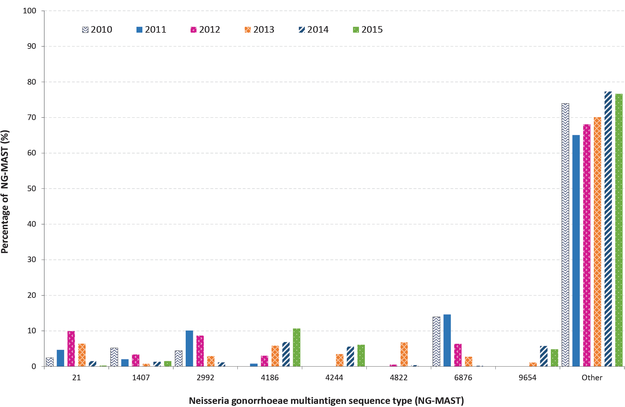

Ethics
Ethical approval was granted by the Prince Charles Hospital Human Research Ethics Committee HREC/15/QPCH/44. Approval for the provision of data held by Queensland Government Department of Health for public interest was granted (PHA 27230).

Funding
Funding was provided by the HIV Foundation Queensland (HIVFQ).

Author details
Ms Sara F. E. Bell,¹ Ph.D. student
A/Prof. Stephen B Lambert,^{2,3} Public Health Physician
A/Prof. Amy V Jennison,⁴ Chief Scientist
Ms Christine JD Guglielmino,⁴ Scientist
Prof. Robert S Ware,⁵ Biostatistician
A/Prof. David M Whiley,¹ Principal Research Fellow

- The University of Queensland, UQ Centre for Clinical Research, Herston, Queensland, Australia
- Communicable Diseases Branch, Queensland Health, Herston, Queensland, Australia
- National Centre for Immunisation Research and Surveillance, Westmead, New South Wales, Australia
- Queensland Health Forensic and Scientific Services, Coopers Plains, Queensland, Australia
- Griffith University, Menzies Health Institute Queensland, Nathan, Queensland, Australia

Corresponding author
Associate Professor David Whiley Principal Research Fellow, Microbial Diagnostics and Characterisation Group, Level 7, Building 71/918, Royal Brisbane and Women’s Hospital, Herston Qld 4029
Phone: (07) 3346 5053 Email: d.whiley@uq.edu.au

References
- Whelan M, Renda C, Hohenadel K, Buchan S, Murti M. All together now: aggregating multiple records to develop a person-based dataset to integrate and enhance infectious disease surveillance in Ontario, Canada. Can J Public Health. 2020;111(5):752–60. doi: https://doi.org/10.17269/s41997-020-00295-5.
- Grome HN, Rebeiro PF, Brantley M, Herrera-Vasquez D, Mathieson SA, Pettit AC. Risk of HIV diagnosis following bacterial sexually transmitted infections in Tennessee, 2013–2017. Sex Transm Dis. 2021;48(11):873–80. doi: https://doi.org/10.1097/OLQ.0000000000001440.
- Martin IMC, Ison CA, Aanensen DM, Fenton KA, Spratt BG. Rapid sequence-based identification of gonococcal transmission clusters in a large metropolitan area. J Infect Dis. 2004;189(8):1497–505. doi: https://doi.org/10.1086/383047.
- Jolley KA, Bray JE, Maiden MCJ. Open-access bacterial population genomics: BIGSdb software, the PubMLST.org website and their applications. Wellcome Open Res. 2018;3:124. doi: https://doi.org/10.12688/wellcomeopenres.14826.1.
- Lahra MM, Hogan TR, Shoushtari M, Armstrong BH. Australian Gonococcal Surveillance Programme Annual Report, 2020. Commun Dis Intell (2018). 2021;45. doi: https://doi.org/10.33321/cdi.2021.45.58.
- Australasian Sexual and Reproductive Health Alliance (ASRHA). Australian STI Management Guidelines for use in primary care. [Internet.] Sydney: ASHRA; 2016. Available from: http://www.sti.guidelines.org.au/.
- Choudhury B, Risley CL, Ghani AC, Bishop CJ, Ward H, Fenton KA et al. Identification of individuals with gonorrhoea within sexual networks: a population-based study. Lancet. 2006;368(9530): 139–46. doi: https//doi.org/10.1016/s0140-6736(06)69003-x.
- Mlynarczyk-Bonikowska B, Serwin AB, Golparian D, Walter de Walthoffen S, Majewski S, Koper M et al. Antimicrobial susceptibility/resistance and genetic characteristics of Neisseria gonorrhoeae isolates from Poland, 2010–2012. BMC Infect Dis. 2014;14:65. doi: https://doi.org/1410.1186/1471-2334-14-65.
- Chen CC, Yen MY, Wong WW, Li LH, Huang YL, Chen KW et al. Tracing subsequent dissemination of a cluster of gonococcal infections caused by an ST1407-related clone harbouring mosaic penA alleles in Taiwan. J Antimicrob Chemother. 2013;68(7):1567–71. doi: https://doi.org/10.1093/jac/dkt059.
- Williamson DA, Chow EPF, Gorrie CL, Seemann T, Ingle DJ, Higgins N et al. Bridging of Neisseria gonorrhoeae lineages across sexual networks in the HIV pre-exposure prophylaxis era. Nat Commun. 2019;10(1):3988. doi: https://doi.org/10.1038/s41467-019-12053-4.
- Queensland Health. North Queensland Aboriginal and Torres Strait Islander HIV Response Plan 2019–2021. Cairns: Queensland Government, Queensland Health, Cairns and Hinterland Hospital and Health Service; 2019. Available from: https://cairns-hinterland.health.qld.gov.au/_media/for-health-professionals/tropical-public-health-service/nq-hiv-response-plan.pdf.

Communicable Diseases Intelligence
ISSN: 2209-6051 Online

Communicable Diseases Intelligence (CDI) is a peer-reviewed scientific journal published by the Office of Health Protection and Response, Department of Health. The journal aims to disseminate information on the epidemiology, surveillance, prevention and control of communicable diseases of relevance to Australia.

Editor: Jennie Hood and Noel Lally
Deputy Editor: Simon Petrie
Design and Production: Kasra Yousefi
Editorial Advisory Board: David Durrheim, Mark Ferson, John Kaldor, Martyn Kirk and Linda Selvey

Website: http://www.health.gov.au/cdi

Contacts
CDI is produced by the Office of Health Protection and Response, Australian Government Department of Health, GPO Box 9848, (MDP 6) CANBERRA ACT 2601

Email: cdi.editor@health.gov.au

Submit an Article
You are invited to submit your next communicable disease related article to the Communicable Diseases Intelligence (CDI) for consideration. More information regarding CDI can be found at: http://health.gov.au/cdi.
Further enquiries should be directed to: cdi.editor@health.gov.au.

This journal is indexed by Index Medicus and Medline.

Creative Commons Licence - Attribution-NonCommercial-NoDerivatives CC BY-NC-ND
© 2022 Commonwealth of Australia as represented by the Department of Health
This publication is licensed under a Creative Commons Attribution-NonCommercial-NoDerivatives 4.0 International Licence from https://creativecommons.org/licenses/by-nc-nd/4.0/legalcode (Licence). You must read and understand the Licence before using any material from this publication.

Restrictions
The Licence does not cover, and there is no permission given for, use of any of the following material found in this publication (if any):
- the Commonwealth Coat of Arms (by way of information, the terms under which the Coat of Arms may be used can be found at www.itsanhonour.gov.au);
- any logos (including the Department of Health’s logo) and trademarks;
- any photographs and images;
- any signatures; and
- any material belonging to third parties.

Disclaimer
Opinions expressed in Communicable Diseases Intelligence are those of the authors and not necessarily those of the Australian Government Department of Health or the Communicable Diseases Network Australia. Data may be subject to revision.

Enquiries
Enquiries regarding any other use of this publication should be addressed to the Communication Branch, Department of Health, GPO Box 9848, Canberra ACT 2601, or via e-mail to: copyright@health.gov.au

Communicable Diseases Network Australia
Communicable Diseases Intelligence contributes to the work of the Communicable Diseases Network Australia.
http://www.health.gov.au/cdna

