Surveillance of adverse events following immunisation in Australia annual report, 2020
Aditi Dey, Han Wang, Helen Quinn, Alexis Pillsbury, Megan Hickie, Lucy Deng, Nicholas Wood, Frank Beard, Kristine Macartney

Abstract
This report summarises Australian spontaneous surveillance data for adverse events following immunisation (AEFI) for 2020, reported to the Therapeutic Goods Administration (TGA), and describes reporting trends over the 21-year period from 1 January 2000 to 31 December 2020. There were 3,827 AEFI records for vaccines administered in 2020, an annual AEFI reporting rate of 14.9 per 100,000 population. There was a slight (3.8%) decrease in the overall AEFI reporting rate in 2020 compared with 2019 (15.5 per 100,000 population). This decrease in the AEFI reporting rate in 2020 is potentially due to the impact of coronavirus disease 2019 (COVID-19) and was mainly from a decline in reported adverse events related to HPV, dTpa, and seasonal influenza vaccines. AEFI reporting rates for most individual vaccines in 2020 were similar to 2019. The most commonly reported adverse events were injection site reaction (37.1%); pyrexia (18.1%); rash (15.8%); vomiting (7.6%); pain (7.4%); headache (5.7%); and urticaria (5.1%). There were six deaths reported to the TGA. In one of the reports, the timing and clinical findings were consistent with a causal association with vaccination. In the remaining five reports, no clear causal relationship with vaccination was found.
Keywords: AEFI, adverse events, vaccines, surveillance, immunisation, vaccine

Introduction
This report summarises national spontaneous surveillance data for adverse events following immunisation (AEFI) reported to the Therapeutic Goods Administration (TGA). The report focuses on AEFI reported for vaccines administered during 2020 and on trends in AEFI reporting over the 21-year period 1 January 2000 – 31 December 2020.
An adverse event following immunisation is defined as any untoward medical occurrence which follows immunisation and which does not necessarily have a causal relationship with the usage of the vaccine.¹ The adverse event may be any unfavourable or unintended sign, abnormal laboratory finding, symptom or disease.¹
Thus, AEFI may be caused by a vaccine or vaccines, or may be coincidental. Adverse events may also include conditions that occur following the incorrect handling and/or administration of a vaccine or vaccines. The post-marketing surveillance of AEFI is particularly important for detection of signals of rare, late onset or unexpected events, which are difficult to detect in pre-registration vaccine trials.
Reports summarising national AEFI surveillance data have been published regularly since 2003.^{2–16} Trends in reported AEFI are influenced by changes to vaccine funding and availability through the National Immunisation Program (NIP); the impact of these changes on the interpretation of trend data has been described in previous reports published since 2003.^{2–16} Changes to the NIP since 2005 are summarised in Appendix A, Table A.1. To assist readers, Appendix A also provides a glossary of abbreviations of vaccines referred to in this report.
Recent changes (2019 to 2020) that impact on AEFI surveillance data presented in this report are:
- July 2020:
  - The funded schedule was expanded for Aboriginal and Torres Strait Islander children living in the Northern Territory, Queensland, South Australia and Western Australia from 13vPCV at 2, 4, 6 and 12 months (3+1) to include an additional dose of 23vPPV at 4 years of age and a second dose 5–10 years later.
  - A single dose of 13vPCV was recommended and funded for Aboriginal and Torres Strait Islander adults at 50 years of age, followed by a dose of 23vPPV 12 months later and a second dose of 23vPPV 5–10 years after that.
  - A single dose of 13vPCV was recommended and funded for non-Indigenous adults at 70 years of age, replacing the previously-funded dose of 23vPPV at 65 years of age.
  - Meningococcal B vaccine was funded for all Aboriginal and Torres Strait Islander children (age < 12 months) and individuals of any age with specified high-risk medical conditions. Catch-up was funded for all Aboriginal and Torres Strait Islander children < 2 years of age for three years, until 30 June 2023.
- March 2020:
  - All children aged 6 months to < 5 years were funded for influenza vaccine under NIP.
  - The first enhanced quadrivalent influenza vaccine (adjuvanted) was funded nationally for adults aged 65 years and over.
- December 2019:
  - In South Australia, multicomponent recombinant meningococcal B vaccine catch-up, for children aged 12–47 months (˂4 years), ceased on 31 December 2019.
- April 2019:
  - Meningococcal ACWY conjugate vaccine was funded under the NIP for adolescents aged 14–16 years delivered through a school-based program and for adolescents aged 15–19 years delivered through primary care providers as part of an ongoing catch-up program.
- March 2019:
  - In the Northern Territory, the annual seasonal influenza vaccination program was funded for all children aged 6 months to < 5 years.
- February 2019
  - Annual seasonal influenza vaccination was funded on the national childhood vaccination schedule for all Australian children aged 6 months to < 5 years.
  - Aboriginal and Torres Strait Islander children and adolescents aged 5–14 years of age were funded for influenza vaccine under NIP.

Methods
AEFI are reported to the TGA by state and territory health departments; by health professionals; by vaccine companies; and by members of the public.¹⁷ All reported AEFI are assessed using internationally-consistent criteria¹⁸ and entered into the Australian Adverse Event Management System (AEMS) database. Where there is insufficient information to determine causality for select serious adverse events, the TGA will attempt to contact the reporter on up to three occasions to elicit further information.

AEFI data
De-identified information on all AEFI reported to the TGA from 1 January 2000 to 31 December 2020 and stored in the AEMS database was released to the National Centre for Immunisation Research and Surveillance (NCIRS) in June 2021. Readers are referred to previous AEFI surveillance reports for a description of the surveillance system.^{3,6}
Records contained in the AEMS database were eligible for inclusion in the analysis if a vaccine was recorded as ‘suspected’ of causal involvement in the reported adverse event and either
- the vaccination occurred between 1 January 2000 and 31 December 2020, or
- for records where the vaccination date was not recorded, the date of onset of symptoms or signs occurred between 1 January 2000 and 31 December 2020.

Study definitions of AEFI outcomes
Australian sponsors (vaccine companies) are required to apply seriousness coding to vaccine AEFI reports to ensure legislated requirements are met. Reports are coded as ‘serious’ or ‘non-serious’ based on criteria similar to those used by the World Health Organization¹⁸ and the United States of America’s Vaccine Adverse Events Reporting System.¹⁹ An adverse event report is defined as ‘serious’ if it meets one or more of the following criteria: (1) results in death; (2) is life-threatening; (3) requires inpatient hospitalisation or prolongation of existing hospitalisation; (4) results in persistent or significant disability/incapacity; (5) is a congenital anomaly/birth defect; or (6) is a medically important event or reaction.
Typically, each AEFI record lists several reaction terms that are symptoms, signs and/or diagnoses that have been coded by TGA staff from the reporter’s description into standardised terms using the Medical Dictionary for Regulatory Activities (MedDRA®).^{20.21}
A limitation of our report was interpretation of the ‘serious’ code for reported adverse events which, while included for completeness, is primarily used as a guide for sponsor reporting. As it is not necessarily applied based on review of detailed and verified clinical data, and may not capture all medically important events, reporting rates of serious adverse events are unlikely to be robust.
In reports published previously, in order to analyse the data, MedDRA® coding terms were grouped to create a set of reaction categories that were broadly analogous to the adverse events listed in previous editions of the Australian Immunisation Handbook.^{17,22} However, the methodological framework of reporting of adverse events was revised prior to compilation of the 2013 AEFI annual report and an amended format for AEFI analyses using MedDRA preferred terms (PTs) was adopted.²³ From the 2013 annual report onwards, MedDRA PTs have been used for analysis. Grouping of adverse events using PTs is more comparable with data from other countries and is internationally accepted.^{24–26} In conjunction with the currently-used national vaccine-specific reporting form,²⁷ the use of PTs allows better reflection of post-marketing surveillance data on vaccines in Australia.

Data analysis
All data analyses were performed using SAS software version 9.4.²⁸ Average annual population-based AEFI reporting rates were calculated for each state and territory and by age group, using 2020 population estimates obtained from the Australian Bureau of Statistics.²⁹ All rates are presented as average annual rates per 100,000 population. Where information was available on the number of doses administered, AEFI reporting rates per 100,000 administered doses were also estimated. ﻿The number of administered doses of each of the vaccines given was obtained from the Australian Immunisation Register (AIR), a national population-based register.³⁰ From 30 September 2016, the Australian Childhood Immunisation Register (ACIR) became a whole-of-life register (AIR), with the ability to record all vaccinations for people of all ages given by a registered vaccination provider.³¹ As part of the transition to a whole-of-life register, from late 2018, all vaccinations given through school-based programs have been recorded on the AIR.

Notes on interpretation
Caution is required when interpreting the data presented in this report. Due to reporting delays and late onset of some AEFI, the data are considered preliminary, particularly for the fourth quarter of 2020. Data published in previous reports may differ from those presented in this report for the same period because this report has been updated to include delayed notifications to the TGA that were not included in prior publications. Data can also differ because records may be updated and recoded when follow-up information is received or when vaccine-specific analyses are conducted.
The information collated in the AEMS database is intended primarily for signal detection and hypothesis generation. While AEFI reporting rates can be estimated using appropriate denominators, they cannot be interpreted as incidence rates, due to under-reporting and biased reporting of suspected events and to the variable quality and completeness of information provided in individual notifications.^{3–14,32}
It is important to note that this report is based on vaccine information and MedDRA PTs collated in the AEMS database and not on comprehensive clinical notes or case reviews. The reported symptoms, signs and diagnoses in each AEFI record in the AEMS database are temporally associated with vaccination but are not necessarily causally associated with a vaccine or vaccines.

Comparison with online Database of Adverse Events Notifications (DAEN)
In August 2012, the TGA made available to the public on its website a searchable database, the Database of Adverse Event Notifications (DAEN), which contains reports of adverse event reports for medicines and vaccines.³³ The data in this report have not been downloaded from DAEN. This report uses data sent to NCIRS by the TGA and includes more detailed information than that provided by DAEN. The numbers published in this report may be different to the numbers in DAEN, due to different dates of data extraction and amendment to reports where further information has become available. In addition, this report provides several features that are not available from DAEN, including long-term trends and population- and dose-based reporting rates, described in the context of changes in vaccine policy and utilisation, and reporting practices.
If the TGA considers that an adverse event report or cluster of adverse event reports represents a potential new safety concern that could change the positive benefit–risk balance of one of the vaccines, the TGA may seek an expert causality assessment, for example from a Vaccine Safety Investigation Group. Each individual report is de-identified and published in DAEN. Publication of a report in DAEN does not mean that the vaccine caused the adverse event, but simply reflects the observations of the person who reported the event.

Results
The AEMS database included a total of 3,827 records where the date of vaccination (or onset of adverse event, if vaccination date was not reported) was between 1 January and 31 December 2020. Of these, 57.8% (2,213) were in females, 40.6% (1,554) in males and 1.6% (60) did not mention their sex (missing /unspecified/indeterminate). Also, 2.1 % (82) were reported in Aboriginal and Torres Strait Islander people.
In 2020, analysis of AEFI reported by ‘organisation type’ showed that 66.7% (2,554) of AEFI were reported to the TGA via states and territories; 9.9% (378) by clinics/practices; 2.3% (88) by hospitals; 1.3% (50) by community pharmacies; 0.6% (23) by community centres; and 0.3% (13) by other organisation types; 18.8% (721) did not mention their organisation type (missing data/unknown). Analysis of AEFI reporting was also undertaken by ‘sender type’ that showed 78.6% (3,009) of AEFI were reported by state and territory health departments; 14.4% (551) by health professionals; 4.3% (163) by patients/consumers; 2.7% (102) by pharmaceutical companies; and 0.1% (2) by ‘other’ (sender type not specified).

Reporting trends
The overall AEFI reporting rate for 2020 was 14.9 per 100,000 population, compared with 15.5 per 100,000 in 2019. The highest rate over the 2000–2020 period was observed in 2010 (17.4 per 100,000), predominantly due to reported AEFI in children following vaccination with the pandemic and 2010 seasonal trivalent influenza vaccines.¹²
Most reported events in 2020 were recorded as non-serious, similar to previous years (Figure 1).^{10,11,16} Figures 2–4 demonstrate marked variations in reporting levels in all age groups associated with changes to the NIP. The decrease in reports in 2020 was mainly attributable to fewer adverse event reports of HPV, dTpa and seasonal influenza vaccinations in 2020.
Figure 1: Adverse events following immunisation, AEMS database, 2000 to 2020, by year and quarter of vaccinationª
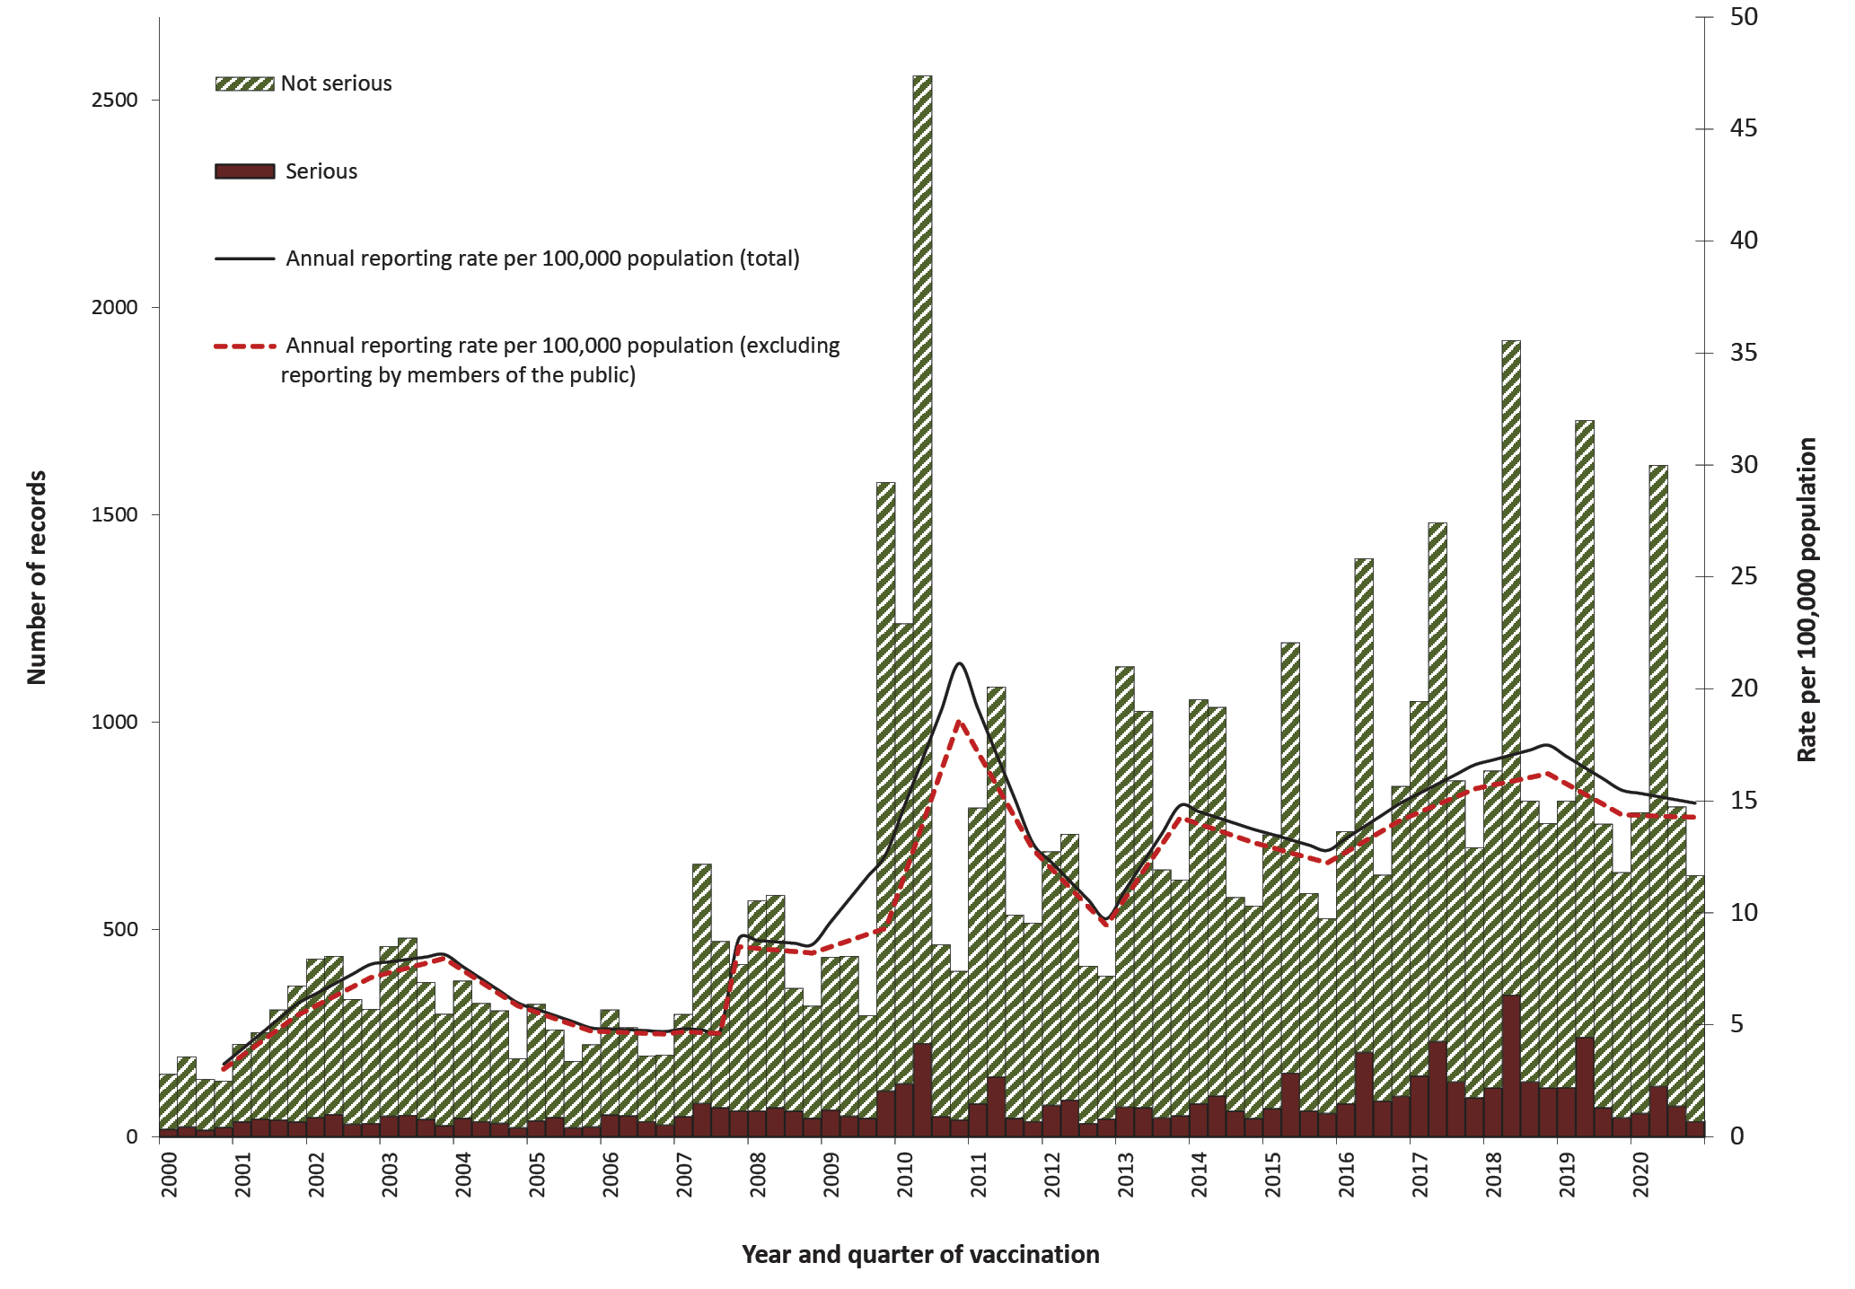
a For reports where the date of vaccination was not recorded, the date of onset or date on which the event was reported to TGA was used as a proxy for vaccination date.
A seasonal pattern of AEFI reporting was apparent in 2020 as in previous years, with a higher number of AEFI notifications for vaccinations administered in the first half of the year (Figure 1). This corresponds to the months when influenza vaccine is predominantly given and when older Australians may be more likely to be given pneumococcal vaccine in conjunction with the influenza vaccine (April to June). Considerably more AEFI reports following influenza vaccination were received in each year from 2010 onwards than had been the case in previous (pre-H1N1 pandemic) years (Figure 4).
Figure 2: Adverse events following immunisation for children aged < 1 year, AEMS database, 2000 to 2020, by year and quarter of vaccination^{a,b}
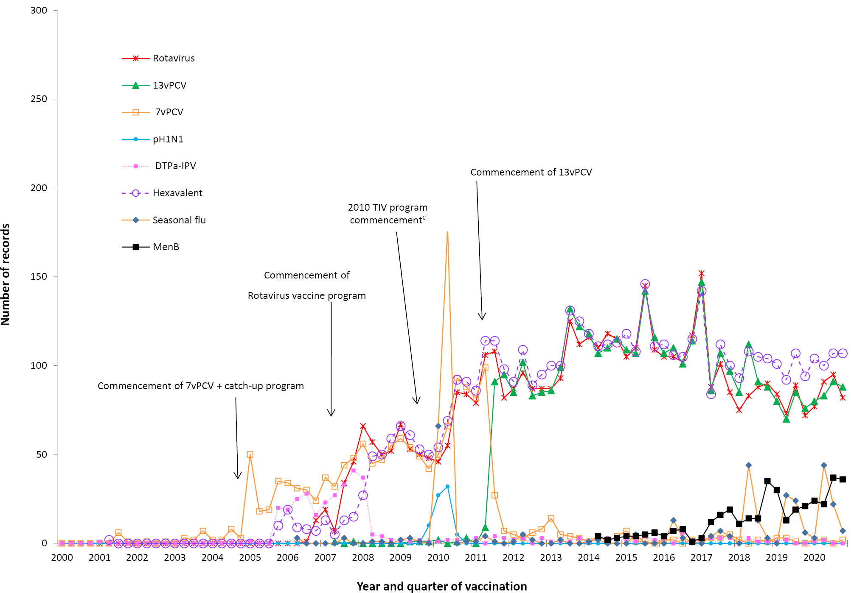
a DTPa-IPV and DTPa-IPV-HepB-Hib (hexavalent) vaccines were introduced into the NIP schedule in November 2005; rotavirus (RotaTeq and Rotarix) vaccines on 1 July 2007; pH1N1 influenza vaccine for children 6 months to 10 years on December 2009; seasonal trivalent influenza vaccine in 2010, which was an extension of existing adult and Indigenous programs to at-risk populations; and the 13-valent pneumococcal conjugate vaccine (13vPCV) on 1 July 2011. In July 2018, the schedule for routine childhood vaccination with 13vPCV changed from 2, 4 and 6 months of age to 2, 4 and 12 months of age. In October 2018, a multicomponent recombinant meningococcal B vaccine was funded by South Australia for children 6 weeks to 12 months of age, with catch-up for children from 12 months to ˂ 4 years of age. From July 2020, meningococcal B vaccine was funded for all Aboriginal and Torres Strait Islander children (age < 12 months) and for individuals of any age with specified high risk medical conditions. From March 2020, all children aged 6 months to < 5 years were funded for influenza vaccine under NIP.
b For reports where the date of vaccination was not recorded, the date of onset or date on which the event was reported to TGA was used as a proxy for vaccination date.
c Safety signal for fever and febrile convulsion found to be due to Seqirus (formerly bioCSL) Fluvax 2010 TIV in children.

Figure 3: Adverse events following immunisation for children aged 1 to < 7 years in frequently reported vaccines, AEMS database, 2000 to 2020, by year and quarter of vaccination^{a,b}
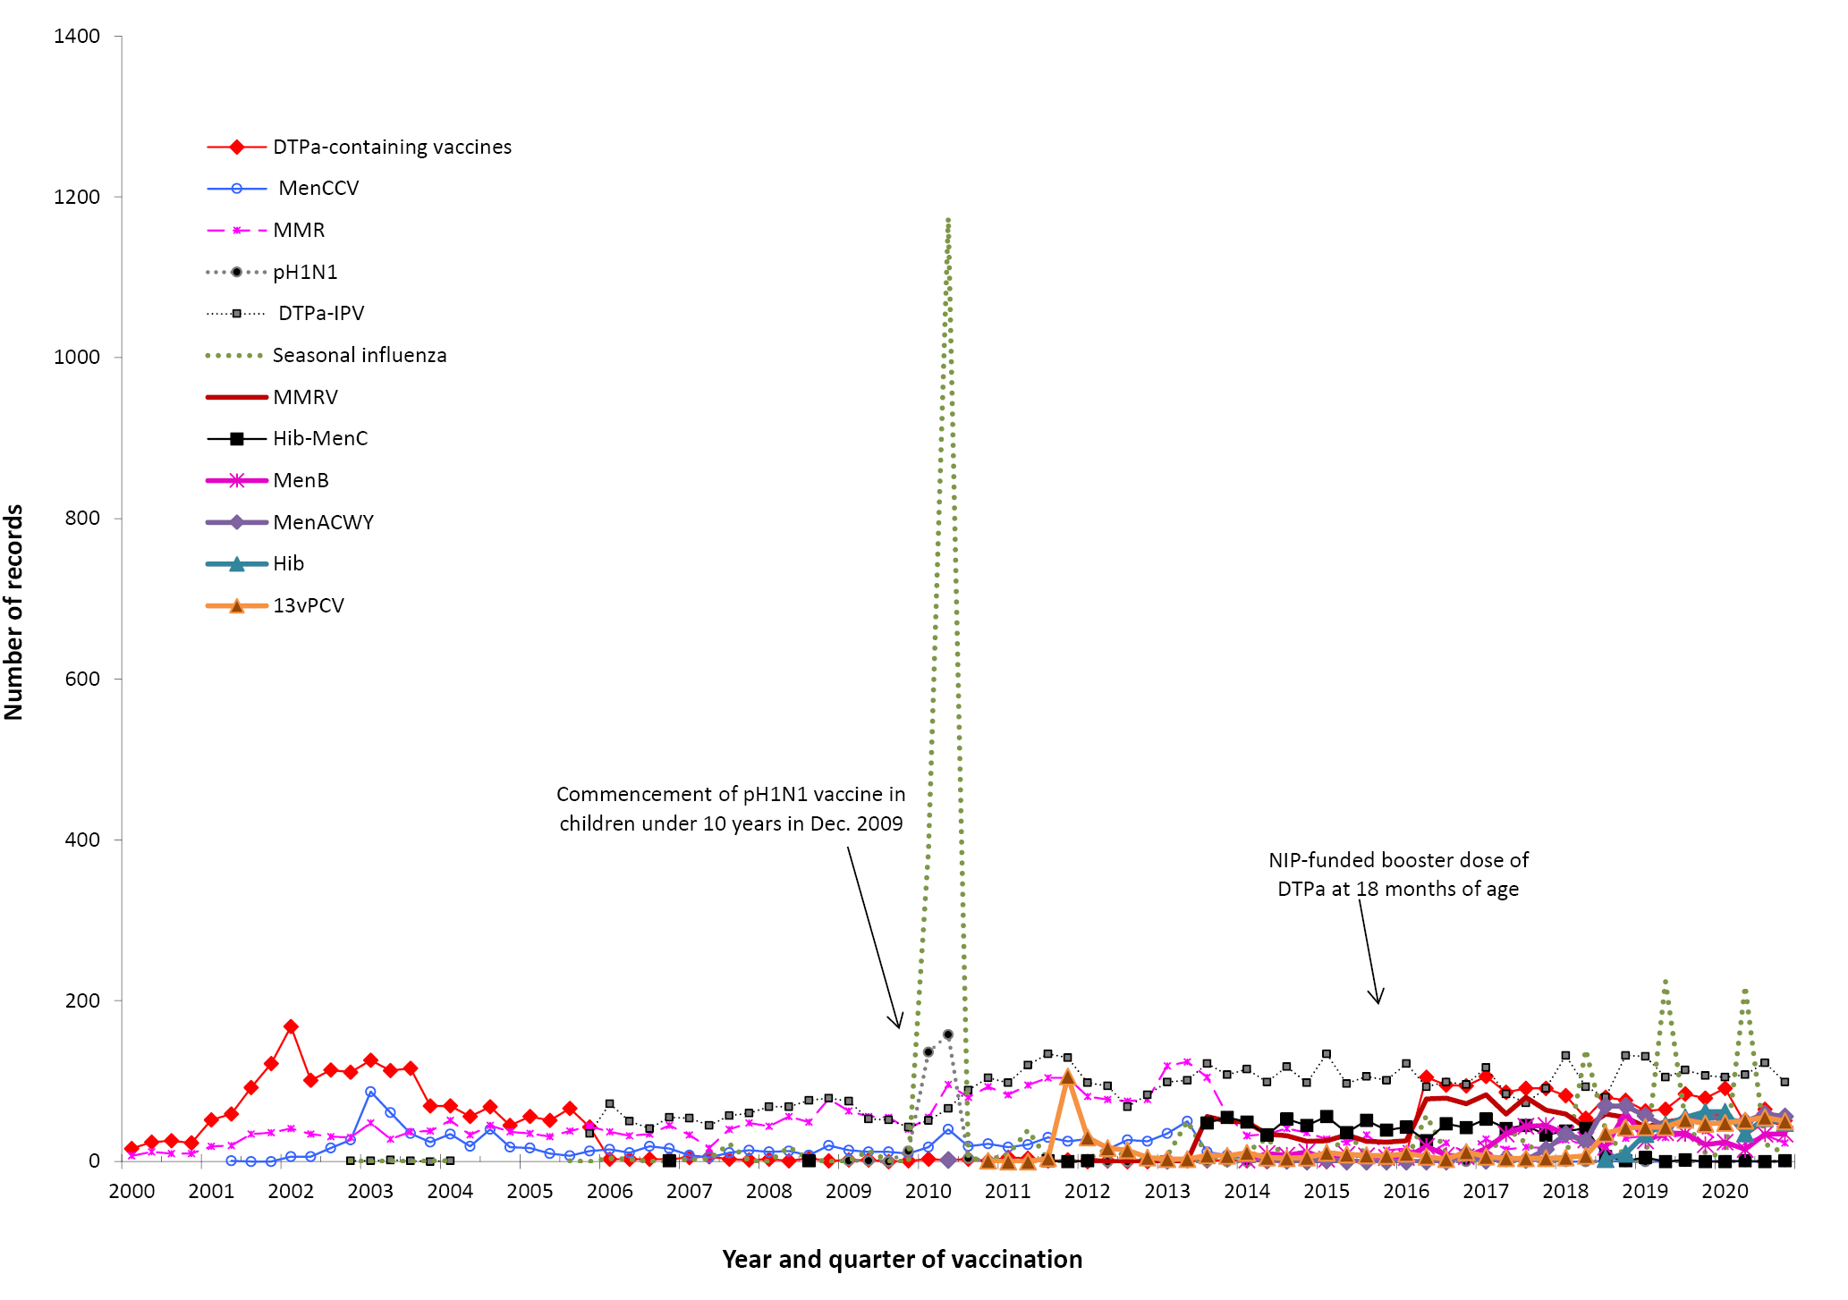
a DTPa-IPV vaccine was introduced into the NIP schedule in November 2005 replacing DTPa and OPV vaccines; seasonal trivalent influenza vaccine in 2010 which was an extension of existing adult and Indigenous programs to at risk populations; MMRV and Hib–MenC vaccines on July 2013, and HPV vaccine program extended to boys in February 2013. MenB vaccine is recommended for use in those with increased risk of invasive meningococcal disease and is not currently funded under the NIP. In April 2016, a NIP-funded booster dose of DTPa vaccine was introduced at 18 months of age. In October 2018, a multicomponent recombinant meningococcal B vaccine was funded by SA for children 6 weeks to 12 months of age, with catch-up for children from 12 months to ˂ 4 years of age. In July 2018, a meningococcal ACWY conjugate vaccine funded for all children at 12 months of age, replacing combined Hib and meningococcal C-containing vaccine. The Hib dose was moved to 18 months and given as a monovalent Hib vaccine. From July 2020, catch-up meningococcal B vaccine are available for all Aboriginal and Torres Strait Islander children < 2 years of age (up to 23 months) for 3 years, until 30 June 2023. From July 2020, funded schedule expanded for Aboriginal and Torres Strait Islander children living in the NT, SA, Qld and WA from 13vPCV at 2, 4, 6 and 12 months (3+1) to include an additional dose of 23vPPV at 4 years of age and a second dose 5–10 years later.
b For reports where the date of vaccination was not recorded, the date of onset or date on which the event was reported to TGA was used as a proxy for vaccination date.

Figure 4: Adverse events following immunisation for people aged 7 years and over in frequently reported vaccines, AEMS database, 2000–2020, by year and quarter of vaccination^{a,b}
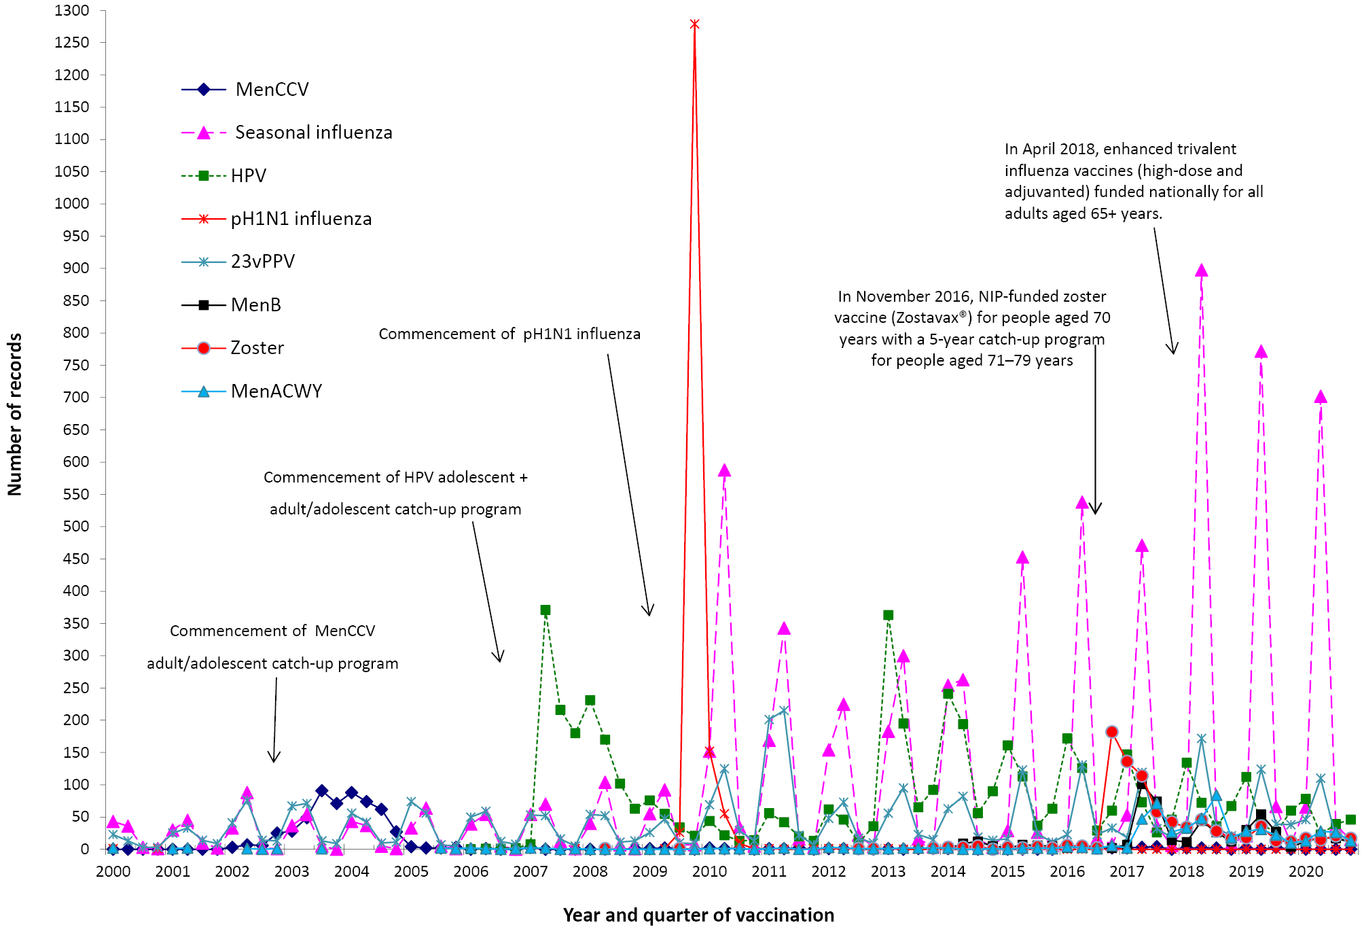
a MenCCV was introduced into the NIP schedule on 1 January 2003; pH1N1 influenza vaccine for children 6 months to 10 years on December 2009; pH1N1 vaccination for those ≥ 10 years commenced on 30 September 2009; seasonal trivalent influenza vaccine in 2010 which was an extension of existing adult and Indigenous programs to at risk populations; and HPV vaccine program extended to boys in February 2013. MenB vaccine is recommended for use in those with increased risk of invasive meningococcal disease and is not currently funded under the NIP. In November 2016, zoster vaccine (Zostavax®) was NIP-funded for people aged 70 years with a 5-year catch-up program for people aged 71–79 years. In April 2018, enhanced trivalent influenza vaccines (high-dose and adjuvanted) funded nationally for all adults aged 65 years and over. From July 2020, a single dose of 13vPCV is recommended and funded for Aboriginal and Torres Strait Islander adults at 50 years of age, followed by a dose of 23vPPV 12 months later and a second dose of 23vPPV 5–10 years after that. A single dose of 13vPCV is recommended and funded for non- Aboriginal and Torres Strait Islander adults at 70 years of age, replacing the previously funded dose of 23vPPV at 65 years of age.
b For reports where the date of vaccination was not recorded, the date of onset or date on which the event was reported to TGA was used as a proxy for vaccination date.

Age distribution
The highest age-specific AEFI reporting rate per 100,000 population occurred in children less than two years of age, the age group scheduled to receive meningococcal ACWY vaccination at 12 months of age and the booster dose of DTPa at 18 months of age, and the age group affected by the change in schedule for 13vPCV from 2, 4 and 6 months of age to 2, 4 and 12 months of age (Figure 5). Compared with 2019, AEFI reporting rates in 2020 declined across most age groups (Figure 5).
The reporting rates per 100,000 doses for most individual vaccines in 2020 were not significantly different to rates in 2019 (Table 1).

Table 1: Vaccine types listed as ‘suspected’ in records of adverse events following immunisation by age groups (aged < 7 years; 7–17 years; 18–64 years; and ≥ 65 years), AEMS database, 2020
Vaccinesª | AEFI records^{b}  (n) | Vaccine doses^{c}  2020 | Reporting rate d  per 100,000 doses (95% CI)
 |  |  | 2020 | 2019
< 7 years
DTPa-containing vaccines | 1,134 | 1,432,321 | 79.2 (74.6 – 83.9) | 79.5 (75.1 – 84.3)
Hexavalent (DTPa-IPV-HepB-Hib) | 438 | 833,468 | 52.6 (47.7 – 57.7) | 48.5 (43.9 – 53.4)
DTPa-IPV | 438 | 309,051 | 141.7 (128.8 – 155.6) | 146.7 (133.5 – 160.8)
DTPa | 258 | 289,802 | 89.0 (78.5 – 100.6) | 99.2 (88.3 – 111.2)
Pneumococcal conjugate -13vPCV | 546 | 848,269 | 64.4 (59.1 – 70.0) | 53.6 (48.8 – 58.6)
Rotavirus vaccine | 351 | 532,175 | 66.0 (59.2 – 73.2) | 57.3 (51.2 – 64.0)
Seasonal influenza | 331 | 990,548 | 33.4 (29.9– 37.2) | 33.2 (29.7– 36.9)
Meningococcal ACWY | 240 | 315,222 | 76.1 (66.8 – 86.9) | 55.7 (48.3 – 63.9)
Measles-mumps-rubella | 228 | 296,383 | 76.9 (67.3– 87.6) | 78.2 (68.8 – 88.6)
Meningococcal B | 226 | 245,811 | 91.9 (80.3 – 104.7) | 70.3 (60.8 – 80.9)
Haemophilus influenzae type b | 201 | 289,672 | 69.4 (60.1 – 79.7) | 73.9 (64.0 – 84.9)
Measles-mumps-rubella-varicella | 197 | 290,121 | 67.9 (58.8 – 78.1) | 65.6 (56.8 – 75.5)
Varicella | 15 | 9,939 | 150.9 (84.5 – 248.9) | 128.2 (73.3 – 208.2)
Hepatitis B | 12 | 20,705 | 58.0 (30.0– 101.2) | 39.0 (19.5– 69.8)
7–17 years
HPV | 174 | 520,912 | 33.4 (28.6 – 38.8) | 34.9 (30.3 – 39.9)
Seasonal influenza | 121 | 962,821 | 12.6 (10.4 – 15.0) | 16.0 (13.2 – 19.2)
dTpa | 113 | 293,656 | 38.5 (31.7 – 46.3) | 44.6 (37.7 – 52.4)
Meningococcal ACWY | 70 | 240,731 | 29.1 (22.7 – 36.7) | 24.8 (19.2 – 31.6)
Meningococcal B | 39 | 40,888 | 95.4 (67.8 – 130.4) | 80.8 (63.2 – 101.8)
23vPPV | 14 | 2,308 | 606.6 (331.6 – 1,017.7) | 304.0 (122.2 – 626.3)
Pneumococcal conjugate -13vPCV | 7 | 1,607 | 435.6 (175.1 – 897.5) | –
Varicella | 6 | 12,020 | 49.9 (18.3 – 108.7) | 49.6 (19.9 – 102.2)
Hepatitis B | 6 | 24,069 | 24.9 (9.2 – 54.3) | 20.4 (7.5 – 44.4)
Measles-mumps-rubella | 2 | 13,648 | 14.7 (1.8 – 52.9) | 36.2 (15.6 – 71.3)
Measles-mumps-rubella-varicella | 2 | 4,930 | 40.6 (4.9 – 146.6) | 102.0 (41.0 – 210.2)
18–64 years
Seasonal influenza | 545 | 4,432,162 | 12.3 (9.3 – 11.2) | 17.6 (16.2 – 19.2)
dTpa | 110 | 635,905 | 17.3 (14.2 – 20.9) | 20.0 (16.4 – 24.2)
23vPPV | 49 | 63,815 | 76.8 (56.8 – 101.5) | 93.3 (68.1 – 124.9)
Hepatitis B | 33 | 161,397 | 20.4 (14.1 – 28.7) | 16.2 (11.0 – 23.1)
MMR | 33 | 87,561 | 37.7 (25.9 – 52.9) | 17.8 (12.0 – 25.4)
Meningococcal B | 17 | 11,625 | 146.2 (85.2 – 234.1) | 181.0 (128.1 – 248.5)
Varicella | 17 | 25,783 | 65.9 (38.4 – 105.6) | 68.3 (42.3 – 104.5)
HPV | 12 | 35,027 | 34.3 (17.7 – 59.8) | –
Hepatitis A | 11 | 134,162 | 8.2 (4.1 –14.7) | 6.6 (4.2 –9.8)
Zoster | 11 | 7,440 | 147.8 (73.8 –264.5) | –
Meningococcal ACWY | 9 | 28,606 | 31.5 (14.4 – 59.7) | 36.5 (22.6 – 55.8)
Pneumococcal conjugate -13vPCV | 9 | 22,144 | 40.6 (18.6 – 77.2) | –
Q fever | 7 | N/A^{e} | – | –
≥ 65 years
Seasonal influenza | 153 | 2,878,567 | 5.3 (4.5 – 6.2) | 8.5 (7.3 – 9.7)
23vPPV | 124 | 322,695 | 38.4 (32.0 – 45.8) | 53.6 (45.7 – 62.4)
Pneumococcal conjugate -13vPCV | 109 | 249,954 | 43.6 (35.8 – 52.6) | –
Zoster | 59 | 166,929 | 35.3 (26.9 – 45.6) | 41.5 (32.5 – 52.3)
dTpa | 19 | 103,384 | 18.4 (11.1 – 28.7) | 23.4 (14.9 – 35.2)
a Records where at least one of the vaccines shown in the table was suspected of causal involvement in the reported adverse event.
b Number of AEFI records in which the vaccine was coded as ‘suspected’ of causal involvement in the reported adverse event and the vaccination was administered between 1 January and 31 December 2020. More than one vaccine may be coded as ‘suspected’ if several were administered at the same time.
c Number of vaccine doses recorded on the AIR and administered between 1 January and 31 December 2020.
d The estimated reporting rate per 100,000 vaccine doses recorded. 95% CI: 95% confidence interval.
e N/A: not applicable.

Figure 5: Reporting rates of adverse events following immunisation per 100,000 population, AEMS database, 2000 to 2020, by age group and year of vaccinationª
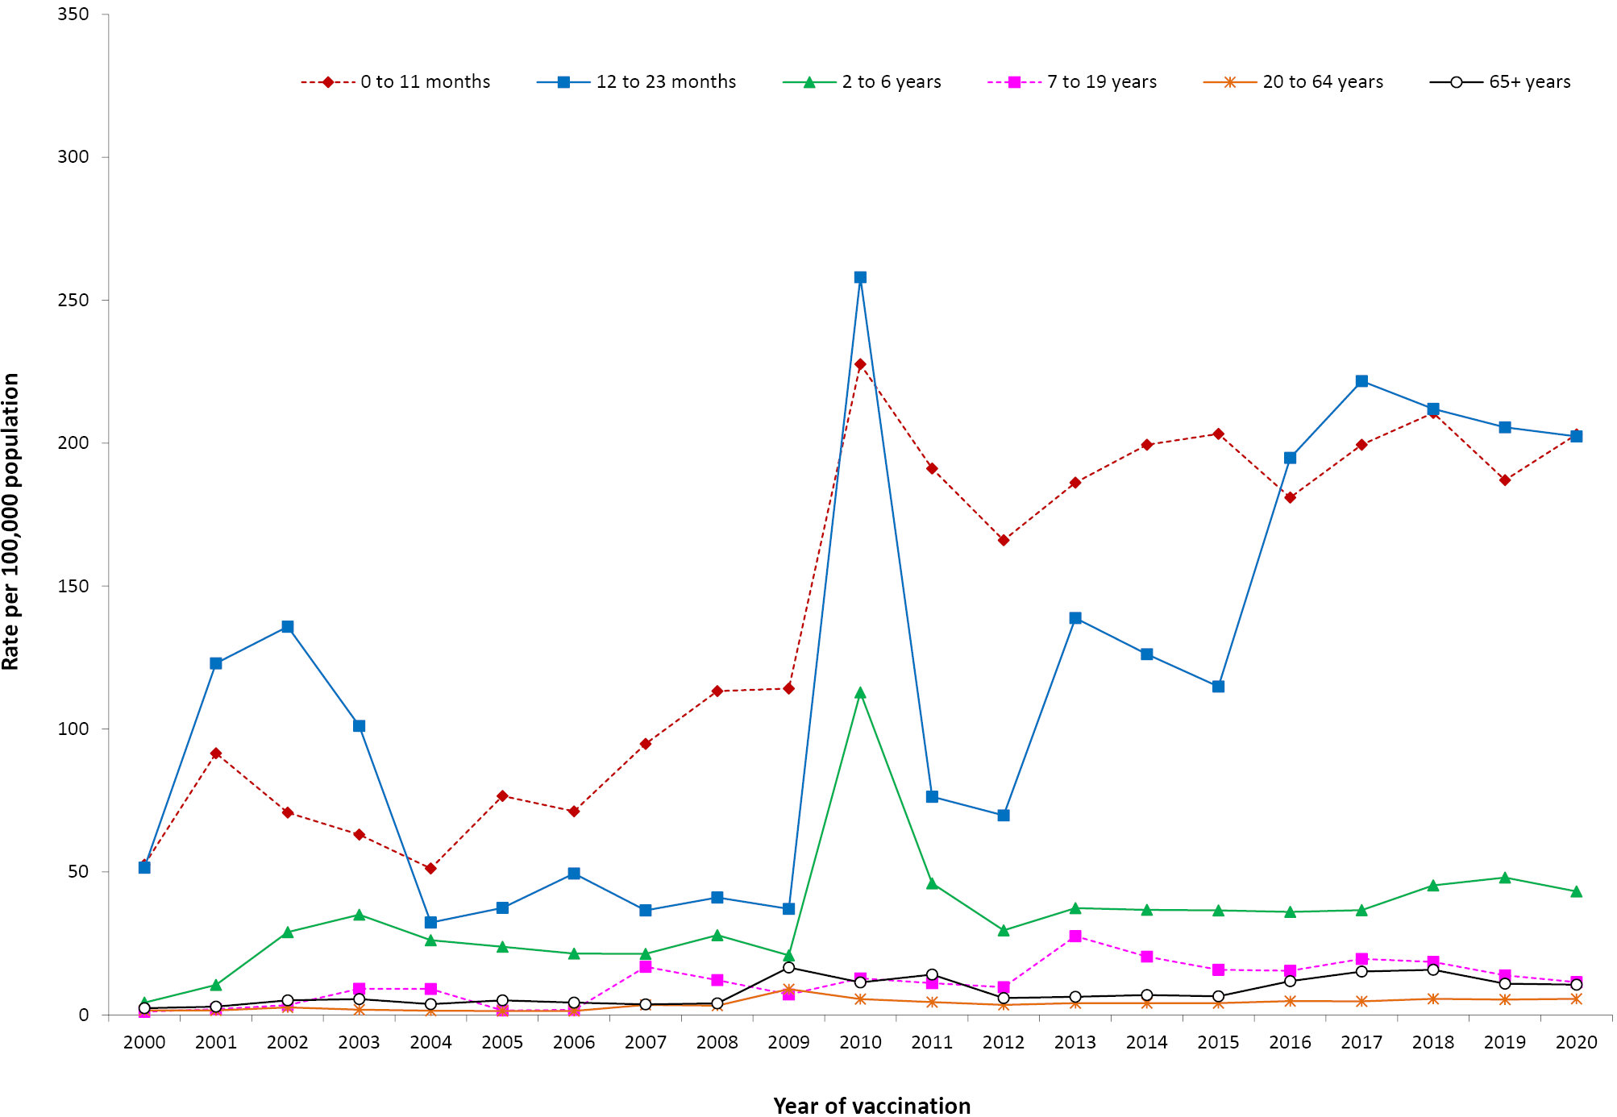
a For reports where the date of vaccination was not recorded, the date of onset or date on which the event was reported to TGA was used as a proxy for vaccination date.

Geographical distribution
Population-based AEFI reporting patterns varied between states and territories during 2020 (Table 2) similar to 2019.¹⁶

Table 2: Adverse events following immunisation (AEFI) records, AEMS database, January to December 2020, by jurisdiction
State or territory | AEFI records |  | Annual reporting rate per 100,000 populationª
 | n | (%) | ‘Serious’ ^{b}  (%) | Aged  <7 years | Overall Rate | (95% Confidence Interval)
Australian Capital Territory | 64 | (1.7) | 0.9 | 68.3 | 14.8 | (11.4– 19.0)
New South Wales | 746 | (19.5) | 0.8 | 42.2 | 9.1 | (8.5– 9.8)
Northern Territory | 52 | (1.4) | 1.6 | 105.0 | 21.1 | (15.8 – 27.7)
Queensland | 615 | (16.1) | 0.6 | 62.0 | 11.9 | (11.0– 12.9)
South Australia | 200 | (5.2) | 1.4 | 49.2 | 11.3 | (9.8 – 13.0)
Tasmania | 72 | (1.9) | 0.9 | 43.1 | 13.3 | (10.4 – 16.8)
Victoria | 1638 | (42.8) | 1.0 | 179.2 | 24.5 | (23.3 – 25.7)
Western Australia | 349 | (9.1) | 0.6 | 67.0 | 13.1 | (11.8 – 14.6)
Other^{c} | 91 | (2.4) | N/A | N/A | N/A | –
Total | 3827 | (100) | 1.1 | 87.1 | 14.9 | (14.4 – 15.4)
a Average annual rates per 100,000 population calculated using mid-2020 population estimates (Australian Bureau of Statistics).
b AEFI records defined as ‘serious’ (i.e. recovery with sequelae, hospitalisation, life-threatening or death).
c Records where the jurisdiction in which the adverse event occurred was not reported or was unclear.

Vaccines
The vaccine most frequently reported as associated with AEFI was seasonal influenza vaccine (1,193 records; 31.2% of total 2020 records), followed by 13vPCV (n = 680, 17.8%); DTPa-IPV (n = 452; 11.8%); hexavalent DTPa-IPV-HepB-Hib (n = 449; 11.7%); rotavirus (n = 358; 9.4%); MenACWY (n = 323; 8.4%); MenB (n = 289; 7.5%); MMR (n = 267; n = 7.0%); DTPa (n = 258; n = 6.7%); and dTpa (n = 242; n = 6.3%) (Table 3).
Of the 1,193 adverse events following seasonal influenza vaccination, 331 (27.7%) were reported in children aged < 7 years. There were 289 reported adverse events following MenB vaccination, with 78.2% of these (226) in children aged < 7 years (Table 3).

Table 3: Vaccine types listed as ‘suspected’ in records of adverse events following immunisation (AEFI), AEMS database, 2020
Suspected vaccine typeª | AEFI records |  | One suspected vaccine only^{b} |  | ‘Serious’^{c} |  | Age group^{d}  < 7 years |  | Age group^{d}  ≥ 7 years
 | n | (%) | n | (%)^{e} | n | (%)^{e} | n | (%)^{e} | n | (%)^{e}
Influenza | 1,193 | (31.2) | 1,005 | (84.2) | 85 | (7.1) | 331 | (27.7) | 819 | (68.7)
13vPCV | 680 | (17.8) | 114 | (16.8) | 55 | (8.1) | 546 | (80.3) | 125 | (18.4)
DTPa-IPV | 452 | (11.8) | 400 | (88.5) | 8 | (1.8) | 438 | (96.9) | 8 | (1.8)
DTPa-IPV-HepB-Hib | 449 | (11.7) | 72 | (16.0) | 50 | (11.1) | 438 | (97.6) | 5 | (1.1)
Rotavirus | 358 | (9.4) | 37 | (10.3) | 56 | (15.6) | 351 | (98.0) | 1 | (0.3)
Men ACWY | 323 | (8.4) | 48 | (14.9) | 17 | (5.3) | 240 | (74.3) | 80 | (24.8)
Meningococcal B | 289 | (7.5) | 154 | (53.3) | 25 | (8.7) | 226 | (78.2) | 58 | (20.1)
MMR | 267 | (7.0) | 39 | (14.6) | 17 | (6.4) | 228 | (85.4) | 36 | (13.4)
DTPa | 258 | (6.7) | 66 | (25.6) | 8 | (3.1) | 250 | (96.9) | 0 | (0.0)
dTpa | 242 | (6.3) | 132 | (54.5) | 8 | (3.3) | 0 | (0.0) | 242 | (100.0)
23vPPV | 224 | (5.9) | 144 | (64.3) | 9 | (4.0) | 34 | (15.2) | 187 | (83.5)
Hib | 206 | (5.4) | 14 | (6.8) | 7 | (3.4) | 201 | (97.6) | 1 | (0.5)
MMRV | 202 | (5.3) | 18 | (8.9) | 6 | (3.0) | 197 | (97.5) | 2 | (1.0)
HPV | 194 | (5.1) | 97 | (50.0) | 4 | (2.1) | 2 | (1.0) | 186 | (95.9)
Zoster | 72 | (1.9) | 59 | (81.9) | 4 | (5.6) | 0 | (0.0) | 70 | (97.2)
Hepatitis B | 54 | (1.4) | 29 | (53.7) | 1 | (1.9) | 12 | (22.2) | 41 | (75.9)
Varicella | 40 | (1.0) | 19 | (47.5) | 4 | (10.0) | 15 | (37.5) | 25 | (62.5)
BCG | 29 | (0.8) | 23 | (79.3) | 0 | (0.0) | 18 | (62.1) | 5 | (17.2)
Hepatitis A | 29 | (0.8) | 8 | (27.6) | 0 | (0.0) | 15 | (51.7) | 13 | (44.8)
dT | 19 | (0.5) | 16 | (84.2) | 2 | (10.5) | 1 | (5.3) | 18 | (94.7)
Q fever | 8 | (0.2) | 8 | (100.0) | 2 | (25.0) | 0 | (0.0) | 8 | (100.0)
Rabies | 5 | (0.1) | 5 | (100.0) | 0 | (0.0) | 1 | (20.0) | 4 | (80.0)
IPV | 5 | (0.1) | 0 | (0.0) | 0 | (0.0) | 0 | (0.0) | 5 | (100.0)
Yellow fever | 4 | (0.1) | 2 | (50.0) | 0 | (0.0) | 0 | (0.0) | 4 | (100.0)
Hepatitis A + B | 4 | (0.1) | 2 | (50.0) | 0 | (0.0) | 0 | (0.0) | 4 | (100.0)
Typhoid | 3 | (0.1) | 1 | (33.3) | 0 | (0.0) | 1 | (33.3) | 2 | (66.7)
Hepatitis A-Typhoid | 3 | (0.1) | 1 | (33.3) | 1 | (33.3) | 0 | (0.0) | 3 | (100.0)
Hib-MenC | 2 | (0.1) | 0 | (0.0) | 0 | (0.0) | 2 | (100.0) | 0 | (0.0)
Tetanus | 2 | (0.1) | 1 | (50.0) | 1 | (50.0) | 1 | (50.0) | 1 | (50.0)
Japanese encephalitis | 1 | (0.0) | 0 | (0.0) | 0 | (0.0) | 1 | (100.0) | 0 | (0.0)
a See appendix for abbreviations of vaccine names.
b AEFI records where only one vaccine was suspected of causal involvement in a reported adverse event.
c ‘Serious’ is defined in the Methods section.
d Includes only AEFI records where an age or date of birth has been reported.
e Percentages are calculated for the number of AEFI records where the vaccine was suspected of causal involvement in the event

Adverse events
The most frequently-reported adverse events in 2020 were injection site reactions (ISRs) (n = 1,418; 37.1% of total); pyrexia (n = 692; 18.1%); rash (n = 604; 15.8%); vomiting (n = 291; 7.6%); pain (n = 282; 7.4%); headache (n = 218; 5.7%); and urticaria (n = 194; 5.1%) (Table 4, Figure 6). Adverse events of particular interest included convulsions (n = 83; 2.2%); anaphylactic reaction (n = 58; 1.5%); hypotonic-hyporesponsive episode (n = 57; 1.5%); Guillain-Barré Syndrome (GBS) (n = 15; 0.4%); and intussusception (n = 10; 0.3%) (Table 4).
The number of reports of particular adverse events has changed over time (Figure 6) in relation to changes in the vaccination schedule (Table A.1).
Figure 6: Selected frequently reported adverse events following immunisation, AEMS database, 2000 to 2020, by year and quarter of vaccinationª
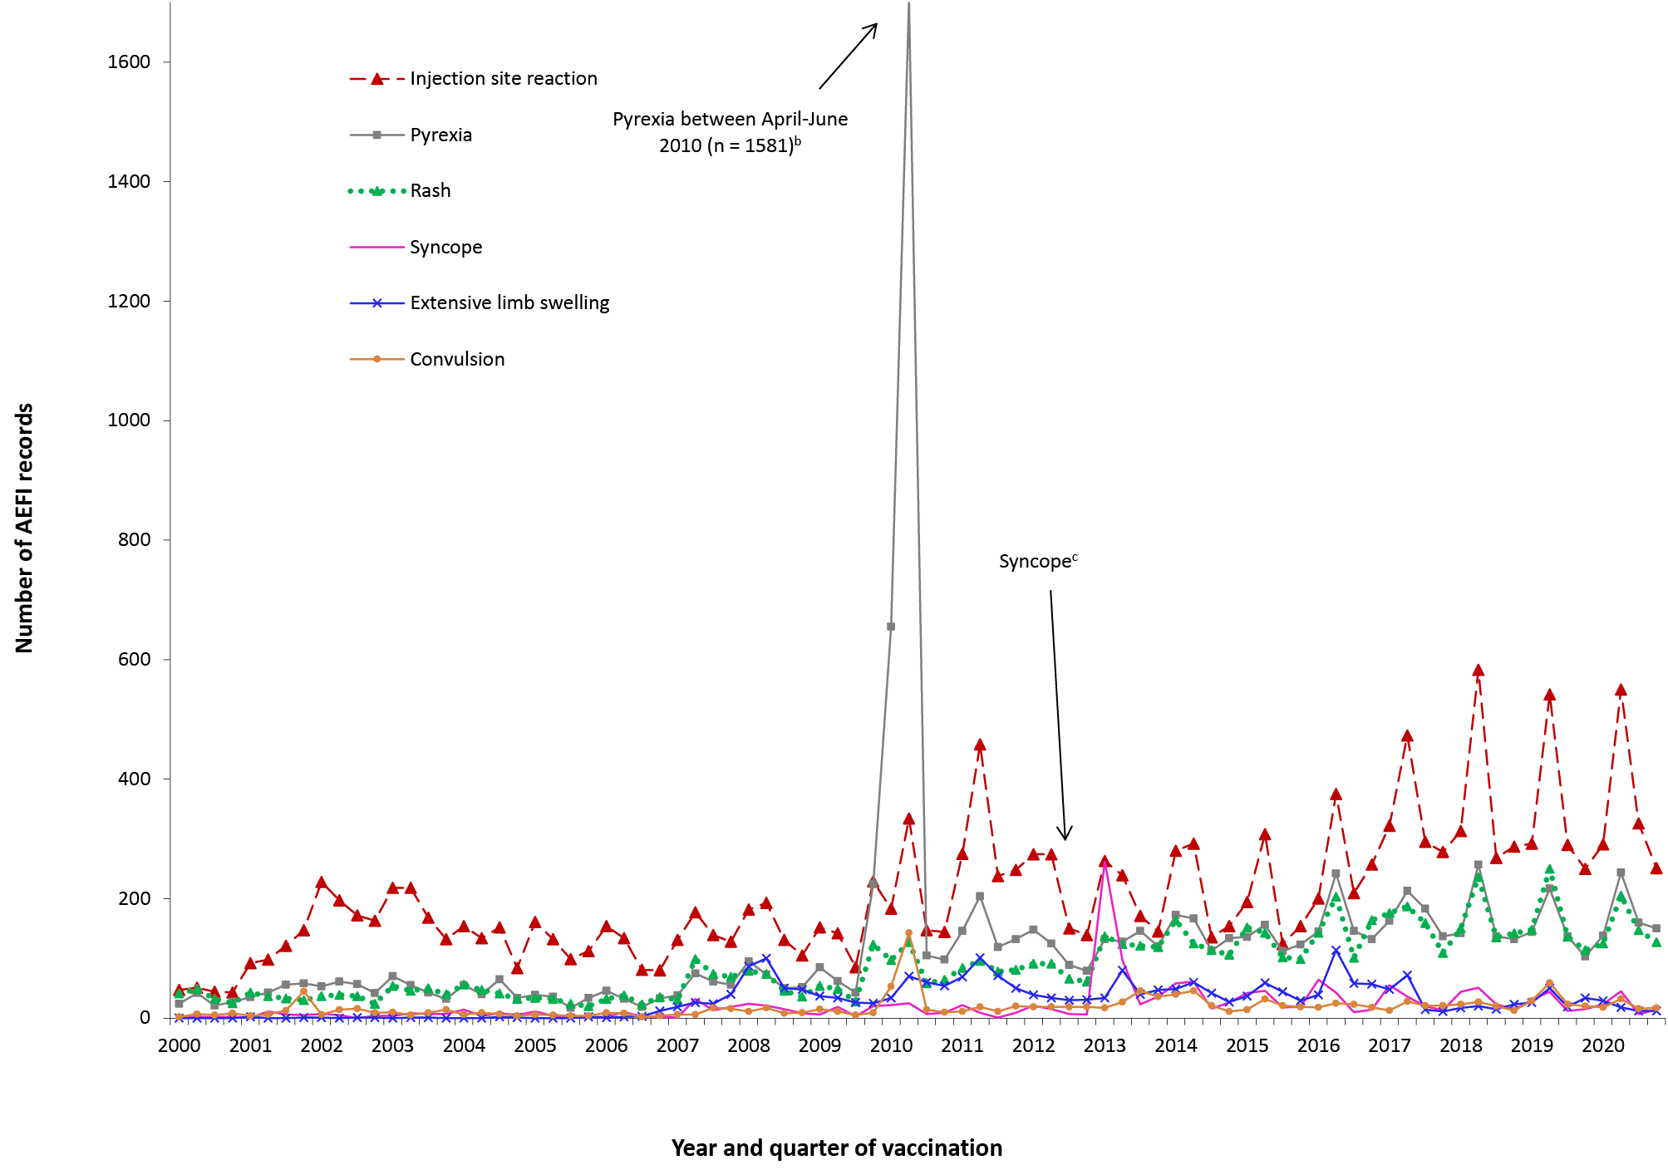
a For reports where the date of vaccination was not recorded, the date of onset or date on which the event was reported to TGA was used as a proxy for vaccination date.
b Associated with administration of Seqirus (formerly bioCSL) Fluvax 2010 TIV and associated stimulated reporting.
c The peak in syncope coincided with the enhanced HPV surveillance program in which there was stimulated reporting of syncope for the first 6 months of 2013.

Table 4: Selected reported adverse eventsª classified by MedDRA Preferred Terms (PT) in records of adverse events following immunisation (AEFI), AEMS database, 2020^{b}
MedDRA Preferred Terms (adverse events) | AEFI records | Only adverse event reported^{c} |  | ‘Serious’^{d} |  | Age group^{e} |  | Age group^{e}
 |  |  |  |  |  | < 7 years |  | ≥ 7 years
 | N | n | (%)^{f} | n | (%)^{f} | n | (%)^{f} | n | (%)^{f}
Injection site reaction^{g} | 1,418 | 784 | (55.3) | 29 | (2.0) | 778 | (54.9) | 616 | (43.4)
Pyrexia | 692 | 39 | (5.6) | 53 | (7.7) | 454 | (65.6) | 222 | (32.1)
Rash^{h} | 604 | 212 | (35.1) | 23 | (3.8) | 400 | (66.2) | 191 | (31.6)
Vomiting | 291 | 33 | (11.3) | 22 | (7.6) | 172 | (59.1) | 112 | (38.5)
Pain | 282 | 22 | (7.8) | 12 | (4.3) | 52 | (18.4) | 212 | (75.2)
Headache | 218 | 4 | (1.8) | 14 | (6.4) | 13 | (6.0) | 200 | (91.7)
Urticaria | 194 | 97 | (50.0) | 8 | (4.1) | 104 | (53.6) | 83 | (42.8)
Irritability | 191 | 6 | (3.1) | 7 | (3.7) | 178 | (93.2) | 9 | (4.7)
Lethargy | 157 | 3 | (1.9) | 9 | (5.7) | 94 | (59.9) | 61 | (38.9)
Nausea | 145 | 2 | (1.4) | 10 | (6.9) | 7 | (4.8) | 135 | (93.1)
Dizziness | 122 | 4 | (3.3) | 9 | (7.4) | 2 | (1.6) | 117 | (95.9)
Injected limb mobility decreased | 104 | 1 | (1.0) | 2 | (1.9) | 13 | (12.5) | 81 | (77.9)
Paraesthesia | 97 | 3 | (3.1) | 13 | (13.4) | 0 | (0.0) | 91 | (93.8)
Myalgia | 97 | 2 | (2.1) | 6 | (6.2) | 5 | (5.2) | 89 | (91.8)
Pruritus | 93 | 4 | (4.3) | 4 | (4.3) | 23 | (24.7) | 68 | (73.1)
Malaise | 93 | 2 | (2.2) | 8 | (8.6) | 9 | (9.7) | 79 | (84.9)
Chills | 91 | 1 | (1.1) | 5 | (5.5) | 19 | (20.9) | 69 | (75.8)
Syncope | 89 | 54 | (60.7) | 6 | (6.7) | 11 | (12.4) | 74 | (83.1)
Decreased appetite | 85 | 1 | (1.2) | 8 | (9.4) | 63 | (74.1) | 21 | (24.7)
Convulsions^{i} | 83 | 45 | (54.2) | 20 | (24.1) | 63 | (75.9) | 16 | (19.3)
Dyspnoea | 82 | 3 | (3.7) | 16 | (19.5) | 9 | (11.0) | 71 | (86.6)
Fatigue | 77 | 1 | (1.3) | 4 | (5.2) | 10 | (13.0) | 62 | (80.5)
Cough | 63 | 3 | (4.8) | 9 | (14.3) | 27 | (42.9) | 34 | (54.0)
Presyncope | 62 | 32 | (51.6) | 4 | (6.5) | 11 | (17.7) | 48 | (77.4)
Abdominal pain | 60 | 0 | (0.0) | 8 | (13.3) | 29 | (48.3) | 31 | (51.7)
Pallor | 59 | 4 | (6.8) | 10 | (16.9) | 39 | (66.1) | 19 | (32.2)
Anaphylactic reaction | 58 | 31 | (53.4) | 19 | (32.8) | 7 | (12.1) | 48 | (82.8)
Hypotonic-hyporesponsive episode | 57 | 40 | (70.2) | 10 | (17.5) | 55 | (96.5) | 2 | (3.5)
Influenza like illness | 54 | 23 | (42.6) | 4 | (7.4) | 2 | (3.7) | 50 | (92.6)
Angioedema | 54 | 6 | (11.1) | 1 | (1.9) | 28 | (51.9) | 25 | (46.3)
Throat irritation | 45 | 2 | (4.4) | 2 | (4.4) | 2 | (4.4) | 43 | (95.6)
Arthralgia | 44 | 6 | (13.6) | 5 | (11.4) | 1 | (2.3) | 41 | (93.2)
Oropharyngeal discomfort | 37 | 0 | (0.0) | 1 | (2.7) | 1 | (2.7) | 32 | (86.5)
Chest discomfort | 37 | 1 | (2.7) | 3 | (8.1) | 0 | (0.0) | 37 | (100.0)
Hot flush | 36 | 1 | (2.8) | 6 | (16.7) | 11 | (30.6) | 24 | (66.7)
Rhinorrhoea | 31 | 0 | (0.0) | 1 | (3.2) | 20 | (64.5) | 10 | (32.3)
Tachycardia | 29 | 1 | (3.4) | 4 | (13.8) | 10 | (34.5) | 17 | (58.6)
Somnolence | 29 | 0 | (0.0) | 5 | (17.2) | 17 | (58.6) | 10 | (34.5)
Haematochezia | 27 | 15 | (55.6) | 6 | (22.2) | 26 | (96.3) | 0 | (0.0)
Hypotonia | 27 | 1 | (3.7) | 5 | (18.5) | 26 | (96.3) | 1 | (3.7)
Hypoaesthesia | 27 | 1 | (3.7) | 1 | (3.7) | 0 | (0.0) | 27 | (100.0)
Apnoea | 20 | 3 | (15.0) | 3 | (15.0) | 19 | (95.0) | 1 | (5.0)
Chest pain | 20 | 3 | (15.0) | 4 | (20.0) | 0 | (0.0) | 20 | (100.0)
Blister | 20 | 1 | (5.0) | 2 | (10.0) | 11 | (55.0) | 9 | (45.0)
Guillain-Barré syndrome | 15 | 11 | (73.3) | 11 | (73.3) | 2 | (13.3) | 9 | (60.0)
Tremor | 14 | 0 | (0.0) | 3 | (21.4) | 1 | (7.1) | 11 | (78.6)
Intussusception | 10 | 10 | (100.0) | 6 | (60.0) | 9 | (90.0) | 0 | (0.0)
Hypotension | 8 | 0 | (0.0) | 1 | (12.5) | 0 | (0.0) | 7 | (87.5)
Hypersensitivity | 7 | 3 | (42.9) | 2 | (28.6) | 0 | (0.0) | 7 | (100.0)
Lymphadenitis | 2 | 1 | (50.0) | 0 | (0.0) | 0 | (0.0) | 2 | (100.0)
a A complete list of adverse events as classified by individual Preferred Terms is available on request.
b Selected reported adverse events reported during Jan-Dec 2020. Note: for injection site reaction, rash and convulsions, PT’s were grouped as described below.
c AEFI records where only one adverse event was reported.
d ‘Serious’ outcomes are defined in the Methods section.
e Includes only AEFI records where an age or date of birth has been reported
f Percentages relate to the number of AEFI records in which the specific adverse event was listed
g ‘Injection site reaction’ includes the following MedDRA PTs: injection site reaction, injection site swelling, injection site pain, injection site mass, injection site erythema, injection site cellulitis, injection site rash, injection site induration, injection site abscess, injection site pruritus, injection site nodule, injected limb mobility decreased, injection site urticaria, injection site inflammation, injection site bruising, injection site infection, and injection site warmth.
h ‘Rash’ includes the following MedDRA PTs: rash, rash generalised, rash erythematous, rash pruritic, rash maculo-papular, rash macular, rash vesicular, rash papular, rash morbilliform, and rash pustular.
i ‘Convulsion’ includes the following MedDRA PTs: febrile convulsion, convulsion, grand mal convulsion, and partial seizures.

Serious adverse events
There were variations in the proportions of reports with outcomes defined as serious (Table 3), although these remained generally low as in previous years. The majority of reported adverse events in 2020 were coded as non-serious (n = 3,537; 92.4%). Fewer than eight percent of reported adverse events in 2020 were coded as serious, noting that not all reports included detailed or clinically verified data.
The TGA reviews all AEFI reports where a fatal outcome is reported. This review is designed to assess whether the medical conditions that caused death represent an emerging safety concern with the vaccine. For each report which the TGA receives, a team of staff, including doctors and nurses, consider the strength of the evidence for a link between vaccination and the condition that caused the death. The team may request more information from health authorities and coroners.
Six deaths were reported to the TGA where the reporter considered that a causal link between vaccination and the event was possible. Following assessment, the TGA established a causal relationship to vaccination for only one of the six reports, where a man in his 70s died following vaccination with Zostavax. For the other five of the six deaths, the TGA did not establish a link between vaccination and the condition which caused the death.
The male in his 70s died approximately a month after Zostavax vaccine administration in early 2020. An independent expert panel found that the patient died following cardiac arrest related to rapid onset of multi-organ failure associated with disseminated Oka (vaccine strain) varicella zoster virus infection and determined his death to be causally related to Zostavax administration. Significant regulatory action was taken by the TGA following this report, including the addition of a boxed warning to the Product Information and Consumer Medicine Information; a requirement for the provision of a Patient Alert Card to health professionals (to give to each patient receiving Zostavax); refrigeration stickers for all providers of Zostavax; sending letters to inform health professionals of the content of the boxed warning; and updating the Australian’s sponsor’s current Risk Management Plan and Periodic Safety Update Reports to include additional consideration of the risk. Updated guidance on the risk versus benefits and clinical recommendations for use of Zostavax was also issued in a statement by the Australian Technical Advisory Group on Immunisation (ATAGI) in 2021.³⁴
The other five fatal reports were in children four years old or younger (one 4 year old and four 1 year old children) who had significant underlying medical conditions and/or an acute illness. The reports involved a range of combinations of childhood vaccinations. Large-scale vaccination means that some people will experience a new illness or die within a few days or weeks of vaccination. These events are often coincidental, rather than being caused by the vaccine. As the number of people, including children, undergoing vaccination has increased, so has reporting of fatal events with a temporal association with vaccination. Review of these individual reports and patterns of reporting does not suggest that the vaccines played a role in the vast majority of these deaths.
One miscarriage (spontaneous abortion) was reported in this period, noting that spontaneous abortions are known to occur in 11–22% of all pregnancies.^{35,36}

Discussion
This report uses similar methodology to the previous seven annual reports.^{2,15,16,37–40} Analysis using MedDRA preferred terms allows for clearer reporting of adverse events, but needs to be taken into account when comparing the data in this report with data from annual reports prior to 2013.
In 2020, there was a slight (3.8%) decrease in the overall AEFI reporting rate compared with the previous year; reporting rates were not significantly lower (with overlapping confidence intervals) in all jurisdictions in 2020 compared with 2019.¹⁶ This decrease in the AEFI reporting rate in 2020 was potentially due to the impact of COVID-19 and was mainly attributable to declines in reported adverse events related to the HPV, dTpa, and seasonal influenza vaccines.
Among people aged 7 to 17 years, there was a decrease in the AEFI reporting rate for HPV vaccine in 2020 (33.4 per 100,000 doses) compared with 2019 (34.9 per 100,000 doses). There was also a reduction in the AEFI reporting rate for dTpa from 2019 (44.6 per 100,000 doses) to 2020 (38.5 per 100,000 doses), in children and adolescents aged 7–17 years. The observed declines in HPV and dTpa AEFI reporting rates, though not statistically significant, may reflect the COVID-19 impact of lockdowns and school closures affecting delivery of school-based vaccinations during 2020.⁴¹
A slight increase was noted in the AEFI reporting rate for MenACWY vaccine in 2020 (29.1 per 100,000 doses) compared with 2019 (24.8 per 100,000 doses) in children and adolescents aged 7–17 years. This may reflect the vaccine’s addition to the NIP for this age group in 2019 (Table A.1). There is usually an increase in reporting of adverse events when a new program or scheduled dose is rolled out, as immunisation providers are more likely to report milder, less serious AEFI for vaccines they are not as familiar with, or that are being given to a new population group. A reduction and stabilisation of reporting rates over time often occurs thereafter.^{2,4,5,7,10,12–16,37–39,42} The variation in reporting of injection site reactions is related to changes in the immunisation schedule for vaccines that are known to have higher rates of ISR, including DTPa-containing, 23vPPV and HPV vaccines.^{3–14,43,44} Increases in reported AEFI were largely associated with time periods when new vaccines were added to the NIP.
Overall, injection site reaction (37.1%); pyrexia (18.1%); rash (15.8%); vomiting (7.6%); pain (7.4%); headache (5.7%); and urticaria (5.1%) were the most commonly-reported adverse events to the TGA in 2020.
AEFI reporting rates for most individual vaccines in 2020 were similar to the corresponding 2019 reporting rates. These findings are similar to nationally-representative vaccine safety data from AusVaxSafety,⁴⁵ which actively monitors the safety of vaccines (e.g. pertussis, zoster, influenza, HPV, COVID-19) in vaccinated people from 375 sentinel surveillance sites nationwide. The COVID-19 vaccination program rolled out from 22 February 2021 in Australia, and AusVaxSafety is conducting active vaccine safety surveillance of COVID-19 vaccines. Safety data of COVID-19 vaccines are not presented in this 2020 report. No safety signals were observed for pertussis, zoster, influenza and HPV vaccines in 2020 in AusVaxSafety.⁴⁵
Overall for data from the AEMS, the majority of AEFI reports detailed non-serious events and no new safety concerns arose during this period (2020). More than half of reported events (57.8%) were in females and 2.1% were reported in Aboriginal and Torres Strait Islander people.
Of the six deaths which were reported during 2020, five were assessed as most likely due to concomitant disease that was pre-existing at the time of vaccination. Disseminated VZV infection from Oka vaccine strain of the live attenuated zoster vaccine, Zostavax, was causally associated with one death. The use of live attenuated VZV-containing vaccines in people who are immunocompromised is contraindicated due to the risk of unchecked vaccine virus replication causing serious disease.¹⁷ Following this report, both regulatory and programmatic action was taken, as described in detail above.
All reports of death are included in the TGA’s safety monitoring data, even if a coroner or expert panel has concluded it is unrelated to COVID-19 vaccination. Reviewing individual reports of adverse events with fatal outcomes is just one part of the TGA’s vaccine monitoring program. The TGA also conducts analyses across all adverse event reports, including those with fatal outcomes, to detect rare or emerging safety signals. Vaccine surveillance staff monitor the medical literature, media and other potential sources of new safety information. The TGA also collaborates with international regulators to review global safety data.
All reporters to provide sufficient information to allow the TGA to assess any causal relationship between the administration of a vaccine and the adverse event reported. The majority of deaths reported in 2020 were assessed as being most likely due to concomitant disease that was pre-existing at the time of vaccination. However, for one of the deaths, the timing of vaccination and the clinical findings were consistent with a causal association.
Previous TGA alerts were also issued following reports made to the TGA in 2017 and 2019 of fatal disseminated varicella zoster virus infection with the vaccine strain.^{46,47}

Conclusion
AEFI reporting rates decreased in 2020 compared with 2019 and the majority of adverse events reports were non-serious transient events. The data reported here are consistent with an overall high level of safety for vaccines used in Australia when administered according to the clinical recommendations contained within the Australian Immunisation Handbook.¹⁷

Acknowledgments
We thank Alexandra Hendry, NCIRS, for providing vaccine dose data from the Australian Immunisation Register.
The National Centre for Immunisation Research and Surveillance is supported by the Australian Government Department of Health and Aged Care, New South Wales Health, and The Children’s Hospital at Westmead, Australia.

Author details
Aditi Dey¹
Han Wang¹
Helen Quinn¹
Alexis Pillsbury ¹
Megan Hickie²
Lucy Deng¹
Nicholas Wood¹
Frank Beard¹
Kristine Macartney¹
- National Centre for Immunisation Research and Surveillance, The University of Sydney and The Children’s Hospital at Westmead, Sydney, Australia
- Pharmacovigilance Branch, Therapeutic Goods Administration, Department of Health and Aged Care, Canberra, Australia

Corresponding author
Dr Aditi Dey
National Centre for Immunisation Research and Surveillance, Locked Bag 4001, Westmead NSW 2145 Australia
Phone: (02) 9845 1416
Fax: (02) 9845 1418
Email: aditi.dey@ health.nsw.gov.au

References
- Council for International Organizations of Medical Sciences (CIOMS) c/o World Health Organization. Definition and Application of Terms for Vaccine Pharmacovigilance: Report of CIOMS/WHO Working Group on Vaccine Pharmacovigilance. Geneva: CIOMS; 2012. Available from: https://www.who.int/vaccine_safety/initiative/tools/CIOMS_report_WG_vaccine.pdf.
- Dey A, Wang H, Quinn HE, Hill R, Macartney KK. Surveillance of adverse events following immunisation in Australia annual report, 2014. Commun Dis Intell Q Rep. 2016;40(3):E377–90.
- Lawrence G, Boyd I, McIntyre P, Isaacs D. Surveillance of adverse events following immunisation: Australia 2002 to 2003. Commun Dis Intell Q Rep. 2004;28(3):324–38.
- Lawrence G, Boyd I, McIntyre P, Isaacs D. Annual report: surveillance of adverse events following immunisation in Australia, 2005. Commun Dis Intell Q Rep. 2006;30(3):319–33.
- Lawrence G, Gold MS, Hill R, Deeks S, Glasswell A, McIntyre PB. Annual report: surveillance of adverse events following immunisation in Australia, 2007. Commun Dis Intell Q Rep. 2008;32(4):371–87.
- Lawrence G, Menzies R, Burgess M, McIntyre P, Wood N, Boyd I et al. Surveillance of adverse events following immunisation: Australia, 2000–2002. Commun Dis Intell Q Rep. 2003;27(3):307–23.
- Lawrence GL, Aratchige PE, Boyd I, McIntyre PB, Gold MS. Annual report on surveillance of adverse events following immunisation in Australia, 2006. Commun Dis Intell Q Rep. 2007;31(3):269–82.
- Lawrence GL, Boyd I, McIntyre PB, Isaacs D. Annual report: surveillance of adverse events following immunisation in Australia, 2004 Commun Dis Intell Q Rep. 2005;29(3):248–62.
- Mahajan D, Cook J, Dey A, Macartney K, Menzies R. Supplementary report: surveillance of adverse events following immunisation among children aged less than seven years in Australia, 1 January to 30 June 2012. Commun Dis Intell Q Rep. 2013;37(2):E130–4.
- Mahajan D, Cook J, Dey A, Macartney K, Menzies RI. Annual report: surveillance of adverse events following immunisation in Australia, 2011. Commun Dis Intell Q Rep. 2012;36(4):E315–32.
- Mahajan D, Cook J, McIntyre P, Macartney K, Menzies R. Supplementary report: surveillance of adverse events following immunisation among children aged less than seven years in Australia, 1 January to 30 June 2011. Commun Dis Intell Q Rep. 2012;36(1):114–9.
- Mahajan D, Cook J, McIntyre PB, Macartney K, Menzies RI. Annual report: surveillance of adverse events following immunisation in Australia, 2010. Commun Dis Intell Q Rep. 2011;35(4):263–80.
- Mahajan D, Roomiani I, Gold MS, Lawrence GL, McIntyre PB, Menzies RI. Annual report: surveillance of adverse events following immunisation in Australia, 2009. Commun Dis Intell Q Rep. 2010;34(3):259–76.
- Menzies R, Mahajan D, Gold MS, Roomiani I, McIntyre P, Lawrence G. Annual report: surveillance of adverse events following immunisation in Australia, 2008. Commun Dis Intell Q Rep. 2009;33(4):365–81.
- Mahajan D, Dey A, Cook J, Harvey B, Menzies R, Macartney K. Surveillance of adverse events following immunisation in Australia annual report, 2013. Commun Dis Intell Q Rep. 2015;39(3):E369–86.
- Dey A, Wang H, Quinn H, Pillsbury A, Glover C, Hickie M et al. Surveillance of adverse events following immunisation in Australia annual report, 2019. Commun Dis Intell (2018). 2021;45. doi: https://doi.org/10.33321/cdi.2021.45.23.
- Australian Technical Advisory Group on Immunisation (ATAGI). Australian Immunisation Handbook. Canberra: Australian Government Department of Health; 2020. Available from: https://immunisationhandbook.health.gov.au/.
- Uppsala Monitoring Centre. WHO Collaborating Centre for International Drug Monitoring. [Website.] Uppsala: Uppsala Monitoring Centre; 2020. Available from: http://www.who-umc.org/.
- Zhou W, Pool V, Iskander JK, English-Bullard R, Ball R, Wise RP et al. Surveillance for safety after immunization: Vaccine Adverse Event Reporting System (VAERS)—United States, 1991–2001. MMWR Surveill Summ. 2003;52(1):1–24.
- Brown EG. Using MedDRA: implications for risk management. Drug Saf. 2004;27(8):591–602. doi: https://doi.org/10.2165/00002018-200427080-00010.
- Brown EG, Wood L, Wood S. The medical dictionary for regulatory activities (MedDRA). Drug Saf. 1999;20(2):109–17. doi: https://doi.org/10.2165/00002018-199920020-00002.
- National Health and Medical Research Council. The Australian Immunisation Handbook. 8th edn. Canberra: Australian Government Department of Health and Ageing; 2003.
- Mahajan D, Dey A, Hill R, Harvey B, Menzies R, McIntyre P et al. Methodological framework for reporting of adverse events following immunisation (AEFI). [Conference presentation.] In: PHAA National Immunisation Conference, 17–19 June 2014; Melbourne, Australia.
- Leroy Z, Broder K, Menschik D, Shimabukuro T, Martin D. Febrile seizures after 2010–2011 influenza vaccine in young children, United States: a vaccine safety signal from the vaccine adverse event reporting system. Vaccine. 2012;30(11):2020–3. doi: https://doi.org/10.1016/j.vaccine.2011.12.042.
- Moro PL, Broder K, Zheteyeva Y, Revzina N, Tepper N, Kissin D et al. Adverse events following administration to pregnant women of influenza A (H1N1) 2009 monovalent vaccine reported to the Vaccine Adverse Event Reporting System. Am J Obstet Gynecol. 2011;205(5):e1–9. doi: https://doi.org/10.1016/j.ajog.2011.06.047.
- Zheteyeva Y, Moro PL, Yue X, Broder K. Safety of meningococcal polysaccharide-protein conjugate vaccine in pregnancy: a review of the Vaccine Adverse Event Reporting System. Am J Obstet Gynecol. 2013;208(6):e1–6. doi: https://doi.org/10.1016/j.ajog.2013.02.027.
- Australian Government Department of Health, Therapeutic Goods Administration (TGA). National Adverse Events Following Immunisation (AEFI) reporting form. [Internet.] Canberra: Australian Government Department of Health. [Accessed on 26 March 2013.] Available from: https://www.tga.gov.au/form/national-adverse-events-following-immunisation-aefi-reporting-form.
- SAS Institute Inc. The SAS system for Windows [computer program]. Version 9.4. Cary, N.C. 2012.
- Australian Bureau of Statistics. Australian Demographic Statistics, Jun 2015. [Internet.] Canberra: Australian Bureau of Statistics; 17 December 2015. Available from: https://www.abs.gov.au/AUSSTATS/abs@.nsf/allprimarymainfeatures/6CBA90A25BAC951DCA257F7F001CC559?opendocument#Time.
- Australian Government Department of Human Services. Australian Immunisation Register. [Internet.] Canberra: Australian Government Department of Human Services. [Accessed on 21 October 2016.] Available from: https://www.humanservices.gov.au/individuals/services/medicare/australian-immunisation-register.
- Australian Government Department of Health. UPDATE: Expansion of Australia’s Immunisation Registers. [Accessed on 21 October 2016.] Available from: https://sydneynorthhealthnetwork.org.au/wp-content/uploads/2015/12/Factsheet-Immunisation-Registers-Expansion-23102015.pdf.
- Varricchio F, Iskander J, Destefano F, Ball R, Pless R, Braun MM et al. Understanding vaccine safety information from the Vaccine Adverse Event Reporting System. Pediatr Infect Dis J. 2004;23(4):287–94. doi: https://doi.org/10.1097/00006454-200404000-00002.
- Australian Government Department of Health, TGA. Database of Adverse Event Notifications. [Internet.] Canberra: Australian Government Department of Health. [Accessed on 26 March 2013.] Available from: http://www.tga.gov.au/safety/daen.htm.
- ATAGI. Australian Technical Advisory Group on Immunisation (ATAGI) clinical advice. Statement on the clinical use of zoster vaccines in older adults in Australia. Canberra: Australian Government Department of Health; July 2021. [Accessed on 28 January 2022.] Available from: https://www.health.gov.au/sites/default/files/documents/2021/07/statement-on-the-clinical-use-of-zoster-vaccine-in-older-adults-in-australia-statement-on-the-clinical-use-of-zoster-vaccine-in-older-adults-in-australia.pdf.
- Rouse CE, Eckert LO, Babarinsa I, Fay E, Gupta M, Harrison MS, et al. Spontaneous abortion and ectopic pregnancy: case definition & guidelines for data collection, analysis, and presentation of maternal immunization safety data. Vaccine. 2017;35(48 pt A):6563–74. doi: https://doi.org/10.1016/j.vaccine.2017.01.047.
- Ammon Avalos L, Galindo C, Li DK. A systematic review to calculate background miscarriage rates using life table analysis. Birth Defects Res A Clin Mol Teratol. 2012;94(6):417–23. doi: https://doi.org/10.1002/bdra.23014.
- Dey A, Wang H, Quinn H, Cook J, Macartney K. Surveillance of adverse events following immunisation in Australia annual report, 2015. Commun Dis Intell Q Rep. 2017;41(3):E264–78.
- Dey A, Wang H, Quinn H, Cook J, Macartney K. Surveillance of adverse events following immunisation in Australia annual report, 2016. Commun Dis Intell (2018). 2018;42. pii:S2209-6051(18)00011-8.
- Dey A, Wang H, Quinn H, Hiam R, Wood N, Beard F et al. Surveillance of adverse events following immunisation in Australia annual report, 2017. Commun Dis Intell (2018). 2019;43. doi: https://doi.org/10.33321/cdi.2019.43.29.
- Dey A, Wang H, Quinn H, Pillsbury A, Glover C, Hickie M et al. Surveillance of adverse events following immunisation in Australia annual report, 2018. Commun Dis Intell (2018). 2020;44. doi: https://doi.org/10.33321/cdi.2020.44.12.
- Hull BP, Hendry AJ, Dey A, Bryant K, Radkowski C, Pellissier S et al. The impact of the COVID-19 pandemic on routine vaccinations in Victoria. Med J Aust. 2021;215(2):83–4. doi: https://doi.org/10.5694/mja2.51145.
- Mahajan D, Dey A, Cook J, Harvey B, Menzies RI, Macartney KK. Surveillance of adverse events following immunisation in Australia, 2012. Commun Dis Intell Q Rep. 2014;38(3):E232–46.
- Simon LS. Pharmacovigilance: towards a better understanding of the benefit to risk ratio. Ann Rheum Dis. 2002;61(Suppl 2):ii88–9.
- Reisinger KS, Block SL, Lazcano-Ponce E, Samakoses R, Esser MT, Erick J et al. Safety and persistent immunogenicity of a quadrivalent human papillomavirus types 6, 11, 16, 18 L1 virus-like particle vaccine in preadolescents and adolescents: a randomized controlled trial. Pediatr Infect Dis J. 2007;26(3):201–9.
- National Centre for Immunisation Research and Surveillance (NCIRS). AusVaxSafety. [Internet.] Sydney: NCIRS; 2019. [Accessed on 1 November 2019.] Available from: http://www.ausvaxsafety.org.au/.
- TGA. Zostavax vaccine: Safety advisory - not to be used in people with compromised immune function. [Internet.] Canberra: Australian Government Department of Health, TGA; 6 July 2020. [Accessed on 8 February 2021.] Available from: https://www.tga.gov.au/alert/zostavax-vaccine-0.
- TGA. Zostavax vaccine: Safety advisory - not to be used in patients with compromised immune function. [Internet.] Canberra: Australian Government Department of Health, TGA; 7 March 2017. [Accessed on 27 November 2017.] Available from: https://www.tga.gov.au/alert/zostavax-vaccine.

Table A.1: Changes in immunisation policy and the National Immunisation Program (2005–2020)ª
Year | Month | Jurisdiction(s)^{b} | Change
2020 | July | NT, Qld, SA, WA | Funded schedule expanded for Aboriginal and Torres Strait Islander children from 13vPCV at 2, 4, 6 and 12 months (3+1) to include an additional dose of 23vPPV at 4 years of age and a second dose 5–10 years later
 | July | All | A single dose of 13vPCV is recommended and funded for Aboriginal and Torres Strait Islander adults at 50 years of age, followed by a dose of 23vPPV 12 months later and a second dose of 23vPPV 5–10 years after that.  A single dose of 13vPCV is recommended and funded for non- Aboriginal and Torres Strait Islander adults at 70 years of age, replacing the previously funded dose of 23vPPV at 65 years of age.  MenB vaccine funded for all Aboriginal and Torres Strait Islander children (age < 12 months) and individuals of any age with specified high risk medical conditions. Catch-up available for all Aboriginal and Torres Strait Islander children < 2 years of age (up to 23 months) for three years, until 30 June 2023.
 | March | All | All children aged 6 months to < 5 years funded for influenza vaccine under NIP.  First enhanced quadrivalent influenza vaccine (adjuvanted) funded nationally for adults aged 65 years and over.
2019 | December | SA | Multicomponent recombinant MenB vaccine catch-up for children aged 12–47 months (˂ 4 years) ceased on 31 December 2019
 | April | All | MenACWY conjugate vaccine funded under the NIP for adolescents aged 14–16 years delivered through a school-based program and adolescents aged 15–19 years delivered through primary care providers as part of an ongoing catch-up program.
 | March | NT | Annual seasonal influenza vaccination program funded for all children aged 6–59 months (< 5 years).
 | February | All | Annual seasonal influenza vaccination funded on the national childhood vaccination schedule for all Australian children aged 6–59 months (< 5 years).  Aboriginal and Torres Strait Islander children and adolescents aged 5–14 years of age funded for influenza vaccine under NIP.
2018 | October | SA | Multicomponent recombinant MenB vaccine funded for children 6 weeks to 12 months of age, with catch-up for children aged 12–47 months (˂ 4 years).
 | July | All | MenACWY conjugate vaccine funded for all children at 12 months of age, replacing Hib-MenC.  Hib dose moved to 18 months and given as monovalent Hib vaccine.  Schedule for routine childhood vaccination with 13vPCV changed from 2, 4 and 6 months of age to 2, 4 and 12 months of age.
 | April | All | Enhanced trivalent influenza vaccines (high-dose and adjuvanted) funded nationally for all adults aged 65+ years.
 | April | ACT, NSW, Qld, SA, Tas.,Vic. | Annual seasonal influenza vaccination funded for all children aged 6–59 months (< 5 years).
 | April | SA | MenACWY conjugate vaccine funded for Aboriginal and Torres Strait Islander children and adolescents aged 12 months to 19 years living in the Eyre and Far North, and Flinders and Upper North regions.
 | February | ACT | MenACWY conjugate vaccine funded for grade 10 students and persons aged 16–19 years who no longer attend school.
 | February | All | A two-dose schedule of 9vHPV funded for adolescents aged 12–14 years, delivered through a school-based program; 4vHPV ceased to be used in the program.
 | January | WA | MenACWY conjugate vaccine funded for children aged aged 12–59 months (< 5 years).
 | January | NSW | MenACWY school-based vaccination program funded for all secondary school students in Years 10 and 11, as well as adolescents aged 15 to 19 years who have not received the vaccine at school.
2017 | January to December | Tas., Vic., WA | MenACWY conjugate vaccine funded for grade 10–12 students.^{c}
 |  | NSW | MenACWY conjugate vaccine funded for grade 11–12 students.^{c}
 |  | Qld. | MenACWY conjugate vaccine funded for grade 10 students and persons aged 15–19 years who no longer attend school.^{c}
 |  | NT | MenACWY conjugate vaccine funded for at-risk people aged 1–19 years living in specified remote regions and all children aged 12 months.^{c}
 | April | SA | MenB vaccine study commenced for grade 10–12 students at participating schools.
2016 | November | All | Zoster vaccine (Zostavax) provided free for people aged 70 years under the NIP, with a five-year catch-up program for people aged 71–79 years.
 | March | All | Free booster dose of DTPa at 18 months of age.
2015 | March to June | ACT, NSW, SA, Tas., Vic., WA | dTpa vaccine funded for women during the third trimester of pregnancy.
 | April | All | New immunisation requirements for family assistance payments were announced by the federal government (the ‘No Jab, No Pay’ policy), to come into effect on 1 January 2016. Only parents of children (aged less than 20 years) who are ‘fully immunised’ or on a recognised catch-up schedule remain eligible to receive the Child Care Benefit, Child Care Rebate, and/or the Family Tax Benefit Part A end-of-year supplement
 | March | All | Seasonal influenza vaccine funded for Aboriginal and Torres Strait Islander children aged 6 months to less than 5 years.  Booster dose of DTPa vaccine recommended at 18 months of age (funded in March 2016).
2014 | December | All | 4vHPV vaccine catch-up program for males aged 14–15 years ceased.
 | July | Qld | dTpa vaccine was funded for women during the third trimester of pregnancy.
2013 | December | All | Secondary school Year 7 HepB vaccine catch-up program ceased, as all younger age cohorts were eligible for infant immunisation under the NIP (commenced 2000).
 | September | NT | dTpa vaccine funded for women during the third trimester of pregnancy and for parents of infants aged < 7 months under cocoon strategy.
 | July | All | Second dose of MMR vaccine, previously given at 4 years, was brought forward to 18 months of age and delivered as MMRV vaccine.  Combined Hib-MenC vaccine, Menitorix, funded for infants aged 12 months. This combination vaccine replaced the single dose of monovalent MenC conjugate vaccine (MenCCV) and booster dose of monovalent Hib vaccine previously scheduled at 12 months of age.
 | February | All | 4vHPV vaccine was extended to males aged 12–13 years, delivered through a school-based program, with a catch-up program for males aged 14–15 years in 2013 and 2014.
2012 | October | NT, Qld, SA, WA | A fourth dose of Prevenar 13, (13vPCV, a 13-valent pneumococcal conjugate vaccine) was listed on the NIP for Indigenous children aged 12-18 months. This replaced the booster dose of Pneumovax23, (23vPPV, a 23-valent pneumococcal polysaccharide vaccine) administered between 18 and 24 months of age for Indigenous children from these jurisdictions.
2011 | March to December | All | 25 March: TGA issued a recall of Batch N3336 of the 23 valent pneumococcal polysaccharide vaccine 23vPPV, Pneumovax 23.  April: Health professionals were advised not to administer a second or subsequent dose of Pneumovax 23 vaccine.  December: Revised recommendations regarding which patients should be re-vaccinated under the NIP were provided.
 | October | All | (to end of September 2012) All children aged 12–35 months who had completed a primary pneumococcal vaccination course with 7vPCV were eligible to receive a free supplementary dose of Prevenar 13.
 | October | NT | Prevenar 13 (13vPCV) replaced Prevenar on the NIP for children at 2, 4 and 6 months of age.
 | July | ACT, NSW, Qld, SA, Tas., Vic., WA | Prevenar 13 (13vPCV) replaced Prevenar on the NIP for children at 2, 4 and 6 months of age.
2010 |  | All | Annual vaccination with seasonal trivalent influenza vaccine (TIV, containing 3 influenza strains: A/H1N1, A/H3N2 and B) was funded under the NIP for people aged 6+ months with medical risk factors (previously subsidised through the Pharmaceutical Benefits Scheme) and all Indigenous people aged 15+ years (previously all Indigenous adults aged 50+ years and those aged 15–49 years with medical risk factors).
 | April to August | All | 23 April: Use of the 2010 seasonal TIV in children 5+ years of age was suspended by Australia’s Chief Medical Officer due to an increased number of reports of fever and febrile convulsions post vaccination. A subsequent investigation identified that Fluvax and Fluvax junior (CSL Biotherapies), but neither of the other two available brands registered for use in young children, were associated with an unacceptably high risk of febrile convulsions.  August: Recommendation to resume the use of seasonal influenza vaccine in children aged 6 months to 5 years, using brands other than Fluvax and Fluvax junior.
2009 | (Late 2009) | All | Single hexavalent DTPa-IPV-Hib-HepB (Infanrix hexa) vaccine in use for all children at 2, 4 and 6 months of age, due to an international shortage of Haemophilus influenzae type b (Hib) (PedvaxHib [monovalent] and Comvax [Hib-HepB]) vaccines.
 | December | All | Pandemic H1N1 2009 influenza vaccine (Panvax) made available to children aged 6 months to 10 years.
 | September | All | 30 September: Panvax rolled out across Australia for people aged 10+ years.
2008 | April | WA | Seasonal influenza vaccination program commenced for all children aged 6–59 months (< 5 years; born after 1 April 2003).
 | March | Old, SA, Vic. | These jurisdictions changed from using two combination vaccines (quadrivalent DTPa-IPV and Hib-HepB) to the single hexavalent DTPa-IPV-HepB-Hib vaccine.
2007 | July | All | Universal funded immunisation against rotavirus at 2 and 4 months of age (Rotarix) or at 2, 4 and 6 months of age (Rotateq).
 | April | All | Funded immunisation against human papillomavirus for all Australian girls aged 12–13 years delivered through a school-based program, with a temporary catch-up program (to December 2009) through schools or primary care providers for females aged 13–26 years.
2005 |  | All | Universal 23-valent pneumococcal polysaccharide vaccine (23vPPV) for adults aged 65+ years replaced previous subsidy through the Pharmaceutical Benefits Scheme.
 | November | All | Universal funded immunisation against varicella at 18 months of age with a school-based catch-up program for children at 10–13 years of age not previously vaccinated and without a history of varicella infection (no funded catch-up for children 2–10 years of age).  IPV was funded to replace OPV, in combination vaccines.
 | January | All | Universal funded infant 7-valent pneumococcal conjugate vaccine (7vPCV) program replaced the previous targeted childhood program, with a catch-up program for children aged < 2 years.
a For documentation, please refer to references 2,4,5,6,10,12,14–16,38–40,42.
b ACT: Australian Capital Territory; NSW: New South Wales; NT: Northern Territory; Qld: Queensland; SA: South Australia; Tas.: Tasmania; Vic.: Victoria; WA: Western Australia.
c For more details see the meningococcal vaccination history table at http://ncirs.org.au/sites/default/files/2019-04/Meningococcal-history-April-2019.pdf.

Appendix A
Abbreviations of vaccine types
Abbreviations | Description
BCG | Bacille Calmette-Guérin (i.e. tuberculosis)
DTPa | diphtheria-tetanus-pertussis (acellular) – paediatric formulation
dTpa | diphtheria-tetanus-pertussis (acellular) – adolescent and adult formulation
DTPa-IPV | combined diphtheria-tetanus-pertussis (acellular) and inactivated poliovirus (quadrivalent)
DTPa-IPV-HepB-Hib | combined diphtheria-tetanus-pertussis (acellular), inactivated poliovirus, hepatitis B and Haemophilus influenzae type b vaccine (hexavalent)
HepB | hepatitis B
Hib | Haemophilus influenzae type b
Hib-HepB | combined Haemophilus influenzae type b and hepatitis B
Hib-MenC | combined Haemophilus influenzae type b and meningococcal C conjugate vaccine
HPV | human papillomavirus
MenACWY | quadrivalent meningococcal (serogroups A, C, W-135, Y) conjugate vaccine
MenB | meningococcal B vaccine
MenCCV | meningococcal C conjugate vaccine
MMR | measles-mumps-rubella
MMRV | measles-mumps-rubella-varicella
pH1N1 | pandemic H1N1 influenza 2009
7vPCV | 7-valent pneumococcal conjugate vaccine
13vPCV | 13-valent pneumococcal conjugate vaccine
23vPPV | 23-valent pneumococcal polysaccharide vaccine

Communicable Diseases Intelligence
ISSN: 2209-6051 Online

Communicable Diseases Intelligence (CDI) is a peer-reviewed scientific journal published by the Office of Health Protection and Response, Department of Health and Aged Care. The journal aims to disseminate information on the epidemiology, surveillance, prevention and control of communicable diseases of relevance to Australia.

Editor: Noel Lally
Deputy Editor: Simon Petrie
Design and Production: Kasra Yousefi
Editorial Advisory Board: David Durrheim, Mark Ferson, John Kaldor, Martyn Kirk and Linda Selvey

Website: http://www.health.gov.au/cdi

Contacts
CDI is produced by the Office of Health Protection and Response, Australian Government Department of Health and Aged Care, GPO Box 9848, (MDP 6) CANBERRA ACT 2601

Email: cdi.editor@health.gov.au

Submit an Article
You are invited to submit your next communicable disease related article to the Communicable Diseases Intelligence (CDI) for consideration. More information regarding CDI can be found at: http://health.gov.au/cdi.
Further enquiries should be directed to: cdi.editor@health.gov.au.

This journal is indexed by Index Medicus and Medline.

Creative Commons Licence - Attribution-NonCommercial-NoDerivatives CC BY-NC-ND
© 2022 Commonwealth of Australia as represented by the Department of Health and Aged Care
This publication is licensed under a Creative Commons Attribution-NonCommercial-NoDerivatives 4.0 International Licence from https://creativecommons.org/licenses/by-nc-nd/4.0/legalcode (Licence). You must read and understand the Licence before using any material from this publication.

Restrictions
The Licence does not cover, and there is no permission given for, use of any of the following material found in this publication (if any):
- the Commonwealth Coat of Arms (by way of information, the terms under which the Coat of Arms may be used can be found at www.itsanhonour.gov.au);
- any logos (including the Department of Health and Aged Care’s logo) and trademarks;
- any photographs and images;
- any signatures; and
- any material belonging to third parties.

Disclaimer
Opinions expressed in Communicable Diseases Intelligence are those of the authors and not necessarily those of the Australian Government Department of Health and Aged Care or the Communicable Diseases Network Australia. Data may be subject to revision.

Enquiries
Enquiries regarding any other use of this publication should be addressed to the Communication Branch, Department of Health and Aged Care, GPO Box 9848, Canberra ACT 2601, or via e-mail to: copyright@health.gov.au

Communicable Diseases Network Australia
Communicable Diseases Intelligence contributes to the work of the Communicable Diseases Network Australia.
http://www.health.gov.au/cdna

The term ‘AEFI record’ is used throughout this report because a single AEFI notification/report to the TGA can generate more than one record in the AEMS database. This may occur if there is a time sequence of separate adverse events in a single patient, such as local and systemic adverse events.
Vaccines are classified as ‘suspected’ if the notification/report contains sufficient information to be valid and a causal relationship between reported adverse events and the vaccine is deemed at least possible.
https://www.tga.gov.au/alert/zostavax-vaccine-2

