COVID-19 in health care workers, Australia 2020
Anna C Rafferty, Moira C Hewitt, Rose Wright, Freya Hogarth, Nick Coatsworth, Frances Ampt, Sally Dougall, Charles Alpren, Louise Causer, Cushla Coffey, Angela Wakefield, Suzy Campbell, Nevada Pingault, Michelle Harlock, Kylie J Smith, Martyn D Kirk

Abstract

Background
Health care workers are at increased risk of SARS-CoV-2 infection due to potential exposure to patients or staff in health care settings. Australian health care services and health care workers experienced intense pressure to prepare for and respond to SARS-CoV-2 infections. We summarise national data on health care worker infections and associated outbreaks during 2020.

Methods
We collected aggregated data on infected health care workers and outbreaks in health care facilities from all jurisdictions. Health care workers working solely in residential aged care and outbreaks in residential aged care facilities were excluded. Jurisdictions provided data on the number of health care setting outbreaks, confirmed cases, hospitalisation, source of infection, and health care worker role. We analysed data for two periods that aligned with two distinct peaks in the epidemic relative to 1 June 2020, referred to here as the first wave (23 January – 31 May 2020) and the second wave (1 June – 18 September 2020).

Results
Jurisdictions reported a total of 2,163 health care worker infections with SARS-CoV-2 during the surveillance period. Source of acquisition was known for 81.0% of cases (1,667/2,059). The majority of cases in the first wave were acquired overseas, shifting to locally-acquired cases in the second wave. The odds of infection in the second wave compared to the first wave were higher for nurses/midwives (odds ratio, OR: 1.61; 95% confidence interval (95% CI): 1.32–2.00), lower for medical practitioners (OR: 0.36; 95% CI: 0.28–0.47) and did not differ for ‘other’ health care workers (OR: 1.07; 95% CI: 0. 87–1.32). The odds of infection in the second wave were higher in a health care setting (OR: 1.76; 95% CI: 1.28–2.41) than in the community.
There were 120 outbreaks in health care settings with 1,428 cases, of which 56.7% (809/1,428) were health care workers. The majority (88/120; 73.8%) of outbreaks in health care settings occurred in the second wave of the epidemic, with 90.9% of these (80/88) occurring in Victoria.

Conclusions
In the second wave of the epidemic, when there was heightened community transmission, health care workers were more likely to be infected in the workplace. Throughout the epidemic, nurses were more likely to be infected than staff in other roles.
Keywords: COVID-19, coronavirus disease 2019, SARS-CoV-2, health care workers, Australia

Background
In December 2019, a novel coronavirus—SARS-CoV-2—emerged and resulted in a global pandemic.¹ Australian health departments detected the first case of coronavirus disease 2019 (COVID-19) in Australia on 23 January 2020. Since that time, Australia has experienced two main epidemic peaks: one driven by imported travel-related infections; and the second by locally-acquired infections, predominantly affecting the eastern seaboard of Australia, in particular the state of Victoria. Implementation of robust public health measures through contact tracing, physical distancing, and rigorous infection control practices, as well as border restrictions and quarantine of returned travellers, resulted in a high level of COVID-19 control by October 2020.²
A prospective cohort study in the UK and USA showed that health care workers face higher exposure risks to SARS-CoV-2 through infected patients and other staff in health care settings.³ COVID-19 poses an important occupational health risk to health care workers that has been recognised globally. Minimising transmission in hospitals, clinics, and other health care settings is important for the protection of health care workers, their patients, and families. Outbreaks in hospitals result in major disruptions to delivery of health care services, including furlough of large numbers of staff; quarantine of other health care worker contacts, families, and visitors; and closure of wards. In addition, outbreaks in hospitals present a risk of spread to affiliated services, such as disability services and residential aged care, particularly in the context of health care staff working across multiple facilities or sectors, and where transfer of residents occurs between facilities.
Australian governments have had a major focus on surveillance and outbreak control of SARS-CoV-2. During 2020, the Australian government established COVID-Net, a national surveillance network for capturing data on clusters and outbreaks. Jurisdictions are responsible for investigating and managing outbreaks, including those in health care settings. Surveillance data on outbreaks and clusters were collected by public health units and state and territory epidemiology and surveillance teams in the course of investigations. COVID-Net epidemiologists reported these data weekly to the COVID-Net national outbreak register established and maintained by the Commonwealth. Case-based surveillance data is captured by jurisdictional public health teams and reported nationally to the National Notifiable Disease Surveillance System (NNDSS).
Infectious disease surveillance that identifies key occupational groups and likely sources of infection informs our understanding of the risks of transmission of SARS-CoV-2. State and territory health departments collect and nationally report data (including occupation and exposure setting) on cases of SARS-CoV-2 infections in workplace settings (including health care settings) and investigate outbreaks. In September 2020, the NNDSS was expanded to collect additional national-level data on health care role and health care setting.⁴ In this paper, we summarise available national data on infections in health care workers and outbreaks that occurred in health care settings in Australia to 18 September 2020.

Methods
We requested aggregated surveillance data from state and territory health departments on the number of cases of COVID-19 and hospitalisations in health care workers from 23 January to 18 September 2020. Data were also collected on the likely source of infection (travel, community-acquired, health care setting) and health care worker role. Data on health care worker infections outside a health care setting (i.e., community acquisition or domestic or overseas travel) were sought so as to assess the comparative incidence of health care worker infections within a health care setting and elsewhere. A health care setting was defined as a hospital (including private and public hospitals, day surgeries, and inpatient psychiatric units) or health care facility, including GP clinics, private psychiatric centres, allied health, home nursing, and disability services.
Complete data was provided for health care worker role and infections acquired in any health care setting, excluding those acquired in residential aged care facilities.
Jurisdictions noted caveats on the data specific to their jurisdiction. One jurisdiction—New South Wales—only reported data for health care workers where infection was likely to have been acquired in a health care setting. For these cases, health care worker role was reported but data on outcomes (hospitalisation) was not provided. For Victoria, data was provided for all identified health care worker cases but the definition used excluded staff who had administrative or non-clinical roles. Victoria did not report data for infections acquired through interstate travel.
We defined a case as a health care worker meeting the confirmed case definition in the Coronavirus Disease 2019 (COVID-19) Communicable Disease Network Australia (CDNA) National Guidelines for Public Health Units, V3.8.⁵ We used the NNDSS definition of a health care worker. This is a broad definition that includes any individual who worked within a hospital or other health care setting (including primary and community care) and had direct or indirect contact with patients or infectious materials, such as a doctor, nurse, orderly, paramedic, laboratory technician, pharmacist, administrative staff, or cleaner.
For the purpose of this analysis, we excluded staff working solely in residential aged care facilities as these workers were covered in routine surveillance of aged-care-associated infections. State and territory health departments and the Australian Government Department of Health conducted surveillance of SARS-CoV-2 in residential aged care settings to collect and report data on infections in staff and residents. The aim of our analysis was to provide a national description of health care worker infections and outbreaks in hospitals and primary care settings by health care worker role and source of acquisition. A key question of national interest for policy was the extent to which health care workers acquired their infection in the workplace compared to the community or overseas.
We requested data on outbreaks occurring in health care settings, including the total number of cases associated with each outbreak, the number of cases in health care workers, and the number of health care workers who likely acquired infection in the health care setting where the outbreak occurred. We defined a health-care-associated outbreak as ≥ 2 cases with an epidemiological link to a health care setting.

Data analysis
Data were analysed for two periods corresponding to the two separate peaks in the epidemic: 23 January – 31 May and 1 June – 18 September. We refer to these two periods as the first wave and second wave, respectively.
We estimated health care worker cases as a proportion of all COVID-19 cases in Australia where the numerator was the number of cases in health care workers and the denominator was all cases reported to the NNDSS based on notification date for the same period. NNDSS data were extracted on 11 November 2020.
We calculated the proportion of health care worker infections reported by jurisdictions by source of acquisition, health care worker role, and outcome (hospitalisation). We calculated the proportion of infected health care workers associated with outbreaks in health care settings where the numerator was the number of cases in health care workers and the denominator was all cases infected in outbreaks in health care settings.
Odds ratios and 95% confidence intervals were calculated for source of acquisition and health care worker role in the second wave. Analyses were undertaken using R 4.0.0.^{6–8}
We did not include New South Wales data in estimates relating to source of acquisition, hospitalisation and the proportion of health care worker cases reported to the NNDSS, as these data were not provided.

Ethical Issues
State and territory health departments collected surveillance data under local public health legislation, which were collected in an aggregated form under the National Health Security Act 2007. As these were routine surveillance activities and we collected summary information that was non-identifiable, we did not seek human research ethics committee review.

Results
From the beginning of the epidemic until 18 September 2020, Australian states and territories reported 2,163 COVID-19 cases in health care workers: 530 in the first wave of the epidemic and 1,633 in the second wave. Victoria reported the majority of health care worker cases, accounting for 82.2% of cases (1,779/2,163) notified in the surveillance period, 34.0% (180/530) in the first wave and 97.9% (1,599/1,633) in the second wave.
Among jurisdictions reporting all health care worker cases, health care workers accounted for an estimated 9.1% of cases (2,059/22,661) of COVID-19 reported to the NNDSS in the surveillance period, an estimated 10.9% of COVID-19 cases in the first wave (445/4,091) and 8.7% of cases in the second wave (1,614/18,570).
Among jurisdictions reporting all health care worker cases and outcomes, 7.3% of infected health care workers (150/2,059) were hospitalised during their illness.

Health care worker role
Information was available on their role for 2,162 health care workers. In the first wave of the epidemic, 22.9% of infections (121/529) were in medical practitioners, 39.5% (209/529) were in nurses/midwives, and 37.6% (199/529) were in ‘other’ health care workers (Figure 1). In the second wave, 9.6% of infections (157 /1,633) were in medical practitioners, 51.3% (837 /1,633) were in nurses/midwives, and 39.1% (639/1,633) were in ‘other’ health care workers. Compared to the first wave, the odds of infection in the second wave were lower for medical practitioners (OR: 0.36; 95% CI: 0.28–0.47), higher for nurses/midwives (OR: 1.61; 95% CI: 1.32–2.00), and did not differ for other health care workers (OR: 1.07; 95% CI: 0. 87–1.32).

Figure 1: Proportion of health care worker SARS-CoV-2 infections by role type and reporting period, 23 January – 18 September 2020, Australia
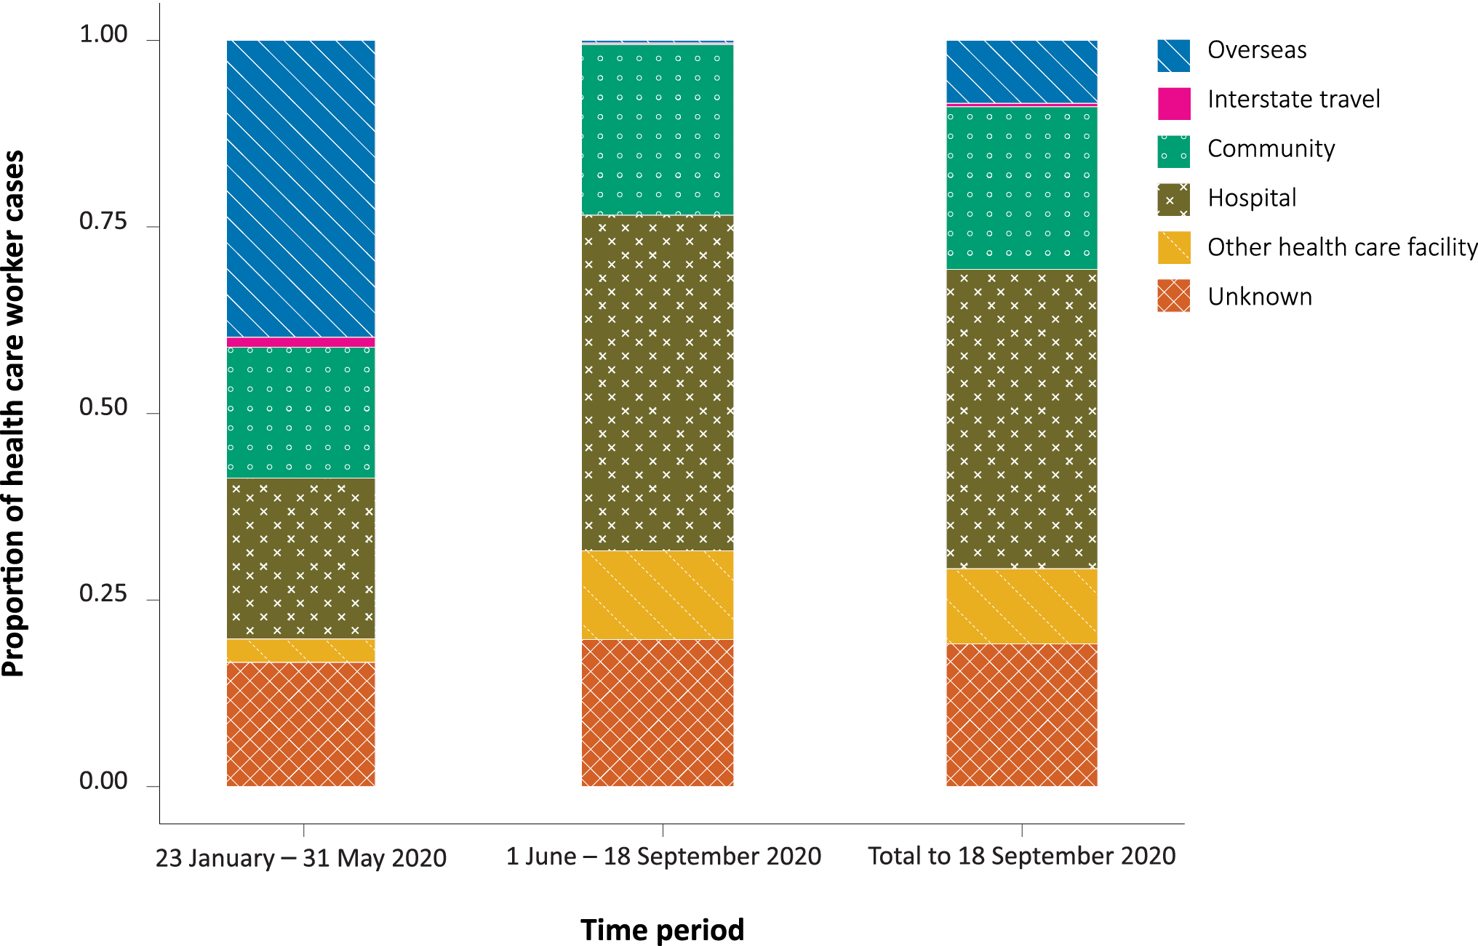

Source of acquisition
Among jurisdictions reporting all cases in health care workers, the likely source of acquisition was known for 81.0% (1,667/2,059) of cases—83.4% (371/445) in the first wave of the epidemic and 80.3% (1,296/1,614) in the second wave (Figure 2).

Figure 2: Source of acquisition of health care worker SARS-CoV-2 infections, 23 January – 18 September 2020, Australia
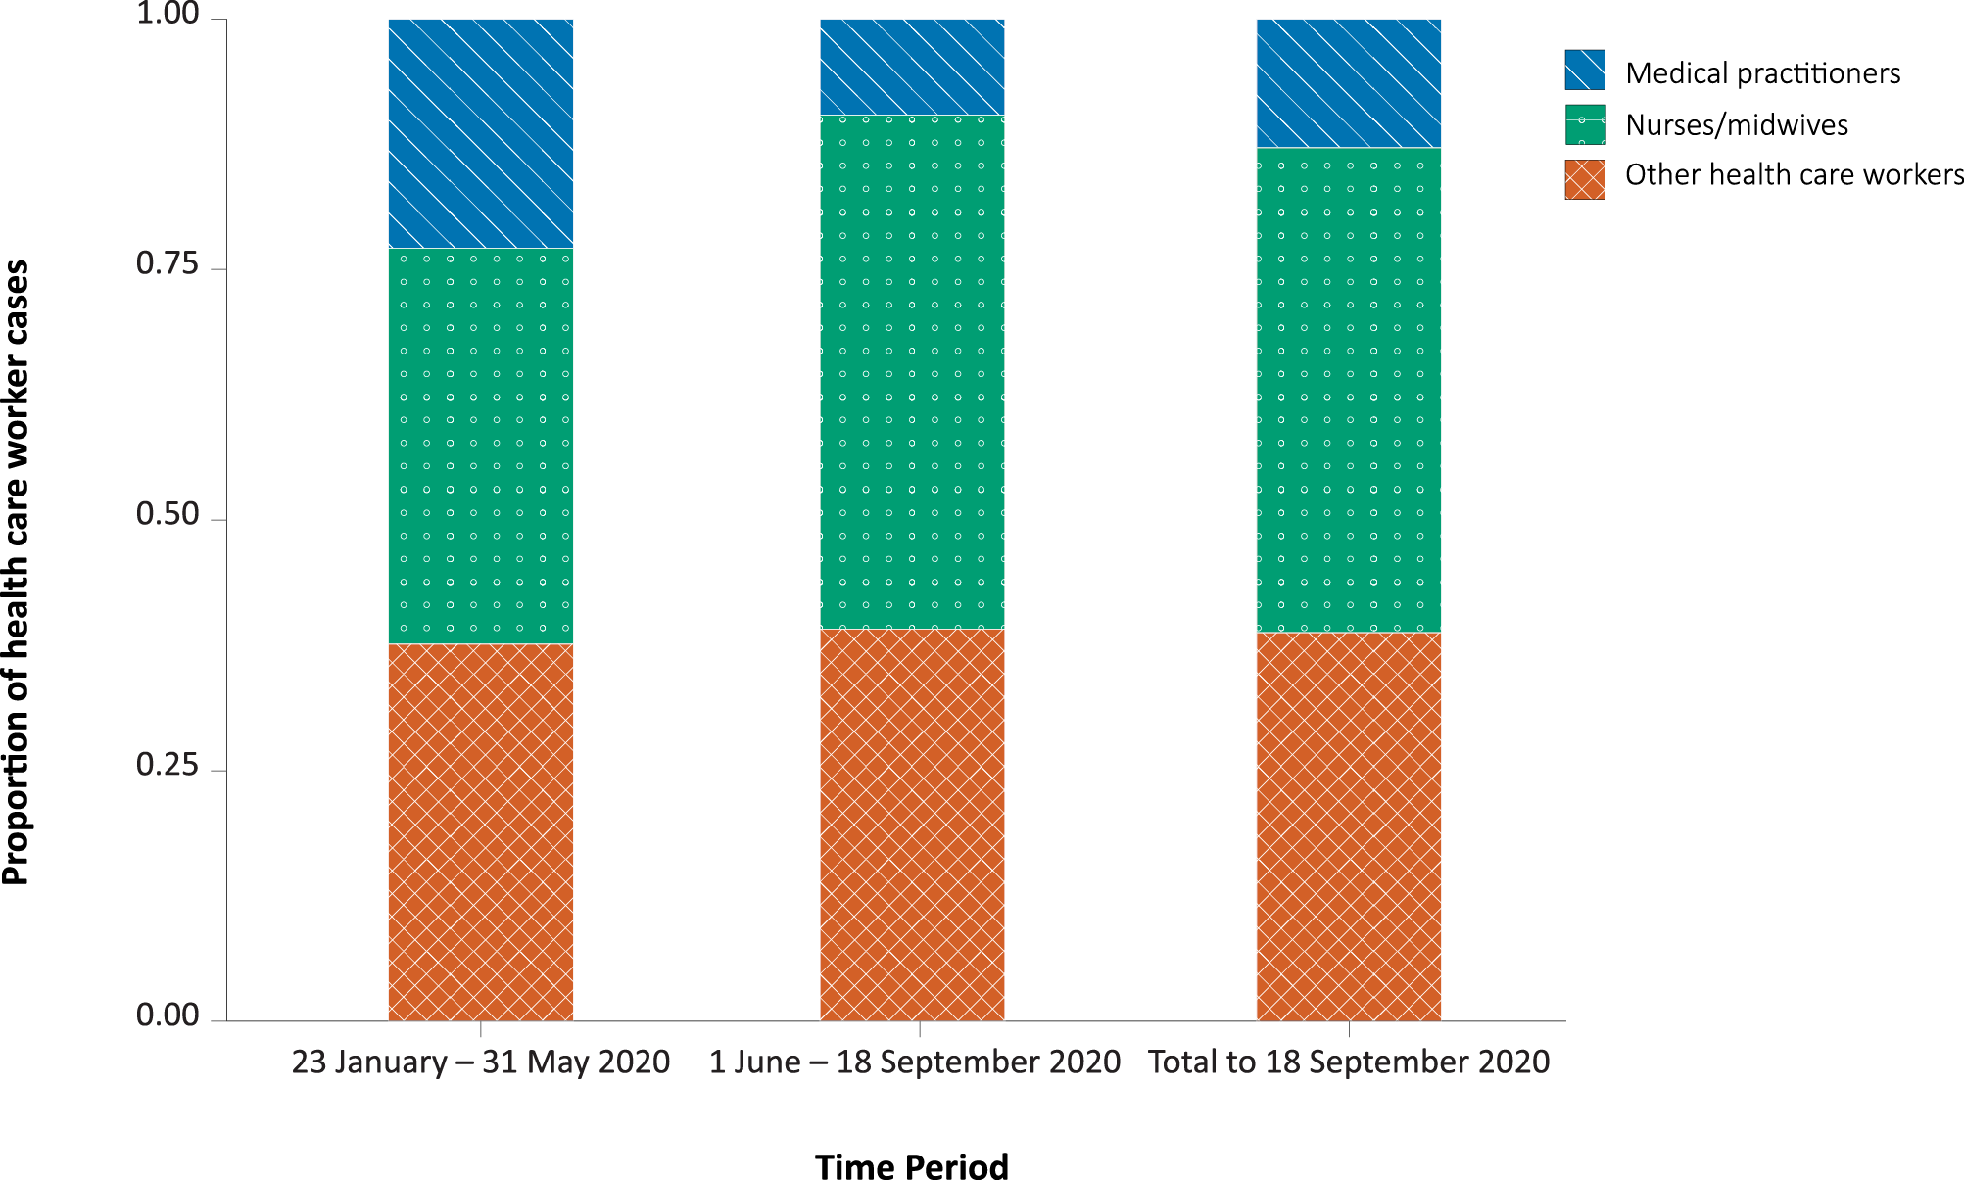
In the first wave, where the likely source was known, 49.3% (183/371) of health care worker cases acquired infection through travel (interstate, overseas or on board a cruise ship), 29.6% (110/371) in a health care setting—hospital (25.6%; 96/371) or other health care facility (3.8%; 14/371)—and 21.0% (78/371) in the community. Source of infection was unknown for 16.6% of health care worker cases (74/445) during the first wave.
In the second wave, where the likely source was known, 0.7% of health care worker cases (9/1,296) acquired infection through travel, 70.8% (918/1,296) in a health care setting—hospital (56.0%; 726/1,296) or other health care facility (14.8%; 192/1,296)—and 28.5% (369/1,296) in the community. Source of infection was unknown for 19.7% of health care worker cases (318/1,614) during the second wave.
Throughout the surveillance period, infection was acquired through travel for 192 health care workers and locally acquired (not overseas, interstate travel or cruise-ship-related) for 1,475 health care workers. Of locally-acquired health care worker infections, 71.3% (918/1,287) in the second wave were acquired in a health care setting, compared to 58.5% (110/188) in the first wave.
For locally-acquired infections, the odds of infection in the second wave compared to the first wave were increased in a health care setting (hospital and other health care facilities) (OR: 1.76; 95% CI: 1.28–2.41).

Outbreaks
During the surveillance period, state and territory health departments reported 120 outbreaks in health care settings, associated with 1,428 cases. The median size of outbreaks was 5 cases (range 2–181 cases). Of the cases associated with these outbreaks, 56.7% (809/1,428) were health care workers, rather than patients and visitors. There were 32 outbreaks in the first wave and 88 in the second wave. Of the cases associated with these outbreaks, 57.7% (192/333) in the first wave and 56.3% (617/1,095) in the second wave were health care workers. The majority of outbreaks in health care settings (73.8%, 88/120) occurred in the second wave, with 90.9% of these (80/88) occurring in Victoria. During the entire surveillance period, 9.6% of outbreak-associated health care worker cases (78/809) were hospitalised.

Discussion
Health care workers were over-represented among Australia’s COVID-19 cases. Health care workers, as defined in this paper, accounted for an estimated 9.1% of all cases of COVID-19 reported during the surveillance period. In comparison, health care workers employed in the ‘hospital’ and ‘medical and other health care services’ industries, according to the Australian Bureau of Statistics definition, represent approximately 4% of the Australian population, although we used a broader definition of a health care worker. In Australia, the proportion of health care worker cases of COVID-19 is comparable to that in Aotearoa New Zealand, where 11% of cases were health care workers as of 12 June 2020.⁹ By contrast, in Canada, in the context of widespread community transmission, the Canadian Institute for Health Information reported that 19.4% of cases (21,842/112,672) were health care workers as of 23 July 2020.¹⁰
The total number of SARS-CoV-2 infections in health care workers was greater in the second wave. Nurses/midwives were more commonly affected than medical practitioners and other health care workers. The higher frequency of nurses/midwives infected likely reflects the larger numbers of these professions in the health care workplace compared to other professions, with nurses and midwives accounting for 57% of registered health care workers in Australia.¹¹ We were unable to establish the source of infection; however, nurses often have frequent and ongoing close contact with patients, increasing their risk of infection. Roles with high patient contact may have additional infection-control procedures in place compared to those without patient contact, potentially reducing their risk of infection.¹²
The source of acquisition of SARS-CoV-2 infections in Australia changed over the course of the epidemic, as international travel was restricted, and transmission in the community increased, particularly in the state of Victoria. This same trend was seen within health-care-worker infections of SARS-CoV-2 in Australia over the surveillance period. The increased odds of infection in a workplace, particularly in the second wave, reflects the experience in Victoria and is consistent with the findings of other studies that health care workers are at greater risk of infection where there is heightened community transmission.^{13,14}
An estimated 7.3% of infected health care workers were hospitalised during their illness, which was lower than the overall hospitalisation rate of 13.3% of cases reported to the NNDSS during the same period. This may be explained by differences in age and comorbidities in health care worker cases compared to all cases reported to NNDSS. We were unable to explore the relationship between these factors and hospitalisation for this analysis. Hospitalisation for COVID-19 is a poor indicator for illness severity, as some jurisdictions required cases to stay in hospital for isolation and outbreak prevention, rather than for treatment of illness.
There have been several large, highly-publicised outbreaks in health care settings in Australia. In Tasmania a total of 138 cases, including 80 cases in health care workers, was associated with a large regional outbreak which originated in a hospital campus. The outbreak resulted in temporary closure of the hospitals and the quarantine of 5,000 people, including hospital staff and their household contacts.¹⁵ In addition, the Royal Melbourne Hospital conducted a prospective study of a large outbreak during the time when transmission in the Victorian community was increasing. As the number of COVID-19 cases in patients increased in the hospital, so did the number of health care worker infections.¹³ The impact of health care worker infections on the sustainability of the health system and the potential for disruption to health care operations is considerable, particularly where large numbers of staff are required to isolate or quarantine.¹⁵
The majority of outbreaks in a health care setting occurred in the second wave of the epidemic. However, while the number of outbreaks and associated health care worker infections was greater in the second wave than the first wave, the proportion of health care worker infections associated with these outbreaks was similar in both waves. Health care workers comprised 57.7% of the cases in the first wave and 56.3% of cases in the second wave. Infection by SARS-CoV-2 represents an occupational health and safety issue for staff in both clinical and non-clinical roles, which needs to be considered in outbreak settings. Health care workers in non-clinical roles can contribute to transmission chains in health care settings, indicating that staff interactions may be an important factor in a proportion of health care worker infections.^{16–19} As such, the inclusion of a wide range of non-clinical workers in the healthcare worker definition is important, as this allows for appropriate testing, investigation and quarantine measures during outbreaks, to ensure spread is limited. In the context of widespread community transmission, health care worker infections may be the result of infections acquired through patient care, from other infected health care workers, or from routine interactions in the community.

Limitations
There are several limitations associated with our analysis of these surveillance data. Most importantly, assessing the source of infection is often subjective and requires intensive investigation. Additionally, outbreak investigation protocols are not standardised across jurisdictions, although there is high-level national guidance for state and territory public health units.
It can be difficult to determine the exact source of acquisition of a COVID-19 case. This includes whether health care workers acquired their infection at work or in the community; and if at work, whether infection was acquired as a result of care of known cases, of other patients, or through non-patient exposures. This analysis was based on collection of aggregated data, which limited our ability to understand the characteristics of exposure for individual cases. In particular, where health care workers acquired their infection in a health care setting, we were unable to determine, from data available for this analysis, whether this was their workplace.
We provided standard definitions of health care settings and of who was considered a health care worker. However, it is likely that there were operational differences in definitions across jurisdictions that are reflected in the data provided for this analysis. Victoria did not provide data on non-clinical health care workers, which is likely to have led to an underestimate of total healthcare worker cases and an overestimation of the odds ratios presented for role type and source of acquisition. Nationally-aggregated data that breaks down source of acquisition by health care worker role were unavailable. Expanded surveillance is currently being implemented in the NNDSS, and will allow for future analysis of these data.
In Australia, the surveillance approach and capacity for response changed over the course of the epidemic. State and territory health departments have robust surveillance and have implemented nationally-agreed standard collection of data for infected health care workers, which are captured on jurisdictional surveillance systems. In May 2020, the NNDSS included additional fields capturing the occupation and the exposure setting of cases. In September 2020, further fields were incorporated into the NNDSS to identify the role of health care workers and their work setting. As a result, it was not possible to report consistent national data for the entire surveillance period from the NNDSS, and data was sought directly from jurisdictions.
For the surveillance period for this analysis, 2,260 cases in health care workers were recorded in the NNDSS compared to the 2,163 cases reported directly to us by jurisdictions. These case numbers are relatively consistent and the small differences are likely to be a reflection of the timing of data collection and the dynamic nature of surveillance data.
In New South Wales, health care worker cases considered to be potentially acquired in a health care setting were reviewed by an expert panel to evaluate the source of infection and inform policy development to minimise future risks in this population. For this analysis, New South Wales only provided information on cases acquired in a healthcare setting, which may affect the ability to compare source of infection data for health care workers.
The increase in COVID-19 cases that occurred in Victoria after June 2020 was the main contributor to the large number of health care worker cases and outbreaks in health care settings. It is important to note that the data presented in this analysis is largely a reflection of the situation in Victoria during the surveillance period and may limit the generalisability of the findings across other jurisdictions and at the national level. The Victorian Department of Health and Human Services is conducting a detailed review of surveillance data to inform future prevention measures in Victoria.

Conclusions
In the second wave of the epidemic, when there was heightened community transmission, health care workers were more likely to be infected in the workplace than in community settings. Throughout the epidemic, nurses were more likely to be infected than staff in other roles. National information on the sources of COVID-19 in health care workers and outbreaks in health care settings is important to inform understanding of risk and prevention measures. Further evaluation of outbreaks in health care settings is required to evaluate factors relating to transmission in these settings and risk factors for staff and the community. Understanding the potential risks associated with transmission in health care settings can support evidence-based policy development and additional prevention measures for health care workers.

Acknowledgements
We acknowledge and thank our jurisdictional colleagues for providing data for this paper. We particularly thank Victoria who provided data in the midst of managing hundreds of new cases a day in the state. We thank the Communicable Disease Network Australia for comments on a draft of this paper. We thank the following people for their assistance in reviewing this manuscript, contributing to literature reviews, and providing data: Rachel Nye; Keeley Allen; Rowena Boyd; Nyssa Watson; Tambri Housen; Bernadette Kenny; Kellie Mitchell; Paula Spokes; Tracie Reinten; ACT Health COVID-19 Operations Team; Queensland COVID Incident Management Team and Queensland Health Public Health Units; Tasmanian Department of Health Public Health Emergency Operations Centre; Western Australian Department of Health Public Health Operations Team; New South Wales Epidemiology and Surveillance Team; New South Wales public health unit staff who undertook case interviews and public health investigations; and other state and territory emergency operations centres and public health units.

Author Details
Anna C Rafferty¹ Moira C Hewitt¹ Rose Wright¹ Freya Hogarth^{1,2} Nick Coatsworth^{3,4} Frances Ampt⁵ Sally Dougall⁵ Charles Alpren⁵ Louise Causer⁶ Cushla Coffey⁷ Angela Wakefield⁷ Suzy Campbell⁷ Nevada Pingault⁸ Michelle Harlock⁹ Kylie J Smith^{9,10} Martyn D Kirk^{1,2}
- National Incident Response Division, Australian Government Department of Health, Canberra, Australia
- National Centre for Epidemiology and Population Health, Australian National University, Acton, ACT, Australia
- Office of the Chief Medical Officer, Australian Government Department of Health, Canberra, Australia
- ANU Medical School, Australian National University, Acton, ACT, Australia
- Victorian Department of Health and Human Services, Melbourne, Australia
- The Kirby Institute, University of NSW, Sydney, Australia
- Queensland Health, Brisbane, Australia
- Department of Health, Western Australia
- Tasmanian Department of Health, Hobart, Australia
- Menzies Institute for Medical Research, University of Tasmania, Hobart, Australia

Corresponding author
Professor Martyn Kirk
National Centre for Epidemiology and Population Health, The Australian National University, Acton ACT 2601, Australia
martyn.kirk@anu.edu.au
+61 4 2613 2181

References
- Rockett RJ, Arnott A, Lam C, Sadsad R, Timms V, Gray KA et al. Revealing COVID-19 transmission in Australia by SARS-CoV-2 genome sequencing and agent-based modeling. Nat Med. 2020;26(9):1398–404.
- COVID-19 National Incident Room Surveillance Team. COVID-19 Australia: Epidemiology Report 28: fortnightly reporting period ending 25 October 2020. Commun Dis Intell (2018). 2020;44. doi: https://doi.org/10.33321/cdi.2020.44.84.
- Nguyen LH, Drew DA, Graham MS, Joshi AD, Guo CG, Ma W et al. Risk of COVID-19 among front-line health-care workers and the general community: a prospective cohort study. Lancet Public Health. 2020;5(9):e475–83.
- Quigley AL, Stone H, Nguyen PY, Chughtai AA, MacIntyre CR. Estimating the burden of COVID-19 on the Australian healthcare workers and health system during the first six months of the pandemic. Int J Nurs Stud. 2020; 114:103811. doi: https://doi.org/10.1016/j.ijnurstu.2020.103811.
- Australian Government Department of Health. Coronavirus Disease 2019 (COVID-19): CDNA national guidelines for public health units. [Internet.] Canberra: Australian Government Department of Health; 29 January 2021. Available from: https://www1.health.gov.au/internet/main/publishing.nsf/Content/cdna-song-novel-coronavirus.htm.
- Aragon TJ, Fay MP, Wollschlaeger D, Omidpanah A. epitools: Epidemiology Tools. [Software.] 22 March 2020. Available from: https://CRAN.R-project.org/package=epitools.
- Wickham H. ggplot2: elegant graphics for data analysis. New York: Springer-Verlag; 2009.
- R Core Team. R: a language and environment for statistical computing. Vienna: R Foundation for Statistical Computing; 2020. Available from: https://www.R-project.org/.
- New Zealand Government Ministry of Health. COVID-19 in health care and support workers in Aotearoa New Zealand. Wellington: New Zealand Government Ministry of Health; 8 October 2020. Available from: https://www.health.govt.nz/publication/covid-19-health-care-and-support-workers-aotearoa-new-zealand.
- Canadian Institute for Health Information (CIHI). COVID-19 cases and deaths among health care workers in Canada. [Data table.] Ottowa: CIHI; 3 September 2020. Available from: https://www.cihi.ca/en/covid-19-cases-and-deaths-among-health-care-workers-in-canada.
- Australian Government, Australian Institute of Health and Welfare (AIHW). Health workforce. [Internet.] Canberra: AIHW; 23 July 2020. Available from: https://www.aihw.gov.au/reports/australias-health/health-workforce.
- Eyre DW, Lumley SF, O’Donnell D, Campbell M, Sims E, Lawson E et al. Differential occupational risks to healthcare workers from SARS-CoV-2 observed during a prospective observational study. eLife. 2020;9:e60675. doi: https://doi.org/10.7554/eLife.60675.
- Buising KL, Williamson D, Cowie BC, MacLachlan J, Orr E, MacIsaac C et al. A hospital-wide response to multiple outbreaks of COVID-19 in health care workers: lessons learned from the field. Med J Aust. 2020. doi: https://doi.org/10.5694/mja2.50850.
- State Government of Victoria, Department of Health and Human Services (DHHS). Protecting our healthcare workers. Melbourne: State Government of Victoria, DHHS; 25 August 2020. Available from: https://www.dhhs.vic.gov.au/sites/default/files/documents/202010/Protecting-our-healthcare-workers-action-plan.pdf.
- Tasmanian Government Department of Health. COVID-19 North West Regional Hospital Outbreak Interim Report. Hobart: State Government of Tasmania, Department of Health; 29 April 2020. [Accessed on 10 May 2021.] Available from: http://health.tas.gov.au/__data/assets/pdf_file/0006/401010/North_West_Regional_Hospital_Outbreak_-_Interim_Report.pdf
- Wee LE, Sim XYJ, Conceicao EP, Aung MK, Goh JQ, Yeo DWT et al. Containment of COVID-19 cases among healthcare workers: the role of surveillance, early detection, and outbreak management. Infect Control Hosp Epidemiol. 2020;41(7):765–71.
- Kabesch M, Roth S, Brandstetter S, Häusler S, Juraschko E, Weigl M, et al. Successful containment of Covid-19 outbreak in a large maternity and perinatal center while continuing clinical service. Pediatr Allergy Immunol. 2020;31(5):560–4.
- Çelebi G, Pişkin N, Çelik Bekleviç A, Altunay Y, Salcı Keleş A, Tüz MA et al. Specific risk factors for SARS-CoV-2 transmission among health care workers in a university hospital. Am J Infect Control. 2020;48(10):1225–30.
- Meredith LW, Hamilton WL, Warne B, Houldcroft CJ, Hosmillo M, Jahun AS et al. Rapid implementation of SARS-CoV-2 sequencing to investigate cases of health-care associated COVID-19: a prospective genomic surveillance study. Lancet Infect Dis. 2020;20(11):1263–71.

Communicable Diseases Intelligence
ISSN: 2209-6051 Online

Communicable Diseases Intelligence (CDI) is a peer-reviewed scientific journal published by the Office of Health Protection and Response, Department of Health. The journal aims to disseminate information on the epidemiology, surveillance, prevention and control of communicable diseases of relevance to Australia.

Editor: Jennie Hood
Deputy Editor: Simon Petrie
Design and Production: Kasra Yousefi
Editorial Advisory Board: David Durrheim, Mark Ferson, John Kaldor, Martyn Kirk and Linda Selvey

Website: http://www.health.gov.au/cdi

Contacts
CDI is produced by the Office of Health Protection and Response, Australian Government Department of Health, GPO Box 9848, (MDP 6) CANBERRA ACT 2601

Email: cdi.editor@health.gov.au

Submit an Article
You are invited to submit your next communicable disease related article to the Communicable Diseases Intelligence (CDI) for consideration. More information regarding CDI can be found at: http://health.gov.au/cdi.
Further enquiries should be directed to: cdi.editor@health.gov.au.

This journal is indexed by Index Medicus and Medline.

Creative Commons Licence - Attribution-NonCommercial-NoDerivatives CC BY-NC-ND
© 2021 Commonwealth of Australia as represented by the Department of Health
This publication is licensed under a Creative Commons Attribution-NonCommercial-NoDerivatives 4.0 International Licence from https://creativecommons.org/licenses/by-nc-nd/4.0/legalcode (Licence). You must read and understand the Licence before using any material from this publication.

Restrictions
The Licence does not cover, and there is no permission given for, use of any of the following material found in this publication (if any):
- the Commonwealth Coat of Arms (by way of information, the terms under which the Coat of Arms may be used can be found at www.itsanhonour.gov.au);
- any logos (including the Department of Health’s logo) and trademarks;
- any photographs and images;
- any signatures; and
- any material belonging to third parties.

Disclaimer
Opinions expressed in Communicable Diseases Intelligence are those of the authors and not necessarily those of the Australian Government Department of Health or the Communicable Diseases Network Australia. Data may be subject to revision.

Enquiries
Enquiries regarding any other use of this publication should be addressed to the Communication Branch, Department of Health, GPO Box 9848, Canberra ACT 2601, or via e-mail to: copyright@health.gov.au

Communicable Diseases Network Australia
Communicable Diseases Intelligence contributes to the work of the Communicable Diseases Network Australia.
http://www.health.gov.au/cdna

Australian Bureau of Statistics. Labour Force, Detailed, August 2020. cat. no. 6291.0.55.003. Available from: https://www.abs.gov.au/statistics/labour/employment-and-unemployment/labour-force-australia-detailed/aug-2020/6291006.xls.

