Immunisation Coverage Annual Report 2018
Brynley Hull, Alexandra Hendry, Aditi Dey, Peter McIntyre, Kristine Macartney, Frank Beard

Abstract
Australian Immunisation Register data have been analysed for children aged < 5 years, focusing on changes in coverage at key milestone ages (12, 24 and 60 months) between 2017 and 2018, while also documenting longer term trends. Fully vaccinated coverage increased at the 12- and 60-months milestones to 93.9% and 94.0%, respectively, but, in the context of additional antigens required, decreased to 90.1% at 24 months. Following the move to a two-dose rotavirus vaccine schedule across Australia from mid-2017, rotavirus vaccine coverage increased from 86.8% to 90.9%. In 2018, most jurisdictions funded influenza vaccine for non-Indigenous children aged 6 months to < 5 years; the National Immunisation Program has funded influenza vaccine for Aboriginal and Torres Strait Islander children and medically at-risk children since 2015 and 2010, respectively. Recorded influenza vaccine coverage in Aboriginal and Torres Strait Islander children doubled from 14.9% to 31.4%, and increased fivefold in non-Indigenous children from 5.0% to 25.9% in 2018. The timeliness of fully vaccinated coverage was also examined at earlier milestones (3 months after due date of last scheduled vaccine) of 9, 15, 21 and 51 months, by area of residence. For all children, coverage among those living in the least advantaged residential area quintile was 3–4% lower than that for those in the most advantaged quintile at the 9-, 15- and 21-month milestones. Importantly, although Aboriginal and Torres Strait Islander children had lower coverage for the second dose of measles-mumps-rubella vaccine at 24 months (91.8% versus 93.1% for non-Indigenous), coverage increased to 98.5% at 60 months; coverage was also high in non-Indigenous children at 96.2%, above the 95% target critical to measles control. These data demonstrate continuing improvements in immunisation coverage and suggest potential new coverage targets for earlier protection in the first two years of life.
Keywords: vaccination coverage, vaccination timeliness, Aboriginal and Torres Strait Islander vaccination coverage, influenza vaccination.

Introduction
This is the twelfth annual Australian immunisation coverage report, with reports now covering the years 2007–2018.^{1–11} This report complements other reports that provide data on vaccination coverage in Australia^{12–14} by highlighting important trends and their relationship to relevant policy and program changes. The report includes detailed analyses of coverage data for children aged < 5 years for the calendar year 2018, with a particular focus on changes from 2017. It also shows trend data from 2009 onwards.
This report uses the longstanding international practice of reporting at key milestone ages to measure coverage against national targets and to track trends over time. National vaccination coverage and timeliness for 2018 was measured using Australian Immunisation Register (AIR) data as at 31 March 2019. Cohort vaccination status was assessed for ‘fully vaccinated’ and individual vaccines at the standard milestones: 12 months of age (for vaccines due at 6 months); 24 months of age (for vaccines due at 6, 12 and 18 months); and 60 months of age (for vaccines due at 48 months), including by Aboriginal and Torres Strait Islander (hereafter respectfully referred to as Indigenous) status and at small area level (Primary Health Network [PHN] and Australian Bureau of Statistics Statistical Area 3 [SA3]). Coverage for vaccines included on the National Immunisation Program (NIP) specifically for Indigenous children was assessed using appropriate milestones/cohorts and for relevant jurisdictions. Timeliness of vaccination was assessed by calculating ‘on-time’ vaccination (within 30 days of recommended age) for selected vaccine doses, by Indigenous status, and ‘fully vaccinated’ coverage at earlier milestones (9, 15, 21 and 51 months) by socioeconomic status and remoteness of area of residence. A more detailed description of the methods used in this report is provided in the Appendix, as is a listing of vaccine abbreviations used herein.
The NIP schedule for children aged < 5 years in 2018 is summarised in Appendix Table A.1. Important recent changes to vaccination policy, the incentive payment system and ‘fully vaccinated’ coverage algorithms are shown in Appendix Box A.1. The most important recent change occurred in July 2018, when the schedule for 13-valent pneumococcal conjugate vaccine (13vPCV) changed from 2, 4 and 6 months of age to 2, 4 and 12 months of age. Consequently, the coverage assessment algorithm for ‘fully vaccinated’ at the 12-month milestone was amended to require either 2 or 3 doses of 13vPCV (rather than 3 doses as previously), and for ‘fully vaccinated’ at the 24-month milestone to require 3 doses of 13vPCV (not previously included at this milestone). Also in July 2018, meningococcal ACWY conjugate vaccine was funded for all children at 12 months of age, replacing the combined Haemophilus influenzae type b (Hib) and meningococcal C (MenC)–containing vaccine, with the Hib component moved to 18 months of age as a monovalent vaccine.
While 2018 represents the second full year of data for the expanded whole-of-life AIR, adult and adolescent vaccination data from the AIR are not included in this report. Adult AIR data are presented in a separate report, which assesses data completeness.¹⁵ Adolescent data will be presented in a future report, after transition of human papillomavirus (HPV) vaccination data from the National HPV Vaccination Program Register and state and/or territory school-based systems to AIR is complete.

Results

Coverage at 12, 24 and 60 months of age

‘Fully vaccinated’
‘Fully vaccinated’ coverage (incorporating all vaccines/antigens included in the relevant assessment algorithm – refer to the ‘Detailed methods’ section in the Appendix) increased slightly between 2017 and 2018 at both 12 months of age (from 93.8% to 93.9%) and 60 months (from 93.3% to 94.0%), but decreased marginally at 24 months (from 90.2% to 90.1%) (refer to Table 1). Longer-term trends in ‘fully vaccinated’ coverage are shown in Figure A.1 in the Appendix. ‘Fully vaccinated’ coverage estimates for 2018 at the three age milestones are also provided by Primary Health Network (PHN) in Appendix Table A.3. For the 60-month age milestone, ‘fully vaccinated’ coverage ranged from a low of 91.0% in the North Coast PHN to a high of 97.5% in the Western NSW PHN.

Table 1: Vaccination coverage estimates (%) by age assessment milestone and vaccine/antigen, Australia, 2017 versus 2018ª
Vaccine/antigen | Milestone age | 2017 (%)^{b} | 2018 (%)^{b}
Fully vaccinated^{a,c} | 12 months^{d} | 93.8 | 93.9
 | 24 months^{e} | 90.2 | 90.1
 | 60 months^{f} | 93.3 | 94.0
Diphtheria, tetanus, acellular pertussis | 12 months^{d} (dose 3) | 94.7 | 94.7
 | 24 months^{e} (dose 4) | 92.4 | 92.8
 | 60 months^{f} (dose 4 or 5) | 93.7 | 94.1
Polio | 12 months^{d} (dose 3) | 94.7 | 94.6
 | 24 months^{e} (dose 3) | 96.3 | 96.4
 | 60 months^{f} (dose 4) | 93.7 | 94.2
Haemophilus influenzae type b | 12 months^{d} (dose 3) | 94.5 | 94.5
 | 24 months^{e} (dose 4) | 94.7 | 94.7
 | 60 months^{f} (dose 4) | 95.6 | 95.9
Hepatitis B | 12 months^{d} (dose 3) | 94.3 | 94.3
 | 24 months^{e} (dose 4) | 95.7 | 95.9
 | 60 months^{f} (dose 4) | 96.0 | 96.4
Measles, mumps, rubella | 12 months | N/A | N/A
 | 24 months^{e} (dose 1) | 95.3 | 95.4
 | 24 months^{e} (dose 2) | 93.0 | 93.0
 | 60 months^{f} (dose 2) | 95.7 | 96.3
Varicella | 12 months | N/A | N/A
 | 24 months^{e} (dose 1) | 92.6 | 92.8
 | 60 months^{f} (dose 1) | 94.6 | 95.1
Meningococcal C-containing | 12 months | N/A | N/A
 | 24 months^{e} (dose 1) | 95.0 | 95.1
 | 60 months^{f} (dose 1) | 96.1 | 96.4
Pneumococcal conjugate | 12 months^{d,g} (dose 2 or 3) | 94.2 | 95.7
 | 24 months^{e} (dose 3) | 95.4 | 95.7
 | 60 months^{f} (dose 3) | 93.1 | 93.9
Rotavirus | 12 months^{d,h} (dose 2 or 3) | 86.8 | 90.9
 | 24 months | N/A | N/A
 | 60 months | N/A | N/A
a Source: Australian Immunisation Register, data as at 31 March 2018 for 2017 estimates and 31 March 2019 for 2018 estimates.
b N/A Not applicable (vaccine either not given prior to this milestone, or contraindicated after previous milestone).
c Refer to Appendix for details of ‘fully vaccinated’ assessment algorithms; coverage estimates in this table are calculated using 12-month wide cohorts and may differ slightly from estimates published elsewhere using rolling annualised cohorts.
d Cohort born 1 January 2016 – 31 December 2016 (2017 estimate) and 1 January 2017 – 31 December 2017 (2018 estimate).
e Cohort born 1 January 2015 – 31 December 2015 (2017 estimate) and 1 January 2016 – 31 December 2016 (2018 estimate).
f Cohort born 1 January 2012 – 31 December 2012 (2017 estimate) and 1 January 2013 – 31 December 2013 (2018 estimate).
g Dose 3 in 2017. Dose 2 or 3 in 2018.
h Dose 2 or 3 in 2017 depending on jurisdiction. Dose 2 in 2018 for all jurisdictions.

Coverage by individual vaccines/antigens
Coverage for individual vaccines/antigens at 12 months of age increased between 2017 and 2018, from 94.2% to 95.7% for pneumococcal conjugate vaccine (PCV) and from 86.8% to 90.9% for rotavirus vaccine (not included in the ‘fully vaccinated’ algorithm), but remained similar for diphtheria-tetanus-acellular pertussis (DTPa) vaccine, hepatitis B (Hep B) vaccine and polio and Hib (given together in a hexavalent combination vaccine) vaccine at just under 95% (refer to Table 1). Longer-term trends in individual vaccine/antigen coverage at 12 months of age are shown in Appendix Figure A.2.
Coverage for vaccines/antigens at the 24-month age assessment milestone either remained the same or increased slightly between 2017 and 2018, with 2018 coverage ranging from 92.8% for varicella vaccine and the fourth dose of DTPa vaccine, due at 18 months of age, to 96.4% for the third dose of polio vaccine, due at 6 months of age (refer to Table 1). Coverage for the third dose of PCV, included in the 24-month age assessment milestone for the first time in July 2018, reached 95.7% in 2018, while coverage for measles-mumps-rubella (MMR) vaccine reached 93.0% for dose 2 and 95.4% for dose 1 (dose 2 included in the ‘fully vaccinated’ algorithm). Longer-term trends in individual vaccine/antigen coverage at 24 months of age are shown in Appendix Figure A.3.
Coverage for individual vaccines/antigens included in the ‘fully vaccinated’ algorithm at the 60-month age milestone increased slightly between 2017 and 2018: from 93.7% to 94.1% for the fourth (or fifth) dose of DTPa vaccine and from 93.7% to 94.2% for the fourth dose of polio vaccine (refer to Table 1). Coverage for vaccines/antigens not included in the ‘fully vaccinated’ algorithm at the 60-month also increased, reaching 96.4% for Hep B vaccine, 96.3% for MMR vaccine, 95.9% for Hib vaccine, 95.1% for varicella vaccine and 93.9%% for PCV. Longer-term trends in individual vaccine/antigen coverage at 60 months of age are shown in Appendix Figure A.4.

Coverage estimates by Indigenous status

‘Fully vaccinated’
Between 2017 and 2018, ‘fully vaccinated’ coverage for Indigenous children increased marginally from 92.3% to 92.4% at 12 months of age and from 96.3% to 96.4% at 60 months, but decreased from 88.4% to 87.8% at the 24-month milestone (refer to Table 2).

Table 2: Vaccination coverage estimates (%) by age assessment milestone, vaccine/antigen and Indigenous status, Australia, 2017 versus 2018ª
Vaccine/antigen | Milestone age | Indigenous (%) |  | non-Indigenous (%)
 |  | 2017^{b} | 2018^{b} | 2017^{b} | 2018^{b}
Fully vaccinated^{c} | 12 months^{d} | 92.3 | 92.4 | 93.9 | 94.0
 | 24 months^{e} | 88.4 | 87.8 | 90.3 | 90.3
 | 60 months^{f} | 96.3 | 96.4 | 93.1 | 93.9
Diphtheria, tetanus, acellular pertussis | 12 months^{d} (Dose 3) | 92.5 | 92.5 | 94.9 | 94.8
 | 24 months^{e} (Dose 4) | 90.3 | 90.6 | 92.5 | 92.9
 | 60 months^{f} (Dose 4 or 5) | 96.5 | 96.5 | 93.5 | 94.0
Polio | 12 months^{d} (Dose 3) | 92.5 | 92.5 | 94.8 | 94.8
 | 24 months^{e} (Dose 3) | 97.1 | 97.2 | 96.3 | 96.4
 | 60 months^{f} (Dose 4) | 96.4 | 96.4 | 93.6 | 94.1
Haemophilus influenzae type b | 12 months^{d} (Dose 3) | 92.5 | 92.5 | 94.7 | 94.6
 | 24 months^{e} (Dose 4) | 95.7 | 95.2 | 94.7 | 94.7
 | 60 months^{f} (Dose 4) | 98.3 | 98.3 | 95.5 | 95.8
Hepatitis B | 12 months^{d} (Dose 3) | 92.5 | 92.6 | 94.5 | 94.4
 | 24 months^{e} (Dose 3) | 97.1 | 97.1 | 95.6 | 95.8
 | 60 months^{f} (Dose 3) | 98.5 | 98.5 | 95.9 | 96.3
Measles, mumps, rubella | 12 months | N/A | N/A | N/A | N/A
 | 24 months^{e} (Dose 1) | 96.6 | 96.6 | 95.2 | 95.3
 | 24 months^{e} (Dose 2) | 91.9 | 91.8 | 93.0 | 93.1
 | 60 months^{f} (Dose 2) | 98.4 | 98.5 | 95.6 | 96.2
Varicella | 12 months | N/A | N/A | N/A | N/A
 | 24 months^{e} (Dose 1) | 91.1 | 91.1 | 92.7 | 92.9
 | 60 months^{f} (Dose 1) | 97.1 | 97.2 | 94.5 | 95.0
Meningococcal C-containing | 12 months | N/A | N/A | N/A | N/A
 | 24 months^{e} (Dose 1) | 96.4 | 96.4 | 94.9 | 95.1
 | 60 months^{f} (Dose 1) | 98.4 | 98.5 | 96.0 | 96.3
Pneumococcal conjugate | 12 months^{d,g} (Dose 2 or 3) | 92.5 | 95.8 | 94.3 | 95.7
 | 24 months^{e} (Dose 3) | 96.5 | 96.8 | 95.3 | 95.6
 | 60 months^{f} (Dose 3) | 95.6 | 96.0 | 93.0 | 93.9
Rotavirus | 12 months^{d,h} (Dose 2 or 3) | 83.5 | 86.7 | 89.5 | 91.2
 | 24 months | N/A | N/A | N/A | N/A
 | 60 months | N/A | N/A | N/A | N/A
a Source: Australian Immunisation Register, data as at 31 March 2018 for 2017 estimates and 31 March 2019 for 2018 estimates.
b N/A Not applicable (vaccine either not given prior to this milestone, or contraindicated after previous milestone).
c Refer to Appendix for details of ‘fully vaccinated’ assessment algorithms; coverage estimates in this table are calculated using 12-month wide cohorts and may differ slightly from estimates published elsewhere using rolling annualised cohorts.
d Cohort born 1 January 2016 – 31 December 2016 (2017 estimate) and 1 January 2017 – 31 December 2017 (2018 estimate).
e Cohort born 1 January 2015 – 31 December 2015 (2017 estimate) and 1 January 2016 – 31 December 2016 (2018 estimate).
f Cohort born 1 January 2012 – 31 December 2012 (2017 estimate) and 1 January 2013 – 31 December 2013 (2018 estimate).
g Dose 3 in 2017. Dose 2 or 3 in 2018.
h Dose 2 or 3 in 2017 depending on jurisdiction. Dose 2 in 2018 for all jurisdictions.
The disparity in ‘fully vaccinated’ coverage between Indigenous and non-Indigenous children remained the same at 12 months of age in 2018 compared with 2017 (1.6 percentage points), but increased at 24 months from 1.9 to 2.5 percentage points (refer to Table 2). Notably, ‘fully vaccinated’ coverage at 60 months of age continues to be higher in Indigenous than in non-Indigenous children (2.5 percentage points in 2018) (refer to Table 2).
Trends in ‘fully vaccinated’ coverage estimates by Indigenous status are shown in Appendix Figures A.5, A.6 and A.7.

Coverage by individual vaccines/antigens
Between 2017 and 2018, coverage for individual vaccines/antigens in Indigenous children increased for PCV (from 92.5% to 95.8%) and rotavirus vaccine (from 83.5% to 86.7%) at the 12-month milestone, but remained largely unchanged for other vaccines/antigens at the three milestones (refer to Table 2).
Although 2018 vaccination coverage in Indigenous children was lower than in non-Indigenous children for all individual vaccines/antigens except PCV at 12 months of age, it was higher at 24 months for polio vaccine, Hib vaccine, Hep B vaccine, PCV and MenC–containing vaccines, and at 60 months for all vaccines/antigens (refer to Table 2). Coverage in Indigenous children was particularly high for MenC-containing, Hep B, the second dose of MMR (all 98.5%) and Hib (98.3%), all by 60 months of age.

Hepatitis A vaccine for Indigenous children
Coverage for the second dose of hepatitis A vaccine by 30 months of age, for the combined four jurisdictions where it is funded for Indigenous children (Northern Territory, Queensland, South Australia and Western Australia), increased slightly from 71.3% in 2017 to 72.4% in 2018. Longer-term trends in hepatitis A vaccine coverage (refer to Appendix Figure A.8) show the highest levels consistently in the Northern Territory (83.8% in the December 2018 quarter).

Pneumococcal vaccine for Indigenous children
Coverage for the additional fourth dose of PCV by 30 months of age, for the combined four jurisdictions where it is funded for Indigenous children (Northern Territory, Queensland, South Australia and Western Australia), decreased marginally from 71.7% in 2017 to 71.4% in 2018. Longer-term trends in PCV fourth-dose coverage (refer to Appendix Figure A.9) show the highest levels consistently in the Northern Territory (86.0% in the December 2018 quarter).

Influenza vaccine coverage for all children aged 6 months to < 5 years
Overall, the national recorded influenza vaccine coverage in children aged 6 months to < 5 years increased markedly between 2017 (5.6%) and 2018 (26.2%). In Indigenous children aged 6 months to < 5 years, coverage more than doubled from 14.9% in 2017 to 31.4% in 2018 (refer to Figure 1), but varied substantially by jurisdiction. In 2018, coverage was highest in the Northern Territory at 73.4%, with three other jurisdictions at or above 30% (Australian Capital Territory, Victoria and Tasmania at 36.1%, 33.2% and 30.0%, respectively) (refer to Figure 1). For non-Indigenous children aged 6 months to < 5 years, there was also substantial variation in recorded coverage by jurisdiction in 2018, with coverage highest in the Australian Capital Territory at 44.4% with four other jurisdictions above 25% (Tasmania, Victoria, New South Wales and Queensland at 30.8%, 28.9%, 25.6% and 25.1%, respectively) (refer to Figure 2).

Figure 1: Recorded coverage of seasonal influenza vaccineª in Indigenous children aged 6 months to < 5 years, by jurisdiction, 2017 versus 2018, Australia^{b,c}
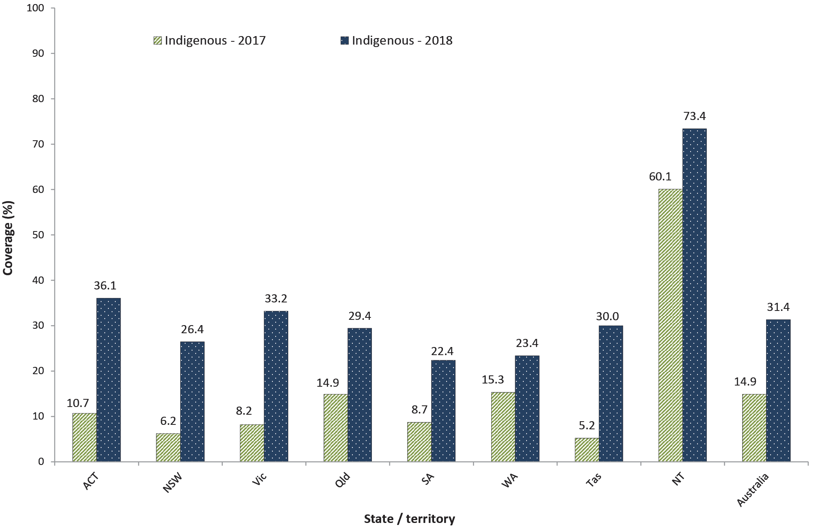
a Any influenza vaccine dose.
b Source: Australian Immunisation Register, data as at 31 March 2019.
c ACT = Australian Capital Territory; NSW = New South Wales; NT = Northern Territory; Qld = Queensland; SA = South Australia; Tas = Tasmania; Vic = Victoria; WA = Western Australia.

Figure 2: Recorded coverage of seasonal influenza vaccineª in non-Indigenous children aged 6 months to < 5 years, by jurisdiction, 2017 versus 2018, Australia^{b,c}
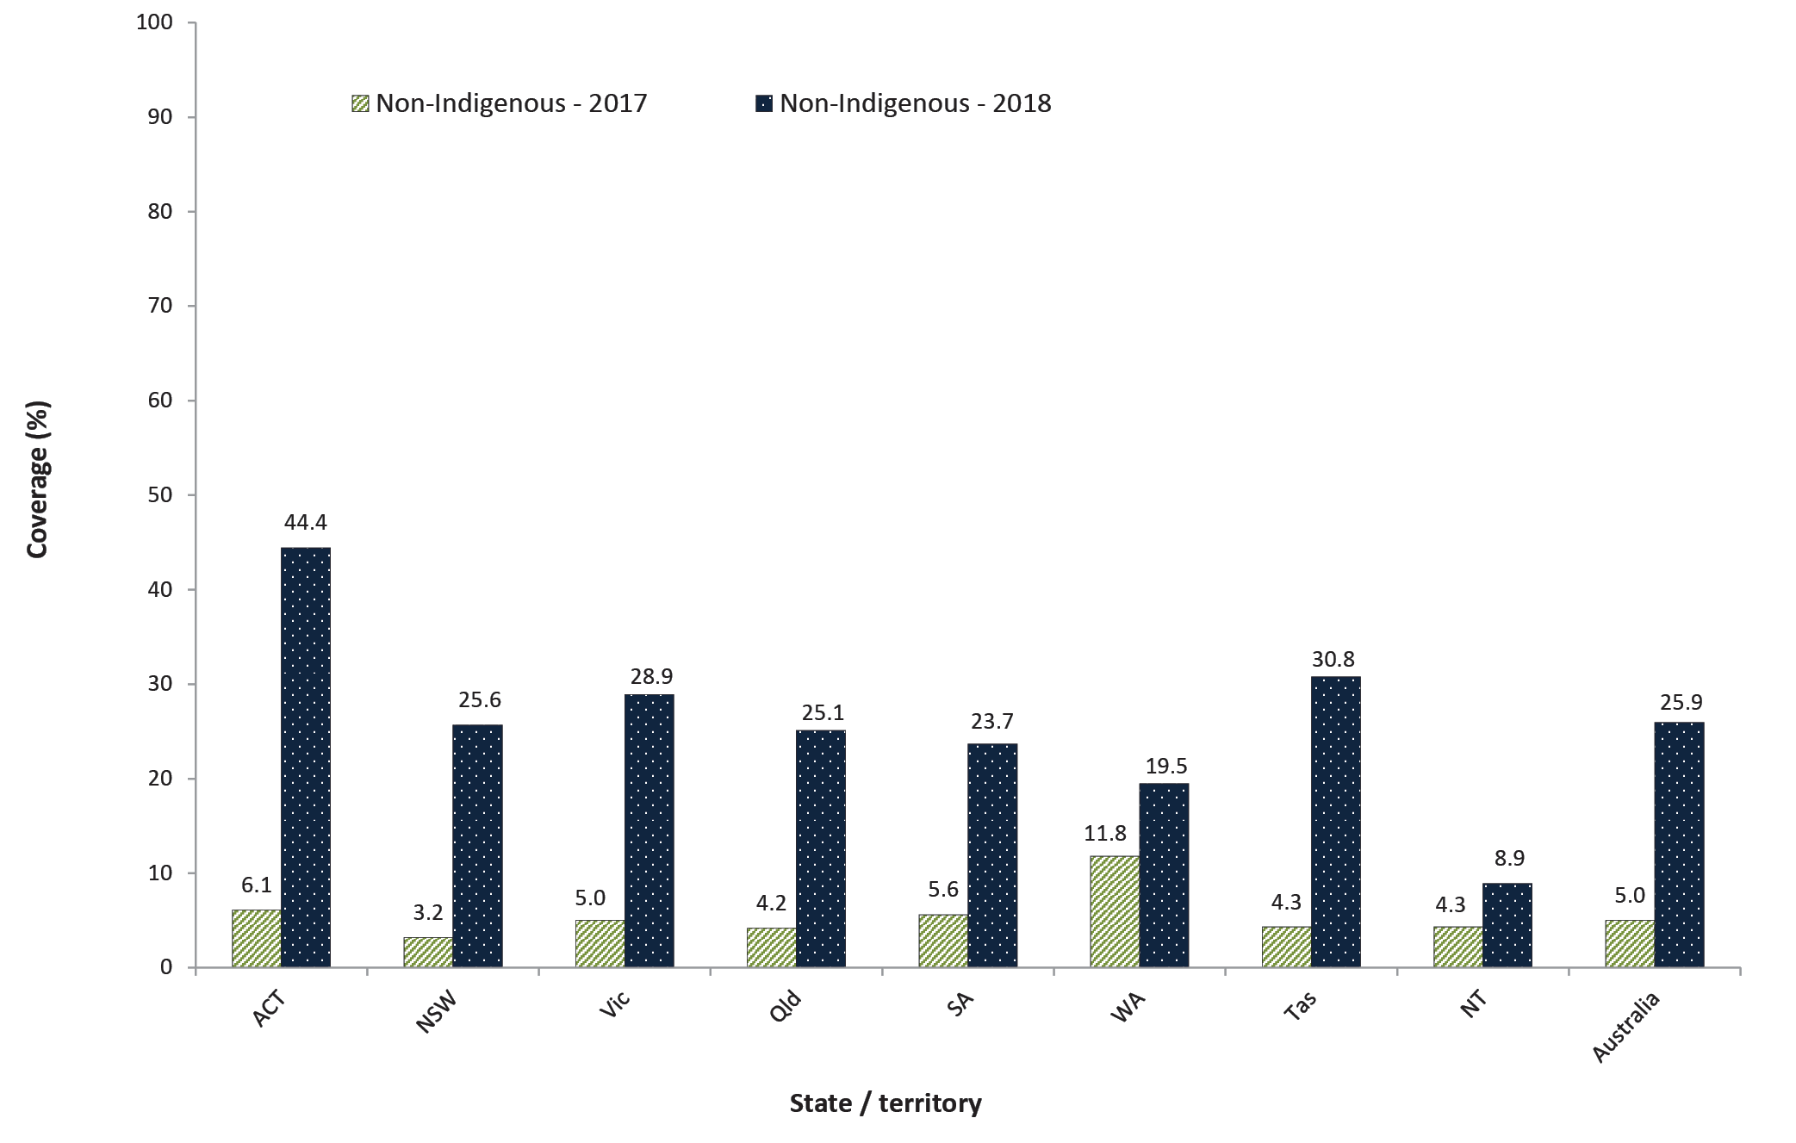
a Any influenza vaccine dose.
b Source: Australian Immunisation Register, data as at 31 March 2019.
c ACT = Australian Capital Territory; NSW = New South Wales; NT = Northern Territory; Qld = Queensland; SA = South Australia; Tas = Tasmania; Vic = Victoria; WA = Western Australia.

Figure 3: Cumulative percentage of children vaccinated with the second dose of DTPa-containing vaccine^{a,b} by age in months and Indigenous status, Australia, 2018^{c}
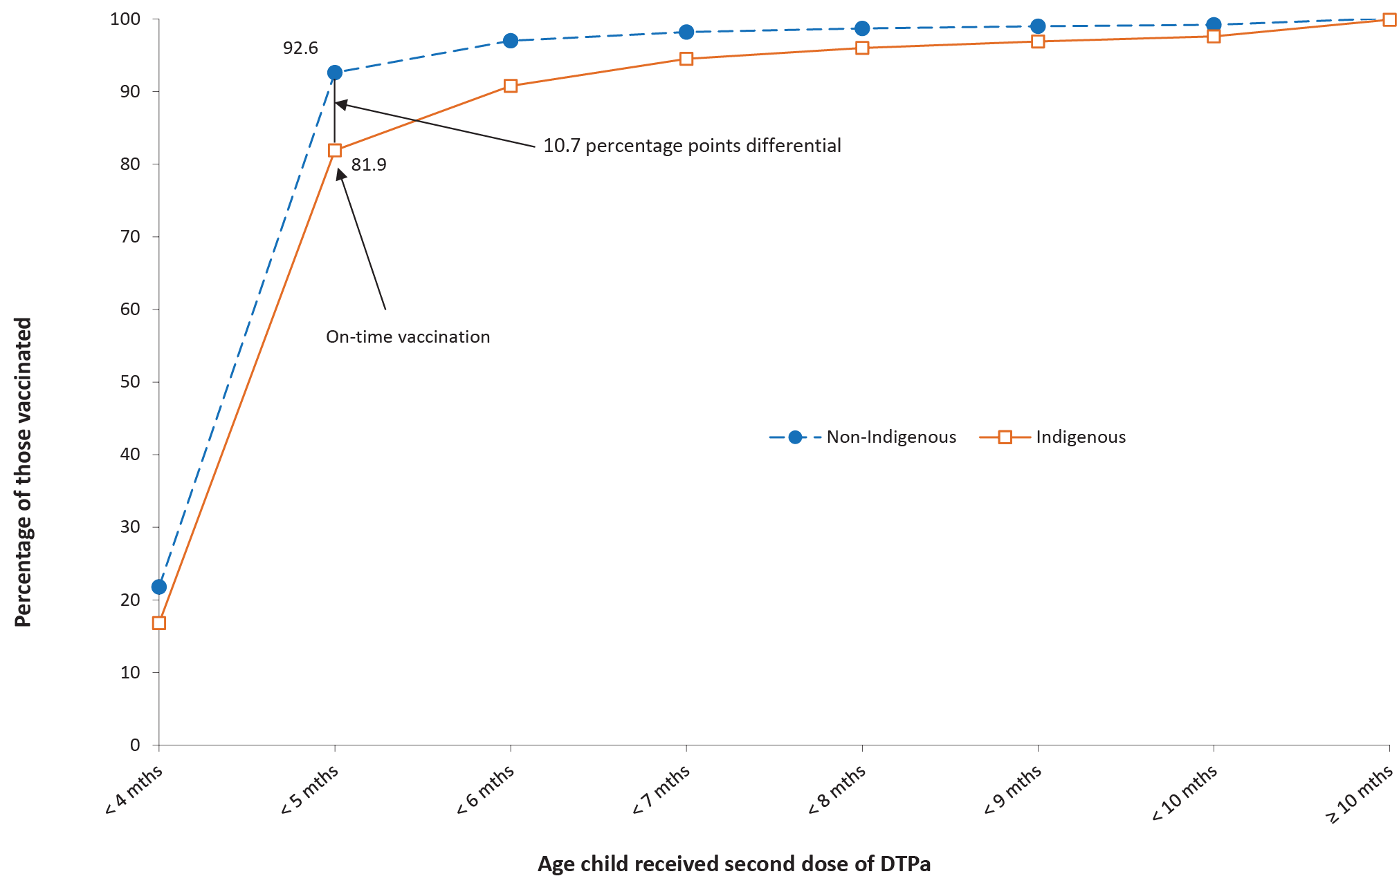
a DTPa = diphtheria (D), tetanus (T) and acellular pertussis-containing (Pa) vaccine.
b Shown as cumulative percentage vaccinated (number of children who received vaccine dose at particular age / total number of children who received the vaccine dose, expressed as a percentage).
c Cohort born in 2016.
a PCV = pneumococcal conjugate vaccine.
b Shown as cumulative percentage vaccinated (number of children who received vaccine dose at particular age / total number of children who received the vaccine dose, expressed as a percentage).
c Cohort born in 2016.

Figure 4: Cumulative percentage of children vaccinated with the second dose of PCV^{a,b} by age in months and Indigenous status, Australia, 2018^{c}
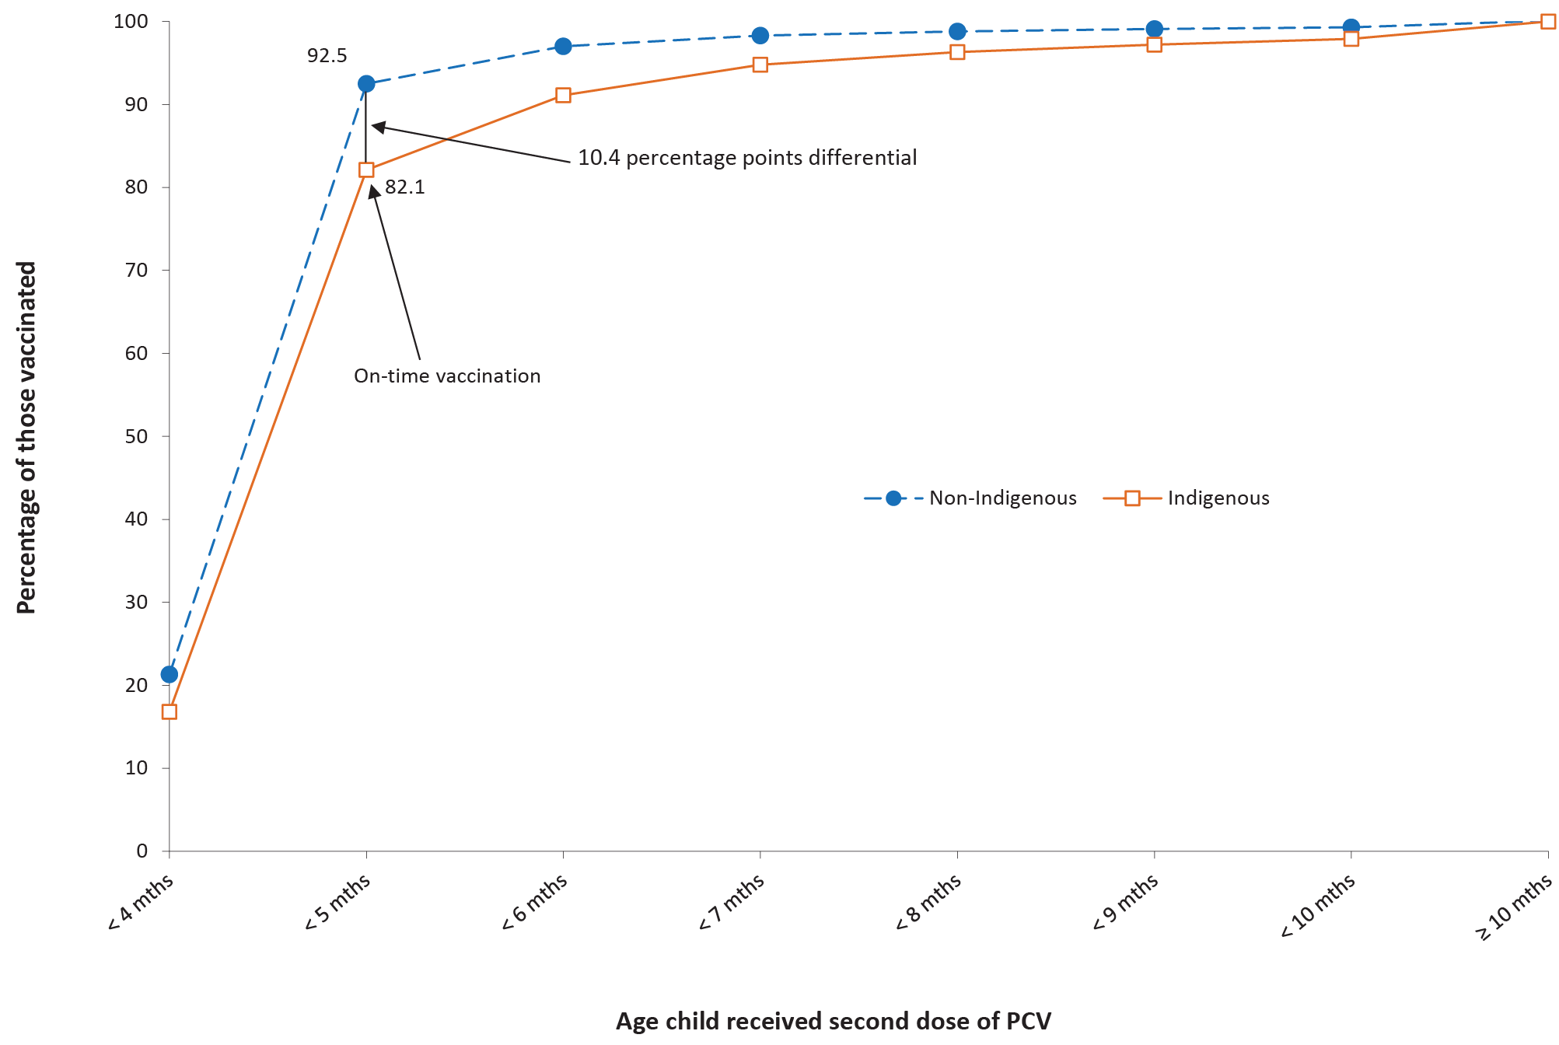
a PCV = pneumococcal conjugate vaccine.
b Shown as cumulative percentage vaccinated (number of children who received vaccine dose at particular age / total number of children who received the vaccine dose, expressed as a percentage).
c Cohort born in 2016.

Timeliness of vaccination
The difference in percentage of children with on-time receipt (within 30 days of the recommended age) of the second dose of DTPa between Indigenous and non-Indigenous children was 10.7 percentage points in 2018 (Figure 3). The differential narrowed with increasing age, with only a 1.6 percentage points differential at 9 months of age (Figure 3).
The on-time vaccination differential for the second dose of PCV between Indigenous and non-Indigenous children in 2018 was similar at 10.4 percentage points, also narrowing to a 1.4 percentage points differential at 9 months of age (Figure 4).
The on-time vaccination differential for the second dose of rotavirus vaccine between Indigenous and non-Indigenous children in 2018 was lower than that for DTPa vaccine and PCV at 5.9 percentage points, narrowing rapidly with increasing age to only 0.2 percentage points at 6 months of age (refer to Figure 5).
Trends in on-time receipt of the first, second and third doses of DTPa vaccine, and the first and second doses of MMR vaccine from 2008 to 2017 by Indigenous status, can be found in our 2017 report.¹¹
Figure 5: Cumulative percentage of children vaccinated with the second dose of rotavirus vaccineª by age in months and Indigenous status, Australia, 2018^{b}
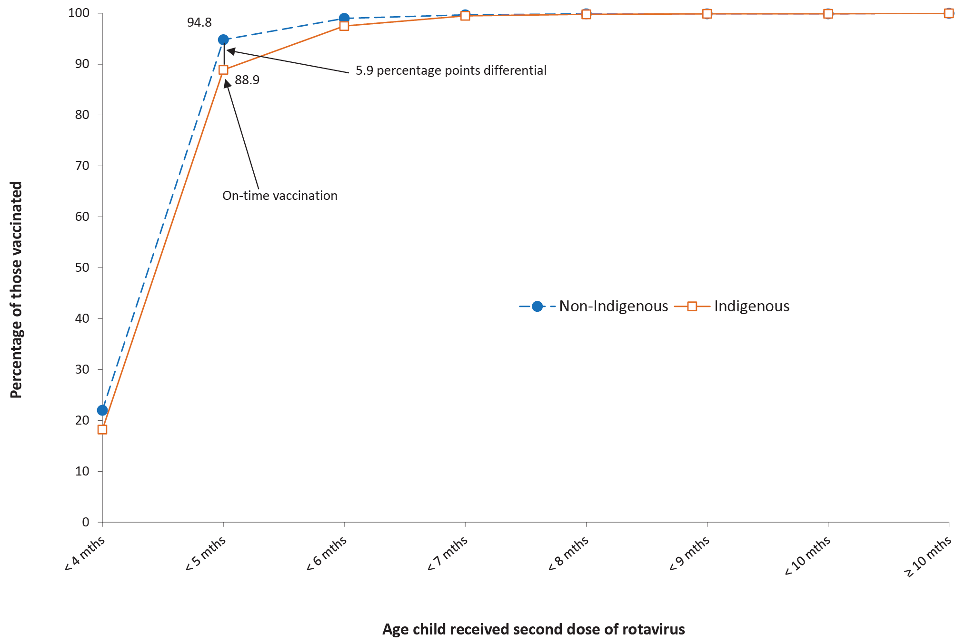
a Shown as cumulative percentage vaccinated (number of children who received vaccine dose at particular age / total number of children who received the vaccine dose, expressed as a percentage).
b Cohort born in 2016.
Tables 3 and 4 present ‘fully vaccinated’ coverage estimates assessed three months after last vaccine dose due, i.e. earlier than the standard assessment milestones in order to capture aspects of timeliness, along with the standard 12-month, 24-month, and 60-month milestones. For all four of the earlier-assessment milestones, ‘fully vaccinated’ coverage in 2018 was lower in Indigenous children residing in ‘Remote’ and ‘Very Remote’ areas than in those residing in ‘Major Cities’ and ‘Inner and Outer Regional’ areas, with the greatest coverage differential at 21 months (Table 3). Coverage at the standard milestones was higher and the disparity lower between Indigenous children in ‘Remote’ and ‘Very Remote’ versus those in ‘Major Cities’ and ‘Inner and Outer Regional’ areas. In non-Indigenous children, substantial differences in ‘fully vaccinated’ coverage were only found for vaccines assessed at 21 months (3–4 percentage points higher for children residing in ‘Major Cities’ and ‘Inner and Outer Regional’ than in ‘Remote’ and ‘Very Remote’) (refer to Table 3). There was a substantial increase in ‘fully vaccinated’ coverage for vaccines due at 48 months when assessed at 60 months versus when assessed at 51 months. This occurred for both Indigenous and non-Indigenous children, and across all Remoteness categories (refer to Table 3).

Table 3: ‘Fully vaccinated’ coverage estimates assessed at earlier (9, 15, 21, 51) and standard (12, 24, 60 months of age: shaded) milestones,ª by Indigenous status and remoteness of area of residence,^{b} Australia, 2018
Indigenous status | Remoteness category | 9 mo^{c} (%)^{d} | 12 mo (%)^{d} | 15 mo (%)^{e} | 21 mo (%)^{e} | 24 mo (%)^{e} | 51 mo (%)^{f} | 60 mo (%)^{f}
Indigenous | Major Cities | 86.0 | 92.6 | 86.2 | 81.6 | 88.8 | 85.3 | 96.4
 | Inner and Outer Regional | 85.6 | 92.5 | 85.9 | 79.3 | 88.3 | 85.1 | 96.9
 | Remote and Very Remote | 82.4 | 91.9 | 82.4 | 72.2 | 83.9 | 82.9 | 95.6
non-Indigenous | Major Cities | 91.2 | 94.1 | 88.6 | 85.8 | 89.9 | 85.7 | 93.6
 | Inner and Outer Regional | 91.3 | 94.2 | 90.0 | 86.5 | 91.3 | 87.0 | 94.7
 | Remote and Very Remote | 91.4 | 94.6 | 89.0 | 82.4 | 88.7 | 84.8 | 94.1
All children | Major Cities | 91.1 | 94.0 | 88.5 | 85.7 | 89.9 | 85.6 | 93.7
 | Inner and Outer Regional | 90.6 | 94.0 | 89.6 | 85.7 | 91.0 | 86.8 | 94.9
 | Remote and Very Remote | 87.7 | 93.5 | 86.3 | 78.2 | 86.8 | 84.0 | 94.7

a Coverage algorithm used for 9/21/51 months milestones same as for 12/24/60, respectively; algorithm used for 15 months same as that for 24 months but excludes doses due at 18 months. For further detail of algorithms, refer to Appendix.
b Accessibility/Remoteness Index of Australia (ARIA++).
c mo = months.
d Cohort born 1 January 2017 – 31 December 2017.
e Cohort born 1 January 2016 – 31 December 2016.
f Cohort born 1 January 2013 – 31 December 2013.

When stratified by the socioeconomic status of the area of residence, in 2018, children residing in areas included in the most-advantaged (fifth) quintile had more than 3 percentage points higher ‘fully vaccinated’ coverage than children in the least-advantaged (first) quintile for the youngest three early assessment ages (9, 15, and 21 months; Table 4). However, this gap decreased at the 51-months age point, where coverage in the most-advantaged quintile was only 1.6 percentage points higher than that in the least-advantaged quintile (refer to Table 4). Coverage at the standard milestones was higher, and the disparity between the most- and least-advantaged quintiles lower, with a particularly substantial increase in ‘fully vaccinated’ coverage for vaccines due at 48 months when assessed at 60 months versus assessed at 51 months, across all socioeconomic status categories (refer to Table 4).
‘Fully vaccinated’ coverage estimates assessed at 9, 15, 21 and 51 months of age in 2018, by PHN, are shown in Table A.4 in the Appendix.
Table 4: ‘Fully vaccinated’ coverage estimates assessed at earlier (9, 15, 21, 51) and standard (12, 24, 60 months: shaded) age milestones,ª by socioeconomic status of area of residence,^{b} Australia, 2018
SEIFAb quintile | 9 mo^{c}  (%)^{d} | 12 mo  (%)^{d} | 15 mo  (%)^{e} | 21 mo  (%)^{e} | 24 mo  (%)^{e} | 51 mo  (%)^{f} | 60 mo  (%)^{f}
First (least advantaged) | 88.9 | 92.9 | 86.5 | 83.0 | 88.1 | 84.8 | 93.5
Second | 90.6 | 93.8 | 89.0 | 85.5 | 90.5 | 86.0 | 94.2
Third | 91.0 | 94.0 | 88.5 | 85.5 | 90.0 | 85.7 | 93.9
Fourth | 91.4 | 94.4 | 89.2 | 86.3 | 90.4 | 86.4 | 94.0
Fifth (most advantaged) | 92.2 | 94.9 | 90.1 | 87.2 | 91.3 | 86.4 | 94.4
All | 90.9 | 93.9 | 88.7 | 85.5 | 90.1 | 85.9 | 94.0
a Coverage algorithm used for 9/21/51 months milestones same as for 12/24/60, respectively; algorithm used for 15 months same as 24 months but excludes doses due at 18 months.
b SEIFA Index of Economic Resources.
c mo = months.
d Cohort born 1 January 2017 – 31 December 2017.
e Cohort born 1 January 2016 – 31 December 2016.
f Cohort born 1 January 2013 – 31 December 2013.

Small area coverage analysis
Vaccination coverage in Australia in 2018 varied within jurisdictions and major capital cities, with coverage in some areas substantially below the national averages, especially the North Coast region of New South Wales and the Gold Coast region of Queensland (refer to Figures 6–8). Most Statistical Area 3-level (SA3) areas in Australia (278/324; 85.8%) had coverage of 95% or higher for the third dose of PCV (refer to Figure 6), with two areas above 99% coverage (‘Broken Hill and Far West’ and ‘Lower Murray’). Over half of the SA3 areas had coverage of 93% or higher for the second dose of MMR vaccine (189/324; 58.3%) (refer to Figure 7) and the fourth dose of DTPa vaccine (171/324; 52.8%) (refer to Figure 8).

Figure 6: Coverage of 13-valent pneumococcal conjugate vaccine at 12 months of age (2 or 3 doses) by Statistical Area 3, Australia and major capital cities, 2018
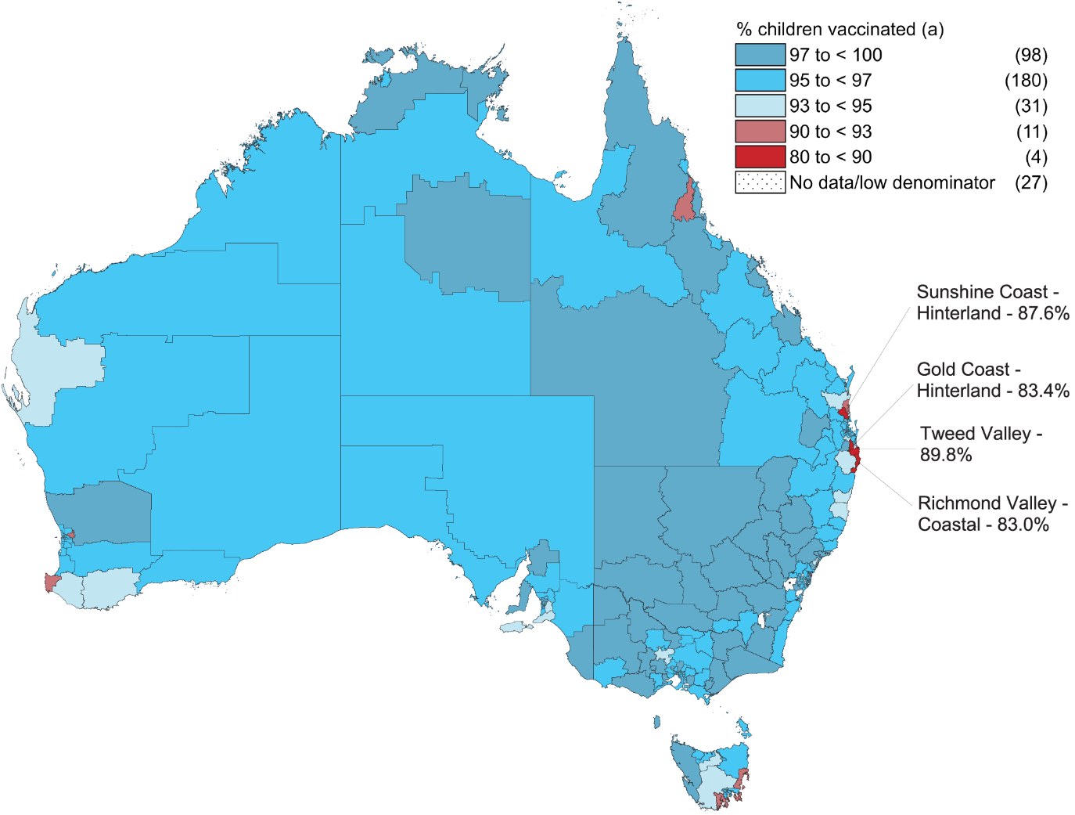
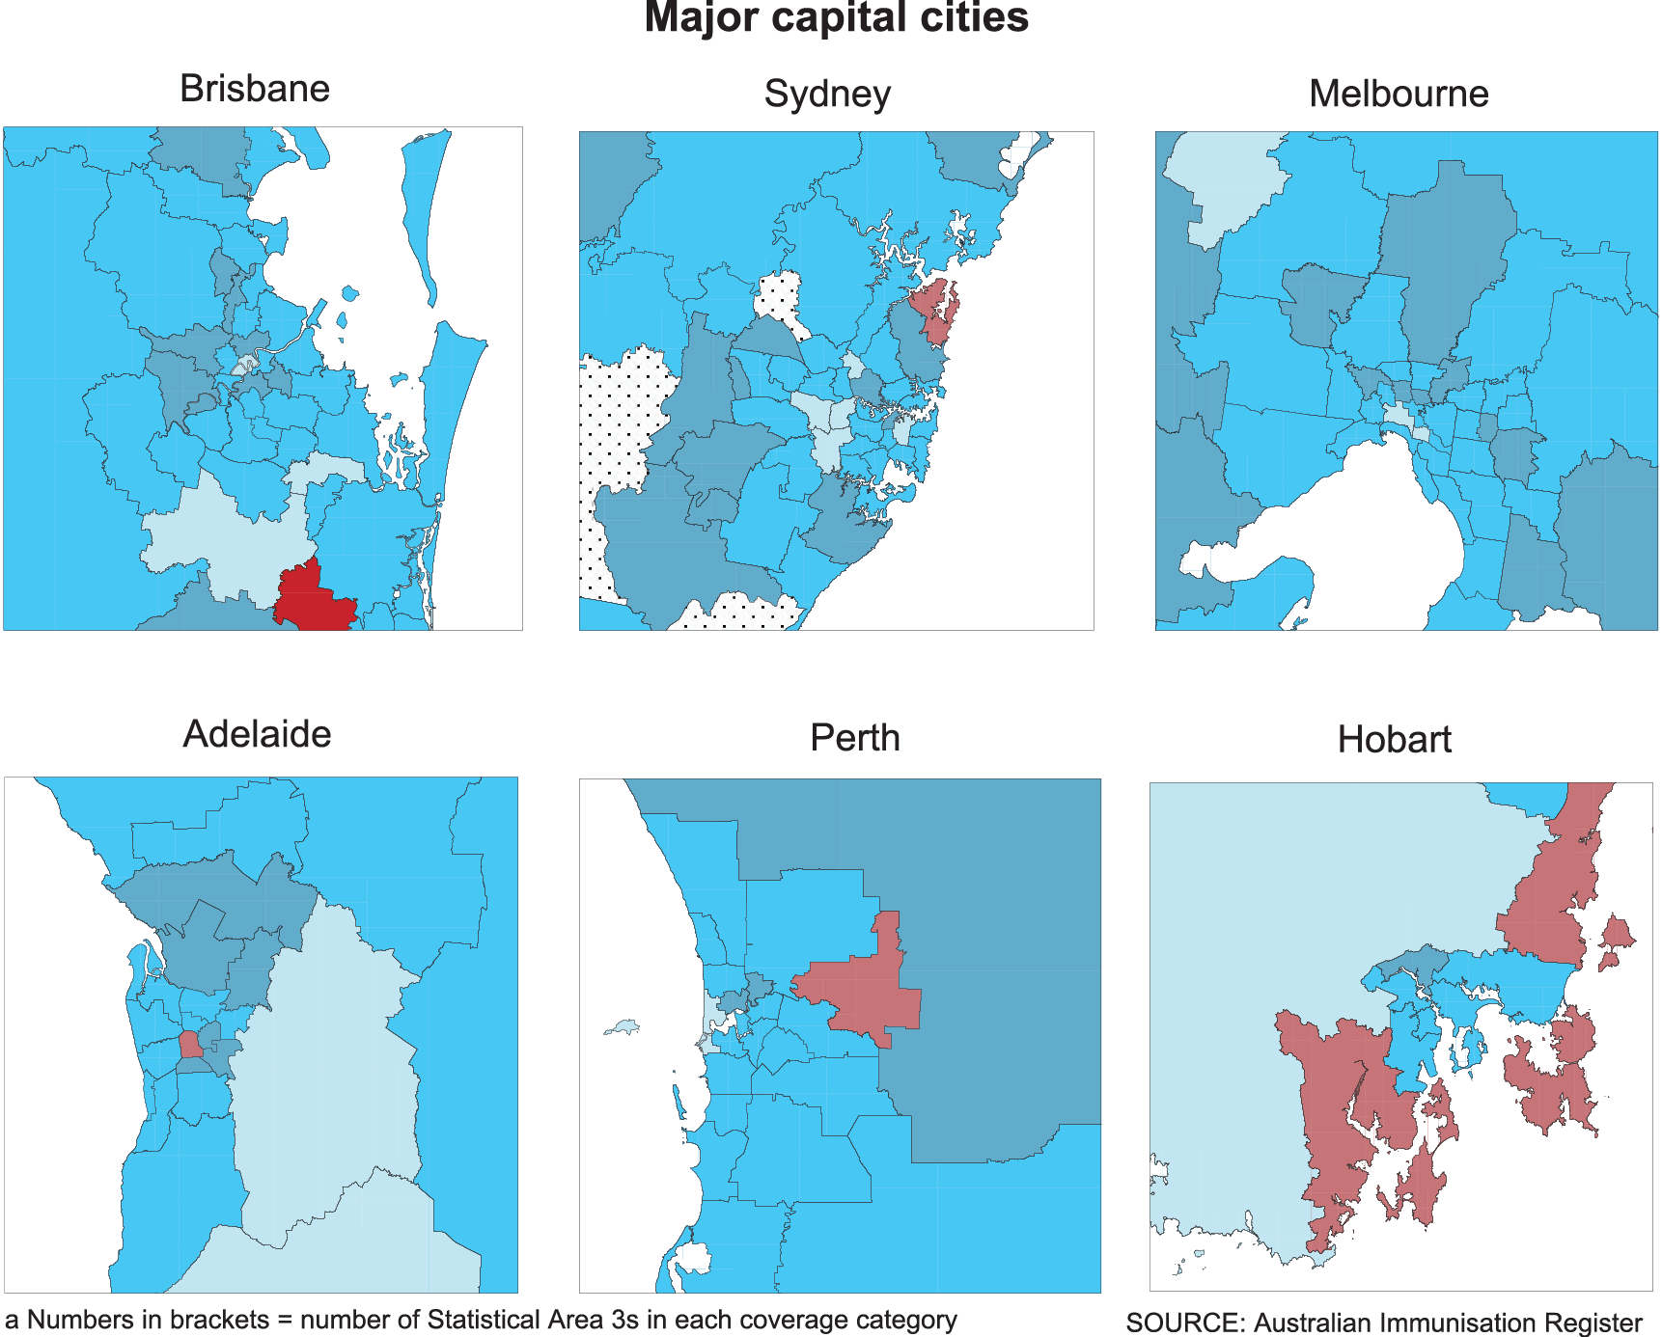
Figure 7: Coverage of 2 doses of measles-mumps-rubella (MMR)-containing vaccine at 24 months of age by Statistical Area 3, Australia and major capital cities, 2018
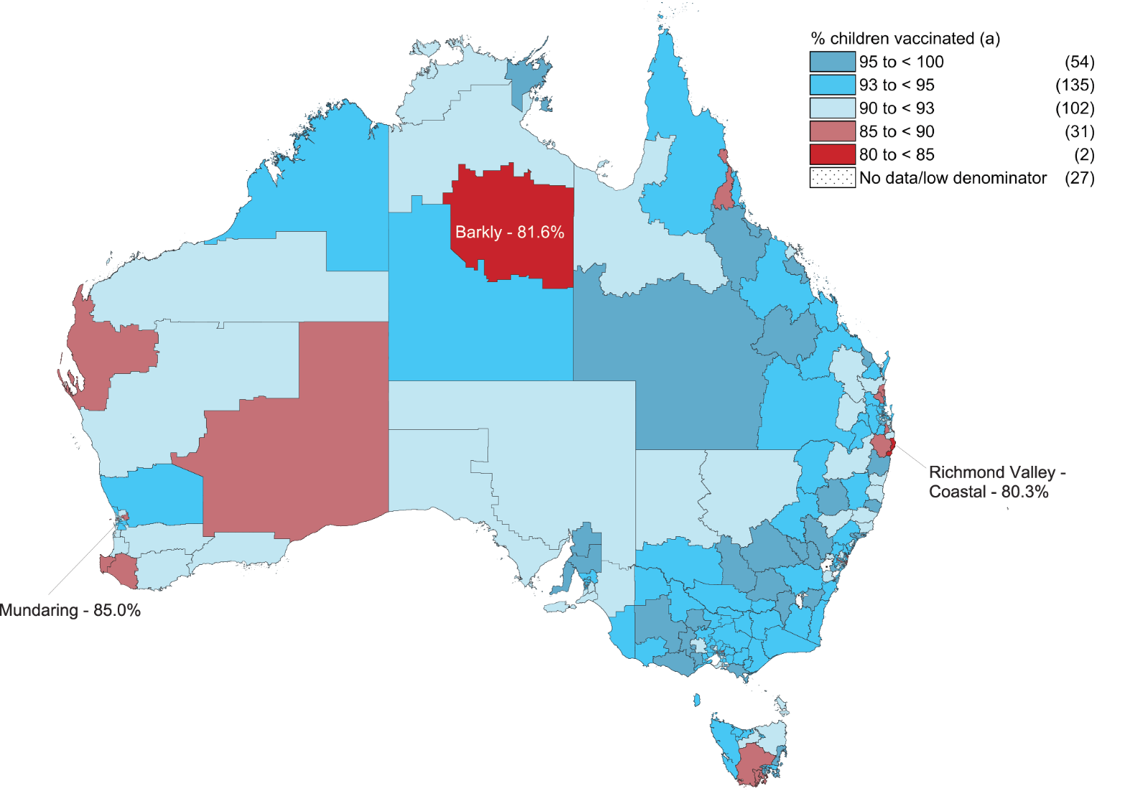
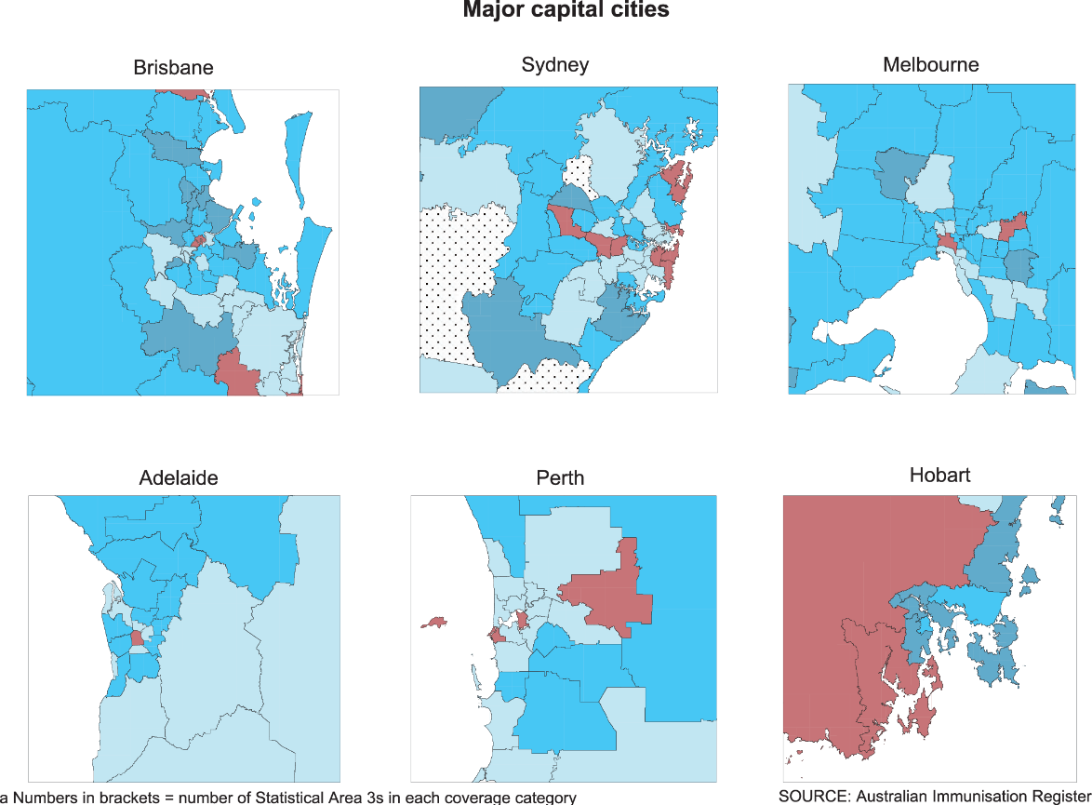
Figure 8: Coverage of 4 doses of diphtheria-tetanus-acellular pertussis (DTPa)-containing vaccine at 24 months by Statistical Area 3, Australia and major capital cities, 2018
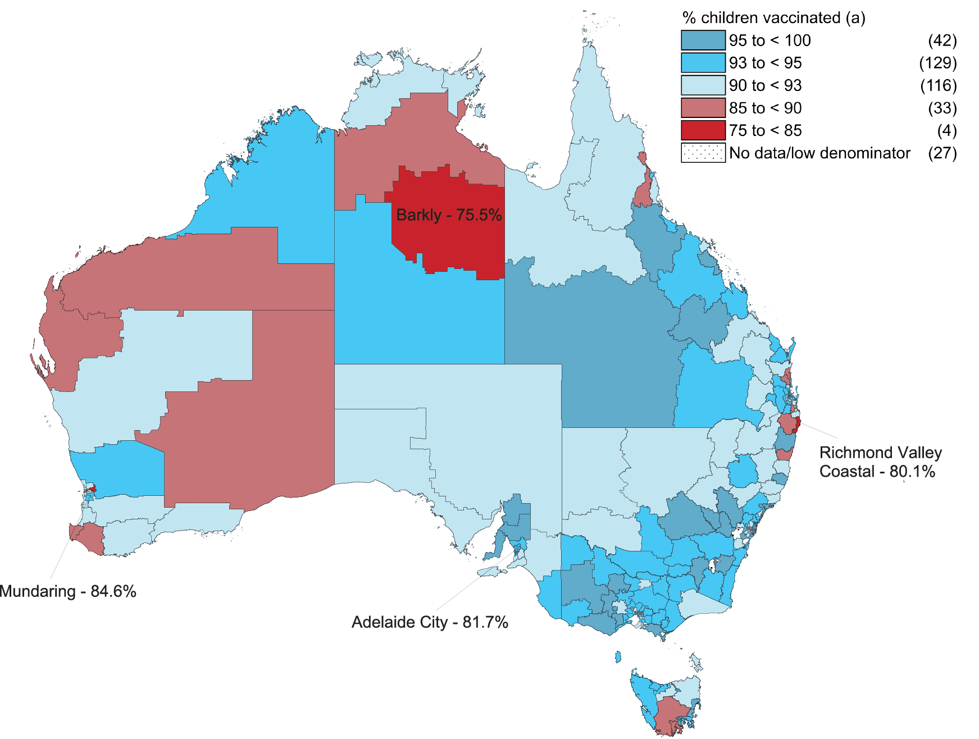
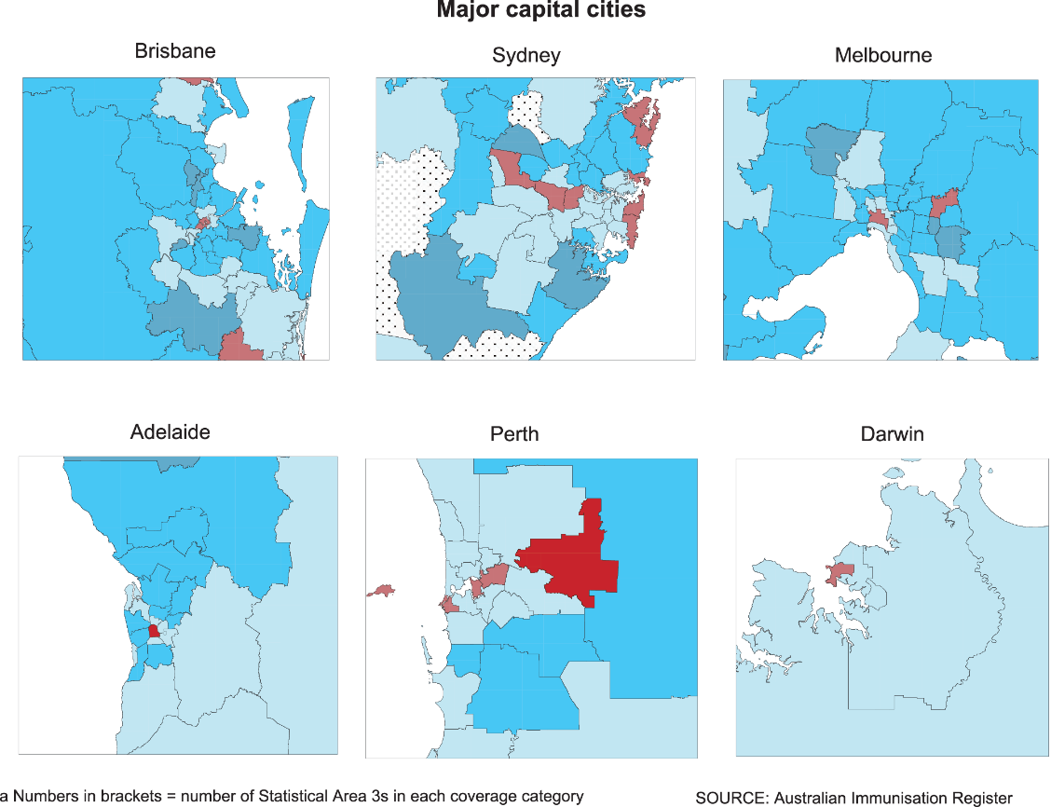

Discussion

Overall findings
Our report shows that ‘fully vaccinated’ coverage in Australia increased between 2017 and 2018 at the 12-month and 60-month age assessment milestones, reaching 93.9% and 94.0%, respectively, in 2018. True coverage is likely to have been higher, given under-reporting to the AIR,^{16,17} making it close to or even slightly above the national coverage target of 95%. The increases in coverage at these milestones over recent years have been potentially influenced by a range of measures, in particular the federal government ‘No Jab No Pay’ policy (implemented from 1 January 2016) and ‘No Jab No Play’ policies implemented in some states.
However, ‘fully vaccinated’ coverage at the 24 month milestone decreased slightly to 91.5% in 2018, several percentage points below coverage at 12 and 60 months of age. The disparity is most likely due to the increased number of antigens now required to be classified as ‘fully vaccinated’ at 24 months, including vaccine doses due at 6 and 12 months as well as the three vaccines (DTPa, Hib and measles-mumps-rubella-varicella [MMRV]) now scheduled at 18 months of age, which is only 6 months prior to the assessment time point. Historically, the 18-month schedule point was associated with lower coverage in the 1990s (when a fourth dose of whole cell pertussis–containing vaccine [DTPw] was given) and more recently monovalent varicella vaccine and then MMRV.^{1,9} In contrast, only one vaccine (DTPa-polio) is scheduled at 48 months and assessed at 60 months, with a 12-month period between due date and assessment date. It may be opportune to consider whether a broader definition of ‘fully vaccinated’ at the latter milestone, with inclusion of more vaccines/antigens, is indicated.

Improvements by individual vaccine
Coverage for individual vaccines/antigens included in the ‘fully vaccinated’ assessment algorithms in 2018 was generally similar to, or slightly higher than, coverage in 2017. However, PCV coverage at the 12-month milestone increased by 1.5 percentage points to 95.7%, attributable to the algorithm requiring 2 or 3 rather than 3 doses of PCV. Coverage for rotavirus vaccine, which is not included in the ‘fully vaccinated’ algorithm because of the strict upper age limits for vaccine administration, increased by 4.1 percentage points to 90.9% in 2018, the first time it has reached over 90%. This is likely due to all jurisdictions using the Rotarix vaccine, which requires 2 rather than 3 doses, from mid-2017. Coverage has previously been shown to be higher in jurisdictions using a 2-dose as opposed to 3-dose schedule.⁹
In the context of 95% targets, which are particularly critical to measles control, coverage at 24 months of age in 2018 was 95.4% for the first dose of MMR vaccine, and while coverage was slightly lower for the second dose of MMR vaccine at 93.0%, it increased to 96.3% by 60 months.

Comparing Indigenous and non-Indigenous coverage
‘Fully vaccinated’ coverage in Indigenous children in 2018 (96.4%) remained higher than in non-Indigenous children at the 60-month milestone, by 2.5 percentage points. ‘Fully vaccinated’ coverage in Indigenous children at the 12-month milestone increased slightly to 92.4%, but remained 1.6 percentage points lower than that in non-Indigenous children. At the 24-month milestone, ‘fully vaccinated’ coverage in Indigenous children decreased by 0.6 percentage points between 2017 and 2018 to 87.8%, with the gap compared to non-Indigenous children widening from 1.9 to 2.5 percentage points lower. This highlights timeliness issues among Indigenous children, as coverage of individual vaccines/antigens due at 6 or 12 months with no further doses (MenC-containing, polio and Hep B vaccines) was over 96% at 24 months. We also noted that although coverage in 2018 for the second dose of MMR and varicella vaccine (now given as MMRV vaccine at 18 months) in Indigenous children was 91–92% at 24 months, it was over 97% at 60 months. This pattern is consistent with long-standing vaccination timeliness issues among Indigenous children.^{1,9}
Coverage for vaccines funded under the NIP for Indigenous children only, either nationally (influenza) or in certain jurisdictions (hepatitis A and PCV dose 4), remained suboptimal in 2018, although coverage in the Northern Territory was substantially higher than in other jurisdictions for all these vaccines. National coverage for hepatitis A vaccine and the fourth dose of PCV was 71% and 72%, respectively. Recorded influenza vaccination coverage in Indigenous children aged 6 months to < 5 years more than doubled nationally to 31.4% in 2018. This increase was almost certainly due to the introduction of state/territory-funded influenza vaccination programs for all children in this age group in all jurisdictions except the Northern Territory in 2018 (Western Australia having had a program in place since 2008),¹⁸ associated with a five-fold increase in recorded coverage in non-Indigenous children nationally, from 5.0% in 2017 to 25.9% in 2018. Universal vaccination programs are known to generally achieve higher coverage than programs limited to specific subgroups, as they circumvent the issues of provider and parent awareness and suboptimal identification of Indigenous people that are barriers to high coverage in Indigenous-specific programs.^{19,20}

A focus on timeliness
We examined a broad range of timeliness indicators in this report. The traditional measure of vaccination receipt within 30 days of the NIP schedule’s recommended age showed some improvement in 2018, with the difference between Indigenous and non-Indigenous children in on-time coverage for second dose due at 4 months of age decreasing for DTPa vaccine (from 11.1 to 10.7 percentage points) and PCV (from 11.1 to 10.4 percentage points). The difference in on-time coverage for the second dose of rotavirus vaccine was lower than that for DTPa vaccine and PCV in 2018, at 5.9 percentage points. In addition, we examined ‘fully vaccinated’ coverage at earlier milestones 3 months after the due date of the last scheduled vaccine, with a focus on remoteness and socioeconomic status of area of residence. ‘Fully vaccinated’ coverage in Indigenous children in remote areas was several percentage points lower than that for Indigenous children in major cities and regional areas, with the greatest differential at the 21-month assessment milestone. This disparity is likely due to greater logistic issues in providing and accessing vaccination in remote areas. Likewise, ‘fully vaccinated’ coverage at the earlier assessment time points was several percentage points lower for children living in areas in the most socioeconomically disadvantaged quintile compared with those in the least disadvantaged quintile, also consistent with access issues.^{21,22} While coverage improved substantially across the board by 60 months of age, the current ‘fully vaccinated’ assessment algorithm at this milestone may not be optimal, given that it includes only vaccines due at 48 months.

Conclusions
This report demonstrates continuing improvements across a range of immunisation indicators in Australia in 2018. However, some issues with timeliness persist, particularly in Indigenous and socioeconomically disadvantaged children. As younger children are generally more vulnerable to severe disease, and Indigenous and socioeconomically disadvantaged children even more so, equitable coverage of vaccination at the earliest appropriate age, in line with the NIP schedule, should be a public health goal for countries such as Australia where high levels of overall vaccine coverage at standard milestone ages have been achieved. New coverage targets for earlier protection in the first 2 years of life may be indicated, along with review of the current ‘fully vaccinated’ assessment algorithms, particularly at the 60-month milestone.

Acknowledgements
The National Centre for Immunisation Research and Surveillance is supported by the Australian Government Department of Health, the NSW Ministry of Health and The Children’s Hospital at Westmead. The opinions expressed in this report are those of the authors, and do not necessarily represent the views of these agencies.

Author details
Brynley Hull¹ Alexandra Hendry¹ Aditi Dey¹ Peter McIntyre¹ Kristine Macartney¹ Frank Beard¹
- National Centre for Immunisation Research and Surveillance

Corresponding author
Brynley Hull

National Centre for Immunisation Research and Surveillance, The Children’s Hospital at Westmead and The University of Sydney, Locked Bag 4001, Westmead NSW 2145.
Telephone: +61 2 9845 1435
Facsimile: +61 2 9845 1418
Email: brynley.hull@health.nsw.gov.au

References
- Hull B, Deeks S, Menzies R, McIntyre P. Immunisation coverage annual report, 2007. Commun Dis Intell Q Rep. 2009;33(2):170–87.
- Hull BP, Mahajan D, Dey A, Menzies RI, McIntyre PB. Immunisation coverage annual report, 2008. Commun Dis Intell Q Rep. 2010 Sep;34(3):241–58.
- Hull B, Dey A, Mahajan D, Menzies RI, McIntyre PB. Immunisation coverage annual report, 2009. Commun Dis Intell Q Rep. 2011;35(2):132–48.
- Hull B, Dey A, Menzies R, McIntyre P. Annual immunisation coverage report, 2010. Commun Dis Intell Q Rep. 2013;37(1):E21–39.
- Hull BP, Dey A, Menzies RI, Brotherton JM, McIntyre PB. Immunisation coverage annual report, 2011. Commun Dis Intell Q Rep. 2013;37(4):E291–312.
- Hull BP, Dey A, Menzies RI, Brotherton JM, McIntyre PB. Immunisation coverage, 2012. Commun Dis Intell Q Rep. 2014;38(3):E208–31.
- Hull BP, Dey A, Beard FH, Menzies RI, Brotherton JM, McIntyre PB. Immunisation coverage annual report, 2013. Commun Dis Intell Q Rep. 2016;40(1):E146–69.
- Hull BP, Hendry AJ, Dey A, Beard F, Brotherton J, McIntyre P. Immunisation coverage annual report, 2014. Commun Dis Intell Q Rep. 2017;41(1):E68–90.
- Hull B, Hendry A, Dey A, Beard F, Brotherton J, McIntyre P. Immunisation coverage annual report, 2015. Commun Dis Intell (2018). 2019;43. doi: https://doi.org/10.33321/cdi.2019.43.11.
- Hull B, Hendry A, Dey A, Beard F, Brotherton J, McIntyre P. Annual immunisation coverage report, 2016. Commun Dis Intell (2018). 2019;43. doi: https://doi.org/10.33321/cdi.2019.43.44.
- Hull B, Hendry A, Dey A, Brotherton J, Macartney K, McIntyre P. Annual immunisation coverage report 2017. Commun Dis Intell (2018). 2019;43. doi: https://doi.org/10.33321/cdi.2019.43.47.
- Australian Institute of Health and Welfare (AIHW). National Health Performance Authority. Healthy communities: Immunisation rates for children in 2012–13. [Internet.] Canberra: Australian Government, AIHW; 2014. Available from: https://meteor.aihw.gov.au/content/index.phtml/itemId/564342.
- AIHW. National Health Performance Authority. In Focus: Healthy communities. Immunisation rates for children in 2014–15. Canberra: Australian Government, AIHW; 2016. Available from: https://www.aihw.gov.au/getmedia/9a2ee78b-0f20-4f72-9d80-3bc2fe0effb6/aihw-mhc-nhpa-16-immunisation-rates-children-2014-15-report-february-2016.pdf.
- AIHW. In Focus: Healthy Communities. Immunisation rates for children in 2015–16. Canberra: Australian Government, AIHW; 2017. [Accessed on 19 August 2018.] Available from: https://www.aihw.gov.au/getmedia/40ddbc3e-5238-435a-8469-a83e270836ee/aihw-mhc-hpf-4-immunisation-rates-children-2015-16-in-focus-june-2017.pdf. Accessed 2018 09/08/2018.
- Hull B, Hendry A, Dey A, Macartney K, McIntyre P, Beard F. Exploratory analysis of the first 2 years of adult vaccination data recorded on AIR. Sydney: National Centre for Immunisation Research and Surveillance; November 2019. [Accessed on 24 June 2020.] Available from: http://ncirs.org.au/sites/default/files/2019-12/Analysis%20of%20adult%20vaccination%20data%20on%20AIR_Nov%202019.pdf.
- Dalton L, Meder K, Beard F, Dey A, Hull B, McIntyre P et al. Australian Immunisation Register Data Transfer Study - Stage 2 Final Report. Sydney: National Centre for Immunisation Research and Surveillance; August 2018. Available from: https://ncirs.org.au/sites/default/files/2018-12/2018%20AIR%20data%20tranfer%20report_FINAL_0.pdf.
- Law C, McGuire R, Ferson MJ, Reid S, Gately C, Stephenson J et al. Children overdue for immunisation: a question of coverage or reporting? An audit of the Australian Immunisation Register. Aust N Z J Public Health. 2019;43(3):214–20.
- Beard FH, Hendry AJ, Macartney K. Early success with room for improvement: influenza vaccination of young Australian children. Med J Aust. 2019;210(11):484–6.
- Hull BP, McIntyre PB. What do we know about 7vPCV coverage in Aboriginal and Torres Strait Islander children? Commun Dis Intell Q Rep. 2004;28(2):238–43.
- Menzies R, Turnour C, Chiu C, McIntyre P. Vaccine preventable diseases and vaccination coverage in Aboriginal and Torres Strait Islander people, Australia 2003 to 2006. Commun Dis Intell Q Rep. 2008;32(Suppl):S2–67.
- Beard FH, Hull BP, Leask J, Dey A, McIntyre PB. Trends and patterns in vaccination objection, Australia, 2002–2013. Med J Aust. 2016;204(7):275.
- Homel J, Edwards B. Factors associated with delayed infant immunization in a nationally representative cohort study. Child Care Health Dev. 2018;44(4):583–91.
- National Centre For Immunisation Research and Surveillance (NCIRS). History of vaccination in Australia. [Internet.] Sydney: NCIRS; 2018. [Accessed on 19 September 2018.] Available from: http://www.ncirs.edu.au/provider-resources/vaccination-history/.
- Hull BP, McIntyre PB, Heath TC, Sayer GP. Measuring immunisation coverage in Australia: a review of the Australian Childhood Immunisation Register. Aust Fam Physician. 1999;28(1):55–60.
- Australian Digital Health Agency (ADHA). Australian Immunisation Register. [Website.] Canberra: Australian Government, ADHA; 2019. [Accessed on 27 August 2019.] Available from: https://developer.digitalhealth.gov.au/products/australian-immunisation-register.
- O’Brien ED, Sam GA, Mead C. Methodology for measuring Australia’s childhood immunisation coverage. Commun Dis Intell. 1998;22(3):36–7.
- Hull BP, McIntyre PB. Immunisation coverage reporting through the Australian Childhood Immunisation Register – an evaluation of the third-dose assumption. Aust N Z J Public Health. 2000;24(1):17–21.
- Hull BP, Lawrence GL, MacIntyre CR, McIntyre PB. Estimating immunisation coverage: is the ‘third dose assumption’ still valid? Commun Dis Intell Q Rep. 2003;27(3):357–61.
- Hugo Centre for Migration and Population Research. Accessibility/Remoteness Index of Australia - ARIA++(2011). [Internet.] Adelaide: University of Adelaide, Hugo Centre for Migration and Population Research, 2011. [Accessed on 17 November 2017.] Available from: https://www.adelaide.edu.au/hugo-centre/spatial_data/.
- Australian Bureau of Statistics. Socio-Economic Indexes for Areas. [Internet.] Canberra: Australian Bureau of Statistics; 2013. [Accessed on 26 February 2018.] Available from: http://www.abs.gov.au/websitedbs/censushome.nsf/home/seifa.
- Australian Bureau of Statistics. Australian Statistical Geography Standard (ASGS). Canberra: Australian Bureau of Statistics; 2011. [Accessed on 17 November 2014.] Available from: http://www.abs.gov.au/websitedbs/d3310114.nsf/home/australian+statistical+geography+standard+%28asgs%29.
- MapInfo. MapInfo Pro version 15.0. [Software.] Pitney Bowes Software, Stamford, Connecticut, USA; 2015.
- Australian Bureau of Statistics. ASGS Geographic Correspondences (2016). Canberra: Australian Bureau of Statistics; 4 April 2018. [Accessed on 15 December 2020.] Available from: https://data.gov.au/dataset/ds-dga-23fe168c-09a7-42d2-a2f9-fd08fbd0a4ce/details.

Appendix

Vaccine abbreviations
13vPCV – 13-valent pneumococcal conjugate vaccine
23vPPV – 23-valent pneumococcal polysaccharide vaccine
DTPa – diphtheria-tetanus-acellular pertussis (children aged under 10 years formulation)
Flu – influenza
Hep A – hepatitis A
Hep B – hepatitis B
Hib – Haemophilus influenzae type b
MenACWY - meningococcal ACWY
MenC – meningococcal C-containing
MMR – measles-mumps-rubella
MMRV – measles-mumps-rubella-varicella
PCV – pneumococcal conjugate vaccine
PPV – pneumococcal polysaccharide vaccine
PRP-OMP – Haemophilus influenzae type b conjugate (meningococcal outer membrane conjugate)

Box A.1: Significant changes in childhood immunisation policy, immunisation incentives and coverage calculation algorithms, Australia, 2014 to 2018ª
July 2018 - Schedule for routine childhood vaccination with 13vPCV changed from 2, 4 and 6 months of age to 2, 4 and 12 months of age. Vaccination coverage assessment algorithm for ‘fully vaccinated’ at the 12-month milestone amended to require either 2 or 3 doses of pneumococcal conjugate vaccine. Vaccination coverage assessment algorithm for ‘fully vaccinated’ at the 24-month milestone amended to require 3 doses of pneumococcal conjugate vaccine.
Meningococcal ACWY conjugate vaccine funded for all children at 12 months of age, replacing combined Hib and MenC-containing vaccine, with the Hib dose moved to 18 months and given as monovalent Hib vaccine.
July 2017 - Queensland, South Australia, Victoria and Western Australia changed from 3-dose RotaTeq® rotavirus vaccine schedule to 2-dose Rotarix® schedule.
Coverage for the second dose of MMR-containing vaccine no longer assessed at 60 months of age.
December 2016 - Vaccination coverage assessment algorithm for ‘fully vaccinated’ at the 24-month milestone amended to require 4 doses of DTPa-containing vaccine.
March 2016 – Booster dose of DTPa vaccine funded at 18 months of age.
January 2016 - New immunisation requirements for federal government family assistance payments (‘No Jab, No Pay’) come into effect. Only parents of children (aged < 20 years, up from < 7 years previously) who are ‘fully vaccinated’ or on a recognised catch-up schedule are eligible to receive the Child Care Benefit, Child Care Rebate and/or the Family Tax Benefit Part A end-of-year supplement. Children with medical contraindications or natural immunity for certain diseases continue to be exempt from the requirements; however, objection on non-medical grounds is no longer a valid exemption.
March 2015 – Seasonal influenza vaccine funded for Aboriginal and Torres Strait Islander children aged 6 months to < 5 years.
December 2014 – Vaccination coverage assessment algorithm for ‘fully vaccinated’ at the 24-month milestone amended to require 1 dose of MenC vaccine and 1 dose of varicella vaccine, along with the second dose of MMR vaccine instead of the first dose as previously. Second dose of MMR vaccine remained in the coverage assessment algorithm for the 60-month milestone age.
a Source: NCIRS History of Vaccination.²³

Detailed methods

The Australian Immunisation Register (AIR)
The Australian Childhood Immunisation Register (ACIR) was established on 1 January 1996 by incorporating demographic data from Medicare on all enrolled children aged < 7 years.²⁴ On 30 September 2016, ACIR expanded to become AIR to collect data on vaccinations given from birth to death.²⁵ All people registered with Medicare are automatically added to AIR. Participation in AIR is ‘opt-out’ and so constitutes a nearly complete population register for Australian residents.²⁴ Persons not enrolled in Medicare can also be added to AIR via a supplementary number. Data are transferred to AIR when a recognised immunisation provider supplies details of an eligible vaccination. This could occur via medical practice management software, through direct data entry on the AIR website or by submitting paper encounter or history forms. High levels of reporting to AIR for child vaccinations are maintained by a system of incentive payments for immunisation providers and carers. These have been discussed in detail elsewhere.^{1,6}

Coverage estimates
This report details national vaccination coverage using AIR data as at 31 March 2019. The cohort method has been used for calculating coverage at the population level (national and state/territory) since ACIR’s inception.²⁶ Cohort vaccination status was assessed at 12 months of age (for vaccines due at 6 months), 24 months of age (for vaccines due at 6, 12 and 18 months) and 60 months of age (for vaccines due at 48 months). A minimum 3-month lag period was allowed for late notification of vaccinations to AIR, but only vaccines given on or before a child’s first, second or fifth birthday, respectively, were included in coverage calculations.²⁶ If a child’s records indicated receipt of the last dose of a vaccine that required more than 1 dose to complete the series, it was assumed that earlier vaccines in the sequence had been given. This assumption has been shown to be valid in the past.^{27,28}
Three-month-wide birth cohorts were used for most of the time-trend analyses, with children aged 12 to < 15 months for the 12-month assessment age, children aged 24 to < 27 months for the 24-month assessment age and children aged 60 to < 63 months for the 60-month assessment age. Either 3-month or 12-month-wide cohorts were used for all other analyses in this report. The 12-month-wide cohorts used in this report were children born between 1 January 2017 and 31 December 2017 for the 12-month milestone; between 1 January 2016 and 31 December 2016 for the 24-month milestone; and between 1 January 2013 and 31 December 2013 for the 60-month (5-year) milestone.
The proportion of children ‘fully vaccinated’ was calculated using the number of children completely vaccinated with the vaccines of interest by the designated age as the numerator and the total number of children registered on AIR in the relevant age cohort as the denominator. Definitions of ‘fully vaccinated‘ coverage are provided in Table A.2: the definitions for the 12-, 24- and 60-month milestones have been nationally agreed for the purpose of standardised reporting, with our definitions for the 9-, 15-, 21- and 51-month milestones based on these for purposes of timeliness analysis (refer to Table A.2).
Vaccination coverage estimates were also calculated for individual NIP vaccines/antigens, including the three NIP vaccines given in early childhood but not routinely reported on and not part of ‘fully vaccinated’ calculations at 12, 24 and 60 months of age. These are a second dose of rotavirus vaccine by 12 months of age; a second dose of hepatitis A vaccine in Indigenous children by 30 months of age; and a fourth dose of 13vPCV in Indigenous children by 30 months of age. The proportion of children vaccinated with the relevant vaccine/antigen and dose was calculated using the number of children vaccinated with the relevant vaccine/dose by the designated age as the numerator and the total number of children registered on AIR in the relevant age cohort as the denominator. Influenza vaccination coverage for children aged 6 months to < 5 years was calculated by dividing the number of children with at least one dose of influenza vaccine recorded on AIR in a calendar year by the total number of children in the 6 months to < 5 years age group registered on AIR the relevant calendar year, by Indigenous status and jurisdiction.

Timeliness of vaccination
On-time vaccination was defined as receipt of a scheduled vaccine dose within 30 days of the recommended age. For example, a child who received the first dose of DTPa vaccine (due by 60 days of age under the NIP but recommended from as early as 6 weeks of age) when they were more than 90 days of age was classified as late for that dose. On-time vaccination was measured in 12-month birth cohorts, with children included in the analysis assessed at up to 3 years after doses were due, to allow time for very late vaccinations to be assessed. Therefore, cohorts assessed for timeliness are not the same as those assessed for coverage milestones. The interval between doses was not evaluated. Timeliness of different vaccines and doses was compared by plotting the cumulative percentage receiving each vaccine dose by age in months.
‘Fully vaccinated’ coverage estimates were also assessed at 3 months after last vaccine dose due, that is, earlier than the standard assessment milestones to capture aspects of timeliness, by remoteness and socioeconomic status of area of residence. The definitions of ‘fully vaccinated’ coverage used are provided in Table A.2.

Remoteness status
The area of residence of children was defined as ‘Major cities’, ‘Inner regional’, ‘Outer regional’, ‘Remote’ and ‘Very remote’ using the Accessibility/Remoteness Index of Australia (ARIA++).²⁹ ARIA++ is a continuous varying index with values ranging from 0 (high accessibility) to 15 (high remoteness), and is based on road distance measurements from over 12,000 populated localities to the nearest Service Centres in five categories based on population size. For analysis in this report, we combined the two ‘Regional’ categories (‘Inner Regional’ and ‘Outer Regional’) into one category and the two ‘Remote’ categories (‘Remote’ and ‘Very Remote’) into one category. ARIA Accessibility/Remoteness categories were assigned to each child using their current recorded postcode of residence on AIR.

Socioeconomic status
Vaccination coverage and timeliness were assessed by socioeconomic status using the ABS Socio Economic Indexes for Areas (SEIFA) Index of Economic Resources.³⁰ The SEIFA index category was assigned for each individual using their recorded postcode of residence on AIR. For this analysis we compared vaccination coverage for children living in postcodes classified as being in the top quintile of all postcodes with regard to economic resources with vaccination coverage for children living in postcodes classified as being in the bottom quintile of postcodes with regard to economic resources.

Small area analysis

SA3
Analysis of coverage was undertaken at small area level using the ABS-defined Statistical Area 3 (SA3),³¹ chosen because each is small enough to show differences within jurisdictions but not too small to render maps unreadable. For both privacy and precision reasons, SA3s with denominators of less than 26 children were not included in any small area analysis. Maps were created using version 15 of the MapInfo mapping software³² and the ABS Census Boundary Information. As postcode is the only geographical indicator available from AIR, the ABS Postal Area to SA3 Concordance 2016 was used to match AIR postcodes to SA3s.³³

PHN
Analysis of coverage was also undertaken at PHN level. PHNs are organisations that work to improve coordination of healthcare in their area, with the boundaries defined by the Australian Government Department of Health. There are 31 PHNs in Australia.

Indigenous status
Indigenous status on AIR is recorded as ‘Indigenous’, ‘non-Indigenous’ or ‘unknown’, as reported by the person (or parent/carer) to Medicare. Indigenous status as recorded in provider vaccination notifications to AIR do not override the data on Indigenous status in the Medicare database, emphasising the importance of vaccine recipients or parents/carers ensuring Medicare details are correct. For this report individuals whose Indigenous status was not specified (less than 1%) were classified as non-Indigenous for the purposes of analysis. While Indigenous status is available in AIR, other parameters such as country of birth, ethnicity and medical condition (including pregnancy) are not.
Table A.1: Australian NIP Schedule for children aged < 5 years in 2018
Age | Vaccine
 | Childhood vaccines
Birth | Hep B
2 months | Hep B | DTPa | Hib | Polio |  |  |  |  | 13vPCV | Rotavirus
4 months | Hep B | DTPa | Hib | Polio |  |  |  |  | 13vPCV | Rotavirus
6 months | Hep B | DTPa | Hib | Polio |  |  |  |  | 13vPCVª |  | Flu^{b}
12 months |  |  |  |  | MMR |  | Men C | Hep A^{c} | 13vPCV |  | Flu^{b}
18 months |  | DTPa | Hib |  |  | MMRV |  | Hep A^{c} |  |  | Flu^{b}
24 months |  |  |  |  |  |  |  |  |  |  | Flu^{b}
48 months |  | DTPa |  | Polio |  |  |  |  | 23vPPV^{d} |  | Flu^{b}
a Aboriginal and Torres Strait Islander children living in the Northern Territory, Western Australia, Queensland and South Australia, and children with specified underlying medical conditions that predispose them to invasive pneumococcal disease.
b Annual vaccination - all Aboriginal and Torres Strait Islander children aged 6 months to < 5 years, all children aged ≥ 6 months with medical risk factors, Aboriginal and Torres Strait Islander people aged ≥ 15 years, non-Indigenous adults aged ≥ 65 years.
c Aboriginal and Torres Strait Islander children – doses at 12 months and 18 months of age in the Northern Territory, Western Australia, Queensland and South Australia.
d Medically at-risk children.

Table A.2: Vaccinations required to be deemed fully vaccinated by each assessment milestone
Milestone | Vaccinationsª
9 months/12 months  (Cohort born 1 January 2017 – 31 December 2017) | 3rd dose DTPa (given at 6 months)  3rd dose IPV (given at 6 months)  3rd dose Hep B (given at 6 months)  3rd dose Hib (given at 6 months)  2nd or 3rd dose 13vPCV (given at 4 or 6 months)^{b}
15 months  (Cohort born 1 January 2016 – 31 December 2016) | 3rd dose DTPa (given at 6 months)  3rd dose IPV (given at 6 months)  3rd dose Hep B (given at 6 months)  4th dose Hib (given at 12 months)^{c}  3rd dose 13vPCV (given at 6 months)  1st dose MenC (given at 12 months)  1st dose MMR (given at 12 months)
21 months/24 months  (Cohort born 1 January 2016 – 31 December 2016) | 4th dose DTPa (given at 18 months)  3rd dose IPV (given at 6 months)  3rd dose Hep B (given at 6 months)  4th dose Hib (given at 12 or 18 months)^{d}  1st dose MenC (given at 12 months)  1st dose Varicella (given at 18 months)  2nd dose MMR (given at 18 months)  3rd dose 13vPCV (given at 6 months)
51 months/60 months  (Cohort born 1 January 2013 – 31 December 2013) | 4th or 5th dose DTPa (given at 48 months)  4th dose IPV (given at 48 months)
a DTPa = diphtheria-tetanus-pertussis (acellular) paediatric formulation; IPV = inactivated polio vaccine; Hep B = hepatitis B; Hib = Haemophilus influenzae type b; PCV = pneumococcal conjugate vaccine; MenC = meningococcal C-containing; MMR = measles-mumps-rubella.
b 3rd dose given at 6 months of age included for cohort born 1 January 2017 – 31 March 2017 as 13vPCV given as 2-, 4- and 6-month schedule; 2nd dose given at 4 months of age included for cohort born 1 April 2017 – 31 December 2017 as 13vPCV given as 2-, 4- and 12-month schedule.
c 4th dose included only for cohort born 1 January 2016 – 30 June 2016 as 4th dose Hib changed from 12 months of age to 18 months of age as of 1 July 2018.
d 4th dose given at 12 months of age for cohort born 1 January 2016 – 30 June 2016 and at 18 months of age for cohort born 1 July 2016 – 31 December 2016.

Table A.3: ‘Fully vaccinated’ coverage at the age milestones of 12 months, 24 months and 60 months, by Primary Health Network, 2018ª
Primary Health Network | 12 months (%)^{b} | 24 months (%)^{c} | 60 months (%)^{d}
Western NSW | 96.0 | 93.0 | 97.5
Western Victoria | 96.0 | 93.9 | 96.8
Gippsland | 94.6 | 92.9 | 96.7
Western Queensland | 93.3 | 88.6 | 96.4
Hunter New England and Central Coast | 95.3 | 92.8 | 96.2
Murray | 94.2 | 91.8 | 96.2
Nepean Blue Mountains | 94.8 | 92.4 | 96.2
South Eastern NSW | 94.9 | 92.9 | 95.7
Murrumbidgee | 95.6 | 93.5 | 95.4
South Western Sydney | 94.0 | 89.9 | 95.1
Tasmania | 93.8 | 90.3 | 95.0
Country SA | 93.9 | 89.9 | 94.9
Darling Downs and West Moreton | 94.2 | 91.4 | 94.8
Northern Queensland | 94.5 | 91.2 | 94.8
Eastern Melbourne | 94.6 | 90.7 | 94.7
South Eastern Melbourne | 94.3 | 90.6 | 94.5
North Western Melbourne | 94.1 | 89.6 | 94.1
Australian Capital Territory | 95.7 | 92.1 | 94.0
Adelaide | 94.3 | 90.4 | 93.8
Western Sydney | 92.9 | 87.8 | 93.7
Brisbane North | 94.8 | 91.4 | 93.7
Central Queensland, Wide Bay, Sunshine Coast | 92.7 | 90.6 | 93.6
Brisbane South | 94.1 | 90.9 | 93.5
Country WA | 92.5 | 82.5 | 93.5
Perth South | 93.4 | 88.0 | 92.8
Northern Territory | 93.5 | 87.4 | 92.4
Perth North | 93.8 | 87.4 | 92.1
Gold Coast | 92.4 | 89.5 | 91.8
Northern Sydney | 93.7 | 89.0 | 91.5
Central and Eastern Sydney | 93.5 | 88.5 | 91.3
North Coast | 89.5 | 87.6 | 91.0
a Data sorted by the ‘60 months’ column (highest to lowest).
b Cohort born 1 January 2017 – 31 December 2017.
c Cohort born 1 January 2016 – 31 December 2016.
d Cohort born 1 January 2013 – 31 December 2013.
Table A.4: ‘Fully vaccinated’ coverage estimates assessed at earlier (9, 15, 21, 51) milestones,ª by Primary Health Network, 2018^{b}
Primary Health Network | 9 months (%)^{c} | 15 months (%)^{d} | 21 months (%)^{d} | 51 months (%)^{e}
Western Victoria | 92.9 | 91.8 | 90.1 | 90.0
Gippsland | 91.1 | 90.6 | 88.9 | 89.8
Murray | 90.7 | 90.1 | 87.0 | 89.3
Nepean Blue Mountains | 92.7 | 91.1 | 88.2 | 88.4
Murrumbidgee | 93.1 | 91.4 | 89.2 | 88.3
Hunter New England and Central Coast | 92.7 | 91.4 | 88.5 | 88.2
Western NSW | 92.5 | 91.8 | 88.2 | 88.1
Australian Capital Territory | 94.2 | 91.6 | 89.0 | 88.0
South Eastern NSW | 92.1 | 91.2 | 88.8 | 87.9
Tasmania | 90.8 | 90.4 | 85.9 | 87.4
Darling Downs and West Moreton | 90.9 | 88.7 | 85.6 | 87.3
Eastern Melbourne | 91.6 | 90.3 | 87.4 | 87.1
South Eastern Melbourne | 90.9 | 88.8 | 86.6 | 87.0
North Western Melbourne | 90.5 | 87.9 | 85.8 | 86.7
Northern Queensland | 90.5 | 89.3 | 84.6 | 86.3
South Western Sydney | 90.5 | 88.3 | 85.1 | 86.3
Brisbane North | 92.5 | 90.2 | 87.4 | 86.2
Country SA | 90.4 | 89.3 | 84.0 | 86.2
Brisbane South | 91.4 | 88.8 | 86.8 | 85.9
Adelaide | 91.1 | 89.0 | 85.4 | 85.6
Central Queensland, Wide Bay, Sunshine Coast | 89.4 | 88.9 | 85.0 | 85.6
Western Sydney | 89.6 | 86.2 | 83.3 | 84.9
Western Queensland | 88.5 | 89.0 | 79.7 | 84.0
Country WA | 86.6 | 83.5 | 75.1 | 83.7
Perth South | 89.5 | 87.1 | 82.8 | 83.6
Central and Eastern Sydney | 91.3 | 87.7 | 84.9 | 83.3
Gold Coast | 89.0 | 86.9 | 84.2 | 83.3
Northern Sydney | 92.0 | 87.9 | 85.8 | 82.8
North Coast | 86.4 | 85.7 | 82.0 | 82.7
Perth North | 90.2 | 87.2 | 82.3 | 82.3
Northern Territory | 88.6 | 85.1 | 80.2 | 81.1
a Coverage algorithm used for 9/21/51 months milestones same as for 12/24/60, respectively; algorithm used for 15 months same as 24 months but excludes doses due at 18 months; for further detail of algorithms, refer to Appendix.
b Data sorted by the ‘< 51 months’ column (highest to lowest).
c Cohort born 1 January 2017 – 31 December 2017.
d Cohort born 1 January 2016 – 31 December 2016.
e Cohort born 1 January 2013 – 31 December 2013.

Figure A.1: Trends in ‘fully vaccinated’ coverage estimates by quarter, Australia, 2009 to 2018^{a,b,c}
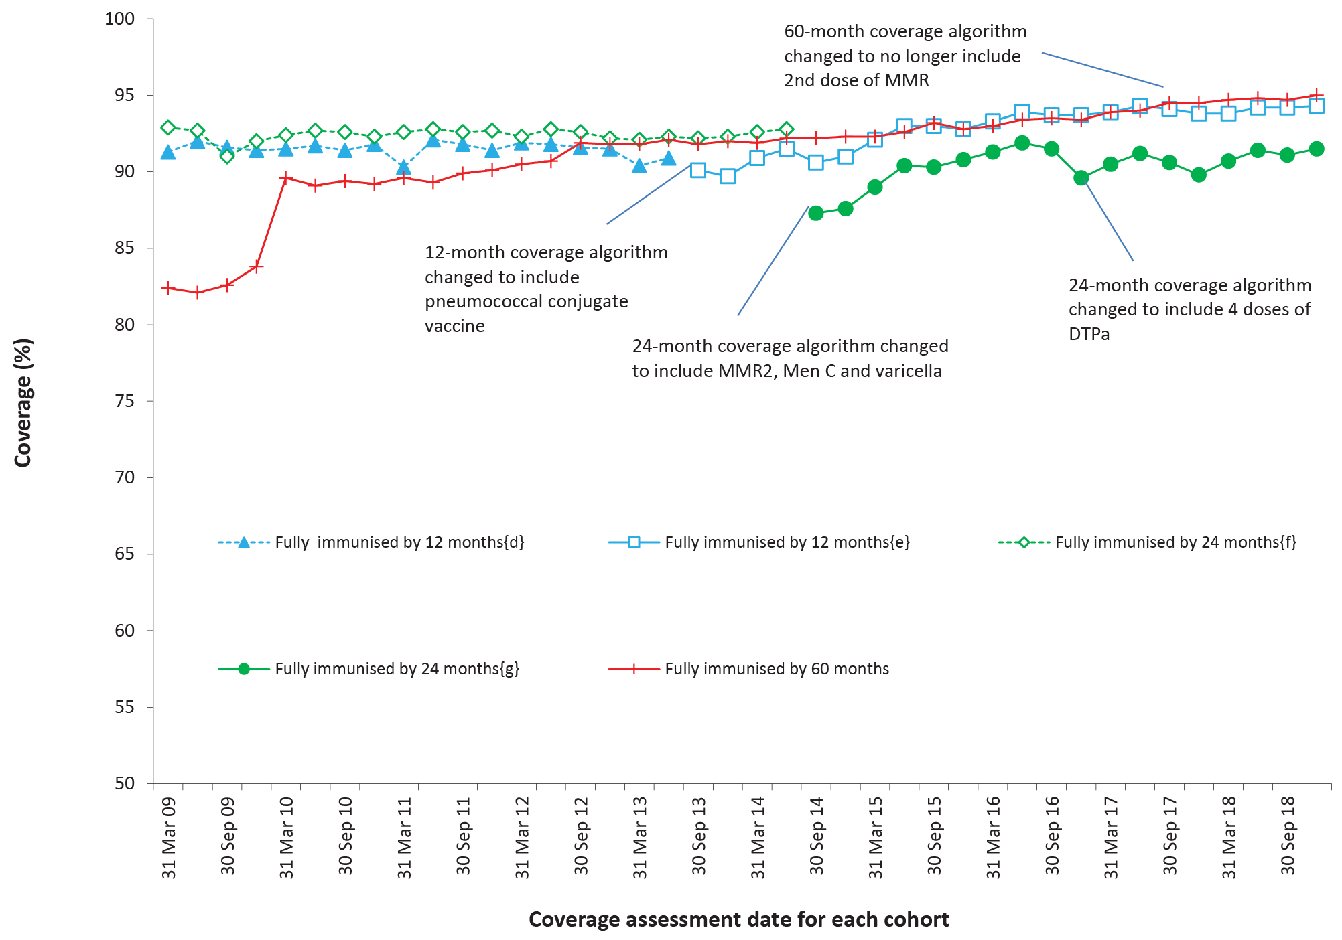
a By 3-month birth cohorts born between 1 January 2008 and 31 December 2017. Coverage assessment date was 12, 24 or 60 months after the last birth date of each cohort. Vaccination coverage estimates are calculated by quarter and may differ slightly from estimates published elsewhere using rolling annualised data.
b Source: Australian Immunisation Register, data as at 31 March 2019.
c MMR2 – second dose of MMR vaccine; MenC – meningococcal C-containing; DTPa – diphtheria-tetanus-acellular pertussis.
d Coverage algorithm before 1 July 2013.
e Coverage algorithm from 1 July 2013.
f Coverage algorithm before 1 July 2014.
g Coverage algorithm from 1 July 2014.

Figure A.2: Trends in vaccination coverage estimates at 12 months of age, by vaccine/antigenª and quarter, Australia, 2009 to 2018^{b,c,d}
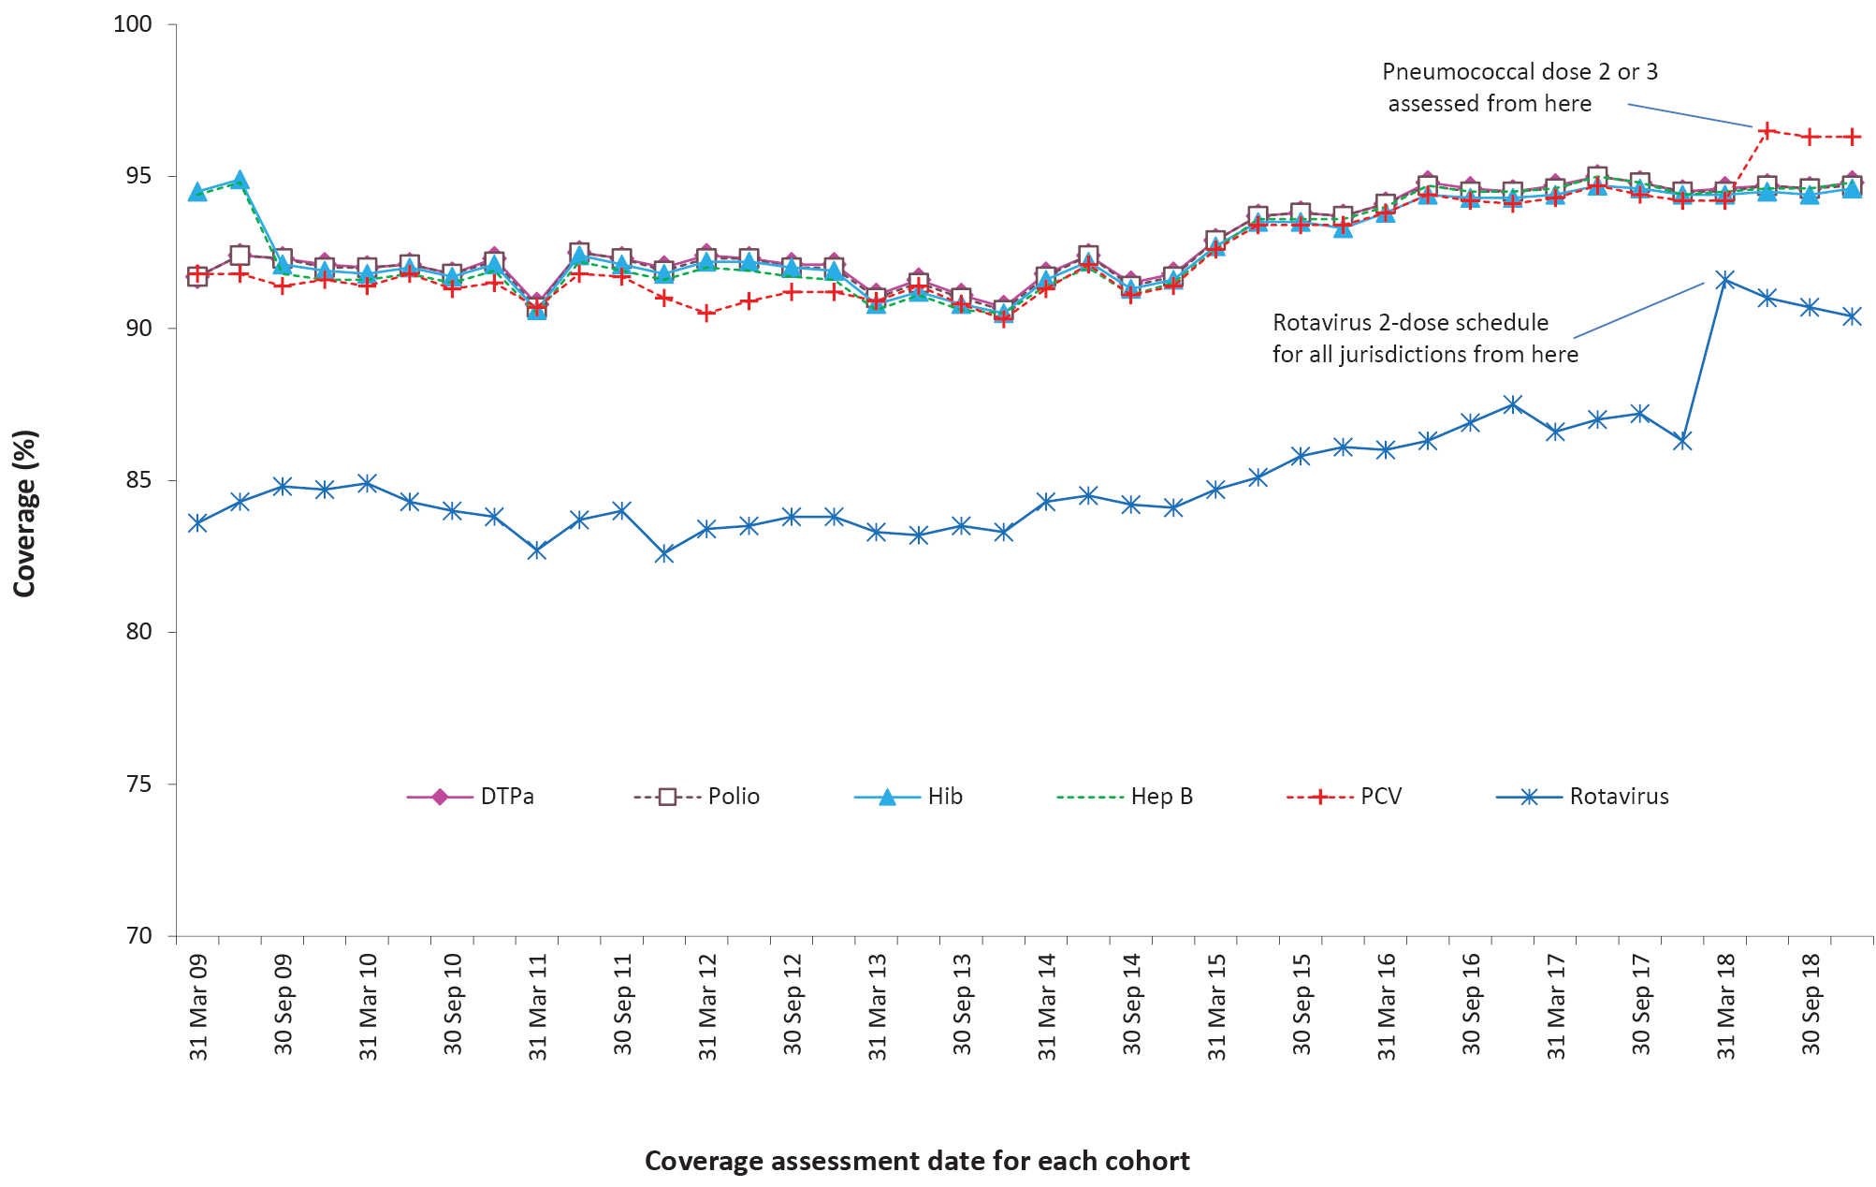
a Fourth dose of DTPa (from October 2016), third dose of polio, third or fourth dose of Hib, third dose of hepatitis B, a dose of varicella, second dose of MMR (from September 2014), and first dose of MenC (MenACWY from July 2018).
b By 3-month birth cohorts born between 1 January 2007 and 31 December 2016. Coverage assessment date was 24 months after the last birth date of each cohort. Vaccination coverage estimates are calculated by quarter and may differ slightly from estimates published elsewhere using rolling annualised data.
c Source: Australian Immunisation Register, data as at 31 March 2019.
d DTPa = diphtheria-tetanus-acellular pertussis; Hib = Haemophilus influenzae type b; Hep B = hepatitis B; MMR = measles-mumps-rubella; MenC = meningococcal C-containing; MenACWY = meningococcal ACWY; MMRV = measles-mumps-rubella-varicella; PCV = pneumococcal conjugate vaccine.

Figure A.3: Trends in vaccination coverage estimates at 24 months of age by vaccine/antigenª and quarter, Australia, 2009 to 2018^{b,c,d}
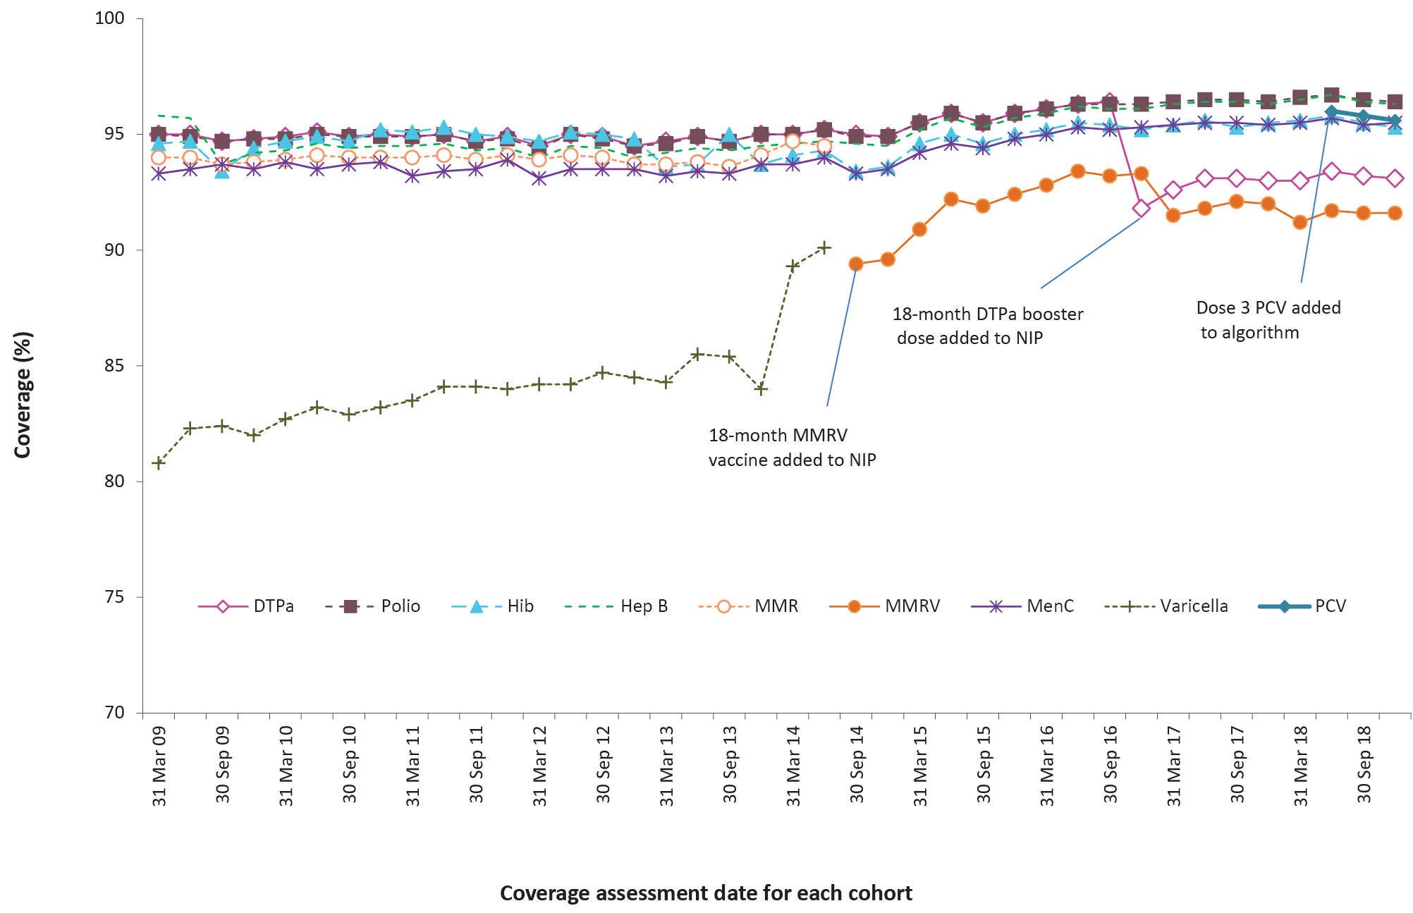
a Fourth dose of DTPa (from October 2016), third dose of polio, third or fourth dose of Hib, third dose of hepatitis B, a dose of varicella, second dose of MMR (from September 2014), and first dose of MenC (MenACWY from July 2018).
b By 3-month birth cohorts born between 1 January 2007 and 31 December 2016. Coverage assessment date was 24 months after the last birth date of each cohort. Vaccination coverage estimates are calculated by quarter and may differ slightly from estimates published elsewhere using rolling annualised data.
c Source: Australian Immunisation Register, data as at 31 March 2019.
d DTPa = diphtheria-tetanus-acellular pertussis; Hib = Haemophilus influenzae type b; Hep B = hepatitis B; MMR = measles-mumps-rubella; MenC = meningococcal C-containing; MenACWY = meningococcal ACWY; MMRV = measles-mumps-rubella-varicella; PCV = pneumococcal conjugate vaccine.

Figure A.4: Trends in vaccination coverage estimates at 60 months of age by vaccine/antigenª and quarter, Australia, 2009 to 2018^{b,c,d}
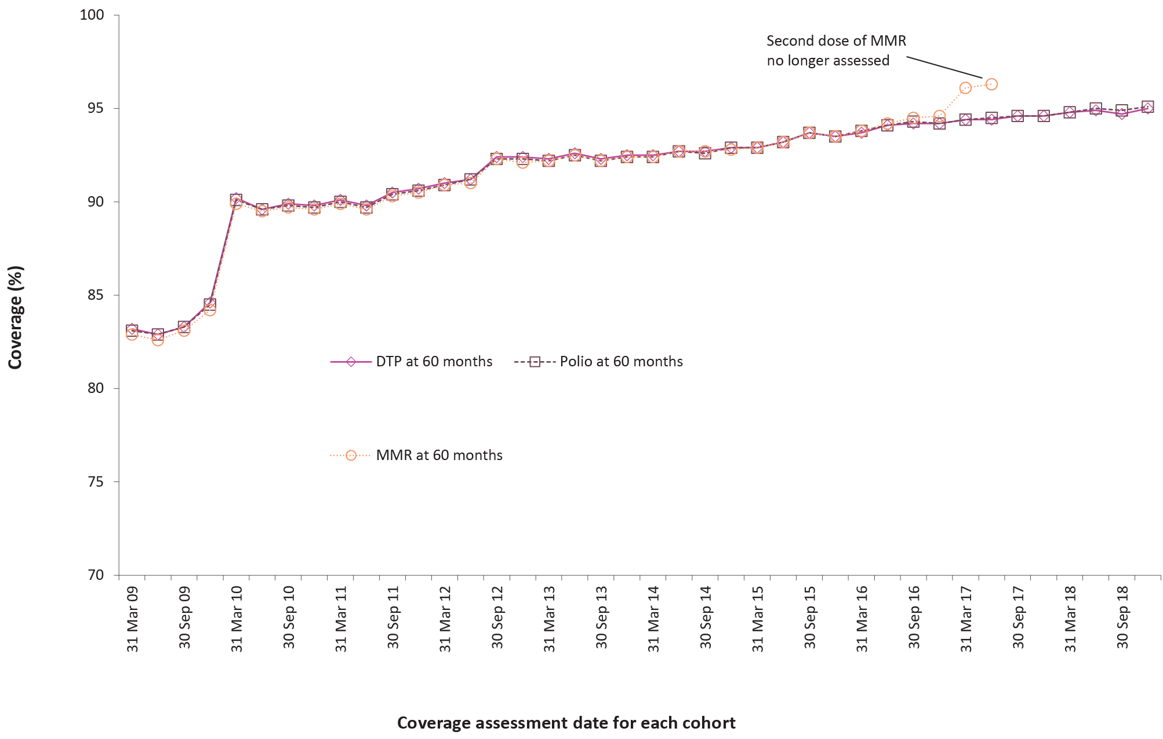
a Fourth or fifth dose of DTPa and fourth dose of polio, second dose of MMR (up until June 2017).
b By 3-month birth cohorts born between 1 January 2004 and 31 December 2013. Coverage assessment date was 60 months after the last birth date of each cohort. Vaccination coverage estimates are calculated by quarter and may differ slightly from estimates published elsewhere using rolling annualised data.
c Source: Australian Immunisation Register, data as at 31 March 2019.
d DTPa = diphtheria-tetanus-acellular pertussis; MMR = measles-mumps-rubella.

Figure A.5: Trends in ‘fully vaccinated’ coverage at 12 months of age by Indigenous status and quarter, Australia, 2009 to 2018^{a,b}
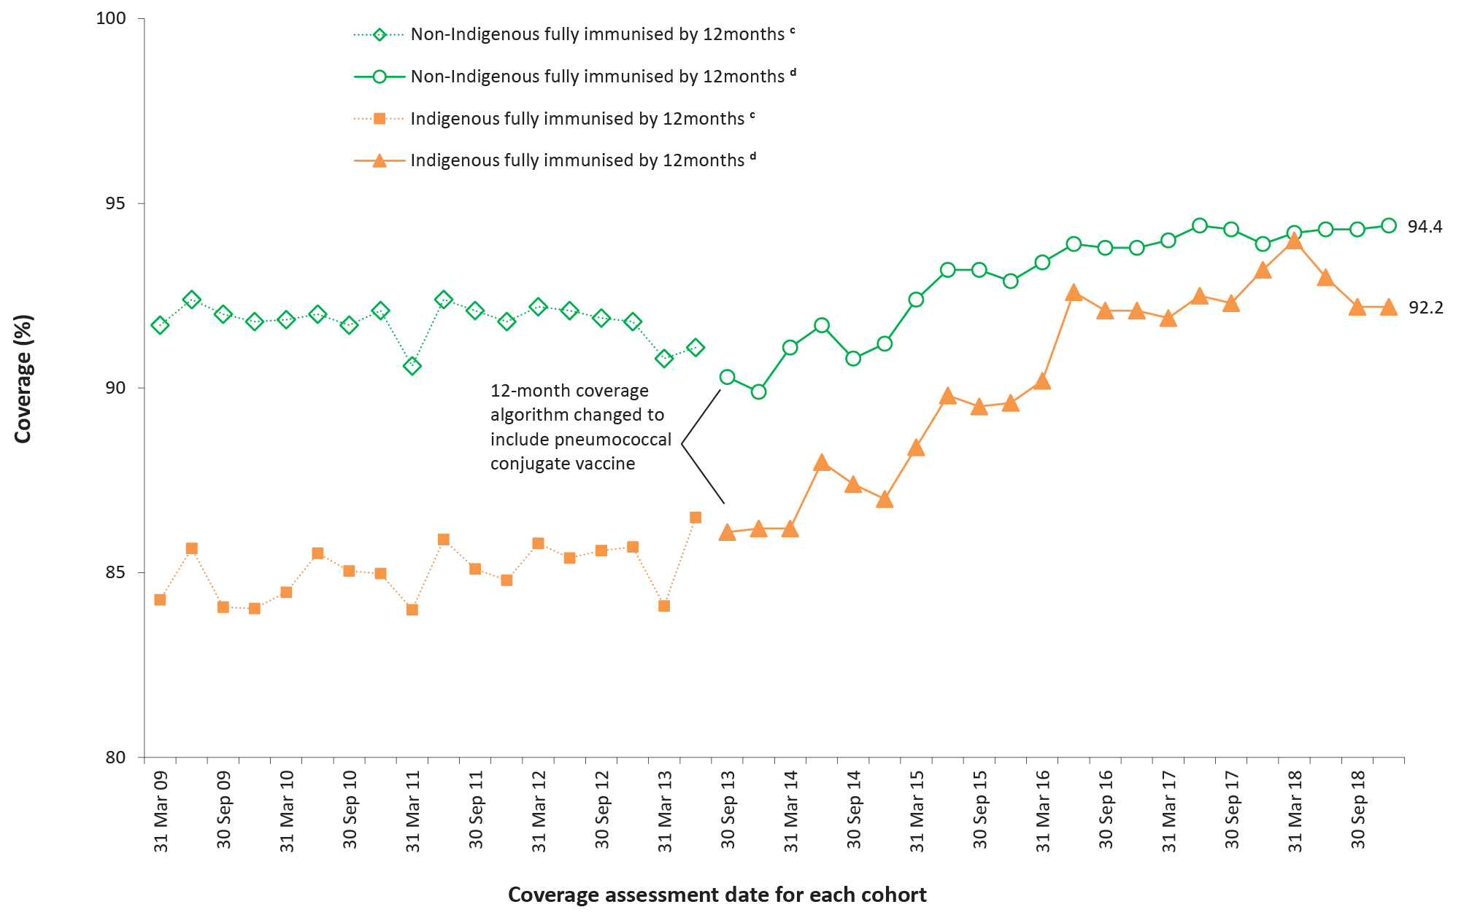
A Vaccination coverage estimates are calculated using 3-month wide birth cohorts by quarter and may differ slightly from estimates published elsewhere using rolling annualised data.
b Source: Australian Immunisation Register, data as at 31 March 2019.
c Coverage algorithm before 1 July 2013.
d Coverage algorithm from 1 July 2013.

Figure A.6: Trends in ‘fully vaccinated’ coverage at 24 months of age by Indigenous status and quarter, Australia, 2009 to 2018^{a,b}
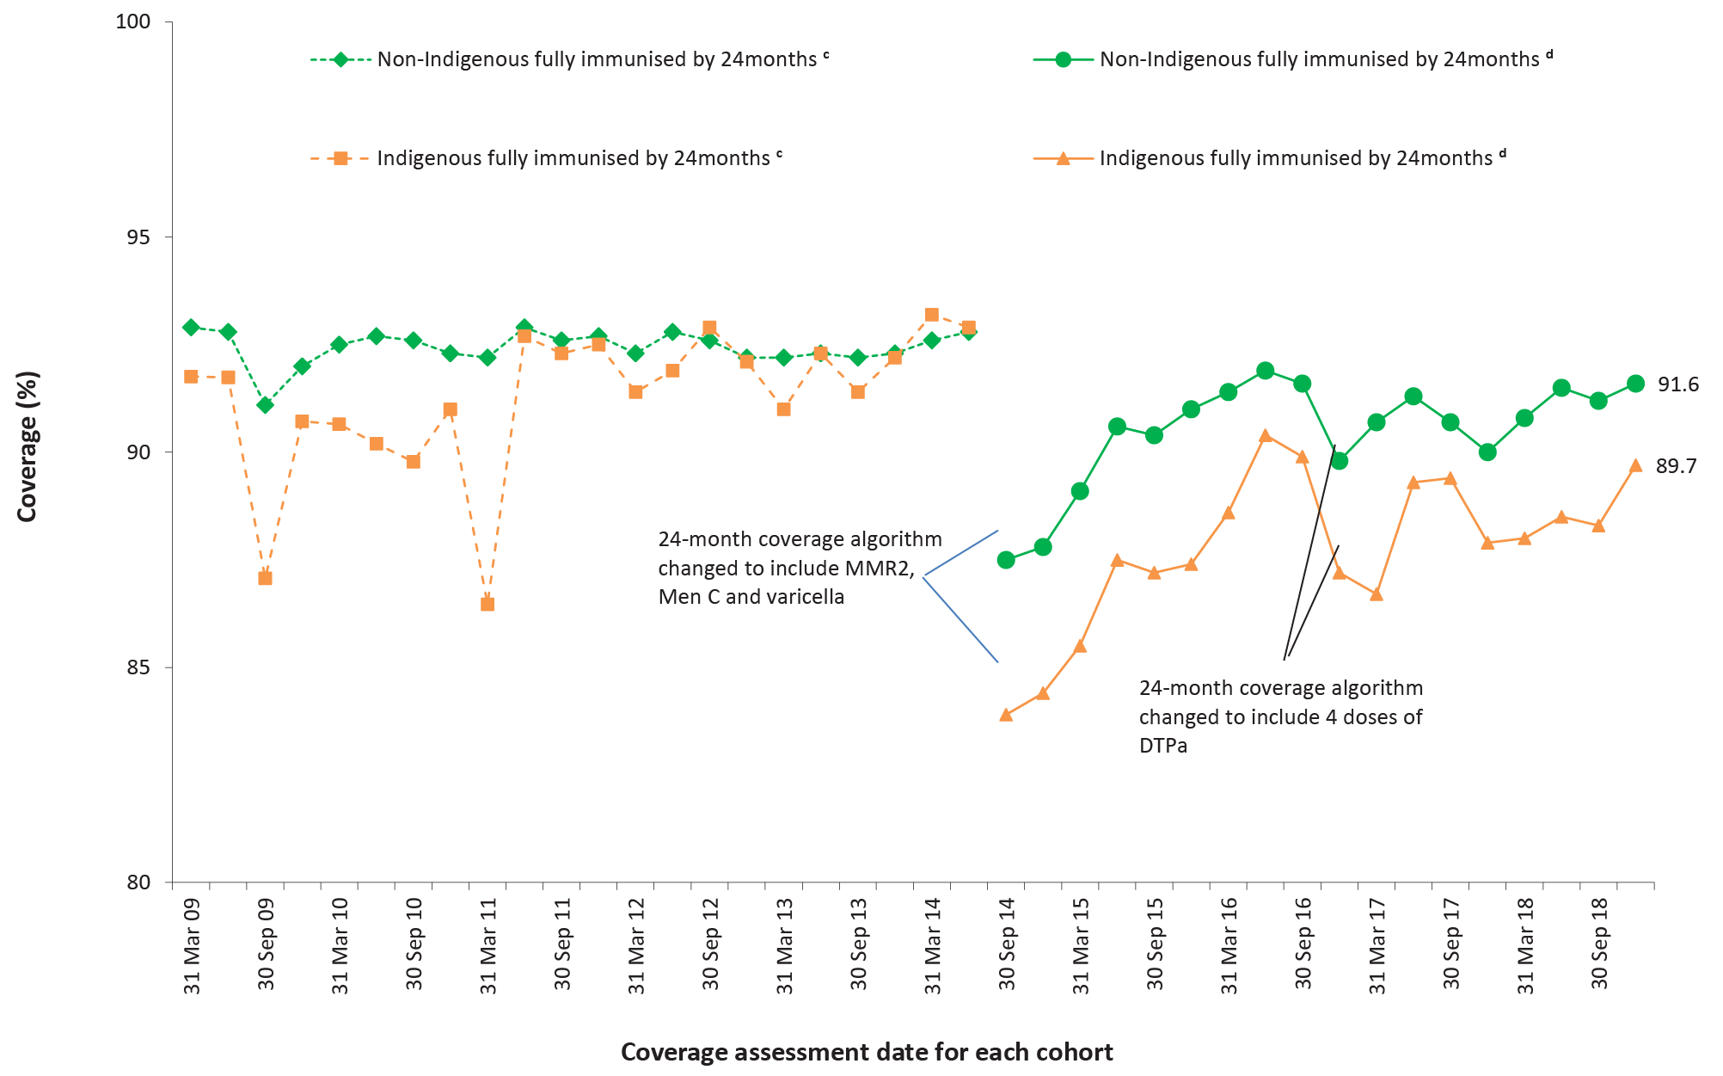
a Vaccination coverage estimates are calculated using 3-month wide birth cohorts by quarter and may differ slightly from estimates published elsewhere using rolling annualised data.
b Source: Australian Immunisation Register, data as at 31 March 2019.
c Coverage algorithm before 1 July 2014.
d Coverage algorithm from 1 July 2014.

Figure A.7: Trends in ‘fully vaccinated’ coverage at 60 months of age by Indigenous status and quarter, Australia, 2009 to 2018^{a,b}
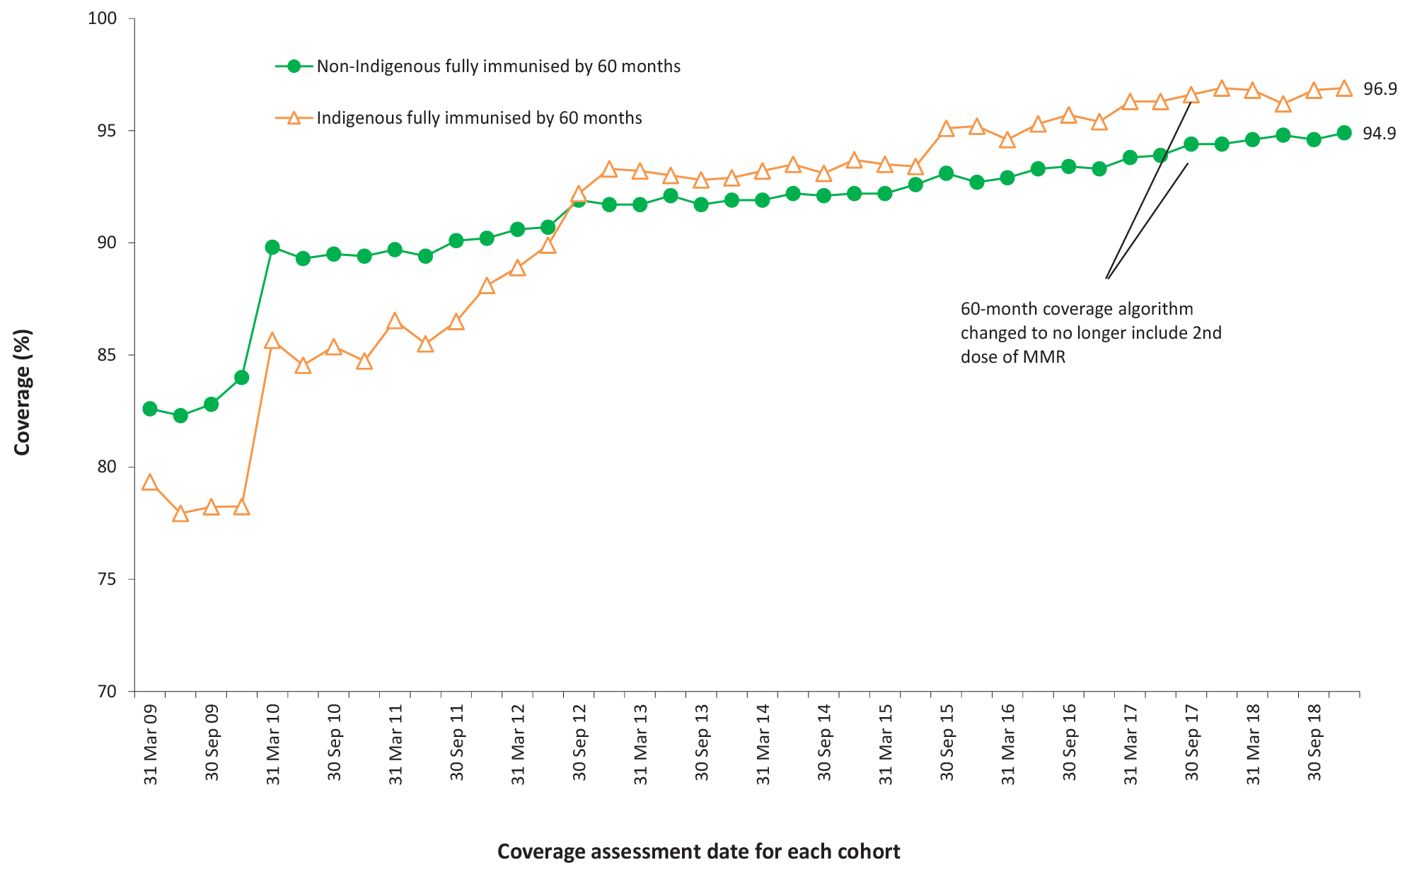
a Vaccination coverage estimates are calculated using 3-month wide birth cohorts by quarter and may differ slightly from estimates published elsewhere using rolling annualised data.
b Source: Australian Immunisation Register, data as at 31 March 2019.

Figure A.8: Trends in coverage estimates for hepatitis A vaccineª for Indigenous children by jurisdiction, Australia,^{b} 2009 to 2018^{c,d}
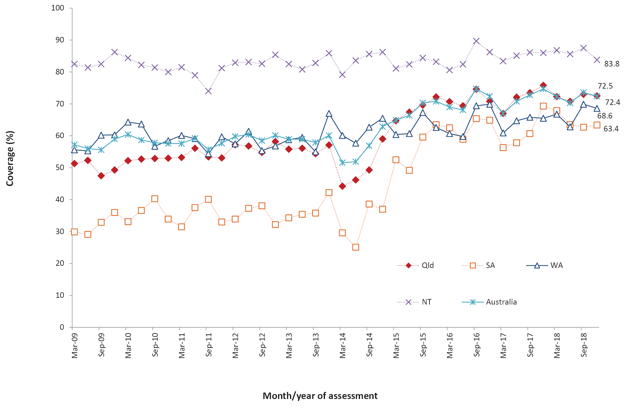
a 18-month dose assessed at 30 months of age in all four jurisdictions.
b Northern Territory (NT), Queensland (Qld), South Australia (SA) and Western Australia (WA) only.
c Vaccination coverage estimates are calculated using 3-month wide birth cohorts by quarter.
d Source: Australian Immunisation Register, data as at 31 March 2019.

Figure A.9: Trends in coverage estimates for pneumococcal vaccineª for Indigenous children by jurisdiction,^{b} Australia, 2009 to 2018^{c,d,e}
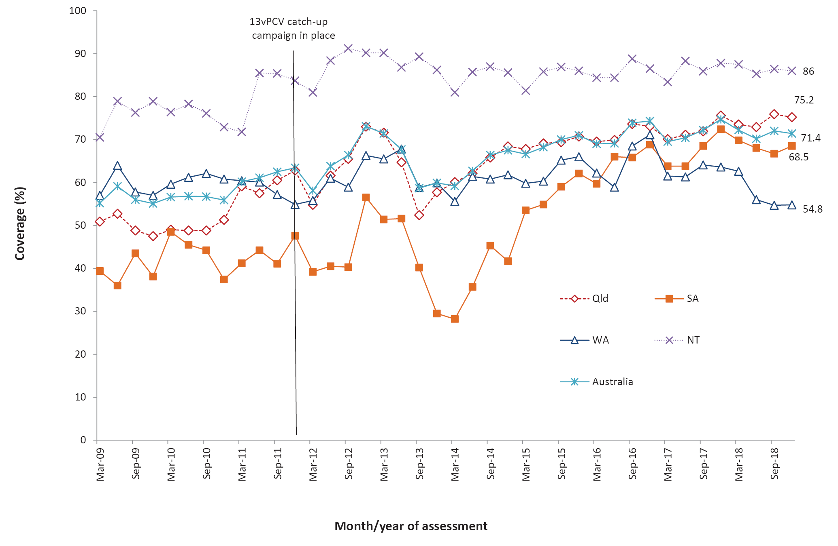
a 12-month booster dose assessed at 30 months of age in all four jurisdictions.
b Northern Territory (NT), Queensland (Qld), South Australia (SA) and Western Australia (WA) only.
c Vaccination coverage estimates are calculated using 3-month wide birth cohorts by quarter.
d 13vPCV = 13-valent pneumococcal conjugate vaccine.
e Source: Australian Immunisation Register, data as at 31 March 2019.

Communicable Diseases Intelligence
ISSN: 2209-6051 Online

Communicable Diseases Intelligence (CDI) is a peer-reviewed scientific journal published by the Office of Health Protection and Response, Department of Health. The journal aims to disseminate information on the epidemiology, surveillance, prevention and control of communicable diseases of relevance to Australia.

Editor: Tanja Farmer
Deputy Editor: Simon Petrie
Design and Production: Kasra Yousefi
Editorial Advisory Board: David Durrheim, Mark Ferson, John Kaldor, Martyn Kirk and Linda Selvey

Website: http://www.health.gov.au/cdi

Contacts
CDI is produced by Environmental Health and Health Protection Policy Branch, Office of Health Protection and Response, Australian Government Department of Health, GPO Box 9848, (MDP 6) CANBERRA ACT 2601

Email: cdi.editor@health.gov.au

Submit an Article
You are invited to submit your next communicable disease related article to the Communicable Diseases Intelligence (CDI) for consideration. More information regarding CDI can be found at: http://health.gov.au/cdi.
Further enquiries should be directed to: cdi.editor@health.gov.au.

This journal is indexed by Index Medicus and Medline.

Creative Commons Licence - Attribution-NonCommercial-NoDerivatives CC BY-NC-ND
© 2021 Commonwealth of Australia as represented by the Department of Health
This publication is licensed under a Creative Commons Attribution-NonCommercial-NoDerivatives 4.0 International Licence from https://creativecommons.org/licenses/by-nc-nd/4.0/legalcode (Licence). You must read and understand the Licence before using any material from this publication.

Restrictions
The Licence does not cover, and there is no permission given for, use of any of the following material found in this publication (if any):
- the Commonwealth Coat of Arms (by way of information, the terms under which the Coat of Arms may be used can be found at www.itsanhonour.gov.au);
- any logos (including the Department of Health’s logo) and trademarks;
- any photographs and images;
- any signatures; and
- any material belonging to third parties.

Disclaimer
Opinions expressed in Communicable Diseases Intelligence are those of the authors and not necessarily those of the Australian Government Department of Health or the Communicable Diseases Network Australia. Data may be subject to revision.

Enquiries
Enquiries regarding any other use of this publication should be addressed to the Communication Branch, Department of Health, GPO Box 9848, Canberra ACT 2601, or via e-mail to: copyright@health.gov.au

Communicable Diseases Network Australia
Communicable Diseases Intelligence contributes to the work of the Communicable Diseases Network Australia.
http://www.health.gov.au/cdna

