Is gentamicin a viable therapeutic option for treating resistant Neisseria gonorrhoeae in New South Wales?
Benjamin H Armstrong, Athena Limnios, David A Lewis, Tiffany Hogan, Ratan Kundu, Sanghamitra Ray, Masoud Shoushtari, Jasmin El Nasser, Tim Driscoll, Monica M Lahra

Abstract
The key issues with Neisseria gonorrhoeae infections, in Australia and elsewhere, are coincident increases in disease rates and in antimicrobial resistance (AMR), although these factors have not been shown to be correlated. Despite advances in diagnosis, control of this disease remains elusive, and incidence in Australia continues to increase. Of the Australian jurisdictions, New South Wales (NSW) has the highest N. gonorrhoeae notifications, and over the five-year period 2015–2019, notifications in NSW have increased above the national average (by 116% versus 85%, respectively).
Gonococcal disease control is reliant on effective antibiotic regimens. However, escalating AMR in N. gonorrhoeae is a global health priority, as the collateral injury of untreated infections has substantive impacts on sexual and newborn health. Currently, our first-line therapy for gonorrhoea is also our last line, with no ideal alternative identified. Despite some limitations, gentamicin is licensed and readily available in Australia, and is proposed for treatment of resistant N. gonorrhoeae in national guidelines; however, supportive published microbiological data are lacking.
Analysis of gonococcal resistance patterns within Australia for the period 1991–2019, including 35,000 clinical isolates from NSW, illustrates the establishment and spread of population-level resistance to all contemporaneous therapies. An analysis of gentamicin susceptibility on 2,768 N. gonorrhoeae clinical isolates from NSW, for the period 2015–2020, demonstrates that the median minimum inhibitory concentration (MIC) for gentamicin in NSW has remained low, at 4.0 mg/L, and resistance was not detected in any isolate. There has been no demonstration of MIC drift over time (p = 0.91, Kruskal-Wallis test), nor differences in MIC distributions according to patients’ sex or site of specimen collection.
This is the first large-scale evaluation of gentamicin susceptibility in N. gonorrhoeae in Australia. No gentamicin resistance was detected in clinical isolates, 2015–2020, hence this is likely to be an available treatment option for resistant gonococcal infections in NSW.
Keywords: Neisseria gonorrhoeae; gonococcal; gentamicin; antimicrobial resistance; treatment; surveillance.

Introduction
Neisseria gonorrhoeae infections are notifiable under legislation in Australia; notification data are recorded in the Australian National Notifiable Diseases Surveillance System (NNDSS).¹ The NNDSS was established in 1991, when the diagnosis of gonococcal infection was reliant on bacterial culture. The introduction of molecular testing for the diagnosis of gonorrhoea in the last two decades, with subsequent scale-up of availability, and widespread uptake of use by clinicians, has coincided with large increases in gonorrhoea notifications in Australia during the last decade.² This increase was initially attributed to the recognised advantages of molecular testing, particularly improved access to, and uptake of, less invasive testing methodologies, and the increased sensitivity of molecular assays. However, recent analysis of the national data has shown that increases in gonococcal notifications over this time period exceed what may be fully explained by increased testing.² Between 2015 and 2019, notifications of gonococcal infections have increased nationally by more than 85%. The state of New South Wales (NSW) has the largest number of gonococcal notifications in Australia,¹ and over this same 5-year period notifications within the state increased by 116%.
Gonococcal disease control is reliant on effective antibiotic treatment of patients and their contacts. However, antimicrobial resistance in N. gonorrhoeae is an identified concern globally.³ In Australia, the increasing gonococcal disease incidence and coincident increasing antimicrobial resistance (AMR) appear unrelated.³ Globally, AMR in N. gonorrhoeae has emerged over time to every agent used as first-line therapy.³ As a consequence of this, our current first-line strategy is also now our last line, as there is no ideal alternate option identified. Hence, once resistance to the first-line extended-spectrum cephalosporin antibiotics is established, therapeutic strategies are uncertain.
Gonococcal AMR in Australia has been continuously monitored since 1981 by a national network of reference laboratories (the National Neisseria Network, NNN). This work is supported by the Australian Government Department of Health, and is called the Australian Gonococcal Surveillance Programme (AGSP). Within Australia, the emergence of AMR in N. gonorrhoeae has long been influenced by the introduction of resistant strains from overseas, where reservoirs are known to exist.^{4–6} Extended-spectrum cephalosporin-resistant, multi-drug-resistant (MDR), and extensively-drug-resistant (XDR) N. gonorrhoeae isolates recently detected in Australia were associated with overseas travel or contact within the Asia-Pacific region.^{5,7,8} Importation of MDR and XDR N. gonorrhoeae remains an ongoing threat: once resistant strains are introduced to a population, resistance frequently becomes established.⁷
If previous trends in gonococcal AMR are our guide, alternate strategies and therapeutic regimens must be considered pre-emptively, including the repurposing of established antimicrobials for use in anti-gonococcal regimens. Three suitable agents currently licensed for use in Australia for consideration are gentamicin, ertapenem, and spectinomycin.⁹
Gentamicin and spectinomycin are recommended by the most recent 2016 WHO guidelines for management of resistant gonococcal infections.¹⁰ More recent Australian guidelines additionally recommend ertapenem for MDR and XDR N. gonorrhoeae.¹¹ Gentamicin is readily available, inexpensive, and has an established side effect profile; like ceftriaxone, it may be administered via a single intramuscular injection. Ertapenem is reported to require intravenous access and multiple doses to achieve reliable cure for gonorrhoea.^{12,13} Unlike gentamicin and ertapenem, spectinomycin is not readily available in Australia.
Recent clinical studies have demonstrated efficacy for gentamicin treatment of urethral gonorrhoea; however, rates of oropharyngeal clearance were reduced compared to current standard therapy, and data on rectal and other body site infections are limited.^{9,14,15} There is a lack of clinical or epidemiological studies to support anti-gonococcal therapy with gentamicin in NSW, or in the broader Australian setting. In this context, a longitudinal evaluation of N. gonorrhoeae gentamicin susceptibility was conducted in vitro, using isolates cultured in NSW, to provide an evidence base to support the use of gentamicin for gonococcal disease resistant to current first-line therapy.

Methods
This study was conducted in the World Health Organization Collaborating Centre for Sexually Transmitted Infections and Antimicrobial Resistance (WHO CC) in Sydney, NSW. This Centre serves as the State Reference Laboratory for pathogenic Neisseria species, and is the NNN’s coordinating laboratory. Standard testing for N. gonorrhoeae from clinical isolates includes confirmation of identification, as well as determination of minimum inhibitory concentration (MIC) values for ceftriaxone, azithromycin, ciprofloxacin, and penicillin. Gentamicin MIC surveys are undertaken periodically and these data were also included in the analysis. Data are reported for clinical and surveillance purposes.
A longitudinal analysis of MIC values from clinical N. gonorrhoeae isolates, obtained from male and female patients tested in NSW over a 39-year period (1981–2019), was performed. A contemporaneous survey was conducted to determine gentamicin MIC values for 100 N. gonorrhoeae clinical isolates, received consecutively during the period 25 August – 3 September 2020.
MIC testing for ceftriaxone, azithromycin, ciprofloxacin and penicillin was performed as previously described.³ Gentamicin MIC values were determined using Etest (bioMérieux, France). Clinical breakpoints for gentamicin have not been established; however, on the basis of clinical correlate data, isolates are considered resistant to gentamicin when the MIC value is ≥ 32 mg/L.¹⁵
This study was deemed a quality improvement project by the South Eastern Sydney Local Health District Research Support Office, and therefore formal ethics committee approval was not required.
Statistical analysis and construction of figures were performed using Prism version 8.4.3 (GraphPad Software, San Diego, California, USA) and Microsoft Excel 2013 version 15.0.5127.1000 (Microsoft Corporation, Redmond, Washington, USA).

Results
The antimicrobial resistance trend data for NSW over the 39-year period from the AGSP’s inception to 2019 are displayed in Figure 1. Early reports from the AGSP monitor the proportion of gonococcal isolates resistant to penicillin only, as this was the therapeutic agent in use at that time. From 1996 onwards, the AGSP has surveyed antimicrobial susceptibilities to four core antibiotics (penicillin, ciprofloxacin, azithromycin and ceftriaxone) and these data are presented (Figure 1). From 1996 to 2019 there were 80,018 gonococcal notifications notified to the NNDSS from NSW and of these, 35,789 clinical N. gonorrhoeae isolates (45%) had antimicrobial susceptibility testing (AST) performed at the WHO CC.

Figure 1: NSW gonococcal resistance by year, 1981–2019ª
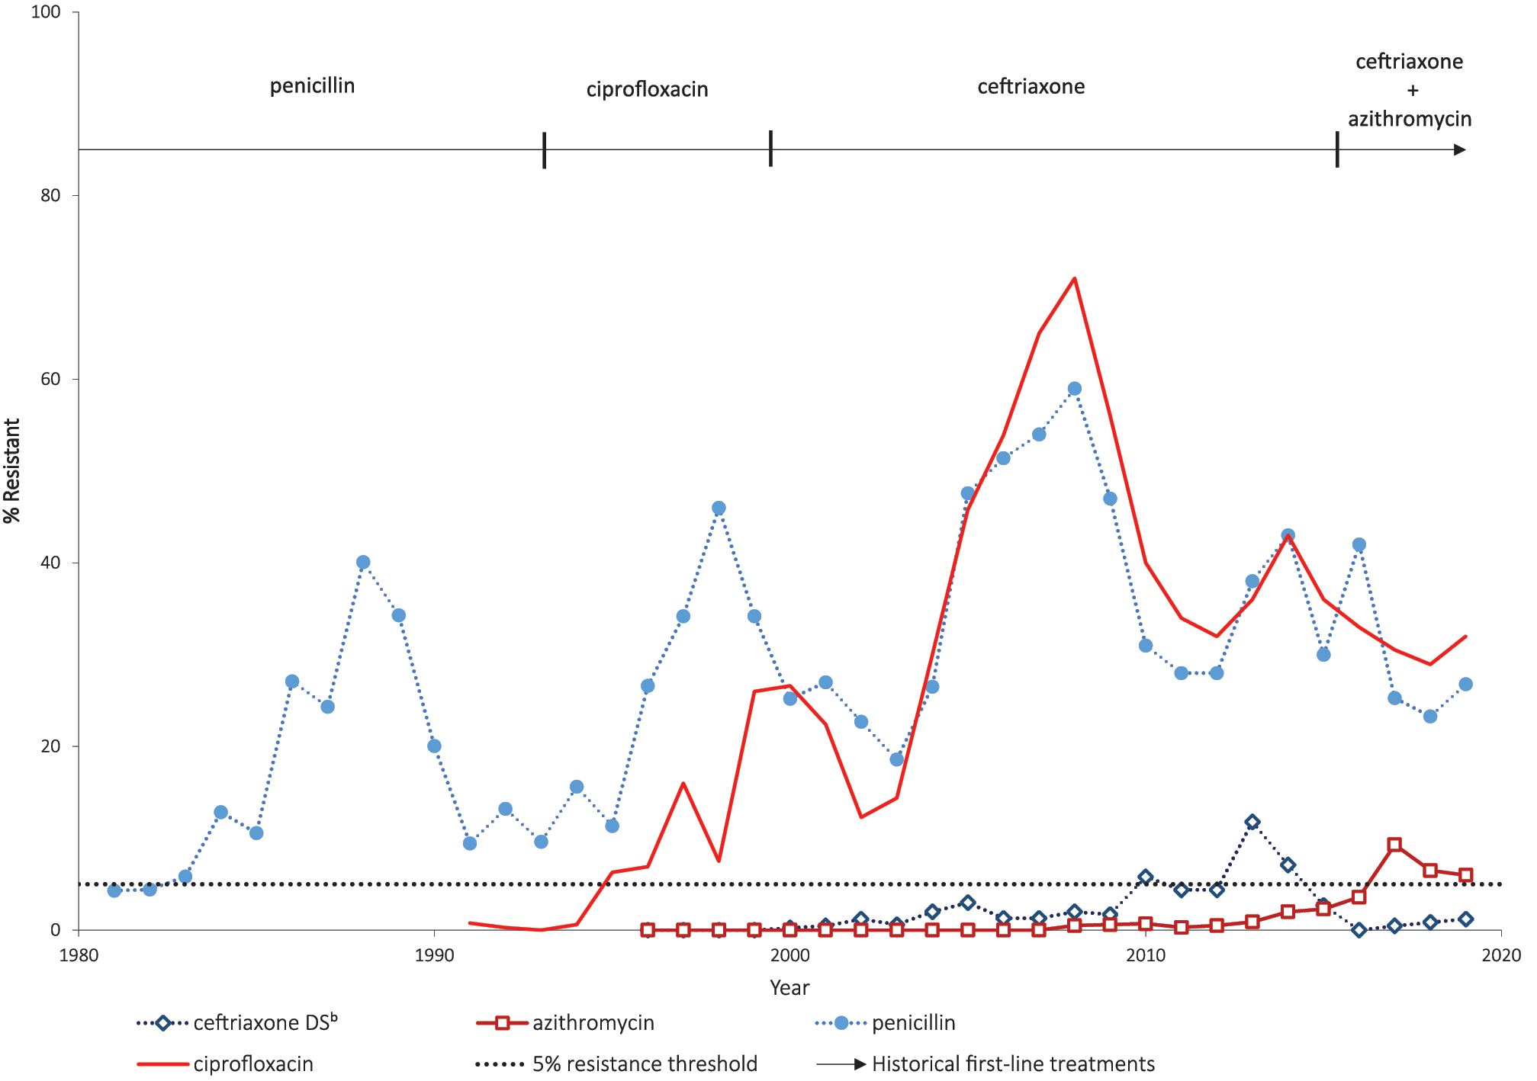
a From data in references 3, 16–67.
b DS: decreased susceptibility.
Over the period of surveillance, recommendations for first-line antibiotic therapy changed in line with AMR evolution and at the point when the proportion resistant was established as greater than the nominal 5% resistance threshold (Figure 1). What can be observed in the longitudinal data is that, once established in the population, resistance remains in excess of the 5% threshold over time, even when former first-line therapies are no longer used to treat gonorrhoea: this can be seen for both penicillin and ciprofloxacin.
The proportion of gonococcal isolates with decreased susceptibility (DS) to ceftriaxone (MIC values in the range 0.06–0.125 mg/L) peaked in 2013, before declining following the introduction of dual therapy with azithromycin.³ Azithromycin resistance increased following the implementation of dual therapy, peaking in 2017, and remained elevated at 6.0% in 2019; however, this agent is adjunctive, and included to preserve ceftriaxone as the mainstay of therapy.
Gentamicin surveys have been conducted at intervals over the period 2015–2019. A total of 2,668 isolates from NSW, for which a gentamicin MIC was determined, were analysed from the period 1 January 2015 to 31 December 2019, inclusive of 367 female and 2,301 male patients. The isolates included 1,476 genital isolates, 471 isolates from pharyngeal specimens, 684 rectal isolates, 11 isolates from patients with disseminated gonococcal infections (DGI), and 26 isolates from other body sites (e.g. conjunctival samples). For the 2,668 isolates, the median MIC (MIC₅₀) and the MIC₉₀ for gentamicin were both 4.0 mg/L, with a range of 0.5–8.0 mg/L (Figure 2). No isolate was resistant to gentamicin (MIC ≥ 32 mg/L) within the 5-year period. For the purposes of this study, contemporaneous isolates were also surveyed, and Figure 3 illustrates the distribution of gentamicin MIC values obtained for 100 consecutive isolates received in 2020. The median MIC was 4.0 mg/L, with a range of 2.0–8.0 mg/L. No isolate was resistant to gentamicin (MIC value ≥ 32 mg/L). There was no significant difference between the MIC distribution of the 2,668 samples from 2015–2019 and that of the 100 consecutive samples from the 2020 survey (p = 0.1104, Kolmogorov-Smirnov test).
Figure 2 Distribution of gentamicin MIC values for 2,668 isolates of N. gonorrhoeae from NSW, 2015–2019
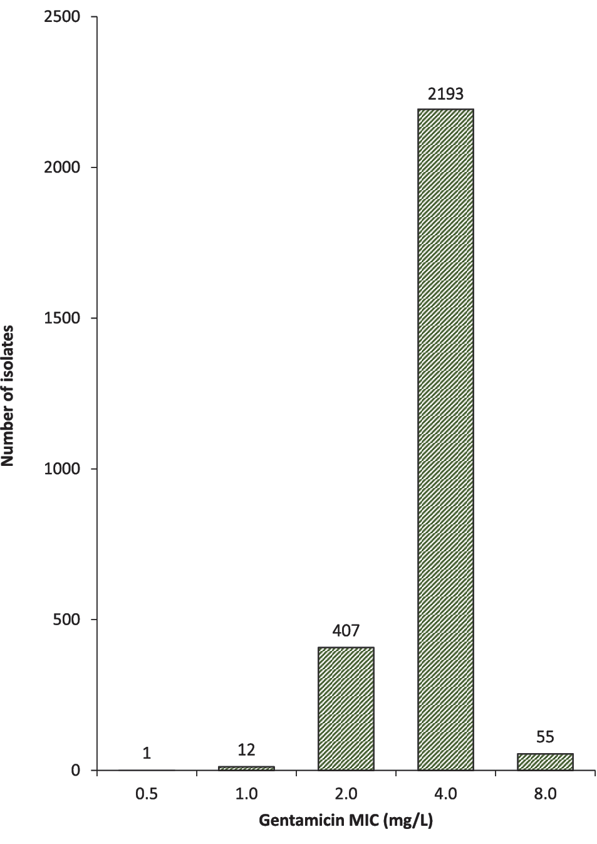

Figure 3: Distribution of gentamicin MIC values for 100 consecutive isolates of N. gonorrhoeae tested within NSW in 2020
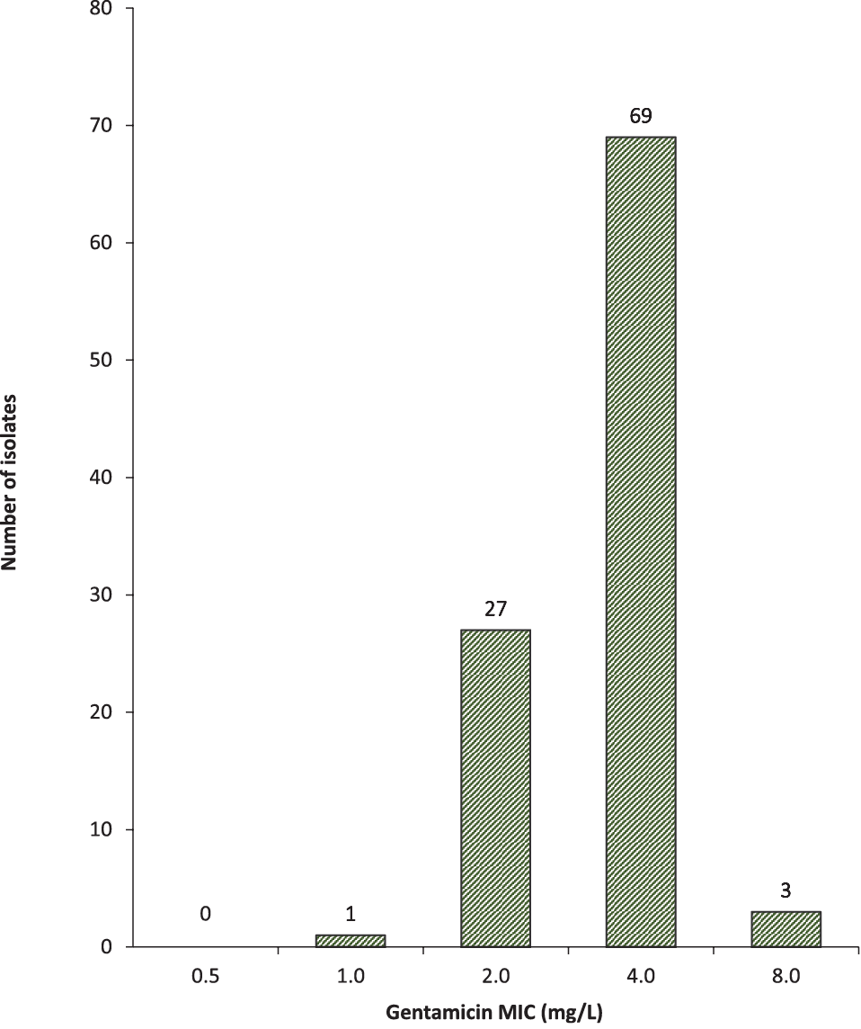
Figure 4: Distribution of gentamicin MIC values for 2,668 isolates of N. gonorrhoeae from NSW, 2015–2019, according to patient sex
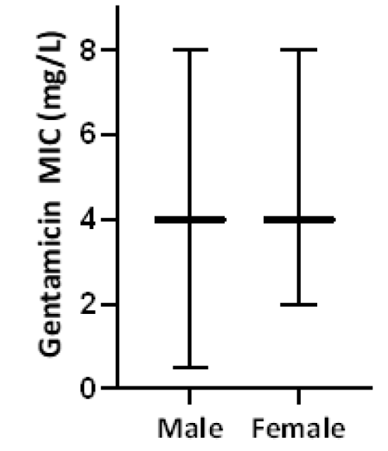
Furthermore, there was no significant difference between MIC distributions in the 2,301 male patients and 367 female patients (p = 0.0882, Kolmogorov-Smirnov test; Figure 4). This is in contrast to resistance patterns seen in N. gonorrhoeae for other drugs that have been first-line therapy.⁶⁸
When comparison of MIC distributions was made according to the anatomical site of specimen collection, no significant difference in MICs was found (p = 0.2, Kruskal-Wallis test). The median gentamicin MIC for samples from each site (genital, pharynx, rectal, and other) was 4.0 mg/L (Figure 5).
When comparison was made between gentamicin MIC distributions by year, there were no significant differences or trends towards increasing or decreasing MICs between 2015 and 2020 (p = 0.91, Kruskal-Wallis test; Figure 6).
Figure 5: Distribution of gentamicin MIC values for 2,668 isolates of N. gonorrhoeae from NSW, 2015–2020, according to site of specimen collection
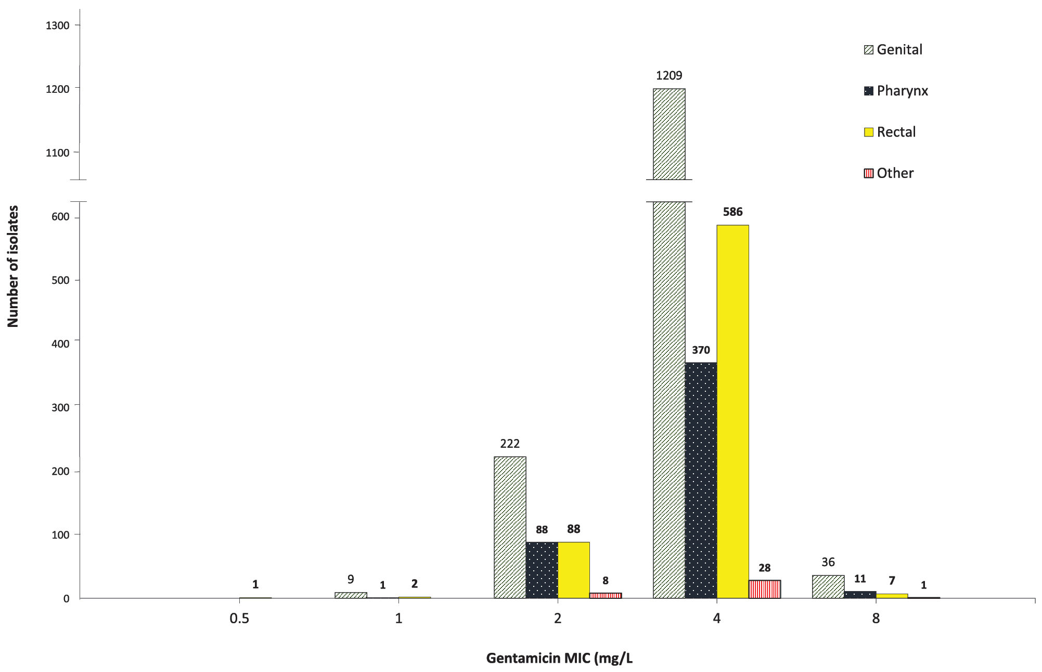
Figure 6: Distribution of gentamicin MIC values for 2,768 isolates of N. gonorrhoeae from NSW, 2015–2020, according to year of isolationª
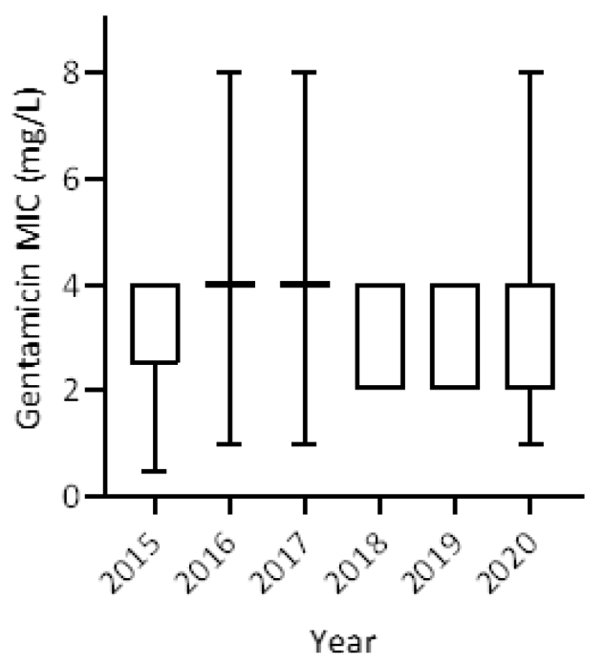
a Data in Figure 6 are inclusive of the 2,668 samples isolated 2015–2019 and the 100 consecutive samples tested in August-September 2020.

Discussion
NSW is an important sentinel site for gonococcal surveillance for Australia. Sydney, the state’s capital, is a key international entry point, with 4.4 million international visitors in 2019. Furthermore, it is estimated that half of all visitors to Australia spend an average of 22 nights in NSW.⁶⁹ Consequently, NSW is at particular risk of importation and subsequent outbreaks of antibiotic-resistant gonococcal infections. This study reports the trend data for gonococcal AMR over four decades and more than 35,000 clinical isolates, as well as novel gentamicin MIC trend data for the past six years.
Our data present a large-scale appreciation of the changing gonococcal AMR landscape in NSW over the past four decades. These data provide baseline susceptibility profiles for the current therapeutic options, and a record of the impact of historical therapies. This also serves to highlight that consequential resistance develops in N. gonorrhoeae to every first-line recommended therapeutic agent over time.^{3,67} Importantly, the AGSP data clearly demonstrate that once resistance becomes established in a population, resistance rates may decline or fluctuate with changes in therapy but do not return to baseline levels, despite cessation of routine use of that agent. Despite the recent reductions in ceftriaxone resistance, increasing MIC levels, coupled with the detection of ceftriaxone-resistant strains (e.g. the A8806 and FC428 clones),^{5,8} likely herald the eventual broader emergence of community-level resistance. Thus, there is urgency in investigating alternate agents for gonococcal treatment and disease control. One potential agent could be gentamicin, as this is readily available in Australia. This current study presents reassuring data on gentamicin susceptibility and considers its suitability as a therapeutic agent to treat antimicrobial-resistant gonorrhoea.
Gentamicin is used widely in hospital settings for the treatment of other gram-negative infections, administered either intramuscularly or intravenously. The side effect profile of gentamicin therapy is well established, and adverse events are rare, but include oto- and nephrotoxicity. As a single-dose injection for treatment, the advantages of gentamicin include elimination of partially-treated infections in those patients who do not return for subsequent doses with other multi-dose antimicrobial treatment regimens, and removes concerns that index patients may share their medication with contacts.
Relevant clinical studies of gentamicin’s efficacy are limited. The largest clinical study of gentamicin therapy for N. gonorrhoeae indicates cure rates of 94% in genital infections when co-administered with azithromycin; however, in this same study, use of gentamicin was associated with significantly reduced cure rates in pharyngeal infection (80%).¹⁴ Another recent, small study (n = 10), stopped early due to poor efficacy, found gentamicin monotherapy for gonococcal pharyngeal infection had significantly lower cure rate (20%).⁷⁰ As urogenital, anorectal, and pharyngeal co-infection are known to be common, further clinical studies are required to fully elucidate the success of gentamicin therapy at various anatomical sites of infection, particularly in the Australian context.^{71,72}
Globally, surveillance data for gentamicin susceptibility in N. gonorrhoeae are very limited. Clinical use as an anti-gonococcal agent is not widespread outside of Malawi, where it has been utilised for over 20 years. There are no reports in the literature of gonococcal resistance to gentamicin, including from studies from Malawi.¹⁵
Whilst there are new drugs for gonorrhoea in phase 3 clinical trials,⁹ the current options for MDR and XDR gonorrhoea in our setting, based on ready availability, are gentamicin and/or ertapenem therapy. For MDR and XDR gonorrhoea uncomplicated ano-genital infections, single-dose intramuscular gentamicin represents the most viable option in terms of both cost and administration route, with expected high cure rates. Given the reported low efficacy of gentamicin in the oro-pharynx, pharyngeal MDR and XDR gonorrhoea infections would most likely respond to intravenous or intramuscular ertapenem, which may be required to be administered multiple times over several days in order to effect clinical and microbiological cure. It is recognised that higher drug and administration costs of ertapenem will impose substantially on our health care system if resistant strains become endemic.^{13,14}
This study is limited to in vitro data. In the ongoing absence of clinical studies and establishment of clinical breakpoints, the correlation between gentamicin MIC values and clinical efficacy, particularly at the oropharyngeal site, remains unclear. Furthermore, ceftriaxone-resistant strains, and MDR and XDR strains of N. gonorrhoeae, remain relatively rare in Australia, so ongoing systematic prospective gentamicin surveillance is required. A further limitation is ascertainment of isolates for AST. The majority of laboratory diagnosis of N. gonorrhoeae is now via molecular tests which currently cannot provide antimicrobial susceptibility data; this is a recognised limitation for gonococcal surveillance systems internationally.⁷³ The AGSP, however, has the highest rates of ascertainment of all enrolled countries in the WHO’s global Gonococcal AMR Surveillance Programme. Furthermore, all gonococcal isolates received by the WHO CC, Sydney, have antimicrobial susceptibility performed, and in the years 2015–2019 these represented 30–35% of all N. gonorrhoeae notifications annually from NSW. Isolates are referred from patients of any sex, from both public and private pathology laboratories servicing inpatient and outpatient settings, and from all areas of the state.
In summary, this study is the first large-scale laboratory-based evaluation of gentamicin susceptibility in N. gonorrhoeae isolates undertaken in Australia. Important findings include that no in vitro resistance to gentamicin, and no gentamicin MIC creep, was detected over the years 2015–2020. These data have applicability to the broader Australian setting and support the inclusion of gentamicin as an option to treat MDR and XDR N. gonorrhoeae within current Australian guidelines. From the surveillance perspective, the addition of gentamicin as an indicator for ongoing surveillance by the AGSP is in progress, in line with the developing surveillance strategies of the WHO Global Antimicrobial Resistance Surveillance System (GLASS).

Acknowledgement
The Australian Gonococcal Surveillance Programme is supported by the Australian Government Department of Health.
We acknowledge the work and legacy of the late Professor John Tapsall, whose foresight and leadership established the National Neisseria Network and its programmes, including the AGSP. The inter-jurisdictional collaboration of the National Neisseria Network over 40 years continues to inform public health strategies in Australia.

Author details
Benjamin H Armstrong^{1,2}
Athena Limnios¹
David A Lewis^{3,4}
Tiffany Hogan¹
Ratan Kundu¹
Sanghamitra Ray¹
Masoud Shoushtari¹
Jasmin El Nasser¹
Tim Driscoll⁵
Monica M Lahra^{1, 2}

- Neisseria Reference Laboratory and World Health Organization Collaborating Centre for STI and AMR, Sydney; New South Wales Health Pathology, Microbiology, The Prince of Wales Hospital, Randwick, NSW 2031, Australia
- School of Medical Sciences, Faculty of Medicine, The University of New South Wales, NSW 2052, Australia
- Western Sydney Sexual Health Centre, Western Sydney Local Health District, Parramatta, NSW 2150, Australia
- Westmead Clinical School and Marie Bashir Institute for Infectious Diseases and Biosecurity, University of Sydney, Westmead , NSW 2145, Australia
- Sydney School of Public Health, Faculty of Medicine and Health, The University of Sydney, NSW 2006, Australia

Corresponding author
Benjamin H Armstrong
Department of Microbiology, New South Wales Health Pathology, The Prince of Wales Hospital, Randwick, NSW, 2031, Australia
Telephone: +61 2 9382 4462
Facsimile: +61 2 9382 9210
Email: benjamin.armstrong@health.nsw.gov.au

References
- Australian Government Department of Health. National Notifiable Diseases Surveillance System. [Internet.] Canberra: Australian Government Department of Health; 2020. [Accessed on 7 October 2020.] https://www9.health.gov.au/cda/source/cda-index.cfm.
- Kirby Institute. National update on HIV, viral hepatitis and sexually transmissible infections in Australia: 2009 –2018. Sydney: Kirby Institute, University of New South Wales; 4 November 2020. Available from: https://kirby.unsw.edu.au/report/national-update-hiv-viral-hepatitis-and-sexually-transmissible-infections-australia-2009-2018.
- Lahra MM, Shoushtari M, George CR, Armstrong BH, Hogan TR. Australian Gonococcal Surveillance Programme annual report, 2019. Commun Dis Intell (2018). 2020;44. doi: https://doi.org/10.33321/cdi.2020.44.58.
- Wang F, Liu J-W, Li Y-Z, Zhang L-J, Huang J, Chen X-S et al. Surveillance and molecular epidemiology of Neisseria gonorrhoeae isolates in Shenzhen, China, from 2010 to 2017. J Glob Antimicrob Resist. 2020;23:269–74.
- Lahra MM, Martin I, Demczuk W, Jennison AV, Lee K-I, Nakayama S-I et al. Cooperative recognition of internationally disseminated ceftriaxone-resistant Neisseria gonorrhoeae strain. Emerg Infect Dis. 2018;24(4):735–40.
- Tapsall JW, Limnios EA, Murphy D. Analysis of trends in antimicrobial resistance in Neisseria gonorrhoeae isolated in Australia, 1997–2006. J Antimicrob Chemother. 2008;61(1):150–5.
- Hanrahan JK, Hogan TR, Buckley C, Trembizki E, Mitchell H, Lau CL et al. Emergence and spread of ciprofloxacin-resistant Neisseria gonorrhoeae in New South Wales, Australia: lessons from history. J Antimicrob Chemother. 2019;74(8):2214–9.
- Lahra M, Ryder N, Whiley D. A new multidrug-resistant strain of Neisseria gonorrhoeae in Australia. N Engl J Med. 2014;371(19):1850–1.
- Lewis DA. New treatment options for Neisseria gonorrhoeae in the era of emerging antimicrobial resistance. Sex Health. 2019;16(5):449–56.
- World Health Organization (WHO). WHO guidelines for the treatment of Neisseria gonorrhoeae. Geneva: WHO; 2016. Available from: https://www.who.int/reproductivehealth/publications/rtis/gonorrhoea-treatment-guidelines/en/.
- Bourne C, Chen M, Lahra M, Lewis D, Marshall L, Paterson D et al. Recommendations for treatment of gonococcal infections in the era of MDR/XDR gonorrhoea (Document for sexual health and infectious diseases specialists). [Internet.] Sydney: Australasian Society for HIV, Viral Hepatitis and Sexual Health Medicine (ASHM); 2019. [Accessed on 8 October 2020.] Available at: https://ashm.org.au/sexual-health/cdna_xdrgonorrhoea_recommendations/.
- Regan DG, Hui BB, Wood JG, Fifer H, Lahra MM, Whiley DM. Treatment for pharyngeal gonorrhoea under threat. Lancet Infect Dis. 2018;18(11):1175–7.
- Fifer H, Hughes G, Whiley D, Lahra MM. Lessons learnt from ceftriaxone-resistant gonorrhoea in the UK and Australia. Lancet Infect Dis. 2020;20(3):276–8.
- Ross JDC, Brittain C, Cole M, Dewsnap C, Harding J, Hepburn T et al. Gentamicin compared with ceftriaxone for the treatment of gonorrhoea (G-ToG): a randomised non-inferiority trial. Lancet. 2019; 393(10190):2511–20.
- Brown LB, Krysiak R, Kamanga G, Mapanje C, Kanyamula H, Banda B et al. Neisseria gonorrhoeae antimicrobial susceptibility in Lilongwe, Malawi, 2007. Sex Transm Dis. 2010;37(3):169–72.
- Tapsall JW, Limnios A, Schultz TR, Thacker C. Quinolone-resistant Neisseria gonorrhoeae isolated in Sydney, Australia, 1991 to 1995. Sex Transm Dis. 1996;23(5):425–8.
- Tapsall JW, Australian Gonococcal Surveillance Program. Gonococcal surveillance – Australia (October – December 1981). Commun Dis Intell. 1982;82(5):2.
- Tapsall JW, Australian Gonococcal Surveillance Program. Gonococcal surveillance – Australia (January – March 1982). Commun Dis Intell. 1982;82(11):2–3.
- Tapsall JW, Australian Gonococcal Surveillance Program. Gonococcal surveillance – Australia (July 1981 – June 1982). Commun Dis Intell. 1982;82(20):2–4.
- Tapsall JW, Australian Gonococcal Surveillance Program. Gonococcal surveillance – Australia (July – September 1982). Commun Dis Intell. 1982;82(25):2–3.
- Tapsall JW, Australian Gonococcal Surveillance Program. Gonococcal surveillance – Australia (October – December 1982). Commun Dis Intell. 1983;83(14):3–4.
- Tapsall JW, Australian Gonococcal Surveillance Program. Gonococcal surveillance – Australia (July 1982 – June 1983). Commun Dis Intell. 1983;83(22):2–4.
- Tapsall JW, Australian Gonococcal Surveillance Program. Gonococcal surveillance – Australia (July – December 1983). Commun Dis Intell. 1984;84(12):3–5.
- Tapsall JW, Australian Gonococcal Surveillance Program. Gonococcal surveillance – Australia (January – June 1984). Commun Dis Intell. 1984;84(22):2–4.
- Tapsall JW, Australian Gonococcal Surveillance Program. Gonococcal surveillance – Australia (July – September 1984). Commun Dis Intell. 1985;85(4):2.
- Tapsall JW, Australian Gonococcal Surveillance Program. Gonococcal surveillance – Australia (October – December 1984). Commun Dis Intell. 1985;85(13):2–3.
- Tapsall JW, Australian Gonococcal Surveillance Program. Gonococcal surveillance – Australia (January – March 1985). Commun Dis Intell. 1985;85(17):2–3.
- Tapsall JW, Australian Gonococcal Surveillance Program. Gonococcal surveillance Australia, April–June 1985. Commun Dis Intell. 1985;85(23):2–3.
- Tapsall JW, Australian Gonococcal Surveillance Program. Gonococcal surveillance Australia, July–September 1985. Commun Dis Intell. 1986;86(6):12–13.
- Tapsall JW, Australian Gonococcal Surveillance Program. Gonococcal surveillance Australia, October–December 1985. Commun Dis Intell. 1986;86(13):8–9.
- Tapsall JW, Australian Gonococcal Surveillance Program. Gonococcal surveillance – Australia (January–March 1986, April–June 1986). Commun Dis Intell. 1986;86(21):6–7.
- Tapsall JW, Australian Gonococcal Surveillance Program. Gonococcal surveillance (Australia). Commun Dis Intell. 1987;87(8):6–7.
- Tapsall JW, Australian Gonococcal Surveillance Program. Gonococcal surveillance – Australia (January–March 1987, April–June 1987). Commun Dis Intell. 1987;87(24):2–9.
- Tapsall JW, Australian Gonococcal Surveillance Program. Gonococcal surveillance – Australia. Commun Dis Intell. 1988;88(9):2–3.
- Tapsall JW, Australian Gonococcal Surveillance Program. Gonococcal surveillance – Australia. Commun Dis Intell. 1988;88(13):14–15.
- Tapsall JW, Australian Gonococcal Surveillance Program. Gonococcal surveillance – Australia. Commun Dis Intell. 1988;88(15):10–11.
- Tapsall JW, Australian Gonococcal Surveillance Program. Gonococcal surveillance – Australia (1 April – 30 June 1988). Commun Dis Intell. 1988;88(23):3–4.
- Tapsall JW, Australian Gonococcal Surveillance Program. Gonococcal surveillance, Australia: 1 July – 30 September 1988. Commun Dis Intell. 1989;89(7):2–3.
- Tapsall JW, Australian Gonococcal Surveillance Program. Gonococcal surveillance, Australia: 1 October – 31 December 1988. Commun Dis Intell. 1989;89(11):2–3.
- Tapsall JW, Australian Gonococcal Surveillance Program. Gonococcal surveillance, Australia: 1 January – 31 March 1989. Commun Dis Intell. 1989;89(18):2–3.
- Tapsall JW, Australian Gonococcal Surveillance Program. Gonococcal surveillance, Australia: 1 April – 30 June 1989. Commun Dis Intell. 1989;89(23):6–7.
- Tapsall JW, Australian Gonococcal Surveillance Program. Gonococcal surveillance, Australia: 1 July – 30 September 1989. Commun Dis Intell. 1990;90(5):7–8.
- Tapsall JW, Australian Gonococcal Surveillance Program. Gonococcal surveillance, Australia, 1 January – 31 March, 1990. Commun Dis Intell. 1990;90(16):6–7.
- Tapsall JW, Australian Gonococcal Surveillance Program. Gonococcal surveillance, Australia 1 April – 30 June 1990. Commun Dis Intell. 1990;90(25):15–17.
- Tapsall JW, Australian Gonococcal Surveillance Program. Gonococcal surveillance – Australia, 1 July – 30 September 1990. Commun Dis Intell. 1991;15(2):20.
- Tapsall JW, Australian Gonococcal Surveillance Program. Gonococcal surveillance – Australia, 1 October – 31 December 1990. Commun Dis Intell. 1991;15(8):143.
- Tapsall JW, Australian Gonococcal Surveillance Program. Gonococcal surveillance – Australia, 1 January – 31 March 1991. Commun Dis Intell. 1991;15(16):266–7.
- Tapsall JW, Australian Gonococcal Surveillance Program. Gonococcal surveillance – Australia, 1 April – 30 June 1991. Commun Dis Intell. 1991;15(21):382.
- Tapsall JW, Australian Gonococcal Surveillance Program. Gonococcal surveillance – Australia, 1 July – 30 September 1991. Commun Dis Intell. 1992;16(2):36.
- Tapsall JW, Australian Gonococcal Surveillance Program. Gonococcal surveillance – Australia, 1 October – 31 December 1991. Commun Dis Intell. 1992;16(8):159.
- Tapsall JW, Australian Gonococcal Surveillance Program. Gonococcal surveillance – Australia, 1 January to 31 March 1992. Commun Dis Intell. 1992;16(13):272.
- Tapsall JW, Australian Gonococcal Surveillance Program. Gonococcal surveillance – Australia, 1 April to 30 June 1992. Commun Dis Intell. 1992;16(20):424.
- Tapsall JW, Australian Gonococcal Surveillance Program. Gonococcal surveillance – Australia, 1 July to 30 September 1992. Commun Dis Intell. 1993;17(6):119.
- Tapsall JW, Australian Gonococcal Surveillance Program. Gonococcal surveillance, Australia, 1 October to 31 December 1992. Commun Dis Intell. 1993;17(9):189–90.
- Tapsall JW, Australian Gonococcal Surveillance Program. Gonococcal surveillance - Australia, 1 April to 30 June 1993. Commun Dis Intell. 1993;17(24):569–70.
- Tapsall JW, Australian Gonococcal Surveillance Program. Gonococcal surveillance, Australia, 1 July to 30 September 1993. Commun Dis Intell. 1994;18(7):165.
- Tapsall JW, Australian Gonococcal Surveillance Program. Gonococcal surveillance, Australia, 1 October to 31 December 1993. Commun Dis Intell. 1994;18(13):306–7.
- Tapsall JW, Australian Gonococcal Surveillance Program. Gonococcal surveillance, Australia, 1 January to 31 March 1994. Commun Dis Intell. 1994;18(21):494–5.
- Tapsall JW, Australian Gonococcal Surveillance Program. Gonococcal surveillance, Australia, 1 April to 30 June 1994. Commun Dis Intell. 1994;16(24):619–20.
- Tapsall JW, Australian Gonococcal Surveillance Program. Gonococcal surveillance, Australia, 1 July to 30 September 1994. Commun Dis Intell. 1995;19(3):68–9.
- Tapsall JW, Australian Gonococcal Surveillance Program. Gonococcal surveillance, Australia, 1 October to 31 December 1994. Commun Dis Intell. 1995;19(11):264–6.
- Tapsall JW, Australian Gonococcal Surveillance Program. Gonococcal surveillance, Australia, 1 January to 31 March 1995. Commun Dis Intell. 1995;19(20):493–5.
- Tapsall JW, Australian Gonococcal Surveillance Program. Gonococcal surveillance, Australia, 1 April to 30 June 1995. Commun Dis Intell. 1995;19(25):668–70.
- Australian Gonococcal Surveillance Program. Penicillin sensitivity of gonococci isolated in Australia, 1981–6. Genitourin Med. 1988;64(3):147–51.
- Tapsall JW, Australian Gonococcal Surveillance Program. Gonococcal surveillance. Commun Dis Intell. 1996;20(19):412.
- Tapsall JW, Australian Gonococcal Surveillance Program. Gonococcal surveillance. Commun Dis Intell. 1996;20(20):433–4.
- Australian Government Department of Health. Gonococcal: Australian Gonococcal Surveillance Programme annual reports. [Internet.] Canberra: Australian Government Department of Health; 2019. Available from: https://www1.health.gov.au/internet/main/publishing.nsf/Content/cda-pubs-annlrpt-gonoanrep.htm.
- George CRR, Kundu RL, Whiley DM, Lahra MM. Are sex norms the norm in gonococcal surveillance? Lancet Microbe. 2020;1(4):e143–4.
- Tourism Research Australia. International Visitor Survey Results (IVS) YE December 2019. [Database.] Canberra: Australian Government, Tourism Research Australia; 2020. [Accessed on 28 September 2020.] https://www.tra.gov.au/Data-and-Research/publications.
- Barbee LA, Soge OO, Morgan J, Leclair A, Bass T, Werth BJ et al. Gentamicin alone is inadequate to eradicate Neisseria gonorrhoeae from the pharynx. Clin Infect Dis. 2020;71(8):1877–82.
- Chan PA, Robinette A, Montgomery M, Almonte A, Cu-Uvin S, Lonks JR et al. Extragenital infections caused by Chlamydia trachomatis and Neisseria gonorrhoeae: a review of the literature. Infect Dis Obstet Gynecol. 2016;2016. doi: https://doi.org/10.1155/2016/5758387.
- Manavi K, Zafar F, Shahid H. Oropharyngeal gonorrhoea: rate of co-infection with sexually transmitted infection, antibiotic susceptibility and treatment outcome. Int J STD AIDS. 2009;21(2):138–40.
- Wi T, Lahra MM, Ndowa F, Bala M, Dillon JAR, Ramon-Pardo P et al. Antimicrobial resistance in Neisseria gonorrhoeae: global surveillance and a call for international collaborative action. PLoS Med. 2017;14(7):e1002344.

Communicable Diseases Intelligence
ISSN: 2209-6051 Online

Communicable Diseases Intelligence (CDI) is a peer-reviewed scientific journal published by the Office of Health Protection and Response, Department of Health. The journal aims to disseminate information on the epidemiology, surveillance, prevention and control of communicable diseases of relevance to Australia.

Editor: Tanja Farmer
Deputy Editor: Simon Petrie
Design and Production: Kasra Yousefi
Editorial Advisory Board: David Durrheim, Mark Ferson, John Kaldor, Martyn Kirk and Linda Selvey

Website: http://www.health.gov.au/cdi

Contacts
CDI is produced by Environmental Health and Health Protection Policy Branch, Office of Health Protection and Response, Australian Government Department of Health, GPO Box 9848, (MDP 6) CANBERRA ACT 2601

Email: cdi.editor@health.gov.au

Submit an Article
You are invited to submit your next communicable disease related article to the Communicable Diseases Intelligence (CDI) for consideration. More information regarding CDI can be found at: http://health.gov.au/cdi.
Further enquiries should be directed to: cdi.editor@health.gov.au.

This journal is indexed by Index Medicus and Medline.

Creative Commons Licence - Attribution-NonCommercial-NoDerivatives CC BY-NC-ND
© 2021 Commonwealth of Australia as represented by the Department of Health
This publication is licensed under a Creative Commons Attribution-NonCommercial-NoDerivatives 4.0 International Licence from https://creativecommons.org/licenses/by-nc-nd/4.0/legalcode (Licence). You must read and understand the Licence before using any material from this publication.

Restrictions
The Licence does not cover, and there is no permission given for, use of any of the following material found in this publication (if any):
- the Commonwealth Coat of Arms (by way of information, the terms under which the Coat of Arms may be used can be found at www.itsanhonour.gov.au);
- any logos (including the Department of Health’s logo) and trademarks;
- any photographs and images;
- any signatures; and
- any material belonging to third parties.

Disclaimer
Opinions expressed in Communicable Diseases Intelligence are those of the authors and not necessarily those of the Australian Government Department of Health or the Communicable Diseases Network Australia. Data may be subject to revision.

Enquiries
Enquiries regarding any other use of this publication should be addressed to the Communication Branch, Department of Health, GPO Box 9848, Canberra ACT 2601, or via e-mail to: copyright@health.gov.au

Communicable Diseases Network Australia
Communicable Diseases Intelligence contributes to the work of the Communicable Diseases Network Australia.
http://www.health.gov.au/cdna

