Re-emergence of dengue virus in regional Queensland: 2019 dengue virus outbreak in Rockhampton, Central Queensland, Australia
Jacina Walker, Alyssa Pyke, Paul Florian, Fred Moore, Nicolas Smoll, Odewumi Adegbija, Arifuzzaman Khan, Rashidul Hasan, Heidi Carroll, Rachael Rodney Harris, Gulam Khandaker

Abstract

Objective(s)
To describe an autochthonous dengue virus type 2 (DENV-2) outbreak in Central Queensland from May 2019 and subsequent public health actions.

Design and setting
Public health outbreak investigation of locally acquired DENV-2 cases in Rockhampton, Central Queensland. This included laboratory investigations, associated mosquito vector surveillance, and control measures implemented in response to the outbreak.

Results
Twenty-one locally-acquired DENV-2 cases were identified during the Rockhampton outbreak (from 23 May to 7 October 2019): 13 laboratory-confirmed and eight probable cases. Clinical symptoms included lethargy (100%); fever (95%); headache (95%); and aches and pains (90%). Inspections of premises demonstrated that Aedes aegypti was present in 9.5% of those investigated which was more than half of the premises identified as containing mosquitoes. Nucleotide sequencing of a DENV-2 isolate recovered from the first confirmed case and DENV-2 RNA from an additional 5 patients indicated a single DENV-2 strain was responsible for the outbreak which was most closely related to DENV-2 strains from Southeast Asia.

Conclusions
The 2019 DENV-2 outbreak in Rockhampton, Central Queensland, Australia, likely resulted from the importation of a strain, most closely related to DENV-2 strains from Southeast Asia and is the first reported outbreak in the region specifically implicating DENV-2. Given the presence of Aedes aegypti in Rockhampton, appropriate medical and mosquito avoidance advice; ongoing surveillance; and deployment of mosquito control strategies for the prevention of dengue and other mosquito-borne diseases should be priorities for this region.
Keywords: Dengue; DENV-2; Aedes aegypti; Central Queensland; Rockhampton

Introduction
Dengue fever is a mosquito-borne infection endemic in most tropical and subtropical countries and is caused by one or more of the four different dengue viruses (DENVs) types 1-4 (DENV 1-4). Affecting over half the world’s population and causing approximately 390 million infections annually,¹ dengue is considered the most prevalent mosquito-borne viral disease in humans. Dengue infections are largely asymptomatic but can manifest in a spectrum of symptoms ranging from a mild fever to more severe and potentially fatal disease outcomes including dengue haemorrhagic fever (DHF) and dengue shock syndrome (DSS).² The DENVs are predominantly transmitted through the bite of an infected Aedes aegypti or Ae. albopictus mosquito, whose vectorial capacity and range are dependent on temperature and climate variability.^{3–5} Currently, there is no World Health Organization recommended pre-qualified vaccine available for the prevention of dengue; control strategies are predominantly dependent on mosquito control and effective community awareness/engagement or public education programs.⁶
The two major species of mosquitoes that spread DENVs are present in Australia. Although the distribution of Ae. aegypti has receded over the last five decades from multiple states to just Queensland, its future re-expansion is a constant threat.⁷ In addition, Ae. albopictus has been established in the Torres Strait Islands since 2006; however, the species has not been identified on the mainland.^{8, 9}
Concordant with the presence of Ae. aegypti and Ae. albopictus, Australia has experienced DENV importation via viraemic travellers, leading to periodic outbreaks,¹⁰ particularly in tropical far north Queensland.¹¹ Moreover, dengue is endemic in Southeast Asia and the Pacific territories which are closely proximal to Australia, and these regions account for most of Australia’s imported dengue cases.^{12–14}
Dengue has been known to occur in Australia as early as the latter half of the nineteenth century following the first recorded outbreak which was detected in North Queensland, Australia, in 1873.¹⁵ Hare et al. reported widespread dengue epidemics in northern, central and southern Queensland regions between 1894 and 1897, including Charters Towers in 1897, where fatal cases of DHF occurred in Australia for the first time.¹⁶
Central Queensland (CQ) has had no reports of local dengue transmission in decades. The last recorded outbreaks occurring in the region were in the summer of 1954–1955 (Emerald, Springsure, Rockhampton, Biloela, Alpha, Jericho, Barcaldine and Gladstone).¹⁷ However, in May 2019, Central Queensland Public Health Unit (CQPHU) was notified of a suspected case of dengue in a resident of Rockhampton with no prior travel history to far north Queensland (FNQ) or overseas. This initiated extensive surveillance in the region and additional dengue cases were identified and reported in the subsequent weeks through passive and active surveillance.
The aim of this work was to report the epidemiological investigation and management of a dengue outbreak in Rockhampton, Queensland in 2019.

Methods
The CQPHU¹⁸ provides public health services for all notifiable conditions in the greater CQ and Central West Queensland Region.¹⁹ Rockhampton is a regional city in CQ, Australia with a population of approximately 80,000 across 580 square kilometres.¹⁸ CQPHU identified the first locally acquired case of dengue in Rockhampton on 23 May 2019; a full outbreak response was then initiated, as per state and national guidelines.¹⁹
CQPHU defined a case of dengue infection in a person who resided in Rockhampton as follows:
- Confirmed case of dengue: no prior travel history to FNQ or overseas from a dengue receptive area (DRA), and with laboratory definitive evidence and clinical evidence with symptom onset since 15 March 2019;
- Probable case of dengue: no prior travel history to FNQ or overseas to a DRA, and with laboratory suggestive evidence and clinical evidence with symptom onset since 15 March, 2019 and epidemiological evidence OR clinical evidence and household epidemiological evidence.
Laboratory investigations included DENV non-structural protein 1 (NS1) antigen enzyme-linked immunosorbent assay (ELISA) and/or reverse transcription polymerase chain reaction (RT-rPCR) testing up to nine days from symptom onset. When retrospective cases were found, flavivirus specific immunoglobulin M (IgM) and Immunoglobulin G (IgG) serology testing was performed. For all cases who had flavivirus serology, both acute and convalescent blood samples (10–14 days after the first sample) were collected and tested to allow adequate time for seroconversion. All positive results from local and private laboratories were re-tested at the reference Queensland Health, Forensics and Scientific Services (FSS), Public Health Virology Laboratory.
The molecular, serological and virus isolation analyses performed at FSS for DENV investigations have been described previously.¹³ Massively parallel sequencing was performed on a DENV-2 isolate (DENV-2 Rock 2019) recovered from the first confirmed DENV-2 Rockhampton case using the Illumina sequencing platform as described previously.¹³ Nucleotide sequencing of the complete DENV-2 envelope (E) genes amplified from an additional five viraemic Rockhampton patients was performed as described previously,^{3,4} with the exception that E gene DNA amplicons were sequenced on the same IIlumina sequencing platform above.
To assist with active case finding, CQPHU instituted a series of public health measures. Firstly, we issued an alert to general practitioners and public hospital emergency departments to lower the threshold for testing. Secondly, CQPHU staff also conducted active human surveillance which included door knocking in a 200 metre radius of identified cases where residents were asked about any clinical symptoms compatible with dengue infection and overseas travel in the preceding three months. Lastly, all symptomatic residents with a clinically compatible illness were interviewed by a clinician from CQPHU and subsequently offered testing for DENV infection¹³ (e.g. NS1, PCR or serology depending on illness onset) or encouraged to present to their general practitioner (GP) for testing.
This outbreak investigation and subsequent reporting has been conducted as part of public health investigation under the Queensland Health Public Health Act 2005, and hence has been exempted from ethical approval.

Results
On 23 May 2019, CQPHU immediately established an Incident Management Team (IMT) and outbreak response following notification of a suspected dengue case in a Rockhampton resident with no prior travel history to FNQ or overseas.
A total of 21 DENV-2 cases were identified with symptom onsets between 2 April 2019 and 24 June 2019. The index case was symptomatic for two weeks prior to laboratory confirmation. There were 13 confirmed and eight probable cases (Figure 1).

Figure 1: Epidemiology curve for dengue cases during the Rockhampton outbreak in 2019
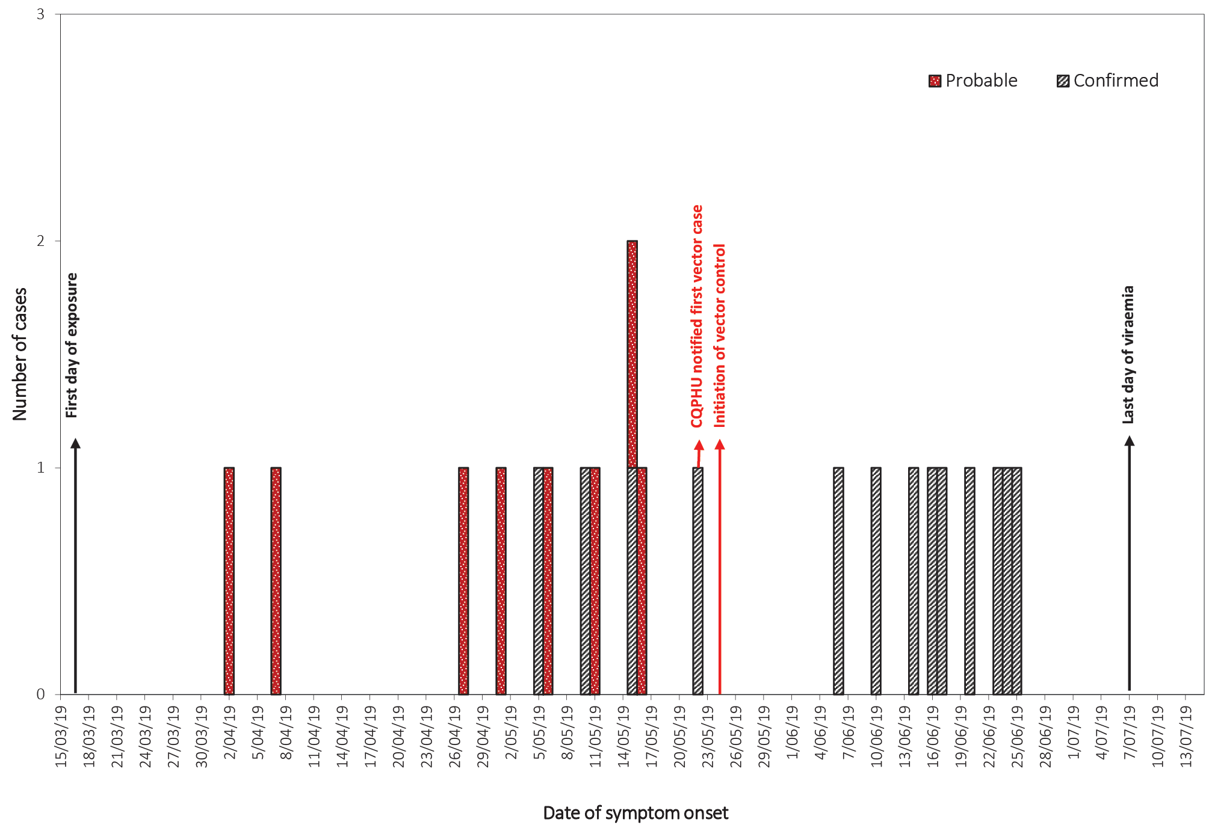
The age of DENV-2 cases ranged from 11 to 71 years (median 37 years); 11 (52%) were female. Common clinical symptoms among cases included lethargy (100%), fever (95%), headache (95%) and myalgia (95%). Of the cases, 14 (67%) sought medical review for their symptoms and two (10%) needed hospital admission, despite the absence of haemorrhagic fever. Table 1 describes the socio-demographic and clinical characteristics of the DENV-2 cases.

Table 1: Demographic and clinical characteristics of dengue cases in Rockhampton, 2019
Characteristic | Frequency (n = 21) | Percentage (%)
Age group
Median age (range), years | 37 (11–71)
< 20 years | 4 | 19
≥ 20 years | 17 | 81
Sex
Female | 11 | 52
Clinical Details
Lethargy | 21 | 100
Fever | 20 | 95
Headache | 20 | 95
Myalgia | 20 | 95
Aches and pains | 19 | 90
Rash | 15 | 71
Nausea/vomiting | 15 | 71
Itchiness | 11 | 52
Abnormal taste | 10 | 48
Diarrhoea | 9 | 43
Abnormal bruising/bleeding | 2 | 10
History of Dengue | 0 | 0
Outcome
Hospitalisation | 2 | 10
GP/ED visit | 14 | 67
GP/ED visit and tested for dengue | 8/14 | 57
GP/ED visit and NOT tested for dengue | 6/14 | 43
Severe cases (e.g. Haemorrhagic fever) | 0 | 0

Outbreak management
The Environmental Health (EH) team of CQPHU conducted indoor residual spraying, focusing environmental inspections on private properties and businesses within the 200 metres radius of laboratory confirmed or suspected cases. The EH team visited 1,158 households. Out of 1,107 (95.6%) completely inspected premises, the team sprayed 884 properties (79.8%) and detected 205 (18.5%) households having presence of mosquitoes. More than 50% of the mosquitoes-present premises (105/205) and 9.5% of all premises inspected (105/1,158 premises) were infested with larvae and/or pupae of Ae. aegypti (i.e. House Index of 9.5%). Particular attention was provided to regions that might facilitate increased dengue transmission throughout the community (e.g. schools, nursing homes, aged care facilities) to survey the presence of artificial and natural containers which could act as breeding areas for the mosquitoes. Artificial containers included but were not limited to plastic pots, buckets, tyres and bird baths. Palm fronds and bromeliads were among the natural containers found.
Natural and artificial containers were either disposed of or emptied and treated with pellets of (s)-methoprene, an insect growth regulator. Indoor and outdoor spraying with a residual insecticide (Temprid75 containing imidacloprid and beta-cyfluthrin) was undertaken, with the householder’s permission. In addition to the house-to-house survey, vector control activities were implemented with a novel ‘lure and kill’ approach of 200 m radius of all probable and confirmed cases by the EH team. This ‘lure and kill’ approach deployed lethal ovitraps to attract ovipositing female mosquitoes; concurrent administration of larvicidal agents to harbouring sites accelerated the vector control strategies.
Public health media campaigns such as Facebook, free-to-air television, local radio and print media highlighted the current outbreak and prevention strategies. Public health messaging included: vigilance in eliminating mosquito breeding sites in and around homes (e.g. pot plant bases and bird baths); the use of mosquito repellent/long-sleeved clothing; and the clinical symptoms of dengue, to encourage early clinical presentation. The outbreak commenced in autumn (i.e. April) and lasted until midwinter (i.e. June). However, we could not identify any pattern in daily temperature (high and low) or rainfall contributing to the outbreak (see Appendix A, Figure A.1).

Nucleotide sequencing and phylogenetic analyses
Nucleotide sequencing and phylogenetic analyses were performed on the DENV-2 Rock 2019 isolate recovered from the first reported case, and complete DENV-2 E genes were amplified from an additional five viraemic patients. A complete DENV-2 genome sequence (GenBank accession number MN982899) was derived from DENV-2 Rock 2019 and was used in phylogenetic analysis comparing 1,431 DENV-2 complete coding regions (Figure 2).

Figure 2: DENV-2 phylogeny of complete open reading frame nucleotide sequencesª
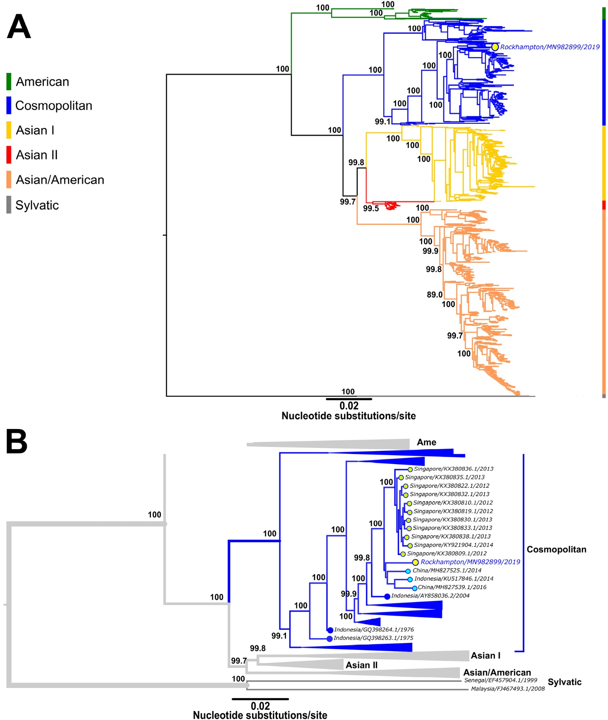
a Figure 2A shows the midpoint rooted, approximately maximum-likelihood phylogenetic tree estimated from 1,431 DENV-2 complete coding region nucleotide sequences. The tree was constructed using FastTree version 2.1.11 software and the general time-reversible (GTR) nucleotide substitution model with the default setting of 20 for rate categories of sites.²⁰ Percentage Shimodaira-Hasegawa-like local support values are shown for key nodes. Multiple sequence alignments were performed using the Multiple Alignment using Fast Fourier Transform (MAFFT) program, version 7.450 and Geneious software, version 10.2.6. The major DENV-2 genotypes (American, Cosmopolitan; Asian I; Asian II; Asian/American and Sylvatic) are shown and the DENV-2 Rockhampton 2019 isolate sequence (GenBank accession number MN982899) is highlighted. Figure 2B shows a summarised version of the phylogenetic tree presented in (A) with major clades collapsed in order to show DENV-2 strains most closely related to DENV-2 Rock 2019 at higher resolution.

The DENV-2 Rock 2019 strain was grouped in the Cosmopolitan genotype and was most closely related to other DENV-2 strains from southeast Asia, including recent strains circulating in China, Indonesia and Singapore. DENV-2 E gene sequences were also obtained from an additional five Rockhampton patients; sequences from two patients were submitted to GenBank, with accession numbers MN982900 and MN982901. The DENV-2 E gene phylogenetics (Figure 3) demonstrated that the sequences of these five additional Rockhampton patients were all clustered together with the sequence from the patient yielding the DENV-2 Rock 2019 isolate, sharing 99.9% nucleotide identity. This finding further indicated that the Rockhampton 2019 outbreak was most likely caused by a single strain of DENV-2. The Rockhampton DENV-2 cluster was most closely related to, and shared 99.8% nucleotide identity each, with two recent DENV-2 strains from Bali 2016 (GenBank accession number MH173164) and Malaysia 2014 (GenBank accession number KJ806811). By comparison, the Rockhampton DENV-2 cluster only shared 98.8% nucleotide identity with the DENV-2 E gene sequence (GenBank accession number MN982889) obtained from the viraemic patient who travelled from Bali to Queensland at the onset of the Rockhampton outbreak, and therefore this patient was not a likely outbreak source.

Figure 3: DENV-2 phylogeny of complete E gene nucleotide sequencesª
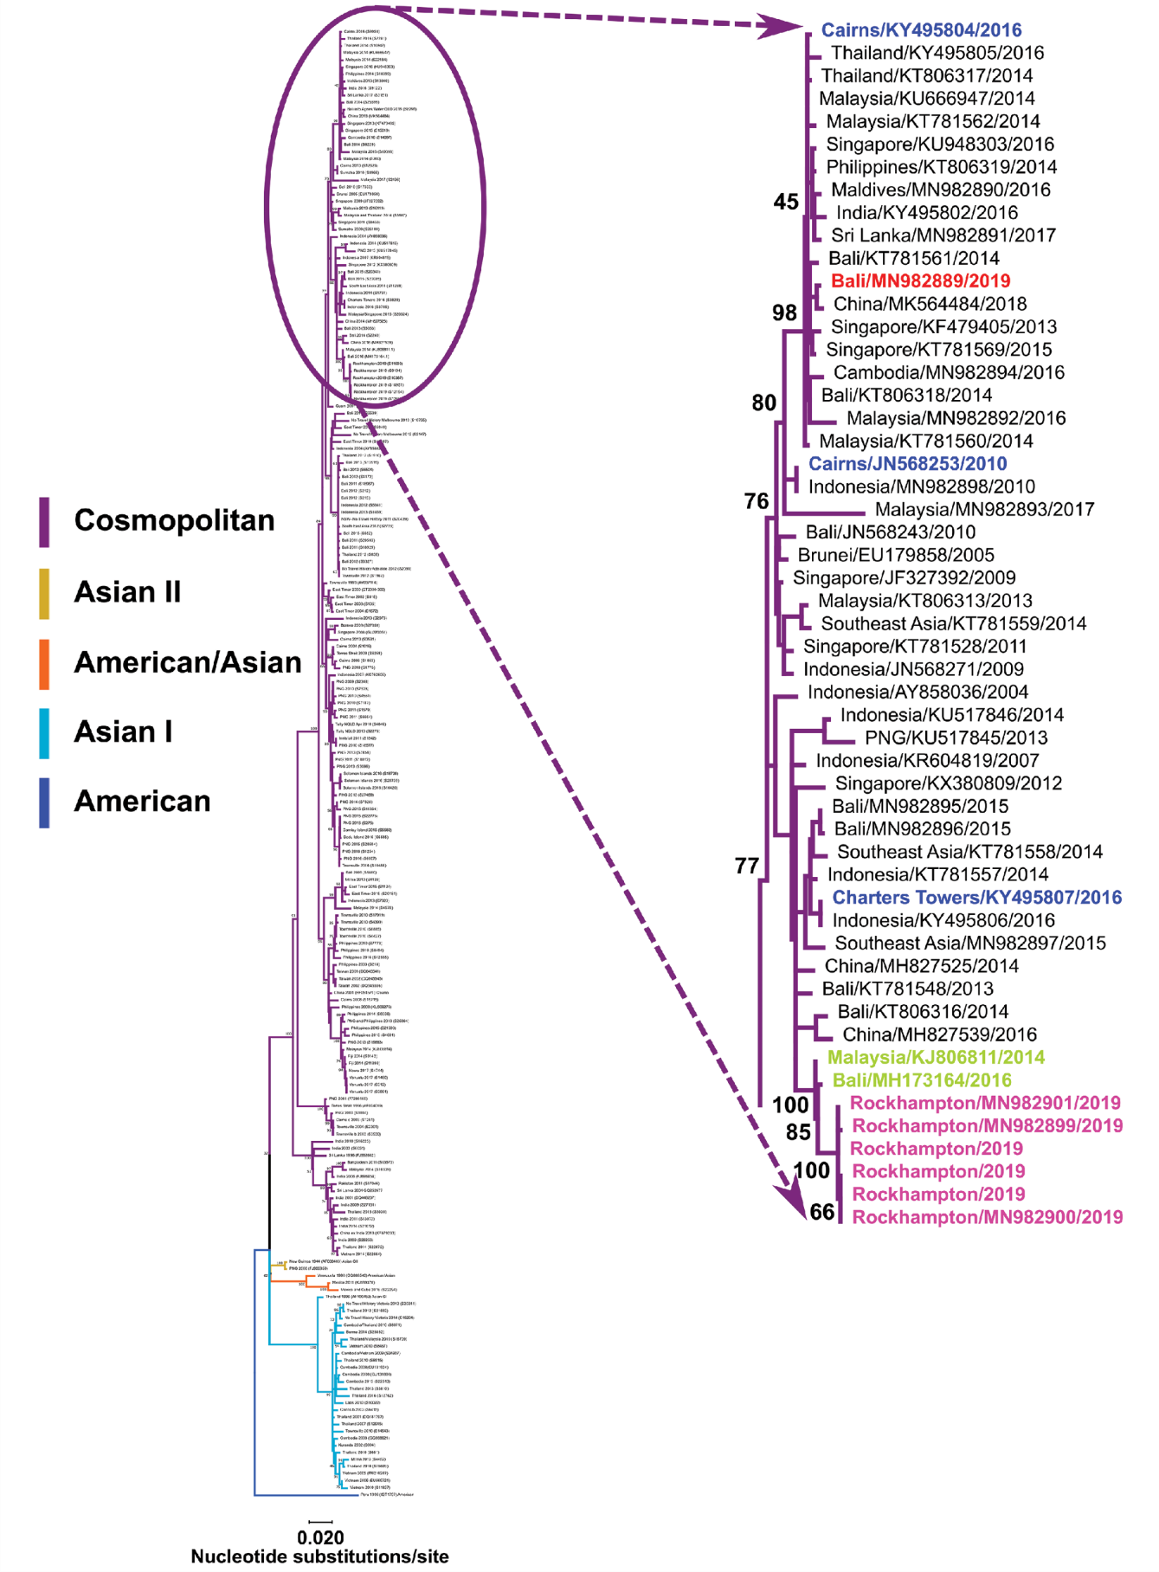
a Maximum-likelihood phylogenetic tree inferred from 208 DENV-2 envelope (E) gene nucleotide sequences (1,485 nucleotides). The tree was constructed using MEGA 7.0 software21 and the GTR+Γ4+I substitution model with bootstrap support (1,000 replications). The inset derived from the DENV-2 Cosmpolitan genotype shows clustering of DENV-2 Rock 2019 sequences (pink) from six patients, including the patient from which DENV-2 was isolated (GenBank accession number MN982899) at higher resolution. DENV-2 strains from other Queensland, Australia local outbreaks are shown in blue and the DENV-2 Bali 2019 sequence (GenBank accession number MN982889) obtained from a viraemic patient who also travelled to Queensland at the onset of the Rockhampton DENV-2 outbreak is shown in red. Percentage bootstrap support values are shown for key nodes.

Discussion
This is the first reported outbreak involving local dengue transmission in Rockhampton CQ, Australia in decades, and the first detected case was a Rockhampton resident with no prior history of overseas travel. Further, this is the first recorded dengue transmission event in CQ specifically implicating DENV-2. Genotyping analysis of Rockhampton DENV-2 sequences suggested the outbreak was caused by a single DENV-2 strain, most closely related to DENV-2 strains from Southeast Asia. Many parts of Southeast Asia, including Indonesia, are dengue endemic zones and their close proximity to Australia inherently poses risks for the spread of dengue within our region. Popular Southeast Asian tourist destinations, such as Bali, have been shown to be major sources of DENVs imported into Australia, and occasionally have facilitated outbreaks in Queensland.^{13,14} With the high annual influx of travellers from Southeast Asia into Queensland, it is feasible that the Rockhampton DENV-2 outbreak may have originated from a traveller from that region.
There are many factors that can lead to a delay in identifying a current outbreak. Dengue manifests over a wide range of clinical symptoms and severity, from clinically asymptomatic cases to severe symptoms such as haemorrhagic fever. Because of an extremely low pre-test probability of dengue, local health professionals do not routinely test for dengue. For example, of the 14 cases who visited GP/hospitals, about 43% (n = 6) of those were not tested for dengue. This is consistent with other outbreaks, such as the large dengue outbreaks of 2003–2004 and 2008–2009 in FNQ which were characterized by delays in notification and in the subsequent mosquito control and public health intervention. Whilst incomplete testing and the absence of an identified index case contributed to a brief lag in notification, effective public health and mosquito control measures were implemented urgently to mitigate the burden of disease.
There were 63 cases of dengue reported in CQ between 2010 and 2020, 42 of which were imported cases, mainly from Southeast Asia (30/63; 47.6%) with the most common country being Indonesia (16/30; 53.3%). Between 1 July 2012 and 30 June 2017, there were 1,360 cases of dengue imported to Queensland by travellers predominantly from Southeast Asia (863, 63.5%), again, with over half coming from Indonesia (482, 55.9%).²²
Similarly, nucleotide sequencing and phylogenetic analysis of Rockhampton DENV-2 E gene sequences indicated they were most closely related to, and shared 99.8% nucleotide identity respectively, with recent Bali 2016 and Malaysian 2014 DENV-2 strains. With the presence of Ae. aegypti in CQ and the known increased number of returning overseas travellers and visitors from dengue endemic countries, considering Rockhampton as a dengue receptive area is important. Enhanced surveillance to detect viraemic patients early enables prompt public health and mosquito control intervention.
Ongoing mosquito control activities, particularly around the household of identified positive cases is an important control measure that requires swift implementation. Interestingly, the bromeliad plant family is a known mosquito breeding reservoir due to the still and stagnant water found in the central well and outer leaf cavities of the plant.²³ These natural water containers were found at many of the properties inspected during the outbreak. Consideration could also be given to the introduction of Wolbachia-infected Ae. aegypti mosquitoes, as these have shown a reduction in transmission in laboratory studies and have been successfully introduced in Northern Australia, curbing dengue transmission.²⁴

Conclusion
The 2019 dengue outbreak in CQ is the first reported outbreak for the region specifically implicating DENV-2. With increased global travel and widening distribution of suitable DENV mosquitoes like Ae. aegypti and Ae. albopictus, all regions which harbour these mosquito species are vulnerable to dengue outbreaks. Further, this vulnerability presents additional concern and public health risks in areas such as Queensland, where largely immunologically naïve populations exist. Consequently, effective and ongoing mosquito avoidance and vector surveillance strategies, coupled with timely public health control measures, are vitally important for preventing and limiting outbreaks. In the currently-reported outbreak, both the rapid localisation, treatment and elimination of mosquito breeding sources, and the increased public awareness of related disease risks that was disseminated through media platforms, largely contributed to effective management of the outbreak, confining case numbers and limiting the further spread of dengue within Queensland.

Acknowledgements
We would like to thank staff from the Queensland Health Communicable Disease Branch and other experienced Queensland Public Health Units, scientists from the Queensland Health Forensic and Scientific Services Laboratory, medical entomologists, Queensland Health media and the Rockhampton Regional Council together who formed our Incident Management Team.

Author details
Jacina Walker^{1,2*}
Alyssa Pyke³
Paul Florian¹
Fred Moore³
Nicolas Smoll¹
Odewumi Adegbija¹
Arifuzzaman Khan¹
Rashidul Hasan⁴
Heidi Carroll⁵
Rachael Rodney Harris²
Gulam Kandaker^{1,4}
- Central Queensland Public Health Unit, Central Queensland Hospital and Health Service, Rockhampton, Queensland, Australia
- National Centre for Epidemiology and Population Health, Research School of Population Health, Australian National University, Canberra, ACT, Australia
- Public Health Virology Laboratory, Forensic and Scientific Services, Coopers Plains, Queensland, Australia
- Central Queensland University, Rockhampton, Queensland, Australia
- Communicable Disease Branch, Queensland Health, Brisbane, Queensland, Australia

Corresponding author
Jacina Walker
Address: Central Queensland Public Health Unit, Central Queensland Hospital and Health Service, Community Health Building, 82-86 Bolsover Street, Rockhampton Qld 4700, Australia
Phone: +617-4920 6989
Fax: +617-4920 6865
Email: jacina.walker@health.qld.gov.au

References
- Bhatt S, Gething PW, Brady OJ, Messina JP, Farlow AW, Moyes CL et al. The global distribution and burden of dengue. Nature. 2013;496(7446):504–7.
- World Health Organization (WHO). Dengue haemorrhagic fever: diagnosis, treatment, prevention and control. 2nd edition. Geneva: WHO; 1997. Available from: https://apps.who.int/iris/handle/10665/41988.
- Lambrechts L, Paaijmans KP, Fansiri T, Carrington LB, Kramer LD, Thomas MB et al. Impact of daily temperature fluctuations on dengue virus transmission by Aedes aegypti. Proc Natl Acad Sci U S A. 2011;108(18):7460–5.
- Gubler DJ, Reiter P, Ebi KL, Yap W, Nasci R, Patz JA. Climate variability and change in the United States: potential impacts on vector- and rodent-borne diseases. Environ Health Perspect. 2001;109(Suppl 2):223–33.
- Halstead SB. Dengue virus–mosquito interactions. Annu Rev Entomol. 2008;53:273–91.
- Castaño-Osorio JC, Giraldo-Garcia AM, Giraldo MI. Current status of vaccines against dengue virus. In Falcón-Lezama JA, Betancourt-Cravioto M, Tapia-Conyer R, eds. Dengue Fever - a Resilient Threat in the Face of Innovation. London: InTechOpen; 2018. doi: https://doi.org/10.5772/intechopen.80820.
- Beebe NW, Cooper RD, Mottram P, Sweeney AW. Australia’s dengue risk driven by human adaptation to climate change. PLoS Negl Trop Dis. 2009;3(5):e429.
- Moore PR, Johnson PH, Smith GA, Ritchie SA, Van Den Hurk AF. Infection and dissemination of dengue virus type 2 in Aedes aegypti, Aedes albopictus, and Aedes scutellaris from the Torres Strait, Australia. J Am Mosq Control Assoc. 2007;23(4):383–8.
- Muzari MO, Devine G, Davis J, Crunkhorn B, van den Hurk A, Whelan P et al. Holding back the tiger: Successful control program protects Australia from Aedes albopictus expansion. PLoS Negl Trop Dis. 2017;11(2). doi: https://doi.org/10.1371/journal.pntd.0005286.
- WHO. Dengue and severe dengue. [Internet.] Geneva: WHO; 23 June 2020. Available from: https://www.who.int/news-room/fact-sheets/detail/dengue-and-severe-dengue.
- Pyke AT. The origins of dengue outbreaks in northern Queensland, Australia, 1990–2017. Microbiol Aust. 2018;39(2):93–5.
- Moore PR, van den Hurk AF, Mackenzie JS, Pyke AT. Dengue viruses in Papua New Guinea: evidence of endemicity and phylogenetic variation, including the evolution of new genetic lineages. Emerg Microbes Infect. 2017;6(12):e114.
- Pyke AT, Gunn W, Taylor C, Mackay IM, McMahon J, Jelley L et al. On the home front: specialised reference testing for dengue in the Australasian region. Trop Med Infect Dis. 2018;3(3):75.
- Warrilow D, Northill JA, Pyke AT. Sources of dengue viruses imported into Queensland, Australia, 2002–2010. Emerg Infect Dis. 2012;18(11):1850–7.
- Lumley GF, Taylor FH. Dengue. Part I. Medical. Part II. Entomological. (Service publication no. 3: University of Sydney School of Public Health and Tropical Medicine.) Glebe: Austen Med. Pub. Co.; 1943.
- Hare FE. The 1897 epidemic of dengue in North Queensland. Aust Med Gaz. 1898;17:98–107.
- Doherty RL. Clinical and epidemiological observations on dengue fever in Queensland, 1954–1955. Med J Aust. 1957;44(22):753–6.
- Australian Bureau of Statistics. Census of Population and Housing: Reflecting Australia - Stories from the Census, 2016. [Website.] Canberra: Australian Bureau of Statistics; 2017. Available from: https://www.abs.gov.au/ausstats/abs@.nsf/mf/2071.0.
- Liu C, Begg K, Johansen C, Whelan P, Kurucz N, Melville L. Communicable Diseases Network Australia National Arbovirus and Malaria Advisory Committee annual report, 2006–07. Commun Dis Intell Q Rep. 2008;32(1):31–47.
- Price MN, Dehal PS, Arkin AP. FastTree 2 – approximately maximum-likelihood trees for large alignments. PLoS One. 2010;5(3):e9490.
- Kumar S, Stecher G, Tamura K. MEGA7: Molecular Evolutionary Genetics Analysis version 7.0 for bigger datasets. Mol Biol Evol. 2016;33(7):1870–4.
- Queensland Health (QH) Communicable Diseases Branch. Mosquito-borne diseases in Queensland, 1 July 2012 – 30 June 2017. Brisbane: Queensland Government, QH; May 2018. Available from: https://www.health.qld.gov.au/__data/assets/pdf_file/0020/712253/mbd-report-annual.pdf.
- Webb C, Doggett S, Russell R. A guide to mosquitoes of Australia. Melbourne: CSIRO Publishing; 2016.
- Ryan PA, Turley AP, Wilson G, Hurst TP, Retzi K, Brown-Kenyon J et al. Establishment of w Mel Wolbachia in Aedes aegypti mosquitoes and reduction of local dengue transmission in Cairns and surrounding locations in northern Queensland, Australia. Gates Open Res. 2020;3:1547. doi: https://doi.org/10.12688/gatesopenres.13061.2.

Appendix A
Figure A.1: Daily temperature (low and high) and rainfall in Rockhampton during the outbreak period
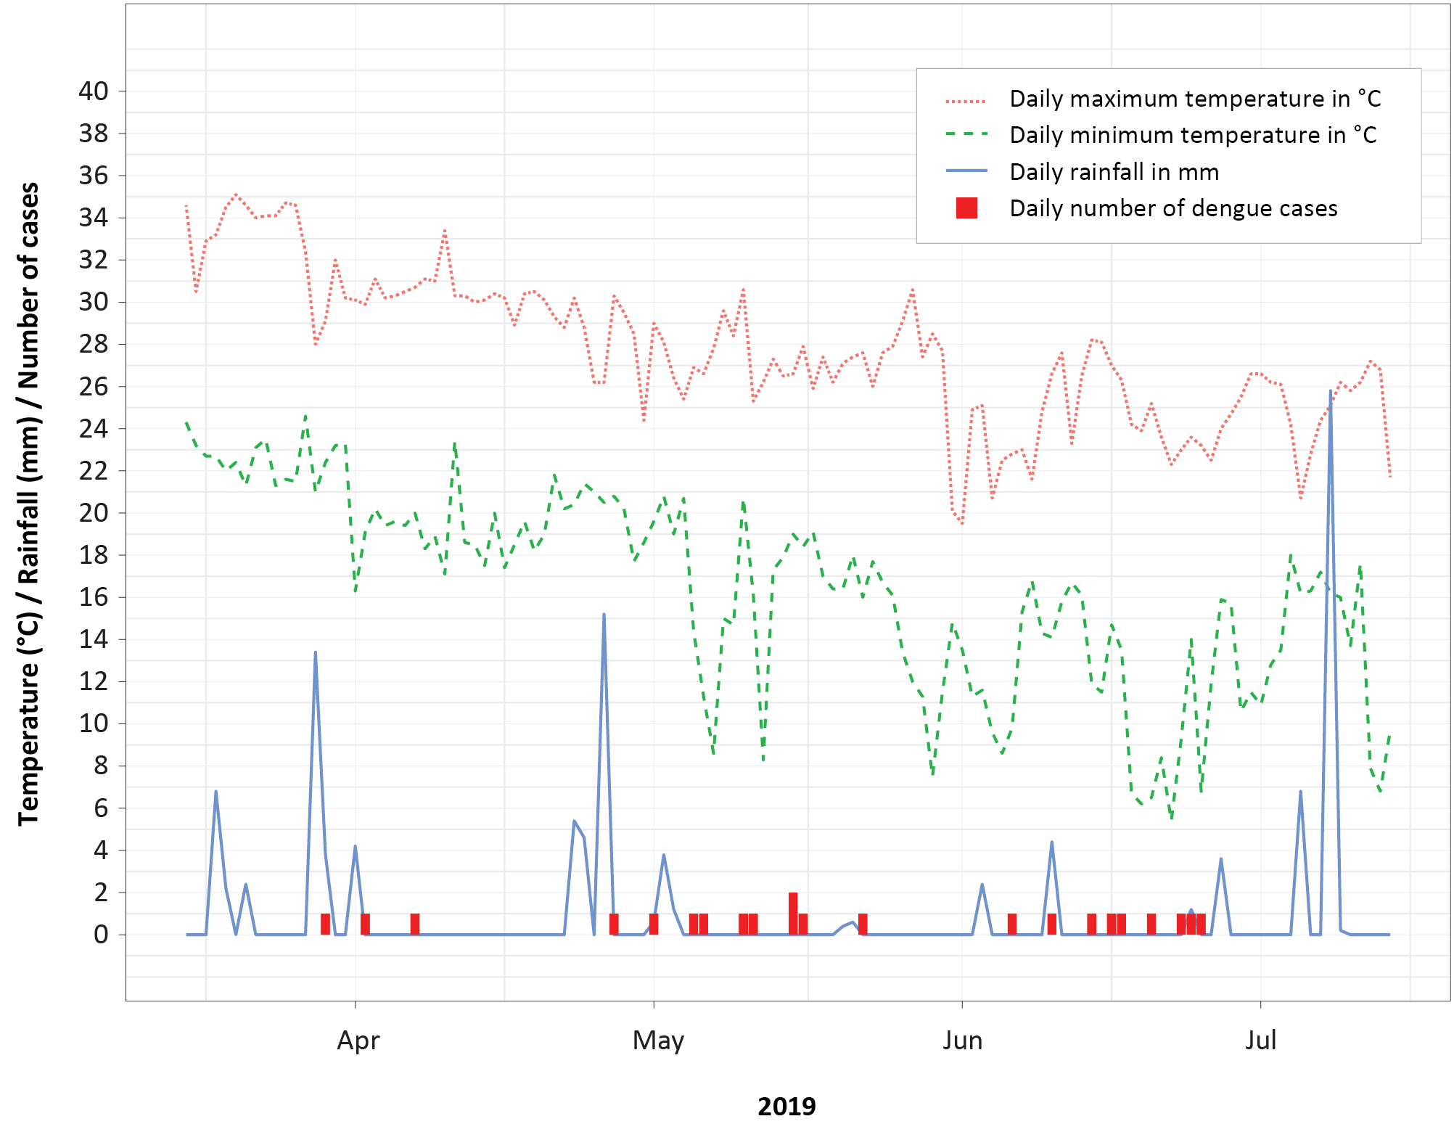

Communicable Diseases Intelligence
ISSN: 2209-6051 Online

Communicable Diseases Intelligence (CDI) is a peer-reviewed scientific journal published by the Office of Health Protection and Response, Department of Health. The journal aims to disseminate information on the epidemiology, surveillance, prevention and control of communicable diseases of relevance to Australia.

Editor: Jennie Hood
Deputy Editor: Simon Petrie
Design and Production: Kasra Yousefi
Editorial Advisory Board: David Durrheim, Mark Ferson, John Kaldor, Martyn Kirk and Linda Selvey

Website: http://www.health.gov.au/cdi

Contacts
CDI is produced by Environmental Health and Health Protection Policy Branch, Office of Health Protection and Response, Australian Government Department of Health, GPO Box 9848, (MDP 6) CANBERRA ACT 2601

Email: cdi.editor@health.gov.au

Submit an Article
You are invited to submit your next communicable disease related article to the Communicable Diseases Intelligence (CDI) for consideration. More information regarding CDI can be found at: http://health.gov.au/cdi.
Further enquiries should be directed to: cdi.editor@health.gov.au.

This journal is indexed by Index Medicus and Medline.

Creative Commons Licence - Attribution-NonCommercial-NoDerivatives CC BY-NC-ND
© 2021 Commonwealth of Australia as represented by the Department of Health
This publication is licensed under a Creative Commons Attribution-NonCommercial-NoDerivatives 4.0 International Licence from https://creativecommons.org/licenses/by-nc-nd/4.0/legalcode (Licence). You must read and understand the Licence before using any material from this publication.

Restrictions
The Licence does not cover, and there is no permission given for, use of any of the following material found in this publication (if any):
- the Commonwealth Coat of Arms (by way of information, the terms under which the Coat of Arms may be used can be found at www.itsanhonour.gov.au);
- any logos (including the Department of Health’s logo) and trademarks;
- any photographs and images;
- any signatures; and
- any material belonging to third parties.

Disclaimer
Opinions expressed in Communicable Diseases Intelligence are those of the authors and not necessarily those of the Australian Government Department of Health or the Communicable Diseases Network Australia. Data may be subject to revision.

Enquiries
Enquiries regarding any other use of this publication should be addressed to the Communication Branch, Department of Health, GPO Box 9848, Canberra ACT 2601, or via e-mail to: copyright@health.gov.au

Communicable Diseases Network Australia
Communicable Diseases Intelligence contributes to the work of the Communicable Diseases Network Australia.
http://www.health.gov.au/cdna

