SARS-CoV-2 RT-PCR test results across symptomatic COVID-19 cases in Auckland, New Zealand, February–June 2020
Kevin Howe, Michael Hale, Gary Edwin Reynolds

Abstract
During the first wave of COVID-19 transmission in New Zealand, a review of RT-PCR testing in all symptomatic cases reported in the Auckland Region found 74% of test results to have been positive. Detection rate was superior for nasopharyngeal swabs than for oropharyngeal samples, and highest one week after symptom onset. Certain symptom presentations may associate with these cases returning negative results, with dyspnoea reported by a greater proportion of cases who tested negative.
Keywords: coronavirus disease 2019; COVID-19; severe acute respiratory syndrome-related coronavirus-2;
SARS-CoV-2

Introduction
Since its emergence, coronavirus disease 2019 (COVID-19) rapidly became a global pandemic.¹ In New Zealand, where an elimination approach was adopted, the number of community cases in its first wave totalled 1,579. This was achieved through an elimination strategy very similar to the ‘aggressive suppression’ strategy used in Australia,² using a combination of lockdowns, contact tracing, and widespread testing to remove community transmission. In particular, the extent of testing is evidenced in positivity rates below 1% in both nations.^{3,4}
The predominant modality of testing for severe acute respiratory syndrome-related coronavirus-2 (SARS-CoV-2) is detection of viral RNA from upper-respiratory swabs using reverse transcription polymerase chain reaction (RT-PCR).⁵ However, the reliability of such tests is not well characterised in the literature,⁶ which has also been largely focused on hospitalised patients despite a wide spectrum of presentation ranging from asymptomatic infection⁷ to severe disease.⁸

Methods
To evaluate the local RT-PCR test sensitivity, we reviewed test results and routine clinical data (including demographics, symptoms, and outcomes) from all confirmed and probable cases of COVID-19 within the metropolitan area of Auckland, New Zealand reported in its first wave, between notification of the first case on 26 February 2020 and recovery of the last case of the initial outbreak on 7 June 2020. Tests performed on confirmed cases, while symptomatic, were included in this study; probable cases who underwent testing were also included, with individual tests from probable cases included if they met criteria of:
- Close contact of identified confirmed case(s) within the 14 days preceding symptom onset; and
- Exhibition of at least two of the following symptoms over course of illness: cough; sore throat; dyspnoea; coryza; anosmia; or fever.
Analysis was performed to compare characteristics between cases with and without negative test results, in order to look for contributing factors for cases testing falsely negative. Data from individual tests were also analysed by site and by timing in relation to symptom onset. This study received institutional ethics approval from the Auckland District Health Board Research Office as a public health investigation.

Results
In total, 528 tests from 472 cases were included, comprising 427 tests from 388 confirmed cases and 101 tests from 84 probable cases. Test samples were made up of nasopharyngeal (NP) and oropharyngeal (OP) swabs. Most were taken in community/primary-care settings (n = 502), with a small number (n = 26) from hospitals.
Of the included cases, the median age was 37 years; 269/472 cases (57%) were female. Fewer than 10% of cases had clinical outcomes of hospitalisation, intensive care unit (ICU) admission, and/or death. Cough was the most common symptom, reported by 342 cases (73%). Between cases with negative result and cases without negative result, no differences in demographic features or clinical outcomes were statistically significant, although some significant differences were observed in symptom presentation. Fever and anosmia were reported by a significantly higher proportion of cases without negative result. Dyspnoea was significantly higher in cases with negative result (Table 1).
Table 1: Demographic & clinical characteristics of included cases, Auckland, New Zealand, February–June 2020
 | All casesª  (n = 472) | Cases with  negative resultª  (n = 117) | Cases without negative resultª  (n = 355) | p value^{b}
Median age (years) | 37 | 34 | 39
Age range | 0.8–99 | 0.8–89 | 10–99 | 0.091
Women | 269 (57) | 65 (56) | 204 (57) | 0.747
Clinical outcomes
- Hospitalisation | 38 (8.1) | 15 (13) | 23 (6.5) | 0.048
- ICU admission | 3 (0.6) | 2 (1.7) | 1 (0.3) | 0.153
- Death | 4 (0.8) | 0 (0) | 4 (1.1) | 0.576
Symptoms
- Cough | 342 (73) | 91 (78) | 251 (71) | 0.153
- Sore throat | 230 (49) | 71 (61) | 159 (45) | 0.004
- Fever | 220 (47) | 38 (32) | 182 (51) | < 0.001
- Coryza | 187 (40) | 56 (48) | 131 (37) | 0.039
- Anosmia | 89 (19) | 11 (9.4) | 78 (22) | 0.0025
- Dyspnoea | 32 (6.8) | 23 (20) | 9 (2.5) | < 0.0001
a Percentage shown in parentheses.
b Statistically significant p-values in bold. Testing for statistical significance performed using Fisher’s exact tests for categorical data and Student’s t-test for case ages. Correction for multiple comparisons was applied using the Benjamini-Hochberg procedure with false discovery rate set at 0.01.
Across all cases, 74% of tests returned positive results (Table 2). Sub-group analysis of only tests from confirmed cases found 91% of tests positive, with all negative tests in this group preceding at least one positive result. Nasopharyngeal swabs showed 77% of tests positive, compared with 48% for oropharyngeal swabs, an absolute difference of 29%.
Most tests were performed in the first few days after symptom onset: 278 tests (52% of total) were taken 0–4 days post onset. Days 1 and 2 together accounted for 25% of total tests done, and the number of tests performed on subsequent days gradually declined. Proportion of test results positive increased gradually from day of symptom onset (56%; 95% CI: 39–72%) to 7–8 days after (89%; 95% CI: 80–98%), then remained largely unchanged before dropping sharply on days 13–14 (44%; 95% CI: 19–68%) (Figure 1).
Figure 1: Proportion of tests positive and number of tests performed in symptomatic COVID-19 patients,ª Auckland, New Zealand, February–June 2020
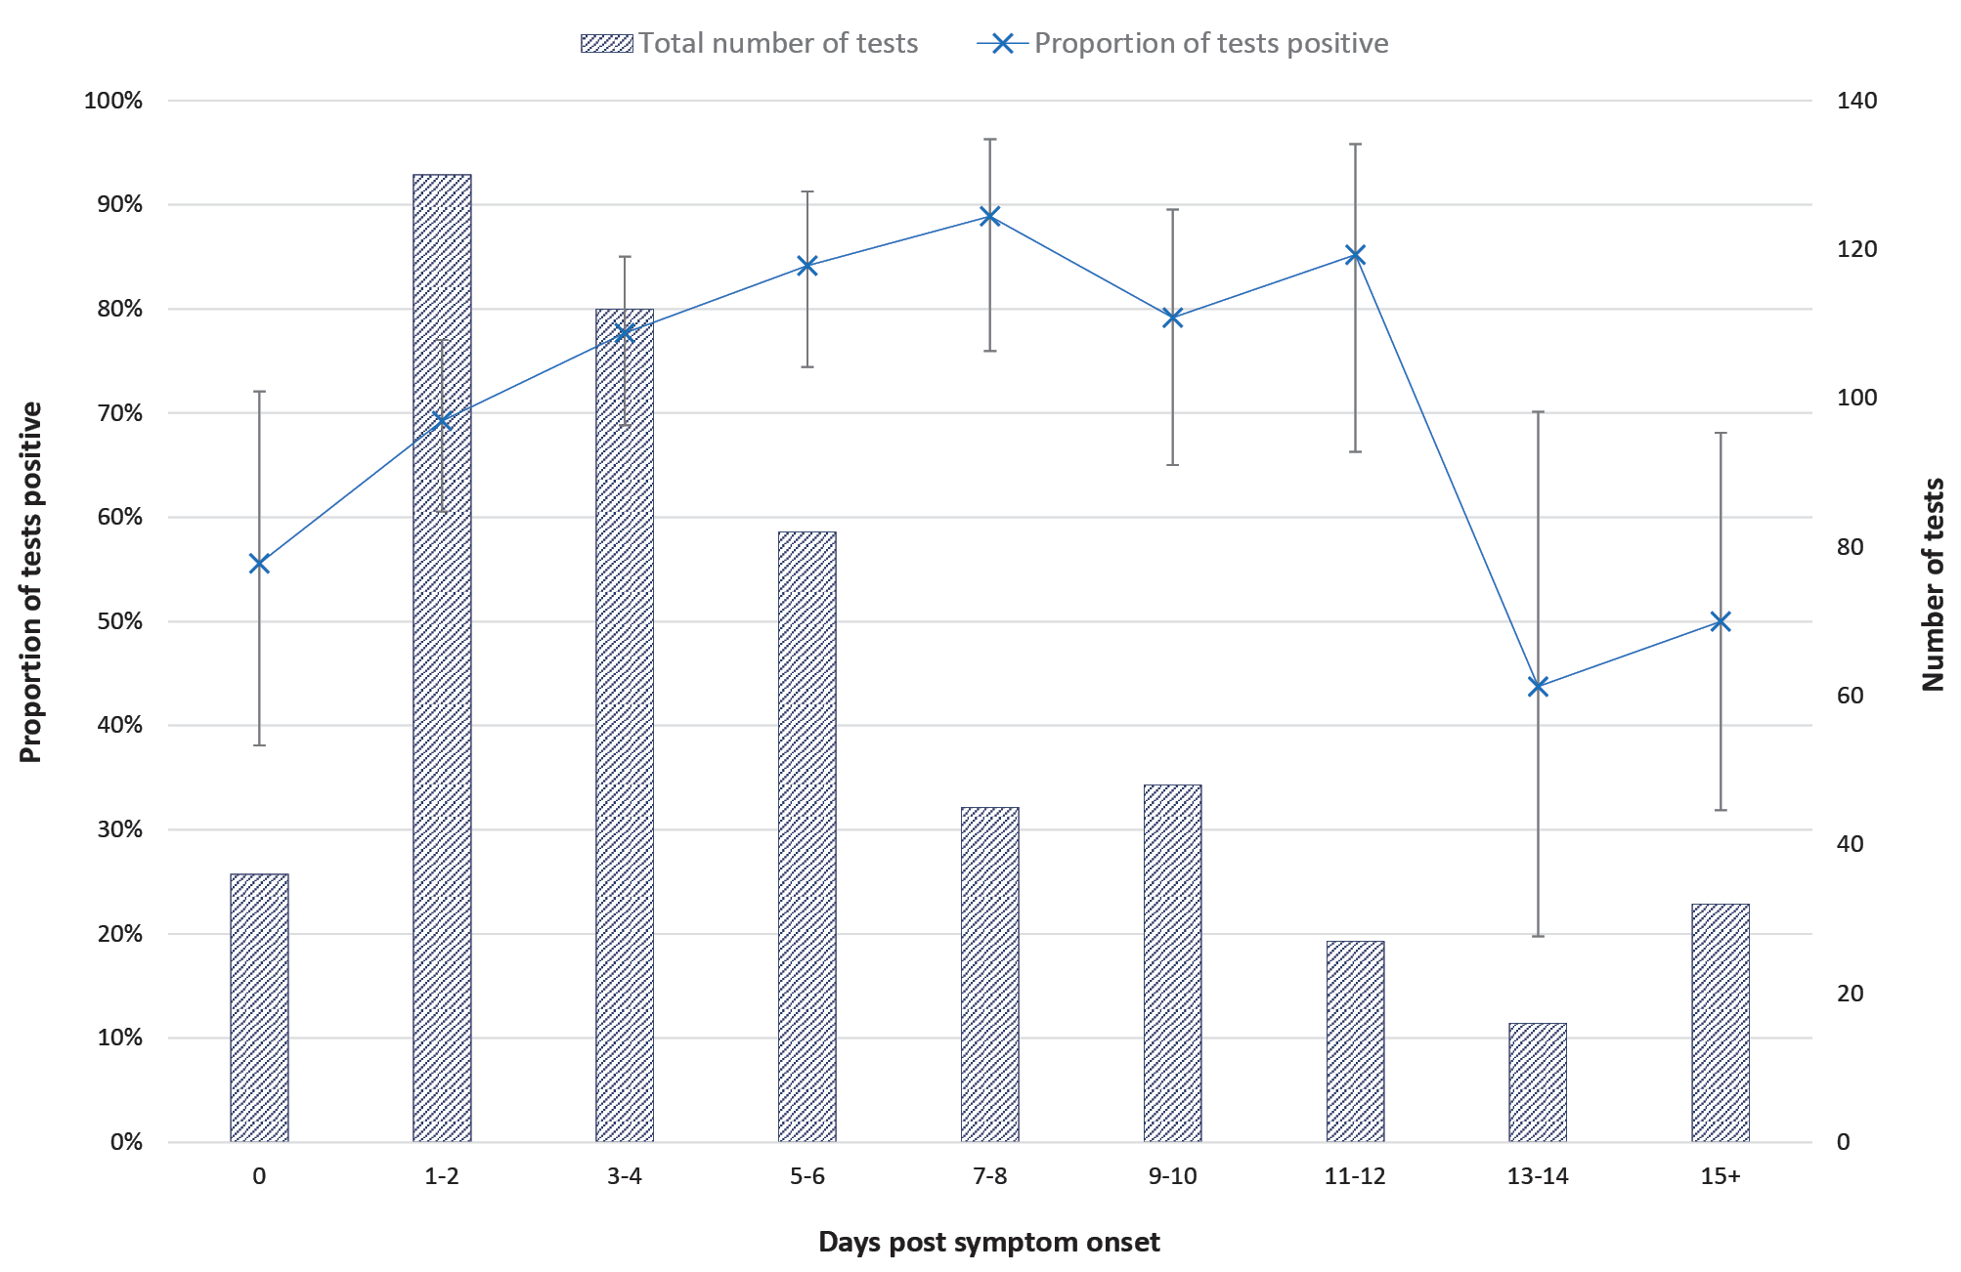
a 95% confidence intervals generated using the Clopper-Pearson method.

Table 2: Results for all included SARS-CoV-2 RT-PCR tests, Auckland, New Zealand,
26 February – 7 June 2020
 |  | Positive test results
 | Number of tests | n | % | 95% CIª
All tests | 528 | 390 | 74 | 70–78
Confirmed cases only | 427 | 390 | 91 | 88–94
Swab site
- Nasopharynx | 425 | 329 | 77 | 73–81
- Oropharynx | 33 | 16 | 48 | 31–66
- Unknown | 70 | 45 | 64 | 52–75
a 95% confidence intervals generated using the Clopper-Pearson method.

Discussion
Our results are consistent with previous findings from hospitalised patients, with initial detection rates for swabs ranging from 32% to 80% depending on sample type and timing of tests.^{9,10} Swab site also impacted detection rate, with nasopharyngeal swabs superior to oropharyngeal samples. This is supported by prior studies finding both higher detection rates⁹ and viral loads¹¹ for nasal swabs than for throat swabs, indicating NP swabs should be preferred for RT-PCR testing.
Our data also indicated changes in detection rate relative to test timing post symptom onset. Although a decrease is expected in the infection’s later stages, we found the proportion of tests positive to peak several days later than was observed in a previous study,¹⁰ while studies on viral loads indicate these to be highest either at day of onset¹² or immediately following.^{11,13} This difference may be due to differences in patient characteristics: our study was comprised predominantly of mild cases, while prior studies have largely consisted of hospitalised patients likely exhibiting moderate to severe disease.
Certain factors in cases’ clinical presentations may also be associated with greater likelihood of testing negative. While our results did not show false-negative results to be associated with greater or lesser symptomology overall, they do suggest that patterns of symptom presentation may be associated with testing falsely negative.
Despite low seasonal influenza activity during the study period,¹⁴ a major limitation of this report is lack of certainty in the diagnosis of COVID-19 for probable cases included in its analysis. Beyond potentially biasing the proportion of results positive in this study, this may also be a confounding factor in analysis of detection rate relative to symptom onset and the characteristics of patients receiving false-negative results. Despite implementing strict inclusion criteria to mitigate this, some misclassification of cases likely remains. However, addressing this by omitting probable cases would almost certainly result in an over-estimation of sensitivity, which could have adverse consequences for public health management of disease transmission if relied upon.
While changes since the early days of the pandemic—such as improved knowledge, test availability, and experience around swab technique—are likely to have resulted in increases in real-world detection rates, our study’s findings nonetheless bring into question the usefulness of individual negative RT-PCR results for ruling out infection in symptomatic patients. Further research is needed to better characterise changes in detection rate and viral load to determine optimal timing for initial testing or re-testing, as well as correlation with serological/antibody changes. Potential associations between patient factors and testing falsely negative also warrant further study.

Acknowledgements
We would like to thank Dr Emma Church for her advice and comment on this study.

Author details
Dr Kevin Howe, MBChB^{1, 2}
Dr Michael Hale, MBChB, MPH²
Dr Gary Edwin Reynolds MBChB, PhD²
- The University of Auckland, School of Medicine, Auckland, New Zealand
- Auckland Regional Public Health Service, Auckland, New Zealand

Corresponding author
Dr Gary Edwin Reynolds
Auckland Regional Public Health Service, Level 2, Building 15, Cornwall Complex, 40 Claude Road, Greenlane, Auckland, 1051, New Zealand
Phone: +64 21 122 2970
Email: GaryR@adhb.govt.nz

References
- Zhu N, Zhang D, Wang W, Li X, Yang B, Song J et al. A novel coronavirus from patients with pneumonia in China, 2019. N Engl J Med. 2020;382(8):727–33.
- Australian Government Department of Health. Eliminating COVID-19 a false hope. [Internet.] Canberra: Australian Government Department of Health; 2020. Available from: https://www.health.gov.au/news/eliminating-covid-19-a-false-hope.
- Environmental Science and Research Institute (ESR), Ministry of Health New Zealand. New Zealand Covid-19 Surveillance Dashboard. [Internet.] Wellington: ESR; 2020. Available from: https://nzcoviddashboard.esr.cri.nz/#!/.
- Giles ML, Wallace EM, Alpren C, Brady N, Crouch S, Romanes F et al. Suppression of SARS-CoV-2 after a second wave in Victoria, Australia. Clin Infect Dis. 2020. doi: https://doi.org/10.1093/cid/ciaa1882.
- Cheng MP, Papenburg J, Desjardins M, Kanjilal S, Quach C, Libman M et al. Diagnostic testing for severe acute respiratory syndrome–related coronavirus-2. Ann Intern Med. 2020;172(11):726–34.
- Marcotte LM, Liao JM. Incorporating test characteristics into SARS-CoV-2 testing policy—sense and sensitivity. JAMA Health Forum. 2020. doi:10.1001/jamahealthforum.2020.0448.
- Arons MM, Hatfield KM, Reddy SC, Kimball A, James A, Jacobs JR et al. Presymptomatic SARS-CoV-2 infections and transmission in a skilled nursing facility. N Engl J Med. 2020;382(22):2081–90.
- Zhou F, Yu T, Du R, Fan G, Liu Y, Liu Z et al. Clinical course and risk factors for mortality of adult inpatients with COVID-19 in Wuhan, China: a retrospective cohort study. Lancet. 2020;395(10229):1054–62.
- Wang W, Xu Y, Gao R, Lu R, Han K, Wu G et al. Detection of SARS-CoV-2 in different types of clinical specimens. JAMA. 2020;323(18):1843–4.
- Kucirka LM, Lauer SA, Laeyendecker O, Boon D, Lessler J. Variation in false-negative rate of reverse transcriptase polymerase chain reaction–Based SARS-CoV-2 tests by time since exposure. Ann Intern Med. 2020;173(4):262–7.
- Zou L, Ruan F, Huang M, Liang L, Huang H, Hong Z et al. SARS-CoV-2 viral load in upper respiratory specimens of infected patients. N Engl J Med. 2020;382(12):1177–9.
- He X, Lau EHY, Wu P, Deng X, Wang J, Hao X et al. Temporal dynamics in viral shedding and transmissibility of COVID-19. Nat Med. 2020;26(5):672–5.
- Wölfel R, Corman VM, Guggemos W, Seilmaier M, Zange S, Müller MA et al. Virological assessment of hospitalized patients with COVID-2019. Nature. 2020;581(7809):465–9.
- ESR. New Zealand influenza intelligence report: week ending 29 September 2019. Wellington: ESR; 2019. Available from: https://www.esr.cri.nz/assets/Influenza-Surveillance-Intelligence-Report-2019_WE29Sept19.pdf.
Communicable Diseases Intelligence
ISSN: 2209-6051 Online

Communicable Diseases Intelligence (CDI) is a peer-reviewed scientific journal published by the Office of Health Protection and Response, Department of Health. The journal aims to disseminate information on the epidemiology, surveillance, prevention and control of communicable diseases of relevance to Australia.

Editor: Jennie Hood
Deputy Editor: Simon Petrie
Design and Production: Kasra Yousefi
Editorial Advisory Board: David Durrheim, Mark Ferson, John Kaldor, Martyn Kirk and Linda Selvey

Website: http://www.health.gov.au/cdi

Contacts
CDI is produced by Environmental Health and Health Protection Policy Branch, Office of Health Protection and Response, Australian Government Department of Health, GPO Box 9848, (MDP 6) CANBERRA ACT 2601

Email: cdi.editor@health.gov.au

Submit an Article
You are invited to submit your next communicable disease related article to the Communicable Diseases Intelligence (CDI) for consideration. More information regarding CDI can be found at: http://health.gov.au/cdi.
Further enquiries should be directed to: cdi.editor@health.gov.au.

This journal is indexed by Index Medicus and Medline.

Creative Commons Licence - Attribution-NonCommercial-NoDerivatives CC BY-NC-ND
© 2021 Commonwealth of Australia as represented by the Department of Health
This publication is licensed under a Creative Commons Attribution-NonCommercial-NoDerivatives 4.0 International Licence from https://creativecommons.org/licenses/by-nc-nd/4.0/legalcode (Licence). You must read and understand the Licence before using any material from this publication.

Restrictions
The Licence does not cover, and there is no permission given for, use of any of the following material found in this publication (if any):
- the Commonwealth Coat of Arms (by way of information, the terms under which the Coat of Arms may be used can be found at www.itsanhonour.gov.au);
- any logos (including the Department of Health’s logo) and trademarks;
- any photographs and images;
- any signatures; and
- any material belonging to third parties.

Disclaimer
Opinions expressed in Communicable Diseases Intelligence are those of the authors and not necessarily those of the Australian Government Department of Health or the Communicable Diseases Network Australia. Data may be subject to revision.

Enquiries
Enquiries regarding any other use of this publication should be addressed to the Communication Branch, Department of Health, GPO Box 9848, Canberra ACT 2601, or via e-mail to: copyright@health.gov.au

Communicable Diseases Network Australia
Communicable Diseases Intelligence contributes to the work of the Communicable Diseases Network Australia.
http://www.health.gov.au/cdna

Confirmed cases were all who had positive laboratory findings for SARS-CoV-2; probable cases were either not tested or tested negative, but classified by medical officers based on a combination of epidemiological exposure, acute respiratory illness, and a timeline of symptoms consistent with infection by the identified exposure.
The 95% confidence interval (95% CI) for this measure was 11–46%, with p < 0.001.

