Australian Meningococcal Surveillance Programme annual report, 2017
Monica M Lahra, Rodney Enriquez and CR Robert George for the National Neisseria Network

Abstract
In 2017, there were 374 laboratory-confirmed cases of invasive meningococcal disease (IMD) analysed by the Australian National Neisseria Network. This was the highest number of laboratory-confirmed cases since 2003. Probable and confirmed cases of IMD are notifiable in Australia; there were 379 IMD cases notified to the National Notifiable Diseases Surveillance System in 2017, the highest number reported since 2005. Meningococcal sero-grouping was determined for 98% (367/374) of laboratory-confirmed IMD cases. Serogroup B infections accounted for 137 cases (37%). The number of serogroup W infections (141 cases, 38%) in 2017 was the highest since the Australian Meningococcal Surveillance Programme (AMSP) began. In addition, the number and proportion of serogroup Y infections (75 cases, 20%) was also the highest recorded by the AMSP. Molecular typing results were available for 315 of the 374 IMD cases (83%). Of the serogroup W IMD strains that were able to be genotyped, 97% (125/129) had the PorA antigen encoding gene type P1.5,2 and of these, 59% (74/125) were sequence type 11, the same type as the hypervirulent serogroup W strain that has been circulating in the UK and South America since 2009. The primary IMD age peak was observed in adults aged 45 years or more, whilst secondary disease peaks were observed in those aged less than 5 years. Serogroup B infections predominated in the age group 15–19 years. Serogroup W infections predominated in those aged 65 years or more. Serogroup Y infections were predominately seen in adults aged 45 years or more. Of the IMD isolates tested for antimicrobial susceptibility, 5.1% (14/276) were resistant to penicillin; decreased susceptibility to penicillin was observed in a further 89% (247/276) of isolates. All isolates tested were susceptible to ceftriaxone; two isolates were less susceptible to ciprofloxacin; and one isolate was resistant to rifampicin.
Keywords: antibiotic resistance, disease surveillance, meningococcal disease, Neisseria meningitidis

Introduction
Australia’s National Neisseria Network (NNN) is an established, collaborative network of reference laboratories in each state and territory that contribute to the laboratory surveillance system of the pathogenic Neisseria species (N. meningitidis and N. gonorrhoeae). Since 1994 the NNN has coordinated laboratory data from the examination of N. meningitidis cases of invasive meningococcal disease (IMD) for the Australian Meningococcal Surveillance Programme (AMSP).¹ The AMSP is funded by the Australian Government Department of Health. The NNN laboratories supply phenotypic and genotypic data of invasive meningococci for the AMSP. These data supplement the notification data from the National Notifiable Diseases Surveillance System (NNDSS),² which includes cases of probable and confirmed cases of IMD. The characteristics of meningococci responsible for IMD, and the associated demographic information, are important considerations for management of individual patients and their contacts, and to inform public health responses for outbreaks or case clusters, locally and nationally. The introduction of the publicly-funded conjugate serogroup C meningococcal vaccine onto the National Immunisation Program in 2003 has seen a significant and sustained reduction in the number of cases of serogroup C IMD after 2003.³ However, IMD remains an issue of public health concern in Australia and continued monitoring of phenotypic and genotypic features of IMD strains is critical to monitor, plan and inform clinical management and public health interventions.

Methods

Case confirmation of invasive meningococcal disease
Case confirmation is based on isolation of N. meningitidis, or a positive nucleic acid amplification testing (NAAT) from a normally sterile site, defined as laboratory definitive evidence of IMD according to the national case definition.⁴ Information regarding the site of infection, age and sex of the patients is collated by the NNN for the AMSP.
IMD cases are categorised on the basis of the site from which N. meningitidis was isolated, or from which meningococcal DNA was detected (blood, joint fluid, vitreous fluid). When N. meningitidis is detected from both blood and cerebrospinal fluid (CSF) from the same patient, the case is classified as one of meningitis.

Phenotyping and genotyping of Neisseria meningitidis
Phenotyping is limited to the determination of the serogroup by detection of soluble polysaccharide antigens. Genotyping of both isolates and DNA extracts is performed by sequencing of products derived from amplification of the porin genes porA, porB and fetA.

Antibiotic susceptibility testing
Isolates were tested to determine their minimum inhibitory concentration (MIC) values to antibiotics used for therapeutic and prophylactic purposes: ceftriaxone, ciprofloxacin; rifampicin. This program defines the penicillin categories as: sensitive (MIC ≤ 0.03 mg/L); less sensitive (MIC 0.06–0.5 mg/L) and resistant (MIC ≥ 1 mg/L).

Results
In 2017, there were 374 laboratory-confirmed cases of IMD analysed by the NNN, and 379 cases notified to the NNDSS.² Thus, laboratory data were available for 99% of notified cases of IMD in Australia in 2017 (Figure 1). This number of laboratory-confirmed cases of IMD was the highest reported since 2003, with an increase of 54% from the previous year (n=243). The number of cases notified to the NNDSS was the highest reported since 2005 (n=390), with an increase of 50% from the previous year (n=252). In 2017, the peak incidence for IMD occurred in mid-winter and early spring (1 July to 30 September 2017) (Table 1).
Table 1: Laboratory-confirmed cases of invasive meningococcal disease, Australia, 2017, by serogroup and quarter
Serogroup | 1 January – 31 March | 1 April – 30 June | 1 July – 30 September | 1 October – 31 December | 2017 Total
B | 26 | 25 | 53 | 33 | 137
C | 3 | 3 | 3 | 5 | 14
Y | 16 | 10 | 30 | 19 | 75
W | 23 | 22 | 54 | 42 | 141
NGª | 2 | 1 | 1 | 1 | 5
ND^{b} | 0 | 0 | 1 | 1 | 2
Total | 70 | 61 | 142 | 101 | 374
a NG: non groupable.
b ND: not determined.

Figure 1: Number of invasive meningococcal disease cases reported to the National Notifiable Diseases Surveillance System compared with laboratory-confirmed data from the Australian Meningococcal Surveillance Programme, Australia, 2017
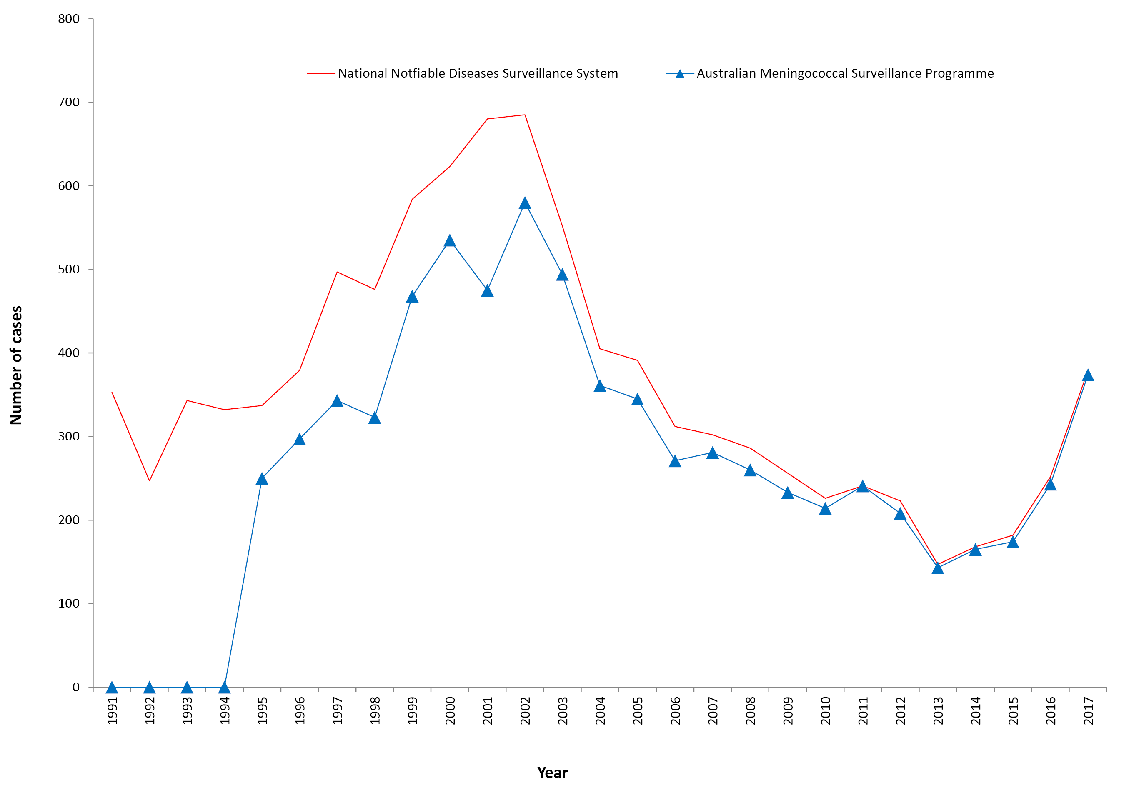

New South Wales reported the highest number of cases (90 cases) in 2017, an increase from 69 cases in 2016 and the highest number of cases reported from this state since 2005 (n=112) (Table 2). Victoria had the second highest number of IMD cases in 2017 (87 cases), and this was the highest number of cases reported in this state since 2002 (n=129). The number of IMD cases reported from the Northern Territory (n=32) was the highest since the inception of the AMSP. Of these, 28 cases were from remote communities of central Australia. There were an additional 7 IMD cases reported from remote central Australia (5 from South Australia, 1 each from Queensland and Western Australia). All jurisdictions, with the exception of the Australian Capital Territory, recorded a rise in IMD cases in 2017 compared to 2016.
Table 2: Number of laboratory-confirmed cases of invasive meningococcal disease, Australia, 2017, by state or territory and serogroup
State/Territory | Serogroup |  |  |  |  |  | Total
 | B | C | Y | W | NGª | ND^{b}
ACT | 0 | 0 | 2 | 0 | 0 | 0 | 2
NSW | 42 | 5 | 19 | 20 | 4 | 0 | 90
NT | 3 | 0 | 3 | 26 | 0 | 0 | 32
Qld | 25 | 0 | 22 | 16 | 0 | 1 | 64
SA | 22 | 0 | 3 | 12 | 0 | 0 | 37
Tas | 6 | 0 | 1 | 8 | 0 | 1 | 16
Vic | 26 | 8 | 17 | 36 | 0 | 0 | 87
WA | 13 | 1 | 8 | 23 | 1 | 0 | 46
Australia | 137 | 14 | 75 | 141 | 5 | 2 | 374
 | 36.6 | 3.7 | 20.1 | 37.7 | 1.3 | 0.5 | %
a NG: non groupable
b ND: not determined

Age distribution
The peak incidence of IMD in 2017, as in 2015 and 2016, occurred in adults aged 45 years or more. This age group represented 36% (136/374) of IMD cases in 2017 (Table 3). The number of cases in adults aged 45–64 years, and adults aged 65 or more years, was the highest for these age groups reported by the AMSP. Prior to 2015, the primary peak incidence of IMD was in children less than 5 years of age. Between 2003 and 2014, the proportion of IMD that occurred in children aged less than 5 years ranged from 28% to 36% of cases. Since 2015, the proportion has ranged from 21% to 23% of cases.

Table 3: Laboratory-confirmed cases of invasive meningococcal disease, Australia, 2017, by age and serogroup
Serogroup | Age group |  |  |  |  |  |  |  |  | Total
 | <1 | 1–4 | 5–9 | 10–14 | 15–19 | 20–24 | 25–44 | 45–64 | 65+
B | 16 | 21 | 7 | 3 | 27 | 13 | 14 | 26 | 10 | 137
C | 0 | 0 | 0 | 0 | 1 | 0 | 10 | 1 | 2 | 14
Y | 6 | 1 | 1 | 2 | 5 | 9 | 6 | 23 | 22 | 75
W | 17 | 21 | 11 | 4 | 8 | 15 | 14 | 20 | 31 | 141
NGª | 1 | 2 | 0 | 0 | 0 | 0 | 1 | 0 | 1 | 5
ND^{b} | 0 | 1 | 0 | 0 | 1 | 0 | 0 | 0 | 0 | 2
Total | 40 | 46 | 19 | 9 | 42 | 37 | 45 | 70 | 66 | 374
%B of within age group | 40.0 | 45.7 | 36.8 | 33.3 | 64.3 | 35.1 | 31.1 | 37.1 | 15.2
a NG: non groupable
b ND: not determined

Anatomical site of samples for laboratory-confirmed cases
In 2017, diagnosis was made by a positive culture in 76% (286/374) of cases; 24% (88/374) of cases were confirmed by NAAT testing alone (Table 4).
Table 4: Number of laboratory-confirmed cases of invasive meningococcal disease, Australia, 2017, by anatomical source and method of confirmation
Specimen type | Isolate of NMª | PCR positive^{b} | Total
Blood | 247 | 30 | 277
CSF +/- Blood | 19 | 53 | 72
Other | 20 | 5 | 25
Total | 286 | 88 | 374
a MC: meningococci
b PCR: polymerase chain reaction
There were 72 diagnoses of meningitis based on cultures or NAAT examination of CSF either alone or with a positive blood sample. There were 277 diagnoses of septicaemia based on cultures or NAAT examination from blood samples alone (Table 4). There were 9 IMD diagnoses from joint fluid, 10 IMD diagnoses by positive eye culture (notifiable in NSW and NT), 3 IMD diagnoses from brain tissue, and 1 IMD diagnosis each from breast aspirate, cysts fluid, and pleural fluid.

Serogroup data

Number and proportions of cases of serogroup B, C, Y, W invasive meningococcal disease
The serogroup was able to be determined for 367 of 374 laboratory-confirmed cases of IMD (98%) in 2017 (Tables 2 and 3). The overall decrease in IMD cases since 2002 was predominantly due to an initial reduction in the number of cases of IMD caused by serogroup C from 2003 to 2007 following the introduction of the serogroup C vaccine. After 2009, a decline in the number of IMD cases caused by serogroup B was reported, from 194 cases in 2009 to 87 cases in 2016. In 2017, there was a rise in the number of IMD cases caused by serogroup B (n=137), the highest number since 2012. New South Wales reported the largest number of serogroup B cases (n=42), representing 46% of IMD cases reported from this state. Serogroup B was reported in all jurisdictions except the Australian Capital Territory. In the years 2006–2012 the proportion of IMD cases caused by serogroup B was 84–88%, in 2013–2014 it was 75–80%, in 2015 it was 64%, and in 2016 and 2017 it was 36%, the lowest proportion of total IMD reported by the AMSP.
The number of IMD cases caused by serogroup C (14 cases) in 2017 was the highest reported since 2007. Victoria reported 8 cases, the highest number the state has recorded since 2004. The other states reporting IMD cases caused by serogroup C were New South Wales (5 cases) and Western Australia (1 case).
Since 2014, the rise in the total number of IMD cases has been due to a rise in the number of cases of IMD caused by serogroups W and Y (Figures 1 and 2). The number of cases of IMD caused by serogroup W in 2017 (141 cases) was the highest reported by the AMSP, almost quadruple the number of cases reported in 2015 (36 cases), and marked a tenfold increase on the average number of annual IMD cases caused by serogroup W reported before 2015. Prior to 2015, the proportion of cases of IMD caused by serogroup W ranged from 1.1% to 4.8% in the period 1997–2012 and 8.4–9.7% in 2013–2014. In 2015 it was 21%, in 2016 it was 44%, and in 2017 it was 38% of the total cases of IMD.
The number and proportion of cases of IMD caused by serogroup Y in 2017 (n=75, 20% of total IMD) was also the highest reported by the AMSP, almost double the number of IMD cases reported in the previous year (40 cases), and a seven-fold increase on the average annual number of serogroup Y cases reported before 2015. Prior to 2015, the proportion of cases of IMD caused by serogroup Y ranged from 1.3% to 4.6% in the period 1997–2010 and 6.2–10.5% in 2011–2014. In 2015 the proportion rose to 12.6%, and again in 2016 to 16.5% of the total cases of IMD for each corresponding year.
Of the 141 IMD cases caused by serogroup W in 2017, Victoria reported the largest number (n=36), where serogroup W represented 41% (36/87) of cases. This was followed by the Northern Territory (n=26) where serogroup W represented 81% (26/32) of cases. Of the 35 cases from remote central Australia, all except one were of Indigenous heritage, and serogroup W comprised 33 (94%) of these cases. Serogroup W was reported in all jurisdictions except the Australian Capital Territory in 2017. Jurisdictions that reported IMD cases caused by serogroup W that were the highest reported by each state or territory since the beginning of the AMSP were the Northern Territory, Queensland, South Australia, Tasmania and Western Australia.
Of the 75 cases of IMD caused by serogroup Y in 2017, Queensland reported the largest number (n=22), where this serogroup represented 34% (22/65 cases) of cases. For the first time since the AMSP began, serogroup Y was reported in all jurisdictions. Jurisdictions that reported IMD cases caused by serogroup Y that were the highest reported by each state since the beginning of the AMSP were New South Wales, Queensland, Victoria and Western Australia.
In 2017, IMD caused by serogroup B was the predominant serogroup only among those aged 15 to 19 years (64%) (Table 3, Figure 3). Serogroup B IMD was of equal predominance with serogroup W for children less than 5 years, the first time since the beginning of the AMSP. The proportion of IMD caused by serogroup B in all other age groups was less than in previous years, due to the large increase in the number of IMD cases caused by serogroup W and Y in these age groups.
In 2017 IMD caused by serogroup W was seen in all age groups, the first time this was reported since the beginning of the AMSP. There was an increase in the number of IMD cases caused by serogroup W across all age groups except those aged 15 to 19 years. For those aged less than 5 years, the number and proportion of IMD cases caused by serogroup W (38 cases, 44%) was the highest recorded for this age group. For those aged more than 45 years, serogroup W was the predominant IMD-causing serogroup (51/136 cases or 38%). Of the 33 serogroup W IMD cases from remote central Australia, 18 of these (54%) were in those aged less than 5 years, and 9 cases (27%) were in those aged 5 to 9 years.
Serogroup Y IMD was also seen in all age groups in 2017; this was also the first time this was reported since the beginning of the AMSP. The largest increase was seen in those aged 45 or more years (46 cases, or 33% of IMD cases in 2017, compared with 25 cases or 29% in 2016).

Genotyping
In 2017, genotyping results were available for 84% (315/374) of IMD cases (Tables 5 and 6). The predominant porA genotype for IMD cases caused by serogroup B continued to be P1.7-2,4 (22 cases, 22% of serogroup B that were typeable) (Figure 4). Other prevalent serogroup B genotypes were P1.7,16-26 (16 cases, 16%), and P1.22,14 (14 cases, 14%), similar to previous years. The predominant porA genotype for serogroup C IMD cases was P1.5-1,10-8 (10 cases, 72% of serogroup C IMD cases that were typeable). The predominant porA genotype for serogroup Y IMD cases was P1.5-1,10-1 (48 cases, 69% of serogroup Y IMD cases that were typeable), and this has been the case since 2014 when the rise in serogroup Y IMD cases was first noted. There were 129 serogroup W IMD cases that were able to be genotyped, 125 of these (97%) were genotype P1.5,2 (Table 5).

Figure 4: Number of porA genotypes for serogroup B in laboratory-confirmed cases of invasive meningococcal disease Australia, 2017
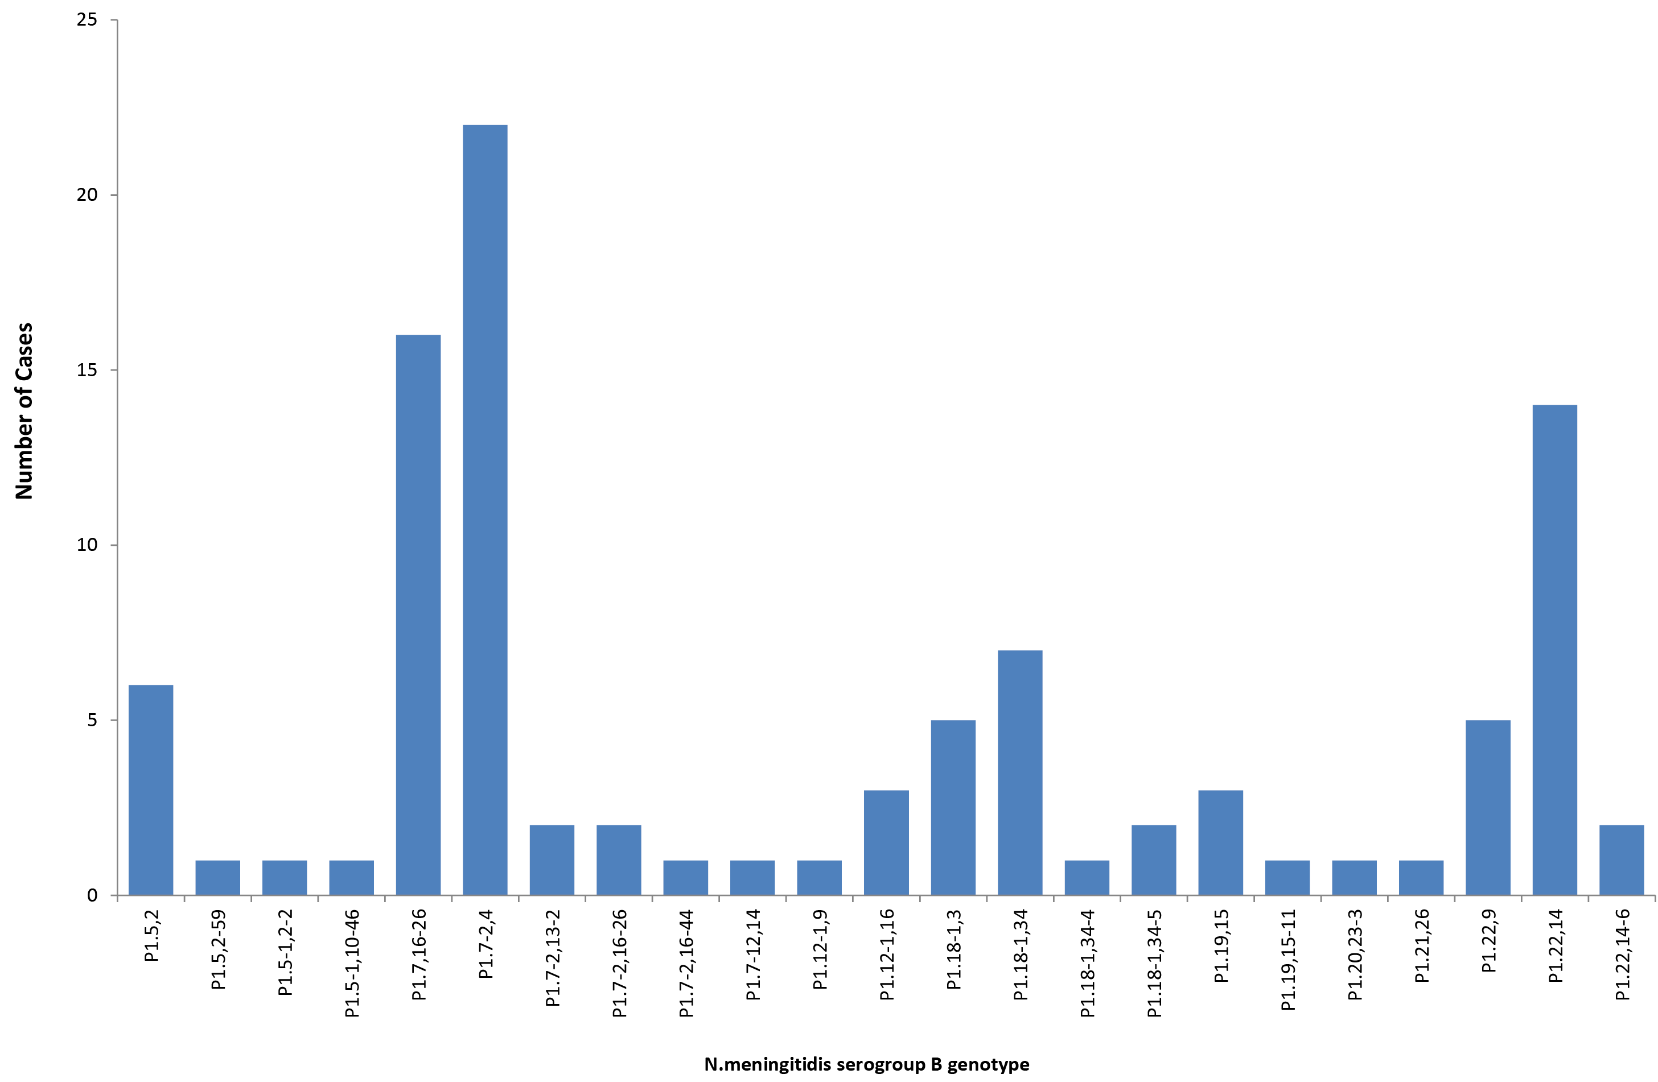

Table 5: Laboratory-confirmed cases of invasive meningococcal disease, Australia, 2017, by porA genotype
2017 AMSP |  | No. PER SEROGROUP
GENOTYPE_PorA | Total | B | C | Y | W | ND
P1.unk,2 | 1 | 0 | 0 | 0 | 1 | 0
P1.5,2 | 136 | 6 | 3 | 1 | 125 | 1
P1.5,2-12 | 1 | 0 | 0 | 0 | 1 | 0
P1.5,2-59 | 1 | 1 | 0 | 0 | 0 | 0
P1.5-1,2-2 | 5 | 1 | 0 | 4 | 0 | 0
P1.5-1,10-1 | 49 | 0 | 0 | 48 | 0 | 1
P1.5-1,10-4 | 7 | 0 | 0 | 6 | 1 | 0
P1.5-1,10-8 | 11 | 0 | 10 | 1 | 0 | 0
P1.5-1,10-12 | 1 | 0 | 0 | 1 | 0 | 0
P1.5-1,10-29 | 1 | 0 | 0 | 1 | 0 | 0
P1.5-1,10-46 | 2 | 1 | 0 | 1 | 0 | 0
P1.5-2,10-1 | 3 | 0 | 0 | 3 | 0 | 0
P1.5-2,10-29 | 3 | 0 | 0 | 3 | 0 | 0
P1.7,16-26 | 16 | 16 | 0 | 0 | 0 | 0
P1.7-2,4 | 22 | 22 | 0 | 0 | 0 | 0
P1.7-2,13-2 | 2 | 2 | 0 | 0 | 0 | 0
P1.7-2,16-26 | 2 | 2 | 0 | 0 | 0 | 0
P1.7-2,16-44 | 1 | 1 | 0 | 0 | 0 | 0
P1.7-12,14 | 1 | 1 | 0 | 0 | 0 | 0
P1.12-1,9 | 1 | 1 | 0 | 0 | 0 | 0
P1.12-1,16 | 3 | 3 | 0 | 0 | 0 | 0
P1.18,25-15 | 1 | 0 | 0 | 0 | 0 | 1
P1.18-1,3 | 5 | 5 | 0 | 0 | 0 | 0
P1.18-1,34 | 7 | 7 | 0 | 0 | 0 | 0
P1.18-1,34-4 | 1 | 1 | 0 | 0 | 0 | 0
P1.18-1,34-5 | 2 | 2 | 0 | 0 | 0 | 0
P1.18-4,25 | 1 | 0 | 0 | 1 | 0 | 0
P1.19,15 | 3 | 3 | 0 | 0 | 0 | 0
P1.19,15-11 | 1 | 1 | 0 | 0 | 0 | 0
P1.19-1,new | 1 | 0 | 0 | 0 | 1 | 0
P1.20,23-3 | 1 | 1 | 0 | 0 | 0 | 0
P1.21,26 | 1 | 1 | 0 | 0 | 0 | 0
P1.22,9 | 5 | 5 | 0 | 0 | 0 | 0
P1.22,14 | 14 | 14 | 0 | 0 | 0 | 0
P1.22,14-6 | 3 | 2 | 1 | 0 | 0 | 0
Total | 315 | 99 | 14 | 70 | 129 | 3

Table 6: Distribution of porA genotype laboratory-confirmed cases of invasive meningococcal disease, Australia, 2017, by state or territory
2017 AMSP | No. PER SEROGROUP PER STATE
GENOTYPE_PorA | NSW | QLD | VIC | SA | WA | ACT | TAS | NT
P1.unk,2 |  |  | 1W
P1.5,2 | 3B,2C,18W,1NG | 1B, 15W | 35W | 8W | 1C, 20W | 1Y | 2B, 8W | 21W
P1.5,2-12 |  |  |  |  |  |  |  | 1W
P1.5,2-59 | 1B
P1.5-1,2-2 | 1B |  | 1Y |  | 3Y
P1.5-1,10-1 | 15Y, 1NG | 15Y | 11Y | 1Y | 3Y | 1Y |  | 2Y
P1.5-1,10-4 | 1Y | 2Y, 1W | 1Y |  |  |  | 1Y | 1Y
P1.5-1,10-8 | 2C |  | 8C, 1Y
P1.5-1,10-12 |  | 1Y
P1.5-1,10-29 |  | 1Y
P1.5-1,10-46 | 1Y |  |  |  | 1B
P1.5-2,10-1 |  | 1Y | 1Y | 1Y
P1.5-2,10-29 | 1Y | 1Y | 1Y
P1.7,16-26 | 7B | 3B | 4B |  |  |  | 1B
P1.7-2,4 | 9B | 3B | 2B | 5B | 1B |  |  | 2B
P1.7-2,13-2 |  | 2B
P1.7-2,16-26 | 1B |  | 1B |  |  |  |  | 1B
P1.7-2,16-44 |  |  | 1B
P1.7-12,14 |  |  | 1B
P1.12-1,9 |  |  | 1B
P1.12-1,16 | 1B | 2B
P1.18,25-15 | 1NG
P1.18-1,3 |  |  | 4B | 1B
P1.18-1,34 | 1B | 2B | 2B |  | 2B
P1.18-1,34-4 |  |  |  |  |  |  | 1B
P1.18-1,34-5 |  | 1B | 1B
P1.18-4,25 |  |  |  |  | 1Y
P1.19,15 | 1B |  |  |  | 1B |  | 1B
P1.19,15-11 |  |  | 1B
P1.19-1,new | 1B
P1.20,23-3 | 1B
P1.21,26 | 1B
P1.22,9 |  | 1B | 4B
P1.22,14 | 9B | 2B |  |  | 3B
P1.22,14-6 | 1B, 1C | 2B

Figure 2: Proportion of serogroups of laboratory-confirmed invasive meningococcal disease, Australia, by year
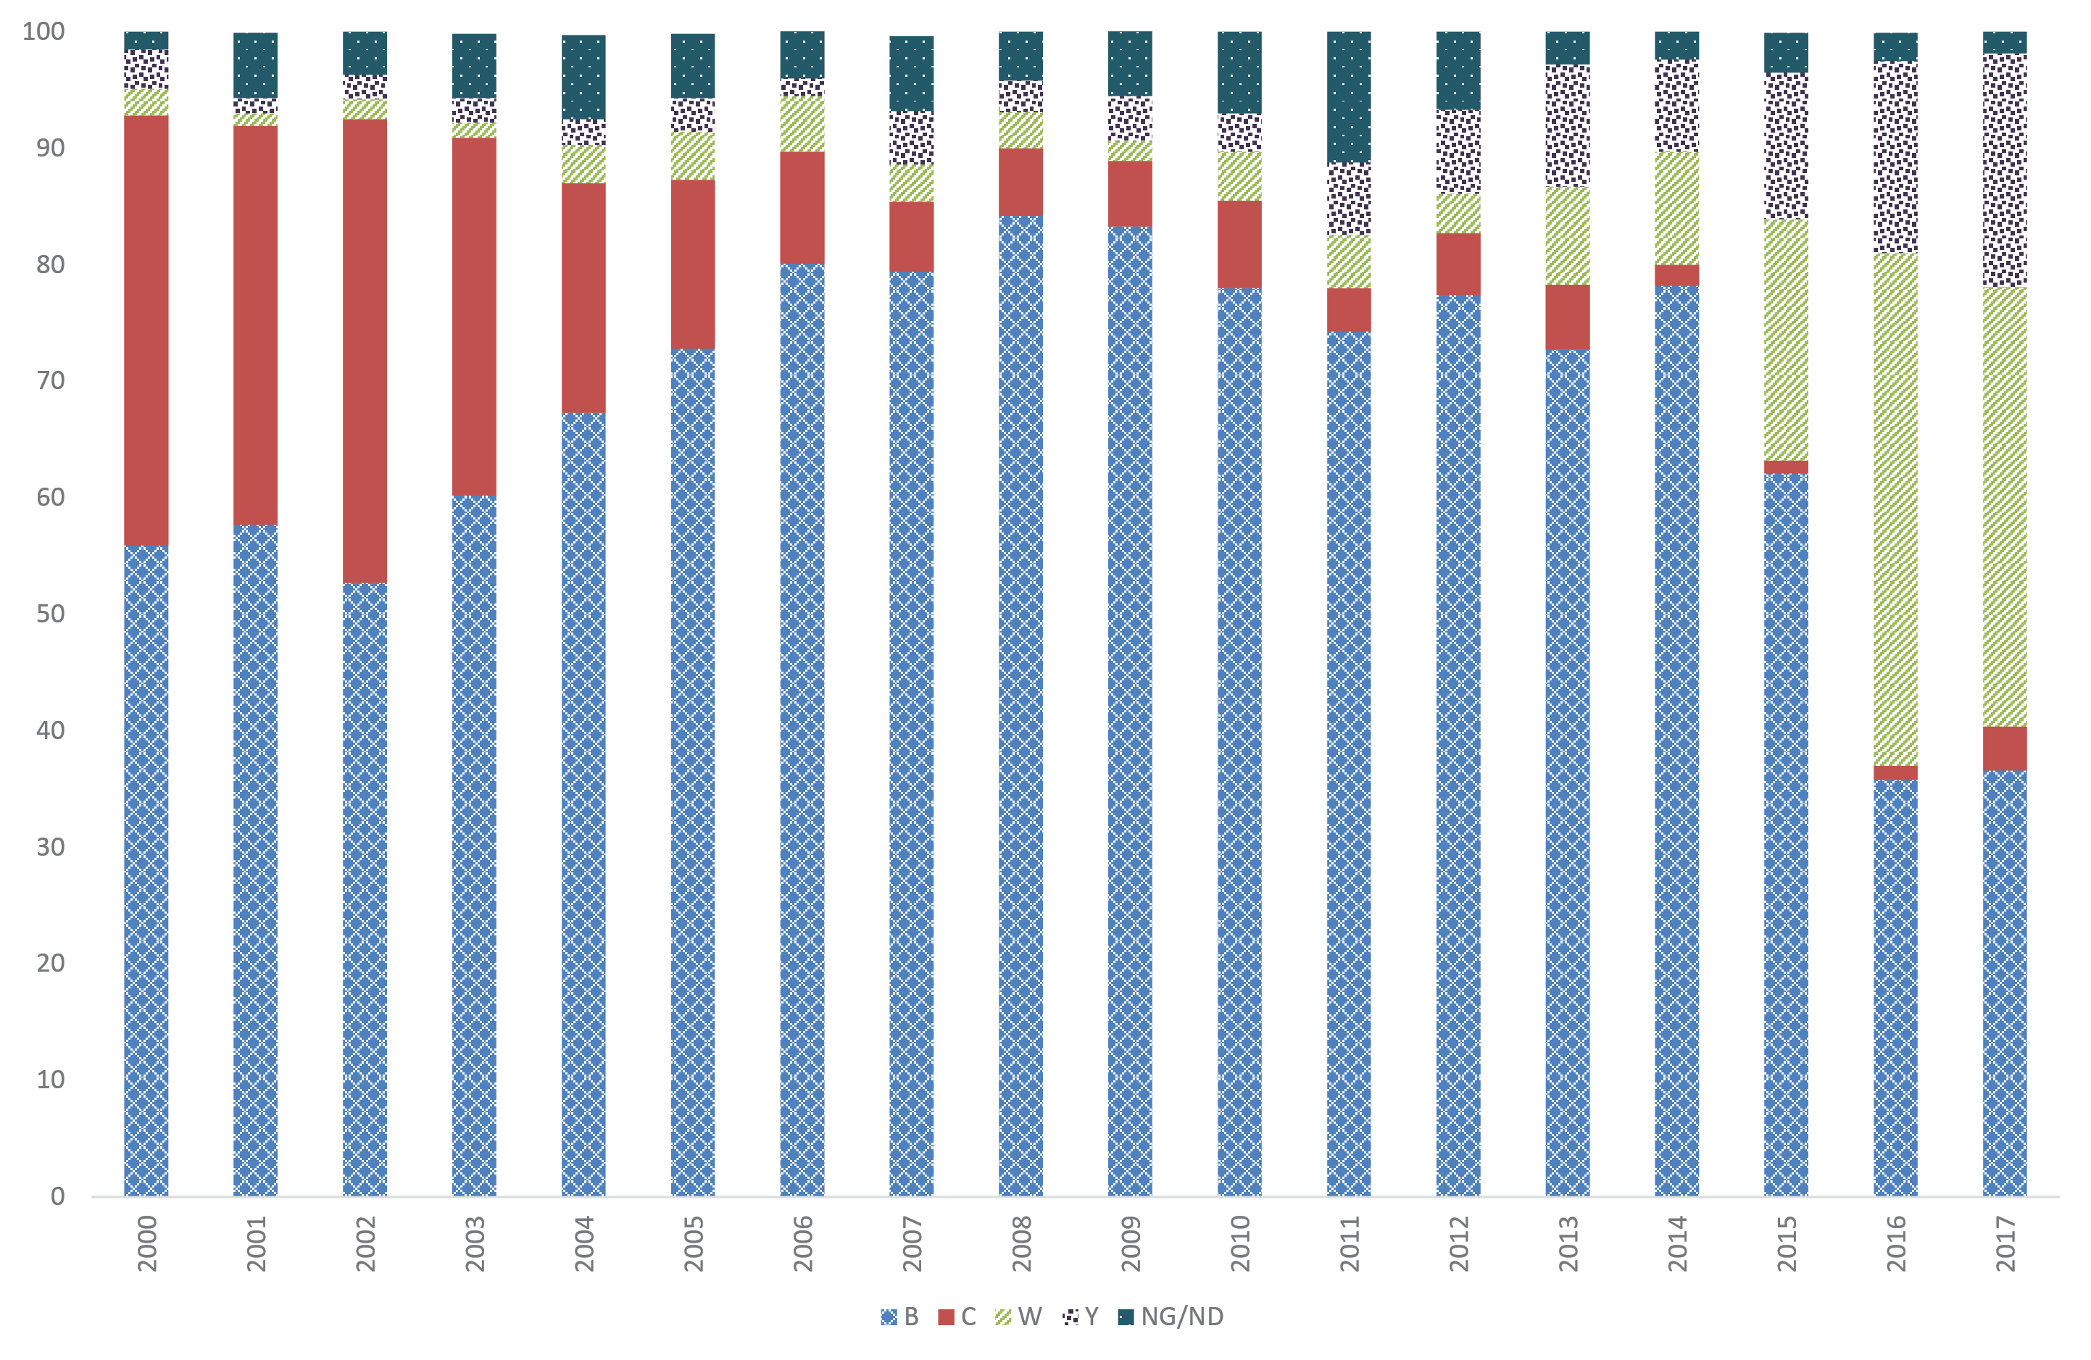

Figure 3: Numbers of cases of laboratory-confirmed invasive meningococcal disease for serogroups B, Y, and W, Australia, 2017, by age
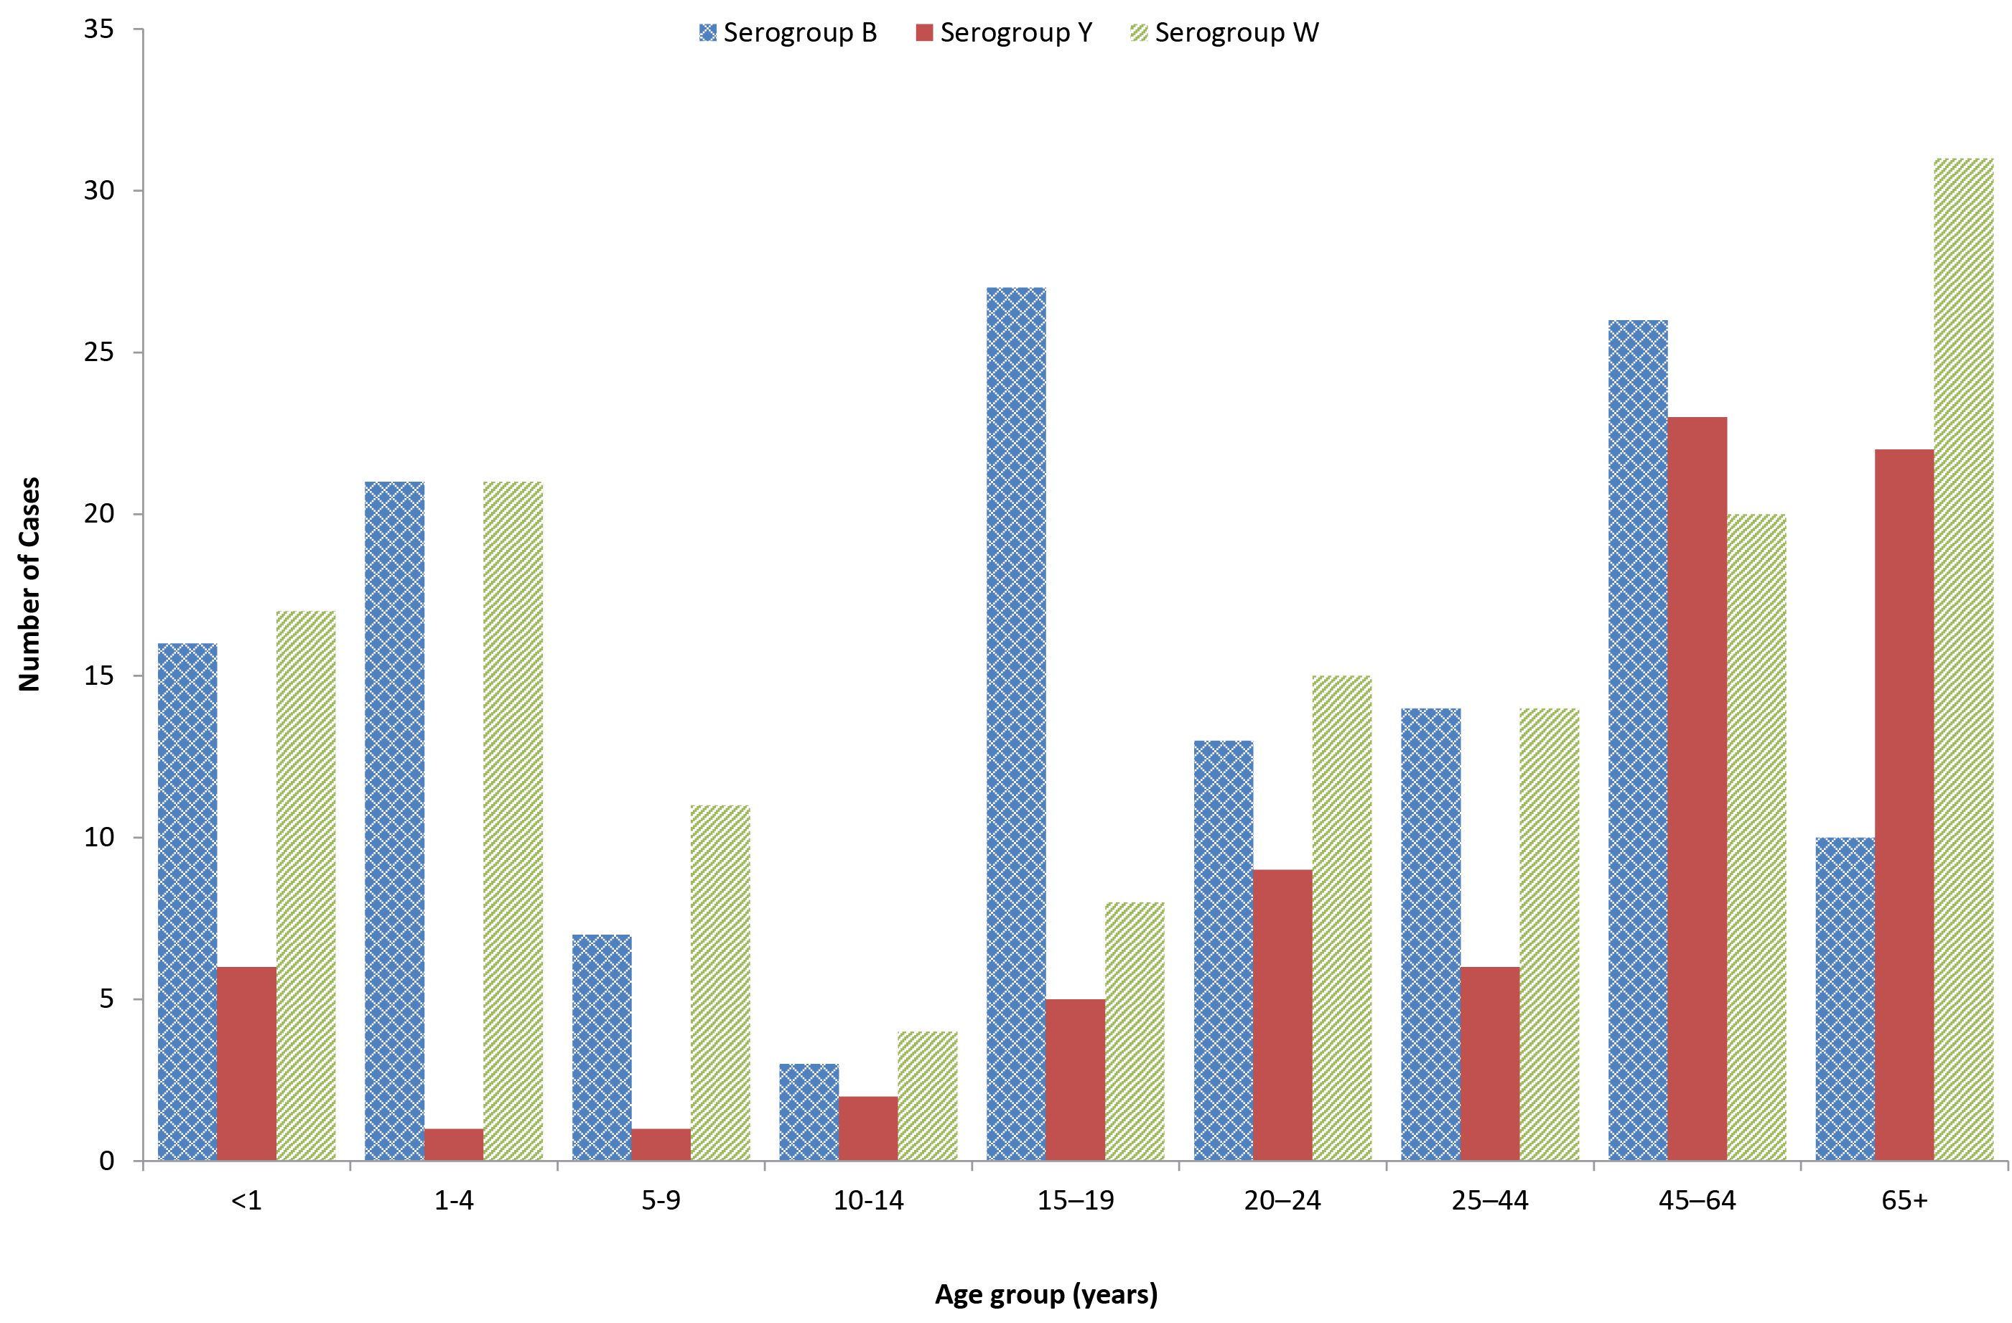

To better understand the molecular epidemiology of isolates associated with IMD in Australia, the Australian Government Department of Health provided funding for whole-genome sequencing (WGS) and phylogenetic analysis of IMD isolates for 2017. This was coordinated by the Microbiological Diagnostic Unit (MDU) Public Health Laboratory at the Peter Doherty Institute for Infection & Immunity in Victoria, in conjunction with the National Neisseria Network (NNN) of Australia.
292 IMD isolates were sequenced between 1 January and 31 December 2017, comprising 78% (292/374) of IMD cases notified to NNDSS during the corresponding period. Genomic analysis identified the ongoing expansion of a W:P1.5,2:F1-1:ST11 (CC11) clone which first emerged in Australia in 2014. Multilocus sequence typing showed that of these, 66% of typeable strains (74/113) were sequence type (ST)-11 — the same strain type as the hypervirulent serogroup W strain that has been reported in the UK and South America since 2009 (Table 7).^{5,6} Within this clone, a distinct “remote Australia” cluster (ST1287/12351(CC11)) was evident. Of the serogroup W IMD cases from remote central Australia, sequence type data was available for 25 of these, and 22 (88%) were W:P.15,2:F1-1:ST1287. Also of note, from the genomic analysis performed in 2017, was a cluster of serogroup C IMD of the finetype C:P1.5-1,10-8:F3-6:ST11(CC11) in men aged 25-49 from Victoria. This finetype C:P1.5-1,10-8:F3-6 is consistent with that seen internationally in outbreaks of serogroup C IMD amongst men who have sex with men (MSM).⁷ Clonal expansion of a serogroup Y ST1655 (ST23 clonal complex) clone was also observed. Amongst serogroup B IMD cases there was not a high degree of genomic relatedness.
Table 7: Laboratory-confirmed cases of serogroup W IMD, Australia, 2017, by sequence type (ST)
Sequence Type | W Genotype
 | P1.5,2 | P1.5,2-12 | P1.new,2 | P1.5-1,10-4 | P1.19-1,new | Not typeable | Total
ST11 | 74 | 0 | 0 | 0 | 0 | 0 | 74
ST23 | 1 | 0 | 0 | 0 | 0 | 0 | 1
ST44 | 0 | 0 | 0 | 0 | 1 | 0 | 1
ST1287 | 25 | 1 | 0 | 0 | 0 | 0 | 26
ST3980 | 1 | 0 | 0 | 0 | 0 | 0 | 1
ST8857 | 1 | 0 | 0 | 0 | 0 | 0 | 1
ST9087 | 1 | 0 | 0 | 0 | 0 | 0 | 1
ST12351 | 6 | 0 | 0 | 0 | 0 | 0 | 6
Not typeable | 1 | 0 | 0 | 0 | 0 | 0 | 1
Total | 110 | 1 | 0 | 0 | 1 | 0 | 112

Antibiotic susceptibility testing
Penicillin susceptibility testing was performed on 74% (276/374) of the IMD cases for 2017. Of these, 5.1% (14/276) were resistant to penicillin (MIC ≥ 1 mg/L), a slightly lower proportion than last year (11/189, 5.8%), which was the highest proportion of isolates with penicillin resistance reported by the AMSP. Strains fully susceptible to penicillin (MIC ≤ 0.03 mg/L) comprised 5.4% (15/276); 89% (247/276) of isolates were less sensitive to penicillin (MIC = 0.06–0.5 mg/L). Of the isolates that were resistant to penicillin, 10 were serogroup W, and represented 8.3% penicillin resistance in all serogroup W isolates available for testing (n=121). Ceftriaxone susceptibility testing was performed on 73% (274/374) of the IMD cases for 2017; all were susceptible. Ciprofloxacin susceptibility testing was performed on 71% (266/374) of the IMD cases for 2017; 2 isolates were less susceptible with an MIC of 0.25 mg/L. Rifampicin susceptibility testing was performed on 71% (265/374) of the IMD cases for 2017; 1 isolate was resistant, with an MIC of 1.0 mg/L.

Discussion
In 2017, there were 374 cases of laboratory-confirmed IMD, representing 99% of the number of notifications to the NNDSS.³ The number of laboratory-confirmed IMD cases in 2017 represents a 50% increase on the previous year. The introduction of the serogroup C vaccine to the national immunisation schedule in 2003 resulted in a very large and sustained reduction in the number and proportion of serogroup C IMD cases in this country; in 2015 the number and proportion of IMD cases caused by serogroup C was the lowest ever reported by the AMSP. In early 2014, a recombinant multi-component meningococcal B vaccine became available in Australia.⁸ This vaccine is not on the national immunisation program but is available for purchase privately. Therefore uptake is elective and the impact of its introduction is yet to be determined in Australia.
Several changes in IMD epidemiology were observed in Australia in 2017. There was a notable increase in the total number of IMD cases, the highest number of laboratory-confirmed cases since 2003, and the highest number of IMD notifications since 2005. The incidence of serogroup W and serogroup Y was the highest ever reported by the AMSP.
In addition, as reported by the AMSP in 2015 and 2016, the primary peak of IMD was observed in adults aged 45 years or older. This was due to the increased number of IMD cases caused by serogroup W and serogroup Y in this age group, although these serogroups also increased in frequency in all age groups in 2017. Secondary disease peaks were observed in those aged less than 5 years.
The numbers of IMD cases caused by each of serogroup W and serogroup Y in 2017 were the highest reported by the AMSP. The number of IMD cases caused by serogroup C was the highest reported by the AMSP since 2007. Serogroup W represented 38% of all laboratory-confirmed IMD cases in 2017. The highest number of serogroup W cases for 2017 was reported in Victoria (36 cases), followed by the Northern Territory (26 cases) and Western Australia (23 cases). Typing of these isolates found that the predominant circulating strain of serogroup W had the porA antigen encoding gene type P1.5,2 and was sequence type (ST)-11. This is the same genotype as the hypervirulent serogroup W strain that emerged in the United Kingdom⁵ and South America⁶ in 2009 and has spread to account for 25% of IMD in the UK in 2014/2015 and 59% of all cases in Chile in 2012. This serogroup W strain is now considered endemic in these regions and is associated with atypical presentations, more severe clinical disease and a higher case fatality rate.⁶ The initial increase in serogroup W in these regions, as is now being demonstrated in Australia, was seen in older adults, but was subsequently reported in all age groups, particularly in adolescents and infants.⁹ In response to the rise of serogroup W cases, the Australian Capital Territory, New South Wales, Victoria, Tasmania, Western Australia and Queensland commenced time-limited meningococcal vaccination programmes, targeting adolescents, that protect against serogroups A, C, W, and Y.¹⁰ Additionally, in response to an outbreak of serogroup W in Central Australia in late 2017, the Northern Territory, South Australia, Western Australia, and Queensland initiated time-limited vaccination programmes, for individuals in affected communities, to protect against serogroups A, C, W, and Y.¹⁰ Vaccination programs have also been implemented in both the United Kingdom and in Chile.^{5,11}
Serogroup Y IMD cases were reported, for the first time since the beginning of the AMSP, in all states and territories and in all age groups. An increase in IMD cases caused by serogroup Y was also observed in the eastern states of New South Wales, Queensland and Victoria and in Western Australia in 2017. The predominant serogroup Y genotype since 2014 (71%, 48/68) is P1.5-1,10-1 whereas in previous years the serogroup Y genotype distribution was more heterogeneous. The emergence of serogroup Y has also been reported recently in Europe.¹² The phenotypic and genotypic characterisation of the serogroup Y isolates is ongoing by the NNN.
Antimicrobial susceptibility testing of IMD isolates in 2017 showed that penicillin resistance was similar to 2016, which was the highest annual number and proportion recorded by the AMSP. The incidence of penicillin resistance in N. meningitidis in Australia had been less than 1% annually of IMD isolates tested in 1996–2014 before rising to 3.4% in 2015 and 5.8% in 2016. The proportion of IMD isolates with penicillin MIC values in the less sensitive category has been increasing in recent years. This proportion ranged from 62–75% in 1996–2006; 67–79% in 2007–2009; 78-88% in 2010–2015, and in 2016 it was 90%. All IMD isolates tested were susceptible to ceftriaxone, while two isolates were less susceptible to ciprofloxacin and one isolate was resistant to rifampicin.
The increase in IMD cases, and particularly those caused by serogroup W and serogroup Y, and the observed increase in antimicrobial resistance in serogroup W isolates are of significant concern. The NNN is continuing to lead further investigations with the Department of Health into these observed changes and is closely monitoring the phenotypic and genotypic features of N. meningitidis causing IMD in Australia. Additional investigations including whole genome sequencing are in place to enhance IMD surveillance. The AMSP data are used for informing treatment guidelines and disease prevention strategies, and to monitor the effect of interventions.

Acknowledgements
Meningococcal isolates were received in the reference centres from many laboratories throughout Australia. The considerable time and effort involved in forwarding these isolates is recognised and these efforts are greatly appreciated. These data could not have been provided without this assistance and the help of clinical colleagues and public health personnel. The Australian Government Department of Health provided funding for the National Neisseria Network.
Members of the AMSP in 2017, to whom isolates and samples should be referred, and enquiries directed, are listed below.

Australian Capital Territory
P Collignon, S Bradbury
Microbiology Department, The Canberra Hospital, Yamba Drive, Garran ACT 2605
Telephone: +61 2 6244 2414
Email: peter.collignon@act.gov.au

New South Wales
MM Lahra, RP Enriquez, EA Limnios, TR Hogan, RL Kundu, J El Nasser
Microbiology Department, New South Wales Health Pathology, The Prince of Wales Hospital, Barker Street, Randwick NSW 2031
Telephone: +61 2 9382 9084
Facsimile: +61 2 9382 9310
Email: monica.lahra@health.nsw.gov.au
M Maley, J Mercer, R Porritt
Department of Microbiology and Infectious Diseases, New South Wales Health Pathology, Liverpool Hospital, Locked Mail Bag 7090, Liverpool BC NSW 1871
Telephone: +61 2 8738 5124
Facsimile: +61 2 8738 5129
Email: Joanne.Mercer@sswahs.nsw.gov.au or Robert.Porritt@sswahs.nsw.gov.au

Northern Territory
R Baird, K Freeman
Microbiology Laboratory, Territory Pathology, Royal Darwin Hospital, Tiwi NT 0810
Telephone: +61 8 8922 8167
Facsimile: +61 8 8922 7788
Email: rob.baird@nt.gov.au

Queensland
G Robertson, J Bates, H Smith, V Hicks
Public Health Microbiology, Forensic and Scientific Services, 39 Kessels Road, Coopers Plains Qld 4108
Telephone: +61 7 3274 9101
Facsimile: +61 7 3274 9175
Email: john_bates@health.qld.gov.au

South Australia
I Bastian, A Lawrence
Microbiology and Infectious Diseases, SA Pathology, Frome Road, Adelaide, SA 5000
Telephone: +61 8 2223503
Facsimile: +61 8 2223543
Email: andrew.lawrence@health.sa.gov.au

Tasmania
L Cooley, B McEwan
Department of Microbiology and Infectious Diseases, Royal Hobart Hospital, 48 Liverpool Street, Hobart Tasmania 7000
Telephone: +61 3 6222 8656
Email: belinda.mcewan@dhhs.tas.gov.au

Victoria
B Howden, K Stevens
Microbiological Diagnostic Unit Public Health Laboratory, Department of Microbiology and Immunology, The University of Melbourne, Parkville Victoria 3052
Telephone: +61 3 8344 5701
Facsimile: +61 3 8344 7833
Email: kerries@unimelb.edu.au

Western Australia
AD Keil, J Bew
Department of Microbiology, Princess Margaret Hospital for Children, 1 Thomas Street, Subiaco WA 6008
Telephone: +61 8 9340 8273
Facsimile: +61 8 9380 4474
Email: tony.keil@health.wa.gov.au or jane.bew@health.wa.gov.au

Author details
Monica M Lahra^{1, 2}
Rodney Enriquez¹
CR Robert George¹
- Neisseria Reference Laboratory and World Health Organisation Collaborating Centre for STD, Sydney. Department of Microbiology, New South Wales Health Pathology, The Prince of Wales Hospital, Randwick, 2031, NSW Australia.
- School of Medical Sciences, Faculty of Medicine, The University of New South Wales, NSW, 2052 Australia

Corresponding author
Professor Monica Lahra,
Director, Microbiology Department, Neisseria Reference Laboratory and WHO Collaborating Centre for STD, New South Wales Health Pathology, Level 4, Campus Centre, The Prince of Wales Hospital, RANDWICK NSW, 2031.
Email: monica.lahra@health.nsw.gov.au

References
- National Neisseria Network. Meningococcal isolate surveillance Australia, 1994. Commun Dis Intell. 1995;19(12):286–289.
- Australian Government Department of Health. National Notifiable Disease Surveillance System (NNDSS). [Internet.] Canberra, Australian Government Department of Health, 2018. Available from: http://www9.health.gov.au/cda/source/cda-index.cfm.
- NNDSS. Number of notifications of Meningococcal disease (invasive), received from state and territory health authorities in the period of 1991 to 2012 and year-to-date notifications for 2014. [Internet.] Australian Government Department of Health, NNDSS, 2014.
- Communicable Diseases Network Australia. Invasive Meningococcal Disease: CDNA National Guidelines for Public Health Units. [Internet.] Australian Government Department of Health, Communicable Diseases Network Australia, 2015. Available from: http://www.health.gov.au/internet/main/publishing.nsf/content/cdna-song-imd.htm .
- Abad R, López EL, Debbag R, Vázquez JA. Serogroup W meningococcal disease: global spread and current affect on the Southern Cone in Latin America. Epidemiol Infect. 2014;142(12):2461–70.
- Ladhani SN, Beebeejaun K, Lucidarme J, Campbell H, Gray S, Kaczmarski E et al. Increase in endemic Neisseria meningitidis capsular group W sequence type 11 complex associated with severe invasive diseas in England and Wales. Clin Infect Dis. 2015;60(4):578–85.
- Taha MK, Claus H, Lappann M, Veyrier FJ, Otto A, Becher D et al. Evolutionary events associated with an outbreak of meningococcal disease in men who have sex with men. PLoS One. 2016;11(5):e0154047.
- Australian Government Department of Health. Meningococcal Disease. Immunise Australia Program. [Internet.] Canberra, Australian Government Department of Health, 2015. Available from: http://www.health.gov.au/internet/immunise/publishing.nsf/Content/immunise-meningococcal
- Araya P, Fernández J, Del Canto F, Seoane M, Ibarz-Pavón AB, Barra G et al. Neisseria meningitidis ST-11 clonal complex, Chile, 2012. Emerg Infect Dis. 2015;21(2):339–41.
- Australian Government Department of Health. Meningococcal W Disease (Invasive). [Internet.] Canberra, Australian Government Department of Health, 2018. Available from: http://www.health.gov.au/internet/main/publishing.nsf/Content/ohp-meningococcal-W.htm .
- Campbell H, Saliba V, Borrow R, Ramsay M, Ladhani SN. Targeted vaccination of teenagers following continued rapid endemic expansion of a single meningococcal group W clone (sequence type 11 clonal complex), United Kingdom 2015. Euro Surveill. 2015;20(28). pii: 21188.
- Bröker M, Jacobsson S, Kuusi M, Pace D, Simões MJ, Skoczynska A et al. Meningococcal serogroup Y emergence in Europe: update 2011. Hum Vaccin Immunother. 2012;8(12):1907–11.

Communicable Diseases Intelligence
ISSN: 2209-6051 Online

Communicable Diseases Intelligence (CDI) is a peer-reviewed scientific journal published by the Office of Health Protection, Department of Health. The journal aims to disseminate information on the epidemiology, surveillance, prevention and control of communicable diseases of relevance to Australia.

Editor: Cindy Toms
Deputy Editor: Simon Petrie
Design and Production: Kasra Yousefi
Editorial Advisory Board: David Durrheim, Mark Ferson, John Kaldor, Martyn Kirk and Linda Selvey

Website: http://www.health.gov.au/cdi

Contacts
Communicable Diseases Intelligence is produced by:
Health Protection Policy Branch, Office of Health Protection, Australian Government Department of Health
GPO Box 9848, (MDP 6) CANBERRA ACT 2601

Email: cdi.editor@health.gov.au

Submit an Article
You are invited to submit your next communicable disease related article to the Communicable Diseases Intelligence (CDI) for consideration. More information regarding CDI can be found at: http://health.gov.au/cdi.
Further enquiries should be directed to: cdi.editor@health.gov.au.

This journal is indexed by Index Medicus and Medline.

Creative Commons Licence - Attribution-NonCommercial-NoDerivatives CC BY-NC-ND
© 2019 Commonwealth of Australia as represented by the Department of Health
This publication is licensed under a Creative Commons Attribution-NonCommercial-NoDerivatives 4.0 International Licence from https://creativecommons.org/licenses/by-nc-nd/4.0/legalcode (Licence). You must read and understand the Licence before using any material from this publication.

Restrictions
The Licence does not cover, and there is no permission given for, use of any of the following material found in this publication (if any):
- the Commonwealth Coat of Arms (by way of information, the terms under which the Coat of Arms may be used can be found at www.itsanhonour.gov.au);
- any logos (including the Department of Health’s logo) and trademarks;
- any photographs and images;
- any signatures; and
- any material belonging to third parties.

Disclaimer
Opinions expressed in Communicable Diseases Intelligence are those of the authors and not necessarily those of the Australian Government Department of Health or the Communicable Diseases Network Australia. Data may be subject to revision.

Enquiries
Enquiries regarding any other use of this publication should be addressed to the Communication Branch, Department of Health, GPO Box 9848, Canberra ACT 2601, or via e-mail to: copyright@health.gov.au

Communicable Diseases Network Australia
Communicable Diseases Intelligence contributes to the work of the Communicable Diseases Network Australia.
http://www.health.gov.au/cdna

