Australian Rotavirus Surveillance Program:
Annual Report, 2017
Susie Roczo-Farkas, Daniel Cowley, Julie E Bines, and the Australian Rotavirus Surveillance Group

Abstract
This report, from the Australian Rotavirus Surveillance Program and collaborating laboratories Australia-wide, describes the rotavirus genotypes identified in children and adults with acute gastroenteritis during the period 1 January to 31 December 2017. During this period, 2,285 faecal specimens were referred for rotavirus G and P genotype analysis, including 1,103 samples that were confirmed as rotavirus positive. Of these, 1,014/1,103 were wildtype rotavirus strains and 89/1,103 were identified as rotavirus vaccine-like. Genotype analysis of the 1,014 wildtype rotavirus samples from both children and adults demonstrated that G2P[4] was the dominant genotype nationally, identified in 39% of samples, followed by equine-like G3P[8] and G8P[8] (25% and 16% respectively). Multiple outbreaks were recorded across Australia, including G2P[4] (Northern Territory, Western Australia, and South Australia), equine-like G3P[8] (New South Wales), and G8P[8] (New South Wales and Victoria). This year also marks the change in the Australian National Immunisation Program to the use of Rotarix exclusively, on 1 July 2017.
Keywords: rotavirus, gastroenteritis, genotypes, surveillance, Australia, vaccine, RotaTeq, Rotarix, G2P[4], G8P[8], equine-like G3P[8]

Introduction
Rotaviruses belong to the Reoviridae family, and are triple-layered dsRNA viruses that contain a segmented genome, consisting of 11 gene segments that encode six structural proteins and six non-structural proteins.¹ The segmented nature of rotavirus has been attributed as one of the major processes by which the virus can evolve, since it allows for reassortment both within and between human and animal strains, leading to the emergence of novel rotavirus strains.² Rotaviruses are the most common cause of severe diarrhoea in young children worldwide, estimated to have caused 215,000 deaths in 2013 worldwide.³ The latest figures are significantly lower than previous estimates of 611,000 deaths per annum,⁴ primarily due to the introduction of rotavirus vaccines, such as Rotarix® [GlaxoSmithKline] and RotaTeq® [Merck]. These two live attenuated oral rotavirus vaccines have been shown to be safe and highly effective in the prevention of severe diarrhoea due to rotavirus infection,^{5,6} and have been introduced in the national immunisation programs of 100 countries, with a further 11 countries planning to introduce in 2019.⁷
Since 1 July 2007, rotavirus vaccines have been included in the Australian National Immunisation Program (NIP), with excellent uptake in subsequent years across the nation. RotaTeq was administered in Queensland, South Australia, and Victoria, while Rotarix was administered in the Australian Capital Territory, New South Wales, the Northern Territory, Tasmania, and Western Australia.⁸ In May 2009, Western Australia changed to RotaTeq, however, all states and territories in Australia have changed to Rotarix on 1 July 2017, under the National Immunisation Program.⁹
A significant impact on acute gastroenteritis disease burden has been observed since vaccine introduction, with studies showing a 78% decline across Australia in both rotavirus-coded and non-rotavirus-coded hospitalisations in children ≤5 years of age.^{8,10,11} Over the first six years after implementation of the rotavirus immunisation program, ~77,000 hospitalisations were prevented.¹¹ Approximately 90% of hospitalisations prevented were in children ≤5 years, with evidence of herd protection in older age groups.
The Australian Rotavirus Surveillance Program (ARSP) has characterised the G- and P- genotypes of rotavirus strains causing severe disease in Australian children ≤5 years since 1999. Surveillance data generated by the ARSP have shown that strain diversity, as well as temporal and geographic changes, occur each year.¹² Ongoing characterisation of circulating rotavirus genotypes will provide insight into whether vaccine introduction has impacted on virus epidemiology, altered circulating strains, or caused vaccine escape strains, which could have ongoing consequences for the success of current and future vaccination programs.
This report describes the G- and P- genotype distribution of rotavirus strains causing severe gastroenteritis in Australia for the period 1 January to 31 December 2017.

Methods
Rotavirus positive faecal specimens detected by quantitative Reverse Transcription Polymerase Chain Reaction (RT-qPCR), enzyme immunoassay (EIA), or latex agglutination in collaborating laboratories across Australia were collected, stored frozen, and forwarded de-identified to the Australian Rotavirus Reference Centre (NRRC) Melbourne, together with metadata including date of collection (DOC), date of birth (DOB), gender, postcode, and the collaborating laboratory rotavirus RT-qPCR cycle threshold (Ct) values. These specimens were received from the following 19 collaborating centres across Australia, located in the Australian Capital Territory (ACT), New South Wales (NSW), Northern Territory (NT), Queensland (Qld), South Australia (SA), Tasmania (Tas), Victoria (Vic), and Western Australia (WA). (n=number of specimens received):
Microbiology Department, Canberra Hospital, ACT (n=22)
Microbiology Department, SEALS-Randwick, Prince of Wales Hospital, NSW (n=110)
Virology Department, The Children’s Hospital at Westmead, NSW (n=85)
Centre for Infectious Diseases & Microbiology, Westmead, NSW (n=33)
The Microbiology Department, John Hunter Hospital, Newcastle, NSW (n=42)
The Microbiology Department, Central Coast, Gosford, NSW (n=10)
Douglas Hanly Moir Pathology, NSW (n=149)
Department of Microbiology, Western Diagnostics Pathology (WDP), Perth, WA (n=74)
Sullivan Nicolaides Pathology, Qld (n=1)
Forensic and Scientific Services, Queensland Health, Herston, Qld (n=1)
Microbiology Division, Pathology Queensland, Herston, Qld (n=406)
The Queensland Paediatric Infectious Diseases Laboratory, Royal Children’s Hospital, Brisbane, Qld
Queensland Health laboratory, Townsville, Qld (n=16)
Microbiology and Infectious Diseases Laboratory, SA Pathology, Adelaide, SA (n=760)
Molecular Medicine, Pathology Services, Royal Hobart Hospital, Hobart, Tas (n=85)
Department of Microbiology, Monash Medical Centre, Clayton, Vic (n=13)
Molecular Infectious Department, Australian Clinical Labs, Clayton, Vic (n=6)
The Serology Department, Royal Children’s Hospital, Parkville, Vic (n=154)
QEII Microbiology Department, PathWest Laboratory Medicine, Nedlands, WA (n=318)
Upon receipt, samples were allocated a unique laboratory code and entered into the NRRC sample tracking database (Excel and REDCap). Samples were then stored at -80 ⁰C until analysed. The presence of rotavirus antigen was confirmed using ProSpecT™ Rotavirus Test, a commercial rotavirus EIA assay (Thermo Fisher), as per manufacturer’s instructions. Samples confirmed as rotavirus positive underwent genotyping analysis, whereas unconfirmed specimens (EIA negative) were not processed further (Figure 1).

Figure 1: Stool sample flowchart
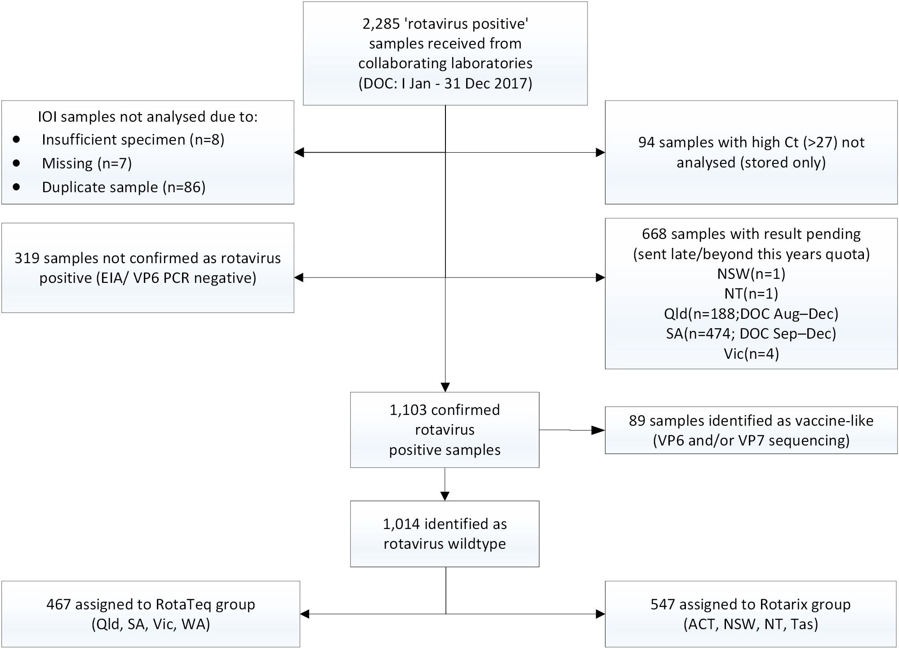
Viral RNA was extracted from 10%–20% faecal extracts using the QIAamp Viral RNA mini extraction kit (Qiagen), according to the manufacturer’s instructions. Rotavirus G- and P- genotypes were determined using an in-house hemi-nested multiplex RT-PCR assay. The first round RT-PCR reactions were performed using the Qiagen One Step RT-PCR kit (Qiagen), using VP7 conserved primers VP7F and VP7R, or VP4 conserved primers VP4F and VP4R. The second round genotyping PCR reactions were conducted using specific oligonucleotide primers for G types G1, G2, G3, G4, G8, and G9, or P types P[4], P[6], P[8], P[9], P[10], and P[11].^{13–16} The G- and P- genotype of each sample was assigned using agarose gel analysis of second round PCR products.
The VP7 and VP4 nucleotide sequence from PCR non-typeable samples was determined by Sanger sequencing, as the primers used in the current G-typing protocol could not assign a genotype to equine-like G3, G12, and unusual or uncommon rotavirus strains. Suspect vaccine excretion cases from RotaTeq states that could not be P-typed, or G1P[8] strains from infants within the age range of recent vaccination in Rotarix states were also sequenced. First round VP7 or VP4 amplicons were purified for sequencing by using the Wizard SV Gel for PCR Clean-Up System (Promega), according to the manufacturer’s protocol. Purified DNA together with oligonucleotide primers (VP7F/R or VP4F/R) were sent to the Australian Genome Research Facility, Melbourne, and sequenced using an ABI PRISM BigDye Terminator Cycle Sequencing Reaction Kit (Applied Biosystems) in an Applied Biosystems 3730xl DNA Analyzer (Applied Biosystems). Sequences were edited with Sequencher v.4.10.1. Genotype assignment was determined using BLAST (http://blast.ncbi.nlm.nih.gov/Blast.cgi) and RotaC v2.0 (http://rotac.regatools.be).¹⁷
Samples sent or identified as vaccine-like were confirmed for vaccine by amplifying a portion of the inner capsid VP6 gene, using human Rot3/Rot5 primers and Superscript III One-Step RT-PCR System with Platinum Taq DNA Polymerase (Invitrogen), as previously described.^{18,19}
This report presents data on samples collected from 1 January to 31 December 2017 from ACT, NSW, Tas, Vic, WA, and from 1 January 2017 – 31 August 2017 in Qld and SA (Figure 2). No samples were received from NT for the period of 1 June – 31 December. Due to an overwhelming number of samples being sent to the NRRC for 2017 (most received after February 2018), any additional samples from Qld, SA or NT could not be included in this report, as they failed to be received within the reporting cycle required for the Program. Therefore, data presented in this report for the full calendar year is limited to ACT, NSW, and Tasmania for the states and territories that administered Rotarix in the NIP for the full 12 months in 2017 (herein referred to as Rotarix group), and WA/Vic for states that changed to Rotarix on 1 July 2017 (referred to as RotaTeq group).
Figure 2: Rotavirus vaccine distribution in the Australian NIP and collaborator locations
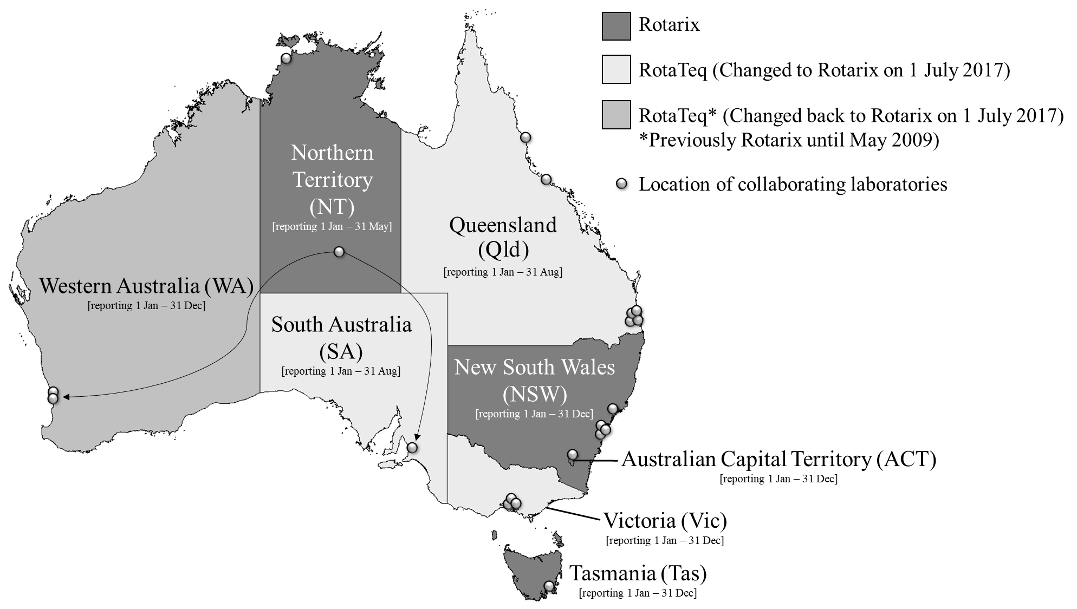

Results

Number of isolates
A total of 2,285 rotavirus positive faecal specimens were sent to the NRRC during the period 1 January to 31 December 2017, for genotyping analysis (Figure 1). Samples with suspected low viral loads (n=94) were stored without analysis, as genotypes could not be consistently assigned to samples with low viral load/high Ct (Ct>27). A further 420 samples were not analysed due to samples being insufficient (n=8), missing (n=7), duplicate (n=86), or could not be confirmed as rotavirus positive by EIA (n=319). Additionally, 668 samples could not be processed due to time and resource limitations. The samples were stored for later analysis as required.
In 2017, 1,103 rotavirus positive samples from patients clinically diagnosed with acute gastroenteritis were identified. For analysis, these samples were divided based on whether a sample had no vaccine component identified (described herein as “wildtype rotavirus”) or had a vaccine component identified based on VP6 or VP7 sequence analysis (“vaccine-like”). A total of 1,014 samples were confirmed as wildtype rotavirus positive by RT-PCR analysis. Of these, 449 were collected from children ≤5 years of age, and 490 were from older children and adults. Samples with no age data (n=75) were analysed as part of the older children/adults group. In addition, 89 samples were identified as rotavirus vaccine-like by VP6 and/or VP7 sequencing.

Wildtype rotavirus specimens:

Age distribution for wildtype rotavirus infections
From 1 January to 31 December 2017, 47.8% (n=449/939) of rotavirus positive samples with age data were obtained from children ≤5 years of age (Table 1). Of the children ≤5 years of age subset, over a third of all samples (36.5%) (n=164/449) were identified in children 13–24 months old, while the next most common age group was 25–36 months where 22.3% (n=100/449) of cases were found.
In addition, 35.2% (n=331/939) of all samples were from individuals ≥20 years of age.

Table 1: Age distribution of rotavirus wildtype gastroenteritis cases
Age  (months) | Age  (years) |  | n |  | % of total |  | % ≤5 years of age
0–6 |  |  | 44 |  | 4.7 |  | 9.8
7–12 | ≤1 |  | 49 |  | 5.2 |  | 10.9
13–24 | 1–≤2 |  | 164 |  | 17.5 |  | 36.5
25–36 | 2–≤3 |  | 100 |  | 10.6 |  | 22.3
37–48 | 3–≤4 |  | 48 |  | 5.1 |  | 10.7
49–60 | 4–≤5 |  | 44 |  | 4.7 |  | 9.8
Subtotal |  |  | 449 |  | 47.8 |  | -
61–120 | 5–≤10 |  | 92 |  | 9.8
121–240 | 10–≤20 |  | 67 |  | 7.1
241–960 | 20–≤80 |  | 258 |  | 27.5
961+ | >80 |  | 73 |  | 7.8
Totalª |  | 939 |  | -
a Excluding 75 specimens with unknown age

Wildtype rotavirus genotype distribution
Genotype analysis was performed on the 1,014 confirmed rotavirus positive cases from children and adults (Table 2). G2P[4] was the most common genotype identified nationally, representing 39% of all specimens analysed. This genotype was identified as the dominant genotype in NT, SA, Tas, and WA, representing 99%, 68%, 40%, and 66% of strains respectively.

Table 2: Rotavirus G- and P- genotype distribution in infants, children and adults, 1 January to 31 December 2017
Centre | Type total | G1P[8] |  | G2P[4] |  | G3P[8] |  | G3P[8]ª |  | G8P[8] |  | G9P[8] |  | G12P[8] |  | Other^{b} |  | Non-type^{c}
 |  | % | n | % | n | % | n | % | n | % | n | % | n | % | n | % | n | % | n
ACT | 19 | - | 0 | - | 0 | 11 | 2 | 84 | 16 | 5 | 1 | - | 0 | - | 0 | - | 0 | - | 0
New South Wales | 363 | 1 | 4 | 9 | 32 | 7 | 25 | 51 | 185 | 25 | 91 | 3 | 12 | <1 | 1 | 2 | 9 | 1 | 4
Northern Territory^{d} | 100 | - | 0 | 99 | 99 | - | 0 | - | 0 | - | 0 | - | 0 | - | 0 | 1 | 1 | - | 0
Queensland | 56 | 2 | 1 | 9 | 5 | 20 | 11 | - | 0 | 13 | 7 | 32 | 18 | - | 0 | 5 | 3 | 20 | 11
South Australia | 112 | 2 | 2 | 68 | 76 | 13 | 15 | 5 | 6 | 4 | 4 | 1 | 1 | - | 0 | 4 | 4 | 4 | 4
Tasmania | 65 | 2 | 1 | 40 | 26 | 3 | 2 | 48 | 31 | 2 | 1 | - | 0 | - | 0 | 5 | 3 | 2 | 1
Victoria | 70 | 4 | 3 | 9 | 6 | 4 | 3 | 10 | 7 | 43 | 30 | 6 | 4 | 14 | 10 | 9 | 6 | 1 | 1
Western Australia | 229 | 1 | 3 | 66 | 151 | 12 | 27 | 4 | 10 | 14 | 32 | 1 | 2 | <1 | 1 | 1 | 2 | <1 | 1
Total | 1,014 | 1 | 14 | 39 | 395 | 8 | 85 | 25 | 255 | 16 | 166 | 4 | 37 | 1 | 12 | 3 | 28 | 2 | 22
a Equine-like G3P[8]
b See Table 3
c A specimen where G- and/or P- genotype was not determined
d Specimens collected in NT were received from interstate laboratories in SA (SA Pathology; n=25) and WA (PathWest Laboratory Medicine/Western Diagnostics Pathology; n=75)

A previously described equine-like G3P[8] strain^{20,21} was the second most common genotype found in Australia, representing 25% of all strains nationally (Table 2). The majority of these equine-like G3P[8] samples were found in NSW, representing 51% of all strains identified within the state. Equine-like G3P[8] was the dominant genotype identified in Tasmania, representing 48% of all strains identified in that state. G8P[8] was the third most common genotype identified nationally, representing 16% of all specimens. G8P[8] was dominant in Victoria, representing 43% of the state total, and was the second dominant genotype in NSW (25% of all genotypes identified in NSW). Other common genotypes identified nationally in 2017 included G3P[8] (8%), G9P[8] (4%), G1P[8] (1%) and G12P[8] (1%).
Twenty-eight (3% of rotavirus positive) specimens were identified as ‘other’, listed in Table 3. G4P[8], an otherwise globally common strain, was detected in NSW (n=3) and Tas (n=2). Whilst one sample was of mixed genotype (G1/G3P[8]), the remaining 22 samples represented 10 uncommon rotavirus genotypes. Seven of these strains included unusual combinations, such as G2P[8], G3P[4], G3P[6], Equine-like G3P[6], G6P[8], G9P[4], and G9P[9]. The remaining were represented by strains that contained an animal VP7 and/or VP4 component. Feline/canine-like G3P[3] was identified in one sample from the NT, feline/canine-like G3P[9] were identified in two samples in Vic, while bovine-like G8P[1] (n=1) was identified in NSW.

Table 3: Mixed and unusual G- and P- genotypes identified in infants, children and adults, 1 January to 31 December 2017
Genotype | RotaTeq |  |  |  | Rotarixª |  |  | Total
 | Qld | SA | Vic | WA | NSW | NT | Tas
EqG3P[6] | - | - | 1 | - | - | - | - | 1
G2P[8] | - | 1 | - | 1 | 1 | - | - | 3
G3P[3] feline/canine | - | - | - | - | - | 1 | - | 1
G3P[4] | - | - | 1 | - | - | - | - | 1
G3P[6] | - | - | 1 | - | - | - | - | 1
G3P[9] feline/canine | - | - | 2 | - | - | - | - | 2
G4P[8] | - | - | - | - | 3 | - | 2 | 5
G6P[8] | - | - | 1 | - | - | - | - | 1
G8P[1] | - | - | - | - | 1 | - | - | 1
G9P[4] | 1 | 3 | - | 1 | 4 | - | 1 | 10
G9P[9] | 1 | - | - | - | - | - | - | 1
MIXED G1/G3P[8] | 1 | - | - | - | - | - | - | 1
Total | 3 | 4 | 6 | 2 | 9 | 1 | 3 | 28
a ACT values are not shown since no ACT detections of these genotypes were made.

Genotypes identified in samples from children ≤5 years of age
449 wildtype rotavirus samples in total were collected from children ≤5 years of age (Table 4). Within this subset, G2P[4] was the most common genotype identified, found in 32% of all samples. Equine-like G3P[8] was the second most common genotype (29%), and G8P[8] strains were the third most common genotype (16%). G1P[8], G3P[8], G9P[8], and G12P[8], represented minor genotypes, identified in 1–10% of all genotypes. (Table 4).

Table 4: Rotavirus G- and P- genotype distribution in infants and children ≤5 years of age, 1 January to 31 December 2017
Centre | Type  total | G1P[8] |  | G2P[4] |  | G3P[8] |  | G3P[8]ª |  | G8P[8] |  | G9P[8] |  | G12P[8] |  | Other^{b} |  | Non-type^{c}
 |  | % | n | % | n | % | n | % | n | % | n | % | n | % | n | % | n | % | n
ACT | 16 | - | 0 | - | 0 | 13 | 2 | 88 | 14 | - | 0 | - | 0 | - | 0 | - | 0 | - | 0
New South Wales | 165 | 1 | 2 | 10 | 16 | 6 | 10 | 56 | 93 | 20 | 33 | 3 | 5 | - | 0 | 2 | 4 | 1 | 2
Northern Territory | 19 | - | 0 | 95 | 18 | - | 0 | - | 0 | - | 0 | - | 0 | - | 0 | 5 | 1 | - | 0
Queensland | 32 | - | 0 | - | 0 | 22 | 7 | - | 0 | 13 | 4 | 41 | 13 | - | 0 | 6 | 2 | 19 | 6
South Australia | 30 | 3 | 1 | 63 | 19 | 17 | 5 | 10 | 3 | - | 0 | - | 0 | - | 0 | - | 0 | 7 | 2
Tasmania | 22 | 0 | 0 | 27 | 6 | 5 | 1 | 55 | 12 | 5 | 1 | - | 0 | - | 0 | 5 | 1 | 5 | 1
Victoria | 42 | 5 | 2 | 10 | 4 | 5 | 2 | 7 | 3 | 45 | 19 | 7 | 3 | 14 | 6 | 7 | 3 | - | 0
Western Australia | 123 | 2 | 3 | 66 | 81 | 14 | 17 | 4 | 5 | 11 | 13 | 1 | 1 | - | 0 | 2 | 2 | 1 | 1
Total | 449 | 2 | 8 | 32 | 144 | 10 | 44 | 29 | 130 | 16 | 70 | 5 | 22 | 1 | 6 | 3 | 13 | 3 | 12
a Equine-like G3P[8]
b See Table 3
c A specimen where G- and/or P- genotype was not determined

Genotypes identified in samples from individuals >5 years of age
A total of 565 rotavirus samples were collected from children >5 years, adults, and patients with an unknown age (n=76) (Table 5). As with the ≤5 years of age group, G2P[4] was the main genotype identified (44%), followed by equine-like G3P[8] (22%) and G8P[8] (17%).

Table 5: Rotavirus G- and P- genotype distribution in children >5 years of age and adults, 1 January to 31 December 2017
Centre | Type  total | G1P[8] |  | G2P[4] |  | G3P[8] |  | G3P[8]ª |  | G8P[8] |  | G9P[8] |  | G12P[8] |  | Other^{b} |  | Non-type^{c}
 |  | % | n | % | n | % | n | % | n | % | n | % | n | % | n | % | n | % | n
ACT | 3 | - | 0 | - | 0 | - | 0 | 67 | 2 | 33 | 1 | - | 0 | - | 0 | - | 0 | - | 0
New South Wales | 198 | 1 | 2 | 8 | 16 | 8 | 15 | 46 | 92 | 29 | 58 | 4 | 7 | 1 | 1 | 3 | 5 | 1 | 2
Northern Territory | 81 | - | 0 | 100 | 81 | - | 0 | - | 0 | - | 0 | - | 0 | - | 0 | - | 0 | - | 0
Queensland | 24 | 4 | 1 | 21 | 5 | 17 | 4 | - | 0 | 13 | 3 | 21 | 5 | - | 0 | 4 | 1 | 21 | 5
South Australia | 82 | 1 | 1 | 70 | 57 | 12 | 10 | 4 | 3 | 5 | 4 | 1 | 1 | - | 0 | 5 | 4 | 2 | 2
Tasmania | 43 | 2 | 1 | 47 | 20 | 2 | 1 | 44 | 19 | - | 0 | - | 0 | - | 0 | 5 | 2 | - | 0
Victoria | 28 | 4 | 1 | 7 | 2 | 4 | 1 | 14 | 4 | 39 | 11 | 4 | 1 | 14 | 4 | 11 | 3 | 4 | 1
Western Australia | 106 | - | 0 | 66 | 70 | 9 | 10 | 5 | 5 | 18 | 19 | 1 | 1 | 1 | 1 | - | 0 | - | 0
Total | 565 | 1 | 6 | 44 | 251 | 7 | 41 | 22 | 125 | 17 | 96 | 3 | 15 | 1 | 6 | 3 | 15 | 2 | 10
a Equine-like G3P[8]
b See Table 3
c A specimen where G- and/or P- genotype was not determined

Distribution of genotypes according to vaccine tendered in children ≤5 years of age
G- and P- genotypes of the 449 wildtype rotavirus samples were divided according to vaccine use (Figure 3). In states where RotaTeq was in use, G2P[4] was the dominant strain overall, representing 46%, compared to 18% in Rotarix states/territories. G8P[8] was the second most common genotype identified, representing 16% of all genotypes identified in RotaTeq states. However, in states and territories that used Rotarix, Equine-like G3P[8] was the dominant strain, representing 54%, compared to 5% in RotaTeq states (Figure 3).

Figure 3: Overall distribution of wildtype rotavirus G- and P- genotypes identified in Australian children ≤5 years of age, based on vaccine useª, Australia, 1 January to 31 December 2017
RotaTeqa states
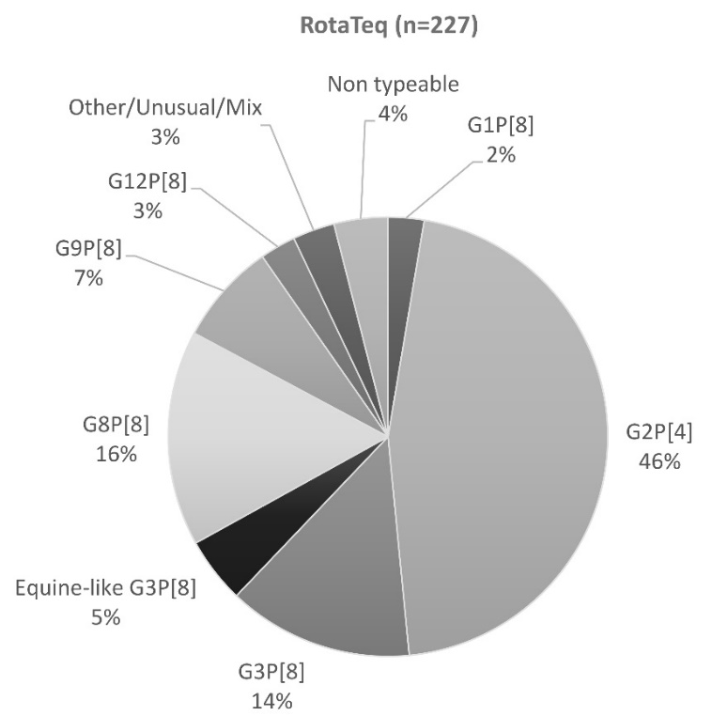
Rotarix states and territories
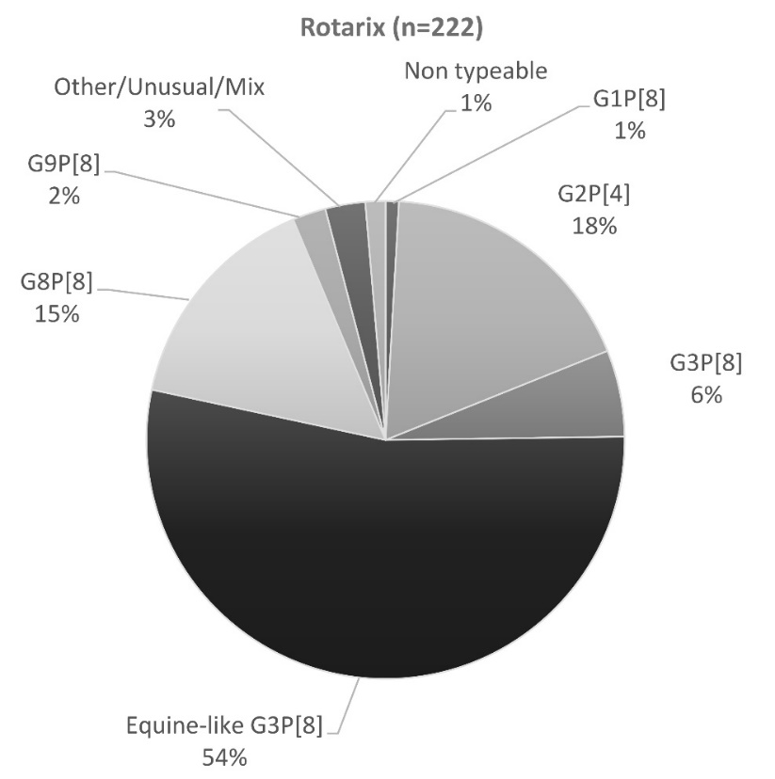
a Australian NIP changed to Rotarix exclusively on 1 July, 2017

On 1 July 2017, Rotarix replaced RotaTeq in WA, Vic, SA, and Qld. After 1 July 2017, all states and territories of Australia exclusively used Rotarix vaccine against rotavirus under the NIP. To identify if the change in vaccination schedule could have had an impact on genotype distribution, further analysis based on date of collection was performed (Figure 4). Although samples were not able to be analysed for the full 6 months after the change from RotaTeq to Rotarix in all four states affected (Queensland, SA, Victoria, and WA) there was a good representation of data from Victoria and WA. In addition, no samples were received from NT for the period of 1 Jun – 31 Dec, therefore data presented in this report for this period is limited to ACT, NSW, and Tasmania for the states and territories that administered Rotarix in the NIP for the full 12 months in 2017. In states where RotaTeq was in use from Jan to Jun, 2017, G2P[4] strains were the dominant genotype in children ≤5 years, identified in 63% of samples, however after the change to Rotarix in July, G2P[4] reduced to 16% (Jul–Dec 2017). However, a similar decrease in G2P[4] strains was observed in jurisdictions that used Rotarix for the whole year, from 56% for the period of Jan–Jun, to 7% in Jul–Dec. In the states that used Rotarix for the full 12 months in 2017, the decrease in G2P[8] strains coincided with an increase of equine-like G3P[8], from 23% (Jan–Jun) to 62% (Jul–Dec). In contrast, equine-like G3P[8] maintained low levels of circulation (≤6%) between Jan–Jun and Jul–Dec in states that changed vaccines in July. An increase in G8P[8] strains was observed in all states and territories irrespective of vaccine used, from ≤4% in Jan–Jun, to 39% and 18% in Jul–Dec respectively (Figure 4).

Figure 4: Overall distribution of wildtype rotavirus G- and P- genotypes identified in Australian children ≤5 years of age, based on vaccine usage, Australia, 1 January to June, and 1 July to 31 December, 2017
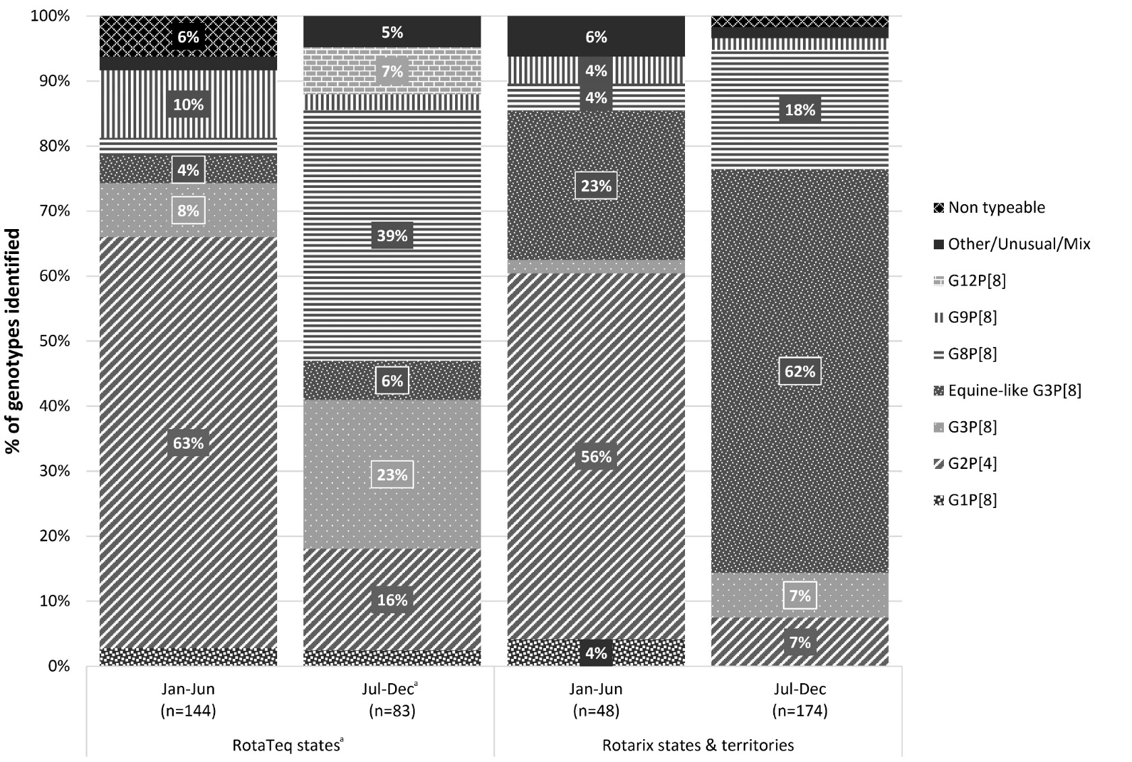
a NIP across Australia changed to Rotarix exclusively from 1st July, 2017.
Note: No samples have been processed after August in RotaTeq states Qld and SA. The majority of RotaTeq samples are represented by WA and Victoria, for which complete year analysis has been performed. Northern Territory represents data from Jan–May, as no samples after May 2017 were received for this reporting period.

Vaccine-like rotavirus specimens:

Age distribution for rotavirus vaccine cases
During the 2017 reporting period, 89 samples were identified as rotavirus vaccine by VP6 and/or VP7 sequencing. 97.8% of these were from the 0–6 months of age group, while 2.2% were from 7–12 month old patients.

Genotype distribution of specimens containing rotavirus vaccine component
The 89 samples that had sequence confirmation of vaccine-like VP6 and/or VP7 were processed further for genotype analysis (Table 6). All samples identified as Rotarix (n=33) were genotyped as G1P[8], while RotaTeq samples (n=56) had more varied genotype combinations, due to the pentavalent nature of the vaccine. Single genotypes were identified in 49 samples, including G1, G4, and G6 with either a P[8] or P non-typeable (P[nt]). Note that G6 samples had to be sequence-confirmed, as primers for this bovine vaccine component are not included in the routine G-typing primer mix. Other combinations included various mixed G-types that contained two to three of all human virus components (G1, G3, and G4) of the RotaTeq vaccine, with either P[8] or P[nt]. Fully non-typeable genotype results were attributed to 4 samples.

Table 6: Rotavirus G- and P- genotypes identified in rotavirus vaccine-like cases
 |  | P[8] | P[nt]
Rotarix | G1 (Rix) | 33 | -
RotaTeq | G1 | 13 | 17
 | G4 | 10 | 4
 | G1/G4 | 2 | 2
 | G1/G6 (VP7 seq) |  | 1
 | G1/G3/G4 | 1
 | G4/G6 (VP7 seq) | 1
 | G6 (VP7 seq) | 1
 | G nt |  | 4

The majority of these P[nt] samples were most likely due to the bovine P[5] component of the RotaTeq vaccine, for which a separate hemi-nested RT-PCR with specific bovine primers would have had to be used to identify the P[5] component. Due to time constraints, this was not performed for these samples.

Discussion
This 2017 Australian Rotavirus Surveillance Program report describes the distribution of rotavirus genotypes and geographic differences of rotavirus strains causing disease in Australia, for the period of 1 January to 31 December 2017. During this surveillance period, three genotypes were attributed to multiple large outbreaks across Australia: G2P[4] (in NT, SA, and WA primarily), equine-like G3P[8] (in NSW), and G8P[8] (in NSW and Victoria), representing 39%, 25%, and 16% of all strains identified respectively. Furthermore, rotavirus was also reported by collaborators as the cause of multiple outbreaks in childcare and elderly residential facilities, indicating that vaccine eligible and ineligible (due to age) groups are also at risk of developing severe rotavirus infections.
In Australia, G2P[4] strains have previously caused a substantial disease burden after vaccine introduction to the Australian NIP, particularly in states and territories that administered Rotarix throughout 2017. Furthermore, G2P[4] was associated with an outbreak in the Northern Territory (2009), despite Rotarix vaccine inclusion in the NIP.^{22,23} During this reporting period, the prevalence of G2P[4] had increased when compared to the previous year, where it was the dominant genotype (39% of all strains identified in 2017, compared to 29% in 2016).²⁴ Recently, G2P[4] has also increased in other countries such as Sweden, Japan, Brazil, and China.^{25–28} Although G2P[4] is currently circulating in both countries with and without rotavirus vaccine in their NIP, the question remains why this genotype causes such a burden in countries where rotavirus vaccines are available.^{25,28–30} An increased proportion of G2P[4] strains have also been reported in Belgium, Brazil, and Scotland, after introduction of the Rotarix vaccine.^{30–32} Indeed, a Belgium study described higher incidence rates of G2P[4] in vaccinated hospitalised cases compared to unvaccinated hospitalised cases.³¹ Lower effectiveness and waning heterotypic response afforded by Rotarix could have contributed to a decrease in herd immunity to this genotype.²² However, G2P[4] strains also accounted for 46% of strains genotyped in states utilising the RotaTeq vaccine during this reporting period. A comparison of the RotaTeq component strain that was isolated in 1992, and G2P[4] strains circulating globally over the last decade, revealed substitutions in antigenic regions.³³ Thus, if current strains continue to accumulate mutations in antigenic regions, both rotavirus vaccines may need to be updated in order to maintain effectiveness.
Equine-like G3P[8] and G8P[8] also caused significant disease in Australia during this reporting period. Equine-like G3P[8] had previously been described as a dominant strain in Australia, primarily in states and territories that use Rotarix, however G8P[8] was considered a rare or unusual genotype in Australia.^{20,34} These two genotypes have recently emerged as either a predominant strain, or have caused outbreaks in other countries. For example, G8P[8] emerged after 2014 in Thailand, Vietnam, and caused outbreaks in Central Japan in 2014 and 2017.^{35–40} Equine-like G3P[8] (or P[4]) also emerged after 2014 as a predominant strain in Germany, Hungary, Indonesia, Japan, and Spain.^{40–45} Thus, the circulation of these strains in Australia reflect global patterns, and not unusual changes unique to Australia.
As reported previously, the diversity of rotavirus genotypes in Australia since vaccine introduction has increased, with the emergence of more unusual zoonotic strains and novel genotypes in the post-vaccine introduction era.³⁴ During this reporting period, several animal-like genotypes were detected across all states and territories, including feline/canine-like G3P[3] (or P[9]), G3P[6], G6P[8], G8P[8], and G8P[1]. These unusual combinations have become more frequent during the past few years, and demonstrate that rotavirus genotype diversity is unpredictable, constantly evolving, and causes unique challenges to any rotavirus vaccination programs that are in effect. Indeed, rotavirus vaccination did not protect against the severity and magnitude of the G8P[8] outbreak in Japan, however, it did play a crucial role in limiting disease severity.³⁵ Not only were paediatric hospitalisations and outpatient visits due to acute gastroenteritis reduced, vaccine introduction also elicited a herd protection effect in older age groups.⁴⁶
During this reporting period, it was observed that children aged 13–24 months of age, and adults ≥20 years of age, were commonly affected by symptomatic rotavirus infection. Rotavirus associated outbreaks in elderly residential homes were reported to the NRRC by collaborators. This shift in age towards an older population, compared to vaccine-eligible age groups, is not a new observation in Australia; and has also been reported in China, Brazil, Finland, Sweden, and Japan.^{25–27,47} A study in China demonstrated the importance of infected children as reservoirs that sustain circulation of rotavirus in adults, where rotavirus infection from child-to-adult transmission was the most important epidemiological setting that impacted on public health.²⁷ Thus, the question is raised whether current licensed rotavirus vaccinations could be considered for other age groups such as the elderly, in order to reduce rotavirus disease burden not only in Australia, but globally.²⁶
Vaccine strains were detected less frequently in 2017 than in previous years. Due to the large quantity of samples that were sent for 2017, the request was made that previously identified vaccine-like strains (i.e. South Australia collaborators screening for RotaTeq by RT-qPCR) would not be sent or analysed as part of the 2017 ARSP. Another reason why this proportion has reduced may be that samples with a Ct higher than 27 would not be sent or analysed, as samples with such high Ct values were commonly too difficult to genotype, or were found to be associated with rotavirus vaccine secretion after recent vaccination.⁴⁸
Sequence confirmation of vaccine-like samples (i.e. G1P[8], G1/G3/G4 with P[8] or P[nt]) is important, otherwise the prevalence of wildtype infections involving either G1P[8], G3P[8], or G4P[8] could be over represented. Indeed, since vaccine introduction in the Australian NIP, common genotypes such as G1, G3, and G4 have drastically dropped in prevalence, emphasising the beneficial effect of rotavirus vaccines.³⁴ Although multiple outbreaks and high incidence of rotavirus was reported for 2017, rotavirus vaccines have still significantly reduced the disease burden in Australia, and in other countries that have introduced rotavirus vaccines into their NIP.^{11,46,47} This year marked an important change in the Australian NIP, from including both RotaTeq and Rotarix in the vaccine schedule in different states and territories, to exclusively Rotarix Australia-wide on 1 July 2017.⁹ However, potential changes in rotavirus distribution and diversity as a result of this change will most likely not be seen until at least three years have passed, as seen previously when Western Australia changed from Rotarix to RotaTeq in 2009.³⁴ Continued monitoring of rotavirus distribution and diversity is required, to inform vaccination programs how the ever-changing epidemiology of rotavirus strains will challenge vaccine effectiveness.
In this 2017 annual report, an increase in rotavirus disease caused by G2P[4], equine-like G3P[8], and G8P[8] was described. G2P[4] was the dominant genotype for the second year in a row, while equine-like G3P[8] continued to cause significant disease burden in Australia. All samples collected from Australian Capital Territory, New South Wales, Tasmania, Victoria, and Western Australia (1 Jan to 31 Dec) were analysed and included in this report. Due to an overwhelming number of samples being sent to the NRRC for 2017 (most received after February 2018), this report reflects samples collected from 1 Jan – 31 Aug for Queensland and South Australia. Samples were not available from Northern Territory for the period of 1 Jun – 31 Dec 2017. The data from 2018 which marks the first full 12 months after change to Rotarix vaccine in all states and territories will provide the first indication of the impact this change may have had on circulating rotavirus strains. However, based on previous observations from the pre- and post-rotavirus vaccine introduction eras in Australia, these trends may take 5 to 10 years to become clear.³⁴

Acknowledgements
The Australian Rotavirus Surveillance Program is supported by grants from the Australian Government Department of Health, GlaxoSmithKline Biologicals SA [Study#116120] and Seqirus (bioCSL) Australia. The Murdoch Children’s Research Institute (MCRI) is supported by the Victorian Government’s Operational Infrastructure Support program. GlaxoSmithKline Biologicals SA was provided the opportunity to review a preliminary version of this manuscript for factual accuracy but the authors are solely responsible for final content and interpretation. The authors received no financial support or other form of compensation related to the development of the manuscript.
We thank H Tran and N Bogdanovic for providing technical assistance.
Rotavirus positive specimens were collected from numerous centres throughout Australia. The significant time and effort involved in the collection, storage, packaging, compiling data and forwarding of specimens was much appreciated.
The National Rotavirus Surveillance Group includes:
The Australian National Rotavirus Reference Centre Australian Rotavirus Surveillance Program Central Laboratory Murdoch Children’s Research Institute, Parkville, Victoria
Mrs Susie Roczo-Farkas; Coordinator, Research Assistant, Enteric Disease Group, Murdoch Children’s Research Institute
Prof Julie Bines; Group Leader, Enteric Disease Group, Murdoch Children’s Research Institute
Dr. Daniel Cowley; Research Officer, Enteric Disease Group, Murdoch Children’s Research Institute

Australian Capital Territory
Ms S. Bradbury, Ms E. Malinsky, and members of members of the Microbiology Department, Canberra Hospital

New South Wales
Prof W. Rawlinson, Prof. M. Lahra, Mr J. Merif, and members of the Virology Division, SEALS, Prince of Wales Hospital
Dr A. Kesson, Ms I. Tam, and members of the Virology Department, The Children’s Hospital at Westmead
Dr V. Sintchenko, T. Olna, Centre for Infectious Diseases and Microbiology, Westmead Hospital
Dr R. Givney, S. Pearce, K. Delves, and members of the Microbiology Department, John Hunter Hospital, Newcastle
Mr D. Spence and members of the Microbiology Department, Pathology North Central Coast, Gosford
Dr M. Wehrhahn and members of Douglas Hanly Moir Pathology, New South Wales

Northern Territory
Dr M. Karimi and members of the Department of Microbiology, Western Diagnostics Pathology, Perth, Western Australia
Ms H. Cook, Centre for Disease Control, Darwin

Queensland
Mr F. Moore, Ms J. McMahon, Forensic and Scientific Services, Queensland Health, Herston
Dr G. Nimmo, Dr C. Bletchly, Ms N. George, and department members, Microbiology Division, Pathology Queensland Central laboratory, Herston
Dr S. Lambert and members of the Queensland Paediatric Infectious Diseases laboratory, Royal Children’s Hospital, Brisbane
Dr L Dang and members of Microbiology Department, Sullivan Nicolaides Pathology, Fortitude Valley
Ms G. Gilmore and members of the Queensland Health laboratory, Townsville

South Australia
Prof G. Higgins, Ms S. Schepetiuk, and members of the Microbiology and Infectious Diseases Laboratory SA Pathology, Adelaide

Tasmania
Dr J. Williamson and members of Molecular Medicine, Pathology Services, Royal Hobart Hospital, Hobart, Tasmania

Victoria
Prof J. Buttery, Mrs D. Kotsanas, and members of the Department of Microbiology, Monash Medical Centre, Clayton
Miss P. Adamopolous and members of the Serology Department, Royal Children’s Hospital, Parkville
E. Hrysoudis, F. Gray, R. Quach, and members of the Molecular Infectious Department, Australian Clinical Labs, Clayton

Western Australia
Prof D Smith, Dr A Levy, Mrs J Lang, and members of QEII Microbiology Department, PathWest Laboratory Medicine WA, Perth

Author details
Mrs Susie Roczo-Farkas¹
Dr Daniel Cowley¹
Prof Julie E Bines^{1,2,3} and the Australian Rotavirus Surveillance Group
- Enteric Diseases Group, Murdoch Children’s Research Institute, Flemington Road, Parkville, Victoria, 3052.
- Department of Paediatrics, University of Melbourne Flemington Road, Parkville, Victoria, 3052.
- Department of Gastroenterology and Clinical Nutrition Flemington Road, Parkville, Victoria, 3052.

Corresponding Author
Mrs Susie Roczo-Farkas Enteric Diseases Group, Level 5, Murdoch Children’s Research Institute Flemington Road Parkville, Victoria, 3052. Ph: 03 8341 6383 Email: susie.roczofarkas@mcri.edu.au

References
- Estes M, Kapikian A. Rotaviruses. In: Fields virology, 5th ed. Philadelphia: Wolters Kluwer Health/Lippincott Williams & Wilkins; 2007, vol. 1. p. 1917–74.
- Moussa A, Fredj MBH, BenHamida-Rebaï M, Fodha I, Boujaafar N, Trabelsi A. Phylogenetic analysis of partial VP7 gene of the emerging human group A rotavirus G12 strains circulating in Tunisia. J Med Microbiol. 2017;66(2):112–8.
- Tate JE, Burton AH, Boschi-Pinto C, Parashar UD. Global, Regional, and National Estimates of Rotavirus Mortality in Children <5 Years of Age, 2000–2013. Clin Infect Dis. 2016;62(Suppl 2):S96–105.
- Parashar UD, Gibson CJ, Bresee JS, Glass RI. Rotavirus and severe childhood diarrhea. Emerg Infect Dis. 2006;12(2):304–6.
- Vesikari T, Matson DO, Dennehy P, Van Damme P, Santosham M, Rodriguez Z, et al. Safety and efficacy of a pentavalent human-bovine (WC3) reassortant rotavirus vaccine. N Engl J Med. 2006;354(1):23–33.
- Ruiz-Palacios GM, Pérez-Schael I, Velázquez FR, Abate H, Breuer T, Clemens SC, et al. Safety and efficacy of an attenuated vaccine against severe rotavirus gastroenteritis. N Engl J Med. 2006;354(1):11–22.
- IVB/WHO. Vaccine in National Immunization Programme Update [Available from: www.who.int/immunization/monitoring_surveillance/VaccineIntroStatus.pptx?ua=1 ].
- Buttery JP, Lambert SB, Grimwood K, Nissen MD, Field EJ, Macartney KK, et al. Reduction in rotavirus-associated acute gastroenteritis following introduction of rotavirus vaccine into Australia’s National Childhood vaccine schedule. Pediatr Infect Dis J. 2011;30(1 Suppl):S25–9.
- Health AGDo. Clinical update: ATAGI advice on Rotarix® to replace RotaTeq® 2017 [Available from: https://beta.health.gov.au/news-and-events/news/clinical-update-atagi-advice-on-rotarixr-to-replace-rotateqr ].
- Macartney K, Dey A, Wang H, Quinn H, Wood N, McIntyre P. Ten years of rotavirus immunisation in Australia: sustained benefits outweigh vaccine-associated risks (Poster). In: 12th International Rotavirus Symposium; Melbourne, Australia; 2016.
- Reyes JF, Wood JG, Beutels P, Macartney K, McIntyre P, Menzies R, et al. Beyond expectations: Post-implementation data shows rotavirus vaccination is likely cost-saving in Australia. Vaccine. 2017;35(2):345–52.
- Kirkwood CD, Boniface K, Bogdanovic-Sakran N, Masendycz P, Barnes GL, Bishop RF. Rotavirus strain surveillance—an Australian perspective of strains causing disease in hospitalised children from 1997 to 2007. Vaccine. 2009;27(Suppl 5):F102–7.
- Gentsch JR, Glass RI, Woods P, Gouvea V, Gorziglia M, Flores J, et al. Identification of group A rotavirus gene 4 types by polymerase chain reaction. J Clin Microbiol. 1992;30(6):1365–73.
- Gouvea V, Glass RI, Woods P, Taniguchi K, Clark HF, Forrester B, et al. Polymerase chain reaction amplification and typing of rotavirus nucleic acid from stool specimens. J Clin Microbiol. 1990;28(2):276–82.
- Itturiza-Gómara M, Cubitt D, Desselberger U, Gray J. Amino acid substitution within the VP7 protein of G2 rotavirus strains associated with failure to serotype. J Clin Microbiol. 2001;39(10):3796–8.
- Simmonds MK, Armah G, Asmah R, Banerjee I, Damanka S, Esona M, et al. New oligonucleotide primers for P-typing of rotavirus strains: Strategies for typing previously untypeable strains. J Clin Virol. 2008;42(4):368–73.
- Maes P, Matthijnssens J, Rahman M, Van Ranst M. RotaC: a web-based tool for the complete genome classification of group A rotaviruses. BMC Microbiol. 2009;9:238.
- Donato CM, Ch’ng LS, Boniface KF, Crawford NW, Buttery JP, Lyon M, et al. Identification of strains of RotaTeq rotavirus vaccine in infants with gastroenteritis following routine vaccination. J Infect Dis. 2012;206(3):377–83.
- Elschner M, Prudlo J, Hotzel H, Otto P, Sachse K. Nested reverse transcriptase-polymerase chain reaction for the detection of group A rotaviruses. J VetMed B Infect Dis Vet Public Health. 2002;49(2):77–81.
- Cowley D, Donato CM, Roczo-Farkas S, Kirkwood CD. Emergence of a novel equine-like G3P[8] inter-genogroup reassortant rotavirus strain associated with gastroenteritis in Australian children. J Gen Virol. 2016;97(2):403–10.
- Roczo-Farkas S, Kirkwood CD, Bines JE. Australian Rotavirus Surveillance Program annual report, 2015. Commun Dis Intell Q Rep. 2016;40(4):E527–38.
- Donato CM, Cowley D, Donker NC, Bogdanovic-Sakran N, Snelling TL, Kirkwood CD. Characterization of G2P[4] rotavirus strains causing outbreaks of gastroenteritis in the Northern Territory, Australia, in 1999, 2004 and 2009. Infect Genet Evol. 2014;28:434–45.
- Kirkwood CD, Roczo-Farkas S. Australian Rotavirus Surveillance Program annual report, 2013. Commun Dis Intell Q Rep. 2014;38(4):E334–42.
- Roczo-Farkas S, Kirkwood CD, Bines JE. Australian Rotavirus Surveillance Program: Annual Report, 2016. Commun Dis Intell Q Rep. 2017;41(4):E455–71.
- Andersson M, Lindh M. Rotavirus genotype shifts among Swedish children and adults-Application of a real-time PCR genotyping. J Clin Virol. 2017;96:1–6.
- Luchs A, Madalosso G, Cilli A, Morillo SG, Martins SR, de Souza KAF, et al. Outbreak of G2P[4] rotavirus gastroenteritis in a retirement community, Brazil, 2015: An important public health risk? Geriatr Nurs. 2017;38(4):283–90.
- Wang Y, Zhang J, Liu P. Clinical and molecular epidemiologic trends reveal the important role of rotavirus in adult infectious gastroenteritis, in Shanghai, China. Infect Genet Evol. 2017;47:143–54.
- Khandoker N, Thongprachum A, Takanashi S, Okitsu S, Nishimura S, Kikuta H, et al. Molecular epidemiology of rotavirus gastroenteritis in Japan during 2014–2015: Characterization of re-emerging G2P[4] after rotavirus vaccine introduction. J Med Virol. 2018;90(6):1040–6.
- Santos VS, Marques DP, Martins-Filho PRS, Cuevas LE, Gurgel RQ. Effectiveness of rotavirus vaccines against rotavirus infection and hospitalization in Latin America: systematic review and meta-analysis. Infect Dis Poverty. 2016;5(1):83.
- Mukhopadhya I, Murdoch H, Berry S, Hunt A, Iturriza-Gomara M, Smith-Palmer A, et al. Changing molecular epidemiology of rotavirus infection after introduction of monovalent rotavirus vaccination in Scotland. Vaccine. 2017;35(1):156–63.
- Matthijnssens J, Zeller M, Heylen E, De Coster S, Vercauteren J, Braeckman T, et al. Higher proportion of G2P[4] rotaviruses in vaccinated hospitalized cases compared with unvaccinated hospitalized cases, despite high vaccine effectiveness against heterotypic G2P[4] rotaviruses. Clin Microbiol Infect. 2014;20(10):O702–10.
- Luchs A, Cilli A, Morillo SG, Carmona Rde C, Timenetsky Mdo C. Rotavirus genotypes circulating in Brazil, 2007–2012: implications for the vaccine program. Rev Inst Med Trop Sao Paulo. 2015;57(4):305–13.
- Donato CM, Zhang ZA, Donker NC, Kirkwood CD. Characterization of G2P[4] rotavirus strains associated with increased detection in Australian states using the RotaTeq(R) vaccine during the 2010–2011 surveillance period. Infect Genet Evol. 2014;28:398–412.
- Roczo-Farkas S, Kirkwood CD, Cowley D, Barnes GL, Bishop RF, Bogdanovic-Sakran N, et al. The impact of rotavirus vaccines on genotype diversity: a comprehensive analysis of 2 decades of Australian surveillance data. J Infect Dis. 2018;218(4):546–54.
- Hoque SA, Kobayashi M, Takanashi S, Anwar KS, Watanabe T, Khamrin P, et al. Role of rotavirus vaccination on an emerging G8P[8] rotavirus strain causing an outbreak in central Japan. Vaccine. 2018;36(1):43–9.
- Kondo K, Tsugawa T, Ono M, Ohara T, Fujibayashi S, Tahara Y, et al. Clinical and molecular characteristics of human rotavirus G8P[8] outbreak strain, Japan, 2014. Emerg Infect Dis. 2017;23(6):968–72.
- Hoa-Tran TN, Nakagomi T, Vu HM, Do LP, Gauchan P, Agbemabiese CA, et al. Abrupt emergence and predominance in Vietnam of rotavirus A strains possessing a bovine-like G8 on a DS-1-like background. Arch Virol. 2016;161(2):479–82.
- Tacharoenmuang R, Komoto S, Guntapong R, Ide T, Sinchai P, Upachai S, et al. Full genome characterization of novel DS-1-like G8P[8] rotavirus strains that have emerged in Thailand: reassortment of bovine and human rotavirus gene segments in emerging DS-1-like intergenogroup reassortant strains. PloS One. 2016;11(11):e0165826.
- Guntapong R, Tacharoenmuang R, Singchai P, Upachai S, Sutthiwarakom K, Komoto S, et al. Predominant prevalence of human rotaviruses with the G1P[8] and G8P[8] genotypes with a short RNA profile in 2013 and 2014 in Sukhothai and Phetchaboon provinces, Thailand. J Med Virol. 2017;89(4):615–20.
- Komoto S, Ide T, Negoro M, Tanaka T, Asada K, Umemoto M, et al. Characterization of unusual DS-1-like G3P[8] rotavirus strains in children with diarrhea in Japan. J Med Virol. 2018;90(5):890–8.
- Arana A, Montes M, Jere KC, Alkorta M, Iturriza-Gómara M, Cilla G. Emergence and spread of G3P[8] rotaviruses possessing an equine-like VP7 and a DS-1-like genetic backbone in the Basque Country (North of Spain), 2015. Infect Genet Evol. 2016;44:137–44.
- Dóró R, Marton S, Bartókné AH, Lengyel G, Agócs Z, Jakab F, et al. Equine-like G3 rotavirus in Hungary, 2015 - Is it a novel intergenogroup reassortant pandemic strain? Acta Microbiol Immunol Hung. 2016;63(2):243–55.
- Malasao R, Saito M, Suzuki A, Imagawa T, Nukiwa-Soma N, Tohma K, et al. Human G3P[4] rotavirus obtained in Japan, 2013, possibly emerged through a human-equine rotavirus reassortment event. Virus genes. 2015;50(1):129–33.
- Pietsch C, Liebert UG. Molecular characterization of different equine-like G3 rotavirus strains from Germany. Infect Genet Evol. 2018;57:46–50.
- Utsumi T, Wahyuni RM, Doan YH, Dinana Z, Soegijanto S, Fujii Y, et al. Equine-like G3 rotavirus strains as predominant strains among children in Indonesia in 2015–2016. Infect Genet Evol. 2018;61:224–8.
- Yoshikawa T, Matsuki T, Sato K, Mizuno M, Shibata M, Hasegawa S, et al. Impact of rotavirus vaccination on the burden of acute gastroenteritis in Nagoya city, Japan. Vaccine. 2018;36(4):527–34.
- Markkula J, Hemming-Harlo M, Salminen MT, Savolainen-Kopra C, Pirhonen J, Al-Hello H, et al. Rotavirus epidemiology 5–6 years after universal rotavirus vaccination: persistent rotavirus activity in older children and elderly. Infect Dis (Lond). 2017;49(5):388–95.
- Schepetiuk S, Kirkwood C, Roczo-Farkas S, Higgins G. Prevalence of RotaTeq vaccine viruses in routine faecal specimens. J Clin Virol. 2015;70:S31–2.

Communicable Diseases Intelligence
ISSN: 2209-6051 Online

Communicable Diseases Intelligence (CDI) is a peer-reviewed scientific journal published by the Office of Health Protection, Department of Health. The journal aims to disseminate information on the epidemiology, surveillance, prevention and control of communicable diseases of relevance to Australia.

Editor: Cindy Toms
Deputy Editor: Simon Petrie
Design and Production: Kasra Yousefi
Editorial Advisory Board: David Durrheim, Mark Ferson, John Kaldor, Martyn Kirk and Linda Selvey

Website: http://www.health.gov.au/cdi

Contacts
Communicable Diseases Intelligence is produced by:
Health Protection Policy Branch, Office of Health Protection, Australian Government Department of Health
GPO Box 9848, (MDP 6) CANBERRA ACT 2601

Email: cdi.editor@health.gov.au

Submit an Article
You are invited to submit your next communicable disease related article to the Communicable Diseases Intelligence (CDI) for consideration. More information regarding CDI can be found at: http://health.gov.au/cdi.
Further enquiries should be directed to: cdi.editor@health.gov.au.

This journal is indexed by Index Medicus and Medline.

Creative Commons Licence - Attribution-NonCommercial-NoDerivatives CC BY-NC-ND
© 2019 Commonwealth of Australia as represented by the Department of Health
This publication is licensed under a Creative Commons Attribution-NonCommercial-NoDerivatives 4.0 International Licence from https://creativecommons.org/licenses/by-nc-nd/4.0/legalcode (Licence). You must read and understand the Licence before using any material from this publication.

Restrictions
The Licence does not cover, and there is no permission given for, use of any of the following material found in this publication (if any):
- the Commonwealth Coat of Arms (by way of information, the terms under which the Coat of Arms may be used can be found at www.itsanhonour.gov.au);
- any logos (including the Department of Health’s logo) and trademarks;
- any photographs and images;
- any signatures; and
- any material belonging to third parties.

Disclaimer
Opinions expressed in Communicable Diseases Intelligence are those of the authors and not necessarily those of the Australian Government Department of Health or the Communicable Diseases Network Australia. Data may be subject to revision.

Enquiries
Enquiries regarding any other use of this publication should be addressed to the Communication Branch, Department of Health, GPO Box 9848, Canberra ACT 2601, or via e-mail to: copyright@health.gov.au

Communicable Diseases Network Australia
Communicable Diseases Intelligence contributes to the work of the Communicable Diseases Network Australia.
http://www.health.gov.au/cdna

All 74 samples were collected in Northern Territory, then referred to WDP for rotavirus diagnostic testing (See Figure 1)
25 samples were collected in Northern Territory, then referred to SA Pathology for rotavirus diagnostic testing (See Figure 1)

