Creutzfeldt–Jakob disease surveillance in Australia: update to December 2017
Christiane Stehmann, Shannon Sarros, Matteo Senesi, Victoria Lewis, Marion Simpson, Catriona McLean, Colin Masters and Steven Collins

Abstract
Nationwide surveillance of human prion diseases (also known as transmissible spongiform encephalopathies), the most common being Creutzfeldt–Jakob disease (CJD), is performed by the Australian National Creutzfeldt–Jakob Disease Registry (ANCJDR), based at the University of Melbourne. National surveillance encompasses the period since 1970, with prospective surveillance occurring from 1993 onwards. Over this prospective surveillance period considerable developments have occurred, especially in relation to pre-mortem diagnostics, the delineation of new disease subtypes and a heightened awareness of prion diseases in the health care setting. The surveillance practices of the ANCJDR have evolved and adapted accordingly. Since the ANCJDR began offering cerebrospinal fluid (CSF) 14-3-3 protein testing in Australia in September 1997, the annual number of referrals has steadily increased to a maximum of 508 in 2017. The number of CSF test referrals in 2017 represents a 20% increase compared to that of 2016. In 2017, there was an overall stabilisation of the annual incidence rate of confirmed prion disease in Australia at expected levels; 72 persons with suspected human prion disease were added to the national register, with 72% of all suspected CJD cases undergoing neuropathological examination. The majority of the 72 suspected cases added to the register are as of 31 December 2017 still classified as “incomplete” (47 cases), while four cases were excluded by either detailed clinical follow-up (1 case) or neuropathological examination (3 cases); 19 cases were classified as definite and two as probable prion disease. No cases of variant CJD (vCJD) were confirmed.
Keywords: Creutzfeldt–Jakob disease, prion disease, transmissible spongiform encephalopathy, disease surveillance

Introduction
The Australian National Creutzfeldt–Jakob Disease Registry (ANCJDR) was established in October 1993 at the University of Melbourne. As described previously,¹ human prion disease can arise sporadically, or from genetic or iatrogenic aetiologies. In 1993, the Allars inquiry² into the use of cadaver-derived pituitary hormones under The Australian Human Pituitary Hormone Program and the association with four medically acquired (iatrogenic) CJD (iCJD) deaths recommended broadening of the responsibilities of the nascent ANCJDR in addition to monitoring for further cases of iCJD in Australia. The monitoring of Australian iCJD cases, related to cadaveric pituitary hormone treatment for infertility or short stature, and contaminated dura mater grafts, remains one of the core objectives of the ANCJDR; however, in response to the recommendations of the Allars inquiry, the ANCJDR’s activities have evolved to encompass the surveillance of all types of CJD, including sporadic, genetic, and variant CJD (vCJD, the form related to bovine spongiform encephalopathy: BSE) and other prion diseases such as Gerstmann Sträussler–Scheinker syndrome and fatal familial insomnia.
CJD was made a notifiable disease in all states and territories of Australia as of June 2006. Most initial notifications to the ANCJDR arise through diagnostic testing undertaken at the ANCJDR; this occurs prior to Health department notification. After a preliminary review of notified cases, those deemed to be genuine suspected human prion disease undergo detailed evaluation after addition to the national surveillance register, to determine whether a case can be excluded from suspicion or can be classified as a “definite”, “probable” or “possible” prion disease case according to EUROCJD endorsed diagnostic criteria and to determine the aetiology of the illness.³
The global incidence of sporadic CJD (sCJD) is commonly reported to be 1 case per million per year; however, in most countries with long-standing surveillance systems in place, such as France and Switzerland, annual incidence rates have been consistently reported above this quoted figure.⁴ Incidence rates as high as 2.4–2.6 cases per million per year have been reported⁴ and multi-national collaborative studies support that intensity of surveillance correlates with reported incidence rates.⁵ Temporally, human prion disease incidence rates have increased in most countries, including Australia, as surveillance mechanisms are optimised and diagnostic testing capabilities improved, in parallel with a generally greater awareness of this rare disease in the health care setting.
In this report, updated national surveillance figures to 31 December 2017 are provided for all retrospective (to 1970) and prospective (from 1993) cases ascertained, including a discussion on case notifications, classifications and overall incidence. In 2017, there was stabilisation of the annual incidence rate of prion disease in Australia at expected levels with 72 persons with suspected human prion disease added to the national register and 72% of all suspected CJD cases undergoing neuropathological examination. As of 31 December, 2017, the majority of the 72 suspected cases added to the register were still classified as “incomplete” (47 cases), while four cases were excluded by either detailed clinical follow-up (one case) or neuropathological examination (three cases); 19 cases were classified as “definite” and two as “probable” prion disease; no cases of variant CJD were confirmed. Since the ANCJDR began offering cerebrospinal fluid (CSF) 14-3-3 protein testing in Australia in September 1997, the annual number of referrals has steadily increased to a maximum of 508 in 2017. The number of CSF test referrals in 2017 represents a 20% increase compared to that of 2016.

Surveillance Methods
Patients with a suspected human prion disease have been prospectively notified to the ANCJDR since 1993. From 1997 onwards, suspected cases have been increasingly notified through referral for diagnostic CSF 14-3-3 protein detection, which has become the predominant notification source. Other ascertainment mechanisms include or have included personal communications from clinicians, families, hospitals and CJD-related groups, as well as health record searches through hospitals and health departments. Once notified to the ANCJDR, referrals undergo prima facie assessment and, if the suspicion of prion disease is supported, the case is added to the register as a formally notified suspected case for continued investigation, with the aim of exclusion or classification according to EUROCJD endorsed diagnostic criteria. Investigation of registered cases can be prolonged as the ANCJDR requires next-of-kin consent to access and compile the appropriate clinical information from various health information sources to facilitate comprehensive evaluation. Response times can vary as the information can be extensive or sources numerous. Medico-demographic questionnaires are offered and forwarded to families, if they are willing to contribute, providing valuable information for analysis and evaluation.
The classification of registered cases remains as “incomplete” until all known available information is gathered and reviewed, or a definitive result from neuropathological assessment is obtained. Cases may be excluded from the register on the basis of neuropathological examination or after thorough clinical evaluation. A “definite” classification requires brain tissue examination, including immunochemistry; “probable” and “possible” cases are reliant on a specific clinical profile and diagnostic test outcomes being met as previously described.³ In keeping with previous reports, the total number of confirmed prion disease cases for 2017, including for statistical analyses, are those that have been classified as “definite” or “probable” cases during 2017.
In conjunction with surveillance responsibilities, the ANCJDR provides diagnostic platforms for ante- and post-mortem diagnostic testing for human prion diseases. The testing of CSF for the presence of a family of low molecular weight proteins called “14-3-3” has been performed weekly by the ANCJDR since 1997. This test has been readily utilised by health services and referrals have increased steadily since its introduction, resulting in 508 test referrals in 2017. As described previously, the CSF 14-3-3 Western blot test provides an increasingly larger proportion of initial notifications of suspected human prion disease to the ANCJDR each year. In 2017, the ANCJDR formally added detection of CSF total-tau protein concentrations, which is also National Association of Testing Authorities / International Laboratory Accreditation Cooperation (NATA/ILAC) accredited, for the diagnosis of CJD, while continuing to develop and transition to the powerful real time-quaking induced conversion (RT-QuIC) assay to detect the presence of misfolded prion protein in CSF. The total-tau enzyme-linked immunosorbent assay (ELISA) test is performed at the National Dementia Diagnostic Laboratories on a fortnightly basis. RT-QuIC is currently performed at the ANCJDR on demand, for research purposes only. The ANCJDR also undertakes Western blot analysis for misfolded, protease-resistant prion protein in brain and tonsil tissue from biopsies or autopsies to supplement immunohistochemical assessment, as required. Prion protein gene (PRNP) testing for sequence variations in the open reading frame, particularly proven disease-causing mutations, is performed by an external, independent provider as appropriate. The ANCJDR actively promotes all diagnostic tests to clinicians and families to achieve the most accurate diagnosis and classification of persons suspected to have prion disease.
Annual human prion disease incidence rates are calculated using direct age-standardisation, based on the 1970–2017 Australian Bureau of Statistics estimated resident population data for Australia and for each state and territory.⁶ Health information is collected through a combination of public health and surveillance responsibilities, based on the national notification of communicable diseases in observance of the National Health Security Act 2007 and Privacy Act 1988 (Cth) 16B. ANCJDR surveillance activities for 2017 were approved by the University of Melbourne Human Research Ethics Committee.

Results
Since the ANCJDR began offering diagnostic CSF 14-3-3 protein testing in Australia in September 1997, the annual number of referrals has steadily increased to a maximum of 508 in 2017 (Figure 1), representing a 20% increase compared to 2016. Figure 2 displays the geographical referral patterns of CSF 14-3-3 requests, proportionate to populations. The positive trend in CSF referral numbers reflects an increased awareness and perceived utility of the 14-3-3 diagnostic test by clinicians.

Figure 1. Annual number of diagnostic CSF 14-3-3 protein test referrals to the ANCJDR, 1997 to 2017
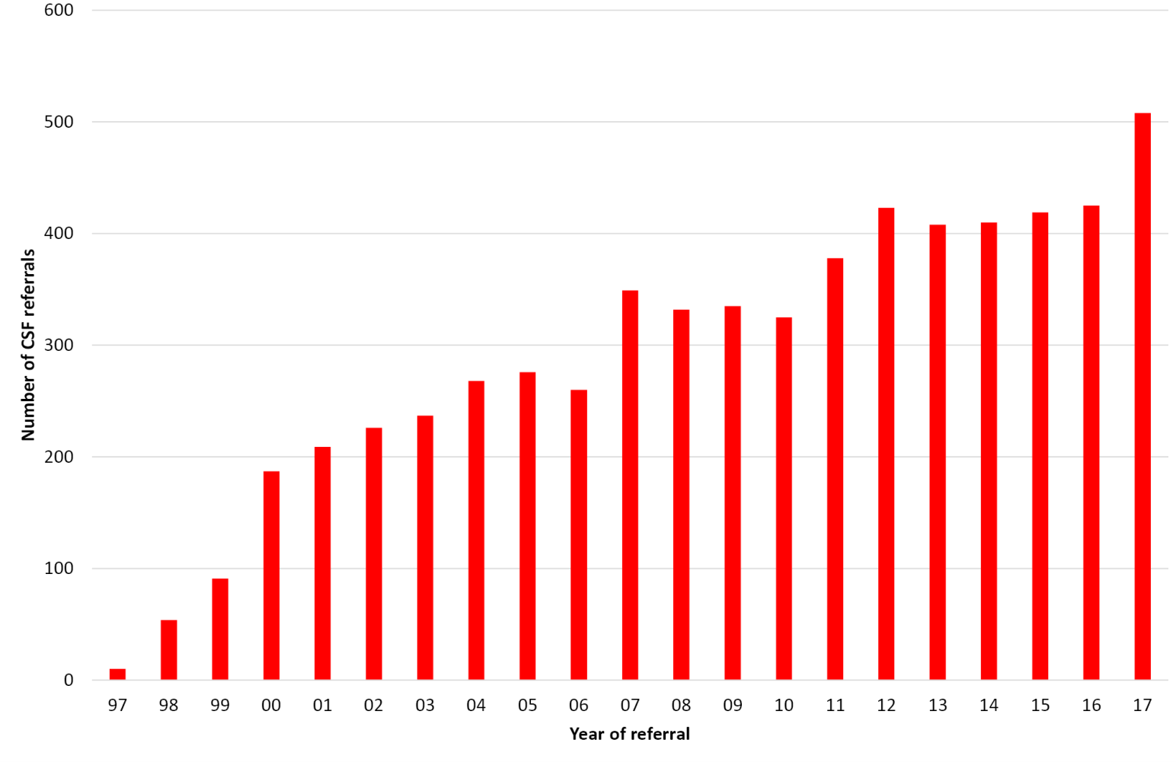
Figure 2. Geographical proportions of CSF 14-3-3 test referrals in 2017
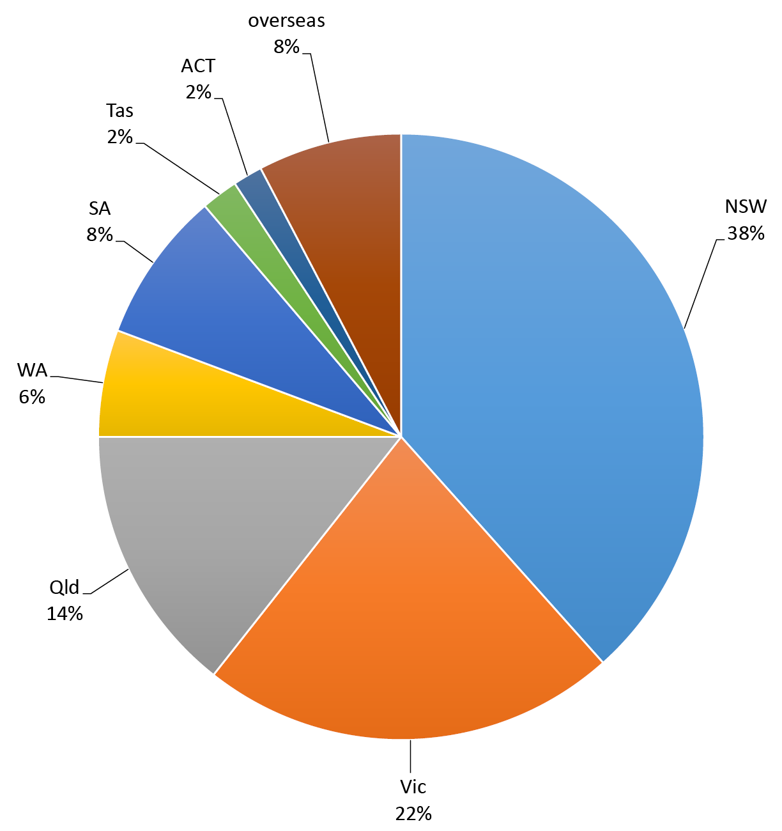
As summarised in Table 1, of the 469 domestic CSF specimens referred to the ANCJDR for testing, 68 specimens tested positive in the 14-3-3 Western blot assay. Of the 371 specimens tested for total-tau protein, 40 specimens returned elevated concentrations of total-tau protein (>1072 pg/ml) sufficient to support the likelihood of CJD. Of the 17 CSF specimens tested using the RT-QuIC assay, six specimens returned positive results, essentially confirming (albeit informally) a clinical diagnosis of CJD. As reported by other national CJD surveillance registries, the reported CSF biomarker results support the complementary utility of the total-tau and RT-QuIC technologies to the 14-3-3 Western blot to aid a pre-mortem diagnosis of CJD or other human prion diseases.
Table 1. Summary of CSF referrals and diagnostic test results (1 January 2017 to 31 December 2017)
 | 14-3-3  Western blot results |  | Total-tau ELISA positive results | Total-tau ELISA negative results | RT-QuIC positive results | RT-QuIC negative results
Positive | 68 | → | 40 | 16 | 31 | 92
Atypical positive | 1 | → | 1
Equivocal | 2 | → | 2 |  | 1¹
Negative | 346 | → | 3 | 305 | 2² | 21
Unsuitable | 31 | → | 1 | 3
Not tested | 13
Overseas referrals | 39
Outstanding test results | 8
Total | 508 |  | 47 | 324 | 6 | 11
1 all tested total-tau positive
2 all tested total-tau negative
Seventy-two persons with genuinely suspected human prion disease were added to the CJD surveillance register in 2017. Cases were initially notified via request for CSF 14-3-3 protein testing (50 cases), personal communication from clinicians (11 cases), the CJD Support Group Network (eight cases), direct health department notification (one case), the hospital (one case) and a neuropathology service (one case). Some previous proactive ANCJDR surveillance mechanisms (e.g. reply-paid mail-outs to clinicians) have been discontinued over time due to human resource constraints. Despite the increasing dominance of referrals related to requests for CSF diagnostic testing, in 2017 case referrals through treating clinicians or the CJD Support Group Network seeking expert advice and guidance from the ANCJDR noticeably increased (16% and 12% of all suspect case notifications, respectively; Table 2).

Table 2. Sources of initial notification of ANCJDR cases ascertained (1 January 1970 to 31 December 2017)
Method | Notifications 2017 (%) | Notifications 1970-2016 (%)
CSF 14-3-3 protein test request | 69 | 54
Neurologists | 16 | 13
CJD Support Group Network | 12 | 1
Hospital | 1 | 1
Neuropathologists | 1 | 8
Health Department | 1 | 1
Death certificates | 0 | 7
Medical record and morbidity data | 0 | 6
Family contact | 0 | 3
Neurologist and neuropathologist mail-out follow-up | 0 | 2
Genetic services | 0 | 2
Other | 0 | 2
Total | 100 | 100

Of the 72 cases added to the register in 2017, two cases were known to the ANCJDR prior to 2017 through CSF referrals. At the time of their referral in 2016, these cases were not added to the register due to a low level of suspicion for prion disease after initial assessment. Further information ascertained in 2017 increased the likelihood of prion disease resulting in formal notification and addition of the cases to the register. The number of formal suspected case additions to the register in 2017 is similar to that of the previous year (71 cases) but higher than the average annual number for the years 2004 to 2015 (66 cases).
By state and territory, only modest absolute fluctuations in the number of suspected case notifications compared to the previous year were observed in 2017 (Figure 3), although relative notifications noticeably increased in Queensland, while a decrease of notifications was observed in Victoria. This was not mirrored by the CSF referral rates in both states.

Figure 3. Prospective, suspected CJD case notifications to the ANCJDR 1997 to 2017, by year and state or territory
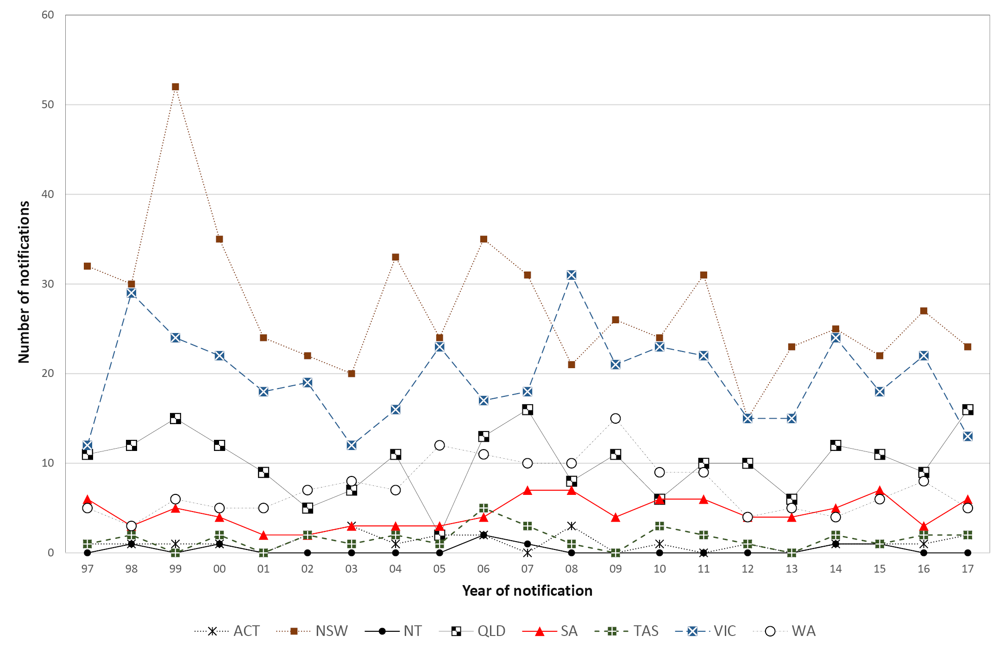
As of 31 December 2017, the majority of the 72 suspected cases added to the register were still classified as “incomplete” (47 cases), while four cases were excluded by either detailed clinical follow-up (1 case) or neuropathological examination (3 cases); 19 cases were classified as “definite” and two as “probable” prion disease; no cases of variant CJD were confirmed.
Since 1993, there has been a positive trend in the annual number of suspected prion disease cases that have undergone post-mortem examination or less commonly brain biopsies, beginning with 12 in 1993 to around 30–40 per year for the period between 2005 and 2017 (Figure 4).

Figure 4. Annual number and proportion of brain autopsies and brain biopsies undertaken for suspected prion disease case deaths from 1993 to 2017
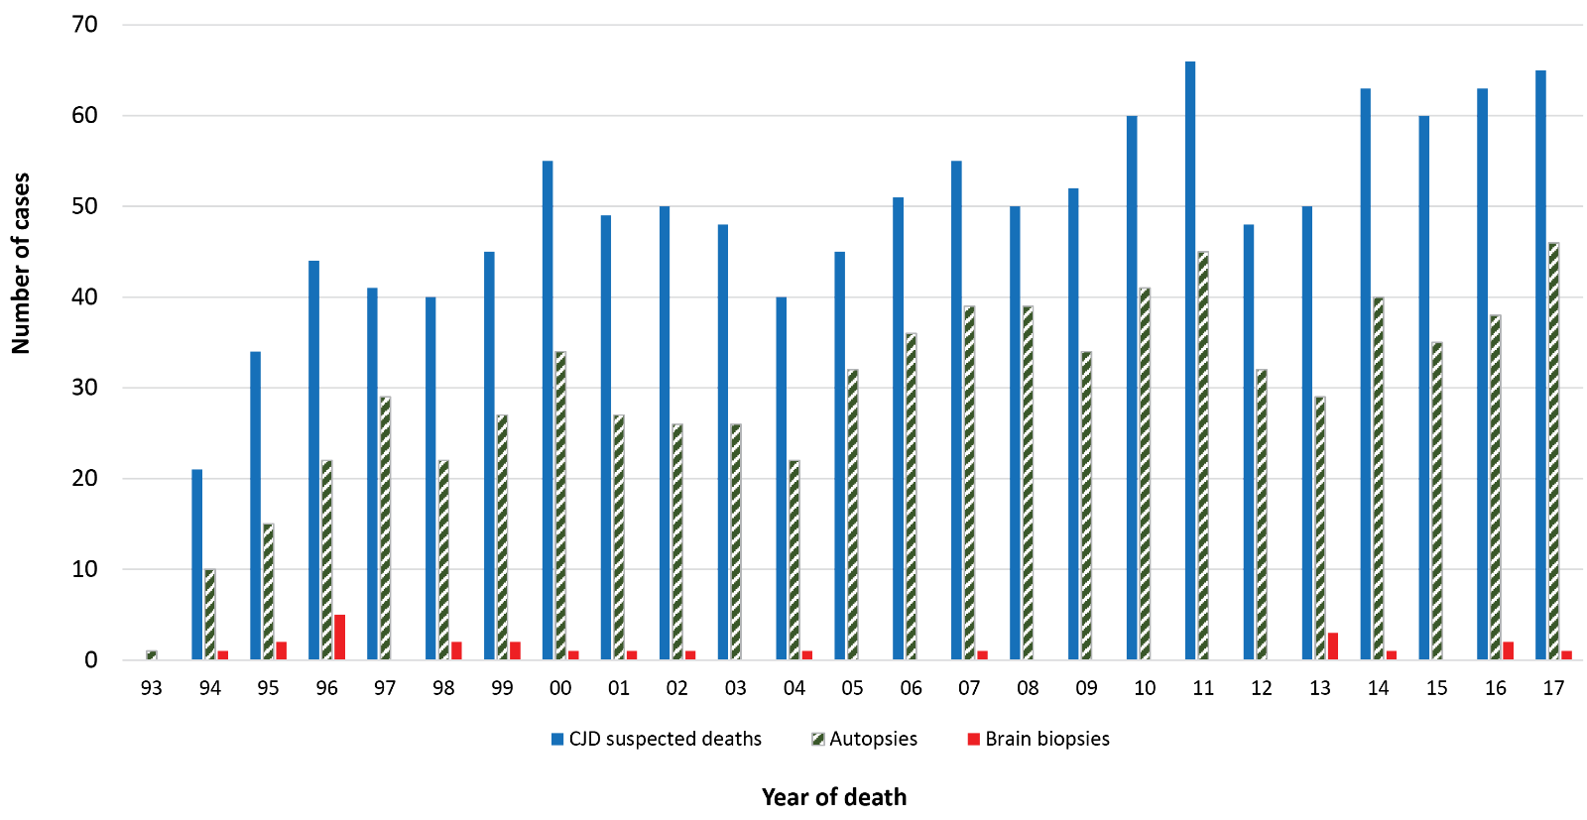

In 2017, the referral rate for brain neuropathological examination was 72% of all suspected human prion disease related deaths (46 autopsies, 1 brain biopsy). The average annual proportion of suspected prion disease cases on the register dying between 1993 and 2016 and undergoing post-mortem brain examination is 60% (range 50–78%). Suspect CJD brain autopsy referral rates in Qld, SA and WA were 80% or higher in 2017 (Table 3).
Table 3. Brain autopsy referral proportions of suspect suspected prion disease case deaths
 | Brain autopsy referral rate in 2017  (% of deaths) | Overall brain autopsy referral rate during  1993-2016 (% of deaths)
NSW | 59 | 63
Vic | 75 | 60
Qld | 87 | 60
WA | 86 | 67
SA | 80 | 59
ACT | 67 | 47
Tas | 0 | 50
NT | 0 | 44

The annual brain autopsy referral rates by state and territory over the 1993 to 2017 period displays considerable fluctuation in each region. In the more populous states, there has generally been an overall temporal increase in rates. In regions with smaller populations, this general positive trend is also present but less robust due to the small population sizes and case numbers.
In Queensland, the influence of the diminished access to a facile suspected CJD autopsy service during 2012–2013 is reflected by the sharp decline in the annual rates (Figure 5). From 2014, Queensland had a significant increase in brain autopsy neuropathological referrals, which mirrors the significant increase in suspect case notifications. The decline of neuropathology referrals in Victoria and New South Wales mirrors reduced suspect case notifications in both states.

Figure 5. Annual brain autopsy referrals from 1993 to 2017, by year and selected state
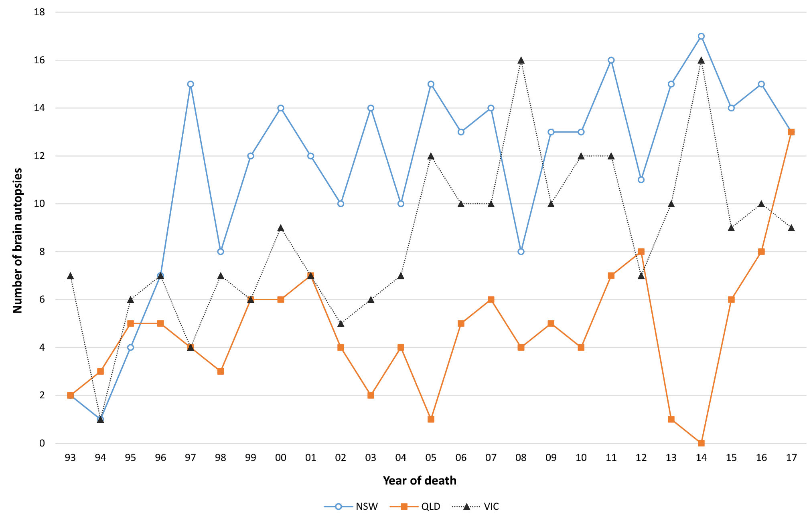
As of 31 December, 2017, there were 1,205 notified cases on the register with 912 of these being classified as “probable” or “definite” prion disease. An additional “definite” iatrogenic case, who was treated in Australia and died in the UK, is included in Table 4; this case is not classified as an Australian case due to the location at death and is thereby excluded from the overall statistical analysis of Australian prion disease cases. Since the start of prospective surveillance in 1993, 737 suspected prion disease cases have been excluded from the register after detailed follow-up, with 18 of these being excluded in 2017 (12 after neuropathological examination).
In 2017, 36 cases were reclassified from “incomplete” to “definite” prion disease and 11 cases to “probable” prion disease; no further cases of “possible” prion disease were classified. The total number of “possible” cases remains at 15, 14 of which were sporadic and one iatrogenic CJD (Table 4). In 2017, the total number of “incomplete” cases under evaluation was only marginally higher than the number in 2016.

Table 4. Overall summary of Australian human prion disease cases by classification, 1 January 1970 to 31 December 2017
Classification | Sporadic | Familial | Iatrogenic | Variant CJD | Unclassified | Total
Definite | 556 | 54 | 5* | 0 | 0 | 615
Probable | 277 | 16 | 4 | 0 | 0 | 297
Possible | 14 | 0 | 1 | 0 | 0 | 15
Incomplete | 0 | 9 | 0 | 0 | 269  (incl 133  living cases) | 278
Total | 847 | 79 | 10 | 0 | 269 | 1,205
* includes 1 definite iatrogenic case who received pituitary hormone treatment in Australia but disease onset and death occurred while a resident of the United Kingdom. This case is not included in statistical analysis since morbidity and mortality did not occur within Australia.
Annual mortality rates for human prion disease in Australia during the period of 1970 to 2016 have generally increased. For the 2017 calendar year case evaluations are still pending for the majority of deaths (Figure 6); the incidence rate is therefore provisional. In 2017, the age-standardised mortality rate is 0.76 deaths per million per year; this is expected to increase once pending neuropathological reviews are reported and investigation and classification of relevant “incomplete” cases is finalised.
The mean annual age-adjusted mortality rate during the period from 1970–2017 is 1 death per million (range, 0.1–1.9). For the prospective surveillance period of 1993 to 2016, the mean annual rate is 1.35 deaths per million (range, 0.7–1.9). By state and territory, the majority of regions in Australia have a mortality rate above 1 case per million per year between 1993 and 2015 (range, 1.1–1.6; Table 5). Tasmania and the Northern Territory report 0.8 and 0.9 deaths per million per year, respectively, which is unlikely to represent a significant difference to other states and territories.
The proportions of human prion disease aetiologies on the register for 2017 are similar to previous years (Figure 7). Overall, the vast majority of human prion disease cases are sporadic (91%) while genetic and iatrogenic cases represent 8% and 1% respectively of all “definite” and “probable” cases.

Figure 6. Human prion disease in Australia from 1970 to 2017; number of cases and age-standardised mortality rates, by year
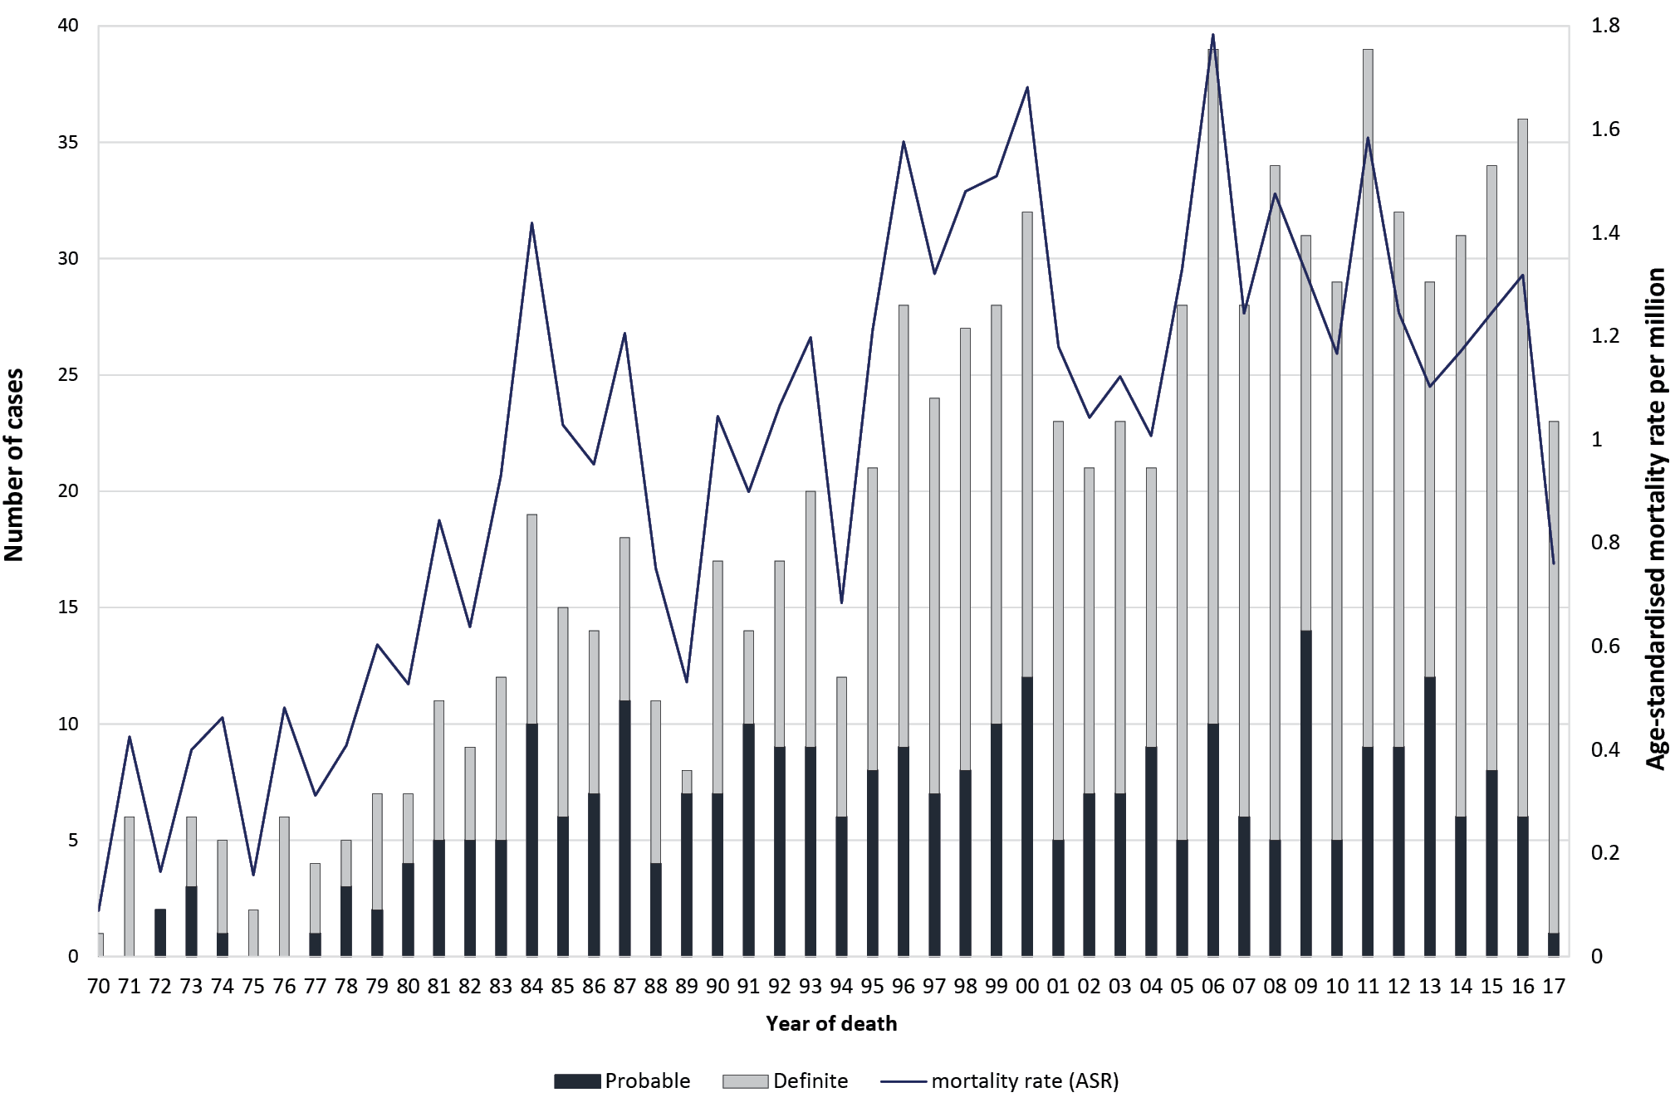

Table 5. “definite” and “probable” human prion disease 1993 to 2017, by year and state or territory
State/  territory | 93 | 94 | 95 | 96 | 97 | 98 | 99 | 00 | 01 | 02 | 03 | 04 | 05 | 06 | 07 | 08 | 09 | 10 | 11 | 12 | 13 | 14 | 15 | 16 | 17 | Total | Average  Crude Mortality Rate  (dths/mill/yr)
ACT |  | 1 |  |  |  |  | 1 |  |  | 1 |  | 1 |  | 1 |  | 2 |  | 1 |  |  | 1 | 1 |  |  |  | 10 | 1.2
NSW | 2 | 3 | 7 | 6 | 10 | 10 | 13 | 12 | 9 | 7 | 7 | 11 | 10 | 12 | 10 | 6 | 11 | 5 | 14 | 7 | 11 | 11 | 11 | 14 | 7 | 226 | 1.3
NT |  |  |  |  |  | 1 |  |  |  |  |  |  |  | 2 | 1 |  |  |  |  |  |  |  | 1 |  |  | 5 | 0.9
Qld | 5 | 2 | 5 | 6 | 3 | 3 | 7 | 7 | 3 | 4 | 3 |  |  | 7 | 2 | 4 | 4 | 2 | 5 | 6 | 4 |  | 8 | 6 | 7 | 103 | 1.1
SA | 1 | 3 | 2 | 3 | 3 | 1 | 3 | 2 |  |  | 1 | 2 | 1 | 1 | 3 | 5 | 2 | 4 | 5 | 2 | 3 | 2 | 4 | 1 | 1 | 55 | 1.4
Tas |  |  |  | 1 |  |  |  |  |  | 2 |  |  | 1 | 2 |  |  |  |  | 1 | 1 |  | 2 |  |  |  | 10 | 0.8
Vic | 10 |  | 4 | 8 | 5 | 9 | 3 | 9 | 10 | 5 | 9 | 5 | 11 | 10 | 6 | 13 | 9 | 13 | 9 | 13 | 8 | 13 | 6 | 11 | 6 | 205 | 1.6
WA | 2 | 3 | 3 | 4 | 3 | 3 | 1 | 2 | 1 | 2 | 3 | 2 | 5 | 4 | 6 | 4 | 5 | 4 | 5 | 3 | 2 | 2 | 4 | 4 | 2 | 79 | 1.5
Total | 20 | 12 | 21 | 28 | 24 | 27 | 28 | 32 | 23 | 21 | 23 | 21 | 28 | 39 | 28 | 34 | 31 | 29 | 39 | 32 | 29 | 31 | 34 | 36 | 23 | 693 | 1.3

Table 6. Prion protein gene (PRNP) mutations/sequence variations identified in Australian cases
Mutation/Polymorphism | Definite/Probable CJD | PM proven Not CJD
E200K | 32 | 3
D178N | 10 | 0
V210I | 8 | 0
P105T | 5 | 0
P102L | 4 | 0
Insert unspecified | 2 | 0
4OPRIa | 1 | 0
2OPRIa | 1 | 0
G131V | 1 | 0
T188A | 1 | 0
V180I | 1 | 0
A133V | 1 | 0
V176G | 1 | 0
Not determined | 4 | 0
a OPRI stands for octapeptide repeat insertion

Figure 7. Overall “definite” and “probable” human prion disease cases 1970 to 2017, by year and aetiology
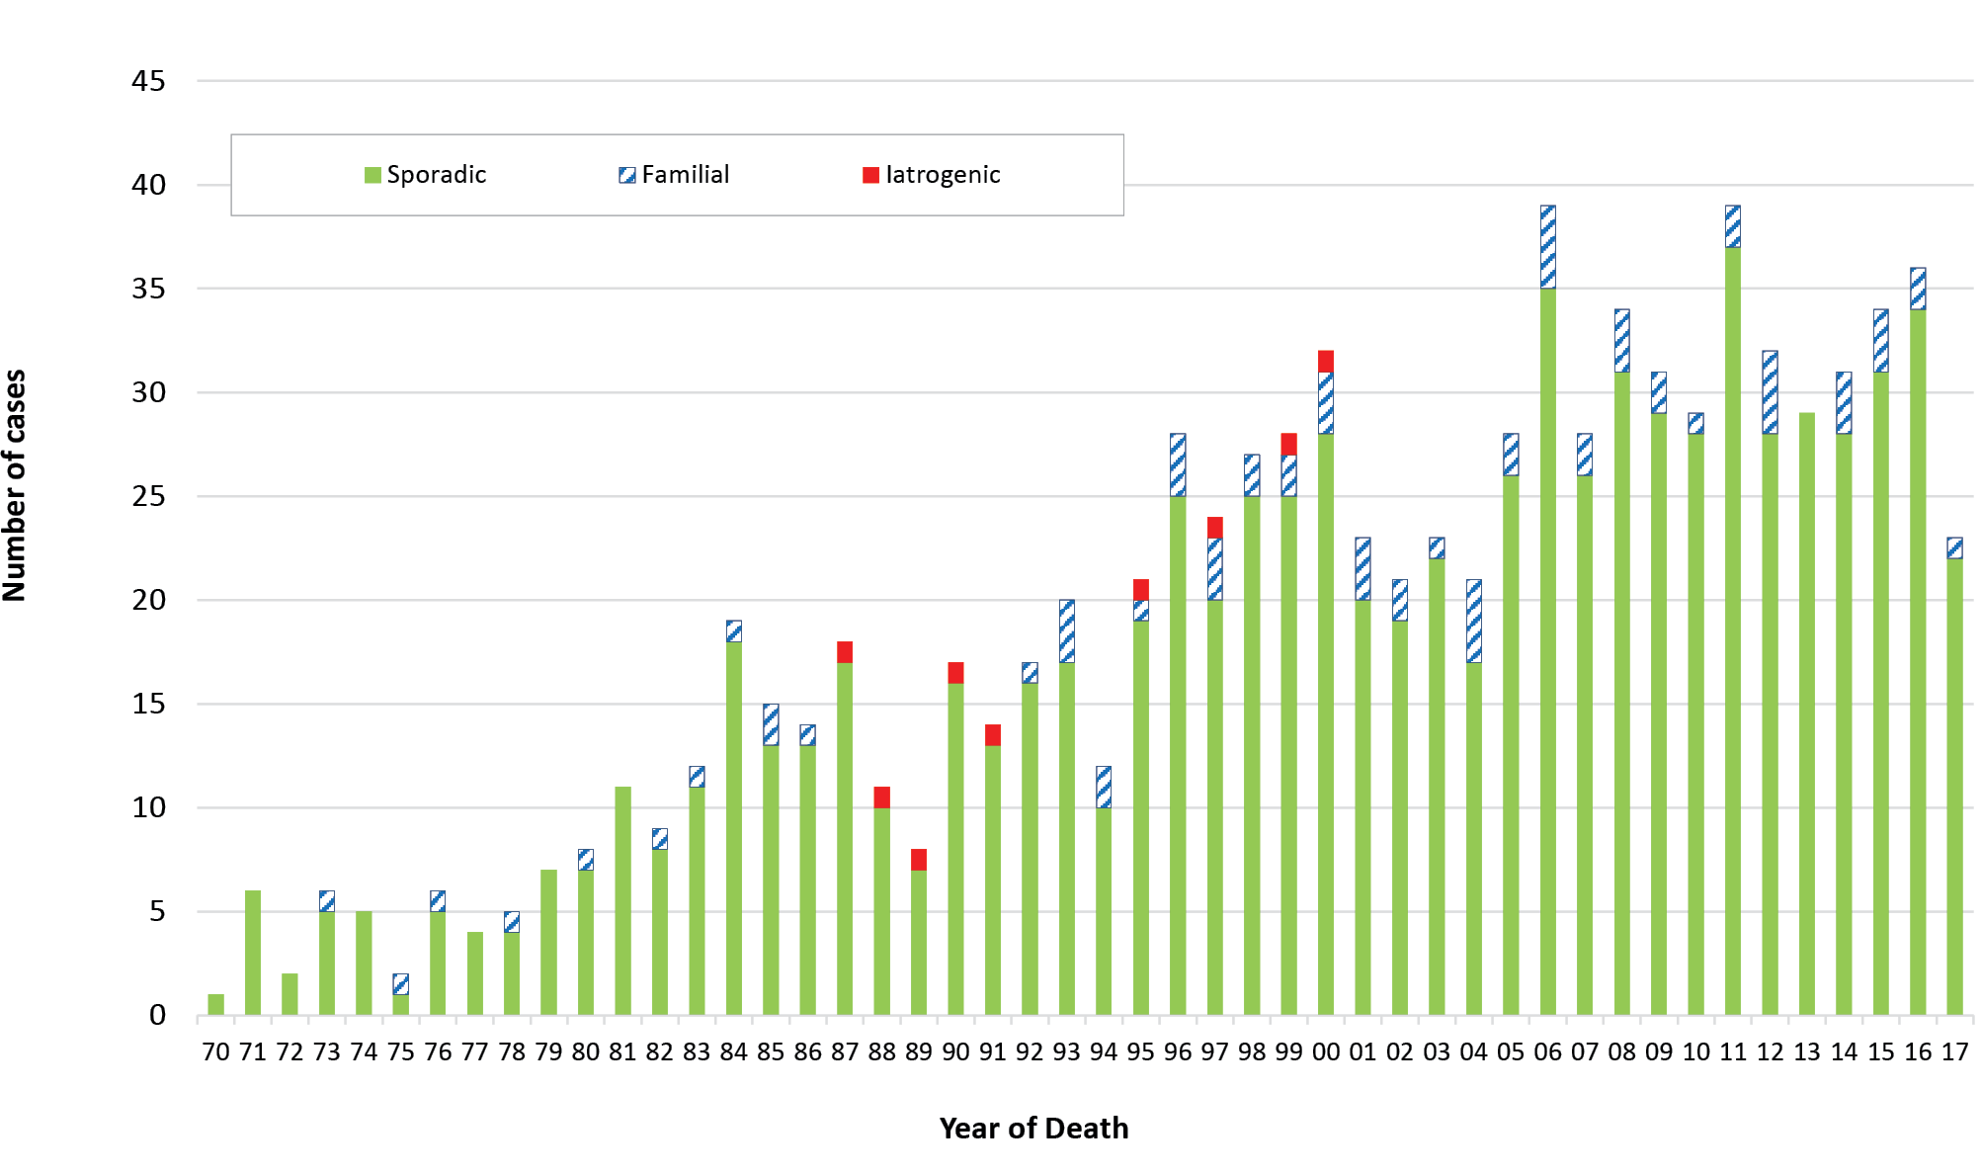

Based on 912 “definite” and “probable” human prion disease cases, the distribution between the males (46%) and females (54%) is similar, with the slight predominance in females reflecting their slightly longer life expectancy.
The average age at death for sporadic prion disease is 66.7 years (range 19–90 years), with the mean duration of disease 6.4 months (range 0.9–84 months). The average age at death in females is 67.2 years (range 19–90 years), slightly later than in males 66.2 years (range 25–90 years), with the disease duration slightly longer in females 7.0 months (range 1–84 months) in comparison to males (5.8, range 0.9–49 months).
The average age at death for genetic prion disease is 57.9 years (range 18–82 years), with the mean duration of disease 14.8 months (range 1.3–192 months). The average age at death in females is 59.6 years (range 18-82 years), later than in males 55.5 years (range 20–82 years), with the disease duration longer in females (15.2 months; range 1.5–192 months) in comparison to males (14.1 months; range 1.3 to 108 months). Of the cases, which were neuropathologically confirmed and proven to be of genetic aetiology, 58 % were females compared to 42 % males.
Between 1 January and 31 December 2017, no vCJD or further iatrogenic prion disease cases were confirmed in Australia. The most recent human-derived pituitary gonadotrophin-related CJD death occurred in 1991, while the most recent Lyodura-related CJD death occurred in 2000.
Since vCJD was first reported in 1996, a total of 231 patients with this disease from 12 countries have been identified. Two of the four US cases, two of the four cases from Ireland, one of the two cases from Canada, and the single case from Japan were most likely exposed to the BSE agent while travelling or residing within the United Kingdom (UK).
Recently, a vCJD case from the UK was the first to be reported as methionine-valine heterozygous at codon 129 of the PRNP gene;⁷ all cases previously have been methionine homozygous. The patient was 36 years old when he presented with psychiatric symptoms prior to onset of neurological features that included cognitive decline, ataxia and myoclonus, dying after an illness of 20 months duration. CSF 14-3-3 and RT-QuIC were negative. Brain MRI revealed features more typical of classical sporadic CJD (bilateral high signal in basal ganglia) without any posterior thalamic high signal (pulvinar sign). The patient did not meet the epidemiologic diagnostic criteria for “probable” or “possible” vCJD although fulfilled criteria for “probable” classical CJD; neuropathology, including Western blot glycotyping was typical of vCJD. It remains uncertain whether this case marks the start of a second wave of vCJD affecting those heterozygous for methionine-valine at codon 129. This case also underscores the importance of performing suspect CJD brain autopsy examinations.

Discussion
In 2017, the number of suspected prion disease notifications and confirmed cases broadly matched the long-term average for the previous 11 years of surveillance (2004 to 2015). By state and territory, only modest fluctuations in the number of suspected case notifications compared to the previous year were observed in 2017 and are within previously observed ranges. Sizeable relative fluctuations in annual suspected case notifications are not surprising given the small absolute case numbers involved. For example, higher notification rates were experienced in 1998 and 1999 when the 14-3-3 protein test was first introduced and in 2006 when notifiable disease legislation was finalised for all states. During 2012 and 2013, reduced numbers of notifications were attributed to several possible factors including the temporary interruption of a facile Queensland suspected prion disease autopsy service, changes to the approach to adding cases to the register for investigation by the ANCJDR and natural fluctuations. From January 2013 to September 2014, a temporary, but practical interruption to brain-only autopsies occurred due to difficulties with a reliable on-call service in Queensland. During this period, no suspected CJD-related autopsies were performed and this was reflected by significantly lower post-mortem numbers during this time. Since the restoration of the routine service through the Royal Brisbane Hospital towards the end of 2014, expected rates of prion disease-related post-mortems have been observed; a corresponding modest increase in “definite” and “probable” cases has been observed. Similarly, in New South Wales, the closure of the neuropathology laboratory for refurbishment extended the time required for autopsy reporting during 2013 and 2014. As expected, post-mortem rates slowed in 2014 due to reporting delays; these figures have returned to an expected level now that the laboratory is fully operational.
Ascertainment mechanisms in 2017 were generally similar to the previous years, with the majority of initial referrals coming through requests for diagnostic CSF 14-3-3 testing. However, in 2017, 28% of suspected case notifications to the ANCJDR were initially through the treating clinician or the CJD Support Group Network. In 2017, the number of CSF referrals for 14-3-3 protein testing to the ANCJDR increased by 20%. This significant increase of diagnostic test referrals coincided with the introduction of CSF total-tau protein estimation, which is complementary to 14-3-3 testing to support a diagnosis of sCJD. The identification of misfolded prion protein in CSF by RT-QuIC continues to be developed by the ANCJDR as a diagnostic test and is currently selectively performed for cases after discussion with clinicians. The addition of CSF total-tau protein estimation to 14-3-3 protein detection as a biomarker for the pre-mortem evaluation of suspected sCJD offers modestly enhanced diagnostic capacity while the ANCJDR completes transition to clearly superior protein amplification techniques such as RT-QuIC (Table 6).
The proportion of post-mortems being performed in suspected prion disease cases increased significantly in 2017, with 72% of all suspect case deaths undergoing neuropathological examination, compared to the long-term average autopsy referral rate of approximately 60% between 1993 and 2016. Noteworthy increases in referral rates were seen in Qld, WA and SA. This contrasts with the findings of an Australian healthcare setting survey where the national hospital post-mortem rate was 12% in 2002–2003.⁸ More recently, a major Australian tertiary centre audit of hospital autopsy data was published and described an autopsy rate of 6.6% in 2011–2013.⁹ The high suspected prion disease-related post-mortem rate underpins the high and consistent number of confirmed Australian human prion disease cases recorded over the more recent time period, and provides confident understanding of the cause of death in suspected cases ultimately determined as non-prion disease.

Acknowledgements
The ANCJDR wishes to thank families, as well as medical practitioners and associated staff for their generous support of Australian CJD surveillance. The ANCJDR also thanks Associate Professor Handan Wand, Professor Matthew Law and Professor John Kaldor (The Kirby Centre; formerly the National Centre in HIV Epidemiology and Clinical Research at the University of New South Wales) for their expert ad hoc epidemiological and statistical support, as well as the CJD Support Group Network for their assistance in surveillance activities.

Author information
Dr Christiane Stehmann – Coordinator¹
Ms Shannon Sarros – Research Assistant¹
Dr Matteo Senesi – Research Fellow¹
Dr Victoria Lewis – Research Fellow¹
Dr Marion Simpson – Neurologist¹
Prof Catriona A McLean – Neuropathologist^{1,2}
Prof Colin L Masters – Director¹
Prof Steven J Collins – Director¹
- Australian National Creutzfeldt–Jakob Disease Registry, Department of Medicine (RMH) and The Florey Institute, The University of Melbourne, Victoria, 3010, Australia
- The Alfred Hospital, Department of Anatomical Pathology, 55 Commercial Rd, Melbourne Vic 3004 Australia

Corresponding author
Prof Steven Collins, Australian National Creutzfeldt–Jakob Disease Registry, Department of Medicine, The University of Melbourne, Victoria, 3010, Australia.
Telephone: +61 8344 1949.
Facsimile: +61 9349 5105.
Email: s.collins@unimelb.edu.au

References
- Klug GM, Boyd A, Zhao T, Stehmann C, Simpson M, McLean CA, et al. Surveillance for Creutzfeldt–Jakob disease in Australia: update to December 2012. Commun Dis Intell Q Rep. 2013;37(2):E115–20.
- Allars M. Report of the inquiry into the use of pituitary derived hormones in Australia and Creutzfeldt–Jakob disease. Canberra: AGPS, 1994.
- Zerr I, Kallenberg K, Summers DM, Romero C, Taratuto A, Heinemann U et al. Updated clinical diagnostic criteria for sporadic Creutzfeldt-Jakob disease. Brain. 2009;132:2659–2668.
- Creutzfeldt–Jakob Disease International Surveillance Network: Surveillance Data. [Internet] Accessed on 16 February 2017. Available from: http://www.eurocjd.ed.ac.uk/surveillance%20data%201.html
- Klug GM, Wand H, Simpson M, Boyd A, Law M, Masters CL et al. Intensity of human prion disease surveillance predicts observed disease incidence. J Neurol Neurosurg Psychiatry. 2013;84:1372–1377.
- Australian Bureau of Statistics. 3101.0 Australian Demographic Statistics – Sept 2017. Tables 51 to 59. Accessed 29/05/2018. Available from: http://www.abs.gov.au/AUSSTATS/abs@.nsf/DetailsPage/3101.0Sep%202017?OpenDocument
- Mok T, Jaunmuktane Z, Joiner S, Campbell T, Morgan C, Wakerley B et al. Variant Creutzfeldt–Jakob disease in a patient with heterozygosity at prnp codon 129. N Engl J Med 2017;376:292–5.
- The Royal College of Pathologists of Australasia Autopsy Working Party. The decline of the hospital autopsy: a safety and quality issue for healthcare in Australia. Med J Aust. 2004;180:281–5.
- Jackett L and McLean C. Hospital autopsy audit: discordant primary clinical diagnoses are found in 20% of cases in a reducing autopsy case load. Selection bias or significant findings? Pathology. 2015;47:499–502.
Communicable Diseases Intelligence
ISSN: 2209-6051 Online

Communicable Diseases Intelligence (CDI) is a peer-reviewed scientific journal published by the Office of Health Protection, Department of Health. The journal aims to disseminate information on the epidemiology, surveillance, prevention and control of communicable diseases of relevance to Australia.

Editor: Cindy Toms
Deputy Editor: Simon Petrie
Design and Production: Kasra Yousefi
Editorial Advisory Board: David Durrheim, Mark Ferson, John Kaldor, Martyn Kirk and Linda Selvey

Website: http://www.health.gov.au/cdi

Contacts
Communicable Diseases Intelligence is produced by:
Health Protection Policy Branch, Office of Health Protection, Australian Government Department of Health
GPO Box 9848, (MDP 6) CANBERRA ACT 2601

Email: cdi.editor@health.gov.au

Submit an Article
You are invited to submit your next communicable disease related article to the Communicable Diseases Intelligence (CDI) for consideration. More information regarding CDI can be found at: http://health.gov.au/cdi.
Further enquiries should be directed to: cdi.editor@health.gov.au.

This journal is indexed by Index Medicus and Medline.

Creative Commons Licence - Attribution-NonCommercial-NoDerivatives CC BY-NC-ND
© 2019 Commonwealth of Australia as represented by the Department of Health
This publication is licensed under a Creative Commons Attribution-NonCommercial-NoDerivatives 4.0 International Licence from https://creativecommons.org/licenses/by-nc-nd/4.0/legalcode (Licence). You must read and understand the Licence before using any material from this publication.

Restrictions
The Licence does not cover, and there is no permission given for, use of any of the following material found in this publication (if any):
- the Commonwealth Coat of Arms (by way of information, the terms under which the Coat of Arms may be used can be found at www.itsanhonour.gov.au);
- any logos (including the Department of Health’s logo) and trademarks;
- any photographs and images;
- any signatures; and
- any material belonging to third parties.

Disclaimer
Opinions expressed in Communicable Diseases Intelligence are those of the authors and not necessarily those of the Australian Government Department of Health or the Communicable Diseases Network Australia. Data may be subject to revision.

Enquiries
Enquiries regarding any other use of this publication should be addressed to the Communication Branch, Department of Health, GPO Box 9848, Canberra ACT 2601, or via e-mail to: copyright@health.gov.au

Communicable Diseases Network Australia
Communicable Diseases Intelligence contributes to the work of the Communicable Diseases Network Australia.
http://www.health.gov.au/cdna

