COVID-19 Australia: Epidemiology Report 62
Reporting period ending 5 June 2022
COVID-19 National Incident Room Surveillance Team

Summary
Four-week reporting period (9 May – 5 June 2022)
As of report 62 onward, the case data provided in this report includes both polymerase chain reaction (PCR) confirmed and rapid antigen test (RAT) probable cases reported to the National Notifiable Diseases Surveillance System (NNDSS), unless otherwise specified. Case definitions are in accordance with the coronavirus disease 2019 (COVID-19) National Guidelines for Public Health Units (SoNG).
At the time of extraction, RAT probable cases were not yet reported to NNDSS from the Northern Territory, Tasmania, and Western Australia; RAT probable cases from Victoria since 2 June 2022 have not yet been reported. At the time of extraction, Queensland has only reported RAT probable cases that have been conducted in a clinical setting; self-administered RAT probable cases are not reported to NNDSS. Due to transmission issues, data was not available from Western Australia since 4 June 2022.
Trends – Nationally, there has been a declining trend in weekly case numbers since mid-May 2022. In the last four weeks from 9 May to 5 June 2022, there were there were 506,923 PCR confirmed and 389,085 RAT probable cases of COVID-19 reported in Australia. In the most recent reporting fortnight, a total of 356,979 confirmed and probable cases were notified (an average of 25,499 cases per day), compared to 539,029 in the previous fortnight (38,502 cases per day).
Age group – In the four weeks ending 5 June 2022, the highest case notification rate was observed among adults aged 40 to 49 years and the lowest rate was among adults aged 70 to 79 years. Across all age groups, weekly case notification rates converged over the four-week reporting period. For the entire Omicron wave to date (15 December 2021 – 5 June 2022), the highest PCR-confirmed notification rate was in adults aged 18 to 29 years.
Aboriginal and Torres Strait Islander persons – Between 9 May and 5 June 2022, there were 21,256 new cases notified in Aboriginal and Torres Strait Islander people. In the current Omicron wave to date (15 December 2021 – 5 June 2022), there have been 183,020 cases of COVID-19 notified in Aboriginal and Torres Strait Islander people, representing 3% of all cases (183,020/6,014,769) reported to NNDSS.
Severity – The notification rate of cases with severe illness has remained relatively stable since early May 2022, at approximately 1.0 cases per 100,000 population. In the current wave, severe cases peaked in the week ending 16 January 2022, at approximately 4.5 per 100,000 population. This is more than three times the peak rate of severe cases observed during the Delta wave, of 1.2 per 100,000 population in the week ending 5 September 2021. In the current reporting period, there were 14 notified cases of paediatric inflammatory multisystem syndrome temporally associated with SARS-Cov-2 (PIMS-TS).
Virology - For samples collected in the four-week period from 9 May to 6 June 2022, the BA.2 Omicron sub-lineage constituted 93.3% (5,304/5,688) of all lineages identified in AusTrakka. This indicates a genuine dominance of the BA.2 lineage among the sequenced samples. Of the Omicron sequences in AusTrakka to date, 45.0% are BA.1; 53.9% are BA.2; and the remaining sequences are made up of BA.3, BA.4 and BA.5. As of 23 May 2022, the CDGN VOC Working Group demoted Delta (B.1.617.2) to a Variant of Interest. No Delta sequences have been identified from samples collected in the past 12 weeks.
Acute respiratory illness – Based on self-reported FluTracking data, over the four-week reporting period, there was a decrease in the prevalence of fever and cough symptoms in the community, while the prevalence of runny nose and sore throat symptoms in the community increased. In the current reporting period, the weekly prevalence of both sets of symptoms was higher than that observed during the peak of the Omicron wave in January 2022.
International situation – According to the World Health Organization (WHO), cumulative global COVID-19 cases stood at almost 529 million, with over 6.3 million deaths reported globally, as of 5 June 2022. In Australia’s near region, the South East Asia and Western Pacific Regions reported 5,360,611 cases and 7,557 deaths in the four-week period to 5 June 2022.
Keywords: SARS-CoV-2; novel coronavirus; 2019-nCoV; coronavirus disease 2019; COVID-19; acute respiratory disease; epidemiology; Australia
This reporting period covers the four-week period of 9 May – 5 June 2022. Within this period, data for each week is compared. The previous reporting period was the preceding four weeks (11 April – 8 May 2022).¹
The focus of this report is on the epidemiological situation in Australia since the beginning of the current Omicron wave. For the purposes of this report, 15 December 2021 is used as a proxy for the beginning of this wave. This date was chosen as, from this date onwards, the majority of sequenced cases were Omicron. Readers are encouraged to consult prior reports in this series for information on the epidemiology of COVID-19 in Australia.
From report 46 onward, and unless otherwise specified, tabulated data and data within the text are extracted from the National Notifiable Diseases Surveillance System (NNDSS) based on ‘notification received date’ rather than ‘diagnosis date’ (see the Technical Supplement for definitions).² As a case’s diagnosis date can be several days prior to the date of its notification, there is potential for newly-notified cases to be excluded from the case count in the current reporting period when reporting by ‘diagnosis date’. Using ‘notification received date’ ensures that the case count for the reporting period better reflects the number of newly-notified cases. As the graphs presented in this report, based on NNDSS data, reflect a longer time period (i.e. year to date and entire pandemic), these will continue to be based on diagnosis date to enable a more accurate understanding of infection risk and local transmission.
From report 59 onwards, cases are no longer separated into ‘locally acquired’ or ‘overseas acquired’. This change in reporting practice has been applied because—as a result of community transmission levels, of the increase in international arrivals, and of reduced quarantine and testing requirements—the ability of jurisdictions to accurately report place of acquisition has been greatly reduced. This directly impacts the value of data around international arrivals. Accordingly, from report 59 onwards, all case numbers should be interpreted as the aggregate of all places of acquisition.
As of report 62 onward, the case data provided in this report includes both polymerase chain reaction confirmed and rapid antigen test probable cases reported to the NNDSS, unless otherwise specified.

Background and data sources
See the Technical Supplement for general information on COVID-19 including modes of transmission, common symptoms and severity.²

Activity

COVID-19 trends

(NNDSS and jurisdictional reporting to the National Incident Centre)
Cumulatively, from the beginning of the pandemic to 5 June 2022, jurisdictions within Australia have reported 7,425,829 COVID-19 cases to the National Incident Centre (Table 1). In the same time period, there have been 4,051,723 PCR-confirmed and 2,197,624 RAT probable cases of COVID-19 reported to NNDSS nationally. The difference in these case numbers arises because cases positive by RAT are not yet systematically reported by all jurisdictions to NNDSS. The analyses in this report include both PCR-confirmed and RAT probable cases reported to the NNDSS, unless otherwise specified.
Table 1: PCR-confirmed and RAT probable COVID-19 cases by jurisdiction, 1 January 2020 – 5 June 2022^{a,b}
 | Australia (total) | ACT | NSW | NT | Qld | SA | Tas. | Vic. | WA
Cases – PCR confirmed | 3,808,343 | 82,018 | 1,487,371 | 17,113 | 538,580 | 342,099 | 42,335 | 965,023 | 333,804
Cases – RAT probable | 3,617,486 | 52,268 | 1,133,628 | 55,834 | 658,496 | 188,953 | 125,913 | 976,763 | 425,631
Cases – total | 7,425,829 | 134,286 | 2,620,999 | 72,947 | 1,197,076 | 531,052 | 168,248 | 1,941,786 | 759,435
a Source: Jurisdictional reporting to the National Incident Centre.
b ACT: Australian Capital Territory; NSW: New South Wales; NT: Northern Territory; Qld: Queensland; SA: South Australia; Tas.: Tasmania; Vic.: Victoria; WA: Western Australia.
In the last four weeks from 9 May to 5 June 2022, there were 506,923 PCR confirmed and 389,085 RAT probable cases of COVID-19 reported in Australia to NNDSS. In the most recent reporting fortnight, a total of 356,979 confirmed and probable cases were notified (an average of 25,499 cases per day), compared to 539,029 in the previous fortnight (38,502 cases per day). In the week ending 5 June 2022, case rates were highest in the Australian Capital Territory at 1,151 per 100,000 population per week, followed by South Australia (1,050 per 100,000 population per week).
Prior to December 2021, the number of cases diagnosed each week had peaked in October 2021, at approximately 15,000 cases diagnosed per week. From December 2021, case numbers increased steeply to a peak of nearly 600,000 cases diagnosed in the week ending 9 January 2022, then declined until the week ending 27 February 2022. From 3 April 2022 case numbers have remained relatively stable at approximately 250,000 to 300,000 cases diagnosed each week (Figure 1). As trends are presented using diagnosis date rather than notification date, case numbers for the most recent week are likely an underestimate; additional cases may be identified in the coming week that have a diagnosis date in this period. In addition, case numbers since January 2022 are an underestimate, as RAT probable cases are not yet systematically reported from all jurisdictions.
Table 2: PCR-confirmed and RAT probable COVID-19 cases by jurisdiction and date of notification, 15 December 2021 – 5 June 2022^{a,b}
Jurisdiction | Reporting period |  |  |  |  |  |  | Current Omicron wave
 | 9 May – 22 May 2022 |  |  | 23 May – 5 June 2022 |  |  | 15 December 2021 – 5 June 2022
 | Confirmed | Probable | Total | Confirmed | Probable | Total | Confirmed |  | Probable | Total
ACT | 7,234  (53.4%) | 6,322  (46.6%) | 13,556 | 5,694  (54.3%) | 4,787  (45.7%) | 10,481 | 81,065  (60.1%) |  | 53,757  (39.9%) | 134,822
NSW | 60,682 (42.0%) | 83,728 (58.0%) | 144,410 | 44,475 (43.1%) | 58,788 (56.9%) | 103,263 | 1,399,518 (59.5%) |  | 954,177 (40.5%) | 2,353,695
NT^{c} | 534 (100.0%) | 0  (0.0%) | 534 | 450 (100.0%) | 0  (0.0%) | 450 | 15,338 (99.6%) |  | 55  (0.4%) | 15,393
Qld^{c} | 19,406 (82.0%) | 4,253 (18.0%) | 23,659 | 13,400 (77.4%) | 3,907 (22.6%) | 17,307 | 532,941 (92.6%) |  | 42,635 (7.4%) | 575,576
SA | 27,804 (49.7%) | 28,190 (50.3%) | 55,994 | 21,033 (51.3%) | 19,933 (48.7%) | 40,966 | 337,869 (63.3%) |  | 196,182 (36.7%) | 534,051
Tas.^{c} | 2,513 (100.0%) | 0  (0.0%) | 2,513 | 1,713 (100.0%) | 0  (0.0%) | 1,713 | 42,248 (100.0%) |  | 0  (0.0%) | 42,248
Vic.^{c} | 50,775 (31.4%) | 110,907 (68.6%) | 161,682 | 37,097 (35.2%) | 68,270 (64.8%) | 105,367 | 815,869 (46.2%) |  | 950,812 (53.8%) | 1,766,681
WA^{c} | 136,681 (100.0%) | 0  (0.0%) | 136,681 | 77,432 (100.0%) | 0  (0.0%) | 77,432 | 592,297 (100.0%) |  | 6  (0.0%) | 592,303
Australia | 305,629 (56.7%) | 233,400 (43.3%) | 539,029 | 201,294 (56.4%) | 155,685 (43.6%) | 356,979 | 3,817,145 (63.5%) |  | 2,197,624 (36.5%) | 6,014,769
a Source: extract from 7 June 2022 for notifications from 15 December 2021 to 5 June 2022.
b ACT: Australian Capital Territory; NSW: New South Wales; NT: Northern Territory; Qld: Queensland; SA: South Australia; Tas.: Tasmania; Vic.: Victoria; WA: Western Australia.
c At the time of extraction, RAT probable cases were not yet available from the Northern Territory, Tasmania, or Western Australia; nor from Victoria since 2 June 2022. At the time of extraction, Queensland only reports RAT cases that have been conducted in a clinical setting; self-administered RAT probable cases are not reported to NNDSS. Data was not available from Western Australia since 4 June 2022.

Figure 1: PCR-confirmed and RAT probable weekly COVID-19 notified cases by diagnosis date, 13 December 2021 – 5 June 2022^{a,b}
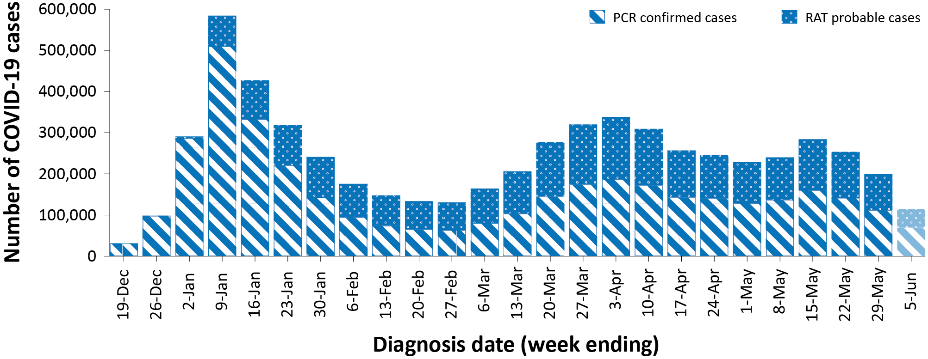
a Source: NNDSS, extract from 7 June 2022 for notifications from 15 December 2021 to 5 June 2022. At the time of extraction, RAT probable cases were not yet available from the Northern Territory, Tasmania, or Western Australia; nor from Victoria since 2 June 2022. At the time of extraction, Queensland only reports RAT cases that have been conducted in a clinical setting; self-administered RAT probable cases are not reported to NNDSS. Data was not available from Western Australia since 4 June 2022.
b The shaded bar at the right represents the most recent reporting week and should be interpreted with caution as additional cases may be identified in the coming week that have a diagnosis date during this period.

Demographic features

(NNDSS)
In the reporting period between 9 May and 5 June 2022, the highest case rate was observed among adults aged 40 to 49 years and the lowest rate was among adults aged 70 to 79 years (Appendix A, Table A.1). Across all age groups, weekly case rates converged over the four-week reporting period (Figure 2). For the entire Omicron wave to date (15 December 2021 – 5 June 2022), the highest case rate was in adults aged 18 to 29 years. For this age group, the weekly notification rate peaked in the week ending 9 January 2022 at 4,464 cases per 100,000 population.
Among paediatric age groups, the highest notification rate during the reporting period was in children aged 12 to 17 years (Figure 2). Following an increasing trend in cases rates during the first half of May 2022, case rates decreased across all paediatric age groups over the reporting period.

Figure 2: PCR-confirmed and RAT probable COVID-19 case rates for (a) all ages and (b) children, by age group by week, Australia, 29 November 2021 – 5 June 2022ª
a
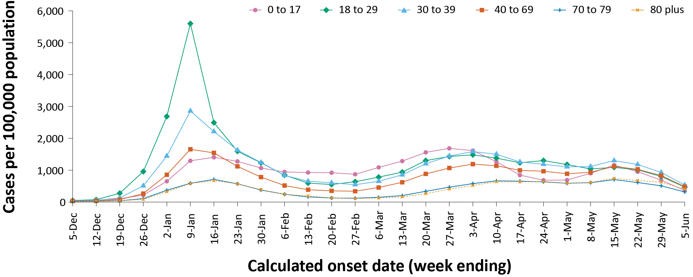
b
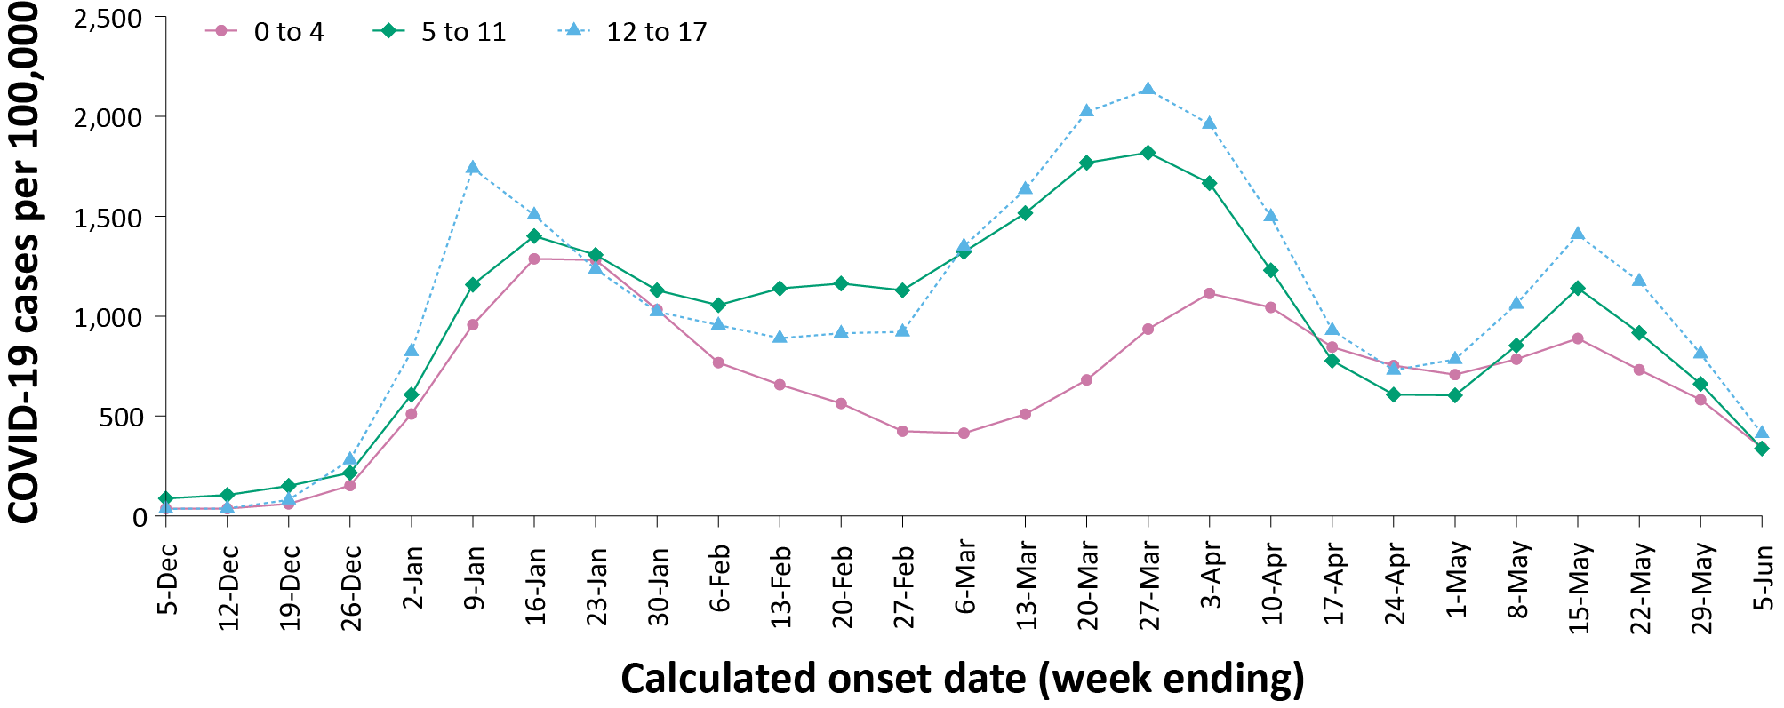
a Source: NNDSS, extract from 7 June 2022 for notifications from 29 November 2021 to 5 June 2022. At the time of extraction, RAT probable cases were not yet available from the Northern Territory, Tasmania, or Western Australia; nor from Victoria since 2 June 2022. At the time of extraction, Queensland only reports RAT cases that have been conducted in a clinical setting; self-administered RAT probable cases are not reported to NNDSS. Data was not available from Western Australia since 4 June 2022.

Aboriginal and Torres Strait Islander persons

(NNDSS)
Overall, since the start of the pandemic, Indigenous status is unknown for approximately 17% of COVID-19 cases. Therefore, the number of cases classified as Aboriginal and Torres Strait Islander people is likely an underrepresentation. During the reporting period, there were 21,256 new COVID-19 cases notified in Aboriginal and Torres Strait Islander people (Table 3). In the current Omicron wave (15 December 2021 – 5 June 2022) there have been 183,020 cases of COVID-19 notified in Aboriginal and Torres Strait Islander people, representing 3% (183,020 / 6,014,769) of all COVID-19 cases in the Omicron wave.
Table 3: PCR-confirmed and RAT probable cases of COVID-19 among Aboriginal and Torres Strait Islander peoples by jurisdiction and date of notification, 31 December 2021 – 5 June 2022ª
Jurisdiction | 9–15 May 2022 | 16–22 May 2022 | 23–29 May 2022 | 30 May – 5 June 2022 | 15 December 2021 – 5 June 2022 (Omicron wave)
Australian Capital Territory | 105 | 88 | 100 | 76 | 2,432
New South Wales | 2,573 | 2,348 | 1,863 | 1,611 | 84,823
Northern Territory^{b} | 29 | 27 | 45 | 24 | 3,041
Queensland^{b} | 622 | 518 | 430 | 368 | 31,328
South Australia | 709 | 616 | 506 | 379 | 15,661
Tasmania^{b} | 37 | 42 | 36 | 24 | 1,469
Victoriab | 994 | 1,095 | 1,040 | 532 | 22,062
Western Australia^{b} | 1,355 | 1,382 | 1,068 | 614 | 22,204
Total | 6,424 | 6,116 | 5,088 | 3,628 | 183,020
a Source: NNDSS, extract from 7 June 2022 for notifications from 15 December 2021 to 5 June 2022.
b At the time of extraction, RAT probable cases were not yet available from the Northern Territory, Tasmania, or Western Australia; nor from Victoria since 2 June 2022. At the time of extraction, Queensland only reports RAT cases that have been conducted in a clinical setting; self-administered RAT probable cases are not reported to NNDSS. Data was not available from Western Australia since 4 June 2022.
Of the COVID-19 cases notified in Aboriginal and Torres Strait Islander people from 15 December 2021 to date, 50% (91,957/183,020) lived in a regional or remote area (Table 4). It should be noted that the reliance on RATs for diagnosing COVID-19 is greater in regional and remote areas than in major cities, resulting in a larger underrepresentation of cases in regional and remote areas than in major cities, due to the incomplete capture of RAT probable cases in NNDSS.
Nationally, there have been 164 COVID-19 associated deaths reported in Aboriginal and Torres Strait Islander people from the start of the pandemic to 5 June 2022. This comprises 60 from New South Wales, 44 from Queensland, 30 from the Northern Territory, 12 from Western Australia, 11 from South Australia and seven from Victoria. An additional 388 Aboriginal and Torres Strait Islander cases have been admitted to intensive care units (ICU) nationally. During the Omicron wave to date, the overall notification rate, to NNDSS, of severe cases (measured as those who were admitted to ICU or died) in Aboriginal and Torres Strait Islander people was 47.5 per 100,000 population, compared to 16.3 per 100,000 population during the Delta wave (Table 5). The higher rates of severe illness during the Omicron wave to date are attributed to the significantly higher levels of disease transmission in the community during the Omicron wave, rather than the Omicron variant inherently causing more severe illness compared to the Delta variant. Note that ICU status in NNDSS is likely incomplete.

Table 4: PCR-confirmed and RAT probable cases of COVID-19 among Aboriginal and Torres Strait Islander people by area of remoteness, 15 December 2021 – 5 June 2022ª
Jurisdiction^{b,c} | Major city |  |  | Inner regional |  |  | Outer regional |  |  | Remote^{d}
 | Confirmed | Probable | Total | Confirmed | Probable | Total | Confirmed | Probable | Total | Confirmed | Probable | Total
ACT | 1,469  (61.8%) | 907  (38.2%) | 2,376 | 19  (86.4%) | 3  (13.6%) | 22 | 4  (57.1%) | 3  (42.9%) | 7 | 0  (0.0%) | 0  (0.0%) | 0
NSW | 28,808  (63.0%) | 16,902  (37.0%) | 45,710 | 13,503  (49.8%) | 13,604  (50.2%) | 27,107 | 3,967  (41.5%) | 5,592  (58.5%) | 9,559 | 709  (35.6%) | 1,284  (64.4%) | 1,993
NT^{e} | 0  (0.0%) | 0  (0.0%) | 0 | 0  (0.0%) | 0  (0.0%) | 0 | 871  (99.3%) | 6  (0.7%) | 877 | 1,940  (98.4%) | 31  (1.6%) | 1,971
Qld^{e} | 8,091  (96.3%) | 314  (3.7%) | 8,405 | 4,663  (93.6%) | 319  (6.4%) | 4,982 | 7,822  (62.2%) | 4,749  (37.8%) | 12,571 | 1,357  (25.5%) | 3,966  (74.5%) | 5,323
SA | 5,146  (62.6%) | 3,071  (37.4%) | 8,217 | 897  (54.9%) | 738  (45.1%) | 1,635 | 2,027  (61.6%) | 1,265  (38.4%) | 3,292 | 1,728  (73.6%) | 621  (26.4%) | 2,349
Tas.^{e} | 16  (100.0%) | 0  (0.0%) | 16 | 997  (100.0%) | 0  (0.0%) | 997 | 441  (100.0%) | 0  (0.0%) | 441 | 9  (100.0%) | 0  (0.0%) | 9
Vic.^{e} | 4,935  (38.8%) | 7,768  (61.2%) | 12,703 | 1,924  (27.5%) | 5,073  (72.5%) | 6,997 | 473  (20.4%) | 1,851  (79.6%) | 2,324 | 0  (0.0%) | 8  (100.0%) | 8
WA^{e} | 12,377  (100.0%) | 0  (0.0%) | 12,377 | 1,430  (100.0%) | 0  (0.0%) | 1,430 | 1,654  (100.0%) | 0  (0.0%) | 1,654 | 6,409  (100.0%) | 0  (0.0%) | 6,409
Australia | 60,84  (67.7%) | 28,962  (32.3%) | 89,804 | 23,433  (54.3%) | 19,737  (45.7%) | 43,170 | 17,259  (56.2%) | 13,466  (43.8%) | 30,725 | 12,152  (67.3%) | 5,910  (32.7%) | 18,062
a Source: NNDSS, extract from 7 June 2022 for notifications from 15 December 2021 to 5 June 2022. Excludes cases with an overseas place of residence, and where place of residence is unknown.
b ACT: Australian Capital Territory; NSW: New South Wales; NT: Northern Territory; Qld: Queensland; SA: South Australia; Tas.: Tasmania; Vic.: Victoria; WA: Western Australia.
c Cases are classified based on jurisdiction of notification not jurisdiction of residence. Some cases are notified to a different jurisdiction to their location of residence.
d ‘Remote’ here also includes areas classified as ‘very remote’.
e At the time of extraction, RAT probable cases were not yet available from the Northern Territory, Tasmania, or Western Australia; nor from Victoria since 2 June 2022. At the time of extraction, Queensland only reports RAT cases that have been conducted in a clinical setting; self-administered RAT probable cases are not reported to NNDSS. Data was not available from Western Australia since 4 June 2022.

Table 5: PCR-confirmed and RAT probable COVID-19 cases in Aboriginal and Torres Strait Islander people by age and highest level of illness severity, Australia, 1 January 2020 to 5 June 2022
Age group (years) | 15 December 2021 – 5 June 2022  (Omicron wave) |  |  |  | 16 June 2021 – 14 December 2021  (Delta wave) |  |  |  | 1 January 2020 – 5 June 2022  (Pandemic to date)
 | ICUª | Diedª | ICU or diedª | Rate ICU or died^{b} | ICUª | Diedª | ICU or diedª | Rate ICU or died^{b} | ICUª | Diedª | ICU or diedª | Rate ICU or died^{b}
0–17 | 34 | 1 | 34 | 10.5 | 8 | 0 | 8 | 2.5 | 42 | 1 | 42 | 12.9
18–59 | 150 | 46 | 190 | 45.5 | 85 | 11 | 89 | 21.3 | 236 | 57 | 280 | 67.1
60+ | 82 | 92 | 155 | 274.6 | 26 | 14 | 33 | 58.5 | 110 | 106 | 190 | 336.7
All | 266 | 139 | 379 | 47.5 | 119 | 25 | 130 | 16.3 | 388 | 164 | 512 | 64.1
a ‘ICU’ and ‘died’ are not mutually exclusive categories; ‘died’ can include cases who died with or without prior admission to ICU. Therefore, the number of cases admitted to ICU or having died will not equal the sum of cases in ICU or died.
b Rate per 100,000 population for the given time period.

Vaccinations

(Department of Health)
As of 5 June 2022, a total of 59,431,403 doses of COVID-19 vaccine had been administered (Table 6), of which 38,211,326 doses were administered by the Commonwealth in primary care or aged care and disability facilities. Nationally, 19,741,825 people aged over 16 years (> 95%) were fully vaccinated. Among children aged 5–11 years, 1,197,425 (52.6%) had received at least one dose, including 886,813 (38.9%) who were fully vaccinated. Among children aged 12-15 years, 1,051,585 (84.5%) had received at least one dose, including 995,952 (80.1%) who were fully vaccinated.
Table 6: Total number of vaccinations administered, by jurisdiction, Australia, 5 June 2022ª
Jurisdiction^{b} | Total number of doses administered | Percentage of people aged 16 and over who have had two or more doses^{d}
Australian Capital Territory | 1,556,063 | > 99%
New South Wales | 18,430,432 | 94.8%
Northern Territory | 589,849 | 88.9%
Queensland | 11,237,870 | 92.4%
South Australia | 4,123,115 | 93.5%
Tasmania | 1,345,627 | 99.1%
Victoria | 15,604,964 | 94.1%
Western Australia | 6,543,483 | 97.7%
Total | 59,431,403 | 95.7%
a Source: Australian Government Department of Health website.³
b ‘Jurisdiction’ refers to state/territory of residence.

Severity

(NNDSS, FluCAN, SPRINT-SARI)
Given the delay between illness onset and severe illness, and so as to provide a more accurate assessment of severity, cases with an onset in the last two weeks were excluded from analyses on the weekly rate of cases with severe illness (defined as cases admitted to ICU or died) and on the proportion of cases admitted to ICU or died.
In the current wave, the notification rate of cases with severe illness peaked in the week ending 16 January 2022, at approximately 4.5 severe cases per 100,000 population per week (Figure 3). This is more than three times the peak weekly rate of severe cases observed during the Delta wave, of 1.2 per 100,000 population in the week ending 5 September 2021. Since early May 2022, severe cases have remained relatively stable at approximately 1.0 cases per 100,000 population per week. Rates of severe cases continue to be greater in older age groups (Figure 4).
Figure 3: COVID-19 cases, deaths and ICU admissions, Australia, by date of onset, Australia, 31 May 2021 to 5 June 2022^{a,b}
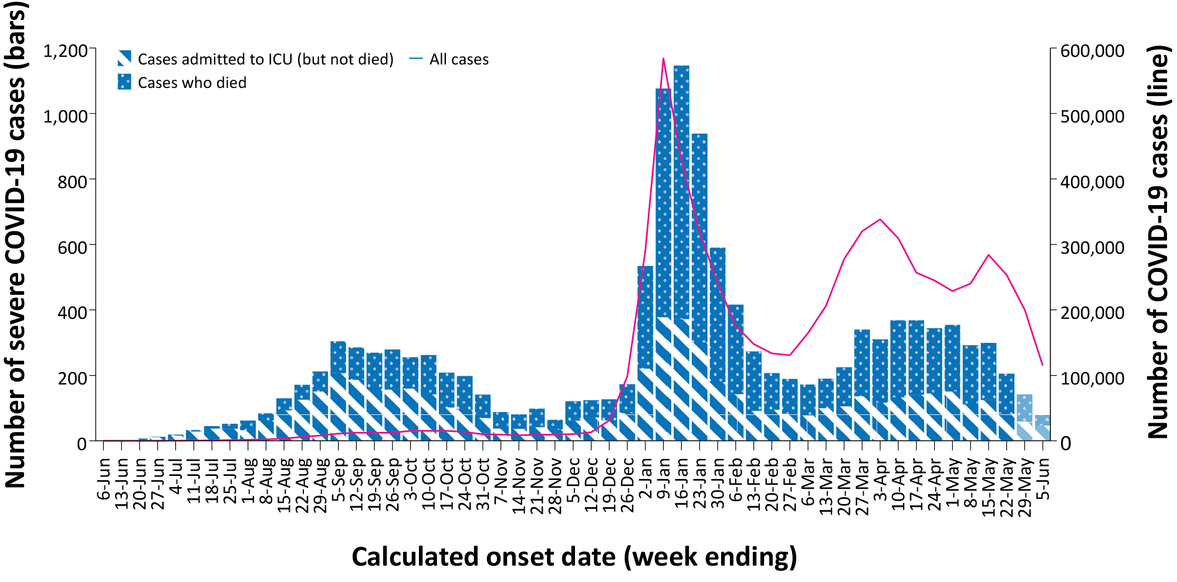
a Source: NNDSS, extract from 7 June 2022 for notifications from 31 May 2021 to 5 June 2022. At the time of extraction, RAT probable cases were not yet available from the Northern Territory, Tasmania, or Western Australia; nor from Victoria since 2 June 2022. At the time of extraction, Queensland only reports RAT cases that have been conducted in a clinical setting; self-administered RAT probable cases are not reported to NNDSS. Data was not available from Western Australia since 4 June 2022.
b The shaded bars at the right represent the most recent two reporting weeks and should be interpreted with caution as cases with an illness onset in these weeks may not have yet developed severe disease.

Figure 4: Age-specific rates of COVID-19 cases admitted to ICU or died, by date of diagnosis, Australia, 31 May 2021 to 22 May 2022ª
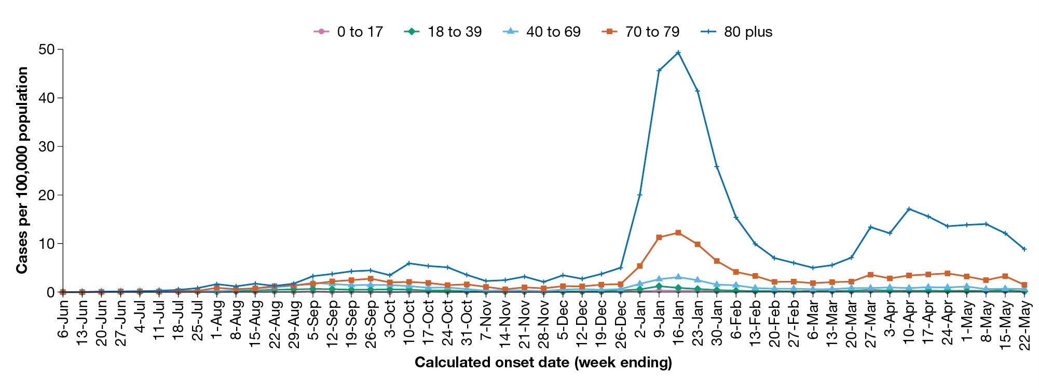
a NNDSS, extract from 7 June 2022. Includes cases with an illness onset from 31 May 2021 to 22 May 2022; cases with an illness onset in the last two weeks (23 May – 5 June 2022) were excluded to account for the delay between onset and development of severe illness.

Hospitalisation and ICU admissions
Between 15 December 2021 and 5 June 2022, there were 3,831 hospital admissions with confirmed COVID-19 reported at Influenza Complications Alert Network (FluCAN) sentinel sites, including 8% (318/3,831) admitted directly to ICU. In the current reporting period to 5 June 2022, there were 523 admissions with COVID-19 reported, including 5% (25/523) who were admitted directly to ICU. From the start of the Omicron wave to 5 June 2022, there were 2,474 COVID-19 cases admitted to ICUs participating in the sentinel surveillance system, Short Period Incidence Study of Severe Acute Respiratory Infection (SPRINT-SARI),⁴ with 235 of these admitted during this reporting period (9 May – 5 June 2022).
Since 15 December 2021, for patients admitted to FluCAN sentinel sites with confirmed COVID-19, the median length of stay was 4 days (interquartile range, IQR: 2–8); mean (standard deviation, SD) = 7.2 days (17.7). This is lower than the median length of stay observed during the Delta wave, which was 6 days (IQR: 3–10); mean (SD) = 8.3 days (16.8).

Risk factors for severe disease
Comorbidity data extracted from SPRINT-SARI reflect the sickest patients with COVID-19 who are managed in ICU; data are therefore not generalisable to all cases (Table 7). In patients admitted to ICU with COVID-19 since 15 December 2021, the most prevalent comorbidity was diabetes, followed by obesity (a body mass index of > 30 or weight over 120 kg). Of those adult patients admitted to ICU since 15 December 2021 for whom comorbidity data was known, 76% (1,555/2,056) had at least one comorbidity; 24% of patients (501/2,056) had none of the listed comorbidities recorded.

Table 7: Comorbidities for adult COVID-19 cases (aged greater than or equal to 18 years) amongst those admitted to ICU, Australia, 15 December 2021 – 5 June 2022ª
Comorbidity | ICU casesª (n = 2,056) (%)
Cardiac disease (n = 2,035) | 502 (25%)
Chronic respiratory condition (n = 2,034)^{b} | 486 (24%)
Diabetes (n = 2,028) | 691 (34%)
Obesity (n = 1,997) | 512 (26%)
Chronic renal disease (n = 2,020) | 313 (16%)
Chronic neurological condition (n = 2,023) | 121 (6%)
Malignancy (n = 2,031) | 244 (12%)
Chronic liver disease (n = 2,029) | 112 (6%)
Immunosuppression (n = 2,011) | 368 (18%)
Number of specified comorbidities (n = 2,056)^{c}
No comorbidities | 501 (24%)
One or more | 1,555 (76%)
Two or more | 980 (48%)
Three or more | 514 (25%)
a Source: SPRINT-SARI. Only includes adult cases (≥ 18 years old) and excludes those with missing data on comorbidities or where comorbidity is unknown.
b Includes asthma.
c Includes chronic respiratory conditions, cardiac disease (excluding hypertension), immunosuppressive condition/therapy, diabetes, obesity, liver disease, renal disease and neurological disorder.

PIMS-TS Paediatric Active Enhanced Disease Surveillance

(PAEDS)
Since the start of the pandemic to 5 June 2022, there have been 124 cases of paediatric inflammatory multisystem syndrome temporally associated with SARS-CoV-2 (PIMS-TS) reported to PAEDS, including 89 cases reported in 2022 and 14 in the current reporting period (Figure 5). The majority of PIMS-TS cases to date have occurred in those aged 5 to < 12 years (55%; 68/124), followed by those aged 6 months to < 5 years (24%; 30/124). To date, there have been no PIMS-TS associated deaths.

Figure 5: PIMS-TS cases reported to PAEDS, by sample month and level of care required, Australia, 1 June 2020 – 5 June 2022ª
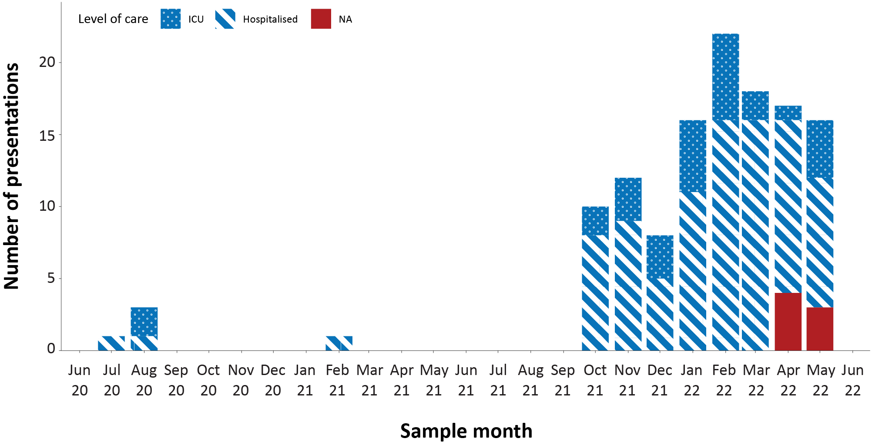
a Source: PAEDS.

COVID-19 deaths
There were 690 COVID-19 associated deaths among COVID-19 cases notified during the reporting period. After rising throughout March and early April 2022, there was a decreasing trend over the current reporting period, with 105 deaths reported in the most recent week, compared with 224 in the first week of the reporting period (week ending 15 May 2022). This brings the total number of COVID-19-associated deaths reported in NNDSS to 8,172 (Table 8).
Across all age groups, the population mortality rate for the current Omicron wave to date has exceeded that of the Delta wave. For those aged 70 years and over, the population mortality rate during the Omicron wave is more than triple that observed during the Delta wave, and in those aged 90 years and over, the population mortality rate during the Omicron wave is approximately seven times higher than that observed during the Delta wave (Table 9). The higher mortality rates during the Omicron wave are attributed to the significantly higher levels of disease transmission in the community during the Omicron wave, rather than the Omicron variant inherently causing more severe illness compared to the Delta variant.

Table 8: Deaths associated with COVID-19 by reporting period, Australia, 1 January 2020 – 5 June 2022^{a,b}
Jurisdiction^{c} | 9–15 May 2022 | 16–22 May 2022 | 23–29 May 2022 | 30 May – 5 June 2022 | 15 December 2021 –  5 June 2022  (Omicron wave) | 1 January 2020 –  5 June 2022  (Pandemic to date)
ACT | 1 (0.4%) | 2 (1.0%) | 2 (1.2%) | 0 (0.0%) | 45 (0.8%) | 57 (0.7%)
NSW | 80 (35.7%) | 76 (38.0%) | 59 (36.6%) | 34 (32.4%) | 2,544 (43.1%) | 3,247 (39.7%)
NT^{d} | 1 (0.4%) | 1 (0.5%) | 3 (1.9%) | 0 (0.0%) | 50 (0.8%) | 51 (0.6%)
Qld^{d} | 46 (20.5%) | 35 (17.5%) | 22 (13.7%) | 11 (10.5%) | 1,088 (18.4%) | 1,095 (13.4%)
SA | 9 (4.0%) | 7 (3.5%) | 8 (5.0%) | 1 (1.0%) | 439 (7.4%) | 443 (5.4%)
Tas. ^{d} | 1 (0.4%) | 0 (0.0%) | 1 (0.6%) | 1 (1.0%) | 18 (0.3%) | 33 (0.4%)
Vic. ^{d} | 72 (32.1%) | 69 (34.5%) | 65 (40.4%) | 55 (52.4%) | 1,636 (27.7%) | 3,155 (38.6%)
WA^{d} | 14 (6.3%) | 10 (5.0%) | 1 (0.6%) | 3 (2.9%) | 82 (1.4%) | 91 (1.1%)
Total | 224 | 200 | 161 | 105 | 5,902 | 8,172
a Source: NNDSS, extract from 7 June 2022 for deaths to 5 June 2022.
b Deaths are categorised into time periods using date of death. Deaths with a missing date of death are classified using date of illness onset.
c ACT: Australian Capital Territory; NSW: New South Wales; NT: Northern Territory; Qld: Queensland; SA: South Australia; Tas.: Tasmania; Vic.: Victoria; WA: Western Australia.
d At the time of extraction, RAT probable cases were not yet available from the Northern Territory, Tasmania, or Western Australia; nor from Victoria since 2 June 2022. At the time of extraction, Queensland only reports RAT cases that have been conducted in a clinical setting; self-administered RAT probable cases are not reported to NNDSS. Data was not available from Western Australia since 4 June 2022.

Table 9: COVID-19 associated deaths notified to NNDSS, by age group and date of onset, 1 January 2020 to 5 June 2022ª
Age group (years) | 15 December 2021 – 5 June 2022  (Omicron wave) |  | 16 June 2021 – 14 December 2021  (Delta wave) |  | 1 January 2020 – 5 June 2022  (Pandemic to date)
 | Deaths | Population mortality rate^{b} | Deaths | Population mortality rate^{b} | Deaths | Population mortality rate^{b}
0–4 | 7 | 0.5 | — | — | 7 | 0.5
5–11 | 1 | < 0.05 | 1 | < 0.05 | 2 | 0.1
12–15 | 2 | 0.2 | 1 | 0.1 | 3 | 0.2
16–17 | 1 | 0.2 | — | — | 1 | 0.2
18–29 | 18 | 0.4 | 8 | 0.2 | 27 | 0.7
30–39 | 48 | 1.3 | 22 | 0.6 | 72 | 1.9
40–49 | 82 | 2.5 | 48 | 1.5 | 132 | 4.0
50–59 | 204 | 6.5 | 122 | 3.9 | 341 | 10.8
60–69 | 540 | 19.7 | 212 | 7.7 | 789 | 28.8
70–79 | 1,175 | 60.2 | 365 | 18.7 | 1,702 | 87.2
80–89 | 2,152 | 245.6 | 440 | 50.2 | 2,972 | 339.1
90+ | 1,571 | 707.8 | 229 | 103.2 | 2,124 | 957.0
Total | 5,801 | 22.5 | 1,448 | 5.6 | 8,172 | 31.7
a Source: NNDSS, extract from 7 June 2022 for deaths to 5 June 2022. At the time of extraction, RAT probable cases were not yet available from the Northern Territory, Tasmania, or Western Australia; nor from Victoria since 2 June 2022. At the time of extraction, Queensland only reports RAT cases that have been conducted in a clinical setting; self-administered RAT probable cases are not reported to NNDSS. Data was not available from Western Australia since 4 June 2022.
b Population mortality rates are presented per 100,000 population for the given time period.

Genomic surveillance and virology

Communicable Disease Genomics Network, AusTrakka and jurisdictional sequencing laboratories)
Nationally, 2.8% of COVID-19 cases have been sequenced since the start of the pandemic in January 2020, based on jurisdictional reporting of cases (Table 10). Case numbers and sequencing proportion are based on PCR results only, as rapid antigen tests do not allow for sequencing. The significant rise in case numbers nationally during recent reporting periods has required jurisdictional laboratories to move towards sequencing for surveillance purposes, resulting in a drop in the overall sequencing proportion. However, the overall output of number of cases sequenced remains similar to, or higher than, previous periods (Figure 6).
Figure 6: Samples in AusTrakka from 13 December 2021 to 5 June 2022, by lineage and date of collectionª
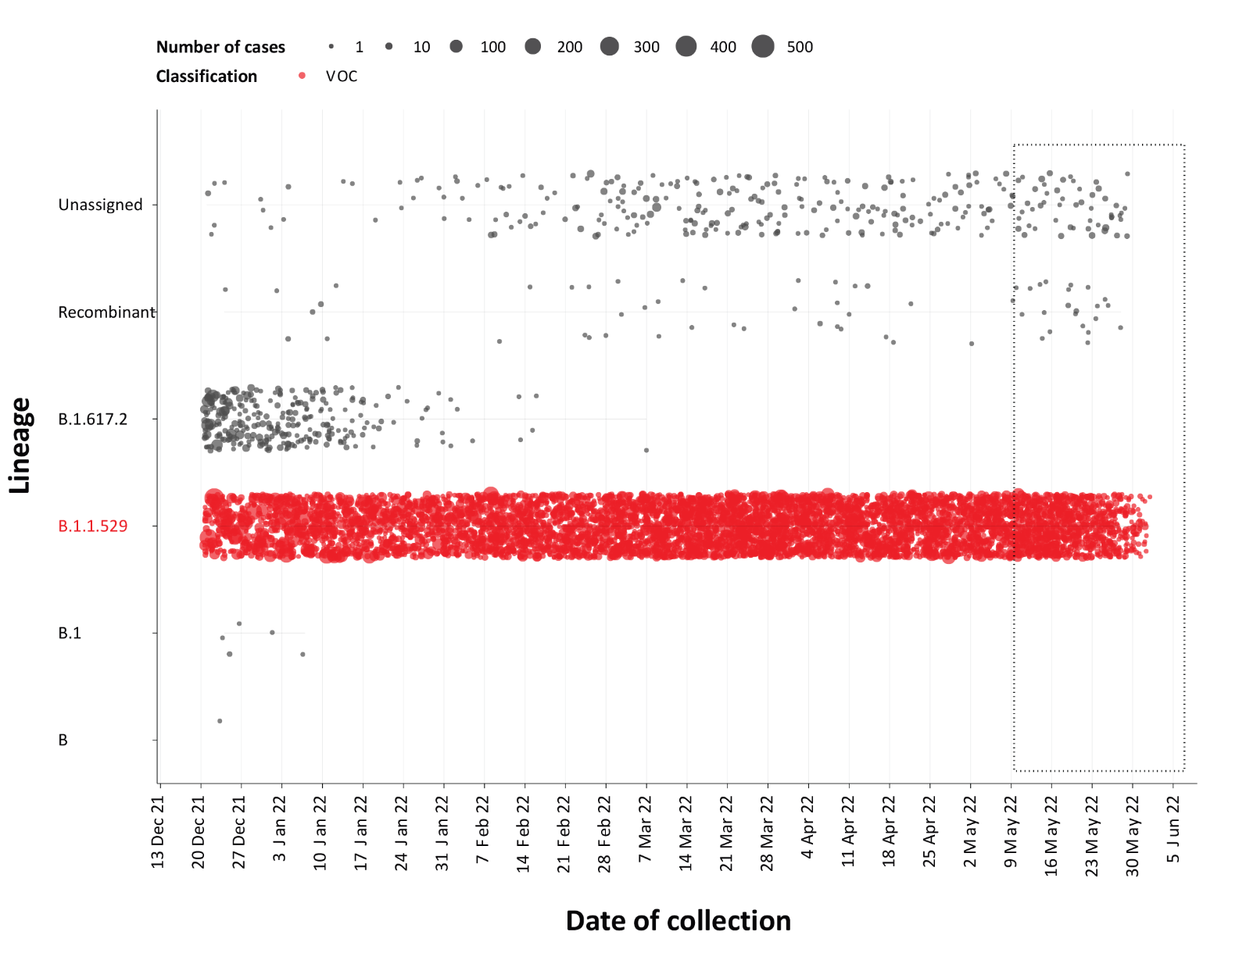
a The current reporting period (9 May to 5 June 2022) is marked by the dashed lines, and variant of concern samples are coloured red. The size of the circle is proportional to the number of samples in the lineage at each time point.

Variants of concern (VOC)
AusTrakka⁵ is actively monitoring and reporting on the one lineage currently designated as a Variant of Concern (VOC) by international organisations, including the World Health Organization (WHO): Omicron (B.1.1.529). The Omicron variant displays a characteristic set of mutations, including a number of variations in the genomic region encoding the spike protein thought to have the potential to increase transmissibility and/or immune evasion. As of 23 May 2022, the Communicable Diseases Genomics Network (CDGN) VOC Working Group demoted Delta (B.1.617.2) to a Variant of Interest. No Delta sequences have been identified from samples collected in the past 12 weeks. The CDGN VOC working group earlier demoted three previously-designated VOCs (Alpha (B.1.1.7); Beta (B.1.351); and Gamma (P.1)) due to the sustained absence of any cases in Australia, and very limited prevalence globally. Further information on variants is available in the Technical Supplement.²
For samples collected in the four-week period from 9 May to 5 June 2022, the BA.2 sub-lineage constituted 93.3% (5,304/5,688) of all lineages identified in AusTrakka (Figure 7). This indicates a genuine dominance of the BA.2 lineage among the sequenced samples. Of the Omicron sequences in AusTrakka to date, 45.0% are BA.1; 53.9% are BA.2; and the remaining sequences are made up of BA.3, BA.4 and BA.5. All sub-sub-lineages have been collapsed into respective major sub-lineages.
Figure 7: Sequences in Austrakka by Omicron sub-lineage and collection date, 11 April to 5 June 2022ª
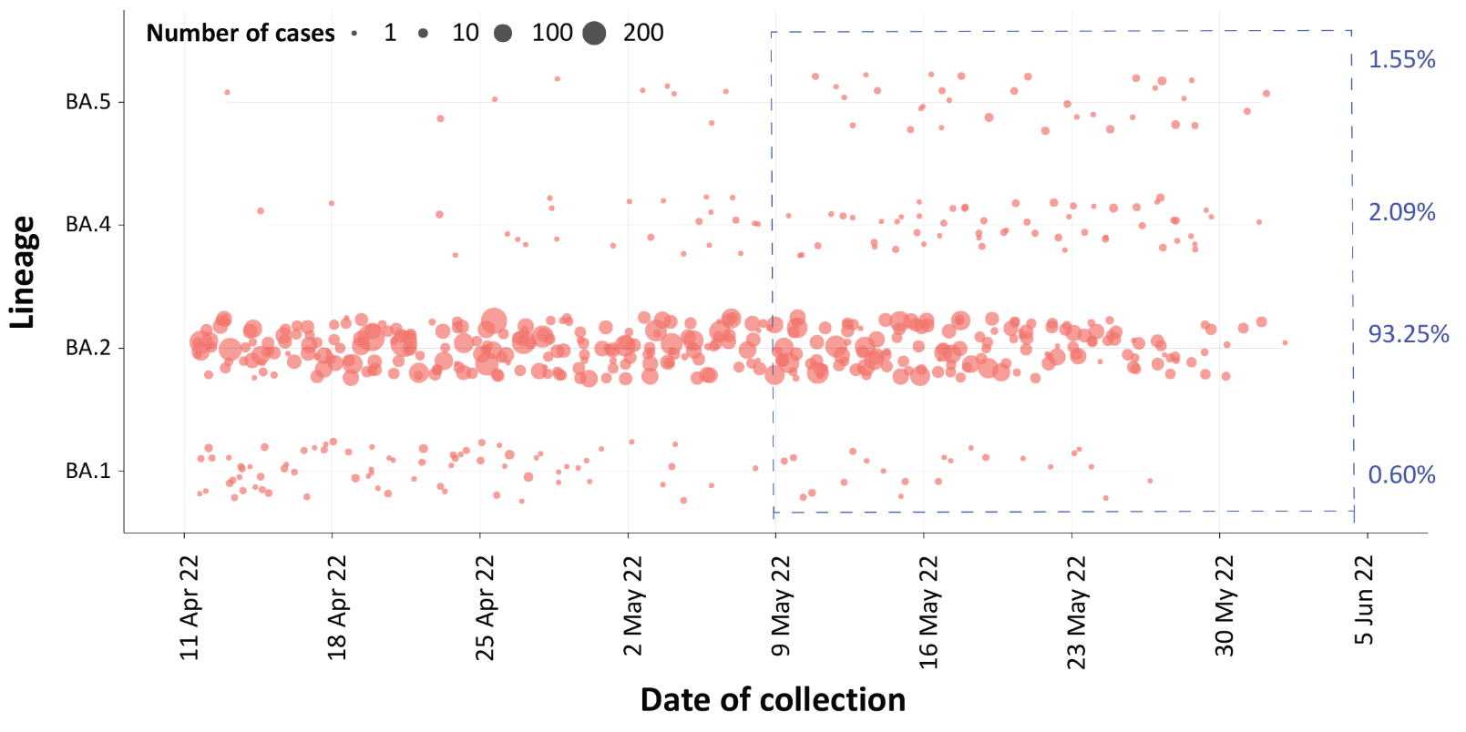
a The current reporting period (9 May to 5 June 2022) is marked by the dashed lines. The size of the circle is proportional to the number of samples in the lineage at each time point.

Table 10: Australian SARS-CoV-2 genome sequences and proportion of positive cases sequenced, 9 May – 5 June 2022 and cumulative to date
Measure | Reporting period  9 May – 5 June 2022 | Cumulative  23 January 2020 – 5 June 2022
SARS-CoV-2 cases sequencedª | 8,295 | 106,135
Percentage of positive cases sequenced^{b} | 2.18% | 2.76%
a Based on individual jurisdictional reports of sequences and case numbers. Calculations of the percentage of cases sequenced based on the number of sequences available in AusTrakka may not always be up-to-date, since this may include duplicate samples from cases and may not represent all available sequence data.
b Total SARS-CoV-2 case numbers as reported by jurisdictional laboratories based on PCR results only. Cases identified via rapid antigen testing are reported differently by each jurisdiction and cannot be followed up for sequencing. They are therefore not included in the sequencing proportions reported here. Sequencing of samples from cases identified in the reporting period may be in process at the time of reporting. Remaining unsequenced samples may be due to jurisdictional sequencing strategy, or where samples have been deemed unsuitable for sequencing (typically because viral loads were too low for sequencing to be successful).

Testing

(State and territory reporting)
From the commencement of the pandemic to 5 June 2022, over 72 million COVID-19 PCR tests have been conducted nationally. Jurisdictional PCR testing rates are driven by current case numbers, testing policies and numbers of people experiencing symptoms. The number, rates and percent positivity of RATs cannot be calculated, as there is currently no reporting of negative RATs.
During the four-week reporting period from 9 May to 5 June 2022, over 2 million PCR tests were conducted. During the reporting period, weekly PCR testing rates increased across all jurisdictions, except for the Australian Capital Territory and Western Australia which saw an overall decrease (Figure 8). In the week ending 5 June 2022, PCR percent positivity by jurisdiction ranged from 3.9% in the Northern Territory to 46.3% in Western Australia.

Figure 8: SARS-CoV-2 polymerase chain reaction (PCR) testing rates per 1,000 population and percent positivity by jurisdiction and date of notification, 31 May 2021 – 5 June 2022ª
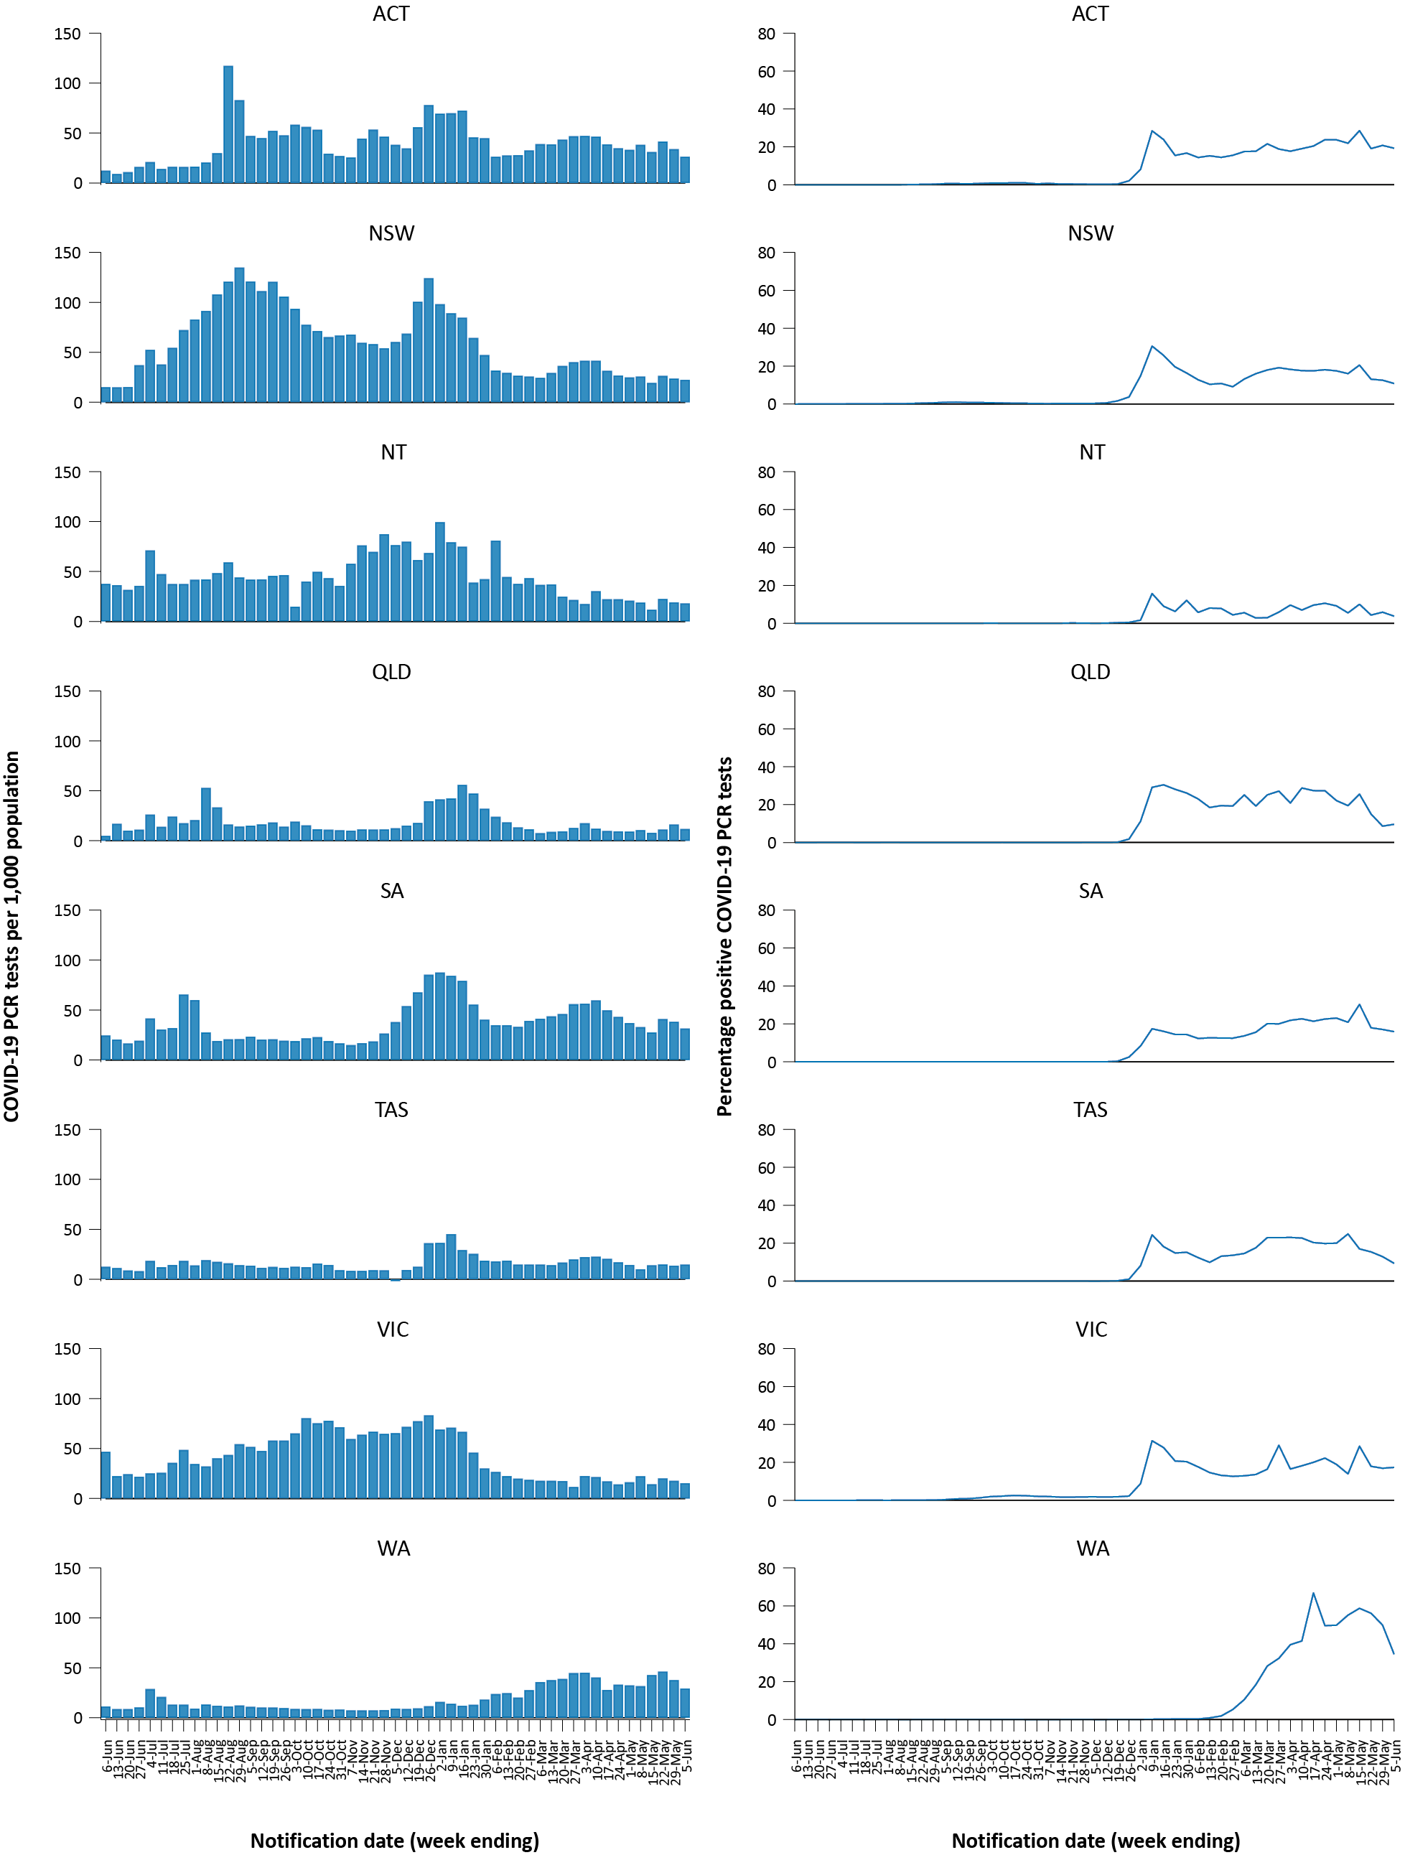
a Source: testing data provided by jurisdictions to the NIR daily, current to 5 June 2022; case data extracted from NNDSS on 7 June 2022 for cases with a notification date up to 5 June 2022; population data based on Australian Bureau of Statistics (ABS) Estimated Resident Population (ERP) as at June 2021. Note: data was not available for Western Australia since 4 June 2022.

Acute respiratory illness

(FluTracking, ASPREN, and Commonwealth Respiratory Clinics)
Based on self-reported FluTracking data,⁶ prevalence of fever and cough in the community over this reporting period increased to 3.1% before decreasing to 2.5% in the last week of the reporting period (Figure 9). This is still higher than the rate observed during the peak of cases in the Omicron wave in January 2022, which was 1.5%. The prevalence of runny nose and sore throat symptoms increased throughout the reporting period from 1.4% to 1.7%, which is notably higher than the prevalence of 0.9% that was observed for runny nose and sore throat symptoms during the peak of the Omicron wave in January 2022.
Figure 9: Weekly trends in respiratory illness amongst FluTracking survey participants (age-standardised) compared to the average of the previous five years, Australia, by epidemiological week,ª 1 January 2020 – 5 June 2022^{b}
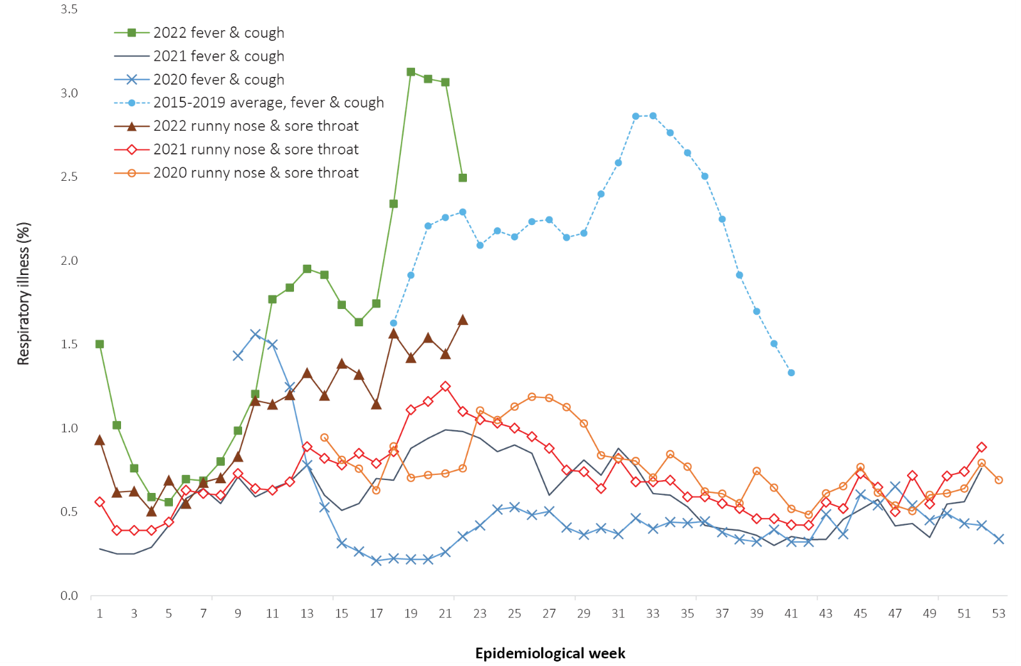
a Epidemiological weeks are a standardised method for numbering weeks across years, with the first epidemiological week of any year ending on the first Saturday in January.
b In years prior to 2020, FluTracking was activated during the main Influenza season from May to October. A historical average beyond the week ending 11 October (epidemiological week 41) is therefore not available. In 2020, FluTracking commenced ten weeks early to capture data for COVID-19. Data on runny nose and sore throat were only collected systematically after 29 March 2020, therefore a historical average for this symptom profile is unavailable.
In this reporting period, acute respiratory illness was highest in those aged 0 to 9 years, based on both self-reported FluTracking data and presentations to Commonwealth Respiratory Clinics. Throughout the reporting period, fever and cough symptoms were observed more commonly in younger age groups and generally decreased with age, whilst the rate of runny nose and sore throat symptoms were highest in those aged 30 to 39 years.
Rates of fever and cough by jurisdiction ranged from 15.8 per 1,000 FluTracking participants in Tasmania to 26.6 per 1,000 participants in Western Australia. Rates of runny nose and sore throat ranged from 12.0 per 1,000 FluTracking participants in the Northern Territory and Tasmania to 16.0 per 1,000 FluTracking participants in Victoria and Western Australia. Overall, rates for both sets of symptoms increased from the previous reporting period.
Over the reporting period, FluTracking data indicated that 33% of participants with ‘fever and cough’ were tested for SARS-CoV-2 with a PCR test and 85% were tested using a RAT (noting that in some instances RATs will be followed up by a PCR test for the same case). Of those with runny nose and sore throat, 13% were tested for SARS-CoV-2 using a PCR test and 70% were tested using a RAT. Of those with fever and cough who tested for SARS-CoV-2, 46% who were tested with a PCR test, and 41% who were tested with a RAT, were positive. In comparison, of participants with runny nose and sore throat who tested for SARS-CoV-2, 22% of those tested by PCR, and 11% of those tested by RAT, tested positive. Note that participants with one set of symptoms are not excluded from having the other. It is important to acknowledge that there may be legitimate reasons why people did not get tested, including barriers to accessing testing. Symptoms reported to FluTracking are not specific to COVID-19 and may also be due to infections with other respiratory pathogens and chronic diseases, such as asthma.
From 9 May to 5 June 2022, there were 84,271 presentations to Commonwealth Respiratory Clinics. Of these, there were 76,018 presentations with consent to share information, with 87% of these (66,095 /76,018) tested for SARS-CoV-2. Of those tested, 13% (8,820 / 66,095) were found to be positive. The most commonly reported symptom amongst presentations that tested positive for COVID-19 was sore throat (56%), followed by cough (52%) and tiredness (44%).
From 9 May to 5 June 2022, there were 473 respiratory illness presentations to the Australian Sentinel Practices Research Network (ASPREN) and Victorian Sentinel Practice Influenza Network (VicSPIN). Respiratory illness presentations to ASPREN and VicSPIN more than doubled when compared to the previous four-week reporting period. Of the 150 respiratory virus swabs processed via ASPREN and VicSPIN in the reporting period, the most common respiratory virus detected was Influenza A (44%; 66/150), followed by Rhinovirus (17%; 26/150); of swabs processed, 7% (11/ 150) were positive for SARS-CoV-2.

Countries and territories in Australia’s near region
According to WHO, countries and territories in the South East Asian and Western Pacific regions reported 5,360,611 newly-confirmed cases and 7,557 deaths in the four-week period to 5 June 2022. The represents a decreasing trend in both new cases and deaths observed in both regions, compared to the previous four-week reporting period. ⁷ In total, since the start of the pandemic, over 119 million cases and over 1 million deaths have been reported in the two regions.⁸
Table 11 outlines new cases and deaths in the four-week period to 5 June 2022 and cumulative cases and deaths for the pandemic in selected countries with the highest number of new cases in the South East Asian region and the Western Pacific region.
As of 5 June 2022, almost 529 million COVID-19 cases and approximately 6.3 million deaths have been reported globally since the start of the pandemic, with a global case fatality rate (CFR) of 1.2%. The two regions reporting the largest burden of disease over the past four weeks were the Western Pacific region (36% of total cases) and the European region (31% of total cases).
Table 11: Cumulative cases and deaths, and new cases and deaths reported in the four-week period to 5 June 2022 for selected countries in Australia’s near region according to WHOª
Country | Cumulative cases | New cases reported in the last 4 weeks | Change in new cases in the last 4 weeks^{b} | Cumulative deaths | New deaths reported in the last 4 weeks | Change in new deaths in the last 4 weeks^{b}
South East Asian region
Indonesia | 6,056,800 | 8,369 | -47% | 156,615 | 234 | -69%
Thailand | 4,466,793 | 141,943 | -68% | 30,171 | 1,083 | -64%
India | 43,176,817 | 74,623 | 12% | 524,692 | 2,379 | -74%
Sri Lanka | 663,869 | 308 | -68% | 16,518 | 9 | -55%
Western Pacific region
China | 3,330,038 | 2,037,990 | 481% | 17,423 | 1,998 | 63%
Republic of Korea | 18,163,686 | 619,288 | -72% | 24,258 | 898 | -77%
Vietnam | 10,724,554 | 50,639 | -90% | 43,080 | 25 | -90%
Japan | 8,913,027 | 854,436 | -20% | 30,735 | 950 | -17%
Australia | 7,373,942 | 1,208,837 | -9% | 8,662 | 1,208 | 34%
Philippines | 3,691,327 | 4,852 | -15% | 60,456 | 17 | -98%
a Source: World Health Organization Coronavirus (COVID-19) Dashboard, accessed 7 June 2022.
b Percent change in the number of newly confirmed cases/deaths in the most recent four-week period compared to the four weeks prior.

Acknowledgements
We thank public health staff from incident emergency operations centres and public health units in state and territory health departments, and the Australian Government Department of Health, along with state and territory public health laboratories. We thank those who have provided data from surveillance systems, such as Commonwealth respiratory clinics, ASPREN, FluTracking, FluCAN, SPRINT-SARI, Communicable Disease Genomics Network, AusTrakka and jurisdictional sequencing laboratories.

Author details

Corresponding author
COVID-19 National Incident Room Surveillance Team
Australian Government Department of Health, GPO Box 9484, MDP 14, Canberra, ACT 2601.
Email: epi.coronavirus@health.gov.au

References
- COVID-19 National Incident Room Surveillance Team. COVID-19 Australia: Epidemiology Report 61: Reporting period ending 8 May 2022. Commun Dis Intell (2018). 2022;46. doi: https://doi.org/10.33321/cdi.2022.46.37.
- COVID-19 National Incident Room Surveillance Team. Technical supplement. COVID-19 Australia: Epidemiology reporting. Commun Dis Intell (2018). 2021;45. doi: https://doi.org/10.33321/cdi.2021.45.2.
- Australian Government Department of Health. Vaccination numbers and statistics. [Internet.] Canberra: Australian Government Department of Health; 2022. [Accessed on 7 June 2022.] Available from: https://www.health.gov.au/initiatives-and-programs/covid-19-vaccines/numbers-statistics.
- Australian and New Zealand Intensive Care Research Centre (ANZIC-RC). SPRINT-SARI: Short period incidence study of severe acute respiratory infection. [Internet.] Melbourne: Monash University, ANZIC-RC; 2020. Available from: https://www.monash.edu/medicine/sphpm/anzicrc/research/sprint-sari.
- Communicable Diseases Genomics Network (CDGN). AusTrakka. [Website.] Melbourne: CDGN; 2020. Available from: https://www.cdgn.org.au/austrakka.
- Dalton C, Durrheim D, Fejsa J, Francis L, Carlson S, d’Espaignet ET et al. Flutracking: a weekly Australian community online survey of influenza-like illness in 2006, 2007 and 2008. Commun Dis Intell Q Rep. 2009;33(3):316–22.
- World Health Organization (WHO). Weekly epidemiological update on COVID-19 – 8 June 2022. [Internet.] Geneva: WHO; 8 June 2022. [Accessed on 9 June 2022.] Available from: https://www.who.int/publications/m/item/weekly-epidemiological-update-on-covid-19---8-june-2022.
- WHO. WHO Coronavirus Disease (COVID-19) dashboard. [Internet.] Geneva: WHO; 2021. Available from: https://covid19.who.int/.

Appendix A: Supplementary figures and tables
Table A1: COVID-19 cases and rates per 100,000 population, by age group, sex, and notification received date, Australia, 15 December 2021 – 5 June 2022^{a,b}
Age group | Four-week reporting period |  |  |  |  |  | Current ‘Omicron’ wave
 | 9 May – 5 June 2022 |  |  |  |  |  | 15 December 2021 – 5 June 2022
 | Cases |  |  | Rate per 100,000 population |  |  | Cases |  |  | Rate per 100,000 population
 | Male | Female | People | Male | Female | People | Male | Female | People | Male | Female | People
0–4 | 20,651 | 19,864 | 40,839 | 2,638.9 | 2,690.3 | 2,685.1 | 139,242 | 131,899 | 273,864 | 17,793.3 | 17,863.6 | 18,006.4
5–11 | 37,260 | 35,419 | 73,651 | 3,172.6 | 3,180.5 | 3,218.9 | 296,816 | 283,157 | 586,763 | 25,273.3 | 25,426.3 | 25,644.6
12–15 | 26,079 | 26,006 | 52,949 | 3,993.7 | 4,204.3 | 4,164.1 | 175,541 | 177,945 | 357,936 | 26,881.9 | 28,767.7 | 28,149.2
16–17 | 9,968 | 11,858 | 22,238 | 3,284.7 | 4,141.2 | 3,770.4 | 77,441 | 88,268 | 167,895 | 25,518.6 | 30,826.1 | 28,465.9
18–29 | 62,639 | 78,580 | 144,196 | 3,024.0 | 3,949.8 | 3,550.9 | 616,153 | 701,740 | 1,335,734 | 29,745.9 | 35,272.9 | 32,893.0
30–39 | 67,938 | 86,289 | 157,006 | 3,644.1 | 4,503.0 | 4,153.0 | 490,805 | 574,042 | 1,077,336 | 26,325.8 | 29,956.7 | 28,496.5
40–49 | 61,894 | 78,017 | 142,179 | 3,790.9 | 4,693.3 | 4,315.0 | 390,504 | 464,193 | 863,498 | 23,917.4 | 27,924.8 | 26,206.2
50–59 | 50,879 | 60,594 | 113,056 | 3,315.1 | 3,766.2 | 3,596.3 | 290,681 | 327,638 | 624,225 | 18,939.5 | 20,364.4 | 19,856.6
60–69 | 35,631 | 40,890 | 77,252 | 2,686.6 | 2,896.7 | 2,821.6 | 188,348 | 201,169 | 392,503 | 14,201.4 | 14,251.0 | 14,336.0
70–79 | 21,584 | 21,798 | 43,717 | 2,281.8 | 2,165.3 | 2,238.9 | 103,415 | 99,227 | 204,058 | 10,932.7 | 9,856.6 | 10,450.4
80–89 | 9,463 | 10,924 | 20,618 | 2,441.8 | 2,234.9 | 2,352.8 | 41,712 | 44,135 | 86,751 | 10,763.1 | 9,029.6 | 9,899.4
90 + | 2,585 | 4,696 | 7,418 | 3,323.1 | 3,257.6 | 3,342.3 | 9,757 | 16,999 | 27,255 | 12,543.1 | 11,792.1 | 12,280.1
a Source: NNDSS, extract from 7 June 2022 for notifications to 5 June 2022. Excludes cases where age or sex data is missing. At the time of extraction, RAT probable cases were not yet available from the Northern Territory, Tasmania, or Western Australia; nor from Victoria since 2 June 2022. At the time of extraction, Queensland only reports RAT cases that have been conducted in a clinical setting; self-administered RAT probable cases are not reported to NNDSS. Data was not available from Western Australia since 4 June 2022.
b Population data based on Australian Bureau of Statistics (ABS) Estimated Resident Population (ERP) as at June 2021.

Communicable Diseases Intelligence
ISSN: 2209-6051 Online

Communicable Diseases Intelligence (CDI) is a peer-reviewed scientific journal published by the Office of Health Protection and Response, Department of Health and Aged Care. The journal aims to disseminate information on the epidemiology, surveillance, prevention and control of communicable diseases of relevance to Australia.

Editor: Noel Lally
Deputy Editor: Simon Petrie
Design and Production: Kasra Yousefi
Editorial Advisory Board: David Durrheim, Mark Ferson, John Kaldor, Martyn Kirk and Linda Selvey

Website: http://www.health.gov.au/cdi

Contacts
CDI is produced by the Office of Health Protection and Response, Australian Government Department of Health and Aged Care, GPO Box 9848, (MDP 6) CANBERRA ACT 2601

Email: cdi.editor@health.gov.au

Submit an Article
You are invited to submit your next communicable disease related article to the Communicable Diseases Intelligence (CDI) for consideration. More information regarding CDI can be found at: http://health.gov.au/cdi.
Further enquiries should be directed to: cdi.editor@health.gov.au.

This journal is indexed by Index Medicus and Medline.

Creative Commons Licence - Attribution-NonCommercial-NoDerivatives CC BY-NC-ND
© 2022 Commonwealth of Australia as represented by the Department of Health and Aged Care
This publication is licensed under a Creative Commons Attribution-NonCommercial-NoDerivatives 4.0 International Licence from https://creativecommons.org/licenses/by-nc-nd/4.0/legalcode (Licence). You must read and understand the Licence before using any material from this publication.

Restrictions
The Licence does not cover, and there is no permission given for, use of any of the following material found in this publication (if any):
- the Commonwealth Coat of Arms (by way of information, the terms under which the Coat of Arms may be used can be found at www.itsanhonour.gov.au);
- any logos (including the Department of Health and Aged Care’s logo) and trademarks;
- any photographs and images;
- any signatures; and
- any material belonging to third parties.

Disclaimer
Opinions expressed in Communicable Diseases Intelligence are those of the authors and not necessarily those of the Australian Government Department of Health and Aged Care or the Communicable Diseases Network Australia. Data may be subject to revision.

Enquiries
Enquiries regarding any other use of this publication should be addressed to the Communication Branch, Department of Health and Aged Care, GPO Box 9848, Canberra ACT 2601, or via e-mail to: copyright@health.gov.au

Communicable Diseases Network Australia
Communicable Diseases Intelligence contributes to the work of the Communicable Diseases Network Australia.
http://www.health.gov.au/cdna

