2025 • Volume • • Electronic publication date:

Mother-to-child transmission of hepatitis B in Far North Queensland, 2013–2023

Josh Hanson, Sharna Radlof, Jenna Coffman, Kathy Lort-Phillips, Simon Smith, Allison Hempenstall, Annie Preston-Thomas

# Abstract

Background

With optimal antenatal and perinatal care and immunisation, the risk of perinatal transmission of hepatitis B virus (HBV) approaches zero. However, it can be logistically challenging to deliver this care to culturally and linguistically diverse populations and to those individuals who are living in remote Australian communities. This study examined the management of pregnant women with chronic hepatitis B (CHB) and their children in Far North Queensland (FNQ). It was hoped that this would identify the successes and limitations of the current FNQ HBV programme which was established in June 2017.

Methods

We used the Queensland notifiable diseases register to identify every female of childbearing age (13–45 years) living in FNQ with CHB during the study period 1 January 2013 – 31 December 2023. We identified the children born to these women during the study period and assessed whether their care was concordant with current Australian HBV management guidelines.

Results

We identified 261 women of childbearing age who had 148 live births during the study period: 93/148 children (63%) were born to First Nations Australian mothers; 58/148 (39%) were born to mothers who were born overseas; and 46/148 (31%) were born to mothers who lived in remote locations. After establishment of the FNQ HBV programme, 71/77 pregnancies (92%) had optimal antenatal HBV care; 71/77 (92%) had optimal perinatal HBV care; and 72/77 infants (94%) had complete HBV vaccination. There have been no children confirmed to be hepatitis B surface antigen (HBsAg) positive since the establishment of the FNQ HBV programme. However, only 70/148 children (47%) have had HBsAg testing.

Conclusions

Antenatal and perinatal care and infant vaccination is currently concordant with national HBV guidelines in > 90% of pregnancies in the FNQ region. There has been no confirmed mother-to-child HBV transmission since establishment of a local HBV programme, although improved child testing is necessary to substantiate this finding.

Keywords: hepatitis B virus; chronic hepatitis B; mother-to-child transmission; public health; preventative medicine; vaccination; tropical Australia; Aboriginal and Torres Strait Islander peoples; primary healthcare

# Background

The prevalence of chronic hepatitis B (CHB) in Far North Queensland (FNQ) in tropical Australia is one of the highest in the country.1 Some of the remote communities across the region’s 380,000 km2 expanse have a community prevalence of CHB exceeding 6%.2 Most individuals living with CHB in FNQ identify as Aboriginal and Torres Strait Islander Australians (hereafter respectfully referred to collectively as First Nations Australians), although a growing proportion have migrated to the region from Papua New Guinea and Southeast Asia where there is a significant CHB burden.3 Delivering optimal CHB care to a geographically dispersed and culturally and linguistically diverse patient population is challenging, particularly when comorbidities compete for finite health resources.4,5

The FNQ hepatitis B programme was established in June 2017 to improve the coordination and delivery of CHB care across the FNQ region. HBV infection is notifiable in Queensland and the FNQ hepatitis B programme has developed a database that uses data from the Queensland notifiable diseases register to identify every individual living with CHB in the FNQ region. The programme has a dedicated HBV nurse who travels to remote communities to perform transient elastography and who records pathology, radiology and other clinical data to assist with the delivery of optimal longitudinal care of people living with CHB in FNQ. The programme’s nurse also plays a critical role in the further education of individuals with CHB and their families. The programme aims to educate primary healthcare workers caring for individuals living with CHB, facilitating the decentralisation of CHB care, a focus of Australia’s National Hepatitis B Strategy.4,6 The programme assists with the dissemination of educational resources from organisations such as Hepatitis Queensland and the Australasian Society for HIV, Viral Hepatitis and Sexual Health Medicine (ASHM) and plays an integral role in the delivery of dedicated educational workshops for local healthcare workers. These workshops aim to increase the knowledge of healthcare workers about CHB infection and have an emphasis on increasing their confidence in prescribing antiviral therapy. The workshops also aim to strengthen relationships between local primary care clinicians and specialist services, ensuring that primary care clinicians have ongoing specialist support.

The FNQ HBV programme’s database can also identify women of childbearing age, which is important: viral transmission at, or shortly after, birth is the most important cause of CHB globally.7 Prevention of mother-to-child transmission is highly cost-effective, obviates the requirement for many decades of CHB care, and is a cornerstone of global strategies to eliminate HBV.8,9 Vaccination of newborn First Nations Australian infants commenced in Queensland in late 1985, at a time when > 20% of children in many remote First Nations Australian communities in FNQ were hepatitis B surface antigen (HBsAg) positive.10 This programme has had a major impact on the incidence of new HBV infections in the FNQ region (Figure 1).2 Appropriate prescription of antiviral therapy in the third trimester of pregnancy and administration of hepatitis B immunoglobulin (HBIG) can further reduce the risk of perinatal transmission.8,11 However, with suboptimal antenatal and perinatal care and incomplete vaccination in some FNQ communities, ongoing mother-to-child transmission of HBV has been documented in the region, adding to the already significant local CHB burden, increasing affected individuals’ risk of liver cancer and cirrhosis.12,13

The FNQ hepatitis B programme has now been established for more than five years and has had an important impact on CHB care uptake in the region.2,5 Far North Queensland is now only one of two statistical area level 3 (SA3) regions in Australia with uptake of CHB care above the national target of 50%.1,6 It was hoped that the additional resourcing dedicated to the management of people living with CHB in the region and the education provided to healthcare workers has also had an impact on local mother-child transmission of HBV. This study was performed to examine if the recent management of pregnant women with CHB and their children in FNQ was concordant with national guidelines for optimal care. It was hoped that this would identify the successes and limitations of the FNQ HBV programme and inform future public health strategies in the region.

Figure 1: Date of birth of individuals living with chronic hepatitis B in the Far North Queensland region in December 2023, stratified by First Nations Australian statusa

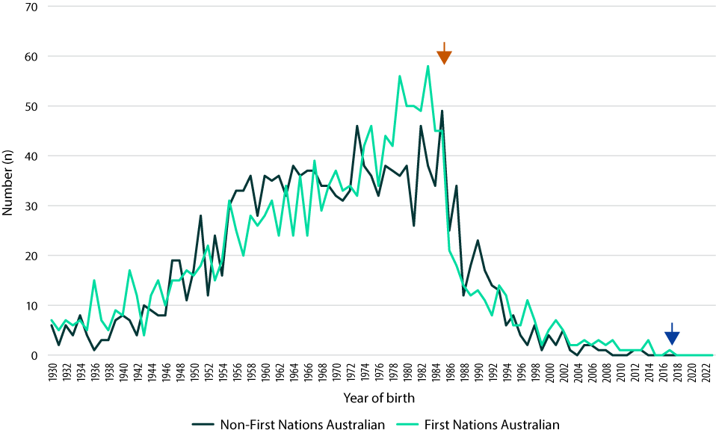

a Arrows show public health interventions. Orange arrow: commencement of vaccination of newborn First Nations Australian infants, in late 1985. Navy arrow: establishment of the FNQ hepatitis B programme, in June 2017.

# Methods

We used the FNQ HBV database to identify every female of childbearing age (aged 13–45 years) during 1 January 2013 – 31 December 2023 living in FNQ with CHB. We identified the children born to these women during the study period and ascertained whether their care was concordant with the current Australian consensus guidelines for the management of hepatitis B.14 These guidelines were used to define whether the mothers had received optimal antenatal HBV care and whether the children had received optimal perinatal care, had received all their recommended HBV vaccines and had their HBV serology checked within 12 months of their birth and before 30 June 2024 (Table 1).

We collected basic demographic data, including the mother’s age, her country of birth, and whether she identified as a First Nations Australian. Individuals living in the Torres and Cape Health and Hospital Service were said to have a remote residence. We collected clinical and laboratory data from individuals’ medical records and their public and private laboratory records. Vaccination data were collected from the Australian Immunisation Register (AIR). Socioeconomic disadvantage was determined using the Socio-Economic Indexes for Areas (SEIFA) Index of Relative Socio-economic Disadvantage, with disadvantaged individuals defined as those living in a suburb or locality with the a SEIFA score in the lowest decile in Australia.15

Data were de-identified, entered into an electronic database and analysed using statistical software (Stata version 18.0). Groups were compared using the chi-square or Fisher’s exact test, as appropriate. The study was approved by the FNQ Human Research Ethics Committee (HREC/16/QCH/109); as the data were retrospective and de-identified, the committee waived the requirement for informed consent.

Table 1: Definitions used in this reporta

| Terminology | Definitionb |
| --- | --- |
| Engaged in care | Receiving antiviral therapy or tested for HBV DNA in the prior 12 months |
| Optimal antenatal care | Maternal viral load tested prior to third trimester; antiviral therapy initiated if indicatedc |
| Optimal perinatal care | Child received HBIG active and passive immunisation within 4 hours of birth |
| Full vaccination | Child received perinatal vaccine and standard vaccination at 2, 4 and 6 months |
| Optimal treatment | Optimal antenatal and perinatal care and complete vaccination |
| Guideline concordant care | Optimal antenatal and perinatal care, complete vaccination and testing of infant within 12 months of birth |

a Definitions are based on the 2022 Australian consensus guidelines for the management of hepatitis B and the 2024 Australasian Society for HIV, Viral Hepatitis, and Sexual Health Medicine (ASHM) hepatitis B mapping report.1,14

b HBV DNA: hepatitis B virus deoxyribose nucleic acid; HBIG: hepatitis B immunoglobulin.

c If HBV viral load > 200 000 IU/mL, antiviral therapy should be commenced from the twenty-eighth week of pregnancy.

# Results

We identified 261 female FNQ residents of childbearing age living with CHB during the study period; 165/261 (63%) identified as a First Nations Australian, 94/261 (36%) lived in a remote location and 164/261 (63%) lived in a disadvantaged location (Table 2). Most were born in Australia (177/261; 68%); of the 84 born overseas, 54 (64%) were born in Asia, most commonly in the Philippines (15/54; 27%) and Laos (8/54; 15%). A further 22 were born in Oceania, 19 of whom (86%) were born in Papua New Guinea.

Table 2: Characteristics of the cohort

| Characteristic | Women of childbearing age living with CHB in the FNQ region n = 261 | Women who had a live birth during the study period n = 84 | Live births during the study period n = 148 |
| --- | --- | --- | --- |
| Age of woman or child (years)a | 43 (38–47) | 40 (25–43) | 6 (3–9) |
| First Nations Australian | 165 (63%) | 54 (64%) | 93 (63%) |
| Socioeconomic disadvantageb | 164 (63%) | 54 (64%) | 94 (64%) |
| Born overseas | 84 (32%) | 31 (37%) | 0 |
| Remote residencec | 94 (36%) | 28 (33%) | 46 (31%) |

a At the end of the study period; median (interquartile range) presented.

b Socioeconomic disadvantage: residence in a suburb or locality with a SEIFA Index of Relative Socio-economic Disadvantage in lowest decile in Australia.15

c Remote residence: residence in Torres and Cape Hospital and Health Service.

Of these 261 women, 84 (32%) had 148 live births during the study period. There was negligible difference in the proportion of First Nations Australian women and non-First Nations Australian women who had live births during the study period: 54/165 (33%) versus 30/96 (31%); *p* = 0.81. Of the 148 live births during the study period, 46 (31%) were to mothers living in a remote location (Figure 2) and 94 (64%) were to mothers living in a disadvantaged location.

After establishment of the programme, there were improvements in the proportion of women having optimal antenatal care, 49/71 (69%) before and 71/77 (92%) after establishment of the programme, *p*< 0.0001; and in the proportion of pregnancies having optimal treatment, 45/71 (63%) before and 63/77 (82%) after establishment of the programme, *p* = 0.01. After establishment of the programme, 71/77 (92%) had viral load testing during pregnancy and all 21 (100%) who met criteria for therapy received tenofovir. After establishment of the FNQ HBV programme, 71/77 (92%) live births had optimal perinatal HBV care and 72/77 (94%) had complete HBV vaccination (Tables 3 and 4; Figures 3 and 4).

Figure 2: Locality of residence of the 84 women who had a live birth during the study period

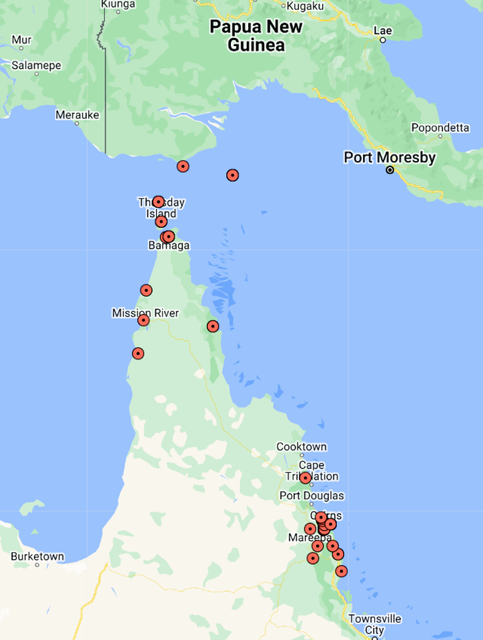

Table 3: Influence of demographic factors on the care of the 148 live birthsa

| Care measure | All n = 148 | First Nations Australian n = 93 | non-First Nations Australian n = 55 | Greatest socioeconomic disadvantageb n = 94 | Less socioeconomic disadvantageb n = 54 | Mother born overseas n = 58 | Mother born in Australia n = 90 |
| --- | --- | --- | --- | --- | --- | --- | --- |
| Optimal antenatal carec | 120 (81%) | 71 (76%) | 49 (89%) | 77 (82%) | 43 (80%) | *52 (90%)a* | *68 (76%)a* |
| Optimal perinatal cared | 133 (90%) | 84 (90%) | 49 (89%) | 86 (91%) | 47 (87%) | 52 (90%) | 81 (90%) |
| Complete vaccinatione | 141 (95%) | 88 (95%) | 53 (96%) | 90 (96%) | 51 (94%) | 56 (97%) | 85 (94%) |
| Follow up HBsAg at 12 monthsf | 24/146 (16%) | 18/91 (20%) | 6 (11%) | 17/93 (18%) | 7/53 (13%) | 6 (10%) | 18/88 (20%) |
| Follow up HBsAg everf | 70/146 (48%) | *50/91 (55%)a* | *20 (36%)a* | *54/93 (58%)a* | *16/53 (30%)a* | *21 (36%)a* | *49/88 (56%)a* |
| Optimal treatmentg | 108 (73%) | 63 (68%) | 45 (82%) | 69 (73%) | 39 (72%) | *48 (83%)a* | *60 (67%)a* |
| Guideline concordant caref,h | 24 (16%) | 18/91 (20%) | 6 (11%) | 17/93 (18%) | 7/53 (13%) | 6 (10%) | 18/88 (20%) |

a Statistically significant differences (*p* < 0.05) are shown in *italics*.

b Socioeconomic disadvantage: residence in a suburb or locality with a SEIFA Index of Relative Socio-economic Disadvantage in lowest decile in Australia.15

c Viral load measured during pregnancy and antiviral therapy prescribed if indicated.

d HBIG and HBsAg at birth.

e HBsAg at birth and complete vaccination at 2, 4 and 6 months.

f Excluding two individuals born < 12 months before the end of the follow up period (30 June 2024).

g Optimal antenatal and perinatal care and complete vaccination.

h Optimal antenatal and perinatal care, complete vaccination and testing of infant’s HBV serology within 12 months of birth.

Table 4: Influence of demographic, geographic and health system factors on the care of the 148 live birthsa

| Care measure | All n = 148 | Remote residenceb n = 46 | Non-remote residenceb n = 102 | Before HBV programme establishedc n = 71 | After HBV programme establishedc n = 77 |
| --- | --- | --- | --- | --- | --- |
| Optimal antenatal cared | 120 (81%) | 37 (80%) | 83 (81%) | *49 (69%)a* | *71 (92%)a* |
| Optimal perinatal caree | 133 (90%) | 39 (85%) | 94 (92%) | 62 (87%) | 71 (92%) |
| Complete vaccinationf | 141 (95%) | 45 (98%) | 96 (94%) | 69 (97%) | 72 (94%) |
| Follow up HBsAg at 12 monthsg | 24/146 (16%) | 10/45 (22%) | 14/101 (14%) | 13/71 (18%) | 11/75 (15%) |
| Follow up HBsAg everg | 70/146 (48%) | *30/45 (67%)a* | *40/101 (40%)a* | *38/71 (54%)a* | *32/75 (43%)a* |
| Optimal treatmenth | 108 (73%) | 32 (70%) | 76 (75%) | *45 (63%)a* | *63 (82%)a* |
| Guideline concordant careg,i | 24/146 (16%) | 10/45 (22%) | 14/101 (14%) | 13/71 (18%) | 11/75 (15%) |

a Statistically significant differences (*p* < 0.05) are shown in *italics*.

b Remote residence: residence in Torres and Cape Hospital and Health Service; non-remote residence: residence in Cairns and Hinterland Hospital and Health Service.

c HBV project established 30 June 2017.

d Viral load measured during pregnancy and antiviral therapy prescribed if indicated.

e HBIG and HBsAg at birth.

f HBsAg at birth and complete vaccination at 2, 4 and 6 months.

g Excluding two individuals born < 12 months before the end of the follow up period (30 June 2024).

h Optimal antenatal and perinatal care and complete vaccination.

i Optimal antenatal and perinatal care, complete vaccination and testing of infant’s HBV serology within 12 months of birth.

Figure 3: Proportion of mothers and children receiving optimal HBV care before, and after, the establishment of the FNQ HBV programme on 30 June 2017a

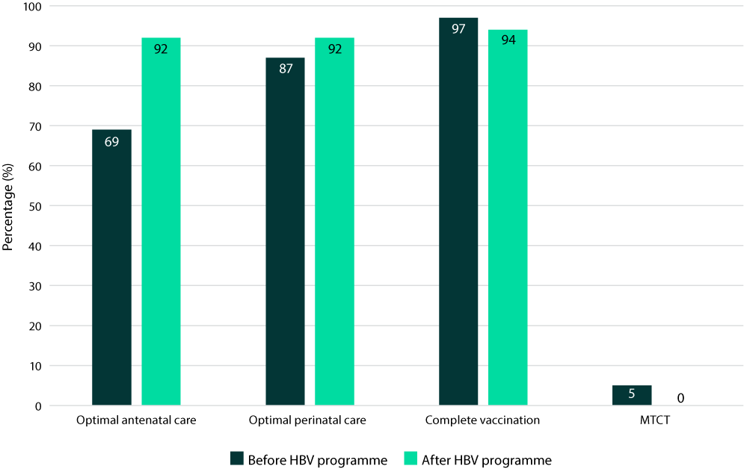

a The proportion of live births in which mother-to-child transmission (MTCT) of HBV was documented – before and after establishment of the programme – is also presented.

Figure 4: Antenatal care of mothers with chronic hepatitis B, perinatal care of their infants and their subsequent vaccination during the study period, stratified by characteristics of the mothersa

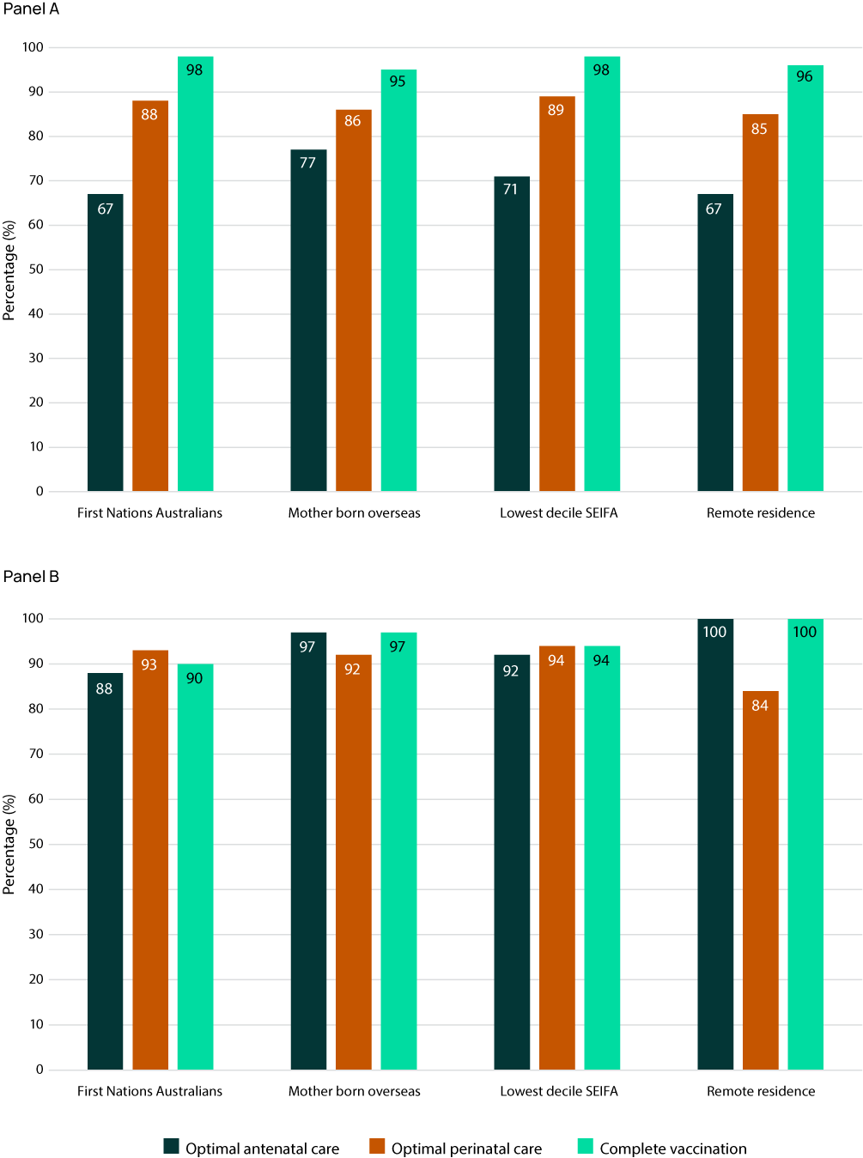

a Panel A shows care applied to births occurring before the establishment of the FNQ hepatitis B programme in June 2017. Panel B shows care applied to births occurring after the FNQ hepatitis B programme’s establishment.

However, rates of serological testing of the children were not as high. Excluding the two infants who were born < 12 months before the end of the follow up period, only 24/146 (16%) infants had their serology checked within 12 months of their birth and only 70/146 (48%) had had HBV serology tested at all. Of these 70, there were two infants (3%) who were confirmed to be hepatitis B surface antigen (HBsAg) positive: both were born to First Nations Australian mothers living in non-remote locations before the FNQ HBV programme was established (in 2014 and early 2017, respectively).

The mother of the first of these two HBsAg-positive children was tested during her pregnancy and was found to be hepatitis B e antigen (HBeAg) positive; tenofovir was prescribed when her viral load was found to be > 1.1 × 108 IU/mL. However, she did not take the tenofovir and, despite her child receiving optimal perinatal care and complete HBV vaccination, the child was HBsAg positive when tested. The second child had received optimal perinatal care and complete HBV vaccination, but the mother’s viral load was not tested during pregnancy, and she did not receive tenofovir. Seven years later she was HBeAg positive with a viral load of 3.95 × 108 IU/mL when tested; her child was HBsAg positive when tested.

The proportion of children who had had their HBV serology tested and who had a positive HBsAg was 2/38 (5%) before the establishment of the HBV programme and 0/32 (0%) afterwards (*p* = 0.50) (Figure 3). Of the 76 children who have been followed for ≥ 12 months and who have not yet had their HBV serology checked, 62 (82%) had optimal antenatal care, 70 (92%) had optimal perinatal care and 70 (92%) had full hepatitis B vaccination.

At the end of the study period, the median age of the women in the cohort was 43 years (interquartile range: 38–47 years); only 81 (31%) were aged less than 40 years. Of the 261 women in this cohort, 150 (57%) were engaged in CHB care in the 2023 calendar year.

# Discussion

Vaccination against HBV has had a dramatic effect on the prevalence of CHB in FNQ, but ongoing mother-to-child transmission has been documented, necessitating more focussed efforts to ensure the elimination of HBV in the region. The study shows the successes of the FNQ HBV programme in this regard, but also highlights the challenges that remain to be addressed. After the establishment of the programme there has been a significant increase in the proportion of women receiving optimal antenatal care, with 92% of women now receiving optimal antenatal care, 92% of children now receiving optimal perinatal care and 94% of children now receiving full HBV vaccination. This has been possible despite the mothers having a diversity of cultural backgrounds, with many living in some of the most remote communities in Australia. In this respect, the FNQ HBV programme is currently helping to deliver care that aligns with the current National Hepatitis B Strategy which aims to ensure that everyone has equitable access to safe, affordable, and effective vaccines and to optimal prevention measures.6 At the end of the study period there was little difference in the rates of optimal antenatal care, optimal perinatal care and full vaccination in the different priority populations.

The prevalence of CHB among First Nations Australians is almost five times that seen in non-First Nations Australians; this contributes to a 2.5 times higher rate of hepatocellular carcinoma.1,16 As the majority of the people living with CHB in the FNQ region identify as First Nations Australians, the goals of the FNQ HBV programme therefore also align with Australia’s ongoing efforts to address the persisting differences in health outcomes that exist between First Nations and non-First Nations Australians, which, in turn, are largely explained by the social determinants of health, and by poorer access to health services.17,18 While the social determinants of health continue to have a major impact on the incidence of infectious diseases in the FNQ region,19–21 successfully mitigating their impact is more complicated.22,23 This contrasts, quite starkly, with the availability of relatively simple interventions that can almost eliminate the risk of perinatal HBV transmission and reduce the risk of subsequent liver disease, providing support for their prioritisation in public health programmes.10,24

There have been no confirmed episodes of mother-to-child transmission of HBV in FNQ since the programme was established in June 2017, although this observation needs to be tempered by the fact that only 47% of the children born to women living with CHB have had their HBV serology tested. There are ongoing efforts to address this issue, and the HBV programme is currently liaising with primary care providers and child health nurses in the region. Some local clinicians argue that venepuncture of infants can be traumatic, and that knowledge of the child serological status is unlikely to change their management in the short term. The child will have no symptoms—and there is no opportunity to initiate antiviral therapy—until the immune system attempts to clear the virus, which is likely to be decades later.7 Even then, therapy is only recommended in Australian guidelines if clearance is prolonged for > 3–6 months.14 However, conversely, earlier knowledge of the child’s status may provide their families with peace of mind and may assist with decisions around household vaccination. A knowledge of the current prevalence of CHB in different age groups will also determine progress towards the World Health Organization target of a prevalence of CHB of < 0.1% in those < 5 years of age, allowing, if appropriate, reprioritisation of public health strategies and redeployment of finite health resources.23,25

Despite the availability of an effective vaccine and other measures to reduce mother-to-child transmission of HBV, this and studies from the Northern Territory of Australia confirm ongoing early childhood transmission of hepatitis B in First Nations communities in both jurisdictions.26 There were 2/70 (3%) FNQ children with known serological results in the 2013–2023 period who were confirmed to be HBsAg positive (the last born in 2017). Meanwhile a 2022 report from remote Aboriginal communities in the Northern Territory identified that 3/33 (9%) children born between 1998 and 2013 were HBsAg positive.26 Although it is not possible to directly compare the two studies, there are several reasons why mother-to-child transmission of HBV may have been greater in the Northern Territory study. Less than 90% of the children in the Northern Territory study had documented perinatal HBIG and full vaccination and, while tenofovir is currently prescribed routinely during late pregnancy in mothers in the Northern Territory with high viral loads, this was not the case between 1998 and 2013.26 Furthermore, every Aboriginal Australian in the Northern Territory to have had HBV genotyping has been identified as having the unique HBV/C4 genotype; this genotype is associated with persisting HBeAg and higher viral loads which increase the risk of mother-to-child transmission.27–29 There are also some data to suggest suboptimal vaccine efficacy against the circulating HBV/C4 genotype.30 However, as in FNQ, the prevalence of CHB among First Nations women in the Northern Territory is significantly lower in those born after the implementation of the vaccination program than in those born before, highlighting the ongoing impact of vaccination in both regions.24 The Northern Territory’s innovative ‘Hep B PAST’ model of care, which has an emphasis on the delivery of decentralised comprehensive CHB care in the primary healthcare setting, would be expected to further reduce the rates of mother-to-child transmission in that jurisdiction.31

The FNQ HBV programme lacks the resources of the Hep B PAST model, but this study demonstrates that it can have a significant impact on the delivery of optimal antenatal care to women with CHB. This will have a salutary effect on mother-to-child transmission which would be expected to decline further as the cohort of women with CHB ages. The programme has also been able to ensure that 57% of the women of childbearing age–including priority populations that have previously struggled to access optimal CHB care–were engaged in care in 2023, a figure that is greater than twice the current rate of 25.5% in the general Australian population.1 This would be expected to have significant long-term health benefits for the women living with CHB in this remote part of Australia.

Our study has limitations. Its retrospective nature precluded the collection of comprehensive data in all cases. Although laboratory and vaccination data were available for the entire study period, an electronic medical record was only established at Cairns Hospital in 2015, meaning that data around the prescription of tenofovir and HBIG may have been incomplete prior to this time, although tenofovir prescription did increase across the region during the study period.1 While there have been no documented cases of mother-to-child transmission since the FNQ programme was established in June 2017, this is at least partly explained by aging of the women of childbearing age in the cohort, increasing the likelihood of HBeAg seroconversion, reducing the likelihood of mother-to-child transmission independent of any contribution from the HBV programme.3,28,29

# Conclusions

Antenatal and perinatal care in the FNQ region is now concordant with national HBV consensus guidelines in > 90% of pregnancies. There has been no confirmed mother-to-child transmission since the establishment of a local HBV programme in June 2017, although improved child testing is necessary to substantiate this finding. The report provides further evidence of the benefits of a decentralised model of CHB care in regional Australia; it also provides more data to support the provision of dedicated resources to assist with the care of people living with, and at risk of, CHB. This is essential if Australia is to reach its stated objective of eliminating hepatitis B as a public health threat by 2030.

# Author details

Dr Josh Hanson,1,2

Ms Sharna Radlof,1

Dr Jenna Coffman,1

Ms Kathy Lort-Phillips,3

Dr Simon Smith,1

Dr Allison Hempenstall,4,5

Dr Annie Preston-Thomas3

1. Department of Medicine, Cairns Hospital, Cairns, Queensland, Australia
2. Kirby Institute, University of New South Wales, Sydney, NSW, Australia
3. Tropical Public Health Unit, Torres and Cape Hospital and Health Service, Queensland, Australia
4. Public Health Unit, Torres and Cape Hospital and Health Service, Queensland, Australia
5. College of Medicine and Dentistry, James Cook University, Queensland, Australia

Corresponding author

Dr Josh Hanson

Department of Medicine, Cairns Hospital, Cairns, Queensland 4870

Phone: +61 7 4226 6333

Email: [jhanson@kirby.unsw.edu.au](mailto:jhanson@kirby.unsw.edu.au)

# References

1. MacLachlan JH, Romero N, Purcell I, Cowie BC. *Viral Hepatitis Mapping Project: Hepatitis B. National Report 2022*. Sydney: ASHM; 2024. Available from: <https://ashm.org.au/wp-content/uploads/2024/08/Aug-Update2_ASHM_ViralHepReport_2024_HBV-web.pdf>.
2. Hanson J, Fox M, Anderson A, Fox P, Webster K, Williams C et al. Chronic hepatitis B in remote, tropical Australia; successes and challenges. *PLoS One*. 2020;15(9):e0238719. doi: <https://doi.org/10.1371/journal.pone.0238719>.
3. Neldner L, Radlof S, Smith S, Littlejohn M, Hempenstall A, Hanson J. Age of hepatitis B e antigen loss in Aboriginal, Torres Strait Islander and non-Indigenous residents of tropical Australia; implications for clinical care. *Commun Dis Intell (2018)*. 2024;48. doi: <https://doi.org/10.33321/cdi.2024.48.48>.
4. Han C, Karamatic R, Hanson J. Chronic hepatitis B care in regional Australia: implications for clinical practice and public health policy. *Intern Med J*. 2024. doi: <https://doi.org/10.1111/imj.16364>.
5. Riddell J, Hempenstall A, Nakata Y, Gregson S, Hayes R, Smith S et al. The high burden of comorbidities in Aboriginal and Torres Strait Islander Australians living with chronic hepatitis B in Far North Queensland, Australia, and the implications for patient management. *PLoS One*. 2023;18(4):e0284151. doi: <https://doi.org/10.1371/journal.pone.0284151>.
6. Australian Government Department of Health and Aged Care. *4th National Hepatitis B Strategy 2023–2030*. Canberra: Australian Government Department of Health and Aged Care; 2024. Available from: <https://www.health.gov.au/sites/default/files/2023-05/fourth-national-hepatitis-b-strategy-2023-2030.pdf>.
7. World Health Organization (WHO). *Guidelines for the prevention, diagnosis, care and treatment for people with chronic hepatitis B infection*. Geneva: WHO; 29 March 2024. Available from: <https://www.who.int/publications/i/item/9789240090903>.
8. Nelson NP, Jamieson DJ, Murphy TV. Prevention of perinatal hepatitis B virus transmission. *J Pediatric Infect Dis Soc*. 2014;3 Suppl 1(Suppl 1):S7–12. doi: <https://doi.org/10.1093/jpids/piu064>.
9. Matthews PC, Ocama P, Wang S, El-Sayed M, Turkova A, Ford D et al. Enhancing interventions for prevention of mother-to-child- transmission of hepatitis B virus. *JHEP Rep*. 2023;5(8):100777. doi: <https://doi.org/10.1016/j.jhepr.2023.100777>.
10. Sheridan J, Donald K, Jameson J. The Queensland hepatitis B program. In *Aboriginal Health Information Bulletin no. 12, November 1989*, N Thomson, P Merrifield eds. Canberra: Australian Institute of Health and Welfare; 1 November 1989. Available from: <https://www.aihw.gov.au/reports/indigenous-australians/aboriginal-health-information-bulletin-no-12-nov/contents/table-of-contents>.
11. Pan CQ, Duan Z, Dai E, Zhang S, Han G, Wang Y et al. Tenofovir to prevent hepatitis B transmission in mothers with high viral load. *N Engl J Med*. 2016;374(24):2324–34. doi: <https://doi.org/10.1056/NEJMoa1508660>.
12. Malcolm RL, Ludwick L, Brookes DL, Hanna JN. The investigation of a ‘cluster’ of hepatitis B in teenagers from an indigenous community in North Queensland. *Aust N Z J Public Health*. 2000;24(4):353–5. doi: <https://doi.org/10.1111/j.1467-842x.2000.tb01591.x>.
13. Hanson J, Radlof S, Littlejohn M, Hempenstall A, Edwards R, Nakata Y et al. Hepatitis B genotypes in Aboriginal and Torres Strait Islander Australians: correlation with clinical course and implications for management. *Intern Med J*. 2024;54(4):647–56. doi: <https://doi.org/10.1111/imj.16181>.
14. Lubel JS, Strasser SI, Thompson AJ, Cowie BC, MacLachlan J, Allard NL et al. Australian consensus recommendations for the management of hepatitis *B. Med J Aust*. 2022;216(9):478–86. doi: <https://doi.org/10.5694/mja2.51430>.
15. Australian Bureau of Statistics. Socio-Economic Indexes for Areas (SEIFA), Australia. Reference period 2021. [Webpage.] Canberra: Australian Bureau of Statistics; 27 April 2023. Available from: <https://www.abs.gov.au/statistics/people/people-and-communities/socio-economic-indexes-areas-seifa-australia/2021>.
16. Howell J, Combo T, Binks P, Bragg K, Bukulatjpi S, Campbell K et al. Overcoming disparities in hepatocellular carcinoma outcomes in First Nations Australians: a strategic plan for action. *Med J Aust*. 2024. doi: <https://doi.org/10.5694/mja2.52395>.
17. Australian Government Productivity Commission. *Closing the Gap. Annual Data Compilation Report: July 2024*. Canberra: Australian Government Productivity Commission; July 2024. Available from: <https://www.pc.gov.au/closing-the-gap-data/annual-data-report/closing-the-gap-annual-data-compilation-july2024.pdf>.
18. Australian Institute of Health and Welfare. The health and welfare of Australia’s Aboriginal and Torres Strait Islander peoples: 2015. Canberra: Australian Institute of Health and Welfare; 9 July 2015. Available from: <https://www.aihw.gov.au/reports/indigenous-australians/indigenous-health-welfare-2015/contents/table-of-contents>.
19. Kang K, Chau KWT, Howell E, Anderson M, Smith S, Davis TJ et al. The temporospatial epidemiology of rheumatic heart disease in Far North Queensland, tropical Australia 1997–2017; impact of socioeconomic status on disease burden, severity and access to care. *PLoS Negl Trop Dis*. 2021;15(1):e0008990. doi: <https://doi.org/10.1371/journal.pntd.0008990>.
20. Hanson J, Smith S, Stewart J, Horne P, Ramsamy N. Melioidosis—a disease of socioeconomic disadvantage. *PLoS Negl Trop Dis*. 2021;15(6):e0009544. doi: <https://doi.org/10.1371/journal.pntd.0009544>.
21. Hempenstall A, Howell E, Kang K, Chau KWT, Browne A, Kris E et al. Echocardiographic screening detects a significant burden of rheumatic heart disease in Australian Torres Strait Islander children and missed opportunities for its prevention. *Am J Trop Med Hyg*. 2021;104(4):1211–4. doi: <https://doi.org/10.4269/ajtmh.20-0846>.
22. Coffey PM, Ralph AP, Krause VL. The role of social determinants of health in the risk and prevention of group A streptococcal infection, acute rheumatic fever and rheumatic heart disease: a systematic review. *PLoS Negl Trop Dis*. 2018;12(6):e0006577. doi: <https://doi.org/10.1371/journal.pntd.0006577>.
23. Australian Institute of Health and Welfare. *Aboriginal and Torres Strait Islander Health Performance Framework – Summary report March 2024*. Canberra: The Australian Institute of Health and Welfare; 2024. Available from: <https://www.indigenoushpf.gov.au/>.
24. Dyda A, McGregor S, Binks P, Davies J, Tong SY, Krause V et al. Hepatitis B prevalence in women giving birth in the Northern Territory, Australia, 2005–2015. *Commun Dis Intell (2018)*. 2022;46. doi: <https://doi.org/10.33321/cdi.2022.46.62>.
25. WHO. *Prevention of mother-to-child transmission of hepatitis B virus: Guidelines on antiviral prophylaxis in pregnancy*. Geneva: WHO; 27 July 2020. Available from: <https://www.who.int/publications/i/item/978-92-4-000270-8>.
26. Sullivan RP, Davies J, Binks P, McKinnon M, Dhurrkay RG, Hosking K et al. Preventing early childhood transmission of hepatitis B in remote aboriginal communities in Northern Australia. *Int J Equity Health*. 2022;21(1):186. doi: <https://doi.org/10.1186/s12939-022-01808-z>.
27. Davies J, Smith EL, Littlejohn M, Edwards R, Sozzi V, Jackson K et al. Towards genotype-specific care for chronic hepatitis B: the first 6 years follow up from the CHARM cohort study. *Open Forum Infect Dis*. 2019;6(11):ofz469. doi: <https://doi.org/10.1093/ofid/ofz469>.
28. Wiseman E, Fraser MA, Holden S, Glass A, Kidson BL, Heron LG et al. Perinatal transmission of hepatitis B virus: an Australian experience. *Med J Aust*. 2009;190(9):489–92. doi: <https://doi.org/10.5694/j.1326-5377.2009.tb02524.x>.
29. Yin Y, Wu L, Zhang J, Zhou J, Zhang P, Hou H. Identification of risk factors associated with immunoprophylaxis failure to prevent the vertical transmission of hepatitis B virus. *J Infect*. 2013;66(5):447–52. doi: <https://doi.org/10.1016/j.jinf.2012.12.008>.
30. Cheah BC, Davies J, Singh GR, Wood N, Jackson K, Littlejohn M et al. Sub-optimal protection against past hepatitis B virus infection where subtype mismatch exists between vaccine and circulating viral genotype in northern Australia. *Vaccine*. 2018;36(24):3533–40. doi: <https://doi.org/10.1016/j.vaccine.2018.01.062>.
31. Hosking K, Binks P, De Santis T, Wilson PM, Gurruwiwi GG, Bukulatjpi SM et al. Evaluating a novel model of hepatitis B care, Hep B PAST, in the Northern Territory of Australia: results from a prospective, population-based study. *Lancet Reg Health West Pac*. 2024;48:101116. doi: <https://doi.org/10.1016/j.lanwpc.2024.101116>.

© Commonwealth of Australia as represented by the Department of Health and Aged Care

ISSN: 2209-6051 Online

This journal is indexed by Index Medicus and Medline.

Creative Commons Licence

This publication is licensed under a Creative Commons Attribution-NonCommercial-NoDerivatives 4.0 International Licence (CC BY-NC-ND) available from <https://creativecommons.org/licenses/by-nc-nd/4.0/legalcode> (Licence). You must read and understand the Licence before using any material from this publication.

Restrictions

The Licence does not cover, and there is no permission given for, use of any of the following material found in this publication (if any):

* the Commonwealth Coat of Arms (by way of information, the terms under which the Coat of Arms may be used can be found on the Department of Prime Minister and Cabinet website;
* any logos (including the Department of Health and Aged Care’s logo) and trademarks;
* any photographs and images;
* any signatures; and
* any material belonging to third parties.

Disclaimer

Opinions expressed in *Communicable Diseases Intelligence* are those of the authors and not necessarily those of the Department of Health and Aged Care or the Communicable Diseases Network Australia. Data may be subject to revision.

Enquiries

Enquiries regarding any other use of this publication should be addressed to the CDI Editor at: [cdi.editor@health.gov.au](mailto:cdi.editor@health.gov.au).

Communicable Diseases Network Australia

Communicable Diseases Intelligence contributes to the work of the [Communicable Diseases Network Australia](http://www.health.gov.au/cdna).

About Communicable Diseases Intelligence

*Communicable Diseases Intelligence* (CDI) is a peer-reviewed scientific journal published by the Health Security & Emergency Management Division, Department of Health and Aged Care. The journal aims to disseminate information on the epidemiology, surveillance, prevention and control of communicable diseases of relevance to Australia.

**Editor**: Christina Bareja • **Deputy Editor**: Simon Petrie • **Design and Production**: Lisa Thompson

**Editorial Advisory Board**: David Durrheim, Mark Ferson, Clare Huppatz, John Kaldor, Martyn Kirk and Meru Sheel

Submit an Article

Submit your next communicable disease related article to CDI for consideration. [Information for authors](https://www1.health.gov.au/internet/main/publishing.nsf/Content/cda-pubs-cdi-auth_inst.htm) and details on how to [submit your publication](https://www1.health.gov.au/internet/main/publishing.nsf/Content/cda-pubs-cdi-auth_inst.htm#submission_package) is available on our website, or by email at [cdi.editor@health.gov.au](mailto:cdi.editor@health.gov.au).

Contact us

Communicable Diseases Intelligence (CDI)

Health Security & Emergency Management Division

Department of Health and Aged Care

GPO Box 9848, CANBERRA ACT 2601

Website: [www.health.gov.au/cdi](http://www.health.gov.au/cdi)

Email: [cdi.editor@health.gov.au](mailto:cdi.editor@health.gov.au)