An outbreak of serotype-1 sequence type 306 invasive pneumococcal disease in an Australian Indigenous population
Heather M Cook, Carolien M Giele, Sanjay H Jayasinghe, Angela Wakefield, Vicki L Krause for the Enhanced Invasive Pneumococcal Disease Surveillance Working Group

Abstract
Between 2010 and 2013, an outbreak of serotype-1 sequence type 306 (ST306) invasive pneumococcal disease (IPD) occurred primarily in remote locations of Northern and Central Australia. This is a descriptive study of the epidemiology of the outbreak using nationwide IPD surveillance data, supplemented with more detailed data held by affected jurisdictions, and of the response to the outbreak, including vaccination strategies. In the year the outbreak peaked (2011), serotype-1 IPD incidence was over 30-fold higher in the affected regions than in the rest of Australia (incidence rate ratio: 30.7 [95% CI 20.1–48.9]). The study includes 245 cases of serotype-1 IPD from the outbreak regions, with 75.5% identified as Indigenous.
No reported cases of serotype-1 IPD occurred in young children who had completed either a 10- or 13-valent pneumococcal conjugate vaccine schedule. However serotype-1 IPD did occur in older children who had previously received 23-valent pneumococcal polysaccharide vaccine.
Development of public-health-focused national IPD management guidelines, including suitable vaccine strategies for consistent use nationwide, could potentially decrease the duration and intensity of similar outbreaks in the future.
Keywords: outbreak, serotype-1, invasive pneumococcal disease, Australian Indigenous, pneumococcal vaccine, Streptococcus pneumoniae

Introduction
The epidemiology of invasive pneumococcal disease (IPD) in Australia has been monitored nationally since 2001 through the National Notifiable Diseases Surveillance System (NNDSS), with the data collection and analysis overseen by the Enhanced Invasive Pneumococcal Disease Surveillance Working Group (EIPDSWG). Quarterly and annual reports on IPD epidemiology are published in Communicable Diseases Intelligence and a subset of IPD notification data is publicly available online.¹
Pneumococcal polysaccharide vaccines (PPVs) have been available for use in Australia since the early 1980s but were under-utilised in the early years.² Formal national recommendations for 23-valent PPV (23vPPV) use commenced in 1986 followed by funded vaccination programs introduced at national and jurisdictional levels.³ In May 2000, the Northern Territory (NT) included Central Australian Indigenous children aged 2 to 5 years in the group recommended to be vaccinated,² who, at the time, had the highest recorded rates of IPD in the world.⁴
The introduction of the 7-valent pneumococcal conjugate vaccine (7vPCV) in 2001 for all Australian Indigenous infants, with a booster dose of 23-valent PPV (23vPPV) for high-risk Indigenous infants and non-Indigenous infants in Central Australia, led to a significant reduction in 7vPCV serotype IPD rates.⁵ As 7vPCV serotypes accounted for only 61.8% of IPD in this group it was anticipated the inclusion of 23vPPV would provide protection against additional serotypes while also boosting immunity to the 7 serotypes in 7vPCV. Although it is possible the 23vPPV booster provided protection against some 23v-non7vPCV serotypes, no impact was clearly evident for serotype-1 disease for the years prior to 2011, with a consistent rate for IPD due to serotype-1 of about 10 cases per 100,000 population seen among Indigenous children aged less than 5 years.⁶
Serotype-1 is recognised as an outbreak type with high invasive potential.^{7–9} This means its prevalence in asymptomatic nasopharyngeal carriage is comparatively low. Due to its high antibiotic sensitivity, outbreaks of serotype-1 have now become rare. For both 10-valent pneumococcal conjugate vaccine (10vPCV) and 13-valent pneumococcal conjugate vaccine (13vPCV), pre-licensure trials showed high immune responses against serotype-1 among children. This translated into significant protection against serotype-1 IPD in multiple settings.^{10–13} Table 1 outlines the serotypes covered by each of the pneumococcal vaccines that have been used in Australia.
Table 1: Streptococcus pneumoniae serotypes targeted by pneumococcal vaccines
Serotypes | 7-valent pneumococcal conjugate vaccine (7vPCV) | 10-valent pneumococcal conjugate vaccine (10vPCV) | 13-valent pneumococcal conjugate vaccine (13vPCV) | 23-valent pneumococcal polysaccharide vaccine (23vPPV)
1 |  | ✓ | ✓ | ✓
2 |  |  |  | ✓
3 |  |  | ✓ | ✓
4 | ✓ | ✓ | ✓ | ✓
5 |  | ✓ | ✓ | ✓
6A |  |  | ✓
6B | ✓ | ✓ | ✓ | ✓
7F |  | ✓ | ✓ | ✓
8 |  |  |  | ✓
9N |  |  |  | ✓
9V | ✓ | ✓ | ✓ | ✓
10A |  |  |  | ✓
11A |  |  |  | ✓
12F |  |  |  | ✓
14 | ✓ | ✓ | ✓ | ✓
15B |  |  |  | ✓
17F |  |  |  | ✓
18C | ✓ | ✓ | ✓ | ✓
19A |  |  | ✓ | ✓
19F | ✓ | ✓ | ✓ | ✓
20 |  |  |  | ✓
22F |  |  |  | ✓
23F | ✓ | ✓ | ✓ | ✓
33F |  |  |  | ✓

In 2010, an increase in cases of serotype-1 IPD was observed in the Central Australian region of the NT, leading to recognition of a serotype-1 outbreak affecting mostly Indigenous persons living in the remote areas of Western Australia (WA), NT and Queensland (Qld).
The following is a supplemental report (augmenting routine Australian IPD surveillance reports) that describes the outbreak of serotype-1 IPD which occurred between 2010 and 2013 within the remote locations of Northern and Central Australia.

Methods

Data collection and analysis
Data on all IPD cases notified to the NNDSS with a diagnosis date from 1 January 2003 to 31 December 2014 were extracted on 12 November 2015. The study analysed cases by Indigenous status, age, resident location, clinical category, risk factors and pneumococcal vaccination status. A detailed description of data definitions and collection methods for NNDSS and the methods used for serotype identification has been given elsewhere.¹⁴ The study reports primarily on the Indigenous population.
Australian Bureau of Statistics mid-year estimated resident populations¹⁵ (extracted on 10 November 2015) were used as the denominator for rates, except in the calculation of rates relating to Hospital and Health Service (HHS) regions in Qld. Population estimates provided by the Queensland Department of Health (Qld DoH) were used for the Qld region-specific calculations.¹⁶
The Queensland Pneumococcal Reference Laboratory performed molecular characterisation of the majority of serotype-1 isolates notified from the 3 jurisdictions during 2010 to 2013.¹⁷
Data were analysed using Stata V13.1 (StataCorp, USA). Ethics approval was not required for the study, as only de-identified data already collected for disease surveillance purposes were used. Permission to use data that had not been captured in the national data collection was obtained from Qld DoH Communicable Diseases Branch and from the NT notifiable diseases data custodian.

Outbreak regions and period
Real-time monitoring of data by EIPDSWG members led to the first identification of an increase in serotype-1 notifications in 2010. Long-term Australian serotype-1 trends were analysed to categorise the outbreak reporting years as: before (2003 to 2009); during (2010 to 2013); and after (2014), and to establish as the outbreak-affected areas the jurisdictions of WA, NT, and Qld.
In Qld the outbreak was limited to certain areas only; these were identified by serotype-1 case resident location and assessed using the HHS regions designated by Qld DoH.¹⁶ HHS regions with high numbers and clustering of serotype-1 cases were considered outbreak-affected and therefore only cases living in those areas were included in the study. These comprised North West; Central West; Townsville; Cairns and Hinterland; and the Torres and Cape. These five HHS regions in Qld, along with all of the WA and NT, are collectively referred to as the ‘outbreak regions’ in this report (see Figure 1). Overseas residents diagnosed with serotype-1 IPD from outbreak regions were excluded. Serotype-1 IPD incidence rates in outbreak versus non-outbreak regions were compared using the incidence rate ratio (IRR) as the metric.

Figure 1: Map of Australia showing the geographical areas (in yellow) affected by the serotype-1 outbreak
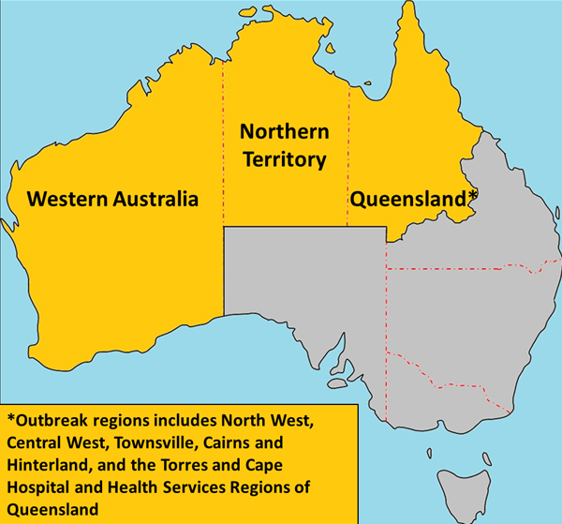
An epidemiological curve of the outbreak was constructed where the outbreak period spanned from the diagnosis of the first outbreak case on 15 June 2010 (i.e. day 1 of week 1) to the last on 22 November 2013.

Outbreak management and vaccination strategies
Meetings were convened by the EIPDSWG chair with input from the Australian Government Vaccine Preventable Diseases section and jurisdictional EIPDSWG representatives.
Varying pneumococcal vaccine schedules as per the National Immunisation Program (NIP), as well as certain jurisdictional-specific programs, were put in place during the outbreak. The outbreak response varied by jurisdiction, with some jurisdictions adopting additional pneumococcal vaccination strategies along with the promotion of existing vaccine recommendations (Table 2).

Table 2: Pneumococcal vaccine programs for Indigenous persons in the outbreak regions (WA, NT and Qld affected areas) during the outbreak period (June 2010 – December 2013)
Vaccine | Western Australia | Northern Territory | Queensland
Prevenar® (7vPCV) | 3 primary doses at age 2, 4 & 6 months plus a booster at 12 months if medically at riskª until end June 2011 | Not in use | 3 primary doses at age 2, 4 & 6 months plus a booster at 12 months if medically at riskª until end June 2011
Synflorix® (10vPCV) | Not in use | 4 primary doses at age 2, 4, 6, and 18 months from October 2009 through September 2011 | Not in use
Prevenar13® (13vPCV) | 3 primary doses at age 6–8 weeks, 4 & 6 months plus a booster at 12 months from July 2011 | 3 primary doses at age 6–8 weeks, 4 & 6 months plus a booster at 18 months from October 2011 | 3 primary doses at age 6–8 weeks, 4 & 6 months plus a booster at 12 months from July 2011
 | Supplementary dose at age 12–35 months for those who received primary course of 7vPCV until September 2012 | Single dose for children at age 12–35 months who received less than 4 doses of 10vPCV or 7vPCV from October 2011 through January 2013 | Supplementary dose at age 12–35 months who received primary course of 7vPCV until September 2012
 |  | Outbreak strategy  Single dose for SEROTYPE-1 IPD cases and their household contacts aged < 6 or > 49 years who had not previously received a SEROTYPE-1 containing conjugate pneumococcal vaccine. Given at least 12 months after any previous polysaccharide pneumococcal vaccine from November 2011 to mid-September 2012 | Outbreak strategy  Single dose for children aged 36–59 months residing in Indigenous communities at risk^{b} from May to September 2012
Pneumovax23® (23vPPV)^{c} | As a booster at age 12–18 months until end June 2011 |  | As a booster at age 12–18 months until end June 2011
 | At age 15–49 years for those with risk factors | At age 15 years | At age 15–49 years for those with risk factors^{b}
 | 5 years after dose 1^{d} | 5 years after dose 1^{d} | 5 years after dose 1^{d}
 | At age 50 years | At age 50 years | At age 50 years
Outbreak strategy
Single dose for SEROTYPE-1 IPD cases and all their household contacts aged 6–49 years who had not previously received a polysaccharide pneumococcal vaccine from October 2011 to mid-September 2012
a Refer to the Australian Immunisation Handbook18 for list of risk factors where vaccination were recommended.
b Includes all Mt Isa, Torres Strait/NPA and Cape York Health Service Districts and the communities of Yarrabah, Palm Island, Woorabinda, Boulia, Winton, Bedourie and Birdsville.
c Not in routine use for children < 15 years in the NT unless medically at risk, however was provided to Central Australian Indigenous children at 2–5 years prior to June 2001 and to all NT Indigenous children at 18 months from June 2001 to October 2009.
d Due to reports of increasing local side effects, the recommendation for repeat doses of 23vPPV was suspended in Australia on 25 March 2011. Revised recommendations regarding which patients should be re-vaccinated under the National Immunisation Program were provided in December 2011.

Results

Overview
A total of 245 cases of serotype-1 IPD were notified in the outbreak regions. This represented a substantial increase in the percentage due to serotype-1 among all IPD in each of the three affected jurisdictions. Collectively, the percentage increased from 2.5% before the outbreak, to 17.7% during 2010–2013 prior to declining across all three jurisdictions by 2014. Almost half of the cases of IPD reported in the NT in 2011 were due to serotype-1 (Table 3).
The epidemiological curve shows 2011 (weeks 29 to 81) had the highest number of cases (n = 130). The geographic spread of cases is demonstrated by the stratification of cases by jurisdiction over the time period (Figure 2).
The serotype-1 incidence rate was higher in the outbreak regions than in the remainder of Australia during this period, sharply rising at the commencement of the outbreak (2010) and reaching a peak in 2011 (IRR 30.70 [95% CI 20.09–48.89]), as shown in Table 4.
All 245 cases of serotype-1 IPD in the outbreak regions had Indigenous status recorded. Of these, 185 (75.5%) identified as Indigenous with a median age of 15 years (range 2 months to 92 years) compared to 27.5 years (range 3 to 93 years) for non-Indigenous cases. Overall the serotype-1 IPD rates among the non-Indigenous population were substantially lower across all ages (Figure 3).

Table 3: Number of cases of IPD and percentage that were due to serotype-1 in the outbreak regions before, during and after the outbreak, by jurisdiction
 | Western Australia |  |  | Northern Territory |  |  | Queensland (outbreak affected) |  |  | All outbreak regions combined
Timespan or year | Ser.1 IPD cases | Total IPD casesª | % of cases due to serotype-1 | Ser.1 IPD cases | Totalª IPD cases | % of cases due to serotype-1 | Ser.1 IPD cases | Totalª IPD cases | % of cases due to serotype-1 | Ser.1 IPD cases | Totalª IPD cases | % of cases due to serotype-1
2003 to 2009  (Before outbreak) | 13 | 1,002 | 1.3 | 6 | 478 | 1.3 | 27 | 389 | 6.9 | 46 | 1,869 | 2.5
2010 to 2013  (During outbreak) | 109 | 844 | 12.9 | 84 | 311 | 27.0 | 52 | 230 | 22.6 | 245 | 1,385 | 17.7
2010 | 21 | 188 | 11.2 | 6 | 55 | 10.9 | 1 | 40 | 2.5 | 28 | 283 | 9.9
2011 | 56 | 237 | 23.6 | 61 | 128 | 47.7 | 13 | 61 | 21.3 | 130 | 426 | 30.5
2012 | 29 | 229 | 12.7 | 17 | 71 | 23.9 | 25 | 72 | 34.7 | 71 | 372 | 19.1
2013 | 3 | 190 | 1.6 | 0 | 57 | 0 | 13 | 57 | 22.8 | 16 | 304 | 5.3
2014 (After outbreak) | 5 | 206 | 2.4 | 0 | 43 | 0 | 2 | 38 | 5.3 | 7 | 287 | 2.4
a excludes cases where the causative serotype was unknown
Table 4. Incidence and rates of serotype-1 IPD in the outbreak regions compared to the rest of Australia, before, during and after the outbreak
Years before, during and after outbreak | Outbreak regions |  | Non-outbreak regions – rest of Australia |  | Outbreak regions versus non-outbreak regions
 | Number | Rate | Number | Rate | IRR | 95% CI
Before (2003 to 2009) | 46 | 0.24 | 197 | 0.16 | 1.50 | 1.07–2.09
During (2010 to 2013) | 245 | 1.93 | 99 | 0.13 | 15.10 | 11.9–19.3
After (2014) | 7 | 0.21 | 3 | 0.01ª | 13.92 | 3.18–83.43
Peak year (2011) | 130 | 4.17 | 26 | 0.14 | 30.70 | 20.09–48.89
a Rounded from 0.014

Figure 2: Epidemiological curve of serotype-1 cases in the outbreak regions, by jurisdiction and outbreak week
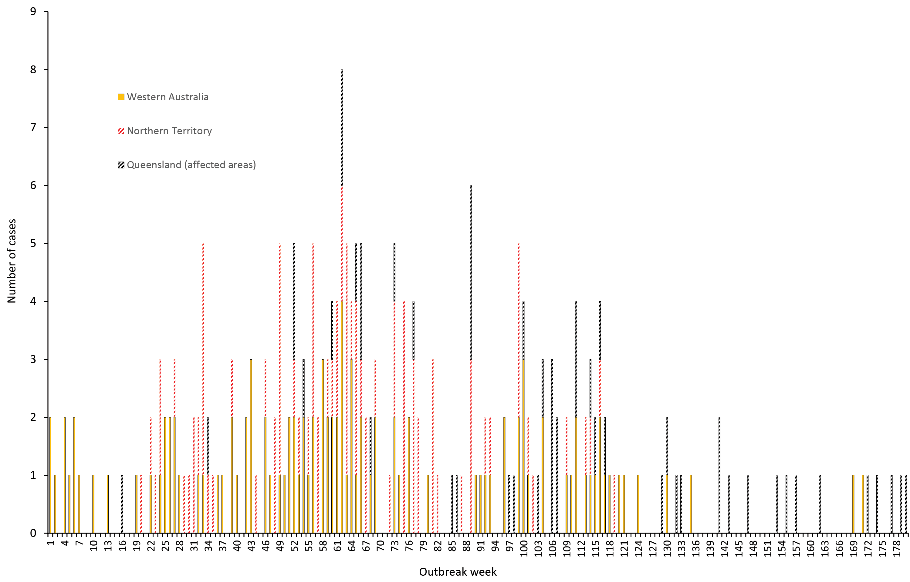

Figure 3. Serotype-1 IPD rates in the outbreak regions, by Indigenous status, 2010–2013
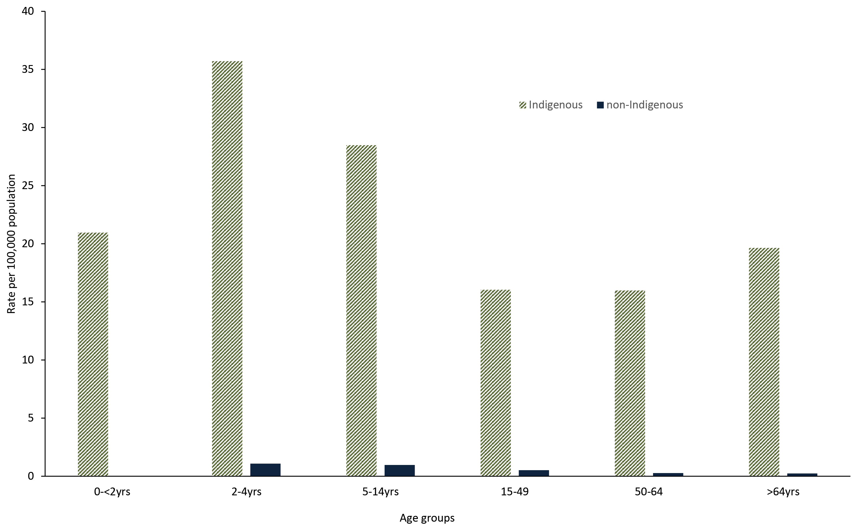
Rates of serotype-1 IPD in the Indigenous population varied across the three jurisdictions, with the difference most pronounced among children (Figure 4). The NT did not have any cases in children aged < 2 years, however the rates in school-aged children in the NT and WA were much higher than in affected regions in Qld.

Figure 4. Serotype-1 IPD rates of Indigenous persons in the out---break regions, 2010–2013, by age groups
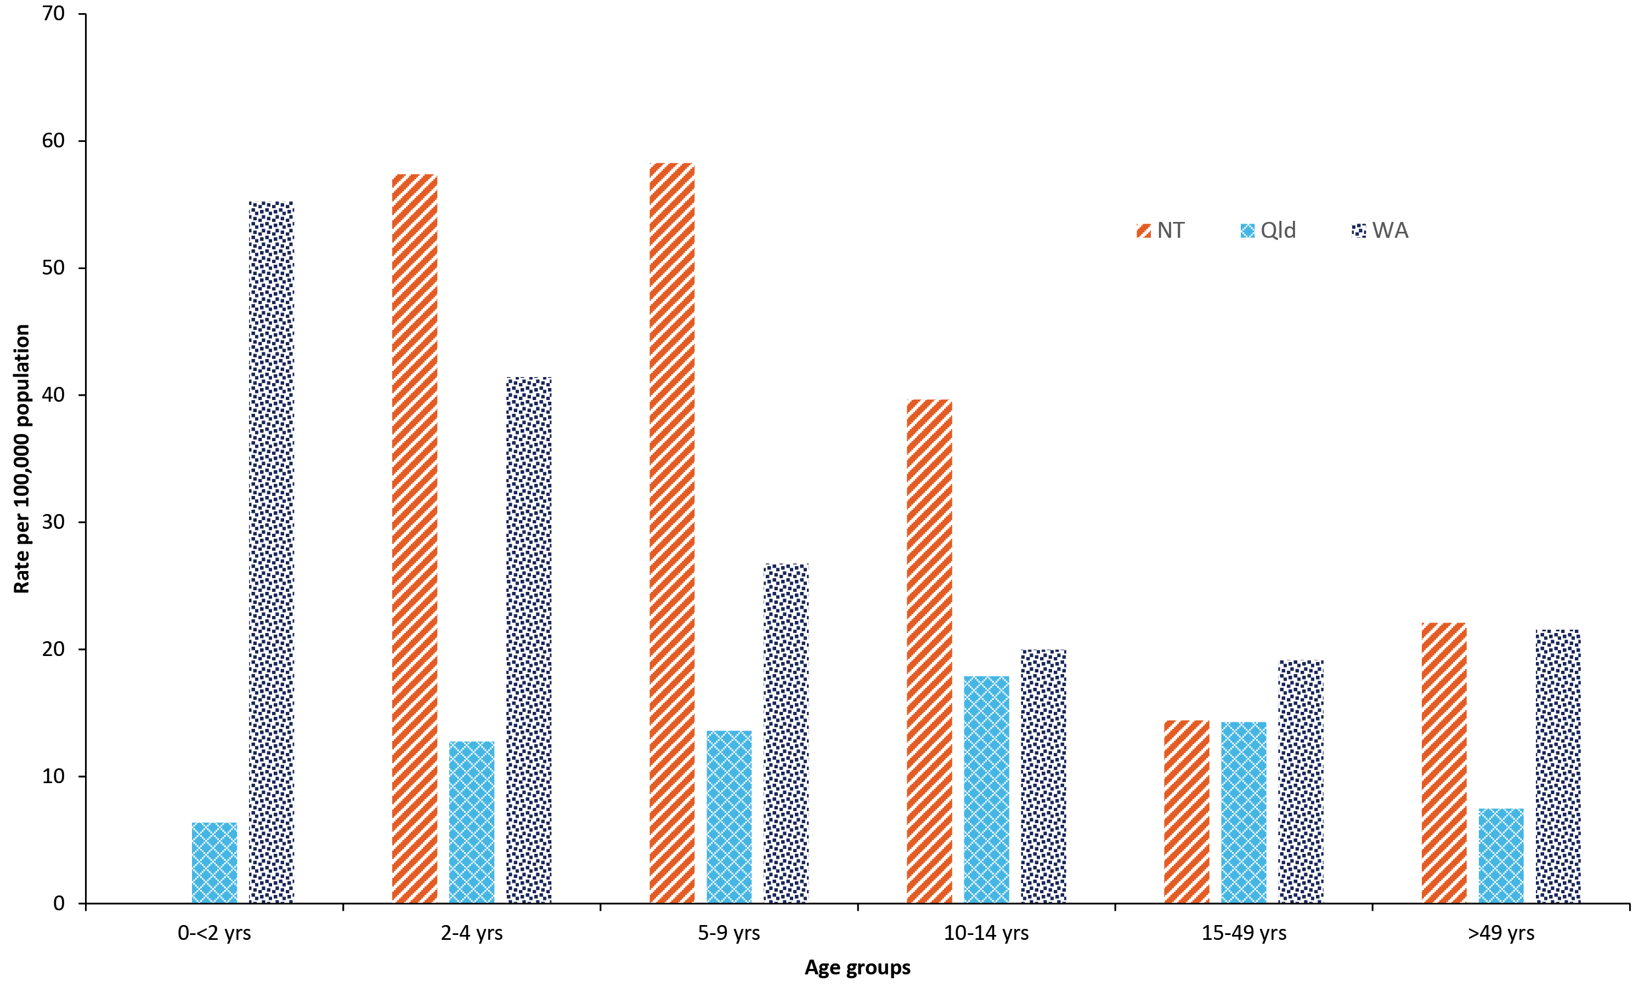

Clinical characteristics and mortality
Information on mortality was not available for 23/245 (9.4%) of cases with serotype-1 IPD. Four deaths were recorded among the 222 cases (4/222,1.8%), two with reported underlying medical risk factors.
The majority of cases presented with pneumonia (n = 199, 81.2%); and eight percent (n = 16) of those had pleural effusion or pleural empyema. There was one case of meningitis.
A summary of the demographic and clinical characteristics of the cases in Indigenous children and adults is shown in table 5.
Table 5: Number of Indigenous serotype-1 cases in the outbreak regions, by characteristics, jurisdiction and age groups, 2010–2013
Characteristic | Western Australia | Northern Territory | Queensland (affected areas) | Total
Aged 0 to 14 years
Mean age in years | 5.5 | 7.5 | 7.7
Median age [range] | 4 [0 to 14] | 8 [3 to 14] | 7 [1 to 14]
Pneumonia | 20 | 35 | 11 | 66
Complicated pneumonia | 0 | 1 | 2 | 3
Died | 1 | 0 | 0 | 1
Received polysaccharide vaccine dose ever | 13 | 35 | 8 | 56
Received polysaccharide vaccine dose within last 5 years | 8 | 15 | 3 | 26
Vaccine history not available | 2 | 0 | 1 | 3
Total aged 0 to 14 years | 33 | 41 | 15 | 89
Aged 15 years or older
Mean age | 36.8 | 39.6 | 33.1
Median age [range] | 33 [15 to 80] | 36 (16 to 92] | 32 [15 to 64]
Pneumonia | 36 | 25 | 20 | 81
Complicated pneumonia | 4 | 0 | 1 | 5
Died | 0 | 0 | 1 | 1
Received polysaccharide vaccine dose ever | 8 | 21 | 10 | 39
Received polysaccharide vaccine dose within last 5 years | 5 | 11 | 6 | 22
Vaccine history not available | 23 | 0 | 7 | 30
Total aged 15 years or older | 41 | 30 | 25 | 96
Total cases (all ages) | 74 | 71 | 40 | 185

Vaccination status
Of the 245 cases, 99 had received at least one dose of a serotype-1 containing vaccine. Two of those 99 cases (both aged three years) however had received a conjugate vaccine containing serotype-1 (i.e.10vPCV) in addition to primary vaccination with the non serotype-1 containing 7vPCV. The remaining 97 cases had received one or more doses of 23vPPV. Of these, two were non-Indigenous persons and both had received the vaccine more than 10 years prior to disease onset.
Of the 95 Indigenous cases vaccinated with 23vPPV, approximately half (n = 48/95) had received a dose within five years prior to disease onset (26 in NT, 13 in WA and 9 in Qld). Of these 48 cases who had received a dose of 23vPPV in the preceding five years, 26 were children who had received the vaccine as a booster dose following 7vPCV. For this group, the age at receipt of vaccine ranged between 17 and 45 months (mean age 23 months, median age 19 months).
Across the three jurisdictions, 53.6% (n = 30/56) of 23vPPV-vaccinated children had received the vaccine more than five years prior to disease onset.
There were 6 Indigenous cases aged > 49 years vaccinated more than 5 years prior to disease onset, all of whom had risk factors identified. Of these, 3 cases were eligible to receive further 23vPPV revaccination prior to disease onset.
There were 8 Indigenous cases aged > 49 years and 2 non-Indigenous cases aged > 64 years who had never received a dose of 23vPPV. These 10 cases all had ‘chronic illness’ recorded as a risk factor.

Discussion
This report describes an outbreak of serotype-1 IPD in Northern and Central Australia from 2010 to 2013. In 2011, rates were over 30-fold higher in the affected regions than across the remainder of Australia. Indigenous children were the most affected; overall, 75.5% of the total 245 cases of serotype-1 IPD within the outbreak regions occurred among the Indigenous population.
Outbreaks of IPD due to serotype-1 have been reported globally, predominantly occurring in closed settings such as prisons and men’s shelters.^{19–21} There are also reports of increases and outbreaks across widespread geographical areas in Africa, Canada, the South Pacific and Europe.^{22–27} Within Australia, a widespread outbreak of serotype-1 pneumococcal disease, affecting mainly Aboriginal men, occurred in the Central Australian region in 1991.²⁸ Molecular characterisation¹⁷ determined that the 2010–2013 Australian outbreak was due to ST306, the same sequence type responsible for IPD serotype-1 outbreaks in the Western Pacific regions of New Caledonia in 2000 and 2007 and French Polynesia in 2002.²³ An outbreak of non-sequenced serotype-1 IPD occurred in New Zealand from 2006 to 2011, peaking in 2009.²⁹
The spatial and temporal relationship of other serotype-1 IPD outbreaks and their geographical proximity to Australia is of interest given they all preceded the one described in this report. Interestingly, this Australian outbreak appeared to originate in the West and then move gradually towards the East Coast, the area closer to the Western Pacific region. It is possible that ST306 was circulating in Australia outside the outbreak regions prior to 2010, but did not progress to widespread transmission. Data in ‘non-outbreak regions’ indicate ongoing low-level circulation of serotype-1 across 2003 to 2014. However, in the absence of molecular typing, it is not known if serotype-1 in these instances was the outbreak strain ST306.
High mobility, overcrowding and poverty that is present in some remote Indigenous populations living in the affected outbreak regions³⁰ most likely contributed to higher serotype-1 ST306 carriage density³¹ and subsequent invasive disease. These social determinants of health have been recognised as contributors in other communicable disease outbreaks such as mumps, syphilis and meningococcal disease which have affected the remote Indigenous population of Australia.^{32–34} Similar to the Australian experience, the serotype-1 IPD increase of 2009 in New Zealand affected mainly school-aged children and young adults with the majority occurring in Pacific and Maori persons.³⁵ The Australian outback showed similarities to those reported elsewhere, such as low case-fatality ratios and a high proportion of pneumonia presentations with complications such as empyema.¹⁹
The striking differences in the serotype-1 IPD rates in children aged < 2 years across the three jurisdictions is most likely a reflection of the differing conjugate vaccine usage at the respective times at which cases peaked in each jurisdiction. Western Australia did not have a program which used a serotype-1 containing conjugate vaccine for infants when the outbreak commenced, whilst the NT was using the 10vPCV which covers serotype-1 as does the 13vPCV that was included on the NIP by the time cases started occurring in Qld. It is likely the conjugate vaccine programs in place provided direct protection to those aged < 2 years as evidenced in immunogenicity and vaccine effectiveness studies for both vaccines.^{10–13}
The NT reported higher rates of serotype-1 IPD in older Indigenous children, as reflected in the rates across the two to 14 year age groups when compared to WA and Qld. The NT also reported a higher number of cases and a higher proportion vaccinated prior to disease onset for these age groups. Even though the 23vPPV vaccine was not in use for NT children at the time of the outbreak, it was recommended as part of earlier NT vaccination schedules. Central Australian Indigenous children were recommended 23vPPV at 2-5 years prior to June 2001 and all NT Indigenous children received 23vPPV at 18 months from June 2001 to October 2009.^{2,3} These earlier 23vPPV strategies, implemented at a time when no other pneumococcal vaccine covering serotype-1 was available to combat the alarming IPD rates in the children of Central Australia,^{2,4} did not appear to provide protection against serotype-1 IPD during the study period, a finding consistent with other studies exploring 23vPPV use in children.⁶ It should be noted however, across the three jurisdictions, that over half of the 23vPPV vaccinated children received the vaccine more than five years prior to disease onset, a timeframe when 23vPPV protection is generally assumed to wane.^{36.37}
The disease rates for those aged 15 years and over were mostly similar across the 3 jurisdictions. This may indicate that the NT policy of routinely offering 23vPPV to all Indigenous persons at 15 years of age provided some protection for younger adults, and a higher vaccination coverage overall suppressed the severity of the outbreak in the NT adult population. It may well be that a higher proportion of the adult population was vaccinated in NT than in WA and Qld; however, accurate 23vPPV coverage estimates are not available. According to vaccination coverage estimates for Indigenous persons in the NT, 34% aged 15–49 years and 42% aged 49 years and over had received a 23vPPV within the previous 5 years in 2011.³⁸ This is noticeably higher than the estimates from the Australian Aboriginal and Torres Strait Islander Health Survey, 2012–2013, for pneumococcal vaccination in the preceding 5 years of 8% in WA, 11% in North Qld and 19% in the NT.³⁹ This lack of reliable 23vPPV coverage estimates for the outbreak regions has precluded an assessment of 23vPPV effectiveness for this outbreak.
While Australia has comprehensive reporting of childhood vaccination coverage,⁴⁰ reliable data specific to 23vPPV uptake in older age groups is lacking. With the recent transition of the Australian Childhood Immunisation Register to the Australian Immunisation Register, Australia now has the capability to record all childhood and adult vaccinations.⁴¹ This should improve assessment of adult vaccination coverage in the future.
The established network of EIPDSWG members enabled the early detection of this cross-jurisdictional outbreak. Ongoing communications within this group were helpful in monitoring and considering appropriate outbreak management strategies and in facilitating molecular typing of isolates. Although IPD outbreaks are uncommon, pre-established guidelines may have assisted in the outbreak management. We would recommend the inclusion of IPD in the Australian Series of National Guidelines for public health management to hasten the availability and use of suitable vaccine strategies that could be implemented consistently nationwide and potentially decrease the duration and intensity of future outbreaks.

Conclusion
The serotype-1 IPD outbreak in 2010–2013 primarily affected the Indigenous population in Australia. Real-time inter-jurisdictional collaboration was useful in monitoring natural progression of the outbreak and in guiding interventions. Serotype-1 containing pneumococcal conjugate vaccines 10vPCV and 13vPCV were protective against serotype-1 IPD in children in this setting while the benefit of 23vPPV was less clear. Having specific outbreak vaccine recommendations and the capacity to apply them, along with early surveillance and the jurisdictional communication that occurred, would assist management of such outbreaks in the future.

Author details
Ms Heather M Cook^{1,2}
Ms Carolien M Giele^{1,3}
Dr Sanjay H Jayasinghe^{1,4,5}
Ms Angela Wakefield^{1,6}
Dr Vicki L Krause^{1,2}
- Enhanced Invasive Pneumococcal Disease Surveillance Working Group
- Centre for Disease Control, Top End Health Services, Northern Territory, Australia
- Communicable Diseases Control, Health Department of Western Australia, Australia
- National Centre for Immunisation Research and Surveillance (NCIRS)
- Discipline of Child and Adolescent Health, Faculty of Medicine and Health, University of Sydney, Australia
- Communicable Diseases Branch, Queensland Health, Australia

Corresponding author
Ms Heather Cook
Gold Coast Public Health Unit, Integrated and Ambulatory Care Services, Gold Coast Health, PO Box 318, NERANG Qld 4211, Australia
Phone: +61 756673200
Email: Heather.Cook2@health.qld.gov.au
Ph: +61 756673200

References
- Australian Government Department of Health. Pneumococcal disease (invasive) Public dataset. [Online.] Canberra: Australian Government Department of Health; 2019. [Accessed on 24 June 2019.] Available from: http://www9.health.gov.au/cda/source/pub_pneum.cfm.
- Krause VL, Reid SJ, Merianos A. Invasive pneumocccal disease in the Northern Territory of Australia, 1994–1998. Med J Aust. 2000;173(S2):S27–31.
- National Centre for Immunisation Research and Surveillance (NCIRS). History of immunisation in Australia. [Internet.] Sydney: NCIRS; 2019. [Accessed on 24 June 2019.] Available from: http://ncirs.org.au/health-professionals/history-immunisation-australia.
- Torzillo PJ, Hanna JN, Morey F, Gratten M, Dixon J, Erlich J. Invasive pneumococcal disease in central Australia. Med J Aust. 1989;162(4):182–6.
- Roche PW, Krause VL, Bartlett M, Coleman D, Cook H, Davis C et al. Invasive pneumococcal disease in Australia, 2004. Commun Dis Intell Q Rep. 2006;30(1):80–92.
- Jayasinghe S, Chiu C, Menzies R, Lehmann D, Cook H, Giele C et al. Evaluation of impact of 23 valent pneumococcal polysaccharide vaccine following 7 valent pneumococcal conjugate vaccine in Australian Indigenous children. Vaccine. 2015;33(48):6666–74.
- Brueggemann AB, Peto TEA, Crook DW, Butler JC, Kristinsson KG, Spratt BG. Temporal and geographic stability of the serogroup-specific invasive disease potential of Streptococcus pneumoniae in children. J Infect Dis. 2004;190(7):1203–11.
- Balsells E, Dagan R, Yildirim I, Gounder PP, Steens A, Muñoz-Almagro C et al. The relative invasive disease potential of Streptococcus pneumoniae among children after PCV introduction: a systematic review and meta-analysis. J Infect. 2018;77(5):368–78.
- Hausdorff WP, Feikin DR, Klugman KP. Epidemiological differences among pneumococcal serotypes. Lancet Infect Dis. 2005;5(2):83–93.
- Yeh SH, Gurtman A, Hurley DC, Block SL, Schwartz RH, Patterson S et al. Immunogenicity and safety of 13-valent pneumococcal conjugate vaccine in infants and toddlers. Pediatrics. 2010;126(3):e493–505.
- Vesikari T, Wysocki J, Chevallier B, Karvonen A, Czajka H, Arsène JP et al. Immunogenicity of the 10-valent pneumococcal non-typeable Haemophilus influenzae protein D conjugate vaccine (PHiD-CV) compared to the licensed 7vCRM vaccine. Pediatr Infect Dis J. 2009;28(4 Suppl):S66–76.
- Andrews NJ, Waight PA, Burbidge P, Pearce E, Roalfe L, Zancolli M et al. Serotype-specific effectiveness and correlates of protection for the 13-valent pneumococcal conjugate vaccine: a postlicensure indirect cohort study. Lancet Infect Dis. 2014;14(9):839–46.
- Hammitt LL, Etyang AO, Morpeth SC, Ojal J, Mutuku A, Mturi N et al. Effect of ten-valent pneumococcal conjugate vaccine on invasive pneumococcal disease and nasopharyngeal carriage in Kenya: a longitudinal surveillance study. Lancet. 2019;393(10186):2146–54.
- Toms C, de Kluyver R, Enhanced Invasive Pneumococcal Disease Surveillance Working Group. Invasive pneumococcal disease in Australia, 2011 and 2012. Commun Dis Intell Q Rep. 2016;40(2):E267–84.
- Australian Bureau of Statistics. 3101.0 - Australian Demographic Statistics, Dec 2014. [Internet.] Canberra: Australian Government, Australian Bureau of Statistics, 2015. [Accessed on 10 November 2015.] Available from: http://www.abs.gov.au/AUSSTATS/abs@.nsf/DetailsPage/3101.0Dec%202014.
- Queensland Health Statistics Unit. Queensland population estimates. [Internet.] Brisbane: Queensland Government Department of Health. Available from: https://qheps.health.qld.gov.au/hsu/infobank/infobank-demography#estimated.
- Staples M, Graham RMA, Jennison AV, Ariotti L, Hicks V, Cook H et al. Molecular characterization of an Australian serotype 1 Streptococcus pneumoniae outbreak. Epidemiol Infect. 2015;143(2):325–33.
- Australian Technical Advisory Group on Immunisation (ATAGI). Australian Immunisation Handbook. [Online.] Canberra: Australian Government Department of Health; 2018. [Accessed on 24 June 2019.] Available from: https://immunisationhandbook.health.gov.au/.
- DeMaria Jr A, Browne K, Berk SL;Sherwood EJ, McCabe WR. An outbreak of type 1 pneumococcal pneumonia in a men’s shelter. JAMA. 1980;244(13):1446–9.
- Mercat A, Nguyen J, Dautzenberg B. An outbreak of pneumococcal pneumonia in two men’s shelters. Chest. 1991;99(1):147–51.
- Dagan R, Gradstein S, Belmaker I, Porat N, Siton Y, Weber G et al. An outbreak of Streptococcus pneumoniae serotype 1 in a closed community in southern Israel. Clin Infect Dis. 2000;30(2):319–21.
- Proulx JF, Déry S, Jetté LP, Ismaël J, Libman M, De Wals P. Pneumonia epidemic caused by a virulent strain of Streptococcus pneumoniae serotype 1 in Nunavik, Quebec. Can Commun Dis Rep. 2002;28(16):129–31.
- Le Hello S, Watson M, Levy M, Marcon S, Brown M, Yvon JF et al. Invasive serotype 1 Streptococcus pneumoniae outbreaks in the South Pacific from 2000 to 2007. J Clin Microbiol. 2010; 48(8):2968-71.
- Grau I, Ardanuy C, Calatayud L, Rolo D, Domenech A, Liñares J et al. Invasive pneumococcal disease in healthy adults: increase of empyema associated with the clonal-type Sweden(1)-ST306. PLoS One. 2012;7(8):e42595.
- Van Mens SP, Van Deursen AMM, Meijvis SCA, Vlaminckx BJM, Sanders EAM, De Melker HE et al. Increased incidence of serotype-1 invasive pneumococcal disease in young female adults in the Netherlands. Epidemiol Infect. 2014;142(9):1996–9.
- Kwambana-Adams BA, Asiedu-Bekoe F, Sarkodie B, Afreh OK, Kuma GK, Owusu-Okyere G et al. An outbreak of pneumococcal meningitis among older children (≥5 years) and adults after the implementation of an infant vaccination programme with the 13-valent pneumococcal conjugate vaccine in Ghana. BMC Infect Dis. 2016;16(1):575.
- LeMeur JB, Lefebvre B, Proulx JF, De Wals P. Limited impact of pneumococcal vaccines on invasive pneumococcal disease in Nunavik (Quebec). Can J Public Health. 2019;110(1):36–43.
- Gratten M, Morey F, Dixon J, Manning K, Torzillo P, Matters R et al. An outbreak of serotype 1 Streptococcus pneumoniae infection in central Australia. Med J Aust. 1993;158(5):340–2.
- Lim E, Heffernan H. Invasive pneumococcal disease in New Zealand, 2011. Porirua: Institute of Environmental Science and Research Ltd; 2012. [Accessed on 26 June 2019.] Available from: https://surv.esr.cri.nz/PDF_surveillance/IPD/2011/2011AnnualIPDRpt.pdf.
- Bailie RS, Wayte KJ. Housing and health in Indigenous communities: key issues for housing and health improvement in remote Aboriginal and Torres Strait Islander communities. Aust J Rural Health. 2006;14(5):171–83.
- Lai JY, Cook H, Yip TW, Berthelsen J, Gourley S, Krause V et al. Surveillance of pneumococcal serotype 1 carriage during an outbreak of serotype 1 invasive pneumococcal disease in central Australia 2010–2012. BMC Infect Dis. 2013:13:409.
- Bright A, Dups J. Infectious and congenital syphilis notifications associated with an ongoing outbreak in northern Australia. Commun Dis Intell Q Rep. 2016;40(1):E7–10.
- Australian Government Department of Health. Meningococcal W disease: Information for health professionals. [Online.] Canberra: Australian Government Department of Health; 2017. [Accessed on 17 October 2018.] Available from: http://www.health.gov.au/internet/main/publishing.nsf/Content/ohp-meningococcal-W-info-hp.htm.
- Greenwood-Smith B, Markey P, Burke J. Mumps outbreak in the Northern Territory 2015–2016. NT Dis Control Bull. 2016;23(4):9-14.
- Heffernan H, Morgan J, Woodhouse R. Invasive pneumococcal disease in New Zealand, 2010. Porirua: Institute of Environmental Science and Research Ltd; 2011. [Accessed on 26 June 2019.] Available from: https://surv.esr.cri.nz/PDF_surveillance/IPD/2010/2010AnnualIPDRpt.pdf.
- World Health Organisation (WHO). Additional summaries of information related to WHO position papers on pneumococcus: Duration of protection and revaccination. Geneva: WHO. [Accessed on 26 June 2019.] Available from: https://www.who.int/immunization/pp_pneumo_additional_summaries/en/.
- Moberley S, Holden J, Tatham DP, Andrews RM. Vaccines for preventing pneumococcal infection in adults. Cochrane Database Syst Rev. 2013;2013(1):CD000422. doi: https://doi.org/10.1002/14651858.CD000422.pub3.
- Cook H, Markey P, O’Hare S, Smith HV, Tindall H, Yip TW et al. A lengthy widespread outbreak of serotype-1 invasive pneumococcal disease shows protection with the 10-valent conjugate vaccine and increased pneumonia complications. [Conference presentation.] Proceedings of the 8th International Symposium on Pneumococci and Pneumococcal Diseases, 2012 March 11-15, Iguaçu Falls, Brazil.
- Australian Bureau of Statistics. 4727.0.55.002 – Australian Aboriginal and Torres Strait Islander Health Survey: Users’ Guide, 2012–13. [Internet.] Canberra: Australian Government, Australian Bureau of Statistics; 2014. [Accessed on 26 July 2018.] Available from: http://www.abs.gov.au/ausstats/abs@.nsf/Lookup/C6F3BD401EF28FD9CA257CAC000D874E.
- Hull BP, Hendry AJ, Dey A, Beard FH, Brotherton JM, McIntyre PB. Immunisation coverage annual report, 2014. Commun Dis Intell Q Rep. 2017;41(1):E68–90.
- Australian Government Services Australia. Australian Immunisation Register. [Online.] Canberra: Australian Government Services Australia; 2018. [Accessed on 26 June 2019.] Available from: https://www.servicesaustralia.gov.au/individuals/services/medicare/australian-immunisation-register.

Communicable Diseases Intelligence
ISSN: 2209-6051 Online

Communicable Diseases Intelligence (CDI) is a peer-reviewed scientific journal published by the Office of Health Protection, Department of Health. The journal aims to disseminate information on the epidemiology, surveillance, prevention and control of communicable diseases of relevance to Australia.

Editor: Tanja Farmer
Deputy Editor: Simon Petrie
Design and Production: Kasra Yousefi
Editorial Advisory Board: David Durrheim, Mark Ferson, John Kaldor, Martyn Kirk and Linda Selvey

Website: http://www.health.gov.au/cdi

Contacts
Communicable Diseases Intelligence is produced by:
Health Protection Policy Branch, Office of Health Protection, Australian Government Department of Health
GPO Box 9848, (MDP 6) CANBERRA ACT 2601

Email: cdi.editor@health.gov.au

Submit an Article
You are invited to submit your next communicable disease related article to the Communicable Diseases Intelligence (CDI) for consideration. More information regarding CDI can be found at: http://health.gov.au/cdi.
Further enquiries should be directed to: cdi.editor@health.gov.au.

This journal is indexed by Index Medicus and Medline.

Creative Commons Licence - Attribution-NonCommercial-NoDerivatives CC BY-NC-ND
© 2020 Commonwealth of Australia as represented by the Department of Health
This publication is licensed under a Creative Commons Attribution-NonCommercial-NoDerivatives 4.0 International Licence from https://creativecommons.org/licenses/by-nc-nd/4.0/legalcode (Licence). You must read and understand the Licence before using any material from this publication.

Restrictions
The Licence does not cover, and there is no permission given for, use of any of the following material found in this publication (if any):
- the Commonwealth Coat of Arms (by way of information, the terms under which the Coat of Arms may be used can be found at www.itsanhonour.gov.au);
- any logos (including the Department of Health’s logo) and trademarks;
- any photographs and images;
- any signatures; and
- any material belonging to third parties.

Disclaimer
Opinions expressed in Communicable Diseases Intelligence are those of the authors and not necessarily those of the Australian Government Department of Health or the Communicable Diseases Network Australia. Data may be subject to revision.

Enquiries
Enquiries regarding any other use of this publication should be addressed to the Communication Branch, Department of Health, GPO Box 9848, Canberra ACT 2601, or via e-mail to: copyright@health.gov.au

Communicable Diseases Network Australia
Communicable Diseases Intelligence contributes to the work of the Communicable Diseases Network Australia.
http://www.health.gov.au/cdna

