Australian Meningococcal Surveillance Programme annual report, 2018
Monica M Lahra, Rodney Enriquez and Tiffany Hogan for the National Neisseria Network

Abstract
Invasive meningococcal disease (IMD) is a notifiable disease in Australia, and both probable and laboratory-confirmed cases of IMD are reported to the National Notifiable Diseases Surveillance System (NNDSS). In 2018, there were 281 IMD cases notified to the NNDSS. Of these, 278 were laboratory-confirmed cases analysed by the reference laboratories of the Australian National Neisseria Network (NNN). On investigation, the serogroup was able to be determined for 98.6% (274/278) of laboratory-confirmed cases. Serogroup B infections accounted for 44.2% of cases (123 cases); serogroup W for 36.3% of cases (101 cases); serogroup Y infections for 15.8% (44 cases) and serogroup C 1.4% (4 cases); and there were two unrelated cases (0.7%) of IMD attributable to serogroup E. Using molecular methods, 181/278 IMD cases were able to be typed. Of note was that 89% of typed serogroup W IMD cases (66/74) were porA antigen type P1.5,2; of this number, 44% (29/66) were sequence type 11, the hypervirulent strain reported in recent outbreaks in Australia and overseas.
The primary age peak of IMD in Australia in 2018 was again observed in adults aged 45 years or more; a secondary disease peak was observed in children and infants aged less than 5 years. Serogroup B infections predominated in those aged less than 5 years, whereas serogroup W and serogroup Y infections predominated in those aged 45 years or more. Of the IMD isolates tested for antimicrobial susceptibility, 1.4% (3/210) were resistant to penicillin with an MIC ≥ 1 mg/L, and decreased susceptibility to penicillin was observed in a further 93.8% (197/210) of isolates. All isolates were susceptible to ceftriaxone and rifampicin; there was one isolate less susceptible to ciprofloxacin.
Keywords: antibiotic resistance; disease surveillance; meningococcal disease; Neisseria meningitidis

Introduction
Australia’s National Neisseria Network (NNN) was established in 1979, as a collaborative network of reference laboratories in each state and territory that contribute to the laboratory surveillance of the pathogenic Neisseria: N. meningitidis and N. gonorrhoeae. Since 1994 the NNN has coordinated laboratory data from cases of invasive meningococcal disease (IMD) for the Australian Meningococcal Surveillance Programme (AMSP), supported by the Australian Government Department of Health and the jurisdictions.¹ The NNN laboratories supply phenotypic and genotypic data to supplement the notification data from the National Notifiable Diseases Surveillance System (NNDSS), which includes cases of probable and laboratory-confirmed IMD.
Notifications of IMD in Australia peaked at 3.5 cases per 100,000 in 2002,² with the majority of disease caused by serogroups B and C. The introduction of the conjugate serogroup C meningococcal vaccine onto the National Immunisation Program in 2003 was followed by significant and sustained reduction over the next 10 years, both of the number of serogroup C IMD cases and of the overall notifications of IMD, with 0.6 cases per 100,000 notified in 2013.^{3,4} After 2013, however, there has been an increase in both serogroup W and serogroup Y disease, and overall IMD notifications rose to 1.5 cases per 100,000 in 2017 falling to 1.1 per 100,000 in 2018.² At the jurisdictional level, implementation of MenACWY immunisation programmes in targeted age groups in 2017 was followed in 2018 by the replacement of the monovalent MenC vaccine with the 4-valent MenACWY vaccine on the National Immunisation Programme.
In 2018, IMD remains a rare disease in Australia, but one of public health concern. Continued monitoring of phenotypic and genotypic features of IMD strains is critical to plan and inform clinical management of cases, case clusters and outbreaks of IMD locally and nationally, and to inform and monitor public health interventions.

Methods

Case confirmation of invasive meningococcal disease
Case confirmation is based on isolation of N. meningitidis, or a positive nucleic acid amplification testing (NAAT) from a normally sterile site, defined as laboratory definitive evidence of IMD according to the national case definition.⁵ Information regarding the site of infection, age and sex of patients is collated by the NNN for the AMSP.
IMD cases are categorised on the basis of the site from which N. meningitidis was isolated, or from which meningococcal DNA was detected (blood, joint fluid, vitreous fluid). When N. meningitidis is detected from both blood and cerebrospinal fluid (CSF) from the same patient, the case is classified as one of meningitis.

Phenotyping and genotyping of Neisseria meningitidis
Phenotyping is limited to the determination of the serogroup by detection of soluble polysaccharide antigens. Genotyping of both isolates and DNA extracts is performed by sequencing of products derived from amplification of the porin genes porA and porB, and the iron-regulated gene fetA, in the outer membrane protein.

Antibiotic susceptibility testing
Isolates were tested to determine their minimum inhibitory concentration (MIC) values to antibiotics used for therapeutic and prophylactic purposes: ceftriaxone, ciprofloxacin, penicillin and rifampicin. This program has historically reported penicillin testing categories as: sensitive (MIC ≤ 0.03 mg/L), less sensitive (MIC 0.06–0.5 mg/L) and resistant (MIC ≥ 1 mg/L). However, to monitor across antimicrobial susceptibility testing methods, a distribution of penicillin MIC values is now reported.

Results
In 2018, there were 278 laboratory-confirmed cases of IMD analysed by the NNN, and 281 cases notified to the NNDSS.² Thus, laboratory data were available for 98.9% of notified cases of IMD in Australia in 2018 (Figure 1). This number of laboratory-confirmed cases of IMD was lower than 2017 (n = 374), which was the highest reported since 2003. The number of cases notified to the NNDSS was also lower than 2017 (n = 379), which was the highest reported since 2005. In 2018, the peak incidence for IMD occurred in mid-winter and early spring (1 July to 30 September 2018) (Table 1).

Figure 1: Number of invasive meningococcal disease cases reported to the National Notifiable Diseases Surveillance System compared with laboratory-confirmed data from the Australian Meningococcal Surveillance Programme, Australia, 1991–2018
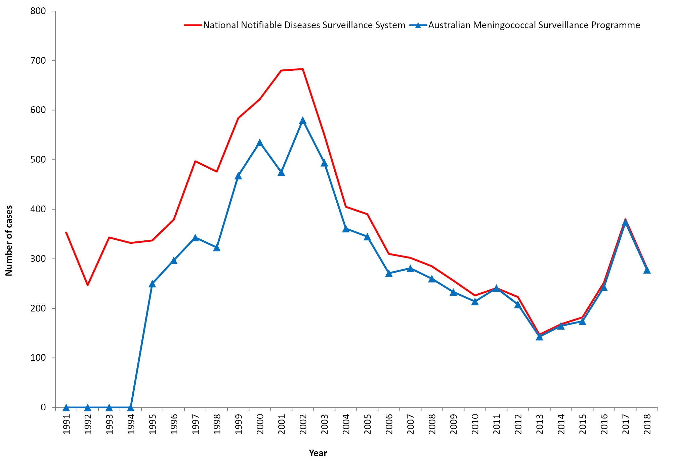
Table 1: Laboratory-confirmed cases of invasive meningococcal disease, Australia.
Serogroup | 1 January – 31 March | 1 April – 30 June | 1 July – 30 September | 1 October – 31 December | 2018 Total
B | 23 | 27 | 34 | 39 | 123
C | 0 | 2 | 1 | 1 | 4
Y | 12 | 10 | 9 | 13 | 44
W | 9 | 16 | 48 | 28 | 101
Otherª | 0 | 1 | 1 | 0 | 2
NG^{b} | 0 | 0 | 0 | 0 | 0
ND^{c} | 1 | 2 | 0 | 1 | 4
Total | 45 | 58 | 93 | 82 | 278
a Other: serogroup E
b Non groupable
c Not determined
In 2018 all jurisdictions, with the exception of the Australian Capital Territory, showed a decrease in the number of IMD cases from the previous year. New South Wales reported the highest number of cases (n = 70) in a decrease from 90 cases in 2017; Queensland had the second highest number (n = 58), a decrease from 64 cases in 2017. The number of cases from each jurisdiction is shown in Table 2. The number of IMD cases reported from the Northern Territory (n = 11) was lower than in 2017 when there was an outbreak of serogroup W IMD (n = 32); all 11 IMD cases in the NT in 2018 were from remote communities of central Australia.

Age distribution
The peak incidence of IMD in 2018, as in the previous three years, occurred in adults aged 45 years or more: this age group represented 32% (89/278) of IMD cases in 2018 (Table 3). Prior to 2015, the primary peak incidence of IMD was in children less than 5 years of age. Between 2003 and 2014, the proportion of IMD that occurred in children aged less than 5 years ranged from 28% to 36% of cases. Since 2015, the proportion has ranged from 21% to 27% of cases.

Anatomical site of samples for laboratory-confirmed cases
In 2018, diagnosis was made by a positive culture in 78% of cases (216/278); 22% of cases (62/278) were confirmed by NAAT testing alone (Table 4).
There were 51 diagnoses of meningitis based on cultures or NAAT examination of CSF either alone or with a positive blood sample. There were 221 diagnoses of septicaemia based on cultures or NAAT examination from blood samples alone (Table 4). Additionally, there were four IMD diagnoses from joint fluid, one IMD diagnosis from placental tissue and one IMD diagnosis from cardiac fluid (post-mortem) (Table 4).

Serogroup data

Number and proportions of cases of serogroup B, C, W, and Y invasive meningococcal disease.
The serogroup was determined for 274/278 laboratory-confirmed cases of IMD (98.6%) in 2018 (Tables 2 and 3). The initial decrease in IMD cases since 2002 was predominantly due to a reduction in the number of IMD cases caused by serogroup C from 2003 to 2007 following the introduction of the serogroup C vaccine. After 2009, a decline in the number of IMD cases caused by serogroup B was reported, from 194 cases in 2009 to 87 cases in 2016. In 2017, there was a rise in the number of IMD cases caused by serogroup B (n = 137), the highest number since 2012. In 2018, the number of IMD cases caused by serogroup B was 123. New South Wales reported the largest number of cases (n = 33) where serogroup B represented 47% of IMD cases reported from this state. South Australia was again the state with the highest proportion of IMD cases reported that were caused by serogroup B (27/34 cases or 79%). Serogroup B was reported in all jurisdictions except in the Australian Capital Territory where 3 cases of IMD were reported in 2018 (Table 2). In the years 2006–2012 the proportion of IMD cases caused by serogroup B was 84–88%, in 2013–2014 it was lower (75–80%), in 2015 it was 64%, and in 2016 and 2017 it was 36%, the lowest proportion of total IMD reported by the AMSP. In 2018, this proportion increased to 44.2% of IMD cases reported (Figure 2).

Table 2: Number of laboratory-confirmed cases of invasive meningococcal disease, Australia, 2018, by state or territory and serogroup
State/Territory | Serogroup |  |  |  |  |  |  | Total
 | B | C | Y | W | Otherª | NG^{b} | ND^{c}
ACT | 0 | 0 | 0 | 3 | 0 | 0 | 0 | 3
NSW | 33 | 2 | 15 | 19 | 0 | 0 | 1 | 70
NT | 3 | 0 | 0 | 8 | 0 | 0 | 0 | 11
Qld | 30 | 1 | 12 | 13 | 2 | 0 | 0 | 58
SA | 27 | 0 | 3 | 4 | 0 | 0 | 0 | 34
Tas | 4 | 0 | 2 | 5 | 0 | 0 | 0 | 11
Vic | 18 | 1 | 10 | 19 | 0 | 0 | 3 | 51
WA | 8 | 0 | 2 | 30 | 0 | 0 | 0 | 40
Australia | 123 | 4 | 44 | 101 | 2 | 0 | 4 | 278
 | 44.2 | 1.4 | 15.8 | 36.3 | 0.7 | 0.0 | 1.4 | %
a Other: serogroup E
b Non groupable
c Not determined
Table 3: Laboratory-confirmed cases of invasive meningococcal disease, Australia, 2018, by age and serogroup
Serogroup | Age group |  |  |  |  |  |  |  |  | Total
 | < 1 | 1–4 | 5–9 | 10–14 | 15–19 | 20–24 | 25–44 | 45–64 | 65+
B | 23 | 22 | 5 | 4 | 21 | 12 | 15 | 11 | 10 | 123
C | 0 | 0 | 0 | 0 | 1 | 0 | 2 | 0 | 1 | 4
Y | 2 | 1 | 1 | 0 | 7 | 4 | 6 | 12 | 11 | 44
W | 10 | 14 | 3 | 0 | 6 | 6 | 20 | 25 | 17 | 101
Otherª | 0 | 0 | 1 | 0 | 1 | 0 | 0 | 0 | 0 | 2
NG^{b} | 0 | 0 | 0 | 0 | 0 | 0 | 0 | 0 | 0 | 0
ND^{c} | 2 | 0 | 0 | 0 | 0 | 0 | 0 | 2 | 0 | 4
Total | 37 | 37 | 10 | 4 | 36 | 22 | 43 | 50 | 39 | 278
%B of within age group | 62.2 | 59.5 | 50.0 | 100.0 | 58.3 | 54.5 | 34.9 | 22.0 | 25.6
a Other: serogroup E
b Non groupable
c Not determined

Figure 2: Proportion of serogroups of laboratory-confirmed invasive meningococcal disease, Australia, by year
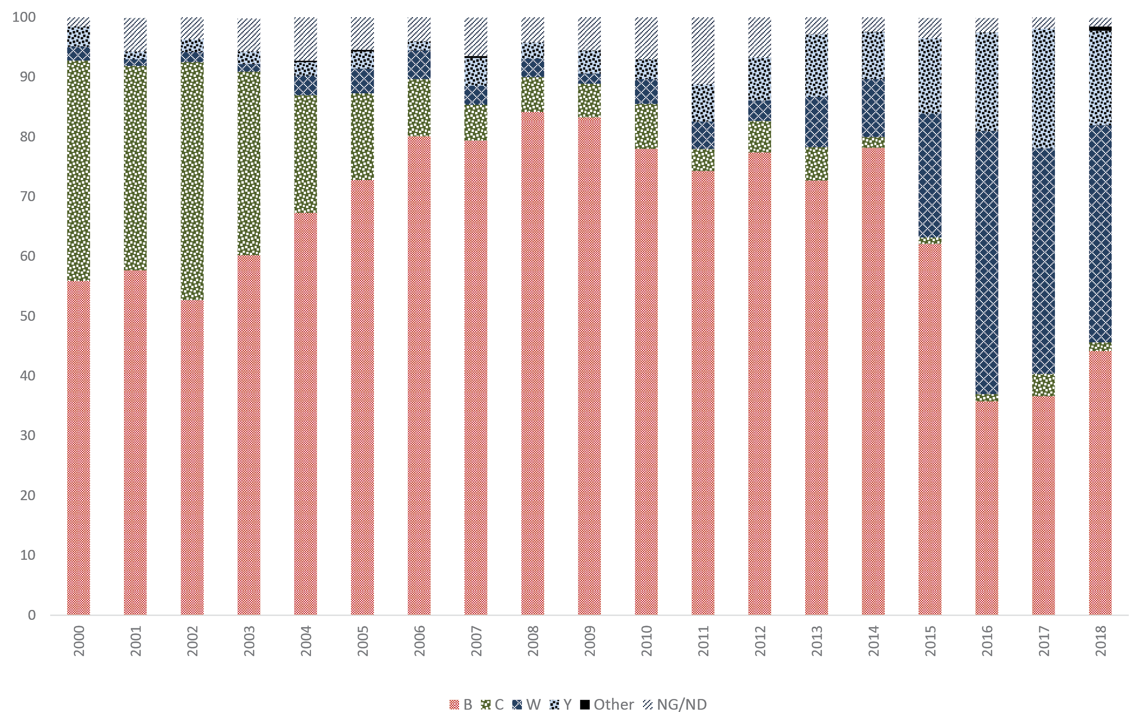

Table 4: Number of laboratory-confirmed cases of invasive meningococcal disease, Australia, 2018, by anatomical source and method of confirmation
Specimen type | Isolate of MCª | PCR positive^{b} | Total
Blood | 188 | 33 | 221
CSF +/- blood | 23 | 28 | 51
Other | 5 | 1 | 6
Total | 216 | 62 | 278
a MC: meningococci
b PCR: polymerase chain reaction
The number of IMD cases caused by serogroup C (4 cases) in 2018 was less than the number reported the previous year, and was similar to national case numbers for the period 2014–2016. New South Wales reported 2 cases, and Queensland and Victoria each reported one case.
Since 2014, the rise in the total number of IMD cases has been due to a rise in the number of cases of IMD caused by serogroups W and Y (Figures 1 and 2). The number of cases of IMD caused by serogroup W in 2018 (101 cases) was the third highest reported by the AMSP (141 cases in 2017, 107 cases in 2016). The 2018 serogroup W case number was almost triple the number of cases reported in 2015 (36 cases) and a tenfold increase in the average annual number of reported IMD cases caused by serogroup W before 2015. Prior to 2015, the proportion of cases of IMD caused by serogroup W ranged from 1.1 to 4.8% in the period 1997–2012 and from 8.4 to 9.7% in 2013–2014. In 2015 it was 21%, in 2016 it was 44%, in 2017 it was 38%, and in 2018 it was 36.3% of the total cases of IMD for each corresponding year (Figure 2).
A similar pattern and trend was seen in the number and proportion of cases of IMD caused by serogroup Y in 2018 (n = 44, 15.8% of total IMD), which was the second highest reported by the AMSP (the highest being the previous year with 75 cases, 20% of total IMD), and triple the average number of annual serogroup Y cases reported before 2015. Prior to 2015, the proportion of cases of IMD caused by serogroup Y ranged from 1.3 to 4.6% in the period 1997–2010 and from 6.2 to 10.5% in 2011–2014. In 2015 the proportion rose to 12.6%, rose again in 2016 to 16.5%, and again in 2017 to 20% of the total cases of IMD for each corresponding year (Figure 2).
Of the 101 laboratory-confirmed cases of IMD caused by serogroup W in 2018, Western Australia reported the largest number of cases (n = 30), where serogroup W represented 75% (30/40) of cases, followed by New South Wales and Victoria (n = 19 each), where serogroup W represented 27.1% and 37.3% of cases respectively. The number of serogroup W IMD cases in Western Australia in 2018 was the highest number yet reported from that jurisdiction. Of the 11 IMD cases from the Northern Territory, all were from remote central Australia, and serogroup W comprised 8 (72.7%) of these cases. For the first time, serogroup W was reported in all jurisdictions (Table 2).
Of the 44 cases of IMD caused by serogroup Y in 2018, New South Wales reported the largest number of cases (n = 15), where this serogroup represented 21.4% (15/70 cases) of IMD cases reported in this jurisdiction. Serogroup Y was reported in all jurisdictions, except the Australian Capital Territory and the Northern Territory (Table 2).
In 2018, there were two cases of IMD caused by serogroup E. This was the first time this serogroup was detected in Australia since 2007, and once prior in 1997.⁴ Both cases were from Queensland: one case was diagnosed by NAAT from blood in a 17 year old female. In the other case, the organism was isolated from blood culture in a 5 year old female. Both cases exhibited the same genotype: P1.21-7,16.

Figure 3: Number of serogroups B, Y and W cases of laboratory-confirmed invasive meningococcal disease, Australia, 2018, by age
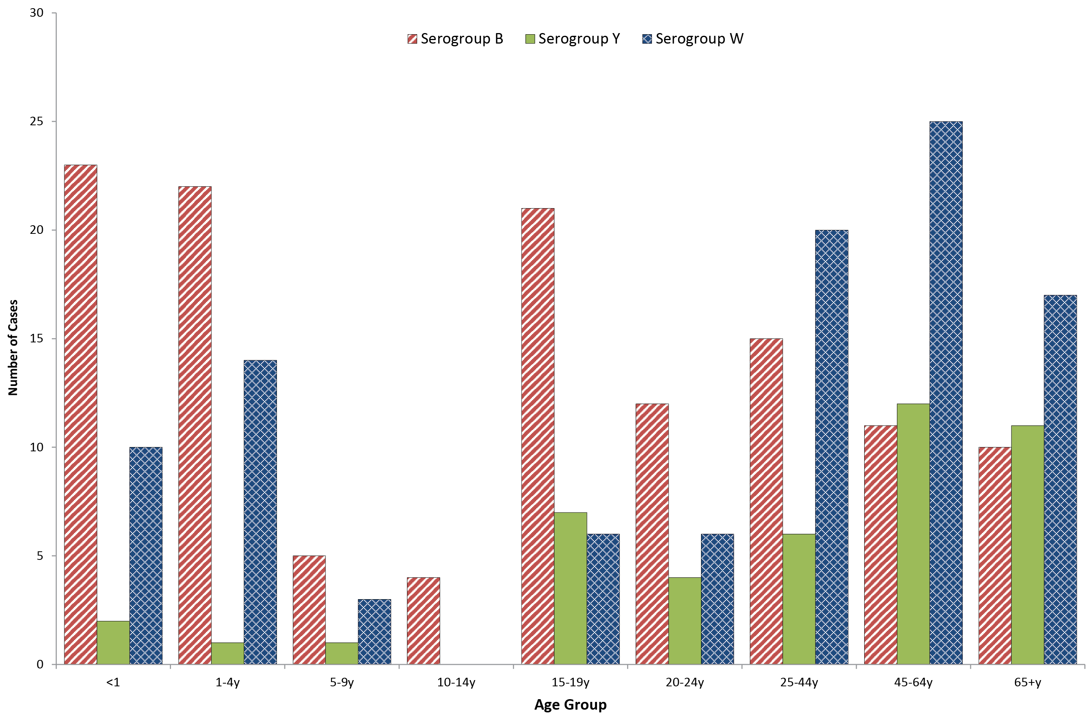

In 2018, IMD caused by serogroup B was the predominant serogroup in all age groups except those aged 25 to 44 years, 45 to 64 years, and 65 years or older. This distribution was similar to patterns seen before 2016 (Table 3, Figure 3).
IMD caused by serogroup W was seen in all age groups in 2018, except those aged from 10 to 14 years. This age group has historically shown low numbers of total IMD cases, and in 2018, only 4 cases, all serogroup B, from a total of 278 cases of IMD were in this age group. For those aged less than 5 years, the number and proportion of IMD cases caused by serogroup W (24 cases, 32.4%) was lower than 2017, which was the highest recorded for this age group. For those aged 25 to 44 years, 45 to 64 years, and those aged 65 or more, IMD caused by serogroup W was the predominant serogroup (20/43 cases or 47%; 25/50 cases or 50%; and 17/39 cases or 44% respectively) (Table 3, Figure 3).
Serogroup Y IMD was also seen in all age groups in 2018, except those aged between 10 to 14 years, with the highest number and proportion seen in those aged 45 or more years (23 cases, 26% of total IMD for this age group), as in previous years (Table 3, Figure 3).

Genotyping
In 2018, genotyping was performed on 66% (181/278) of IMD cases. Results are shown in Tables 5 and 6. There were 70 serogroup B cases typed, for which the predominant porA type in 2018 continues to be P1.7-2,4 (19/70, 27%). Other prevalent serogroup B genotypes were P1.7,16-26 (10 cases, 14%), and P1.22,14 (9 cases, 13%), similar to previous years. Also of note, the highest number of genotype P1.19,15 (7 cases, 10%) were reported since AMSP genotyping data reporting commenced in 2009. Two of the 4 serogroup C cases were typed; both were P1.5-1,10-8. For serogroup Y IMD, the predominant genotype was P1.5-1,10-1 (22 cases, 69%), as has been reported since 2014, when the increase in serogroup Y IMD was first noted in Australia. For serogroup W IMD, the predominant genotype remains P1.5,2 (66 cases, 89%) (Table 5, Table 6). Of these, 29 cases (44%) were clonal complex 11, the same strain type as the hypervirulent serogroup W strain also reported in the UK and South America since 2009 (Table 7).^{6,7}
Table 5: Laboratory-confirmed cases of invasive meningococcal disease, Australia, 2018, by porA genotype
2018 AMSP | Number per serogroup
GENOTYPE_PorA | TOTAL | B | C | Y | W | Otherª | ND
P1.5,2 | 71 | 4 | 0 | 0 | 66 | 0 | 1
P1.5,10 | 2 | 0 | 0 | 2 | 0 | 0 | 0
P1.5,new | 1 | 0 | 0 | 0 | 1 | 0 | 0
P1.5-1,10 | 1 | 0 | 0 | 1 | 0 | 0 | 0
P1.5-1,10-1 | 23 | 0 | 0 | 22 | 1 | 0 | 0
P1.5-1,10-4 | 6 | 0 | 0 | 2 | 4 | 0 | 0
P1.5-1,10-8 | 2 | 0 | 2 | 0 | 0 | 0 | 0
P1.5-1,10-12 | 1 | 0 | 0 | 1 | 0 | 0 | 0
P1.5-1,2-2 | 1 | 0 | 0 | 1 | 0 | 0 | 0
P1.5-2,10-1 | 3 | 0 | 0 | 3 | 0 | 0 | 0
P1.7,16-26 | 10 | 10 | 0 | 0 | 0 | 0 | 0
P1.7,30 | 1 | 1 | 0 | 0 | 0 | 0 | 0
P1.7-2,4 | 19 | 19 | 0 | 0 | 0 | 0 | 0
P1.7-2,16-26 | 1 | 1 | 0 | 0 | 0 | 0 | 0
P1.7-11,16-26 | 1 | 1 | 0 | 0 | 0 | 0 | 0
P1.7-36,14 | 1 | 1 | 0 | 0 | 0 | 0 | 0
P1.7-63,9 | 1 | 1 | 0 | 0 | 0 | 0 | 0
P1.12-6,13-49 | 1 | 1 | 0 | 0 | 0 | 0 | 0
P1.17-6,23 | 1 | 1 | 0 | 0 | 0 | 0 | 0
P1.18-1,30-3 | 1 | 1 | 0 | 0 | 0 | 0 | 0
P1.18-1,30-6 | 1 | 1 | 0 | 0 | 0 | 0 | 0
P1.18-1,34 | 6 | 5 | 0 | 0 | 1 | 0 | 0
P1.18-10,43 | 1 | 0 | 0 | 0 | 1 | 0 | 0
P1.19,15 | 7 | 7 | 0 | 0 | 0 | 0 | 0
P1.19-1,15 | 2 | 2 | 0 | 0 | 0 | 0 | 0
P1.19-1,15-11 | 1 | 1 | 0 | 0 | 0 | 0 | 0
P1.21-7,16 | 2 | 0 | 0 | 0 | 0 | 2 | 0
P1.22,14 | 9 | 9 | 0 | 0 | 0 | 0 | 0
P1.22,14-3 | 2 | 2 | 0 | 0 | 0 | 0 | 0
P1.22,14-6 | 1 | 1 | 0 | 0 | 0 | 0 | 0
P1.22-1,14 | 1 | 1 | 0 | 0 | 0 | 0 | 0
Total | 181 | 70 | 2 | 32 | 74 | 2 | 1
a Other: serogroup E

Table 6: Distribution of porA genotype laboratory-confirmed cases of invasive meningococcal disease, Australia, 2018, by state or territory
2018 AMSP | Number per serogroup per state
GENOTYPE_PorA | NSW | Qld | Vic | SA | WA | ACT | Tas | NT
P1.5,2 | 1B, 7W | 2B, 10W | 15W, 1ND |  | 21W |  | 1B, 5W | 8W
P1.5,10 |  | 2W
P1.5,new |  |  |  |  |  | 1W
P1.5-1,10 |  | 1Y
P1.5-1,10-1 | 5Y | 6Y | 6Y, 1W | 1Y | 2Y |  | 2Y
P1.5-1,10-4 | 1Y | 1W | 1Y, 3W
P1.5-1,10-8 |  | 1C | 1C
P1.5-1,10-12 |  |  |  | 1Y
P1.5-1,2-2 |  |  | 1Y
P1.5-2,10-1 |  | 1Y | 2Y
P1.7,16-26 | 3B | 2B | 3B | 2B
P1.7,30 |  |  |  | 1B
P1.7-2,4 | 5B | 1B | 3B | 10B
P1.7-2,16-26 |  | 1B
P1.7-11,16-26 |  |  | 1B
P1.7-36,14 |  | 1B
P1.7-63,9 | 1B
P1.12-6,13-49 |  | 1B
P1.17-6,23 |  | 1B
P1.18-1,30-3 |  |  | 1B
P1.18-1,30-6 |  |  | 1B
P1.18-1,34 |  | 1B, 1W | 2B | 1B | 1B
P1.18-10,43 |  |  |  |  | 1W
P1.19,15 | 1B | 2B | 1B | 2B |  |  | 1B
P1.19-1,15 |  | 2B
P1.19-1,15-11 |  |  |  |  | 1B
P1.21-7,16 |  | 2E
P1.22,14 | 1B | 4B | 3B |  |  |  |  | 1B
P1.22,14-3 |  | 2B
P1.22,14-6 |  |  | 1B
P1.22-1,14 |  | 1B

Figure 4: Number of porA genotypes for serogroup B in laboratory-confirmed cases of invasive meningococcal disease Australia, 2018
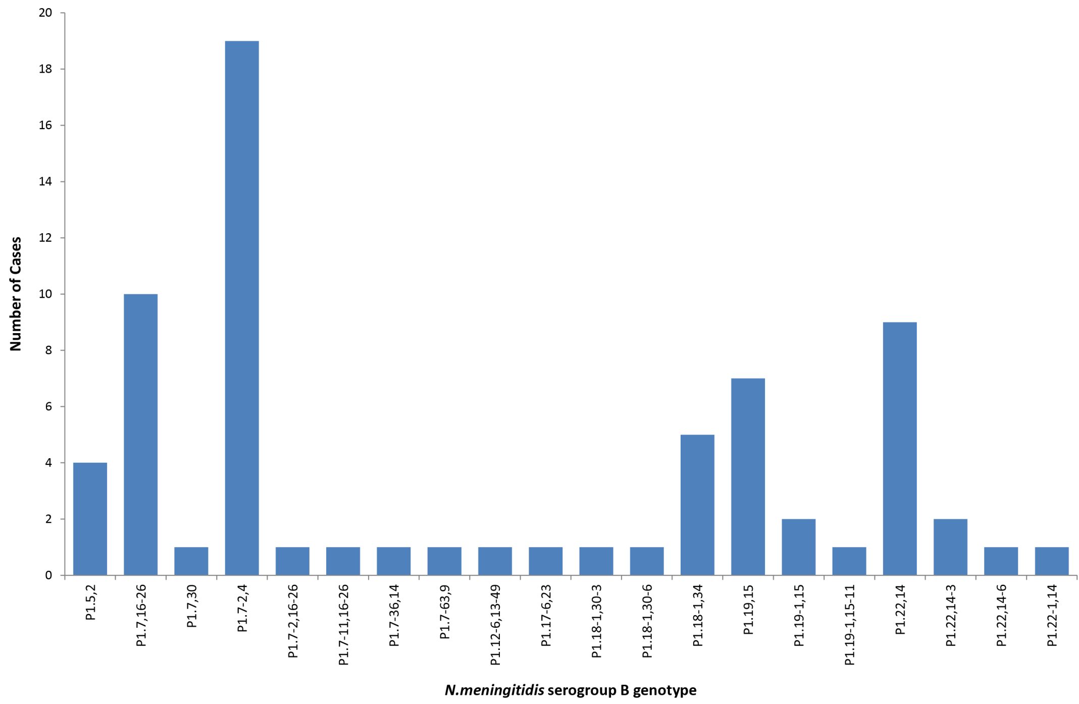

Table 7: Laboratory-confirmed cases of serogroup W invasive meningococcal disease, Australia, 2018, by sequence type (ST)
Sequence Type | W Genotype
 | P1.5,2 | P1.5,new | P1.5-1,10-1 | P1.5-1,10-4 | P1.18-1,34 | P1.18-10,43 | Total
ST11 | 29 | 1 | 0 | 3 | 0 | 0 | 33
ST574 | 1 | 0 | 0 | 0 | 0 | 0 | 1
ST1158 | 0 | 0 | 0 | 0 | 1 | 0 | 1
ST1287 | 9 | 0 | 0 | 0 | 0 | 0 | 9
ST1655 | 0 | 0 | 1 | 0 | 0 | 0 | 1
ST2780 | 1 | 0 | 0 | 0 | 0 | 0 | 1
ST12351 | 16 | 0 | 0 | 0 | 0 | 1 | 17
ST13135 | 2 | 0 | 0 | 0 | 0 | 0 | 2
Not determined | 8 | 0 | 0 | 1 | 0 | 0 | 9
Total | 66 | 1 | 1 | 4 | 1 | 1 | 74

To better understand the molecular epidemiology of isolates associated with IMD in Australia, 163 IMD isolates were sequenced between 1 January and 31 December 2018 comprising 59% of IMD cases (163/281) notified to NNDSS for this period. Sequencing was performed by laboratories in three states: the Microbiological Diagnostic Unit, Public Health Laboratory, University of Melbourne; the Molecular Epidemiology Unit, Public Health Microbiology (MDU PHL), Forensic and Scientific Services, Queensland; and the School of Biomedical Sciences, Faculty of Health and Medical Sciences, The University of Western Australia. Phylogenetic analysis was undertaken by bioinformaticians and epidemiologists from the WHO Regional Reference Laboratory for Invasive Bacterial Diseases, Vaccine Preventable, based at MDU PHL (Melbourne), supported by funding from a National Health and Medical Research Partnership Grant (GNT1149991). Isolates sequenced were from Vic (n = 47, representing 89% of notified cases), Qld (44, 76%), SA (20, 59%), WA (14, 35%), NSW (14, 19%), NT (12, 100%), Tas (11, 100%) and ACT (1, 33%). There were 15 clonal complex (cc) groups represented amongst the 163 isolates, with three clonal complexes predominant: cc11 (63/163, 39%), cc23 (27/163, 17%) and cc41/44 (24/163, 15%). The cc11 was predominately serogroup W (59/63, 93%); cc23 was associated exclusively with serogroup Y; and cc41/44 exclusively with serogroup B. Amongst the serogroup W cc11 isolates there were five sequence types (STs): ST-11 (36/59, 61%), ST-1287 (11/59, 16%), ST-12351 (11/59, 18%), ST-2780 (1/59), and ST-13135 (1/59). A cluster of ST-1287 and ST12351 isolates was identified in 2017 as associated with IMD within remote regions of Australia. Ten isolates from among the 2018 isolates were found to be highly related to the 2017 cluster. Of the serogroup Y isolates, 24/30 (80%) were ST-1655. These isolates are not phylogenetically closely related. Serogroup B showed greatest genetic diversity, comprising isolates within 10 clonal complexes. A closely related cluster of B:P1.7-2,4:F1-5:ST-154:cc41/44 isolates was observed in 2018.

Antibiotic susceptibility testing
Isolates of N meningitidis are tested against both treatment and clearance antibiotics: penicillin, ceftriaxone, rifampicin and ciprofloxacin.
Penicillin susceptibility testing was possible for 76.2% (212/278) of IMD cases in 2018, and the distribution of penicillin MIC values is shown in Table 8. There were 4.7% (10/212) strains fully susceptible to penicillin (MIC ≤ 0.03 mg/L). Three isolates, 1.4% (3/212) were resistant to penicillin with MIC ≥ 1 mg/L, a lower proportion than reported in 2017 (5.1%) and 2016 (5.8%) as shown in Figure 5. Of the isolates that were resistant to penicillin with an MIC ≥ 1 mg/L, two were serogroup W and one was serogroup C; all were from Queensland.
Figure 5: Proportion of penicillin susceptible, less susceptible and resistant invasive meningococcal disease isolates, Australia, by year
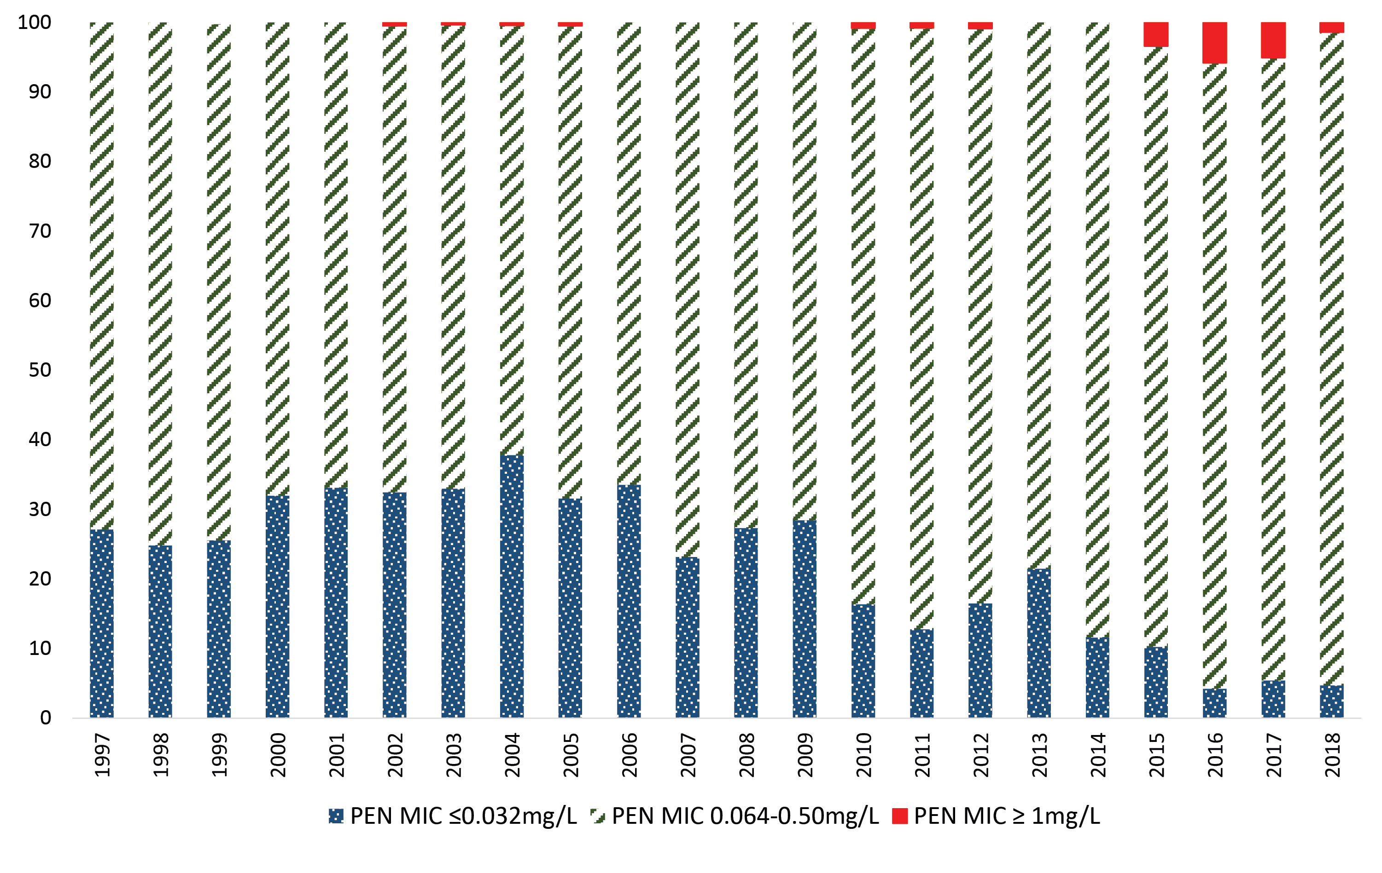

Table 8: Penicillin MIC distribution of laboratory-confirmed invasive meningococcal disease isolates, Australia, 2018
Penicillin MIC distribution
MIC mg/L | ≤0.032 | 0.064 | 0.125 | 0.25 | 0.5 | 1 | 2 | ≥4 | Total
Number | 10 | 41 | 30 | 56 | 72 | 3 | 0 | 0 | 212
% | 4.7 | 19.3 | 14.2 | 26.4 | 34.0 | 1.4 | 0 | 0 | 100

Of the 72 isolates with a penicillin MIC of 0.5 mg/L, 60 isolates were serogroup W, and this represented 70% (60/86) of serogroup W isolates available for MIC determination. In recent years, there has been an increasing proportion of invasive meningococcal disease isolates with decreased susceptibility and resistance to penicillin (Figure 5), with serogroup W demonstrating higher penicillin MIC and higher proportions of resistance. In 2017, 10/14 isolates that were resistant to penicillin with an MIC ≥ 1 mg/L were serogroup W, and this represented 8.3% resistance in all serogroup W isolates available for MIC determination (n = 121). In 2016, 11 isolates were resistant to penicillin with an MIC ≥ 1 mg/L, all of which were serogroup W, and this represented 11% resistance in all serogroup W isolates available for MIC determination (n = 99).
Ceftriaxone susceptibility testing was performed on 76% (210/278) of the IMD cases for 2018, and all were susceptible. Ciprofloxacin susceptibility testing was performed on 68% (189/278) of the IMD cases for 2018, and 1 isolate was less susceptible with an MIC of 0.25 mg/L. Rifampicin susceptibility testing was performed on 69% (191/278) of the IMD cases for 2018, and all were susceptible.

Discussion
In 2018, 278 of 281 IMD notifications (98.9%) were laboratory confirmed.³ This was a decrease in the number of notifications of IMD in Australia from 2017 (380), which was the highest reported since 2006.
Following the increases in serogroup W and Y disease in Australia 2016–2017, jurisdictions variably implemented time-limited quadrivalent ACWY vaccination programs for either adolescents (15–19 years) or infants, children, adolescents and young adults (0–20 years) in 2017 or 2018.⁸ From 1 July 2018, the nationally funded MenC vaccine scheduled for administration at 12 months of age was replaced with a quadrivalent serogroup ACWY vaccine on the National Immunisation Program (NIP).⁸ A recombinant multi-component meningococcal B vaccine has been available in Australia since 2014,⁹ however this vaccine is not currently on the NIP.
As reported by the AMSP since 2015, the primary peak of IMD continues to be observed in adults aged 45 years or older and is attributable to the increased number of IMD cases caused by serogroups W and Y. Secondary disease peaks were observed in those aged less than 5 years, due primarily to serogroup B cases in this age category.
With regards to IMD serogroup analysis, the number of IMD cases caused by serogroup B in 2018 was less than the previous year, and New South Wales reported the largest number; however, South Australia continues to report the highest proportion of serogroup B in the notifications of IMD nationally. The predominant genotype for IMD cases caused by serogroup B in Australia continues to be P1.7-2,4, however, of note the highest number of genotype P1.19,15 was reported since AMSP genotyping data reporting commenced in 2009. The P1.19,15 genotype accounted for 10% of typeable serogroup B IMD cases.
Whilst the numbers of IMD cases caused by serogroup W and serogroup Y in 2018 were each lower than those reported in 2017—the highest reported by the AMSP—the proportion of IMD cases attributable to serogroup W and Y continues to be much higher than was reported for these serogroups prior to 2015. The number of IMD caused by serogroup C was less than the previous year, which was the highest reported by the AMSP since 2007.
In 2018 serogroup W represented 36% of all laboratory-confirmed IMD cases in 2018, a decrease from 2017, but for the first time was reported in all jurisdictions with the highest proportions in Western Australia (30%), New South Wales and Victoria (19% each). The predominant circulating strain of serogroup W continues to be genotype P1.5,2 sequence type (ST)-11. This same hypervirulent serogroup W strain previously emerged in the United Kingdom⁷ and South America⁶ in 2009 and spread to account for 25% of IMD in the UK in 2014–2015, and 59% of all cases in Chile in 2012. Serogroup W ST11 is associated with atypical presentations, more severe clinical disease and a higher case fatality rate.⁷ The initial increase in serogroup W, overseas and in Australia, was seen in older adults, but was subsequently reported in all age groups, particularly in adolescents and infants.¹⁰ In July 2018 there was a small cluster of 3 cases of serogroup W IMD in Hobart, Tasmania.
The number and proportion of cases of IMD caused by serogroup Y in 2018 was the second highest reported by the AMSP, and triple the average number of annual serogroup Y cases reported before 2015. The highest case numbers were reported in New South Wales, Queensland and Victoria. The predominant serogroup Y genotype since 2014 continues to be P1.5-1,10-1 whereas in previous years the serogroup Y genotype distribution was more heterogeneous. The emergence of serogroup Y has also been reported recently in Europe.¹¹ The phenotypic and genotypic characterisation of the serogroup Y isolates is ongoing by the NNN.
In 2018 there were two cases of IMD caused by serogroup E, the first time since 2007 this serogroup was detected in IMD cases in Australia. Both cases were from Queensland and both exhibited the same genotype P1.21-7,16.
Genomic investigations showed that in 2018 there were 15 clonal complex (cc) groups represented amongst the 163 isolates typed, with 3 clonal complexes (cc) predominant: cc11 (39%), cc23 (17%) and cc41/44 (15%). The cc11 was predominately serogroup W (93%), cc23 was associated exclusively with serogroup Y, and cc41/44 exclusively with serogroup B. Amongst the serogroup W cc11 isolates there were 5 sequence types (ST): ST-11 (36/60, 61%), ST-1287 (11/59, 16%), ST-12351 (11/59, 18%), ST-2780 (1/59), and ST-13135 (1/59). A cluster of ST-1287 and ST12351 isolates was identified in 2017 as associated with IMD within remote regions of Australia. Ten isolates from 2018 isolates were found to be highly related to the 2017 cluster. Of the serogroup Y isolates, 24/30 (80%) were ST-1655. These isolates are not phylogenetically closely related. Serogroup B showed greatest genetic diversity comprising isolates within 10 clonal complexes. A closely-related cluster of B:P1.7-2,4:F1-5:ST-154:cc41/44 isolates was observed in 2018.
Antimicrobial susceptibility testing of IMD isolates showed that penicillin resistance was reduced in 2018 compared with 2016 and 2017, which had been the highest annual number and proportion of penicillin-resistant IMD isolates recorded by the AMSP. The incidence of penicillin resistance in N. meningitidis in Australia had been less than 1% annually for IMD isolates tested in 1996–2014, rising to 3.4% in 2015 and 5.8% in 2016, before dropping slightly to 5.1% in 2017. In 2018 1.4% of meningococcal isolates were resistant. The proportion of IMD isolates with penicillin MIC values in the less sensitive category has been increasing in recent years. These proportions ranged from 62% to 75% in 1996–2006; 67–79% in 2007–2009; 78–88% in 2010–2015, 90% in 2016 and 2017, and in 2018 was 94%. The majority of penicillin-resistant meningococcal isolates are serogroup W. All IMD isolates tested in 2018 were susceptible to ceftriaxone and rifampicin, while one isolate was less susceptible to ciprofloxacin.
The recent increase in IMD cases, and particularly those caused by serogroup W and serogroup Y, and the observed increase in antimicrobial resistance in serogroup W isolates are of significant concern. The NNN is continuing to closely monitor the phenotypic and genotypic features of N. meningitidis causing IMD in Australia, and the impact of the recent changes in the immunisation schedule directed to address these changes. Additional investigations, including whole genome sequencing, are in place to enhance IMD surveillance. The AMSP data are also used for informing treatment guidelines and other disease prevention strategies.

Acknowledgements
Meningococcal isolates were received in the reference centres from many laboratories throughout Australia. The considerable time and effort involved in forwarding these isolates is recognised, and these efforts are greatly appreciated. These data could not have been provided without this assistance, and without the help of clinical colleagues and public health personnel. The Australian Government Department of Health provided funding for the National Neisseria Network.
Members of the AMSP in 2018, to whom isolates and samples should be referred, and enquiries directed, are listed below.

Australian Capital Territory
P Collignon, S Bradbury
Microbiology Department The Canberra Hospital Gilmore Crescent Garran ACT 2605
Telephone: +61 2 6244 2510
Email: peter.collignon@act.gov.au

New South Wales
MM Lahra, RP Enriquez, EA Limnios, TR Hogan, RL Kundu, J El Nasser
Microbiology Department, World Health Organisation Collaborating Centre for STI and AMR before Microbiology Department , New South Wales Health Pathology, The Prince of Wales Hospital Barker Street, Randwick NSW 2031
Telephone: +61 2 9382 9084
Facsimile: +61 2 9382 9310
Email: monica.lahra@health.nsw.gov.au
M Maley, J Mercer, R Porritt
Department of Microbiology and Infectious Diseases New South Wales Health Pathology, Liverpool Hospital, Locked Mail Bag 7090 Liverpool BC NSW 1871
Telephone: +61 8738 5124
Facsimile: +61 2 8738 5129
Email: Joanne.Mercer@sswahs.nsw.gov.au or Robert.Porritt@sswahs.nsw.gov.au

Northern Territory
R Baird, K Freeman
Microbiology Department Territory Pathology Royal Darwin Hospital Rocklands Drive Tiwi NT 0810
Telephone: +61 8 8922 8167
Facsimile: +61 8 8922 7788
Email: rob.baird@nt.gov.au

Queensland
G Robertson, J Bates, H Smith, V Hicks, A. Jennison, G. Micalizzi
Public Health Microbiology Queensland Health Forensic and Scientific Services 39 Kessels Road Coopers Plains Qld 4108
Telephone: +61 7 3096 2825
Facsimile: +61 7 3096 2973+61 7 3274 9175
Email: Gino.Micalizzi@health.qld.gov.au

South Australia
I Bastian, A Lawrence, J Holds
SA Pathology Royal Adelaide Hospital Site. Microbiology and Infectious Diseases Royal Adelaide Hospital North Terrace, Adelaide, SA 5000
Telephone: +61 8 8222 3335
Facsimile: +61 8 2223543
Email: andrew.lawrence@health.sa.gov.au

Tasmania
L Cooley, B McEwan
Department of Microbiology and Infectious Diseases Royal Hobart Hospital 48 Liverpool Street Hobart Tasmania 7000
Telephone: +61 3 6222 8656
Email: belinda.mcewan@dhhs.tas.gov.au

Victoria
B Howden, K Stevens
Microbiological Diagnostic Unit Public Health Laboratory Department of Microbiology and Immunology The Peter Doherty Institute The University of Melbourne Parkville Victoria 3052
Telephone: +61 3 8344 5713
Facsimile: +61 3 8344 7833
Email: kerries@unimelb.edu.au

Western Australia
AD Keil, J Bew
Department of Microbiology QEII Medical Centre, PP Block Level 5 PathWest Laboratory Medicine WA Hospital Avenue Nedlands, WA 6009
Telephone: +61 8 6383 4501
Facsimile: +61 8 9382 8046
Email: tony.keil@health.wa.gov.au or jane.bew@health.wa.gov.au

Author details
Monica M Lahra^{1, 2} Rodney Enriquez¹ Tiffany Hogan¹
- Neisseria Reference Laboratory and World Health Organisation Collaborating Centre for STI and AMR, Sydney. Department of Microbiology, New South Wales Health Pathology, The Prince of Wales Hospital, Randwick, 2031, NSW Australia
- School of Medical Sciences, Faculty of Medicine, The University of New South Wales, NSW, 2052 Australia

Corresponding author
Professor Monica Lahra
Director, World Health Organisation Collaborating Centre for STI and AMR, Microbiology Department, Neisseria Reference Laboratory and WHO Collaborating Centre for STI and AMR, New South Wales Health Pathology, Level 4, Campus Centre, The Prince of Wales Hospital, RANDWICK NSW, 2031.
Email: monica.lahra@health.nsw.gov.au

References
- National Neisseria Network. Meningococcal isolate surveillance Australia 1994. Commun Dis Intell. 1995;19(12)286–9.
- Australian Government Department of Health. National Notifiable Disease Surveillance System (NNDSS). [Internet.] Australian Government Department of Heath, 2019. Available from: http://www9.health.gov.au/cda/source/cda-index.cfm .
- NNDSS. Number of notifications of Meningococcal disease (invasive), received from state and territory health authorities in the period of 1991 to 2012 and year-to-date notifications for 2014. [Internet.] Australian Government Department of Health, NNDSS, 2014.
- Australian Government Department of Health. Meningococcal Disease (Invasive). [Internet.] Australian Government Department of Health, 2019. Available from: https://www.health.gov.au/internet/main/publishing.nsf/Content/ohp-meningococcal-W.htm .
- Communicable Diseases Network Australia. Invasive Meningococcal Disease: CDNA National Guidelines for Public Health Units. [Internet.] Australian Government Department of Health, 2017. Available from: http://www.health.gov.au/internet/main/publishing.nsf/content/cdna-song-imd.htm.
- Abad R, López EL, Debbag R, Vázquez JA. Serogroup W meningococcal disease: global spread and current affect on the Southern Cone in Latin America. Epidemiol Infect. 2014;142(12):2461–70.
- Ladhani SN, Beebeejaun K, Lucidarme J, Campbell H, Gray S, Kaczmarski E, et al. Increase in endemic Neisseria meningitidis capsular group W sequence type 11 complex associated with severe invasive disease in England and Wales. Clin Infect Dis. 2015;60(4):578–85.
- Chiu C, Dey A, Wang H, Menzies R, Deeks S, Mahajan D et al. Vaccine preventable diseases in Australia, 2005 to 2007. Commun Dis Intell Q Rep. 2010;34:S1–167.
- Australian Government Department of Health. Meningococcal Disease. Immunise Australia Program. [Internet.] Australian Government Department of Heath, 2015. Available from: http://www.health.gov.au/internet/immunise/publishing.nsf/Content/immunise-meningococcal
- Araya P, Fernández J, Del Canto F, Seoane M, Ibarz-Pavón AB, Barra G, Pidal P et al. Neisseria meningitidis ST-11 clonal complex, Chile 2012. Emerg Infect Dis. 2015;21(2):339–41.
- Bröker M, Jacobsson S, Kuusi M, Pace D, Simões MJ, Skoczynska A et al. Meningococcal serogroup Y emergence in Europe: update 2011. Hum Vaccin Immunother. 2012;8(12):1907–11.

Communicable Diseases Intelligence
ISSN: 2209-6051 Online

Communicable Diseases Intelligence (CDI) is a peer-reviewed scientific journal published by the Office of Health Protection, Department of Health. The journal aims to disseminate information on the epidemiology, surveillance, prevention and control of communicable diseases of relevance to Australia.

Editor: Cindy Toms
Deputy Editor: Simon Petrie
Design and Production: Kasra Yousefi
Editorial Advisory Board: David Durrheim, Mark Ferson, John Kaldor, Martyn Kirk and Linda Selvey

Website: http://www.health.gov.au/cdi

Contacts
Communicable Diseases Intelligence is produced by:
Health Protection Policy Branch, Office of Health Protection, Australian Government Department of Health
GPO Box 9848, (MDP 6) CANBERRA ACT 2601

Email: cdi.editor@health.gov.au

Submit an Article
You are invited to submit your next communicable disease related article to the Communicable Diseases Intelligence (CDI) for consideration. More information regarding CDI can be found at: http://health.gov.au/cdi.
Further enquiries should be directed to: cdi.editor@health.gov.au.

This journal is indexed by Index Medicus and Medline.

Creative Commons Licence - Attribution-NonCommercial-NoDerivatives CC BY-NC-ND
© 2019 Commonwealth of Australia as represented by the Department of Health
This publication is licensed under a Creative Commons Attribution-NonCommercial-NoDerivatives 4.0 International Licence from https://creativecommons.org/licenses/by-nc-nd/4.0/legalcode (Licence). You must read and understand the Licence before using any material from this publication.

Restrictions
The Licence does not cover, and there is no permission given for, use of any of the following material found in this publication (if any):
- the Commonwealth Coat of Arms (by way of information, the terms under which the Coat of Arms may be used can be found at www.itsanhonour.gov.au);
- any logos (including the Department of Health’s logo) and trademarks;
- any photographs and images;
- any signatures; and
- any material belonging to third parties.

Disclaimer
Opinions expressed in Communicable Diseases Intelligence are those of the authors and not necessarily those of the Australian Government Department of Health or the Communicable Diseases Network Australia. Data may be subject to revision.

Enquiries
Enquiries regarding any other use of this publication should be addressed to the Communication Branch, Department of Health, GPO Box 9848, Canberra ACT 2601, or via e-mail to: copyright@health.gov.au

Communicable Diseases Network Australia
Communicable Diseases Intelligence contributes to the work of the Communicable Diseases Network Australia.
http://www.health.gov.au/cdna

