Australian National Enterovirus Reference Laboratory annual report, 2015
Jason A Roberts, Linda K Hobday, Aishah Ibrahim, Thomas Aitken and Bruce R Thorley

Abstract
Australia conducts surveillance for cases of acute flaccid paralysis (AFP) in children less than 15 years as recommended by the World Health Organization (WHO) as the main method to monitor its polio-free status. Cases of AFP in children are notified to the Australian Paediatric Surveillance Unit or the Paediatric Active Enhanced Disease Surveillance System and faecal specimens are referred for virological investigation to the National Enterovirus Reference Laboratory. In 2015, no cases of poliomyelitis were reported from clinical surveillance and Australia reported 1.2 non-polio AFP cases per 100,000 children, meeting the WHO performance criterion for a sensitive surveillance system. Two non-polio enteroviruses, enterovirus A71 and coxsackievirus B3, were identified from clinical specimens collected from AFP cases. Australia complements the clinical surveillance program with enterovirus and environmental surveillance for poliovirus. Two Sabin-like polioviruses were isolated from sewage collected in Melbourne in 2015, which would have been imported from a country that uses the oral polio vaccine. The global eradication of wild poliovirus type 2 was certified in 2015 and Sabin poliovirus type 2 will be withdrawn from oral polio vaccine in April 2016. Laboratory containment of all remaining wild and vaccine strains of poliovirus type 2 will occur in 2016 and the National Enterovirus Reference Laboratory was designated as a polio essential facility. Globally, in 2015, 74 cases of polio were reported, only in the two remaining countries endemic for wild poliovirus: Afghanistan and Pakistan. This is the lowest number reported since the global polio eradication program was initiated.
Keywords: poliovirus, acute flaccid paralysis, surveillance, enterovirus, poliomyelitis, eradication, vaccination

Introduction
Australia has established clinical and virological surveillance schemes to monitor its polio-free status. The clinical surveillance follows the World Health Organization (WHO) recommendation of investigating cases of acute flaccid paralysis (AFP) in children less than 15 years of age as an age group at high risk of poliovirus infection. AFP cases are ascertained either by clinicians notifying the Australian Paediatric Surveillance Unit (APSU) via a monthly report card or through the Paediatric Active Enhanced Disease Surveillance System (PAEDS) at five sentinel tertiary paediatric hospitals.^{1,2,3} The WHO recommends that two faecal specimens be collected for virological investigation at least 24 hours apart and within 14 days of the onset of paralysis from cases of AFP to exclude poliovirus as the causative agent. It is a requirement of the WHO polio eradication program that the specimens are tested in a WHO-accredited laboratory, which for Australia is the National Enterovirus Reference Laboratory (NERL) at the Victorian Infectious Diseases Reference Laboratory (VIDRL). The clinical and laboratory data from AFP cases in children is reviewed by the Polio Expert Panel (PEP) and reported to the WHO as evidence of Australia’s continued polio-free status.
Enterovirus and environmental surveillance programs were established as virological surveillance for poliovirus to complement the clinical surveillance program focussed on AFP cases in children. Enteroviruses other than poliovirus have been associated with AFP and poliovirus infection may manifest clinically without paralysis. The Enterovirus Reference Laboratory Network of Australia (ERLNA) involves public diagnostic virology laboratories reporting enterovirus typing results from clinical specimens to exclude poliovirus involvement and establish the epidemiology of non-polio enteroviruses (NPEVs) in Australia. Most poliovirus infections are asymptomatic with the virus shed for weeks in the faeces of infected persons. WHO supports the testing of environmental or raw sewage samples as a means of detecting the presence of wild poliovirus in polio-free countries. The testing of environmental samples commenced at a sentinel site in metropolitan Melbourne from late 2014.
The number of wild polio cases worldwide decreased from 359 in 2014 to 74 in 2015.⁴ Cases were reported only from the two remaining polio endemic countries: Afghanistan and Pakistan. Nigeria was declared polio-free in September 2015, after more than 12 months with no detection of wild poliovirus.⁵ Only wild poliovirus serotype 1 was detected in 2015, with the last report of wild poliovirus type 3 in Nigeria in November 2012.⁶ The global eradication of wild poliovirus type 2 was certified in September 2015, with the last detection reported in India in 1999.⁷ This achievement has led to the planned globally-synchronised withdrawal of Sabin 2 poliovirus from OPV along with laboratory containment of this serotype from 2016, which will involve restricted access at a limited number of facilities worldwide.⁸ The three poliovirus serotypes will remain in the inactivated polio vaccine and all countries will incorporate at least one dose of inactivated polio vaccine in the routine immunisation schedule to maintain immunity to poliovirus type 2 ahead of the switch from trivalent OPV to bivalent OPV in April 2016.
In May 2014, the WHO Director-General declared the international spread of wild poliovirus in the northern hemisphere low season to be a Public Health Emergency of International Concern. The situation has been assessed every three months since then and the declaration has remained in place with countries known to be exporting wild poliovirus required to ensure all residents and long-term visitors are vaccinated between four weeks and 12 months prior to international travel.⁹ At the seventh meeting of the Emergency Committee, in November 2015, outbreaks of circulating vaccine-derived poliovirus (cVDPV) were added to the declaration. These cVDPV outbreaks are indicative of gaps in routine immunization, and type 2 cVDPV outbreaks in Guinea, Myanmar, Nigeria and Pakistan during 2015 are cause for public health concern in the lead-up to the switch to bivalent OPV.¹⁰
This report summarises the polio surveillance program in Australia for 2015, encompassing clinical surveillance for AFP cases in children and virological surveillance for poliovirus.

Methods

Acute flaccid paralysis surveillance
Paediatricians reviewing a patient less than 15 years of age presenting with AFP, or clinicians reviewing a patient of any age with suspected poliomyelitis, are requested to notify the NERL. Cases of suspected poliomyelitis are notifiable under the Nationally Notifiable Disease Surveillance Scheme.¹¹ Paediatricians notify AFP cases to the APSU via a monthly report card. Upon receipt of the notification, the AFP National Surveillance Co-ordinator based within the NERL forwards a clinical questionnaire for the clinician to complete. Alternatively, AFP cases are ascertained by PAEDS nursing staff from medical records and are enrolled in the surveillance program with parental or guardian consent.
According to the WHO surveillance criterion, two faecal specimens must be collected more than 24 hours apart due to intermittent virus shedding, and within 14 days of the onset of paralysis, while the virus titre remains high, to be classified as adequate. The faecal specimens are tested free of charge by the NERL.
The PEP, a subcommittee of the Communicable Disease Network of Australia, reviews the clinical and laboratory data for all notified cases of AFP, irrespective of whether they are an eligible or ineligible case. An eligible case is an Australian child less than 15 years of age with AFP (including Guillain-Barre syndrome and transverse myelitis) or an Australian of any age with suspected polio.
The PEP classifies cases of AFP as:
- Poliomyelitis due to wild poliovirus, vaccine-derived poliovirus (VDPV) or vaccine-associated paralytic poliomyelitis (VAPP);
- Polio-compatible if there is insufficient evidence to exclude poliomyelitis;
- Non-polio AFP or;
- Non-AFP.
The clinician is contacted if the PEP requires more information regarding the AFP case before a final classification can be made. After each PEP meeting the Australian AFP case classifications are forwarded to WHO for inclusion in the global AFP surveillance data published in the Weekly Epidemiological Record. Ineligible cases are not reported to WHO.
The WHO AFP surveillance performance indicator for a polio non-endemic country is 1 case of non-polio AFP per 100,000 children aged less than 15 years.¹² For Australia in 2015, this equated to 44 cases, based on the Australian Bureau of Statistics data released in December 2014. An AFP surveillance scheme that satisfies the WHO surveillance performance indicator is deemed sufficiently sensitive to detect a wild poliovirus importation in children of that country. The WHO surveillance performance indicator for laboratory testing is that at least 80% of notified AFP cases have adequate faecal specimens collected and tested in a WHO-accredited laboratory.

Virus culture
Upon receipt at the NERL, faecal specimens are treated with minimum essential medium containing Earle’s salts, chloroform (9.1% v/v) and phosphate buffered saline. The suspension is clarified and the supernatant inoculated onto the two mammalian cell lines recommended by WHO for the isolation of poliovirus: L20B (a transgenic mouse epithelial cell line expressing the human poliovirus receptor, CD155) and RD-A (human rhabdomyosarcoma).^{13,14}
Two WHO real-time reverse transcription polymerase chain reaction (RT-PCR) tests are used to determine whether a poliovirus is a wild strain, oral poliomyelitis vaccine (OPV) strain (Sabin-like) or a vaccine-derived poliovirus (VDPV), in a process known as intratypic differentiation (ITD).¹⁵ The NERL sequences the complete poliovirus viral protein 1 (VP1) genomic region, which contains a major neutralising antibody binding site. The VP1 genomic sequence provides valuable biological information, including the number of mutations within a significant region of the OPV virus strain, and it enables phylogenetic analysis of wild poliovirus to rapidly determine the likely source of the virus, as utilised in the 2007 wild poliovirus importation.¹⁶

Enterovirus surveillance
The ERLNA was established primarily as a means of detecting imported poliovirus amongst untyped enteroviruses from clinical specimens. The network consists of 10 public sector diagnostic virology laboratories in the Australian Capital Territory (Canberra Hospital), New South Wales (Royal Prince Alfred Hospital and the Institute of Clinical Pathology and Medical Research), Queensland (Queensland Health and Scientific Services), South Australia (SA Pathology), Tasmania (Royal Hobart Hospital), Victoria (Royal Children’s Hospital and VIDRL) and Western Australia (Queen Elizabeth II Medical Centre and the Princess Margaret Hospital for Children).
The NERL encourages members of the ERLNA to perform their own enterovirus typing. It has advised members of the ERLNA on enterovirus detection, supplied laboratory and computer analysis protocols and performed tests in parallel with other laboratories for quality assurance purposes. The NERL receives untyped enteroviruses from four laboratories for typing on a regular basis. The other laboratories perform their own enterovirus typing and report the results to the NERL for inclusion in the national enterovirus database.
The NERL screens clinical specimens for enterovirus using a semi-nested RT-PCR directed to highly conserved sequence in the 5’ non-translated region (NTR).¹⁷ Enterovirus typing is primarily performed by amplifying a fragment of the VP1 genomic region according to a published method,¹⁸ but the complete nucleotide sequence of VP1 is required to type some enteroviruses. The enterovirus typing RT-PCR is directed to a region of sequence divergence that allows differentiation between enterovirus genomes. As a consequence, the enterovirus sequence based typing assay is not as sensitive as the pan-enterovirus detection assay. This can result in an enterovirus being detected by pan-enterovirus RT-PCR in a clinical specimen without subsequent identification by the VP1 enterovirus typing assay.

Environmental surveillance
Environmental samples are processed by the NERL according to the two-phase separation procedure published by WHO.¹⁹ In brief, 800 ml of sewage is collected as a grab sample prior to any biological or chemical treatment and referred to the NERL within 24 hours. At the laboratory 500 ml of the sample is vigorously shaken at 4 ºC with dextran, polyethylene glycol and sodium chloride. The mixture is incubated overnight at 4 ºC in a separating funnel and the lower organic phase collected the next day and clarified with chloroform. The sample extract is then inoculated onto the L20B and RD-A cell lines and observed microscopically for cytopathic effect as for faecal specimens. All enterovirus isolates from cell culture are typed by nucleic acid sequencing as described in the Methods section for enterovirus surveillance.

Results

Classification of AFP cases
A total of 73 notifications of AFP cases involving children less than 15 years of age were received in 2015 (Table 1). The PEP classified 53 cases as non-polio AFP, a rate of 1.2 cases per 100,000 children less than 15 years of age, which exceeds the WHO AFP surveillance performance criterion for a polio-free country of one case of non-polio AFP per 100,000 children (Table 2, Figure 1). Seventeen cases were notified by more than one source, whether by two or more clinicians or a clinician and the PAEDS system. Three notifications were deemed to be ineligible due to the patient’s age being greater than 14 years or the clinical presentation was subsequently determined not to be AFP.

Table 1: Notification of acute flaccid paralysis cases, 2015 by state or territory
State or territory | Estimated population aged <15 yearsª | Expected number of AFP cases in 2015 | Total number of notifications | Ineligible notifications | Duplicate notifications | Eligible cases with final classification by PEP | Non-polio AFP rate per 100,000 children
ACT | 72,136 | 1.0 | 0 | 0 | 0 | 0 | 0.00
NSW | 1,408,878 | 14.0 | 15 | 2 | 3 | 10 | 0.71
NT | 54,047 | 0.5 | 1 | 0 | 0 | 1 | 2.00
Qld | 934,862 | 9.0 | 19 | 0 | 4 | 15 | 1.67
SA | 297,318 | 3.0 | 7 | 0 | 2 | 5 | 1.67
Tas | 94,607 | 1.0 | 3 | 0 | 0 | 3 | 3.00
Vic | 1,069,274 | 10.5 | 19 | 1 | 7 | 11 | 1.05
WA | 491,262 | 5.0 | 9 | 0 | 1 | 8 | 1.60
Australia | 4,422,384 | 44.0 | 73 | 3 | 17 | 53 | 1.20
a Australian Bureau of Statistics, estimated population at 30 June 2014. Available at www.abs.gov.au.

Table 2: Australia’s surveillance for cases of acute flaccid paralysis, 2015, compared with the main World Health Organization performance indicators
WHO surveillance performance indicator for AFP cases in children <15 years | Performance of Australia’s AFP surveillance
≥1.0 non-polio AFP case / 100,000 children (44 cases for Australia in 2015) | 53 cases classified as non-polio AFP | 1.20 (53 / 44) non-polio AFP cases / 100,000 children <15 years
≥80% of classified AFP cases with adequate specimens (2 faecal specimens collected at least 24 hours apart and within 14 days of onset of paralysis) | 15 AFP cases with adequate specimens collected | 28% (15 / 53) classified non-polio AFP cases with adequate specimens

Figure. 1. Non-polio AFP rate, Australia 1995 to 2015ª
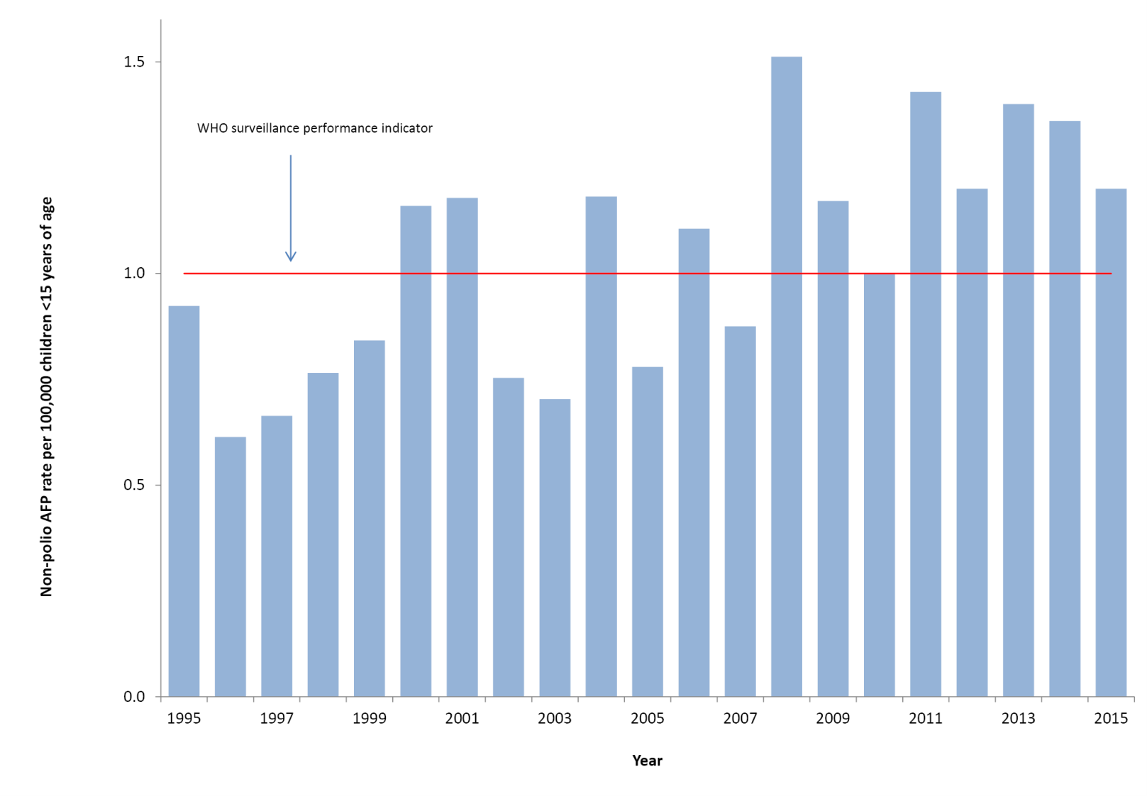
a The WHO AFP surveillance performance indicator for a polio non-endemic country is one case per 100,000 children <15 years of age, which is highlighted by the red line.
In 2015, an Australian adult was hospitalised with fever, weakness and significant back pain upon returning from Pakistan. High signal in the anterior horn cell region of the patient’s spinal cord by magnetic resonance imaging and the detection of enterovirus in a faecal specimen by the local laboratory led to the case being investigated as suspected poliomyelitis. Salmonella paratyphi was isolated from blood culture and the final diagnosis was post-infectious inflammation presenting as acute disseminated encephalomyelitis. The NERL identified the enterovirus as type A76, one of the newly described enteroviruses, which the laboratory has not detected in Australia before.

Notification of AFP cases by state and territory
In 2015, AFP cases were notified from all jurisdictions in Australia except the Australian Capital Territory (Table 1). This result may not be surprising, since the Australian Capital Territory is expected to report one case every one to two years based on the population less than 15 years of age, however, no AFP cases have been notified from this jurisdiction since 2009. The non-polio AFP rates for eligible cases by jurisdiction exceeded the WHO AFP surveillance performance indicator of one case per 100,000 children in all other states and territory except New South Wales, which was the second year in a row that Australia’s most populous state did not meet this surveillance criterion.

Faecal collection from AFP cases
A total of 73 faecal specimens from 42 of the 53 eligible cases were tested at the NERL in 2015. Fifteen AFP cases met the WHO criterion for specimen testing with two faecal specimens collected within 14 days of the onset of paralysis (Figure 2, Tables 2 and 3). The proportion of cases with at least one specimen collected within 14 days of the onset of paralysis was 75%, while 83% of cases had a specimen collected any time after the onset of paralysis. No poliovirus was detected in any of the specimens. Enterovirus A71 was isolated from one AFP case each originating from Queensland, South Australia and Western Australia, while coxsackievirus B3 was isolated from one AFP case in Western Australia.
Figure 2. Adequate faecal specimens collected from AFP cases, Australia 1995 to 2015ª
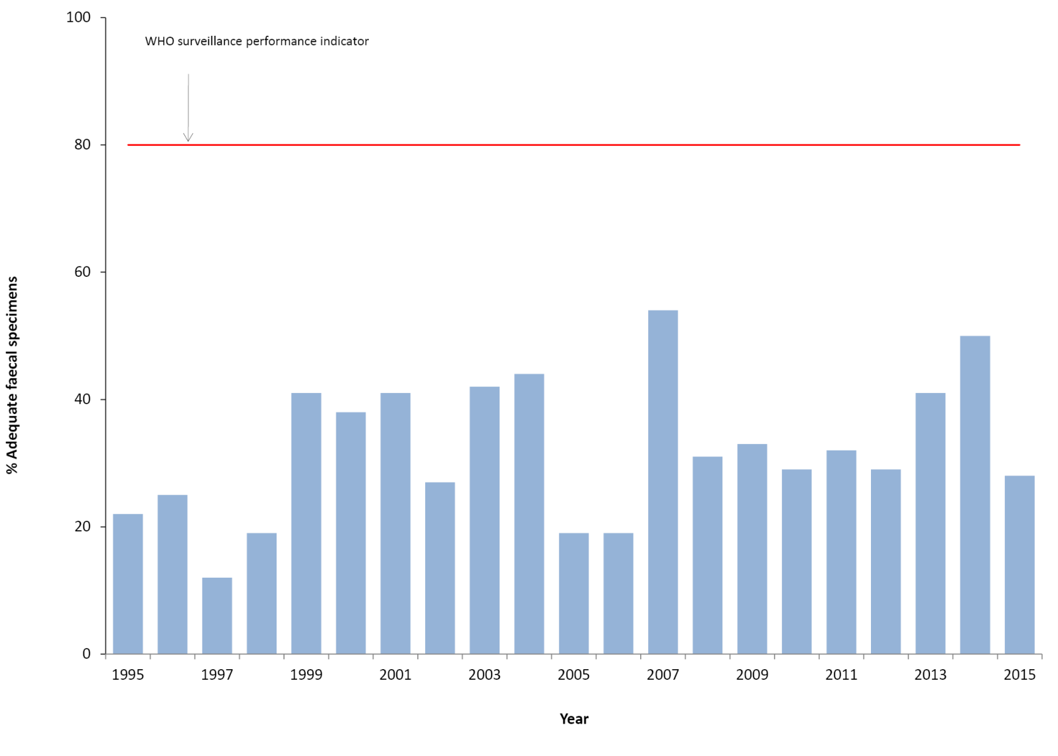
a The main WHO criterion for adequate specimen collection is two faecal specimens collected more than 24 hours apart and within 14 days of the onset of paralysis from 80% of the cases classified as non-polio AFP.

Table 3: Specimens referred to the NERL Australia, 2015
Result | Specimens from AFP cases involving children  < 15 years of age | Specimens from AFP cases involving patients  ≥ 15 years of age | Enterovirus Surveillance | Environmental Surveillance | Total
PV1SL | 0 | 0 | 10 | 0 | 10
PV2SL | 0 | 0 | 0 | 1 | 1
PV3SL | 0 | 0 | 0 | 1 | 1
Non-polio enterovirus | 5 | 3 | 112 | 26 | 146
Enterovirus | 0 | 0 | 35 | 1 | 36
Rhinovirus | 0 | 0 | 3 | 0 | 3
No enterovirus identified | 68 | 3 | 25 | 0 | 96
Total | 73 | 6 | 185 | 29 | 293

Table 4: Enterovirus test results from the NERL Australia, 1995 to 2015
Year | Poliovirus |  | Non-polio enterovirus | No enterovirus detected | EVID results referredª | Total samples reviewed
 | Sabin-like | Non-Sabin-like
1995 | 190 | 0 | 200 | 13 | 0 | 403
1996 | 224 | 0 | 198 | 9 | 0 | 431
1997 | 124 | 0 | 76 | 0 | 0 | 200
1998 | 52 | 0 | 15 | 4 | 0 | 71
1999^{b} | 60 | 1 | 9 | 9 | 0 | 79
2000 | 45 | 0 | 44 | 47 | 0 | 136
2001^{b} | 46 | 5 | 33 | 75 | 0 | 159
2002 | 36 | 0 | 21 | 49 | 0 | 106
2003 | 9 | 0 | 15 | 47 | 0 | 71
2004 | 6 | 0 | 26 | 61 | 0 | 93
2005 | 18 | 0 | 10 | 39 | 0 | 67
2006 | 2 | 0 | 6 | 71 | 29 | 108
2007^{c} | 0 | 2 | 32 | 115 | 107 | 256
2008 | 0 | 0 | 20 | 92 | 77 | 189
2009^{d} | 1 | 0 | 63 | 78 | 113 | 255
2010 | 0 | 0 | 170 | 39 | 108 | 317
2011 | 0 | 0 | 174 | 61 | 205 | 440
2012 | 0 | 0 | 155 | 97 | 123 | 375
2013e | 1 | 0 | 242 | 198 | 230 | 671
2014 | 0 | 0 | 68 | 128 | 506 | 702
2015^{f} | 12 | 0 | 185 | 96 | 168 | 461
a Enterovirus Identification (EVID) results include retrospective data made available via the ERNLA.
b Untyped enterovirus or uncharacterised poliovirus isolates were referred for further testing after completion of a laboratory inventory. The 6 isolates (one in 1999 and five in 2001) tested as non-Sabin-like and were subsequently identified as wild type poliovirus prototype strains and were destroyed.
c Wild poliovirus type 1 was imported from Pakistan.
d A Sabin-like poliovirus type 1 was identified from an unimmunised infant.
e A Sabin-like poliovirus type 2 was identified from an infant who was immunised overseas with oral polio vaccine and hospitalised with diarrhoea upon return to Australia.
f Ten archived Sabin-like poliovirus type 1 samples were identified during a laboratory clean-up. Single isolations of Sabin-like poliovirus type 2 and type 3 were identified from sewage.

Enterovirus surveillance
Putative poliovirus samples in long-term storage were referred by a laboratory and were subsequently identified as Sabin poliovirus type 1. A total of 353 NPEVs were typed by members of the Enterovirus Reference Laboratory Network of Australia from clinical specimens (Tables 3 and 4). The most common genotypes identified, in order of decreasing frequency, were coxsackievirus B5, coxsackievirus A6, echovirus 6, and echovirus 18 collectively accounting for more than half the total, while only sporadic detections of enterovirus A71 were reported.

Environmental surveillance
Twenty-nine sewage samples were collected at a sentinel site in metropolitan Melbourne from January to August 2015. Two Sabin-like polioviruses were isolated in this period: type 3 in February and type 2 in March. The type 3 Sabin-like poliovirus had one nucleotide different from the Sabin prototype sequence, indicative of a recent vaccination event, but the type 2 poliovirus had four mutations compared to prototype sequence suggestive of five months replication. NPEVs act as an indicator organism for the collection, transport and test procedures and were identified from 26 samples. Enterovirus RNA was detected in one other sample but was of insufficient amount to type, while rhinovirus was identified in another sample.

Polio regional reference laboratory activities
As part of its role as a Polio Regional Reference Laboratory, in 2015, the NERL received specimens from AFP cases referred from Brunei Darussalam (4 cases), Pacific Island countries (17 cases) and Papua New Guinea (26 cases). Sabin-like poliovirus type 3 was isolated from one AFP case from Fiji and Sabin-like poliovirus type 1 from one case from Papua New Guinea. NPEVs were reported from one AFP case from Brunei Darussalam, two cases from the Pacific Islands and 10 AFP cases from Papua New Guinea.

Quality assurance programs
In 2015, the NERL was accredited as a WHO Polio Regional Reference Laboratory through participation in the annual WHO poliovirus isolation quality assurance panel. The laboratory was accredited for quality and competence as a medical laboratory by the National Association of Testing Authorities and also successfully participated in the Royal College of Pathologists of Australasia quality assurance panel for enterovirus detection by RT-PCR.

Discussion
Australia has met the WHO non-polio AFP surveillance target for the eighth year in a row, reporting 1.2 cases per 100,000 children less than 15 years of age. The notification of AFP cases via the APSU monthly report card and the PAEDS system has routinely met the international standard that assesses whether an imported case of polio in children less than 15 years of age would be detected, although gaps in AFP surveillance were noted at the sub-national level in the Australian Capital Territory and New South Wales.^{1,2,3} Australia has never met the strict WHO surveillance target for adequate stool collection from 80% of the non-polio AFP cases, however 75% of the cases had at least one specimen collected within 14 days of the onset of paralysis. Enterovirus and environmental surveillance for poliovirus supplement the AFP surveillance program and in total provide a comprehensive surveillance system monitoring Australia’s polio-free status.
Four key points in 2015 highlight the significant progress made in the WHO polio eradication program:
- The reporting of 74 polio cases worldwide, all caused by wild poliovirus type 1, is the lowest number recorded since the goal of global polio eradication was declared in 1988;
- The declaration of Nigeria as polio-free, in September 2015, reduced the number of endemic polio countries to two (Afghanistan and Pakistan), the fewest ever recorded;
- In 2015, for the first time since at least 2000, no polio-free countries reported importations of wild polio; and
- The certification of the global eradication of wild poliovirus type 2, in September 2015, leaves serotypes 1 and 3 as the remaining targets of the eradication program.^{4,5,7}
Furthermore, wild poliovirus type 3, last detected in 2012, is likely to have been eradicated, but WHO may be circumspect in certifying this achievement as fewer than 1% of poliovirus type 3 infections present with paralysis or poliomyelitis.⁴ It is essential that sensitive surveillance systems are maintained until the global eradication of polio is declared for all three poliovirus serotypes.
Never have there been so few polio cases involving only one of the three poliovirus serotypes in so few countries. This achievement underscores the WHO Polio Endgame Eradication Strategic Plan, 2013–2018, that recommends the withdrawal of the Sabin poliovirus type 2 strain from oral polio vaccine in April 2016.²⁰ While wild poliovirus type 2 has been eradicated, outbreaks of paralytic polio caused by circulating vaccine-derived poliovirus type 2 have occurred with the virus evolving through person-to-person transmission in areas with low polio vaccine coverage that will be prevented by removal of the virus from oral polio vaccine. From April 2016, all countries will include at least one dose of trivalent inactivated polio vaccine in routine immunisation schedules as insurance to maintain immunity to poliovirus type 2.
The withdrawal of poliovirus type 2 from the oral polio vaccine means the last remaining stocks of the virus will be held by vaccine production facilities and research and diagnostic laboratories. WHO has requested all facilities to destroy any unwanted material containing type 2 poliovirus or to transfer it to a polio essential facility that complies with the strict laboratory containment regulations stipulated in the 3rd edition of the WHO Global Action Plan to minimize poliovirus facility-associated risk after type-specific eradication of wild polioviruses and sequential cessation of OPV use (GAPIII).²¹ Wild poliovirus type 2 material must have been destroyed or contained by 31 December 2015 and Sabin poliovirus type 2 material must be destroyed or contained by 31 July 2016.
At the end of 2015, the Australian government nominated the NERL to WHO as a polio essential facility for wild and OPV/Sabin poliovirus strains, which will enable the laboratory to continue to fully characterise all polioviruses detected in Australia. The detection of two Sabin poliovirus strains, including a type 2 serotype estimated to have been replicating in one or more persons for more than five months, from sewage collected in Melbourne during 2015, is a stark reminder that poliovirus importations continue to occur since Australia ceased usage of oral polio vaccine in 2005. Laboratories in Australia are recommended to refer any putative poliovirus from any source immediately to the NERL for full characterisation. The identification of Sabin poliovirus type 1 from archived laboratory samples demonstrates that not all stocks of poliovirus have been accounted for in Australia, supporting the recommendation made by the National Certification Commission for Poliomyelitis Eradication to review the laboratory containment of poliovirus.²²

Acknowledgements
The authors thank the clinicians and healthcare workers who participated in the AFP surveillance program in 2015 as well as the teams at APSU and PAEDS. The active involvement of the laboratory members of the ERLNA is gratefully acknowledged. The polio surveillance program co-ordinated by the NERL is funded by the Australian Government Department of Health, the Victorian Government Department of Health and VIDRL.

Author details
Dr Jason Roberts, Senior Medical Scientist¹
Ms Linda Hobday, Medical Scientist¹
Mrs Aishah Ibrahim, Medical Scientist¹
Mr Thomas Aitken, Administration Assistant¹
A/Prof. Bruce Thorley, Senior Medical Scientist, Laboratory Head¹
- National Enterovirus Reference Laboratory, Victorian Infectious Diseases Reference Laboratory, Doherty Institute, 792 Elizabeth St, Melbourne 3000, Victoria, Australia

Corresponding author
A/Prof. Bruce Thorley
Senior Medical Scientist, Laboratory Head, National Enterovirus Reference Laboratory, Victorian Infectious Diseases Reference Laboratory, Locked Bag 815, CARLTON SOUTH VIC 3053.
Telephone: +61 3 9342 9607.
Facsimile: +61 3 9342 9665.
Email: bruce.thorley@mh.org.au

References
- Australian Paediatric Surveillance Unit (APSU). Study Protocol, Acute Flaccid Paralysis. [Internet.] APSU, 2014. [Accessed: 1 March 2016.] Available from: http://www.apsu.org.au/assets/current-studies/AFP-Study-Protocol-June-2014.pdf
- Australian Paediatric Surveillance Unit (APSU). Paediatric Active Enhanced Disease Surveillance. [Internet.]. APSU. [Accessed: 1 March 2016.] Available from: http://www.apsu.org.au/surveillance-systems/paeds/ .
- Zurynski Y, McIntyre P, Booy R, Elliott EJ, PAEDS Investigators Group. Paediatric active enhanced disease surveillance: a new surveillance system for Australia. J Paediatr Child Health. 2013;49(7):588–94.
- World Health Organization (WHO). Wild poliovirus 2011–2016. [Internet.] WHO, 2016. [Accessed: 21 March 2016.] Available from: http://www.polioeradication.org/Portals/0/Document/Data&Monitoring/WPV_2011-2016_15MAR.pdf
- World Health Organization (WHO). WHO removes Nigeria from polio endemic list. [Internet.] WHO, 2015. [Accessed: 21 March 2016.] Available from: http://www.who.int/mediacentre/news/releases/2015/nigeria-polio/en/
- Kew OM, Cochi SL, Jafari HS, Sassilak SG, Mast EE, Diop OM et al. Possible eradication of wild poliovirus type 3 – worldwide, 2012. MMWR Morb Mortal Wkly Rep. 2014; 63(45):1031–3.
- World Health Organization (WHO). Global eradication of wild poliovirus type 2 declared. [Internet.] WHO, 2015. [Accessed: 1 March 2016.] Available from: http://www.polioeradication.org/mediaroom/newsstories/Global-eradication-of-wild-poliovirus-type-2-declared/tabid/526/news/1289/Default.aspx
- World Health Organization (WHO). Containment of polioviruses. [Internet.] WHO. [Accessed: 21 March 2016.] Available from: http://www.polioeradication.org/Posteradication/Containment.aspx
- World Health Organization (WHO). Statement on the 8th IHR Emergency Committee meeting regarding the international spread of poliovirus. [Internet.] WHO, 2016. [Accessed: 29 March 2016.] Available from: http://www.who.int/mediacentre/news/statements/2016/8th-IHR-emergency-committee-polio/en/
- World Health Organization (WHO). Circulating vaccine-derived poliovirus cases, 2000–2016. [Internet.] WHO, 2016. [Accessed: 29 March 2016.] Available from: http://www.polioeradication.org/Dataandmonitoring/Poliothisweek/Circulatingvaccinederivedpoliovirus.aspx
- Department of Health. Poliovirus infection. [Internet.] Australian Government, Department of Health, 2015. [Accessed: 29 March 2016.] Available from: http://www.health.gov.au/internet/main/publishing.nsf/Content/cda-surveil-nndss-casedefs-cd_polio.htm
- World Health Organization (WHO). Poliomyelitis. In WHO-recommended standards for surveillance of selected vaccine-preventable diseases. (WHO/V&B/03.01) Geneva: WHO, Department of Vaccines and Biologicals, 2003.
- Wood DJ, Hull B. L20B cells simplify culture of polioviruses from clinical samples. J Med Virol. 1999;58(2):188–92.
- World Health Organization (WHO). Polio Laboratory Manual, 4th edition. (WHO/IVB/04.10) Geneva: WHO, Department of Immunization, Vaccines and Biologicals, 2004.
- Kilpatrick DR, Yang CF, Ching K, Vincent A, Iber J, Campagnoli R, et al. Rapid group-, serotype-, and vaccine strain-specific identification of poliovirus isolates by real-time reverse transcription PCR using degenerate primers and probes containing deoxyinosine residues. J Clin Microbiol. 2009;47(6):1939–41.
- Stewardson AJ, Roberts JA, Beckett CL, Prime HT, Loh PS, Thorley BR et al. An imported case of poliomyelitis in Melbourne, Australia. Emerg Infect Dis. 2009;15(1):63–5.
- Roberts JA, Thorley BR. Chapter 32: Enterovirus. In Schuller M, Sloots TP, James GS, Halliday CL, Carter IWJ, eds. PCR for Clinical Microbiology: An Australian and International Perspective (1st edition.). Dordrecht: Springer, 2010.
- Nix WA, Oberste MS, Pallansch MA. Sensitive, seminested PCR amplification of VP1 sequences for direct identification of all enterovirus serotypes from original clinical specimens. J Clin Microbiol. 2006;44(8):2698–704.
- World Health Organization (WHO). Guidelines for environmental surveillance of poliovirus circulation. (WHO/V&B/03.03) Geneva: WHO, Department of Vaccines and Biologicals, 2003.
- World Health Organization (WHO). Polio eradication and endgame strategic plan 2013–2018. Geneva: WHO, 2013.
- World Health Organization (WHO). WHO Global Action Plan to minimize poliovirus facility-associated risk after type-specific eradication of wild polioviruses and sequential cessation of OPV use (GAPIII). Geneva: WHO, 2015.
- Paterson BJ, Durrheim DN. Review of Australia’s polio surveillance. Commun Dis Intell Q Rep. 2013;37(2):E149–55.
Communicable Diseases Intelligence
ISSN: 2209-6051 Online

Communicable Diseases Intelligence (CDI) is a peer-reviewed scientific journal published by the Office of Health Protection, Department of Health. The journal aims to disseminate information on the epidemiology, surveillance, prevention and control of communicable diseases of relevance to Australia.

Editor: Tanja Farmer
Deputy Editor: Simon Petrie
Design and Production: Kasra Yousefi
Editorial Advisory Board: David Durrheim, Mark Ferson, John Kaldor, Martyn Kirk and Linda Selvey

Website: http://www.health.gov.au/cdi

Contacts
Communicable Diseases Intelligence is produced by:
Health Protection Policy Branch, Office of Health Protection, Australian Government Department of Health
GPO Box 9848, (MDP 6) CANBERRA ACT 2601

Email: cdi.editor@health.gov.au

Submit an Article
You are invited to submit your next communicable disease related article to the Communicable Diseases Intelligence (CDI) for consideration. More information regarding CDI can be found at: http://health.gov.au/cdi.
Further enquiries should be directed to: cdi.editor@health.gov.au.

This journal is indexed by Index Medicus and Medline.

Creative Commons Licence - Attribution-NonCommercial-NoDerivatives CC BY-NC-ND
© 2020 Commonwealth of Australia as represented by the Department of Health
This publication is licensed under a Creative Commons Attribution-NonCommercial-NoDerivatives 4.0 International Licence from https://creativecommons.org/licenses/by-nc-nd/4.0/legalcode (Licence). You must read and understand the Licence before using any material from this publication.

Restrictions
The Licence does not cover, and there is no permission given for, use of any of the following material found in this publication (if any):
- the Commonwealth Coat of Arms (by way of information, the terms under which the Coat of Arms may be used can be found at www.itsanhonour.gov.au);
- any logos (including the Department of Health’s logo) and trademarks;
- any photographs and images;
- any signatures; and
- any material belonging to third parties.

Disclaimer
Opinions expressed in Communicable Diseases Intelligence are those of the authors and not necessarily those of the Australian Government Department of Health or the Communicable Diseases Network Australia. Data may be subject to revision.

Enquiries
Enquiries regarding any other use of this publication should be addressed to the Communication Branch, Department of Health, GPO Box 9848, Canberra ACT 2601, or via e-mail to: copyright@health.gov.au

Communicable Diseases Network Australia
Communicable Diseases Intelligence contributes to the work of the Communicable Diseases Network Australia.
http://www.health.gov.au/cdna

telephone 03-9342 9607, email enterovirus@mh.org.au
http://www.apsu.org.au/
available at http://www.who.int/wer/en/

