Australian National Enterovirus Reference Laboratory annual report, 2016
Jason A Roberts, Linda K Hobday, Aishah Ibrahim and Bruce R Thorley

Abstract
Australia monitors its polio-free status by conducting surveillance for cases of acute flaccid paralysis (AFP) in children less than 15 years of age, as recommended by the World Health Organization (WHO). Cases of AFP in children are notified to the Australian Paediatric Surveillance Unit or the Paediatric Active Enhanced Disease Surveillance System and faecal specimens are referred for virological investigation to the National Enterovirus Reference Laboratory. In 2016, no cases of poliomyelitis were reported from clinical surveillance and Australia reported 1.38 non-polio AFP cases per 100,000 children, meeting the WHO performance criterion for a sensitive surveillance system. Several non-polio enteroviruses, coxsackievirus A6, enterovirus A71, enterovirus A74 and enterovirus D68, were identified from clinical specimens collected from AFP cases. The global withdrawal of Sabin poliovirus type 2 from oral polio vaccine occurred in April 2016. This event represents the start of the polio endgame with an increased focus on the laboratory containment of all remaining wild and vaccine strains of poliovirus type 2. The National Enterovirus Reference Laboratory was designated as a polio essential facility as part of this process. In 2016, 37 cases of wild polio were reported with three countries remaining endemic: Afghanistan, Nigeria and Pakistan. Nigeria was declared polio-free in 2015, after 12 months without detection of wild poliovirus, but was reinstated as an endemic country after the reporting of four cases in August 2016. This is a salient reminder of the need to maintain sensitive surveillance for poliovirus until global eradication is certified.
Keywords: poliovirus, acute flaccid paralysis, surveillance, enterovirus, poliomyelitis, eradication, vaccination

Introduction
Australia has established clinical and virological surveillance schemes to monitor its polio-free status. The clinical surveillance follows the World Health Organization (WHO) recommendation of investigating cases of acute flaccid paralysis (AFP) in children less than 15 years of age as an age group at high risk of poliovirus infection. AFP cases are ascertained either by clinicians notifying the Australian Paediatric Surveillance Unit (APSU) via a monthly report card or through the Paediatric Active Enhanced Disease Surveillance System (PAEDS) at five sentinel tertiary paediatric hospitals.^{1,2,3} The WHO recommends that two faecal specimens be collected for virological investigation at least 24 hours apart and within 14 days of the onset of paralysis from cases of AFP to exclude poliovirus as the causative agent. It is a requirement of the WHO polio eradication program that the specimens are tested in a WHO-accredited laboratory, which for Australia is the National Enterovirus Reference Laboratory (NERL) at the Victorian Infectious Diseases Reference Laboratory (VIDRL). The clinical and laboratory data from AFP cases in children is reviewed by the Polio Expert Panel (PEP) and reported to the WHO as evidence of Australia’s continued polio-free status.
Enterovirus and environmental surveillance programs were established as virological surveillance for poliovirus to complement the clinical surveillance program focussed on AFP cases in children. Enteroviruses other than poliovirus have been associated with AFP and poliovirus infection may manifest clinically without paralysis such as meningitis. The Enterovirus Reference Laboratory Network of Australia (ERLNA) involves public diagnostic virology laboratories reporting enterovirus typing results from clinical specimens to exclude poliovirus involvement and establish the epidemiology of non-polio enteroviruses (NPEVs) in Australia. Most poliovirus infections are asymptomatic with the virus shed for weeks in the faeces of infected persons. WHO supports the testing of environmental or raw sewage samples as a means of detecting the presence of wild poliovirus in polio-free countries.
The number of wild polio cases worldwide decreased from 74 in 2015 to 37 in 2016.⁴ Afghanistan and Pakistan accounted for most of the cases, with 13 and 20 reported respectively. Nigeria was declared polio-free in September 2015, after more than 12 months with no detection of wild poliovirus, however four cases were reported in August 2016 in security-compromised areas.⁵ Only wild poliovirus serotype 1 was detected in 2016, with the last report of wild poliovirus type 3 in Nigeria in November 2012.⁶ The global eradication of wild poliovirus type 2 was certified in September 2015, with the last detection reported in India in 1999.⁷ This achievement led to the globally synchronised withdrawal of Sabin 2 poliovirus from OPV along with laboratory containment of this serotype from 2016, which involves restricted access at a limited number of facilities worldwide.⁸ The three poliovirus serotypes will remain in the inactivated polio vaccine and all countries will incorporate at least one dose of inactivated polio vaccine in the routine immunisation schedule to maintain immunity to poliovirus type 2 with the switch from trivalent OPV to bivalent OPV in April 2016.⁹
Vaccine-derived poliovirus can cause outbreaks of paralytic polio and in 2016, cases caused by circulating strains were reported in Laos, Nigeria and Pakistan.¹⁰ WHO have declared the international spread of wild poliovirus and circulating vaccine-derived poliovirus to be a Public Health Emergency of International Concern since May 2014. The situation has been assessed every three months since then and the declaration has remained in place with countries known to be exporting wild poliovirus and circulating vaccine-derived poliovirus required to ensure all residents and long-term visitors are vaccinated between four weeks and 12 months prior to international travel.¹¹
This report summarises the polio surveillance program in Australia for 2016, encompassing clinical surveillance for AFP cases in children and virological surveillance for poliovirus.

Methods

Acute flaccid paralysis surveillance
Paediatricians reviewing a patient less than 15 years of age presenting with AFP, or clinicians reviewing a patient of any age with suspected poliomyelitis, are requested to notify the NERL. Poliovirus infection, including suspected poliomyelitis, is notifiable under the Nationally Notifiable Disease Surveillance System.¹² Paediatricians notify AFP cases to the APSU via a monthly report card. Upon receipt of the notification, the AFP National Surveillance Co-ordinator based within the NERL forwards a clinical questionnaire for the clinician to complete. Alternatively, AFP cases are ascertained by PAEDS nursing staff from medical records and are enrolled in the surveillance program with parental or guardian consent.
According to the WHO surveillance criterion, two faecal specimens must be collected more than 24 hours apart due to intermittent virus shedding, and within 14 days of the onset of paralysis, while the virus titre remains high, to be classified as adequate. The faecal specimens are tested free of charge by the NERL.
The PEP, a subcommittee of the Communicable Disease Network of Australia, reviews the clinical and laboratory data for all notified cases of AFP, irrespective of whether they are an eligible or ineligible case. An eligible case is an Australian child less than 15 years of age with AFP (including Guillain-Barre syndrome and transverse myelitis) or an Australian of any age with suspected polio.
The PEP classifies cases of AFP as:
- Poliomyelitis due to wild poliovirus, vaccine-derived poliovirus (VDPV) or vaccine-associated paralytic poliomyelitis (VAPP);
- Polio-compatible if there is insufficient evidence to exclude poliomyelitis;
- Non-polio AFP or;
- Non-AFP.
The clinician is contacted if the PEP requires more information regarding the AFP case before a final classification can be made. After each PEP meeting the Australian AFP case classifications are forwarded to WHO for inclusion in the global AFP surveillance data published in the Weekly Epidemiological Record. Ineligible cases are not reported to WHO.
The WHO AFP surveillance performance indicator for a polio non-endemic country is 1 case of non-polio AFP per 100,000 children aged less than 15 years.¹³ For Australia in 2016, this equated to 45 cases, based on the Australian Bureau of Statistics data released in December 2015. An AFP surveillance scheme that satisfies the WHO surveillance performance indicator is deemed sufficiently sensitive to detect a wild poliovirus importation in children of that country. The WHO surveillance performance indicator for laboratory testing is that at least 80% of notified AFP cases have adequate faecal specimens collected and tested in a WHO-accredited laboratory.

Virus culture
Upon receipt at the NERL, faecal specimens are treated with minimum essential medium containing Earle’s salts, chloroform (9.1% v/v) and phosphate buffered saline. The suspension is clarified and the supernatant inoculated onto the two mammalian cell lines recommended by WHO for the isolation of poliovirus: L20B (a transgenic mouse epithelial cell line expressing the human poliovirus receptor, CD155) and RD-A (human rhabdomyosarcoma).^{14,15}
Two WHO real-time reverse transcription polymerase chain reaction (RT-PCR) tests are used to determine whether a poliovirus is a wild strain, oral poliomyelitis vaccine (OPV) strain (Sabin-like) or a vaccine-derived poliovirus (VDPV), in a process known as intratypic differentiation (ITD).¹⁶ The NERL sequences the complete poliovirus viral protein 1 (VP1) genomic region, which contains a major neutralising antibody binding site. The VP1 genomic sequence provides valuable biological information, including the number of mutations within a significant region of the OPV virus strain, and it enables phylogenetic analysis of wild poliovirus to rapidly determine the likely source of the virus, as utilised in the 2007 wild poliovirus importation.¹⁷

Enterovirus surveillance
The ERLNA was established primarily as a means of detecting imported poliovirus amongst untyped enteroviruses from clinical specimens. The network consists of nine public sector diagnostic virology laboratories in the Australian Capital Territory (Canberra Hospital), New South Wales (Royal Prince Alfred Hospital and the Institute of Clinical Pathology and Medical Research), Queensland (Queensland Health and Scientific Services), South Australia (SA Pathology), Tasmania (Royal Hobart Hospital), Victoria (Royal Children’s Hospital and VIDRL) and Western Australia (Queen Elizabeth II Medical Centre).
The NERL encourages members of the ERLNA to perform their own enterovirus typing. It has advised members of the ERLNA on enterovirus detection, supplied laboratory and computer analysis protocols and performed tests in parallel with other laboratories for quality assurance purposes. The NERL receives untyped enteroviruses from four laboratories for typing on a regular basis. The other laboratories perform their own enterovirus typing and report the results to the NERL for inclusion in the national enterovirus database.
The NERL screens clinical specimens for enterovirus using a semi-nested RT-PCR directed to highly conserved sequence in the 5’ non-translated region (NTR).¹⁸ Enterovirus typing is primarily performed by amplifying a fragment of the VP1 genomic region according to a published method,¹⁹ but the complete nucleotide sequence of VP1 is required to type some enteroviruses. The enterovirus typing RT-PCR is directed to a region of sequence divergence that allows differentiation between enterovirus genomes. As a consequence, the enterovirus sequence based typing assay is not as sensitive as the pan-enterovirus detection assay. This can result in an enterovirus being detected by pan-enterovirus RT-PCR in a clinical specimen without subsequent identification by the VP1 enterovirus typing assay.

Results

Classification of AFP cases
A total of 96 notifications of AFP cases involving children less than 15 years of age were received in 2016 (Table 1). The PEP classified 62 cases as non-polio AFP, a rate of 1.38 cases per 100,000 children less than 15 years of age, which exceeds the WHO AFP surveillance performance criterion for a polio-free country of one case of non-polio AFP per 100,000 children (Table 2, Figure 1). Transverse myelitis and Guillain-Barré syndrome were the most common cause of non-polio AFP in 2016, with the PEP classifying 16 cases each with these two conditions.

Table 1: Notification of acute flaccid paralysis cases, 2016 by state or territory.
State or territory | Estimated population aged <15 yearsª | Expected number of AFP cases in 2016 | Total number of notifications | Ineligible notifications | Duplicate notifications | Eligible cases with final classification by PEP^{b} | Non-polio AFP rate per 100,000 children
ACT | 73,674 | 1.0 | 0 | 0 | 0 | 0 | 0.00
NSW | 1,427,380 | 14.0 | 19 | 2 | 1 | 16 | 1.14
NT | 53,990 | 0.5 | 1 | 0 | 0 | 1 | 2.00
Qld | 944,386 | 9.5 | 31 | 1 | 16 | 14 | 1.47
SA | 298,953 | 3.0 | 8 | 0 | 1 | 7 | 2.33
Tas | 94,182 | 1.0 | 2 | 0 | 0 | 2 | 2.00
Vic | 1,085,207 | 11.0 | 31 | 3 | 10 | 18 | 1.64
WA | 497,775 | 5.0 | 4 | 0 | 0 | 4 | 0.80
Australia | 4,475,547 | 45.0 | 96 | 6 | 28 | 62 | 1.38
a Australian Bureau of Statistics, estimated population at 30 June 2015. Available at www.abs.gov.au.
b Includes one case classified as polio-compatible in Queensland.

Figure. 1. Non-polio acute flaccid paralysis rate, Australia 1995 to 2016ª
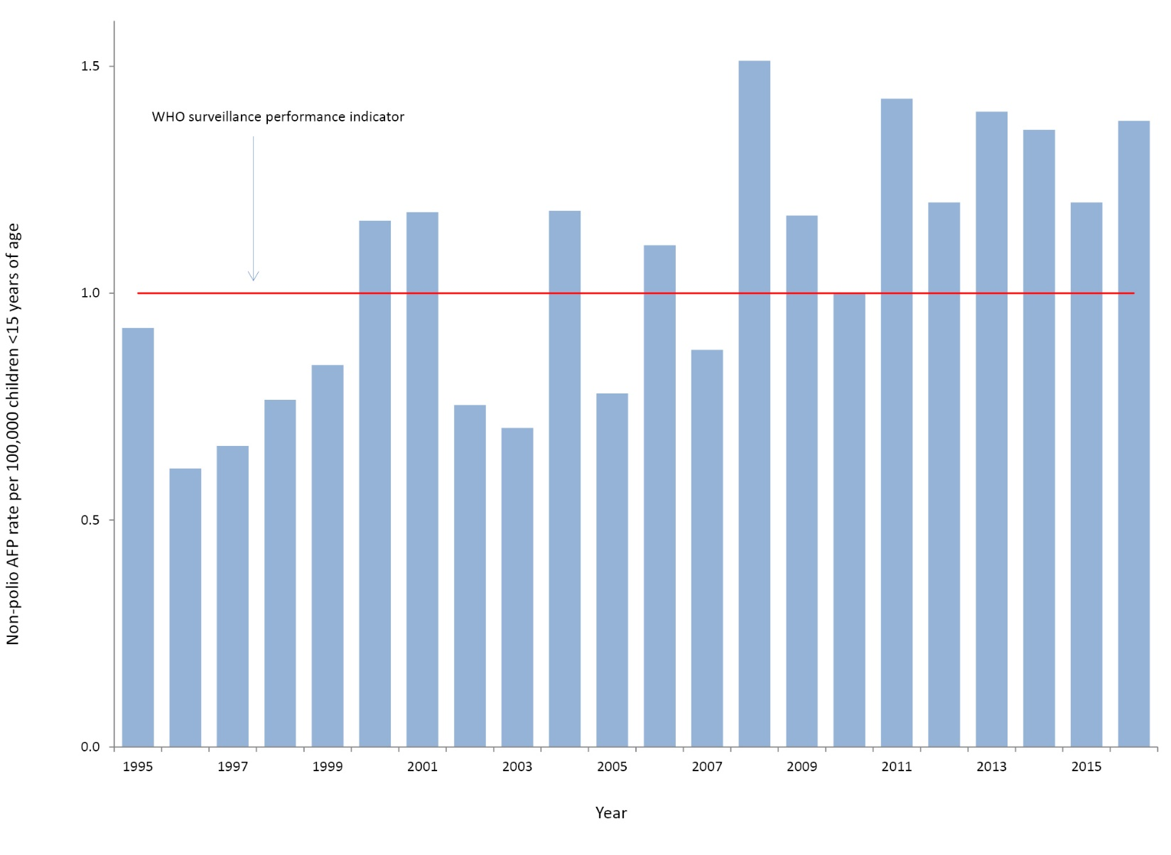
a The WHO AFP surveillance performance indicator for a polio non-endemic country is one case per 100,000 children <15 years of age, which is indicated by the red line.
Table 2: Australia’s surveillance for cases of acute flaccid paralysis, 2016, compared with the main World Health Organization performance indicators
WHO surveillance performance indicator for AFP cases in children <15 years | Performance of Australia’s AFP surveillance
≥1.0 non-polio AFP case / 100,000 children (44 cases for Australia in 2016) | 62 cases classified as non-polio AFP | 1.38 (62 / 45) non-polio AFP cases / 100,000 children <15 years
≥80% of classified AFP cases with adequate specimens (2 faecal specimens collected at least 24 hours apart and within 14 days of onset of paralysis) | 28 AFP cases with adequate specimens collected | 45% (28 / 62) classified non-polio AFP cases with adequate specimens

One of the AFP cases from Queensland was classified by the PEP as polio-compatible. While the final diagnosis was myeloradiculitis, the patient’s condition was suggestive of poliomyelitis with anterior horn cell inflammation of the spinal cord and no stool specimens were collected to confirm or exclude poliovirus infection. The case was included in the non-polio AFP data in Table 1 to be consistent with the reporting system used by WHO for Australia.
Twenty-eight cases were notified by more than one source, whether by two or more clinicians or a clinician and the PAEDS system. Six notifications were deemed to be ineligible due to the patient’s age being greater than 14 years or the clinical presentation was subsequently determined not to be AFP.

Notification of AFP cases by state and territory
In 2016, AFP cases were notified from all jurisdictions in Australia except the Australian Capital Territory (Table 1). This result may not be surprising, since the Australian Capital Territory is expected to report one case every one to two years based on the population less than 15 years of age, however, no AFP cases have been notified from this jurisdiction since 2009. The non-polio AFP rates for eligible cases by jurisdiction exceeded the WHO AFP surveillance performance indicator of one case per 100,000 children in all other states and territory except Western Australia with a non-polio AFP rate of 0.80 per 100,000 children less than 15 years of age.

Faecal collection from AFP cases
A total of 90 faecal specimens from 51 of the 62 eligible cases were tested at the NERL in 2016. Twenty-eight AFP cases met the WHO criterion for specimen testing with two faecal specimens collected within 14 days of the onset of paralysis, representing 45% of the cases classified as non-polio AFP compared to the WHO criterion of 80% of cases (Figure 2, Table 2). The proportion of cases with at least one specimen collected within 14 days of the onset of paralysis was 69%, while 73% of cases had a specimen collected any time after the onset of paralysis. No poliovirus was detected in any of the specimens. The following non-polio enteroviruses were identified from stool specimens collected from non-polio AFP cases with the jurisdiction indicated in brackets: coxsackievirus A6 (NSW), enterovirus A71 (two cases in Victoria with the onset of paralysis seven months apart), enterovirus A74 (South Australia) and enterovirus D68 (South Australia).
Figure 2. Adequate faecal specimen rate, Australia 1995 to 2016ª
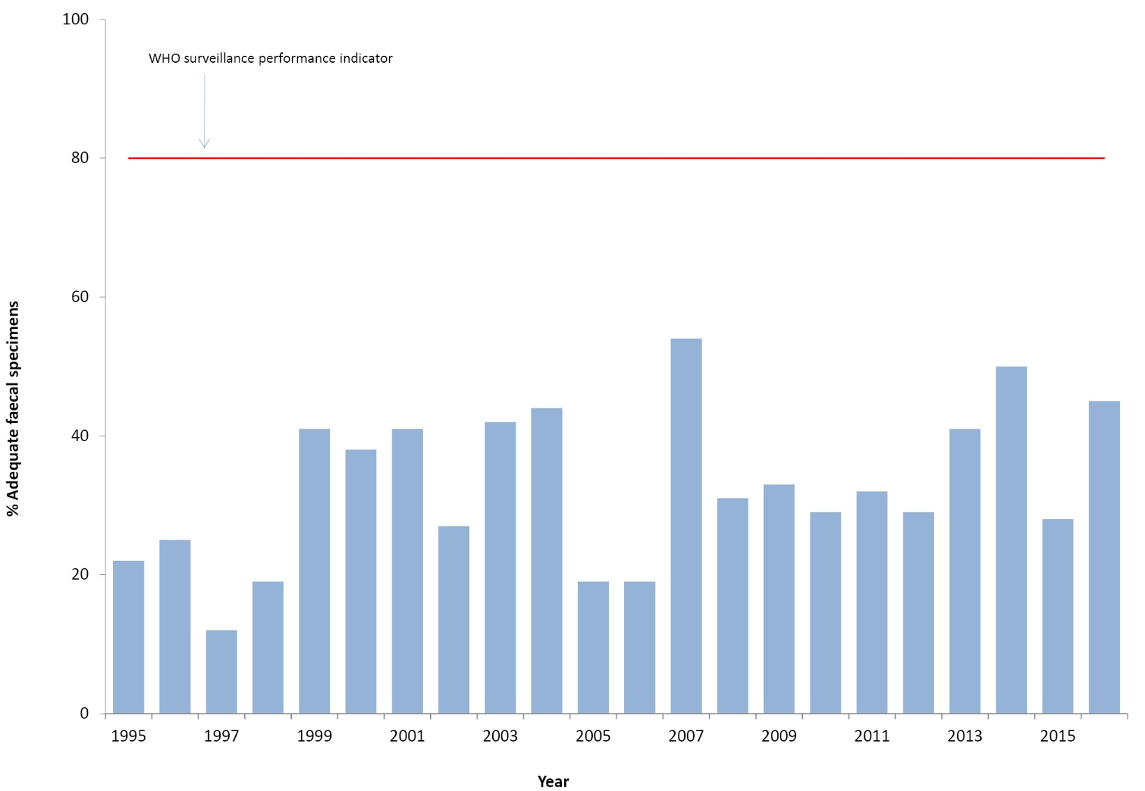
* The main WHO criterion for adequate specimen collection is two faecal specimens collected more than 24 hours apart and within 14 days of the onset of paralysis from 80% of the cases classified as non-polio AFP
Table 3: Specimens referred to the NERL Australia, 2016.
Result | Specimens from AFP cases involving children < 15 years of age | Specimens from AFP cases involving patients ≥15 years of age | Enterovirus Surveillance | Total
Non-polio enterovirus | 7 | 0 | 235 | 242
No enterovirus identified | 83 | 1 | 59 | 143
Total | 90 | 1 | 294 | 385

Table 4: Enterovirus test results from the NERL Australia, 1995 to 2016.
Year | Poliovirus |  | Non-polio enterovirus | No enterovirus detected | EVID results referredª | Total samples reviewed
 | Sabin-like | Non-Sabin-like
1995 | 190 | 0 | 200 | 13 | 0 | 403
1996 | 224 | 0 | 198 | 9 | 0 | 431
1997 | 124 | 0 | 76 | 0 | 0 | 200
1998 | 52 | 0 | 15 | 4 | 0 | 71
1999^{b} | 60 | 1 | 9 | 9 | 0 | 79
2000 | 45 | 0 | 44 | 47 | 0 | 136
2001^{b} | 46 | 5 | 33 | 75 | 0 | 159
2002 | 36 | 0 | 21 | 49 | 0 | 106
2003 | 9 | 0 | 15 | 47 | 0 | 71
2004 | 6 | 0 | 26 | 61 | 0 | 93
2005 | 18 | 0 | 10 | 39 | 0 | 67
2006 | 2 | 0 | 6 | 71 | 29 | 108
2007^{c} | 0 | 2 | 32 | 115 | 107 | 256
2008 | 0 | 0 | 20 | 92 | 77 | 189
2009^{d} | 1 | 0 | 63 | 78 | 113 | 255
2010 | 0 | 0 | 170 | 39 | 108 | 317
2011 | 0 | 0 | 174 | 61 | 205 | 440
2012 | 0 | 0 | 155 | 97 | 123 | 375
2013e | 1 | 0 | 242 | 198 | 230 | 671
2014 | 0 | 0 | 68 | 128 | 506 | 702
2015^{f} | 12 | 0 | 185 | 96 | 168 | 461
2016 | 0 | 0 | 242 | 143 | 227 | 612
a Enterovirus Identification (EVID) results include retrospective data made available via the ERNLA.
b Untyped enterovirus or uncharacterised poliovirus isolates were referred for further testing after completion of a laboratory inventory. The 6 isolates (one in 1999 and five in 2001) tested as non-Sabin-like and were subsequently identified as wild type poliovirus prototype strains and were destroyed.
c Wild poliovirus type 1 was imported from Pakistan.
d A Sabin-like poliovirus type 1 was identified from an unimmunised infant.
e A Sabin-like poliovirus type 2 was identified from an infant who was immunised overseas with oral polio vaccine and hospitalised with diarrhoea upon return to Australia.
f Ten archived Sabin-like poliovirus type 1 samples were identified during a laboratory clean-up. Single isolations of Sabin-like poliovirus type 2 and type 3 were identified from sewage.

Enterovirus surveillance
A total of 235 NPEVs were typed by the NERL and an additional 227 by members of the Enterovirus Reference Laboratory Network of Australia from clinical specimens (Tables 3 and 4). No polioviruses were reported amongst the enterovirus typings. The most common genotypes of NPEV identified by the laboratory network, in order of decreasing frequency, were echovirus 18, coxsackievirus A6, echovirus 6 and coxsackievirus B4.

Polio regional reference laboratory activities
As part of its role as a Polio Regional Reference Laboratory, in 2016, the NERL received specimens from AFP cases referred from Brunei Darussalam (1 case), Pacific Island countries (15 cases) and Papua New Guinea (27 cases). Sabin-like poliovirus type 3 was isolated from one AFP case from Papua New Guinea, which was likely to have been associated with a recent vaccination event. NPEVs were reported from seven AFP cases from the Pacific Islands and 11 cases from Papua New Guinea.

Quality assurance programs
In 2016, the NERL was accredited as a WHO Polio Regional Reference Laboratory through participation in the annual WHO quality assurance panels for poliovirus isolation, intratypic differentiation and sequencing. The laboratory also successfully participated in the Royal College of Pathologists of Australasia quality assurance panel for enterovirus detection by RT-PCR.

Discussion
Australia has met the WHO non-polio AFP surveillance target for the ninth year in a row, reporting 1.38 cases per 100,000 children less than 15 years of age. The notification of AFP cases via the APSU monthly report card and the PAEDS system has routinely met the international standard that assesses whether an imported case of polio in children less than 15 years of age would be detected, although gaps in AFP surveillance were noted at the sub-national level in the Australian Capital Territory and Western Australia, based on the WHO surveillance target.^{1,2,3,13} An investigation of AFP case reporting at the SA4 level, the largest substate region, from 2001 to 2015, was initiated by the National Certification Commission for Poliomyelitis Eradication in 2016 (in press). The study found 9% of regions underreported AFP cases compared to the WHO surveillance target and may be at risk of not detecting an imported case of poliomyelitis. On the other hand, a number of subnational regions reported a higher number of cases than expected but were not likely to have been associated with an unidentified enterovirus cluster based on the available evidence, notwithstanding that stool specimens were not collected from more than half the cases.
Australia has never met the strict WHO surveillance target for adequate stool collection from 80% of the non-polio AFP cases; however 69% of the cases had at least one specimen collected within 14 days of the onset of paralysis. Enterovirus surveillance acts as a supplement to the AFP surveillance program in Australia, providing an additional means of monitoring Australia’s polio-free status. In 2015, the WHO Regional Office for Europe released Enterovirus surveillance guidelines, which covered the rationale and characteristics of an ideal enterovirus surveillance system in support of the polio eradication initiative.²⁰ The guidelines included the protocol for the semi-nested RT-PCR amplification of enterovirus RNA that is the basis of the NERL’s enterovirus typing procedure.
The worldwide removal of the Sabin poliovirus type 2 strain from the oral polio vaccine, in April 2016, was a historic event in vaccinology and public health.⁹ This event was based on the certification of wild poliovirus type 2 eradication in 2015 and the need to stop outbreaks of circulating vaccine-derived poliovirus type 2 from occurring in areas with low polio vaccine coverage. The switch from trivalent to bivalent oral polio vaccine, containing Sabin poliovirus types 1 and 3 strains, is the start of the polio endgame with a focus on the laboratory containment of poliovirus stocks and poliovirus potentially infectious material.⁸ The initial phase involved the destruction of wild and vaccine strains of poliovirus type 2 or transfer to a designated polio essential facility, such as the NERL.
The detection of Sabin poliovirus type 2 in sewage in India in August–September 2016 led to a major public health investigation that identified the source as a number of private clinics continuing to administer trivalent oral polio vaccine after the global cessation date.²¹ This demonstrated the importance of polio containment surveys, such as was completed in Australia for wild poliovirus strains in 2002, and also the sensitivity of environmental surveillance to detect all types of poliovirus.^{22,23} The number of sewage collection sites has increased in polio-endemic countries and WHO plans to expand environmental surveillance in polio-free countries and especially those at high risk of polio importation. The NERL previously tested sewage collected in regional New South Wales and metropolitan Melbourne between 2010 and 2015 and will resume regular environmental testing in 2017.
Nigeria was declared polio-free in September 2015, after 12 months without detection of any wild poliovirus. The subsequent reporting of four polio cases in Nigeria due to indigenous (not imported) wild poliovirus type 1 in August 2016 was a setback but also a significant reminder of the need to maintain sensitive AFP surveillance and stool specimen collection.⁵ Nevertheless the reporting of 37 cases of wild poliomyelitis, all due to type 1, in Afghanistan, Nigeria and Pakistan represents the lowest number of polio cases reported since the eradication initiative commenced in 1988. In 2016, WHO maintained the declaration that the international spread of poliovirus continued to be a public health emergency of international concern and placed public health conditions on the countries involved to limit the global transmission of wild poliovirus and vaccine-derived poliovirus.¹¹

Acknowledgements
The authors thank the clinicians and healthcare workers who participated in the AFP surveillance program in 2016 as well as the teams at APSU and PAEDS. The active involvement of the laboratory members of the ERLNA is gratefully acknowledged. The poliovirus surveillance program co-ordinated by the NERL is funded by the Australian Government Department of Health, the Victorian government Department of Health and VIDRL.

Author details
Dr Jason Roberts, Senior Medical Scientist¹
Ms Linda Hobday, Medical Scientist, National AFP Surveillance Coordinator¹
Mrs Aishah Ibrahim, Medical Scientist¹
A/Prof. Bruce Thorley, Senior Medical Scientist, Laboratory Head¹
- National Enterovirus Reference Laboratory, Victorian Infectious Diseases Reference Laboratory, Doherty Institute, 792 Elizabeth St, Melbourne 3000, Victoria, Australia

Corresponding author
A/Prof. Bruce Thorley
Senior Medical Scientist, Laboratory Head, National Enterovirus Reference Laboratory, Victorian Infectious Diseases Reference Laboratory, Locked Bag 815, CARLTON SOUTH VIC 3053.
Telephone: +61 3 9342 9607.
Facsimile: +61 3 9342 9665.
Email: bruce.thorley@mh.org.au

References
- Australian Paediatric Surveillance Unit (APSU). Study Protocol, Acute Flaccid Paralysis. [Internet.] APSU, 2014. [Accessed: 13 March 2017.] Available from: http://www.apsu.org.au/assets/current-studies/AFP-Study-Protocol-June-2014.pdf
- Australian Paediatric Surveillance Unit (APSU). Paediatric Active Enhanced Disease Surveillance. [Internet.]. APSU. [Accessed: 1 March 2016.] Available from: http://www.apsu.org.au/surveillance-systems/paeds/.
- Zurynski Y, McIntyre P, Booy R, Elliott EJ, PAEDS Investigators Group. Paediatric active enhanced disease surveillance: a new surveillance system for Australia. J Paediatr Child Health. 2013;49(7):588–94.
- World Health Organization (WHO). Wild poliovirus 2012–2017. [Internet.] WHO, 2017. [ Accessed: 20 March 2017.] Available from: http://polioeradication.org/wp-content/uploads/2017/03/WPV_2012-2017_14Mar17.pdf
- World Health Organization. Continued endemic wild poliovirus transmission in security-compromised areas—Nigeria 2016. Wkly Epidemiol Rec. 2017; 92(8): 89–96.
- Kew OM, Cochi SL, Jafari HS, Sassilak SG, Mast EE, Diop OM et al. Possible eradication of wild poliovirus type 3 – worldwide, 2012. MMWR Morb Mortal Wkly Rep. 2014; 63(45):1031–3.
- World Health Organization (WHO). Global eradication of wild poliovirus type 2 declared. [Internet.] WHO, 2015. [Accessed: 20 March 2017.] Available from: http://www.polioeradication.org/mediaroom/newsstories/Global-eradication-of-wild-poliovirus-type-2-declared/tabid/526/news/1289/Default.aspx
- World Health Organization (WHO). Key points about containment. Why the world needs to contain the poliovirus. [Internet.] WHO. [Accessed: 07 April 2017.] Available from: http://polioeradication.org/polio-today/preparing-for-a-polio-free-world/containment/key-points/
- Hampton LM, Farrell M, Ramirez-Gonzalez A, Menning L, Shendale S, Lewis I et al. Cessation of trivalent oral poliovirus vaccine and introduction of inactivated poliovirus vaccine — worldwide, 2016. MMWR Morb Mortal Wkly Rep. 2016;65(35):934–8.
- World Health Organization (WHO). Circulating vaccine-derived poliovirus. [Internet.] WHO. [Accessed: 07 April 2017.] Available from: http://polioeradication.org/polio-today/polio-now/this-week/circulating-vaccine-derived-poliovirus/
- World Health Organization (WHO). Twelfth meeting of the Emergency Committee under the International Health Regulations (2015) regarding the international spread of poliovirus. [Internet.] WHO, 2017. [Accessed: 07 April 2017.] Available from: http://www.who.int/mediacentre/news/statements/2017/poliovirus-twelfth-ec/en/
- Department of Health. Poliovirus infection. [Internet.] Australian Government, Department of Health, 2015. [Accessed: 20 March 2017.] Available from: http://www.health.gov.au/internet/main/publishing.nsf/Content/cda-surveil-nndss-casedefs-cd_polio.htm
- World Health Organization (WHO). Poliomyelitis. In WHO-recommended standards for surveillance of selected vaccine-preventable diseases. (WHO/V&B/03.01) Geneva: WHO, Department of Vaccines and Biologicals, 2003.
- Wood DJ, Hull B. L20B cells simplify culture of polioviruses from clinical samples. J Med Virol. 1999;58(2):188–92.
- World Health Organization (WHO). Polio Laboratory Manual, 4th edition. (WHO/IVB/04.10) Geneva: WHO, Department of Immunization, Vaccines and Biologicals, 2004.
- Kilpatrick DR, Yang CF, Ching K, Vincent A, Iber J, Campagnoli R, et al. Rapid group-, serotype-, and vaccine strain-specific identification of poliovirus isolates by real-time reverse transcription PCR using degenerate primers and probes containing deoxyinosine residues. J Clin Microbiol. 2009;47(6):1939–41.
- Stewardson AJ, Roberts JA, Beckett CL, Prime HT, Loh PS, Thorley BR et al. An imported case of poliomyelitis in Melbourne, Australia. Emerg Infect Dis. 2009;15(1):63–5.
- Roberts JA, Thorley BR. Chapter 32: Enterovirus. In Schuller M, Sloots TP, James GS, Halliday CL, Carter IWJ, eds. PCR for Clinical Microbiology: An Australian and International Perspective (1st edition.). Dordrecht: Springer, 2010.
- Nix WA, Oberste MS, Pallansch MA. Sensitive, seminested PCR amplification of VP1 sequences for direct identification of all enterovirus serotypes from original clinical specimens. J Clin Microbiol. 2006;44(8):2698–704.
- World Health Organization (WHO). Enterovirus surveillance guidelines; guidelines for enterovirus surveillance in support of the polio eradication initiative. Denmark: The Regional Office for Europe of the World Health Organization, 2015.
- World Health Organization. Detection of Sabin-like type 2 poliovirus after global cessation of trivalent oral poliovirus vaccine in Hyderabad and Ahmedabad, India, August–September 2016. Wkly Epidemiol Rec. 2017; 92(1): 9-11.
- D’Souza RM, Kennsett M, Watson C. Australia declared polio free. Commun Dis Intell Q Rep. 2002;26(2):253–60.
- Maes EF, Diop OM, Jorba J, Chavan S, Tangermann RH, Wassilak SG. Surveillance Systems to Track Progress Toward Polio Eradication — Worldwide, 2015–2016. MMWR Morb Mortal Wkly Rep. 2017;66(13):359–65.

Communicable Diseases Intelligence
ISSN: 2209-6051 Online

Communicable Diseases Intelligence (CDI) is a peer-reviewed scientific journal published by the Office of Health Protection, Department of Health. The journal aims to disseminate information on the epidemiology, surveillance, prevention and control of communicable diseases of relevance to Australia.

Editor: Tanja Farmer
Deputy Editor: Simon Petrie
Design and Production: Kasra Yousefi
Editorial Advisory Board: David Durrheim, Mark Ferson, John Kaldor, Martyn Kirk and Linda Selvey

Website: http://www.health.gov.au/cdi

Contacts
Communicable Diseases Intelligence is produced by:
Health Protection Policy Branch, Office of Health Protection, Australian Government Department of Health
GPO Box 9848, (MDP 6) CANBERRA ACT 2601

Email: cdi.editor@health.gov.au

Submit an Article
You are invited to submit your next communicable disease related article to the Communicable Diseases Intelligence (CDI) for consideration. More information regarding CDI can be found at: http://health.gov.au/cdi.
Further enquiries should be directed to: cdi.editor@health.gov.au.

This journal is indexed by Index Medicus and Medline.

Creative Commons Licence - Attribution-NonCommercial-NoDerivatives CC BY-NC-ND
© 2020 Commonwealth of Australia as represented by the Department of Health
This publication is licensed under a Creative Commons Attribution-NonCommercial-NoDerivatives 4.0 International Licence from https://creativecommons.org/licenses/by-nc-nd/4.0/legalcode (Licence). You must read and understand the Licence before using any material from this publication.

Restrictions
The Licence does not cover, and there is no permission given for, use of any of the following material found in this publication (if any):
- the Commonwealth Coat of Arms (by way of information, the terms under which the Coat of Arms may be used can be found at www.itsanhonour.gov.au);
- any logos (including the Department of Health’s logo) and trademarks;
- any photographs and images;
- any signatures; and
- any material belonging to third parties.

Disclaimer
Opinions expressed in Communicable Diseases Intelligence are those of the authors and not necessarily those of the Australian Government Department of Health or the Communicable Diseases Network Australia. Data may be subject to revision.

Enquiries
Enquiries regarding any other use of this publication should be addressed to the Communication Branch, Department of Health, GPO Box 9848, Canberra ACT 2601, or via e-mail to: copyright@health.gov.au

Communicable Diseases Network Australia
Communicable Diseases Intelligence contributes to the work of the Communicable Diseases Network Australia.
http://www.health.gov.au/cdna

telephone 03-9342 9607, email enterovirus@mh.org.au
http://www.apsu.org.au/
available at http://www.who.int/wer/en/

