Australian National Enterovirus Reference Laboratory annual report, 2018
Jason A Roberts, Linda K Hobday, Aishah Ibrahim and Bruce R Thorley

Abstract
Australia monitors its polio-free status by conducting surveillance for cases of AFP in children less than 15 years of age, as recommended by the WHO. Cases of AFP in children are notified to the Australian Paediatric Surveillance Unit or the Paediatric Active Enhanced Disease Surveillance System and faecal specimens are referred for virological investigation to the National Enterovirus Reference Laboratory. In 2018, no cases of poliomyelitis were reported from clinical surveillance and Australia reported 1.24 non-polio AFP cases per 100,000 children, meeting the WHO performance criterion for a sensitive surveillance system. Several non-polio enteroviruses, coxsackievirus A4, coxsackievirus B1, echovirus 9, echovirus 30, enterovirus D68 and enterovirus A71, were identified from clinical specimens collected from AFP cases. Australia also performs enterovirus and environmental surveillance to complement the clinical system focussed on children. In 2018, 33 cases of wild polio were reported with three countries remaining endemic: Afghanistan, Nigeria and Pakistan.
Keywords: poliovirus, acute flaccid paralysis, surveillance, enterovirus, poliomyelitis, eradication, vaccination

Introduction
Australia has established clinical and virological surveillance schemes to monitor its polio-free status. The clinical surveillance follows the World Health Organization (WHO) recommendation of investigating cases of acute flaccid paralysis (AFP) in children less than 15 years of age due to a higher risk of poliovirus infection. AFP cases are ascertained either by clinicians notifying the Australian Paediatric Surveillance Unit (APSU) via a monthly report card or through the Paediatric Active Enhanced Disease Surveillance System (PAEDS) at seven sentinel tertiary paediatric hospitals.^{1,2} The WHO recommends that two faecal specimens be collected for virological investigation at least 24 hours apart and within 14 days of the onset of paralysis from cases of AFP to exclude poliovirus as the causative agent. It is a requirement of the WHO polio eradication program that the specimens are tested in a WHO-accredited laboratory, which for Australia is the National Enterovirus Reference Laboratory (NERL) at the Victorian Infectious Diseases Reference Laboratory (VIDRL), at the Peter Doherty Institute for Infection and Immunity. The clinical and laboratory data from AFP cases in children is reviewed by the Polio Expert Panel (PEP) and reported to the WHO as evidence of Australia’s continued polio-free status.
Enterovirus and environmental surveillance programs were established as virological surveillance for poliovirus to complement the clinical surveillance program focussed on AFP cases in children. Non-polio enteroviruses, such as enterovirus A71 and enterovirus D68, have been associated with AFP with an increased interest in the latter after reports of a possible association with acute flaccid myelitis since 2010.^{3,4} Non-paralytic poliovirus infection may manifest clinically from a mild febrile illness to meningitis or meningoencephalitis. The Enterovirus Reference Laboratory Network of Australia (ERLNA) involves public diagnostic virology laboratories reporting enterovirus typing results from clinical specimens to exclude poliovirus involvement and establish the epidemiology of non-polio enteroviruses (NPEVs) in Australia. Most poliovirus infections are asymptomatic with the virus shed for weeks in the faeces of infected persons. WHO supports the testing of environmental samples, such as raw sewage and river water, as a means of detecting the presence of wild poliovirus in polio-free countries.
The number of wild polio cases worldwide increased slightly from 22 in 2017 to 33 in 2018 with Afghanistan and Pakistan accounting for all cases: 21 and 12, respectively.⁵ While Nigeria has not reported wild polio cases since August 2016, the country has not been declared polio-free due to inadequate surveillance in inaccessible regions with ongoing security issues.⁶ Globally, only wild poliovirus serotype 1 was detected in 2018, with the last report of wild poliovirus type 3 in Nigeria in November 2012.⁵ The global eradication of wild poliovirus type 2 was certified in September 2015, with the last detection reported in India in 1999.⁷ No importation of wild poliovirus from endemic countries has been reported worldwide since 2014, an indication of wild poliovirus transmission being restricted to the last remaining reservoirs.
In 2018, outbreaks of paralytic polio caused by circulating vaccine-derived poliovirus were reported in the Democratic Republic of Congo, Indonesia, Mozambique, Niger, Nigeria, Papua New Guinea, and Somalia.^{8,9,10} WHO have declared the international spread of wild poliovirus and circulating vaccine-derived poliovirus to be a Public Health Emergency of International Concern since May 2014. The situation has been assessed every three months since then and the declaration has remained in place with countries known to be exporting wild poliovirus and circulating vaccine-derived poliovirus required to ensure all residents and long-term visitors are vaccinated between four weeks and 12 months prior to international travel.¹¹
This report summarises the polio surveillance program in Australia for 2018, encompassing clinical surveillance for AFP cases in children and virological surveillance for poliovirus.

Methods

Acute flaccid paralysis surveillance
Paediatricians reviewing a patient less than 15 years of age presenting with AFP, or clinicians reviewing a patient of any age with suspected poliomyelitis, are requested to notify the NERL. Poliovirus infection, including suspected poliomyelitis, is notifiable under the Nationally Notifiable Disease Surveillance System.¹² Paediatricians notify AFP cases to the APSU via a monthly report card. Upon receipt of the notification, the AFP National Surveillance Co-ordinator based within the NERL forwards a clinical questionnaire for the clinician to complete. Alternatively, AFP cases are ascertained by PAEDS nursing staff from medical records and are enrolled in the surveillance program with parental or guardian consent.
According to the WHO surveillance criterion two faecal specimens must be collected more than 24 hours apart due to intermittent virus shedding, and within 14 days of the onset of paralysis, while the virus titre remains high, to be classified as adequate. The faecal specimens are tested free of charge by the NERL.
The PEP, a subcommittee of the Communicable Disease Network of Australia, reviews the clinical and laboratory data for all notified cases of AFP, irrespective of whether they are an eligible or ineligible case. An eligible case is an Australian child less than 15 years of age with AFP (including Guillain-Barré syndrome and transverse myelitis) or an Australian of any age with suspected polio.

The PEP classifies cases of AFP as:
- Poliomyelitis due to wild poliovirus, vaccine-derived poliovirus (VDPV) or vaccine-associated paralytic poliomyelitis (VAPP);
- Polio-compatible if there is insufficient evidence to exclude poliomyelitis;
- Non-polio AFP or;
- Non-AFP.
The clinician is contacted if the PEP requires more information regarding the AFP case before a final classification can be made. After each PEP meeting the Australian AFP case classifications are forwarded to WHO for inclusion in the global AFP surveillance data published in the Weekly Epidemiological Record. Ineligible cases are not reported to WHO.
The WHO AFP surveillance performance indicator for a polio non-endemic country is 1 case of non-polio AFP per 100,000 children aged less than 15 years.¹³ For Australia in 2018, this equated to 46 cases, based on the Australian Bureau of Statistics data released in December 2017. An AFP surveillance scheme that satisfies the WHO surveillance performance indicator is deemed sufficiently sensitive to detect a wild poliovirus importation in children of that country. The WHO surveillance performance indicator for laboratory testing is that at least 80% of notified AFP cases have adequate faecal specimens collected and tested in a WHO-accredited laboratory.

Virus culture
Upon receipt at the NERL, faecal specimens are treated with minimum essential medium containing Earle’s salts and extracted with chloroform, which enteroviruses are resistant to, for removal of bacteria and fungi. The suspension is clarified via centrifugation and the supernatant inoculated onto the two mammalian cell lines recommended by WHO for the isolation of poliovirus: L20B (a transgenic mouse epithelial cell line expressing the human poliovirus receptor, CD155) and RD-A (human rhabdomyosarcoma).^{14,15}
Two WHO real-time reverse transcription polymerase chain reaction (RT-PCR) tests are used to determine whether a poliovirus is a wild strain, oral poliomyelitis vaccine (OPV) strain (Sabin-like) or a vaccine-derived poliovirus (VDPV), in a process known as intratypic differentiation (ITD).¹⁶ The NERL sequences the complete poliovirus viral protein 1 (VP1) genomic region, which contains a major neutralising antibody binding site. The VP1 genomic sequence provides valuable biological information, including the number of mutations within a significant region of the OPV virus strain, and it enables phylogenetic analysis of wild poliovirus to rapidly determine the likely source of the virus, as utilised in the 2007 wild poliovirus importation.¹⁷

Environmental surveillance
Environmental samples are processed by the NERL according to the two-phase separation procedure published by WHO.¹⁸ In brief, 800 ml of sewage is collected as a grab sample prior to any biological or chemical treatment and referred to the NERL within 24 hours. At the laboratory 500 ml of the sample is vigorously shaken at 4 ºC with dextran, polyethylene glycol and sodium chloride. The mixture is incubated overnight at 4 ºC in a separating funnel and the lower organic phase collected the next day and clarified using chloroform treatment and centrifugation. The sample extract is inoculated onto the L20B and RD-A cell lines and observed microscopically for cytopathic effect as for faecal specimens. All enterovirus isolates from cell culture are typed by nucleic acid sequencing as described in the Methods section for enterovirus surveillance.

Enterovirus surveillance
The ERLNA was established primarily as a means of detecting imported poliovirus amongst untyped enteroviruses from clinical specimens. The network consists of nine public sector diagnostic virology laboratories in the Australian Capital Territory (Canberra Hospital), New South Wales (Royal Prince Alfred Hospital and the Institute of Clinical Pathology and Medical Research), Queensland (Queensland Health and Scientific Services), South Australia (SA Pathology), Tasmania (Royal Hobart Hospital), Victoria (Royal Children’s Hospital and VIDRL) and Western Australia (Queen Elizabeth II Medical Centre).
The NERL encourages members of the ERLNA to perform their own enterovirus typing. It has advised members of the ERLNA on enterovirus detection, supplied laboratory and computer analysis protocols and performed tests in parallel with other laboratories for quality assurance purposes. The NERL receives untyped enteroviruses from four laboratories for typing on a regular basis. The other laboratories perform their own enterovirus typing and report the results to the NERL for inclusion in the national enterovirus database.
The NERL screens clinical specimens for enterovirus using a real-time RT-PCR directed to highly conserved sequence in the 5’ untranslated region (UTR).¹⁹ Enterovirus typing is primarily performed using an in-house nested RT-PCR assay, the first round of the assay amplifies the entire capsid-encoding region of the virus and the second round targets a fragment of the VP3/VP1 genomic region. If the typing assay does not amplify a suitable fragment for sequencing and serotype determination, a second semi-nested RT-PCR assay targeting the 5’UTR is employed to determine the enterovirus species and may exclude poliovirus. PCR products are sequenced using Illumina MiSeq next-generation sequencing when full genome or complete capsid sequences are required or if virus mixtures were detected by Sanger sequencing methodology.

Results

Classification of AFP cases
A total of 86 notifications of AFP cases were received in 2018 (Table 1). The PEP classified 57 cases as non-polio AFP, a rate of 1.24 cases per 100,000 children less than 15 years of age, which exceeds the WHO AFP surveillance performance criterion for a polio-free country of one case of non-polio AFP per 100,000 children (Table 2, Figure 1). Guillain-Barré syndrome and transverse myelitis were the most common cause of non-polio AFP in 2018, with the PEP classifying 21 and 11 cases, respectively, with these two conditions.

Table 1: Notification of acute flaccid paralysis cases, 2018 by state and territory.
State or territory | Estimated population aged <15 yearsª | Expected number of AFP cases in 2018 | Total number of notifications | Ineligible notifications | Duplicate notifications | Eligible cases with final classification by PEP^{b} | Non-polio AFP rate per 100,000 children
ACT | 78,249 | 1.0 | 0 | 0 | 0 | 0 | 0.00
NSW | 1,464,826 | 14.5 | 10 | 0 | 1 | 9 | 0.62
NT | 53,749 | 0.5 | 5 | 0 | 2 | 3 | 6.0
Qld | 966,725 | 9.5 | 14 | 1 | 3 | 10 | 1.05
SA | 305,587 | 3.0 | 3 | 0 | 0 | 3 | 1.00
Tas | 93,486 | 1.0 | 1 | 1 | 0 | 0 | 0.00
Vic | 1,166,390 | 11.5 | 45 | 5 | 16 | 24 | 2.09
WA | 502,207 | 5.0 | 8 | 0 | 0 | 8 | 1.60
Australia | 4,631,219 | 46.0 | 86 | 7 | 22 | 57 | 1.24
a Australian Bureau of Statistics, estimated population at 30 June 2017. Available at www.abs.gov.au.
b Includes two cases classified as polio-compatible in New South Wales and South Australia and one case as polio-compatible — zero evidence in New South Wale
Table 2: Australia’s surveillance for cases of acute flaccid paralysis, 2018, compared with the main World Health Organization performance indicators.
WHO surveillance performance indicator for AFP cases in children <15 years | Performance of Australia’s AFP surveillance
≥1.0 non-polio AFP case / 100,000 children (45 cases for Australia in 2018) | 57 cases classified as non-polio AFP | 1.24 (57 / 46) non-polio AFP cases / 100,000 children <15 years
≥80% of classified AFP cases with adequate specimens (2 faecal specimens collected at least 24 hours apart and within 14 days of onset of paralysis | 25 AFP cases with adequate specimens collected | 44% (25 / 57) classified non-polio AFP cases with adequate specimens

Figure 1. Non-polio acute flaccid paralysis rate, Australia 1995 to 2018ª
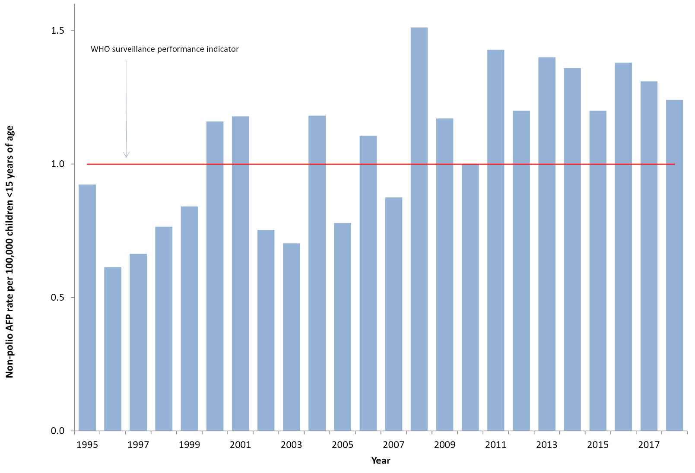
a The WHO AFP surveillance performance indicator for a polio non-endemic country is one case per 100,000 children <15 years of age, which is highlighted by the red line.
One AFP case from New South Wales and one from a resident of South Australia were classified by the PEP as polio-compatible with a signal detected by magnetic resonance imaging in the anterior horn cells of their spines; however, stool specimens were not referred to the NERL to confirm or exclude poliovirus infection. While both patients were reported to be immunised against polio, the symptoms were suggestive of enterovirus infection but this was not confirmed by testing performed at the local hospital laboratory. A third AFP case from New South Wales was notified but no further clinical information was provided by the clinician and it was classified according to the WHO scheme as polio-compatible—zero evidence to indicate the only information available was the initial notification. The three cases were included in the non-polio AFP data in Table 1, to be consistent with the reporting system used by WHO for Australia.
Twenty-two cases were notified by more than one source, whether by two or more clinicians through the APSU or a clinician and the PAEDS system. Seven notifications were deemed to be ineligible due to the patient’s age being greater than 14 years or the clinical presentation was subsequently determined not to be AFP.

Notification of AFP cases by state and territory
In 2018, AFP cases were notified from all jurisdictions in Australia except the Australian Capital Territory (Table 1). The non-polio AFP rates for eligible cases exceeded the WHO AFP surveillance performance indicator of one case per 100,000 children less than 15 years of age in half the states and territories with the Australian Capital Territory, New South Wales, and Tasmania not reaching the target and Victoria reporting 42% of the cases while having 25% of the target population.

Faecal collection from AFP cases
A total of 82 faecal specimens from 42 of the 57 eligible cases were tested at the NERL in 2018. Specimens collected from 25 of the AFP cases classified as non-polio AFP were considered adequate according to the WHO criterion of two faecal specimens collected within 14 days of the onset of paralysis, representing 44% of the classified cases compared to the WHO criterion of 80% (Figure 2, Table 2). The proportion of cases with at least one specimen collected within 14 days of the onset of paralysis was 65%, while 74% of cases had a specimen collected any time after the onset of paralysis. No poliovirus was detected in any of the specimens. The following non-polio enteroviruses were identified from stool specimens collected from eight non-polio AFP cases with the jurisdiction specified in brackets: coxsackievirus A4 (Victoria), coxsackievirus B1 (Victoria), echovirus 9 (New South Wales), echovirus 30 (Victoria), enterovirus A71 (Victoria) and enterovirus D68 (three separate cases in New South Wales, Queensland and South Australia).

Figure 2. Adequate faecal specimen collection rate, Australia 1995 to 2018ª
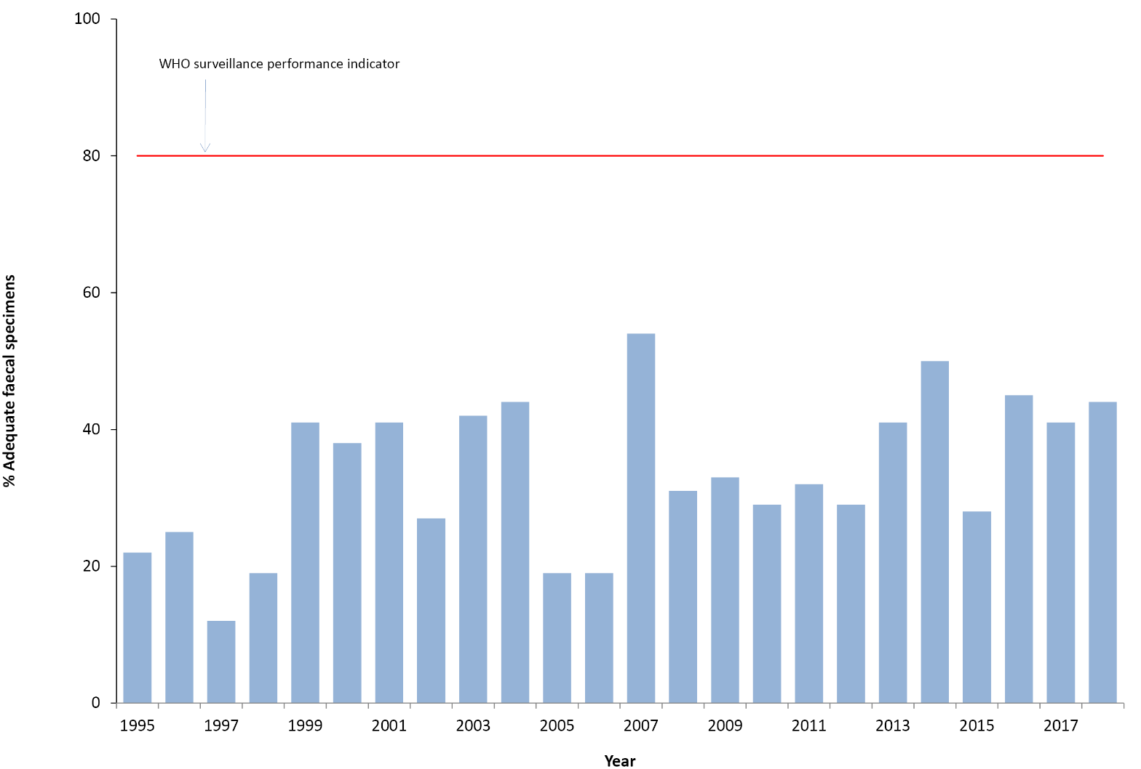
a The WHO criterion for adequate specimen collection is two faecal specimens collected more than 24 hours apart and within 14 days of the onset of paralysis from 80% of the cases classified as non-polio AFP, which is highlighted by the red line.
Table 3: Laboratory results reported by the NERL, 2018.
Result | Specimens from AFP cases involving children < 15 years of age | Specimens from AFP cases involving patients ≥15 years of age | Environmental Surveillance | Enterovirus Surveillance | Total
Sabin poliovirus type 1 | 0 | 0 | 2 | 0 | 2
Non-polio enterovirus | 12 | 0 | 19 | 200 | 231
No enterovirus identified | 70 | 2 | 1 | 16 | 89
Total | 82 | 2 | 22 | 216 | 322

Table 4: Enterovirus test results from samples originating in Australia, 1995 to 2018.
Year | Poliovirus |  | Non-polio enterovirus | No enterovirus detected | EVID results referredª | Total samples reviewed
 | Sabin-like | Non-Sabin-like
1995 | 190 | 0 | 200 | 13 | 0 | 403
1996 | 224 | 0 | 198 | 9 | 0 | 431
1997 | 124 | 0 | 76 | 0 | 0 | 200
1998 | 52 | 0 | 15 | 4 | 0 | 71
1999^{b} | 60 | 1 | 9 | 9 | 0 | 79
2000 | 45 | 0 | 44 | 47 | 0 | 136
2001^{b} | 46 | 5 | 33 | 75 | 0 | 159
2002 | 36 | 0 | 21 | 49 | 0 | 106
2003 | 9 | 0 | 15 | 47 | 0 | 71
2004 | 6 | 0 | 26 | 61 | 0 | 93
2005 | 18 | 0 | 10 | 39 | 0 | 67
2006 | 2 | 0 | 6 | 71 | 29 | 108
2007^{c} | 0 | 2 | 32 | 115 | 107 | 256
2008 | 0 | 0 | 20 | 92 | 77 | 189
2009^{d} | 1 | 0 | 63 | 78 | 113 | 255
2010 | 0 | 0 | 170 | 39 | 108 | 317
2011 | 0 | 0 | 174 | 61 | 205 | 440
2012 | 0 | 0 | 155 | 97 | 123 | 375
2013e | 1 | 0 | 242 | 198 | 230 | 671
2014 | 0 | 0 | 68 | 128 | 506 | 702
2015^{f} | 12 | 0 | 185 | 96 | 168 | 461
2016 | 0 | 0 | 242 | 143 | 227 | 612
2017^{g} | 1 | 1 | 204 | 92 | 173 | 471
2018^{h} | 2 | 0 | 231 | 89 | 198 | 520
a Enterovirus Identification (EVID) results include retrospective data made available via the ERNLA.
b Untyped enterovirus or uncharacterised poliovirus isolates were referred for further testing after completion of a laboratory inventory. The 6 isolates (one in 1999 and five in 2001) tested as non-Sabin-like and were subsequently identified as wild type poliovirus prototype strains and were destroyed.
c Wild poliovirus type 1 was imported from Pakistan.
d A Sabin-like poliovirus type 1 was identified from an unimmunised infant.
e A Sabin-like poliovirus type 2 was identified from an infant who was immunised overseas with oral polio vaccine and hospitalised with diarrhoea upon return to Australia.
f Ten archived Sabin-like poliovirus type 1 samples were identified during a laboratory clean-up. Single isolations of Sabin-like poliovirus type 2 and type 3 were identified from sewage.
g A Sabin-like poliovirus type 3 and a VDPV2 (non-Sabin-like) were isolated from sewage.
h Two separate isolations of Sabin-like poliovirus type 1 were identified from sewage.

Environmental surveillance
Environmental surveillance was established at a wastewater treatment plant in Melbourne from October 2017. Twenty-two collections were tested in 2018 and Sabin-like poliovirus type 1 was isolated on two separate occasions as well as NPEVs from 19 other samples; no enterovirus was isolated from one sample. Enterovirus infections are ubiquitous and the isolation of NPEVs from sewage acts as an indicator of the quality of the collection and test procedures.

Enterovirus surveillance
A total of 200 NPEVs were typed by the NERL and an additional 198 by members of the Enterovirus Reference Laboratory Network of Australia from clinical specimens (Tables 3 and 4). No polioviruses were reported amongst the enterovirus typings. The most common types of NPEV identified by the laboratory network, in order of decreasing frequency, were echovirus 30, coxsackievirus A6, echovirus 6 and echovirus 18.

Polio regional reference laboratory activities
As part of its role as a Polio Regional Reference Laboratory, in 2018, the NERL received four stool specimens from AFP cases in Brunei Darussalam and 19 from Pacific Island countries with no poliovirus isolated from the specimens. In May 2018, the NERL reported a vaccine-derived poliovirus (VDPV) type 1 from Papua New Guinea, which was subsequently identified as a circulating strain or cVDPV1. As a result of the ensuing international public health response, a total of 750 stool specimens were tested by the NERL from Papua New Guinea in 2018, including 499 from AFP cases involving children less than 15 years of age, 36 from AFP cases greater than 14 years of age and 215 from contacts of AFP cases. Twenty-six cases of cVDPV1 were reported by the NERL in 2018 and the virus was detected in a further seven contacts of AFP cases.

Quality assurance programs
In 2018, the NERL was accredited as a WHO Polio Regional Reference Laboratory through participation in the annual WHO quality assurance panels for poliovirus isolation, intratypic differentiation and sequencing. The laboratory also successfully participated in the Royal College of Pathologists of Australasia quality assurance panel for enterovirus detection by RT-PCR and the Quality Control for Molecular Diagnostics (QCMD) panel for enterovirus typing.

Discussion
In 2018, Australia met the WHO non-polio AFP surveillance target for the eleventh year in a row, reporting 1.24 cases per 100,000 children less than 15 years of age. The notification of AFP cases via the APSU monthly report card and the PAEDS system has routinely met the international standard that assesses whether an imported case of polio in children less than 15 years of age would be detected, although gaps in AFP surveillance were noted at the sub-national level in the Australian Capital Territory, New South Wales and Tasmania based on the WHO surveillance target. PAEDS routinely performs retrospective audits at the hospitals where it operates to identify any missed cases of AFP as a check of the system’s performance and none were identified in New South Wales and South Australia.² Australia has never met the strict WHO surveillance target for adequate stool collection from 80% of the non-polio AFP cases; however 65% of the cases had at least one specimen collected within 14 days of the onset of paralysis. The APSU, PAEDS and members of the Polio Expert Panel and the National Certification Commission for Polio Eradication in Australia have endeavoured to improve the rate of adequate faecal specimen collection from AFP cases through provision of information to clinicians, presentations at tertiary paediatric hospitals and reviewing data to identify areas for improvement.
Enterovirus and environmental surveillance supplement the AFP surveillance program providing additional means of monitoring Australia’s polio-free status. Poliovirus was not identified through enterovirus surveillance in 2018, but two Sabin-like poliovirus type 1 isolates were reported from sewage. The Sabin poliovirus strains would have been associated with a visitor or returned traveller from a country that still uses oral polio vaccine since Australia replaced this vaccine with inactivated polio vaccine in 2005. A VDPV type 2 was isolated from sewage in Melbourne in 2017 but was not detected again after six months of weekly collections at the same site in 2018. The virus was classified as an ambiguous VDPV by WHO as the ultimate source is not known and these types of poliovirus have been reported by a number of other countries performing environmental surveillance for poliovirus.²⁰
While the focus of the national polio surveillance program is wild poliovirus and VDPV, non-polio enteroviruses of public health significance can be identified through the clinical and supplementary surveillance programs. Enterovirus D68 (EV-D68) was reported from three cases of AFP over six months in 2018, from three different states, and the PEP considered one of the cases to have an association with the virus infection. EV-D68 was first reported from an AFP case in Australia in 2010 and one other in 2016.²¹ The global detection of EV-D68 in clinical specimens was sporadic until 2008, when cases of acute respiratory illness including fatalities were reported in the Philippines, United Kingdom, Japan, Netherlands, New Zealand, Canada and culminated in a large outbreak in the United States of America in 2014.²² The United States does not perform AFP surveillance and clinical reports involving EV-D68 since 2014 have focussed on the presentation of acute flaccid myelitis, which is a subset of AFP. More recently an active, prospective surveillance program for EV-D68 was established in the United States to better understand the epidemiology of the virus.²³ The NERL will continue to monitor EV-D68 transmission in Australia through AFP and enterovirus surveillance while recognising the main clinical presentation is respiratory illness rather than neurological disease.^{24,25}

Acknowledgements
The authors thank the clinicians and healthcare workers who participated in the AFP surveillance program in 2018 as well as the teams at APSU and PAEDS. The active involvement of the laboratory members of the ERLNA is gratefully acknowledged. The poliovirus surveillance program co-ordinated by the NERL is funded by the Australian Government Department of Health, the Victorian government Department of Health and VIDRL.

Author details
Dr Jason Roberts, Senior Medical Scientist¹
Ms Linda Hobday, Medical Scientist, National AFP Surveillance Coordinator²
Mrs Aishah Ibrahim, Medical Scientist²
Dr Bruce Thorley, Senior Medical Scientist, Laboratory Head²
- Electron Microscopy Laboratory, Victorian Infectious Diseases Reference Laboratory, Doherty Institute, 792 Elizabeth St, Melbourne 3000, Victoria, Australia
- National Enterovirus Reference Laboratory, Victorian Infectious Diseases Reference Laboratory, Doherty Institute, 792 Elizabeth St, Melbourne 3000, Victoria, Australia

Corresponding author
Dr Bruce Thorley
Senior Medical Scientist, Laboratory Head, National Enterovirus Reference Laboratory, Victorian Infectious Diseases Reference Laboratory, Locked Bag 815, CARLTON SOUTH VIC 3053.
Telephone: +61 3 9342 9607.
Facsimile: +61 3 9342 9665.
Email: bruce.thorley@vidrl.org.au

References
- Australian Paediatric Surveillance Unit (APSU). Study Protocol, Acute Flaccid Paralysis. [Internet.] APSU, 2014. [Accessed: 4 March 2019.] Available from: http://www.apsu.org.au/assets/current-studies/AFP-Study-Protocol-June-2014.pdf
- McRae JE, Quinn HE, Saravanos GL, McMinn A, Britton PN, Wood N et al. Paediatric Active Enhanced Disease Surveillance (PAEDS) annual report 2016: Prospective hospital-based surveillance for serious paediatric conditions. Commun Dis Intell (2018). 2018;43. https://doi.org/10.33321/cdi.2019.43.5.
- Dyda A, Stelzer-Braid S, Adam D, Chughtai AA, MacIntyre CR. The association between acute flaccid myelitis (AFM) and enterovirus D68 (EV-D68) – what is the evidence for causation? Euro Surveill. 2018;23(3). https://doi.org/10.2807/1560-7917.ES.2018.23.3.17-00310.
- Chang PC, Chen SC, Chen KT. The current status of the disease caused by Enterovirus 71 infections: Epidemiology, pathogenesis, molecular epidemiology and vaccine development. Int J Environ Res Public Health. 2016 13(9). pii: E890.
- World Health Organization (WHO). Global wild poliovirus 2014-2019. [Intenet.] WHO, 2019. [Accessed: 29 March 2019.] Available from: http://polioeradication.org/wp-content/uploads/2019/02/global-wild-poliovirus-2013-2019-20190219.pdf
- Bolu O, Nnadi C, Damisa E, Braka F, Siddique A, Archer WR, et al. Progress toward poliomyelitis eradication — Nigeria, January–December 2017. MMWR Morb Mortal Wkly Rep 2018;67(8):253–6.
- World Health Organization (WHO). Global eradication of wild poliovirus type 2 declared. [Internet.] WHO, 2015. [Accessed: 29 March 2019.] Available from: http://www.polioeradication.org/mediaroom/newsstories/Global-eradication-of-wild-poliovirus-type-2-declared/tabid/526/news/1289/Default.aspx
- Mbaeyi C, Alleman MM, Ehrhardt D, Wiesen E, Burns CC, Liu H et al. Update on vaccine-derived poliovirus oubreaks – Democratic Republic of Congo and Horn of Africa, 2017-2018. MMWR Morb Mortal Wkly Rep. 2019;68(9):225–30.
- Bauri M, Wilkinson AL, Ropa B, Feldon K, Snider CJ, Anand A et al. Notes from the field: circulating vaccine-derived poliovirus type 1 and outbreak response – Papua New Guinea, 2018. MMWR Morb Mortal Wkly Rep. 2019;68(5):119–20.
- Jorba J, Diop OM, Iber J, Henderson E, Zhao K, Sutter RW et al. Update on vaccine-derived polioviruses — Worldwide, January 2017 – June 2018. MMWR Morb Mortal Wkly Rep. 2018;67(42):1189–94.
- World Health Organization (WHO). Statement of the Twentieth IHR Emergency Committee regarding the international spread of poliovirus. [Internet.] WHO, 2019.[ Accessed: 29 March 2019.] Available from: https://www.who.int/news-room/detail/01-03-2019-statement-of-the-twentieth-ihr-emergency-committee
- Department of Health. Poliovirus infection. [Internet.] Australian Government, Department of Health, 2015. [Accessed: 29 March 2019.] Available from: http://www.health.gov.au/internet/main/publishing.nsf/Content/cda-surveil-nndss-casedefs-cd_polio.htm
- World Health Organization (WHO). Poliomyelitis. In WHO-recommended standards for surveillance of selected vaccine-preventable diseases. (WHO/V&B/03.01) Geneva: WHO, Department of Vaccines and Biologicals, 2003.
- Wood DJ, Hull B. L20B cells simplify culture of polioviruses from clinical samples. J Med Virol. 1999;58(2):188–92.
- World Health Organization (WHO). Polio Laboratory Manual, 4th edition. (WHO/IVB/04.10) Geneva: WHO, Department of Immunization, Vaccines and Biologicals, 2004.
- Kilpatrick DR, Yang CF, Ching K, Vincent A, Iber J, Campagnoli R et al. Rapid group-, serotype-, and vaccine strain-specific identification of poliovirus isolates by real-time reverse transcription PCR using degenerate primers and probes containing deoxyinosine residues. J Clin Microbiol. 2009;47(6):1939–41.
- Stewardson AJ, Roberts JA, Beckett CL, Prime HT, Loh PS, Thorley BR et al. An imported case of poliomyelitis in Melbourne, Australia. Emerg Infect Dis. 2009;15(1):63–5.
- World Health Organization (WHO). Guidelines for environmental surveillance of poliovirus circulation. (WHO/V&B/03.03) Geneva: WHO, Department of Vaccines and Biologicals, 2003.
- Roberts, JA. Thesis. “Chapter 2: Development of a Novel Enterovirus Detection and Super-Speciation Assay”, An integrated bioinformatics and computational biophysics approach to enterovirus surveillance and research. RMIT University, 2014: 62-109. [Accessed: 27 March 2018.] Available from: https://researchbank.rmit.edu.au/view/rmit:162129
- Burns CC, Diop OM, Sutter RW, Kew OM. Vaccine-derived polioviruses. J Infect Dis. 2014;210(Suppl 1):S283–93.
- Levy A, Roberts J, Lang J, Tempone S, Kesson A, Dofai A et al. Enterovirus D68 disease and molecular epidemiology in Australia. J Clin Virol. 2015:69;117–21.
- Holm-Hansen CC, Midgley SE, Fischer TK. Global emergence of enterovirus D68: a systematic review. Lancet Infect Dis. 2016;16(5):e64–75.
- Kujawski SA, Midgley CM, Rha B, Lively JY, Nix WA, Curns AT et al. Enterovirus D68-associated acute respiratory illness – new vaccine surveillance network United States July–October, 2017 and 2018. MMWR Morb Mortal Wkly Rep. 2019;68(12):277–80.
- Suresh S, Forgie S, Robinson J. Non-polio enterovirus detection with acute flaccid paralysis: a systematic review. J Med Virol. 2018;90(1):3–7.
- Harvala H, Broberg E, Benschop K, Berginc N, Ladhani S, Susi P et al. Recommendations for enterovirus diagnostics and characterisation within and beyond Europe. J Clin Virol. 2018;101:11–7.
Communicable Diseases Intelligence
ISSN: 2209-6051 Online

Communicable Diseases Intelligence (CDI) is a peer-reviewed scientific journal published by the Office of Health Protection, Department of Health. The journal aims to disseminate information on the epidemiology, surveillance, prevention and control of communicable diseases of relevance to Australia.

Editor: Tanja Farmer
Deputy Editor: Simon Petrie
Design and Production: Kasra Yousefi
Editorial Advisory Board: David Durrheim, Mark Ferson, John Kaldor, Martyn Kirk and Linda Selvey

Website: http://www.health.gov.au/cdi

Contacts
Communicable Diseases Intelligence is produced by:
Health Protection Policy Branch, Office of Health Protection, Australian Government Department of Health
GPO Box 9848, (MDP 6) CANBERRA ACT 2601

Email: cdi.editor@health.gov.au

Submit an Article
You are invited to submit your next communicable disease related article to the Communicable Diseases Intelligence (CDI) for consideration. More information regarding CDI can be found at: http://health.gov.au/cdi.
Further enquiries should be directed to: cdi.editor@health.gov.au.

This journal is indexed by Index Medicus and Medline.

Creative Commons Licence - Attribution-NonCommercial-NoDerivatives CC BY-NC-ND
© 2020 Commonwealth of Australia as represented by the Department of Health
This publication is licensed under a Creative Commons Attribution-NonCommercial-NoDerivatives 4.0 International Licence from https://creativecommons.org/licenses/by-nc-nd/4.0/legalcode (Licence). You must read and understand the Licence before using any material from this publication.

Restrictions
The Licence does not cover, and there is no permission given for, use of any of the following material found in this publication (if any):
- the Commonwealth Coat of Arms (by way of information, the terms under which the Coat of Arms may be used can be found at www.itsanhonour.gov.au);
- any logos (including the Department of Health’s logo) and trademarks;
- any photographs and images;
- any signatures; and
- any material belonging to third parties.

Disclaimer
Opinions expressed in Communicable Diseases Intelligence are those of the authors and not necessarily those of the Australian Government Department of Health or the Communicable Diseases Network Australia. Data may be subject to revision.

Enquiries
Enquiries regarding any other use of this publication should be addressed to the Communication Branch, Department of Health, GPO Box 9848, Canberra ACT 2601, or via e-mail to: copyright@health.gov.au

Communicable Diseases Network Australia
Communicable Diseases Intelligence contributes to the work of the Communicable Diseases Network Australia.
http://www.health.gov.au/cdna

telephone 03-9342 9607, email enterovirus@vidrl.org.au
http://www.apsu.org.au/
http://www.who.int/wer/en/

