The improving state of Q fever surveillance.

A review of Queensland notifications, 2003–2017
Sarah Tozer, Caitlin Wood, Damin Si, Michael Nissen, Theo Sloots, Stephen Lambert

Abstract
Q fever is a notifiable zoonotic disease in Australia, caused by infection with Coxiella burnetii. This study has reviewed 2,838 Q fever notifications reported in Queensland between 2003 and 2017 presenting descriptive analyses, with counts, rates, and proportions. For this study period, Queensland accounted for 43% of the Australian national Q fever notifications. Enhanced surveillance follow-up of Q fever cases through Queensland Public Health Units was implemented in 2012, which improved the data collected for occupational risk exposures and animal contacts. For 2013–2017, forty-nine percent (377/774) of cases with an identifiable occupational group would be considered high risk for Q fever. The most common identifiable occupational group was agricultural/farming (31%). For the same period, at-risk environmental exposures were identified in 82% (961/1,170) of notifications; at-risk animal-related exposures were identified in 52% (612/1,170) of notifications; abattoir exposure was identified in 7% of notifications. This study has shown that the improved follow-up of Q fever cases since 2012 has been effective in the identification of possible exposure pathways for Q fever transmission. This improved surveillance has highlighted the need for further education and heightened awareness of Q fever risk for all people living in Queensland, not just those in previously-considered high risk occupations.
Keywords: Coxiella burnetii; Q fever; Queensland; surveillance; notifiable disease

Introduction
Q fever, a zoonotic disease caused by the bacterium Coxiella burnetii, has a worldwide distribution with the exception of New Zealand and Antarctica.^{1–4} Q fever in humans is contracted by the inhalation of contaminated dust particles or bacterium-containing aerosols shed from infected animals.⁵ It has historically been described as an occupational disease primarily noted in abattoir workers, veterinarians, shearers, tanners, and farmers. However, more current reports suggest that exposures from other sources may have previously been overlooked, or are becoming more common.^{6,7} Several animal species are known to shed C. burnetii into the environment and to be potential reservoirs for transmission of Q fever. In Australia, these include livestock, domestic mammals and native wildlife such as wallabies, dingoes and kangaroos.^{6,8–10}
Q fever is a notifiable condition under the National Notifiable Disease list and Public Health Act (2005). Primary infection results in clinical manifestations ranging from no symptoms to acute Q fever. The classical presentation of acute Q fever is an influenza-like illness, fevers, sweats, headaches, less commonly including also other conditions such as hepatitis and pneumonia. Of symptomatic patients, 2% are hospitalised.⁴ Approximately 5% of acute Q fever cases develop chronic Q fever, identified months or years after initial infection. Chronic Q fever presents as endocarditis in 60–70% of cases, or chronic pneumonia with or without hepatitis.⁴ A third disease state, chronic fatigue syndrome (CFS) or post Q fever fatigue syndrome (QFS), was first described in Australian abattoir workers.¹¹ Acute and chronic Q fever are treatable, with doxycycline which is the antibiotic of choice.¹²
In Australia, a whole-cell vaccine against Q fever (Q Vax®) was first licensed in 1989, and is manufactured by Seqirus, a subsidiary of CSL limited (Commonwealth Serum Laboratories, Victoria, Australia). The vaccine is recommended for at-risk individuals aged 15 years or older. Workplace Health and Safety (WHS) (Work Health and Safely Act 2011) monitor use of the vaccine in order to reduce Q fever acquired in the workplace. Between 2001 and 2006, Q Vax® was used in a government-funded vaccination program, the National Q Fever Management Program (NQFMP), with the aim of reducing the incidence of disease.¹³
The aims of this report are to describe the extent and trends of Q fever notification data in Queensland over a 15-year period and to investigate enhanced data following changes to the surveillance of Q fever. From 2012, all public health units in Queensland were instructed to complete an enhanced Q fever surveillance form (Q fever case report form) hence providing more consistent follow-up, including details on risk exposures and animal contacts. Although previous epidemiological reports reviewing the Australian national Q fever notifications have been published,^{7,14} to date there have been no publications reporting Q fever notifications isolated to Queensland, Australia.

Methods
Q fever case notification data, for all confirmed cases in Queensland, between 1 January 2003 and 31 December 2017, were extracted from the Notifiable Conditions System (NOCS) by the Communicable Disease Branch of Queensland Health. Confirmed cases fulfilled the national case definition for Q fever notification (Australian Government Department of Health, Australia 2004). This requires either: (i) the detection of C. burnetii via culture; (ii) the detection of C. burnetii by molecular methods; or (iii) the seroconversion or significant increase in antibody level to Phase II antigen in paired sera taken in the absence of a recent Q fever vaccination, at least 14 days apart, and screened in parallel.
Data available in the NOCS are compiled from clinical information initiated and provided by diagnostic testing from pathology providers, with follow-up from select individual public health units (PHUs) via case reporting forms. From 2012 onwards, enhanced surveillance data have been captured using laboratory-initiated notifications of Q fever cases and then direct patient contact via the PHU, collecting data with the Q fever case report forms. Individual public health unit investigators conduct this survey either by phone questionnaire or in person. The data are then entered into the NOCS. The data fields extracted for analysis included: year of onset; age; sex; Indigenous status; local government area (LGA) of residence; Hospital and Health Service (HHS) division; occupation; whether hospitalisation was required; exposure to animals; abattoir and environmental related risk exposures; Q fever vaccination status; and awareness of risk for Q fever and Q fever vaccination.
This study provides descriptive analyses, with counts, rates, and proportions of the notification data per year and using three 5-year periods from 2003 to 2017. Estimated Resident Population (ERP) data were attained per year from the Australian Bureau of Statistics for populations for Queensland and within LGAs.¹⁵ Queensland data were also analysed according to HHS divisions of Queensland Health. Population data for HHS were obtained directly from the open access Queensland Government website.¹⁶ The estimated notification rate per LGA or HHS was calculated for each year accordingly:
Where the notification rate for multiple years was calculated, the average ERP for the total period was used as an estimated denominator. Where possible, Queensland state Q fever data were compared to Australian national Q fever data, sourced from the National Notifiable Diseases Surveillance System.¹⁷
Data were cleaned and analysed using the software Microsoft Excel 2011 and R.¹⁸ Surveillance data included a free text field for place of work. Data captured in this field were aggregated into work group categories: see the Appendix for details of groupings (Table A.1). Visualisation of the spatial distribution of case notification counts or rates per HHS and LGA was performed by creating choropleth maps in Q GIS.¹⁹

Results

Q fever notification counts and rates by age and sex
Between 2003 and 2017, a total of 2,838 cases of Q fever were notified in Queensland. Annual case notification rates ranged from 3.0 to 5.1 per 100,000 population. Annual notification counts and rates for Queensland and Australia have been presented together in Figure 1. Although the notifications fluctuated over this study period, the annual Queensland notification rate remained approximately double the national notification rate. For this period, Queensland accounted for 43.1% (2,838/6,591) of all the national Australian Q fever notifications while the population of Queensland represented only 19.6% of the Australian population during this time frame.

Figure 1: Q fever notifications and annual rates/100,000 population for Queensland and Australia, by year, 2003–2017
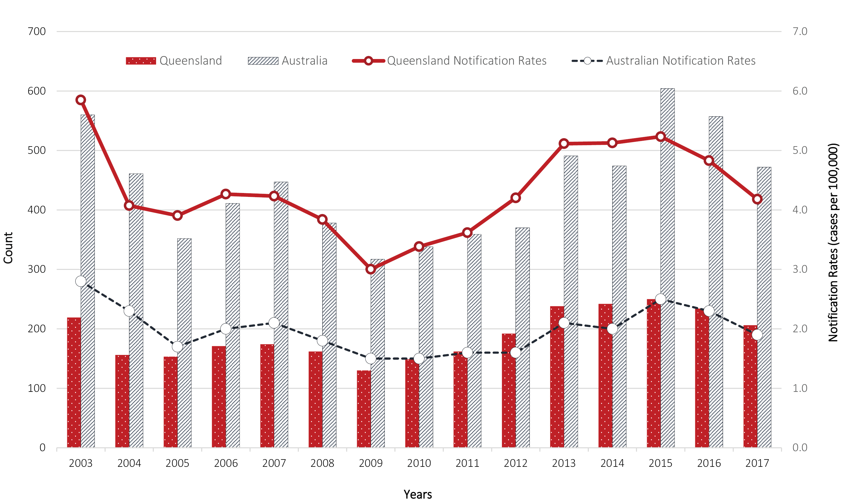

Of the 2,838 Q fever cases notified in Queensland, 2,231 specified their Indigenous status. Of these respondents, 5.5% (n = 123) were Aboriginal and/or Torres Strait Islander Australians. This percentage remained stable over the entire study period.
In Queensland, for the entire study period, age and gender were recorded for every case record. Q fever was notified in all age groups. The median age of cases was 46 years (interquartile range (IQR): 33–57). The median age for males was 45 years (IQR 32–57) and for females 48 years (IQR 36–58). Across the entire study period, the highest crude case notifications were in the 55–59 years age group, followed by the 40–44 years age group. During the 15-year period analysed, 117 notifications occurred in children aged ≤ 15 years, with an increase in notifications occurring as age increased.
Overall, 74.6% (2,118/2,838) of all notifications were recorded as male, and 25.4% (720/2,838) were female. When stratified by gender and age (Figure 2), males in the 40–44 age group had the highest number of cases in Queensland over the study period. Q fever occurred more frequently in males than females with an overall ratio (M:F) of 3.0:1 (Table 1).

Figure 2: Summary of Queensland Q fever notifications by sex and 5-year age groupings, 2003–2017
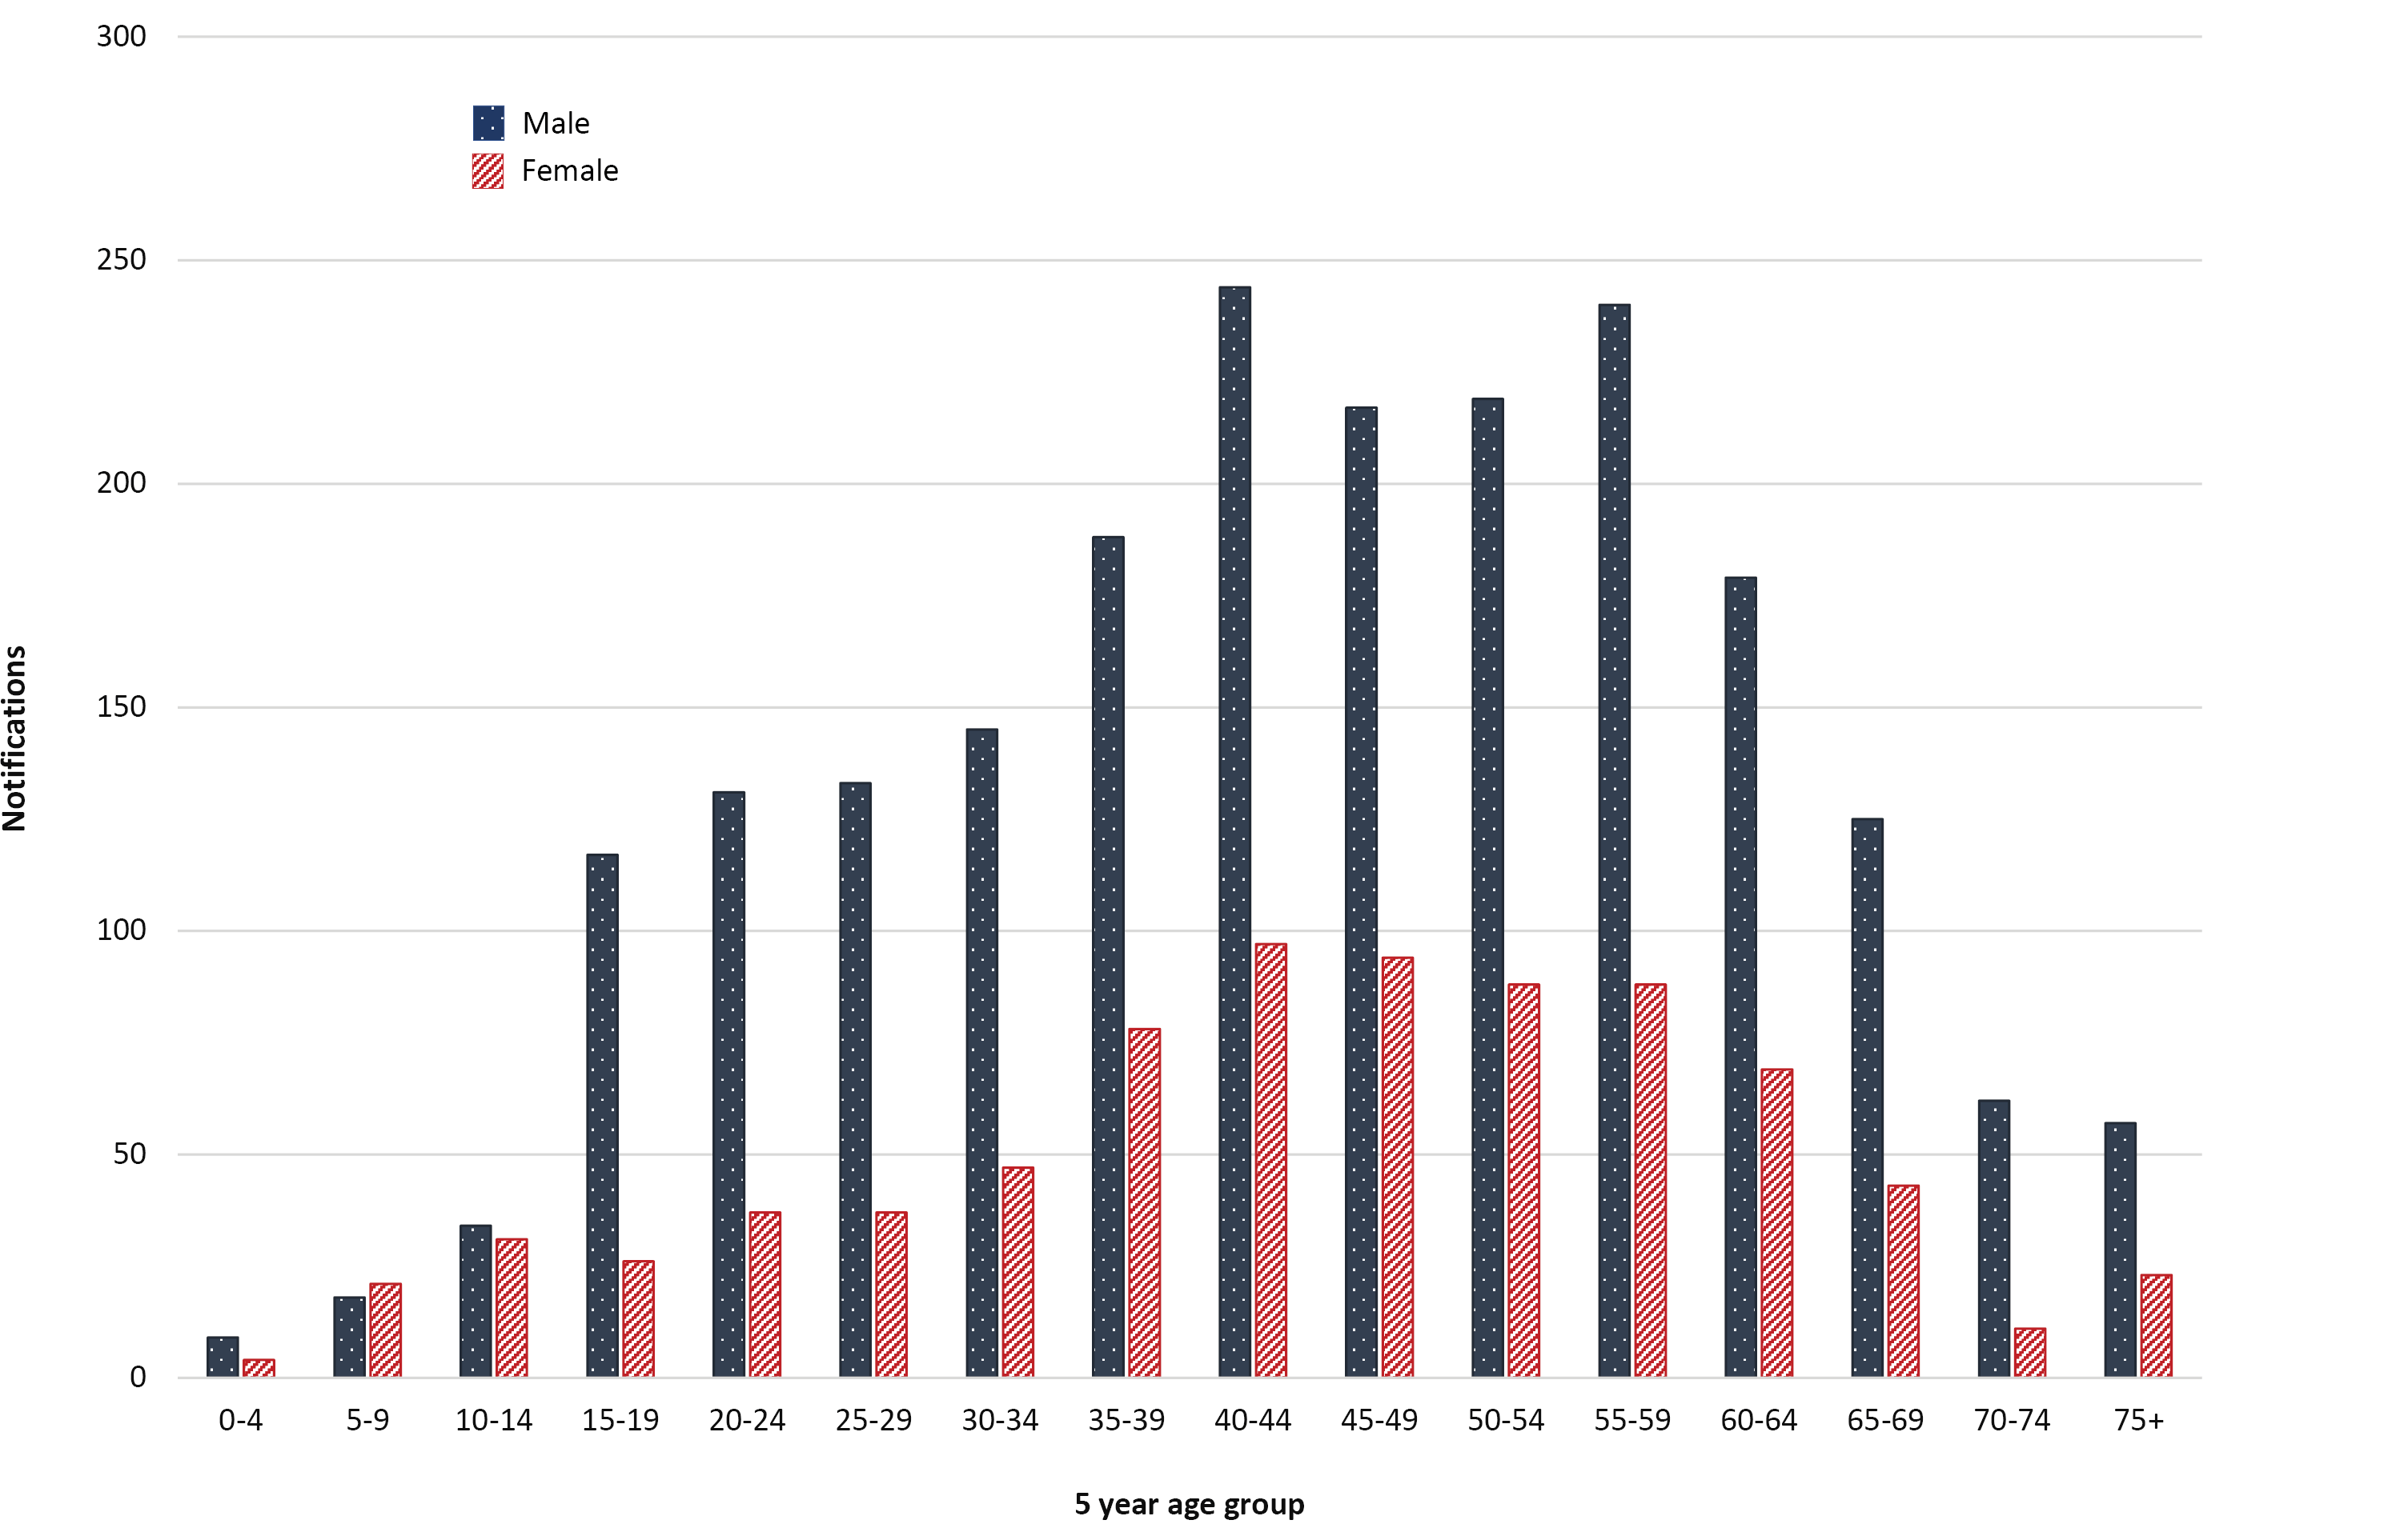

Table 1: Confirmed Q fever cases in Queensland between 2003 and 2017,ª summarised by 5-year periods and for the entire period
 | 2003–2007 | 2008–2012 | 2013–2017 | Overall  2003–2017
No. cases | 873 | 795 | 1,170 | 2,838
No. of male cases | 669 (76.6%) | 575 (72.3%) | 874 (74.7%) | 2,118 (74.6%)
Notification rate (males) | 6.76 | 5.19 | 7.31 | 6.43
No. of female cases | 204 (23.4%) | 220 (27.7%) | 296 (25.3%) | 720 (25.4%)
Notification rate (females) | 2.05 | 1.98 | 2.44 | 2.17
Male: female ratio | 3.3:1 | 2.6:1 | 3.0:1 | 3.0:1
Median age (IQR) | 43 (31–55) | 46 (34–57) | 48 (34–59) | 46 (33–57)
Median male age (IQR) | 42 (30–54) | 46 (33–57) | 48 (34–60) | 45 (32–57)
Median female age (IQR) | 46 (34–57) | 48 (37–58) | 49 (36–58) | 48 (36–58)
a Notification rates were calculated as an annual average notification / 100,000 population. Numbers inside parentheses are the percentage of total cases for that period.
From 2003 to 2017 the proportion of notifications recorded as female remained relatively similar (21.5% in 2003, 23.3% in 2017), however there was a noticeable increase from 18.1% in 2006 to a peak of 29.6% in 2008. From 2008 onwards, the proportion remained largely stable, gradually decreasing to 23.3%. A summary of Queensland notification counts and average annual notification rates/100,000 population by gender and age groups is presented, aggregated into three 5-year periods, in Table A.2 (Appendix).

Distribution of Q fever notifications, by HHS and LGA
Over the full 15 year study period 2003–2017, 22.0% (n = 625/2,838) of all Queensland notifications were from the Darling Downs HHS area, with 13.0% (n = 368/2,838) from the South West HHS, and 9.2% (n = 261/2,838) from Townsville HHS (Table 2 and Figure 3). However, the highest average annual Q fever case notification rate/100,000 population over this period was for the South West HHS (95.5), then Central West HHS (52.5) followed by the Darling Downs HHS divisions (15.9).
Cumulative Q fever notification rates, aggregated by residential LGA, for consecutive 5-year periods are presented in Figure 4 to show geographical distribution of Q fever notifications across Queensland. For each period, the LGA of Mareeba had the highest 5-year case notification rate. Other LGAs that consistently had high case notification rates for the study period were Balonne, Paroo and Murweh.

Figure 3: Q fever case notifications (%) for Queensland by Hospital Health Service divisions,ª 2003–2017
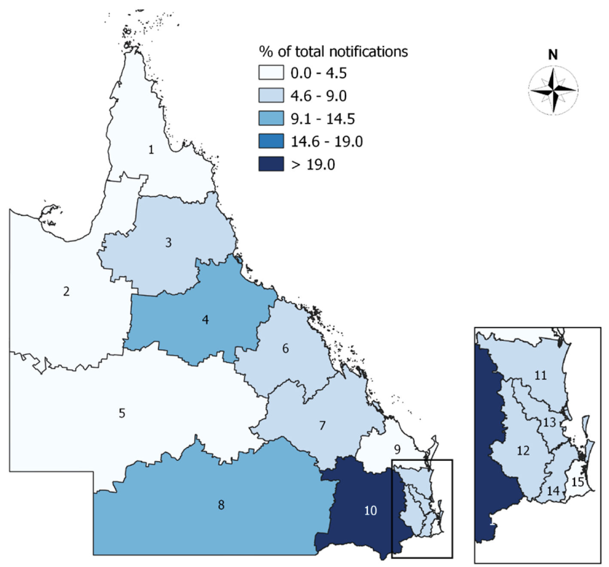
a Numbers correspond to HHS divisions: 1 = Torres and Cape; 2 = North West; 3 = Cairns and Hinterland; 4 = Townsville; 5 = Central West; 6 = Mackay; 7 = Central Queensland; 8 = South West; 9 = Wide Bay; 10 =Darling Downs; 11 = Sunshine Coast; 12 = West Moreton; 13 = Metro North;14 = Metro South; 15 = Gold Coast.

Table 2: Notifications of Q fever by Hospital and Health Service (HHS) of residence, 2003–2017, Queensland
Hospital Health Service  division | Total No. of notifications | % of all Qld cases | % hospitalised | Notification rate/100,000 population
Darling Downs | 625 | 22.0 | 33.1 | 15.9
South West | 368 | 13.0 | 24.7 | 95.5
Townsville | 261 | 9.2 | 47.9 | 7.8
Metro South | 234 | 8.3 | 47.0 | 1.5
Cairns and Hinterland | 225 | 7.9 | 31.6 | 6.5
West Moreton | 216 | 7.6 | 50.0 | 6.1
Sunshine Coast | 170 | 6.0 | 36.5 | 3.2
Mackay | 161 | 5.7 | 43.5 | 6.5
Central Queensland | 141 | 5.0 | 50.4 | 4.6
Metro North | 131 | 4.6 | 45.8 | 1.0
Gold Coast | 123 | 4.3 | 52.8 | 1.6
Central West | 94 | 3.3 | 48.9 | 52.5
Wide Bay | 70 | 2.5 | 58.6 | 2.3
Torres and Cape | 13 | 0.5 | 30.8 | 3.6
North West | 5 | 0.2 | 40.0 | 1.1
Interstate/international | 1 | 0.0 | 100.0 | –
Total Qld notifications | 2,838 | 100 | 40.0 | 4.9

Figure 4: Q fever notification rates (per 100,000 population) aggregated by residential LGA for 5-year periods, from 2003 to 2017

Hospitalisation and work absences due to Q fever
During 2003–2017, hospitalisation data were recorded for 2,123/2,838 Q fever patients, of which 53.3% (1,134/2,123) required hospitalisation. This figure represents 40.0% of the total Q fever cases for this period. Hospitalised patients had a length of stay ranging from 1 to 57 days. Of patients that were hospitalised, the median stay was 5 days (mean = 6.3 days; IQR 3–7 days). Collectively, days of hospitalisation for these patients amounted to 6,336 days. Number of days absent from work due to illness was recorded for 947 patients (33.3%), with 864 (30.4%) requiring at least 1 day absent. Number of days absent per case ranged from 1 to 330 days, median 10 days (mean = 14.5 days; IQR 5–20 days).

Occupational groups
For the years 2003–2012, the majority of notified cases (74%; 1,239/1,668) had either unanswered or unidentifiable responses for the free-text field describing their occupation. For the years 2013–2017, most cases (89%; 1,044/1,170) had a response entered for occupation; however, 26% (270/1,044) of these were classed as unknown, according to the reclassification described in the Appendix (Table A.1).
Table 3 shows a summary of Q fever cases per occupational category for the years 2013–2017. Of the 774 cases that could be reclassified into occupational categories, 31% were involved in agricultural or farming activities, 20% were unemployed or retired, 13% involved working in a trade. Of these cases with identifiable occupational groups, approximately 49% (377/774) of cases would be considered at-risk occupational groups within Australia.²⁰
Table 3: Q fever cases in Queensland (2013–2017) by occupational category
Occupational categories | No. cases (%)
Agricultural/farmingª | 236 (30.5%)
Unemployed/retired | 153 (19.8%)
Trades | 104 (12.8%)
Teaching or student | 46 (5.9%)
Transportª | 43 (5.6%)
Meat processingª | 40 (5.2%)
Gardening/lanscapingª | 37 (4.8%)
Administrative | 37 (4.8%)
Health/hospitality | 31 (4.0%)
Mining | 19 (2.5%)
Services | 12 (1.6%)
Wildlifeª | 11 (1.4%)
Veterinary/ companion animalsª | 10 (1.3%)
a Occupational groups that are considered ‘high risk’ for Q fever within Australia.
b Numbers in parentheses are column percentages

At-risk exposures within one month prior to onset of Q fever
For the study period 2003–2017, at-risk exposure data fields for Q fever notifications in Queensland were summarised into three categories: animal-related; environmental; and abattoir (Table 4). Details of at-risk exposures under these three categories are presented in Table 5, Table 6, and Table 7; note that multiple exposures can be recorded for an individual case. Identification of exposures that may increase risk of disease are described in reports by Queensland Government Workplace Health and Safety,²¹ or in the Communicable Diseases Network Australia (CDNA) Q fever National Guidelines for Public Health Units.²⁰ Additional data for any animal contact, that may not involve ‘at-risk’ activities, were only available from 2012 onwards, hence are presented for 2013–2017 only.
Table 4: Summary of at-risk exposure groups for Q fever cases in Queensland, by 5-year period
 |  | Overall study period |  | 5-year time framesª
 |  | 2003–2017ª | 2003–2007 | 2008–2012 | 2013–2017
Total number of Q fever cases |  | 2,838 | 873 | 795 | 1,170
Exposures during 1 month prior to onset of illness^{b}
Abattoir related exposure
 | No. with any abattoir exposure | 138 (5%) | 18 (2%) | 35 (4%) | 85 (7%)
Animal-related exposures
 | No. with any animal-related exposure | 1,240 (44%) | 329(38%) | 299 (38%) | 612 (52%)
Environmental exposure
 | No. with any environmental exposure | 1,530 (54%) | 109 (12%) | 460 (58%) | 961 (82%)
No. cases with any exposure to a putative risk factor^{c} |  | 1,995 (70%) | 512 (63%) | 481 (61%) | 1,002 (86%)
No. cases without information or no reports of risk exposures± |  | 807 (28%) | 325 (37%) | 314 (39%) | 168 (14%)
a Numbers in parentheses are column percentages
b Multiple exposures can be recorded for the same individual
c As per definition of persons at increased risk of disease as reported by Queensland Government Workplace Health and Safety or in the Communicable Diseases network Australia (CDNA) Q fever National Guidelines for Public Health Units 20

Table 5: Details of at-risk animal-related exposures for Queensland Q fever cases during the one month prior to disease onset
 | Time period
 | 2003–2007 |  |  | 2008–2012 |  |  | 2013–2017
Total number of Q fever cases | 873 |  |  | 795 |  |  | 1,170
Total animal related exposures (% of column) | 329 (38%) |  |  | 299 (38%) |  |  | 612 (52%)
 | Responders | Responders positive for exposure | % positive of total cases | Responders | Responders positive for exposure | % positive of total cases | Responders | Responders positive for exposure | % positive of total cases
worked with animal manure/fertiliser | 524 | 41 (8%) | 5% | 480 | 145 (30%) | 18% | 1,009 | 353 (35%) | 30%
worked with straw or animal bedding | 519 | 18 (3%) | 2% | 483 | 92 (19%) | 12% | 1,004 | 223 (22%) | 19%
observing or assisted in animal birthing | 516 | 144 (28%) | 16% | 482 | 121 (25%) | 15% | 1,015 | 199 (20%) | 17%
involved in slaughtering, skinning or meat processing | 522 | 27 (5%) | 3% | 483 | 68 (14%) | 9% | 1,010 | 161 (16%) | 14%
involved in shooting/hunting | 525 | 18 (3%) | 2% | 481 | 45 (9%) | 6% | 1,007 | 156 (15%) | 13%
attended a saleyard or animal show | 520 | 20 (4%) | 2% | 474 | 53 (11%) | 7% | 1,006 | 127 (13%) | 11%
worked with wool | 521 | 10 (2%) | 1% | 487 | 26 (5%) | 3% | 1,019 | 70 (7%) | 6%
Table 6: Details of environmental exposures for Queensland Q fever cases during the one month prior to disease onset
 | Time period
 | 2003–2007 |  |  | 2008–2012 |  |  | 2013–2017
Total number of Q fever cases | 873 |  |  | 795 |  |  | 1,170
Environmental exposure (% of column) | 109 (12%) |  |  | 460 (58%) |  |  | 961 (82%)
 | Responders | Responders positive for exposure | % positive of total cases | Responders | Responders positive for exposure | % positive of total cases | Responders | Responders positive for exposure | % positive of total cases
exposure to dust from paddock or animal yards | 504 | 68 (13%) | 8% | 492 | 316 (64%) | 40% | 1,041 | 703 (68%) | 60%
live/work within 300 m of bush/scrub/forest area | 496 | 70 (13%) | 8% | 487 | 317 (65%) | 40% | 1,039 | 684 (66%) | 58%
live/work within 1 km of abattoir/animal grazing or saleyards | 501 | 63 (12%) | 7% | 482 | 254 (53%) | 32% | 1,041 | 613 (59%) | 52%
lived on a farm | 531 | 51 (10%) | 6% | 493 | 215 (44%) | 27% | 1,016 | 488 (48%) | 42%
exposure to livestock transport | 521 | 50 (10%) | 6% | 486 | 206 (42%) | 26% | 1,018 | 516 (51%) | 44%
had contact with untreated water | 527 | 50 (10%) | 6% | 487 | 147 (30%) | 18% | 1,028 | 480 (47%) | 41%
visited a farm | 522 | 62 (12%) | 7% | 488 | 191 (41%) | 24% | 723 | 310 (43%) | 26%
laundered clothes from someone who works with animals | 521 | 27 (5%) | 3% | 488 | 123 (25%) | 15% | 1,020 | 262 (26%) | 22%
contact with a Q fever infected person | 528 | 9 (2%) | 1% | 493 | 26 (5%) | 3% | 1,040 | 56 (5%) | 5%
consumed unpasteurised milk or milk products | 527 | 12 (2%) | 1% | 496 | 41 (8%) | 5% | 1,042 | 56 (5% | 5%
Table 7: Details of abattoir exposures for Queensland Q fever cases during the one month prior to disease onset
 | Time period
 | 2003–2007 |  |  | 2008–2012 |  |  | 2013–2017
Total number of Q fever cases  Abattoir related exposure (% of column) | 873 |  |  | 795 |  |  | 1,170
 | 18 (2%) |  |  | 35 (4%) |  |  | 85 (7%)
 | Responders | Responders positive for exposure | % positive of total cases | Responders | Responders positive for exposure | % positive of total cases | Responders | Responders positive for exposure | % positive of total cases
worked inside the abattoir | 133 | 13 (2%) | 1% | 269 | 27 (10%) | 3% | 1,011 | 67 (7%) | 6%
worked in the grounds of the abattoir | 80 | 4 (1%) | 0% | 91 | 13 (14%) | 1% | 333 | 26 (8%) | 2%
visited abattoir | 83 | 2 (0%) | 0% | 86 | 10 (12%) | 1% | 338 | 23 (7%) | 2%
contract worker at an abattoir | 81 | 4 (1%) | 0% | 80 | 6 (8%) | 1% | 321 | 9 (3%) | 1%

Table 8: Direct animal and insect contact in the one month prior to onset of Q fever, 2013–2017
Animals and insects | Responded yes | % of total cases (n = 1,170)
dogs | 661 | 56.5%
Australian native wildlife | 587 | 50.2%
kangaroos | 418
small marsupials | 169
cattle | 569 | 48.6%
cats | 332 | 28.4%
sheep | 204 | 17.4%
ticks | 197 | 16.8%
feral pigs | 156 | 13.3%
domestic goat | 109 | 9.3%
domestic pigs | 80 | 6.8%
feral goat | 67 | 5.7%
horses | 66 | 5.6%
other | 215 | 18.4%

Table 9: Details of awareness of risk and vaccination from notified Q fever cases in Queensland, by 5-year periods
 | Period
 | 2003–2007 | 2008–2012 | 2013–2017
Total number of Q fever cases | 873 | 795 | 1,170
Aware that they were at risk of Q fever
No. of responders (response rate) | 530 (61%) | 490 (62%) | 1,050 (90%)
Yes | 142 (27%) | 103 (21%) | 220 (21%)
No | 330(62%) | 357 (73%) | 774 (74%)
Unknown | 58 (11%) | 30 (6%) | 56 (5%)
Aware of Q fever vaccination
No. of responders (response rate) | 526 (60%) | 488 (61%) | 1,048 (90%)
Yes | 239 (45%) | 216 (44%) | 445 (42%)
No | 213 (40%) | 239(49%) | 543 (52%)
Unknown | 74 (14%) | 33(7%) | 60 (6%)
Table 10: Personal awareness of risk of Q fever, in cases who responded yes to an ‘at-risk’ exposure during the one month prior to disease onset, 2013–2017
“At-risk” exposure in 1 month prior to disease onsetª | Personal awareness of risk
 | No | Yes | Unknown | Total
Environmental | 698 (74%) | 208 (22%) | 37 (4%) | 943
Animal | 391 (59%) | 194 (29%) | 18 (3%) | 603
Abattoir | 42 (50%) | 36 (43%) | 6 (7%) | 84
a Multiple exposures can be recorded for the same individual. Definitions of persons at increased risk of disease as reported by Queensland Government Workplace Health and Safety or in the Communicable Diseases Network Australia (CDNA) Q fever National Guidelines for Public Health Units.20
For the period 2013–2017, from the risk exposures detailed in Table 6, environmental exposures were identified in 82% (961/1,170) of all Q fever notifications in Queensland, with 60% of total cases (703/1,170) reporting exposure to dust from paddocks or animal yards in the one month prior to disease onset. Fifty-eight percent of total cases (684/1,170) responded ‘yes’ to living or working within 300 metres of bush/scrub/forest areas. This was followed by living or working within 1 kilometre of an abattoir/animal grazing land or saleyards, indicated in 52% of total cases (613/1,170). For the same period, at-risk animal-related exposures (as detailed in Table 5) were evident in 52% (612/1,170) of notified Q fever cases in Queensland. The most frequent activity was using animal manure or fertiliser, followed by assisting or observing in an animal birthing. Of those who assisted in animal birthing, 65% (131/199) specified cattle. Of 1,170 cases notified, 7% (n = 85) reported some abattoir exposure in the month prior to disease onset, including: working inside or on the grounds of an abattoir; working as a contractor; or visiting an abattoir (Table 8).

Additional animal contact surveillance data (2013–2017)
From 2013–2017, 99.9% of cases reported at least one direct animal contact in the one month prior to onset of disease (1,169/1,170). A summary of exposure to specific animals is presented in Table 8. Caution should be taken when interpreting this data, as it includes multiple animal co-exposures and these exposures were not confirmed as the source of Q fever. The most common animal contacts recorded were dogs (n = 661; 56.5%) followed by native wildlife (n = 619; 52.9%) then cattle (n = 569; 48.6%).

Q fever vaccination status and subjects’ awareness of risk of contracting disease
A summary of the Queensland Q fever notification subjects’ awareness, of the risk for contracting Q fever and of the Q fever vaccine, is presented in Table 9. From those who responded, 27% of cases from 2003 to 2007 were aware they were at risk of Q fever; this reduced to 21% for the periods 2008–2012 and 2013–2017. For awareness of the Q fever vaccine, the crude proportion of cases who were aware decreased slightly from 45% (2003–2007) to 42% (2012–2017). However, it is clear that response rate for surveillance fields increased over these periods, hence a comparison of crude measures may be unreliable. Over the entire study period, 75% (2,137/2,838) of cases had vaccination status recorded. Of these, 92% had not been previously vaccinated, 3% were listed as being vaccinated for Q fever and 5% were unknown.
For the years 2013–2017, 86% of cases were linked to at least one previously described ‘at-risk’ exposure during the 1 month prior to disease onset. (Table 4) However, for the same period, only 21% of cases were aware that they might be at risk of Q fever (Table 9). Data for those who responded yes to ‘at-risk’ exposures have been cross-referenced with the data field for awareness of Q fever risk. The ‘at-risk’ exposure category with the least awareness was environmental-related and the most awareness was for the notified cases who had abattoir-related exposure shown in Table 10.

Discussion
Overall, for this study period, Queensland accounted for approximately 43% of the national Q fever notifications. Queensland continues to report more Q fever cases than other states within Australia. The fluctuations in annual Q fever notification rates for Queensland seen over time may be due to the influence of multiple factors. These may include the end of the NQFMP in 2006, heightened awareness by general practitioners, changes in surveillance, testing and reporting of case notifications and the occurrence of outbreaks.^{4,7,22}
Other studies have reported that Q fever predominately occurs in males of working age, with highest notification rates in the 40–59 years age group;^{7,14,23,24} this trend remains true for the Queensland data analysed in this study. It was previously reported, from Australian national data, that the average age of case notifications and the proportion of female cases had increased over time from 1991 to 2014.⁷ In the current study, the average age of notified cases was seen to be increasing over time, however, the proportion of notifications recorded as female remained relatively constant. There was a peak identified in the proportion of female notifications immediately following the end of the NQFMP; this could be explained by a reduction in male notifications following the success of the program, which was targeted at farming and meat-processing industries.⁷
The overall Q fever notification rate in Queensland was approximately double the Australian national notification rate; however, when examining the notification rates by LGA and HHS, it is clear that some geographic regions within Queensland reported rates consistently above the average. The distribution of Q fever seems to vary between and within countries, likely due to the wide range of animal reservoirs, differences in C. burnetii strains and environmental factors that are not yet completely understood.²⁵ However, reporting biases may also exist with notification data, due to underreporting in areas with less access to testing and reduced Q fever awareness. The geographical distribution of Q fever within Queensland requires more in-depth spatial and/or spatio-temporal analysis to identify clustering of disease across space and time and to identify potential risk factors that may be linked to geographical hotspots.
When examining the surveillance data field responses across this study period, it was clear that since the implementation of enhanced Q fever surveillance in 2012, there has been an improvement in the overall response rate to survey questions. This has allowed ‘at-risk’ exposures that are likely sources of Q fever transmission to be identified for a greater number of cases. Improved Q fever surveillance, as is evident in Queensland, will allow improved planning for educational campaigns and efforts to increase vaccine uptake so as to prevent a greater number of Q fever cases. In 2018, in order to provide nationally consistent advice and guidance to public health units, Q fever reporting was included within the Series of National Guidelines (SoNG), including a national Case Reporting Form. This has allowed comparable data to be collected across multiple states so that the epidemiology of Q fever can be analysed accurately at a national and international level.
The most frequent occupational group for the 2013–2017 period, from respondents with an identifiable response, was agricultural/farming, followed by retired or unemployed. It was interesting that just over 5% of notifications worked in meat processing. For this period, 51% of cases would be considered to be in a classical at-risk occupational group for Q fever in Australia and therefore such cases should be preventable with correct vaccination.²⁰ It highlights the poor uptake of Q Vax® or the knowledge gap that still exists in some at-risk occupations. With the remaining 49% of cases not having an at-risk occupation, this study reiterates that occupation is a poor proxy for Q fever risk exposure. This is in line with a New South Wales report for Q fever notifications during a similar period.²³ We acknowledge that there were difficulties analysing occupation data, as many entries were unidentifiable; included area codes, specific organisation names or suburbs rather than an occupation. However, the quality of data improved from 2012 onwards, likely because of the change in survey protocol and enhancement of Q fever surveillance.
This study found that approximately 7% of Queensland Q fever notifications have reported abattoir exposure in the 1 month prior to illness. This includes working in or on the grounds of the abattoir, working as a contractor of an abattoir or visiting an abattoir. This figure is much lower that what has been reported for Victoria, Australia, where 25% of notifications were still related to abattoir exposures for the years 2009-2013.²⁴ This is likely because in Queensland, the abattoir workforce is currently well educated on the risks of Q fever and are mandated to be checked for prior exposure and vaccinated prior to commencing work. Hence, this data does not suggest a reduced risk of Q fever in the meat processing industry in Queensland, rather an improvement in Q fever prevention within this industry.
This study has identified, with improved surveillance data, that the most frequent at-risk exposures for Q fever notifications in Queensland (2013–2017) were environmental exposures: exposure to dust from animal paddocks, living within 300 metres of bush/scrub/forest and living or working within 1 kilometre of an abattoir. The transmission of Q fever to humans from environmental dispersal of C. burnetii from animal holdings and abattoirs has been documented in a review article.²⁶ Although that review did not include any Australian publications, it is likely that similar scenarios exist within Australia; local investigations are warranted to assess the risk of airborne geographical dispersal of C. burnetii to Queensland communities, from wildlife areas, livestock holdings and abattoirs.
It has been previously reported that only 2% of acute Q fever cases require hospitalisation;⁴ however, this study showed that 40.0% of the total Q fever cases spent at least one day in hospital. This is similar to a report from New South Wales, Australia, where 46.5% of cases from 2011–2015 were hospitalised. Without current comparable nationwide data, it is uncertain whether these hospitalisation rates are consistent throughout Australia or are higher for these two states. However, it may be worth noting that combined, Queensland and New South Wales account for approximately 80% of all national Q fever notifications.⁷
Overall, surveillance of Q fever notifications in Queensland has improved since the development of the case report form and implementation of case follow-up by public health units in 2012. This enhanced surveillance revealed that 86% of notified cases had an at-risk exposure (environmental, animal or abattoir) in the one month prior to disease onset and 99% of notifications had animal contact. Q fever acquired from known at-risk exposures should be preventable with the use of vaccination. Greater awareness of the potential risk through indirect environmental exposures should be a focus to help reduce the impact of Q fever on public health in Queensland.

Ethics approvals
This work was approved by Children’s Health Queensland Ethics Committee.
Review of notifications and vaccination coverage in Queensland HREC 08/QRCH/66AM01, Dated: 15/04/2015.

Acknowledgments
Dr Penny Hutchinson, Public Health Medical Officer, for her extensive efforts and vigilant collation of Q fever notification data from the Darling Downs.

Author details
Sarah Tozer^{1,2,3}* Caitlin Wood^{1,3}* Damin Si⁴ Michael Nissen^{2,5} Theo Sloots^{1,2} Stephen Lambert²
- Centre for Children’s Health Research, Queensland Paediatric Infectious Disease Laboratory, Lady Cilento Research Precinct, South Brisbane, Queensland
- Children’s Health Research Centre, University of Queensland, South Brisbane, Queensland
- The University of Queensland, School of Veterinary Science, Gatton, Queensland
- Communicable Diseases Branch, Prevention Division, Department of Health, Queensland Government.
- Director of Scientific Affairs & Public Health, GSK Vaccines Intercontinental, Singapore
* denotes that these co-authors contributed equally to the research.

Corresponding author
Dr Sarah Jane Tozer – Queensland Health
Phone: +617 3646 0857
Sarah.Tozer@health.qld.gov.au

References
- Fournier PE, Marrie TJ, Raoult D. Diagnosis of Q fever. J Clin Microbiol. 1998;36(7):1823–34.
- Greenslade E, Beasley R, Jennings L, Woodward A, Weinstein P. Has Coxiella burnetii (Q fever) been introduced into New Zealand? Emerg Infect Dis. 2003;9(1):138–40.
- Kaplan MM, Bertagna P. The geographical distribution of Q fever. Bull World Health Organ. 1955;13(5):829–60.
- Cutler SJ, Bouzid M, Cutler RR. Q fever. J Infect. 2007;54(4):313–8.
- Stoker MG, Marmion BP. The spread of Q fever from animals to man; the natural history of a rickettsial disease. Bull World Health Organ. 1955;13(5):781–806.
- Tozer SJ, Lambert SB, Strong CL, Field HE, Sloots TP, Nissen MD. Potential animal and environmental sources of Q fever infection for humans in Queensland. Zoonoses Public Health. 2014;61(2):105–12.
- Sloan-Gardner TS, Massey PD, Hutchinson P, Knope K, Fearnley AE. Trends and risk factors for human Q fever in Australia, 1991–2014. Epidemiol Infect. 2017;145:787–95.
- Cooper A, Stephens J, Ketheesan N, Govan B. Detection of Coxiella burnetii DNA in wildlife and ticks in northern Queensland, Australia. Vector Borne Zoonotic Dis. 2013;13(1):12–6.
- Banazis MJ, Bestall AS, Reid SA, Fenwick SG. A survey of Western Australian sheep, cattle and kangaroos to determine the prevalence of Coxiella burnetii. Vet Microbiol. 2010;143(2–4):337–45.
- Stevenson S, Gowardman J, Tozer S, Woods M. Life-threatening Q fever infection following exposure to kangaroos and wallabies. BMJ Case Rep. 2015. doi: https://doi.org/10.1136/bcr-2015-210808.
- Marmion BP, Shannon M, Maddocks I, Storm P, Penttila I. Protracted debility and fatigue after acute Q fever. Lancet. 1996;347(9006):977–8.
- Watanabe A, Takahashi H. Diagnosis and treatment of Q fever: attempts to clarify current problems in Japan. J Infect Chemother. 2008;14(1):1–7.
- Palmer C, McCall B, Jarvinen K, Krause M, Heel K. ‘The dust hasn’t settled yet’: the National Q fever Management Program, missed opportunities for vaccination and community exposures. Aust N Z J Public Health. 2007;31(4):330–2.
- Garner MG, Longbottom HM, Cannon RM, Plant AJ. A review of Q fever in Australia 1991–1994. Aust N Z J Public Health. 1997;21(7):722–30.
- Australian Bureau of Statistics. [Website.] Canberra: Australian Government: Australian Bureau of Statistics; 2019. [Accessed on 17 April 2019.] Available from: http://www.abs.gov.au/
- Queensland Health. Population health data and statistics. [Internet.] Brisbane: Queensland Government: Queensland Health; 2020. [Accessed on 19 February 2020.] Available from: https://www.health.qld.gov.au/research-reports/population-health
- Australian Government Department of Health. National Notifiable Diseases Surveillance System. [Internet.] Canberra; Australian Government Department of Health; 2019. [Accessed on 20 February 2020.] Available from: http://www9.health.gov.au/cda/source/rpt_4.cfm
- The R project for statistical computing. [Internet.] Vienna, Austria: The R Foundation for Statistical Computing; 2019. Available from: http://www.r-project.org/
- QGIS: a free and open source geographic information system. [Website.] Open Source Geospatial Foundation Project; 2019. Available from: https://qgis.org/
- Communicable Diseases Network Australia (CDNA). Q fever: CDNA national guidelines for public health units. Canberra: Australian Government Department of Health, CDNA; 2018. [Accessed on 6 December 2018.] Available from: http://www.health.gov.au/internet/main/publishing.nsf/Content/56DFBAB23468BF71CA2583520001F02F/$File/Q-fever-SoNG2018.pdf
- WorkCover Queensland. Q fever. [Internet.] Brisbane: Queensland Government: Workplace Health and Safety; 2019. [Accessed on 11 February 2020.] Available from: https://www.worksafe.qld.gov.au/injury-prevention-safety/hazardous-exposures/biological-hazards/diseases-from-animals/q-fever
- Gunaratnam P, Massey PD, Eastwood K, Durrheim D, Graves S, Coote D et al. Diagnosis and management of zoonoses – A tool for general practice. Aust Fam Physician. 2014;43(3):124–8.
- Clutterbuck HC, Eastwood K, Massey PD, Hope K, Mor SM. Surveillance system enhancements for Q fever in NSW, 2005–2015. Commun Dis Intell (2018). 2018;42. pii: S2209-6051(18)00012-10.
- Bond KA, Franklin L, Sutton B, Stevenson MA, Firestone SM. Review of 20 years of human acute Q fever notifications in Victoria, 1994–2013. Aust Vet J. 2018;96(6):223–30.
- Million M, Raoult D. Recent advances in the study of Q fever epidemiology, diagnosis and management. J Infect. 2015;71(Suppl 1):S2–9.
- Clark NJ, Soares Magalhães RJ. Airborne geographical dispersal of Q fever from livestock holdings to human communities: a systematic review and critical appraisal of evidence. BMC Infect Dis. 2018;18(1):218.

Appendix: supplementary tables
Table A.1: NOCS field ‘place of work’ free text words aggregated into new categories
New field | Classification | Aggregated free text terms
Occupation | Administrative | sales / reception / admin / recruit / office / retail / survey / account / book / politic / lawyer
 | Agricultural / farming | farm / grazier / livestock / cattle / sheep / horse / camel / goat / pig / shear / muster / stockman / station / farrier / fish / wool / drover / grower / cotton / fruit / cane
 | Gardening / landscape | landscape / lawn / grass / mow / grounds / earth / garden / aborist
 | Health / hospitality | health / therapist / beaut / carer / nurse / doctor / hosp / bar / tavern
 | Meat industry | abattoir / meat / butcher / pet food / specific names of abattoirs in Queensland
 | Mining | miner / mining / mine
 | Services | army / navy / airforce / soldier / barrack / police / RAAF / veteran
 | Teaching / student | student / college / school / teach / specific names of universities in Queensland
 | Trades | handy / mechanic / maintain / caretaker / glazier / courier / tile / machin / baker / build / construction / paint / boiler / apprentice / concrete / builder / labourer / cabinet / electrician / fencer
 | Transport | truck / transport / drive / rail
 | Unemployed / retired | unemployed / retired / pension
 | Veterinary | vet / anim / cat breeder / breeder / dog
 | Wildlife | wild / roo / shoot / ranger
 | Unknown | Any numbers / unknown / not stated
Table A.2: Queensland Q fever notifications aggregated into three 5-year periods by age grouping and sex from 2003–2017
 | 2003–2007 |  | 2008–2012 |  | 2013–2017
Sex/Age group | Count | average annual rate/ 100,000 | Count | average annual rate/ 100,000 | Count | average annual rate/ 100,000
Queensland Population
0–4 | 4 | 0.31 | 2 | 0.13 | 7 | 0.44
5–9 | 9 | 0.67 | 7 | 0.49 | 16 | 0.99
10–14 | 22 | 1.57 | 14 | 0.96 | 19 | 1.25
15–19 | 46 | 3.38 | 48 | 3.19 | 54 | 3.51
20–24 | 58 | 4.16 | 41 | 2.59 | 58 | 3.42
25–29 | 57 | 4.34 | 43 | 2.70 | 70 | 4.05
30–34 | 63 | 4.39 | 49 | 3.30 | 70 | 4.17
35–39 | 94 | 6.57 | 61 | 3.82 | 80 | 5.12
40–44 | 111 | 7.56 | 98 | 6.29 | 113 | 6.76
45–49 | 94 | 6.72 | 94 | 6.09 | 126 | 7.87
50–54 | 93 | 7.21 | 88 | 6.09 | 132 | 8.43
55–59 | 88 | 7.36 | 103 | 7.92 | 137 | 9.50
60–64 | 62 | 6.67 | 76 | 6.41 | 110 | 8.57
65–69 | 37 | 5.19 | 38 | 4.17 | 93 | 8.02
70–74 | 15 | 2.65 | 12 | 1.80 | 46 | 5.36
75+ | 20 | 1.86 | 21 | 1.73 | 39 | 2.76
Total | 873 | 4.45 | 795 | 3.61 | 1,170 | 4.89
Male
0–4 | 2 | 0.30 | 2 | 0.26 | 5 | 0.61
5–9 | 7 | 1.02 | 5 | 0.68 | 6 | 0.72
10–14 | 11 | 1.53 | 11 | 1.47 | 12 | 1.54
15–19 | 39 | 5.61 | 35 | 4.55 | 43 | 5.47
20–24 | 45 | 6.36 | 35 | 4.36 | 51 | 5.94
25–29 | 51 | 7.72 | 28 | 3.47 | 54 | 6.25
30–34 | 52 | 7.30 | 40 | 5.41 | 53 | 6.36
35–39 | 80 | 11.30 | 47 | 5.93 | 61 | 7.90
40–44 | 84 | 11.59 | 75 | 9.71 | 85 | 10.30
45–49 | 71 | 10.26 | 58 | 7.60 | 88 | 11.22
50–54 | 67 | 10.40 | 61 | 8.53 | 91 | 11.83
55–59 | 59 | 9.75 | 79 | 12.16 | 102 | 14.38
60–64 | 46 | 9.73 | 48 | 8.01 | 85 | 13.41
65–69 | 28 | 7.76 | 26 | 5.67 | 71 | 12.25
70–74 | 13 | 4.68 | 10 | 3.00 | 39 | 9.14
75+ | 14 | 3.12 | 15 | 0.29 | 28 | 4.50
Total | 669 | 6.84 | 575 | 5.24 | 874 | 7.35
Female
0–4 | 2 | 0.32 | 0 | 0.00 | 2 | 0.26
5–9 | 2 | 0.31 | 2 | 0.29 | 10 | 1.27
10–14 | 11 | 1.61 | 3 | 0.42 | 7 | 0.95
15–19 | 7 | 1.05 | 13 | 1.77 | 11 | 1.46
20–24 | 13 | 1.90 | 6 | 0.77 | 7 | 0.84
25–29 | 6 | 0.92 | 15 | 1.91 | 16 | 1.85
30–34 | 11 | 1.52 | 9 | 1.21 | 17 | 2.01
35–39 | 14 | 1.94 | 14 | 1.74 | 19 | 2.40
40–44 | 27 | 3.63 | 23 | 2.92 | 28 | 3.30
45–49 | 23 | 3.26 | 36 | 4.61 | 38 | 4.66
50–54 | 26 | 4.03 | 27 | 3.70 | 41 | 5.15
55–59 | 29 | 4.91 | 24 | 3.68 | 35 | 4.78
60–64 | 16 | 3.50 | 28 | 4.77 | 25 | 3.85
65–69 | 9 | 2.55 | 12 | 2.65 | 22 | 3.80
70–74 | 2 | 0.70 | 2 | 0.60 | 7 | 1.62
75+ | 6 | 0.95 | 6 | 0.86 | 11 | 1.39
Total | 204 | 2.08 | 220 | 2.00 | 296 | 2.46

Communicable Diseases Intelligence
ISSN: 2209-6051 Online

Communicable Diseases Intelligence (CDI) is a peer-reviewed scientific journal published by the Office of Health Protection, Department of Health. The journal aims to disseminate information on the epidemiology, surveillance, prevention and control of communicable diseases of relevance to Australia.

Editor: Tanja Farmer
Deputy Editor: Simon Petrie
Design and Production: Kasra Yousefi
Editorial Advisory Board: David Durrheim, Mark Ferson, John Kaldor, Martyn Kirk and Linda Selvey

Website: http://www.health.gov.au/cdi

Contacts
Communicable Diseases Intelligence is produced by:
Health Protection Policy Branch, Office of Health Protection, Australian Government Department of Health
GPO Box 9848, (MDP 6) CANBERRA ACT 2601

Email: cdi.editor@health.gov.au

Submit an Article
You are invited to submit your next communicable disease related article to the Communicable Diseases Intelligence (CDI) for consideration. More information regarding CDI can be found at: http://health.gov.au/cdi.
Further enquiries should be directed to: cdi.editor@health.gov.au.

This journal is indexed by Index Medicus and Medline.

Creative Commons Licence - Attribution-NonCommercial-NoDerivatives CC BY-NC-ND
© 2020 Commonwealth of Australia as represented by the Department of Health
This publication is licensed under a Creative Commons Attribution-NonCommercial-NoDerivatives 4.0 International Licence from https://creativecommons.org/licenses/by-nc-nd/4.0/legalcode (Licence). You must read and understand the Licence before using any material from this publication.

Restrictions
The Licence does not cover, and there is no permission given for, use of any of the following material found in this publication (if any):
- the Commonwealth Coat of Arms (by way of information, the terms under which the Coat of Arms may be used can be found at www.itsanhonour.gov.au);
- any logos (including the Department of Health’s logo) and trademarks;
- any photographs and images;
- any signatures; and
- any material belonging to third parties.

Disclaimer
Opinions expressed in Communicable Diseases Intelligence are those of the authors and not necessarily those of the Australian Government Department of Health or the Communicable Diseases Network Australia. Data may be subject to revision.

Enquiries
Enquiries regarding any other use of this publication should be addressed to the Communication Branch, Department of Health, GPO Box 9848, Canberra ACT 2601, or via e-mail to: copyright@health.gov.au

Communicable Diseases Network Australia
Communicable Diseases Intelligence contributes to the work of the Communicable Diseases Network Australia.
http://www.health.gov.au/cdna

https://www.health.qld.gov.au/clinical-practice/guidelines-procedures/diseases-infection/notifiable-conditions/register.

