Tuberculosis notifications in Australia, 2015–2018
Amy Bright, Justin T Denholm, Chris Coulter, Justin Waring and Rick Stapledon on behalf of the National Tuberculosis Advisory Committee, for the Communicable Diseases Network Australia and the Australian Mycobacterium Reference Laboratory Network

Abstract
In 2018, the National Notifiable Diseases Surveillance System received 1,438 tuberculosis (TB) notifications, representing a rate of 5.8 per 100,000 population, consistent with the preceding three years. Australia has achieved and maintained good tuberculosis (TB) control since the mid-1980s, sustaining a low annual TB incidence rate of approximately five to six cases per 100,000 population. The number of multi-drug-resistant TB (MDR-TB) cases diagnosed in Australia is low by international standards, with approximately 2% of TB notifications per year classified as MDR-TB. Australia’s overseas-born population continue to represent the majority of TB notifications (between 86% to 89% across the four reporting years) and the Aboriginal and Torres Strait Islander population continues to record TB rates around four to five times higher than the Australian-born Non-Indigenous population. Whilst Australia has achieved and maintained excellent control of TB in Australia, sustained effort is required to reduce local rates further, especially among Aboriginal and Torres Strait Islander populations, and to contribute to the achievement of the World Health Organization’s goal to end the global TB epidemic by 2035.
Keywords: Australia, tuberculosis, Mycobacterium tuberculosis, communicable disease surveillance, epidemiology, annual report.

Introduction
Australia has one of the lowest tuberculosis (TB) incidence rates in the world and has maintained excellent TB control for the last three decades. However, Australia’s proximity to some of the highest TB incidence countries in the world and its large migrant intake from these regions means that continued vigilance is required to sustain and improve on Australia’s already low TB incidence rate.
At the sixty-seventh World Health Assembly (WHA) in May 2014, the Australian Government endorsed the Global strategy and targets for tuberculosis prevention, care and control after 2015, also known as the World Health Organization (WHO) End TB Strategy.¹ At the first global Ministerial Conference on TB in November 2017, United Nations (UN) member states, including Australia, reaffirmed commitment to the End TB Strategy. The End TB Strategy’s goal is to end the global TB epidemic by 2035; it sets targets to reduce TB incidence by 90% and TB deaths by 95% worldwide by this time.²
Australia is well placed to achieve TB elimination with an excellent health care system and robust surveillance and governance frameworks already in place. However, like other low-incidence countries with positive migration policies, further reductions in domestic incidence rates are challenged by high rates of people movement and TB importation from high incidence settings. It is likely that the greatest reduction in Australia’s TB incidence rates will be achieved through the improvement of TB control globally, in particular in the Western Pacific and South-East Asian regions.
Surveillance of TB in Australia is overseen by the National Tuberculosis Advisory Committee (NTAC), a subcommittee of the Communicable Diseases Network Australia (CDNA). NTAC has the key role of providing strategic, expert advice to CDNA, and subsequently the Australian Government, on a coordinated national approach to TB control. NTAC also develops and reviews nationally-agreed policy and guidelines for the control of TB in Australia.
This report combines data from 2015–2018. It describes the epidemiology of notified cases of TB in Australia and includes some discussion on the factors that impact on the control of TB in Australia. Reporting of TB notifications in Australia ensures that Australia’s TB control progress can be monitored and provides evidence to support the development of new TB control strategies.

Methods
TB is a nationally notifiable disease in Australia and is monitored using the National Notifiable Disease Surveillance System (NNDSS). Medical practitioners, public health laboratories and other health professionals are required under state and territory public health legislation to report cases of TB to jurisdictional health authorities. The National Health Security Act 2007 provides the legislative basis for the national notification of communicable diseases and authorises the exchange of health information between the Australian Government and state and territory governments. State and territory health departments transfer these notifications regularly to the NNDSS. The primary responsibility for public health action resulting from a notification resides with state and territory health departments.
The Tuberculosis Data Quality Working Group (TBDQWG), a working group of NTAC, has representation from states and territories, the Australian Government and the Australian Mycobacterium Reference Laboratory Network (AMRLN). It ensures routine and timely reporting of trends and emerging issues in TB. The TBDQWG is also responsible for maintaining national consistency and currency in data standards and systems for TB surveillance that are relied upon to produce this report.
With the exception of the pre-migration screening data, the data presented in this report represent a point-in-time analysis of notified cases of TB in Australia. This report presents data extracted from NNDSS during February 2020. Due to the dynamic nature of the NNDSS, data in this report may vary from data reported in other NNDSS reports and reports of TB notifications at the state or territory level. Detailed notes on case definition, data collection, quality control and the categorisation of population subgroups are available in the 2007 annual report.³
In accordance with the Torres Strait Treaty, some Torres Strait Islanders and coastal people from Papua New Guinea (PNG) are allowed free movement (without passports or visas) within the northern Torres Strait Islands of Australia and PNG. This free movement is to allow for traditional activities to take place and does not include visits for health treatment.⁴ However, at times, PNG nationals do still present with TB to Queensland health care clinics in the Torres Strait. In these instances, patients meeting the national case definitions for TB are notified in Australia, and identified in the NNDSS as ‘Residents of the Torres Strait Protection Zone (TSPZ) accessing TB treatment in Queensland’, but the patient is transferred back to PNG for supervised treatment provided they are well enough to travel.
This report presents data analysed by date of diagnosis, a derived field within the NNDSS. The methodology for date of diagnosis for TB changed in January 2014 and was applied to all notifications. The diagnosis date for TB is now equivalent to the notification received date, whereas previously the diagnosis date represented the onset date or, where the date of onset was not known, the earliest of the specimen collection date, the notification date, or the notification receive date.
Reported rates were calculated using population data published by the Australian Bureau of Statistics (ABS). Overall population rates were calculated using midyear estimated resident population (ERP) data described by the 3101.0 - Australian Demographic Statistics, September 2019 dataset. Rates by country of birth were calculated using 2016 ERP data described by the 3412.0 - Migration, Australia, 2017–2018 dataset. Rates for population subgroups (i.e. overseas born, Aboriginal and Torres Strait Islander peoples and Australian born non Indigenous) by age and by state and territory were calculated using 2016 ERP data described by the 3412.0 - Migration, Australia, 2017–2018 dataset. Note that ERP data by country of birth by state and territory are based on the 2016 Census as data are only available for Census years and ERP data for the Aboriginal and Torres Strait Islander population are also based on the 2016 Census data.
The pre-migration screening data represent a calendar year analysis of TB cases detected through the offshore pre-migration screening process. Cases of TB identified through this process are not included in the NNDSS as they are identified prior to entry to Australia. Pre-migration screening data are provided by the Australian Government Department of Home Affairs.

Results

Epidemiological situation in 2015–2018
In 2018, a total of 1,438 cases of TB were reported to the NNDSS, representing a rate of 5.8 cases per 100,000 compared with 1,249 cases (5.2 cases per 100,000) in 2015 (Table 1). Over the four year period the absolute number of cases rose by 15%, with an 11% rise in the notification rate of TB (Table 2). A case classification (whether new or relapse) was reported for 99–100% of cases in each year: 2015 (99%; n = 1,242), 2016 (100%; n = 1,364), 2017 (99%; n = 1,430) and 2018 (99%; n = 1,433). Of those cases with a reported case classification, 95% were classified as new in 2015 (n = 1,185) and 2016 (n = 1,298), and 96% in 2017 (n = 1,376) and 2018 (n = 1,369) (Table 2). A case is classified as new when a patient has never been treated for TB or when a patient has been treated previously for less than one month. Relapse was reported in 57 cases in 2015, 66 cases in 2016, 54 cases in 2017 and 64 cases in 2018, with the majority of those cases across the four-year period having a treatment history of full or partial treatment overseas (Table 3).

Table 1: Notifications of tuberculosis in Australia, 2013 to 2018, by state and territory and year
State/Territory | Notification numbers |  |  |  |  |  | 5 year meanª | Rangeª
 | 2013 | 2014 | 2015 | 2016 | 2017 | 2018
 |  |  |  |  |  |  |  | Lower | Upper
ACT | 18 | 30 | 16 | 24 | 24 | 34 | 22 | 16 | 30
NSW | 443 | 475 | 444 | 533 | 542 | 509 | 487 | 443 | 542
NT | 43 | 29 | 27 | 22 | 21 | 18 | 28 | 21 | 43
Qld | 153 | 166 | 182 | 181 | 190 | 199 | 174 | 153 | 190
SA | 69 | 48 | 85 | 86 | 74 | 83 | 72 | 48 | 86
Tas | 8 | 9 | 13 | 9 | 10 | 9 | 10 | 8 | 13
Vic | 377 | 447 | 351 | 366 | 442 | 450 | 397 | 366 | 447
WA | 149 | 139 | 131 | 143 | 132 | 136 | 139 | 131 | 149
Australia | 1,260 | 1,343 | 1,249 | 1,364 | 1,435 | 1,438 | 1,330 | 1,249 | 1,438
a Covers the period 2013 to 2017.

Table 2: Notified cases and rates of tuberculosis in Australia, 2015–2018, by case classification and state or territory
State/Territory | New cases |  | Relapse cases |  | Total casesª
 | Notifications (n) | Rate per 100,000 | Notifications (n) | Rate per 100,000 | Notifications (n) | Rate per 100,000
2018
ACT | 32 | 7.8 | 1 | 0.2 | 34 | 8.3
NSW | 476 | 6.1 | 33 | 0.4 | 509 | 6.5
NT | 17 | 6.9 | 1 | 0.4 | 18 | 7.3
Qld | 189 | 3.8 | 10 | 0.2 | 199 | 4.0
SA | 80 | 4.6 | 3 | 0.2 | 83 | 4.8
Tas | 9 | 1.7 | 0 | 0.0 | 9 | 1.7
Vic | 436 | 6.9 | 10 | 0.2 | 450 | 7.1
WA | 130 | 5.0 | 6 | 0.2 | 136 | 5.3
Australia | 1,369 | 5.6 | 64 | 0.3 | 1,438 | 5.8
2017
ACT | 21 | 5.1 | 3 | 0.7 | 24 | 5.8
NSW | 519 | 6.6 | 21 | 0.3 | 542 | 6.9
NT | 21 | 8.5 | 0 | 0.0 | 21 | 8.5
Qld | 181 | 3.7 | 8 | 0.2 | 190 | 3.9
SA | 71 | 4.1 | 3 | 0.2 | 74 | 4.3
Tas | 9 | 1.7 | 1 | 0.2 | 10 | 1.9
Vic | 428 | 6.8 | 14 | 0.2 | 442 | 7.0
WA | 126 | 4.9 | 4 | 0.2 | 132 | 5.1
Australia | 1,376 | 5.6 | 54 | 0.2 | 1,435 | 5.8
2016
ACT | 24 | 6.0 | 0 | 0.0 | 24 | 6.0
NSW | 501 | 6.5 | 32 | 0.4 | 533 | 6.9
NT | 21 | 8.5 | 1 | 0.4 | 22 | 9.0
Qld | 171 | 3.5 | 10 | 0.2 | 181 | 3.7
SA | 85 | 5.0 | 1 | 0.1 | 86 | 5.0
Tas | 9 | 1.7 | 0 | 0.0 | 9 | 1.7
Vic | 349 | 5.7 | 17 | 0.3 | 366 | 5.9
WA | 138 | 5.4 | 5 | 0.2 | 143 | 5.6
Australia | 1,298 | 5.4 | 66 | 0.3 | 1,364 | 5.6
2015
ACT | 14 | 3.5 | 2 | 0.5 | 16 | 4.0
NSW | 420 | 5.5 | 21 | 0.3 | 444 | 5.8
NT | 24 | 9.8 | 3 | 1.2 | 27 | 11.0
Qld | 179 | 3.7 | 3 | 0.1 | 182 | 3.8
SA | 83 | 4.9 | 2 | 0.1 | 85 | 5.0
Tas | 13 | 2.5 | 0 | 0.0 | 13 | 2.5
Vic | 328 | 5.4 | 19 | 0.3 | 351 | 5.8
WA | 124 | 4.9 | 7 | 0.3 | 131 | 5.2
Australia | 1,185 | 5.0 | 57 | 0.2 | 1,249 | 5.2
a Total case numbers include 17 cases without a case classification (2018 = 5; 2017 = 5; 2016 = 0; and 2015 = 7).

Table 3: Notified tuberculosis cases classified as relapse, 2015–2018, by treatment history
Treatment History | Notifications (n) | Percentage of relapse cases (%)ª
2018
Relapse following full treatment only in Australia | 16 | 25%
TB following partial treatment only in Australia | 6 | 9%
Relapse following full or partial treatment overseas | 42 | 66%
2017
Relapse following full treatment only in Australia | 16 | 30%
TB following partial treatment only in Australia | 5 | 9%
Relapse following full or partial treatment overseas | 33 | 61%
2016
Relapse following full treatment only in Australia | 20 | 30%
TB following partial treatment only in Australia | 6 | 9%
Relapse following full or partial treatment overseas | 40 | 61%
2015
Relapse following full treatment only in Australia | 18 | 32%
TB following partial treatment only in Australia | 2 | 4%
Relapse following full or partial treatment overseas | 37 | 65%
a Totals may not add up to 100% due to rounding.

In the last decade, the rate of TB in Australia has ranged from 5.2 per 100,000 in 2015 to 6.2 per 100,000 in 2010 and 2011. A small but steady rise was observed from 2003 to 2011, followed by a small decline to 2015, increasing again in recent years (Figure 1).

Figure 1: Notification rates of tuberculosis, Australia, 1960–2018
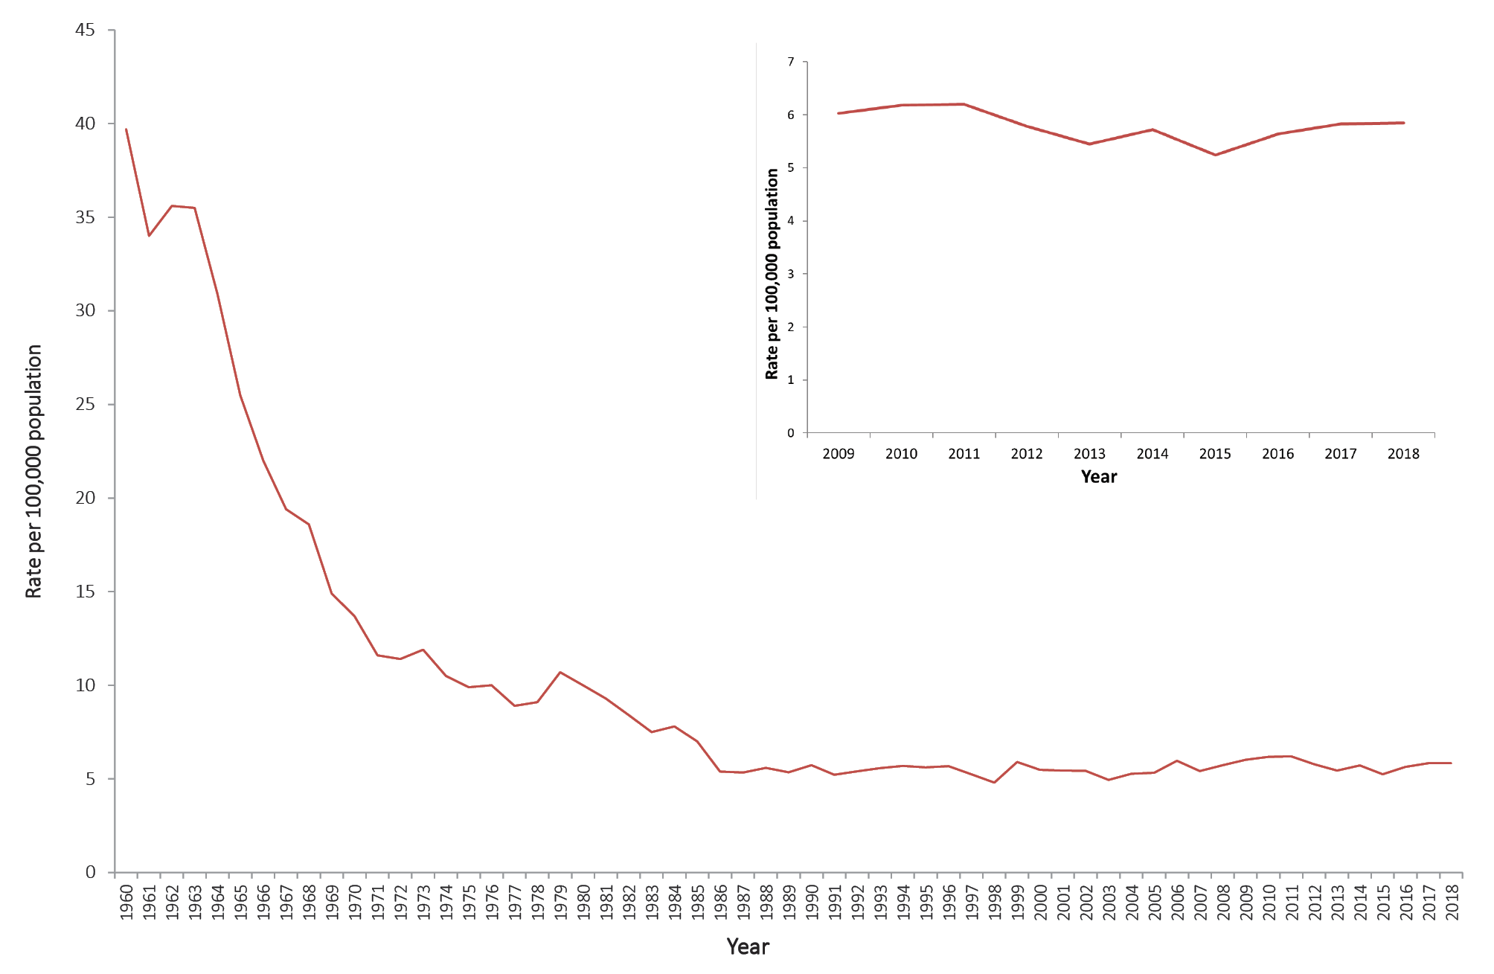

Geographic distribution
In 2018, the Australian Capital Territory recorded a rate of 8.3 per 100,000 (n = 34), a 104% increase on the rate in 2015 (4.0 per 100,000) and the highest rate recorded in the Australian Capital Territory since the collection of NNDSS data commenced in 1992. The Northern Territory and Tasmania both recorded declining rates of TB between 2015 and 2018, with reductions of 34% and 32% respectively (Figure 2).

Figure 2: Notification rates of tuberculosis in Australia, 2011–2018, by state or territory
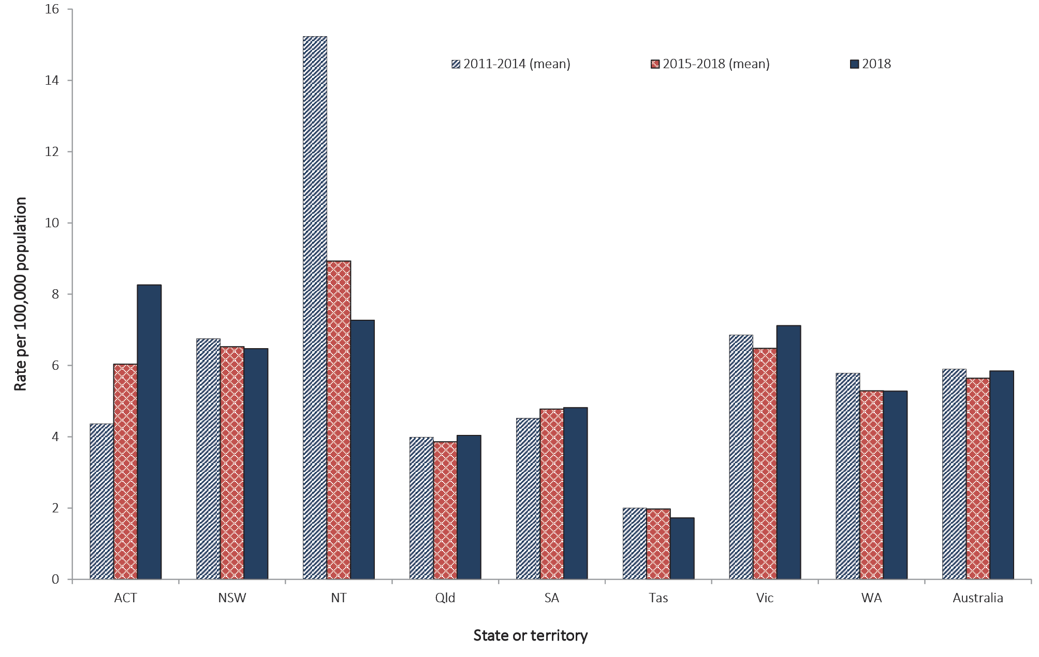

Tuberculosis in the Australian-born population
In 2018, the rate of TB in the Australian-born population was the same as the preceding three years at 0.9 per 100,000, declining from 1.0 per 100,000 in 2015. The rate of TB in Aboriginal and Torres Strait Islander people born in Australia over the last four years was approximately between five and six times the rate of TB in the Australian-born Non-Indigenous population (Table 4). The rate of TB in the Australian-born Non-Indigenous population continues to remain relatively stable and has not exceeded 0.9 per 100,000 in the last decade. The rate of TB in the Aboriginal and Torres Strait Islander population has ranged from 3.8 to 7.5 per 100,000 in the last decade (Figure 3).

Table 4: Notified casesª and rates of tuberculosis, Australia, 2015–2018,ª by population subgroup and state or territory
State or territory | Australian-born Indigenous |  | Australian-born  Non-Indigenous |  | Overseas-born
 | Notifications (n) | Rate per 100,000 | Notifications (n) | Rate per 100,000 | Notifications (n) | Rate per 100,000
2018
ACT | 0 | – | 6 | 2.1 | 28 | 24.7
NSW | 4 | 1.5 | 33 | 0.6 | 472 | 20.3
NT | 4 | 5.4 | 3 | 2.6 | 11 | 19.8
Qld | 14 | 6.3 | 18 | 0.5 | 167 | 14.6
SA | 3 | 7.1 | 11 | 0.9 | 69 | 16.5
Tas | 0 | – | 1 | 0.2 | 8 | 11.8
Vic | 1 | 1.7 | 48 | 1.1 | 400 | 21.1
WA | 3 | 3.0 | 12 | 0.8 | 121 | 13.5
Australia | 29 | 3.6 | 132 | 0.8 | 1,276 | 18.5
2017
ACT | 0 | – | 0 | – | 24 | 21.1
NSW | 5 | 1.9 | 45 | 0.9 | 492 | 21.1
NT | 6 | 8.0 | 2 | 1.7 | 13 | 23.5
Qld | 10 | 4.5 | 23 | 0.7 | 156 | 13.7
SA | 1 | 2.4 | 11 | 0.9 | 62 | 14.8
Tas | 0 | – | 4 | 0.9 | 6 | 8.8
Vic | 2 | 3.5 | 42 | 1.0 | 398 | 21.0
WA | 2 | 2.0 | 11 | 0.7 | 119 | 13.3
Australia | 26 | 3.3 | 138 | 0.8 | 1,270 | 18.4
2016
ACT | 0 | – | 3 | 1.1 | 21 | 18.5
NSW | 7 | 2.6 | 50 | 1.0 | 474 | 20.4
NT | 7 | 9.4 | 2 | 1.7 | 13 | 23.5
Qld | 8 | 3.6 | 21 | 0.6 | 152 | 13.3
SA | 0 | – | 6 | 0.5 | 80 | 19.1
Tas | 0 | – | 0 | – | 9 | 13.3
Vic | 2 | 3.5 | 31 | 0.7 | 333 | 17.6
WA | 1 | 1.0 | 9 | 0.6 | 133 | 14.9
Australia | 25 | 3.1 | 122 | 0.7 | 1,215 | 17.6
2015
ACT | 0 | – | 3 | 1.1 | 13 | 11.5
NSW | 3 | 1.1 | 46 | 0.9 | 395 | 17.0
NT | 9 | 12.1 | 3 | 2.6 | 15 | 27.1
Qld | 15 | 6.8 | 22 | 0.6 | 145 | 12.7
SA | 0 | – | 8 | 0.6 | 76 | 18.1
Tas | 0 | – | 0 | – | 13 | 19.2
Vic | 1 | 1.7 | 39 | 0.9 | 310 | 16.4
WA | 4 | 4.0 | 12 | 0.8 | 115 | 12.8
Australia | 32 | 4.0 | 133 | 0.8 | 1,082 | 15.7
a Excludes one notification in 2018 (unknown COB); one notification in 2017 (unknown COB); two notifications in 2016 (Indigenous status unknown); and two in 2015 (1 unknown COB and one Indigenous status unknown).
Figure 3: Notified cases and rate of tuberculosis in Australia, 2007 to 2018, by population subgroup
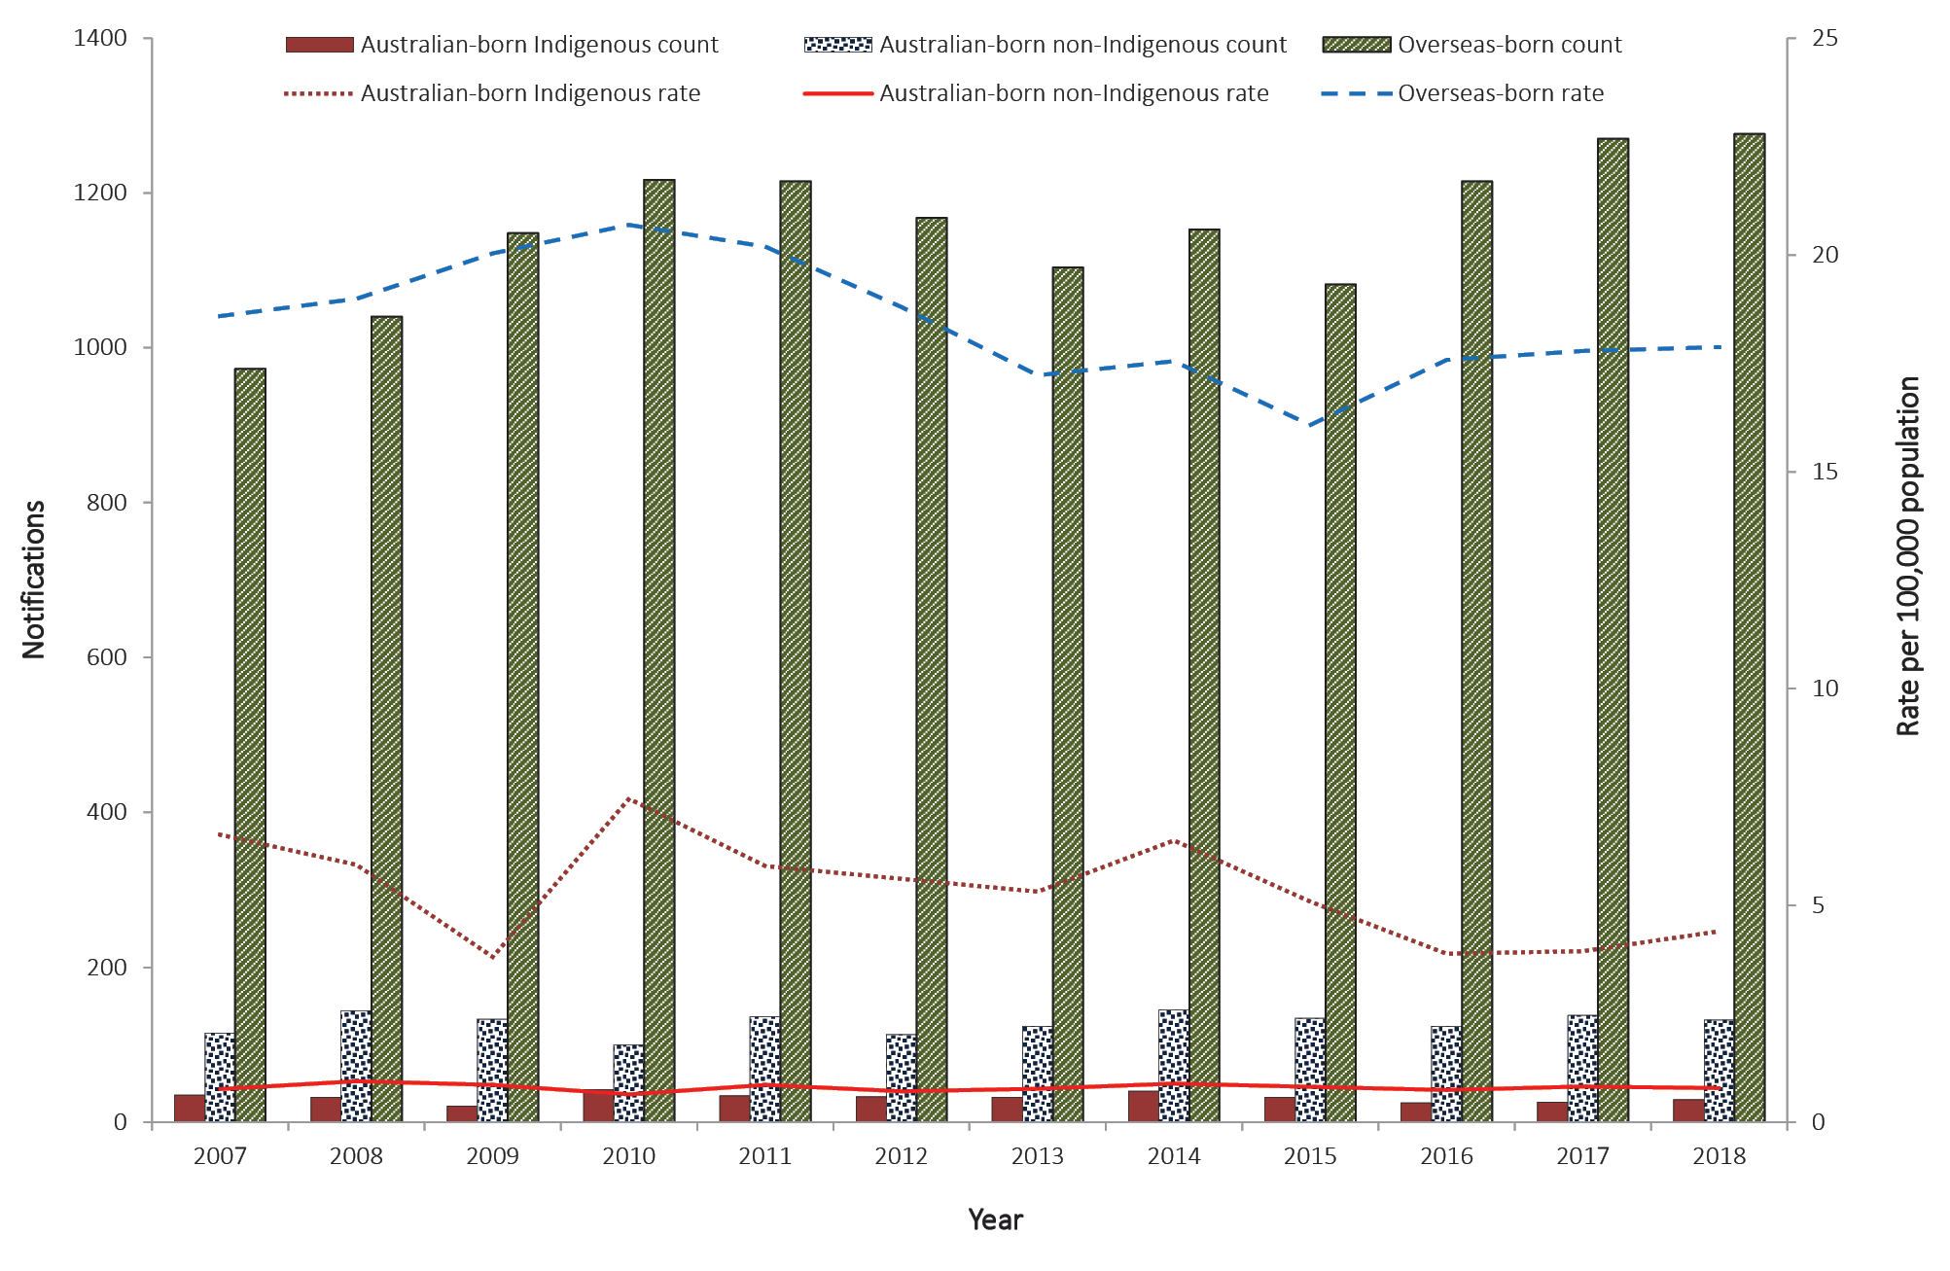

Tuberculosis in the overseas-born population
Between 2015 and 2018, all but three cases were reported with country of birth information (2018, n = 1; 2017, n = 1; 2016, n = 0; and 2015, n = 1). The majority of cases across the four-year period were in people reported as overseas-born: 89% (n = 1,276) in 2018; 89% (n = 1,270) in 2017; 89% (n = 1,215) in 2016; and 87% (n = 1,082) in 2015 (Table 5). Between 2015 and 2018, the rate of TB in the overseas-born population was considerably higher than in the Australian-born population, by a factor of 17 to 20 times higher, consistent with historical trends (Figure 3).
Table 5: Notified cases and rates of tuberculosis in Australia for frequently-reported countries of birth, 2015–2018, by residency status
Country of birth | Residency status |  |  |  | Estimated resident population^{b} | Estimated rate per 100,000 population | WHO incidence rate per 100,000 population^{c}
 | International students | Permanent residents | Other | Total casesª
2018
India | 33 | 110 | 60 | 220 | 592,310 | 37 | 199
Philippines | 10 | 84 | 42 | 143 | 277,510 | 52 | 554
Vietnam | 15 | 86 | 18 | 127 | 256,310 | 50 | 182
China | 16 | 54 | 15 | 90 | 650,700 | 14 | 67
Nepal | 52 | 11 | 14 | 80 | 94,470 | 85 | 151
Indonesia | 13 | 17 | 18 | 50 | 85,700 | 58 | 316
Afghanistan | 0 | 22 | 12 | 35 | 59,730 | 59 | 189
Papua New Guinea | 2 | 10 | 17 | 31 | 34,690 | 92 | 432
Myanmar | 2 | 20 | 7 | 29 | 36,900 | 79 | 338
Pakistan | 7 | 12 | 7 | 28 | 84,340 | 33 | 265
Malaysia | 10 | 7 | 9 | 28 | 173,680 | 16 | 92
Thailand | 3 | 15 | 8 | 27 | 79,040 | 34 | 153
Sri Lanka | 2 | 16 | 2 | 22 | 134,500 | 16 | 64
Bangladesh | 0 | 16 | 2 | 20 | 52,100 | 38 | 221
New Zealand | 0 | 17 | 1 | 20 | 568,290 | 4 | 7
Other overseas-born | 43 | 209 | 62 | 326
Total overseas-born | 208 | 706 | 294 | 1,276
Australian-born | – | – | – | 161
Unknown country of birth | – | – | – | 1
Total | – | – | – | 1,438
2017
India | 31 | 144 | 60 | 251 | 538,070 | 47 | 204
Philippines | 12 | 96 | 37 | 152 | 265,780 | 57 | 554
Vietnam | 21 | 91 | 12 | 133 | 250,590 | 53 | 188
China | 24 | 48 | 16 | 92 | 606,310 | 15 | 68
Nepal | 41 | 15 | 14 | 72 | 73,840 | 98 | 152
Indonesia | 21 | 11 | 13 | 47 | 82,500 | 57 | 319
Malaysia | 9 | 14 | 11 | 35 | 164,680 | 21 | 94
Thailand | 8 | 14 | 9 | 31 | 76,220 | 41 | 156
PNG | 5 | 8 | 15 | 27 | 34,630 | 81 | 432
Myanmar | 2 | 16 | 8 | 26 | 35,490 | 73 | 355
Afghanistan | 0 | 18 | 3 | 23 | 56,590 | 41 | 189
Bangladesh | 4 | 14 | 4 | 23 | 49,160 | 47 | 221
Cambodia | 0 | 20 | 2 | 23 | 36,190 | 64 | 326
Pakistan | 9 | 10 | 3 | 22 | 76,580 | 29 | 267
Sri Lanka | 2 | 14 | 4 | 20 | 129,530 | 15 | 64
Other OS born | 27 | 196 | 56 | 293
Total overseas-born | 216 | 729 | 267 | 1270
Australian-born | – | – | – | 164
Unknown country of birth | – | – | – | 1
Total | – | – | – | 1,435
2016
India | 31 | 132 | 72 | 251 | 489,410 | 51 | 211
Philippines | 6 | 90 | 37 | 141 | 252,690 | 56 | 554
Vietnam | 15 | 82 | 18 | 117 | 243,220 | 48 | 193
China | 14 | 65 | 11 | 92 | 557,690 | 16 | 70
Nepal | 32 | 15 | 13 | 63 | 58,980 | 107 | 154
Indonesia | 13 | 17 | 14 | 45 | 78,970 | 57 | 322
Myanmar | 2 | 21 | 10 | 33 | 34,070 | 97 | 372
Thailand | 9 | 13 | 7 | 30 | 71,250 | 42 | 160
Pakistan | 5 | 18 | 5 | 28 | 69,660 | 40 | 268
Bangladesh | 5 | 15 | 5 | 27 | 46,250 | 58 | 221
Cambodia | 1 | 20 | 1 | 24 | 35,100 | 68 | 347
Malaysia | 9 | 9 | 6 | 24 | 152,900 | 16 | 94
PNG | 1 | 10 | 10 | 22 | 34,260 | 64 | 432
Somalia | 0 | 14 | 8 | 22 | 9,220 | 239 | 270
Afghanistan | 0 | 13 | 8 | 22 | 53,670 | 41 | 189
Other OS born | 17 | 169 | 68 | 274
Total overseas-born | 160 | 703 | 293 | 1,215
Australian-born | – | – | – | 149
Unknown country of birth | – | – | – | –
Total | – | – | – | 1,364
2015
India | 28 | 123 | 58 | 221 | 449,040 | 49 | 217
Vietnam | 9 | 94 | 19 | 125 | 235,590 | 53 | 199
Philippines | 10 | 53 | 31 | 98 | 241,130 | 41 | 550
China | 17 | 53 | 18 | 92 | 508,870 | 18 | 72
Nepal | 22 | 15 | 11 | 50 | 50,150 | 100 | 156
Indonesia | 15 | 17 | 7 | 40 | 77,000 | 52 | 325
Myanmar | 0 | 16 | 14 | 32 | 32,160 | 100 | 391
PNG | 2 | 9 | 20 | 31 | 33,510 | 93 | 432
Sudan | 1 | 16 | 5 | 23 | 19,730 | 117 | 88
Thailand | 7 | 6 | 8 | 23 | 66,400 | 35 | 163
Bangladesh | 1 | 15 | 3 | 23 | 43,090 | 53 | 221
Cambodia | 0 | 15 | 4 | 20 | 34,420 | 58 | 367
Afghanistan | 0 | 13 | 4 | 19 | 49,550 | 38 | 189
Ethiopia | 0 | 15 | 4 | 19 | 13,130 | 145 | 192
Malaysia | 4 | 6 | 7 | 18 | 143,420 | 13 | 90
Other OS born | 23 | 166 | 45 | 246
Total overseas-born | 139 | 632 | 258 | 1,080
Australian-born | – | – | – | 166
Unknown country of birth | 1 | 1 | 1 | 3
Total | – | – | – | 1,249
a Total includes cases reported without a residency status.
b 2018 Population data is sourced from the Australian Bureau of Standards’ 3412.0 - Migration, Australia, 2017–2018 - Estimated Resident Population by Country of Birth - 1996 to 2018
c Rates from the World Health Organization TB Burden Estimates, 2019.

Country of birth
Over the last four years (2015–2018), the top five most frequently reported countries of birth for TB cases were India, Vietnam, the Philippines, China and Nepal. These five countries across the last four years contributed to more than half of all the overseas-born cases (2018 = 52%; 2017 = 55%; 2016 = 55%; 2015 = 54%) (Table 5). In 2018, of the most frequently reported countries of birth listed in Table 6, those born in Papua New Guinea (92 per 100,000) Nepal (85 per 100,000) and Myanmar (79 per 100,000) recorded the highest estimated rates of TB.

Table 6: Notified cases of tuberculosis in overseas-born people in Australia, 2015–2018, by residency status and state or territory
Residency status | ACT | NSW | NT | Qld | SA | Tas | Vic | WA | Australia
2018
Permanent resident | 13 | 257 | 7 | 80 | 4 | 2 | 265 | 77 | 705
Refugee | 0 | 13 | 0 | 17 | 11 | 1 | 7 | 0 | 49
Overseas student | 2 | 102 | 0 | 18 | 12 | 2 | 54 | 18 | 208
Visitor | 6 | 45 | 4 | 11 | 5 | 2 | 20 | 9 | 102
Other | 6 | 38 | 0 | 27 | 1 | 1 | 42 | 15 | 130
Unauthorised person | 0 | 4 | 0 | 1 | 1 | 0 | 1 | 1 | 8
Resident of the Torres Strait Treaty Zone accessing TB treatment in Queensland | N/A | N/A | N/A | 13 | N/A | N/A | N/A | N/A | 13
Unknown or not reported | 1 | 13 | 0 | 0 | 35 | 0 | 11 | 1 | 61
Total overseas-born cases | 28 | 472 | 11 | 167 | 69 | 8 | 400 | 121 | 1,276
2017
Permanent resident | 17 | 298 | 7 | 80 | 2 | 0 | 250 | 74 | 728
Refugee | 0 | 8 | 1 | 9 | 3 | 1 | 9 | 3 | 34
Overseas student | 3 | 87 | 1 | 20 | 11 | 4 | 75 | 15 | 216
Visitor | 3 | 49 | 4 | 12 | 12 | 1 | 14 | 4 | 99
Other | 0 | 31 | 0 | 27 | 0 | 0 | 40 | 22 | 120
Unauthorised person | 0 | 2 | 0 | 1 | 0 | 0 | 3 | 1 | 7
Resident of the Torres Strait Treaty Zone accessing TB treatment in Queensland | N/A | N/A | N/A | 7 | N/A | N/A | N/A | N/A | 7
Unknown or not reported | 1 | 17 | 0 | 0 | 34 | 0 | 7 | 0 | 59
Total overseas-born cases | 24 | 492 | 13 | 156 | 62 | 6 | 398 | 119 | 1,270
2016
Permanent resident | 11 | 287 | 7 | 72 | 8 | 1 | 229 | 88 | 703
Refugee | 0 | 7 | 2 | 16 | 11 | 2 | 6 | 2 | 46
Illegal foreign fisher | 0 | 0 | 1 | 0 | 0 | 0 | 0 | 0 | 1
Overseas student | 6 | 77 | 2 | 19 | 10 | 2 | 35 | 9 | 160
Visitor | 2 | 46 | 0 | 19 | 9 | 2 | 12 | 9 | 99
Other | 2 | 45 | 1 | 22 | 0 | 2 | 43 | 21 | 136
Unauthorised person | 0 | 2 | 0 | 1 | 0 | 0 | 3 | 2 | 8
Resident of the Torres Strait Treaty Zone accessing TB treatment in Queensland | N/A | N/A | N/A | 3 | N/A | N/A | N/A | N/A | 3
Unknown or not reported | 0 | 10 | 0 | 0 | 42 | 0 | 5 | 2 | 59
Total overseas-born cases | 21 | 474 | 13 | 152 | 80 | 9 | 333 | 133 | 1,215
2015
Permanent resident | 6 | 248 | 8 | 73 | 10 | 2 | 220 | 66 | 633
Refugee | 0 | 7 | 1 | 12 | 10 | 6 | 10 | 2 | 48
Illegal foreign fisher | 0 | 0 | 1 | 0 | 0 | 0 | 0 | 0 | 1
Overseas student | 4 | 53 | 0 | 15 | 8 | 3 | 37 | 19 | 139
Visitor | 1 | 36 | 4 | 17 | 13 | 1 | 13 | 12 | 97
Other | 2 | 38 | 1 | 17 | 0 | 1 | 24 | 12 | 95
Unauthorised person | 0 | 5 | 0 | 1 | 0 | 0 | 1 | 2 | 9
Resident of the Torres Strait Treaty Zone accessing TB treatment in Queensland | N/A | N/A | N/A | 10 | N/A | N/A | N/A | N/A | 10
Unknown or not reported | 0 | 8 | 0 | 0 | 35 | 0 | 5 | 2 | 50
Total overseas-born cases | 13 | 395 | 15 | 145 | 76 | 13 | 310 | 115 | 1,082

Note that these estimated rates must be interpreted with caution, as temporary residents are included in Australia’s TB notifications (the numerator) but may not be included in the Australian Bureau of Statistics’ estimated resident population (the denominator).

Residency status
Residency status was available for 95% of overseas-born TB cases reported between 2015 and 2018 (2018: 1,215/1,276; 2017: 1,211/1,270; 2016: 1,156/1,215; 2015: 1,032/1,082). Residency status is self-reported at the time of diagnosis and is not verified against migration records. Across the four years, the majority of overseas-born cases reported with a residency status were reported as permanent residents: 58% in 2018 (705/1,215); 60% in 2017 (728/1,211); 61% in 2016 (703/1,156); and 61% in 2015 (633/1,032) (Table 6). The second-most-reported overseas-born residency status category was ‘overseas student’: 17% in 2018 (208/1,215); 18% in 2017 (216/1,211); 14% in 2016 (160/1,156); and 13% in 2015 (139/1,032).

Time between arrival in Australia and diagnosis
In 2018, data on year of arrival were available for 98% of overseas-born cases (1,254/1,276), the same as 2017 (98%; 1,242/1,270), increasing from 2016 (96%; 1,164/1,215) and 2015 (96%; 1,042/1,082). Of these cases in 2018, 44% (551/1,254) were diagnosed with active TB within four years of arrival in Australia, consistent with the preceding three years: 45% in 2017 (555/1,242); 45% in 2016 (525/1,164); and 44% in 2015 (460/1,042). Of those diagnosed within four years of arrival in Australia, the proportion of ‘overseas students’ in 2018 (33%; 184/551) was similar to the proportion in 2017 (34%; 189/555) but an increase from 26% in both 2016 (137/525) and 2015 (119/460) (Figure 4).

Figure 4: Notified cases of tuberculosis in the overseas-born population in Australia, 2015–2018, by residency status and number of years since arrival
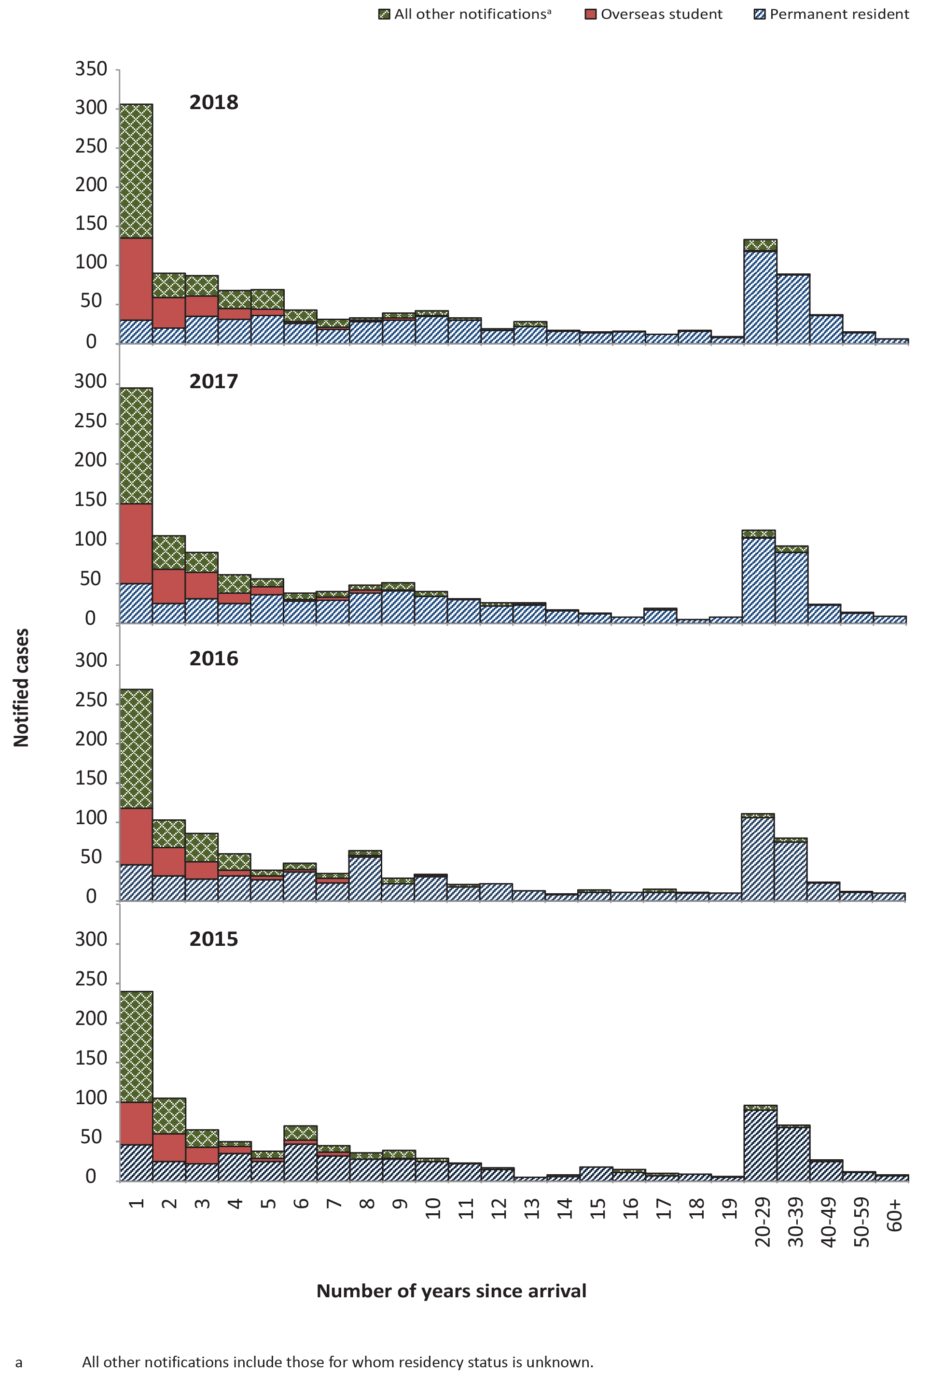

Age and sex distribution
Age and sex were reported for all TB cases notified between 2015 and 2018. Similar to previous years, there were more males than females notified with TB, with females accounting for 49% in 2018; 46% in 2017; and 47% in both 2016 and 2015. Similar to previous years, TB was predominantly seen in young adults aged 25–34 years (2018: 10.6 per 100,000; 2017: 10.8 per 100,000; 2016: 11.0 per 100,000; and 2015: 9.9 per 100,000); this was driven by the high rates observed in overseas-born cases in this age group (Table 7).
Table 7: Notification rates of tuberculosis, Australia, 2015–2018, by population subgroup and age group
Age group | Australian-born Indigenous |  | Australian-born Non-Indigenous |  | Overseas-born |  | Total
 | Notifications (n) | Rate per 100,000 | Notifications (n) | Rate per 100,000 | Notifications (n) | Rate per 100,000 | Notifications (n) | Rate per 100,000
2018
0–4 | 0 | – | 21 | 1.5 | 7 | 10.4 | 28 | 1.8
5–14 | 0 | – | 7 | 0.3 | 14 | 4.2 | 21 | 0.7
0–14 | 0 | – | 28 | 0.7 | 21 | 5.3 | 49 | 1.1
15–24 | 4 | 2.6 | 18 | 0.8 | 200 | 29.1 | 222 | 7.0
25–34 | 5 | 4.4 | 13 | 0.6 | 365 | 27.9 | 384 | 10.6
35–44 | 9 | 10.3 | 11 | 0.5 | 217 | 19.2 | 237 | 7.3
45–54 | 5 | 6.2 | 9 | 0.4 | 136 | 12.8 | 150 | 4.8
55–64 | 2 | 3.8 | 22 | 1.2 | 133 | 14.2 | 157 | 5.6
65+ | 4 | 11.8 | 31 | 1.4 | 204 | 14.8 | 239 | 6.5
2017
0–4 | 0 | – | 20 | 1.4 | 3 | 4.5 | 23 | 1.5
5–14 | 0 | – | 14 | 0.6 | 16 | 4.8 | 30 | 1.0
0–14 | 0 | – | 34 | 0.9 | 19 | 4.8 | 53 | 1.2
15–24 | 2 | 1.3 | 25 | 1.1 | 200 | 29.1 | 227 | 7.2
25–34 | 5 | 4.4 | 15 | 0.7 | 371 | 28.3 | 391 | 10.8
35–44 | 6 | 6.8 | 9 | 0.4 | 221 | 19.5 | 236 | 7.3
45–54 | 6 | 7.5 | 11 | 0.5 | 116 | 10.9 | 133 | 4.2
55–64 | 5 | 9.5 | 15 | 0.8 | 131 | 14.0 | 151 | 5.4
65+ | 2 | 5.9 | 29 | 1.3 | 212 | 15.3 | 244 | 6.6
2016
0–4 | 1 | 1.1 | 10 | 0.7 | 3 | 4.5 | 14 | 0.9
5–14 | 0 | – | 3 | 0.1 | 18 | 5.4 | 21 | 0.7
0–14 | 1 | 0.4 | 13 | 0.3 | 21 | 5.3 | 35 | 0.8
15–24 | 4 | 2.6 | 19 | 0.8 | 164 | 23.9 | 188 | 5.9
25–34 | 1 | 0.9 | 17 | 0.8 | 380 | 29.0 | 398 | 11.0
35–44 | 0 | – | 8 | 0.4 | 225 | 19.9 | 233 | 7.2
45–54 | 5 | 6.2 | 7 | 0.3 | 111 | 10.4 | 124 | 3.9
55–64 | 7 | 13.3 | 20 | 1.1 | 122 | 13.0 | 149 | 5.4
65+ | 7 | 20.6 | 38 | 1.7 | 192 | 13.9 | 237 | 6.5
2015
0–4 | 2 | 2.1 | 16 | 1.1 | 7 | 10.4 | 25 | 1.6
5–14 | 2 | 1.1 | 8 | 0.3 | 11 | 3.3 | 21 | 0.7
0–14 | 4 | 1.5 | 24 | 0.6 | 18 | 4.5 | 46 | 1.0
15–24 | 3 | 1.9 | 27 | 1.2 | 154 | 22.4 | 184 | 5.8
25–34 | 3 | 2.6 | 17 | 0.8 | 338 | 25.8 | 359 | 9.9
35–44 | 7 | 8.0 | 7 | 0.3 | 184 | 16.3 | 198 | 6.1
45–54 | 10 | 12.4 | 14 | 0.7 | 99 | 9.3 | 123 | 3.9
55–64 | 2 | 3.8 | 16 | 0.9 | 121 | 12.9 | 139 | 5.0
65+ | 3 | 8.8 | 28 | 1.2 | 168 | 12.2 | 200 | 5.4

Tuberculosis in children aged under 15 years
One of the most important measures of TB control is the incidence in children aged less than 15 years, because these cases represent recent TB infection. This is especially important in Aboriginal and Torres Islander children in whom disease most likely reflects local transmission. Children aged less than 15 years contributed 3–4% of all TB cases across the four reporting years: 3% in 2018 (49/1,438); 4% in 2017 (53/1,435); 3% in 2016 (35/1,364); and 4% in 2015 (46/1,249) (Table 8). Australian-born Non-Indigenous children represented more than half the total cases in the 0–14 years age group across all reporting years with the exception of 2016: 57% in 2018 (28/49); 64% in 2017 (34/53); 37% in 2016 (13/35); and 52% in 2015 (24/46). Of the Australian-born Non-Indigenous children, the most frequently reported risk factor was having one or more parent born overseas (2018: n = 18; 2017: n = 21; 2016: n = 9; and 2015: n = 15) followed by having a ‘household member or close contact with TB’ (2018: n = 15; 2017: n = 21; 2016: n = 8; and 2015: n = 13). Note that more than one risk factor may be reported for each notified case of TB. The rate of TB in Australian-born Non-Indigenous children has remained relatively stable over the past decade (range: 0.3 to 0.9 per 100,000), whilst the rate in Aboriginal and Torres Strait Islander children (range: 0 to 2.6 per 100,000) has fluctuated over that time. The rate of TB in overseas-born children has ranged from 4.5 to 8.8 per 100,000, but overall rates appear to have declined (Figure 5).

Table 8: Notified cases of tuberculosis,ª Australia, 2015–2018, by population subgroup and selected risk factors
Risk factor^{b} | Australian-born Indigenous | Australian-born Non-Indigenous | Overseas-born | Total
2018
Household or other close contact with TB | 14 | 30 | 188 | 232
Ever resided in a correctional facility^{c} | 4 | 1 | 7 | 12
Ever resided in an aged care facility^{c} | – | – | 1 | 1
Ever employed in an institution^{c,d} | – | 2 | 10 | 12
Currently or previously^{c} employed in health industry in Australia or overseas | – | 22 | 122 | 144
Ever homeless | 5 | 2 | 7 | 14
Past travel to or residence in a high-risk country | 6 | 41 | 1018 | 1065
Chest X-ray suggestive of old untreated TB | – | 6 | 76 | 82
Currently receiving immunosuppressive therapy | 1 | 8 | 55 | 64
Australian-born child with one or more parent born in a high-risk country | – | 21 | 2 | 23
None of the above risk factors | 13 | 33 | 177 | 223
Total cases assessed for risk factors | 28 | 125 | 1,242 | 1,395
2017
Household or other close contact with TB | 11 | 40 | 153 | 204
Ever resided in a correctional facility^{c} | 3 | 2 | 2 | 7
Ever resided in an aged care facility^{c} | – | 1 | 1 | 2
Ever employed in an institution^{c,d} | – | 1 | 13 | 14
Currently or previously^{c} employed in health industry in Australia or overseas | – | 10 | 114 | 124
Ever homeless | 5 | 1 | 9 | 15
Past travel to or residence in a high-risk country | 3 | 41 | 1054 | 1098
Chest X-ray suggestive of old untreated TB | 1 | 3 | 56 | 60
Currently receiving immunosuppressive therapy | 3 | 7 | 55 | 65
Australian-born child with one or more parent born in a high-risk country | – | 23 | 1 | 24
None of the above risk factors | 11 | 44 | 157 | 212
Total cases assessed for risk factors | 26 | 132 | 1,239 | 1,397
2016
Household or other close contact with TB | 12 | 24 | 138 | 174
Ever resided in a correctional facility^{c} | – | 1 | 7 | 8
Ever resided in an aged care facility^{c} | 1 | 1 | 5 | 7
Ever employed in an institutionc,^{d} | 2 | – | 12 | 14
Currently or previously^{c} employed in health industry in Australia or overseas | 1 | 13 | 119 | 133
Ever homeless | 3 | 2 | 7 | 12
Past travel to or residence in a high-risk country | 3 | 48 | 981 | 1032
Chest X-ray suggestive of old untreated TB | – | 2 | 37 | 39
Currently receiving immunosuppressive therapy | 2 | 8 | 55 | 65
Australian-born child with one or more parent born in a high-risk country | – | 14 | 2 | 16
None of the above risk factors | 4 | 31 | 158 | 193
Total cases assessed for risk factors | 24 | 111 | 1,182 | 1,317
2015
Household or other close contact with TB | 17 | 29 | 133 | 179
Ever resided in a correctional facility^{c} | 2 | 3 | 7 | 12
Ever resided in an aged care facility^{c} | – | – | 3 | 3
Ever employed in an institutionc,^{d} | – | – | 9 | 9
Currently or previously^{c} employed in health industry in Australia or overseas | 1 | 3 | 97 | 101
Ever homeless | 3 | 2 | 8 | 13
Past travel to or residence in a high-risk country | 2 | 43 | 838 | 883
Chest X-ray suggestive of old untreated TB | – | 4 | 47 | 51
Currently receiving immunosuppressive therapy | – | 9 | 39 | 48
Australian-born child with one or more parent born in a high-risk country | 1 | 21 | 0 | 22
None of the above risk factors | 9 | 29 | 98 | 136
Total cases assessed for risk factors | 27 | 119 | 997 | 1,143
a Excludes cases with no reported risk factors and unknown country of birth.
b More than one risk factor may be reported for each notified case of TB.
c Within the preceding five years.
d Institution is defined as a correctional facility, aged care facility or homeless shelter.

Figure 5: Notified cases and rate of tuberculosis in children aged 0–14 years, Australia in 2007–2018, by population subgroup
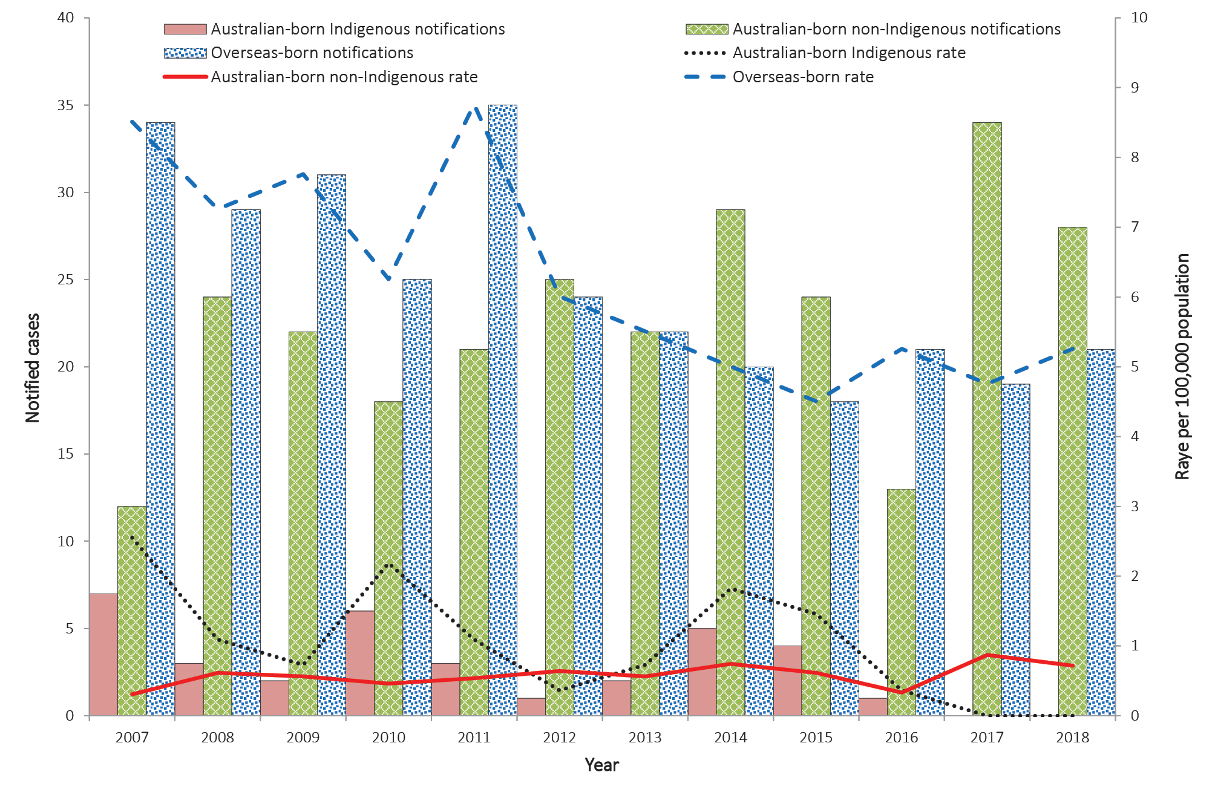

Selected risk factors for tuberculosis
Selected risk factor data were provided for over 90% of notified cases reported between 2015 and 2018: (97% in 2018 (1,395/1,438); 97% in 2017 (1,397/1,435); 97% in 2016 (1,317/1,364); and 92% in 201 (1,143/1,249). Of those cases assessed for risk factors, the most frequently-reported risk factor was past travel to or residence in a high-risk country: 76% in 2018 (1,065/1,395); 79% in 2017(1,098/1,397); 78% in 2016 (1,032/1,317); and 77% in 2015 (883/1,143) (Table 8). When stratified by population subgroup, the most frequently reported known risk factor in both overseas-born cases and in Australian-born Non-Indigenous cases across the four reporting years was past travel to or residence in a high-risk country, while in Aboriginal and Torres Strait Islander cases, having a ‘household member or close contact with TB’ was more frequently reported).
There were 144 people who were currently or had previously worked in a health care setting in 2018; 124 in 2017; 133 in 2016; and 101 in 2015. Of these cases, 31% (45/144) in 2018 were reportedly working in a health care setting in Australia at the time of diagnosis or within 12 months of diagnosis; 39% (48/124) in 2017; 35% (46/133) in 2016; and 35% (35/101) in 2015. One case in 2018 reported working in an Australian healthcare as their only factor; four reported similarly in 2017, five in 2016 and eight in 2015. Of the cases reportedly working in a health care setting in Australia at the time of diagnosis or within 12 months of diagnosis, 42% (19/45) in 2018; 35% (17/48) in 2017; 54% (25/46) in 2016; and 46% (16/35) in 2015 were reported to have extrapulmonary disease only, which is generally not communicable.

Tuberculosis and HIV status
People living with HIV are predisposed to re-activation of latent TB and rapid progression of the disease in recently acquired infection.⁵ In Australia, it is recommended that all patients with TB are tested for HIV, and all HIV patients are tested for the presence of latent or active TB.^{5,6} HIV testing history of notified cases of TB was reported for 98% of cases (n = 1,406) in 2018; 99% (n = 1,422) in 2017; 98% (n = 1,333) in 2016; and 97% (n = 1,211) in 2015. Of the cases with a reported HIV testing history, 89% of cases (1,255/1,406) in 2018 had a known HIV status; 88% (1,256/1,422) in 2017; 79% (1,051/1,333) in 2016; and 69% (841/1,211) in 2015. Of those cases with a known HIV status, 2% of cases (23/1,255) in 2018 were HIV positive; 2% (26/1,256) in 2017; 2% (21/1,051) in 2016; and 2% (20/841) in 2015 (Table 9).
Table 9: Notified cases of tuberculosis, Australia, 2015–2018, by population subgroup and HIV status
HIV testing history | Australian-born Indigenous | Australian-born Non-Indigenous | Overseas-born | Unknown population subgroup | Total
2018
HIV positive | 0 | 3 | 20 | 0 | 23
HIV negative | 26 | 93 | 1,113 | 0 | 1232
HIV tested, result unknown | 0 | 1 | 16 | 0 | 17
Not tested | 2 | 30 | 97 | 0 | 129
Refused testing | 0 | 0 | 5 | 0 | 5
Total - known HIV testing history | 28 | 127 | 1,251 | 0 | 1406
Total - unknown HIV testing history | 1 | 5 | 25 | 1 | 32
Total | 29 | 132 | 1,276 | 1 | 1,438
2017
HIV positive | 1 | 3 | 22 | 0 | 26
HIV negative | 23 | 94 | 1113 | 0 | 1,230
HIV tested, result unknown | 0 | 2 | 13 | 0 | 15
Not tested | 2 | 34 | 109 | 0 | 145
Refused testing | 0 | 1 | 5 | 0 | 6
Total - known HIV testing history | 26 | 134 | 1,262 | 0 | 1,422
Total - unknown HIV testing history | 0 | 4 | 8 | 1 | 13
Total | 26 | 138 | 1,270 | 1 | 1,435
2016
HIV positive | 0 | 2 | 18 | 1 | 21
HIV negative | 24 | 81 | 925 | 0 | 1,030
HIV tested, result unknown | 0 | 7 | 88 | 0 | 95
Not tested | 1 | 28 | 156 | 1 | 186
Refused testing | 0 | 0 | 1 | 0 | 1
Total - known HIV testing history | 25 | 118 | 1,188 | 2 | 1,333
Total - unknown HIV testing history | 0 | 4 | 27 | 0 | 31
Total | 25 | 122 | 1,215 | 2 | 1,364
2015
HIV positive | 0 | 0 | 20 | 0 | 20
HIV negative | 26 | 77 | 717 | 1 | 821
HIV tested, result unknown | 0 | 12 | 151 | 0 | 163
Not tested | 6 | 39 | 156 | 1 | 202
Refused testing | 0 | 0 | 5 | 0 | 5
Total - known HIV testing history | 32 | 128 | 1,049 | 2 | 1,211
Total - unknown HIV testing history | 0 | 5 | 33 | 0 | 38
Total | 32 | 133 | 1,082 | 2 | 1,249

Anatomical site of disease
Across the four reporting years (2015–2018), 99% of notified cases had a reported anatomical site of TB disease. Pulmonary disease was reported in 64% of cases (925/1,438) in 2018; 62% (894/1,435) in 2017; 64% (876/1,364) in 2016; and 64% (795/1,249) in 2015. Of those cases 81% in 2018 (747/925) were reported as having pulmonary disease only; 81% (720/894) in 2017; 82% (717/876) in 2016; and 84% (668/795) in 2015. Extrapulmonary disease only was reported in 36% of cases (513/1,438) in 2018; 38% (540/1,1435) in 2017; 36% (488/1,364) in 2016; and 36% (454/1,249) in 2015. The most frequently-reported extrapulmonary only site of disease across the four reporting years was the lymph nodes (2018: n = 256; 2017: n = 268; 2016: n = 249; and 2015: n = 223).Of the more severe forms of TB, the numbers of cases of miliary and meningeal TB were higher in 2017 and 2018 than in 2015 and 2016 (Table 10).

Table 10: Notified cases of tuberculosis in Australia, 2015–2018, by site of disease and case classification
Site | New cases | Relapse cases | Unknown case classification
2018
Pulmonary
Pulmonary only | 700 | 45 | 2
Pulmonary plus other sites | 171 | 5 | 2
Pulmonary cases – Total | 871 | 50 | 4
Extrapulmonary onlyª
Pleural | 59 | 2 | 0
Lymph nodes | 256 | 5 | 0
Bone/joint | 28 | 1 | 0
Genito/urinary | 30 | 0 | 0
Miliary/disseminated | 14 | 0 | 0
Meningeal | 13 | 1 | 0
Peritoneal | 30 | 1 | 0
Other | 97 | 3 | 1
Extrapulmonary cases – Total | 498 | 14 | 1
Unknown site of disease – Total | 2 | 1 | 0
Total anatomical sites^{a,b} | 1,609 | 69 | 7
Total cases | 1,369 | 64 | 5
2017
Pulmonary
Pulmonary only | 687 | 32 | 1
Pulmonary plus other sites | 168 | 6 | 0
Pulmonary cases – Total | 855 | 38 | 1
Extrapulmonary onlyª
Pleural | 56 | 1 | 0
Lymph nodes | 268 | 12 | 2
Bone/joint | 30 | 0 | 1
Genito/urinary | 21 | 0 | 0
Miliary/disseminated | 12 | 0 | 0
Meningeal | 17 | 0 | 0
Peritoneal | 31 | 1 | 0
Other | 108 | 2 | 0
Extrapulmonary cases – Total | 521 | 16 | 3
Unknown site of disease – Total | 5 | 0 | 0
Total anatomical sites^{a,b} | 1,604 | 60 | 4
Total cases | 1,376 | 54 | 5
2016
Pulmonary
Pulmonary only | 679 | 38 | 0
Pulmonary plus other sites | 154 | 5 | 0
Pulmonary cases – Total | 833 | 43 | 0
Extrapulmonary onlyª
Pleural | 68 | 5 | 0
Lymph nodes | 249 | 11 | 0
Bone/joint | 25 | 0 | 0
Genito/urinary | 18 | 0 | 0
Miliary/disseminated | 8 | 1 | 0
Meningeal | 6 | 0 | 0
Peritoneal | 23 | 1 | 0
Other | 92 | 6 | 0
Extrapulmonary cases – Total | 465 | 23 | 0
Unknown site of disease – Total | 3 | 0 | 0
Total anatomical sites^{a,b} | 1,496 | 67 | 0
Total cases | 1,298 | 66 | 0
2015
Pulmonary
Pulmonary only | 633 | 29 | 6
Pulmonary plus other sites | 122 | 5 | 0
Pulmonary cases – Total | 755 | 34 | 6
Extrapulmonary onlyª
Pleural | 57 | 1 | 0
Lymph nodes | 223 | 14 | 1
Bone/joint | 25 | 5 | 0
Genito/urinary | 28 | 1 | 0
Miliary/disseminated | 4 | 0 | 0
Meningeal | 8 | 0 | 0
Peritoneal | 25 | 0 | 0
Other | 83 | 2 | 0
Extrapulmonary cases – Total | 430 | 23 | 1
Unknown site of disease – Total | 4 | 0 | 0
Total anatomical sites^{a,b} | 1,349 | 62 | 7
Total cases | 1,185 | 57 | 7
a More than one extrapulmonary site may be reported for each notified case of TB.
b Includes anatomical sites from pulmonary cases with other sites of infection.
In children aged less than 15 years, pulmonary disease was reported in 78% of cases (38/49) in 2018; 83% (44/53) in 2017; 71% (25/35) in 2016; and 80% (37/46) in 2015. Extrapulmonary disease only was reported in 22% of cases (11/49) in 2018; 17% (9/53) in 2017; 29% (10/35) in 2016; and 20% (9/46) in 2015. Of the extrapulmonary-disease-only cases, the most frequently-reported extrapulmonary site of disease was the lymph nodes (2018: n = 4; 2017: n = 2; 2016: n = 4; and 2015: n = 5). One case of meningeal TB was reported in 2018; two in 2017; one in 2016; and one in 2015. One (1) case of miliary TB was reported across the four reporting years in 2018.

Bacteriologically-confirmed cases
In 2018, 88% of cases (1,259/1,438) were laboratory confirmed as TB; in 2017 86% (1,235/1,435); in 2016 87% (1,190/1,364); and 88% (1,095/1,249) in 2015. The remaining cases in each of the reporting years were diagnosed using clinical and radiological evidence only. Of the total number of cases reported with pulmonary disease in 2018, 90% were bacteriologically confirmed (837/925); 89% (799/894) in 2017; 92% (805/876) in 2016; and 92% (729/795) in 2015. Of the bacteriologically-confirmed cases with pulmonary disease, 78% (650/837) were either sputum culture positive or bronchoscopy washings/aspirate culture positive in 2018; 77% (619/799) in 2017; 84% (678/805) in 2016; and 85% (622/729) in 2015.
Of the extrapulmonary-only cases, 82% (422/513) in 2018 were bacteriologically and/or histologically confirmed; 81% (435/540) in 2017; 79% (385/488) in 2016; and 81% (366/454) in 2015. Of those, 69% (293/422) in 2018 were ‘other culture’ positive; 75% (325/435) in 2017; 77% (296/385) in 2016; and 75% (276/366) in 2015. Cases with extrapulmonary disease only are generally not infectious and rarely are a source of transmission.⁷

Children aged less than 15 years
In 2018, 61% of cases (30/49) in children aged less than 15 years were bacteriologically and/or histologically confirmed as TB; 49% (26/53) in 2017; 54% (19/35) in 2016; and 52% (24/46) in 2015. Of those, 73% (22/30) in 2018 were reported with pulmonary disease; 73% (19/26) in 2017; 74% (14/19) in 2016; and 71% (17/24) in 2015.
Of the extrapulmonary-only cases in children aged less than 15 years, 73% (8/11) in 2018 were bacteriologically and/or histologically confirmed; 78% (7/9) in 2017; 50% (5/10) in 2016; and 78% (7/9) in 2015. The WHO recommends that wherever possible, a diagnosis of TB in a child should be bacteriologically confirmed.⁸

Drug-resistant tuberculosis in Australia
Drug susceptibility test (DST) results were available for just over three quarters of the TB cases notified across the four reporting years (2018: 79%, 1,132/1,438; 2017: 77%, 1,101/1,435; 2016: 78%, 1,068/1,364; and 2015: 79%, 990/1,249). Of those cases, 12% (133/1,132) in 2018 had resistance to at least one of the standard first line anti-tuberculosis agents reported; 11% (117/1,101) in 2017; 12% (130/1,068) in 2016; and 14% (135/990) in 2015. Rifampicin mono-resistance remained low and was reported in less than 1% of cases (0.4%, 4/1,132) for which DST results were available in 2018; 0.2% (2/1,101) in 2017; 0.3% (3/1,068) in 2016; and 0.6% (6/990) in 2015. Isoniazid mono-resistance was more common than rifampicin mono-resistance and was reported in 5% of cases with DST results available across all four reporting years (2018: 61/1,132; 2017: 56/1,101; 2016: 55/1,068; and 2015: 54/990). In 2018, there were 27 cases of MDR TB (2%, 27/1,132); 22 (2%, 22/1,101) in 2017; 25 (2%, 25/1,068); and 29 (3%, 29/990) in 2015. There was one case of extensively drug-resistant (XDR) TB reported in 2018 and two reported in 2015. No XDR TB cases were reported in 2016 and 2017 (Table 11). The majority of Australia’s MDR TB and XDR TB cases are reported in the overseas-born population. Of the MDR TB cases in 2018, 74% (20/27) were reported in overseas-born persons; 91% (20/22) in 2017; 96% (24/25) in 2016; and 79% (23/29) in 2015. Four (4) cases in 2018; one in 2017; none in 2016; and three in 2015 were born in Papua New Guinea, with all cases in 2018 and two in 2015 identified as residents of the TSPZ accessing TB treatment in Queensland. Of the remaining cases, the most commonly-reported countries of birth across the four reporting years were Vietnam, China, India and the Philippines, which is consistent with previous years. The XDR TB case reported in 2018 was in an overseas student born in Nepal who was diagnosed with pulmonary disease only but was sputum smear negative at the time of diagnosis. No other risk factors were reported for this case. The two XDR TB cases reported in 2015 were in permanent residents, born in Myanmar and Vietnam. The case born in Myanmar was diagnosed with pulmonary disease and extrapulmonary site involvement (pleural) but was sputum smear negative at the time of diagnosis. This case reported travel to or through or residence in a high-risk country/countries other than Myanmar. The case born in Vietnam was diagnosed with extrapulmonary disease (lymph nodes) with reported travel to or through or residence in a high-risk country/countries other than Vietnam.
Table 11: Notified cases of tuberculosis with drug susceptibility testing (DST) results available, Australia, 2015–2018, by drug susceptibility profile
Drug susceptibility testing (DST) profile | Notifications (n) | Percentage of notifications (%)
2018
Resistance to at least one first line anti-tuberculosis agentsª | 133 | 12%
Mono-resistance to rifampicin^{b} | 4 | <1%
Mono-resistance to isoniazid^{b} | 61 | 5%
MDR-TB^{c} | 27 | 2%
XDR-TB^{d} | 1 | <1%
Total cases with DST results | 1,132
2017
Resistance to at least one first line anti-tuberculosis agentsª | 117 | 11%
Mono-resistance to rifampicin^{b} | 2 | <1%
Mono-resistance to isoniazid^{b} | 56 | 5%
MDR-TB^{c} | 22 | 2%
XDR-TB^{d} | 0 | –
Total cases with DST results | 1,101
2016
Resistance to at least one first line anti-tuberculosis agentsª | 130 | 12%
Mono-resistance to rifampicin^{b} | 3 | <1%
Mono-resistance to isoniazid^{b} | 55 | 5%
MDR-TB^{c} | 25 | 2%
XDR-TB^{d} | 0 | –
Total cases with DST results | 1,068
2015
Resistance to at least one first line anti-tuberculosis agentsª | 135 | 14%
Mono-resistance to rifampicin^{b} | 6 | 1%
Mono-resistance to isoniazid^{b} | 54 | 5%
MDR-TB^{c} | 29 | 3%
XDR-TB^{d} | 2 | <1%
Total cases with DST results | 990
a Isoniazid, rifampicin, pyrazinamide, ethambutol and streptomycin.
b Mono-resistance is a case that is resistant to only the specified anti-TB agent and susceptible to all other anti-TB agents.
c Resistance to at least isoniazid and rifampicin but not XDR-TB.
d Resistance to isoniazid and rifampicin, and any of the fluoroquinolones, and to at least one of the three injectable second-line drugs.

Australian-born MDR TB
Of the Australian born MDR TB cases, in 2018 five of the seven cases reported pulmonary disease only and the remaining two cases were reported as having pulmonary disease with extrapulmonary site involvement. Of the two cases in 2017, one was reported with pulmonary disease only and one with extrapulmonary site only, in 2016 the single Australian-born case was reported as having pulmonary disease with extrapulmonary site involvement and in 2015 four out of the six cases had pulmonary disease only one had pulmonary disease and extrapulmonary site involvement and one had extrapulmonary sites only. Four (4) of the Australian born MDR TB cases in 2018 and two cases in 2015 were reported as being Indigenous.

Treatment outcomes
The treatment outcomes of an annual patient cohort are reported in the following year’s annual report. This allows adequate time for all cases notified in a single year to begin treatment and for the treatment outcomes to be recorded in the NNDSS. Treatment outcomes for the 2015, 2016 and 2017 patient cohorts are reported in this annual report. Treatment outcomes for the 2018 patient cohort will be reported in the 2019 annual report.
In 2017, treatment success, which included those who completed treatment and were reported as cured, was reported in 86% of cases (1,239/1,435), consistent with historical trends (2016: 86%, 1,168/1,435; and 2015: 83%, 1,034/1,248).
Twenty (20) cases (1%) were reported to have died from TB in 2017; 16 cases (1%) in 2016; and 13 cases (1%) in 2015. Deaths due to TB were predominately people who were overseas-born (Table 12).

Table 12: Notified cases of tuberculosis, Australia, 2015–2017, by population subgroup and treatment outcome
Treatment outcome | Australian-born Indigenous |  | Australian-born Non-Indigenous |  | Overseas-born |  | Total
 | Notifications (n) | Percentage of notifications (%) | Notifications (n) | Percentage of notifications (%) | Notifications (n) | Percentage of notifications (%) | Notifications (n) | Percentage of notifications (%)
2017
Cured | 4 | 15% | 6 | 4% | 63 | 5% | 73 | 5%
Completed treatment | 15 | 58% | 114 | 83% | 1,037 | 82% | 1,166 | 81%
Interrupted treatmentª | 0 | 0% | 0 | 0% | 3 | 0% | 3 | 0%
Died of tuberculosis | 3 | 12% | 6 | 4% | 11 | 1% | 20 | 1%
Defaulted^{b} | 3 | 12% | 2 | 1% | 21 | 2% | 26 | 2%
Failure^{c} | 0 | 0% | 1 | 1% | 0 | 0% | 1 | 0%
Not followed up, outcome unknown | 0 | 0% | 1 | 1% | 7 | 1% | 9 | 1%
Transferred out of Australia | 0 | 0% | 0 | 0% | 66 | 5% | 66 | 5%
Died of other causes | 1 | 4% | 2 | 1% | 38 | 3% | 41 | 3%
Still under treatment | 0 | 0% | 6 | 4% | 24 | 2% | 30 | 2%
Total | 26 | 100% | 138 | 100% | 1,270 | 100% | 1,435 | 100%
2016
Cured | 2 | 8% | 11 | 9% | 57 | 5% | 70 | 5%
Completed treatment | 20 | 80% | 89 | 73% | 992 | 82% | 1,102 | 81%
Interrupted treatmentª | 0 | 0% | 2 | 2% | 4 | 0% | 6 | 0%
Died of tuberculosis | 1 | 4% | 3 | 2% | 12 | 1% | 16 | 1%
Defaulted^{b} | 0 | 0% | 3 | 2% | 18 | 1% | 21 | 2%
Failure^{c} | 0 | 0% | 0 | 0% | 1 | 0% | 1 | 0%
Not followed up, outcome unknown | 0 | 0% | 3 | 2% | 2 | 0% | 5 | 0%
Transferred out of Australia | 0 | 0% | 0 | 0% | 75 | 6% | 75 | 5%
Died of other causes | 1 | 4% | 11 | 9% | 37 | 3% | 49 | 4%
Still under treatment | 1 | 4% | 0 | 0% | 17 | 1% | 19 | 1%
Total | 25 | 100% | 122 | 100% | 1,215 | 100% | 1,364 | 100%
2015
Cured | 3 | 9% | 7 | 5% | 53 | 5% | 64 | 5%
Completed treatment | 19 | 59% | 108 | 81% | 843 | 78% | 970 | 78%
Interrupted treatmentª | 1 | 3% | 1 | 1% | 5 | 0% | 7 | 1%
Died of tuberculosis | 1 | 3% | 3 | 2% | 9 | 1% | 13 | 1%
Defaulted^{b} | 1 | 3% | 1 | 1% | 16 | 1% | 18 | 1%
Failure^{c} |  | 0% |  | 0% |  | 0% | 0 | 0%
Not followed up, outcome unknown | 0 | 0% | 0 | 0% | 7 | 1% | 7 | 1%
Transferred out of Australia | 0 | 0% | 3 | 2% | 67 | 6% | 70 | 6%
Died of other causes | 2 | 6% | 5 | 4% | 20 | 2% | 27 | 2%
Still under treatment | 5 | 16% | 5 | 4% | 62 | 6% | 73 | 6%
Total | 32 | 100% | 133 | 100% | 1082 | 100% | 1248 | 100%
a ‘Interrupted treatment’ is defined as treatment interrupted for two months or more but completed.
b ‘Defaulted’ is defined as failed to complete treatment.
c ‘Failure’ is defined as sputum culture positive at five months or later.

Table 13: Number of cases and case detection rates of tuberculosis identified through offshore pre-migration screening process, 2015–2018
Year | Number of casesª | Case detection rate  (estimated rate per 100,000 medical examinations)
2015 | 431 | 78
2016 | 445 | 76
2017 | 502 | 81
2018 | 614 | 94
a The number of cases includes cases newly diagnosed through the pre-migration screening process and cases that were already on treatment for TB at the time of screening.
Note: Comparison of pre-migration screening data to previous years should be interpreted with some caution.

Pre-migration health screening
The Migration Regulations 1994, enabled by the Migration Act 1958, stipulate that visa applicants must meet certain Public Interest Criteria; and these criteria include a stipulation that visa applicants must be free from TB or not be a “[…] threat to public health in Australia or a danger to the Australian community”.⁹ Therefore, permanent resident visa applicants, and some temporary resident visa applicants, are required to undergo offshore pre-migration screening which includes a medical examination and a chest x-ray to screen for active TB. Children aged less than 11 years of age are required to undergo a physical examination. Children aged two to 11 years from higher risk countries who are applying for permanent visas are also required to undergo either an Interferon Gamma Release Assay (IGRA) blood test or Tuberculin Skin Test (TST) and, if the result is positive, a chest x-ray. Visa applicants who are identified as having active TB during pre-migration screening are required to undergo treatment for the disease before entry to Australia. Children identified with latent TB (active TB excluded) are asked to present to a state -or territory- based TB service for assessment after migration but are not required to have latent TB treated before migration.
In 2018, there was a 22% increase in the number of TB cases detected through offshore pre-migration screening compared with 2017 (Table 13). In 2018, the highest rate of TB detected through offshore pre-migration screening was in the 65 to 69 year old age group (189 per 100,000). As was also seen for 2017, in 2018 the Philippines (n = 164) and India (n = 100) again made up over 40% of all TB cases detected in visa applicants. Nepal’s number of identified TB cases increased significantly in both 2017 and 2018: from 46 TB cases identified in 2017, 2018 saw an 85% increase in TB identified with 85 TB cases. Of the 614 TB cases detected through offshore pre-migration screening in 2018, 80% were temporary visa applicants (n = 484) and 20% were permanent visa applicants (n = 130). This was perhaps a reflection of the increase of temporary visa immigration medical examinations (IME) from 515,687 in 2017 to 563,484 in 2018, whilst the permanent visa IME caseload decreased from 105,003 to 87,122 over the same period.
The largest number of TB cases identified within temporary visa applicants in 2018 were detected in the Visitor visa cohort (n = 231), followed by the Student visa cohort (n = 166). These rates follow a similar trend to 2017; however, 2018 volumes indicate an overall increase in both Visitor visa applicants (by 7%) and Student visa applicants (by 17%) compared to 2017.
Some form of drug resistance was observed in 10% of TB cases that underwent resistance testing in 2018 (n=33), detected through offshore pre-migration screening, while MDRTB was reported in 10 of the 33 cases. A total of six cases of MDRTB were identified in applicants from five different countries, Vietnam, Bhutan, China, India and Philippines.

TB elimination
The rate of TB in Australia in 2015–2018 remains amongst the lowest recorded globally. Together with a relatively small number of other countries where TB incidence is < 10 per 100,000, Australia is in a position where TB elimination, defined as < 1 case per million population, may be feasible by 2050, noting that there is an ongoing risk of imported cases from countries with high TB incidence (Table 14).
Table 14: Australia milestonesª to achieve TB elimination
Goal | 2018 | Milestone | Targets
 |  | 2020 | 2035 | 2050
To reduce overall TB incidence rate in Australia | 5.8 per 100,000 | 3.1 per 100,000  (10% reduction per annum) | < 1 per 100,000 | < 1 per million  (WHO elimination target)
To reduce the rate of TB in Indigenous Australians | 4.4 per 100,000 | 1.6 per 100,000  (20% reduction per annum) | < 1 per 1 million  (WHO elimination target) | –
To reduce the rate of TB in Australian-born Non-Indigenous Australians | 0.8 per 100,000 | Maintain pre-elimination rates  (< 1 per 100,000) | < 1 per million  (WHO elimination target) | –
a The proposed annual reductions have been set to achieve the WHO elimination targets for low-incidence countries.
Further information on Australia’s Strategic Plan for Control of TB can be found in The Strategic Plan for Control of Tuberculosis in Australia, 2016–2020: Towards Disease Elimination.

Discussion
In many ways, the picture presented in this report is a familiar one for those engaged in TB services in Australia. Overall, the annual TB incidence between 2015 and 2018 has remained at less than 6 per 100,000, with low rates of multidrug resistance, low mortality and high treatment success. The considerable majority of TB cases continue to occur in migrants from higher incidence settings, with notifications in the Australian born population consistently less than 1 per 100,000. However, these relatively stable numbers risk masking the considerable activity occurring in TB services across Australia, and the substantial impact of the disease on individuals and families. They also stand in contrast with Australia’s stated timeline for moving towards TB elimination by 2035, towards which little progress is yet evident. Careful review of this data, then, is important for consideration of opportunities to further strengthen TB management in Australia, particularly with relation to those groups at highest risk.
This report includes consolidated data from several years of TB notifications in Australia. While our intention is for future reports to return to an annual format, this current digest allows for comment on several important themes arising from across this period.
While most cases of TB in Australia are new, a small proportion of cases do occur after prior local treatment. Recurrent cases have historically often been assumed to represent relapse after initial therapy; however, it is increasingly recognised that a considerable proportion in some context relates to reinfection. In Australia, expansion of whole genome sequencing availability now means that more than 60% of isolates are routinely sequenced, with further programmatic incorporation planned. This will allow a greater capacity to distinguish relapse from reinfection, which we hope to include in future reports.
Several demographic groups are at increased risk of TB in Australia, and programmatic responses must engage with relevant communities in ways that allow effective diagnosis, treatment and prevention to occur. Foremost are migrants to Australia, with > 88% of cases occurring in people born outside Australia. However, migrant communities are diverse, and health system responses must be more nuanced in their engagement and response. In this report, we note that migrants from India, the Philippines and Vietnam contributed more than a third of Australian notifications in 2018, highlighting the importance of considering these communities in national planning. In line with increased population size, the total numbers of TB cases continues to grow. TB services must accordingly expand, reflecting both increased numbers of cases and the diverse patient populations which they serve. We also note that around 15% of TB cases in 2015–2018 occurred in international students, who may benefit from additional support through prevention and early detection efforts. Although the burden of TB in Australian Aboriginal and Torres Strait Islander people is low (3.6 per 100,000 in 2018), it is more than four times the rate of disease in other Australian-born people. ‘Closing the Gap’ in TB notifications calls for a better understanding of TB in Aboriginal and Torres Strait Islander communities. While this should involve a closer consideration of TB epidemiology, a better understanding of the social determinants of TB and the holistic impact of both TB disease and response is warranted.
TB antimicrobial resistance (AMR) is a significant barrier to TB elimination and a substantial component of AMR epidemiology globally. At approximately 2% of notified cases where DST was performed, MDR-TB remains uncommon in Australia. Failure to address emerging drug resistance in our region may lead to an increasing number of drug-resistant cases in the Australian migrant population; but over the reporting period, both isoniazid resistance and MDR tuberculosis resistance remain low and stable.¹⁰ Of Australian-born MDR-TB cases in 2015–2018, six of 19 cases were in Aboriginal and/or Torres Strait Islander people. Careful epidemiological analysis and application of next-generation sequencing technologies should be applied jurisdictionally to understand the reasons for any MDR-TB cases in Australian-born people including Aboriginal and Torres Strait Islander people.
The detrimental synergies between TB and HIV coinfection are well-recognised, and Australia continues to have low rates of coinfection. Historically, Australia has had limited data reporting regarding HIV infection in people with TB, related both to low levels of reported testing and to policy impediments to centralised data collection. Across the 2015–2018 reporting period, significant improvement has been seen, with the proportion of cases with known HIV status increasing from 69% to 89%. This increase in testing and reporting has not been accompanied by an increase in the number or proportion of people with HIV/TB coinfection, which has remained ≤ 2% across this period.
As most TB notifications in Australia are connected with international migration, inclusion of pre-migration screening information in this report provides useful insight. Over the reporting period, both the absolute number and rate of TB diagnoses have increased in pre-migration assessments. By 2018, the rate of TB diagnosis was > 90 per 100,000 applicants, which is 16-fold higher than the Australian annual incidence. This underscores the value of pre-migration testing for active TB, both in facilitating access to care for applicants and in reducing the TB burden in Australia after arrival. We also note the expansion of pre-migration testing during this period to include LTBI assessment for children in the 2–11 years age group. The impact of such assessment, and evaluation of the health value of testing other groups for latent TB infection as part of pre-migration evaluation, will be considered in future investigations.
Australia’s national system for recording and reporting TB remains strong, but this report also allows an opportunity to consider data that are not available or presented here. No systematic data collection has occurred regarding the financial impact of TB in Australia, for example, and availability of this information would enhance understanding of the burden of TB in our context. While information is presented here on TB mortality, greater standardisation of definitions would be valuable, as would systematic collection of data on TB morbidity.
Overall, while the consistency of TB incidence and good clinical outcomes reported here support continuation of current service models, this very stability in light of limited progress towards TB elimination invites consideration of alternative approaches to disease prevention and a consideration of how disease importation can be minimised. Future reports will seek to include data on additional program indicators, including latent TB management, and will continue to monitor Australian TB program activity and outcomes towards elimination.

Acknowledgements
National Tuberculosis Advisory Committee members (in alphabetical order): Dr Simone Barry, Dr Ivan Bastian Dr Chris Coulter, Dr Justin Denholm, Clinical Associate Professor Mark Hurwitz, Dr Vicki Krause, Gary Lum (Medical Advisor), Professor Ben Maris, Mr Neil Heron Professor George Rubin, Dr Richard Stapledon, Dr David Stock, Dr Justin Waring (Chair), Ms Kate Pennington (TB Epidemiologist) and the NTAC Secretariat from the Department of Health.
Tuberculosis Data Quality Working Group members (in alphabetical order): Ms Kim Bailey, Ms Rowena Boyd, Ms Michelle Brigham (Chair), Ms Meredith Charman, Ms Maree Hose, Ms Kerryn Lodo, Ms Alex Marmor, Mr Byron Minas, Ms Bridget O’Connor, Ms Kate Pennington, Ms Lisa Shephard, Ms Ee Laine Tay and Dr Justin Waring with Mark Trungove from the Secretariat.
The Australian Mycobacterium Reference Laboratory Network: SA Pathology, Royal Adelaide Hospital, South Australia; Queensland Health Pathology Services, Herston Hospitals Complex, Herston, Queensland; Victorian Infectious Diseases Reference laboratory, North Melbourne, Victoria; PathWest Laboratory Medicine, QEII Medical Centre, Nedlands, Western Australian; and the Institute of Clinical Pathology and Medical Research, Westmead Hospital, Westmead, New South Wales
The data on which this report is based is the work of many people in addition to those noted above. We thank the public health laboratories, State and Territory communicable disease control units, public health units, staff in State and Territory TB control programs and the Department of Home Affairs.

Author details
Amy Bright¹
Justin T Denholm²
Chris Coulter³
Justin Waring⁴
Richard Stapledon⁵

- Office of Health Protection and Response Division, Department of Health, Canberra, ACT
- Victorian Tuberculosis Program, Melbourne Health, Melbourne Vic
- Queensland Mycobacterium Reference Laboratory, Pathology Queensland, Brisbane Qld
- Western Australia Tuberculosis Program, WA Health, Perth WA
- South Australian Tuberculosis Services, Royal Adelaide Hospital, Adelaide SA

Corresponding author
Email: ntac.secretariat@health.gov.au

References
- World Health Assembly, 67. Global strategy and targets for tuberculosis prevention, care and control after 2015 (WHA67.1). Geneva: World Health Organization (WHO); 2014. Available from: https://apps.who.int/iris/handle/10665/162760.
- WHO. The end TB strategy: global strategy and targets for tuberculosis, prevention, care and control after 2015. [Internet.] Geneva: WHO; 2014. [Accessed on 18 March 2020.] Available from: https://www.who.int/tb/strategy/en/.
- Barry C, Konstantinos A, National Tuberculosis Advisory Committee, Tuberculosis notifications in Australia, 2007. Commun Dis Intell Q Rep. 2009;33(3):304–15.
- Australian Government Department of Foreign Affairs and Trade (DFAT). Guidelines for traditional visitors travelling under the Torres Strait Treaty. [Internet.] Canberra: DFAT. [Accessed on 18 March 2020.] Available from: https://www.dfat.gov.au/geo/torres-strait/Pages/guidelines-for-traditional-visitors-travelling-under-the-torres-strait-treaty
- Australian Government Department of Health. Communicable Diseases Network Australia National Guidelines for Public Health Units - Management of TB. [Internet.] Canberra: Australian Government Department of Health; 2015. [Accessed on 28 April 2020.] Available from: https://www1.health.gov.au/internet/main/publishing.nsf/Content/cdna-song-tuberculosis
- Australian Government Department of Health. Communicable Diseases Network Australia National Guidelines for Public Health Units - Human Immunodeficiency Virus (HIV). [Internet.] Canberra: Australian Government Department of Health; 2014. [Accessed on 28 April 2020.] Available from: https://www1.health.gov.au/internet/main/publishing.nsf/Content/cdna-song-HIV.htm
- Sepkowitz KA. How contagious is tuberculosis? Clin Infect Dis. 1996;23(5):954–62.
- WHO. Guidance for national tuberculosis programmes on the management of tuberculosis in children. (Second edition.) Geneva: WHO; 2014. Available from: https://www.who.int/tb/publications/childtb_guidelines/en/.
- Australian Government. Schedule 4 Migration Regulations 1994. (Statutory Rules No. 268 1994.) Canberra: Australian Government; 9 September 2020. [Accessed on 15 September 2020.] Available from: https://www.legislation.gov.au/Details/F2020C00814
- Ragonnet R, Trauer JM, Denholm JT, Marais BJ, McBryde ES. High rates of multidrug-resistant and rifampicin-resistant tuberculosis among re-treatment cases: where do they come from? BMC Infect Dis. 2017;17(1):36. doi: https://doi.org/10.1186/s12879-016-2171-1.

Communicable Diseases Intelligence
ISSN: 2209-6051 Online

Communicable Diseases Intelligence (CDI) is a peer-reviewed scientific journal published by the Office of Health Protection, Department of Health. The journal aims to disseminate information on the epidemiology, surveillance, prevention and control of communicable diseases of relevance to Australia.

Editor: Tanja Farmer
Deputy Editor: Simon Petrie
Design and Production: Kasra Yousefi
Editorial Advisory Board: David Durrheim, Mark Ferson, John Kaldor, Martyn Kirk and Linda Selvey

Website: http://www.health.gov.au/cdi

Contacts
Communicable Diseases Intelligence is produced by:
Health Protection Policy Branch, Office of Health Protection, Australian Government Department of Health
GPO Box 9848, (MDP 6) CANBERRA ACT 2601

Email: cdi.editor@health.gov.au

Submit an Article
You are invited to submit your next communicable disease related article to the Communicable Diseases Intelligence (CDI) for consideration. More information regarding CDI can be found at: http://health.gov.au/cdi.
Further enquiries should be directed to: cdi.editor@health.gov.au.

This journal is indexed by Index Medicus and Medline.

Creative Commons Licence - Attribution-NonCommercial-NoDerivatives CC BY-NC-ND
© 2020 Commonwealth of Australia as represented by the Department of Health
This publication is licensed under a Creative Commons Attribution-NonCommercial-NoDerivatives 4.0 International Licence from https://creativecommons.org/licenses/by-nc-nd/4.0/legalcode (Licence). You must read and understand the Licence before using any material from this publication.

Restrictions
The Licence does not cover, and there is no permission given for, use of any of the following material found in this publication (if any):
- the Commonwealth Coat of Arms (by way of information, the terms under which the Coat of Arms may be used can be found at www.itsanhonour.gov.au);
- any logos (including the Department of Health’s logo) and trademarks;
- any photographs and images;
- any signatures; and
- any material belonging to third parties.

Disclaimer
Opinions expressed in Communicable Diseases Intelligence are those of the authors and not necessarily those of the Australian Government Department of Health or the Communicable Diseases Network Australia. Data may be subject to revision.

Enquiries
Enquiries regarding any other use of this publication should be addressed to the Communication Branch, Department of Health, GPO Box 9848, Canberra ACT 2601, or via e-mail to: copyright@health.gov.au

Communicable Diseases Network Australia
Communicable Diseases Intelligence contributes to the work of the Communicable Diseases Network Australia.
http://www.health.gov.au/cdna

The date the notification of the disease was received by the Communicable Disease Section of the Health Authority (i.e. the date the notification was received by the state or territory health department).
https://www.abs.gov.au/statistics/people/population/national-state-and-territory-population/sep-2019.
https://www.abs.gov.au/statistics/people/population/migration-australia/2017-18.
Excluding the category ‘none of the above risk factors’.
Pulmonary cases include both pulmonary-only cases and pulmonary cases that also have extrapulmonary sites detected.
‘Other culture’ includes specimens, other than sputum or bronchoscopy washings/aspirate, in which mycobacteria tuberculosis complex was isolated by culture, at the time of diagnosis.
Resistance to isoniazid and rifampicin, and any of the fluoroquinolones, and to at least one of the three injectable second-line drugs.
https://www1.health.gov.au/internet/main/publishing.nsf/Content/ohp-ntac-tb-strat-plan.htm.

