COVID-19, Australia: Epidemiology Report 8:
Reporting period from 19:00 AEDT 14 March to 23:59 AEDT 22 March 2020
COVID-19 National Incident Room Surveillance Team
Erratum: An error occurred in Figure 1 (Confirmed cases of COVID-19 infection, Australia, by date of illness onset) as originally published, which inadvertently transposed the numbers of reported cases for Western Australia and Victoria. This has now been amended.

Summary
This is the eighth epidemiological report for coronavirus disease 2019 (COVID-19), reported in Australia as at 23:59 Australian Eastern Daylight Time [AEDT] 22 March 2020. It includes data on COVID-19 cases diagnosed in Australia, the international situation and a review of current evidence.
Keywords: SARS-CoV-2; novel coronavirus; 2019-nCoV; coronavirus disease 2019; COVID-19; acute respiratory disease; case definition; epidemiology; Australia
The following epidemiological data are subject to change both domestically and internationally due to the rapidly evolving situation. Australian cases are still under active investigation. While every effort has been made to standardise the investigation of cases nationally, there may be some differences between jurisdictions.
In Australia:
- There have been 1,765 confirmed cases, including seven deaths, reported in Australia as at 23:59 AEDT 22 March 2020. Of confirmed cases, 43% were reported from NSW, 21% from Qld, 18% from Vic, 8% from SA, 7% from WA, 2% from ACT, 1% from Tas, and 0.2% from NT;
- Sixty-five percent of the total number of reported cases so far have been during the current reporting period;
- Hospitalisation status was recorded for 717 cases, of which 26% (n = 190) were reported to have been hospitalised due to their COVID-19 infection. Of these hospitalised cases, ICU (Intensive Care Unit) status was recorded for 87 cases, of which 20% (n = 17) were were admitted to an ICU, with two cases requiring ventilation; and
- Virus genome sequences currently available from Australian cases indicate introductions from China, Iran, Europe and the USA, reflecting global diversity of SARS-COV-2 and corroborating field epidemiology.
Internationally:
- 292,142 infections have been confirmed globally, with 12,784 deaths;
- Cases have so far been reported in 175 countries, territories and areas globally;
- So far, the largest number of confirmed infections (29%; n = 81,498) within any country has been reported in mainland China, with the largest number of deaths (38%; n = 4,827) in Italy;
- The number of daily new cases reported in mainland China has continued to decrease. Cases have continued to increase in other countries, territories and areas globally, with the greatest increases currently occurring in the European Region; and
- Approximately 52% (n = 151,293) of all cases have been reported from the European Region, predominately from Italy, Spain, Germany and France.

Australian situation
As at 23:59 AEDT 22 March 2020, there were 1,765 confirmed cases, including seven deaths in Australia, reported to the National Notifiable Diseases Surveillance System (NNDSS) (Table 1, Figure 1). Of the 1,765 confirmed cases, 43% (n = 766) were reported in NSW, 21% (n = 362) from Qld, 18% (n = 313) from Vic, 8% (n = 137) from SA, 7% (n = 130) from WA, 2% (n = 32) from ACT, 1% (n = 21) from Tas, and 0.2% (n = 4) from NT (Figure 2). The rate of cases in Australia per 100,000 population was 7.0; this varied across jurisdictions with NSW 9.5, SA 7.8, ACT 7.5, Qld 7.1, WA 5.0, Vic 4.8, Tas 3.9 and NT 1.6. Of the cases with a usual residence in Australia, most cases are reported to reside within major metropolitan areas, with a small number of cases reported outside these areas (Figure 2).
During the current reporting period a total of 1,143 cases were reported. NSW (38%) reported the largest number of new cases, followed by Queensland (24%).
The median age of all 1,795 reported Australian cases was 48 years (range 0–94 years), with the highest proportion of cases aged between 20–29 and 60–69 years (Figure 3). Confirmed case rates within a given age cohort were highest for both males and females aged 60–69 years (Figure 4). There continues to be very few cases reported among children. The male-to-female ratio was approximately 1:1 overall.
Of the 1,765 confirmed cases, 51% (n = 907) had data on symptoms. Of the symptoms reported, cough (69%; n=628) was the most common. Fifty percent (n = 454) reported fever, 46% (n = 415) reported sore throat, 36% (n = 329) reported headache, and 28% (n = 251) reported muscular pain. Only 2% or fewer of all cases reported either abdominal pain, pneumonia or acute respiratory disease (ARD). An analysis of symptom combinations highlights that cough is the predominant clinical presentation in combination with fever and/or sore throat (Figure 5).
Hospitalisation status was recorded for 717 cases of which 26% (n = 190) were reported to have been hospitalised due to their COVID-19 infection. Of these hospitalised cases, ICU (Intensive Care Unit) status was recorded for 87 cases of which 20% (n = 17) were recorded being admitted to an ICU, with two cases requiring ventilation.
Seven COVID-19 deaths were confirmed in Australia up to 22 March 2020. The median age of deceased individuals was 81 years (range 78 to 94 years). Three of these deaths were from an aged care facility, one was associated with a cruise ship repatriation and the other three cases were acquired in the community. Three of the cases were male and four were female. The period between the date of illness onset and death ranged from 0 to 12 days.
Of cases with a reported place of acquisition (1,281 of 1,765), sixty-eight percent (n = 872) had a recent international travel history and 32% (n = 409) were locally acquired (Figure 6). The majority of recent overseas acquired cases reported a travel history to the European Region or the Americas Region. Of the locally acquired cases the majority were considered to be contacts of a confirmed case, with a very small number of cases not able to be epidemiologically linked to a confirmed case. For the remainder of cases where a place of acquisition has not been reported, these cases are currently under public health investigation.
Virus genome sequences currently available from Australian cases indicate introductions from China, the Islamic Republic of Iran, Europe and the USA, reflecting the global diversity of SARS-COV-2 and corroborating field epidemiology (Figure 7).

Figure 1: Confirmed cases of COVID-19 infection, Australia, by date of illness onsetª
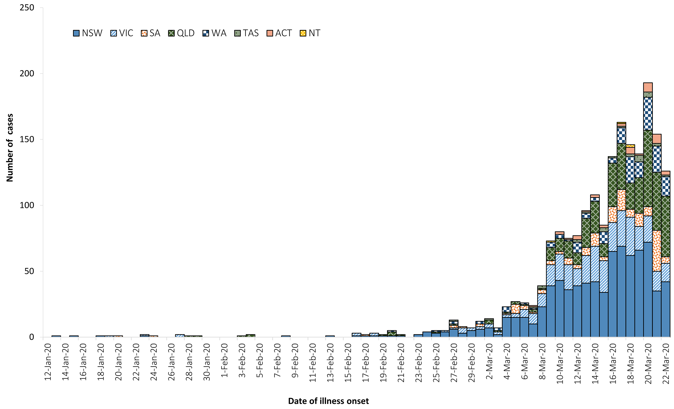
a Recently reported cases shown in the graph should be interpreted with caution as there can be delays in reporting.
Figure 2: Confirmed cases of COVID-19, Australia, by location of usual residence and statistical area level 3ª
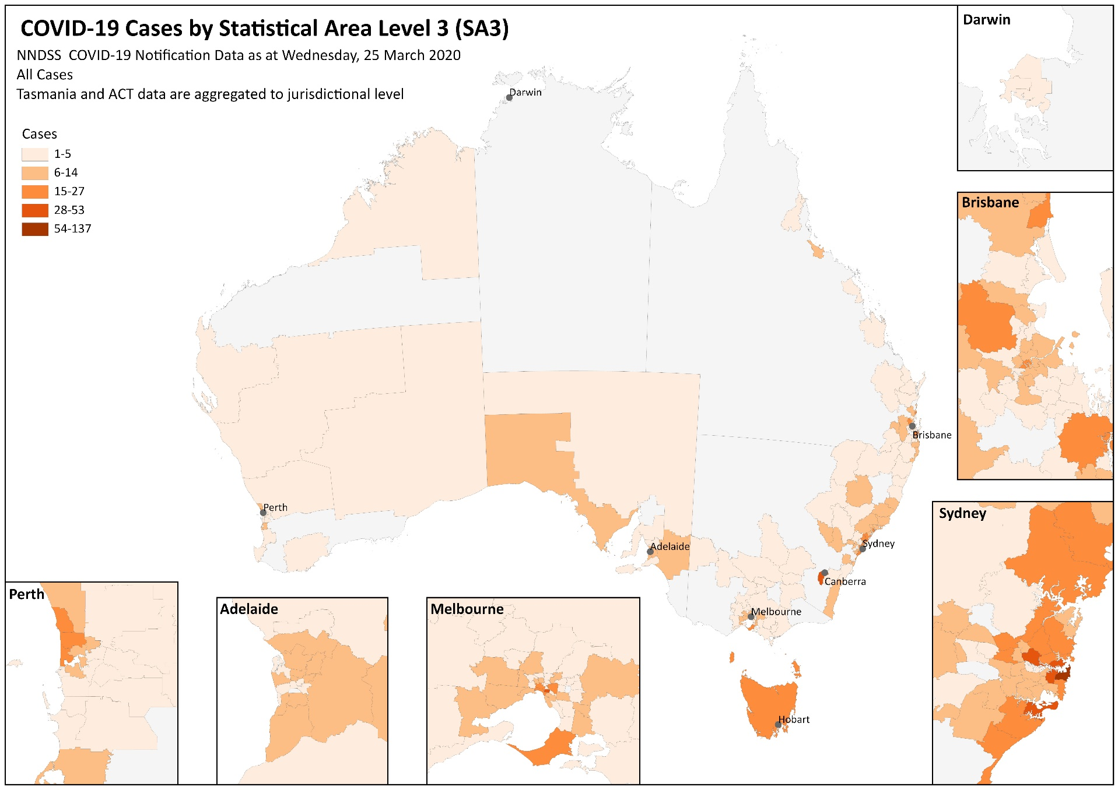
a Represents the usual location of residence of a case, which does not necessarily mean that this is the place where they acquired their infection or were diagnosed. Overseas residents who do not have a usual place of residence in Australia are not shown.

Table 1: Cumulative notified cases of confirmed COVID-19 and diagnostic tests performed, Australia, by jurisdiction
Jurisdictionª | Number of new cases this reporting period^{b}  (19:00 AEDT 14 March to 23:59 AEDT 22 March 2020) | Total cases^{b}  (to 23:59 AEDT 22 March 2020) | Cases per 100,000 population | Cumulative number of tests performed  (proportion of tests positive %)
NSW | 445 | 766 | 9.5 | 59,131 (1.3%)
Vic | 90 | 313 | 4.8 | 24,813 (1.3%)
Qld | 273 | 362 | 7.1 | 31,868 (1.1%)
WA | 169 | 130 | 5.0 | 9,498 (1.4%)
SA | 117 | 137 | 7.8 | 13,000 (1.1%)
Tas | 19 | 21 | 3.9 | 1,020 (2.1%)
NT | 3 | 4 | 1.6 | 1,098 (0.4%)
ACT | 27 | 32 | 7.5 | 2,628 (1.2%)
Total | 1,143 | 1,765 | 7.0 | 143,056 (1.2%)
a NSW = New South Wales, Vic = Victoria, Qld = Queensland, WA = Western Australia, SA = South Australia, Tas = Tasmania, NT = Northern Territory, ACT = Australian Capital Territory.
b Due to the dynamic nature of the NNDSS, data in this extract is subject to retrospective revision and may vary from data reported in previously published reports and reports of notification data by states and territories.

Figure 3: Age distribution of COVID-19 cases, Australia, by sex
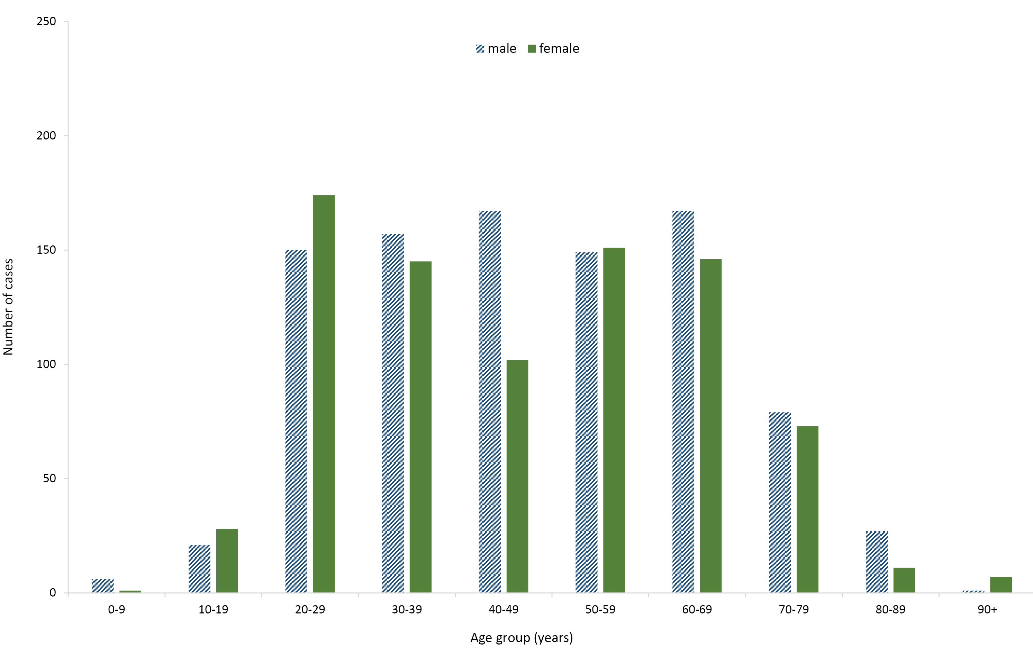

Figure 4: Case rates of COVID-19 cases, Australia, by age and sex
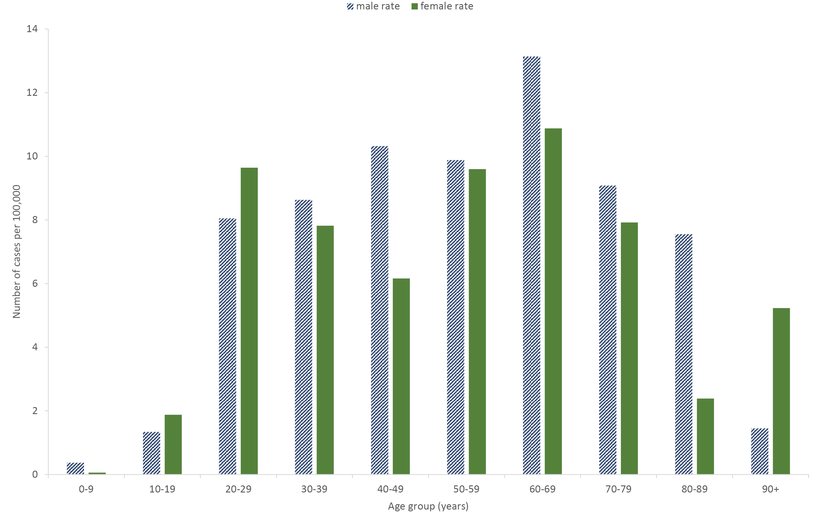
Figure 5: Variation in combinations of COVID-19 symptoms in confirmed cases, Australiaª
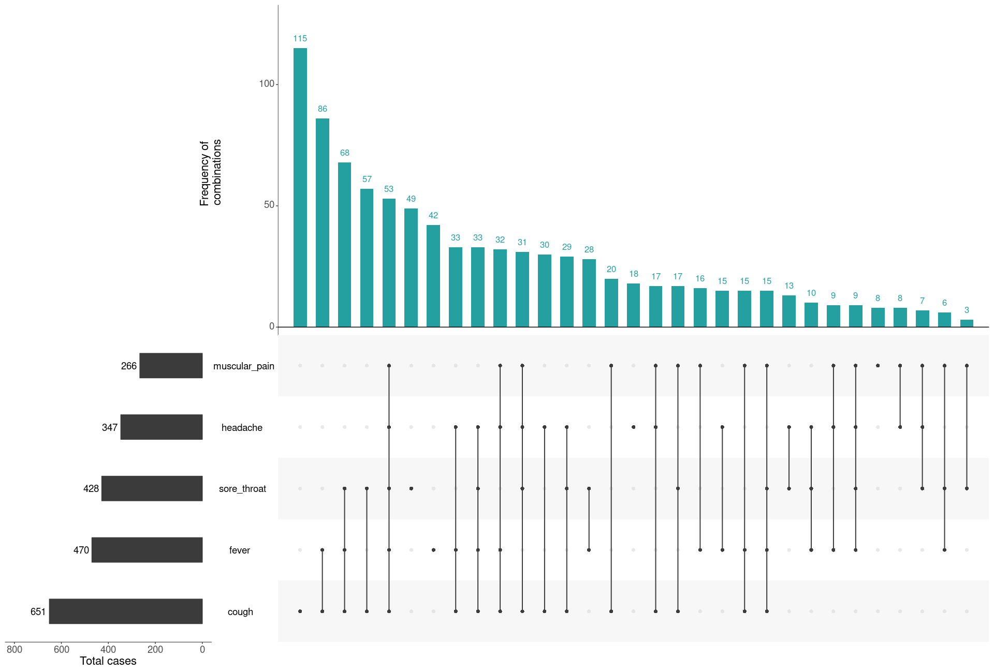
a This figure shows the variation in combinations of symptoms observed in reported cases (n = 938) for the five most frequently observed symptoms (cough, fever, sore throat, headache, muscular pain). The bars on the left show the frequency of symptom occurrence in any combination with other symptoms. The circles and lines indicate particular combinations of symptoms observed in individual patients. The green bars indicate the frequency of occurrence of the corresponding combination of symptoms.
Figure 6: Number of COVID-19 cases by place of acquisition over time, Australia (n = 1,765)ª
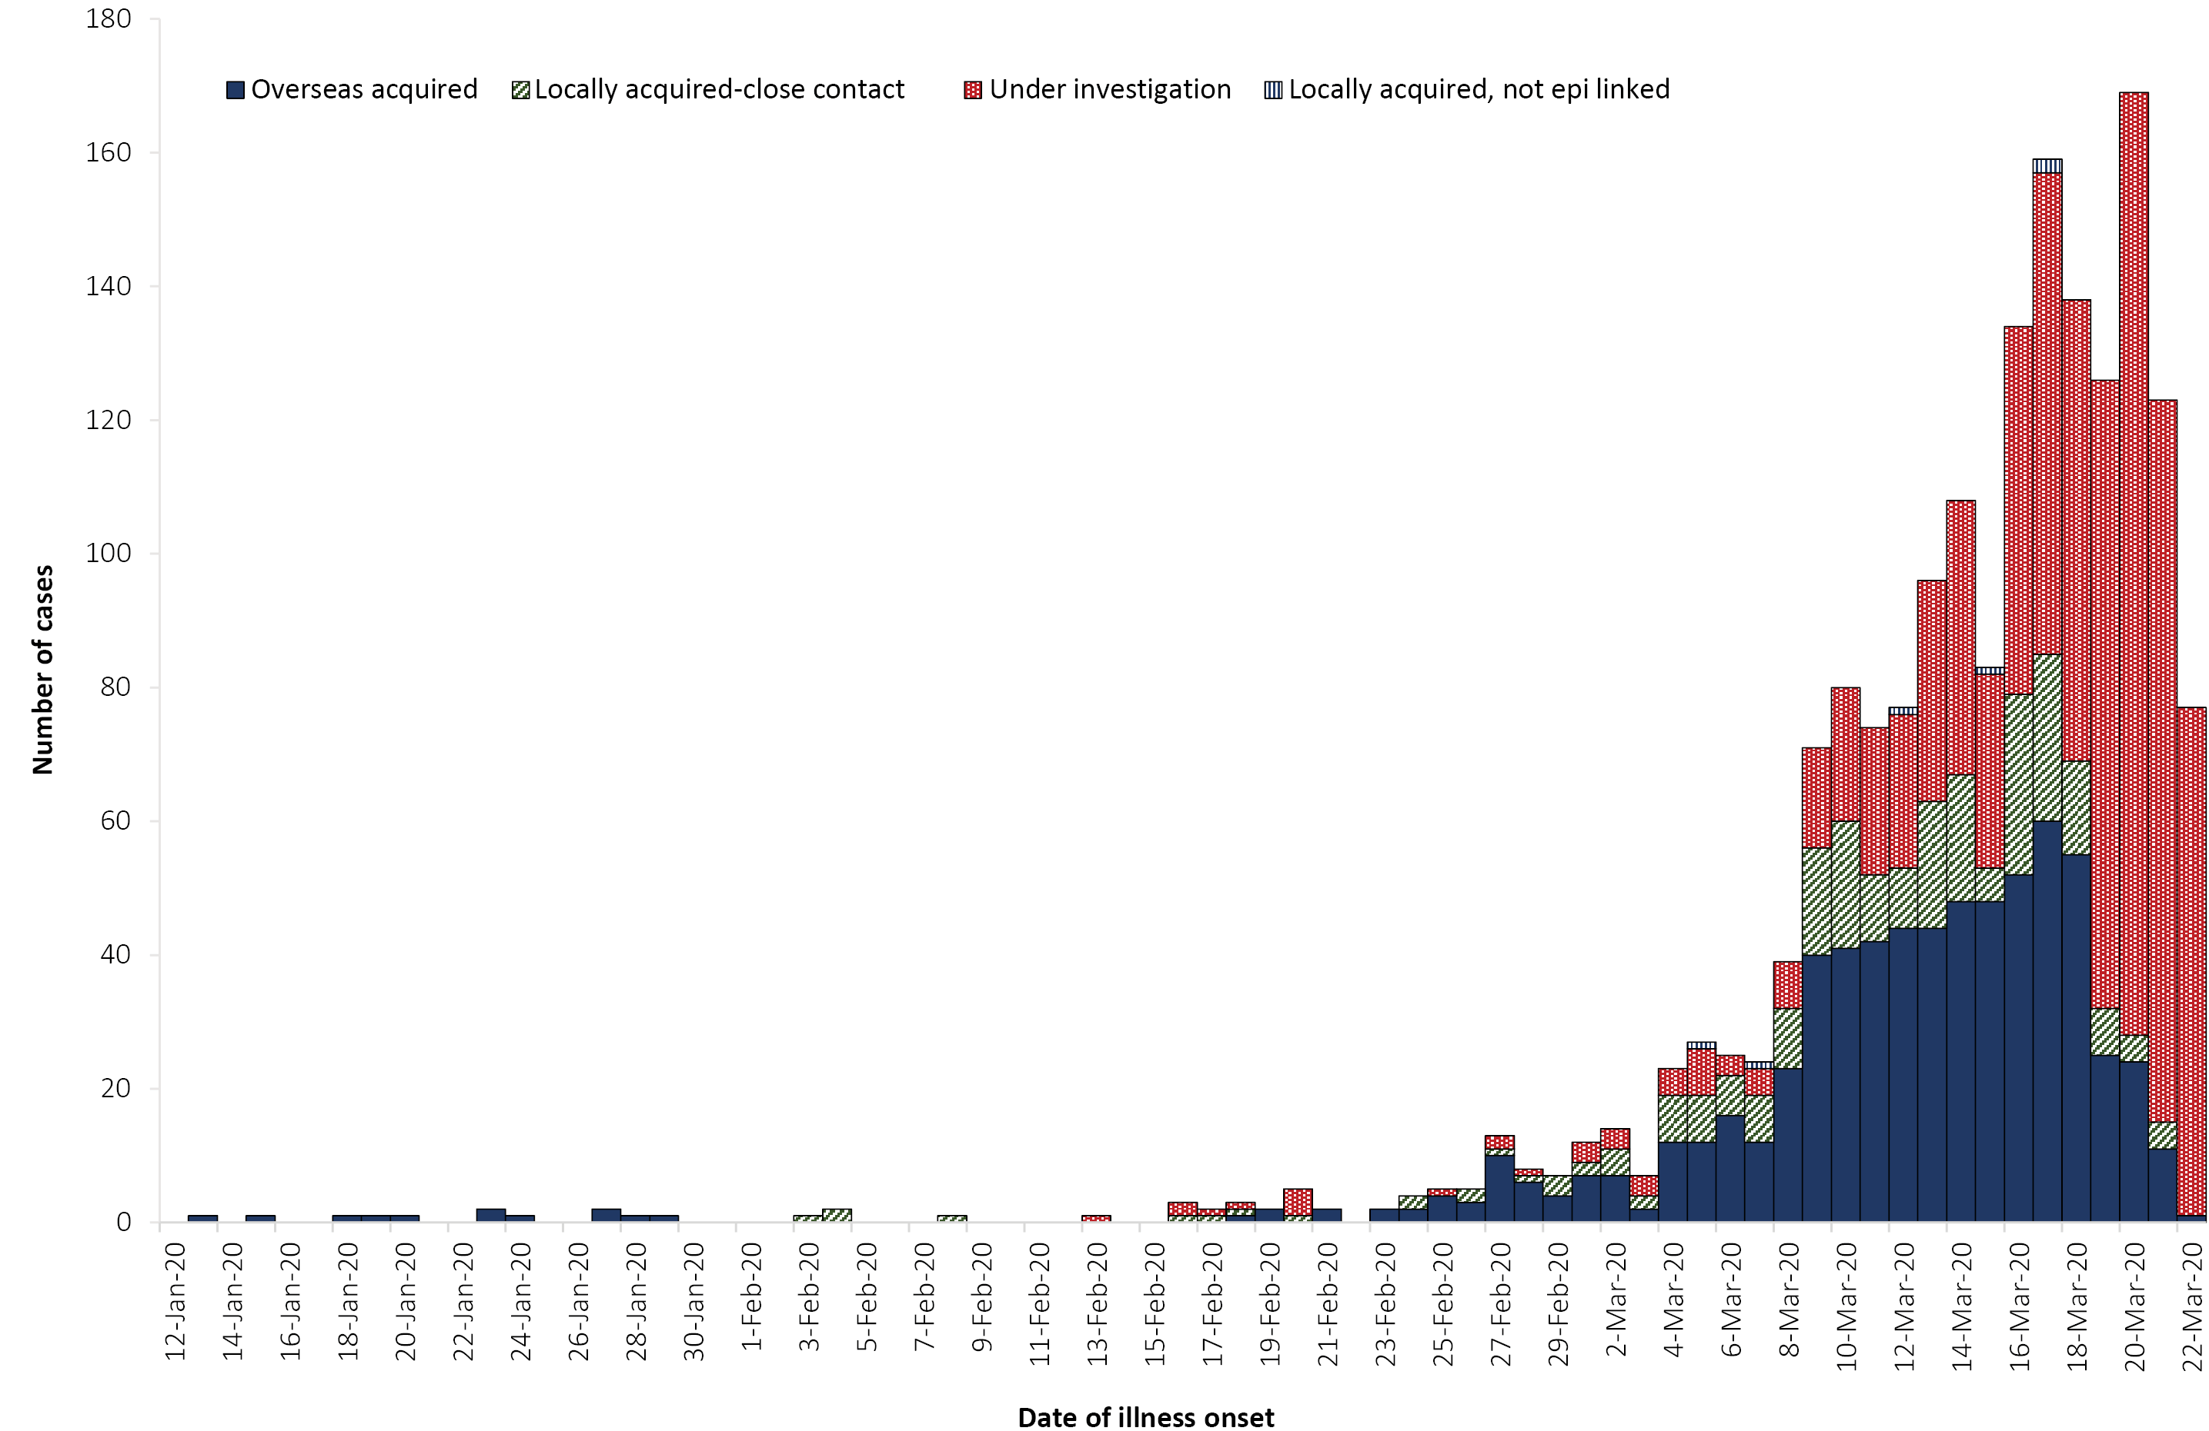
a Recently reported cases shown in the graph should be interpreted with caution as there can be delays in reporting.
Figure 7: Confirmed cases of overseas acquired COVID-19 infection (n = 872) by WHO region of originª
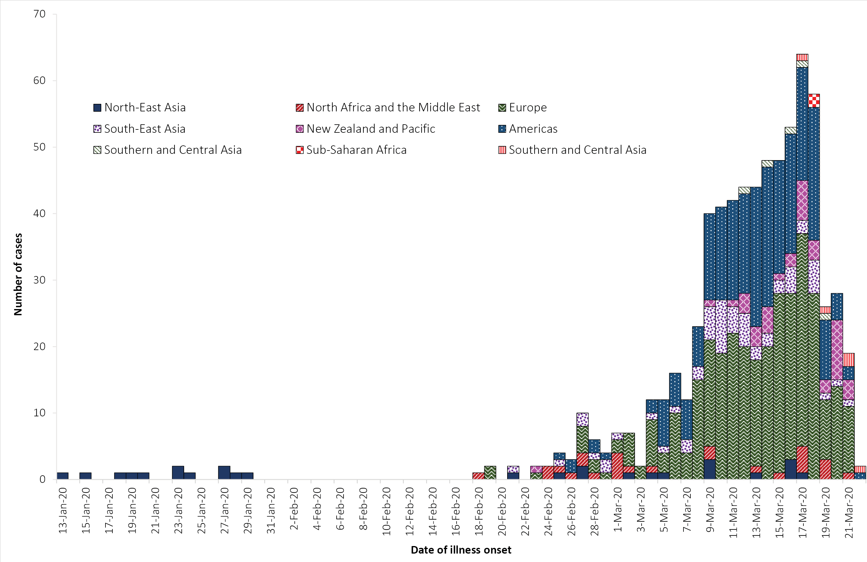
a Recently reported cases shown in the graph should be interpreted with caution as there can be delays in reporting.

International situation
As at 23:59 AEDT 22 March 2020, the number of confirmed COVID-19 cases reported to the World Health Organization (WHO) was 292,142 globally.¹ The proportion of total cases reported from mainland China has continued to decrease, from 57% on 14 March, to 29% on 22 March 2020.^{1,2}
The number of new cases reported outside of mainland China has continued or rapidly increase. The total number of confirmed COVID-19 cases reported by 174 countries, territories and areas outside mainland China in the current reporting week has increased more than threefold (n = 210,644) compared to the preceding week (n = 61,518).^{1,2} Italy reported 25% (n = 53,578) of all cases outside of mainland China; Spain reported 12% (n = 24,926); Germany reported 10% (n = 21,463); the US reported 7% (n = 15,219); and the Islamic Republic of Iran reported 5% (n = 10,610). Forty countries, territories and areas reported cases of COVID-19 for the first time in the past seven days. Of all the countries, territories and areas outside of mainland China with known transmission classification (n = 174), 59% (n = 103) have reported local transmission of COVID-19.
Globally, there are very different epidemics occurring in different countries, with the trajectories of different countries’ outbreaks after their first 100 cases showing remarkable variation. Figure 8 highlights that for a number of countries outside of mainland China which have reported more than 100 cases, their rates of increase continue to be quite substantial, particularly Italy, Spain and the United States of America. For several other countries or regions including Singapore, Japan and Hong Kong there continues to be a slow rate of increase in their number of new cases, with the Republic of Korea reporting very few new cases each day.
Figure 8: Number of COVID-19 cases (logarithmic scale) by selected country and days since passing 100 cases, up to 22 March 2020
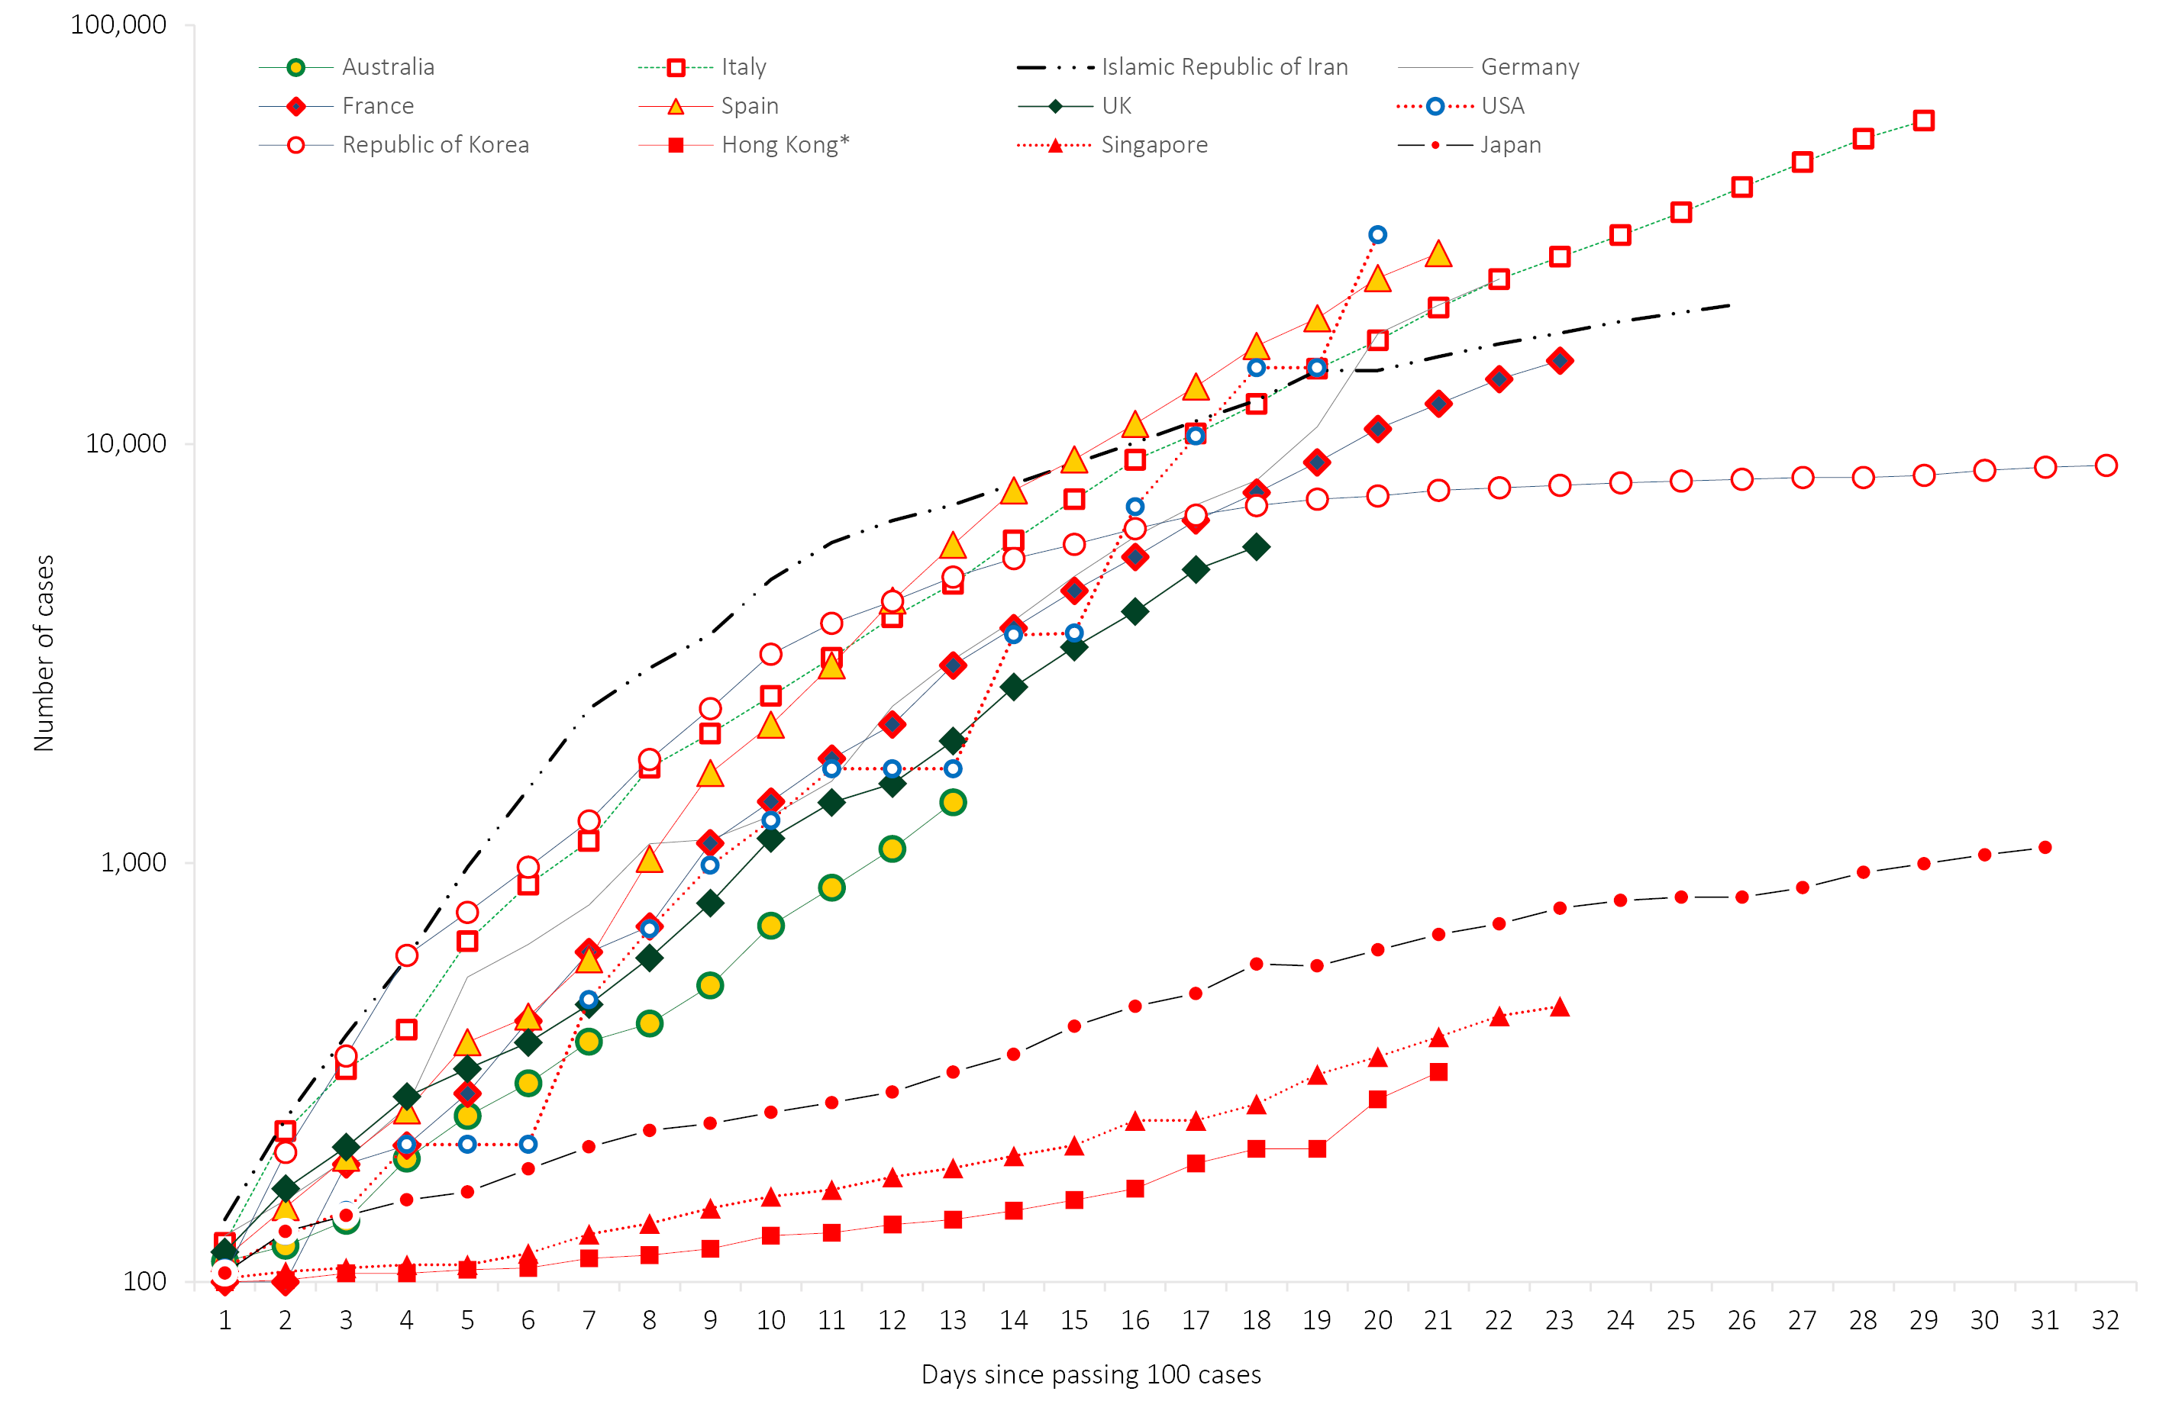
Globally, 12,783 deaths have been reported. Almost three-quarters (74%; n = 9,517) of global deaths have been reported by 174 countries, territories and areas outside of mainland China. Of the deaths reported outside of mainland China, 51% (n = 4,827) were reported in Italy, 16% (n = 1,556) in the Islamic Republic of Iran, and 14% (n = 1,326) in Spain.¹ The global proportion of cases that are reported to have died is 4.4%. This proportion is likely to be an overestimate due to the likely variable levels of under-ascertainment of cases, especially those with mild infections. There is wide variation in this proportion globally, with countries such as Italy (9.0%), the Islamic Republic of Iran (7.5%) and Spain (5.3%) reporting substantially higher proportions.

Epidemiological features of COVID-19
The current estimates on epidemiological parameters including severity, transmissibility and incubation period are uncertain. Estimates are likely to change as more information becomes available.

Transmission
Human-to-human transmission of SARS-CoV-2 is via droplets and fomites from an infected person to a close contact.³ COVID-19 can often present as a common cold-like illness where the virus is shed for a prolonged time after symptoms end, including in stools.⁴ A virological analysis of nine hospitalised cases found active virus replication in upper respiratory tract tissues, with pharyngeal virus shedding very high during the first week of symptoms.⁴ However, current evidence does not support airborne or faecal-oral spread as major factors in transmission.³
A study in China showed household contacts and those who travelled with a confirmed COVID-19 case were strongly associated with an increased risk of infection.⁵ The study also examined the average time from symptom onset to disease confirmation among cases who were identified through contact-based surveillance (i.e. monitoring and testing of close contacts of confirmed COVID-19 cases) and symptom-based surveillance (i.e. symptomatic screening at airports, community fever monitoring and testing of hospital patients). Cases identified through contact-based surveillance were associated with a 2.3 day decrease from symptom onset to disease confirmation and a 1.9 day decrease from symptom onset to isolation, compared to cases found by symptom-based surveillance. Modelling studies suggest that undocumented infections are the source for over three-quarters of documented cases and effective contact tracing increases the probability of control.^{5,6}
Infection of a dog with SARS-CoV-2 has been reported to the International Organisation for Animal Health (OIE) on two occasions since the outbreak began.⁷ Both dogs were in Hong Kong and had close contact with owners with COVID-19. Neither dog showed clinical signs of infection and there is no evidence that dogs play a role in disease spread. Further studies are underway to understand if and how different animal species could be affected by COVID-19.

Incubation period
Estimates of median incubation period, based on seven published studies, are 5 to 6 days (ranging from 0 to 14 days).⁸ Patients with long incubation periods do occasionally occur, however they are likely to be ‘outliers’ who should be studied further but are unlikely to represent a change in epidemiology of the virus.⁸

Molecular epidemiology
The initial COVID-19 cases were reported in late December 2019 following the discovery of a cluster of pneumonia cases at the Huanan Seafood Market in Wuhan China. However, subsequent work has identified SARS-CoV-2 cases as early as 1 December 2019 in Wuhan.⁹ Additionally, a phylogenetic analysis of whole genome sequences has dated the emergence of SARS-CoV-2 infection in humans to between late November and early December 2019.¹⁰ Since December 2019, the virus has diversified into multiple lineages as it has spread globally with some degree of geographical clustering (Figure 9). The whole genome sequences currently available from Australian cases (n=25) are mostly in returned travellers from China, the Islamic Republic of Iran, Europe and the USA, and thereby reflect this global diversity (Figure 9). Recent work describes an emerging clade linked to the epidemic in the Islamic Republic of Iran,¹¹ which highlights how genomic epidemiology can shed light on un-sampled locations. The high number of independent introduction events within Australia from Europe is also striking. Continuing these analyses as more data from Australia become available will corroborate and query field data on the epidemiological links among clusters within and between jurisdictions.
Figure 9: Phylogeny of global SARS-CoV-2 genome sequencesª
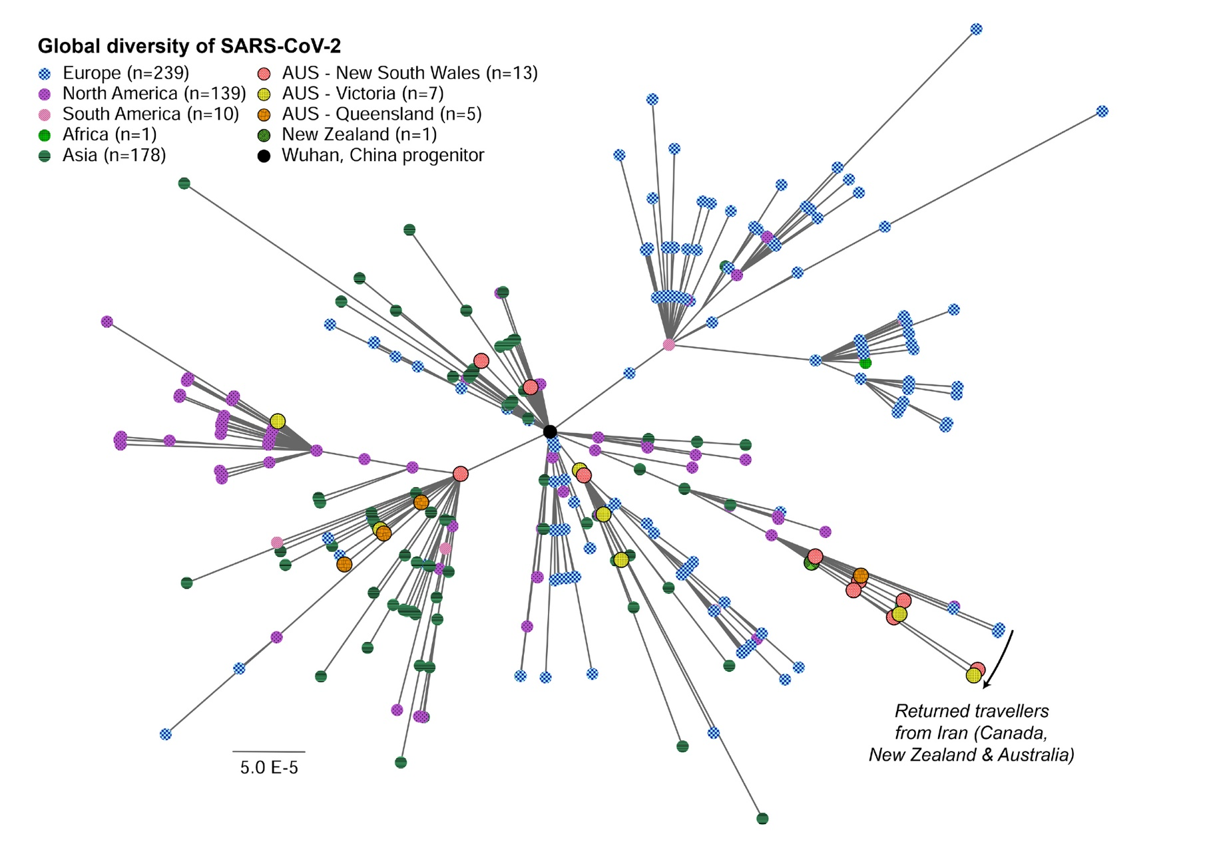
a Publicly available high quality, whole genome sequences were downloaded from www.gisaid.org, aligned and analysed using a phylogenetic approach with PhyML (n = 594 as of 21 March 2020). Individual sequences are shown as circles and coloured by country or region as per the key provided. Globally, SARS-CoV-2 has diversified into multiple lineages with some geographic clustering apparent. Australian strains are generally dispersed across the global phylogeny although notable clusters include one of returned travellers from the Islamic Republic of Iran. The scale is proportional to the number of substitutions per site.

Clinical features
A recently published meta-analysis supports previous research that COVID-19 presents as mild illness in the majority of cases with fever and cough being the most commonly reported symptoms. Severe or fatal outcomes tend to occur in the elderly or those with comorbid conditions.^{3,12}
Some COVID-19 patients show neurological signs such as headache, nausea and vomiting. There is evidence that SARS-CoV-2 viruses are not always confined to the respiratory tract and may invade the central nervous system inducing neurological symptoms.¹³ As such, it is possible that invasion of the central nervous system is partially responsible for the acute respiratory failure of COVID-19 patients.¹³
Examination of cases and their close contacts in China found a positive association between age and time from symptom onset to recovery. Median time to recovery was estimated to be 27 days in 20–29 year olds, 32 days in 50–59 year olds, and 36 days in those aged over 70 years. The study also found an association between clinical severity and time from symptom onset to time to recovery. Compared to people with mild disease, those with moderate and severe disease were associated with a 19% and 58% increase in time to recovery, respectively.⁵
A retrospective cohort study looking at risk factors for mortality among patients with COVID-19 who have experienced a definite outcome found an increase in the odds of in-hospital death associated with older age, higher sequential organ failure assessment score and elevated blood d-dimer levels on admission.¹⁴ Detectable SARS-CoV-2 RNA persisted for a median of 20 days in survivors and until death in non-survivors.¹⁴

Treatment
Current clinical management of COVID-19 cases focuses on early recognition, isolation, appropriate infection control measures and provision of supportive care.¹⁵ Whilst there is no specific antiviral treatment currently recommended for patients with suspected or confirmed SARS-CoV-2 infection, multiple clinical trials are underway to evaluate a number of therapeutic agents, including remdesivir, lopinavir/ritonavir, and chloroquine.¹⁶

Public health response
A summary of the key events that have been associated with the emergence of COVID-19, including Australia’s public health response activities is provided at Figure 10. Since COVID-19 first emerged internationally, public health responses in Australia have continued to evolve with the changing body of knowledge and epidemiological profile, both from overseas and in Australia. During the current reporting period, the Australian Health Protection Principal Committee have issued advice to inform the national public health response to the pandemic including the broadening of the 14-day quarantine requirement for all travellers from overseas, regardless of the country, as well as physical distancing measures.¹⁷
Figure 10. Timeline of COVID-19 related events, including Australian public health response activities
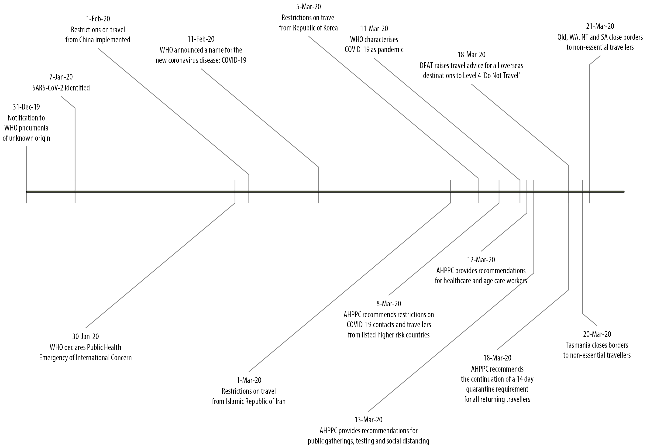

Methods
Data for this report were current as at 23:59 hours AEDT, 22 March 2020.
This report outlines what is known epidemiologically on COVID-19 in Australia and from publicly available data from WHO Situation Reports, other countries’ official updates and the scientific literature. Data on domestic cases in this report were collected from the NNDSS and additionally informed by jurisdictional health department media releases. The Communicable Diseases Network Australia (CDNA) developed the case definition for suspect and confirmed cases, which was modified at different time points during the outbreak (Table 2). Data were analysed using Stata to describe the epidemiology of COVID-19 in Australia and the progress of the epidemic. Data for the international cases of COVID-19 by country were compiled from the latest WHO Situation Report. Case definitions may vary by country making comparisons difficult. Rapid reviews of the current state of knowledge on COVID-19 were conducted from the literature using PubMed.
Table 2: Australian COVID-19 case definition as of 22 March 2020¹⁸
Version | Date of development | Suspect Case | Confirmed Case
2.2 | 21 March 2020 | A. If the patient satisfies epidemiological and clinical criteria, they are classified as a suspect case.  Epidemiological criteria  - International travel in the 14 days before illness onset.  OR  - Close contact in 14 days before illness onset with a confirmed case of COVID-19.  Clinical criteria  - Fever (≥ 38 °C) or history of fever (e.g. night sweats, chills).  OR  - Acute respiratory infection (e.g. shortness of breath, cough, sore throat) with or without fever.  B. If the patient has bilateral community-acquired pneumonia (critically ill) and no other cause is identified, with or without recent international travel, they are classified as a suspect case.  C. If any healthcare worker with direct patient contact has a fever (≥ 38 °C) or history of fever (e.g. night sweats, chills) AND an acute respiratory infection (e.g. shortness of breath, cough, sore throat), they are classified as a suspect case. | A person who tests positive to a validated specific SARS-CoV-2 nucleic acid test or has the virus identified by electron microscopy or viral culture.

Acknowledgements
This report represents surveillance data reported through CDNA as part of the nationally-coordinated response to COVID-19. We thank public health staff from incident emergency operations centres in state and territory health departments, and the Australian Government Department of Health, along with state and territory public health laboratories. We thank John Grewar for providing the R-code to produce Figure 5. We also thank John-Sebastian Eden and Eddie Holmes (University of Sydney and Westmead Institute for Medical Research) for graciously allowing the use of their phylogenetic tree (Figure 9).

Author details

Corresponding author
Andrew C. Breed
NIR Surveillance Team, Communicable Disease Epidemiology and Surveillance Section, Health Protection Policy Branch, Australian Government Department of Health, GPO Box 9484, MDP 14, Canberra, ACT 2601.
Email: epi.coronavirus@health.gov.au

References
- World Health Organization (WHO). Coronavirus disease 2019 (COVID-19) situation report – 54: 22 March 2020. Geneva: WHO; 2020. [Accessed on 24 March 2020.] Available from: https://www.who.int/docs/default-source/coronaviruse/situation-reports/20200322-sitrep-62-covid-19.pdf.
- WHO. Coronavirus disease 2019 (COVID-19) situation report – 47: 14 March 2020. Geneva: WHO; 2020. [Accessed on 24 March 2020.] Available from: https://www.who.int/docs/default-source/coronaviruse/situation-reports/20200314-sitrep-54-covid-19.pdf.
- WHO. Report of the WHO-China joint mission on coronavirus disease 2019 (COVID-19). Geneva: WHO; 2020. [Accessed on 1 March 2020.] Available from: https://www.who.int/docs/default-source/coronaviruse/who-china-joint-mission-on-covid-19-final-report.pdf.
- Zhou F, Yu T, Du R, Fan G, Liu Y, Liu Z et al. Clinical course and risk factors for mortality of adult inpatients with COVID-19 in Wuhan, China: a retrospective cohort study. Lancet. 2020. doi: https://doi.org/10.1016/S0140-6736(20)30566-3.
- Bi Q, Wu Y, Mei S, Ye C, Zou X, Zhang Z et al. Epidemiology and transmission of COVID-19 in Shenzhen China: analysis of 391 cases and 1286 of their close contacts. medRxiv. 2020. doi: https://doi.org/10.1101/2020.03.03.20028423.
- Li R, Pei S, Chen B, Song Y, Zhang T, Yang W et al. Substantial undocumented infection facilitates the rapid dissemination of novel coronavirus (SARS-CoV2). Science. 2020. doi: https://doi.org/10.1126/science.abb3221.
- World Organisation for Animal Health (OIE). Questions and Answers on the 2019 coronavirus disease (COVID-19). [Internet.] Paris, OIE; 2020. [Accessed on 26 March 2020.] Available from: https://www.oie.int/en/scientific-expertise/specific-information-and-recommendations/questions-and-answers-on-2019novel-coronavirus/.
- WHO. Coronavirus disease 2019 (COVID-19) situation report – 29: 18 February 2020. Geneva: WHO; 2020. [Accessed on 15 March 2020.] Available from: https://www.who.int/docs/default-source/coronaviruse/situation-reports/20200218-sitrep-29-covid-19.pdf.
- Huang C, Wang Y, Li X, Ren L, Zhao J, Hu Y et al. Clinical features of patients infected with novel coronavirus in Wuhan, China. Lancet. 2020;395(10223):497-506. doi: https://doi.org/10.1016/S0140-6736(20)30183-5.
- Bedford T, Neher R, Hadfield J, Hodcroft E, Ilcisin M, Müller N. Genomic analysis of nCOV spread. Situation report 2020-01-30. [Internet.] 2020. Available from: https://nextstrain.org/narratives/ncov/sit-rep/2020-01-30.
- Eden JS, Rockett R, Carter I, Rahman H, de Ligt J, Hadfield J et al. An emergent clade of SARS-CoV-2 linked to returned travellers from Iran. bioRxiv. 2020. doi: https://doi.org/10.1101/2020.03.15.992818.
- Sun P, Qie S, Liu Z, Ren J, Xi JJ. Clinical characteristics of 50466 patients with 2019-nCoV infection. medRxiv. 2020. doi: https://doi.org/10.1101/2020.02.18.20024539.
- Li Y, Bai W, Hashikawa T. The neuroinvasive potential of SARS-CoV2 may be at least partially responsible for the respiratory failure of COVID-19 patients. J Med Virol. 2020. doi: https://doi.org/10.1002/jmv.25728.
- Woelfel R, Corman VM, Guggemos W, Seilmaier M, Zange S, Mueller MA et al. Clinical presentation and virological assessment of hospitalized cases of coronavirus disease 2019 in a travel-associated transmission cluster. medRxiv. 2020. doi: https://doi.org/10.1101/2020.03.05.20030502.
- WHO. Clinical management of severe acute respiratory infection when novel coronavirus (nCoV) infection is suspected. [Internet.] Geneva: WHO; 2020. [Accessed on 23 February 2020.] Available from: https://www.who.int/publications-detail/clinical-management-of-severe-acute-respiratory-infection-when-novel-coronavirus-(ncov)-infection-is-suspected.
- Harrison, C. Coronavirus puts drug repurposing on the fast track. Nat Biotechnol. 2020. doi: https://doi.org/10.1038/d41587-020-00003-1.
- Australian Government Department of Health. Latest statement from the Australian Health Protection Principal Committee (AHPPC) on coronavirus (COVID-19). [Internet.] Canberra: Australian Government Department of Health; 21 March 2020. [Accessed on 24 March 2020.] Available from: https://www.health.gov.au/news/latest-statement-from-the-australian-health-protection-principal-committee-ahppc-on-coronavirus-covid-19.
- Australian Government Department of Health. Novel coronavirus 2019 (2019-nCoV) - CDNA national guidelines for public health units. [Internet.] Canberra: Australian Government Department of Health; 2020. [Accessed on 24 March 2020.] Available from: https://www1.health.gov.au/internet/main/publishing.nsf/Content/7A8654A8CB144F5FCA2584F8001F91E2/$File/interim-COVID-19-SoNG-v2.2.pdf.

Communicable Diseases Intelligence
ISSN: 2209-6051 Online

Communicable Diseases Intelligence (CDI) is a peer-reviewed scientific journal published by the Office of Health Protection, Department of Health. The journal aims to disseminate information on the epidemiology, surveillance, prevention and control of communicable diseases of relevance to Australia.

Editor: Tanja Farmer
Deputy Editor: Simon Petrie
Design and Production: Kasra Yousefi
Editorial Advisory Board: David Durrheim, Mark Ferson, John Kaldor, Martyn Kirk and Linda Selvey

Website: http://www.health.gov.au/cdi

Contacts
Communicable Diseases Intelligence is produced by:
Health Protection Policy Branch, Office of Health Protection, Australian Government Department of Health
GPO Box 9848, (MDP 6) CANBERRA ACT 2601

Email: cdi.editor@health.gov.au

Submit an Article
You are invited to submit your next communicable disease related article to the Communicable Diseases Intelligence (CDI) for consideration. More information regarding CDI can be found at: http://health.gov.au/cdi.
Further enquiries should be directed to: cdi.editor@health.gov.au.

This journal is indexed by Index Medicus and Medline.

Creative Commons Licence - Attribution-NonCommercial-NoDerivatives CC BY-NC-ND
© 2019 Commonwealth of Australia as represented by the Department of Health
This publication is licensed under a Creative Commons Attribution-NonCommercial-NoDerivatives 4.0 International Licence from https://creativecommons.org/licenses/by-nc-nd/4.0/legalcode (Licence). You must read and understand the Licence before using any material from this publication.

Restrictions
The Licence does not cover, and there is no permission given for, use of any of the following material found in this publication (if any):
- the Commonwealth Coat of Arms (by way of information, the terms under which the Coat of Arms may be used can be found at www.itsanhonour.gov.au);
- any logos (including the Department of Health’s logo) and trademarks;
- any photographs and images;
- any signatures; and
- any material belonging to third parties.

Disclaimer
Opinions expressed in Communicable Diseases Intelligence are those of the authors and not necessarily those of the Australian Government Department of Health or the Communicable Diseases Network Australia. Data may be subject to revision.

Enquiries
Enquiries regarding any other use of this publication should be addressed to the Communication Branch, Department of Health, GPO Box 9848, Canberra ACT 2601, or via e-mail to: copyright@health.gov.au

Communicable Diseases Network Australia
Communicable Diseases Intelligence contributes to the work of the Communicable Diseases Network Australia.
http://www.health.gov.au/cdna

Data were extracted on 24 March 2020 with data reported to 22 March 2020. Due to the dynamic nature of the NNDSS, data in this extract are subject to retrospective revision and may vary from data published in previous reports and reports of notification data by states and territories.

