2019-nCoV acute respiratory disease, Australia: Epidemiology Report 1
Reporting week 26 January – 1 February 2020
2019-nCoV National Incident Room Surveillance Team

Summary
This is the first epidemiological report of novel coronavirus (2019-nCoV) acute respiratory disease infections reported in Australia at 19:00 Australian Eastern Daylight Time [AEDT] 1 February 2020. It includes data on Australian cases notified during the week 26 January to 1 February 2020 and in the previous week (19 to 25 January 2020), the international situation and current information on the severity, transmission and spread of the 2019-nCoV infection.
Keywords: novel coronavirus (2019-nCoV); respiratory disease; case definition; epidemiology; Australia
The following epidemiological data are subject to change both domestically and internationally due to the rapidly evolving situation. Australian cases are still under active investigation. While every effort has been made to standardise the investigation of cases nationally, there may be some differences between jurisdictions.
In Australia:
- A total of twelve cases of 2019-nCoV infection were notified up until 1 February 2020;
- All twelve cases reported a travel history to China, and 92% (11/12) had a travel history to Wuhan, Hubei Province, China;
- The majority of cases (92%, 11/12) developed mild to moderate symptoms, with one case (8%, 1/12) admitted to intensive care;
- Zero deaths were reported; and
- Two days elapsed since the onset of illness in the latest confirmed case and the date of this report.
Internationally:
- Case numbers are increasing rapidly with 11,953 infections confirmed globally; and
- The majority of confirmed infections (11,821) were reported in China, as well as 259 deaths

Domestic cases
There were twelve confirmed cases reported in Australia as at 19:00 AEDT 1 February 2020 (Table 1). Cases were reported in New South Wales (n = 4), Victoria (n = 4), Queensland (n = 2) and South Australia (n = 2). The first onset of signs and symptoms in a case occurred on 13 January 2020 (Figure 1). The majority of cases (92%, 11/12) had a travel history to Wuhan. The remaining case had direct contact with a confirmed case from Wuhan while travelling in China. All cases acquired their infection in China, which resulted in many close contacts requiring investigation. The median age of cases was 45 (range 21–66) years. The male-to-female ratio was 1.4:1. All cases (12/12) reported fever and/or chills and 83% (10/12) reported cough. Two cases reported with pneumonia (Figure 2). Approximately 75% (9/12) of cases were hospitalised for clinical management and infection control, including one patient who was admitted to an Intensive Care Unit (ICU). The clinical course of infection was unavailable from these preliminary data. There were no deaths associated with the outbreak in Australia. The median time between onset of illness and collection of a specimen was 1 day (range 0–9 days).
Table 1: Cumulative notified cases of confirmed 2019-nCoV by jurisdiction, Australia, 2020
Jurisdiction | This week  (26 Jan to 1 Feb)  No. of cases | Last week  (19 to 25 Jan)  No. of cases | Total cases  (as of 1 Feb 2020)  No. of cases
NSW | 0 | 4 | 4
Vic | 2 | 2 | 4
Qld | 2 | 0 | 2
WA | 0 | 0 | 0
SA | 2 | 0 | 2
Tas | 0 | 0 | 0
NT | 0 | 0 | 0
ACT | 0 | 0 | 0
Total cases | 6 | 6 | 12

Figure 1: Confirmed cases of 2019-nCoV infection by date of illness onset, Australia 2020
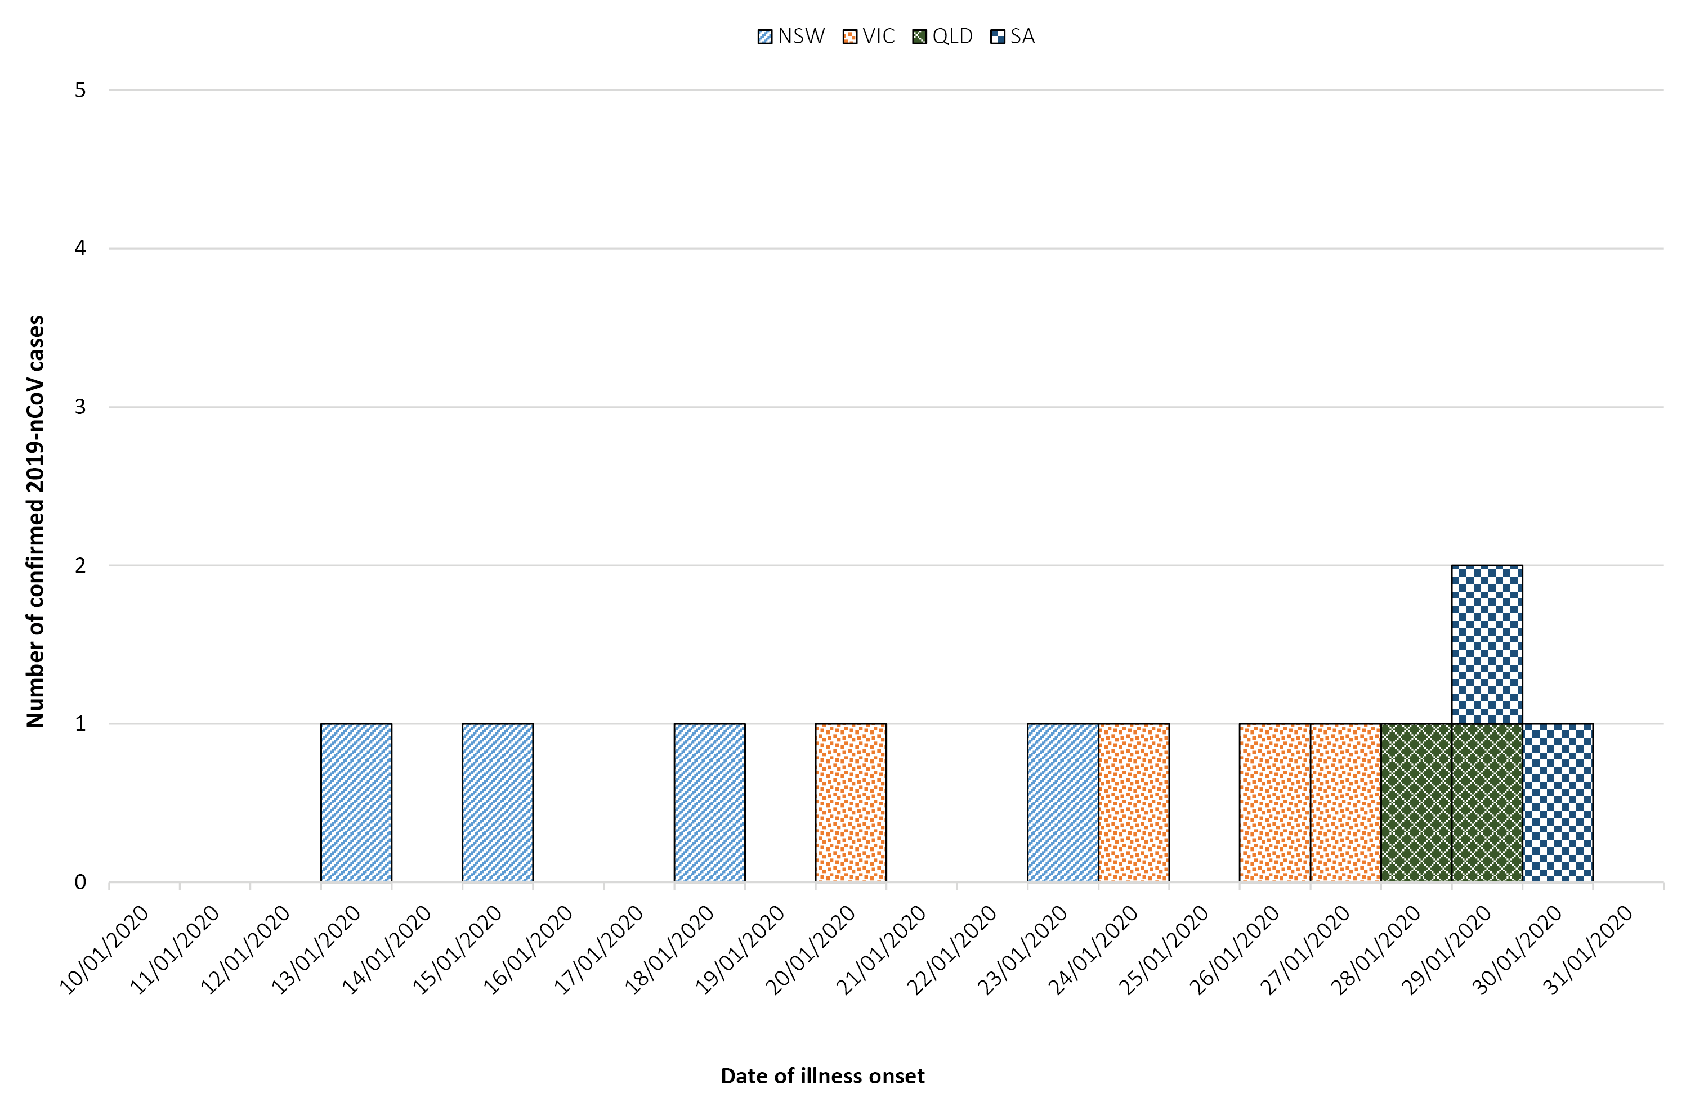

Figure 2: Signs and symptoms reported by 2019-nCoV cases in Australia, 2020 (n = 12)
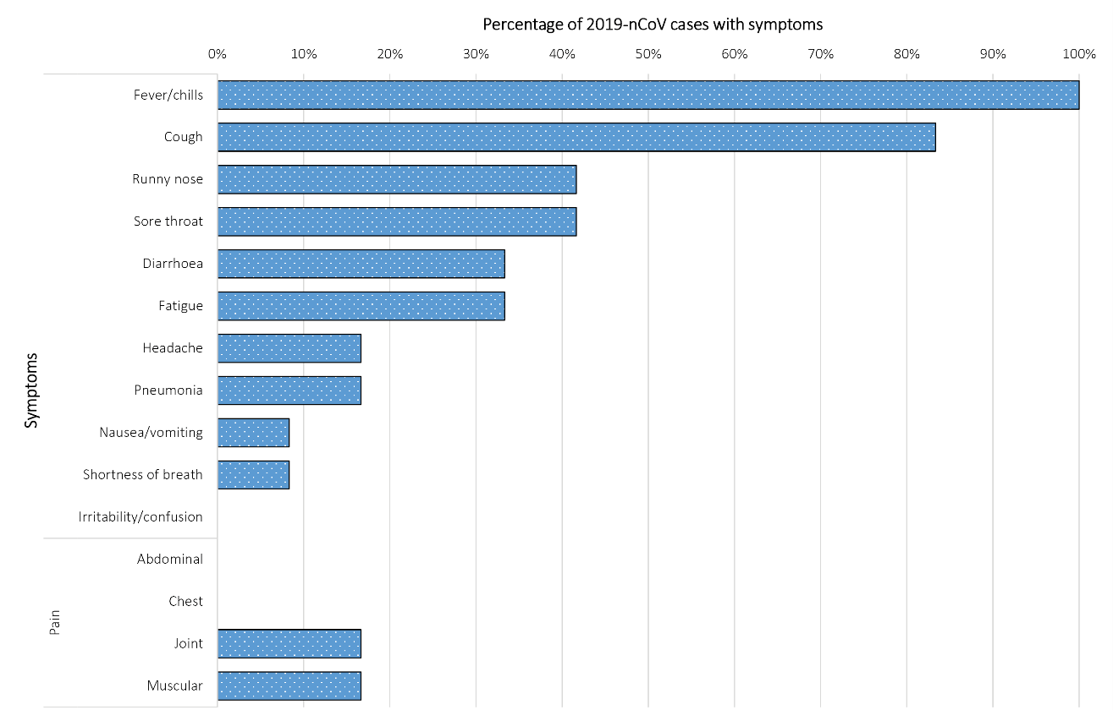

International status report
As at 19:00 AEST 1 February 2020 the number of confirmed 2019-nCoV cases was 11,953 globally (Table 2). Mainland China reported the majority of cases (11,791) and all of the 259 deaths.¹
Table 2: Cumulative confirmed cases of 2019-nCoV globally, excluding Australia, 2019-2020
Country / Special Administrative Region | This reporting week (26 Jan to 1 Feb 2020) | Total cases (from Dec 2019)¹
Cambodia | 1 | 1
Canada | 4 | 4
mainland China | 10,504 | 11,791
Finland | 1 | 1
France | 3 | 6
Germany | 7 | 7
Hong Kong | 8 | 13
India | 1 | 1
Italy | 2 | 2
Japan | 14 | 17
Macau | 5 | 7
Malaysia | 8 | 8
Nepal | 0 | 1
Philippines | 1 | 1
Republic of South Korea | 10 | 12
Russian Federation | 2 | 2
Singapore | 13 | 16
Spain | 1 | 1
Sri Lanka | 1 | 1
Sweden | 1 | 1
Taiwan | 7 | 10
Thailand | 15 | 19
United Arab Emirates | 4 | 4
United Kingdom | 2 | 2
United States of America | 5 | 7
Vietnam | 4 | 6

Background
The World Health Organization (WHO) declared the outbreak of 2019-nCoV a Public Health Emergency of International Concern (PHEIC) on 30 January 2020.² Cases were initially associated with exposure to a wet market – located in Wuhan, Hubei Province, China – indicating a possible zoonotic source. Sustained human-to-human transmission is now likely to be occurring in the majority of provinces outside of Hubei Province in China. Additionally, limited instances of human-to-human transmission were observed in a number of countries outside mainland China.^{3, 4}
As of 1 February 2020, mainland China had reported 11,791 confirmed 2019-nCoV cases and 259 deaths.⁵
As of 1 February 2020, countries and Special Administrative Regions outside of mainland China have reported 162 confirmed 2019-nCoV cases and zero deaths.
The current estimates on epidemiological parameters including severity, transmissibility and incubation period are uncertain. Estimates are likely to change as more information becomes available.

Severity
Patients with 2019-nCoV infection present with a wide range of symptoms. Most seem to have mild disease, and about 20% appear to progress to severe disease, including pneumonia, respiratory failure and in some cases death.⁶

Transmission
The exact nature of transmission is poorly understood. WHO report ‘during previous outbreaks due to other coronavirus (Middle-East Respiratory Syndrome (MERS) and Severe Acute Respiratory Syndrome (SARS)), human-to-human transmission occurred through droplets, contact and fomites, suggesting that the transmission mode of the 2019-nCoV can be similar’.⁷ Sustained human-to-human transmission is likely to be now occurring in the majority of provinces in mainland China. The basic reproductive number, R₀, indicates how contagious an infectious disease is and is defined as the average expected number of secondary cases produced by a single infection in a completely susceptible population. Chinese authorities reported a preliminary R₀ of 1.4–2.5 on 23 January 2020 to the WHO International Health Regulations (2005) Emergency Committee.⁸ On 31 January 2020, Thailand reported its first instance of close community human-to-human transmission (not within a household setting).⁹ Other instances were reported in Japan, Germany and Vietnam.⁴

Incubation period
Current estimates of the incubation period of 2019-nCoV from the WHO range from 2 to 10 days, with these estimates to be refined as more data become available.⁷ A recently-published article characterising the first 425 cases in Wuhan, Hubei Province China estimated the median incubation period to be 5.2 days (95% confidence interval, 4.1–7.0).¹⁰

Recommendations for control
The WHO recommends the general public reduce their exposure and transmission to 2019-nCoV by:
- Frequently cleaning hands by using alcohol-based hand rub or soap and water;
- When coughing and sneezing cover mouth and nose with flexed elbow or tissue – throw tissue away immediately and wash hands;
- Avoid close contact with anyone who has fever and cough;
- If you have a fever, cough and difficulty breathing seek medical care early and share previous travel history with your health care provider.

Treatment
Currently there is no specific medication recommended for 2019-nCoV. Antibiotics are not effective against viruses. Some antiviral medications have shown promise in treating MERS and are now being tested for their effectiveness against 2019-nCoV.¹¹ Experimental vaccines are also in development. Clinical care of suspected patients with 2019-nCoV should focus on early recognition, immediate isolation, implementation of appropriate infection prevention and control measures and provision of optimised supportive care.⁶

Methods
Data for this report were current as at 19:00 hours AEDT, 1 February 2020.
This report outlines what is known epidemiologically on 2019-nCoV in Australia and from publicly available data from WHO Situation Reports, other countries’ official updates and the scientific literature. Data on domestic cases in this report were collected from National Notifiable Diseases Surveillance System (NNDSS) and state and territory case investigation reports. The Communicable Diseases Network Australia (CDNA) developed the case definition for suspected and confirmed cases, which was modified at different time points in the epidemic (23 January and 27 January 2020) (Table 3). CDNA developed national guidance on investigating suspected and confirmed cases of 2019-nCoV. Based on this guidance, state and territory health department investigators conducted interviews of suspected cases to collect core and enhanced data for inclusion in NNDSS. Data were analysed using Stata to describe the epidemiology of infections in Australia and the progress of the epidemic.
Table 3: Australian 2019-nCoV case definition as of 1 February 2020¹²
Date of development | Suspected Cases | Confirmed Cases
27 January 2020 | As the full clinical spectrum of illness is not known, clinical and public health judgement should also be used to determine the need for testing in patients who do not meet the clinical criteria below. If the patient satisfies epidemiological and clinical criteria, they are classified as a suspect case.  Epidemiological criteria  - Travel to Hubei Province, China in the 14 days before the onset of illness.ª  OR  - Travel to agreed areas of human-to-human transmission, or a declared outbreak, within 14 days before onset of illness.  OR  - Close contact in 14 days before illness onset with a case of 2019-nCoV.  Clinical criteria  - Fever or history of fever (≥38 °C) and acute respiratory infection (sudden onset of respiratory infection with at least one of: shortness of breath, cough or sore throat).  OR  - Severe acute respiratory infection requiring admission to hospital with clinical or radiological evidence of pneumonia or acute respiratory distress syndrome (i.e. even if no evidence of fever). | A person who tests positive to a specific 2019-nCoV PCR test (when available) or has the virus identified by electron microscopy or viral culture, at a reference laboratory.
a The previous case definition developed on 23 January 2020 required that suspected cases had travelled to the city of Wuhan.
Data for the international reports of 2019-nCoV case numbers by country were compiled from a range of sources. Case definitions for these case counts varied considerably making comparisons difficult. Rapid reviews of the current state of knowledge on 2019-nCoV were conducted from the literature using PubMed.

Acknowledgements
This report represents surveillance data reported through CDNA as part of the nationally coordinated response to 2019-nCoV. We thank public health staff from incident emergency operations centres in state & territory health departments, and the Australian Government Department of Health; along with state and territory public health laboratories.

Author details

Corresponding author
Liz J Walker
NIR Surveillance Team, Communicable Disease Epidemiology and Surveillance Section, Health Protection Policy Branch, Australian Government Department of Health, GPO Box 9484, MDP 14, Canberra, ACT 2601.
Telephone: +61 2 6289 1512.
Email: epi.coronavirus@health.gov.au

References
- World Health Organization (WHO). Novel coronavirus (2019-nCoV) situational report-12: 1 February 2020. Geneva: WHO; 2020. [Accessed on 1 February 2020.] Available from: https://www.who.int/docs/default-source/coronaviruse/situation-reports/20200201-sitrep-12-ncov.pdf?sfvrsn=273c5d35_2.
- WHO. Statement on the second meeting of the International Health Regulations (2005) Emergency Committee regarding the outbreak of novel coronavirus (2019-nCoV). [Internet.] Geneva: WHO; 2020. [Accessed on 31 January 2020.] Available from: https://www.who.int/news-room/detail/30-01-2020-statement-on-the-second-meeting-of-the-international-health-regulations-(2005)-emergency-committee-regarding-the-outbreak-of-novel-coronavirus-(2019-ncov).
- Rothe C, Schunk M, Sothmann P, Bretzel G, Froeschl G, Wallrauch C et al. Transmission of 2019-nCoV infection from an asymptomatic contact in Germany. N Engl J Med. 2020. https://doi.org/10.1056/NEJMc2001468.
- Phan LT, Nguyen TV, Luong QC, Nguyen TV, Nguyen HT, Le HQ et al. Importation and human-to-human transmission of a novel coronavirus in Vietnam. N Engl J Med. 2020. https://doi.org/10.1056/nejmc2001272.
- National Health Commission, China. Update on pneumonia of new coronavirus infection as of 21:00 on January 31 2020. [Internet.] Beijing, China: National Health Commission; 2020. [Accessed on 1 February 2020.] Available from: http://www.nhc.gov.cn/yjb/s7860/202002/84faf71e096446fdb1ae44939ba5c528.shtml.
- WHO. Novel coronavirus (2019-nCoV) situational report-8: 28 January 2020. Geneva: WHO; 2020. [Accessed on 29 January 2020.] Available from: https://www.who.int/docs/default-source/coronaviruse/situation-reports/20200128-sitrep-8-ncov-cleared.pdf?sfvrsn=8b671ce5_2.
- WHO. Novel coronavirus (2019-nCoV) situational report-7: 27 January 2020. Geneva: WHO; 2020. [Accessed on 28 January 2020.] Available from: https://www.who.int/docs/default-source/coronaviruse/situation-reports/20200127-sitrep-7-2019--ncov.pdf?sfvrsn=98ef79f5_2.
- WHO. Statement on the meeting of the International Health Regulations (2005) Emergency Committee regarding the outbreak of novel coronavirus (2019-nCoV). [Internet.] Geneva: WHO; 2020. [Accessed on 24 January 2020.] Available from: https://www.who.int/news-room/detail/23-01-2020-statement-on-the-meeting-of-the-international-health-regulations-(2005)-emergency-committee-regarding-the-outbreak-of-novel-coronavirus-(2019-ncov).
- Department of Disease Control, Ministry of Public Health, Thailand. Ministry of Public Health reports that group of experts confirm five additional cases and invites people to carry surgical masks to protect themselves. [Internet.] Mueang Nonthaburi, Thailand: Department of Disease Control, Ministry of Public Health; 2020. [Accessed on 1 February 2020.] Available from: https://ddc.moph.go.th/viralpneumonia/eng/file/news/news_no8_310163_1.pdf.
- Li Q, Guan X, Wu P, Wang X, Zhou L, Tong Y et al. Early transmission dynamics in Wuhan, China, of novel coronavirus-infected pneumonia. N Engl J Med. 2020. https://doi.org/10.1056/NEJMoa2001316.
- Paules CI, Marston HD, Fauci AS. Coronavirus infections—more than just the common cold. JAMA. 2020. https://doi.org/10.1001/jama.2020.0757.
- Australian Government Department of Health. Novel coronavirus 2019 (2019-nCoV) - CDNA national guidelines for public health units 2020. [Internet.] Canberra: Australian Government Department of Health; 2020. [Accessed on 1 February 2020.] Available from:https://www1.health.gov.au/internet/main/publishing.nsf/Content/cdna-song-novel-coronavirus.htm.

Communicable Diseases Intelligence
ISSN: 2209-6051 Online

Communicable Diseases Intelligence (CDI) is a peer-reviewed scientific journal published by the Office of Health Protection, Department of Health. The journal aims to disseminate information on the epidemiology, surveillance, prevention and control of communicable diseases of relevance to Australia.

Editor: Cindy Toms
Deputy Editor: Simon Petrie
Design and Production: Kasra Yousefi
Editorial Advisory Board: David Durrheim, Mark Ferson, John Kaldor, Martyn Kirk and Linda Selvey

Website: http://www.health.gov.au/cdi

Contacts
Communicable Diseases Intelligence is produced by:
Health Protection Policy Branch, Office of Health Protection, Australian Government Department of Health
GPO Box 9848, (MDP 6) CANBERRA ACT 2601

Email: cdi.editor@health.gov.au

Submit an Article
You are invited to submit your next communicable disease related article to the Communicable Diseases Intelligence (CDI) for consideration. More information regarding CDI can be found at: http://health.gov.au/cdi.
Further enquiries should be directed to: cdi.editor@health.gov.au.

This journal is indexed by Index Medicus and Medline.

Creative Commons Licence - Attribution-NonCommercial-NoDerivatives CC BY-NC-ND
© 2019 Commonwealth of Australia as represented by the Department of Health
This publication is licensed under a Creative Commons Attribution-NonCommercial-NoDerivatives 4.0 International Licence from https://creativecommons.org/licenses/by-nc-nd/4.0/legalcode (Licence). You must read and understand the Licence before using any material from this publication.

Restrictions
The Licence does not cover, and there is no permission given for, use of any of the following material found in this publication (if any):
- the Commonwealth Coat of Arms (by way of information, the terms under which the Coat of Arms may be used can be found at www.itsanhonour.gov.au);
- any logos (including the Department of Health’s logo) and trademarks;
- any photographs and images;
- any signatures; and
- any material belonging to third parties.

Disclaimer
Opinions expressed in Communicable Diseases Intelligence are those of the authors and not necessarily those of the Australian Government Department of Health or the Communicable Diseases Network Australia. Data may be subject to revision.

Enquiries
Enquiries regarding any other use of this publication should be addressed to the Communication Branch, Department of Health, GPO Box 9848, Canberra ACT 2601, or via e-mail to: copyright@health.gov.au

Communicable Diseases Network Australia
Communicable Diseases Intelligence contributes to the work of the Communicable Diseases Network Australia.
http://www.health.gov.au/cdna

