2024 • Volume 48 • https://doi.org/10.33321/cdi.2024.48.44 • Electronic publication date: 24/06/2024

Australian vaccine preventable disease epidemiological review series: Hepatitis B, 2000–2019
Nicole Sonneveld, Joanne Jackson, Aditi Dey, Stephen Lambert, Katrina Clark, Benjamin Cowie, Kristine Macartney, Frank Beard

Abstract

Introduction
Hepatitis B vaccination was nationally funded for adolescents in 1996, with inclusion of universal infant immunisation under the National Immunisation Program (NIP) in May 2000. This study describes hepatitis B epidemiology in Australia in the two decades since 2000.

Methods
This article analyses newly-acquired (within the prior 24 months) and unspecified (all other) hepatitis B notifications (2000–2019) from the National Notifiable Diseases Surveillance System; acute hepatitis B hospitalisations (2001–2019) from the National Hospital Morbidity Database; and acute (2000–2019) and chronic (2006–2019) hepatitis B deaths from the Australian Bureau of Statistics and Australian Coordinating Registry. Rates over the reporting period were described overall, and by age group, sex, and Aboriginal and Torres Strait Islander status (Aboriginal and/or Torres Strait Islander versus other [neither Aboriginal nor Torres Strait Islander, unknown or not stated]). Trend analyses were performed using Poisson or negative binomial regression. Additional analyses were performed for the cohort born after May 2000.

Results and discussion
The annual all-age notification rate per 100,000 per year declined (p < 0.001) from 2.13 in 2000 to 0.65 in 2019 for newly-acquired hepatitis B and from 38.3 to 22.3 for unspecified hepatitis B (likely to predominantly represent chronic hepatitis B). Newly-acquired and unspecified hepatitis B notification rates were lowest among children aged < 15 years. The most substantial reductions in notification rates of newly-acquired hepatitis B were among adolescents aged 15–19 years and young adults aged 20–24 and 25–29 years (respectively 17-, 11-, and 7-fold); these age groups also recorded the most substantial reductions in unspecified hepatitis B notifications (respectively 5-, 3.5-, and 2-fold). Newly-acquired hepatitis B notification and acute hepatitis B mortality rates were two- to threefold higher in males than females. The all-age newly-acquired hepatitis B notification rate in Aboriginal and Torres Strait Islander people decreased twofold between 2000 and 2019, but remained threefold higher than in other people. Acute hepatitis B hospitalisations also declined over the study period (p < 0.001) and followed similar patterns. There were no acute or chronic hepatitis B deaths among people born after May 2000; this cohort featured 52 newly-acquired and 887 unspecified hepatitis B notifications. Due to lack of data on country of birth (and hence eligibility for infant vaccination under the NIP or overseas programs), vaccination status and likely transmission routes, we were unable to assess factors contributing to these potentially preventable infections.

Conclusion
Adolescent and infant immunisation under the NIP has led to significant reductions in notification rates of newly-acquired hepatitis B, and in acute hepatitis B hospitalisation rates, both overall and in Aboriginal and Torres Strait Islander people. Unspecified hepatitis B notification rates have also greatly decreased in children and young adults, likely largely due to the impact of overseas infant immunisation programs on prevalence in child and adolescent migrants. Work to improve completeness of variables within national datasets is crucial, along with enhanced surveillance of both newly-acquired and unspecified hepatitis B cases to investigate transmission routes, vaccination status and factors contributing to acquisition of hepatitis B, in order to optimise the impact of immunisation programs and ensure linkage with care.
Keywords: Hepatitis B; acute hepatitis B; chronic hepatitis B; disease surveillance; immunisation; epidemiology; vaccine preventable disease

Introduction
Hepatitis B is caused by the hepatitis B virus (HBV),¹ which is transmitted through exposure to infected bodily fluids, including through transmission from mother to child (predominantly at birth),² through sexual³ and close household contact,⁴ and through the unsafe use of needles, either in healthcare settings^{5,6} or with injecting drug use.⁷ In young children, acute HBV infection is asymptomatic in more than 90% of cases.⁸ In people over the age of 5 years, acute hepatitis B is symptomatic in approximately one-third to half of infected individuals and most commonly presents with an initial phase of malaise, loss of appetite and low-grade fever after an average incubation period of 90 days, followed by jaundice and abdominal pain, which usually resolves within one to three months.^{8,9} However, in a small proportion of reported adult cases (0.5–1%), acute infection can lead to acute liver failure requiring transplantation.^{9,10}
Subsequent to acute infection, chronic hepatitis B—defined as the persistence of hepatitis B surface antigen (HBsAg) in the blood for six months or longer—may develop. The risk of developing chronic hepatitis B is inversely correlated with age: acute infection progresses to chronic hepatitis B in 90% of infected infants, in 30% of infected children 1–4 years of age, and in approximately 5% of infected adults.^{8,11} Chronic infection can lead, over time, to liver fibrosis, cirrhosis and liver failure, as well as to hepatocellular carcinoma (HCC),^{12,13} and is a significant public health challenge worldwide.¹⁴ More than 90% of all deaths attributable to hepatitis B globally are caused by complications of chronic infection.¹⁵ Given the high likelihood of progression to chronic hepatitis B infection among infants, prevention of mother to child transmission through universal infant immunisation, including a birth dose, is highly effective in reducing the burden of chronic hepatitis B and is a hallmark of the global hepatitis B strategy.¹⁴
In Australia, immunisation against hepatitis B, the most important preventive measure available, was first recommended for at-risk adults and infants born to HBsAg-positive mothers in 1986 (Box 1).¹⁶ The first nationally funded program commenced in 11- and 12-year-old adolescents in 1996. Infant hepatitis B vaccination was included under the National Immunisation Program (NIP) in May 2000 as a birth dose of monovalent paediatric vaccine, followed by three doses of a combination vaccine in the primary course.¹⁶
Subsequent to the inclusion of hepatitis B vaccine on the NIP, a reduction in notifications of both acute and chronic hepatitis B has been described.^{18–21} Despite this, hepatitis B remains the most common blood-borne viral infection in Australia, and the estimated prevalence of chronic hepatitis B was 0.9% in 2020.²² Populations most affected by hepatitis B within Australia are Aboriginal and Torres Strait Islander peoples and those born overseas.^{18,19,22,23} Albeit with some variation, hepatitis B vaccination is currently state- or territory-funded for susceptible Aboriginal and Torres Strait Islander people in all jurisdictions^{24–30} except the Australian Capital Territory.³¹ All refugees and humanitarian entrants are eligible for catch-up vaccination under the NIP,^{32,33} although other migrants from hepatitis B endemic countries can only access funded vaccination in Queensland, Tasmania and Victoria.^{26,28,29} Limited data are available on uptake through these state- and territory-funded vaccination programs. Besides vaccination, an important strategy in reducing the burden of hepatitis B in Australia is the screening of priority populations, which aims to increase case ascertainment, improve linkage with care, offer adequate treatment, and provide follow-up of contacts of people living with chronic hepatitis B.³⁴
We aimed to describe the epidemiology of hepatitis B in Australia in the two decades since introduction of universal infant hepatitis B immunisation under the NIP.
Box 1: Summarised history of hepatitis B immunisation programs in Australia^{a,b}
1982
First hepatitis B vaccine (serum-derived) registered for use in Australia.
1984
First state-funded immunisation program for at-risk individuals commenced in Queensland, with all other states and territories commencing similar programs at a later time (up to 2016).
1986
Hepatitis B vaccination recommended nationally for at-risk adults and babies born to HBsAg-positive mothers.
1987/1988
Recombinant hepatitis B vaccines registered for use in Australia.
1990
First funded universal vaccination program for infants in the Northern Territory.
1996/1997
Hepatitis B vaccination recommended and funded nationally for all 11–12-year-old adolescents, and recommended (but not funded) for all infants.
1998–2007
All states and territories commenced school-based adolescent vaccination programs at various times from 1998 onwards.¹⁷ Prior to the commencement of school-based programs, adolescents received funded vaccination through community immunisation providers such as general practitioners.
2000 (May)
Universal infant hepatitis B immunisation program commenced under the NIP with a monovalent birth dose, followed by three doses of combination vaccine in the primary course.
2013
Funded school-based adolescent vaccination program ceased as all adolescents were previously eligible for the universal infant immunisation program.
a Reference 16.
b HBsAg: hepatitis B surface antigen; NIP: National Immunisation Program.

Methods
Observational study covering the period 1 January 2000 to 31 December 2019, with data obtained from the following sources.

Notifications
Notifications of hepatitis B were obtained from the National Notifiable Diseases Surveillance System (NNDSS), a dataset held by the Australian Government Department of Health and Aged Care which collates data obtained by state and territory health departments. All notifications of both confirmed newly-acquired and confirmed unspecified hepatitis B, the current case definitions for which are provided in Table 1, were eligible for inclusion. While unspecified hepatitis B notifications likely predominantly reflect chronic hepatitis B infections, due to the definition used, these notifications may include recent infections. All jurisdictions used the same Communicable Diseases Network Australia (CDNA) endorsed case definition from 2004 onwards, with jurisdictional variation prior to that year. Variables obtained from this dataset are provided in Table 2.

Hospitalisations
The Australian Institute of Health and Welfare (AIHW) captures clinical and demographic data of patients admitted to public and private hospitals in Australia in the National Hospital Morbidity Database (NHMD). All hospital admissions with a principal diagnosis of acute hepatitis B, as defined by the International Statistical Classification of Diseases and Related Health Problems, tenth revision, Australian Modification (ICD-10-AM), code B16, were eligible for inclusion. Hospitalisation data were available for the period 1 July 2001 to 30 June 2019 only. Therefore, hospitalisation data for the years 2001 and 2019 were annualised based on data from the last six months of 2001 and the first six months of 2019. Variables obtained from this dataset are provided in Table 2. Given the nature of chronic hepatitis B sequelae, repeat admission among people with chronic hepatitis B infection is common. As we were unable to identify repeat admissions for the same individual, we did not evaluate hospitalisations due to chronic hepatitis B.

Mortality
Mortality data were obtained from data collated by the Australian Bureau of Statistics (ABS) prior to 2006, and by the Australian Coordinating Registry (ACR) from 2006 onwards. All deaths between 1 January 2000 and 31 December 2019 with an underlying cause of death of acute hepatitis B, as defined by the International Statistical Classification of Diseases and Related Health Problems, tenth revision (ICD-10), code B16, were eligible for inclusion. In addition, all deaths between 1 January 2006 and 31 December 2019 with chronic hepatitis B (ICD-10 codes B18.0 and B18.1) as the underlying or an associated cause of death were eligible for inclusion. Deaths due to or associated with chronic hepatitis B were unavailable for the years 2000 to 2005. We defined a death as chronic hepatitis B attributable if the underlying cause of death was chronic hepatitis B, or if the underlying cause of death was hepatocellular carcinoma (ICD-10 code C22.0) or liver disease (ICD-10 codes K74.0, K74.1, K74.2, K74.6, K76.6, K76.7 or K76.9) and chronic hepatitis B was an associated cause of death. Variables obtained from this dataset are provided in Table 2.
Table 1: Case definitions of newly-acquired hepatitis B and unspecified hepatitis B notifiable to the NNDSS,ª for the periods 2004 to 30 June 2015,^{b} and from 1 July 2015 onwards^{c}
Case | Definition of confirmed case, 2004 – June 2015^{b} | Definition of confirmed case, July 2015 onwards^{c}
Newly-acquired hepatitis B | Detection of HBsAg in a patient shown to be negative within the last 24 months  OR  Detection of HBsAg and IgM to hepatitis B core antigen, in the absence of prior evidence of hepatitis B virus infection  OR  Detection of hepatitis B virus by nucleic acid testing, and IgM to hepatitis B core antigen, in the absence of prior evidence of hepatitis B virus infection | Detection of HBsAg in a patient shown to be negative within the last 24 months  OR  Detection of HBsAg and IgM to hepatitis B core antigen, except where there is prior evidence of infection  OR  Detection of hepatitis B virus by nucleic acid testing, and IgM to hepatitis B core antigen, except where there is prior evidence of hepatitis B infection
Unspecified hepatitis B | Detection of hepatitis B surface antigen or hepatitis B virus by nucleic acid testing in a case who does not meet any of the criteria for a newly acquired case. | Detection of HBsAg, or hepatitis B virus by nucleic acid testing, except where there is prior evidence of hepatitis B infection  AND  The case does not meet any of the criteria for a newly-acquired case
a NNDSS: National Notifiable Diseases Surveillance System; HBsAg: hepatitis B surface antigen; IgM: immunoglobulin M.
b Reference 35.
c References 36,37.
Table 2: Variables obtained for notification, hospitalisation and mortality data
Notifications | Hospitalisations | Mortality
State or territory providing the notificationª | State or territory of usual residence | State or territory of usual residence
Sex | Sex | Sex
Aboriginal and Torres Strait Islander status | Aboriginal and Torres Strait Islander status | Aboriginal and Torres Strait Islander status
Date of birth | Age group | Date of birth
Date of diagnosis | Admission date | Date of death
Age at onset | Length of stay | Age at death
Death due to disease | Principal diagnosis for admission | Place of birth^{d}
Vaccination status^{b} | Additional diagnoses | Period of residence in Australia
Country of birth^{c,d} | Mode of separation | Underlying causes of death
Place of acquisition^{c,d} |  | Associated causes of death
Hospitalised due to disease^{c}
a The Communicable Diseases Network Australia implemented the cross-border notification protocol on 1 January 2009, establishing that notifications are reported by the state or territory of residence.³⁸
b Depending on availability (due to change in definition during the report period), vaccination status includes either the variables vaccine type, vaccination date and age at time of vaccination, or vaccination status defined as fully vaccinated for age, partially vaccinated for age or not vaccinated.
c Variable obtained for cases of newly-acquired hepatitis B only.
d According to the Standard Australian Classification of Countries (SACC) 2011 code.

Population estimates
For the annual total Australian population estimates, state and territory population estimates, sex-specific population estimates, and population estimates in each age group, the mid-year estimated resident population (ERP) was obtained from the ABS. Annual Aboriginal and Torres Strait Islander population estimates used are the back-cast and projected population estimates as calculated from the 2016 Census by the ABS. As a back-cast estimate was unavailable for the year 2000 based on the 2016 Census, we subtracted from the 2001 estimate the average annual percentage change in population over the following five years. Population estimates for the category ‘other people’ were obtained by subtracting the Aboriginal and Torres Strait Islander population estimates from the total Australian population estimates.

Statistical analysis
Notification and hospitalisation rates were calculated per 100,000 population per year and as average values over the entire period, as well as by age group, sex, Aboriginal and Torres Strait Islander status and state or territory. Rates by sex and by Aboriginal and Torres Strait Islander status were age-standardised using direct age-standardisation to the ‘Standard Population for Use in Age-Standardisation Table’.³⁹ Age-standardisation was not performed if the observed number of events was fewer than 20 in any population, as per AIHW recommendation.⁴⁰ Notification and hospitalisation rates by Aboriginal and Torres Strait Islander status were also age-stratified. Analysis was conducted for the 2000–2019 period, except for unspecified hepatitis B notifications in the Northern Territory where 2005–2019 data only were analysed, as the Northern Territory did not provide notification data prior to 2005. Mortality rates were calculated per million population per year. Overall chronic hepatitis B mortality rates were assessed for deaths with chronic hepatitis B as the underlying cause of death, for chronic hepatitis B attributable deaths (as defined above), and for all deaths with chronic hepatitis B as the underlying or an associated cause of death. Subgroup analyses were undertaken for chronic hepatitis B attributable deaths. Age-standardised and age-stratified incidence rate ratios were calculated for Aboriginal and Torres Strait Islander peoples compared to other people, and age-standardised rate ratios for males to females. Trend analyses were performed for notification and hospitalisation data using Poisson regression models, or negative binomial regression, as appropriate. Analyses of notification and mortality data were performed additionally for the birth cohort born after May 2000 in order to more accurately describe the epidemiology of hepatitis B among individuals eligible for funded infant immunisation under the NIP. This was not possible for hospitalisation data, as date of birth was unavailable in this dataset. Length of hospital admission was summarised using medians. We assessed the proportion of acute hepatitis B hospitalisations and acute hepatitis B deaths with additional diagnosis or associated cause of death of chronic hepatitis B, i.e. ICD-10-AM and ICD-10 codes B18.0 and B18.1.
Aboriginal and Torres Strait Islander status was defined either as ‘Aboriginal and Torres Strait Islander’ (Aboriginal and/or Torres Strait Islander) or as the composite category ‘other’, which included those neither Aboriginal nor Torres Strait Islander and those whose Aboriginal and Torres Strait Islander status was unknown or not stated. At the national level, hospitalisation data were analysed by Aboriginal and Torres Strait Islander status for the period from 2010 to 2019 only, in line with AIHW recommendations based on an acceptable level of completeness of Aboriginal and Torres Strait Islander status data.⁴¹ Additional analyses of hospitalisation data by Aboriginal and Torres Strait Islander status were undertaken for the 2001 to 2019 period for the Northern Territory, Queensland, South Australia and Western Australia, and for the 2007 to 2019 period for New South Wales and Victoria, in line with AIHW data completeness recommendations.⁴¹ Notification and mortality data were analysed by Aboriginal and Torres Strait Islander status for all states and territories over the entire 2000–2019 period.
Age groups were assigned as follows: < 1; 1–4; 5–9; 10–14; 15–19; 20–24; 25–29; 30–39; 40–49; 50–64; and ≥ 65 years, and combined as appropriate. For notifications where the age at onset recorded in the NNDSS dataset was incorrect based on the number of years between the month and year of birth and diagnosis date, age was calculated using the fifteenth day of the birth month as a proxy. Median age at death was compared between Aboriginal and Torres Strait Islander and other people, and between males and females, using a t-test or Mann-Whitney U test, as appropriate.
Country of birth and place of acquisition data were grouped into the following categories: Australia; New Zealand; other Oceania; North-West Europe; Southern and Eastern Europe; North Africa and the Middle East; South-East Asia; North-East Asia; Southern and Central Asia; the Americas; and Sub-Saharan Africa. Place of acquisition was described for newly-acquired hepatitis B notifications only, and country of birth for newly-acquired hepatitis B notifications (2000–2019) and hepatitis B deaths only (2006–2019).
Data completeness in notification, hospitalisation and mortality data was analysed for selected data fields by calculating the percentage coded as other than unknown, blank or missing.
Statistical analyses were performed using Microsoft Excel 2010 (Microsoft Corporation, Redmond, WA, USA) and Stata 14 (Statacorp LLC, College Station, TX, USA).

Ethical approval
The Sydney Children’s Hospital Network Human Research Ethics Committee has provided an exemption from ethical approval for surveillance activities involving de-identified data conducted by the National Centre for Immunisation Research and Surveillance under its funding agreement with the Australian Government Department of Health and Aged Care, such as this review.

Results

Newly-acquired/acute hepatitis B
There were 4,945 notifications of newly-acquired hepatitis B between 2000 and 2019 (average annual rate 1.13 per 100,000 per year; 95% confidence interval [95% CI]: 1.10–1.16, Table 3). The crude annual notification rate declined threefold over the reporting period, from 2.13 per 100,000 per year (95% CI: 1.93–2.35) in 2000 to 0.65 per 100,000 per year (95% CI: 0.55–0.75; p < 0.001) in 2019 (Figure 1).
Between 1 July 2001 and 30 June 2019, there were 2,390 hospitalisations where acute hepatitis B was the principal diagnosis (average annual rate 0.60 per 100,000 per year [95% CI: 0.58–0.62], Table 4). The crude annual hospitalisation rate decreased twofold over the reporting period, from 0.77 per 100,000 per year (95% CI: 0.65–0.90) in 2001 to 0.37 per 100,000 per year (95% CI: 0.30–0.45) in 2019 (p < 0.001; Figure 1). The median length of stay was 4 days (interquartile range [IQR]: 1–7 days). Of the 2,390 acute hepatitis B hospitalisations between 1 July 2001 and 30 June 2019, there were 132 (5.5%) which included chronic hepatitis B (ICD-10-AM code B18.0 or B18.1) as an additional diagnosis associated with the admission.
There were 253 deaths reported between 2000 and 2019 where acute hepatitis B was the underlying cause of death (average annual rate 0.58 per million population per year [95% CI: 0.51–0.65]). The highest rate was observed in 2014 (30 deaths) at 1.28 per million population per year (95% CI: 0.86–1.82), whereas there were no deaths reported with acute hepatitis B as the underlying cause of death in 2010 (Figure 1). Deaths reported from 2006 onwards have both underlying and associated causes of death available. Of the 190 deaths during 2006–2019 with acute hepatitis B as the underlying cause of death, six (3.2%) also included chronic hepatitis B (ICD-10 code B18.0 or B18.1) as an associated cause of death.
Table 3: Newly-acquired hepatitis B total notification count and average crude rate per 100,000 population per year over 2000–2019, and notification count and annual rate per 100,000 population per year in 2019, in Australia and by state or territory^{a,b}
Jurisdiction^{b} | Total count | Average annual notification rate |  | Count in 2019 | Annual notification rate in 2019
 |  | Rate per 100,000 | 95% CI^{c} |  | Rate per 100,000 | 95% CI^{c}
ACT | 58 | 0.80 | 0.61–1.03 | 0 | 0 | N/A
NSW | 887 | 0.62 | 0.58–0.66 | 17 | 0.21 | 0.12–0.34
NT | 123 | 2.74 | 2.27–3.27 | 3 | 1.22 | 0.25–3.56
Qld | 1,044 | 1.21 | 1.14–1.28 | 56 | 1.10 | 0.83–1.43
SA | 228 | 0.71 | 0.62–0.80 | 5 | 0.29 | 0.09–0.67
Tas. | 191 | 1.90 | 1.64–2.19 | 6 | 1.12 | 0.41–2.44
Vic. | 1,723 | 1.57 | 1.50–1.64 | 54 | 0.82 | 0.62–1.07
WA | 691 | 1.53 | 1.42–1.65 | 23 | 0.88 | 0.56–1.32
Australia | 4,945 | 1.13 | 1.10–1.16 | 164 | 0.65 | 0.55–0.75
a Data source: National Notifiable Diseases Surveillance System.
b ACT: Australian Capital Territory; NSW: New South Wales; NT: Northern Territory; Qld: Queensland; SA: South Australia; Tas.: Tasmania; Vic.: Victoria; WA: Western Australia.
c CI: confidence interval; N/A: not applicable.
Figure 1: Annual rate of newly-acquired hepatitis B notifications (2000–2019), acute hepatitis B hospitalisations (2001–2019),ª and deaths with acute hepatitis B as the underlying cause (2000–2019), Australia^{b}
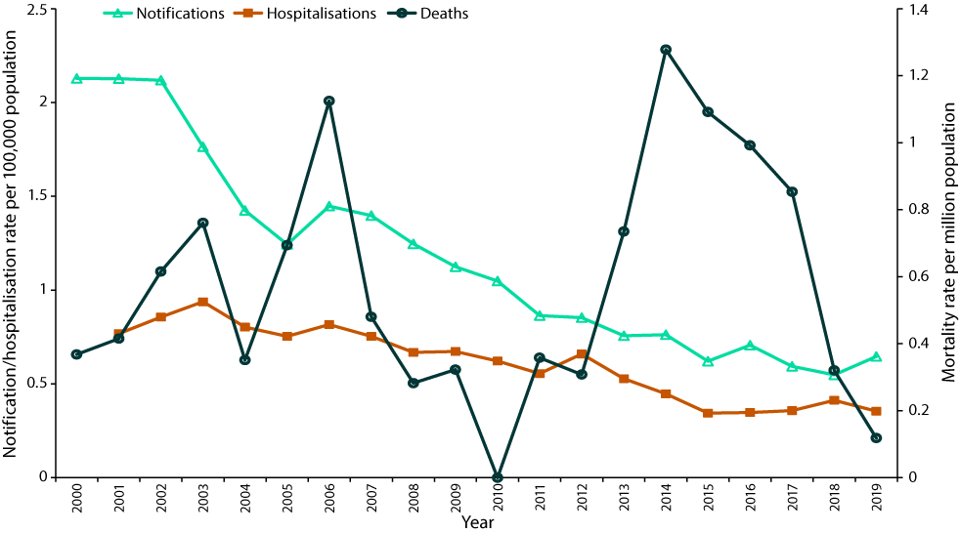
a Hospitalisation data for the years 2001 and 2019 are annualised based on data from 1 July – 31 December 2001 and 1 January – 30 June 2019, respectively.
b Data sources: National Notifiable Diseases Surveillance System for notification data, Australian Institute of Health and Welfare National Hospital Morbidity Database for hospitalisation data, and Australian Bureau of Statistics (2000–2005) and Australian Coordinating Registry (2006–2019) for death data.
Table 4: Acute hepatitis B hospitalisation count and average annual rate per 100,000 population per year over 2001–2019, and hospitalisation count and annual rate per 100,000 per year in 2019, in Australia and by state or territory^{a,b,c}
Jurisdiction^{b} | Total count | Average annual hospitalisation rate^{c} |  | Count in 2019 | Annual hospitalisation rate in 2019^{c}
 |  | Rate per 100,000 | 95% CI^{d} |  | Rate per 100,000 | 95% CI^{d}
ACT | 25 | 0.36 | 0.23–0.53 | 0 | 0 | N/A
NSW | 661 | 0.48 | 0.45–0.52 | 34 | 0.42 | 0.29–0.59
NT | 74 | 1.72 | 1.35–2.10 | 6 | 2.44 | 0.90–5.31
Qld | 351 | 0.42 | 0.38–0.47 | 16 | 0.31 | 0.18–0.51
SA | 131 | 0.43 | 0.36–0.50 | 0 | 0 | N/A
Tas. | 51 | 0.53 | 0.40–0.70 | 1–4e | 0.37 | 0.05–1.35
Vic. | 862 | 0.82 | 0.77–0.88 | 26 | 0.39 | 0.26–0.58
WA | 304 | 0.70 | 0.63–0.79 | NP^{e} | 0.23 | 0.08–0.50
Australia | 2,509 | 0.60 | 0.58–0.62 | 90 | 0.36 | 0.29–0.44
a Data source: Australian Institute for Health and Welfare National Hospital Morbidity Database.
b ACT: Australian Capital Territory; NSW: New South Wales; NT: Northern Territory; Qld: Queensland; SA: South Australia; Tas.: Tasmania; Vic.: Victoria; WA: Western Australia.
c Hospitalisation data for the years 2001 and 2019 are annualised based on data from 1 July – 31 December 2001 and 1 January – 30 June 2019, respectively.
d CI: confidence interval; N/A: not applicable.
e In line with Australian Institute for Health and Welfare requirements, counts smaller than 5 are suppressed. Counts between 1 and 4 are provided as a range, and other cell counts may be reported as NP (not published) to avoid potential back calculation.
Figure 2: Annual rate of newly-acquired hepatitis B notifications (2000–2019), by age group among people aged: (A) < 15 years; (B) 15–29 years; and (C) ≥ 30 yearsª
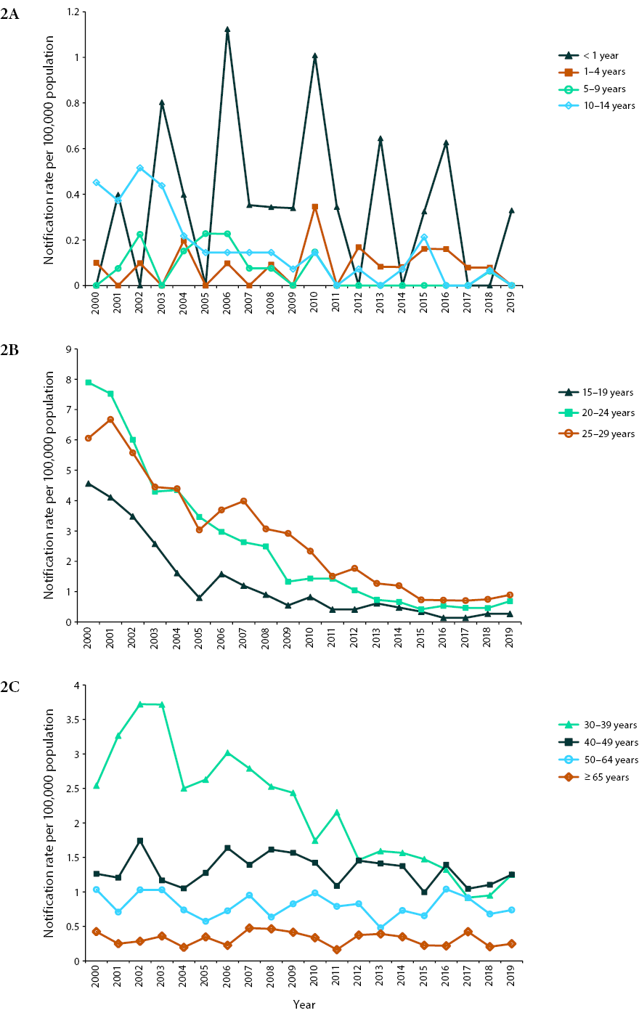
a Data source: National Notifiable Diseases Surveillance System.

Age distribution
The average annual rate of newly-acquired hepatitis B notifications between 2000 and 2019 was lowest in young children under the age of 10 years, with 20 notifications in the < 1 year age group during this time period, 20 in the 1–4 year age group and 17 in the 5–9 year age group, equating to notification rates of 0.35, 0.09 and 0.06 per 100,000 population per year, respectively. Notification rates remained stable at low levels between 2000 and 2019 among children aged < 5 years, whilst rates declined in the 5–9 year and 10–14 year age groups (p = 0.008 and <0.001, respectively; Figure 2A). From 2000 to 2005, a steep decline in the notification rate among adolescents aged 15–19 years was observed, followed by a more gradual decline (overall 17-fold decline from 2000 to 2019, p < 0.001; Figure 2B). While the average annual notification rate was highest among young adults aged 25–29 years (2.58 per 100,000 population per year [95% CI: 2.41–2.76]) and 20–24 years (2.32 per 100,000 population per year [95% CI: 2.15–2.50]), a 7-fold (p < 0.001) and 11-fold (p < 0.001) respective decline in notification rate was observed from 2000 to 2019 in these age groups (Figure 2B). Notification rates declined twofold over the 2000 to 2019 period among adults aged 30–39 years (p < 0.001), while rates remained largely stable among adults aged ≥ 40 years (Figure 2C). In all age groups where notification rates declined over the study period, rates appear to have largely plateaued from around 2015 onwards. In the last reporting year, 2019, the highest notification rate of newly-acquired hepatitis B was jointly observed among adults aged 30–39 years at 1.25 per 100,000 population per year (95% CI: 0.92–1.67), and those aged 40–49 years at 1.25 per 100,000 population per year (95% CI: 0.90–1.70).
In children aged < 5 years, there were 1–4 acute hepatitis B hospitalisations in total over 2001–2019. Among the other age groups, the average annual hospitalisation rate was highest in adults aged 30–39 years at 1.06 per 100,000 population per year (95% CI: 0.98–1.15), and lowest in children aged 5–9 years at 0.04 per 100,000 population per year (95% CI: 0.02–0.08). There was a significant decline in the acute hepatitis B hospitalisation rate over this time period among the age groups 10–19 years (7-fold; p < 0.001), 20–29 years (7-fold; p < 0.001), 30–39 years (1.5-fold; p < 0.001) and 50–64 years (3-fold; p<0.001), but not in the age groups 0–9 years (p = 0.60), 40–49 years (p = 0.05), and ≥ 65 years (p = 0.05; Figure 3).
There were no deaths with acute hepatitis B as underlying cause of death among people younger than 10 years of age between 2000 and 2019. In the age groups 10–19 and 20–29 years, there were 1–5 deaths over the reporting period. The number of deaths with acute hepatitis B as the underlying cause increased with increasing age (15, 44, 94 and 95 deaths among adults aged 30–39, 40–49, 50–64 and ≥ 65 years, respectively). The corresponding mortality rates per million population per year were 0.24 (95% CI: 0.13–0.39); 0.72 (95% CI: 0.52–0.96); 1.22 (95% CI: 0.99–1.50) and 1.56 (95% CI: 1.26–1.90).
Figure 3: Annual rate of acute hepatitis B hospitalisations (2001–2019), by age group^{a,b}
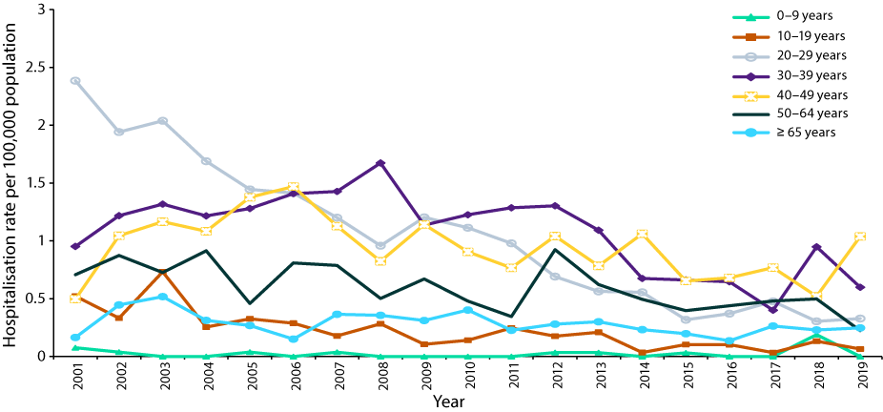
a Data source: Australian Institute of Health and Welfare National Hospital Morbidity Database.
b Hospitalisation data for the years 2001 and 2019 are annualised based on data from 1 July – 31 December 2001 and 1 January – 30 June 2019, respectively.

Sex distribution
The average annual age-standardised notification rate of newly-acquired hepatitis B among males was 1.50 per 100,000 population per year (95% CI: 1.45–1.56) with a threefold decline in incidence over time (p < 0.001; Figure 4). The average annual age-standardised notification rate among females was 0.78 per 100,000 population per year (95% CI: 0.74–0.82), and this also declined (3.5-fold) over the 2000–2019 period (p < 0.001; Figure 4). For all cases across the period, the age-standardised male to female rate ratio was 1.94 on average (95% CI: 1.82–2.06), with the annual rate ratio ranging from 1.38 (95% CI: 1.08–1.76) in 2004 to 3.43 (95% CI: 2.39–5.02) in 2014.
The average annual age-standardised hospitalisation rate among males was 0.80 per 100,000 population per year (95% CI: 0.76–0.84), with a twofold decline over time (p < 0.001; Figure 4). The average annual hospitalisation rate among females was 0.41 per 100,000 population per year (95% CI: 0.39–0.44), which also declined (3.5-fold) between 2001 and 2019 (p < 0.001; Figure 4). The age-standardised male to female rate ratio was 1.93 (95% CI: 1.77–2.10) on average across the period.
For deaths during 2000–2019, where the underlying cause of death was acute hepatitis B, the average age-standardised mortality rate was 0.81 per million population per year (95% CI: 0.70–0.94) among males and 0.28 per million population per year (95% CI: 0.22–0.35) among females. This equates to a rate ratio of 2.89 (95% CI: 2.18–3.88). Age at time of death (between 2006 and 2019) was not significantly different between males (60.8 years) and females (64.1 years) (p = 0.15).
Figure 4: Annual rate of newly-acquired hepatitis B notifications (2000–2019) and acute hepatitis B hospitalisations (2001–2019), by sex^{a,b,c}
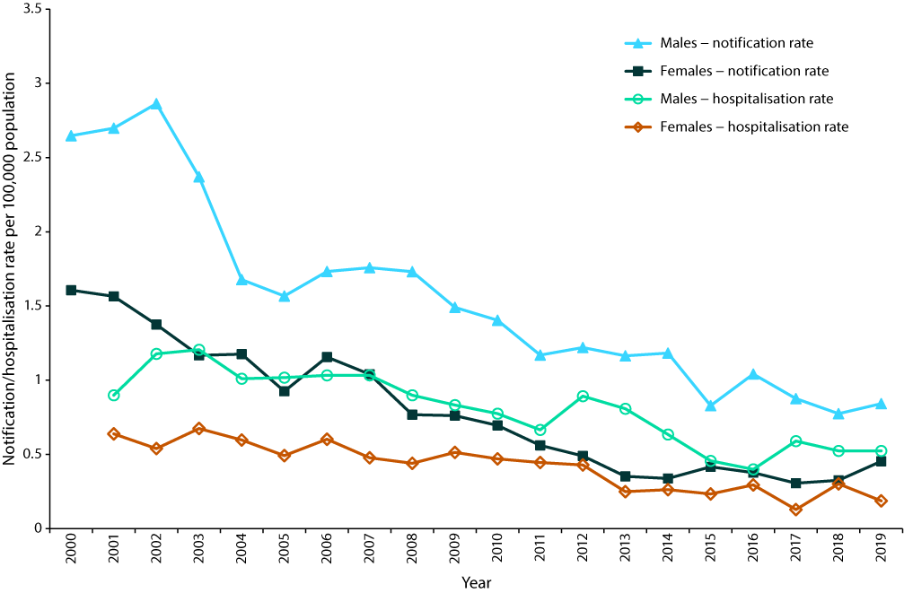
a Data sources: National Notifiable Diseases Surveillance System for notification data; Australian Institute of Health and Welfare National Hospital Morbidity Database for hospitalisation data.
b In line with AIHW recommendations, rates were not age-standardised as <20 events occurred in some of the analysed populations.
c Hospitalisation data for the years 2001 and 2019 are annualised based on data from 1 July – 31 December 2001 and 1 January – 30 June 2019, respectively.

Aboriginal and Torres Strait Islander people
Of 4,945 notifications of newly-acquired hepatitis B over 2000 to 2019, Aboriginal and Torres Strait Islander status was unknown for 708 (14.3%). Completeness was lowest in 2000 at 76.3% and highest in 2016 at 95.9%. Over the entire 2000–2019 period, completeness ranged between 63.4% (Tasmania) and 100% (South Australia). Among Aboriginal and Torres Strait Islander people, the age-standardised average annual notification rate of newly-acquired hepatitis B between 2000 and 2019 was 3.09 per 100,000 population per year (95% CI: 2.77–3.44). For other people, this rate was 1.08 per 100,000 population per year (95% CI: 1.05–1.11). The average age-standardised rate ratio was 2.87 (95% CI: 2.56–3.21). The crude annual notification rate declined over this period in both groups (twofold among Aboriginal and Torres Strait Islander people, and 3.5-fold among other people; p < 0.001; Figure 5A). The crude average annual notification rate among Aboriginal and Torres Strait Islander people was higher than among other people in every state and territory, except in the Australian Capital Territory and Tasmania, where low numbers of notifications affected the precision of the estimated rate ratio, and where data completeness for Aboriginal and Torres Strait Islander status over the 2000–2019 period was lowest at 69.0% and 63.4%, respectively.
Figure 5: Annual rates of (A) newly-acquired hepatitis B notifications (2000–2019)^{a,b} and (B) acute hepatitis B hospitalisations (2010–2019),^{a,b,c} by Aboriginal and Torres Strait Islander status
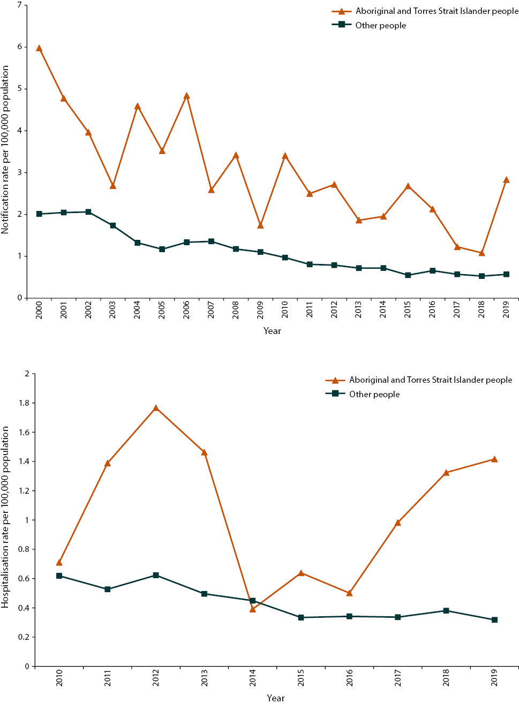
a Data sources: National Notifiable Diseases Surveillance System for notification data, and Australian Institute of Health and Welfare National Hospital Morbidity Database for hospitalisation data.
b In line with AIHW recommendations, rates were not age-standardised as < 20 events occurred in some of the analysed populations.
c Hospitalisation data for the year 2019 are annualised based on data from 1 January – 30 June 2019.
Among Aboriginal and Torres Strait Islander people, the average annual notification rate for newly-acquired hepatitis B between 2000 and 2019 was lowest in children aged 0–4 and 5–9 years at 0.28 (95% CI: 0.09–0.65) and 0.06 (95% CI: 0.001–0.33) notifications per 100,000 population per year respectively (Table 5). The average annual notification rate was highest in people 25–29 years of age at 6.10 per 100,000 population per year (95% CI: 4.70–7.79), followed by those aged 20–24 years at 5.66 per 100,000 population per year (95% CI: 4.40–7.18), and those aged 30–39 years at 5.13 per 100,000 population per year (95% CI: 4.14–6.27). The average annual age-specific notification rate significantly declined among Aboriginal and Torres Strait Islander people aged 10–14 years (p < 0.001), 15–19 years (p < 0.001), 20–24 years (p < 0.001) and 25–29 years (p < 0.001), but not among those 0–9 years or 30 years and older (data not shown). The average annual notification rate was significantly higher among Aboriginal and Torres Strait Islander people compared to other people in all age groups, except in those aged 0–4 and 5–9 years (Table 5). Rate ratios were between 2.5 and 5 in the age groups covering 15 to 64 years, with higher but less precise estimates in the 10–14 years and ≥ 65-year age groups.
The age-standardised acute hepatitis B hospitalisation rate was higher in Aboriginal and Torres Strait Islander people (average annual rate 1.20 per 100,000 population per year; 95% CI: 0.93–1.51) than in other people (0.44 per 100,000 population per year; 95% CI: 0.41–0.47). The average hospitalisation rate ratio for Aboriginal and Torres Strait Islander compared to other people was 2.72 (95% CI: 2.10–3.47) overall. Acute hepatitis B hospitalisations declined significantly over 2010–2019 for other people (crude rate declined 3.5-fold; p < 0.001), but not for Aboriginal and Torres Strait Islander people (p = 0.51; Figure 5B). Median length of stay was also higher in Aboriginal and Torres Strait Islander (5 days [IQR 3–7.5 days]) than in other people (4 days [IQR 2–6 days]; p < 0.001). The crude average annual hospitalisation rate among Aboriginal and Torres Strait Islander people was significantly higher than the rate among other people in all states and territories, except in the Australian Capital Territory, Victoria and Tasmania, with Tasmania not reporting any hospitalisations among Aboriginal and Torres Strait Islander people over the period 2010 to 2019 (data not shown).
The average annual acute hepatitis B hospitalisation rate among Aboriginal and Torres Strait Islander people between 2010 and 2019 was highest in those aged 20–29 years (1.54 per 100,000 population per year [95% CI: 0.94–2.38]), 30–39 years (2.03 per 100,000 population per year [95% CI: 1.22–3.18]) and 40–49 years (2.09 per 100,000 population per year [95% CI: 1.24–3.30]; Table 6). There were no acute hepatitis B hospitalisations over the 10-year period for Aboriginal and Torres Strait Islander children aged 0–4 years. The average annual hospitalisation rate in other age groups was less than 1 per 100,000 population per year. Acute hepatitis B hospitalisation rates among Aboriginal and Torres Strait Islander people did not decline significantly over the 2010 to 2019 period in any age group (p ≥ 0.05; data not shown). Hospitalisations rates were significantly higher among Aboriginal and Torres Strait Islander people than other people in the age groups 5–9 years (rate ratio [RR]: 108.51 [95% CI: 13.94–4890.54]), 10–19 years (RR: 6.41 [95% CI: 2.76–13.74]), 20–29 years (RR: 2.93 [95% CI: 1.75–4.67]), 30–39 years (RR: 2.43 [95% CI: 1.44–3.87]), and 40–49 years (RR: 2.66 [95% CI: 1.55–4.29]).
All deaths between 2004 and 2019 had a known Aboriginal and Torres Strait Islander status. Prior to 2004, Aboriginal and Torres Strait Islander status was recorded using a combined category for non-Indigenous and unknown status, preventing ascertainment of data completeness. Across the 2000–2019 period, there were 29 deaths where acute hepatitis B was the underlying cause of death among Aboriginal and Torres Strait Islander people (age-standardised average annual rate 3.64 per million population per year; 95% CI: 2.29–5.44), and 224 among other people (0.48 per million population per year; 95% CI: 0.42–0.55). The average rate ratio for death with acute hepatitis B as the underlying cause of death, comparing Aboriginal and Torres Strait Islander to other people, was 7.54 (95% CI: 4.67–11.44). Between 2006 and 2019, the median age of death with acute hepatitis B as the underlying cause of death in Aboriginal and Torres Strait Islander people was younger (51 years) than in other people (63 years; p = 0.002).
Table 5: Newly-acquired hepatitis B notifications, 2000–2019, by age group and Aboriginal and Torres Strait Islander status, Australiaª
Age group (years) | Aboriginal and Torres Strait Islander status | Newly-acquired hepatitis B notifications 2000–2019
 |  | Number | Rate per 100,000 | 95% CI for rate^{b} | RR^{c} | 95% CI for rate^{b,c}
0–4 | Aboriginal and Torres Strait Islander | 5 | 0.28 | 0.09–0.65 | 2.11 | 0.65–5.41
 | Other | 35 | 0.13 | 0.09–0.18
5–9 | Aboriginal and Torres Strait Islander | 1 | 0.06 | 0.001–0.33 | 0.98 | 0.02–6.30
 | Other | 16 | 0.06 | 0.03–0.10
10–14 | Aboriginal and Torres Strait Islander | 13 | 0.83 | 0.44–1.42 | 7.09 | 3.41–13.95
 | Other | 31 | 0.12 | 0.08–0.17
15–19 | Aboriginal and Torres Strait Islander | 70 | 5.03 | 3.92–6.36 | 4.94 | 3.74–6.44
 | Other | 277 | 1.02 | 0.90–1.15
20–24 | Aboriginal and Torres Strait Islander | 68 | 5.66 | 4.40–7.18 | 2.59 | 1.99–3.33
 | Other | 647 | 2.19 | 2.02–2.36
25–29 | Aboriginal and Torres Strait Islander | 64 | 6.10 | 4.70–7.79 | 2.48 | 1.89–3.20
 | Other | 758 | 2.46 | 2.29–2.64
30–39 | Aboriginal and Torres Strait Islander | 94 | 5.13 | 4.14–6.27 | 2.52 | 2.02–3.10
 | Other | 1,249 | 2.04 | 1.93–2.15
40–49 | Aboriginal and Torres Strait Islander | 53 | 3.41 | 2.56–4.46 | 2.70 | 2.00–3.57
 | Other | 758 | 1.27 | 1.18–1.36
50–64 | Aboriginal and Torres Strait Islander | 26 | 1.92 | 1.25–2.81 | 2.46 | 1.60–3.65
 | Other | 588 | 0.80 | 0.72–0.84
≥ 65 | Aboriginal and Torres Strait Islander | 10 | 2.07 | 0.99–3.80 | 6.88 | 3.25–12.95
 | Other | 182 | 0.30 | 0.26–0.35
a Data source: National Notifiable Diseases Surveillance System.
b CI: confidence interval.
c RR: rate ratio.
Table 6: Acute hepatitis B hospitalisations, 2010–2019, by age group and Aboriginal and Torres Strait Islander status, Australiaª
Age group (years) | Aboriginal and Torres Strait Islander status | Acute hepatitis B hospitalisations 2010–2019
 |  | Number^{b} | Rate per 100,000 | 95% CI for rate^{c} | RR^{d} | 95% CI for rate^{c,d}
0–4 | Aboriginal and Torres Strait Islander | 0 | 0 | — | — | —
 | Other | 1–4 | 0.01 | 0.0002–0.04
5–9 | Aboriginal and Torres Strait Islander | NP | 0.77 | 0.31–1.58 | 108.51 | 13.94–4890.54
 | Other | 1–4 | 0.01 | 0.0002–0.04
10–19 | Aboriginal and Torres Strait Islander | 10 | 0.61 | 0.29–1.12 | 6.41 | 2.76–13.74
 | Other | 26 | 0.09 | 0.06–0.14
20–29 | Aboriginal and Torres Strait Islander | 20 | 1.54 | 0.94–2.38 | 2.93 | 1.75–4.67
 | Other | 174 | 0.53 | 0.45–0.61
30–39 | Aboriginal and Torres Strait Islander | 19 | 2.03 | 1.22–3.18 | 2.43 | 1.44–3.87
 | Other | 271 | 0.84 | 0.74–0.94
40–49 | Aboriginal and Torres Strait Islander | 18 | 2.09 | 1.24–3.30 | 2.66 | 1.55–4.29
 | Other | 245 | 0.79 | 0.69–0.89
50–64 | Aboriginal and Torres Strait Islander | 5 | 0.59 | 0.19–1.37 | 1.21 | 0.39–2.88
 | Other | 202 | 0.49 | 0.42–0.56
≥ 65 | Aboriginal and Torres Strait Islander | 1–4 | 0.96 | 0.20–2.81 | 3.93 | 0.79–11.88
 | Other | 85 | 0.24 | 0.20–0.30
a Data source: Australian Institute for Health and Welfare National Hospital Morbidity Database. Hospitalisation data for the year 2019 are annualised based on data from 1 January – 30 June 2019.
b In line with Australian Institute for Health and Welfare requirements, counts smaller than 5 are suppressed. Counts between 1 and 4 are provided as a range, and other cell counts may be reported as ‘not published’ (NP) to avoid potential back calculation
c CI: confidence interval.
d RR: rate ratio.

State and territory variations
Across the reporting period, the highest average annual notification rate was in the Northern Territory at 2.74 per 100,000 population per year (95% CI: 2.27–3.27), and the lowest average annual notification rate was in New South Wales at 0.62 per 100,000 population per year (95% CI: 0.58–0.66) (Table 3). Over the reporting period, the notification rate significantly declined in all states and territories (p < 0.001), except in the Australian Capital Territory (p = 0.06) (Figure 6).
The Northern Territory had the highest reporting rate of acute hepatitis B hospitalisations over the entire period (1.72 per 100,000 population per year; 95% CI: 1.35–2.10), as well as in 2019 (2.44 per 100,000 population per year; 95% CI: 0.90–5.31) (Table 4). The lowest average annual hospitalisation rate was observed in the Australian Capital Territory (0.36 per 100,000 population per year; 95% CI: 0.23–0.53). Between 2001 and 2019, the hospitalisation rate significantly declined in New South Wales (p < 0.001), South Australia (p = 0.047), Tasmania (p = 0.01), Victoria (p < 0.001) and Western Australia (p < 0.001), but not in the Australian Capital Territory (p = 0.96), the Northern Territory (p = 0.75) and Queensland (p = 0.11) (Figure 6).
The average annual death rate with acute hepatitis B as the underlying cause was highest in the Northern Territory at 3.11 per million population per year (95% CI: 1.70–5.23), and lowest in Tasmania at 0.20 per million population per year (95% CI: 0.02–0.72). Due to the low number of deaths per state or territory, rates were variable over the reporting period (data not shown).
Figure 6: Annual rate of newly-acquired hepatitis B notifications (2000–2019) and acute hepatitis B hospitalisations (2001–2019) in Australia, by state and territory^{a,b,c}
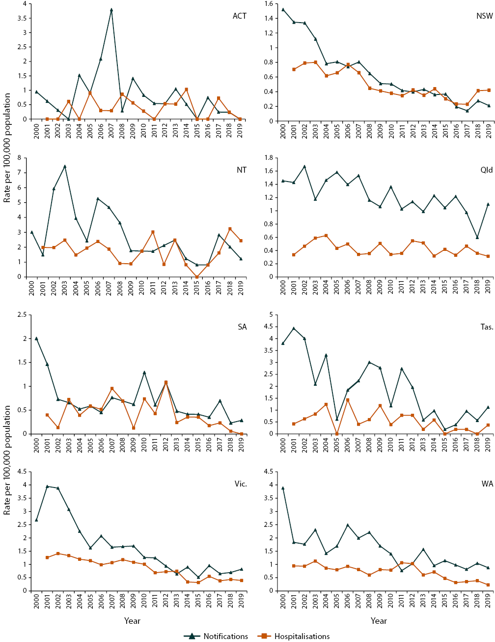
a Data sources: National Notifiable Diseases Surveillance System for notification data, and Australian Institute of Health and Welfare National Hospital Morbidity Database for hospitalisation data.
b Note that the scale on the y-axis varies per state or territory.
c Hospitalisation data for the years 2001 and 2019 are annualised based on data from 1 July – 31 December 2001 and 1 January – 30 June 2019, respectively.

Place of acquisition
Place of acquisition was reported in 2,662 of 4,945 notifications of newly-acquired hepatitis B (53.8%), with the majority of these recorded as acquired in Australia (n = 2,481; 93.2%). The second most common place of acquisition was South-East Asia (89 notifications; 2.7%), with the remaining regions contributing fewer than 1% of notifications each.

Country of birth
Among the 4,945 notifications of newly acquired hepatitis B during 2000–2019, Australia was the most common country of birth recorded (n = 1874; 37.9%) (Table 7). Other regions of birth included South-East Asia (n = 118; 2.4%), North-West Europe (n = 96; 1.9%) and Southern and Eastern Europe (n = 82; 1.7%). A further 158 notifications (3.2%) had country of birth reported as ‘overseas, country unknown’. Country of birth was not recorded for 2,291 (46.3%) notifications. There was no apparent trend in the proportion of notifications where Australia was the country of birth, nor where the country of birth was unknown (formal statistical test not performed).
Country or region of birth was reported for all 190 deaths with acute hepatitis B as the underlying cause between 2006 and 2019. Of these deaths, 71 were among people born in Australia (37.4%; Table 7). Other common areas of birth were South-East Asia (n = 35; 18.4%), Southern and Eastern Europe (n = 25; 13.2%) and North-East Asia (n = 21; 11.1%).

Vaccination status
Vaccination status was available for only 42 of 4,945 (0.8%) notifications of newly-acquired hepatitis B.

Birth cohort analysis
Of the 4,945 newly-acquired hepatitis B notifications, 52 (1.1%) occurred in a person born in May 2000 or later. Sixteen of these notifications were in individuals born in Australia, who would have been eligible for infant vaccination under the NIP, with ten notifications in people born overseas, and 26 in people where country of birth was not recorded. Twelve notifications were recorded as acquired overseas, 20 as acquired in Australia, and place of acquisition was unknown for the remaining 20. Of the 16 notifications among people identified to be eligible for infant vaccination under the NIP, two were recorded as Aboriginal and Torres Strait Islander. Ten notifications were in children younger than one year of age, with three each in the age groups 1–4 and 10–19 years. Vaccination information was available for four of the 16 notifications.
There were no deaths from acute hepatitis B infection reported among people born after May 2000.
Table 7: Notification count and percentage of newly-acquired hepatitis notifications (2000–2019), and acute and chronic hepatitis B death count and percentage of total deaths (2006–2019), by country of birth or Standard Australian Classification of Countries (SACC) major group at birth, Australiaª
Country of birth or major SACC group at birth | Newly-acquired hepatitis B notifications (2010–2019) |  | Acute hepatitis B deaths^{b} (2006–2019) |  | Chronic hepatitis B deaths^{c} (2006–2019)
 | Count | % | Count^{d} | %^{d,e} | Count^{d} | %^{d,e}
Australia | 1,874 | 37.9 | 71 | 37.4 | 67 | 22.3
New Zealand | 48 | 1.0 | 1–5 | NP | 12 | 4.0
Other Oceania | 31 | 0.6 | 16 | 8.4 | 23 | 7.7
North-West Europe | 96 | 1.9 | 7 | 3.7 | 7 | 2.3
Southern and Eastern Europe | 82 | 1.7 | 25 | 13.2 | 45 | 15.0
North Africa and the Middle East | 54 | 1.1 | 1–5 | NP | 21 | 7.0
South-East Asia | 118 | 2.4 | 35 | 18.4 | 68 | 22.7
North-East Asia | 79 | 1.6 | 21 | 11.1 | 44 | 14.7
Southern and Central Asia | 56 | 1.1 | 1–5 | NP | 6 | 2.0
Americas | 25 | 0.5 | 1–5 | NP | 1–5 | NP
Sub-Saharan Africa | 33 | 0.7 | 1–5 | NP | 1–5 | NP
Overseas, unknown country | 158 | 3.2 | 0 | 0.0 | 0 | 0.0
Unknown | 2,291 | 46.3 | 0 | 0.0 | 0 | 0.0
a Data sources: National Notifiable Diseases Surveillance System for notification data, and Australian Coordinating Registry for death data.
b Deaths with acute hepatitis B as the underlying cause of death.
c Deaths with chronic hepatitis B as the underlying cause of death, and deaths with chronic hepatitis B as an associated cause of death and hepatocellular carcinoma or liver disease as the underlying cause of death.
d In line with Australian Coordinating Registry requirements, counts smaller than 6 are suppressed. Counts between 1 and 5 are provided as a range, and other cell counts may be reported as NP to avoid potential back calculation.
e NP: not provided.

Unspecified/chronic hepatitis B
There were 126,223 notifications of unspecified hepatitis B between 2000 and 2019, equating to an average annual rate of 28.8 per 100,000 population per year (95% CI: 28.6–28.9). Notification rates of unspecified hepatitis B declined in the overall population, from 38.3 per 100,000 population per year in 2000 (95% CI: 37.5–39.2) to 22.3 per 100,000 population per year (95% CI: 21.8–22.9) in 2019 (a 1.7-fold reduction; p < 0.001; Figure 7).
Between 2006 and 2019, there were 128 deaths with chronic hepatitis B recorded as the underlying cause of death, and 392 with chronic hepatitis B recorded as an associated cause, 172 of which had hepatocellular carcinoma recorded as the underlying cause but none with liver disease, making 300 (128+172) chronic hepatitis B attributable deaths. The average annual mortality rate was 0.40 per million population per year (95% CI: 0.33–0.47) for chronic hepatitis B as underlying cause of death, 0.93 per million population per year (95% CI: 0.83–1.05) for chronic hepatitis B attributable deaths, and 1.62 per million population per year (95% CI: 1.48–1.77) for all deaths with chronic hepatitis B as underlying or associated cause. Mortality rates increased between 2006 to 2019 for all three categories (p = 0.02 for deaths with chronic hepatitis B as the underlying cause of death, p < 0.001 for chronic hepatitis B attributable deaths and all deaths; Figure 8).
Figure 7: Annual rate of unspecified hepatitis B notifications between 2000 and 2019 in Australia overall, and by sex^{a,b}
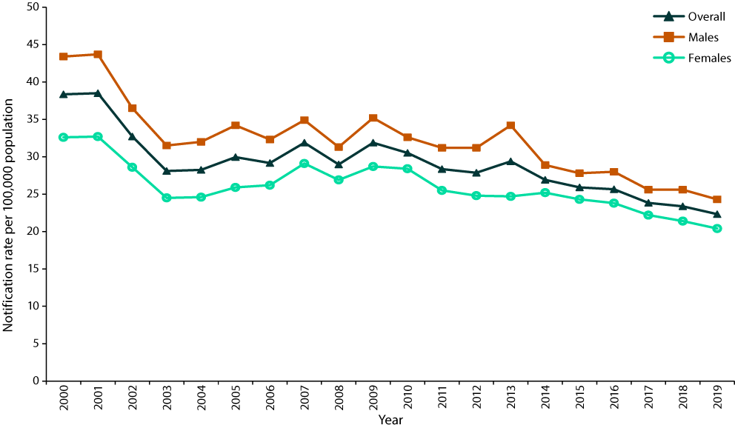
a Data source: National Notifiable Diseases Surveillance System.
b Sex-specific notification rates are age-standardised.
Figure 8: Annual rate of deaths with chronic hepatitis B as the underlying cause of death, annual rate of chronic hepatitis B attributable deaths, and annual rate of deaths with chronic hepatitis B as the underlying or an associated cause of death between 2006 and 2019, Australia^{a,b}
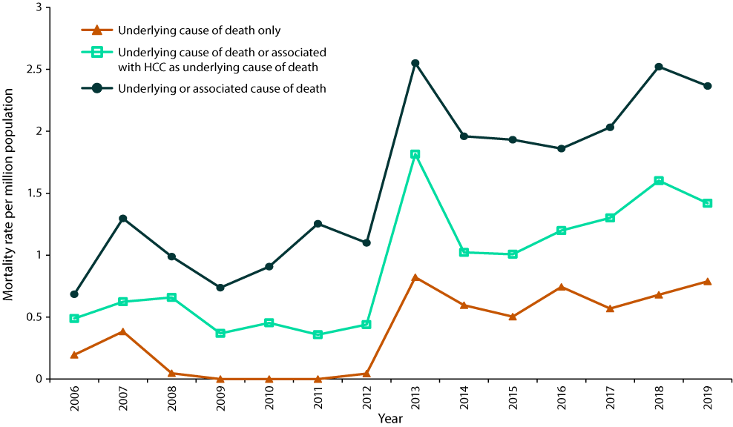
a Data source: Australian Coordinating Registry.
b HCC: hepatocellular carcinoma.

Age distribution
The average notification rate was highest among adults aged 25–29 years (60.0 per 100,000 population per year; 95% CI: 59.2–60.9), followed by those aged 30–39 years (57.2 per 100,000 population per year; 95% CI: 56.7–57.8) and those aged 20–24 years (40.9 per 100,000 population per year; 95% CI: 40.2–41.6). While the notification rate declined among 30–39-year-old adults (1.5-fold; p = 0.008; Figure 9C), the rate was higher than among other age groups in the latter half of the reporting period. In contrast, the notification rate among 20–24 and 25–29-year-old adults declined markedly over the latter half of the reporting period (a 3.5-fold and twofold decrease, respectively, over the entire period; p < 0.001 for both; Figure 9B). Notification rates declined most among adolescents 10–14 and 15–19 years of age (fivefold in both groups; p < 0.001; Figures 9A and B), and to a lesser extent in younger children (twofold in children < 1 year of age, 2.5-fold in children 1–4 years of age, and fourfold in children 5–9 years of age; p values ≤ 0.001) and in adults 40–49 years of age (1.5-fold; p < 0.001). Rates did not decline in adults aged 50–64 years (p = 0.99) and those aged ≥ 65 years (p = 0.19).
There were no chronic hepatitis B attributable deaths among people < 30 years of age between 2006 and 2019. In other age groups, the highest average annual rate of chronic hepatitis B attributable deaths was in adults aged ≥ 65 years (143 deaths, 3.10 deaths per million population per year [95% CI: 2.61–3.65]), followed by 50–64 years (109 deaths, 1.90 per million population per year [95% CI: 1.56–2.29]), 40–49 years (35 deaths, 0.79 per million population per year [95% CI: 0.55–1.10]), and 30–39 years (13 deaths, 0.29 per million population per year [95% CI: 0.15–0.49]). Chronic hepatitis B attributable deaths increased over the 2006 to 2019 period among adults aged 30–39 years (p = 0.047), 50–64 years (p = 0.001) and ≥ 65 years (p < 0.001), but not among those aged 40–49 years (p = 0.25; Figure 9D).
Figure 9: Annual rates of unspecified hepatitis B notifications (2000–2019), by age group among people aged (A) <15 years, (B) 15–29 years and
(C) ≥ 30 years; and (D) annual rate of chronic hepatitis B attributable deaths (2006–2019) by age group among adults aged ≥ 30 yearsª
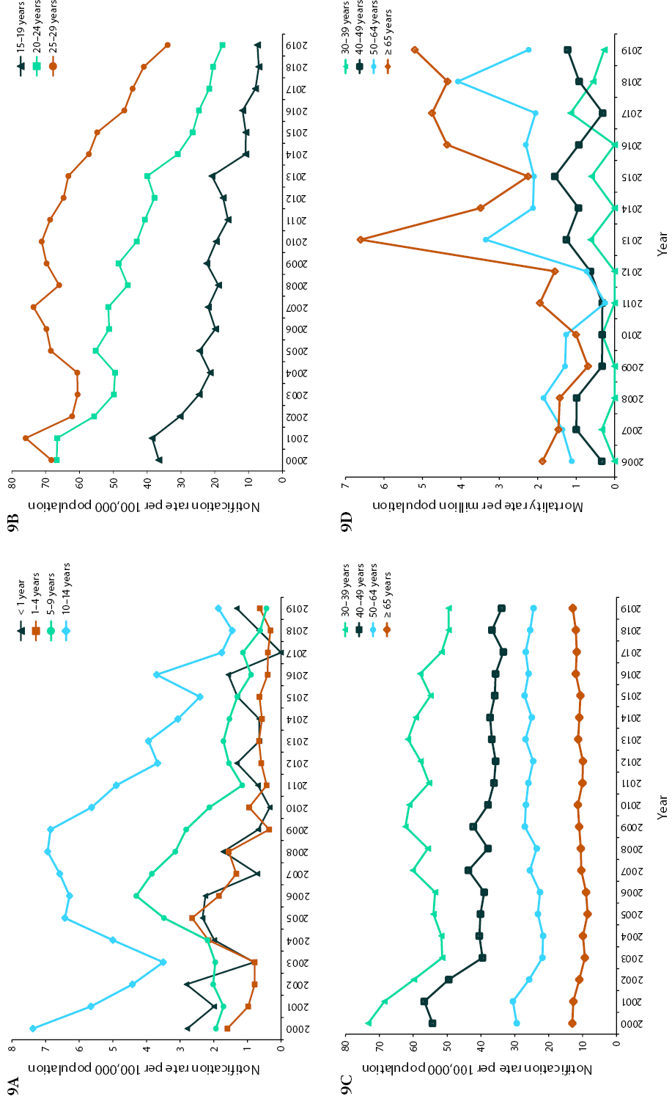
a Data sources: National Notifiable Diseases Surveillance System for notification data; Australian Coordinating Registry for death data.

Sex distribution
The average annual age-standardised notification rate in males was 31.9 per 100,000 population per year (95% CI: 31.7–32.2), and in females 25.8 per 100,000 population per year (95% CI: 25.6–26.0), which equates to an average rate ratio of 1.24 (95% CI: 1.22–1.25). The age-standardised rate ratio ranged between 1.14 (95% CI: 1.09–1.20) in 2015 and 1.38 (95% CI: 1.32–1.45) in 2013. Rates declined in males as well as in females (p < 0.001; Figure 7).
There were 213 chronic hepatitis B attributable deaths in males, and 87 in females. The average annual age-standardised chronic hepatitis B attributable mortality rate in males was 1.25 per million population per year (95% CI: 1.09–1.43), and in females 0.47 per million population per year (95% CI: 0.38–0.59). The average rate ratio was 2.64 (95% CI: 2.04–3.44).

Aboriginal and Torres Strait Islander people
Unspecified hepatitis B notifications were not analysed by Aboriginal and Torres Strait Islander status due to low completeness. Aboriginal and Torres Strait Islander status completeness for unspecified hepatitis B notifications over the entire 2000–2019 period was 48%, ranging from 38% in 2002 to 58% in 2018. The highest overall Aboriginal and Torres Strait Islander status completeness was in SA at 97%, with completeness > 90% in each year except 2001. Overall completeness and completeness in 2019, respectively, in the remaining states and territories was as follows: 40% and 55% in the Australian Capital Territory; 26% and 27% in New South Wales; 92% and 82% in the Northern Territory; 57% and 88% in Queensland; 59% and 73% in Tasmania; 48% and 54% in Victoria, and 90% and 92% in Western Australia.
Aboriginal and Torres Strait Islander status was available for all 300 chronic hepatitis B attributable deaths. Of these 300 deaths, 27 (9.0%) occurred in Aboriginal and Torres Strait Islander people and 273 in other people. The average age-standardised annual mortality rate was 4.93 per million population per year (95% CI: 3.09–7.39) among Aboriginal and Torres Strait Islander people and 0.78 per million population per year (95% CI: 0.69–0.88) among other people, equating to an average rate ratio over 2006 to 2019 of 6.34 (95% CI: 3.93–9.59).

State and territory variations
The largest number of unspecified hepatitis B notifications in this period was reported in New South Wales at 51,581 notifications (Table 8). The highest average annual notification rate was observed in the Northern Territory at 71.6 per 100,000 population per year (95% CI: 68.8–74.4). While the notification rate in the Northern Territory substantially declined over the reporting period (p < 0.001; Figure 10), this decline was not uniform with the notification rate peaking in 2013 (132.0 per 100,000 population per year). However, the Northern Territory still had the highest rate in 2019 (31.3 per 100,000 population per year [95% CI: 24.7–39.1]). Notification rates also significantly declined in New South Wales (p < 0.001), Queensland (p = 0.002) and Victoria (p < 0.001), but not in the Australian Capital Territory (p = 0.16), South Australia (p = 0.33), Tasmania (p = 0.31) and Western Australia (p = 0.22).
During 2006–2019, there were 1–5 chronic hepatitis B attributable deaths in each of the Australian Capital Territory and Tasmania. In the other jurisdictions, the average annual chronic hepatitis B attributable mortality rate was highest in the Northern Territory (21 deaths, 6.40 per million population per year [95% CI: 3.96–9.78]), followed by Victoria (79 deaths, 0.98 per million population per year [95% CI: 0.78–1.22]), New South Wales (95 deaths, 0.92 per million population per year [95% CI: 0.74–1.12]), South Australia (20 deaths, 0.86 per million population per year [95% CI: 0.53–1.33]), Queensland (54 deaths, 0.84 per million population per year [95% CI: 0.63–1.10]), and Western Australia (26 deaths, 0.78 per million population per year [95% CI: 0.51–1.14]).
Table 8: Unspecified hepatitis B total notification count and average annual rate over 2000–2019, and notification count and annual rate in 2019, in Australia and by state or territoryª
Jurisdiction^{b} | Total count | Average annual notification rate |  | Count in 2019 | Annual notification rate in 2019
 |  | Rate per 100,000 | 95% CI^{c} |  | Rate per 100,000 | 95% CI^{c}
ACT | 1,585 | 21.81 | 20.75–22.91 | 87 | 20.41 | 16.35–25.17
NSW | 51,581 | 36.08 | 35.77–36.39 | 2,167 | 26.79 | 25.68–27.95
NT^{d} | 2,496 | 71.57 | 68.79–74.44 | 77 | 31.28 | 24.69–39.10
Qld | 16,823 | 19.48 | 19.18–19.77 | 888 | 17.43 | 16.30–18.62
SA | 6,869 | 21.25 | 20.75–21.76 | 300 | 17.12 | 15.23–19.17
Tas. | 896 | 8.93 | 8.36–9.54 | 60 | 11.22 | 8.56–14.45
Vic. | 34,426 | 31.35 | 31.02–31.68 | 1,655 | 25.09 | 23.89–26.33
WA | 11,544 | 25.55 | 25.08–26.02 | 429 | 16.35 | 14.84–17.98
Australia | 126,223 | 28.78 | 28.63–28.94 | 5,663 | 22.33 | 21.75–22.91
a Data source: National Notifiable Diseases Surveillance System.
b ACT: Australian Capital Territory; NSW: New South Wales; NT: Northern Territory; Qld: Queensland; SA: South Australia; Tas.: Tasmania; Vic.: Victoria; WA: Western Australia.
c CI: confidence interval.
d The average annual notification rate covers the years 2005 to 2019 only.
Figure 10: Annual rate of unspecified hepatitis B notifications in Australia, by state or territory,
2000–2019ª
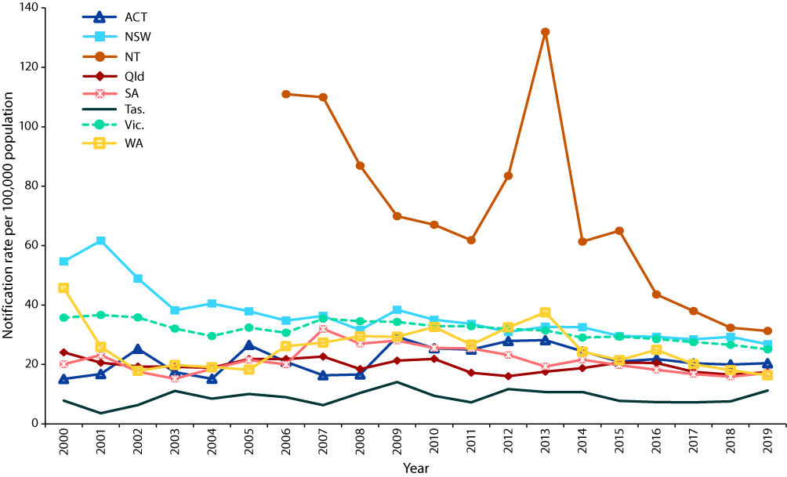
a Data source: National Notifiable Diseases Surveillance System.

Country of birth
Country of birth information was not available for unspecified hepatitis B notifications.
Country or region of birth was reported for all 300 chronic hepatitis B attributable deaths between 2006 and 2019. Of these deaths, 67 were among people born in Australia (22.3%; Table 7). The most common area of birth among chronic hepatitis B attributable deaths was South-East Asia at 68 deaths (22.7%). Other common areas of birth were Southern and Eastern Europe (15.0%) and North-East Asia (14.7%).

Birth cohort analysis
Among the 126,233 unspecified hepatitis B notifications, 887 (0.7%) were in individuals born from May 2000 onwards. As country of birth was not available for unspecified hepatitis B notifications, it is unclear what proportion of these would have been eligible for infant vaccination under the Australian NIP. The largest number of cases in this cohort was notified in Victoria (n = 262; 29.5%), followed by New South Wales (n = 242; 27.3%), Queensland (n = 167; 18.8%) and Western Australia (n = 99; 11.2%). More than half of the notifications (n = 483; 54.5%) were in males. By age group, the largest number of notifications was reported in adolescents between 10–19 years of age (n = 404; 45.6%), followed by children 5–9 years of age (n = 253; 28.5%), children aged 1–4 years (n = 172; 19.4%), and infants < 1 year of age (n =58; 6.5%). Aboriginal and Torres Strait Islander status was not reported for 264 notifications (29.8%), with 67 of the total 887 recorded as being among Aboriginal and Torres Strait Islander people (7.6%).
Vaccination status was unavailable (blank or unknown) for 788 of the 887 notifications (88.8%) in people born from May 2000 onwards. Thirty-three people (3.7%) were recorded as not having received any hepatitis B vaccinations. The number of hepatitis B vaccine doses given was available for 17 notifications (1.9%).
There were no chronic hepatitis B attributable deaths among people born since May 2000.

Discussion
Our study shows that the notification rates of both newly-acquired and unspecified hepatitis B infection have substantially decreased in the two decades since the introduction of funded universal infant hepatitis B immunisation under the NIP. Hospitalisations due to acute hepatitis B have followed a similar declining trend. However, individuals, including those eligible for funded vaccination, continue to acquire hepatitis B within Australia. This review highlights males and Aboriginal and Torres Strait Islander people as groups at higher risk, and identifies gaps in data needed to better understand current transmission pathways to allow for the optimisation of immunisation programs and other public health strategies.
Analysis by age group showed the lowest notification rates of both newly-acquired and unspecified hepatitis B, the latter of which is likely to predominantly represent chronic hepatitis B, among children aged < 15 years. Uptake of hepatitis B vaccination in infants has been high since its introduction under the NIP,⁴² with three-dose coverage (excluding the birth dose) estimated at 94.8% at 12 months of age in 2019.⁴³ We also found marked declines in newly-acquired and unspecified hepatitis B notifications among adolescents aged 15–19 years (17-fold and 5-fold, respectively), who were eligible for adolescent hepatitis B immunisation programs at age 11–12 years until cohorts eligible for the infant hepatitis B immunisation program reached this age, and among young adults aged 20–24 and 25–29 years (newly-acquired notification rate declined by 11-fold and 7-fold, respectively, and unspecified rate by 3.5-fold and 2-fold), who were also eligible for adolescent hepatitis B immunisation programs. Uptake of adolescent hepatitis B vaccination, nationally funded from 1996 to 2013, was estimated to be 60–75% through school-based programs.^{44–46} Given this relatively moderate coverage, the substantial decrease in rates in eligible age groups suggests both direct protection (including, in migrants, from infant immunisation programs which commenced in the 1990s in many endemic countries)⁴⁷ and indirect herd effects via reduced horizontal transmission from vaccinated peers. Our findings provide both updated and more detailed evidence on the effect of hepatitis B immunisation programs, and are broadly consistent with previous Australian and international studies demonstrating a decline in hepatitis B incidence and prevalence among birth cohorts eligible for infant and adolescent immunisation programs.^{46,48–52}
No significant decline in newly-acquired hepatitis B notification rates were observed in adults aged ≥ 40 years; the 40–49-year age group had the highest newly-acquired hepatitis B notification and acute hepatitis B hospitalisation rates in 2019. The United States (US), despite a marked reduction in the incidence of acute hepatitis B overall, observed an increasing rate among adults aged ≥ 40 years starting approximately 20 years after implementation of their universal infant immunisation program.^{49,53} Some have hypothesised that the increased incidence among unvaccinated US adult populations in certain states may be in the context of increased risk behaviour, with the prevalence of chronic hepatitis B increasing among people who inject drugs.^{54–56} While we did not see a similar increase among older age groups in Australia, continued monitoring is required to determine whether universal vaccination among non-susceptible adults, as introduced in the US,⁵³ could become warranted in the progress towards elimination.³⁴ The increasing chronic hepatitis B attributable mortality rate that we found, particularly among adults aged ≥ 50 years, could be partly due to improved ascertainment, as modelling suggests that chronic hepatitis B attributable deaths have decreased or plateaued since 2010.⁴⁷ Australian guidelines currently recommend a risk-based approach to both HBV screening and vaccination,^{57,58} although some have argued that universal adult screening is needed to improve diagnosis and treatment of chronic hepatitis B.⁵⁹
In relation to sex differences, we found a twofold higher newly-acquired hepatitis B notification rate and acute hepatitis B hospitalisation rate in males than in females, and a 3- and 2.5-fold higher acute and chronic hepatitis B-related death rate, respectively. Similar sex disparities have been observed in other developed countries.^{49,60,61}
In Aboriginal and Torres Strait Islander people, the all-age notification rate of newly-acquired hepatitis B decreased twofold between 2000 and 2019, but was threefold higher than in other people. Acute hepatitis B hospitalisation and mortality rates varied over the study period, but were on average three and 7.5 times higher in Aboriginal and Torres Strait Islander people than in other people, respectively, and the chronic hepatitis B attributable mortality rate was six times higher. These disproportionately high mortality rates may reflect, in part, poorer access to healthcare and a high burden of comorbid conditions among Aboriginal and Torres Strait Islander people.^{62,63} Analysis of the 2016–2019 period has demonstrated no significant disparity in newly-acquired hepatitis B notification rates between Aboriginal and Torres Strait Islander and other children/adolescents aged < 15 years, i.e. those eligible for infant vaccination under the NIP, but no decline in rates in Aboriginal and Torres Strait Islander adults aged ≥50 years,⁶⁴ despite eligibility for state-funded immunisation programs in all six states. Vaccination uptake in these targeted programs (outside the NIP) is poorly documented and likely to be suboptimal. Including hepatitis B vaccination for all susceptible Aboriginal and Torres Strait Islander people under the NIP would likely increase coverage and would likely lead to a reduction in the number of acute and chronic hepatitis B cases,¹⁸ and by extension deaths. While Aboriginal and Torres Strait Islander status completeness improved substantially between 2000 and 2019 for newly-acquired hepatitis B notifications, completeness remains poor (< 50%) for unspecified hepatitis B notifications, likely due to much more limited follow-up by public health units. While the prevalence of chronic hepatitis B in Aboriginal and Torres Strait Islander people has decreased substantially since the introduction of targeted and universal immunisation programs,^{65–68} from approximately 10.8% prior to 2000 to 3.5% in studies conducted after 2000,⁶⁹ further exploration of strategies to improve Aboriginal and Torres Strait Islander status completeness for unspecified hepatitis B notifications are required to facilitate data-driven policy and program enhancement to meet targets of relevant national strategies.^{34,70–72}
Among states and territories, the Northern Territory had the highest all-age rates over the 2000–2019 period for newly-acquired and unspecified hepatitis B notifications, acute hepatitis B hospitalisations, and acute and chronic hepatitis B deaths. This is consistent with the high prevalence of hepatitis B in the Northern Territory,^{22,73} and with its population having the highest proportion of Aboriginal and Torres Strait Islander people of any jurisdiction.⁷⁴ However, the newly-acquired hepatitis B notification rate in the Northern Territory declined significantly over the study period and by 2019 was not significantly different from other jurisdictions. This may be due, in part, to the introduction in the Northern Territory of a universal hepatitis B infant immunisation program in 1990, a decade before inclusion on the NIP, although the Northern Territory acute hepatitis B hospitalisation rate did not decrease significantly over the study period and remained 7-fold higher than the national rate in 2019. Given it usually takes many years for chronic hepatitis B infection to progress to serious sequelae such as hepatocellular carcinoma, which has an estimated 4.5 to 6-fold higher incidence in Aboriginal and Torres Strait Islander people than in non-Indigenous people,^{75,76} the full effect of immunisation programs may not be realised for decades.⁷⁷
In terms of country of birth and acquisition of newly-acquired hepatitis B, we found that, of notifications where the relevant information was recorded, three-quarters were in people born in Australia and most (93%) were acquired in Australia. However, these data should be interpreted with caution due to the high proportion of missing data (approximately half) for these fields. Data on country of birth and acquisition were unavailable for unspecified hepatitis B notifications, which likely mostly represent chronic hepatitis B. However, previous studies have shown that more than two-thirds of people living with chronic hepatitis B in Australia were born (and likely acquired the disease) overseas,²² with the most common country of birth being China,²³ and with particularly high prevalence among women born in Sierra Leone and South-East Asian countries,^{78,79} and among certain refugee populations.^{80–82} Similarly, we found that approximately four-fifths (78%) of chronic hepatitis B attributable deaths occurred in people born overseas. It is important to optimise hepatitis B screening among migrants from areas of high endemicity in order to engage individuals in chronic hepatitis B care, to offer vaccination to those susceptible, and to screen and vaccinate contacts of those found to have chronic hepatitis B. Vaccination is currently only state-funded in Queensland, Tasmania and Victoria for non-humanitarian migrants from hepatitis B-endemic areas. Ensuring the adequate protection of susceptible adults travelling to hepatitis B endemic areas should also remain a priority within travel clinics and other health care settings.^{58,83}
Our study has some limitations. The newly-acquired hepatitis B notification rate is likely an underestimate of the true rate, given the substantial proportion of asymptomatic or mildly symptomatic acute infections.⁹ Changes in ascertainment (e.g. clinician testing practices) and coding could have occurred over time. Prior to 2004, there was considerable variation in hepatitis case definitions between jurisdictions,⁸⁴ but all jurisdictions implemented the CDNA endorsed case definition in 2004, with minor modifications made in 2015.^{36,37} Some acute hepatitis B-related hospitalisations and deaths may have been misclassified, given the proportion with chronic hepatitis B-related additional diagnoses (6%) or associated causes of death (3%). This could lead to overestimation of acute hepatitis B hospitalisation and death, although underdiagnosis and under-ascertainment of cases may have counteracted this effect to some extent. We did not assess chronic hepatitis B-related hospitalisations, which likely represent the bulk of hepatitis B-related hospitalisations in Australia, and the chronic hepatitis B death rates which we present likely underestimate true mortality: while we found 60 deaths in 2019 with chronic hepatitis B as underlying or associated cause of death, recent modelling estimates 363 deaths attributable to chronic hepatitis B in that year.⁸⁵
We were also unable to assess hepatitis B rates within at-risk groups other than Aboriginal and Torres Strait Islander people, due to low data completeness of country of birth and absence of information on risk behaviour, and we did not attempt to correlate observed trends with changes in key migrant groups to Australia over the 20-year period. It would be particularly important to ascertain transmission routes and risk factors in individuals eligible for funded vaccination programs who acquire hepatitis B, which may represent missed opportunities for vaccination, deficiencies in antenatal screening and management of infants of HBsAg positive mothers, and vaccine failure. Despite the clear success of the infant immunisation program in reducing notification rates among those potentially eligible, 52 cases of newly-acquired and 887 of unspecified hepatitis B were reported in this cohort born since May 2000 over our 20-year study period. However, due to lack of data on country of birth (and hence on eligibility for infant vaccination under the NIP or overseas programs), on vaccination status and on likely transmission routes, we were unable to assess the factors contributing to these potentially preventable infections. Enhanced surveillance and follow-up investigation of all notified cases of hepatitis B in individuals born from May 2000 onwards would improve our understanding of these factors and would inform ongoing prevention strategies. Measures to improve completeness of Aboriginal and Torres Strait Islander status, in accordance with relevant national strategies,^{34,72} particularly for unspecified hepatitis B notifications, along with follow-up investigation of all notified cases in Aboriginal and Torres Strait Islander people, would also be of considerable benefit to inform actions to address the inequitable disparity in disease rates. Linkage of the NNDSS to other relevant data sources, e.g. via the Australian Immunisation Register – Multi-Agency Data Integration Project (AIR-MADIP)⁸⁶ or to hospitalisation data,⁷¹ would facilitate identification of other population subgroups at higher risk of hepatitis B.
In conclusion, adolescent and infant immunisation programs in Australia have led to significant reductions in notification rates of newly-acquired hepatitis B, and in acute hepatitis B hospitalisation rates, both at the overall national level and in Aboriginal and Torres Strait Islander people. Unspecified hepatitis B notification rates have also greatly reduced in children and young adults, likely largely due to the impact of overseas infant immunisation programs on prevalence in child and adolescent migrants. Continued monitoring and surveillance are required, particularly given that newly acquired hepatitis B notification rates have plateaued since 2015. Work to improve completeness of variables within national datasets is crucial, along with enhanced surveillance of both newly-acquired and unspecified hepatitis B cases to investigate transmission routes, vaccination status and factors contributing to acquisition of hepatitis B, in order to optimise the impact of immunisation programs, to ensure linkage with care, and to screen and vaccinate contacts.

Acknowledgments
We would like to acknowledge the Communicable Diseases Network Australia for providing access to notification data; the Australian Institute for Health and Welfare for providing access to hospitalisation data; and the Australian Coordinating Registry, state and territory registries of births, deaths and marriages, state and territory coroners, and the National Coronial Information System for providing access to cause-of-death data. NCIRS is supported by the Australian Government Department of Health and Aged Care, the New South Wales Ministry of Health and The Sydney Children’s Hospitals Network. The opinions expressed in this report are those of the authors and do not necessarily represent the views of these agencies.

Author details
Dr Nicole Sonneveld,¹
Dr Joanne Jackson,¹
Dr Aditi Dey,^{1,2}
A/Prof. Stephen B Lambert,¹
Ms Katrina K Clark,¹
Prof. Benjamin C Cowie,³
Prof. Kristine K Macartney,^{1,2}
A/Prof. Frank H Beard^{1,2}
- National Centre for Immunisation Research and Surveillance, Westmead, New South Wales, Australia
- The University of Sydney, New South Wales, Australia
- WHO Collaborating Centre for Viral Hepatitis, Peter Doherty Institute for Immunity and Infection, Melbourne, Australia
Corresponding author
Dr Nicole Sonneveld
National Centre for Immunisation Research and Surveillance, Locked Bag 4001, Westmead NSW 2145, Australia
Telephone: +61 2 9845 0258
Email: Nicole.Sonneveld@health.nsw.gov.au

References
- Dane DS, Cameron CH, Briggs M. Virus-like particles in serum of patients with Australia-antigen-associated hepatitis. Lancet. 1970;295(7649):695–8. doi: https://doi.org/10.1016/s0140-6736(70)90926-8.
- Wiseman E, Fraser MA, Holden S, Glass A, Kidson BL, Heron LG et al. Perinatal transmission of hepatitis B virus: an Australian experience. Med J Aust. 2009;190(9):489–92. doi: https://doi.org/10.5694/j.1326-5377.2009.tb02524.x.
- Struve J, Giesecke J, Lindh G, Weiland O. Heterosexual contact as a major route for transmission of acute hepatitis B among adults. J Infect. 1990;20(2):111–21. doi: https://doi.org/10.1016/0163-4453(90)93288-4.
- Davis LG, Weber D, Lemon S. Horizontal transmission of hepiatitis B virus. Lancet. 1989;333(8643):889–93. doi: https://doi.org/10.1016/s0140-6736(89)92876-6.
- Mahoney FJ, Stewart K, Hu H, Coleman P, Alter MJ. Progress toward the elimination of hepatitis B virus transmission among health care workers in the United States. Arch Intern Med. 1997;157(22):2601–5. doi: https://doi.org/10.1001/archinte.1997.00440430083010.
- Lanini S, Puro V, Lauria FN, Fusco FM, Nisii C, Ippolito G. Patient to patient transmission of hepatitis B virus: a systematic review of reports on outbreaks between 1992 and 2007. BMC Med. 2009;7:15. doi: https://doi.org/10.1186/1741-7015-7-15.
- Lettau LA, McCarthy JG, Smith MH, Hauler SC, Morse LJ, Ukena T et al. Outbreak of severe hepatitis due to delta and hepatitis B viruses in parenteral drug abusers and their contacts. N Engl J Med. 1987;317(20):1256–62. doi: https://doi.org/10.1056/NEJM198711123172004.
- McMahon BJ, Alward WLM, Hall DB, Heyward WL, Bender TR, Francis DP, et al. Acute hepatitis B virus infection: relation of age to the clinical expression of disease and subsequent development of the carrier state. J Infect Dis. 1985;151(4):599–603. doi: https://doi.org/10.1093/infdis/151.4.599.
- Van Damme P, Ward JW, Shouval D, Zanetti A. 25 – Hepatitis B vaccines. In Plotkin SA, Orenstein WA, Offit PA, Edwards KM, eds. Plotkin’s Vaccines (7th edition). Amsterdam: Elsevier, 2018;342–74.e17. doi: https//doi.org/10.1016/B978-0-323-35761-6.00025-0.
- Bernuau J, Goudeau A, Poynard T, Dubois F, Lesage G, Yvonnet B et al. Multivariate analysis of prognostic factors in fulminant hepatitis B. Hepatology. 1986;6(4):648–51. doi: https://doi.org/10.1002/hep.1840060417.
- Edmunds WJ, Medley GF, Nokes DJ, Hall AJ, Whittle HC. The influence of age on the development of the hepatitis B carrier state. Proc Biol Sci. 1993;253(1337):197–201. doi: https://doi.org/10.1098/rspb.1993.0102.
- McMahon BJ, Alberts SR, Wainwright RB, Bulkow L, Lanier AP. Hepatitis B–related sequelae: prospective study in 1400 hepatitis B surface antigen–positive Alaska native carriers. Arch Intern Med. 1990;150(5):1051–4. doi: https://doi.org/10.1001/archinte.150.5.1051.
- Lok ASF, McMahon BJ. Chronic hepatitis B. Hepatology. 2007;45(2):507–39. doi: https://doi.org/10.1002/hep.21513.
- World Health Organization (WHO). Global health sector strategy on viral hepatitis 2016–2021. Towards ending viral hepatitis. Geneva: WHO; June 2016. Available from: https://apps.who.int/iris/handle/10665/246177.
- Stanaway JD, Flaxman AD, Naghavi M, Fitzmaurice C, Vos T, Abubakar I et al. The global burden of viral hepatitis from 1990 to 2013: findings from the Global Burden of Disease Study 2013. Lancet. 2016;388(10049):1081–8. doi: https://doi.org/10.1016/S0140-6736(16)30579-7.
- National Centre for Immunisation Research and Surveillance (NCIRS). Significant events in hepatitis B vaccination practice in Australia. Sydney: NCIRS; July 2021. [Accessed on 8 March 2022.] Available from: https://www.ncirs.org.au/sites/default/files/2021-07/Hepatitis-B-history-July%202021.pdf.
- Ward K, Quinn H, Menzies R, McIntyre P. A history of adolescent school based vaccination in Australia. Commun Dis Intell Q Rep. 2013;37(2):E168–74.
- Wattiaux AL, Yin JK, Beard F, Wesselingh S, Cowie B, Ward J et al. Hepatitis B immunization for indigenous adults, Australia. Bull World Health Organ. 2016;94(11):826–34A. doi: https://doi.org/10.2471/BLT.16.169524.
- Ioannides S, Beard F, Larter N, Clark K, Wang H, Hendry A et al. Vaccine preventable diseases and vaccination coverage in Aboriginal and Torres Strait Islander people, Australia, 2011–2015. Commun Dis Intell (2018). 2019;43. doi: https://doi.org/10.33321/cdi.2019.43.36.
- Dey A, Wang H, Beard F, Macartney K, McIntyre P. Summary of national surveillance data on vaccine preventable diseases in Australia, 2012–2015. Commun Dis Intell (2018). 2019;43. doi: https://doi.org/10.33321/cdi.2019.43.58.
- Kirby Institute. National update on HIV, viral hepatitis and sexually transmissible infections in Australia 2009–2018. Sydney: University of New South Wales, Kirby Institute; 4 November 2020. Available from: https://kirby.unsw.edu.au/report/national-update-hiv-viral-hepatitis-and-sexually-transmissible-infections-australia-2009-2018.
- MacLachlan JH, Stewart S, Cowie BC. Viral Hepatitis Mapping Project: geographic diversity in chronic hepatitis B and C prevalence, management and treatment. National Report 2020. Darlinghurst: Australasian Society for HIV, Viral Hepatitis, and Sexual Health Medicine (ASHM); 2021. Available from: https://ashm.org.au/wp-content/uploads/2022/04/ASHM_ViralHepReport_2020_WEB_final.pdf.
- MacLachlan JH, Cowie BC. Cultural and linguistic diversity of people living with chronic hepatitis B in 2011–2016: changing migration, shifting epidemiology. Aust N Z J Public Health. 2018;42(5):441–3. doi: https://doi.org/10.1111/1753-6405.12826.
- New South Wales Government Department of Health (NSW Health). Additional Commonwealth and NSW-funded free vaccines. [Internet.] Sydney: NSW Health; 2020. [Accessed on 8 March 2022.] Available from: https://www.health.nsw.gov.au/immunisation/Pages/gp_catchup.aspx.
- Northern Territory Government Department of Health (NT Health) Public Health Unit. NT Immunisation Schedule Adult and special risk groups. [Internet.] Darwin: NT Health; August 2021. [Accessed on 8 March 2022.] Available from: https://digitallibrary.health.nt.gov.au/prodjspui/handle/10137/775.
- Queensland Government Department of Health (Queensland Health). Immunisation Schedule Queensland. [Internet.] Brisbane: Queensland Health; 22 February 2021. [Accessed on 8 March 2022.] Available from: https://www.health.qld.gov.au/clinical-practice/guidelines-procedures/diseases-infection/immunisation/schedule.
- Government of South Australia Department of Health (SA Health). High Risk Hepatitis B Immunisation Program. [Internet.] Adelaide: SA Health; 2021. [Accessed on 8 March 2022.] Available from: https://www.sahealth.sa.gov.au/wps/wcm/connect/public+content/sa+health+internet/conditions/immunisation/immunisation+programs/high+risk+hepatitis+b+immunisation+program.
- Tasmanian Government Department of Health. State-Funded Hepatitis B Vaccine for High Risk Groups in Tasmania. Hobart: Tasmanian Government Department of Health; 2020. [Accessed on 8 March 2022.] Available from: https://www.health.tas.gov.au/sites/default/files/2021-11/Hep_B_vaccine_high_risk_for_health_professionals_DoHTasmania2020.pdf.
- Victoria State Government Department of Health. Immunisation schedule Victoria and vaccine eligibility criteria. [Internet.]. Melbourne: Victoria State Government Department of Health; 11 November 2021. [Accessed on 8 March 2022.] Available from: https://www.health.vic.gov.au/immunisation/immunisation-schedule-victoria-and-vaccine-eligibility-criteria.
- Western Australian Government Department of Health (WA Health). Western Australian Immunisation Schedule. Perth: WA Health; 2021. [Accessed on 8 March 2022.] Available from: https://ww2.health.wa.gov.au/-/media/Files/Corporate/general-documents/Immunisation/PDF/WA-Immunisation-Schedule.pdf.
- Australian Capital Territory Government Department of Health (ACT Health). Hepatitis B. [Internet.] Canberra: ACT Health; 18 March 2021. [Accessed on 8 March 2022.] Available from: https://www.health.act.gov.au/services-and-programs/immunisation/adults/hepatitis-b.
- Australian Government Department of Health and Aged Care. National Immunisation Program: Free catch-up vaccines for refugees and other humanitarian entrants aged 20 years and over. Canberra: Australian Government Department of Health and Aged Care; 2017. [Accessed on 3 May 2022.] Available from: https://www.health.gov.au/sites/default/files/free-catch-up-vaccines-for-refugees-and-humanitarian-entrants-aged-20-years-and-over-fact-sheet_0.pdf.
- Australian Government Department of Health and Aged Care. National Immunisation Program - Free catch-up vaccines for all individuals aged 10 to 19 years. Canberra: Australian Government Department of Health and Aged Care; 2017. [Accessed on 3 May 2022.] Available from: https://www.health.gov.au/sites/default/files/free-catch-up-vaccines-for-10-to-19-year-olds-fact-sheet-free-catch-up-vaccines-for-10-to-19-years-fact-sheet.pdf.

- Australian Government Department of Health and Aged Care. Third National Hepatitis B Strategy: 2018-2022. Canberra: Australian Government Department of Health and Aged Care; 2018. Available from: https://www.health.gov.au/sites/default/files/documents/2022/06/third-national-hepatitis-b-strategy-2018-2022.pdf.
- Yohannes K, Roche PW, Roberts A, Liu C, Firestone SM, Bartlett M et al. Australia’s notifiable diseases status, 2004, annual report of the National Notifiable Diseases Surveillance System. Commun Dis Intell Q Rep. 2006;30(1):1–79.
- Australian Government Department of Health and Aged Care, Communicable Diseases Network Australia. Hepatitis B (Newly acquired). Australian national notifiable diseases case definition. Canberra: Australian Government Department of Health and Aged Care; 1 July 2015. [Accessed on 8 March 2022.] Available from: https://www.health.gov.au/sites/default/files/documents/2022/06/hepatitis-b-newly-acquired-surveillance-case-definition.pdf.
- Australian Government Department of Health and Aged Care, Communicable Diseases Network Australia. Hepatitis B (unspecified). Australian national notifiable diseases case definition. Canberra: Australian Government Department of Health and Aged Care; 1 July 2015. [Accessed on 8 March 2022.] Available from: https://www.health.gov.au/sites/default/files/documents/2022/06/hepatitis-b-unspecified-surveillance-case-definition.pdf.
- Australian Government Department of Health and Aged Care. National Notifiable Diseases Surveillance System (NNDSS) public dataset – Influenza (laboratory confirmed). [Webpage.] Canberra: Australian Government Department of Health and Aged Care; 2022. [Accessed on 12 April 2022.] Available from: https://www.health.gov.au/resources/publications/national-notifiable-diseases-surveillance-system-nndss-public-dataset-influenza-laboratory-confirmed.
- Australian Bureau of Statistics. 3101.0 – Australian Demographic Statistics, Mar 2013. Feature article: which poplulation to use for age standardisation? [Webpage.] Canberra: Australian Bureau of Statistics; 26 September 2013. [Accessed on 15 March 2023.] Available from: https://www.abs.gov.au/ausstats/abs@.nsf/Lookup/3101.0Feature+Article1Mar%202013.
- Australian Institute of Health and Welfare (AIHW). Principles on the use of direct age-standardisation in administrative data collections: for measuring the gap between Indigenous and non-Indigenous Australians. Canberra: Australian Government, AIHW; 7 October 2011. Available from: https://www.aihw.gov.au/reports/indigenous-australians/principles-on-the-use-of-direct-age-standardisatio/summary.
- AIHW. Indigenous identification in hospital separations data. Quality report. Canberra: Australian Government, AIHW; 2013. Available from: https://www.aihw.gov.au/getmedia/adcaf32e-d2d1-4df0-b306-c8db7c63022e/13630.pdf.
- Hull BP, Dey A, Menzies RI, Brotherton JM, McIntyre PB. Immunisation coverage annual report, 2011. Commun Dis Intell Q Rep. 2013;37(4):E291–312.
- Hull B, Hendry A, Dey A, Macartney K, Beard F. Immunisation coverage annual report 2019. Commun Dis Intell (2018). 2021;45. doi: https://doi.org/10.33321/cdi.2021.45.18.
- Hull B, Dey A, Campbell-Lloyd S, Menzies RI, McIntyre PB. NSW annual immunisation coverage report, 2011. N S W Public Health Bull. 2012;23(9–10):179–86. doi: https://doi.org/10.1071/NB12084.
- Mak DB, Bulsara MK, Wrate MJ, Carcione D, Chantry M, Efller PV. Factors determining vaccine uptake in Western Australian adolescents. J Paediatr Child Health. 2013;49(11):895–900. doi: https://doi.org/10.1111/jpc.12030.
- Lu X, Quinn HE, Menzies RI, Hueston L, Gilbert L, McIntyre PB. Hepatitis B seroepidemiology in Australia, one decade after universal vaccination of infants and adolescents. Infect Disord Drug Targets. 2020;20(3):341–7. doi: https://doi.org/10.2174/1871526518666181001144303.
- McCulloch K, Romero N, MacLachlan J, Allard N, Cowie B. Modeling progress toward elimination of hepatitis B in Australia. Hepatology. 2020;71(4):1170–81. doi: https://doi.org/10.1002/hep.30899.
- Khetsuriani N, Mosina L, Van Damme P, Mozalevskis A, Datta S, Tohme RA. Progress toward hepatitis B control – World Health Organization European Region, 2016–2019. MMWR Morb Mortal Wkly Rep. 2021;70(30):1029–35. doi: https://doi.org/10.15585/mmwr.mm7030a1.
- Centers for Disease Control and Prevention (CDC). Viral Hepatitis Surveillance Report. United States, 2019. Atlanta: United States Government Department of Health and Human Services, CDC; May 2021. Available from: https://www.cdc.gov/hepatitis/statistics/2019surveillance/pdfs/2019HepSurveillanceRpt.pdf.
- Sandhu HS, Roesel S, Sharifuzzaman M, Chunsuttiwat S, Tohme RA. Progress toward hepatitis B control – South-East Asia Region, 2016–2019. MMWR Morb Mortal Wkly Rep. 2020;69(30):988–92. doi: https://doi.org/10.15585/mmwr.mm6930a2.
- Woodring J, Pastore R, Brink A, Ishikawa N, Takashima Y, Tohme RA. Progress toward hepatitis B control and elimination of mother-to-child transmission of hepatitis B virus – Western Pacific Region, 2005-2017. MMWR Morb Mortal Wkly Rep. 2019;68(8):195–200. doi: https://doi.org/10.15585/mmwr.mm6808a2.
- Whitford K, Liu B, Micallef J, Yin JK, Macartney K, Van Damme P et al. Long-term impact of infant immunization on hepatitis B prevalence: a systematic review and meta-analysis. Bull World Health Organ. 2018;96(7):484–97. doi: https://doi.org/10.2471/BLT.17.205153.
- Weng MK, Doshani M, Khan MA, Frey S, Ault K, Moore KL et al. Universal hepatitis B vaccination in adults aged 19–59 Years: updated recommendations of the Advisory Committee on Immunization Practices – United States, 2022. MMWR Morb Mortal Wkly Rep. 2022;71(13):477–83. doi: https://doi.org/10.15585/mmwr.mm7113a1.
- Ly KN, Xing J, Spradling PR. Trends in prevalence and characteristics of resolved and current hepatitis B among US-born persons: National Health and Nutrition Examination Survey, 2001–2018. J Infect Dis. 2021;224(5):804–12. doi: https://doi.org/10.1093/infdis/jiab224.
- Iqbal K, Klevens RM, Kainer MA, Baumgartner J, Gerard K, Poissant T et al. Epidemiology of acute hepatitis B in the United States from population-based surveillance, 2006–2011. Clin Infect Dis. 2015;61(4):584–92. doi: https://doi.org/10.1093/cid/civ332.
- Harris AM, Iqbal K, Schillie S, Britton J, Kainer MA, Tressler S et al. Increases in acute hepatitis B virus infections – Kentucky, Tennessee, and West Virginia, 2006–2013. MMWR Morb Mortal Wkly Rep. 2016;65(3):47–50. doi: https://doi.org/10.15585/mmwr.mm6503a2.
- Australasian Society for HIV, Viral Hepatitis and Sexual Health Medicine (ASHM). National Hepatitis B Testing Policy 2020. Sydney: ASHM; 2020. Available from: https://testingportal.ashm.org.au/files/ASHM_TestingPolicy_2020_HepatitisB_07_2.pdf.
- Australian Government Department of Health and Aged Care. Australian Immunisation Handbook. Canberra: Australian Government Department of Health and Aged Care, Australian Technical Advisory Group on Immunisation (ATAGI); 2018. Available from: https://immunisationhandbook.health.gov.au/.
- Allard NL, MacLachlan JH, Tran L, Yussf N, Cowie BC. Time for universal hepatitis B screening for Australian adults. Med J Aust. 2021;215(3):103–5.e1. doi: https://doi.org/10.5694/mja2.51114.
- Binka M, Butt ZA, Wong S, Chong M, Buxton JA, Chapinal N et al. Differing profiles of people diagnosed with acute and chronic hepatitis B virus infection in British Columbia, Canada. World J Gastroenterol. 2018;24(11):1216–27. doi: https://doi.org/10.3748/wjg.v24.i11.1216.
- Whelan J, Sonder G, Heuker J, van den Hoek A. Incidence of acute hepatitis B in different ethnic groups in a low-endemic country, 1992–2009: increased risk in second generation migrants. Vaccine. 2012;30(38):5651–5. doi: https://doi.org/10.1016/j.vaccine.2012.06.080.
- Wigg AJ, Narayana SK, Hartel G, Medlin L, Pratt G, Powell EE et al. Hepatocellular carcinoma amongst Aboriginal and Torres Strait Islander peoples of Australia. J EClinicalMedicine. 2021;36:100919. doi: https://doi.org/10.1016/j.eclinm.2021.100919.
- Riddell J, Hempenstall A, Nakata Y, Gregson S, Hayes R, Smith S et al. The high burden of comorbidities in Aboriginal and Torres Strait Islander Australians living with chronic hepatitis B in Far North Queensland, Australia, and the implications for patient management. PLoS One. 2023;18(4):e0284151. doi: https://doi.org/10.1371/journal.pone.0284151.
- Jackson J, Sonneveld N, Rashid H, Karpish L, Wallace S, Whop L et al. Vaccine Preventable Diseases and Vaccination Coverage in Aboriginal and Torres Strait Islander People, Australia, 2016–2019. Commun Dis Intell (2018). 2023;47. doi: https://doi.org/10.33321/cdi.2023.47.32.
- Reekie J, Kaldor JM, Mak DB, Ward J, Donovan B, Hocking JS et al. Long-term impact of childhood hepatitis B vaccination programs on prevalence among Aboriginal and non-Aboriginal women giving birth in Western Australia. Vaccine. 2018;36(23):3296–300. doi: https://doi.org/10.1016/j.vaccine.2018.04.057.
- Liu B, Guthridge S, Li SQ, Markey P, Krause V, McIntyre P et al. The end of the Australia antigen? An ecological study of the impact of universal newborn hepatitis B vaccination two decades on. Vaccine. 2012;30(50):7309–14. doi: https://doi.org/10.1016/j.vaccine.2012.09.033.
- Davies J, Li SQ, Tong SY, Baird RW, Beaman M, Higgins G et al. Establishing contemporary trends in hepatitis B sero-epidemiology in an Indigenous population. PLoS One. 2017;12(9):e0184082. doi: https://doi.org/10.1371/journal.pone.0184082.
- Deng L, Reekie J, Ward JS, Hayen A, Kaldor JM, Kong M et al. Trends in the prevalence of hepatitis B infection among women giving birth in New South Wales. Med J Aust. 2017;206(7):301–5. doi: https://doi.org/10.5694/mja16.00823.
- Graham S, MacLachlan JH, Gunaratnam P, Cowie BC. Chronic hepatitis B prevalence in Australian Aboriginal and Torres Strait Islander people before and after implementing a universal vaccination program: a systematic review and meta-analysis. Sex Health. 2019;16(3):201–11. doi: https://doi.org/10.1071/SH18150.
- MacLachlan JH, Romero N, Higgins N, Coutts R, Chan R, Stephens N et al. Epidemiology of chronic hepatitis B and C in Victoria, Australia: insights and impacts from enhanced surveillance. Aust N Z J Public Health. 2020;44(1):59–64. doi: https://doi.org/10.1111/1753-6405.12934.
- Rowe SL, Cowie BC. Using data linkage to improve the completeness of Aboriginal and Torres Strait Islander status in communicable disease notifications in Victoria. Aust N Z J Public Health. 2016;40(2):148–53. doi: https://doi.org/10.1111/1753-6405.12434.
- Australian Government Department of Health. Fifth National Aboriginal and Torres Strait Islander Blood Borne Viruses and Sexually Transmissible Infections Strategy: 2018–2022. Canberra: Australian Government Department of Health and Aged Care; 2018. Available from: https://www.health.gov.au/sites/default/files/documents/2022/06/fifth-national-aboriginal-and-torres-strait-islander-bloodborne-viruses-and-sexually-transmissible-infections-strategy-2018-2022.pdf.
- Wood N, Backhouse J, Gidding HF, Gilbert GL, Lum G, McIntyre PB. Estimates of chronic hepatitis B virus infection in the Northern Territory. Commun Dis Intell Q Rep. 2005;29(3):289–90.
- AIHW. Profile of Indigenous Australians. [Internet.] Canberra: Australian Government, AIHW; 2020. [Accessed on 17 March 2022.] Available from: https://www.aihw.gov.au/reports/australias-health/profile-of-indigenous-australians.
- Parker C, Tong SYC, Dempsey K, Condon J, Sharma SK, Chen JWC et al. Hepatocellular carcinoma in Australia’s Northern Territory: high incidence and poor outcome. Med J Aust. 2014;201(8):470–4. doi: https://doi.org/10.5694/mja13.11117.
- Condon JR, Zhang X, Dempsey K, Garling L, Guthridge S. Trends in cancer incidence and survival for Indigenous and non-Indigenous people in the Northern Territory. Med J Aust. 2016;205(10):454–8. doi: https://doi.org/10.5694/mja16.00588.
- McMahon BJ, Bulkow LR, Singleton RJ, Williams J, Snowball M, Homan C et al. Elimination of hepatocellular carcinoma and acute hepatitis B in children 25 years after a hepatitis B newborn and catch-up immunization program. Hepatology. 2011;54(3):801–7. doi: https://doi.org/10.1002/hep.24442.
- He WQ, Duong MC, Gidding H, MacLachlan J, Wood J, Kaldor JM et al. Trends in chronic hepatitis B prevalence in Australian women by country of birth, 2000 to 2016. J Viral Hepat. 2020;27(1):74–80. doi: https://doi.org/10.1111/jvh.13202.
- Reekie J, Gidding HF, Kaldor JM, Liu B. Country of birth and other factors associated with hepatitis B prevalence in a population with high levels of immigration. J Gastroenterol Hepatol. 2013;28(9):1539–44. doi: https://doi.org/10.1111/jgh.12245.
- Gibson-Helm M, Teede H, Block A, Knight M, East C, Wallace EM et al. Maternal health and pregnancy outcomes among women of refugee background from African countries: a retrospective, observational study in Australia. BMC Pregnancy Childbirth. 2014;14:392. doi: https://doi.org/10.1186/s12884-014-0392-0.
- Masters PJ, Lanfranco PJ, Sneath E, Wade AJ, Huffam S, Pollard J et al. Health issues of refugees attending an infectious disease refugee health clinic in a regional Australian hospital. Aust J Gen Pract. 2018;47(5):305–10. doi: https://doi.org/10.31128/AFP-10-17-4355.
- Ngo CC, Maidment C, Atkins L, Eagar S, Smith MM. Blood screen findings in a 2-year cohort of newly arrived refugees to Sydney, Australia. Public Health Res Pract. 2018;28(1):2811804. doi: https://doi.org/10.17061/phrp2811804.
- Heywood AE, Nothdurft H, Tessier D, Moodley M, Rombo L, Marano C et al. Pre-travel advice, attitudes and hepatitis A and B vaccination rates among travellers from seven countries. J Travel Med. 2016;24(1):taw069. doi: https://doi.org/10.1093/jtm/taw069.
- Chiu C, Dey A, Wang H, Menzies R, Deeks S, Mahajan D et al. Vaccine preventable diseases in Australia, 2005 to 2007. Commun Dis Intell Q Rep. 2010;34(Supp):S1–167.
- McCulloch K, Romero N, MacLachlan J, Cowie BC. National Surveillance for Hepatitis B Indicators: Measuring the progress towards the targets of the National Hepatitis B Strategy. Annual report 2020. Melbourne: WHO Collaborating Centre for Viral Hepatitis, the Doherty Institute; 2021. Available from: https://www.doherty.edu.au/uploads/content_doc/National_Surveillance_for_Hepatitis_B_Indicators_2020_final.pdf.
- Australian Government Department of Health. Australian Immunisation Register link to the Multi-Agency Data Integration Project. Canberra: Australian Government Department of Health and Aged Care; 2022. [Accessed on 13 April 2022.] Available from: https://www.health.gov.au/sites/default/files/documents/2022/03/australian-immunisation-register-link-to-the-multi-agency-data-integration-project.pdf.

About Communicable Diseases Intelligence
Communicable Diseases Intelligence (CDI) is a peer-reviewed scientific journal published by the Health Protection Policy & Surveillance Division, Department of Health and Aged Care. The journal aims to disseminate information on the epidemiology, surveillance, prevention and control of communicable diseases of relevance to Australia.
© 2024 Commonwealth of Australia as represented by the Department of Health and Aged Care
ISSN: 2209-6051 Online
This journal is indexed by Index Medicus and Medline.
This publication is licensed under a Creative Commons Attribution-NonCommercial-NoDerivatives 4.0 International Licence (CC BY-NC-ND) available from https://creativecommons.org/licenses/by-nc-nd/4.0/legalcode (Licence). You must read and understand the Licence before using any material from this publication.
Restrictions
The Licence does not cover, and there is no permission given for, use of any of the following material found in this publication (if any):
- the Commonwealth Coat of Arms (by way of information, the terms under which the Coat of Arms may be used can be found at www.pmc.gov.au/resources/commonwealth-coat-arms-information-and-guidelines);
- any logos (including the Department of Health and Aged Care’s logo) and trademarks;
- any photographs and images;
- any signatures; and
- any material belonging to third parties.
Disclaimer
Opinions expressed in Communicable Diseases Intelligence are those of the authors and not necessarily those of the Australian Government Department of Health and Aged Care or the Communicable Diseases Network Australia. Data may be subject to revision.
Enquiries
Enquiries regarding any other use of this publication should be addressed to the CDI Editor at: cdi.editor@health.gov.au
Communicable Diseases Network Australia
Communicable Diseases Intelligence contributes to the work of the Communicable Diseases Network Australia. www.health.gov.au/cdna
Editor: Christina Bareja • Deputy Editor: Simon Petrie • Design and Production: Lisa Thompson/Kasra Yousefi
Editorial Advisory Board: David Durrheim, Mark Ferson, Clare Huppatz, John Kaldor, Martyn Kirk, Meru Sheel and Stephanie Williams
Contacts
CDI is produced by:
Health Protection Policy & Surveillance Division, Australian Government Department of Health and Aged Care,
GPO Box 9848, (MDP 6) CANBERRA ACT 2601
Website: www.health.gov.au/cdi
Email: cdi.editor@health.gov.au
Submit an Article
You are invited to submit your next communicable disease related article to the Communicable Diseases Intelligence (CDI) for consideration. More information regarding CDI can be found at: www.health.gov.au/cdi.
Further enquiries should be directed to: cdi.editor@health.gov.au

