• Volume • • Electronic publication date:

Differential COVID-19 case ascertainment by age and vaccination status in Victoria, Australia: a serosurveillance and record linkage study

Joshua Szanyi, David J Price, Kylie S Carville, Mitch Batty, Sarah Yallop, Suellen Nicholson, Theo Karapanagiotidis, Stacey Rowe, Sheena Sullivan, Vinay Menon, Daniel West, Lakshmi Manoharan, Eliza Copsey, Suman S Majumdar, Brett Sutton, Deborah A Williamson, Jodie McVernon

# Abstract

Objectives

To compare serological evidence of prior severe acute respiratory syndrome coronavirus 2 (SARS-CoV-2) infection with linked coronavirus disease 2019 (COVID-19) case notification data in Victoria, Australia, and to determine *in vitro* SARS-CoV-2 neutralisation activity based on prior infection and vaccination history.

Design, setting, participants

Four cross-sectional serological surveys were conducted between 30 June and 31 October 2022 (a period of Omicron BA.4/BA.5 dominance) using 1,974 residual serum samples obtained from the Victorian Infectious Diseases Reference Laboratory. Serological results were linked to COVID-19 case notification and vaccination data. Surrogate virus neutralisation testing was performed to obtain *in vitro* inhibition estimates by anti-nucleocapsid serostatus and COVID-19 vaccination history.

Main outcome measures

Adjusted anti-SARS-CoV-2 spike and nucleocapsid seropositivity by sex, age and region of residence; adjusted proportion of cases notified by anti-nucleocapsid serostatus, age and number of COVID-19 vaccination doses received; adjusted percentage *in vitro* inhibition against wildtype and Omicron BA.4/BA.5 SARS-CoV-2 variants by anti-nucleocapsid serostatus and COVID-19 vaccination history.

Results

The prevalence of anti-SARS-CoV-2 nucleocapsid antibodies was inversely proportional to age. In October 2022, prevalence was 84% (95% confidence interval [95% CI]: 75–93%) among 18–29-year-olds, compared to 39% (95% CI: 27–52%) among ≥ 80-year-olds. In most age groups, approximately 40% of COVID-19 cases appear to have been notified via existing surveillance mechanisms. Case notification was highest among individuals older than 80 years and people who had received COVID-19 vaccine booster doses. *In vitro* neutralisation of Omicron BA.4/BA.5 sub-variants was highest for individuals with evidence of both prior infection and booster vaccination.

Conclusions

Under-notification of SARS-CoV-2 infections in the Victorian population is not uniform across age and vaccination strata. Seroprevalence data that give insights into case notification behaviour provide additional context for the interpretation of existing COVID-19 surveillance information.

Keywords: COVID-19; SARS-CoV-2; serosurveillance; seroprevalence; antibody; vaccination; testing

# Introduction

Diagnostic testing and notification of positive tests to public health authorities do not capture all severe acute respiratory syndrome coronavirus 2 (SARS-CoV-2) infections that have occurred in a population,1 due to variability in test-seeking and reporting behaviour, assay sensitivity,2 fluctuations in access to testing, and the presence of asymptomatic infections. Seroprevalence studies thus provide an additional source of evidence to inform estimation of population exposure to SARS-CoV-2 infection, and by extension, case ascertainment and population-level immunity to coronavirus disease 2019 (COVID-19). This information can then, for example, assist in forecasting the impact of future outbreaks, planning healthcare resourcing, and estimating the likely burden of long COVID. Such studies generally include testing for anti-spike antibodies (anti-S; induced by both previous infection and vaccination) and anti-nucleocapsid antibodies (anti-N; these are not induced by vaccines that target the spike protein and therefore indicate prior infection in the Australian context).1,3

Victoria (and the rest of Australia) experienced relatively minimal SARS-CoV-2 transmission in 2020 and 2021 compared to many other jurisdictions globally. This was followed by widespread transmission of the Omicron BA.1 and BA.2 sub-variants from late 2021, then sustained community transmission of the Omicron BA.4 and BA.5 sub-variants which were first detected in Australia in April 2022. By mid-2022 most COVID-19 diagnostic testing in the state was being conducted via rapid antigen test (RAT), but polymerase chain reaction (PCR) testing was still available.4 Between January 2022 and 12 October 2022 (encompassing most of the study period), individuals returning a positive RAT were required to report this result to the Victorian State Government Department of Health. Thereafter, reporting was recommended rather than required. As of 31 October 2022, over 2.6 million positive SARS-CoV-2 tests had been notified in Victoria since the start of the COVID-19 pandemic.5

Recent COVID-19 serosurveillance studies using donor blood sera6–8 showed an increase in anti-N seroprevalence in Victoria from 23% in early 2022 to 67% in August 2022,8 consistent with extensive transmission of SARS-CoV-2 Omicron sub-variants during this period. However, these results were not linked to COVID-19 case notification and vaccination data. Analysis of population seroprevalence linked to notification, vaccination, and functional antibody data may provide actionable insights into contemporary trends in case detection and signal alterations in cohort or population-level susceptibility over time due to waning immunity. These are key components informing pandemic policymaking, such as approaches to vaccination and targeting high-risk subgroups for diagnostic testing.

The aim of this study was therefore to pilot a SARS-CoV-2 serosurveillance platform in Victoria that was linked to COVID-19 case notification and vaccination data. Specifically, this study aimed to: (a) determine the seroprevalence of anti-S and anti-N antibodies in Victoria using residual sera; (b) estimate COVID-19 case ascertainment in Victoria through linkage of serological data with COVID-19 vaccination and case notification data; and (c) determine *in vitro* viral neutralisation activity for a subset of individuals stratified by past exposure phenotype.

# Methods

## Sample selection

Approximately 500 residual serum samples per month from pathology testing submitted to the Victorian Infectious Diseases Reference Laboratory (VIDRL) for other diagnostic purposes were retrieved for serological analysis from 30 June to 31 October 2022. Samples were included if they were from individuals aged 18 years or older. Samples were excluded if their postcode was outside Victoria, if they were referred from sexual health clinics or for HIV or viral hepatitis testing, and if they had returned a positive result for another notifiable disease. A list of samples meeting the inclusion and exclusion criteria was reviewed each month, in date order, until approximately 500 samples with sufficient volume from the survey period were retrieved.

## Serological assays

Roche Elecsys anti-SARS-CoV-2 nucleocapsid (N) and spike (S) assays (automated semi-quantitative electro-chemiluminescence immunoassays; Roche Diagnostics GmbH, Mannheim, Germany) were used for the detection of total antibody against SARS-CoV-2 antigens in serum. In these assays, a biotinylated recombinant SARS-CoV-2 antigen (N or S) and a ruthenium-labelled recombinant SARS-CoV-2 antigen are bound by antibodies present in the sample and captured on a streptavidin coated microparticle bead forming a sandwich complex. The microparticle bead is in turn magnetically captured onto an electrode, then washed; application of voltage to the electrode induces a chemiluminescence signal. Signal intensity is proportional to the amount of antibody bound to the SARS-CoV-2 antigen. Results are reported as positive or negative relative to a control sample. All samples were tested according to the manufacturer’s instructions for use.

## Neutralisation assays

Neutralising activity was assessed using the GenScript SARS-CoV-2 Surrogate Virus Neutralization Test (sVNT; GenScript USA, Inc., Piscataway, NJ, USA), a competitive blocking enzyme-linked immunosorbent assay designed to mimic the *in vivo* virus neutralisation process.9 The assay detects levels of neutralising antibodies against SARS-CoV-2 that inhibit the interaction between the viral spike receptor binding domain (S-RBD) and the human angiotensin converting enzyme 2 (hACE2) cell surface receptor. Firstly, serum samples are incubated with a recombinant SARS-CoV-2 S-RBD reporter fragment (for this study, wildtype and Omicron BA.4/BA.5 conjugates were used) and any neutralising antibody present in the sample will bind, forming an antibody-RBD complex. Following incubation in a microtiter plate coated with hACE2, the incubated samples are washed to remove non-specific interactions. Lastly, a colorimetric substrate is added and the results are read spectrophotometrically. Colour intensity is inversely proportional to the neutralizing antibody titre and results are presented as percentage inhibition as per the manufacturer’s instructions for use (with < 20% inhibition defined as seronegative and ≥ 20% inhibition defined as seropositive).

## Anti-spike and anti-nucleocapsid antibody seroprevalence

Logistic regression models were constructed with antibody seropositivity as the dependent variable and age, sex, region of residence and sample collection time point as independent variables, using weights calculated on 2021 census data for the Victorian population aged 18 years and over obtained from the Australian Bureau of Statistics (ABS).10 An interaction term between sample collection time point and age, sex or region of residence was added to each model depending on the demographic variable of interest to allow for the generation of sample collection time-point-specific estimates of anti-N and anti-S seropositivity with 95% confidence intervals within each demographic group. Estimates were not adjusted for assay sensitivity or specificity.

## Data linkage and linked data analysis

COVID-19 case notification and vaccination data were linked to serological results via the Victorian Department of Health’s Transmission and Response Epidemiology Victoria (TREVi) database and the Australian Immunisation Register (AIR) respectively. Reporting of COVID-19 vaccinations to the AIR was mandated from 20 February 2021 onwards.

Linkage was performed using a multi-stage deterministic linkage approach based on permutations of participants’ dates of birth, first names, and surnames. Data were de-identified prior to analysis. Standard definitions used by the Victorian Department of Health were applied to ensure that two notifications received within a short interval were not classified as two infection events. Estimates, in age and vaccination strata, of the proportions of individuals with a case notification by anti-N serostatus and of seropositive individuals with a case notification, were adjusted for age, sex and region of residence using logistic regression models weighted based on ABS data for the Victorian population aged ≥ 18 years.10

## Neutralising antibody responses

For each survey, 100 samples were randomly selected (equally across age quartiles) for surrogate virus neutralisation testing as described above. Adjusted estimates of percentage inhibition by anti-N seropositivity and vaccination status were generated via beta regression models, controlling for age, sex, and area of residence, and using weights calculated from ABS data on the Victorian population aged ≥ 18 years.10

## Sensitivity analyses

For samples unable to be linked to a COVID-19 vaccination record, it was not possible to determine whether they were truly unvaccinated or whether linkage for these individuals failed. Accordingly, a sensitivity analysis was performed in which unlinked individuals were randomly assigned a number of vaccination doses based on their age and the overall distribution of vaccination dose uptake by age in the Victorian population as of 1 September 2022 (Appendix A, Table A.1).11 Individuals who had been successfully linked to vaccination data retained their original number of vaccine doses. Ten iterations of vaccine dose allocations were performed, with the primary regression analyses repeated on the data set at each iteration. The ten sets of regression outputs were then pooled using Rubin’s rules to obtain the results.

## Ethical considerations

Serological testing was completed under a legal direction by the Victorian Chief Health Officer under the *Public Health and Wellbeing Act (2008)*.[1] Data linkage was completed by the Victorian Department of Health under the *Public Health and Wellbeing Act (2008)* and the *Health Records Act (2001)*.[2] Ethical approval was obtained from the Royal Melbourne Hospital Human Research Ethics Committee (reference number: HREC/88386/MH-2022).

# Results

Following the removal of samples from the same individual collected at multiple time points (n = 20; only latest sample retained), 1,974 samples were included in the analysis. Demographic characteristics, serostatus, vaccination status, and COVID-19 case notifications for individuals included in the cohort at each monthly collection point are summarised in Table 1 (see also Appendix A, Figure A.1). Of those individuals included in the cohort, 15.5% (n = 305) were not linked to a record in the vaccination database and 70.1% (n = 1,384) were not linked to the notification database. Overall, 98% (n = 1,935) and 60.3% (1,191) of tested samples returned a positive result for anti-S and anti-N antibodies respectively.

Table 1: Characteristics of individuals included in the cohort (total, and by blood sample collection month)

| Category | Characteristic | Totala N = 1,974 30/06/22 – 31/10/22 | | June/July n= 529 30/06/22 – 31/07/22 | | August n = 470 01/08/22 – 31/08/22 | | September n = 469 01/09/22 – 30/09/22 | | October n = 500 01/10/22 – 31/10/22 | |
| --- | --- | --- | --- | --- | --- | --- | --- | --- | --- | --- | --- |
| n | % | n | % | n | % | n | % | n | % |
| Sex | Male | 1,035 | 52.4% | 284 | 53.7% | 228 | 48.5% | 256 | 54.6% | 266 | 53.2% |
| Female | 937 | 47.5% | 245 | 46.3% | 242 | 51.5% | 213 | 45.4% | 232 | 46.4% |
| Missing | 2 | 0.1% | 0 | 0% | 0 | 0% | 0 | 0% | 2 | 0.4% |
| Age (years) | Median | 50.0 | — | 52.1 | — | 49.2 | — | 50.7 | — | 47.5 | — |
| IQRb | 35.3–64.9 | — | 36.5–66.9 | — | 33.4–63.8 | — | 37.4–65.2 | — | 34.5–63.0 | — |
| Area of residence | Metropolitan Melbourne | 1,603 | 81.2% | 422 | 79.8% | 393 | 83.6% | 382 | 81.4% | 402 | 66.7% |
| Regional Victoria | 371 | 18.8% | 107 | 20.2% | 77 | 16.3% | 87 | 18.6% | 98 | 33.3% |
| Vaccination status prior to blood sampling | Unvaccinated or missing | 305 | 15.5% | 80 | 15.1% | 65 | 13.8% | 72 | 15.4% | 82 | 16.4% |
| One dose | 25 | 1.3% | 8 | 1.5% | 6 | 1.3% | 6 | 1.3% | 5 | 1.0% |
| Two doses | 388 | 19.7% | 112 | 21.2% | 103 | 21.9% | 85 | 18.1% | 88 | 17.6% |
| Three doses | 807 | 40.9% | 254 | 48.0% | 196 | 41.7% | 159 | 33.9% | 198 | 39.6% |
| Four doses | 429 | 21.7% | 73 | 13.8% | 97 | 21.6% | 136 | 29.0% | 123 | 24.6% |
| Five doses | 20 | 1.0% | 2 | 0.4% | 3 | 0.6% | 11 | 2.3% | 4 | 0.8% |
| Number of notified SARS-CoV-2 infections prior to blood sampling | Nil or missing | 1,384 | 70.1% | 383 | 72.4% | 326 | 69.4% | 323 | 68.9% | 346 | 69.2% |
| One | 562 | 28.5% | 143 | 27.0% | 133 | 28.3% | 138 | 29.4% | 148 | 29.6% |
| Two | 27 | 1.4% | 3 | 0.6% | 11 | 2.3% | 7 | 1.5% | 6 | 1.2% |
| Three | 1 | 0.1% | 0 | 0% | 0 | 0% | 1 | 0.2% | 0 | 0% |
| Anti-nucleocapsid serostatus (unadjusted) | Negative | 782 | 39.6% | 262 | 49.5% | 179 | 38.1% | 171 | 36.5% | 168 | 33.6% |
| Positive | 1,191 | 60.3% | 266 | 50.3% | 291 | 61.9% | 298 | 63.5% | 332 | 66.4% |
| Missing | 1 | 0.1% | 1 | 0.2% | 0 | 0% | 0 | 0% | 0 | 0% |
| Anti-spike serostatus (unadjusted) | Negative | 38 | 1.9% | 19 | 3.6% | 11 | 2.3% | 4 | 0.9% | 3 | 0.6% |
| Positive | 1,935 | 98.0% | 509 | 96.2% | 459 | 97.7% | 465 | 99.1% | 497 | 99.4% |
| Missing | 1 | 0.1% | 1 | 0.2% | 0 | 0% | 0 | 0% | 0 | 0% |

a Specimen collection date was missing for six samples.

b IQR: interquartile range.

Figure 1: Anti-spike and anti-nucleocapsid antibody seroprevalence (and 95% confidence intervals) among the study cohort, by specimen collection month and demographic groupa,b

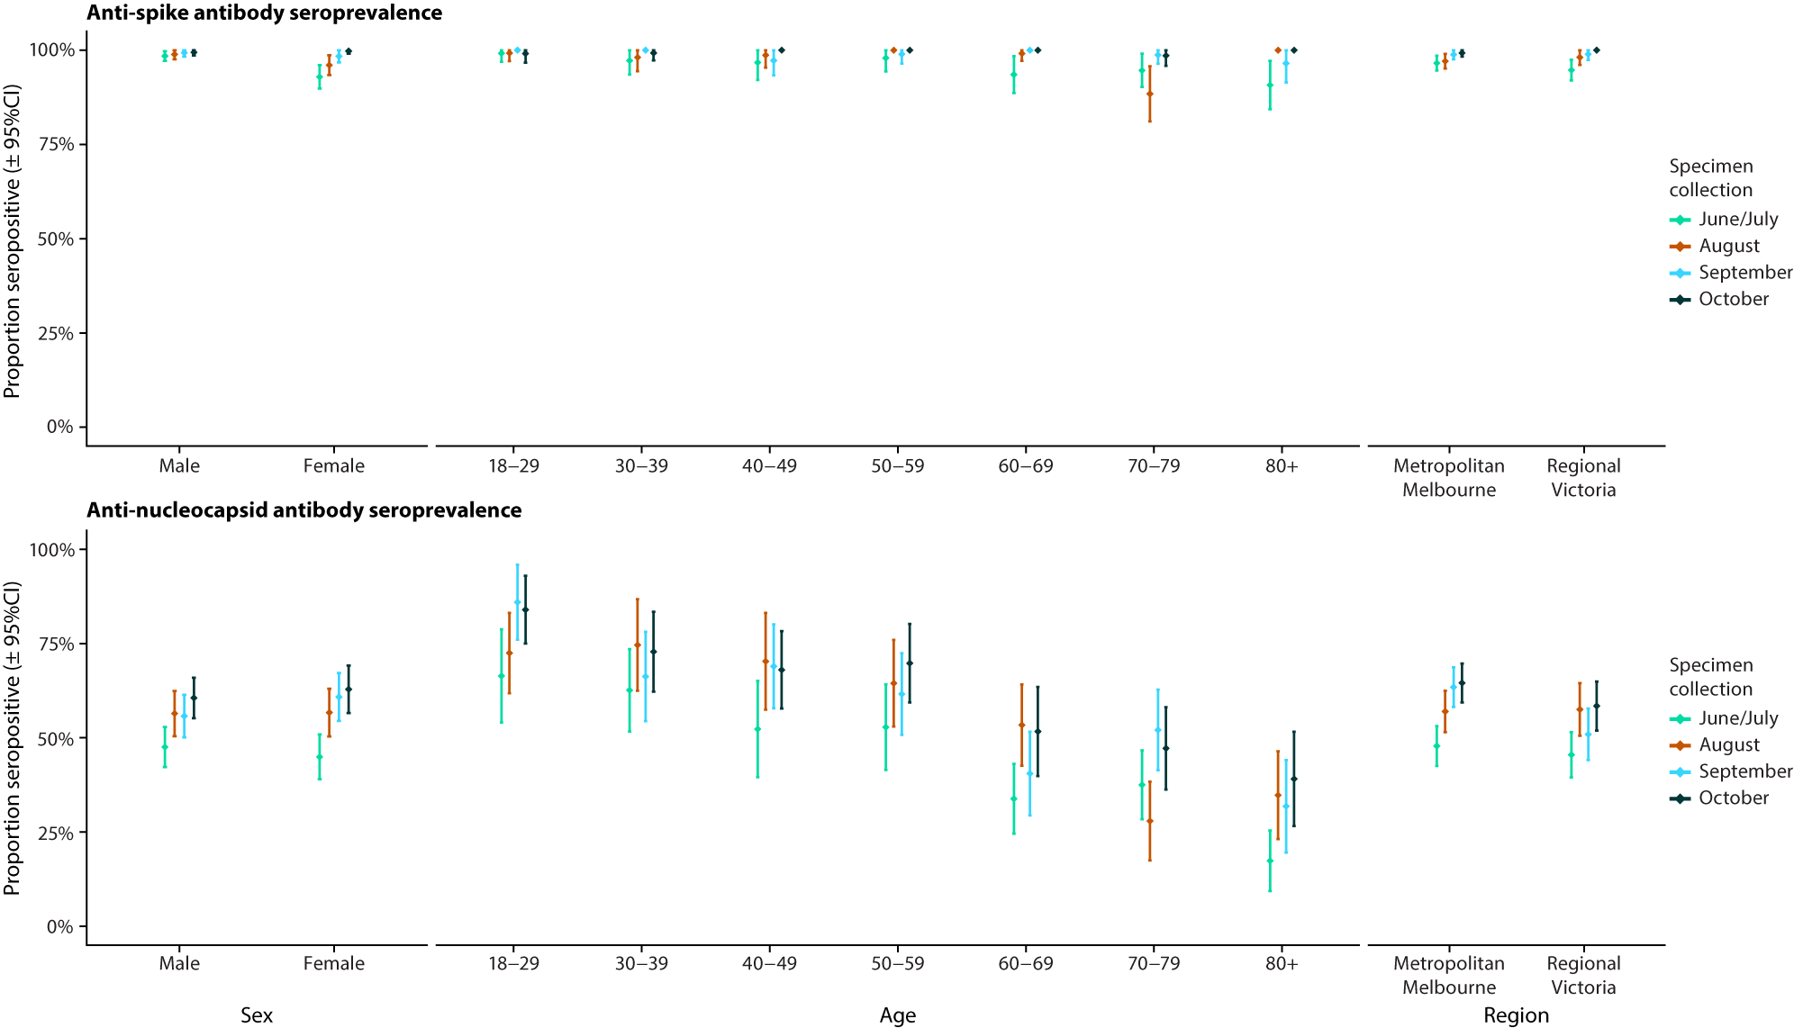

a Specimens were collected during the following months of 2022: June/July (n = 529), August (n = 470), September (n = 469) and October (n = 500). Serosurveys were analysed by collection month and by demographic group (sex, age and region of residence). All estimates are adjusted for sex, age and region of residence as applicable.

b 95% CI: 95% confidence interval.

Figure 1 shows anti-S and anti-N seropositivity over the sample collection period, by age, sex and region of residence. Anti-S seropositivity remained high over the specimen collection period in all demographic groups. Anti-N seropositivity increased between the first and last specimen collection period in all demographic strata. Adjusted anti-N seropositivity in October was highest amongst the youngest age group (18–29 years) at 84% (95% confidence interval [CI]: 75–93%) and lowest amongst the oldest age group (≥ 80 years) at 39% (95% CI: 27–52%).

The adjusted proportion of cases notified by anti-N serostatus, stratified by age, is shown in Figure 2(A). Among anti-N negative samples (n = 782), the adjusted proportion of case notifications was low, particularly among those aged ≥ 60 years; for example, 4% (95% CI: 1–7%) among those aged 60–69 years compared with 13% (95% CI: 7–20%) among samples from people aged 50–59 years. For anti-N positive individuals younger than 80 years, the adjusted proportion of case notifications was approximately 40%; this was higher (65% [95% CI: 54–75%]) for people aged ≥ 80 years. Among all anti-N seropositive individuals (n = 1,191), the adjusted proportion of case notifications increased with additional COVID-19 vaccine doses received (Figure 2(B)). For example, this was 36% (95% CI: 29–42%) among anti-N seropositive individuals who had received two vaccine doses and 54% (95% CI: 46–61%) among anti-N seropositive individuals who had received four or more vaccine doses.

The adjusted proportion of individuals who were anti-N seropositive by case notification status, stratified by age, is shown in Figure 3(A). Note that these results, and those presented in Figure 3(B), are generated from separate regression models to those presented in Figure 2. The proportion of individuals who were seropositive with no prior COVID-19 case notifications decreased with age; this was highest among individuals aged 18 to 29 years (70%, [95% CI: 63–77%]) and lowest among those aged 80 years and over (13% [95% CI: 9–18%]). When stratifying by vaccination status (Figure 3(B)), individuals who had received at least four COVID-19 vaccine doses prior to blood sampling and who had not been a notified case were the least likely to be anti-N seropositive (25% [95% CI: 21–30%]).

Figure 4 shows sVNT inhibition stratified by exposure history. Neutralisation activity tended to be higher against wildtype virus than against Omicron BA.4/BA.5 across all combinations of serological results and vaccination doses. Neutralisation also increased with serological evidence of previous infection (anti-N seropositivity) and with increasing vaccine doses. Lower neutralising activity was observed among older compared to younger individuals with respect to Omicron BA.4/BA.5 (Appendix A, Figure A.2).

When vaccination status was re-assigned (based on the distribution of vaccine doses in Victoria by age as of 1 September 2022) for individuals not linked to a vaccination record, and analyses by vaccine dose strata were repeated as a sensitivity analysis, uncertainty substantially increased among the zero-dose cohort but overall trends in relation to other vaccination groups were maintained (Appendix A, Figure A.3).

Figure 2: Proportion of individuals with a COVID-19 case notification prior to blood sampling by anti-nucleocapsid serostatus, stratified (A) by age and (B) by number of COVID-19 vaccine doses receiveda,b

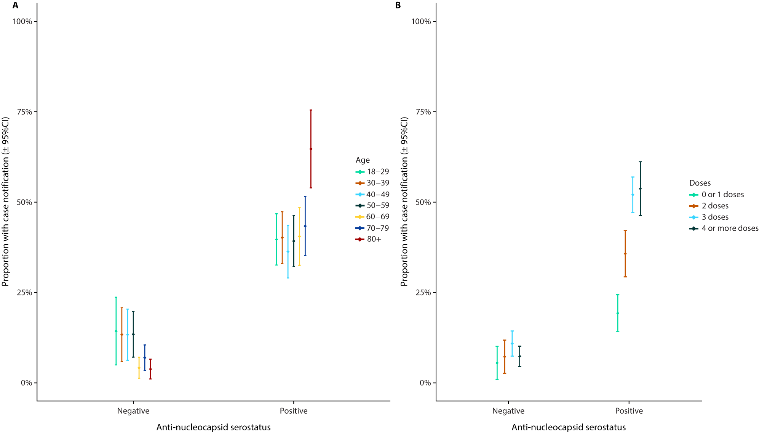

a All estimates are adjusted for sex, age and region of residence as applicable (n = 1,971).

b 95% CI: 95% confidence interval.

Figure 3: Proportion of individuals who are anti-nucleocapsid seropositive by prior COVID-19 case notification status, stratified (A) by age and (B) by number of COVID-19 vaccine doses receiveda,b

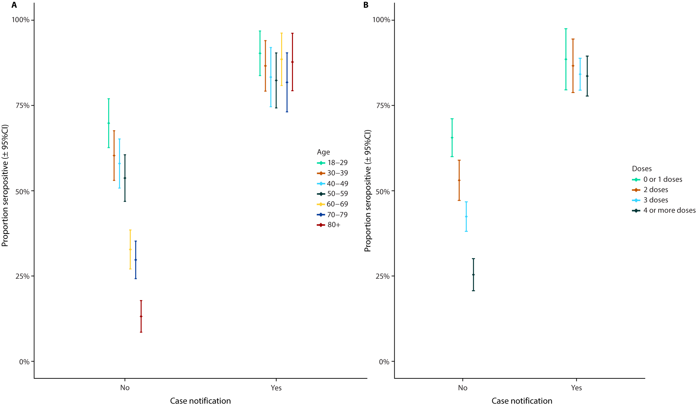

a All estimates are adjusted for sex, age and region of residence as applicable (n = 1,971).

b 95% CI: 95% confidence interval.

Figure 4: Adjusted percentage inhibition against wildtype SARS-CoV-2 and Omicron BA.4/BA.5, by exposure historya,b

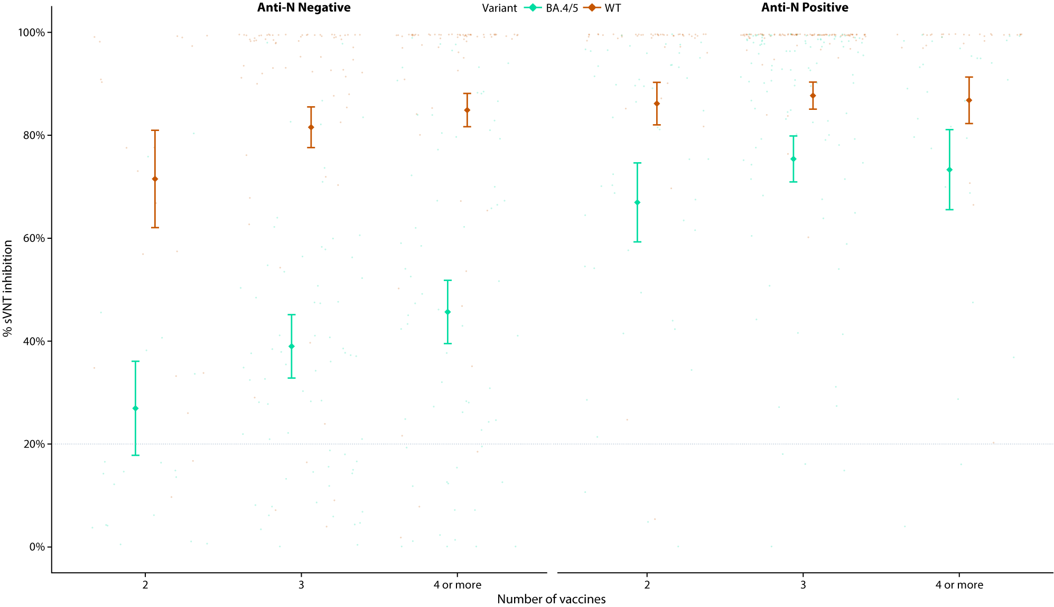

a Exposure history is based on anti-nucleocapsid seropositivity and on the number of COVID-19 vaccine doses received. Points represent percentage inhibition for each sample, whereas diamonds and error bars represent the mean and 95% confidence interval percentage inhibition as estimated by the beta regression model. All estimates are adjusted for sex, age and region of residence. The threshold for test positivity (20%) is indicated by the horizontal dotted line (n = 342).

b WT: wildtype; BA.4/BA.5: Omicron BA.4/BA.5 sub-variants; sVNT: surrogate virus neutralisation test; anti-N: anti-nucleocapsid.

# Discussion

This study, conducted between 30 June and 31 October 2022, suggests that COVID-19 case ascertainment in Victoria varies by age and vaccination status. The findings indicate relatively low notification of SARS-CoV-2 infections, particularly among younger age groups (approximately 40%, for example, among those aged 18–29 years). Higher case detection among those ≥ 80 years of age may be a result of the increased propensity for symptomatic disease amongst older individuals,12 differences in test-seeking behaviour by age and vaccination status, exposure to SARS-CoV-2 testing in the context of presentations to health care services, and/or routine testing in aged-care facilities. Case notification also varied by the number of vaccine doses an individual had received, with more highly vaccinated individuals who had serological evidence of prior infection being more likely to be a notified case. This proportion ranged from 19% (95% CI: 14–24%) among individuals who had not completed a primary (two-course) vaccination series to 54% (95% CI: 46–61%) among those who had received four or more vaccine doses after adjusting for age, sex, and region of residence.

When examining functional antibody responses, the highest levels of neutralisation (particularly against Omicron BA.4 and BA.5) were observed among individuals with evidence of both booster vaccination and previous infection, reflecting the results of studies finding that protection resulting from previous infection and vaccination in combination is higher than that from infection or vaccination alone.13,14 It is not currently possible, however, to directly and quantitatively correlate percentage inhibition values derived from sVNT assays with a specific level of protection against SARS-CoV-2 infection, as there is no defined correlate of protection for sVNT titres. The clinical significance of *in vitro* neutralisation responses in terms of protection against severe or critical COVID-19 are also unclear.

The importance of these results is not that COVID-19 case notifications were incomplete, but that this was not uniform across age and vaccination uptake strata. Therefore, for example, if one was to attempt to validate a SARS-CoV-2 transmission model against Victorian data, one would have to account not only for under-reporting but also for how this under-reporting varies among different groups. Accordingly, a strength of this analysis is linkage of seroprevalence results with COVID-19 vaccination and notification data which has not been conducted previously in Australia. Internationally, such an approach has been used in Canada to identify predictors of infection by socio-economic status and estimate case ascertainment,15 and in Denmark to estimate the percentage of individuals infected soon after Omicron variant emergence, case ascertainment, and the then-current COVID-19 infection fatality ratio.1

While this study provides novel insights into COVID-19 in Victoria, results should be interpreted in light of potential biases due to, for example, limitations inherent in the deterministic data linkage approach utilised. Specifically, 15.5% of individuals were not able to be linked to a record in the vaccination database, suggesting they were either unvaccinated or linkage was unsuccessful. There was therefore a substantial discrepancy between the percentage of individuals appearing unvaccinated in this cohort following linkage to immunisation records and COVID-19 vaccination coverage in Victoria – only an estimated 3% of Victorians aged 16 years and over have not received a COVID-19 vaccine.16 Sensitivity analyses did, however, reflect trends observed in the primary analysis and therefore do not change our conclusions.

Furthermore, analyses were performed on residual serum samples and therefore participants may not be representative of the general Victorian population. Study participants broadly reflected the Victorian population in terms of age distribution, sex and residence in metropolitan Melbourne. However, it was not possible to further assess representativeness in terms of other demographic factors, comorbidities, or healthcare seeking behaviour given data limitations.

It is also important to consider the lower sensitivity of anti-N assays for asymptomatic17 and vaccinated3 individuals, the possible presence of repeated infections which cannot be differentiated using serology, and anti-N waning.17 Published estimates of the longitudinal trajectory of anti-N antibodies vary, but the estimated half-life of anti-N IgG has been reported as 85 days (95% credibility interval: 81–90 days) in a longitudinal seroprevalence study of healthcare workers in the United Kingdom.17 Higher peak anti-N levels have been observed among older individuals and individuals symptomatic with their acute infection.17 The probability of anti-N seroconversion may also vary by COVID-19 vaccination status; for example, in one study seroconversion following PCR-confirmed SARS-CoV-2 infection occurred in only 40% of vaccinees compared to 93% of placebo recipients.3 Factors such as these likely explain the observation that not all notified cases were anti-N positive in this analysis. Importantly, however, while the sensitivity of commercial anti-S assays has been shown to be reduced for detecting Omicron-induced compared to wildtype-induced antibodies, this is not the case for anti-N assays.18,19

This project successfully piloted a serosurveillance approach that provided new insights into the prevalence of prior SARS-CoV-2 infection in Victoria. Now that a transition period has been reached in which there is sustained community transmission of SARS-CoV-2 in Australia and the virus is being managed alongside other communicable diseases, the objectives of serosurveillance will inevitably shift from obtaining simple estimates of total population exposure to more nuanced analyses aiming, for example, to identify sub-populations at highest risk of morbidity and mortality and to inform ongoing vaccination strategies.20 This could be facilitated in future through the use of data linkage approaches. As prior infection with SARS-CoV-2 is now widespread, the utility of anti-N assays in informing pandemic intelligence and response may become limited; in this context, variant-specific neutralisation assays, as demonstrated in this study, may become increasingly informative.20

# Acknowledgments

The authors would like to acknowledge all staff at the Victorian Infectious Diseases Reference Laboratory and the Victorian Department of Health who provided laboratory and technical support for this project.

# Declaration of interests

JS, separate to this work, is currently conducting a study of COVID-19 vaccine effectiveness at the Melbourne School of Population and Global Health (The University of Melbourne) which is sponsored by Moderna. Moderna had no role in the current study.

# Role of the funding source

The Victorian Department of Health commissioned and funded VIDRL to conduct this project. sVNT testing and analysis was funded and performed by VIDRL. The Victorian Department of Health reviewed and approved the study design and interim reports and performed data linkage.

# Data sharing statement

Individual participant data from this study are not able to be shared.

# Author details

Joshua Szanyi (MD)1,2

David J Price (PhD)1,2

Kylie S Carville (MAppEpid)1,3

Mitch Batty (PhD)3

Sarah Yallop (MPS)3

Suellen Nicholson (BSc)3

Theo Karapanagiotidis (BAS)3

Stacey Rowe (PhD)4,5

Sheena Sullivan (PhD)1,2,3,6

Vinay Menon (MPH)6

Daniel West (MFinAnal/MBA)6

Lakshmi Manoharan (MPH)6

Eliza Copsey (GradCertEpi)6

Suman S Majumdar (FRACP)4,6,7

Brett Sutton (FAFPHM)4,6

Deborah A Williamson (PhD)1,3,8

Jodie McVernon (PhD)1,3

1. Department of Infectious Diseases, University of Melbourne, at the Peter Doherty Institute for Infection and Immunity, Victoria, Australia
2. Centre for Epidemiology and Biostatistics, Melbourne School of Population and Global Health, University of Melbourne, Victoria, Australia
3. Victorian Infectious Diseases Reference Laboratory, Royal Melbourne Hospital, at the Peter Doherty Institute for Infection and Immunity, Victoria, Australia
4. School of Public Health and Preventive Medicine, Monash University, Melbourne, Australia
5. Department of Health Professions, University of San Francisco, San Francisco, California, US
6. Victorian Department of Health, Melbourne, Victoria, Australia
7. Burnet Institute, Melbourne, Victoria, Australia
8. Walter and Eliza Hall Institute, Melbourne, Victoria, Australia

Corresponding author

Dr Joshua Szanyi

Population Interventions Unit | Centre for Epidemiology and Biostatistics, The University of Melbourne, Victoria 3010 Australia

email: joshua.szanyi@unimelb.edu.au

# References

1. Erikstrup C, Laksafoss AD, Gladov J, Kaspersen KA, Mikkelsen S, Hindhede L et al. Seroprevalence and infection fatality rate of the SARS-CoV-2 Omicron variant in Denmark: a nationwide serosurveillance study. *Lancet Reg Health Eur*. 2022;21:100479. doi: https://doi.org/10.1016/j.lanepe.2022.100479.
2. Venekamp RP, Schuit E, Hooft L, Veldhuijzen IK, van den Bijllaardt W, Pas SD et al. Diagnostic accuracy of SARS-CoV-2 rapid antigen self-tests in asymptomatic individuals in the omicron period: a cross-sectional study. *Clin Microbiol Infect*. 2023;29(3):391.e1–7. doi: https://doi.org/10.1016/j.cmi.2022.11.004.
3. Follmann D, Janes HE, Buhule OD, Zhou H, Girard B, Marks K et al. Antinucleocapsid antibodies after SARS-CoV-2 infection in the blinded phase of the randomized, placebo-controlled mRNA-1273 COVID-19 vaccine efficacy clinical trial. *Ann Intern Med*. 2022;175(9):1258–65. doi: https://doi.org/10.7326/M22-1300.
4. Australian Government Department of Health and Aged Care. AHPPC statement on COVID-19 winter update and ongoing health protection measures to support our community. [Internet.] Canberra: Australian Government Department of Health and Aged Care; 8 July 2022. [Accessed on 2 April 2023.] Available from: https://www.health.gov.au/news/ahppc-statement-on-covid-19-winter-update-and-ongoing-health-protection-measures-to-support-our-community.
5. Victoria State Government. Victorian COVID-19 data: COVID-19 case numbers and vaccinations. [Webpage.] Melbourne: Victoria State Government; 2022. [Accessed on 1 December 2022.] Available from: https://www.coronavirus.vic.gov.au/victorian-coronavirus-covid-19-data.
6. The Australian COVID-19 Serosurveillance Network. *Seroprevalence of SARS-CoV-2-specific antibodies among Australian blood donors: Round 2 update*. Sydney: University of New South Wales (UNSW), the Kirby Institude; 26 July 2022. Available from: https://www.kirby.unsw.edu.au/sites/default/files/documents/COVID19-Blood-Donor-Report-Round2-May-Jun-2022%5B1%5D.pdf.
7. The Australian COVID-19 Serosurveillance Network. *Seroprevalence of SARS-CoV-2-specific antibodies among Australian blood donors, February–March 2022*. Sydney: UNSW, the Kirby Institude; 3 June 2022. Available from: https://www.kirby.unsw.edu.au/sites/default/files/documents/COVID19-Blood-Donor-Report-Round1-Feb-Mar-2022%5B1%5D.pdf.
8. The Australian COVID-19 Serosurveillance Network. *Seroprevalence of SARS-CoV-2-specific antibodies among Australian blood donors: Round 3 update, 2022*. Sydney: UNSW, the Kirby Institude; 3 November 2022. Available from: https://www.kirby.unsw.edu.au/sites/default/files/documents/COVID19-Blood-Donor-Report-Round3-Aug-Sep-2022%5B1%5D.pdf.
9. Tan CW, Chia WN, Qin X, Liu P, Chen MIC, Tiu C et al. A SARS-CoV-2 surrogate virus neutralization test based on antibody-mediated blockage of ACE2–spike protein–protein interaction. *Nat Biotechnol*. 2020;38(9):1073–8. doi: https://doi.org/10.1038/s41587-020-0631-z.
10. Australian Bureau of Statistics. Census DataPacks. [Webpage.] Canberra: Australian Bureau of Statistics; 2021. [Accessed in November 2022.] Available from: https://www.abs.gov.au/census/find-census-data/datapacks.
11. Victoria State Government. Weekly COVID-19 vaccine data. [Webpage.] Melbourne: Victoria State Government; 2021. [Accessed on 5 January 2022.] Available from: https://www.coronavirus.vic.gov.au/weekly-covid-19-vaccine-data.
12. Sah P, Fitzpatrick MC, Zimmer CF, Abdollahi E, Juden-Kelly L, Moghadas SM et al. Asymptomatic SARS-CoV-2 infection: a systematic review and meta-analysis. *Proc Natl Acad Sci U S A*. 2021;118(34):e2109229118. doi: https://doi.org/10.1073/pnas.2109229118.
13. Altarawneh HN, Chemaitelly H, Ayoub HH, Tang P, Hasan MR, Yassine HM et al. Effects of previous infection and vaccination on symptomatic Omicron infections. *N Engl J Med*. 2022;387(1):21–34. doi: https://doi.org/10.1056/NEJMoa2203965.
14. Bobrovitz N, Ware H, Ma X, Li Z, Hosseini R, Cao C et al. Protective effectiveness of previous SARS-CoV-2 infection and hybrid immunity against the omicron variant and severe disease: a systematic review and meta-regression. *Lancet Infect Dis*. 2023;23(5):556–67. doi: https://doi.org/10.1016/S1473-3099(22)00801-5.
15. Kanji JN, Nguyen LT, Plitt SS, Charlton CL, Fenton J, Braun S et al. Seropositivity to SARS-CoV-2 in Alberta, Canada in a post-vaccination period (March 2021–July 2021). *Infect Dis (Lond)*. 2022;54(9):666–76. doi: https://doi.org/10.1080/23744235.2022.2080250.
16. Australian Government Department of Health and Aged Care. Vaccination numbers and statistics. [Webpage.] Canberra: Australian Government Department of Health and Aged Care; 2022. [Accessed on 19 December 2022.] Available from: https://www.health.gov.au/our-work/covid-19-vaccines/vaccination-numbers-and-statistics.
17. Lumley SF, Wei J, O’Donnell D, Stoesser NE, Matthews PC, Howarth A et al. The duration, dynamics, and determinants of severe acute respiratory syndrome coronavirus 2 (SARS-CoV-2) antibody responses in individual healthcare workers. *Clin Infect Dis*. 2021;73(3):e699–709. doi: https://doi.org/10.1093/cid/ciab004.
18. Grunau B, Tom J, Asamoah-Boaheng M, O’Brien SF, Drews SJ, Sediqi S et al. Sensitivity of the Elecsys nucleocapsid assay for the detection of preceding SARS-CoV-2 infections. *Open Forum Infect Dis*. 2022;9(8):ofac349. doi: https://doi.org/10.1093/ofid/ofac349.
19. Springer DN, Perkmann T, Jani CM, Mucher P, Prüger K, Marculescu R et al. Reduced sensitivity of commercial spike-specific antibody assays after primary infection with the SARS-CoV-2 omicron variant. *Microbiol Spectr*. 2022;10(5):e0212922. doi: https://doi.org/10.1128/spectrum.02129-22.
20. Duarte N, Yanes-Lane M, Arora RK, Bobrovitz N, Liu M, Bego MG et al. Adapting serosurveys for the SARS-CoV-2 vaccine era. *Open Forum Infect Dis*. 2021;9(2):ofab632. doi: https://doi.org/10.1093/ofid/ofab632.

# Appendix A

Table A.1: Percentage distribution of vaccine doses by age in Victoria as of 1 September 2022a

| Vaccine doses | Age group (years) | | | | | | |
| --- | --- | --- | --- | --- | --- | --- | --- |
| 18–29 | 30–39 | 40–49 | 50–59 | 60–69 | 70–79b | 80+b |
| 0 | 10.1 | 4.2 | 2.2 | 1.6 | 1.4 | 0.9 | 0.9 |
| 1 | 2.5 | 1.6 | 1.2 | 1.6 | 1.3 | 0.0 | 0.0 |
| 2 | 37.5 | 32.6 | 24.9 | 18.8 | 12.1 | 7.1 | 7.1 |
| 3 | 50.0 | 33.7 | 43.8 | 50.1 | 20.3 | 27.1 | 27.1 |
| 4c | 0.0 | 27.9 | 27.9 | 27.9 | 64.9 | 64.9 | 64.9 |
| 5d | — | — | — | — | — | — | — |

a Values refer to percentages within each age group.

b Vaccine dose distributions in these two age groups were not reported separately and were thus assumed to be uniform within these age groups for purposes of the sensitivity analysis.

c Fourth dose vaccine coverage was reported in 30–59 and 60+ year age groups only and was assumed to be uniform within these age groups in this analysis.

d Not publicly reported; assumed to be zero in all age groups for this analysis.

Figure A.1: Age distribution of individuals included in the study cohort (grey bars)a

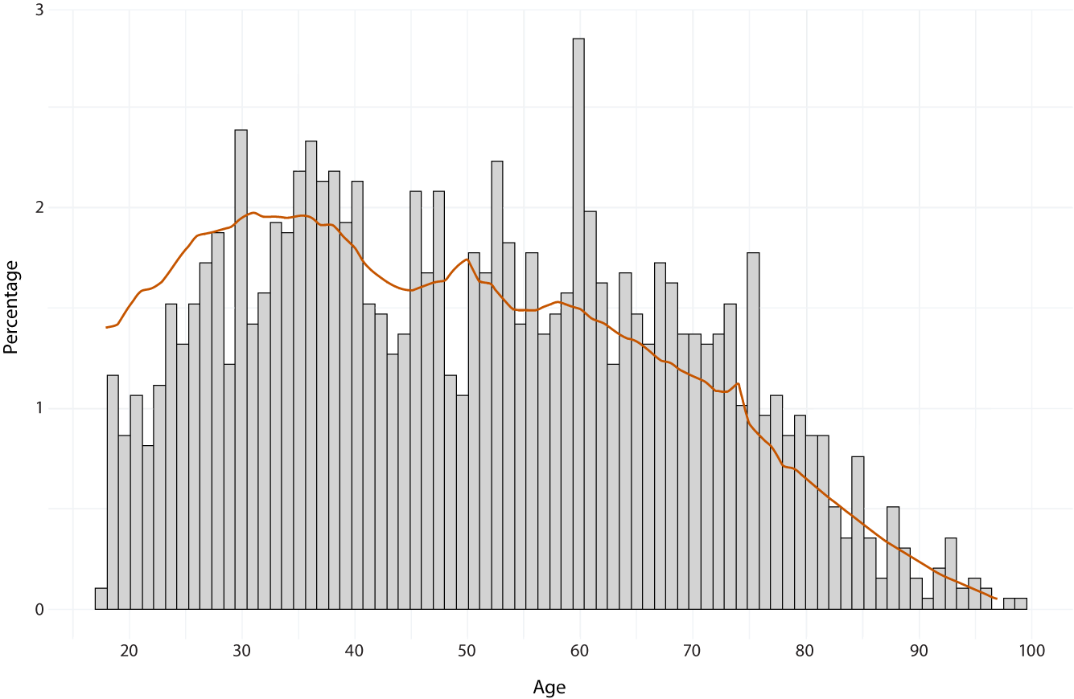

a The orange line indicates the age distribution of ≥ 18-year-olds in Victoria, as per 2021 census data (ABS).

Figure A.2: Percentage inhibition against wildtype SARS-CoV-2 and Omicron BA.4/BA.5 in age strataa,b

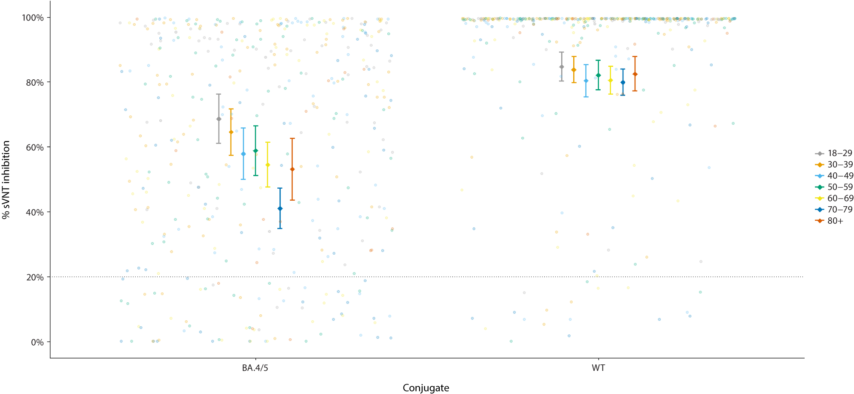

a The threshold for test positivity (20%) is indicated by the horizontal dotted line (n = 396).

b WT: wildtype; BA.4/BA.5: Omicron BA.4/BA.5 sub-variants; sVNT: surrogate virus neutralisation test.

Figure A.3: Proportions of individuals (A) with a COVID-19 case notification prior to blood sampling by anti-nucleocapsid serostatus and (B) who are  
anti-nucleocapsid seropositive by prior COVID-19 case notification statusa,b

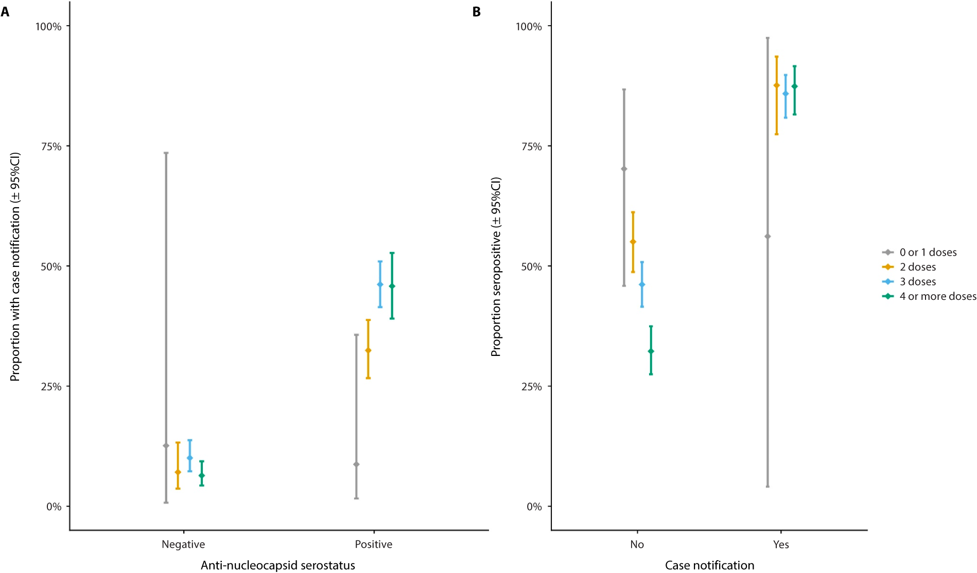

a Proportions are stratified by number of COVID-19 vaccine doses received as per the sensitivity analysis (n = 1,971).

b 95% CI: 95% confidence interval.

About Communicable Diseases Intelligence

Communicable Diseases Intelligence (CDI) is a peer-reviewed scientific journal published by the Health Security & Emergency Management Division, Department of Health and Aged Care. The journal aims to disseminate information on the epidemiology, surveillance, prevention and control of communicable diseases of relevance to Australia.

© Commonwealth of Australia as represented by the Department of Health and Aged Care

ISSN: 2209-6051 Online

This journal is indexed by Index Medicus and Medline.

This publication is licensed under a Creative Commons Attribution-NonCommercial-NoDerivatives 4.0 International Licence (CC BY-NC-ND) available from https://creativecommons.org/licenses/by-nc-nd/4.0/legalcode (Licence). You must read and understand the Licence before using any material from this publication.

Restrictions

The Licence does not cover, and there is no permission given for, use of any of the following material found in this publication (if any):

* the Commonwealth Coat of Arms (by way of information, the terms under which the Coat of Arms may be used can be found at www.pmc.gov.au/resources/commonwealth-coat-arms-information-and-guidelines);
* any logos (including the Department of Health and Aged Care’s logo) and trademarks;
* any photographs and images;
* any signatures; and
* any material belonging to third parties.

Disclaimer

Opinions expressed in *Communicable Diseases Intelligence* are those of the authors and not necessarily those of the Australian Government Department of Health and Aged Care or the Communicable Diseases Network Australia. Data may be subject to revision.

Enquiries

Enquiries regarding any other use of this publication should be addressed to the CDI Editor at: [cdi.editor@health.gov.au](mailto:cdi.editor@health.gov.au)

Communicable Diseases Network Australia

Communicable Diseases Intelligence contributes to the work of the Communicable Diseases Network Australia. www.health.gov.au/cdna

**Editor**: Christina Bareja • **Deputy Editor**: Simon Petrie • **Design and Production**: Lisa Thompson

**Editorial Advisory Board**: David Durrheim, Mark Ferson, Clare Huppatz, John Kaldor, Martyn Kirk, Meru Sheel and Stephanie Williams

Contacts

CDI is produced by:

Health Security & Emergency Management Division, Australian Government Department of Health and Aged Care,  
GPO Box 9848, (MDP 6) CANBERRA ACT 2601

Website: [www.health.gov.au/cdi](http://www.health.gov.au/cdi)

Email: [cdi.editor@health.gov.au](mailto:cdi.editor@health.gov.au)

Submit an Article

You are invited to submit your next communicable disease related article to the *Communicable Diseases Intelligence* (CDI) for consideration. More information regarding CDI can be found at: www.health.gov.au/cdi.

Further enquiries should be directed to: [cdi.editor@health.gov.au](mailto:cdi.editor@health.gov.au)

1. https://www.legislation.vic.gov.au/in-force/acts/public-health-and-wellbeing-act-2008/056.
2. https://www.legislation.vic.gov.au/in-force/acts/health-records-act-2001/047.