2024 • Volume 48 • https://doi.org/10.33321/cdi.2024.48.30 • Electronic publication date: 21/08/2024

Yersiniosis outbreaks in Gold Coast residential aged care facilities linked to nutritionally-supplemented milkshakes, January–April 2023
Candice Colbran, Fiona May, Kate Alexander, Ian Hunter, Russell Stafford, Robert Bell, Anne Cowdry, Fiona Vosti, Sharon Jurd, Trudy Graham, Gino Micalizzi, Rikki Graham, Vicki Slinko

Abstract
In January 2023, an outbreak of Yersinia enterocolitica in residential aged care facilities (RACF) was identified by the Gold Coast Public Health Unit and confirmed using whole genome sequencing. During the outbreak period there were 11 confirmed and 14 probable cases of Y. enterocolitica notified in RACF and 30 suspected cases with compatible illness. Eleven cases (20%) were confirmed as Biotype 1A non-typable (BT1A NT) sequence type (ST) 278 within 4–15 single nucleotide polymorphisms (SNP) of each other. Combined epidemiological, trace-back and laboratory investigations identified nutritional milkshakes, stored at ideal growing conditions for Yersinia and given to vulnerable RACF residents, as the likely outbreak vehicle. This highlights that Y. enterocolitica Biotype 1A can be pathogenic in humans and transmission via atypical sources should be considered in outbreak investigations.
This report outlines the response and challenges associated with investigating outbreaks in aged care.
Keywords: Yersinia; yersiniosis; outbreak; aged care; foodborne infections

Background and methods
Yersiniosis is generally a mild gastrointestinal illness caused by Yersinia enterocolitica, and rarely Y. pseudotuberculosis. Symptoms include fever, abdominal pain and diarrhoea which can be bloody.¹ Infection can be transmitted by consuming or handling contaminated food, commonly undercooked or raw pork products; milk or milk products with suboptimal pasteurisation; or untreated water.² Complications are usually rare but infection may lead to sepsis.¹

Outbreak detection
On 20 January 2023, the Gold Coast Public Health Unit (GCPHU) was notified of a gastrointestinal illness outbreak in a residential aged care facility (RACF) (Facility A), later confirmed to be Y. enterocolitica Biotype 1A non-typeable (BT1A NT). Soon after, a single gastroenteritis case in RACF Facility B and gastrointestinal outbreaks in two further RACFs (Facility C and D) were notified to the PHU, all with confirmed cases of yersiniosis. These notifications coincided with an increase in yersiniosis notifications across Queensland.^{3,4}

Case finding
In Queensland, RACFs are encouraged to notify their local Public Health Unit of all gastrointestinal illness outbreaks and to undertake faecal testing of symptomatic residents to identify the pathogen. After testing of cases at Facility A identified Yersinia enterocolitica in stool samples of multiple residents, testing of all residents in the affected wing of Facility A identified additional asymptomatic cases.
Yersiniosis is a notifiable condition in Queensland. All notifications of yersiniosis in Gold Coast RACFs between 16 January 2023 (onset of the first case) and 17 April 2023 (date of final outbreak control team meeting) were included in the outbreak.

Ethics approval
This investigation was conducted as part of operational public health unit work and under the Queensland Public Health Act (2005) in response to an acute threat to public health. Ethics approval was therefore not required.

Description of outbreaks
Cases were defined as outlined in Box 1.
Box 1: Case definitions
Confirmed case
A Gold Coast RACF resident or staff member with culture positive Y. enterocolitica BT1A NT sequence type (ST) 278, with or without symptoms; with an onset or specimen collection date between 16 January 2023 and 17 April 2023
Probable case
A Gold Coast RACF resident or staff member with Y. enterocolitica detected by PCR, with or without symptoms; with an onset or specimen collection date between 16 January 2023 and 17 April 2023
Suspected case
A Gold Coast RACF resident or staff member with symptoms consistent with yersiniosis, at a facility which has had an outbreak declared (see RACF outbreak definition below); with an onset or specimen collection date between 16 January 2023 and 17 April 2023
RACF outbreak
An outbreak was declared when two or more cases of Y. enterocolitica (isolated by culture or detected by PCR) were detected in residents and/or staff members of the same Gold Coast RACF. An outbreak was declared over when there were no new cases of yersiniosis in the facility for two incubation periods (20 days).
There was a total of 55 cases. Six cases (11%) were in RACF staff; the remaining cases were residents. Resident cases ranged in age from 54 to 101 years with a median of 87 years. More females (n = 41; 75%) were affected than males (n = 14; 25%). Date of onset was known for 46 cases and ranged from 16 January to 17 February 2023, with a peak in late January (see Figure 1). Where a case was asymptomatic or date of onset was not available, the date of specimen collection was used.
There were 11 confirmed cases (20%), 14 probable cases (25%), and 30 suspected cases (55%). Most cases (n = 46; 84%) were symptomatic, eight (15%) were asymptomatic (three of which were culture positive) and the symptoms of one case were unknown.
No cases presented to the emergency department. One case, under palliation prior to Yersinia diagnosis, died.
Five facilities had cases with diagnosed Y. enterocolitica (confirmed or probable). Three of these facilities had outbreaks declared, with the remaining two having single cases (see Figure 1).
Figure 1: Epidemic curve of residential aged care facility (RACF) Yersinia Enterocolitica BT1A NT (ST278) outbreak cases, Gold Coast, 16 January to 9 March 2023 and timeline of important eventsª
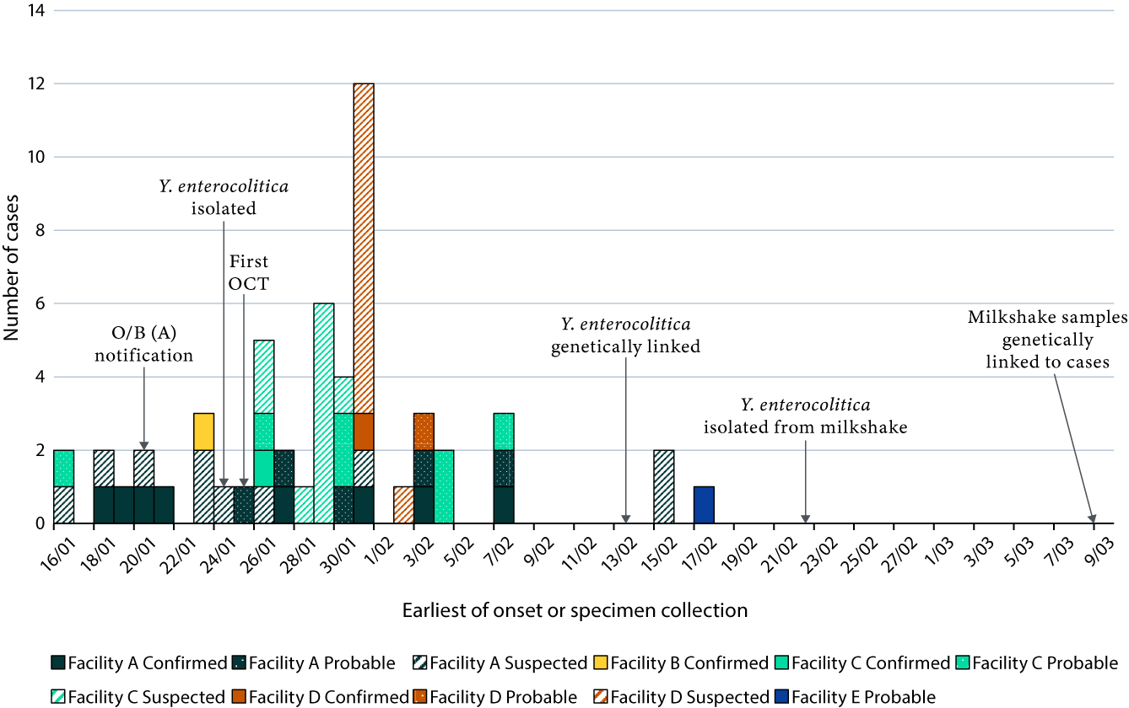
a O/B (A): outbreak in facility A; OCT: outbreak control team.

Environmental and laboratory investigations

Environmental health investigation
All facilities implicated in the outbreaks were inspected by the Gold Coast Public Health Unit (GCPHU). Information about food preparation processes and suppliers was recorded, water supplies were inspected, and procedures reviewed. Information was obtained about meal plans, use of food supplements, dietary requirements, special needs of cases (e.g., assistance with eating), interactions with animals and staff movements between affected facilities. There were no staff members that worked across all affected facilities. Foods commonly consumed by the cases were sampled, ensuring brands and batch numbers were recorded. Environmental swabs were obtained from one facility. All samples were submitted to Queensland Health Forensic and Scientific Services (QHFSS) Public Health Microbiology (PHM) laboratory for testing.
Further investigation into milkshake making practices occurred after Y. enterocolitica was isolated from prepared nutritional milkshakes in Facility C (see ‘microbiological analysis’ section, below). Ingredients included full cream or skim milk, milk powder, vanilla ice cream, liquid flavouring, thickeners (various levels of thickness) and a supplement powder. Milkshakes were prepared in bulk and stored in jugs at 2–8 °C for 24 hours until requested by residents and then discarded if not used. Samples of individual milkshake ingredients from the facility were submitted to QHFSS PHM for testing.
Comparison of milkshake ingredients across implicated facilities identified that fresh milk, milk powder and vanilla ice-cream were commonly used in nutritional shakes. The same brand of fresh milk was used across all five facilities, but due to the short shelf life of fresh milk, it is likely that facilities used different batches during the outbreak. Other ingredients were used at some facilities but not all.

Microbiological analysis
Clinical, food and environmental samples were tested at the PHM laboratory at QHFSS. An homogenate of the foods using phosphate buffered saline (PBS) pH 6.5 (1/10 dilution) was incubated at 4 °C for a total of 21 days. At seven days and at 21 days, homogenates were sub-cultured into a modified Rappaport-Vassiliadis broth (25 °C/4 days) and at the same time onto selective Yersinia agar (30 °C/2 days). Broths were sub-cultured onto selective Yersinia agar after incubation.
Environmental swabs were incubated in 10 mL PBS pH 6.5 and incubated and sub-cultured using the same media and timelines as mentioned above.
Y. enterocolitica was isolated from 11 clinical samples and from three of 113 food samples (the three food samples coming from one RACF). Yersinia was not isolated from individual milkshake ingredients, including fresh milk, or from environmental swabs.

Genomic analysis
All Queensland Y. enterocolitica 1A isolates underwent whole genome sequencing by QHFSS PHM to assess genetic relatedness and identify potential clusters. Of these specimens, 11 were human isolates from Gold Coast RACF residents and all were sequenced as ST278. Another 11 were from food isolates (coming from three food samples), with nine (82%) of those sequenced as ST278. The nine food isolates came from two milkshake samples (both from Facility C). Single nucleotide polymorphism (SNP) analysis of ST278 isolates from RACF cases in the context of publicly available ST278 sequences showed that the RACF isolates had a higher degree of similarity to each other than to the publicly available sequences. The ST278 isolates grown from the milkshake samples displayed the same level of genetic similarity to each other (4–15 SNPs) as to the RACF isolates. Therefore, at the 15 SNP level, the milkshakes and RACF cases were considered to have formed a genetic cluster.

Public health response
All RACFs were practising safe food handling techniques.
A product recall of individual milkshake ingredients did not occur given no clear source of contamination was identified.
No new cases of yersiniosis were identified in any of the facilities after 17 February 2023. Community notifications of yersiniosis also reduced state-wide in late February.

Discussion
Yersinia enterocolitica BT1A is generally considered to be non-pathogenic in humans.^{5,6} These outbreaks highlight that BT1A can be pathogenic, particularly in vulnerable populations, although with generally mild symptoms.
Outbreaks of yersiniosis have been associated with pork products; with ready-to-eat salad mix; with fresh spinach; and with unpasteurised milk, and less commonly, other milk products.^{7–11}
The source of this outbreak was thought to be a contaminated batch of an ingredient used in the milkshakes at Facility C, with it being an ingredient commonly used at the other facilities and available to the community. The frequent use of various milk products within affected facilities made it difficult to identify this single contaminant. Gastroenteritis was likely caused by the made-up milkshakes stored at ideal Yersinia growing conditions for 24 hours and given to elderly, frail residents. Whatever the specific source of contamination, it is likely to also have been the cause of the increase in community cases of the same strain, but was unable to be identified or confirmed. The wave of Yersinia cases in Queensland reduced to baseline levels by the end of February 2023 with no specific intervention or food recall, so was likely to be a contaminated batch of one ingredient that had been depleted.
The role of an infected staff member or food handler was considered as a potential source of infection. However, no staff member worked across all affected facilities.
A limitation of these investigations is the complexity and length of time required to culture Y. enterocolitica. The delay between specimen collection and culture result was up to 28 days, and an additional delay of one to two weeks was required for sequence typing.
This investigation identifies that, despite adequate handling and storage of food products, bacteria can persist and cause symptomatic illness in a susceptible population.

Author details
Dr Candice Colbran¹
Dr Fiona May¹
Dr Kate Alexander¹
Ian Hunter¹
Dr Russell Stafford²
Robert Bell²
Anne Cowdry¹
Fiona Vosti¹
Sharon Jurd¹
Trudy Graham³
Gino Micalizzi³
Dr Rikki Graham³
Dr Vicki Slinko^{1,4}
- Gold Coast Public Health Unit, Gold Coast Hospital and Health Service
- OzFoodNet, Queensland Health, Communicable Diseases Branch
- Public Health Microbiology, Queensland Health Forensic and Scientific Services
- School of Public Health, University of Queensland
Corresponding author
Dr Candice Colbran
Address: Gold Coast Public Health Unit, Gold Coast Health, Carrara, Queensland
Phone: +61 7 5667 3200
Email: Candice.Colbran@health.qld.gov.au

References
- Centers for Disease Control and Prevention (CDC). Yersinia enterocolitica (Yersiniosis). [Webpage.] Atlanta: United States Government Department of Health and Human Services, CDC: 24 October 2016. [Accessed on 10 March 2023.] Available from: https://www.cdc.gov/yersinia/.
- CDC. Yersinia enterocolitica (Yersiniosis): information for health & lab professionals. [Webpage.] Atlanta: United States Government Department of Health and Human Services, CDC: 25 May 2016. [Accessed on 10 March 2023.] Available from: https://www.cdc.gov/yersinia/healthcare.html.
- Queensland Government Department of Health (Queensland Health). Notifiable conditions weekly totals. [Webpage.] Brisbane: Queensland Health; 2023. [Accessed on 2 February 2023.] Available from: https://www.health.qld.gov.au/clinical-practice/guidelines-procedures/diseases-infection/surveillance/reports/notifiable/weekly.
- Queensland Health. Notifiable conditions annual reporting. [Webpage.] Brisbane: Queensland Health; 2023. [Accessed on 2 February 2023.] Available from: https://www.health.qld.gov.au/clinical-practice/guidelines-procedures/diseases-infection/surveillance/reports/notifiable/annual.
- Yue Y, Zheng J, Sheng M, Liu X, Hao Q, Zhang S et al. Public health implications of Yersinia enterocolitica investigation: an ecological modeling and molecular epidemiology study. Infect Dis Poverty. 2023;12(1):41. doi: https://doi.org/10.1186/s40249-023-01063-6.
- Le Guern AS, Martin L, Savin C, Carniel E. Yersiniosis in France: overview and potential sources of infection. Int J Infect Dis. 2016;46:1–7. doi: https://doi.org/10.1016/j.ijid.2016.03.008.
- MacDonald E, Heier BT, Nygård K, Stalheim T, Cudjoe KS, Skjerdal T et al. Yersinia enterocolitica outbreak associated with ready-to-eat salad mix, Norway, 2011. Emerg Infect Dis. 2012;18(9):1496–9. doi: https://doi.org/10.3201/eid1809.120087.
- Espenhain L, Riess M, Müller L, Colombe S, Ethelberg S, Litrup E et al. Cross-border outbreak of Yersinia enterocolitica O3 associated with imported fresh spinach, Sweden and Denmark, March 2019. Euro Surveill. 2019;24(24):1900368. doi: https://doi.org/10.2807/1560-7917.ES.2019.24.24.1900368.
- Ackers ML, Schoenfeld S, Markman J, Smith MG, Nicholson MA, DeWitt W et al. An outbreak of Yersinia enterocolitica O:8 infections associated with pasteurized milk. J Infect Dis. 2000;181(5):1834–7. doi: https://doi.org/10.1086/315436.
- Black RE, Jackson RJ, Tsai T, Medvesky M, Shayegani M, Feeley JC et al. Epidemic Yersinia enterocolitica infection due to contaminated chocolate milk. N Engl J Med. 1978;298(2):76–9. doi: https://doi.org/10.1056/NEJM197801122980204.
- Shayegani M, Morse D, DeForge I, Root T, Parsons LM, Maupin PS. Microbiology of a major foodborne outbreak of gastroenteritis caused by Yersinia enterocolitica serogroup O:8. J Clin Microbiol. 1983;17(1):35–40. doi: https://doi.org/10.1128/jcm.17.1.35-40.1983.

About Communicable Diseases Intelligence
Communicable Diseases Intelligence (CDI) is a peer-reviewed scientific journal published by the Health Security & Emergency Management Division, Department of Health and Aged Care. The journal aims to disseminate information on the epidemiology, surveillance, prevention and control of communicable diseases of relevance to Australia.
© 2024 Commonwealth of Australia as represented by the Department of Health and Aged Care
ISSN: 2209-6051 Online
This journal is indexed by Index Medicus and Medline.
This publication is licensed under a Creative Commons Attribution-NonCommercial-NoDerivatives 4.0 International Licence (CC BY-NC-ND) available from https://creativecommons.org/licenses/by-nc-nd/4.0/legalcode (Licence). You must read and understand the Licence before using any material from this publication.
Restrictions
The Licence does not cover, and there is no permission given for, use of any of the following material found in this publication (if any):
- the Commonwealth Coat of Arms (by way of information, the terms under which the Coat of Arms may be used can be found at www.pmc.gov.au/resources/commonwealth-coat-arms-information-and-guidelines);
- any logos (including the Department of Health and Aged Care’s logo) and trademarks;
- any photographs and images;
- any signatures; and
- any material belonging to third parties.
Disclaimer
Opinions expressed in Communicable Diseases Intelligence are those of the authors and not necessarily those of the Australian Government Department of Health and Aged Care or the Communicable Diseases Network Australia. Data may be subject to revision.
Enquiries
Enquiries regarding any other use of this publication should be addressed to the CDI Editor at: cdi.editor@health.gov.au
Communicable Diseases Network Australia
Communicable Diseases Intelligence contributes to the work of the Communicable Diseases Network Australia. www.health.gov.au/cdna
Editor: Christina Bareja • Deputy Editor: Simon Petrie • Design and Production: Lisa Thompson
Editorial Advisory Board: David Durrheim, Mark Ferson, Clare Huppatz, John Kaldor, Martyn Kirk, Meru Sheel and Stephanie Williams
Contacts
CDI is produced by:
Health Security & Emergency Management Division, Australian Government Department of Health and Aged Care,
GPO Box 9848, (MDP 6) CANBERRA ACT 2601
Website: www.health.gov.au/cdi
Email: cdi.editor@health.gov.au
Submit an Article
You are invited to submit your next communicable disease related article to the Communicable Diseases Intelligence (CDI) for consideration. More information regarding CDI can be found at: www.health.gov.au/cdi.
Further enquiries should be directed to: cdi.editor@health.gov.au

