• Volume • • Electronic publication date:

Outbreak investigation of norovirus gastroenteritis in a childcare facility in Central Queensland, Australia: a household level case series analysis

Connie Schulz, Amanda Wyatt, Jacina Walker, Nicolas Smoll, Emma Field, Gulam Khandaker

# Abstract

Introduction

Noroviruses are one of the most common causes of gastroenteritis in all age groups, including children. However, little has been reported on the transmission of norovirus within childcare facilities and the subsequent impact at the household level.

Methods

We conducted an outbreak investigation of norovirus gastroenteritis in Central Queensland, Australia during May 2021, in a childcare facility and the associated exposed households. Case definitions and outbreak management were employed as per the Communicable Disease Network Australia guidelines for norovirus and suspected viral gastroenteritis. Each case or carer and respective household member was interviewed to determine the date and time of symptom onset, health outcomes, and infector-infectee pairs. We estimated attack rates within the childcare facility and households, and basic reproductive number (R0) for norovirus using time-dependent methods.

Results

A total of 41 people developed gastrointestinal symptoms as a result of this outbreak, with 25 cases (61%) acquiring the infection in the centre and 16 cases (39%) occurring at households. Serial intervals were estimated as a mean 2.4 days (standard deviation 1.7 days), with a majority of cases (73%) in children under two years of age within the centre. Three faecal specimens were obtained, all detecting norovirus genotype II. The time-dependent R0 was 1.5 (95% confidence interval [95% CI]: 1.0–2.2).

Discussion

The attack rate within the childcare facility was highest amongst children aged less than 2 years, highlighting the risk of infection for this age group. We recommend the exclusion of asymptomatic household contacts from childcare facilities to reduce the length and severity of norovirus outbreaks. Further investigation into childcare facility risk factors and associated households are required to optimise public health interventions.

Keywords: Norovirus; gastroenteritis; outbreak

# Introduction

Noroviruses are single-stranded ribonucleic acid (RNA) viruses first detected in stool samples collected from a gastroenteritis outbreak in Norwalk, Ohio, in 1968; they are recognised as the leading cause of acute viral gastroenteritis worldwide.1,2 Noroviruses can be classified into at least six genogroups (genogroups GI to GVI), three of which have been identified in humans (GI, GII and GIV).3 Of these three genogroups, less is known about GIV (alphatron-like noroviruses) as they are the most recently discovered.4 Genogroups GI and GII are more commonly detected in society, with GI associated with food and waterborne outbreaks and GII noroviruses associated with person-to-person transmission.5

The estimated incidence of gastroenteritis in Australia is 17.2 million cases per year (95% confidence interval [95% CI]: 14.5–19.9 million).6 Norovirus-related gastrointestinal illnesses are one of the leading causes of gastroenteritis outbreaks and are implicated in over 50% of outbreaks in Australia. Globally, norovirus causes $USD4.2 billion (95% uncertainty interval [95% UI]: $USD3.2–5.7 billion) in direct health system costs and $USD60.3 billion (95% UI: $USD44.4–83.4 billion) in societal costs per year.7

Norovirus outbreaks can occur continuously throughout the year; however, in Australia, outbreaks are more commonly found from late winter to early summer.8 One study from Melbourne, Australia, indicated prevalence was highest during spring and summer (September – February), suggesting there is a greater risk of transmission during this time.9

Noroviruses appear to be most prevalent in the younger age groups. Children up to 4 years of age are responsible for 54.4% and 73.1% of noroviruses cases in the Eastern Mediterranean and African regions respectively.7 Bruggink et. al. reviewed 287 norovirus outbreaks from 2014 to 2015 in Victoria Australia, with childcare facility outbreaks accounting for 49.1% in non-healthcare settings, and 9.4% of the total outbreaks. The latter proportion was the second largest, after aged care facility outbreaks (69.3%).10 Little has been reported on the transmission of noroviruses within childcare facilities, nor on the subsequent impact at the household level. The aim of this investigation was to estimate the attack rate of norovirus within a childcare facility and associated households during an outbreak in Central Queensland.

# Methods

Notification of seven individuals with gastroenteritis symptoms by the childcare facility to the respective public health unit (PHU) occurred on 19 May 2021.

The guidelines for the public health management of gastroenteritis outbreaks due to norovirus or suspected viral agents in Australia were recommended by the public health unit.11 As part of this outbreak, additional information was collected on secondary transmission within the households.

## Study settings and population

The childcare facility provides early learning services to children aged between 6 weeks and 5 years, with a total of eight rooms. There were 195 enrolled attendees and 38 staff, with a daily capacity consisting of 138 infants and/or children per day across the entirety of the facility. All children enrolled in the childcare care facility attended for at least one day during the outbreak, confirming exposure opportunities for all attendees. Mixing of childcare facility attendees occurred with children of all ages in the early mornings and late afternoons when attendance numbers were low. For this investigation, a child was classified as a childcare facility attendee or household contact less than 18 years of age. Those 18 years and older were either caregivers within the household or staff within the childcare facility.

## Case definitions

A case definition of norovirus consistent with the Communicable Disease Network Australia (CDNA) guidelines was used (Appendix A.1).11 An initial review of suspected cases of childcare attendees with gastroenteritis symptoms, by Kaplan’s criteria, indicated this was likely an outbreak due to norovirus.11 This included vomiting in greater than 50% of the affected population, a mean incubation period of 24–48 hours, illness duration averaging 12–60 hours and no laboratory confirmation at that point in the investigation.11

## Study design

The study design implemented was adapted from Smoll et al. 2021, similarly a case series analysis, where the family of each case was called and data obtained about symptomatology at home.12 Information was gathered from contact tracing interviews, with parents of the children and with staff who were identified, by the childcare facility, as having gastroenteritis symptoms at home or at the childcare facility during the period 13–22 May 2021. Verbal consent was obtained prior to the collection of information, which included: age; gender; role (carer, teacher, child); household contacts; childcare assigned room; date last attended childcare; date and time of symptom onset; date and time of last symptom episode; symptoms; laboratory specimen provided; medical interventions; outcome; and unwell household members. To improve compliance with specimen collection, pathology request forms were offered to those symptomatic by the local PHU. No cohort information from the unexposed households was collected. The cases who introduced the disease to the household were paired with each family member with a rational transmission route consistent with gastroenteritis, identifying the infector-infectee pairs used for serial interval calculations.12 Children who had contact time of more than 48 hours with a symptomatic individual within the childcare facility, and who still experienced symptoms based on a known epidemiological link within the household, were classified as household transmissions.

## Laboratory investigation

Four faecal samples were provided to the local Queensland Health Laboratory. Contamination discounted one sample; the remaining three samples were tested by Forensic and Scientific Services (FSS), Brisbane, Australia. A phylogenetic reverse transcription polymerase chain reaction test (RT-PCR) was performed, allowing simultaneous diagnosis and genotyping of Norwalk-like viruses.13

## Public health and infection prevention and control measures

As part of the initial interview with the childcare facility, infection prevention and control measures were advised by public health nurses, and a line list obtained of the symptomatic individuals. Interventions were implemented by the facility on the day of notification, as per the CDNA guidelines for the public health management of gastroenteritis outbreaks due to norovirus or suspected viral agents in Australia.11 These included increased cleaning frequency, using the recommended cleaning solution, and removal of soft toys and furnishings from the rooms to reduce fomite transmission.11 Information detailing gastroenteritis signs and symptoms, transmission, and prevention strategies for distribution to families was also provided to the centre.11 Daily lists of suspected cases were provided by the childcare facility manager to the PHU derived from reported non-attendance, symptom disclosure by the parent or carer, or symptomatic individuals while at the childcare facility. The childcare facility implemented the recommended exclusion times for symptomatic children (24 hours post last symptoms) and staff (48 hours post last symptoms). In addition to the recommended public health interventions, the facility extended exclusion to children or siblings if a known symptomatic individual was within their household for the duration of the outbreak. The facility also engaged a commercial cleaner to fog the childcare facility with disinfectant solutions on 22–23 May 2021.

## Statistical methods

The data were cleaned and analysed using R statistical software (version 4.0.3). The serial interval was the time difference between the symptom onset of each infector-infectee pair.12 Those infected from the childcare facility were considered as the first generation, while transmission from household member to household member was second generation infection.

The childcare facility attack rate was the number of childcare facility attendee cases divided by the total number of children enrolled in the facility, excluding staff, to better understand transmission rates amongst the attendees. The household attack rate was the number of cases within the house, less the household index case (case who introduced the virus to the household), divided by the number of household occupants.

The basic reproductive number (R0) was calculated using a time-dependent estimation and included all exposed individuals (attendees, staff and household occupants) assumed to have been exposed to norovirus.14,15 The R0 estimation was derived from incidence and serial interval data from the preceding seven days (days 1–7). This was calculated prior to the implementation of infection control and prevention measures to best describe the transmissibility of norovirus in this outbreak. An effective reproductive number (R), measuring transmission at a specific point in time where some individuals may no longer be susceptible or interventions have been put in place, is a tool to indicate the effectiveness of interventions to monitor changes in transmission.16 An R value of less than one indicates outbreak control has been achieved, as the transmission is occurring to less than one other person.

# Results

A total of 284 individuals were exposed: the 195 children enrolled; 38 staff; and 51 household contacts (Table 1). This outbreak resulted in a total of 41 cases of norovirus. Of the 41 cases, three were confirmed cases of norovirus genus II by PCR of faecal samples, with the remaining 38 cases meeting the suspected case definition. There were 25 first-generation cases (61%) and 16 second-generation cases (39%). The first-generation cases consisted of three staff members (3/41; 7%) and 22 children.

Table 1: Exposure descriptors associated with norovirus childcare facility outbreak, Central Queensland

| Exposure | Count (n) | Percentage (%) | Attack rate (95% CI) |
| --- | --- | --- | --- |
| Total households exposed | 25 | — | — |
| Household occupants, median (range) | 4 (2–5) | — | — |
| Total childcare attendeesa | 195 | 68.7 (195/284) | 11.3% (7.2–16.6) |
| Total staff | 38 | 13.4 (38/284) | 7.9% (1.7–21.4) |
| Total household members exposedb | 51 | 18.0 (51/284) | 31.4% (19.1–45.9) |
| Total persons exposed | 284 | 100 | 14.4% (10.6–19.1) |
| Overall time-dependent R0, day 0–2 (95% CI) | 1.5 (1.0–2.2) | — | — |

a Total childcare attendees include all children enrolled in the childcare facility. Maximum daily number of children to attend the childcare facility is 138, whereas there are 195 total enrolments.

b Total exposed includes all household members minus the childcare facility cases.

## Attack rates

The overall attack rate of norovirus gastroenteritis among childcare attendees was 11.3% (95% CI: 7.2–16.6%). All cases (n = 22) among the childcare attendees were from six of the eight rooms. The proportion of positive cases (41.5%) was highest in the rooms for those aged < 2 years (Table 2) (refer to Figure 1 for exposure source daily incidence). In these rooms, there were a total of 32 children exposed, resulting in an attack rate of 53.1%.

There were 51 people within households exposed, and 16 infected, for a household attack rate of 31.4% (95% CI: 19.1–45.9%) (Table 1). On closer inspection, the primary case, in addition to 24 contactable infants/children or staff, acquired the infection at the childcare facility and brought the infection to the family cluster, resulting in 16 infector-infectee pairs (Table 2; Figure 2).

The predominant reported symptom was vomiting (80.5%), with diarrhoeal episodes reported for 41.5% of cases (Table 2). One of the household cases, a caregiver, was hospitalised and treated for dehydration. There were no deaths.

Additional cases were identified within the childcare facility experiencing gastrointestinal symptoms in the week prior to notification of the outbreak. Our investigation determined that the primary case in this outbreak was a staff member, working in one of the eight rooms (with children aged 6 weeks to < 2 years), in their pre-symptomatic but infectious period. Transmission from this case resulted in 10 infections (45.5% of the cases among children within the childcare facility) within this room over the course of the outbreak. A total of 26 children and three staff members exposed at the childcare facility met the criteria for a confirmed or suspected case of gastroenteritis. There were 10 cases among siblings (five sibling pairs) who resided in the same household, with both siblings attending the childcare facility; however, the siblings were enrolled in different rooms within the facility. Secondary infection among four of the siblings was identified as household contacts, based on their symptom onset and exposure timeline, as per our adopted methodology.

Table 2: Case descriptors associated with norovirus childcare facility outbreak, Central Queensland

| Descriptor | Category | Count (n) | Percentage (%) |
| --- | --- | --- | --- |
| Total infections |  | 41 | 100 |
| Childcare facility acquired | Child | 22 | 53.7 |
| Staff | 3 | 7.3 |
| Secondary infection (household cases) | Parent | 12 | 29.3 |
| Childa | 4 | 9.7 |
| Sex | Male | 23 | 56.1 |
| Female | 18 | 43.9 |
| Childcare facility room categories | 6 weeks – 2 years | 17 | 41.5 |
| 2–4 years | 3 | 7.3 |
| 4–5 years | 2 | 4.9 |
| Symptoms | Vomiting | 33 | 80.5 |
| Diarrhoea | 17 | 41.5 |
| Medical interventions | GP treatmentb | 2 | 4.9 |
| Home only | 38 | 92.7 |
| Medical outcomes | Hospitalised | 1 | 2.4 |
| Deaths | 0 | 0 |

a ‘Child’ includes four children who likely acquired the infection via household transmission, i.e., not a childcare facility case as determined by the case definition.

b GP: general practitioner.

Figure 1: Epidemic curve of daily incidence of norovirus cases by exposure sourcea

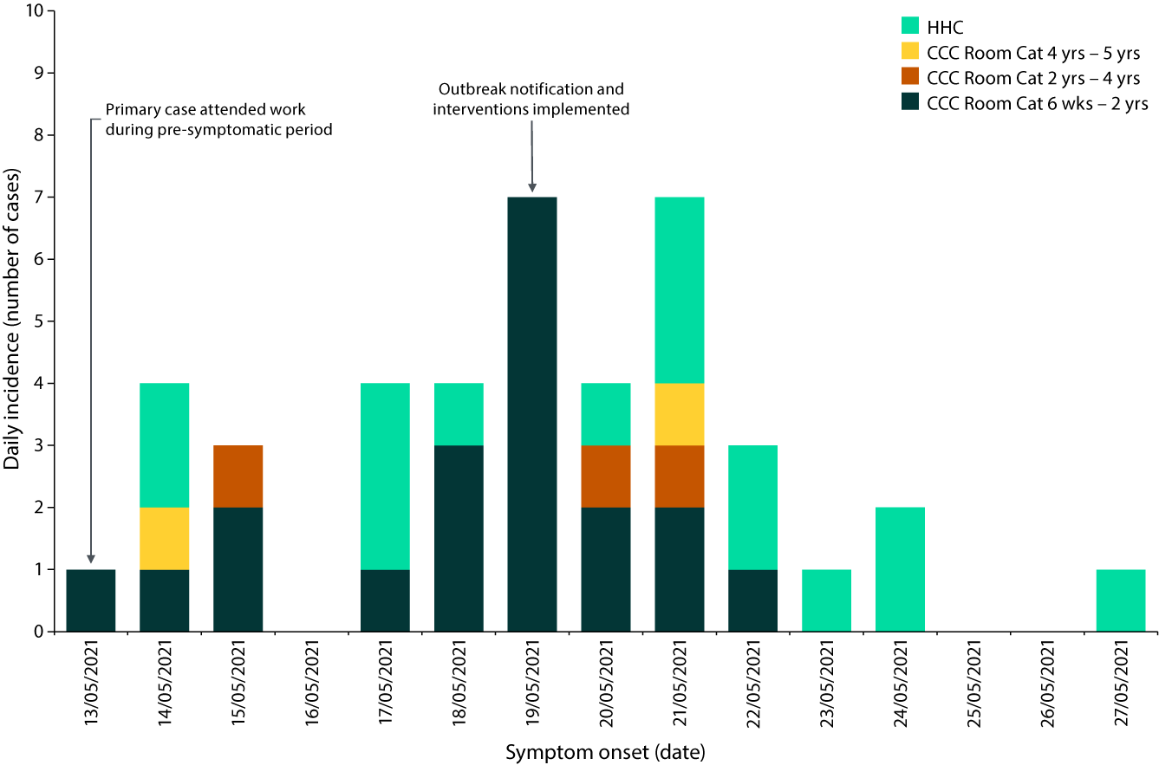

a HHC: household contact; CCC Room Cat: childcare facility room category per age group.

Figure 2: Network graph of norovirus outbreak showing transmission from childcare facility, to corresponding householdsa

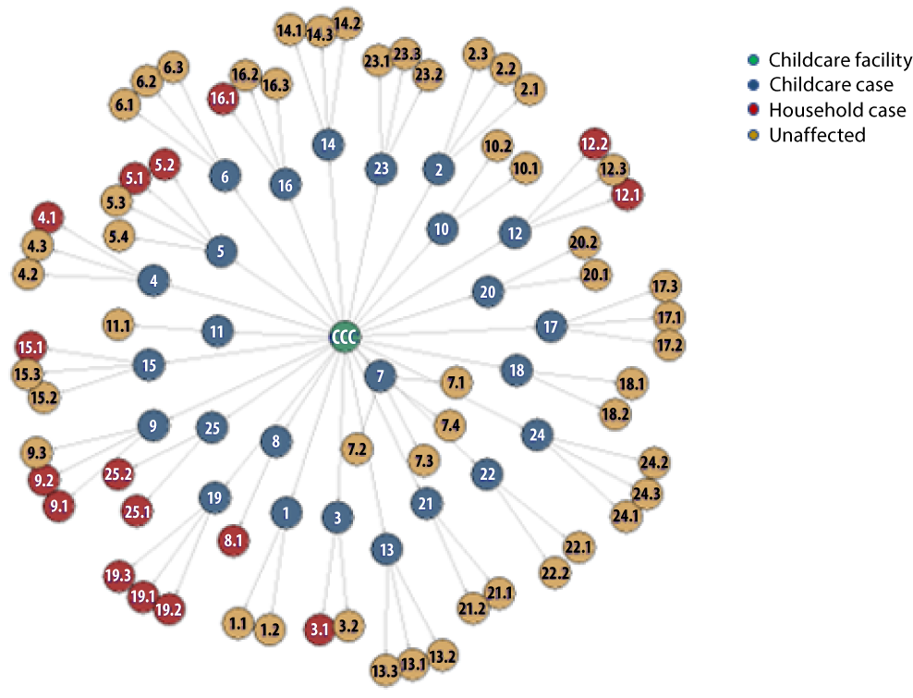

a All index cases (blue nodes) are those who acquired the infection at the childcare facility (green node), effectively introducing norovirus to the home. Node 16 was the primary case. Red nodes indicate the household members identified as cases and yellow for those exposed yet unaffected within the household. Each node contains a number indicating the cluster ID (first number), followed by the household member ID (second).

## Serial interval

The resultant infector-infectee pairs allowed the estimation of serial intervals, which were used to establish a reasonable generation time distribution for estimation of the basic reproductive number (R0). We found a gamma distribution fit best on our serial intervals resulting in a generation time distribution with a mean of 2.4 days (SD 1.7).

## Estimation of basic reproductive number (R0)

The R0, using time-dependent methods during the growth phase of this outbreak (days 5 to 7), was 1.5 (95% CI: 1.0–2.2). This indicates that the transmissibility of norovirus, prior to implementation of infection prevention and control measures, was from one person to more than one other person (two cases would infect another three individuals). Figure 3, showing the reproductive number gradually approaching a value of < 1 from day 8–9 of the outbreak, suggests that control of the outbreak was subsequently achieved: the mean R crossed 1 on day 11. Thereafter, transmission of each case (on average) was to less than one other person.

Figure 3: Time-dependent reproductive number (R0) from outbreak notification

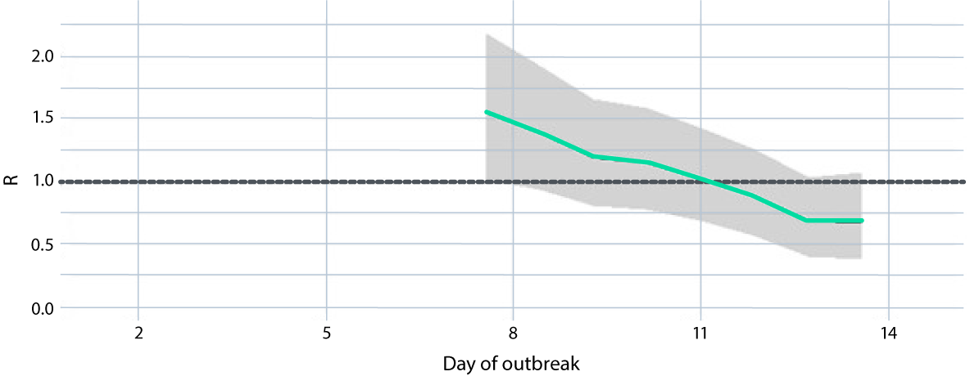

# Discussion

This investigation into a childcare facility norovirus outbreak demonstrated a significant impact on both the attendees and subsequent households. There were 11.3% of attendees impacted, with the highest attack rate amongst those aged < 2 years (53.1%). The secondary attack rate (household attack rate) indicated that almost one-third of household members experienced symptoms consistent with norovirus infection (31.4%). Vomiting was the most predominant symptom found amongst cases in this outbreak (80.5% vomiting versus 41.5% diarrheal episodes). Gastric emptying is delayed as a result of norovirus infection and the reduction in gastric motility is believed to be responsible for causing nausea and vomiting.17 Depending on the viral load, pathogenicity and host immune response manifestation of diseases varies. El-Heneidy et al. similarly found the incidence of vomiting (85.4%) among norovirus infected Australian children aged ≤ 2 years to be more than double the incidence of diarrhoea (35.4%) in their community-based birth cohort study.18

Smoll et al. calculated the attack rate (25%) in a similar childcare facility norovirus outbreak by using the average attendees excluding staff as the denominator. The authors did not report any explanation for choosing it as denominator in calculating the attack rate. By obtaining confirmation of attendance during this outbreak, all enrolments were considered as having an exposure opportunity and were included in the denominator. Had we employed the same definition of the denominator as Smoll et al., the calculated attack rate would be higher: 15.9% instead of 11.3%.12 Our denominator for the attack rate calculations is more conclusive and well represented based on the number of susceptible individuals present during the outbreak.

The attack rate of norovirus within this outbreak (11.3%) is favourable in comparison to those reported in other publications (25–38%), with reported transmission within the facility ending after ten days.12,19,20 A systematic review of norovirus outbreak publications from 1993 to 2011 analysed 118 outbreaks, determined as person-to-person transmission.19 While the settings of these outbreaks are not known, they calculated a median attack rate of 27% (interquartile range [IQR]: 12–46%).19 This is comparable to the 25% attack rate Smoll et al. reported within a childcare facility where the outbreak continued for 22 days.12 Additionally, Marks et al. reported the attack rate of a norovirus outbreak within a school as 31%, with the outbreak lasting 22 days.21 In contrast, the overall attack rate within our childcare facility was lower than the expected outcomes reported by the literature, likely due to adherence to the recommended public health advice. CDNA recommends various interventions to prevent and control norovirus outbreaks, including the isolation of symptomatic individuals and exclusion from care for 48 hours following the last symptomatic episode to reduce the transmission within the childcare facility.11 With ongoing risk of COVID-19 infection in community during the time period, the childcare facility excluded children who had symptomatic household member/s from attending the facility, likely further limiting pathogen transmission and accordingly reducing the overall attack rate and the outbreak duration. Moreover, around ~90% of children < 5 years age develop norovirus antibody titres indicating acquired immunity, although the level of protection from this acquired immunity is unknown and may fluctuate based on the genetic drift of norovirus strains.22

The distribution of cases in this study was largely in younger age groups (less than 2 years of age) which is consistent with findings that they may experience a higher incidence of norovirus.23,24 Hullegie et al. and Faramand et al. both report on the vulnerability within the younger age groups (specifically those under one year of age) and as well as first year day-care attendees.23,24 In our study, 41.5% of cases were isolated to rooms for children aged less than two years of age, reflecting the higher rate of transmission amongst this age group. Causes of cross infection within these rooms could occur via fomite or person-to-person transmission, by either staff members or children when the rooms combined during the mornings and late afternoons. Children become more behaviorally self-sufficient as they get older, and the hands-on level of care they require reduces. Over time they can respond to and implement promoted hand hygiene practices, reducing potential transmissions.25

Implementation of recommended public health interventions to control the spread of norovirus infection is paramount. Differences in outbreak management, including notification time to the relevant public health authority and the adherence to public health recommendations, likely impact on norovirus attack rates and outbreak duration.20,21,26 While there was a delay in notification of our outbreak to the relevant public health authority (day 6), the interventions implemented were immediate and effective. Our outbreak investigation reported a substantially lower reproductive number of 1.5 than was seen in a similar outbreak in a childcare centre in Central Queensland (2.4);12 our reproduction number was also lower than the aggregate value (2.6) from a retrospective review of norovirus outbreaks among childcare centres in the United States of America (USA).27 Additional to the public health infection prevention and control recommendations from the PHU, the exclusion of children from attending childcare due to any symptomatic household member(s) likely reduced norovirus transmission and re-introduction across the whole centre, reducing the outbreak duration and overall attack rate.

A randomised controlled trial, on the effectiveness of active infection prevention and control training in childcare facilities within the Australian Capital Territory, found a 50–66% reduction in the rate of diarrhoeal episodes within the childcare facilities when both staff and children were provided with active training in the spread of infection, and in effective hand hygiene.25 However, when stratified into age categories, there was no significant reduction in diarrheal episodes in those aged ≤ 2 years.25 This suggested that hand hygiene practices alone provided minimal benefit for this age group. Routine interventions were implemented in our outbreak, including the removal of soft toys, mats and pillows to reduce fomite transmission, and increased touch point cleaning frequency with a diluted sodium hypochlorite solution; these measures likely contributed to the low attack rates obtained. The case distribution identified in this study amongst these younger age groups reflects the potential contribution of behavioural risk factors and the need for bolstered infection prevention and control measures against norovirus transmission.

Beyond infection within the primary setting, infection prevention and control measures implemented within the households can reduce disease spread amongst family members. Our analysis and the literature indicate that around one-third of individuals within a household are likely to have symptomatic norovirus infection as a result of an outbreak involving younger children.12,21,28 Secondary household infections where the primary case is older reportedly have lower attack rates within the home.29,30 A trial conducted within households in the USA, with children aged 6 months to 5 years attending out of home care, found that the promotion of hand-hygiene material and supply of hand sanitiser within the households significantly lowered the secondary gastrointestinal illness rate in intervention families compared with control families.28 Targeted infection prevention and control strategies, including adequate hand hygiene practices and appropriate cleaning recommendations, could further support families in mitigating norovirus spread within the households. While this information was provided to the facilities for distribution to affected families in Queensland as per the relevant guidelines, the execution of these practices by the families remains unknown.11

## Strengths and limitations

Active case finding is used to mitigate the potential of reporting bias.31 We adapted the method of active case finding for this investigation, demonstrated to be successful in the reduction of tuberculosis transmission, to reduce under-reporting of symptomatic cases.31

The difficulties of norovirus as a pathogen summarised by Ong include diagnosis difficulties due to the possibility of asymptomatic infection.32 Symptoms, if mild enough, can also be overlooked reducing the identification of both primary and secondary cases. Evidence of asymptomatic viral excretion has previously been investigated, where 37.5% of asymptomatic children within a childcare facility experienced at least one faecal viral excretion with detected norovirus.33 As demonstrated by El-Heneidy et al., faecal testing of all exposed individuals is required to understand the true spread of disease.18 While faecal specimens were requested from each investigated participant, only four samples were supplied. One sample was discarded due to contamination; the remaining three samples identified the causal pathogen (norovirus GII) by PCR. The confirmed sample number fulfilled the recommended adequate specificity required for norovirus as per the CDNA guidelines for gastrointestinal outbreak management.11

This norovirus outbreak affected more than 10% of the childcare attendees, resulting in transmission to almost one-third of the exposed individuals within the impacted households. Transmission was highest among childcare facility attendees in the younger age groups (less than two years of age). Early notification to PHUs and strict adherence to recommended infection control advice likely contributed to an eight-day outbreak duration post notification. Moreover, exclusion of asymptomatic household contacts from childcare facilities could reduce the length and severity of norovirus outbreaks in these settings. We recommend an investigation into childcare facility-specific risk factors including age and room categories; restriction of cross-room intermingling during an outbreak; and the implementation of relevant infection control advice at a household level, to optimise public health interventions and mitigate the spread of norovirus in both the childcare facilities and households.

# Ethical considerations

This study was approved by the Australian National University (ANU) Human Research Ethics Committee (HREC Ref number 2017/909), including the use of oral consent. The most recent variation of this protocol was approved by the Chair of the ANU HREC on 6 October 2022 with a current expiry of 7 February 2027. The outbreak investigation is considered an urgent public health action and covered by the Public Health Act 2005 (Queensland). Verbal consent was obtained from all the participants (parent/carer/facility staff) upon commencement of the telephone interview.

# Author details

Connie Schulz,1,2

Amanda Wyatt,1

Jacina Walker,1

Nicolas Smoll,1

Emma Field,2

Gulam Khandaker1

1. Central Queensland Public Health Unit, Central Queensland Hospital and Health Service, Rockhampton, QLD 4700, Australia.
2. National Centre for Epidemiology and Population Health, Australian National University, Canberra, Australia.

Corresponding author

Gulam Khandaker

Central Queensland Public Health Unit, Central Queensland Hospital and Health Service, Rockhampton, Queensland, Australia

Telephone: +61 7 4920 6989

Email: Gulam.Khandaker@health.qld.gov.au

# References

1. Kapikian AZ, Wyatt RG, Dolin R, Thornhill TS, Kalica AR, Chanock RM. Visualization by immune electron microscopy of a 27-nm particle associated with acute infectious nonbacterial gastroenteritis. *J Virol*. 1972;10(5):1075–81. doi: https://doi.org/10.1128/JVI.10.5.1075-1081.1972.
2. Xue C, Fu Y, Zhu W, Fei Y, Zhu L, Zhang H et al. An outbreak of acute norovirus gastroenteritis in a boarding school in Shanghai: a retrospective cohort study. BMC Public Health. 2014;14(1):1092. doi: https://doi.org/10.1186/1471-2458-14-1092.
3. Muscillo M, Fratini M, Graffeo R, Sanguinetti M, Martella V, Green KY et al. GIV noroviruses in wastewaters and in stool specimens from hospitalized patients. Food Environ Virol. 2013;5(4):194–202. doi: https://doi.org/10.1007/s12560-013-9121-5.
4. Chhabra P, de Graaf M, Parra GI, Chan MCW, Green K, Martella V et al. Updated classification of norovirus genogroups and genotypes. J Gen Virol. 2019;100(10):1393–406. doi: https://doi.org/10.1099/jgv.0.001318.
5. Polkowska A, Räsänen S, Nuorti P, Maunula L, Jalava K. Assessment of food and waterborne viral outbreaks by using field epidemiologic, modern laboratory and statistical methods—lessons learnt from seven major norovirus outbreaks in Finland. Pathogens. 2021;10(12):1624. doi: https://doi.org/10.3390/pathogens10121624.
6. Hall G, Kirk MD, Becker N, Gregory JE, Unicomb L, Millard G et al. Estimating foodborne gastroenteritis, Australia. Emerg Infect Dis. 2005;11(8):1257–64. doi: https://doi.org/10.3201/eid1108.041367.
7. Bartsch SM, Lopman BA, Ozawa S, Hall AJ, Lee BY. Global economic burden of norovirus gastroenteritis. PLoS One. 2016;11(4):e0151219. doi: https://doi.org/10.1371/journal.pone.0151219.
8. Mounts AW, Ando T, Koopmans M, Bresee JS, Noel J, Glass RI. Cold weather seasonality of gastroenteritis associated with Norwalk‐like viruses. J Infect Dis. 2000;181(s2):S284–7. doi: https://doi.org/10.1086/315586.
9. Sinclair MI, Hellard ME, Wolfe R, Mitakakis TZ, Leder K, Fairley CK. Pathogens causing community gastroenteritis in Australia. J Gastroenterol Hepatol. 2005;20(11):1685–90. doi: https://doi.org/10.1111/j.1440-1746.2005.04047.x.
10. Bruggink LD, Moselen JM, Marshall JA. The molecular epidemiology of norovirus outbreaks in Victoria, 2014 to 2015. Commun Dis Intell Q Rep. 2017;41(1):E21–32.
11. Australian Government Department of Health and Aged Care, Communicable Diseases Network Australia (CDNA). Guidelines for the public health management of gastroenteritis outbreaks due to norovirus or suspected viral agents in Australia. [Internet]. Canberra: Australian Government Department of Health and Aged Care, CDNA: April 2010. Available from: https://www.health.gov.au/sites/default/files/documents/2020/03/norovirus-and-suspected-viral-gastroenteritis-cdna-national-guidelines-for-public-health-units-guidelines.pdf.
12. Smoll NR, Khan A, Walker J, McMahon J, Kirk M, Khandaker G. A norovirus gastroenteritis outbreak in an Australian child-care center: a household-level analysis. PLoS One. 2021;16(11):e0259145. doi: https://doi.org/10.1371/journal.pone.0259145.
13. Vinjé J, Koopmans MPG. Simultaneous detection and genotyping of “Norwalk-like viruses” by oligonucleotide array in a reverse line blot hybridization format. J Clin Microbiol. 2000;38(7):2595–601. doi: https://doi.org/10.1128/JCM.38.7.2595-2601.2000.
14. Thompson RN, Stockwin JE, van Gaalen RD, Polonsky JA, Kamvar ZN, Demarsh PA et al. Improved inference of time-varying reproduction numbers during infectious disease outbreaks. Epidemics. 2019;29:100356. doi: https://doi.org/10.1016/j.epidem.2019.100356.
15. Enserink R, Mughini-Gras L, Duizer E, Kortbeek T, Van Pelt W. Risk factors for gastroenteritis in child day care. Epidemiol Infect. 2015;143(13):2707–20. doi: https://doi.org/10.1017/S0950268814003367.
16. Gostic KM, McGough L, Baskerville EB, Abbott S, Joshi K, Tedijanto C et al. Practical considerations for measuring the effective reproductive number, Rt. PLOS Comput Biol. 2020;16(12):e1008409. doi: https://doi.org/10.1371/journal.pcbi.1008409.
17. Glass RI, Parashar UD, Estes MK. Norovirus gastroenteritis. N Engl J Med. 2009;361(18):1776–85. doi: https://doi.org/10.1056/NEJMra0804575.
18. El-Heneidy A, Grimwood K, Mihala G, Lambert S, Ware RS. Epidemiology of norovirus in the first 2 years of life in an Australian community-based birth cohort. Pediatr Infect Dis J. 2022;41(11):878–84. doi: https://doi.org/10.1097/INF.0000000000003667.
19. Matthews JE, Dickey BW, Miller RD, Felzer JR, Dawson BP, Lee AS et al. The epidemiology of published norovirus outbreaks: a review of risk factors associated with attack rate and genogroup. Epidemiol Infect. 2012;140(7):1161–72. doi: https://doi.org/10.1017/S0950268812000234.
20. Li J, Gao X, Ye YL, Wan T, Zang H, Mo PH et al. An acute gastroenteritis outbreak associated with person-to-person transmission in a primary school in Shanghai: first report of a GI.5 norovirus outbreak in China. BMC Infect Dis. 2018;18(1):316. doi: https://doi.org/10.1186/s12879-018-3224-4.
21. Marks PJ, Vipond IB, Regan FM, Wedgwood K, Fey RE, Caul EO. A school outbreak of Norwalk-like virus: evidence for airborne transmission. Epidemiol Infect. 2003;131(1):727–36. doi: https://doi.org/10.1017/s0950268803008689.
22. Kulkarni R, Lole K, Chitambar SD. Seroprevalence of antibodies against GII.4 norovirus among children in Pune, India. J Med Virol. 2016;88(9):1636–40. doi: https://doi.org/10.1002/jmv.24495.
23. Hullegie S, Bruijning-Verhagen P, Uiterwaal CSPM, van der Ent CK, Smit HA, de Hoog MLA. First-year daycare and incidence of acute gastroenteritis. Pediatrics. 2016;137(5):e20153356. doi: https://doi.org/10.1542/peds.2015-3356.
24. Farahmand M, Moghoofei M, Dorost A, Shoja Z, Ghorbani S, Kiani SJ et al. Global prevalence and genotype distribution of norovirus infection in children with gastroenteritis: a meta‐analysis on 6 years of research from 2015 to 2020. Rev Med Virol. 2022;32(1):e2237. doi: https://doi.org/10.1002/rmv.2237.
25. Roberts L, Jorm L, PhD Bvs MSc(Epid), Patel M, Smith W, Douglas RM et al. Effect of infection control measures on the frequency of diarrheal episodes in child care: a randomized, controlled trial. Pediatrics. 2000;105(4 pt 1):743–6. doi: https://doi.org/10.1542/peds.105.4.743.
26. Vivancos R, Keenan A, Sopwith W, Smith K, Quigley C, Mutton K et al. Norovirus outbreak in a cruise ship sailing around the British Isles: investigation and multi-agency management of an international outbreak. J Infect. 2010;60(6):478–85. doi: https://doi.org/10.1016/j.jinf.2010.03.018.
27. Steele MK, Wikswo ME, Hall AJ, Koelle K, Handel A, Levy K et al. Characterizing norovirus transmission from outbreak data, United States. Emerg Infect Dis. 2020;26(8):1818–25. doi: https://doi.org/10.3201/eid2608.191537.
28. Sandora TJ, Taveras EM, Shih MC, Resnick EA, Lee GM, Ross-Degnan D et al. A randomized, controlled trial of a multifaceted intervention including alcohol-based hand sanitizer and hand-hygiene education to reduce illness transmission in the home. Pediatrics. 2005;116(3):587–94. doi: https://doi.org/10.1542/peds.2005-0199.
29. Solano R, Alseda M, Godoy P, Sanz M, Bartolomé R, Manzanares-Laya S et al. Person-to-person transmission of norovirus resulting in an outbreak of acute gastroenteritis at a summer camp. Eur J Gastroenterol Hepatol. 2014;26(10):1160–6. doi: https://doi.org/10.1097/MEG.0000000000000179.
30. Marsh ZA, Grytdal SP, Beggs JC, Leshem E, Gastañaduy PA, Rha B et al. The unwelcome houseguest: secondary household transmission of norovirus. Epidemiol Infect. 2018;146(2):159–67. doi: https://doi.org/10.1017/S0950268817002783.
31. Ayabina DV, Gomes MGM, Nguyen NV, Vo L, Shreshta S, Thapa A et al. The impact of active case finding on transmission dynamics of tuberculosis: a modelling study. PLoS One. 2021;16(11):e0257242. doi: https://doi.org/10.1371/journal.pone.0257242.
32. Ong CW. Norovirus: a challenging pathogen. Healthc Infect. 2013;18(4):133–42. doi: https://doi.org/10.1071/HI13016.
33. Marques Mendanha de Oliveira D, Souza M, Souza Fiaccadori F, César Pereira Santos H, das Dôres de Paula Cardoso D. Monitoring of calicivirus among day-care children: evidence of asymptomatic viral excretion and first report of GI.7 norovirus and GI.3 sapovirus in Brazil. J Med Virol. 2014;86(9):1569–75. doi: https://doi.org/10.1002/jmv.23791.

# Appendix A.1: Outbreak and case definitions

A gastroenteritis outbreak is defined as ‘two or more cases of diarrhoea and/or vomiting in a defined time frame in a setting that is prone to outbreaks of norovirus’.11

A confirmed case is an individual who returned a positive laboratory test from a faecal specimen by polymerase chain reaction (PCR).11

A suspected case is an individual from the exposed group with clinical symptoms of two or more episodes of vomiting and/or three or more episodes of diarrhoea in a 24-hour period.11

About Communicable Diseases Intelligence

Communicable Diseases Intelligence (CDI) is a peer-reviewed scientific journal published by the Health Security & Emergency Management Division, Department of Health and Aged Care. The journal aims to disseminate information on the epidemiology, surveillance, prevention and control of communicable diseases of relevance to Australia.

© Commonwealth of Australia as represented by the Department of Health and Aged Care

ISSN: 2209-6051 Online

This journal is indexed by Index Medicus and Medline.

This publication is licensed under a Creative Commons Attribution-NonCommercial-NoDerivatives 4.0 International Licence (CC BY-NC-ND) available from https://creativecommons.org/licenses/by-nc-nd/4.0/legalcode (Licence). You must read and understand the Licence before using any material from this publication.

Restrictions

The Licence does not cover, and there is no permission given for, use of any of the following material found in this publication (if any):

* the Commonwealth Coat of Arms (by way of information, the terms under which the Coat of Arms may be used can be found at www.pmc.gov.au/resources/commonwealth-coat-arms-information-and-guidelines);
* any logos (including the Department of Health and Aged Care’s logo) and trademarks;
* any photographs and images;
* any signatures; and
* any material belonging to third parties.

Disclaimer

Opinions expressed in *Communicable Diseases Intelligence* are those of the authors and not necessarily those of the Australian Government Department of Health and Aged Care or the Communicable Diseases Network Australia. Data may be subject to revision.

Enquiries

Enquiries regarding any other use of this publication should be addressed to the CDI Editor at: [cdi.editor@health.gov.au](mailto:cdi.editor@health.gov.au)

Communicable Diseases Network Australia

Communicable Diseases Intelligence contributes to the work of the Communicable Diseases Network Australia. www.health.gov.au/cdna

**Editor**: Christina Bareja • **Deputy Editor**: Simon Petrie • **Design and Production**: Lisa Thompson/Kasra Yousefi

**Editorial Advisory Board**: David Durrheim, Mark Ferson, Clare Huppatz, John Kaldor, Martyn Kirk, Meru Sheel and Stephanie Williams

Contacts

CDI is produced by:

Health Security & Emergency Management Division, Australian Government Department of Health and Aged Care,  
GPO Box 9848, (MDP 6) CANBERRA ACT 2601

Website: [www.health.gov.au/cdi](http://www.health.gov.au/cdi)

Email: [cdi.editor@health.gov.au](mailto:cdi.editor@health.gov.au)

Submit an Article

You are invited to submit your next communicable disease related article to the *Communicable Diseases Intelligence* (CDI) for consideration. More information regarding CDI can be found at: www.health.gov.au/cdi.

Further enquiries should be directed to: [cdi.editor@health.gov.au](mailto:cdi.editor@health.gov.au)